Extended Figures
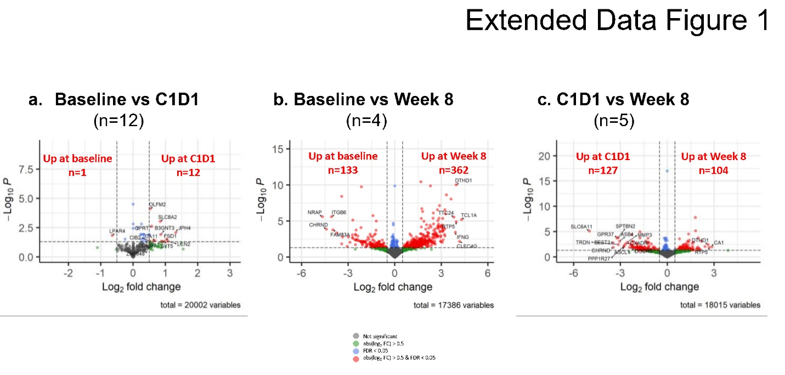
Extended Data Figure 1. Results of differential gene expression analysis of paired sample by treatment (timepoint).
a-c. Volcano plots of the results of differential gene expression analysis of paired samples between baseline and C1D1 (a), baseline and week 8 (b), and C1D1 and week 8 (c). Genes with the absolute log2-fold changes > 0.5 and FDR > 0.05 are in green, genes with the absolute log2-fold changes < 0.5 and FDR < 0.05 are in blue, and genes the absolute log2-fold changes > 0.5 and FDR < 0.05 are in red.

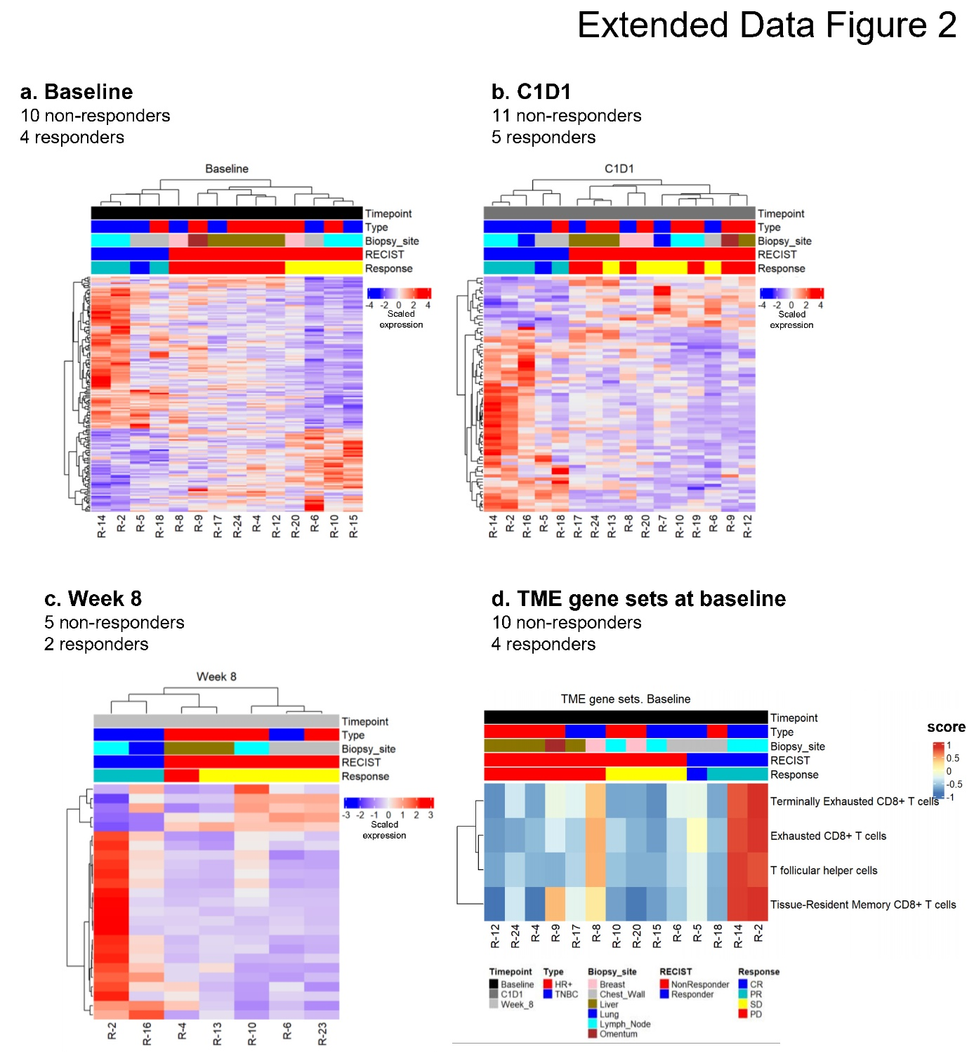
Extended Data Figure 2. Results of differential gene expression analysis of analyses of responders vs non-responders at each timepoint.
a-c. Heatmaps of significantly differentially expressed genes (absolute log2-fold > 0.5 and FDR-adjusted p-value < 0.05) in analysis of responders vs non-responders at baseline (a), C1D1 (b), and week 8 (c). There were 10 non-responders and four responders at baseline; 11 non-responders and five responders at C1D1; five non-responders and two responders at week 8. The analysis was performed using the DESeq2 package. The rows and the columns are clustered hierarchically with Pearson’s distance.
d. Heatmap of gene set scores of TME gene sets with two-sided Wilcoxon sum rank test p-values < 0.1 between responders and non-responders at baseline. The columns are ordered by RECIST response, and the rows are clustered hierarchically with Pearson’s distance.
TME, tumor microenvironment
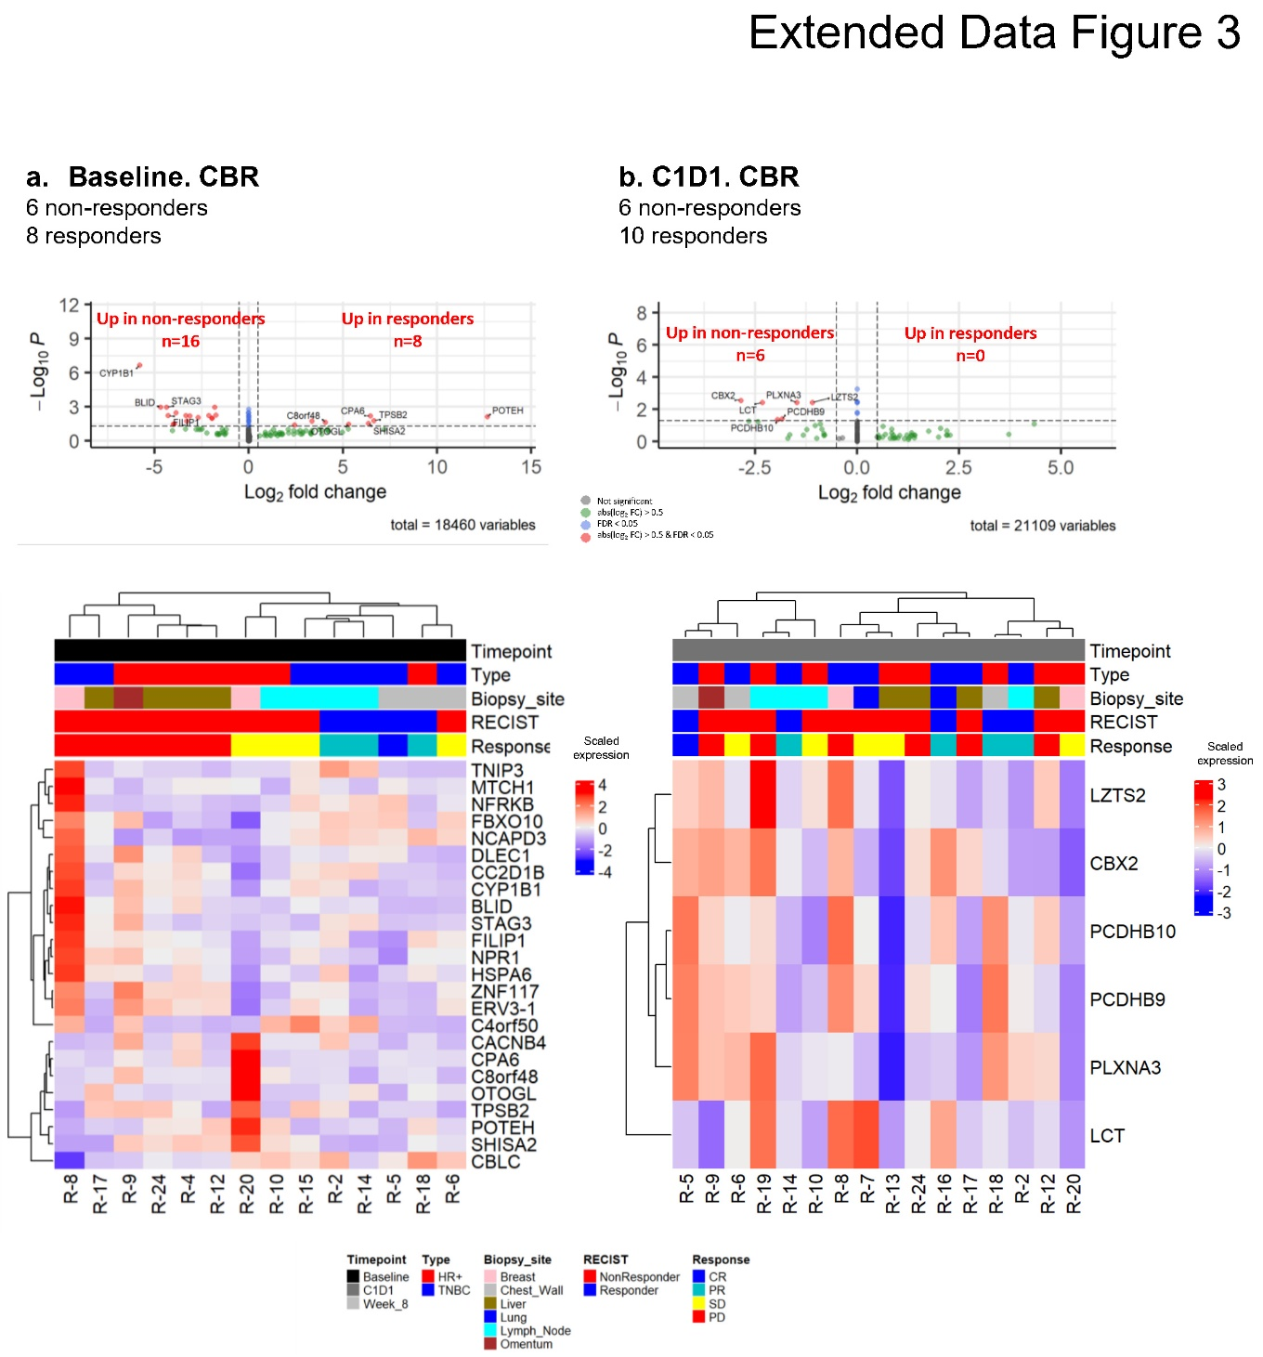
Extended Data Figure 3. Results of differential gene expression of clinical benefit rate at baseline (a) and C1D1 (b).
Volcano plots of the results of differential gene expression analysis between CBR responders and non-responders at baseline (a, top panel), and C1D1 (b, top panel). Genes with the absolute log2-fold changes > 0.5 and FDR > 0.05 are in green, genes with the absolute log2-fold changes < 0.5 and FDR < 0.05 are in blue, and genes the absolute log2-fold changes > 0.5 and FDR < 0.05 are in red.
Heatmaps of significantly differentially expressed genes (absolute log2-fold > 0.5 and FDR-adjusted p-value < 0.05) in analysis of CBR responders vs non-responders at baseline (a, bottom panel) and C1D1 (b, bottom panel). The rows and the columns are clustered hierarchically with Pearson’s distance.
There were six non-responders and eight responders at baseline; six non-responders and ten responders at C1D1. The analysis was performed using the DESeq2 package.
CBR, clinical benefit rate
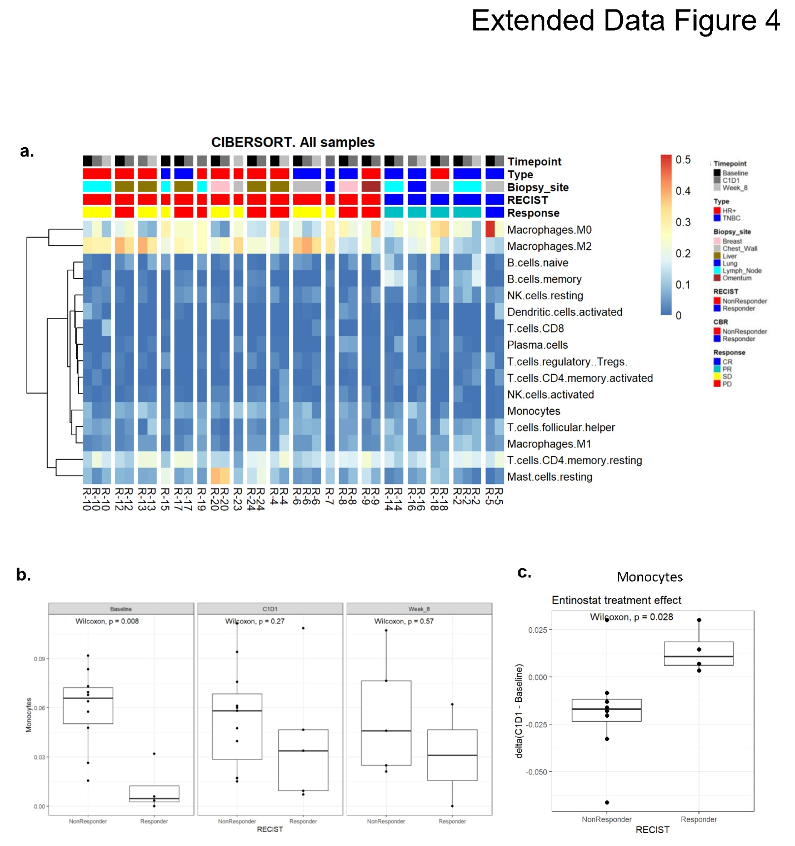
Extended Data Figure 4. Results of analysis of 22 immune cell type proportions estimated by CIBERSORTx.
a. Heatmap of estimated CIBERSORTx cell proportions (n=37). The only proportions that had a standard deviation more than 0.01 are shown. The rows are clustered hierarchically with euclidian distance. The columns are ordered by patient, time, and response.
b. Boxplots of monocyte proportions between responder vs non-responders at each timepoint are shown (n=37).
c. Boxplot of treatment effect between responders and non-responder (after entinostat) in monocytes (n=12).
Two-sided Wilcoxon rank sum test p-values are shown

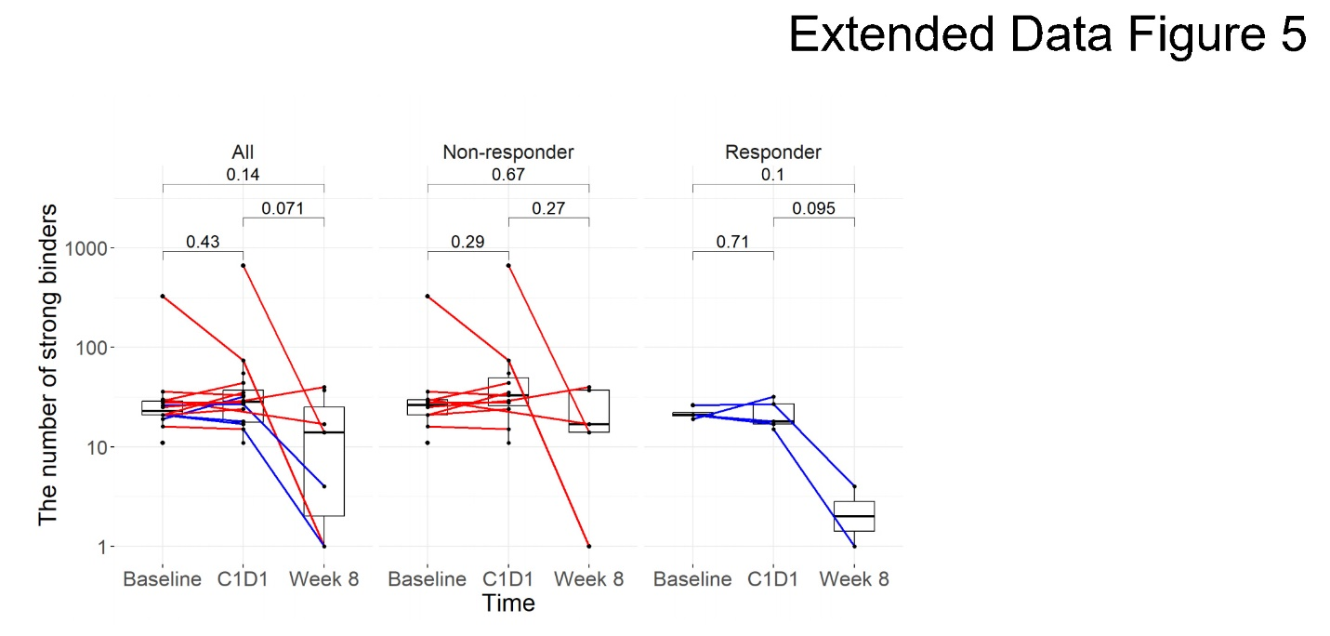
Extended Data Figure 5. Results of neoantigen analysis
Boxplots of the number of strong neoantigen binders in all samples (n=37) over timepoints, as well as for non-responders and responders. Paired two-sided Wilcoxon rank sum test p-values are shown

