Supplementary Figure 1. Immobility examples conferring high immobility burden. Any additional hospitalised immobility, either by a worse score already shown or by an additional hospitalised day with any immobility, would also be considered high immobility burden.

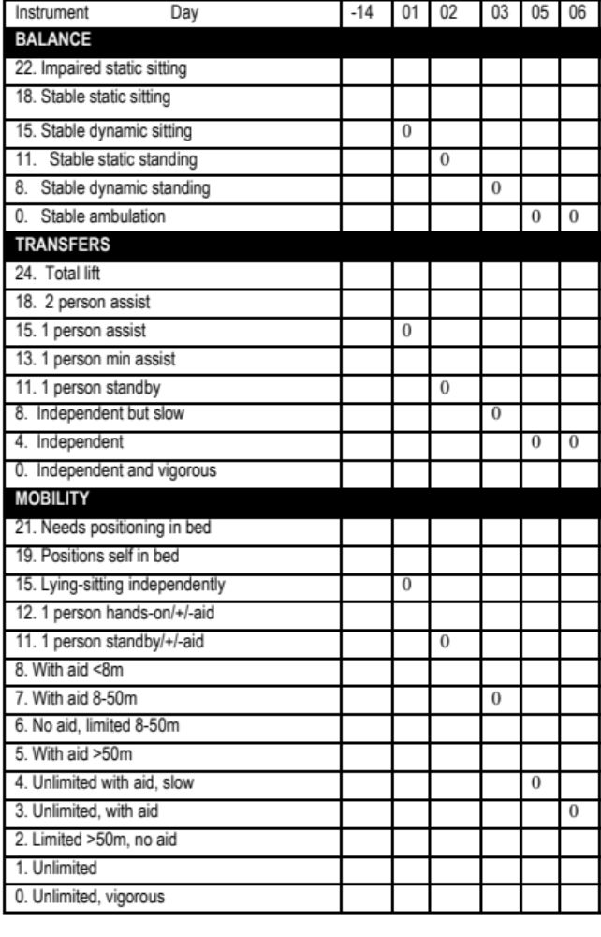

Supplementary Table 1. Prevalence of frailty index (FI) deficits at baseline and follow-up. Items removed from previously used FI were the ability to ambulate, transfer, and walk upstairs [ref].

Frailty index deficit | Baseline prevalence | Follow-up prevalence
General Health (fair/poor/very poor) | 14% | 20%
Myocardial infarction | 20% | 21%
Hypertension | 49% | 55%
Diabetes | 11% | 12%
Stroke | 8% | 11%
Cancer | 24% | 29%
COPD | 12% | 13%
Delirium | 10% | 12%
Near vision | 2% | 6%
Distant vision | 7% | 8%
Conversational hearing | 2% | 3%
Hearing in noisy room | 26% | 37%
Urinary Incontinence | 10% | 11%
Accidental fall | 36% | 28%
Weight loss | 1% | 4%
Feeding | 1% | 2%
Making hot drink | 2% | 4%
Washing up | 3% | 8%
Managing finances | 4% | 4%
Laundry | 6% | 12%
Shopping | 13% | 14%
Social activities | 8% | 11%
Gardening | 37% | 33%
Polypharmacy | 31% | 31%
Grooming | 1% | 3%
Bathing | 2% | 4%
Dressing | 2% | 3%
Toileting | 1% | 2%
Immediate Recall (<4 words) | 31% | 26%
Delayed Recall (<2 words) | 29% | 26%
Verbal fluency (<=10 animals) | 8% | 17%
Verbal fluency (<=10 letter words) | 17% | 22%
All % refer to impairments (deficits).

Supplementary Table 2. Sensitivity Analysis. Associations between baseline immobility and follow-up Frailty Index.

 | β | 95% CI |  | p
Baseline Frailty Index | 0.071 | 0.066 | 0.076 | <0.001
Age (per year) | 0.003 | 0.002 | 0.004 | <0.001
Sex (women cf men) | -0.008 | -0.018 | 0.002 | 0.175
No admission | [ref] |  |  | ref
Low immobility burden | 0.020 | -0.001 | 0.042 | 0.060
High immobility burden | 0.077 | 0.047 | 0.106 | <0.001
*Exlcuded if any participants if they had any elective admission. This was identified post hoc based on recorded admission diagnosis. Fourteen participants were excluded.

 | β | 95% CI |  | p
Baseline Frailty Index | 0.081 | 0.075 | 0.086 | <0.001
Baseline mobility (per level) | 0.001 | -0.023 | 0.026 | 0.909
Age (per year) | 0.004 | 0.003 | 0.005 | <0.001
Sex (women cf men) | -0.007 | -0.017 | 0.003 | 0.175
No admission | [ref] |  |  | [ref]
Low immobility burden | 0.019 | -0.001 | 0.040 | 0.074
High immobility burden | 0.066 | 0.038 | 0.093 | <0.001
Mobility at baseline was an ordinal variable ranging from immobile, dependent on others, independent if using an aid, to independently able.

 | β | 95% CI |  | p
Baseline Frailty Index | 0.072 | 0.075 | 0.086 | <0.001
Age (per year) | 0.003 | 0.003 | 0.005 | <0.001
Sex (women cf men) | -0.009 | -0.017 | 0.003 | 0.062
No admission | [ref] |  |  | [ref]
Low immobility burden | 0.022 | 0.001 | 0.041 | 0.043
High immobility burden | 0.064 | 0.036 | 0.093 | <0.001
Immobility Burden Levels – only the frist 7 days of hospitalisation included in analysis

 | β | 95% CI |  | p
Baseline Frailty Index | 0.072 | 0.067 | 0.077 | <0.001
Age (per year) | 0.003 | 0.002 | 0.004 | <0.001
Sex (women cf men) | -0.009 | -0.019 | 0.001 | 0.07
Immobility Burden | 0.009 | 0.005 | 0.013 | <0.001
Immobility Burden as a continuous variable

 | β | 95% CI |  | p
Baseline Frailty Index | 0.072 | 0.067 | 0.077 | <0.001
Age (per year) | 0.003 | 0.002 | 0.004 | <0.001
Sex (women cf men) | -0.009 | -0.019 | 0.001 | 0.07
Admission | 0.034 | 0.018 | 0.051 | <0.001
Admission – any admission

 | β | 95% CI |  | p
Baseline Frailty Index | 0.072 | 0.067 | 0.077 | <0.001
Age (per year) | 0.003 | 0.002 | 0.004 | <0.001
Sex (women cf men) | -0.010 | -0.019 | 0 | 0.053
No admission | [ref] |  |  | [ref]
Low immobility burden | 0.007 | -0.018 | 0.031 | 0.58
High immobility burden | 0.057 | 0.026 | 0.089 | <0.001
NEWS | 0.011 | -0.003 | 0.026 | 0.13
NEWS – National Early Warning Score mean

 | β | 95% CI |  | p
Baseline Frailty Index | 0.071 | 0.066 | 0.076 | <0.001
Age (per year) | 0.003 | 0.002 | 0.004 | <0.001
Sex (women cf men) | -0.009 | -0.019 | 0.001 | 0.073
No admission | [ref] |  |  | [ref]
Low immobility burden | 0.018 | -0.002 | 0.038 | 0.084
High immobility burden | 0.069 | 0.041 | 0.097 | <0.001
IMDD | 0.003 | -0.001 | 0.006 | 0.128
IMDD – Index of Multiple Deprevation Quintiles

