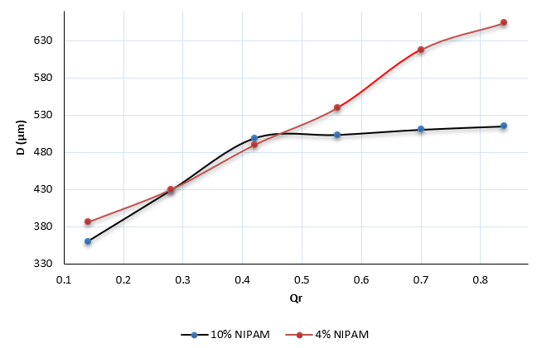
Diagram 1 The diameter of the droplets produced according to the flow rate ratio in two cases of 4% and 10% NIPAM.
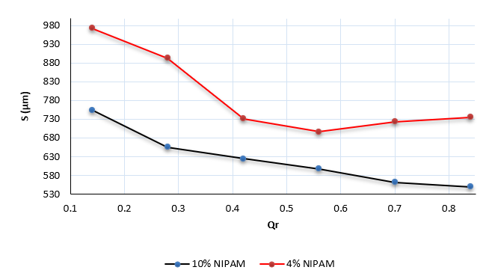
Diagram 2 The center-to-center distance of two drops in the outlet channel of the channel in two NIPAM states of 4% and 10%.

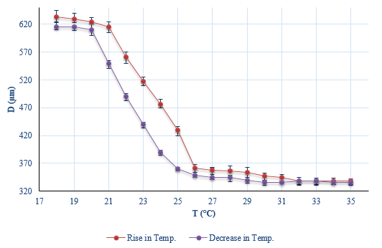
Diagram 3 Representation of the temperature-dependent change in the diameter of 10% NIPAM droplets.

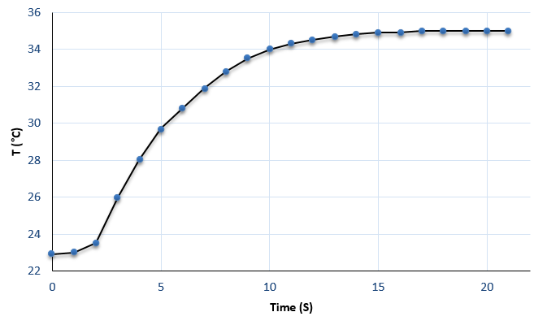
Diagram 4 Diagram of the transient response of a microheater to an electric current at a voltage of 5 volts

