Supplementary material to Varada et al.,

Distinguishing self from non-self RNA by editing-specific inosine patterns

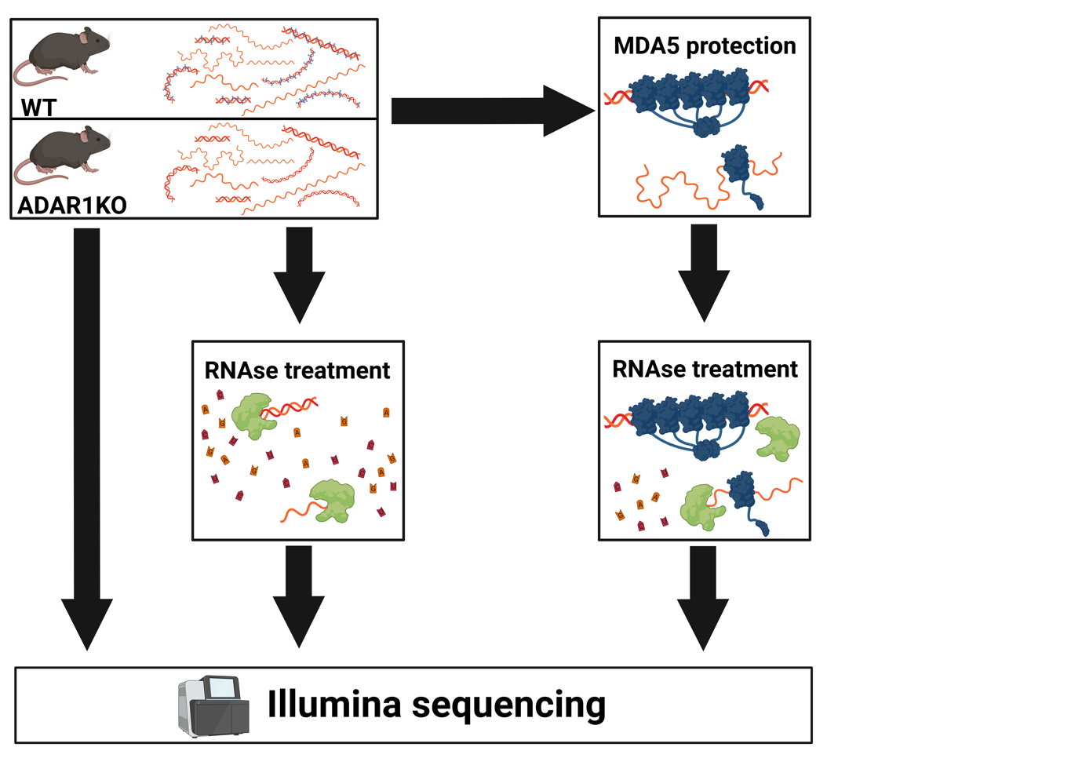
Supplementary figure 1:
Characterization of MDA5 protected RNAs. Total RNA from mouse liver was isolated. An aliquot of the total RNA was used for library preparation to allow quantification of expressed genes (left arrow). An aliquot of the total liver RNA was treated with an RNAse mixture to assess RNAse resistant sites (middle arrow). A fraction of the total liver RNA was incubated with recombinant MDA5 and treated with RNAses. The protected RNAs were used for Illumina library preparation (right arrow).

Supplementary table 1:
Sequencing IDs, origin of RNA, genotype of mice, treatment of samples and corresponding read numbers are indicated.
ID | organ | genotype | treatment | read numbers
RV01001 | liver | Mavs-/- | MDA5 protected | 17.004.948
RV01004 | liver | Mavs-/- | MDA5 protected | 17.750.618
RV01007 | liver | Mavs-/- | MDA5 protected | 18.850.273
RV01002 | liver | Mavs-/- | RNAse only | 10.283.844
RV01005 | liver | Mavs-/- | RNAse only | 9.105.496
RV01008 | liver | Mavs-/- | RNAse only | 14.786.880
RV01003 | liver | Mavs-/- | input | 28.241.330
RV01006 | liver | Mavs-/- | input | 29.169.825
RV01009 | liver | Mavs-/- | input | 30.849.504
RV01010 | liver | Adar-/-; Mavs-/- | MDA5 protected | 17.137.732
RV01013 | liver | Adar-/-; Mavs-/- | MDA5 protected | 17.662.011
RV01016 | liver | Adar-/-; Mavs-/- | MDA5 protected | 18.872.072
RV01011 | liver | Adar-/-; Mavs-/- | RNAse only | 12.369.156
RV01014 | liver | Adar-/-; Mavs-/- | RNAse only | 10.022.532
RV01017 | liver | Adar-/-; Mavs-/- | RNAse only | 9.301.382
RV01012 | liver | Adar-/-; Mavs-/- | input | 131.278.150
RV01015 | liver | Adar-/-; Mavs-/- | input | 31.623.717
RV01018 | liver | Adar-/-; Mavs-/- | input | 32.712.242

Supplementary figure 2:
Principle component analysis demonstrates a clear separation of input (top) and MDA5-protected (bottom) RNAs isolated from livers of Adar1^{-/-}; Mavs ^{-/-} double-knock (red dots) out mice or Mavs^{-/-} (turquoise dots) control mice.

Supplementary figure 3: Fraction of repeat-derived reads in input and MDA5-protected samples as found in wildtype (Mavs^{-/-}) ADAR1 knockout (Adar^{-/-}, Mavs^{-/-}) or in reads of both genotypes. In the MDA5-protected samples, the largest proportion of repeats is found in introns,, 3’UTRs and intergenic regions.
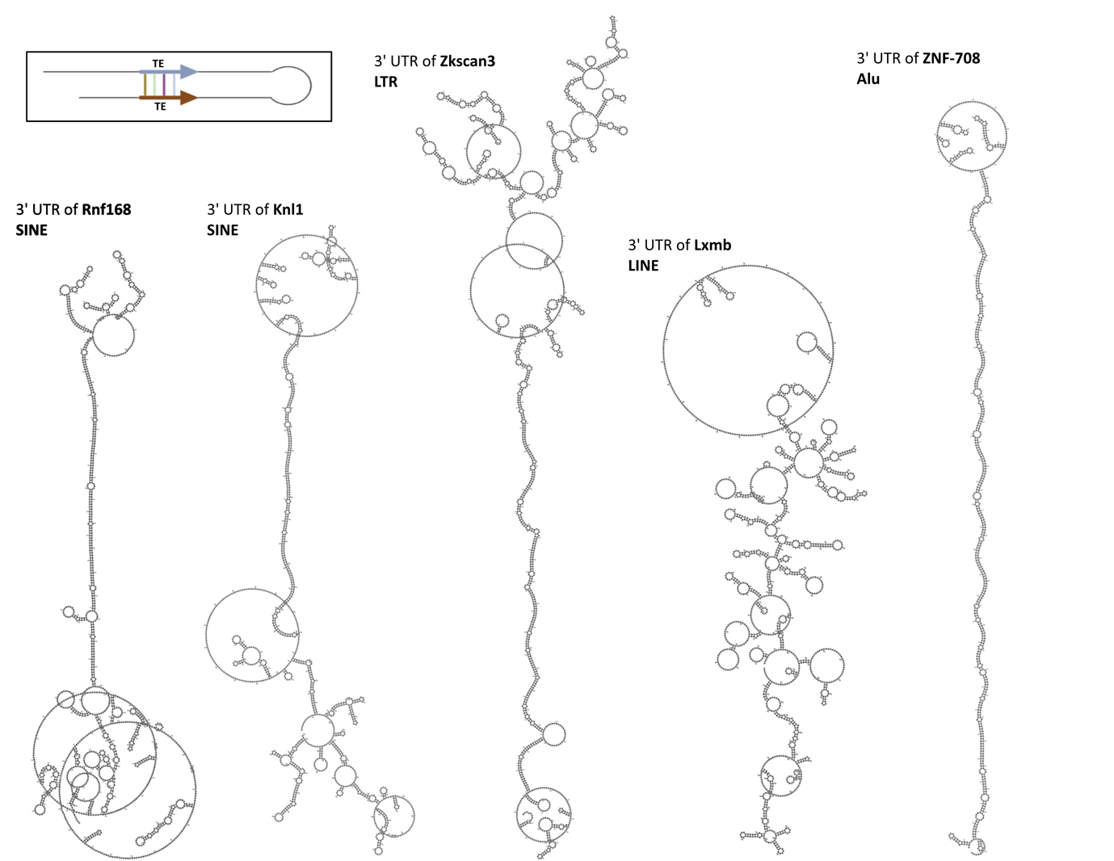

Supplementary figure 4: Secondary structure prediction of MDA5-protected RNA fragments

Supplementary figure 5: Structured, MDA5-protected RNAs support MDA5 polymerization. A) In vitro transcribed RNAs harboring two inverted SINEs from the 3’ UTRs of Rnf168 and Knl1, a LTR element (Zkscan3), a single SINE (1/2 element) or a LINE-b element were tested for their ability to support ATP hydrolysis of MDA5. The 3’ UTR of the human ZNF-708 transcript, harboring two inverted Alu elements and poly I:C were used as controls. Indeed, the inverted SINEs and the LTR element do efficiently support ATP hydrolysis, while a single SINE (1/2 element) and a LINE-b element fail to support ATP hydrolysis. B) In the presence of non-hydrolysable AMP-PNP MDA5 forms filaments along the structured 3’ UTRs of Rnf168, Knl1 and the LTR-element in Zkscan3, similar to ZNF-708 and poly I:C. Again, the single SINE and the LINE-b element fail to support filament formation. C) Electron micrographs showing the formation of filaments on the inverted SINEs found in the 3’ UTRs of Rnf168, Knl1, or the LTR element Zkscan3. Human ZNF-708 harboring two inverted Alu elements and poly I:C RNA serve as positive controls. Bar=100nm.

Supplementary figure 6:Inosine incorporation by T7 polymerase
In vitro transcriptions were set up with 500µM rNTPs where GTP was substitutes with 10, 20, and 50% ITP. Concentrations higher than 50% ITP inhibited transcription. The concentration of incorporated ITP was determined by HPLC of hydrolyzed RNAs A) Rnf168, B) Knl1. C) shows levels of input inosine and ratios of inosines over the sum of I & G. D) Amount of editing measured for Zkscan3 (LTR), Rnf168, Knl1 (both SINEs) and ZNF-708 (human Alu). Editing levels were measured by Sanger sequencing of RT-PCR products where the hight of the G peak was divided by the sum of the heights of the A and G peaks, for all adenosines present in the double-stranded structure.

Supplementary figure 7: Only inosines incorporated by in vitro editing can suppress MDA5 filament formation.
A) The 3' UTR of mouse Knl1 carrying two inverted SINEs was in vitro transcribed in the presence or absence of 10, 20, or 50% inosine triphosphate or in-vitro edited by recombinant ADAR1p110, ADAR1p150 or ADAR2 and incubated with recombinant MDA5 lacking the CARD domains in the presence of non-hydrolyzable ATP. Unedited RNA and RNA with inosines incorporated during in vitro transcription support MDA5 filament formation. In contrast, RNAs that were edited in vitro by any ADAR enzyme no longer support filament formation.
B) The experiment described in A) was performed with in vitro transcribed 3' UTR of human Znf708 which carries two inverted Alu elements. Again, only unedited RNA or RNAs carrying inosines incorporated by in-vitro transcription support MDA5 filament formation, while in vitro edited RNAs fail to support MDA5 filaments.
C & D quantitation of 10 ROIs of the data shown in A and B, respectively.

Supplementary figure 8: The double-stranded UTRs of Rnf168, Knl1 and the LTR element Zkscan3 induce an interferon response stimulating Irf7 expression that is antagonized by in vitro editing but not by inosines introduced by in vitro transcription.
Immortalized mouse embryonic fibroblasts were transfected with 300ng of in vitro transcribed and dephosphorylated RNA originating from the 3' UTRs of the mouse Rnf168 or Knl1 genes harboring two inverted SINEs. Also the in vitro transcribed LTR element located at the Zkscan3 gene was transcribed. The RNA was either transfected as is, or was treated with recombinant ADAR2, ADAR1p110 or ADAR1p150. Alternatively, GTP was substituted by ITP during in vitro transcription to 10%, 20% or 50%, as indicated. 24 hrs post transfection total RNA was extracted, cDNA was synthesized from 200ng RNA and the cDNA was used for qPCR to determine expression levels of Irf7. Gapdh was used as a reference. the fold change induction over Mock transfected (transfection reagent only) was calculated and is plotted on the Y-axes. In vitro transcribed RNAs or RNAs in which inosines were substituting guanosines during in vitro transcription can boostIRF7 expression, comparable to rI:rC RNA. In contrast, RNAs edited by ADAR2, ADAR1p110 or ADAR1p150 fail to cause an IFN response.

Supplementary Figure 9: In vitro editing patterns by ADAR2, ADAR1p110, ADAR1p150.
In vitro transcribed RNA from Rnf168, Knl, and Zkscan3 were refolded and in vitro edited with recombinant ADAR2, ADAR1p110, ADAR1p150. To determine A to I conversions, the RNA was reverse transcribed, overlapping fragments of the RNA were amplified using specific primers and PCR products were sequenced. G peaks were determined over A peaks. ADAR2 edits are highlighted in shades of green, ADAR1p110 edits in amber, and ADAR1p150 edits in lilac. Shadings indicate 25-50% editing (light), 50-75% editing (medium), and > 75% editing dark. On average ADAR2 edits more sites than either isoform of ADAR1. Only few editing events occur opposite unpaired cytosines (red dots). Red asterisks in the sequence highlight adenosines.

Supplementary Figure 10: Mountain plot of in silico folded RNAs with and without in vitro editing. Black line: folding of RNAs without inosines. RNAs with inosines introduced by ADAR2 (red line), ADAR1p110 (green line) or ADAR1p150 (blue line). The number of basepairs is indicated by the increase on the y-axes. As can be seen, the black (unedited) line is always leading to more basepairs than the edited (red, green, blue) RNAs.

Supplementary Figure 11: In vivo editing patterns by ADAR2, ADAR1p110, ADAR1p150.
ADAR-less MEF cells were transfected or transduced with vectors expressing ADAR2, ADAR1p110 or ADAR1p150, respectively. 24 hrs post ADAR induction RNA was isolated, reverse transcribed and the 3’ UTRs of endogenous Rnf168, Knl1, and Zkscan3 sequences were amplified and sequenced. G peaks were determined over A peaks. ADAR2 edits are highlighted in shades of green, ADAR1p110 edits in amber, and ADAR1p150 edits in lilac. Shadings indicate 25-50% editing (light), 50-75% editing (medium), and > 75% editing dark. On average ADAR2 edits more sites than either isoform of ADAR1. Only few editing events occur opposite unpaired cytosines (red dots). Red asterisks in the sequence highlight adenosines.

Supplementary figure 12: Comparison of editing patterns introduced by ADAR1p150. In vitro transcribed RNA of Knl1 and Zkscan3 were edited with ADAR1p150 vitro. The same RNA fragments were amplified from cDNA generated from ADAR-less MEFs transduced with ADAR1p150 expressing lentivirus (rhomboids). Sites that are edited by ADAR1 in the liver of mice as previously reported and deposited in UCSC genome browser are highlighted by black arrows.

