Supplementary Information

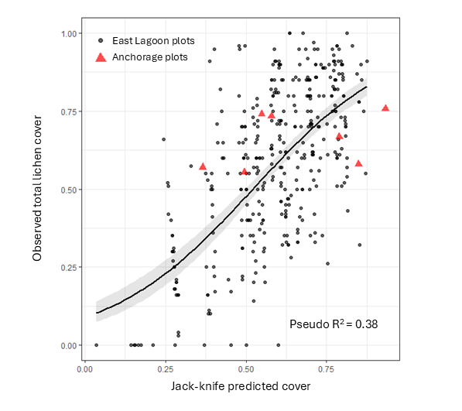
Fig. S1: Observed versus Jack-knife predicted regression plot for the best model explaining the total amount of lichen cover on East Lagoon island (black dots). The total cover was found by adding up the proportion of crustose, fruticose and foliose cover. The mean of the observed total cover (59 %) matches the mean of the jack-knife predictions (59 %), indicating no systematic over- or underestimation even though individual predictions may vary (pseudo-R² = 0.38). For Anchorage Island, we applied the East Lagoon Island model to 7 vegetation plots using the same environmental predictors. The mean observed cover (66 %) and mean predicted cover (65 %) for these plots also show no systematic over- or underestimation.

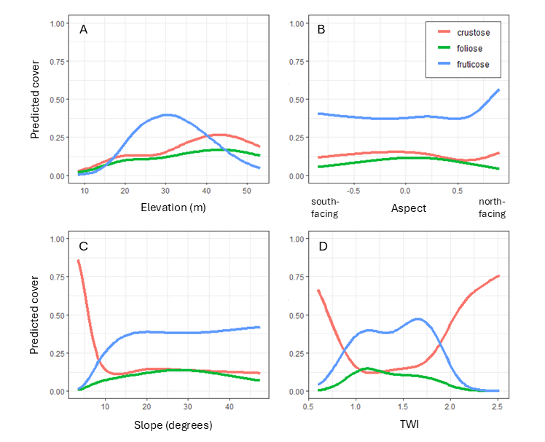
Fig. S2: The effect of elevation (A), aspect (B), slope (C) and topographic wetness index (TWI) (D) on the proportion of predicted cover for crustose (red line), foliose (green line) and fruticose (blue line) lichens. The plots are based on the best model and evaluate the effect of each predictor on the response variable, given the effect of the other predictors (using average values for these predictors) in the model.

Table S1. Summary of predictor effects retained in the best‐fit Dirichlet regression model (lowest AIC) of proportional cover for crustose, fruticose and foliose lichens and bare rock on East Lagoon Island (n = 381 plots). Estimated coefficients (Estimate), standard errors (SE), z‐values and p‐values are given for each spline basis of the four environmental covariates (elevation, aspect, slope, topographic wetness index) and for the significant two‐way interactions.
Predictor | Crustose |  |  |  | Fruticose |  |  |  | Foliose |  |  |  | Bare rock
 | Estimate | SE | z-value | p-value | Estimate | SE | z-value | p-value | Estimate | SE | z-value | p-value | Estimate | SE | z-value | p-value
Elevation (spline 1) | -6.13 | 2.03 | -3.02 | 0.003 | 6.85 | 1.60 | 4.30 | <0.001 |  |  |  |  | -5.50 | 1.95 | -2.82 | 0.005
Elevation (spline 2) | -7.10 | 2.50 | -2.84 | 0.004 | 7.72 | 2.10 | 3.68 | <0.001 |  |  |  |  | -6.22 | 2.30 | -2.71 | 0.007
Elevation (spline 3) | -12.35 | 4.70 | -2.63 | 0.009 | 15.98 | 3.78 | 4.23 | <0.001 |  |  |  |  | -9.89 | 4.49 | -2.20 | 0.028
Elevation (spline 4) | -10.96 | 2.78 | -3.95 | <0.001 | 9.16 | 2.19 | 4.18 | <0.001 |  |  |  |  | -5.95 | 2.48 | -2.40 | 0.016
Aspect (spline 1) | 6.07 | 0.84 | 7.21 | <0.001 | -3.54 | 0.78 | -4.54 | <0.001 |  |  |  |  | 2.09 | 0.87 | 2.41 | 0.016
Aspect (spline 2) | 6.23 | 0.91 | 6.84 | <0.001 | -4.26 | 0.89 | -4.78 | <0.001 |  |  |  |  | 2.89 | 0.99 | 2.91 | 0.004
Aspect (spline 3) | 11.70 | 1.77 | 6.62 | <0.001 | -7.02 | 1.70 | -4.13 | <0.001 |  |  |  |  | 3.91 | 1.85 | 2.11 | 0.035
Aspect (spline 4) | 8.05 | 0.81 | 9.99 | <0.001 | -3.03 | 0.78 | -3.91 | <0.001 | -1.97 | 0.75 | -2.62 | 0.009 | 3.17 | 0.86 | 3.70 | <0.001
Slope (spline 1) | -8.91 | 1.38 | -6.45 | <0.001 |  |  |  |  |  |  |  |  | -3.85 | 1.20 | -3.21 | 0.001
Slope (spline 2) | -11.13 | 2.03 | -5.48 | <0.001 |  |  |  |  | 3.90 | 1.81 | 2.15 | 0.031 | -5.38 | 1.80 | -2.99 | 0.003
Slope (spline 3) | -23.18 | 3.63 | -6.38 | <0.001 |  |  |  |  |  |  |  |  | -9.41 | 3.20 | -2.94 | 0.003
Slope (spline 4) | -15.01 | 2.74 | -5.47 | <0.001 |  |  |  |  | 6.05 | 2.45 | 2.47 | 0.013 | -6.90 | 2.37 | -2.90 | 0.004
TWI (spline 1) | -12.61 | 2.50 | -5.04 | <0.001 |  |  |  |  |  |  |  |  | -5.99 | 2.21 | -2.71 | 0.007
TWI (spline 2) | -16.34 | 3.01 | -5.43 | <0.001 |  |  |  |  |  |  |  |  | -9.57 | 2.72 | -3.52 | <0.001
TWI (spline 3) | -27.38 | 5.23 | -5.24 | <0.001 |  |  |  |  |  |  |  |  | -13.44 | 4.59 | -2.93 | 0.003
TWI (spline 4) | -15.41 | 3.12 | -4.94 | <0.001 |  |  |  |  |  |  |  |  | -6.50 | 2.70 | -2.41 | 0.016
Slope x Aspect |  |  |  |  |  |  |  |  | -0.03 | 0.01 | -2.03 | 0.043
Elevation x TWI | 0.26 | 0.06 | 4.39 | <0.001 | -0.17 | 0.05 | -3.71 | <0.001 |  |  |  |  | 0.13 | 0.05 | 2.51 | 0.012
Slope x TWI | 0.26 | 0.05 | 5.06 | <0.001 |  |  |  |  |  |  |  |  | 0.13 | 0.04 | 2.92 | 0.004
Elevation x Aspect | -0.17 | 0.02 | -9.05 | <0.001 | 0.13 | 0.02 | 6.74 | <0.001 | 0.07 | 0.02 | 3.87 | <0.001 | -0.06 | 0.02 | -3.29 | 0.001

