Table 1. Compounds found in FPHD.
Name | Structure | Oral bioavailability (%) |  | Drug-like properties | Targets number
Creatinine | 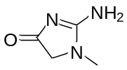 |  | 79.74 | 0.02 | 25
2,3-Dihydro-5,7-dihydroxy- 2,8-dimethyl-6-(3-methyl-2- butenyl)-4H-1-benzopyran- 4-one | 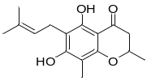 |  | - | - | 221
gamma-Octalactone | 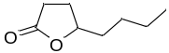 |  | - | - | 187
Histamine | 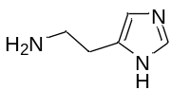 |  | 44.10 | 0.01 | 61
Sinapine | 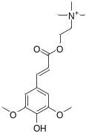 |  | 1.21 | 0.18 | 341
Nicotinic acid | 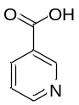 |  | 47.65 | 0.02 | 245
Mimosine | 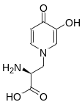 |  | - | - | 284
Nicotinamide | 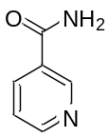 |  | 71.13 | 0.02 | 194
Gentianaine | 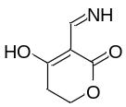 |  | - | - | 142
Tuliposide B | 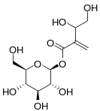 |  | - | - | 325
Cryptochlorogenic acid | 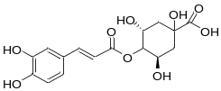 |  | - | - | 324
Verbenalin | 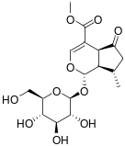 |  | 12.69 | 0.44 | 335
Tuberosine A | 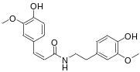 |  | 102.67 | 0.34 | 506
Bavachin | 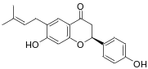 |  | - | - | 364
Quassimarin | 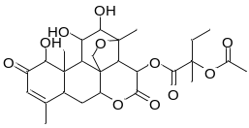 |  | - | - | 354
Piceatannol | 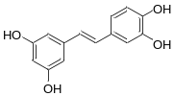 |  | 72.29 | 0.13 | 355
Succinic acid | 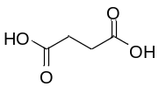 |  | 29.62 | 0.01 | 259
Polydatin | 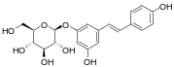 |  | 21.44 | 0.50 | 328
Protocatechuic acid | 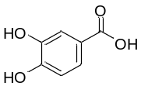 |  | 25.37 | 0.04 | 362
Canthoside B | 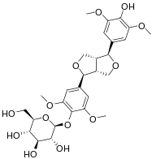 |  | - | - | 311
4-Hydroxybenzoic acid | 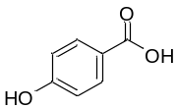 |  | 30.15 | 0.03 | 127
Geniposide | 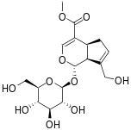 |  | 14.64 | 0.44 | 331
Justicidin B | 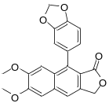 |  | - | - | 348
Daphentin | 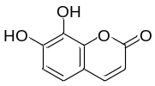 |  | 24.23 | 0.07 | 284
Syringic acid | 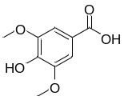 |  | 47.78 | 0.06 | 297
Methyl(2,4-dihydroxy-3-formyl-6- methoxy)phenylketone | 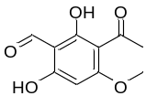 |  | - | - | 39
p-Coumaric acid | 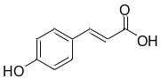 |  | 43.29 | 0.04 | 206
7-Hydroxycoumarin | 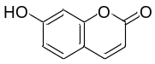 |  | 27.37 | 0.05 | 276
Berberastine | 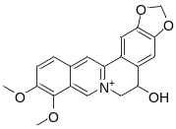 |  | - | - | 308
Methyl-5,7-dihydroxy- 2(Z)-octenoate | 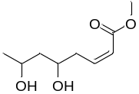 |  | - | - | 265
Podolide | 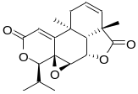 |  | - | - | 349
Loliolide | 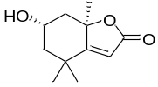 |  | 44.66 | 0.08 | 206
Icariside B9 | 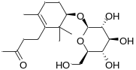 |  | - | - | 309
Miraxanthin III | 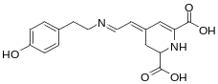 |  | - | - | 298
Bruceine E | 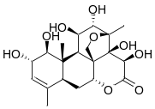 |  | 10.59 | 0.74 | 289
Angelol B | 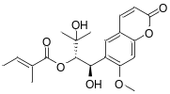 |  | - | - | 61
Tagitinin F | 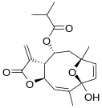 |  | - | - | 356
Erianin | 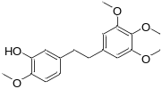 |  | - | - | 463
Dihydrocapsaicin | 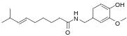 |  | 47.07 | 0.19 | 508
Terpinyl acetate | 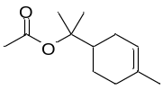 |  | 28.97 | 0.05 | 508
Santenone alcohol | 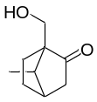 |  | - | - | 141
Gentianadine | 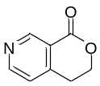 |  | - | - | 93
Menthyl acetate | 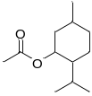 |  | 22.24 | 0.05 | 223
Aristolophenanlactone I | 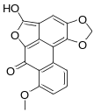 |  | - | - | 326
Mesaconic acid | 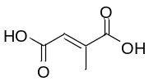 |  | 69.77 | 0.02 | 154
Pyroracemic acid | 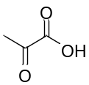 |  | 54.46 | 0.01 | 135
trans-Aconitic acid | 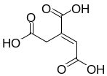 |  | - | - | 272
5,6,7-Trimethoxycoumarin | 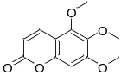 |  | 32.54 | 0.12 | 301
Sanleng acid | 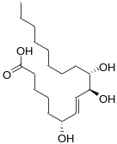 |  | 13.37 | 0.20 | 400
6-Gingerol | 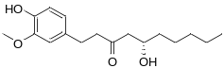 |  | 35.64 | 0.16 | 440
Damascenine | 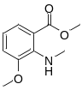 |  | - | - | 280

