Contents
Appendix 1. Code list of COVID-19 definition 1
Appendix 2. Code list of study outcomes 5
Appendix 3. Definition of immunocompromised status at the index date 12
Appendix 3. Supplement tables and figures 13

Appendix 1. Code list of COVID-19 definition
Concept Id | Concept name |  | domain
3661405 | Acute bronchitis caused by SARS-CoV-2 | COVID Diagnosis | Condition
3655976 | Acute hypoxemic respiratory failure due to disease caused by Severe acute respiratory syndrome coronavirus 2 | COVID Diagnosis | Condition
3661748 | Acute kidney injury due to disease caused by Severe acute respiratory syndrome coronavirus 2 | COVID Diagnosis | Condition
3661406 | Acute respiratory distress syndrome due to disease caused by Severe acute respiratory syndrome coronavirus 2 | COVID Diagnosis | Condition
3662381 | Asymptomatic SARS-CoV-2 | COVID Diagnosis | Condition
756031 | Bronchitis caused by COVID-19 | COVID Diagnosis | Condition
3656667 | Cardiomyopathy due to disease caused by Severe acute respiratory syndrome coronavirus 2 | COVID Diagnosis | Condition
3656668 | Conjunctivitis due to disease caused by Severe acute respiratory syndrome coronavirus 2 | COVID Diagnosis | Condition
439676 | Coronavirus infection | COVID Diagnosis | Condition
37311061 | COVID-19 | COVID Diagnosis | Condition
4100065 | Disease due to Coronaviridae | COVID Diagnosis | Condition
3656669 | Dyspnea caused by Severe acute respiratory syndrome coronavirus 2 | COVID Diagnosis | Condition
37310284 | Encephalopathy due to disease caused by Severe acute respiratory syndrome coronavirus 2 | COVID Diagnosis | Condition
3661885 | Fever caused by Severe acute respiratory syndrome coronavirus 2 | COVID Diagnosis | Condition
37310283 | Gastroenteritis caused by SARS-CoV-2 (severe acute respiratory syndrome coronavirus 2) | COVID Diagnosis | Condition
37310286 | Infection of upper respiratory tract caused by Severe acute respiratory syndrome coronavirus 2 | COVID Diagnosis | Condition
3663281 | Lower respiratory infection caused by SARS-CoV-2 | COVID Diagnosis | Condition
3661631 | Lymphocytopenia due to Severe acute respiratory syndrome coronavirus 2 | COVID Diagnosis | Condition
37310287 | Myocarditis due to disease caused by Severe acute respiratory syndrome coronavirus 2 | COVID Diagnosis | Condition
37310254 | Otitis media due to disease caused by Severe acute respiratory syndrome coronavirus 2 | COVID Diagnosis | Condition
704995 | Patient meets COVID-19 clinical diagnostic criteria | COVID Diagnosis | Observation
700297 | Patient meets COVID-19 laboratory confirmation criterion (detection of specific RNA in a clinical specimen using a molecular amplification detection test) | COVID Diagnosis | Observation
704996 | Patient meets COVID-19 laboratory diagnostic criteria | COVID Diagnosis | Observation
700296 | Patient meets COVID-19 presumptive laboratory evidence criteria (detection of specific antigen in a clinical specimen, OR detection of specific antibody in serum, plasma, or whole blood indicative of a new or recent infection) | COVID Diagnosis | Observation
37016927 | Pneumonia caused by Human coronavirus | COVID Diagnosis | Condition
3661408 | Pneumonia caused by SARS-CoV-2 | COVID Diagnosis | Condition
40479642 | Pneumonia due to Severe acute respiratory syndrome coronavirus | COVID Diagnosis | Condition
756039 | Respiratory infection caused by COVID-19 | COVID Diagnosis | Condition
3655977 | Rhabdomyolysis due to disease caused by Severe acute respiratory syndrome coronavirus 2 | COVID Diagnosis | Condition
3655975 | Sepsis due to disease caused by Severe acute respiratory syndrome coronavirus 2 | COVID Diagnosis | Condition
320651 | Severe acute respiratory syndrome | COVID Diagnosis | Condition
37396171 | Severe acute respiratory syndrome of upper respiratory tract | COVID Diagnosis | Condition
37311060 | Suspected COVID-19 | COVID Diagnosis | Observation
3661632 | Thrombocytopenia due to Severe acute respiratory syndrome coronavirus 2 | COVID Diagnosis | Condition
45763724 | Suspected coronavirus infection | COVID Diagnosis | Observation
40218804 | 2019-ncov coronavirus, sars-cov-2/2019-ncov (covid-19), any technique, multiple types or subtypes (includes all targets), non-cdc | COVID19 positive test | Measurement
40218805 | Cdc 2019 novel coronavirus (2019-ncov) real-time rt-pcr diagnostic panel | COVID19 positive test | Measurement
44789510 | Coronavirus nucleic acid detection | COVID19 positive test | Measurement
44811805 | Coronavirus nucleic acid detection assay | COVID19 positive test | Measurement
45770687 | Coronavirus RNA (ribonucleic acid) detection assay | COVID19 positive test | Measurement
44807536 | Coronavirus RNA (ribonucleic acid) measurement by NAAT (nucleic acid amplification test) | COVID19 positive test | Measurement
3667069 | Detection of ribonucleic acid of Severe acute respiratory syndrome coronavirus 2 using polymerase chain reaction | COVID19 positive test | Observation
36660491 | Human coronavirus 229E RNA [Presence] in Lower respiratory specimen by NAA with non-probe detection | COVID19 positive test | Measurement
36659667 | Human coronavirus HKU1 RNA [Presence] in Lower respiratory specimen by NAA with non-probe detection | COVID19 positive test | Measurement
36660329 | Human coronavirus NL63 RNA [Presence] in Lower respiratory specimen by NAA with non-probe detection | COVID19 positive test | Measurement
36660364 | Human coronavirus OC43 RNA [Presence] in Lower respiratory specimen by NAA with non-probe detection | COVID19 positive test | Measurement
742224 | Infectious agent antigen detection by immunoassay technique, qualitative or semiquantitative, multiple-step method; severe acute respiratory syndrome coronavirus (eg, SARS-CoV, SARS-CoV-2 [COVID-19]) (Coronavirus disease [COVID-19]) | COVID19 positive test | Measurement
700360 | Infectious agent detection by nucleic acid (DNA or RNA); severe acute respiratory syndrome coronavirus 2 (SARS-CoV-2) (Coronavirus disease [COVID-19]), amplified probe technique | COVID19 positive test | Measurement
742218 | Infectious disease (bacterial or viral respiratory tract infection), pathogen-specific nucleic acid (DNA or RNA), 22 targets including severe acute respiratory syndrome coronavirus 2 (SARS-CoV-2), qualitative RT-PCR, nasopharyngeal swab | COVID19 positive test | Measurement
742219 | Infectious disease (bacterial or viral respiratory tract infection), pathogen-specific nucleic acid (DNA or RNA), 22 targets including severe acute respiratory syndrome coronavirus 2 (SARS-CoV-2), qualitative RT-PCR, nasopharyngeal swab | COVID19 positive test | Measurement
36661384 | Influenza virus A and B and SARS-CoV-2 (COVID-19) and SARS-related CoV RNA panel - Respiratory specimen by NAA with probe detection | COVID19 positive test | Measurement
36661375 | Influenza virus A and B and SARS-CoV-2 (COVID-19) identified in Respiratory specimen by NAA with probe detection | COVID19 positive test | Measurement
36661376 | Influenza virus A and B RNA and SARS-CoV-2 (COVID-19) N gene panel - Respiratory specimen by NAA with probe detection | COVID19 positive test | Measurement
705104 | Measurement of Coronavirus (Coronavirinae subfamily species) | COVID19 positive test | Measurement
705105 | Measurement of Coronavirus (Coronavirinae subfamily species) antigen | COVID19 positive test | Measurement
37310257 | Measurement of Severe acute respiratory syndrome coronavirus 2 antigen | COVID19 positive test | Measurement
756055 | Measurement of Severe acute respiratory syndrome coronavirus 2 (SARS-CoV-2) | COVID19 positive test | Measurement
586310 | Measurement of Severe acute respiratory syndrome coronavirus 2 (SARS-CoV-2) Genetic material using Molecular method | COVID19 positive test | Measurement
704991 | Measurement of Severe acute respiratory syndrome coronavirus 2 (SARS-CoV-2) in Blood | COVID19 positive test | Measurement
756029 | Measurement of Severe acute respiratory syndrome coronavirus 2 (SARS-CoV-2) in Respiratory specimen | COVID19 positive test | Measurement
586307 | Measurement of Severe acute respiratory syndrome coronavirus 2 (SARS-CoV-2) in Saliva | COVID19 positive test | Measurement
705107 | Measurement of Severe acute respiratory syndrome coronavirus 2 (SARS-CoV-2) in Sample from nose | COVID19 positive test | Measurement
704976 | Measurement of Severe acute respiratory syndrome coronavirus 2 (SARS-CoV-2) in Sample from oropharynx | COVID19 positive test | Measurement
586309 | Measurement of Severe acute respiratory syndrome coronavirus 2 (SARS-CoV-2) in Specified specimen | COVID19 positive test | Measurement
756065 | Measurement of Severe acute respiratory syndrome coronavirus 2 (SARS-CoV-2) in Unspecified specimen | COVID19 positive test | Measurement
702834 | Measurement of Severe acute respiratory syndrome coronavirus 2 (SARS-CoV-2) specific cell-mediated immune response in Blood | COVID19 positive test | Measurement
704992 | Measurement of Severe acute respiratory syndrome coronavirus 2 (SARS-CoV-2) using Culture method | COVID19 positive test | Measurement
705001 | Measurement of Severe acute respiratory syndrome coronavirus 2 (SARS-CoV-2) using Nucleic acid amplification technique | COVID19 positive test | Measurement
705000 | Measurement of Severe acute respiratory syndrome coronavirus 2 (SARS-CoV-2) using Nucleic acid amplification technique in Blood | COVID19 positive test | Measurement
756085 | Measurement of Severe acute respiratory syndrome coronavirus 2 (SARS-CoV-2) using Nucleic acid amplification technique in Respiratory specimen | COVID19 positive test | Measurement
586308 | Measurement of Severe acute respiratory syndrome coronavirus 2 (SARS-CoV-2) using Nucleic acid amplification technique in Saliva | COVID19 positive test | Measurement
705106 | Measurement of Severe acute respiratory syndrome coronavirus 2 (SARS-CoV-2) using Nucleic acid amplification technique in Sample from nose | COVID19 positive test | Measurement
704975 | Measurement of Severe acute respiratory syndrome coronavirus 2 (SARS-CoV-2) using Nucleic acid amplification technique in Sample from oropharynx | COVID19 positive test | Measurement
756084 | Measurement of Severe acute respiratory syndrome coronavirus 2 (SARS-CoV-2) using Nucleic acid amplification technique in Unspecified specimen | COVID19 positive test | Measurement
704993 | Measurement of Severe acute respiratory syndrome coronavirus 2 (SARS-CoV-2) using Sequencing | COVID19 positive test | Measurement
723477 | SARS-CoV-2 (COVID-19) Ag [Presence] in Respiratory specimen by Rapid immunoassay | COVID19 positive test | Measurement
706167 | SARS-CoV-2 (COVID-19) N gene [Cycle Threshold #] in Unspecified specimen by NAA with probe detection | COVID19 positive test | Measurement
706157 | SARS-CoV-2 (COVID-19) N gene [Cycle Threshold #] in Unspecified specimen by Nucleic acid amplification using CDC primer-probe set N1 | COVID19 positive test | Measurement
706155 | SARS-CoV-2 (COVID-19) N gene [Cycle Threshold #] in Unspecified specimen by Nucleic acid amplification using CDC primer-probe set N2 | COVID19 positive test | Measurement
715272 | SARS-CoV-2 (COVID-19) N gene [Presence] in Nasopharynx by NAA with probe detection | COVID19 positive test | Measurement
757678 | SARS-CoV-2 (COVID-19) N gene [Presence] in Nose by NAA with probe detection | COVID19 positive test | Measurement
706161 | SARS-CoV-2 (COVID-19) N gene [Presence] in Respiratory specimen by NAA with probe detection | COVID19 positive test | Measurement
586524 | SARS-CoV-2 (COVID-19) N gene [Presence] in Respiratory specimen by Nucleic acid amplification using CDC primer-probe set N1 | COVID19 positive test | Measurement
586525 | SARS-CoV-2 (COVID-19) N gene [Presence] in Respiratory specimen by Nucleic acid amplification using CDC primer-probe set N2 | COVID19 positive test | Measurement
36661378 | SARS-CoV-2 (COVID-19) N gene [Presence] in Saliva (oral fluid) by NAA with probe detection | COVID19 positive test | Measurement
586520 | SARS-CoV-2 (COVID-19) N gene [Presence] in Serum or Plasma by NAA with probe detection | COVID19 positive test | Measurement
706175 | SARS-CoV-2 (COVID-19) N gene [Presence] in Unspecified specimen by NAA with probe detection | COVID19 positive test | Measurement
706156 | SARS-CoV-2 (COVID-19) N gene [Presence] in Unspecified specimen by Nucleic acid amplification using CDC primer-probe set N1 | COVID19 positive test | Measurement
706154 | SARS-CoV-2 (COVID-19) N gene [Presence] in Unspecified specimen by Nucleic acid amplification using CDC primer-probe set N2 | COVID19 positive test | Measurement
723469 | SARS-CoV-2 (COVID-19) ORF1ab region [Cycle Threshold #] in Respiratory specimen by NAA with probe detection | COVID19 positive test | Measurement
706168 | SARS-CoV-2 (COVID-19) ORF1ab region [Cycle Threshold #] in Unspecified specimen by NAA with probe detection | COVID19 positive test | Measurement
723478 | SARS-CoV-2 (COVID-19) ORF1ab region [Presence] in Respiratory specimen by NAA with probe detection | COVID19 positive test | Measurement
723464 | SARS-CoV-2 (COVID-19) ORF1ab region [Presence] in Unspecified specimen by NAA with probe detection | COVID19 positive test | Measurement
586516 | SARS-CoV-2 (COVID-19) [Presence] in Unspecified specimen by Organism specific culture | COVID19 positive test | Measurement
723471 | SARS-CoV-2 (COVID-19) RdRp gene [Cycle Threshold #] in Respiratory specimen by NAA with probe detection | COVID19 positive test | Measurement
723470 | SARS-CoV-2 (COVID-19) RdRp gene [Cycle Threshold #] in Unspecified specimen by NAA with probe detection | COVID19 positive test | Measurement
706160 | SARS-CoV-2 (COVID-19) RdRp gene [Presence] in Respiratory specimen by NAA with probe detection | COVID19 positive test | Measurement
706173 | SARS-CoV-2 (COVID-19) RdRp gene [Presence] in Unspecified specimen by NAA with probe detection | COVID19 positive test | Measurement
586528 | SARS-CoV-2 (COVID-19) RNA [Cycle Threshold #] in Respiratory specimen by NAA with probe detection | COVID19 positive test | Measurement
586529 | SARS-CoV-2 (COVID-19) RNA [Cycle Threshold #] in Unspecified specimen by NAA with probe detection | COVID19 positive test | Measurement
715262 | SARS-CoV-2 (COVID-19) RNA [Log #/volume] (viral load) in Unspecified specimen by NAA with probe detection | COVID19 positive test | Measurement
706158 | SARS-CoV-2 (COVID-19) RNA panel - Respiratory specimen by NAA with probe detection | COVID19 positive test | Measurement
706169 | SARS-CoV-2 (COVID-19) RNA panel - Unspecified specimen by NAA with probe detection | COVID19 positive test | Measurement
723476 | SARS-CoV-2 (COVID-19) RNA [Presence] in Nasopharynx by NAA with non-probe detection | COVID19 positive test | Measurement
586526 | SARS-CoV-2 (COVID-19) RNA [Presence] in Nasopharynx by NAA with probe detection | COVID19 positive test | Measurement
757677 | SARS-CoV-2 (COVID-19) RNA [Presence] in Nose by NAA with probe detection | COVID19 positive test | Measurement
706163 | SARS-CoV-2 (COVID-19) RNA [Presence] in Respiratory specimen by NAA with probe detection | COVID19 positive test | Measurement
36661377 | SARS-CoV-2 (COVID-19) RNA [Presence] in Respiratory specimen by Sequencing | COVID19 positive test | Measurement
715260 | SARS-CoV-2 (COVID-19) RNA [Presence] in Saliva (oral fluid) by NAA with probe detection | COVID19 positive test | Measurement
715261 | SARS-CoV-2 (COVID-19) RNA [Presence] in Saliva (oral fluid) by Sequencing | COVID19 positive test | Measurement
723463 | SARS-CoV-2 (COVID-19) RNA [Presence] in Serum or Plasma by NAA with probe detection | COVID19 positive test | Measurement
706170 | SARS-CoV-2 (COVID-19) RNA [Presence] in Unspecified specimen by NAA with probe detection | COVID19 positive test | Measurement
723467 | SARS-CoV-2 (COVID-19) S gene [Cycle Threshold #] in Respiratory specimen by NAA with probe detection | COVID19 positive test | Measurement
723468 | SARS-CoV-2 (COVID-19) S gene [Cycle Threshold #] in Unspecified specimen by NAA with probe detection | COVID19 positive test | Measurement
723465 | SARS-CoV-2 (COVID-19) S gene [Presence] in Respiratory specimen by NAA with probe detection | COVID19 positive test | Measurement
586519 | SARS-CoV-2 (COVID-19) S gene [Presence] in Serum or Plasma by NAA with probe detection | COVID19 positive test | Measurement
723466 | SARS-CoV-2 (COVID-19) S gene [Presence] in Unspecified specimen by NAA with probe detection | COVID19 positive test | Measurement
586517 | SARS-CoV-2 (COVID-19) whole genome [Nucleotide sequence] in Isolate by Sequencing | COVID19 positive test | Measurement
757685 | SARS-CoV+SARS-CoV-2 (COVID-19) Ag [Presence] in Respiratory specimen by Rapid immunoassay | COVID19 positive test | Measurement
706172 | SARS-like coronavirus N gene [Cycle Threshold #] in Unspecified specimen by NAA with probe detection | COVID19 positive test | Measurement
706171 | SARS-like coronavirus N gene [Presence] in Unspecified specimen by NAA with probe detection | COVID19 positive test | Measurement
706166 | SARS-related coronavirus E gene [Cycle Threshold #] in Unspecified specimen by NAA with probe detection | COVID19 positive test | Measurement
586523 | SARS-related coronavirus E gene [Presence] in Respiratory specimen by NAA with probe detection | COVID19 positive test | Measurement
586518 | SARS-related coronavirus E gene [Presence] in Serum or Plasma by NAA with probe detection | COVID19 positive test | Measurement
706174 | SARS-related coronavirus E gene [Presence] in Unspecified specimen by NAA with probe detection | COVID19 positive test | Measurement
706159 | SARS-related coronavirus+MERS coronavirus RNA [Presence] in Respiratory specimen by NAA with probe detection | COVID19 positive test | Measurement
706165 | SARS-related coronavirus RNA [Presence] in Respiratory specimen by NAA with probe detection | COVID19 positive test | Measurement
723472 | SARS-related coronavirus RNA [Presence] in Unspecified specimen by NAA with probe detection | COVID19 positive test | Measurement

*For codes in the measurement domain positive was identified using the following codes: 45884084, 45877985, 4181412, 4126681, 9191, 45879438.

Appendix 2. Code list of study outcomes
Concept ID | Concept name
Outcome | Cerebral venous sinus thrombosis (CVST)
4102202 | Cerebral venous sinus thrombosis
4048786 | Cerebral venous thrombosis of sigmoid sinus
4043735 | Cerebral venous thrombosis of straight sinus
4111713 | Non-pyogenic venous sinus thrombosis
314667 | Nonpyogenic thrombosis of intracranial venous sinus
4116206 | Septic thrombophlebitis of cavernous sinus
4121335 | Septic thrombophlebitis of lateral sinus
4119136 | Septic thrombophlebitis of sagittal sinus
4041680 | Septic thrombophlebitis of sigmoid sinus
4100225 | Thrombophlebitis lateral venous sinus
4217471 | Thrombophlebitis of basilar sinus
4104695 | Thrombophlebitis of cavernous sinus
4167985 | Thrombophlebitis of inferior sagittal sinus
764714 | Thrombophlebitis of sigmoid sinus
4100224 | Thrombophlebitis of superior longitudinal venous sinus
4098706 | Thrombophlebitis of superior sagittal sinus
4277833 | Thrombophlebitis of torcular Herophili
764710 | Thrombophlebitis of transverse sinus
4228209 | Thrombosis of basilar sinus
4234264 | Thrombosis of cavernous venous sinus
4048890 | Thrombosis of inferior sagittal sinus
4057329 | Thrombosis of lateral venous sinus
4102203 | Thrombosis of superior longitudinal sinus
4290940 | Thrombosis of superior sagittal sinus
4079905 | Thrombosis of torcular Herophili
4105338 | Thrombosis transverse sinus
Outcome | DVT
762047 | Acute bilateral thrombosis of subclavian veins
762148 | Acute deep vein thrombosis of bilateral iliac veins
761444 | Acute deep vein thrombosis of bilateral lower limbs following coronary artery bypass graft
35616028 | Acute deep vein thrombosis of left iliac vein
35615035 | Acute deep vein thrombosis of left lower limb following procedure
761416 | Acute deep vein thrombosis of left upper limb following coronary artery bypass graft
35615031 | Acute deep vein thrombosis of left upper limb following procedure
43531681 | Acute deep vein thrombosis of lower limb
35616027 | Acute deep vein thrombosis of right iliac vein
35615034 | Acute deep vein thrombosis of right lower limb following procedure
761415 | Acute deep vein thrombosis of right upper limb following coronary artery bypass graft
35615030 | Acute deep vein thrombosis of right upper limb following procedure
44782746 | Acute deep venous thrombosis
44782751 | Acute deep venous thrombosis of axillary vein
762008 | Acute deep venous thrombosis of bilateral axillary veins
760875 | Acute deep venous thrombosis of bilateral calves
765155 | Acute deep venous thrombosis of bilateral ileofemoral veins
762017 | Acute deep venous thrombosis of bilateral internal jugular veins
762417 | Acute deep venous thrombosis of bilateral legs
762020 | Acute deep venous thrombosis of bilateral popliteal veins
765546 | Acute deep venous thrombosis of bilateral tibial veins
762004 | Acute deep venous thrombosis of both upper extremities
44782742 | Acute deep venous thrombosis of calf
44782747 | Acute deep venous thrombosis of femoral vein
762015 | Acute deep venous thrombosis of ileofemoral vein of left leg
765541 | Acute deep venous thrombosis of ileofemoral vein of right lower extremity
44782748 | Acute deep venous thrombosis of iliofemoral vein
44782752 | Acute deep venous thrombosis of internal jugular vein
762009 | Acute deep venous thrombosis of left axillary vein
760876 | Acute deep venous thrombosis of left calf
765540 | Acute deep venous thrombosis of left femoral vein
765922 | Acute deep venous thrombosis of left internal jugular vein
762418 | Acute deep venous thrombosis of left lower extremity
765537 | Acute deep venous thrombosis of left upper extremity
44782767 | Acute deep venous thrombosis of lower extremity as complication of procedure
46270071 | Acute deep venous thrombosis of lower limb due to coronary artery bypass grafting
762022 | Acute deep venous thrombosis of politeal vein of right leg
44782743 | Acute deep venous thrombosis of popliteal vein
762021 | Acute deep venous thrombosis of popliteal vein of left leg
762010 | Acute deep venous thrombosis of right axillary vein
760877 | Acute deep venous thrombosis of right calf
762013 | Acute deep venous thrombosis of right femoral vein
762018 | Acute deep venous thrombosis of right internal jugular vein
762419 | Acute deep venous thrombosis of right lower extremity
762005 | Acute deep venous thrombosis of right upper extremity
44782745 | Acute deep venous thrombosis of thigh
44782744 | Acute deep venous thrombosis of tibial vein
762026 | Acute deep venous thrombosis of tibial vein of left leg
765156 | Acute deep venous thrombosis of tibial vein of right leg
44782421 | Acute deep venous thrombosis of upper extremity
764016 | Acute deep venous thrombosis of upper extremity after coronary artery bypass graft
44782766 | Acute deep venous thrombosis of upper extremity as complication of procedure
762048 | Acute thrombosis of left subclavian vein
45757410 | Acute thrombosis of mesenteric vein
762049 | Acute thrombosis of right subclavian vein
36712892 | Acute thrombosis of splenic vein
44782762 | Acute thrombosis of subclavian vein
37109253 | Bilateral acute deep vein thrombosis of femoral veins
40478951 | Bilateral deep vein thrombosis of lower extremities
4046884 | Deep vein thrombosis of leg related to air travel
4133004 | Deep venous thrombosis
4181315 | Deep venous thrombosis associated with coronary artery bypass graft
45773536 | Deep venous thrombosis of femoropopliteal vein
763942 | Deep venous thrombosis of left lower extremity
761980 | Deep venous thrombosis of left upper extremity
443537 | Deep venous thrombosis of lower extremity
4133975 | Deep venous thrombosis of pelvic vein
40480555 | Deep venous thrombosis of peroneal vein
4322565 | Deep venous thrombosis of profunda femoris vein
763941 | Deep venous thrombosis of right lower extremity
761928 | Deep venous thrombosis of right upper extremity
4207899 | Deep venous thrombosis of tibial vein
4028057 | Deep venous thrombosis of upper extremity
193512 | Embolism and thrombosis of the renal vein
435565 | Embolism and thrombosis of the vena cava
4119760 | Iliofemoral deep vein thrombosis
4124856 | Inferior mesenteric vein thrombosis
4281689 | Phlegmasia alba dolens
4284538 | Phlegmasia cerulea dolens
4309333 | Postoperative deep vein thrombosis
46285905 | Provoked deep vein thrombosis
4033521 | Splenic vein thrombosis
4055089 | Superior mesenteric vein thrombosis
42538533 | Thrombosis of iliac vein
44811347 | Thrombosis of internal jugular vein
765049 | Thrombosis of left peroneal vein
4317289 | Thrombosis of mesenteric vein
4203836 | Thrombosis of subclavian vein
4175649 | Thrombosis of the popliteal vein
4153353 | Traumatic thrombosis of axillary vein
46285904 | Unprovoked deep vein thrombosis
4221821 | Thrombophlebitis of deep veins of lower extremity
46271900 | Recurrent deep vein thrombosis
4189004 | Deep vein thrombosis of leg related to intravenous drug use
Outcome | SVT
4033521 | Splenic vein thrombosis
36712892 | Acute thrombosis of splenic vein
4033521 | Splenic vein thrombosis
196715 | Budd-Chiari syndrome
199837 | Portal vein thrombosis
4317289 | Thrombosis of mesenteric vein
4092406 | Portal thrombophlebitis
36712892 | Acute thrombosis of splenic vein
4173167 | Mesenteric embolus
4144032 | Mesenteric thrombus and/or embolus
45757410 | Acute thrombosis of mesenteric vein
45757409 | Chronic thrombosis of mesenteric vein
4318407 | Thrombophlebitis of mesenteric vein
4124856 | Inferior mesenteric vein thrombosis
4055089 | Superior mesenteric vein thrombosis
199837 | Portal vein thrombosis
36717492 | Acute occlusion of mesenteric vein
45757410 | Acute thrombosis of mesenteric vein
4124856 | Inferior mesenteric vein thrombosis
4055089 | Superior mesenteric vein thrombosis
4317289 | Thrombosis of mesenteric vein
45757409 | Chronic thrombosis of mesenteric vein
4318407 | Thrombophlebitis of mesenteric vein
4173167 | Mesenteric embolus
4144032 | Mesenteric thrombus and/or embolus
36717492 | Acute occlusion of mesenteric vein
36712892 | Acute thrombosis of splenic vein
196715 | Budd-Chiari syndrome
35624285 | Complete obstruction of hepatic portal vein
4301208 | Hepatic vein thrombosis
37110194 | Hepatic veno-occlusive disease with immunodeficiency syndrome
37109927 | Obstruction of visceral vein
4238060 | Portal vein obstruction
4033521 | Splenic vein thrombosis
4277276 | Veno-occlusive disease of the liver
37111372 | Visceral venous thrombosis
36712891 | Chronic thrombosis of splenic vein
Outcome | Pulmonary embolism
4120091 | Acute massive pulmonary embolism
45768439 | Acute pulmonary embolism
45768888 | Acute pulmonary thromboembolism
4309039 | Hemorrhagic pulmonary infarction
762808 | Infarction of lung due to embolus
40480461 | Infarction of lung due to iatrogenic pulmonary embolism
4108681 | Postoperative pulmonary embolus
4091708 | Pulmonary air embolism
440417 | Pulmonary embolism
37109911 | Pulmonary embolism due to and following acute myocardial infarction
37016922 | Pulmonary embolism on long-term anticoagulation therapy
43530605 | Pulmonary embolism with pulmonary infarction
4119608 | Pulmonary fat embolism
254662 | Pulmonary infarction
4253796 | Pulmonary microemboli
45766471 | Pulmonary oil microembolism
4121618 | Pulmonary thromboembolism
4119610 | Pulmonary tumor embolism
4119607 | Subacute massive pulmonary embolism
4119609 | Subacute pulmonary fat embolism
4236271 | Recurrent pulmonary embolism
Outcome | Myocardial infarction
4119457 | Acute Q wave infarction - anterolateral
4119943 | Acute Q wave infarction - anteroseptal
4121464 | Acute Q wave infarction - inferior
4121465 | Acute Q wave infarction - inferolateral
4124684 | Acute Q wave infarction - lateral
4119948 | Acute Q wave infarction - widespread
4126801 | Acute Q wave myocardial infarction
4296653 | Acute ST segment elevation myocardial infarction
46270162 | Acute ST segment elevation myocardial infarction due to left coronary artery occlusion
761737 | Acute ST segment elevation myocardial infarction due to occlusion of circumflex coronary artery
46270163 | Acute ST segment elevation myocardial infarction due to right coronary artery occlusion
43020460 | Acute ST segment elevation myocardial infarction involving left anterior descending coronary artery
45766076 | Acute ST segment elevation myocardial infarction of anterior wall involving right ventricle
761736 | Acute ST segment elevation myocardial infarction of anteroapical wall
46270159 | Acute ST segment elevation myocardial infarction of anterolateral wall
46270160 | Acute ST segment elevation myocardial infarction of anteroseptal wall
45766116 | Acute ST segment elevation myocardial infarction of inferior wall
45766151 | Acute ST segment elevation myocardial infarction of inferior wall involving right ventricle
35611570 | Acute ST segment elevation myocardial infarction of inferolateral wall
35611571 | Acute ST segment elevation myocardial infarction of inferoposterior wall
46274044 | Acute ST segment elevation myocardial infarction of lateral wall
46270161 | Acute ST segment elevation myocardial infarction of posterior wall
46273495 | Acute ST segment elevation myocardial infarction of posterobasal wall
46270158 | Acute ST segment elevation myocardial infarction of posterolateral wall
46270164 | Acute ST segment elevation myocardial infarction of septum
45766075 | Acute anterior ST segment elevation myocardial infarction
4178129 | Acute anteroapical myocardial infarction
4267568 | Acute anteroseptal myocardial infarction
312327 | Acute myocardial infarction
44782769 | Acute myocardial infarction due to left coronary artery occlusion
44782712 | Acute myocardial infarction due to right coronary artery occlusion
45766115 | Acute myocardial infarction during procedure
434376 | Acute myocardial infarction of anterior wall
45766150 | Acute myocardial infarction of anterior wall involving right ventricle
438438 | Acute myocardial infarction of anterolateral wall
4243372 | Acute myocardial infarction of apical-lateral wall
4108669 | Acute myocardial infarction of atrium
4151046 | Acute myocardial infarction of basal-lateral wall
4275436 | Acute myocardial infarction of high lateral wall
438170 | Acute myocardial infarction of inferior wall
45771322 | Acute myocardial infarction of inferior wall involving right ventricle
438447 | Acute myocardial infarction of inferolateral wall
441579 | Acute myocardial infarction of inferoposterior wall
436706 | Acute myocardial infarction of lateral wall
4324413 | Acute myocardial infarction of posterobasal wall
4051874 | Acute myocardial infarction of posterolateral wall
4303359 | Acute myocardial infarction of septum
4147223 | Acute myocardial infarction with rupture of ventricle
4145721 | Acute non-Q wave infarction
4119944 | Acute non-Q wave infarction - anterolateral
4119456 | Acute non-Q wave infarction - anteroseptal
4119945 | Acute non-Q wave infarction - inferior
4119946 | Acute non-Q wave infarction - inferolateral
4121466 | Acute non-Q wave infarction - lateral
4124685 | Acute non-Q wave infarction - widespread
4270024 | Acute non-ST segment elevation myocardial infarction
35610091 | Acute nontransmural myocardial infarction
319039 | Acute posterior myocardial infarction
444406 | Acute subendocardial infarction
35610093 | Acute transmural myocardial infarction
4119947 | Acute widespread myocardial infarction
37109912 | Arrhythmia due to and following acute myocardial infarction
438172 | Atrial septal defect due to and following acute myocardial infarction
4124687 | Cardiac rupture due to and following acute myocardial infarction
4215259 | First myocardial infarction
4108678 | Hemopericardium due to and following acute myocardial infarction
4173632 | Microinfarct of heart
45771327 | Mitral valve regurgitation due to acute myocardial infarction with papillary muscle and chordal rupture
45766214 | Mitral valve regurgitation due to acute myocardial infarction without papillary muscle and chordal rupture
45766212 | Mitral valve regurgitation due to and following acute myocardial infarction
4323202 | Mixed myocardial ischemia and infarction
4329847 | Myocardial infarction
37309626 | Myocardial infarction due to demand ischemia
4170094 | Myocardial infarction in recovery phase
4200113 | Non-Q wave myocardial infarction
4030582 | Postoperative myocardial infarction
35610087 | Postoperative nontransmural myocardial infarction
4206867 | Postoperative subendocardial myocardial infarction
35610089 | Postoperative transmural myocardial infarction
4207921 | Postoperative transmural myocardial infarction of anterior wall
4209541 | Postoperative transmural myocardial infarction of inferior wall
37109911 | Pulmonary embolism due to and following acute myocardial infarction
4108679 | Rupture of cardiac wall without hemopericardium as current complication following acute myocardial infarction
4108219 | Rupture of chordae tendinae due to and following acute myocardial infarction
4124686 | Silent myocardial infarction
765132 | Subendocardial myocardial infarction
45766114 | Subsequent ST segment elevation myocardial infarction
45766113 | Subsequent ST segment elevation myocardial infarction of anterior wall
45773170 | Subsequent ST segment elevation myocardial infarction of inferior wall
4108217 | Subsequent myocardial infarction
4108677 | Subsequent myocardial infarction of anterior wall
4108218 | Subsequent myocardial infarction of inferior wall
45766241 | Subsequent non-ST segment elevation myocardial infarction
4108680 | Thrombosis of atrium, auricular appendage, and ventricle due to and following acute myocardial infarction
439693 | True posterior myocardial infarction
37109910 | Ventricular aneurysm due to and following acute myocardial infarction
Outcome | Heart failure
44782718 | Acute combined systolic and diastolic heart failure
4023479 | Acute congestive heart failure
312927 | Acute cor pulmonale
40481042 | Acute diastolic heart failure
44782655 | Acute exacerbation of chronic congestive heart failure
442310 | Acute heart failure
764877 | Acute heart failure co-occurrent with normal ejection fraction
4108245 | Acute left ventricular failure
4327205 | Acute left-sided congestive heart failure
4267800 | Acute left-sided heart failure
44782733 | Acute on chronic combined systolic and diastolic heart failure
40481043 | Acute on chronic diastolic heart failure
764874 | Acute on chronic heart failure co-occurrent with normal ejection fraction
37309625 | Acute on chronic right-sided congestive heart failure
40480602 | Acute on chronic systolic heart failure
4215446 | Acute right-sided congestive heart failure
4233424 | Acute right-sided heart failure
40480603 | Acute systolic heart failure
4193236 | Ayerza's syndrome
439698 | Benign hypertensive heart disease with congestive cardiac failure
4030258 | Bernheim's syndrome
4242669 | Biventricular congestive heart failure
4215802 | Cardiac asthma
4177493 | Cardiac insufficiency due to prosthesis
4233224 | Cardiac insufficiency during AND/OR resulting from a procedure
4264636 | Cardiac insufficiency following cardiac surgery
4259490 | Cardiorespiratory failure
44782719 | Chronic combined systolic and diastolic heart failure
4229440 | Chronic congestive heart failure
4195892 | Chronic cor pulmonale
40479576 | Chronic diastolic heart failure
444031 | Chronic heart failure
764876 | Chronic heart failure co-occurrent with normal ejection fraction
4206009 | Chronic left-sided congestive heart failure
4009047 | Chronic left-sided heart failure
4284562 | Chronic right-sided congestive heart failure
4014159 | Chronic right-sided heart failure
40479192 | Chronic systolic heart failure
4108244 | Compensated cardiac failure
319835 | Congestive heart failure
44784345 | Congestive heart failure as early postoperative complication
762002 | Congestive heart failure as post-operative complication of cardiac surgery
762003 | Congestive heart failure as post-operative complication of non-cardiac surgery
44782428 | Congestive heart failure due to cardiomyopathy
4139864 | Congestive heart failure due to left ventricular systolic dysfunction
4142561 | Congestive heart failure due to valvular disease
36713488 | Congestive heart failure stage B
36712928 | Congestive heart failure stage B due to ischemic cardiomyopathy
43021826 | Congestive heart failure stage C
36712927 | Congestive heart failure stage C due to ischemic cardiomyopathy
43021825 | Congestive heart failure stage D
44782713 | Congestive heart failure with right heart failure
4307356 | Cor pulmonale
4111554 | Decompensated cardiac failure
4311437 | Decompensated chronic heart failure
443587 | Diastolic heart failure
43530643 | Diastolic heart failure stage B
43021842 | Diastolic heart failure stage C
43021841 | Diastolic heart failure stage D
43022068 | Exacerbation of congestive heart failure
316139 | Heart failure
4124705 | Heart failure as a complication of care
37311948 | Heart failure with mid range ejection fraction
40486933 | Heart failure with normal ejection fraction
45766164 | Heart failure with reduced ejection fraction
45766167 | Heart failure with reduced ejection fraction due to cardiomyopathy
45766165 | Heart failure with reduced ejection fraction due to coronary artery disease
45773075 | Heart failure with reduced ejection fraction due to heart valve disease
45766166 | Heart failure with reduced ejection fraction due to myocarditis
4004279 | High output heart failure
44782728 | Hypertensive heart AND chronic kidney disease with congestive heart failure
439696 | Hypertensive heart and renal disease with (congestive) heart failure
439694 | Hypertensive heart and renal disease with both (congestive) heart failure and renal failure
314378 | Hypertensive heart disease with congestive heart failure
444101 | Hypertensive heart failure
439846 | Left heart failure
4185565 | Low cardiac output syndrome
4103448 | Low output heart failure
316994 | Malignant hypertensive heart disease with congestive heart failure
4141124 | Postvalvulotomy syndrome
764873 | Reduced ejection fraction co-occurrent and due to acute heart failure
764871 | Reduced ejection fraction co-occurrent and due to acute on chronic heart failure
764872 | Reduced ejection fraction co-occurrent and due to chronic heart failure
4199500 | Refractory heart failure
4138307 | Right heart failure due to pulmonary hypertension
4195785 | Right heart failure secondary to left heart failure
4273632 | Right ventricular failure
35615055 | Saddle embolus of pulmonary artery with acute cor pulmonale
4079695 | Sepsis-associated left ventricular failure
4079296 | Sepsis-associated right ventricular failure
44784442 | Symptomatic congestive heart failure
443580 | Systolic heart failure
43530642 | Systolic heart failure stage B
36717359 | Systolic heart failure stage B due to ischemic cardiomyopathy
43020421 | Systolic heart failure stage C
36712929 | Systolic heart failure stage C due to ischemic cardiomyopathy
43021840 | Systolic heart failure stage D
40482857 | Cardiorenal syndrome
4153875 | Cardiac insufficiency as a complication of care
4215511 | Emergency hospital admission for heart failure
4215689 | Heart failure confirmed
4173819 | Impaired left ventricular function

Appendix 3. Definition of immunocompromised status at the index date
Individuals who are immunocompromised at the index data were defined by the recording of certain conditions or certain conditions plus treatments prior to index date. Individuals were considered immunocompromised if they have one or more of the following conditions recorded within 365 days prior to index date:
- HIV/AIDS
- Haematological malignancies
- Solid malignancies
- Other intrinsic immune conditions
Individuals were defined as being immunocompromised if they were treated with antineoplastic and immunomodulating agents between 183 days to one day prior to index date.
Individuals were also defined as being immunocompromised if they were treated with systemic corticosteroids between 183 days to one day prior to index date and had a recording of the following within 365 days prior to index date:
- Organ transplantations
- Rheumatologic/inflammatory conditions (rheumatoid arthritis, inflammatory bowel disease, and systemic lupus erythematosus)

Appendix 3. Supplement tables and figures
Figure S1: Age-sex specific incidence rates of study events among the background population.

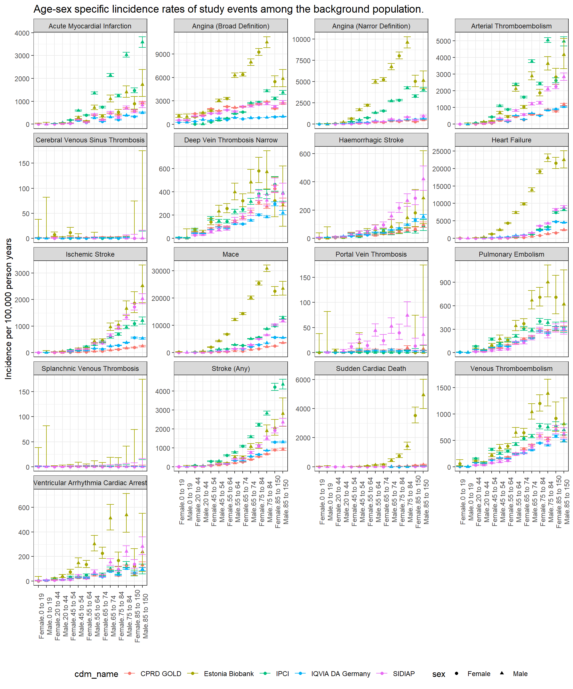

Figure S2. Crude incidence rates after infection, stratified by Covid-19 infection history.
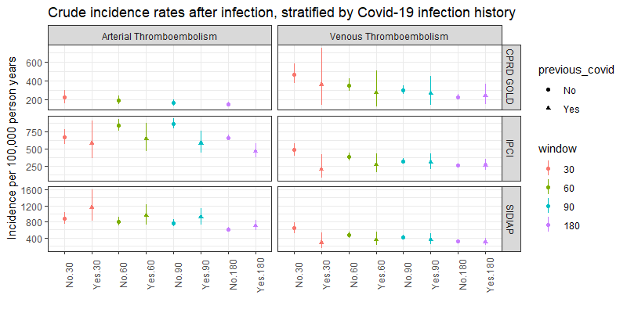
* number of events among people with Covid-19 history in CPRD GOLD was below 5 thus not shown here.

Figure S3. Incidence rates after infection, stratified by number of doses of vaccines received prior to infection.
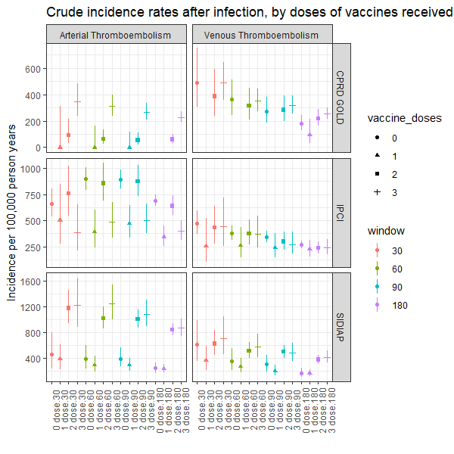
* number of events among people with Covid-19 history in CPRD GOLD was below 5 thus not shown here.

Figure S4. Age-sex specific incidence rate ratios of ATE among people with COVID-19 infection stratified by age and sex, by database.
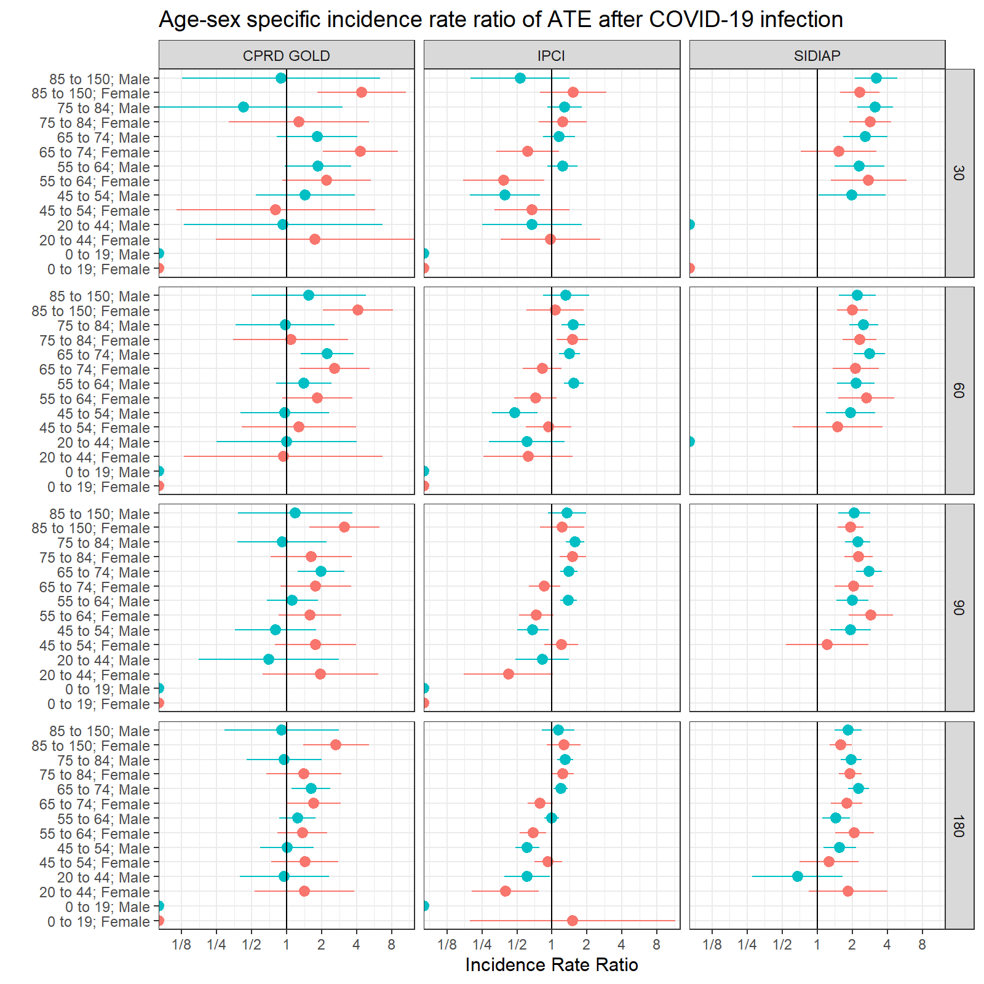

Figure S5. Age-sex specific incidence rate ratios of VTE among people with COVID-19 infection stratified by age and sex, by database.
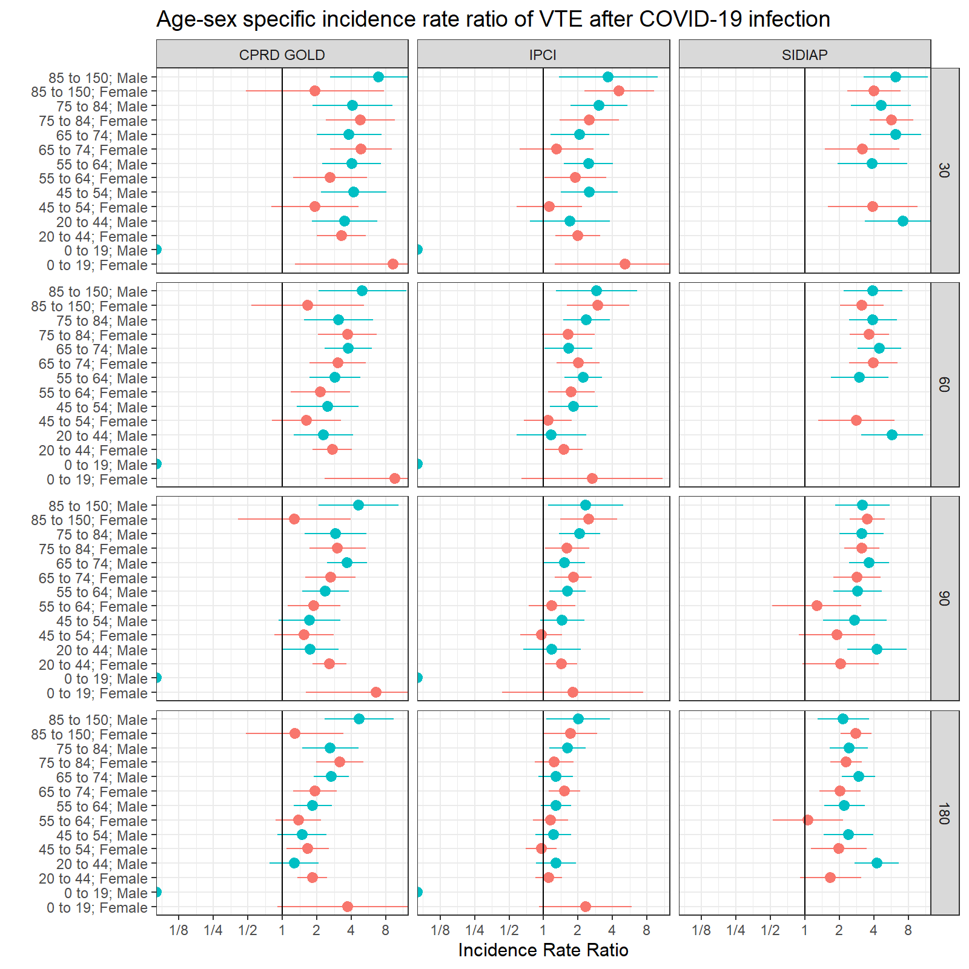

S6. Sensitivity analysis, Standardised incidence rate ratio of ATE and VTE stratified by vaccine and covid status, and immunocompromised status.
