Table 1: General characteristics of the patients and euploid frozen embryo transfer (eFET) cycle outcomes. BMI: body mass index. E2: estradiol, P4: progesterone, eET: euploid embryo transfer, LPS: luteal phase support.

Category | Case 1 | Case 2 | Case 3
Age (years) | 32 | 31 | 31
BMI (kg/m2) | 25.33 | 23.3 | 32.2
AMH (ng/mL) | 7.2 | 7.79 | 7.1
AFC (n) | 24 | 22 | 20
Previous eFET cycle | No previous eFET | One natural cycle and one HRT | Decapeptyl 3.75 mg + HRT
Endometrial Thickness before LPS | No previous eFET | 8mm Triple line | 7.7mm Triple Line
P4 day of eET with conventional LPS | No previous eFET | 9.45 ng/ml | 10.63 ng/ml
Suppression length: Decapeptyl 3.75 im + letrozole 5mg/day. | 2 months | 2 months | 3 months
E2 after hormonal suppression | 31.71 pg/ml | 17.12 pg/nl | 5.79 ng/ml
Endometrial Thickness before LPS | 7.9 mm  Triple line | 8mm  Triple line | 7.9 mm  Triple line
P4 day of eET with intensive LPS | 9.79 ng/ml | 20.23 ng/ml | 7.41 ng/ml
Treatment outcome | Livebirth | Live birth | Livebirth

Table 2: Ultrasound images of the patients before undergoing IVF treatment and images of office diagnostic hysteroscopy with saline instillation, performed for the three cases after hormonal suppression before endometrial preparation.
 | Case 1 | Case 2 | Case 3
TVUS findings before treatment | Diffuse adenomyosis in posterior wall, hyperechoic islands, myometrial cysts, echogenic sub-endometrial glands | Diffuse adenomyosis, globular uterus, asymmetrical thickening, hyperechoic islands, JZ anomalies | Diffuse adenomyosis in anterior wall and fundus, asymmetrical thickening, hyperechoic islands, fan-shaped shadowing, translesional vascularity
TVUS images  (at first consultation) | 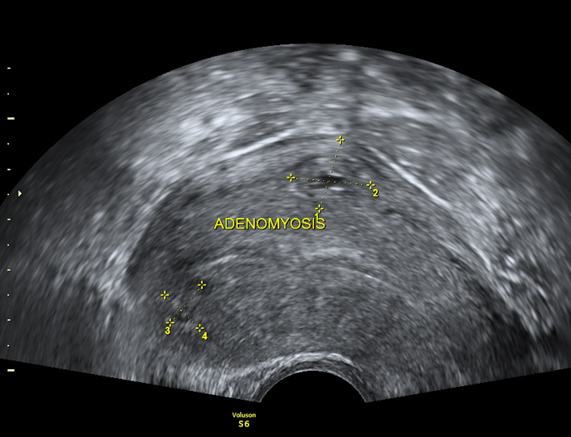  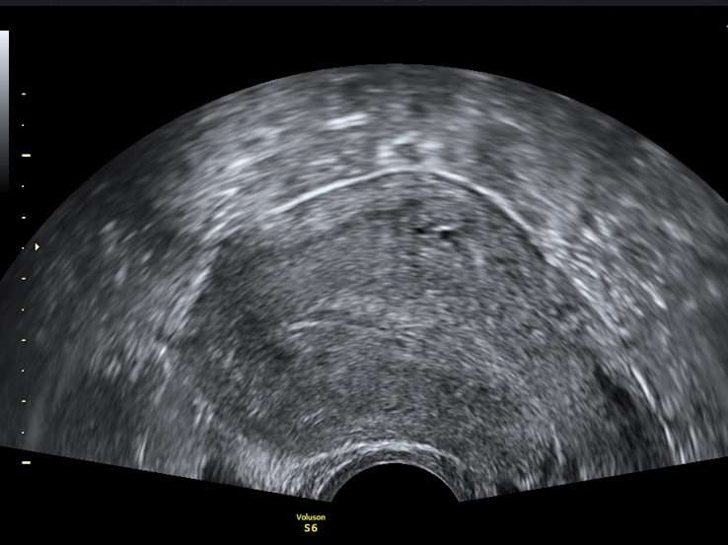 | 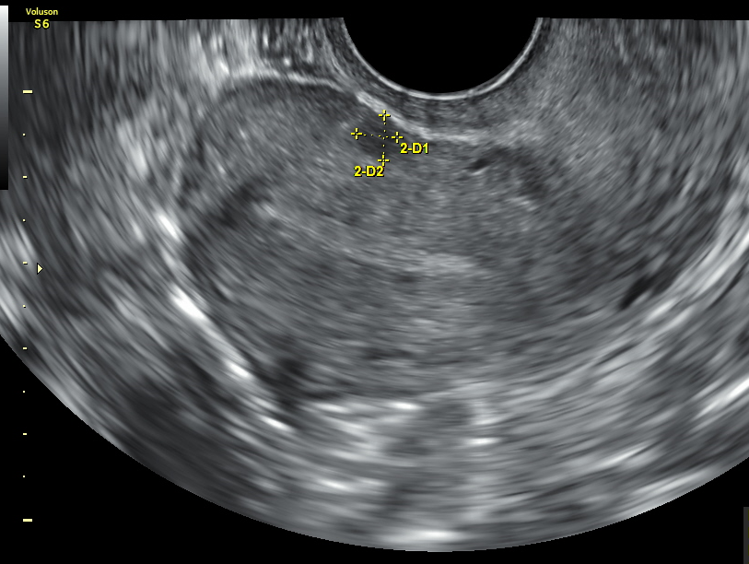  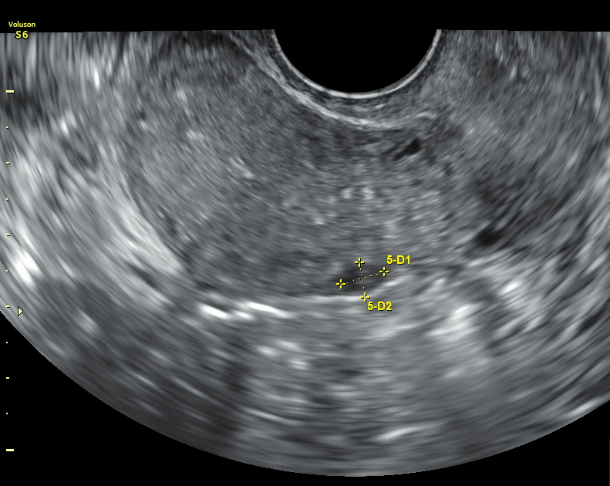 | 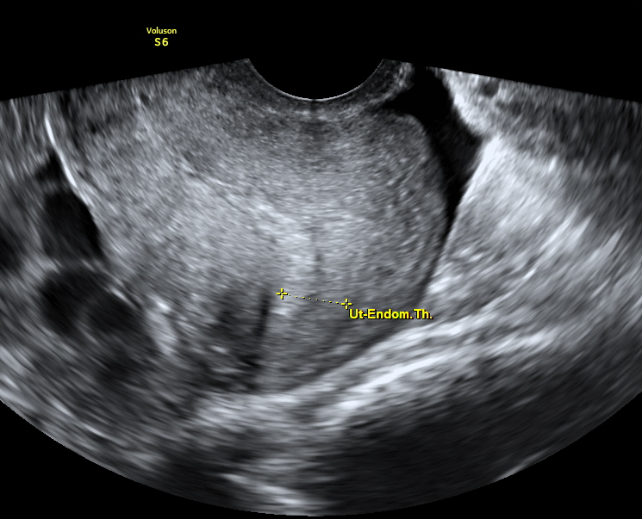  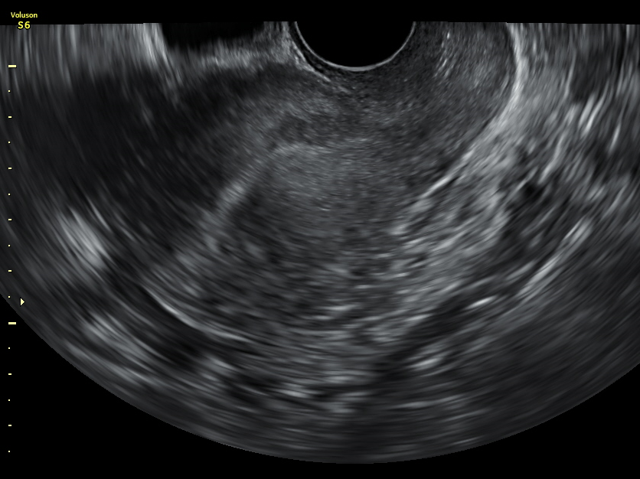
Diagnostic hysteroscopy after hormonal suppression | 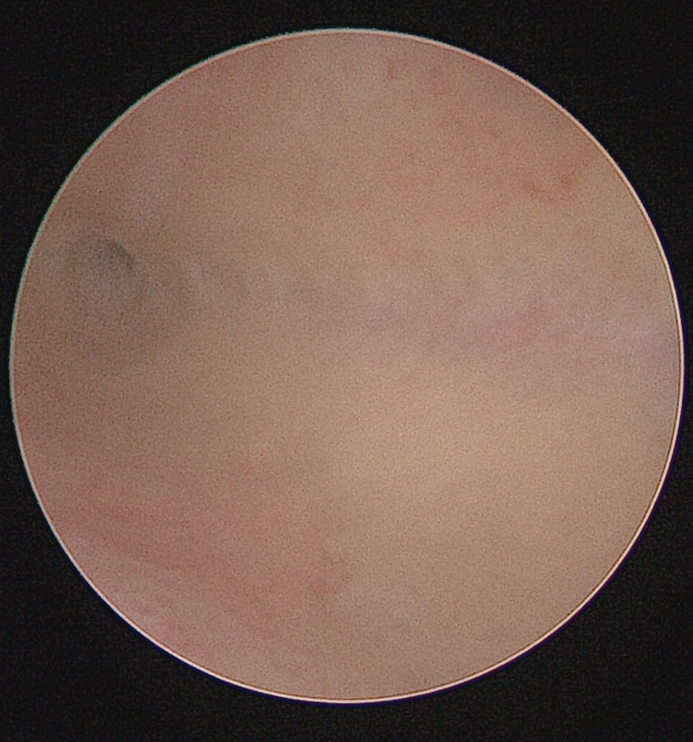  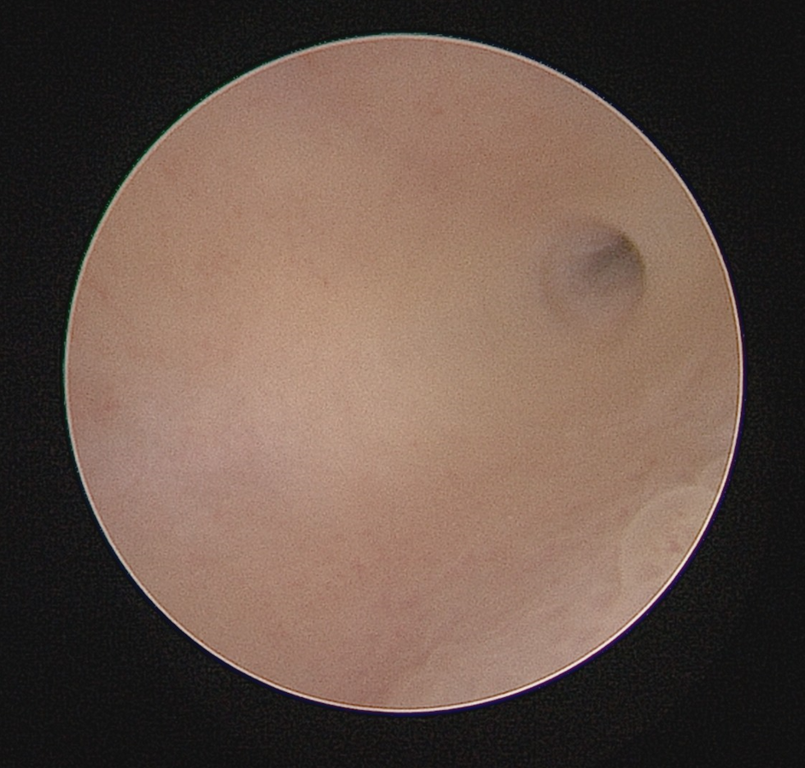 | 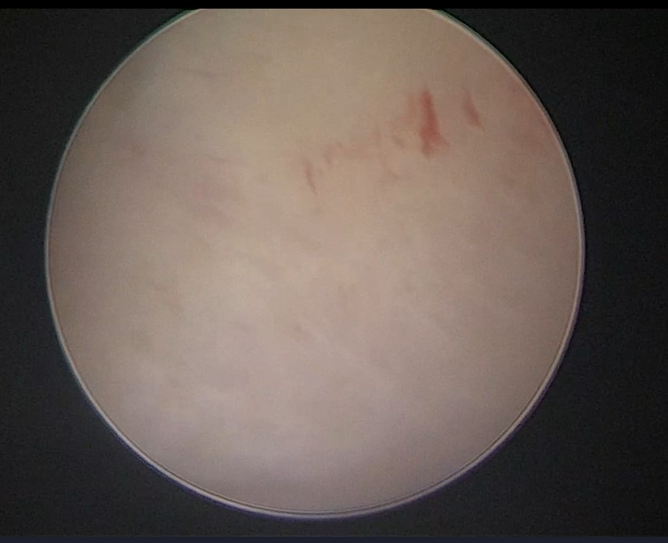  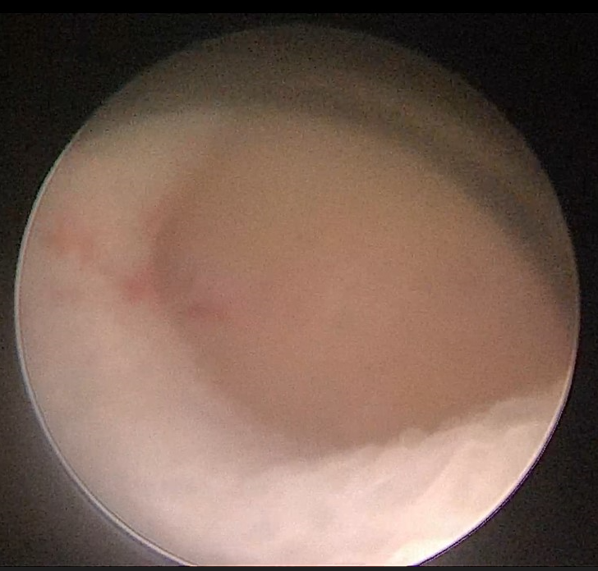 | 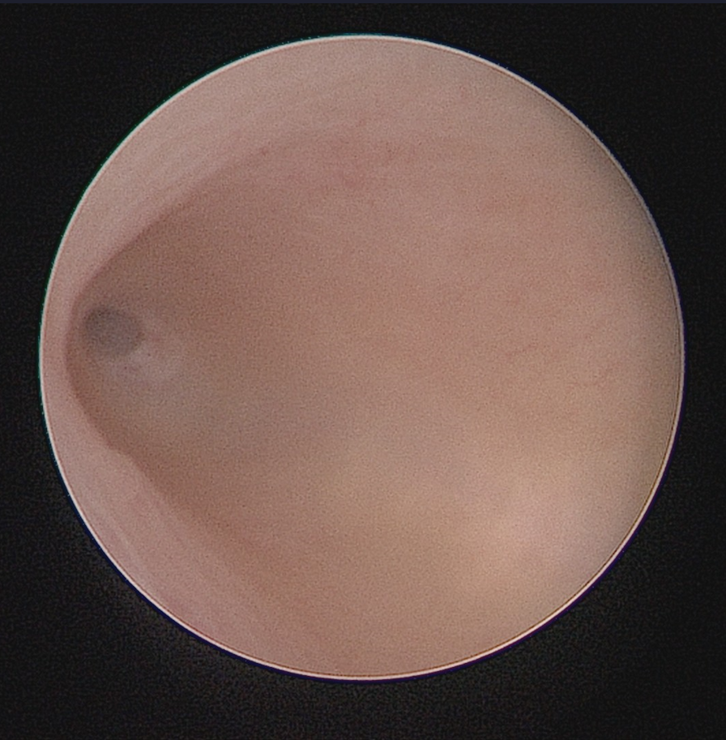  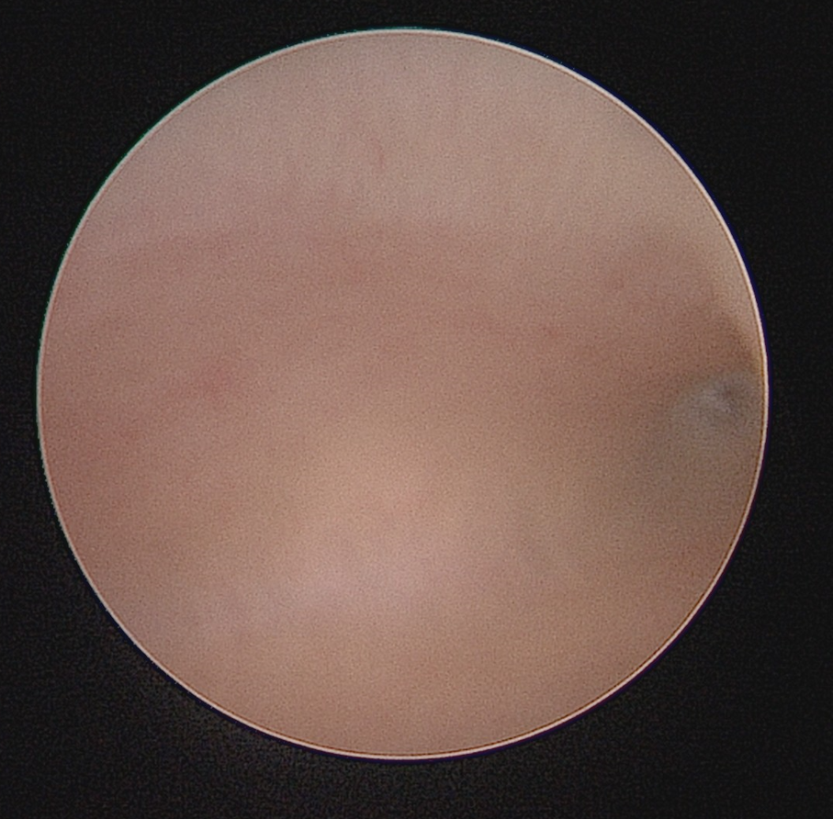

Table 3: Description of criteria, extension and severity of adenomyosis.
Schematic mapping system of adenomyosis severity* |  | MUSA criteria for diagnosis of adenomyosis** |  | Extension of the disease
Diffuse adenomyosis | Diffuse inside the myometrium and thickening of the uterine walls | Direct features | Myometrial cysts, hyperechogenic islands and echogenic subendometrial lines and buds | The extension of each type of adenomyotic lesion in the external myometrium and the JZ determines the grades and severity.
Diffuse adenomyosis | Diffuse adenomyosis of the JZ: diffuse inside the JZ and thickening of the JZ | Indirect features | Globular uterus, asymmetrical myometrial thickening, fan-shaped shadowing, translesional vascularity and irregular or interrupted junctional zone. | Mild (<25%)  Moderate (25–50%)  Severe (>50%)
Focal adenomyosis | Focal lesions within the outer myometrium
Focal adenomyosis | Focal daenomyosis of the JZ: focal lesion in the JZ.
Adenomyoma

*Adapted from Lazzeri et al ., 2018 [10].
**Morphological Uterus Sonographic Assessment (MUSA) criteria for diagnosis of adenomyosis. Adapted from Van den Bosch et al., [17].

Table 4: the adenomyosis severity for the three cases based on the Lazzeri classification, 2018 [10].
Case | Features | Score | Severity
1 | - Focal adenomyosis: Two focal intramyometrial lesions (10 and 20 mm)  - Diffuse adenomyosis, with thickening of all the uterine walls.  - Globally enlarged uterus | Focal:3  Diffuse: 4 | 7 (Severe)
2 | - Focal adenomyosis: two focal lesions (<10 mm).  - Diffuse adenomyosis, affecting all the uterine walls.  - Globally enlarged uterus | Focal:2  Diffuse:4 | 6 (moderate)
3 | - Focal adenomyosis: One focal lesion (<10 mm)  - Diffuse adenomyosis, affecting all the uterine walls.  - Globally enlarged uterus.  - Junctional Zone infiltration (ZP): >50–80%. | Focal:1  Diffuse: 4  Junctional zone infiltration: 3 | 8 (Severe)

