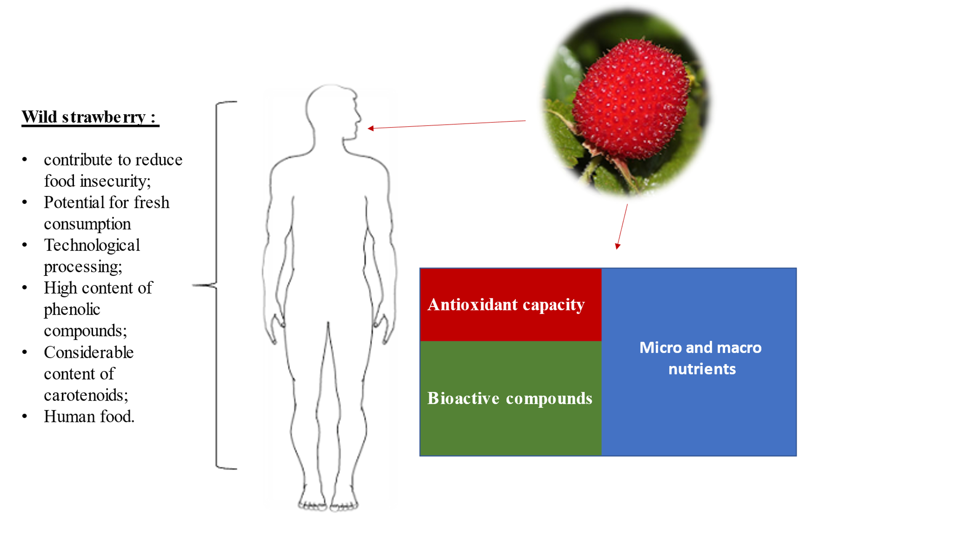
Statement of Novelty

Wild strawberry (Rosaceae Rubus rosifolius Smith) is considered an unconventional fruit because its consumption is not widespread by the population, is limited to only some communities. Literature does not show studies that characterize micro and macronutrients, bioactive composts and antioxidant activity of these fruits and, therefore, this research was carried out. Furthermore, the composition of vegetables is affected by intrinsic and extrinsic factors and therefore they undergo variations. Through the results found, it is possible to encourage the inclusion of these fruits in the population's diet, in addition to using unconventional food plants, rich in nutrients and bioactive compounds, as raw material for the development of food products, which can bring benefits to health and add value to resources locations.

