Shear wave splitting and seismic velocity structure in the onshore focal area of the 2024 Noto Peninsula earthquake, central Japan, as a fluid-promoted multifault rupture in a compressional inversion area

Tomomi Okada, Martha Kane Savage, Ayaka Tagami, Ryotaro Fujimura, Ryota Takagi, Keisuke Yoshida, Satoshi Matsumoto, Kentaro Emoto, Yoshiko Yamanaka, Kei Katsumata, Takuto Maeda, Motoko Ishise, Shin'ichi Sakai, Masatoshi Miyazawa, Hiroshi Yakiwara, Kazutoshi Imanishi, Naoki Uchida, Satoshi Hirahara, Shu'utoku Kimura, Toshiko Terakawa, Mako Ohzono, Takuo Shibutani, Takahiro Shiina, Yoshihiro Hiramatsu

Supplementary materials

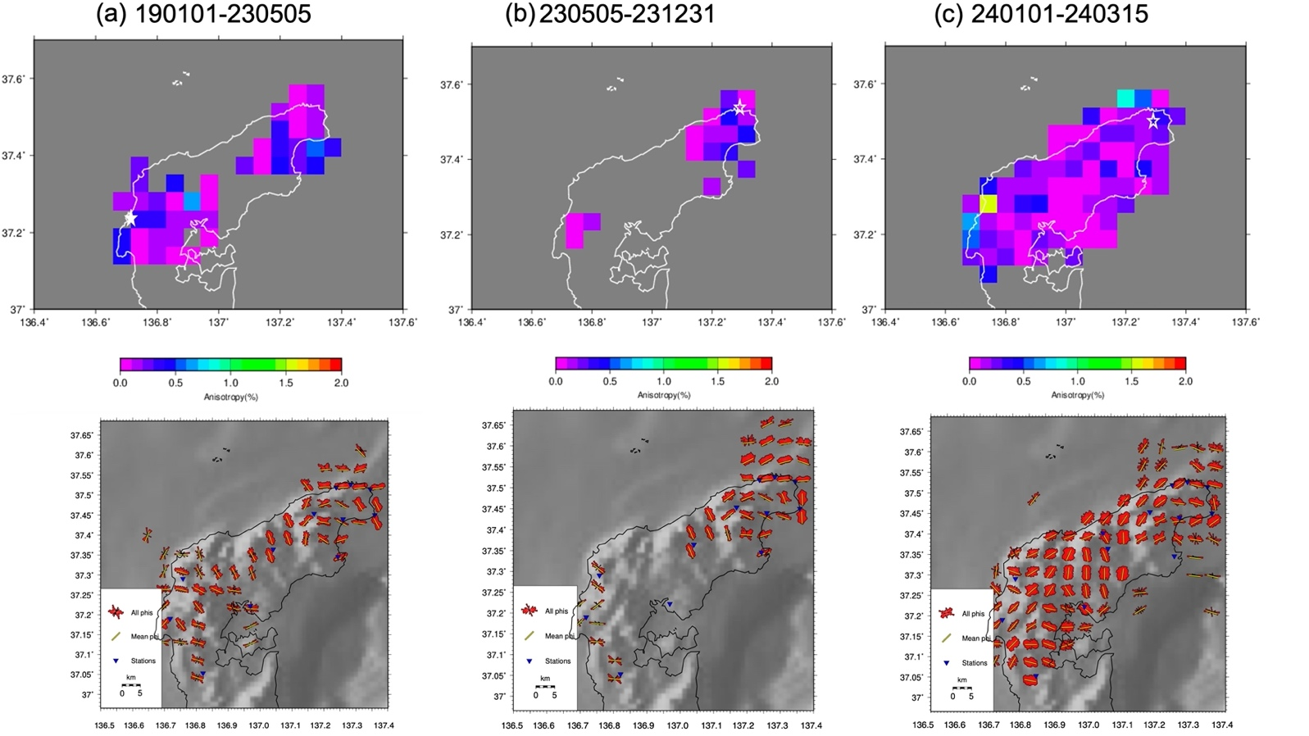

Fig. S1. Spatial average of the polarization of a fast shear wave from shear wave splitting calculated by inverse weighting proportional to the square of the distance from the station and the spatial average of the degree of anisotropy in the periods from (a) 1/1/2019 to 05/05/2023, (b) 05/05/2023 to 12/31/2023, and (c) 01/01/2024 to 03/15/2024. The solid star in (a), open small star in (b), and open large star in (c) denote the epicenters of the 2007 M6.9 Noto–Hanto, 2023 M6.5, and 2024 M7.6 Noto Peninsula earthquakes, respectively.

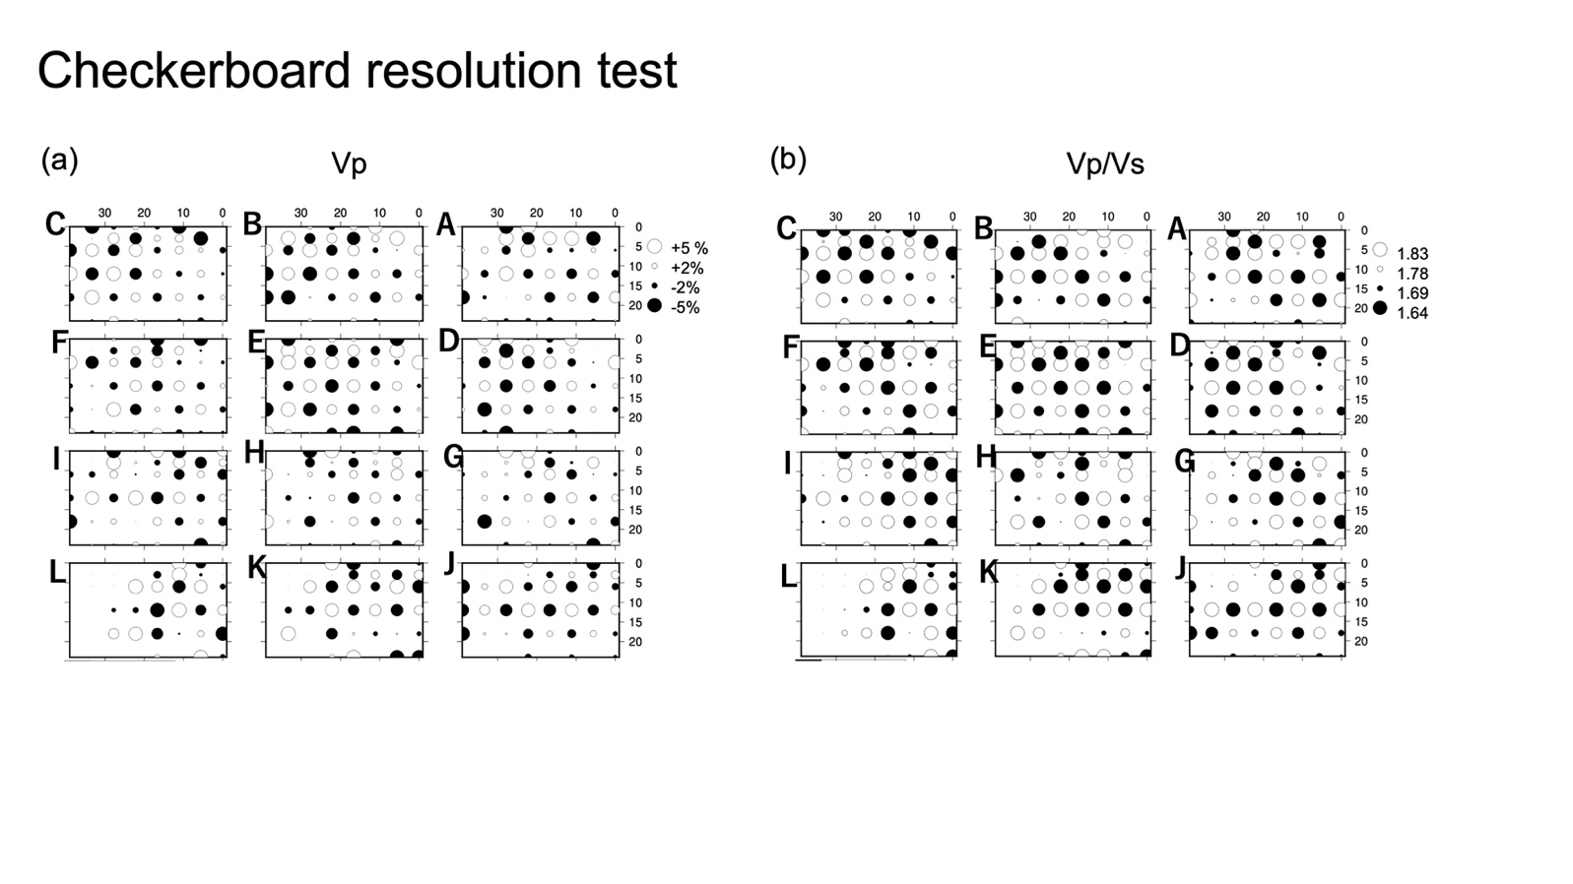
Fig. S2. Results of the checkerboard resolution test for (a) dVp and (b) Vp/Vs. The locations of the cross sections are the same as those in Figs. 4-6.

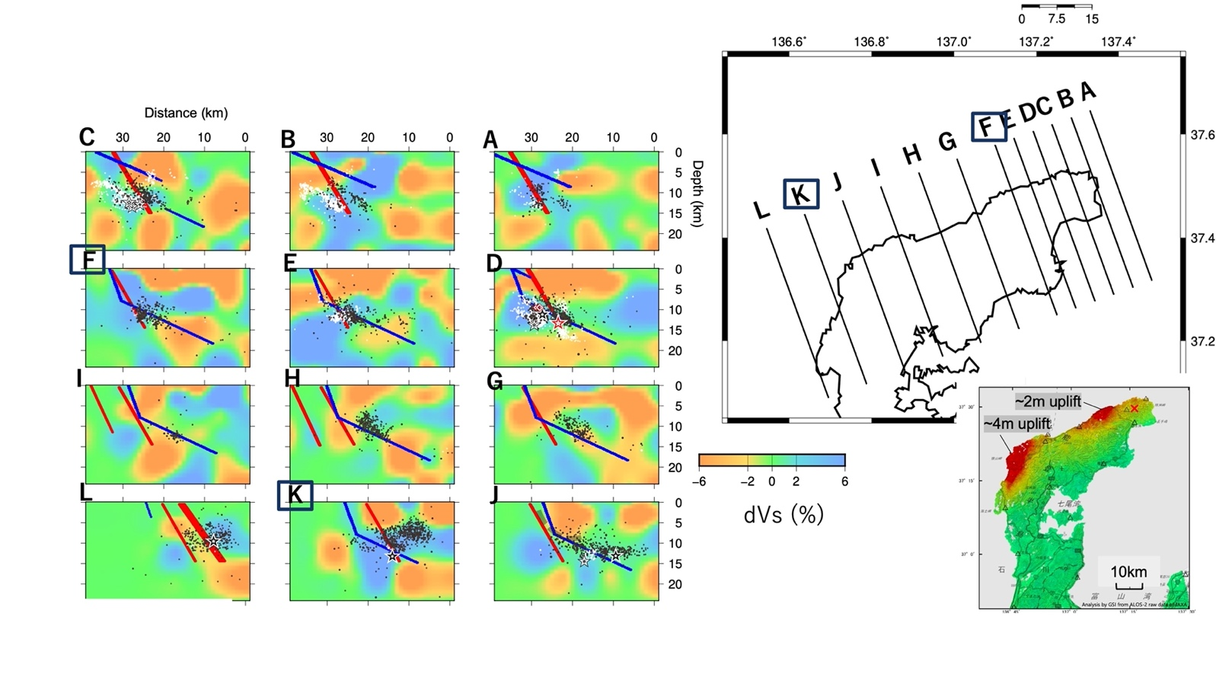

Fig. S3. Results of seismic velocity tomography: cross-sections along lines A to L for dVs with two fault models: red is the fault model from the Nihon-kai Earthquake and Tsunami Research Project (2015), and blue is the fault model from Yamada et al. (2024). The black and red stars in D denote the M5.5 earthquake at 16:06 on January 1st, 2024, and the M7.6 earthquake at 16:10 on January 1st, 2024, respectively. The white stars and the black stars denote the earthquakes with magnitude greater than or equal to M5.4, before the M7.6 earthquake and after the M7.6 earthquake, respectively. The white dots and the black dots in all the cross sections denote earthquakes with magnitudes smaller than M5.4, from 2019 before the M7.6 earthquake and after the M7.6 earthquake, respectively. The bottom right figure shows the seismic displacement obtained by InSAR analysis (green and red indicate no uplift and approximately 4 m uplift, respectively) (Geospatial Information Authority of Japan, 2024).

