Supplementary figures
Anti-seizure medication in pregnancy and pregnancy, baby, and child outcomes: a population-based cohort study
Emily Moore¹, Morven Millar¹, Rachel Merrick¹, Tanja Mueller^{1,2}, Victoria Stark¹, Lynne Jarvis¹, Amanj Kurdi^{1,2,3,4,5}, Leanne Hopkins¹, Stuart McTaggart¹, Rute Vieira^{1,6}, Marion Bennie^{1,2}, Rachael Wood^{1,7}*
Corresponding author: Professor Rachael Wood, rachael.wood@phs.scot
Keywords: anti-seizure medication, pregnancy, congenital conditions, developmental concerns, cohort study, Scotland
¹ Public Health Scotland, Glasgow/Edinburgh, UK
² Strathclyde Institute of Pharmacy and Biomedical Sciences, University of Strathclyde, Glasgow, UK
³ College of Pharmacy, Hawler Medical University, Erbil, Kurdistan Region, Iraq
⁴ Al-Kitab University, Kirkuk, 36015, Iraq
⁵ School of Pharmacy, Sefako Makgatho Health Sciences University, Pertoria 0205, South Africa
⁶ Institute of Applied Health Sciences, University of Aberdeen, Aberdeen, UK
⁷ Usher Institute, University of Edinburgh, Edinburgh, UK

Figure 1: All singleton pregnancies conceived in Scotland between 1 April 2010 and 2 July 2023 (pregnancy cohort) that were exposed to an ASM during pregnancy: by gestational week that the pregnancy was first exposed to the ASM
ASM exposure during pregnancy is counted from 28 days before conception
(-2 weeks gestation) up to the end of pregnancy.

Figure 2: Odds ratios for the association between exposure to anti-seizure medicine (ASM) during pregnancy and pregnancy loss; singleton pregnancies conceived in Scotland between 1 April 2010 and 2 July 2023 (pregnancy cohort):
Propensity score approach and primary analysis (adjusted) models.
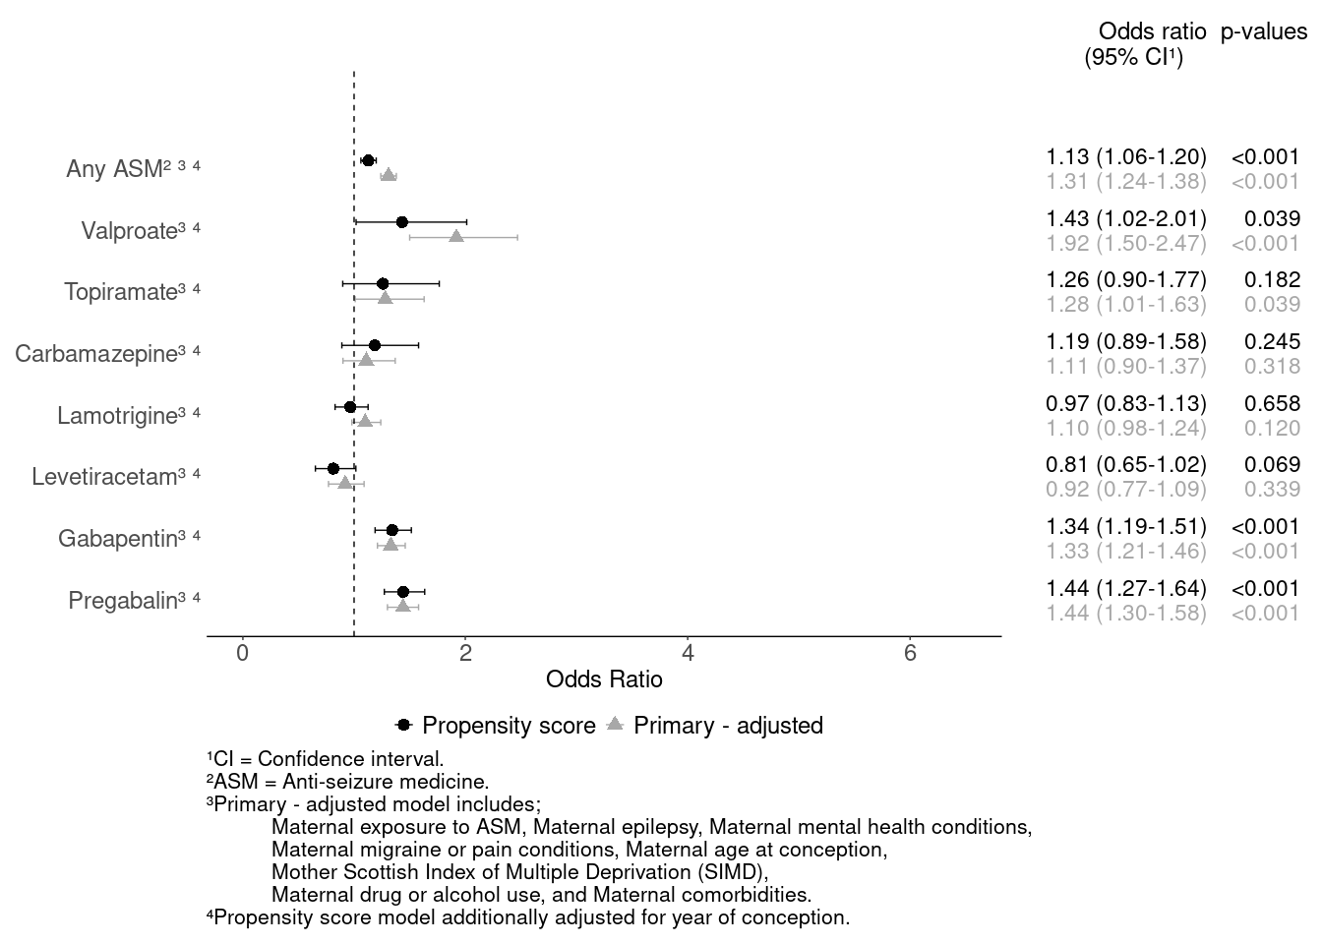

Figure 3: Odds ratios for the association between exposure to anti-seizure medicine (ASM) during pregnancy and pregnancy loss; singleton pregnancies conceived in Scotland between 1 April 2010 and 2 July 2023 (pregnancy cohort):
Restricted to pregnancies from women reported to have epilepsy.
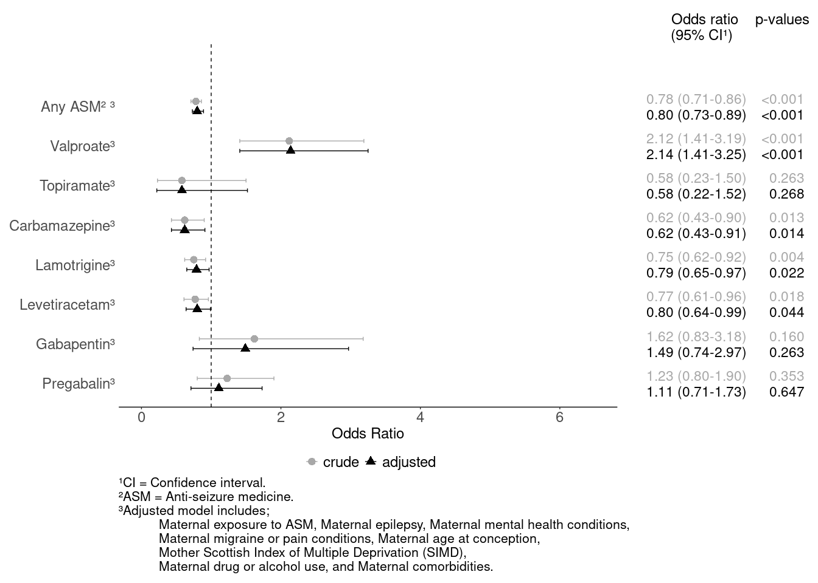

Figure 4: Odds ratios for the association between exposure to anti-seizure medicine (ASM) during pregnancy and pregnancy loss; singleton pregnancies conceived in Scotland between 1 April 2010 and 2 July 2023 (pregnancy cohort):
Stratified by maternal high dose folic acid status.
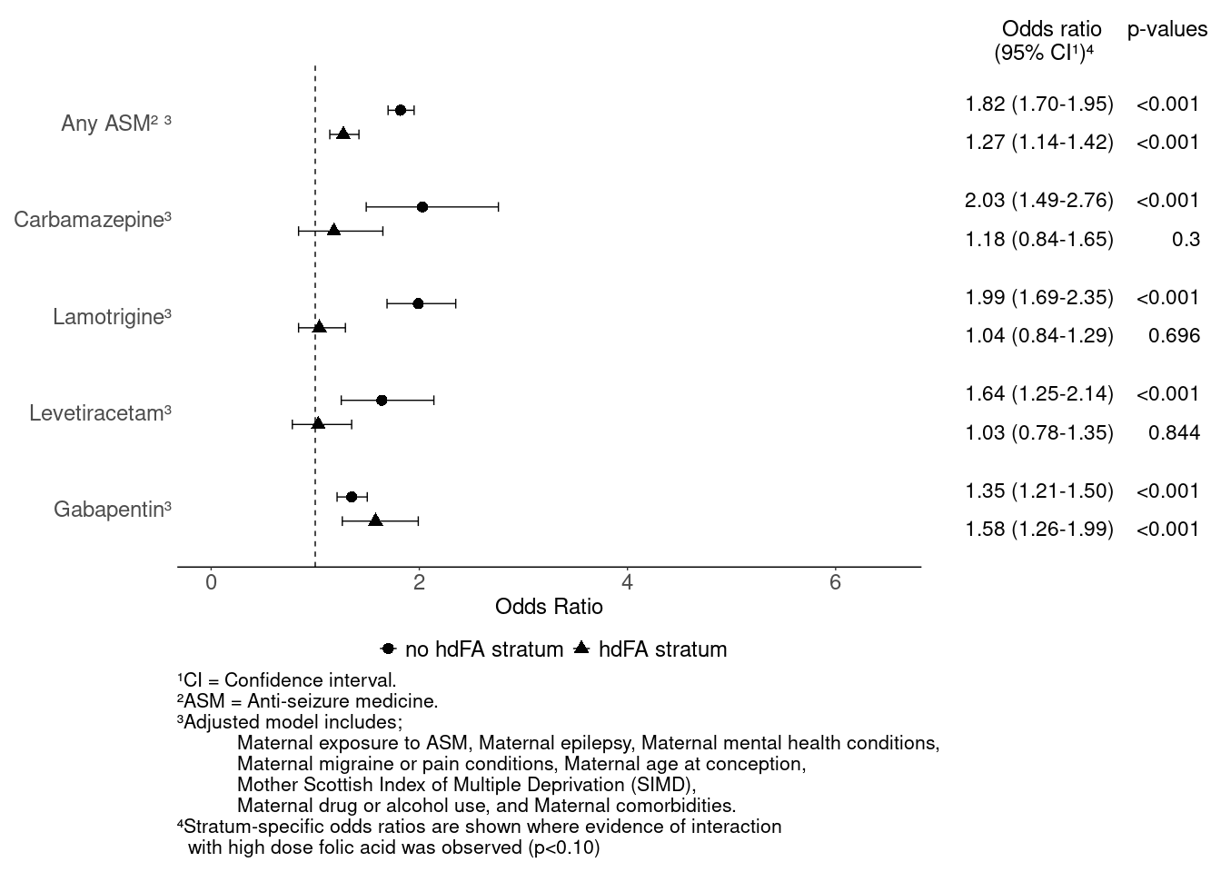

Figure 5: Odds ratios for the association between exposure to anti-seizure medicine (ASM) during pregnancy and congenital conditions; babies from singleton pregnancies conceived in Scotland between 1 April 2010 and 2 April 2021 (baby cohort):
Propensity score approach and primary analysis (adjusted) models.
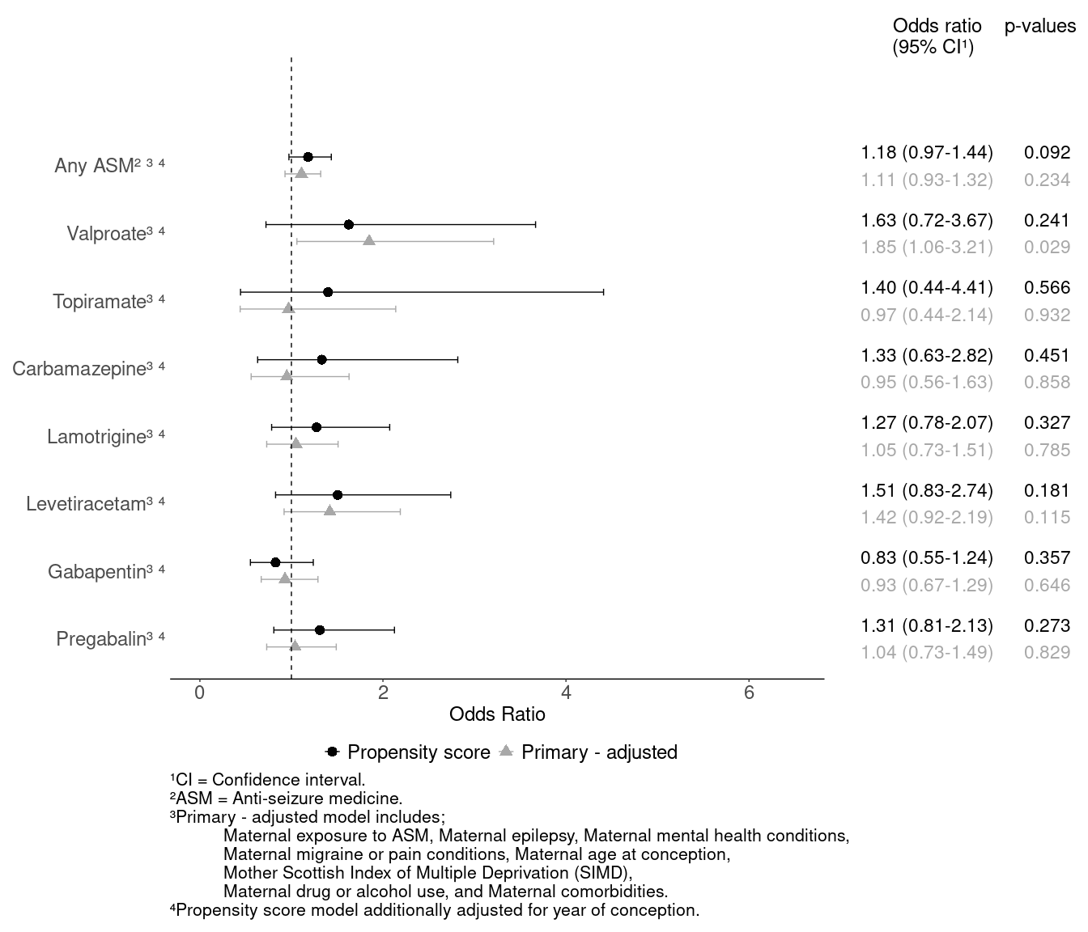

Figure 6: Odds ratios for the association between exposure to anti-seizure medicine (ASM) during pregnancy and congenital conditions; babies from singleton pregnancies conceived in Scotland between 1 April 2010 and 2 April 2021 (baby cohort):
Restricted to babies from women reported to have epilepsy.
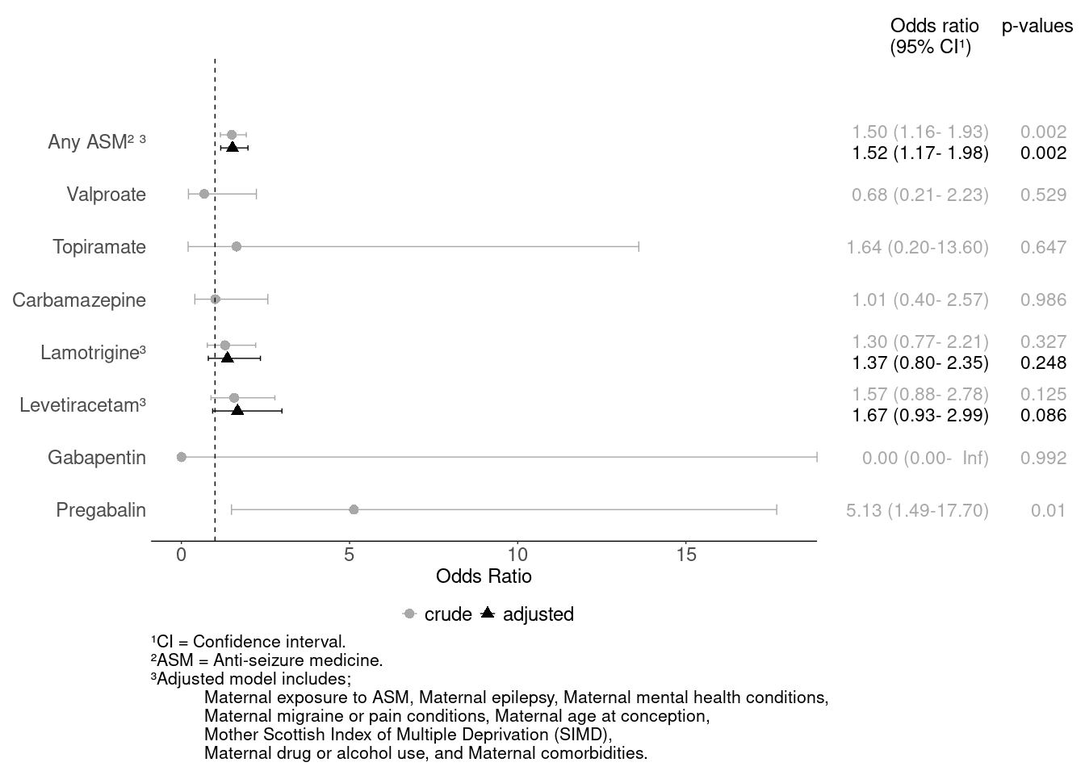

Figure 7: Odds ratios for the association between exposure to anti-seizure medicine (ASM) during pregnancy and congenital conditions; babies from singleton pregnancies conceived in Scotland between 1 April 2010 and 2 April 2021 (baby cohort):
Restricted to babies reaching at least 12⁺⁰ weeks gestation.
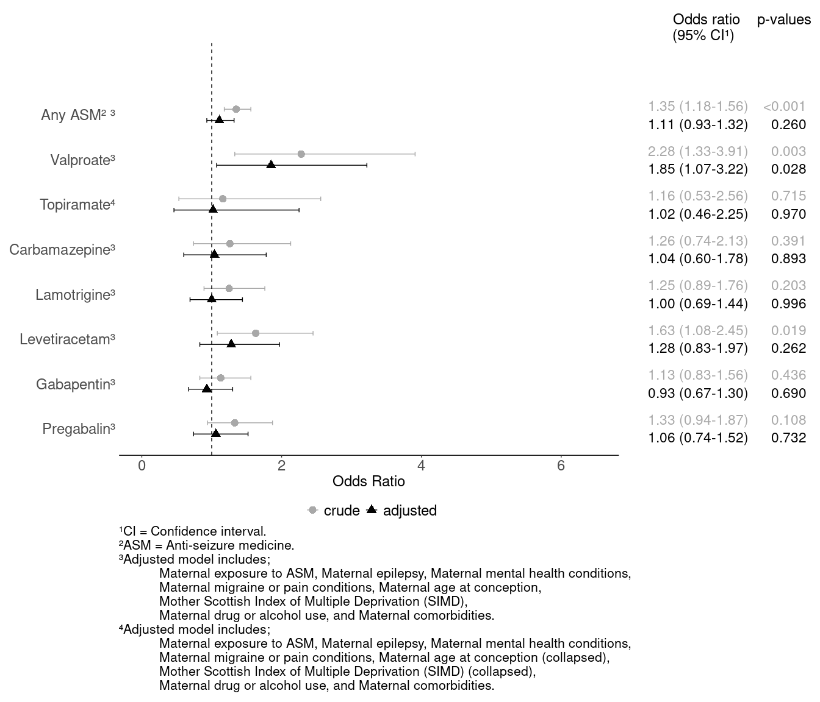

Figure 8: Odds ratios for the association between exposure to anti-seizure medicine (ASM) during pregnancy and early childhood developmental concerns (at 27-30 month assessment); live births from singleton pregnancies conceived in Scotland between 1 April 2010 and 1 July 2020 (live birth cohort):
Propensity score approach and primary analysis (adjusted) models.
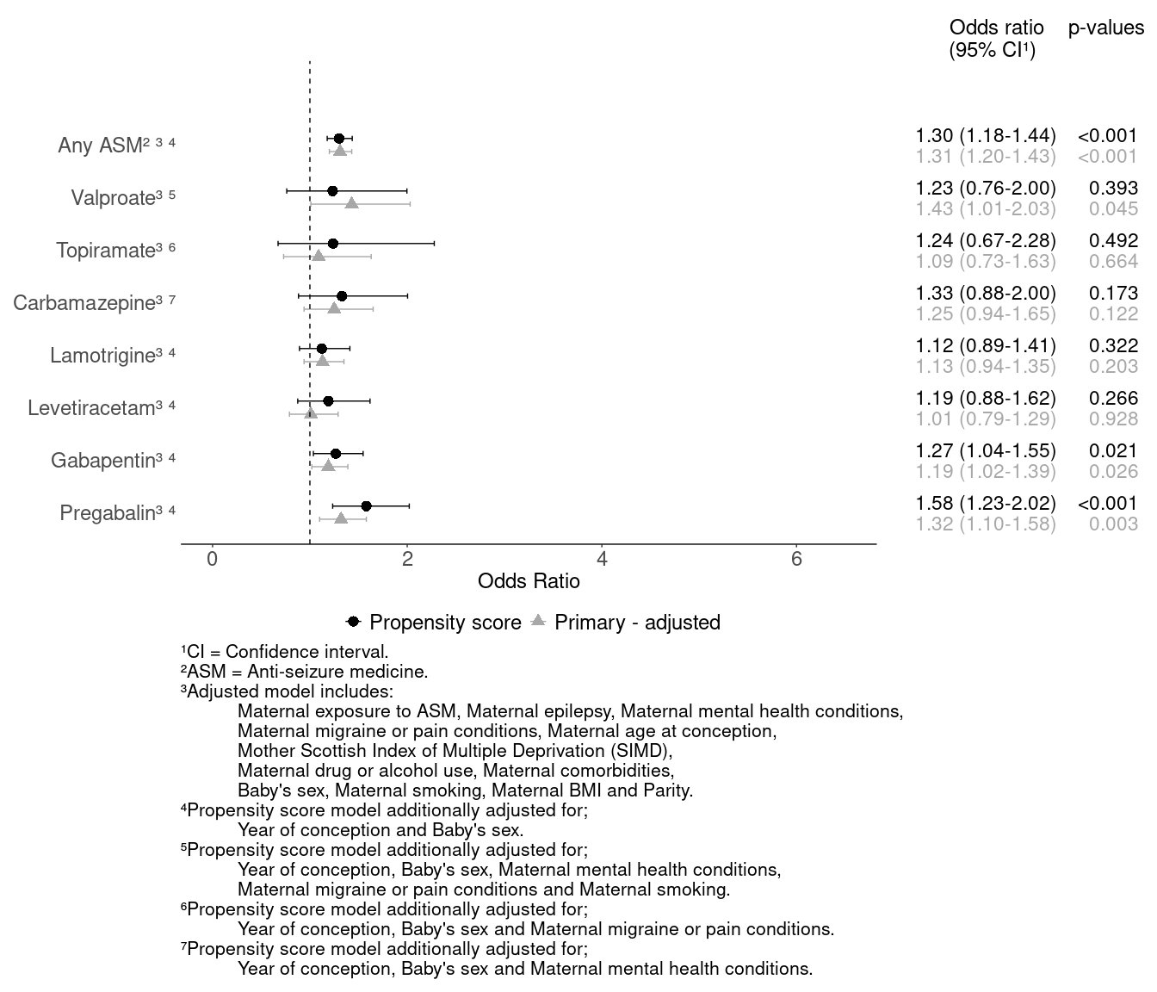

Figure 9: Odds ratios for the association between exposure to anti-seizure medicine (ASM) during pregnancy and early childhood developmental concerns (at 27-30 month assessment); live births from singleton pregnancies conceived in Scotland between 1 April 2010 and 1 July 2020 (live birth cohort):
Restricted to live-born babies to women reported to have epilepsy.
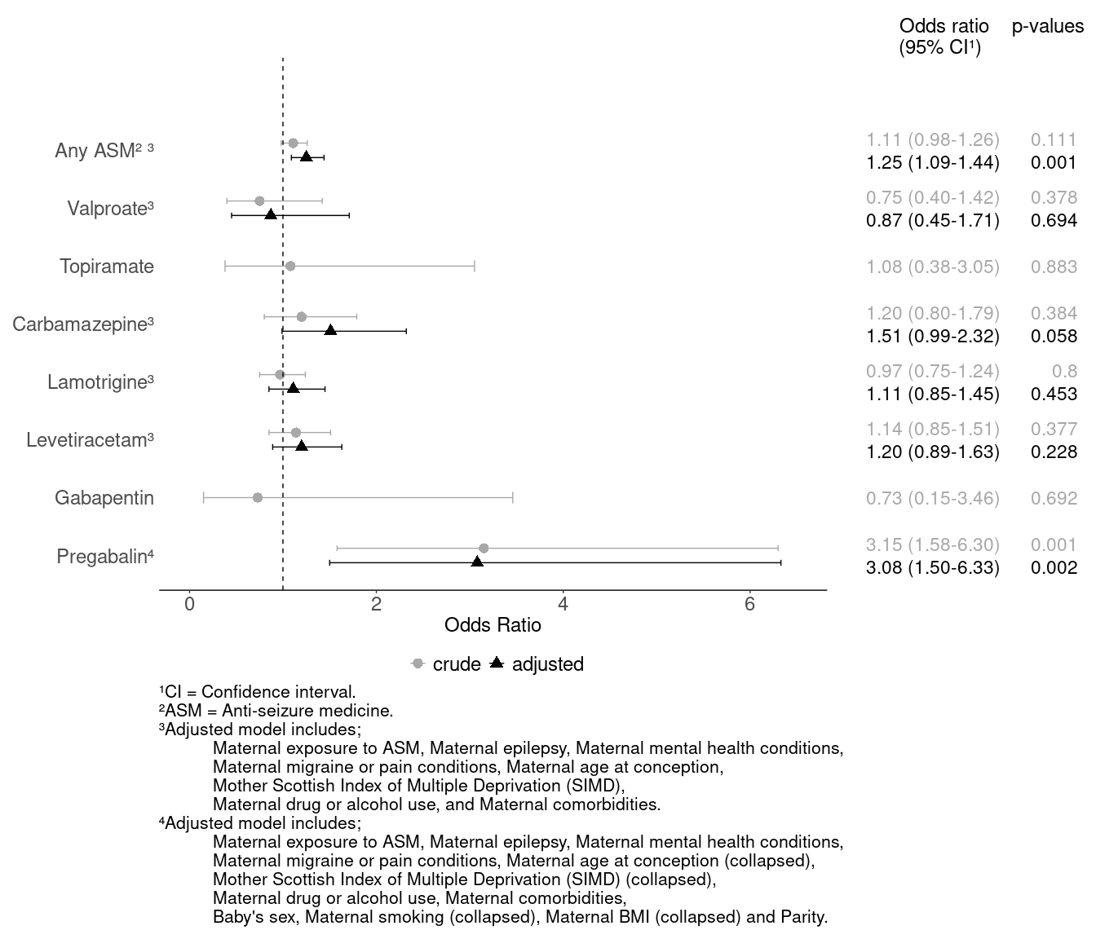

Figure 10: Odds ratios for the association between exposure to anti-seizure medicine (ASM) during pregnancy and early childhood developmental concerns (at 27-30 month assessment); live births from singleton pregnancies conceived in Scotland between 1 April 2010 and 1 July 2020 (live birth cohort):
Stratified by maternal high dose folic acid status.
