Supporting Information

Size and doping effects on the HER performance in Ag and Cu clusters

Uzma Zahoor*, Panpan Wang, Farhat Shakeel, Abdul Munam Khan Waqar Ahmed,
Yigang Cao, Chunyao Niu*
International Laboratory for Quantum Functional Materials of Henan, and School of Physics and Laboratory of Zhongyuan Light, Zhengzhou University, Zhengzhou 450001, China
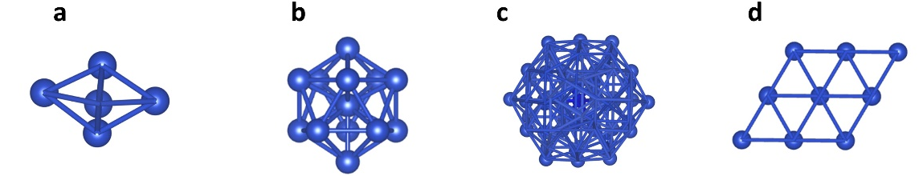
Fig.1 The optimized structures for the Cu₅, Cu₁₃, Cu₅₅ clusters and the Cu (111) surface.
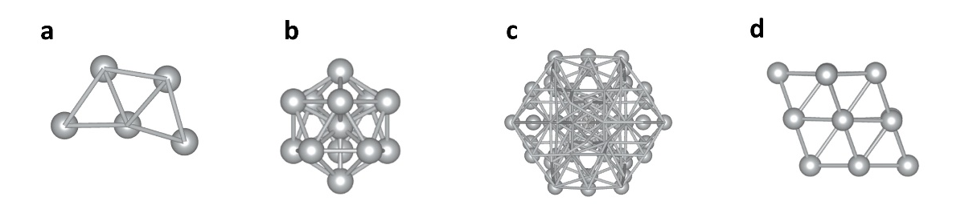
Fig.2 The optimized structures for the Ag₅, Ag₁₃, Ag₅₅ clusters and the Ag (111) surface.

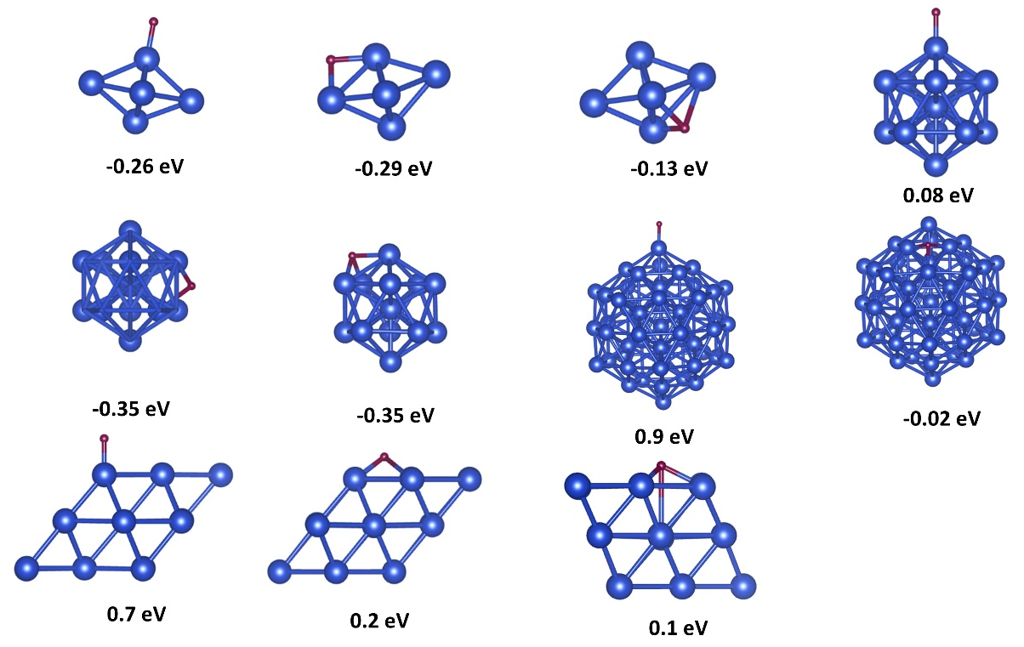
Fig.3 The adsorption free energy of H on different sites of Cu₅ Cu₁₃ Cu₅₅ and Cu (111) surface.
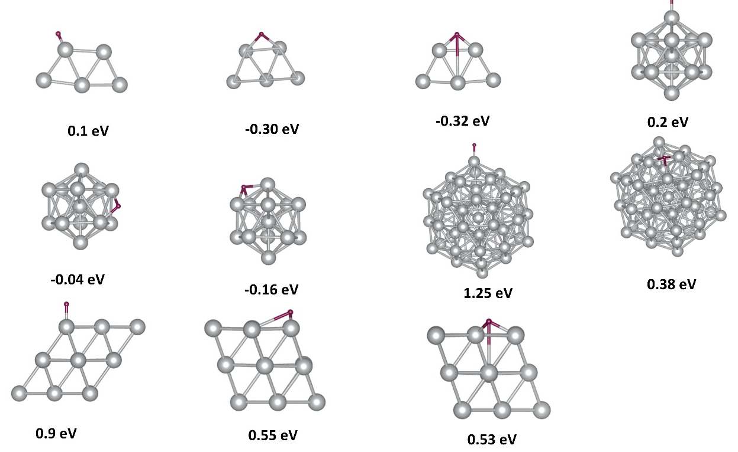

Fig.4 The adsorption free energy of H on different sites of Ag₅ Ag₁₃ Ag₅₅ and Cu (111) surface.
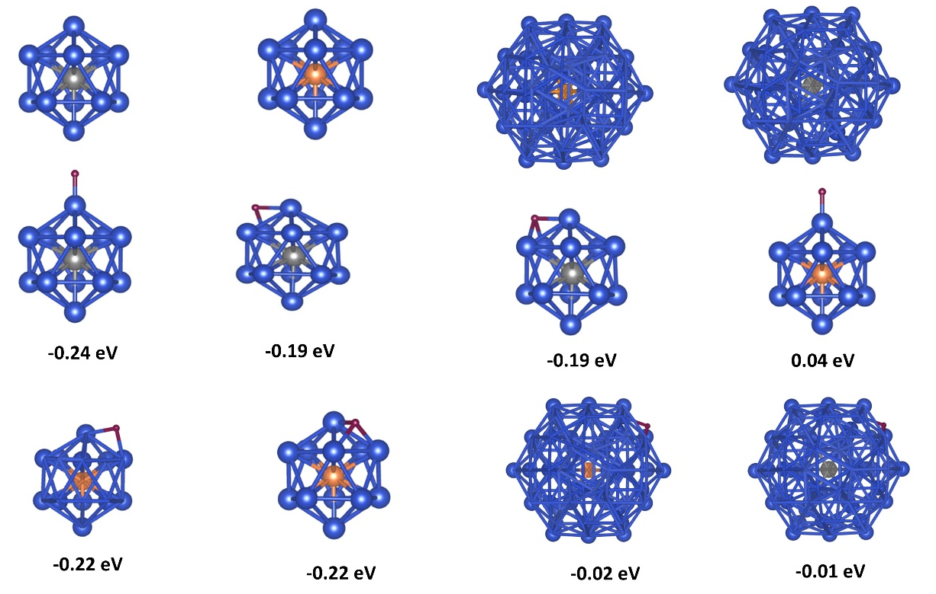
Fig.5 Pt and Ni doped Cu₁₃ and Cu₅₅ clusters with adsorption free energy of Hydrogen on different sites
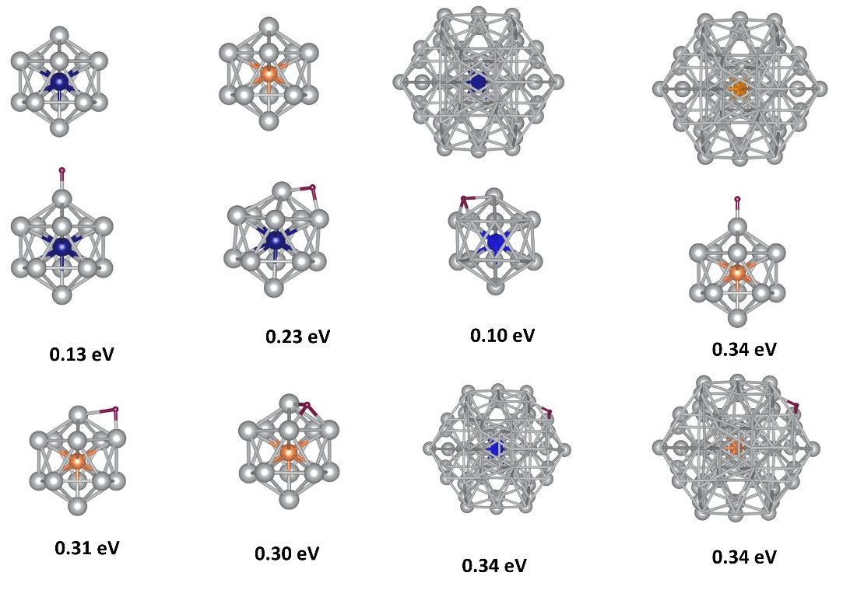
Fig.6 Pt and Ni doped Ag₁₃ and Ag₅₅ clusters with adsorption free energy of Hydrogen on different sites.

