Supplementary Information
Enhanced Hydrogen Evolution Reaction Kinetics by Sulfur Incorporation in Transition Metal-Based Oxyhydroxide Electrodes
Jun Seok Ha^{a,b,i}, Seung Hun Lee^{a,i}, Sung Jun Lee^{c}, In Tae Kim^{c}, Seo Hyun Park^{c}, Woo Jae Lee^{d}, Kyeong-Ho Kim^{e}, Jooyoung Lee^{b}, Yangdo Kim^{a*}, Sung Mook Choi^{b,f*}, Yoo Sei Park^{g,h*}

AUTHOR ADDRESS.
ª Department of Materials Science and Engineering, Pusan National University, Busan, 46241, Republic of Korea
^{b} Department of Energy & Environment Materials Research Division, Korea Institute of Materials Science (KIMS), Changwon 51508, Republic of Korea
^{c} Department of Urban, Energy, and Environmental Engineering, Chungbuk National University, Chungdae-ro 1, Seowon-Gu, Cheongju, Chungbuk 28644, Republic of Korea
^{d} Division of Nanotechnology and Semiconductor Engineering, Pukyong National University, 45 Yongso-ro, Busan 48513, Republic of Korea
^{e} Department of Materials Science and Engineering, Pukyong National University, Busan 48513, Republic of Korea
^{f} Advanced Materials Engineering, University of Science and Technology (UST), Yuseong-gu, Daejeon 34113, Republic of Korea
^{g} Department of Nanoenergy Engineering, Pusan National University, 50, Busandaehak-ro 63 beon-gil 2, Geumjeong-gu, Busan 46241, Republic of Korea
^{h} Department of Nano Fusion Technology, Pusan National University, Busandaehak-ro 63 beon-gil 2, Geumjeong-gu, Busan 46241, Republic of Korea
^{i} These authors contributed equally: Jun Seok Ha, Seung Hun Lee

*E-mail: yoosei@pusan.ac.kr (Prof. Yoo Sei Park), akyzaky@kims.re.kr (Dr. Sung Mook Choi), yangdo@pusan.ac.kr (Prof. Yangdo Kim)
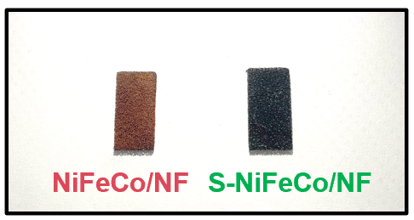
Figure S1. Photographs of NiFeCo/NF and S-NiFeCo/NF.

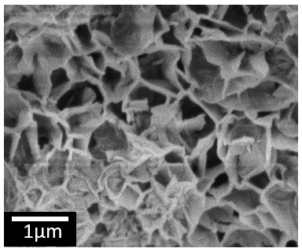
Figure S2. SEM image of NiFeCo/NF.

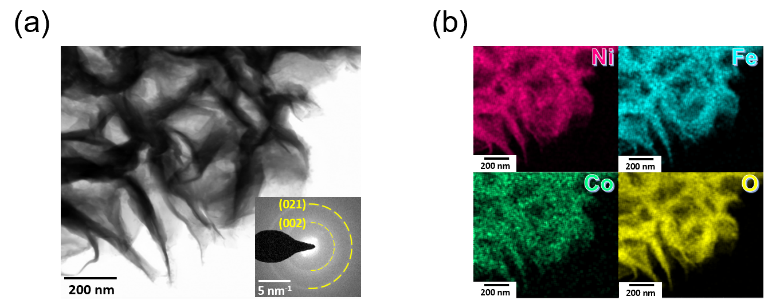
Figure S3. (a) TEM image of NiFeCo/NF. (b) EDS elemental mapping images of the NiFeCo/NF : Ni(red), Fe(blue), Co(green), O(yellow).

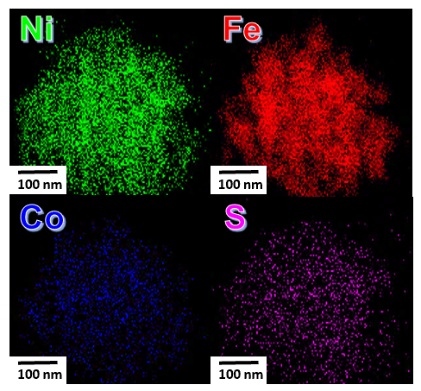
Figure S4. EDS elemental mapping images of the S-NiFeCo/NF : Ni(green), Fe(red), Co(blue), S(purple).

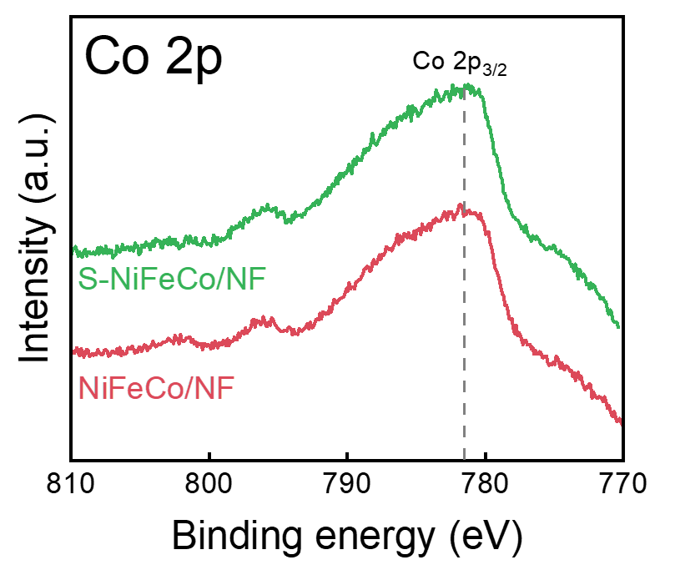
Figure S5. XPS spectrum Co 2p.

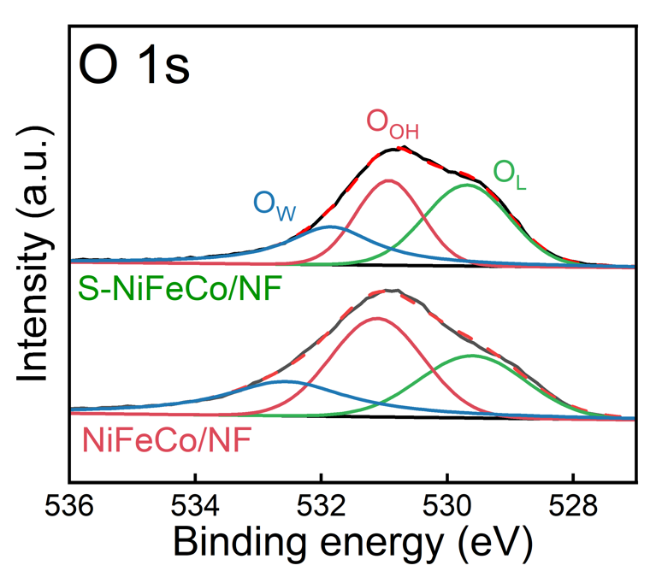
Figure S6. XPS spectrum O 1s.

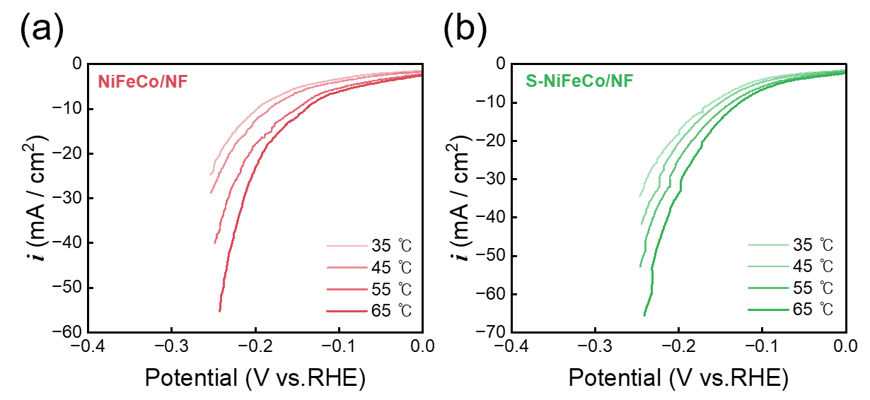
Figure S7. LSV curves of (a) NiFeCo/NF and (b) S-NiFeCo/NF at different temperatures.

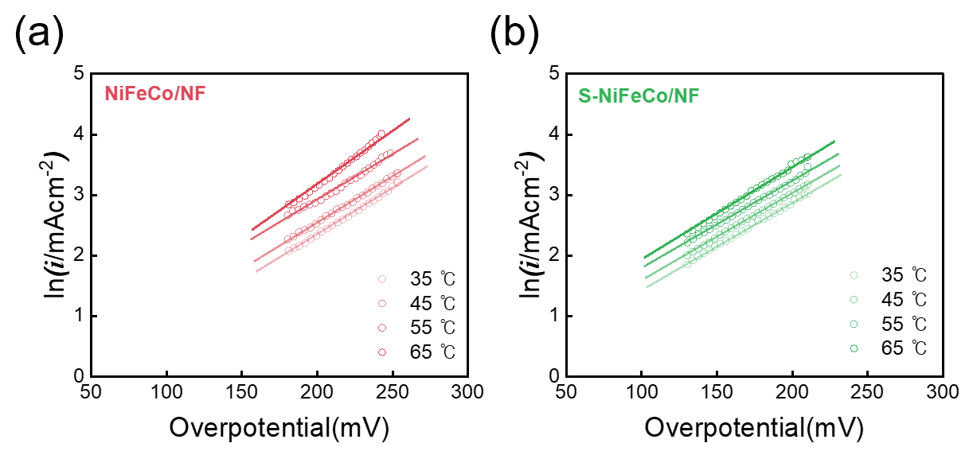
Figure S8. ln(i/mAcm⁻²) vs. overpotential plots of (a) NiFeCo/NF, (b) S-NiFeCo/NF at different temperatures.

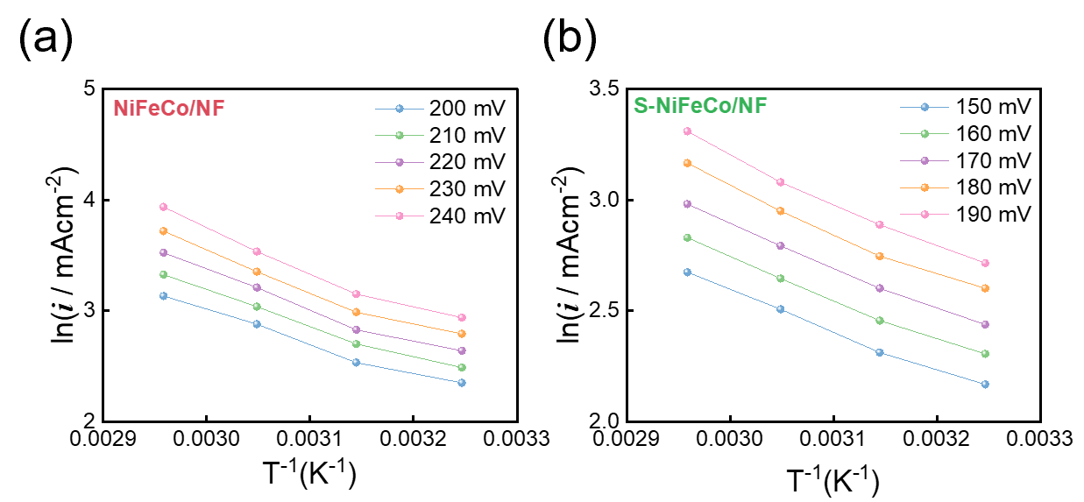
Figure S9. Arrhenius plots of (a) NiFeCo/NF and (b) S-NiFeCo/NF at different overpotentials.

