Doping-Induced Conductivity Enhancement in Mechanically Robust and Flexible SWCNT/Conjugated-Polymer Composites for High-Performance EMI Shielding

Min Seon Kim,¹ Yejin Ahn,¹ Sung Woo Hong,^{2,3,4}* and Bong-Gi Kim^{1,5}*

¹Department of Materials Science and Engineering, Konkuk University, Seoul 05029, Republic of Korea.

²Green Circulation R&D Department, Korea Institute of Industrial Technology, Cheonan-si, Chungcheongnam-do 31056, Republic of Korea.

³Convergence Research Center for Solutions to Electromagnetic Interference in Future-mobility, Korea Institute of Science and Technology, Seoul 02792, Republic of Korea.

⁴Department of Chemical Engineering, Chung-Ang University, Seoul 06974, Republic of Korea.

⁵Advanced Materials Program, Konkuk University, Seoul 05029, Republic of Korea.

To whom correspondence, E-mail: swhong@kitech.re.kr (Sung Woo Hong, 0000-0003-0846-3539) and bgkim2015@konkuk.ac.kr (Bong-Gi Kim, 0000-0003-1386-3705)

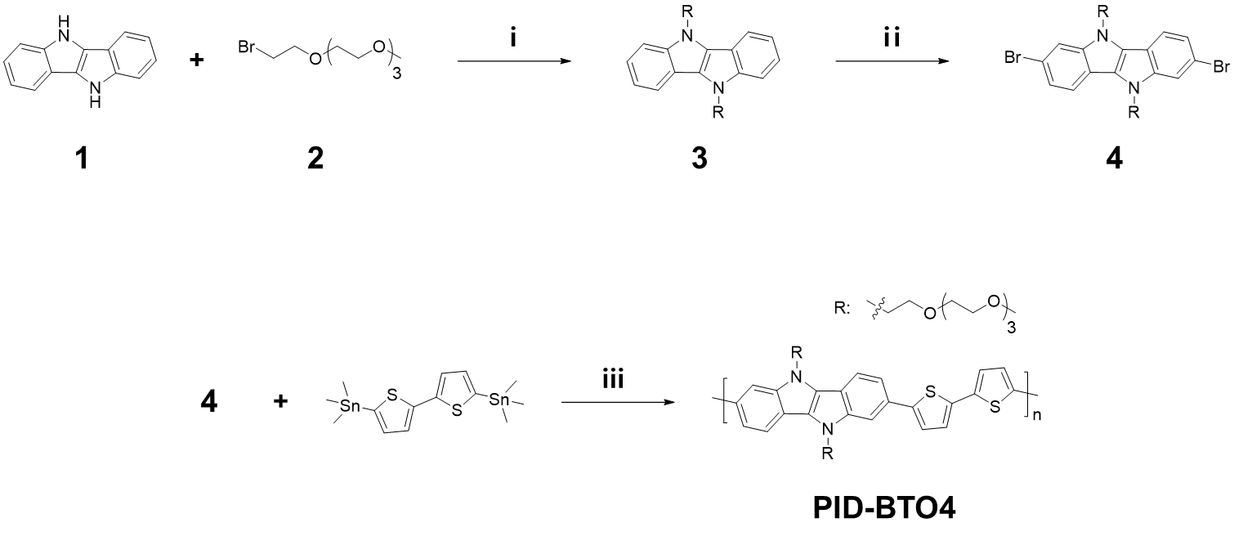
Scheme S1 Detailed synthetic scheme of PID-BTO4. (ⅰ) Sodium hydride (NaH), tetrahydrofuran (THF), reflux, 24 hours. (ⅱ) N-Bromosuccinimide (NBS), N,N-Dimethylformamide (DMF), RT, 30 min. (ⅲ) Pd₂(dba)₃, p(o-tol)₃, toluene, 110 ℃, 24 hours.

Materials. Compound 1 was prepared using previously described methods [S1]. Triethylene glycol 2-bromoethyl methyl ether (compound 2) and 5,5'-bis(trimethylstannyl)-2,2'-bithiophene were purchased from Tokyo chemical industry (TCI) and used without further purification.

Compound 3. Compound 3 was prepared using previously described methods [S1, S2]. The crude product was purified by silica gel column chromatography using ethyl acetate and THF at a 13:1 ratio as the eluent, yielding Compound 3 as a light greenish oil with an 85% yield. 1H-NMR (500 MHz, DMSO-d6, ppm): 7.88 (dd, 4H), 7.24 (dd, 2H), 4.69 (t, 4H), 3.83 (t, 4H), 3.44-3.24 (m, 24H), 3.20 (s, 6H); 13C-NMR (500 MHz, DMSO-d6, ppm): 141.6, 126.1, 121.3, 120.0, 115.1, 113.7, 113.3, 71.6, 70.5, 70.2, 70.15, 70.1, 70.05, 69.9, 58.4, 45.4, 40.6, 40.4, 40.1, 39.9, 39.7, 39.5, 39.3; HRLC-MS (ESI+) m/z: calculated for C₃₂H₄₄Br₂N₂O₈ [M+H]+: 745.1244, found: 745.1523.

Compound 4. Compound 4 was prepared using previously described methods [S1, S2]. The crude product was purified by column chromatography. The light greenish oil was precipitated from n-hexane at -18℃ to afford Compound 4 as a white powder (yield: 72%). 1H-NMR (500 MHz, DMSO-d6, ppm): 7.88 (dd, 4H), 7.24 (dd, 2H), 4.69 (t, 4H), 3.83 (t, 4H), 3.44-3.24 (m, 24H), 3.20 (s, 6H); 13C-NMR (500 MHz, DMSO-d6, ppm): 141.6, 126.1, 121.3, 120.0, 115.1, 113.7, 113.3, 71.6, 70.5, 70.2, 70.15, 70.1, 70.05, 69.9, 58.4, 45.4, 40.6, 40.4, 40.1, 39.9, 39.7, 39.5, 39.3; HRLC-MS (ESI+) m/z: calculated for C₃₂H₄₄Br₂N₂O₈ [M+H]+: 745.1244, found: 745.1523.

PID-BTO4. PID-BTO4 was obtained through Stille-type cross-coupling polymerization. In a 50 mL dry Schlenk flask, Compound 4 (1.0025 g, 1.35 mmol) and 5,5'-bis(trimethylstannyl)-2,2'-bithiophene (0.6623 g, 1.35 mmol) were dissolved in toluene (20 mL) and DMF (5 mL) under an argon atmosphere. After adding tris(dibenzylideneacetone)dipalladium (0) (2.5 mol%) and tris(o-tolyl)phosphine (8 mol%) to the Schlenk flask. the reaction mixture was vigorously stirred at 110 ℃ for 24 h. To terminate the polymerization, 2-tributylstannyl thiophene (1 drop) and 2-bromothiophene (1 drop) were added at internal of 6 h. The polymer solution was poured into hexane, and the crude PID-BTO4 was collected by filtration. It was then purified by Soxhlet extraction in the order of hexane, acetone and methanol. Finally, the insoluble parts were dissolved in chloroform and reprecipitated into hexane to obtain PID-BTO4.

PID-BT. PID-BT was synthesized similarly to PID-BTO4, following the same procedure but using only toluene as the solvent without DMF.

EMI shielding measurement. The EMI shielding measurements of SWCNT/CP films were conducted using a vector network analyzer (VNA, N5222B, Keysight, USA), a millimeter-wave controller (N5292A, Keysight, USA), a frequency extender (N5293AX03, Keysight, USA), and a rectangular waveguide test fixture for the corresponding frequency bands. The power coefficients and EMI SE values were calculated from the S-parameters (S₁₁, S₁₂, S₂₂, and S₂₁) in the broadband frequency ranges of the X- (8.2-12.4 GHz), Ka- (26.5-40 GHz), V- (50-75 GHz), and W-bands (75-110 GHz) as follows:
$$R+T+A=1$$
$$R={\left|S_{11}\right|}^{2} or {\left|S_{22}\right|}^{2}$$
$$T={\left|S_{12}\right|}^{2} or {\left|S_{21}\right|}^{2}$$
where R, T, and A are the power coefficient of reflection, transmission, and absorption, respectively. The power coefficient is suitable for investigating the actual fraction of reflection and absorption of specimens because it involves the quantity of reflection at the initial interface. In contrast, the total shielding effectiveness (SE_{T}) is appropriate for comparing the overall blocked incident wave. The SE_{R} and SE_{A} are understood as the percentage of reflection and absorption, respectively. The SE_{R} is the proportion of the reflection to the incident wave. The SE_{A} is the proportion of the absorption to the wave that has passed through in the first interface; reflected wave are not accounted for. The EMI SE is calculated by the T and R values as follows:
$${SE}_{R}=10log\left(\frac{1}{1-R}\right)$$
$${SE}_{A}=10log\left(\frac{1-R}{T}\right)$$
$${SE}_{T}={SE}_{R}+{SE}_{A}=10log\left(\frac{1}{T}\right)$$
In the X-band, the dielectric permittivity (ε) and magnetic permeability (μ) values were calculated from the S-parameters using the Nicholson-Ross-Weir (NRW) method due to the high frequency [S3]. The correlation between the reflection coefficient (Г) and the S-parameter is as follows:
$$Γ=Χ±Χ\sqrt{Χ^{2}-1}$$
$$Χ=\frac{1-V_{1}V_{2}}{V_{1}-V_{2}}=\frac{1-(S_{21}+S_{11})(S_{21}-S_{11})}{\left(S_{21}+S_{11}\right)-(S_{21}-S_{11})}$$
The ε and μ are established that
$$\frac{μ}{ε}={\left(\frac{1+Γ}{1-Γ}\right)}^{2}=c_{1}$$
$$με=-{\left\{\frac{c}{ωd}ln\left(\frac{1}{z}\right)\right\}}^{2}=c_{2}$$
where c, ω, and d represent the speed of light, wave frequency, and sample thickness, respectively. The transmission coefficient (z) represent as:
$$z=\frac{V_{1}-Γ}{1-V_{1}Γ}$$
Finally, ε and μ can be determined
$ε=\sqrt{\frac{c_{2}}{c_{1}}}$ and $μ=\sqrt{c_{1}c_{2}}$
The SWCNT/CP films possessed S₁₁ close to 1 due to high conductivity and reflection; therefore, the calculated values of ε and μ were unreliable. To increase the reliability of permittivity and permeability measurements, an SWCNT/PBTTT thin film on a polyamide substrate was mounted and compared in the pristine, F4TCNQ-, and AuCl₃-doped states. The electrical conductivity of the F4TCNQ- and AuCl₃-doped CNT/PBTTT thin film was similarly adjusted to 500 S/cm by controlling the concentration of dopant solution (F4TCNQ at 0.005 wt.% and AuCl₃ at 0.0025 wt.%) with a soaking time of 10 min, to compare ε values at the similar conductivity levels.

Table S1 Comparison of EMI shielding performance, mechanical properties, folding reliability of representative EMI shielding materials
Materials¹ | Thickness  [μm] | EMI SE  [dB] | Young’s modulus  [GPa] | Tensile strength  [MPa] | Folding reliability  [Cycles @ radius] | EMI SE  retention rate [%] | Ref.
CNT/NR | 2600 | 43.5 | 0.004 | 10.6 | 5000  @ 2R | 94 | [S4]
PU-AgNW/CFF | 360 | 106 | 0.037 | 9.6 | 5000  @ 2R | 97 | [S5]
Ag-CNT | 7.8 | 66 | 8.9 | 76.1 | 2000 | 94 | [S6]
AgNW/Cellulose | 44.5 | 101 | 3.35 | 60.7 | 1500 | 94 | [S7]
GNS-Fe₃O₄/PVDF | 300 | 52 | 0.296 | 16.6 | 1000 | 91.9 | [S8]
Ag/NWF/FeCO  @rGO/WPU | 400 | 77.1 | 0.187 | 7.8 | 1000 | 99.6 | [S9]
MXene/ANF | 14 | 24.1 | 13.6 | 301 | 10000 | 96.3 | [S10]
PIF/MXene | 132 | 41.4 | 0.6 | 12 | 500 | 97 | [S11]
FeCoNi/TPU/PPy | 200 | 26.3 | 3.0 | 16 | 10000 | 92.3 | [S12]
Cellulose/MXene/GO | 30 | 54 | 14 | 324 | 5000 | - | [S13]
MXene sediment/PVA | 118 | 30.8 | 1.3 | 19 | 5000 | - | [S14]
SWCNT/PID-BT  (pristine) | 23 | 47 | 12.1 | 82.6 | 300000  @ 3R | 98.8 | This  work
SWCNT/PID-BT  (F4TCNQ-doped) | 22 | 63.1 | 12.7 | 83.6 | 300000  @ 3R | 99.6 | This  work
SWCNT/PID-BT  (AuCl₃-doped) | 23.8 | 75.1 | 11.3 | 76.1 | 300000  @ 3R | 101.3 | This  work
¹Only samples for which the folding evaluation was verified were selected to compare other properties.
²Only cases where evaluation conditions can be specified are indicated.

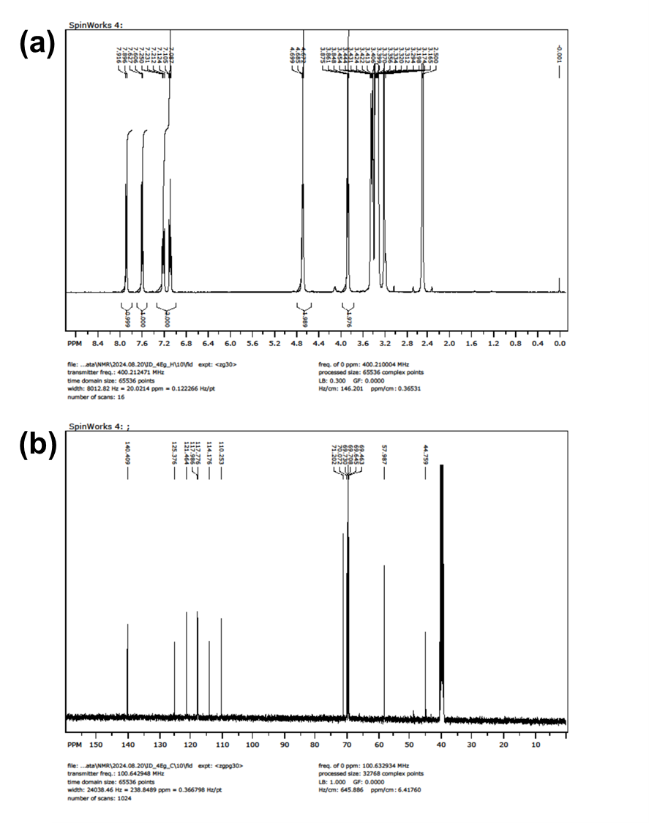
Fig. S1 (a) ¹H- and (b) ¹³C-NMR spectra of Compound 3.
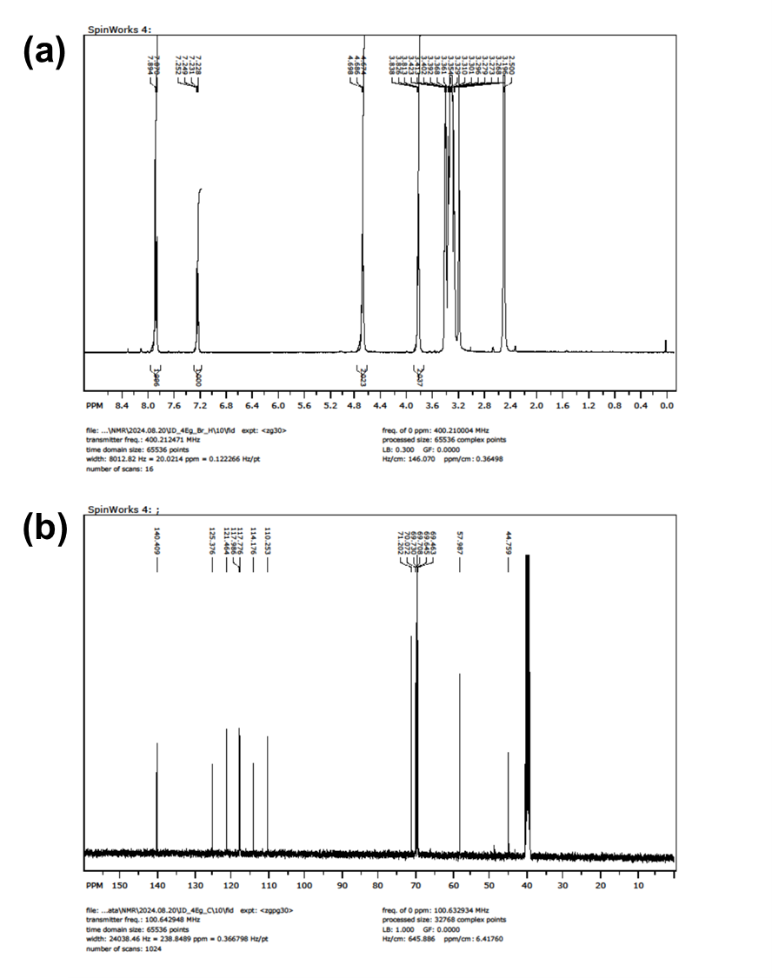
Fig. S2 (a) ¹H- and (b) ¹³C-NMR spectra of compound 4
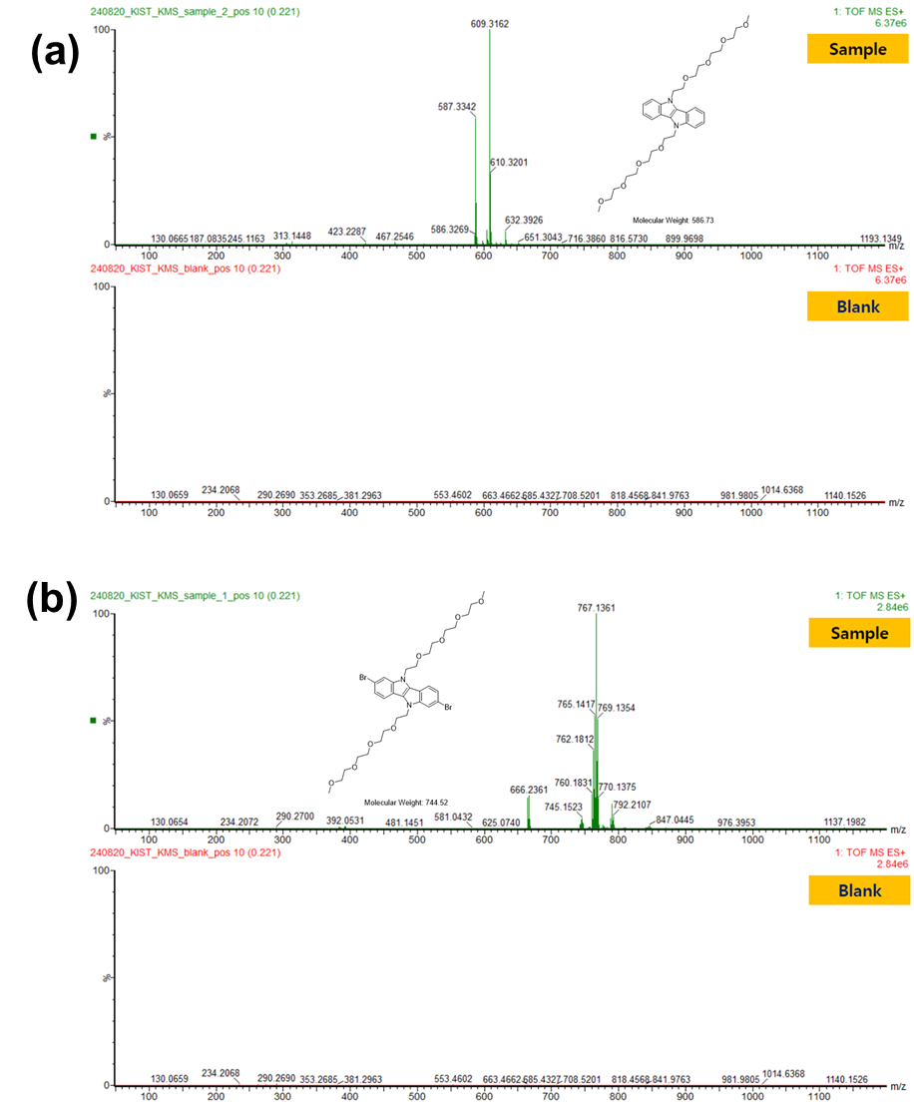
Fig. S3 High resolution LC-MS analysis of (a) Compound 3 and (b) Compound 4.
Fig. S4 UV–Vis absorption spectra of each CP before and after doping. (a) PFO, b) PID-BTO4, (c) P3HT, (d) PID-BT, and (e) PBTTT.

Fig. S5 Electrical conductivity of doped CPs using (a) F4TCNQ and (b) AuCl₃ as dopant. (c) Energy level diagram of the applied CPs (HOMO) and F4TCNQ (LUMO).

Fig. S6 photoelectron spectra of (a) PID-BT and (b) PID-BTO4.
Fig. S7 Comparison of UV–Vis absorption spectra PID-BT (solution and film), PID-BT@SWCNT, and SWCNT/PID-BT containing different amounts of SWCNT.

Fig. S8 EMI SE performances of SWCNT/PID-BT composites for (a) pristine and (b) AuCl₃-doped free-standing films.

Fig. S9 SEM images of the SWCNT/CP composite films containing 50 wt.% SWCNT. (a) SWCNT/PFO, (b) SWCNT/PID-BTO4, (c) SWCNT/P3HT, and (d) SWCNT/PBTTT.

Fig. S10 EMI SE performances of SWCNT/CP composites containing 50 wt.% SWCNT for (a) pristine and (b) F4TCNQ-doped, and (c) AuCl₃-doped free-standing films.

Fig. S11 Comparison of (a) the tensile stress-strain curve of the SWCNT/PID-BT composite containing 50 wt.% SWCNT and (b) mechanical properties before and after doping.

Fig. S12 The change in EMI SE before and after folding-unfolding cycles at a folding radius of 3R for (a) pristine, (b) F4TCNQ-doped, and (c) AuCl₃-doped SWCNT/PID-BT, and at a folding radius of 1R for (d) pristine, (e) F4TCNQ-doped, and (f) AuCl₃-doped SWCNT/PID-BT containing 50 wt.% SWCNT.

Fig. S13 Apparent change of the SWCNT/PID-BT composite film containing 50 wt.% SWCNT after 300,000 folding-unfolding cycles.

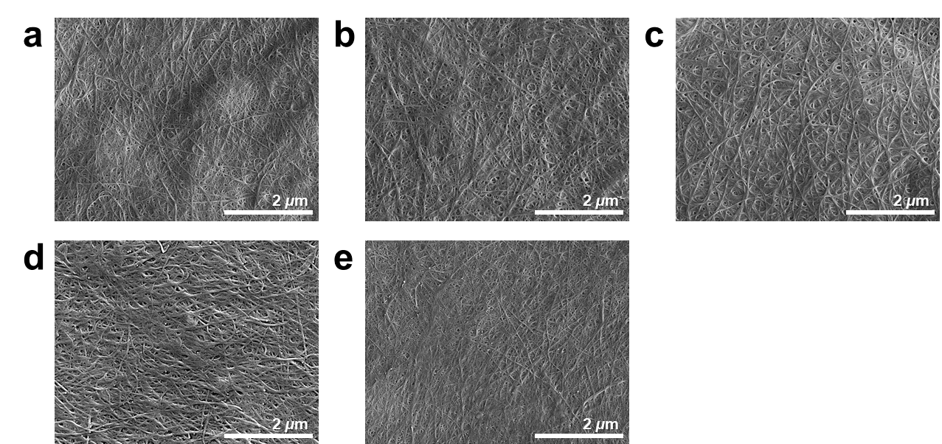
Fig. S12 SEM images of CNT/CP films with (a) PFO, (b) PID-BTO4, (c) P3HT, (d) PID-BT, and (e) PBTTT.

References
1. In YR, Han JM, Kwon JE, Kim B-G, Moon HC (2022) Rational molecular design of electrochromic conjugated polymers: Toward high-performance systems with ultrahigh coloration efficiency. Chem Eng J 433:133808. https://doi.org/10.1016/j.cej.2021.133808
2. Park J, Yoon SE, Kang Y, Lee I, Kim JH, Kim B-G (2019) Doping characteristics of isoindoloindole-based conjugated polymer toward robust transformable organic conductor. Org Electron 75:105435. https://doi.org/10.1016/j.orgel.2019.105435
3. Kondawar SB, Modak PR (2020) Chapter 2 - Theory of EMI shielding. In: Joseph K, Wilson R, George G (eds) Materials for Potential EMI Shielding Applications. Elsevier, p 9-25
4. Jia L-C, Yan D-X, Yang Y, Zhou D, Cui C-H, Bianco E, Lou J, Vajtai R, Li B, Ajayan PM, Li Z-M (2017) High Strain Tolerant EMI Shielding Using Carbon Nanotube Network Stabilized Rubber Composite. Advanced Materials Technologies 2:1700078.
https://doi.org/10.1002/admt.201700078
5. Jia L-C, Xu L, Ren F, Ren P-G, Yan D-X, Li Z-M (2019) Stretchable and durable conductive fabric for ultrahigh performance electromagnetic interference shielding. Carbon 144:101-108. https://doi.org/10.1016/j.carbon.2018.12.034
6. Shi Y-Y, Liao S-Y, Wang Q-F, Xu X-Y, Wang X-Y, Gu X-Y, Hu Y-G, Zhu P-L, Sun R, Wan Y-J (2024) Enhancing the Interaction of Carbon Nanotubes by Metal–Organic Decomposition with Improved Mechanical Strength and Ultra-Broadband EMI Shielding Performance. Nano-Micro Lett 16:134. https://doi.org/10.1007/s40820-024-01344-1
7. Liang C, Ruan K, Zhang Y, Gu J (2020) Multifunctional Flexible Electromagnetic Interference Shielding Silver Nanowires/Cellulose Films with Excellent Thermal Management and Joule Heating Performances. ACS Appl Mater Interfaces 12:18023-18031. https://doi.org/10.1021/acsami.0c04482
8. Guo Z, Ren P, Fu B, Ren F, Jin Y, Sun Z (2020) Multi-layered graphene-Fe3O4/poly (vinylidene fluoride) hybrid composite films for high-efficient electromagnetic shielding. Polymer Testing 89:106652. https://doi.org/10.1016/j.polymertesting.2020.106652
9. Ren W, Zhu H, Yang Y, Chen Y, Duan H, Zhao G, Liu Y (2020) Flexible and robust silver coated non-woven fabric reinforced waterborne polyurethane films for ultra-efficient electromagnetic shielding. Compos B Eng 184:107745.
https://doi.org/10.1016/j.compositesb.2020.107745
10. Lei C, Zhang Y, Liu D, Wu K, Fu Q (2020) Metal-Level Robust, Folding Endurance, and Highly Temperature-Stable MXene-Based Film with Engineered Aramid Nanofiber for Extreme-Condition Electromagnetic Interference Shielding Applications. ACS Appl Mater Interfaces 12:26485-26495. https://doi.org/10.1021/acsami.0c07387
11. Sun K, Wang F, Yang W, Liu H, Pan C, Guo Z, Liu C, Shen C (2021) Flexible Conductive Polyimide Fiber/MXene Composite Film for Electromagnetic Interference Shielding and Joule Heating with Excellent Harsh Environment Tolerance. ACS Appl Mater Interfaces 13:50368-50380. https://doi.org/10.1021/acsami.1c15467
12. Zhao W, Zhao B, Wu Z, Pei K, Qian Y, Luo K, Xu C, Liu M, Wang M, Zhang J, Che R (2023) Dopant Engineering of Flexible MNPs/TPU/PPy Core–Shell Films for Controllable Electromagnetic Interference Shielding. ACS Appl Mater Interfaces 15:28410-28420. https://doi.org/10.1021/acsami.3c02454
13. Li B, Wu N, Yang Y, Pan F, Wang C, Wang G, Xiao L, Liu W, Liu J, Zeng Z (2023) Graphene Oxide-Assisted Multiple Cross-Linking of MXene for Large-Area, High-Strength, Oxidation-Resistant, and Multifunctional Films. Adv Funct Mater 33:2213357.
https://doi.org/10.1002/adfm.202213357
14. Zheng S, Wu N, Liu Y, Wu Q, Yang Y, Li B, Hu C, Liu J, Zeng Z (2023) Multifunctional flexible, crosslinked composites composed of trashed MXene sediment with high electromagnetic interference shielding performance. Advanced Composites and Hybrid Materials 6:161. https://doi.org/10.1007/s42114-023-00741-1

