Title: Oligotrophic bacteria and pathotrophic fungi moderate multitrophic interactions in semi-arid and arid environments.

Supplementary Materials

Table S1 List of dryland field sites including site name, ecosystem type, long-term mean annual precipitation (MAP, in mm year−1), inter-annual rainfall variability (Coefficient of Variation, CV), mean annual temperature (MAT, in ºC), one year rainfall (OYR), three month rainfall (TMR) and aridity index (AI)). Long term mean annual rainfall and temperature based on WorldClim2 (1970–2000).

Site | Ecosystem Type | Dominant Species/Vegetation | Soil Description | CV | pH | MAP | OYR | TMR | MAT | AI
Broken Hill | Arid | Maireana pyramidata | Brown calcareous sand | 0.28 | 5.42 | 238 | 181 | 91 | 18.3 | 2.01
Milparinka | Arid | Astreblea lappeacea, A. pectinata, and Abutilon halophilum | Grey ‘cracking’ clay | 0.52 | 6.07 | 227 | 189 | 67.6 | 20.3 | 1.86
Charleville | Semi-arid | Eremophila gilesii (native invasive woody scrub) | Red sandy, porous | 0.53 | 6 | 349 | 439.6 | 58.8 | 18.8 | 2.93
Quilpie | Semi-arid | Eragrostis setifolia, Sclerolaena species, and Abutilon halophilum | Hard red clay, gravelly | 0.57 | 6.2 | 390 | 343.4 | 27.6 | 21.9 | 3.1
Cobar | Semi-arid | Erodium crinitum, Helipterum species, Medicago species, Ptilotus species, and Austrostipa scabra | Lowland floodplain red soil, clay with gravel | 0.27 | 5.93 | 462 | 401.4 | 32.4 | 20.9 | 3.74
Nyngan | Semi-arid | Calotis lappulacea, Erodium crinitum, Austrostipa scabra, Helipterum species, and Medicago species | Upland floodplain red soil, clay with gravel | 0.31 | 5.99 | 441 | 493.6 | 72.2 | 18.6 | 3.71

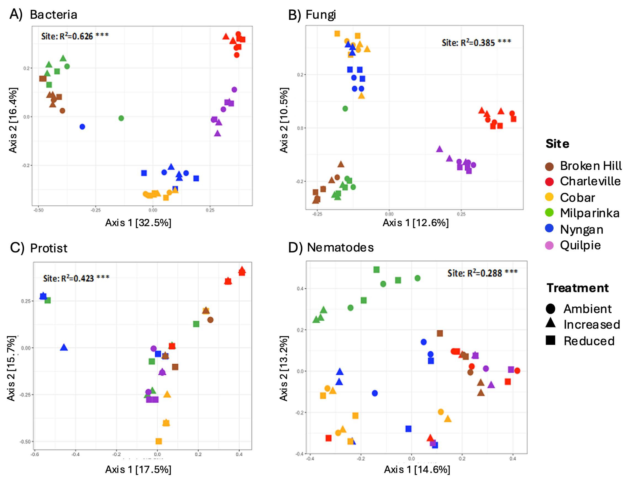

Fig. S1 Plots showing Principal Coordinates Analyses (PCoA) based on Bray–Curtis distance matrices for (A) Bacterial, (B) Fungal, (C) Protist, and (D) Nematode community structure across Sites and Rainfall treatments. Statistics for significant PERMANOVA results testing the effect of Site, Rainfall and their interactions on composition inserted. *Significance codes: *** = <0.001; ** = <0.01; * = 0.05.

Table S2 Comparison of multitrophic cooccurrence network properties derived from RMT-Pearson correlation and SparCC of combined ASV dataset (n = 54 samples) that included bacteria and eukaryotes (fungi, protists, and nematodes).

Network metrics | RMT-Pearson Correlation | SparCC
Number of Nodes | 98 | 75
Number of edges | 288 | 197
Positive (%) | 60 | 65.5
Negative (%) | 40 | 34.5
Average number of neighbors | 5.878 | 5.253
Network diameter | 7 | 7
Network radius | 1 | 1
Network density | 0.03 | 0.035
Clustering coefficient | 0.133 | 0.201
Trophic group distribution (%)
Bacteria | 67.06 | 67.09
Fungi | 28.24 | 25.32
Protist/Nematodes | 4.71 | 7.59

Table S3 presents the LEfSe results showing differential relative abundance across three climatic conditions (Arid, Semi-arid High CV and Semi-arid Low CV, with only significant results (P < 0.001) included.

Group | taxa | Trophic Group | FDR | LDAscore
Fungi | g__Penidiellopsis | Saprotroph | 5.12E-09 | 1.53
Bacteria | f__Pseudonocardiaceae | Oligotroph | 2.78E-08 | 1.85
Bacteria | f__Solibacteraceae | Oligotroph | 2.78E-08 | 2.24
Bacteria | p__Chloroflexi | Oligotroph | 2.78E-08 | 2.13
Bacteria | p__Gemmatimonadetes | Oligotroph | 2.85E-08 | 1.34
Fungi | s__Coniochaeta_ligniaria | Saprotroph | 6.11E-08 | 1.78
Bacteria | p__AD3 | Oligotroph | 6.11E-08 | 1.23
Bacteria | f__Thermogemmatisporaceae | Oligotroph | 6.17E-08 | 2.31
Fungi | s__Ruhlandiella_berolinensis | Saprotroph | 6.17E-08 | 2.3
Fungi | s__Preussia_flanaganii | Saprotroph | 1.75E-07 | 2.08
Bacteria | p__WPS_2 | Oligotroph | 2.56E-07 | 1.18
Fungi | s__Cystofilobasidium_macerans | Saprotroph | 2.83E-07 | 1.32
Bacteria | g__Rubellimicrobiums | Oligotroph | 4.06E-07 | 1.13
Fungi | s__Podospora_intestinacea | Saprotroph | 4.09E-07 | 1.59
Fungi | s__Spirosphaera_cupreorufescens | Saprotroph | 4.09E-07 | 1.01
Fungi | s__Preussia_polymorpha | Saprotroph | 4.09E-07 | 1.89
Bacteria | g__Balneimonass | Copiotroph | 4.49E-07 | 1.76
Fungi | f__Teratosphaeriaceae | Saprotroph | 4.95E-07 | 1.84
Bacteria | f__Conexibacteraceae | Oligotroph | 5.10E-07 | 1.82
Fungi | s__Westerdykella_nigra | Saprotroph | 5.43E-07 | 2.15
Bacteria | c__ABS_6 | Oligotroph | 6.21E-07 | 1.15
Fungi | f__Pleosporaceae | Saprotroph | 7.38E-07 | 2.68
Bacteria | g__Methylobacterium | Oligotroph | 7.38E-07 | 1.32
Fungi | o__Chaetothyriale | Saprotroph | 7.42E-07 | 2.23
Fungi | s__Rhizophlyctis_rosea | Pathotroph | 7.42E-07 | 1.99
Bacteria | f__FFCH4570 | Unknown | 7.47E-07 | 1.36
Fungi | f__Trichomeriaceae | Saprotroph | 7.47E-07 | 1.61

Table S4 Pearson correlation coefficients (r) between network modules and soil variables (with the p-value in parentheses). Bold indicates significant correlations (p<0.05).

Network | Module | pH | Total.N | Total.C | CN.ratio | Total.P | CP.ratio | NP.ratio | Sand | Silt | Clay | VR | SB
Semi-arid Low CV | 1 | -0.15  (0.6) | 0.18  (0.5) | 0.22  (0.4) | 0 .074  (0.8) | 0.048  (0.8) | 0.18  (0.5) | 0.15  (0.5) | 0.067  (0.8) | 0.089  (0.7) | -0.16  (0.5) | 0.22  (0.4) | 0.45  (0.06)
Semi-arid Low CV | 2 | -0.025  (0.9) | 0.18  (0.5) | 0.14  (0.6) | 0.0023  (1) | -0.055  (0.8) | 0.14  (0.6) | 0.19  (0.5) | 0.012  (1) | 0.1  (0.7) | -0.086  (0.7) | 0.17  (0.5) | 0.49  (0.04)
Semi-arid Low CV | 3 | 0.15  (0.6) | 0.14  (0.6) | -0.0011  (1) | -0.15  (0.6) | 0.6  (0.008) | -0.13  (0.6) | 0.017  (0.9) | -0.34  (0.2) | 0.43  (0.08) | 0.22  (0.4) | 0.36  (0.1) | 0.14  (0.6)
Semi-arid Low CV | 4 | 0.42  (0.08) | 0.062  (0.8) | -0.2  (0.4) | -0.27  (0.3) | 0.33  (0.2) | -0.27  (0.3) | 0.0064  (1) | -0.39  (0.1) | 0.31  (0.2) | 0.39  (0.1) | 0.38  (0.1) | 0.024  (0.9)
Semi-arid Low CV | 5 | 0.13  (0.6) | 0.17  (0.5) | -0.014  (1) | -0.2  (0.4) | 0.21  (0.4) | -0.064  (0.8) | 0.13  (0.6) | -0.28  (0.3) | 0.3  (0.2) | 0.22  (0.4) | 0.28  (0.3) | 0.22  (0.4)
Semi-arid Low CV | 6 | 0.044  (0.9) | -0.23  (0.4) | 0.071  (0.8) | 0.34  (0.2) | -0.41  (0.09) | 0.17  (0.5) | -0.11  (0.7) | 0.17  (0.5) | -0.16  (0.5) | -0.15  (0.6) | -0.093  (0.7) | 0.31  (0.2)
Semi-arid Low CV | 7 | -0.36  (0.1) | -0.17  (0.5) | 0.18  (0.5) | 0.37  (0.1) | -0.53  (0.02) | 0.28  (0.3) | -0.057  (0.8) | 0.44  (0.07) | -0.45  (0.06) | -0.36  (0.1) | -0.31  (0.2) | -0.12  (0.6)
Semi-arid High CV | 1 | -0.21  (0.4) | -0.073  (0.8) | -0.051  (0.8) | -0.095  (0.7) | -0.44  (0.07) | -0.0015  (1) | -0.017  (0.9) | 0.16  (0.5) | 0.036  (0.9) | -0.44  (0.07) | 0.43  (0.07) | 0.21  (0.4)
Semi-arid High CV | 2 | -0.23  (0.3) | -0.22  (0.4) | -0.22  (0.4) | -0.27  (0.3) | -0.4  (0.1) | -0.18  (0.5) | -0.17  (0.5) | 0.095  (0.7) | 0.22  (0.4) | -0.47  (0.05) | 0.6  (0.009) | -0.06  (0.8)
Semi-arid High CV | 3 | -0.2  (0.4) | 0.22  (0.4) | 0.19  (0.4) | 0.14  (0.6) | -0.1  (0.7) | 0.22  (0.4) | 0.24  (0.3) | 0.01  (1) | -0.14  (0.6) | -0.041  (0.9) | -0.093  (0.7) | -0.047  (0.9)
Semi-arid High CV | 4 | 0.017  (0.9) | 0.09  (0.7) | 0.046  (0.9) | -0.035  (0.9) | -0.28  (0.3) | 0.057  (0.8) | 0.09  (0.7) | 0.096  (0.7) | 0.0025  (1) | -0.19  (0.4) | -0.36  (0.1) | -0.064  (0.8)
Semi-arid High CV | 5 | 0.17  (0.5) | -0.03  (0.9) | -0.075  (0.8) | -0.06  (0.8) | 0.29  (0.3) | -0.12  (0.6) | -0.074  (0.8) | -0.15  (0.6) | 0.036  (0.9) | 0.33  (0.2) | -0.26  (0.3) | -0.22  (0.4)
Semi-arid High CV | 6 | -0.2  (0.4) | -0.038  (0.9) | -0.094  (0.7) | -0.085  (0.7) | 0.44  (0.07) | -0.15  (0.6) | -0.1  (0.7) | -0.38  (0.1) | 0.28  (0.3) | 0.36  (0.1) | 0.1  (0.7) | -0.6  (0.009)
Arid | 1 | -0.16  (0.5) | -0.28  (0.3) | -0.24  (0.3) | 0.011  (1) | 0.003  (1) | -0.25  (0.3) | -0.25  (0.3) | 0.21  (0.4) | -0.082  (0.7) | -0.21  (0.4) | -0.54  (0.02) | -0.39  (0.1)
Arid | 2 | 0.14  (0.6) | 0.0052  (1) | -0.07  (0.8) | -0.1  (0.7) | -0.03  (0.9) | -0.072  (0.8) | 0.0061  (1) | 0.13  (0.6) | 0.2  (0.4) | -0.23  (0.3) | -0.35  (0.2) | -0.17  (0.5)
Arid | 3 | -0.59  (0.009) | -0.082  (0.7) | 0.11  (0.7) | 0.46  (0.06) | -0.061  (0.8) | 0.074  (0.8) | -0.064  (0.8) | -0.02  (0.9) | -0.21  (0.4) | 0.11  (0.7) | -0.41  (0.09) | -0.69  (0.002)
Arid | 4 | -0.25  (0.3) | -0.047  (0.9) | 0.015  (1) | 0.085  (0.7) | -0.12  (0.6) | 0.0044  (1) | -0.04  (0.9) | -0.16  (0.5) | 0.026  (0.9) | 0.18  (0.5) | 0.06  (0.8) | -0.32  (0.2)

