Supplementary file:

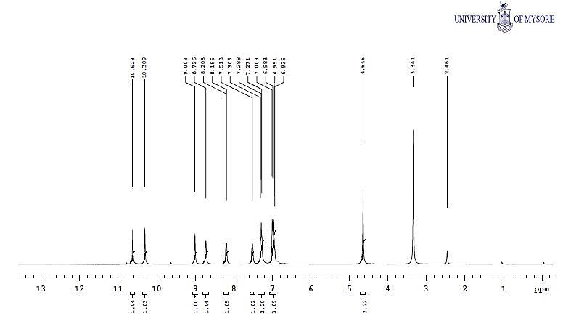
Supplementary Figure1: HNMR spectra of compound (9a).

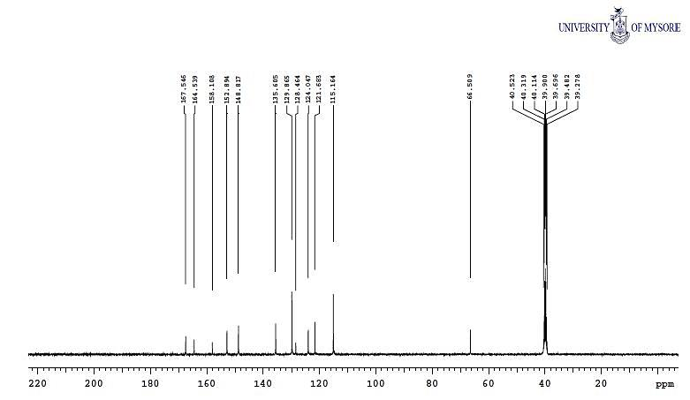
Supplementary Figure 2: 13CNMR spectra of compound (9a).

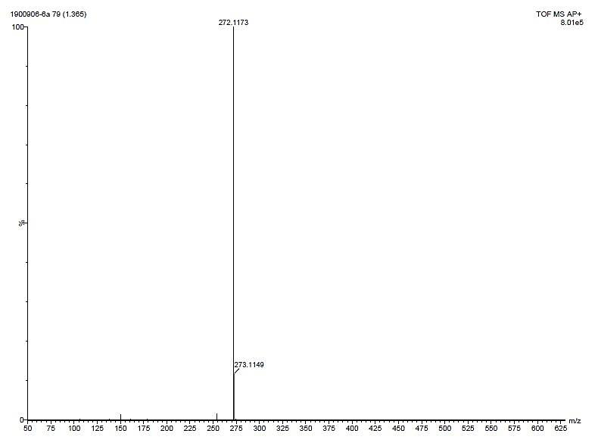
Supplementary Figure 3: Mass spectra of compound (9a).
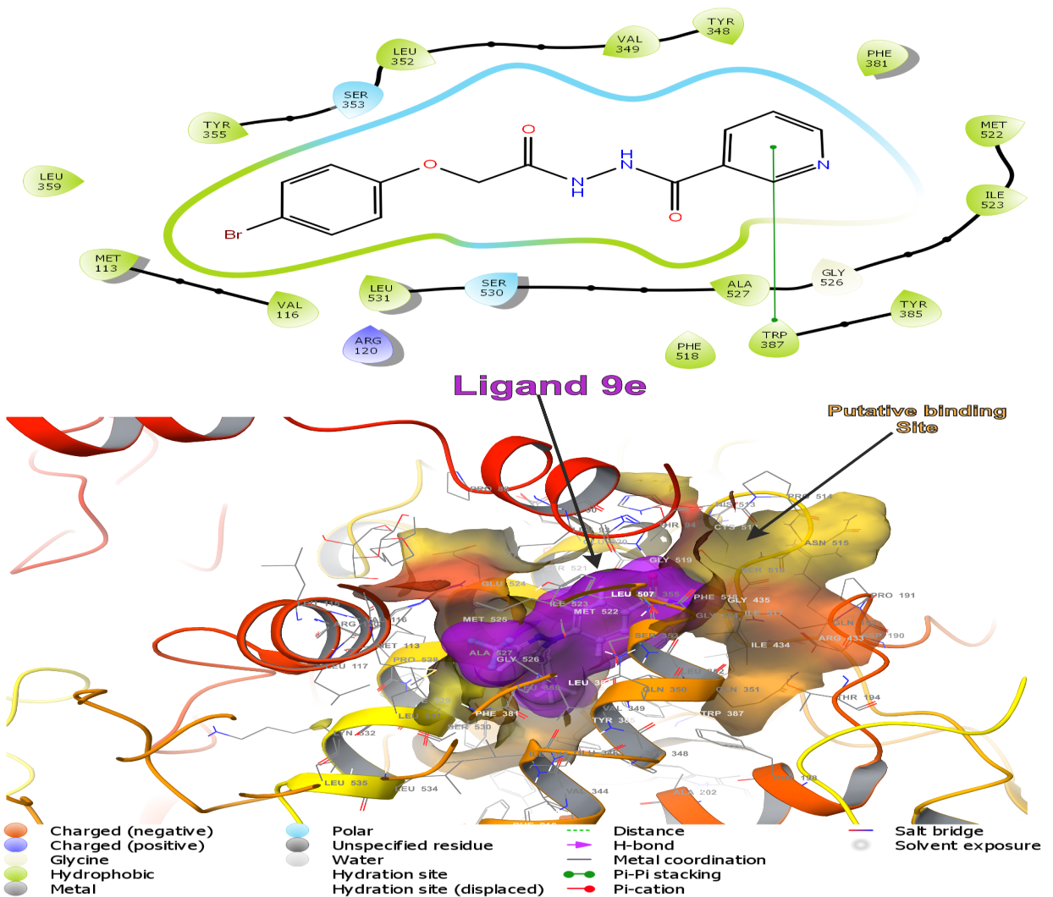

Supplementary Figure 4: The lowest energy conformation of docking result of ligand (9e) with COX-1 (3KK6). The three dimensional putative binding cavity of COX-1 is represented in olive yellow mixed with light orange and the ligand in dark pink.
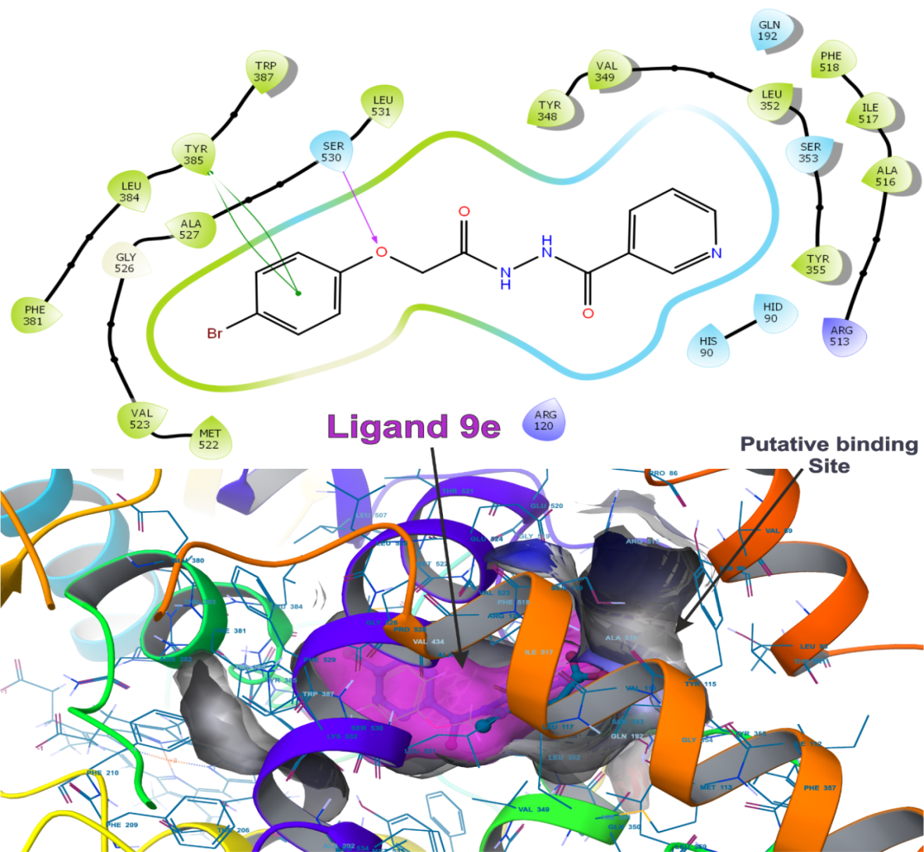
Supplementary Figure 5: The lowest energy conformation of docking result of ligand (9e) with COX-2 (4COX). The three dimensional putative binding cavity of COX-2 is represented in solid grey and the ligand in dark pink.

