Supplement
S1 Table. Household fixed-effect regression model of malaria status. Number of households is 11 886, prevalence of malaria is 44% and prevalence of anemia is 83.2%.
 | Effect of malaria on hemoglobin
Covariate | N | Mean Hb  [SD] [g/L] | Hb Change  [95% CI] [g/L] | P-Value
Baseline total | 17 599 | 93 [17] | Reference
Acute effect | 7740 | 89 [17] | -4 [-6; -3] | < 0.001 ***
Prolonged effect | 2905 | 90 [17] | -5 [-7; -4] | 0.002 **
Significance codes: < 0.001 ‘***’; < 0.01 ‘**’; < 0.05 ‘*’

S2 Table. Household fixed-effect regression model of malaria status adjusted for age. Number of households is 11 886, prevalence of malaria is 44% and prevalence of anemia is 83.2%.
 | Effect of malaria on hemoglobin
Covariate | N | Mean Hb  [SD] [g/L] | Hb Change  [95% CI] [g/L] | P-Value
Baseline total | 17 599 | 93 [17] | Reference
Acute effect | 7740 | 89 [17] | -8 [-9; -7] | < 0.001 ***
Prolonged effect | 2905 | 90 [17] | -7 [-8; -6] | < 0.001 ***
Age
6 - 12 | 1918 | 88 [16] | Reference
13 - 24 | 3750 | 87 [17] | -2 [-3; -1] | 0.003 **
25 – 36 | 3942 | 91 [17] | 3 [2; 4] | < 0.001 ***
37 – 48 | 4091 | 96 [16] | 8 [7; 9] | < 0.001 ***
49 – 59 | 3898 | 110 [15] | 13 [12; 14] | < 0.001 ***
Significance codes: < 0.001 ‘***’; < 0.01 ‘**’; < 0.05 ‘*’

S3 Table. Household fixed-effect regression model of malaria status adjusted for sex. Number of households is 11 886, prevalence of malaria is 44% and prevalence of anemia is 83.2%.
 | Effect of malaria on hemoglobin
Covariate | N | Mean Hb  [SD] [g/L] | Hb Change  [95% CI] [g/L] | P-Value
Baseline total | 17 599 | 93 [17] | Reference
Acute effect | 7740 | 89 [17] | -4 [-6; -3] | < 0.001 ***
Prolonged effect | 2905 | 90 [17] | -5 [-7; -4] | < 0.001 ***
Sex
Male | 8962 | 92 [17] | Reference
Female | 8637 | 94 [17] | 2 [1; 3] | < 0.001 ***
Significance codes: < 0.001 ‘***’; < 0.01 ‘**’; < 0.05 ‘*’

S4 Table. Main household fixed-effect regression model of malaria status adjusted for sex and age. Number of households is 11 886, prevalence of malaria is 44% and prevalence of anemia is 83.2%.
 | Effect of malaria on hemoglobin
Covariate | N | Mean Hb  [SD] [g/L] | Hb Change  [95% CI] [g/L] | P-Value
Baseline total | 17 599 | 93 [17] | Reference
Acute effect | 7740 | 89 [17] | -8 [-9; -7] | < 0.001 ***
Prolonged effect | 2905 | 90 [17] | -7 [-8; -6] | < 0.001 ***
Sex
Male | 8962 | 92 [17] | Reference
Female | 8637 | 94 [17] | 2 [1; 3] | < 0.001 ***
Age
6 - 12 | 1918 | 88 [16] | Reference
13 - 24 | 3750 | 87 [17] | -2 [-3; -1] | 0.002 **
25 – 36 | 3942 | 91 [17] | 3 [2; 4] | < 0.001 ***
37 – 48 | 4091 | 96 [16] | 8 [7; 9] | < 0.001 ***
49 – 59 | 3898 | 110 [15] | 13 [12; 14] | < 0.001 ***
Significance codes: < 0.001 ‘***’; < 0.01 ‘**’; < 0.05 ‘*’

S5 Table. Household fixed-effect regression model of malaria status adjusted for age and controlling for interaction between age and malaria status. Number of households is 11 886, prevalence of malaria is 44% and prevalence of anemia is 83.2%.
 | Effect of malaria on hemoglobin
Covariate | N | Mean Hb  [SD] [g/L] | Hb Change  [95% CI] [g/L] | P-Value
Baseline total | 17 599 | 93 [17] | Reference
Acute effect | 7740 | 89 [17] | -6 [-9; -4] | < 0.001 ***
Prolonged effect | 2905 | 90 [17] | -6 [-9; -3] | < 0.001 ***
Age
6 - 12 | 1918 | 88 [16] | Reference
13 - 24 | 3750 | 87 [17] | 0 [-2; 2] | 0.725
25 – 36 | 3942 | 91 [17] | 5 [3; 7] | < 0.001 ***
37 – 48 | 4091 | 96 [16] | 9 [7; 11] | < 0.001 ***
49 – 59 | 3898 | 110 [15] | 12 [10; 14] | < 0.001 ***
Age * Malaria acute
6 – 12 |  |  | Reference
13 – 24 |  |  | -5 [-7; -2] | 0.001 **
25 – 36 |  |  | -3 [-6; 0] | 0.031 *
37 – 48 |  |  | 0 [-3; 2] | 0.734
49 – 59 |  |  | 2 [-1; 4] | 0.177
Age * Malaria prolonged
6 – 12 |  |  | Reference
13 – 24 |  |  | -2 [-6; 1] | 0.218
25 – 36 |  |  | -2 [-6; 1] | 0.205
37 – 48 |  |  | -2 [-5; 2] | 0.279
49 – 59 |  |  | 1 [-3; 4] | 0.832
Significance codes: < 0.001 ‘***’; < 0.01 ‘**’; < 0.05 ‘*’

S6 Table. Household fixed-effect regression model of malaria status adjusted for sex and controlling for interaction between sex and malaria status. Number of households is 11 886, prevalence of malaria is 44% and prevalence of anemia is 83.2%.
 | Effect of malaria on hemoglobin
Covariate | N | Mean Hb  [SD] [g/L] | Hb Change  [95% CI] [g/L] | P-Value
Baseline total | 17 599 | 93 [17] | Reference
Acute effect | 7740 | 89 [17] | -4 [-5; -2] | < 0.001 ***
Prolonged effect | 2905 | 90 [17] | -4 [-6; -3] | < 0.001 ***
Sex
Male | 8962 | 92 [17] | Reference
Female | 8637 | 94 [17] | 3 [2; 4] | < 0.001 ***
Sex * Malaria acute
Male |  |  | Reference
Female |  |  | -1 [-3; 1] | 0.185
Sex * Malaria prolonged
Male |  |  | Reference
Female |  |  | -2 [-4; 0] | 0.095
Significance codes: < 0.001 ‘***’; < 0.01 ‘**’; < 0.05 ‘*’

S7 Table. Household fixed-effect regression model of malaria status adjusted for age, sex, controlling for interaction between age and malaria status and sex and malaria status. Number of households is 11 886, prevalence of malaria is 44% and prevalence of anemia is 83.2%.
 | Effect of malaria on hemoglobin
Covariate | N | Mean Hb  [SD] [g/L] | Hb Change  [95% CI] [g/L] | P-Value
Baseline total | 17 599 | 93 [17] | Reference
Acute effect | 7740 | 89 [17] | -6 [-8; -4] | < 0.001 ***
Prolonged effect | 2905 | 90 [17] | -5 [-8; -2] | 0.002 **
Sex
Male | 8962 | 92 [17] | Reference
Female | 8637 | 94 [17] | 3 [2; 4] | < 0.001 ***
Age
6 - 12 | 1918 | 88 [16] | Reference
13 - 24 | 3750 | 87 [17] | 0 [-2; 2] | 0.908
25 – 36 | 3942 | 91 [17] | 4 [2; 6] | < 0.001 ***
37 – 48 | 4091 | 96 [16] | 8 [7; 10] | < 0.001 ***
49 – 59 | 3898 | 110 [15] | 12 [10; 14] | < 0.001 ***
Age * Malaria acute
6 – 12 |  |  | Reference
13 – 24 |  |  | -4 [-7; 2] | 0.002 **
25 – 36 |  |  | -2 [-6; 0] | 0.056
37 – 48 |  |  | 0 [-3; 3] | 0.946
49 – 59 |  |  | 2 [-1; 5] | 0.136
Age * Malaria prolonged
6 – 12 |  |  | Reference
13 – 24 |  |  | -2 [-5; 2] | 0.284
25 – 36 |  |  | -2 [-6; 1] | 0.249
37 – 48 |  |  | -2 [-5; 2] | 0.343
49 – 59 |  |  | 1 [-3; 4] | 0.716
Sex * Malaria acute
Male |  |  | Reference
Female |  |  | -1 [-3; 0] | 0.141
Sex * Malaria prolonged
Male |  |  | Reference
Female |  |  | -2 [-5; 0] | 0.021 *
Significance codes: < 0.001 ‘***’; < 0.01 ‘**’; < 0.05 ‘*’

S8 Table. Household fixed-effect regression model of malaria status adjusted for age, sex, controlling for interaction between age and sex. Number of households is 11 886, prevalence of malaria is 44% and prevalence of anemia is 83.2%.
 | Effect of malaria on hemoglobin
Covariate | N | Mean Hb  [SD] [g/L] | Hb Change  [95% CI] [g/L] | P-Value
Baseline total | 17 599 | 93 [17] | Reference
Acute effect | 7740 | 89 [17] | -8 [-9; -7] | < 0.001 ***
Prolonged effect | 2905 | 90 [17] | -7 [-8; -6] | < 0.001 ***
Sex
Male | 8962 | 92 [17] | Reference
Female | 8637 | 94 [17] | 3 [1; 5] | 0.002
Age
6 - 12 | 1918 | 88 [16] | Reference
13 - 24 | 3750 | 87 [17] | -1 [-3; 1] | 0.263
25 – 36 | 3942 | 91 [17] | 3 [2; 5] | < 0.001 ***
37 – 48 | 4091 | 96 [16] | 9 [7; 10] | < 0.001 ***
49 – 59 | 3898 | 110 [15] | 14 [12; 15] | < 0.001 ***
Age * Female
6 – 12 |  |  | Reference
13 – 24 |  |  | -2 [-2; 0] | 0.096
25 – 36 |  |  | -1 [-1; 2] | 0.458
37 – 48 |  |  | -1 [-1; 1] | 0.412
49 – 59 |  |  | -1 [-1; 2] | 0.556
Significance codes: < 0.001 ‘***’; < 0.01 ‘**’; < 0.05 ‘*’

S9 Table. Random-effect regression model of malaria. Number of households is 11 886, prevalence of malaria is 44% and prevalence of anemia is 83.2%.
 | Effect of malaria on hemoglobin
Covariate | N | Mean Hb  [SD] [g/L] | Hb Change  [95% CI] [g/L] | P-Value
Baseline total [Intercept] | 17 599 | 93 [17] | 99 [99; 100] | < 0.001 ***
Acute effect | 7740 | 89 [17] | -10 [-11; -10] | < 0.001 ***
Prolonged effect | 2905 | 90 [17] | -9 [-10; -8] | < 0.001 ***
Significance codes: < 0.001 ‘***’; < 0.01 ‘**’; < 0.05 ‘*’

S10 Table. Random-effect regression model of malaria adjusted for age. Number of households is 11 886, prevalence of malaria is 44% and prevalence of anemia is 83.2%.
 | Effect of malaria on hemoglobin
Covariate | N | Mean Hb  [SD] [g/L] | Hb Change  [95% CI] [g/L] | P-Value
Baseline total [Intercept] | 17 599 | 93 [17] | 94 [93; 95] | < 0.001 ***
Acute effect | 7740 | 89 [17] | -11 [-12; -11] | < 0.001 ***
Prolonged effect | 2905 | 90 [17] | -9 [-10; -9] | < 0.001 ***
Age [months]
6 – 12 | 1918 | 88 [16] | Reference
13 – 24 | 3750 | 87 [17] | -1 [-2; 0] | 0.069
25 – 36 | 3942 | 91 [17] | 4 [3; 5] | < 0.001 ***
37 – 48 | 4091 | 96 [16] | 9 [8; 1] | < 0.001 ***
49 – 59 | 3898 | 110 [15] | 14 [13; 15] | < 0.001 ***
Significance codes: < 0.001 ‘***’; < 0.01 ‘**’; < 0.05 ‘*’

S11 Table. Random-effect regression model of malaria adjusted for sex. Number of households is 11 886, prevalence of malaria is 44% and prevalence of anemia is 83.2%.
 | Effect of malaria on hemoglobin
Covariate | N | Mean Hb  [SD] [g/L] | Hb Change  [95% CI] [g/L] | P-Value
Baseline total [Intercept] | 17 599 | 93 [17] | 98 [98; 99]
Acute effect | 7740 | 89 [17] | -10 [-11; -10] | < 0.001 ***
Prolonged effect | 2905 | 90 [17] | -9 [-10; -8] | < 0.001 ***
Sex
Male | 8962 | 92 [17] | Reference
Female | 8637 | 94 [17] | 2 [1; 2] | < 0.001 ***
Significance codes: < 0.001 ‘***’; < 0.01 ‘**’; < 0.05 ‘*’

S12 Table. Random-effect regression model of malaria adjusted for age and sex Number of households is 11 886, prevalence of malaria is 44% and prevalence of anemia is 83.2%.
 | Effect of malaria on hemoglobin
Covariate | N | Mean Hb  [SD] [g/L] | Hb Change  [95% CI] [g/L] | P-Value
Baseline total [Intercept] | 17 599 | 93 [17] | 93 [92; 94] | < 0.001
Acute effect | 7740 | 89 [17] | -11 [-12; -11] | < 0.001 ***
Prolonged effect | 2905 | 90 [17] | -10 [-10; -9] | < 0.001 ***
Age [months]
6 – 12 | 1918 | 88 [16] | Reference
13 – 24 | 3750 | 87 [17] | -1 [-2; 0] | 0.072
25 – 36 | 3942 | 91 [17] | 4 [3; 5] | < 0.001 ***
37 – 48 | 4091 | 96 [16] | 9 [8; 10] | < 0.001 ***
49 – 59 | 3898 | 110 [15] | 14 [13; 15] | < 0.001 ***
Sex
Male | 8962 | 92 [17] | Reference
Female | 8637 | 94 [17] | 2 [1; 2] | < 0.001 ***
Model summary
Significance codes: < 0.001 ‘***’; < 0.01 ‘**’; < 0.05 ‘*’

S13 Table. Random-effect regression model of malaria adjusted for age and controlling for interaction between age and malaria status. Number of households is 11 886, prevalence of malaria is 44% and prevalence of anemia is 83.2%.
 | Effect of malaria on hemoglobin
Covariate | N | Mean Hb  [SD] [g/L] | Hb Change  [95% CI] [g/L] | P-Value
Baseline total [Intercept] | 17 599 | 93 [17] | 93 [92; 94] | < 0.001 ***
Acute effect | 7740 | 89 [17] | -10 [-12; -9] | < 0.001 ***
Prolonged effect | 2905 | 90 [17] | -9 [-11; -7] | < 0.001 ***
Age [months]
6 – 12 | 1918 | 88 [16] | Reference
13 – 24 | 3750 | 87 [17] | 0 [-1; 1] | 0.984
25 – 36 | 3942 | 91 [17] | 5 [4; 6] | < 0.001 ***
37 – 48 | 4091 | 96 [16] | 10 [8; 11] | < 0.001 ***
49 – 59 | 3898 | 110 [15] | 13 [11; 14] | < 0.001 ***
Age * Malaria acute
6 – 12 |  |  | Reference
13 – 24 |  |  | -2 [-4; 0] | 0.024 *
25 – 36 |  |  | -2 [-4; 0] | 0.014 *
37 – 48 |  |  | -1 [-3; 1] | 0.348
49 – 59 |  |  | 2 [0; 4] | 0.044 *
Age * Malaria prolonged
6 – 12 |  |  | Reference
13 – 24 |  |  | 0 [-2; 3] | 0.926
25 – 36 |  |  | -2 [-4; 1] | 0.17
37 – 48 |  |  | -1 [-3; 1] | 0.44
49 – 59 |  |  | 1 [-1; 4] | 0.296
Significance codes: < 0.001 ‘***’; < 0.01 ‘**’; < 0.05 ‘*’

S14 Table. Random-effect regression model of malaria adjusted for sex and controlling for interaction between sex and malaria status. Number of households is 11 886, prevalence of malaria is 44% and prevalence of anemia is 83.2%.
 | Effect of malaria on hemoglobin
Covariate | N | Mean Hb  [SD] [g/L] | Hb Change  [95% CI] [g/L] | P-Value
Baseline total [Intercept] | 17 599 | 93 [17] | 98 [98; 99] | < 0.001 ***
Acute effect | 7740 | 89 [17] | -10 [-11; -9] | < 0.001 ***
Prolonged effect | 2905 | 90 [17] | -9 [-10; -8] | < 0.001 ***
Sex
Male | 8962 | 92 [17] | Reference
Female | 8637 | 94 [17] | 2 [1; 3] | < 0.001 ***
Sex * Malaria acute
Male |  |  | Reference
Female |  |  | 0 [-1; 1] | 0.653
Sex * Malaria prolonged
Male |  |  | Reference
Female |  |  | -1 [-2; 0] | 0.184
Significance codes: < 0.001 ‘***’; < 0.01 ‘**’; < 0.05 ‘*’

S15 Table. Random-effect regression model of malaria adjusted for age and sex, controlling for interaction between age and malaria status and sex and malaria status. Number of households is 11 886, prevalence of malaria is 44% and prevalence of anemia is 83.2%.
 | Effect of malaria on hemoglobin
Covariate | N | Mean Hb  [SD] [g/L] | Hb Change  [95% CI] [g/L] | P-Value
Baseline total [Intercept] | 17 599 | 93 [17] | 93 [92; 94] | < 0.001 ***
Acute effect | 7740 | 89 [17] | -10 [-12; -9] | < 0.001 ***
Prolonged effect | 2905 | 90 [17] | -9 [-11; -7] | < 0.001 ***
Sex
Male | 8962 | 92 [17] | Reference
Female | 8637 | 94 [17] | 2 [1; 3] | < 0.001 ***
Age
6 - 12 | 1918 | 88 [16] | Reference
13 - 24 | 3750 | 87 [17] | 0 [-1; 1] | 0.978
25 – 36 | 3942 | 91 [17] | 5 [4; 6] | < 0.001 ***
37 – 48 | 4091 | 96 [16] | 10 [8; 11] | < 0.001 ***
49 – 59 | 3898 | 110 [15] | 13 [11; 14] | < 0.001 ***
Age * Malaria acute
6 – 12 |  |  | Reference
13 – 24 |  |  | -2 [-4; 0] | 0.025 *
25 – 36 |  |  | -2 [-4; 0] | 0.016 *
37 – 48 |  |  | -1 [-3; 1] | 0.408
49 – 59 |  |  | 2 [0; 4] | 0.045 *
Age * Malaria prolonged
6 – 12 |  |  | Reference
13 – 24 |  |  | 0 [-2; 3] | 0.88
25 – 36 |  |  | -2 [-4; 1] | 0.18
37 – 48 |  |  | -1 [-3; 2] | 0.491
49 – 59 |  |  | 1 [-1; 4] | 0.28
Sex * Malaria acute
Male |  |  | Reference
Female |  |  | 0 [-1; 1] | 0.482
Sex * Malaria prolonged
Male |  |  | Reference
Female |  |  | -1 [-2; 0] | 0.143
Significance codes: < 0.001 ‘***’; < 0.01 ‘**’; < 0.05 ‘*’

S16 Table. Subset analysis of females. Household fixed-effect regression of malaria status stratified by age. Number of households is 7048, prevalence of malaria is 44.7% and prevalence of anemia is 81.8%.
 | Effect of malaria on hemoglobin
Covariate | N | Mean Hb  [SD] [g/L] | Hb Change  [95% CI] [g/L] | P-Value
Baseline total [Intercept] | 8637 | 94 [17] | Reference
Acute effect | 3864 | 90 [17] | -6 [-8; -3] | < 0.001 ***
Prolonged effect | 1377 | 91 [17] | -6 [-9; -4] | < 0.001 ***
Significance codes: < 0.001 ‘***’; < 0.01 ‘**’; < 0.05 ‘*’

S17 Table. Subset analysis of females. Household fixed-effect regression of malaria status adjusted for age. For thick smear microscopy: number of households is 7052, prevalence of malaria is 44.7% and prevalence of anemia is 81.8%. For rapid diagnostic test: number of households is 7048, prevalence of malaria is 54.6%, prevalence of anemia is 81.8%. We excluded an additional 9 children from rapid diagnostic test analysis because no outcome data was available.
 | Effect of malaria on hemoglobin
Covariate | N | Mean Hb  [SD] [g/L] | Hb Change  [95% CI] [g/L] | P-Value
Baseline total [Intercept] | 8637 | 94 [17] | Reference
Acute effect | 3864 | 90 [17] | -9 [-11; -7] | < 0.001 ***
Prolonged effect | 1377 | 91 [17] | -9 [-12; -7] | < 0.001 ***
Age [months]
6 – 12 | 934 | 89 [16] | Reference
13 – 24 | 1805 | 88 [17] | -3 [-6; 1] | 0.01 *
25 – 36 | 1910 | 92 [17] | 2 [0; 5] | 0.09
37 – 48 | 2071 | 9.7 [16] | 8 [6; 1] | < 0.001 ***
49 – 59 | 1917 | 110 [15] | 12 [10; 15] | < 0.001 ***
Significance codes: < 0.001 ‘***’; < 0.01 ‘**’; < 0.05 ‘*’

S18 Table. Subset analysis of females. Household fixed-effect regression of malaria status adjusted for age and controlling for interaction between age and malaria status. For thick smear microscopy: number of households is 7052, prevalence of malaria is 44.7% and prevalence of anemia is 81.8%. For rapid diagnostic test: number of households is 7048, prevalence of malaria is 54.6%, prevalence of anemia is 81.8%. We excluded an additional 9 children from rapid diagnostic test analysis because no outcome data was available.
 | Effect of malaria on hemoglobin
Covariate | N | Mean Hb  [SD] [g/L] | Hb Change  [95% CI] [g/L] | P-Value
Baseline total [Intercept] | 8637 | 94 [17] | Reference
Acute effect | 3864 | 90 [17] | -10 [-14; -5] | < 0.001 ***
Prolonged effect | 1377 | 91 [17] | -8 [-13; -2] | < 0.005 **
Age [months]
6 – 12 | 934 | 89 [16] | Reference
13 – 24 | 1805 | 88 [17] | -1 [-5; 3] | 0.729
25 – 36 | 1910 | 92 [17] | 2 [-2; 6] | 0.261
37 – 48 | 2071 | 9.7 [16] | 9 [5; 12] | < 0.001 ***
49 – 59 | 1917 | 110 [15] | 9 [6; 13] | < 0.001 ***
Age * malaria acute
6 – 12 |  |  | Reference
13 – 24 |  |  | -3 [-8; 3] | 0.298
25 – 36 |  |  | 0 [-5; 6] | 0.957
37 – 48 |  |  | 0 [-5; 5] | 0.94
49 – 59 |  |  | 5 [0; 1] | 0.045 *
Age * malaria chronic
6 – 12 |  |  | Reference
13 – 24 |  |  | -6 [-13; 1] | 0.116
25 – 36 |  |  | 0 [-7; 7] | 0.975
37 – 48 |  |  | -3 [-9; 4] | 0.418
49 – 59 |  |  | 3 [-4; 9] | 0.43
Significance codes: < 0.001 ‘***’; < 0.01 ‘**’; < 0.05 ‘*’

S19 Table. Subset analysis of males. Household fixed-effect regression of malaria status. Number of households is 7215, prevalence of malaria is 43.2% and prevalence of anemia is 84.5%.
 | Effect of malaria on hemoglobin
Covariate | N | Mean Hb  [SD] [g/L] | Hb Change  [95% CI] [g/L] | P-Value
Baseline total [Intercept] | 8962 | 92 [17] | Reference
Acute effect | 3876 | 88 [17] | -4 [-6; -1] | 0.002 **
Prolonged effect | 1528 | 89 [16] | -4 [-6; -1] | 0.002 **
Significance codes: < 0.001 ‘***’; < 0.01 ‘**’; < 0.05 ‘*’

S20 Table. Subset analysis of males. Household fixed-effect regression of malaria status adjusted for age. Number of households is 7215, prevalence of malaria is 43.2% and prevalence of anemia is 84.5%.
 | Effect of malaria on hemoglobin
Covariate | N | Mean Hb  [SD] [g/L] | Hb Change  [95% CI] [g/L] | P-Value
Baseline total [Intercept] | 8962 | 92 [17] | Reference
Acute effect | 3876 | 88 [17] | -7 [-9; -5] | < 0.001 ***
Prolonged effect | 1528 | 89 [16] | -5 [-8; -3] | < 0.001 ***
Age [months]
6 – 12 | 984 | 87 [17] | Reference
13 – 24 | 1945 | 86 [17] | -2 [-4; 1] | 0.128
25 – 36 | 2032 | 90 [17] | 3 [1; 5] | 0.01 *
37 – 48 | 2020 | 95 [17] | 8 [5; 1] | < 0.001 ***
49 – 59 | 1981 | 10 [16] | 13 [11; 16] | < 0.001 ***
Significance codes: < 0.001 ‘***’; < 0.01 ‘**’; < 0.05 ‘*’

S21 Table. Subset analysis of males. Household fixed-effect regression of malaria status adjusted for age and controlling for interaction between age and malaria status. Number of households is 7215, prevalence of malaria is 43.2% and prevalence of anemia is 84.5%.
 | Effect of malaria on hemoglobin
Covariate | N | Mean Hb  [SD] [g/L] | Hb Change  [95% CI] [g/L] | P-Value
Baseline total [Intercept] | 8962 | 92 [17] | Reference
Acute effect | 3876 | 88 [17] | -5 [-9; -1] | 0.017 *
Prolonged effect | 1528 | 89 [16] | -3 [-8; 2] | 0.309
Age [months]
6 – 12 | 984 | 87 [17] | Reference
13 – 24 | 1945 | 86 [17] | 1 [-2; 5] | 0.479
25 – 36 | 2032 | 90 [17] | 7 [3; 11] | < 0.001 ***
37 – 48 | 2020 | 95 [17] | 8 [4; 11] | < 0.001 ***
49 – 59 | 1981 | 10 [16] | 13 [10; 16] | < 0.001 ***
Age * malaria acute
6 – 12 |  |  | Reference
13 – 24 |  |  | -7 [-12; -2] | 0.01 *
25 – 36 |  |  | -6 [-11; 0] | 0.032 *
37 – 48 |  |  | 0 [-5; 5] | 0.901
49 – 59 |  |  | 1 [-4; 6] | 0.719
Age * malaria chronic
6 – 12 |  |  | Reference
13 – 24 |  |  | -3 [-9; 4] | 0.389
25 – 36 |  |  | -7 [-14; -1] | 0.072
37 – 48 |  |  | -3 [-1; 3] | 0.338
49 – 59 |  |  | -1 [-7; 6] | 0.842
Significance codes: < 0.001 ‘***’; < 0.01 ‘**’; < 0.05 ‘*’

S22 Table. Subset analysis of participants tested during the low malaria season (December – June). Household fixed-effect regression main model of malaria status adjusted for age and controlling for interaction between age and malaria status. Number of households is 4398, prevalence of malaria is 23.5% and prevalence of anemia is 76.3%. Included surveys are MIS 2010-11 (975), MIS 2014 (3), MIS 2017-18 (5415).
 | Effect of malaria on hemoglobin
Covariate | N | Mean Hb  [SD] [g/L] | Hb Change  [95% CI] [g/L] | P-Value
Baseline total | 6393 | 98 [16] | Reference
Acute effect | 1499 | 93 [16] | -7 [-9; -6] | < 0.001 ***
Prolonged effect | 613 | 93 [16] | -7 [-1; -5] | < 0.001 ***
Sex
Male | 3241 | 98 [16] | Reference
Female | 3152 | 99 [16] | 2 [1; 3] | 0.002
Age
6 - 12 | 708 | 104 [15] | Reference
13 - 24 | 1326 | 92 [16] | -2 [-4; 0] | 0.126
25 – 36 | 1397 | 98 [16] | 4 [2; 6] | < 0.001 ***
37 – 48 | 1520 | 110 [15] | 7 [5; 9] | < 0.001 ***
49 – 59 | 1442 | 104 [14] | 12 [10; 14] | < 0.001 ***
Significance codes: < 0.001 ‘***’; < 0.01 ‘**’; < 0.05 ‘*’

S23 Table. Subset analysis of participants tested during the peak malaria season (July – November). Household fixed-effect regression of malaria status adjusted for age and controlling for interaction between age and malaria status. For thick smear microscopy: number of households is 7317, prevalence of malaria is 55.7% and prevalence of anemia is 87.1%. Included surveys are MIS 2010-11 (4951), MIS 2014 (6107), MIS 2017-18 (148).
 | Effect of malaria on hemoglobin
Covariate | N | Mean Hb  [SD] [g/L] | Hb Change  [95% CI] [g/L] | P-Value
Baseline total | 11 206 | 90 [17] | Reference
Acute effect | 6241 | 88 [17] | -8 [-9; -6] | < 0.001 ***
Prolonged effect | 2292 | 89 [17] | -7 [-8; -5] | < 0.001 ***
Sex
Male | 5721 | 89 [17] | Reference
Female | 5485 | 91 [17] | 2 [1; 3] | < 0.001 ***
Age
6 - 12 | 1210 | 86 [16] | Reference
13 - 24 | 2424 | 84 [17] | -2 [-4; -1] | 0.008 **
25 – 36 | 2545 | 87 [17] | 2 [0; 4] | 0.013 *
37 – 48 | 2571 | 93 [16] | 9 [7; 10] | < 0.001 ***
49 – 59 | 2456 | 98 [16] | 14 [13; 16] | < 0.001 ***
Significance codes: < 0.001 ‘***’; < 0.01 ‘**’; < 0.05 ‘*’

S24 Subset analysis of MIS 2010-11 (May – January). Household fixed-effect regression of malaria status adjusted for age and controlling for interaction between age and malaria status. The number of households is 3939, prevalence of malaria is 65.2% and prevalence of anemia is 88.2%. Data was gathered during high season (4951) and low season (975).
 | Effect of malaria on hemoglobin
Covariate | N | Mean Hb  [SD] [g/L] | Hb Change  [95% CI] [g/L] | P-Value
Baseline total | 5926 | 90 [17] | Reference
Acute effect | 3861 | 89 [17] | -2 [-4; 0] | 0.059
Prolonged effect | 1020 | 90 [17] | 0 [-3; 2] | 0.787
Sex
Male | 3044 | 90 [17] | Reference
Female | 2882 | 91 [17] | 2 [1; 3] | 0.003 **
Age
6 - 12 | 651 | 85 [17] | Reference
13 - 24 | 1301 | 84 [16] | -1 [-3; 1] | 0.226
25 – 36 | 1328 | 88 [16] | 2 [0; 4] | 0.062
37 – 48 | 1363 | 93 [15] | 9 [8; 11] | < 0.001 ***
49 – 59 | 1283 | 99 [15] | 16 [14; 18] | < 0.001 ***
Significance codes: < 0.001 ‘***’; < 0.01 ‘**’; < 0.05 ‘*’

S25 Subset analysis of MIS 2014 (September – December). The number of households is 3938, prevalence of malaria is 47.7% and prevalence of anemia is 86.6%. Data was gathered during high season (6107) and low season (3).
 | Effect of malaria on hemoglobin
Covariate | N | Mean Hb  [SD] [g/L] | Hb Change  [95% CI] [g/L] | P-Value
Baseline total | 6110 | 90 [17] | Reference
Acute effect | 2913 | 86 [17] | -11 [-12; -9] | < 0.001 ***
Prolonged effect | 1787 | 89 [17] | -10 [-12; -8] | < 0.001 ***
Sex
Male | 3107 | 89 [18] | Reference
Female | 3003 | 91 [17] | 2 [1; 3] | < 0.001 ***
Age
6 - 12 | 657 | 87 [16] | Reference
13 - 24 | 1297 | 84 [17] | -2 [-4; 0] | 0.048 *
25 – 36 | 1404 | 87 [16] | 2 [0; 5] | 0.038 *
37 – 48 | 1402 | 94 [17] | 8 [6; 10] | < 0.001 ***
49 – 59 | 1350 | 98 [16] | 13 [11; 15] | < 0.001 ***
Significance codes: < 0.001 ‘***’; < 0.01 ‘**’; < 0.05 ‘*’

S26 Subset analysis of MIS 2017-18 (November – March). The number of households is 3838, prevalence of malaria is 17.4% and prevalence of anemia is 74%. Data was gathered during high season (148) and low season (5415).
 | Effect of malaria on hemoglobin
Covariate | N | Mean Hb  [SD] [g/L] | Hb Change  [95% CI] [g/L] | P-Value
Baseline total | 5563 | 99 [16] | Reference
Acute effect | 966 | 95 [16] | -8 [-10; -6] | < 0.001 ***
Prolonged effect | 475 | 93 [16] | -8 [-11; -6] | < 0.001 ***
Sex
Male | 2811 | 99 [16] | Reference
Female | 2752 | 10 [15] | 2 [1; 3] | 0.002**
Age
6 - 12 | 610 | 94 [14] | Reference
13 - 24 | 1152 | 93 [15] | -2 [-5; 0] | 0.035 *
25 – 36 | 1210 | 99 [15] | 4 [2; 7] | < 0.001 ***
37 – 48 | 1326 | 102 [15] | 7 [5; 9] | < 0.001 ***
49 – 59 | 1265 | 105 [14] | 11 [9; 13] | < 0.001 ***
Significance codes: < 0.001 ‘***’; < 0.01 ‘**’; < 0.05 ‘*’

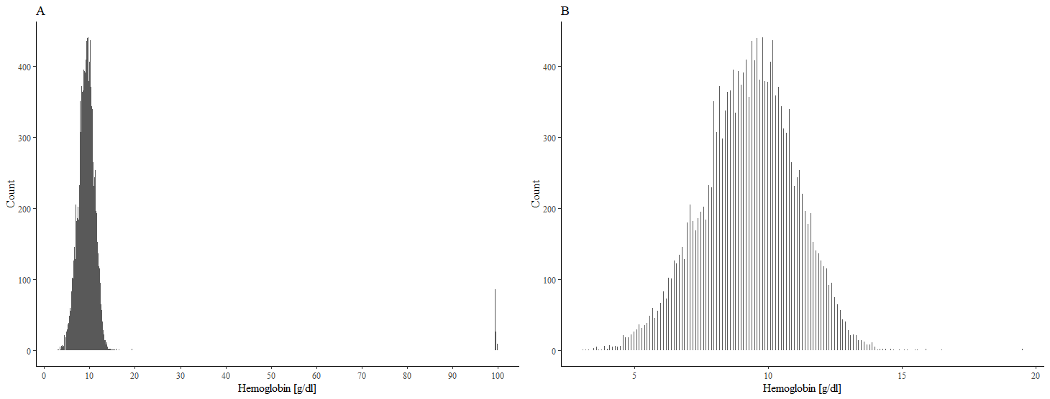
S27 Histograms of the hemoglobin distribution in the study population before (A) and after (B) excluding values of > 50 g/dL. We excluded 176 cases with hemoglobin values from 994 to 999 g/dL from the analysis which left the distribution as shown in panel B.

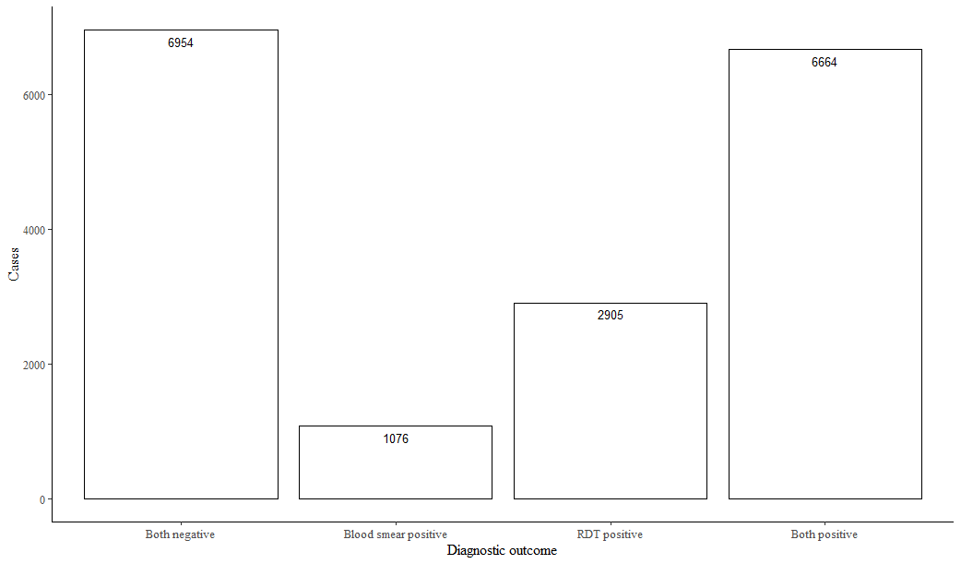
S28 Disparities in diagnostic outcome based on test method. Overlap between thick smear microscopy results and rapid diagnostic test results is somewhat limited. This can be a result of limited test quality and the time course of disease.

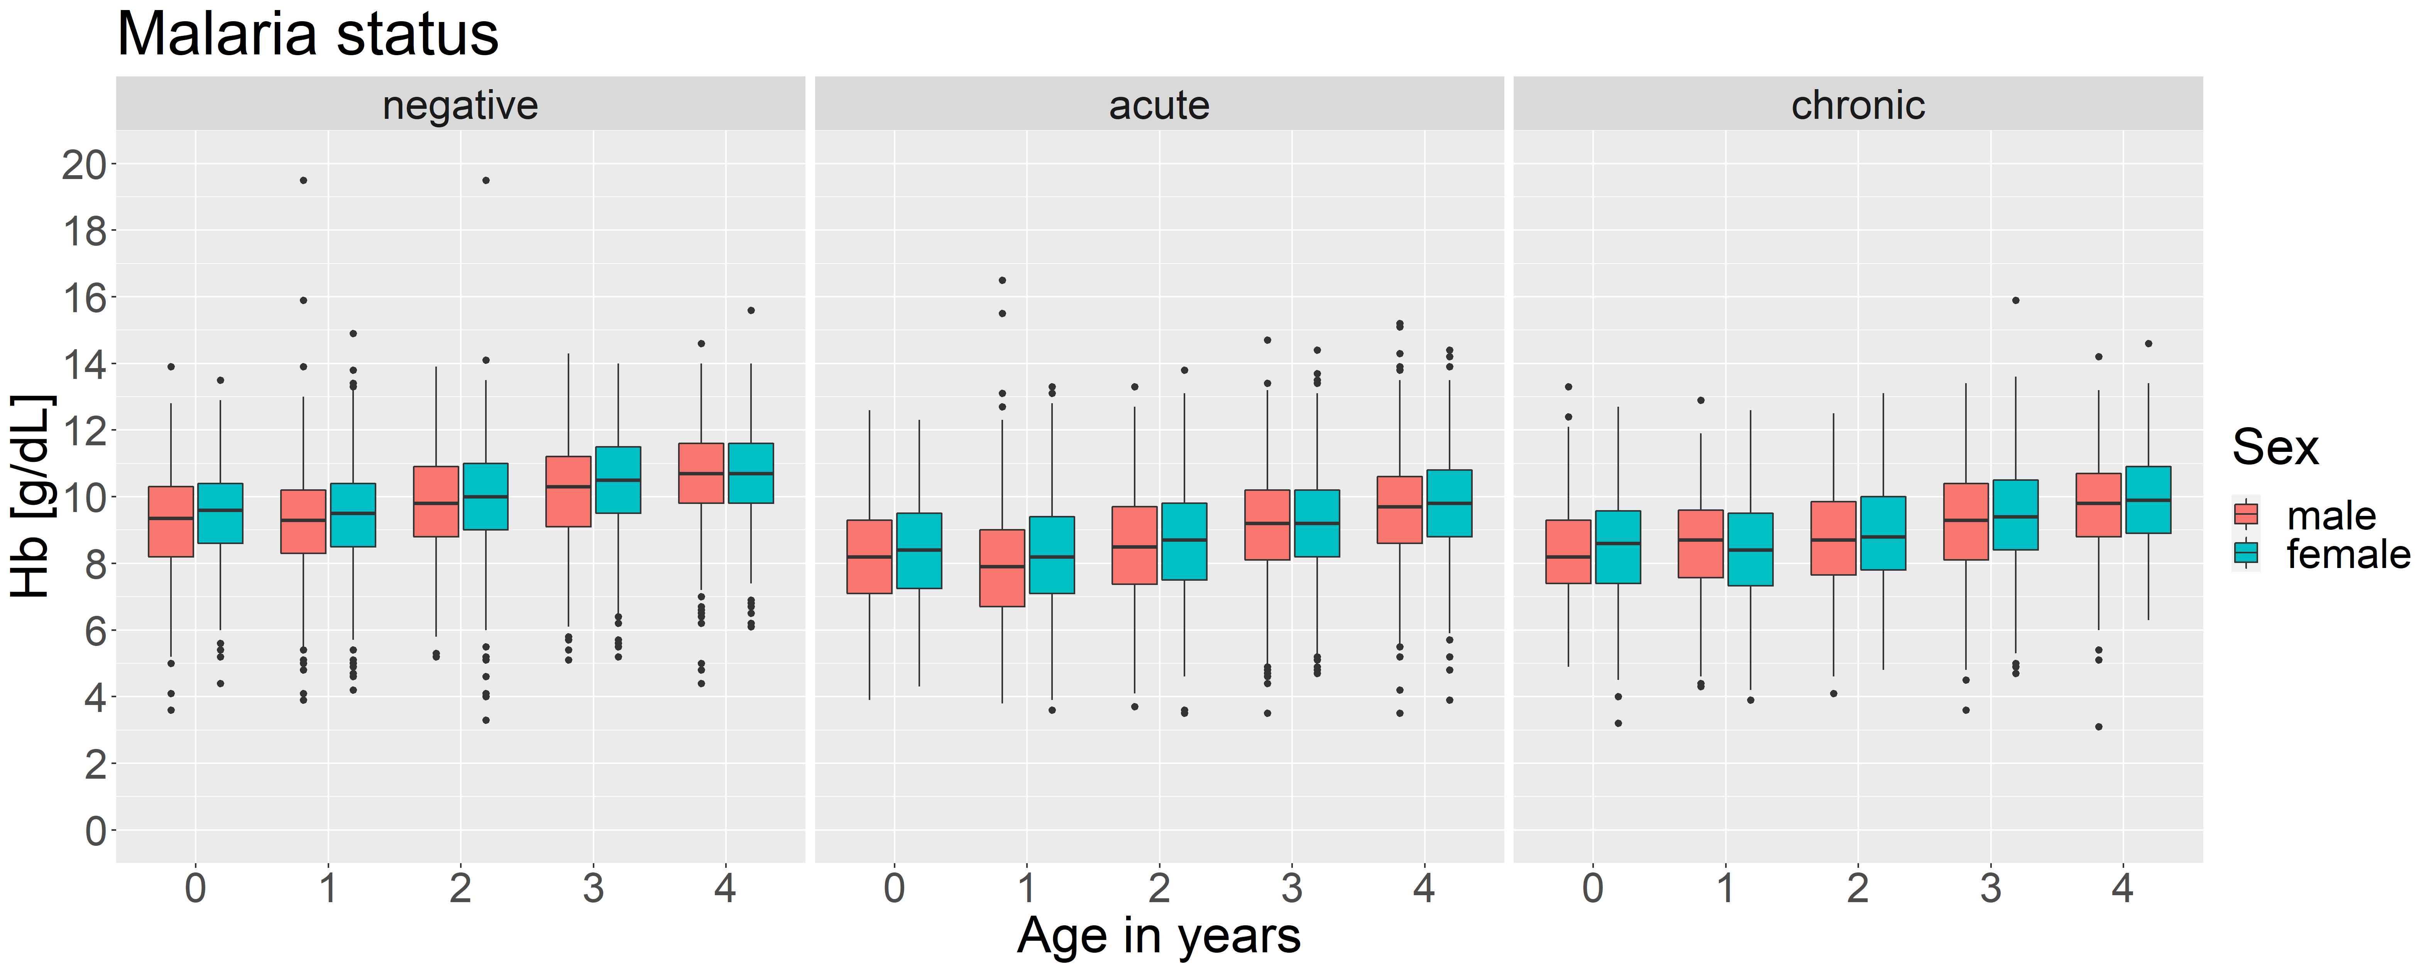
S29. Hemoglobin distribution based on malaria status and sex by age group. In both boys and girls, hemoglobin levels increase with age. Overall, girls have slightly higher mean hemoglobin than boys. Malaria positive children have lower hemoglobin levels throughout all age groups.
S30. Final model form and internal parameters:
The final model was stratified for malaria status, age, sex and household fixed-effect and takes the following form:
Y_{im}= α + β_{V}V_{im} + β_{X}X_{im} + β_{W}W_{im} + μ_{m} + ε_{im}
where
α is the intercept,
Y_{im} is the Hb concentration of child i within household m,
V_{im} is the child i’s Malaria status,
X_{im} is the child i’s age group,
W_{im} is the child i’s sex,
β_{V/X/W} is the association between Hb concentration and Malaria status/age group/sex,
μ_{m} is the household fixed effect and
ɛ_{im} is the residual unexplained individual-level variation.

