APPENDICES
Appendix 1
Participant Experience Survey.
Researcher: Participant ID:

Baseline (T0):

Q1. Please rate your current breathlessness using the scale⁵⁰ below:

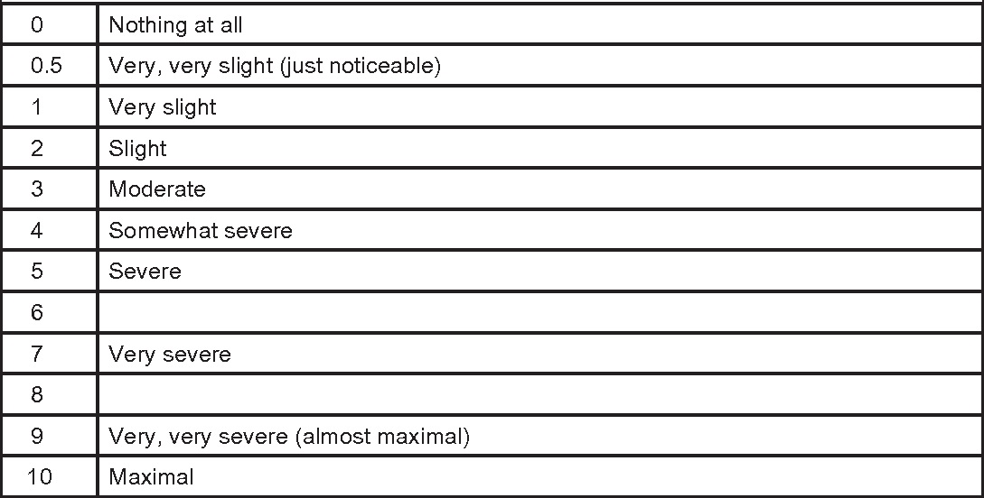

Answer:…………………………………………

Q2. Please rate your current breathing discomfort with the scale⁵¹ below (0 = no discomfort, 10 = maximal imaginable discomfort)?

0 1 2 3 4 5 6 7 8 9 10

Q3. Please rate your current level of anxiety using the scale⁵² below.

Not at all anxious  (1) | A little anxious  (2) | Moderately anxious (3) | Very anxious  (4) | Extremely anxious  (5)
 |  |  |  | 
1 hour (T1):

Q1. Please rate your current breathlessness using the scale⁵⁰ below:

Answer:…………………………………………

Q2. Please rate your current breathing discomfort with the scale⁵¹ below (0 = no discomfort, 10 = maximal imaginable discomfort)?

0 1 2 3 4 5 6 7 8 9 10

Q3. Using the scale⁵¹ below, please rate any changes in your comfort levels with breathing since commencing the oxygen or nitric oxide gas:

Marked deterioration  (-2) | Slight deterioration  (-1) | No change (0) | Slight improvement  (+1) | Marked improvement  (+2)
 |  |  |  | 
Q4. Please rate your current level of anxiety using the scale⁵² below.

Not at all anxious  (1) | A little anxious  (2) | Moderately anxious (3) | Very anxious  (4) | Extremely anxious  (5)
 |  |  |  | 
24 hours (T4):

Q1. Please rate your current breathlessness using the scale⁵⁰ below:

Answer:…………………………………………

Q2. Please rate your current breathing discomfort with the scale⁵¹ below (0 = no discomfort, 10 = maximal imaginable discomfort)?

0 1 2 3 4 5 6 7 8 9 10

Q3. Using the scale⁵¹ below, please rate any changes in your comfort levels with breathing since commencing the oxygen or nitric oxide gas:

Marked deterioration  (-2) | Slight deterioration  (-1) | No change (0) | Slight improvement  (+1) | Marked improvement  (+2)
 |  |  |  | 
Q4. Please rate your current level of anxiety using the scale⁵² below.

Not at all anxious  (1) | A little anxious  (2) | Moderately anxious (3) | Very anxious  (4) | Extremely anxious  (5)
 |  |  |  | 
48 hours (T5):

Q1. Please rate your current breathlessness using the scale⁵⁰ below:

Answer:…………………………………………

Q2. Please rate your current breathing discomfort with the scale⁵¹ below (0 = no discomfort, 10 = maximal imaginable discomfort)?

0 1 2 3 4 5 6 7 8 9 10

Q3. Using the scale⁵¹ below, please rate any changes in your comfort levels with breathing since commencing the oxygen or nitric oxide gas:

Marked deterioration  (-2) | Slight deterioration  (-1) | No change (0) | Slight improvement  (+1) | Marked improvement  (+2)
 |  |  |  | 
Q4. Please rate your current level of anxiety using the scale⁵² below.

Not at all anxious  (1) | A little anxious  (2) | Moderately anxious (3) | Very anxious  (4) | Extremely anxious  (5)
 |  |  |  | 
Appendix 2
The AKIN classification/staging system of acute kidney injury ⁴⁸ ª
Stage | SCr | UO
1 | ↑ SCr ≥26.5 μmol/L (≥0.3 mg/dL) or ↑SCr ≥150 a 200% (1.5 a 2×) | <0.5 mL/kg/h (>6 h)
2 | ↑ SCr >200 a 300% (>2 a 3×) | <0.5 mL/kg/h (>12 h)
3^{b} | ↑ SCr >300% (>3×) or if baseline SCr ≥353.6 μmol/L (≥4 mg/dL) ↑SCr ≥44.2 μmol/L (≥0.5 mg/dL) | <0.3 mL/kg/h (24 h) oranuria (12 h)
ªSCr, serum creatinine; UO, urine output.
^{b}Stage 3 also includes patients requiring RRT independent of the stage (defined by SCr and/or UO) they are in at the moment they initiate RRT.

