Mortality Trends in Gunshot and Firearm-related Assault Victims: A CDC Wonder Database Analysis from 1999 to 2020

Supplementary files

Supplemental Table 1: Annual percent change (APC) of gunshot and firearm-related assault per 100,000 in the United States, 1999 to 2020
Year Interval | APC (95% CI)
Overall
1999-2014 | -0.75 (95% CI: -2.31 to 0.19)
2014-2020 | 6.51 (95% CI: 3.28 to 14.20)
Male
1999-2014 | -0.75 (95% CI: -2.48 to 0.24)
2014-2020 | 6.56 (95% CI: 3.25 to 15.27)
Female
1999-2014 | -0.96 (95% CI: -1.69 to -0.36)
2014-2020 | 6.66 (95% CI: 4.54 to 10.13)
Hispanic or Latino
1999-2006 | -0.37 (95% CI: -2.13 to 3.19)
2006-2013 | -7.11 (95% CI: -12.97 to 5.18)
2013-2020 | 5.49 (95% CI: 3.37 to 8.36)
Non-Hispanic White
1999-2014 | -0.12 (95% CI: -1.26 to 0.75)
2014-2020 | 7.41 (95% CI: 4.67 to 14.96)
American Indian or Alaska Native
1999-2012 | -2.77 (95% CI: -4.64 to -1.26)
2012-2020 | 9.06 (95% CI: 6.47 to 12.90)
Asian or Pacific Islander
1999-2006 | -1.19 (95% CI: -5.13 to 11.84)
2006-2010 | -11.75 (95% CI: -19.38 to 3.31)
2010-2020 | 1.09 (95% CI: -3.47 to 7.96)
Black or African American
1999-2014 | -0.62 (95% CI: -2.79 to 0.56)
2014-2020 | 7.63 (95% CI: 3.68 to 18.48)
White
1999-2007 | 0.04 (95% CI: -1.20 to 4.61)
2007-2013 | -3.29 (95% CI: -8.18 to 0.87)
2013-2020 | 4.66 (95% CI: 2.66 to 7.78)

Supplemental Table 2: Gunshot and firearm-related mortality in the United States, stratified by gender and ethnicity, 1999 to 2020
Year | Overall | Male | Female | Hispanic or Latino | Non-  Hispanic | Population
1999 | 12,055 | 9,993 | 2,062 | 2,045 | 9.942 | 279,040,168
2000 | 11,878 | 9,923 | 1,955 | 2,042 | 9.759 | 281,421,906
2001 | 12,467 | 10,485 | 1,982 | 2,239 | 10,134 | 284,968,955
2002 | 12,904 | 10,817 | 2,087 | 2,259 | 10,552 | 287,625,193
2003 | 12,944 | 11,011 | 1,933 | 2,421 | 10,454 | 290,107,933
2004 | 12,590 | 10,735 | 1,855 | 2,329 | 10,198 | 292,805,298
2005 | 13,439 | 11,485 | 1,954 | 2,586 | 10,785 | 295,516,599
2006 | 13,719 | 11,691 | 2,028 | 2,571 | 11,087 | 298,379,912
2007 | 13,580 | 11,568 | 2,012 | 2,488 | 11,037 | 301,231,207
2008 | 13,111 | 11,135 | 1,976 | 2,324 | 10,743 | 304,093,966
2009 | 12,347 | 10,348 | 1,999 | 2,189 | 10,051 | 306,771,529
2010 | 12,003 | 10,104 | 1,899 | 1,989 | 9,935 | 308,745,538
2011 | 11,972 | 10,032 | 1,940 | 1,911 | 10,017 | 311,591,917
2012 | 12,490 | 10,524 | 1,966 | 1,940 | 10,517 | 313,914,040
2013 | 12,055 | 10,162 | 1,893 | 1,838 | 10,182 | 316,128,839
2014 | 11,804 | 9,944 | 1,860 | 1,802 | 9,957 | 318,857,056
2015 | 13,801 | 11,696 | 2,105 | 2,089 | 11,659 | 321,418,820
2016 | 15,258 | 12,895 | 2,363 | 2,376 | 12,844 | 323,127,513
2017 | 15,422 | 12,967 | 2,455 | 2,353 | 13,032 | 325,719,178
2018 | 14,811 | 12,372 | 2,439 | 2,300 | 12,477 | 327,167,434
2019 | 15,290 | 12,861 | 2,429 | 2,402 | 12,866 | 328,239,523
2020 | 20,378 | 17,260 | 3,118 | 3,087 | 17,257 | 329,484,123

Supplemental Table 3: Gunshot and firearm-related assault Age Adjusted Mortality Rates per 100,000 in the United States, overall rates, and stratified by gender, 1999 to 2020
Year | Overall | Male | Female
1999 | 4.27  (95% CI: 4.2-4.35) | 7.08  (95% CI: 6.94-7.22) | 1.45  (95% CI: 1.39-1.51)
2000 | 4.18  (95% CI: 4.1-4.25) | 6.97  (95% CI: 6.83-7.1) | 1.36  (95% CI: 1.3-1.42)
2001 | 4.32  (95% CI: 4.25-4.4) | 7.27  (95% CI: 7.13-7.41) | 1.39  (95% CI: 1.33-1.45)
2002 | 4.45  (95% CI: 4.38-4.53) | 7.44  (95% CI: 7.3-7.58) | 1.43  (95% CI: 1.37-1.49)
2003 | 4.43  (95% CI: 4.36-4.51) | 7.5  (95% CI: 7.36-7.64) | 1.33  (95% CI: 1.27-1.39)
2004 | 4.28  (95% CI: 4.2-4.35) | 7.27  (95% CI: 7.14-7.41) | 1.26  (95% CI: 1.21-1.32)
2005 | 4.55  (95% CI: 4.47-4.62) | 7.75  (95% CI: 7.61-7.89) | 1.32  (95% CI: 1.26-1.38)
2006 | 4.61  (95% CI: 4.53-4.69) | 7.79  (95% CI: 7.65-7.93) | 1.37  (95% CI: 1.31-1.43)
2007 | 4.53  (95% CI: 4.45-4.6) | 7.69  (95% CI: 7.55-7.83) | 1.33  (95% CI: 1.27-1.39)
2008 | 4.34  (95% CI: 4.27-4.42) | 7.35  (95% CI: 7.21-7.48) | 1.32  (95% CI: 1.26-1.38)
2009 | 4.07  (95% CI: 4-4.14) | 6.81  (95% CI: 6.67-6.94) | 1.3  (95% CI: 1.25-1.36)
2010 | 3.92  (95% CI: 3.85-3.99) | 6.61  (95% CI: 6.48-6.74) | 1.23  (95% CI: 1.17-1.29)
2011 | 3.88  (95% CI: 3.81-3.95) | 6.53  (95% CI: 6.4-6.66) | 1.26  (95% CI: 1.2-1.31)
2012 | 4.03  (95% CI: 3.96-4.11) | 6.82  (95% CI: 6.69-6.95) | 1.26  (95% CI: 1.21-1.32)
2013 | 3.88  (95% CI: 3.81-3.95) | 6.55  (95% CI: 6.42-6.67) | 1.22  (95% CI: 1.16-1.27)
2014 | 3.79  (95% CI: 3.73-3.86) | 6.38  (95% CI: 6.25-6.5) | 1.19  (95% CI: 1.13-1.24)
2015 | 4.4  (95% CI: 4.33-4.47) | 7.47  (95% CI: 7.33-7.61) | 1.3  (95% CI: 1.24-1.35)
2016 | 4.88  (95% CI: 4.8-4.96) | 8.23  (95% CI: 8.09-8.38) | 1.49  (95% CI: 1.43-1.55)
2017 | 4.92  (95% CI: 4.84-5) | 8.23  (95% CI: 8.08-8.37) | 1.52  (95% CI: 1.46-1.58)
2018 | 4.74  (95% CI: 4.66-4.82) | 7.85  (95% CI: 7.71-7.99) | 1.54  (95% CI: 1.48-1.6)
2019 | 4.85  (95% CI: 4.78-4.93) | 8.15  (95% CI: 8-8.29) | 1.53  (95% CI: 1.46-1.59)
2020 | 6.51  (95% CI: 6.42-6.6) | 10.94  (95% CI: 10.78-11.11) | 1.95  (95% CI: 1.88-2.02)

Supplemental Table 4: Gunshot and firearm-related assault Age Adjusted Mortality Rates per 100,000, stratified by ethnicity in the United States, 1999 to 2020
Year | Hispanic or Latino | Non-Hispanic
1999 | 5.28  (95% CI: 5.04-5.52) | 4.09  (95% CI: 4.01-4.17)
2000 | 5  (95% CI: 4.77-5.23) | 4  (95% CI: 3.92-4.08)
2001 | 5.21  (95% CI: 4.98-5.43) | 4.13  (95% CI: 4.05-4.22)
2002 | 5.04  (95% CI: 4.82-5.26) | 4.28  (95% CI: 4.2-4.37)
2003 | 5.27  (95% CI: 5.05-5.49) | 4.24  (95% CI: 4.16-4.33)
2004 | 4.93  (95% CI: 4.72-5.14) | 4.15  (95% CI: 4.07-4.23)
2005 | 5.3  (95% CI: 5.09-5.51) | 4.37  (95% CI: 4.28-4.45)
2006 | 5.05  (95% CI: 4.85-5.25) | 4.47  (95% CI: 4.38-4.55)
2007 | 4.74  (95% CI: 4.55-4.93) | 4.45  (95% CI: 4.37-4.53)
2008 | 4.35  (95% CI: 4.17-4.54) | 4.31  (95% CI: 4.23-4.39)
2009 | 4.04  (95% CI: 3.87-4.22) | 4.02  (95% CI: 3.95-4.1)
2010 | 3.53  (95% CI: 3.37-3.69) | 3.99  (95% CI: 3.91-4.06)
2011 | 3.37  (95% CI: 3.21-3.52) | 3.99  (95% CI: 3.92-4.07)
2012 | 3.37  (95% CI: 3.22-3.53) | 4.2  (95% CI: 4.11-4.28)
2013 | 3.16  (95% CI: 3.02-3.31) | 4.07  (95% CI: 3.99-4.15)
2014 | 3.04  (95% CI: 2.89-3.18) | 3.95  (95% CI: 3.88-4.03)
2015 | 3.45  (95% CI: 3.3-3.6) | 4.62  (95% CI: 4.53-4.7)
2016 | 3.86  (95% CI: 3.7-4.02) | 5.15  (95% CI: 5.06-5.24)
2017 | 3.74  (95% CI: 3.59-3.89) | 5.16  (95% CI: 5.07-5.25)
2018 | 3.63  (95% CI: 3.48-3.79) | 4.96  (95% CI: 4.87-5.04)
2019 | 3.75  (95% CI: 3.6-3.91) | 5.13  (95% CI: 5.04-5.22)
2020 | 4.76  (95% CI: 4.59-4.93) | 6.93  (95% CI: 6.83-7.04)

Supplemental Table 5: Gunshot and firearm-related assault in the United States, stratified by race, 1999 to 2020
Year | American Indian or Alaskan Native | Asian or  Pacific Islander | Black or  African American | White
1999 | 125 | 240 | 5821 | 5869
2000 | 105 | 230 | 5907 | 5636
2001 | 100 | 203 | 6051 | 6113
2002 | 133 | 253 | 6497 | 6021
2003 | 131 | 251 | 6578 | 5984
2004 | 124 | 206 | 6391 | 5869
2005 | 137 | 292 | 6922 | 6088
2006 | 130 | 292 | 7326 | 5971
2007 | 108 | 214 | 7161 | 6097
2008 | 118 | 215 | 6720 | 6058
2009 | 125 | 223 | 6353 | 5646
2010 | 134 | 178 | 6313 | 5378
2011 | 118 | 202 | 6325 | 5327
2012 | 126 | 216 | 6780 | 5368
2013 | 122 | 184 | 6596 | 5153
2014 | 136 | 181 | 6489 | 4998
2015 | 168 | 216 | 7788 | 5629
2016 | 199 | 257 | 8620 | 6182
2017 | 170 | 216 | 8702 | 6334
2018 | 228 | 252 | 8295 | 6036
2019 | 211 | 256 | 8830 | 5993
2020 | 270 | 268 | 12305 | 7535

Supplemental Table 6: Gunshot and firearm-related assault Age Adjusted Mortality Rates per 100,000 in the United States, stratified by race, 1999 to 2020
Year | American Indian or Alaskan Native | Asian or  Pacific Islander | Black or  African American | White
1999 | 4.17  (95% CI: 3.4-4.94) | 1.95  (95% CI: 1.7-2.20) | 14.98  (95% CI: 14.59-15.37) | 2.55  (95% CI: 2.49-2.62)
2000 | 3.22  (95% CI: 2.58-3.85) | 1.83  (95% CI: 1.59-2.08) | 15.1  (95% CI: 14.71-15.49) | 2.45  (95% CI: 2.38-2.51)
2001 | 2.98  (95% CI: 2.38-3.58) | 1.51  (95% CI: 1.3-1.72) | 15.19  (95% CI: 14.8-15.57) | 2.63  (95% CI: 2.57-2.70)
2002 | 3.83  (95% CI: 3.16-4.50) | 1.81  (95% CI: 1.59-2.04) | 16.16  (95% CI: 15.77-16.56) | 2.58  (95% CI: 2.51-2.64)
2003 | 3.65  (95% CI: 2.99-4.30) | 1.73  (95% CI: 1.51-1.95) | 16.17  (95% CI: 15.78-16.56) | 2.56  (95% CI: 2.5-2.63)
2004 | 3.28  (95% CI: 2.68-3.87) | 1.4  (95% CI: 1.21-1.59) | 15.51  (95% CI: 15.13-15.90) | 2.49  (95% CI: 2.43-2.55)
2005 | 3.44  (95% CI: 2.85-4.04) | 1.88  (95% CI: 1.66-2.09) | 16.55  (95% CI: 16.16-16.95) | 2.6  (95% CI: 2.53-2.66)
2006 | 3.3  (95% CI: 2.7-3.89) | 1.8  (95% CI: 1.59-2.01) | 17.19  (95% CI: 16.79-17.59) | 2.52  (95% CI: 2.46-2.59)
2007 | 2.54  (95% CI: 2.06-3.03) | 1.28  (95% CI: 1.11-1.46) | 16.63  (95% CI: 16.24-17.02) | 2.56  (95% CI: 2.5-2.63)
2008 | 2.76  (95% CI: 2.24-3.27) | 1.25  (95% CI: 1.09-1.42) | 15.39  (95% CI: 15.02-15.76) | 2.54  (95% CI: 2.48-2.60)
2009 | 2.99  (95% CI: 2.44-3.55) | 1.25  (95% CI: 1.08-1.41) | 14.44  (95% CI: 14.08-14.08) | 2.34  (95% CI: 2.28-2.40)
2010 | 2.89  (95% CI: 3.29-3.39) | 0.97  (95% CI: 0.83-1.11) | 14.16  (95% CI: 13.81-14.51) | 2.23  (95% CI: 2.17-2.29)
2011 | 2.66  (95% CI: 2.17-3.16) | 1.1  (95% CI: 0.95-1.26) | 14.05  (95% CI: 13.7-14.41) | 2.2  (95% CI: 2.14-2.26)
2012 | 2.75  (95% CI: 2.26-3.23) | 1.13  (95% CI: 0.98-1.29) | 14.96  (95% CI: 14.6-15.32) | 2.21  (95% CI: 2.15-2.27)
2013 | 2.67  (95% CI: 2.18-3.15) | 0.95  (95% CI: 0.81-1.08) | 14.44  (95% CI: 14.09-14.79) | 2.11  (95% CI: 2.05-2.17)
2014 | 2.97  (95% CI: 2.46-3.48) | 0.9  (95% CI: 0.77-1.04) | 14  (95% CI: 13.66-14.35) | 2.07  (95% CI: 2.02-2.13)
2015 | 3.53  (95% CI: 2.99-4.08) | 1.03  (95% CI: 0.89-1.17) | 16.64  (95% CI: 16.26-17.01) | 2.31  (95% CI: 2.25-2.38)
2016 | 4.21  (95% CI: 3.62-4.80) | 1.18  (95% CI: 1.03-1.33) | 18.36  (95% CI: 17.97-18.75) | 2.55  (95% CI: 2.48-2.61)
2017 | 3.46  (95% CI: 2.93-3.98) | 0.97  (95% CI: 0.84-1.10) | 18.36  (95% CI: 17.97-18.75) | 2.62  (95% CI: 2.55-2.68)
2018 | 4.73  (95% CI: 4.11-5.35) | 1.12  (95% CI: 0.98-1.26) | 17.44  (95% CI: 17.06-17.82) | 2.47  (95% CI: 2.41-2.53)
2019 | 4.42  (95% CI: 3.81-5.03) | 1.12  (95% CI: 0.99-1.26) | 18.45  (95% CI: 18.06-18.84) | 2.48  (95% CI: 2.41-2.54)
2020 | 5.47  (95% CI: 4.81-6.13) | 1.16  (95% CI: 1.02-1.30) | 25.5  (95% CI: 25.05-25.96) | 3.13  (95% CI: 3.06-3.20)

Supplemental Table 7: Gunshot and firearm-related assault Age Adjusted Mortality Rates per 100,000, stratified by census region in the United States, 1999 to 2020
Year | Northeast | Midwest | South | West
1999 | 2.72  (95% CI: 2.58-2.86) | 3.98  (95% CI: 3.82-4.13) | 5.51  (95% CI: 5.36-5.65) | 3.91  (95% CI: 3.76-4.06)
2000 | 2.85  (95% CI: 2.71-3) | 3.89  (95% CI: 3.74-4.04) | 5.31  (95% CI: 5.17-5.45) | 3.81  (95% CI: 3.66-3.96)
2001 | 2.86  (95% CI: 2.71-3) | 4.17  (95% CI: 4.01-4.33) | 5.37  (95% CI: 5.23-5.51) | 4.08  (95% CI: 3.92-4.23)
2002 | 2.84  (95% CI: 2.7-2.99) | 3.95  (95% CI: 3.8-4.1) | 5.63  (95% CI: 5.49-5.77) | 4.37  (95% CI: 4.21-4.53)
2003 | 2.97  (95% CI: 2.82-3.11) | 3.89  (95% CI: 3.74-4.04) | 5.62  (95% CI: 5.48-5.76) | 4.33  (95% CI: 4.17-4.48)
2004 | 2.97  (95% CI: 2.82-3.12) | 3.66  (95% CI: 3.51-3.81) | 5.33  (95% CI: 5.19-5.47) | 4.29  (95% CI: 4.13-4.44)
2005 | 3.14  (95% CI: 2.98-3.29) | 3.96  (95% CI: 3.81-4.12) | 5.6  (95% CI: 5.46-5.75) | 4.56  (95% CI: 4.4-4.72)
2006 | 3.38  (95% CI: 3.22-3.53) | 4.14  (95% CI: 3.98-4.29) | 5.67  (95% CI: 5.33-5.81) | 4.35  (95% CI: 4.2-4.51)
2007 | 3.09  (95% CI: 2.94-3.24) | 3.88  (95% CI: 3.73-4.04) | 5.99  (95% CI: 5.84-6.13) | 3.96  (95% CI: 3.81-4.11)
2008 | 2.96  (95% CI: 2.81-3.11) | 4.04  (95% CI: 3.89-4.2) | 5.64  (95% CI: 5.5-5.78) | 3.68  (95% CI: 3.53-3.82)
2009 | 2.8  (95% CI: 2.66-2.94) | 3.91  (95% CI: 3.75-4.06) | 5.24  (95% CI: 5.1-5.37) | 3.35  (95% CI: 3.22-3.48)
2010 | 3.04  (95% CI: 2.9-3.19) | 3.79  (95% CI: 3.64-3.94) | 4.95  (95% CI: 4.81-5.08) | 3.18  (95% CI: 3.05-3.31)
2011 | 2.99  (95% CI: 2.84-3.14) | 3.94  (95% CI: 3.78-4.09) | 4.89  (95% CI: 4.76-5.01) | 3.04  (95% CI: 2.91-3.17)
2012 | 2.95  (95% CI: 2.8-3.09) | 4.18  (95% CI: 4.02-4.34) | 5.09  (95% CI: 4.96-5.22) | 3.14  (95% CI: 3.01-3.26)
2013 | 2.6  (95% CI: 2.46-2.74) | 4.06  (95% CI: 3.9-4.21) | 4.93  (95% CI: 4.8-5.06) | 3.05  (95% CI: 2.92-3.18)
2014 | 2.5  (95% CI: 2.36-2.63) | 3.86  (95% CI: 3.71-4.01) | 4.94  (95% CI: 4.82-5.07) | 2.9  (95% CI: 2.77-3.02)
2015 | 2.7  (95% CI: 2.56-2.84) | 4.68  (95% CI: 4.51-4.85) | 5.78  (95% CI: 5.64-5.92) | 3.35  (95% CI: 3.22-3.49)
2016 | 2.71  (95% CI: 2.57-2.85) | 5.44  (95% CI: 5.26-5.62) | 6.41  (95% CI: 6.26-6.55) | 3.63  (95% CI: 3.49-3.77)
2017 | 2.67  (95% CI: 2.53-2.81) | 5.58  (95% CI: 5.4-5.76) | 6.4  (95% CI: 6.26-6.55) | 3.58  (95% CI: 3.45-3.72)
2018 | 2.65  (95% CI: 2.51-2.79) | 5.18  (95% CI: 5-5.38) | 6.2  (95% CI: 6.06-6.35) | 3.43  (95% CI: 3.29-3.56)
2019 | 2.52  (95% CI: 2.39-2.66) | 5.19  (95% CI: 5.01-5.37) | 6.71  (95% CI: 6.56-6.86) | 3.34  (95% CI: 3.21-3.47)
2020 | 3.72  (95% CI: 3.55-3.89) | 7.46  (95% CI: 7.25-7.67) | 8.55  (95% CI: 8.39-8.72) | 4.39  (95% CI: 4.24-4.54)

Supplemental Table 8: Gunshot and firearm-related assault Age Adjusted Mortality Rates per 100,000, stratified by state percentiles in the United States
State | AAMR | Rank | Percent
District of Columbia | 20.44 | 1 | 100.00%
Mississippi | 19.08 | 2 | 97.80%
Louisiana | 17.67 | 3 | 95.60%
Alabama | 12.94 | 4 | 93.40%
Missouri | 12.54 | 5 | 91.30%
South Carolina | 11.6 | 6 | 89.10%
Arkansas | 10.91 | 7 | 86.90%
Tennessee | 10.64 | 8 | 84.70%
Illinois | 9.96 | 9 | 82.60%
Maryland | 9.32 | 10 | 80.40%
Georgia | 8.99 | 11 | 78.20%
Kentucky | 8.79 | 12 | 76.00%
Delaware | 8.67 | 13 | 73.90%
Indiana | 8.35 | 14 | 71.70%
New Mexico | 8.21 | 15 | 69.50%
North Carolina | 7.91 | 16 | 67.30%
Ohio | 7.83 | 17 | 65.20%
Oklahoma | 7.57 | 18 | 63.00%
Michigan | 7.48 | 19 | 60.80%
Pennsylvania | 7 | 20 | 58.60%
Florida | 6.51 | 21 | 56.50%
Kansas | 6.38 | 22 | 54.30%
Texas | 6.28 | 23 | 52.10%
West Virginia | 6.21 | 24 | 50.00%
Arizona | 5.82 | 25 | 47.80%
Virginia | 5.68 | 26 | 45.60%
Nevada | 5.28 | 27 | 43.40%
Alaska | 5.16 | 28 | 41.30%
Wisconsin | 4.87 | 29 | 39.10%
California | 4.69 | 30 | 36.90%
Wyoming | 4.5 | 31 | 34.70%
Colorado | 4.28 | 32 | 32.60%
Montana | 4.14 | 33 | 30.40%
South Dakota | 3.74 | 34 | 28.20%
Connecticut | 3.21 | 35 | 26.00%
New Jersey | 3.18 | 36 | 23.90%
New York | 3.11 | 37 | 21.70%
Iowa | 3.1 | 38 | 17.30%
Nebraska | 3.1 | 38 | 17.30%
North Dakota | 3.04 | 40 | 15.20%
Oregon | 2.97 | 41 | 10.80%
Washington | 2.97 | 41 | 10.80%
Minnesota | 2.76 | 43 | 8.60%
Rhode Island | 2.41 | 44 | 6.50%
Utah | 2.37 | 45 | 4.30%
Idaho | 2.05 | 46 | 2.10%
Massachusetts | 1.99 | 47 | 0.00%

Supplementary figure 1: Gunshot and firearm-related assault Age Adjusted Mortality Rates per 100,000 in the United States, overall rates, and stratified by gender, 1999 to 2020

Supplementary figure 2: Gunshot and firearm-related assault Age Adjusted Mortality Rates per 100,000 in the United States, stratified by ethnicity, 1999 to 2020

Supplementary figure 3: Gunshot and firearm-related assault Age Adjusted Mortality Rates per 100,000 in the United States, stratified by race, 1999 to 2020

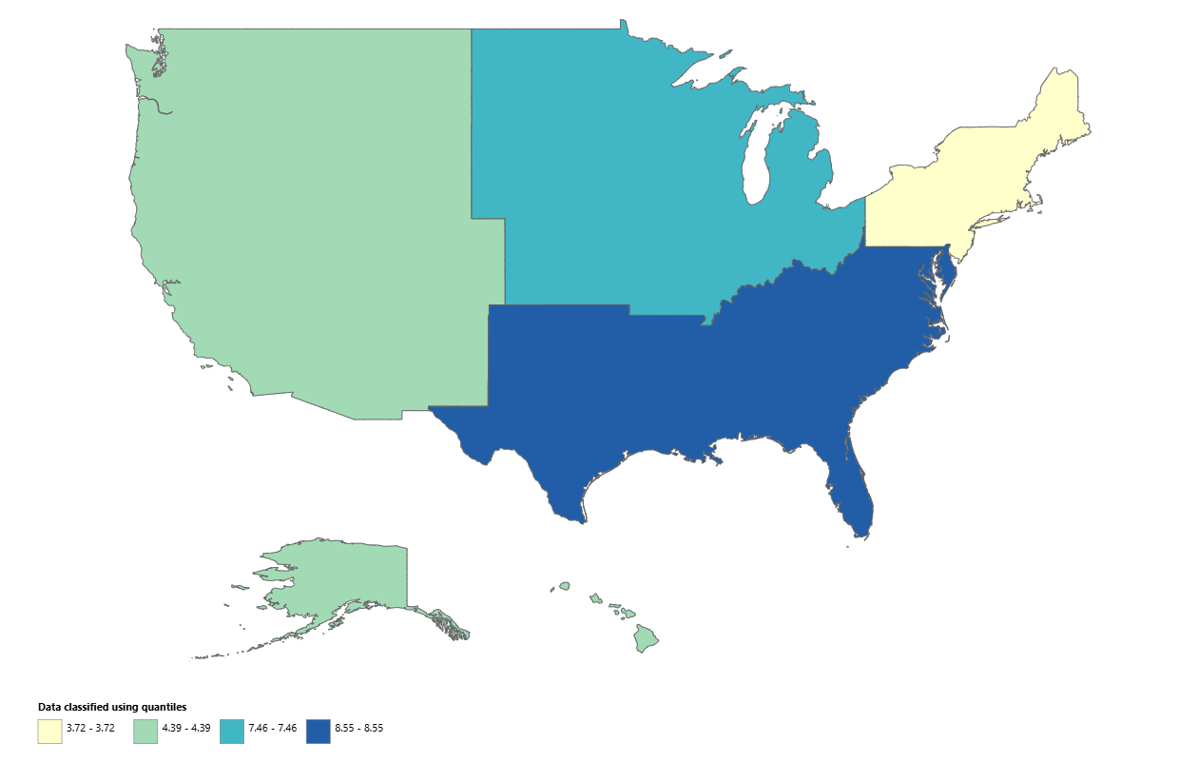
Supplementary figure 4: Gunshot and firearm-related assault Age Adjusted Mortality Rates per 100,000, stratified by census region in the United States, for the year 2020
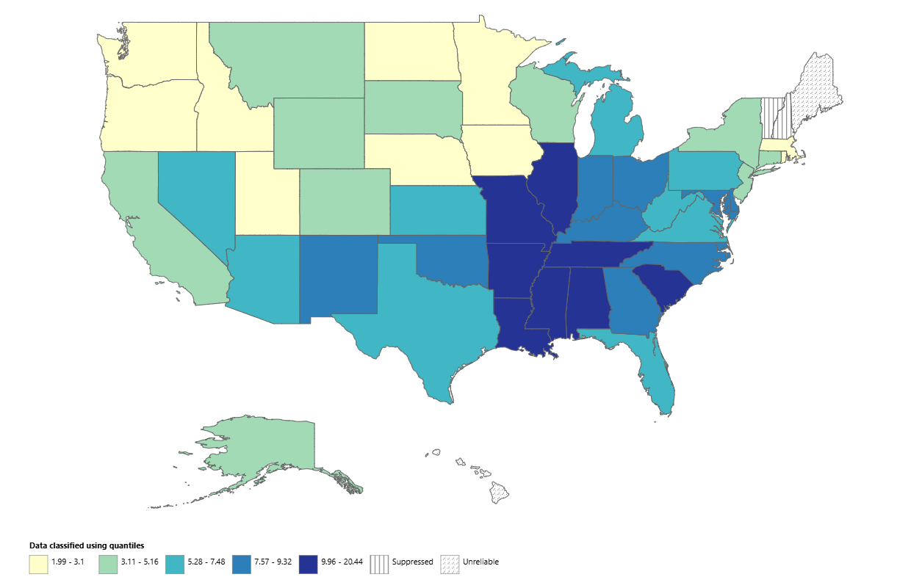
Supplementary figure 5: Gunshot and firearm-related assault Age Adjusted Mortality Rates per 100,000, stratified by states in the United States, for the year 2020

