Supplementary Information:

Fig. S1 Percentage of hawksbill turtle nests in Chapadão, Minas and Sibauma, on the southern coastline of the state of Rio Grande do Norte, Brazil across the nesting season obtained from five nesting seasons (2014/2015 to 2018/2019). N = 622 nests.

Table S1 Satellite tag deployments on nesting hawksbill turtles at the southern coastline of Rio Grande do Norte, Brazil. * indicates second deployment for a consecutive nesting season. The subset of turtles used for clutch frequency estimates are depicted in bold.
Turtle ID | Model | CCL (cm) | Deployment date | Transmission Days | ARGOS fixes excluding Z | GPS fixes
1 | SPLASH10-F-296A | 91.2 | 2/28/15 | 49 | 56 | 90
2 | SPOT-293A | 86.1 | 2/28/15 | 36 | 165 | -
2* | SPOT-375 | 85.4 | 2/17/18 | 566 | 2962 | -
3 | SPOT-293A | 88.9 | 3/2/15 | 138 | 410 | -
3* | SPLASH10-F-296A | 88.4 | 1/17/18 | 257 | 618 | 373
4 | SPLASH10-F-296A | 86.3 | 3/5/15 | 341 | 621 | 215
4* | SPLASH10-F-296A | 88 | 12/26/17 | 91 | 340 | 159
5 | SPOT-293A | 84.5 | 3/7/15 | 154 | 412 | -
6 | SPOT-293A | 98.5 | 3/21/15 | 140 | 420 | -
6* | SPOT-375 | 97 | 2/16/18 | 236 | 885 | -
7 | SPLASH10-F-296A | 95.5 | 1/16/16 | 244 | 230 | 2823
7* | SPOT-375 | 95.7 | 1/28/18 | 325 | 911 | -
8 | SPOT-293A | 98.1 | 1/22/16 | 149 | 599 | -
9 | SPLASH10-F-296A | 86.7 | 2/10/16 | 527 | 2370 | 2808
9* | SPLASH10-F-334 | 86.5 | 1/15/19 | 142 | 693 | 1935
10 | SPOT-293A | 82.8 | 2/10/16 | 60 | 235 | -
11 | SPOT-293A | 86.4 | 2/27/16 | 53 | 135 | -
11* | Kiwi-Sat K2G 376D | 86.3 | 2/25/19 | 324 | 2066 | -
12 | SPLASH10-F-296A | 102.7 | 3/11/16 | 489 | 1667 | 1162
13 | SPOT-293A | 84.4 | 3/29/16 | 156 | 390 | -
14 | SPOT-293A | 94.5 | 5/2/16 | 686 | 1894 | -
14* | Kiwi-Sat K2G 376D | 93.5 | 2/27/19 | 82 | 432 | -
15 | SPOT-293A | 89.3 | 2/22/17 | 101 | 278 | -
16 | SPOT-293A | 93.8 | 3/17/17 | 258 | 625 | -
16* | Kiwi-Sat K2G 376D | 94.5 | 3/9/19 | 74 | 242 | -
17 | SPLASH10-F-296A | 91.4 | 4/7/17 | 209 | 310 | 310
17* | SPLASH10-F-334 | 91.7 | 4/8/19 | 334 | 665 | 1275
18 | SPOT-293A | 91.2 | 4/13/17 | 260 | 309 | -
19 | SPOT-375 | 93.3 | 12/20/18 | 390 | 2089 | -
20 | SPOT-375 | 85.2 | 12/29/18 | 382 | 3198 | -
21 | Kiwi-Sat K2G 376D | 95 | 2/6/19 | 332 | 2061 | -
22 | Kiwi-Sat K2G 376D | 94.2 | 3/19/19 | 80 | 492 | -
23 | Kiwi-Sat K2G 376D | 85 | 4/4/19 | 28 | 99 | -
24 | SPOT-375 | 91.5 | 4/10/19 | 280 | 1827 | -
25 | SPLASH10-F-334 | 97.2 | 4/11/19 | 279 | 2464 | 1769

Table S2 Number of nesting events at Chapadão, Minas and Sibauma, on the southern coastline of the state of Rio Grande do Norte, Brazil during the nesting season determined based on females encountered nesting and nests found by tracks, in which the nesting female was not encountered but the nest was confirmed. Information on the number of individual nesting hawksbill encountered each season from 2014/15 to 2018/19.

Season | Nesting event | Nov | Dec | Jan | Feb | Mar | Apr | May | Jun | Before 10 Dec | After 15 Apr | Sum | Individual females | Total nests
14/15 | observed | 0 | 1 | 22 | 26 | 32 | 15 | 1 |  | 0 | 3 | 97 | 41 | 114
14/15 | unobserved | 0 | 1 | 0 | 7 | 5 | 4 | 0 |  | 1 | 0 | 17 |  | 114
15/16 | observed | 0 | 5 | 22 | 31 | 34 | 8 | 1 |  | 0 | 4 | 101 | 33 | 122
15/16 | unobserved | 2 | 7 | 2 | 3 | 4 | 2 | 1 |  | 6 | 2 | 21 |  | 122
16/17 | observed | 0 | 2 | 28 | 31 | 30 | 7 | 2 |  | 0 | 6 | 100 | 51 | 121
16/17 | unobserved | 0 | 2 | 2 | 8 | 4 | 3 | 2 |  | 1 | 4 | 21 |  | 121
17/18 | observed | 0 | 4 | 23 | 29 | 36 | 5 | 0 | 0 | 0 | 0 | 97 | 37 | 127
17/18 | unobserved | 1 | 3 | 2 | 12 | 5 | 4 | 2 | 1 | 3 | 4 | 30 |  | 127
18/19 | observed | 0 | 3 | 25 | 38 | 40 | 13 | 0 | 0 | 0 | 2 | 119 | 48 | 138
18/19 | unobserved | 0 | 3 | 1 | 4 | 5 | 3 | 2 | 1 | 0 | 5 | 19 |  | 138

Table S3 Number of individual hawksbill turtles observed nesting during each of the nesting season considered at our study. Numbers are indicated based on turtles nesting one, two, three, four, five or six times during each nesting season as according to data obtained from nesting beach monitoring. The percentage of transient individuals, which were observed nesting only once within the nesting season is also indicated.
Season | 1 | 2 | 3 | 4 | 5 | 6 | % transient
14/15 | 19 | 3 | 8 | 8 | 2 | 1 | 46
15/16 | 9 | 6 | 6 | 5 | 5 | 2 | 27
16/17 | 27 | 8 | 9 | 5 | 2 | 0 | 53
17/18 | 17 | 4 | 7 | 9 | 0 | 0 | 46
18/19 | 16 | 10 | 12 | 6 | 4 | 0 | 33

Table S4 Average day for first nesting event of hawksbill turtles in each nesting season considering December 1st as day zero as well as for all seasons combined. SD = standard deviation; PRL – Population residence length; ECF_{PRL} – average estimated clutch frequency for the population.
 | First nesting day (day zero December 1st)
 | 14/15 | 15/16 | 16/17 | 17/18 | 18/19 | All seasons | Departure date | PRL at breeding site | ECF_{PRL}
Average | 74.7 | 62.6 | 63.1 | 63.5 | 67.8 | 67.2 | 119.8 | 52.6 | 4.5
SD | 32.4 | 29.4 | 27.2 | 27.9 | 29.5 | 29.3 | 24.4
N | 41 | 33 | 51 | 37 | 48 | 210 | 35

Table S5 Nesting beach monitoring data for the subset of individuals that were satellite tracked including observed clutch frequency (OCF) and estimated clutch frequency (ECF_{b}), as well as the number of assumed nests (Ax) in which the turtle was not encountered, where x is the sequential number of each assumed nest. + means nesting events detected by beach monitoring without haul-out location generated by the satellite tag. The record that the turtle was instrumented with FastGPS tags is highlighted in bold.
ID | PTT Type | Nest 1 | Nest 2 | Nest 3 | Nest 4 | Nest 5 | Nest 6 | OCF | ECF_{b} | Assumed nests
1 | GPS | 1/28/15 | 2/12/15 | 2/27/15 | 3/13/15 | - | - | 4 | 4 | 0
2 | ARGOS | 1/28/15 | A1 | 2/27/15 | A2 | 3/29/15 | - | 3 | 5 | 2
3 | ARGOS | 1/19/15 | 2/3/15 | A3 | 3/2/15 | 3/17/15 | - | 4 | 5 | 1
3* | GPS | 1/16/18 | A4 | A5 | 3/5/18 | - | - | 2 | 4 | 2
4 | GPS | 1/19/15 | 2/2/15 | A6 | 3/4/15 | 3/19/15 | - | 4 | 5 | 1
4* | GPS | 12/27/17 | A7 | 1/28/18 | 2/14/18 | - | - | 3 | 4 | 1
7 | GPS | 1/16/16 | 2/2/16 | 2/18/16 | 3/4/16 | 03/20/16 | - | 5 | 5 | 0
7* | ARGOS | 2/1/18 | 2/16/18 | 3/4/18 | 3/19/18 | - | - | 4 | 4 | 0
8 | ARGOS | 1/21/16 | - | - | - | - | - | 1 | 1 | 0
9* | GPS | 1/14/19 | 2/5/19 | 02/20/19+ | 3/9/19 | 03/24/19+ | - | 5 | 5 | 0
10 | ARGOS | 1/25/16 | 2/9/16 | A8 | 3/11/16 | - | - | 3 | 4 | 1
11 | ARGOS | 1/28/16 | 2/12/16 | 2/26/16 | 3/14/16 | - | - | 4 | 4 | 0
11* | ARGOS | 1/24/19 | A9 | 2/24/19 |  | - | - | 2 | 3 | 1
13 | ARGOS | 1/25/16 | 2/11/16 | 2/27/16 | 3/13/16 | 3/29/16 | - | 5 | 5 | 0
19 | ARGOS | 12/19/18 | - | - | - | - | - | 1 | 1 | 0
20 | ARGOS | 12/28/18 | - | - | - | - | - | 1 | 1 | 0
21 | ARGOS | 1/18/19 | 2/6/19 | A10 | 3/11/19 | 3/28/19 | - | 4 | 5 | 1
25 | GPS | 1/24/19 | A11 | 2/25/19 | 3/11/19 | 3/25/19 | 4/11/19 | 5 | 6 | 1

Table S6 Number of nests encountered by nesting hawksbill tracks (i.e., in which the individual turtle was not encountered) during the expected return interval of turtles, between 12 and 20 days after last observed nesting event. In the cases where haul-outs occurred within the relevant interval, the date is provided. NA = not applicable.
Assumed nests | 12 days | 20 days | Nests encountered by tracks | Haul-outs
A1 | 2/9/15 | 2/17/15 | 3 | NA
A2 | 3/11/15 | 3/19/15 | 2 | NA
A3 | 2/15/15 | 2/23/15 | 4 | NA
A4 | 1/28/18 | 2/5/18 | 2 | 2/4/18
A5 | 2/12/18 | 2/20/18 | 0 | 2/18/18
A6 | 2/14/15 | 2/22/15 | 5 | NA
A7 | 1/8/18 | 1/16/18 | 0 | 1/13/18
A8 | 2/21/16 | 2/29/16 | 2 | NA
A9 | 2/5/19 | 2/13/19 | 4 | NA
A10 | 2/18/19 | 2/26/19 | 0 | NA
A11 | 2/5/19 | 2/13/19 | 4 | NA

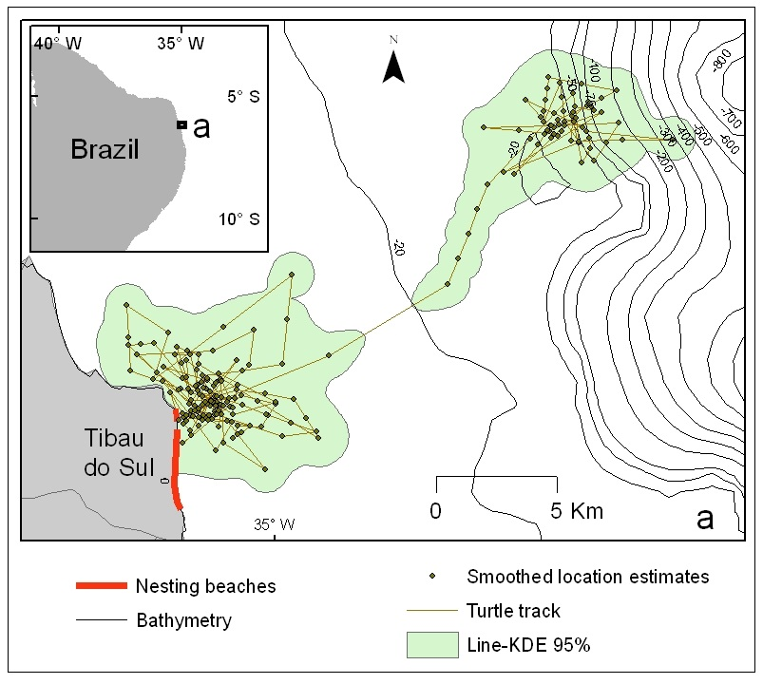
Fig. S2 Example of split home range contour using the line Kernel Density Estimation function from program Open Jump HoRAE. Note that the first polygon close to the nesting site within -20 m isobath was associated with the internesting habitat and the subsequent polygon located at deeper waters was associated to foraging. The last location estimate obtained through state space model from first polygon (internesting habitat) and the first from the second polygon (foraging habitat) occurred both on 6th May 2019. This date was used to determine the end of the breeding season for this individual hawksbill turtle (ID 16*).

Fig. S3 Individual residence length (IRL) at the breeding site for nesting hawksbill turtles in the southern coastline o Rio Grande do Norte state, Brazil. * indicates the second deployment for the same individual turtle in consecutive seasons. The subset of turtles used for clutch frequency estimates are depicted in bold.

Fig. S4 Distribution in percentage of first nest record for beach monitoring (N = 210) in black, first nest record for turtles that were satellite tracked in light gray (N = 35) and the departure from the breeding site (N = 35) through satellite telemetry in dark grey.

