Supporting Information for:
Flexible and Tough Nanofibrous Ceramics via the Additive Manufacturing of Self-Assembling Preceramic Polymer-Block Copolymer Feedstocks
John J. Bowen†^{1,2}, Caitlyn M. Clarkson†^{1,3}, Kaitlin N. Detwiler¹, Amanda H. Trout⁴, Benito Roman-Manso⁵, Connor Wykoff^{1,2}, Hilmar Koerner^{1*}, and Matthew B. Dickerson^{1*}
† These authors contributed equally to the work
- Materials and Manufacturing Directorate, Air Force Research Laboratory, Wright-Patterson AFB, Ohio 45433, United States
- UES, Inc., Dayton, Ohio 45432, United States
- NRC Research Associateship Programs, The National Academies, Washington, DC 20001, United States
- Center for Electron Microscopy and Analysis, The Ohio State University, Columbus, OH, 43212, United States
- Harvard John A. Paulson School of Engineering and Applied Sciences, Harvard University, Cambridge, MA, United States
Email: hilmar.koerner.1@us.af.mil; matthew.dickerson.6@us.af.mil;

Figure S1. A) Ceramic nanofiber bundles contract and expand as the printed trace does, following the path of the object. B) Ceramic nanofibers follow bends around objects in pyrolyzed printed traces.

Figure S2. Stitched SEM micrographs showing a single nanofiber traced along a 300 micron path, indicated by the green line to guide the eye. Scale bar is 50μm.
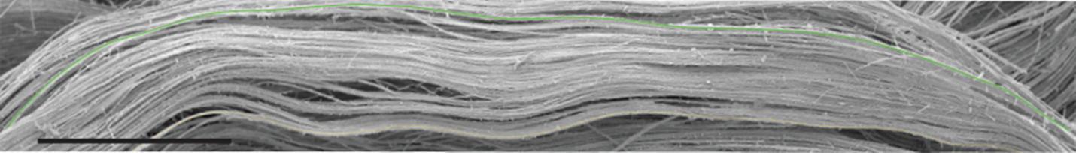

Figure S3. SEM micrographs of drop cast, thermally cured, and pyrolyzed PCP/BCP ink samples at A) lower and B) higher magnification
Figure S4. SEM micrographs of samples cast in a half cylinder PDMS mold show the presence of aligned nanofibers without printing.
A
B
50 µm
10 µm
Figure S5. A) A pyrolyzed trace printed with a 580 µm nozzle. B) Higher magnification image of the trace shown in A). These samples show the importance of the confinement effect, indicated by the disorder/lack of alignment in the center, in contrast with strong alignment seen in smaller diameter samples throughout.
50 µm

Figure S6. A bundle of ceramic nanofibers printed with a 250 µm nozzle shows adhesion between individual fibers
Figure S7. A) A 200 µm printed and pyrolyzed filament B) is deflected by hand. The 200 µm printed filaments show lower deflection angles before breaking than do the 250 µm filaments.

Figure S8. An SEM micrograph of polymeric fibers. A thermally crosslinked polymeric part was acid etched to remove non-SMP-10 derived polymer, leaving behind SMP-10 containing fibers.
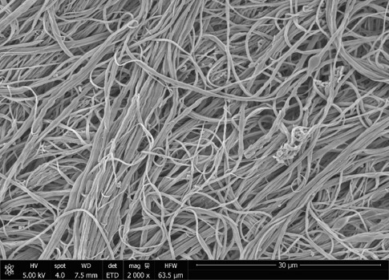
10 µm
Figure S9. DSC scans of dried PCP/BCP inks showing the thermal transitions of the material for two heating scans. Scan 1 (heat 1) is on a non-thermally treated PCP/BCP sample and scan 2 (heat 2) is of the same sample after a 10°C/min cool (i.e., the thermally annealed sample). The material has three glass transition (Tg) temperatures. At low temperature, the mid-block has a Tg of -45°C, at intermediate temperature, there is a very weak Tg at 54°C that could belong to SMP-10, and at 121°C the PMMA block has a Tg. During the first heat, there is an enthalpy relaxation peak superimposed on the Tg of PMMA, most likely due to physical ageing close to the Tg of this material.

Figure S10. In situ, non-isothermal curing of PCP/BCP printed objects using a DSC. Data taken on the DSC Discovery series on freshly printed, dried 3D printed specimens for three heating rates. The peak temperature and enthalpy of reaction decrease with decreasing heating rate. Exothermic is down.
Figure S11. Deviations from ideal curing ramp rates (A) 10°C/min and B) 15°C/min) and temperatures lead not only to differences in average diameter, but also less homogenous nanofiber geometries. Scale bars 5 µm

Figure S12. Printed traces thermally cured at A) lower temperatures (80°C) exhibit uneven nanofibers and pre-fiber objects, while B) those cured at higher temperatures (180°C) show nanofiber coalescence, leading to more ovular nanofibers. Arrows are given in B to guide the eye.

Figure S13. Illustration of morphological changes during heating and curing of printed filaments. A) Schematic of two measurement directions. B) Multi-scale morphology of printed filaments, fibers (red) and hypothesized BCP morphology (green) between the fibers (blue). C) Flow velocity induced alignment of BCP lamellae (green) parallel to the build platform. D) Suggested change in BCP morphology with increased temperature and curing from lamellar to cylinder BCP morphology.

Figure S14. TEM micrographs of partially cured (100°C) printed BCP/PCS traces show a wormlike morphology in between fibers, which are bright white.

Figure S15. TEM micrographs and EDS maps foils of pyrolyzed tows. A) TEM micrograph of a pyrolyzed nanofiber bundle, taken from near the outer crust. B) TEM micrograph detailing the presence of ceramic nanofoam present between and around the fibers. C) EDS mapping indicating the presence of silicon (orange), oxygen (green), and carbon (blue), E-G) with the individual channels shown below. With the exception of the crust, which is silicon rich, the composition of the nanofoam and nanofibers is homogenous.

Figure S16. Nanofoam density change throughout nanofiber tow. A) Graphical representation of ceramic nanofibers (black circles) surrounded by a higher density of nanofoam (i.e., nanocoral) at the surface of the tow than in the center. B) SEM micrograph of a mounted and polished tow with three regions, corresponding respectively with C/F, D/G, and E/H. Numbers are given in the top right of the following micrographs to indicate from which region they are taken. C, F) The region closest to the surface of the tow shows the greatest density of nanofoam around the nanofibers. D, G) The density of nanofoam surrounding the nanofibers decreases, indicated by the darker gray of the epoxy, E, H) with the lowest density of nanofoam closest to the center and the clearest division between individual nanofibers.
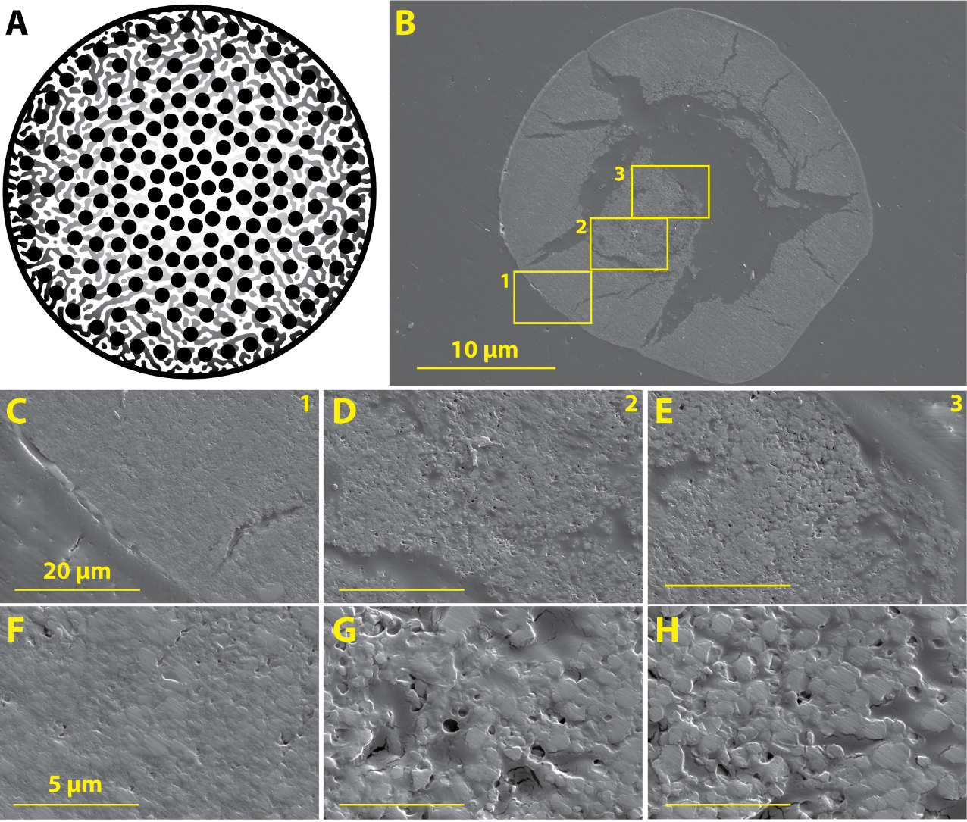

Figure S17. A) A ceramic nanofibrous filament is B-C) pulled apart with increasing application of strain, D) revealing long nanofiber pullout regions. The eventual breaking point, a pre-existing crack, is indicated with yellow arrows to guide the eye.
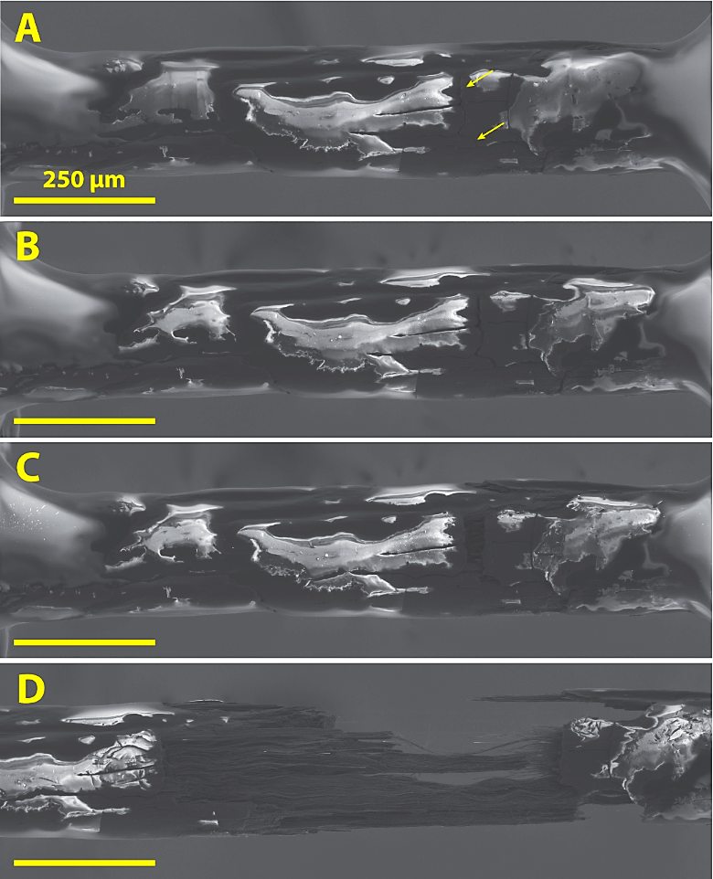

Figure S18. SEM micrographs of pullout regions of printed fibers. The outlines of fibers made up of nanocoral morphology ceramics are indicated by arrow to guide the eye.
Figure S19. A printed assembly of nanofiber bundles aligned in one direction in two layers is deflected by hand. The lack of gaps between individual fibers constrains the flexibility of the entire part but does not completely remove it. Scale bars are 1 cm.
