- Small mammal species common names, scientific names, and four-letter abbreviations
Hispid pocket mouse (Chaetodipus hispidus) CHHI
Ord’s kangaroo rat (Dipodomys ordii) DIOR
Longtailed vole (Microtus longicaudus) MILO
Prairie vole (Microtus ochrogaster) MIOC
Meadow vole (Microtus pennsylvanicus) MIPE
House mouse (Mus musculus) MUMU
Northern grasshopper mouse (Onychomys leucogaster) ONLE
Olivebacked pocket mouse (Perognathus fasciatus) PEFA
Silky pocket mouse (Perognathus flavus) PEFL
Plains pocket mouse (Perognathus flavescens) PEFV
North American deer mouse (Peromyscus maniculatus) PEMA
Western harvest mouse (Reithrodontomys megalotis) REME
Plains harvest mouse (Reithrodontomys montanus) REMO

- NMDS stressplot

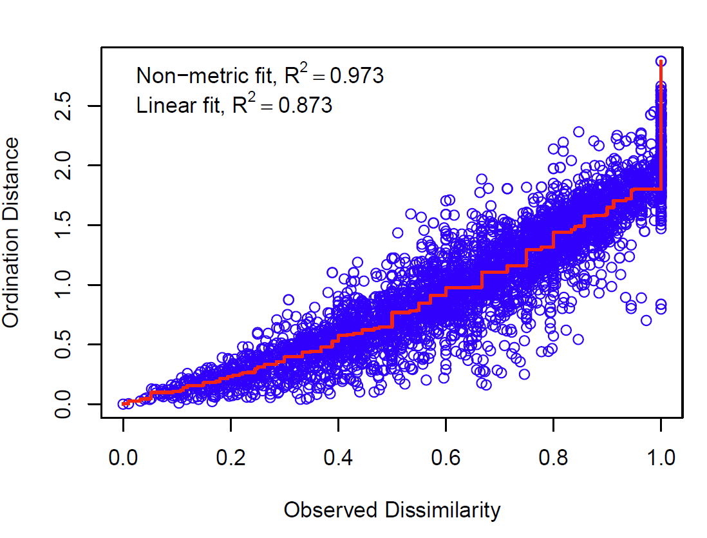
Supplementary Fig 1. NMDS stressplot to evaluate ordination quality. NMDS had a stress value of 0.164 and was plotted as Fig 1 in the manuscript.

- NMDS ordination graph for year
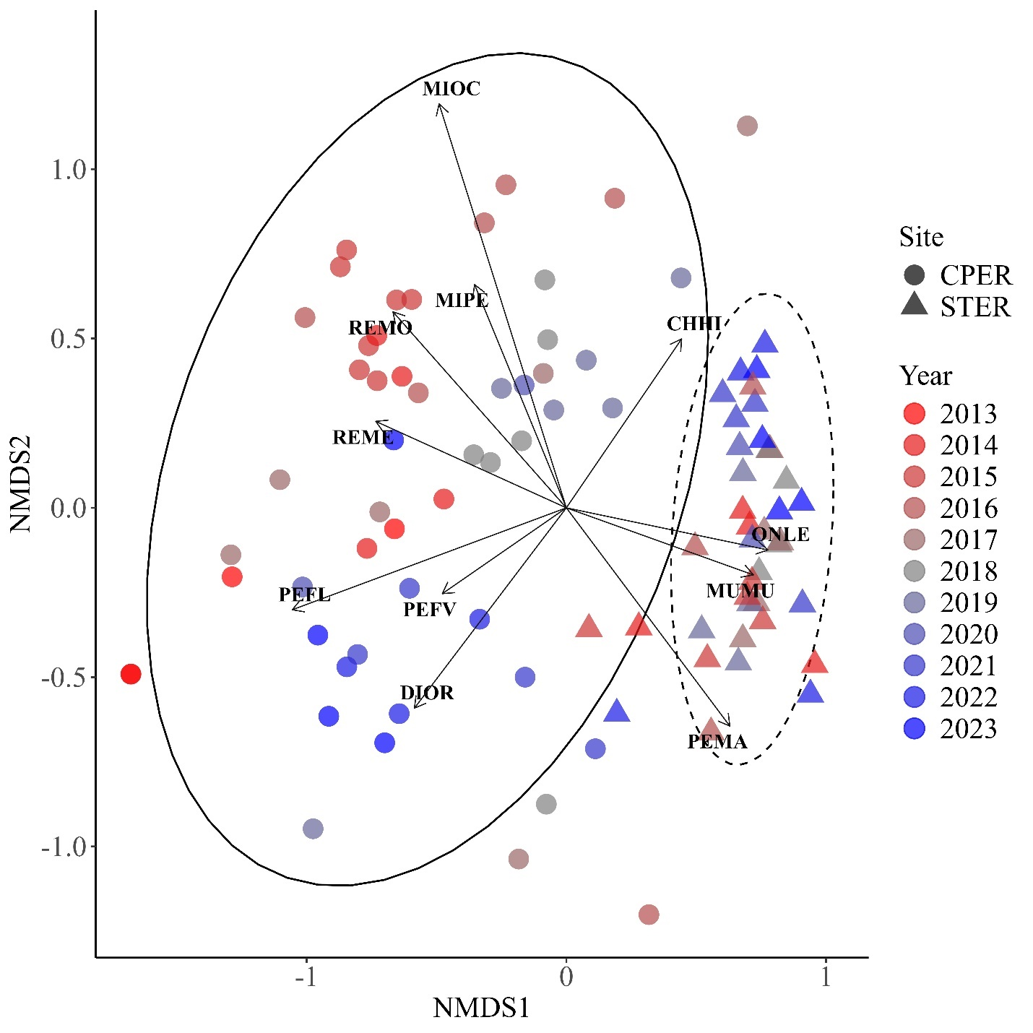
Supplementary Fig 2. The two-dimensional non-metric multidimensional scaling (NMDS) ordination plot showing two sites in Colorado, United States, with small mammal community compositional differences (NMDS stress = 0.164, using Bray-Curtis distance). Annual variation highlighted by color red to blue. CPER is a native shortgrass prairie site whereas STER is an active agricultural site. Ovals represent confidence intervals within which 95% of communities would be expected to fall in the ordination.

- NMDS ordination graph for season
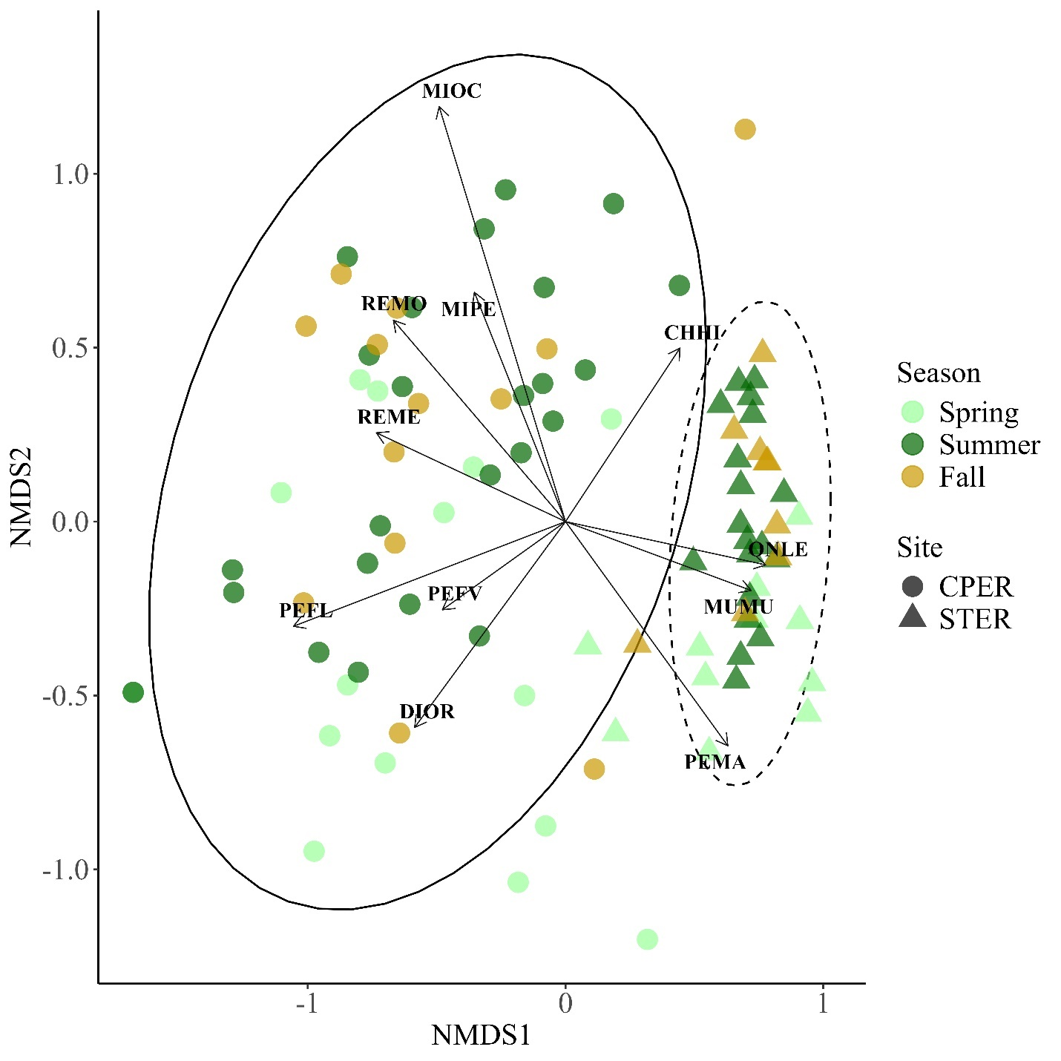
Supplementary Fig 3. The two-dimensional non-metric multidimensional scaling (NMDS) ordination plot showing two sites in Colorado, United States, with small mammal community compositional differences (NMDS stress = 0.164, using Bray-Curtis distance). Seasonal variation highlighted by color light green – spring, dark green – summer, and yellow – fall. CPER is a native shortgrass prairie site whereas STER is an active agricultural site. Ovals represent confidence intervals within which 95% of communities would be expected to fall in the ordination.

