Supplementary Information

Network Analysis for Estimating Standardization Trend in the Genomics
Eun Bit Bae¹, Se Jin Nam², Sun Ju Ahn¹
¹Institute of Quantum Biophysics, Sungkyunkwan University, Seoul, South Korea
²Department of Global Convergence, Sungkyunkwan University, Seoul, South Korea

Class level | Class | Catogory | Total frequency (N=)
Large | Academic | Biology | 1025
Large | Academic | General | 1313
Large | Academic | Genetics | 8522
Large | Academic | Medicine | 3344
Large | Academic | Proteomics | 1510
Large | Academic | Statistics | 624
Middle | Technical | Biologicals | 707
Middle | Technical | Clinical | 1103
Middle | Technical | Company/Consortium | 536
Middle | Technical | Database/Software | 1393
Middle | Technical | Disease | 1204
Middle | Technical | Gene | 3276
Middle | Technical | Genetics term | 3019
Middle | Technical | Methods | 1725
Middle | Technical | Organism | 490
Middle | Technical | Pathogen | 1006
Middle | Technical | Proteomics | 1034
Middle | Technical | Statistics | 720
Table S1. Keywords frequency of academic/ technical category. Database (Data related) category: N=702, Software category: N=691

Modularity= 0 |  | Modularity= 1 |  | Modularity= 2 |  | Modularity= 3
Keyword | PageRank | Keyword | PageRank | Keyword | PageRank | Keyword | PageRank
genome | 0.0167 | gene | 0.0244 | nano gram | 0.0159 | WGS | 0.0087
SNP | 0.0148 | mRNA | 0.0067 | tumor | 0.0105 | Escherichia | 0.0084
disease | 0.0128 | qPCR | 0.0066 | therapy | 0.0076 | bacteria | 0.0061
allele | 0.0119 | microarray | 0.0052 | EGFR | 0.0056 | pathogen | 0.0053
clinician | 0.0097 | Arabidopsis | 0.0048 | IHC | 0.0043 | Mycobacterium | 0.0051
genomics | 0.0084 | geNorm | 0.0048 | KRAS | 0.0041 | MLST | 0.0047
Illumina | 0.0075 | gene normalization | 0.0047 | NSCLC | 0.0041 | NCBI | 0.0039
Bayesian | 0.0072 | NormFinder | 0.0045 | targeted therapy | 0.0040 | MiSeq | 0.0038
genetics | 0.0058 | cDNA | 0.0042 | amplicon | 0.0037 | Pseudomonas | 0.0038
bioinformatics | 0.0058 | miRNA | 0.0035 | tumor DNA | 0.0037 | Streptococcus | 0.0037
Modularity= 4 |  | Modularity= 5 |  | Modularity= 6 |  | Modularity= 7
Keyword | PageRank | Keyword | PageRank | Keyword | PageRank | Keyword | PageRank
CpG | 0.0053 | rRNA | 0.0042 | protein | 0.0152 | diagnosis | 0.0077
WHO | 0.0051 | nucleotide | 0.0038 | biomarker | 0.0095 | CNV | 0.0056
DNA methylation | 0.0040 | GenBank | 0.0037 | proteomics | 0.0087 | genomic hybridization | 0.0054
methylation | 0.0037 | codon | 0.0036 | algorithm | 0.0075 | genomic DNA | 0.0047
MGMT | 0.0036 | genotyping | 0.0033 | peptide | 0.0063 | STR | 0.0032
inhibitor | 0.0036 | mitochondrial genome | 0.0031 | database | 0.0060 | chromosome | 0.0031
AML | 0.0036 | mtDNA | 0.0031 | knowledge | 0.0047 | BAC | 0.0030
ROC | 0.0034 | phylogenetic | 0.0031 | reproducibility | 0.0046 | aCGH | 0.0029
TMZ | 0.0032 | tRNA | 0.0031 | FDR | 0.0040 | MLPA | 0.0028
IDH | 0.0031 | RNA | 0.0029 | measurement | 0.0040 | haplotype | 0.0028
Table S2. Keywords list of modularity score in order of PageRank top ten. Colors in Figure 1 followed modularity score and the node size followed PageRank score.

1-year similarity |  | 1-year interval similarity |  | 2-year interval similarity
Year | Similarity | Year | Similarity | Year | Similarity
2000 - 2001 | 0.267 | 2000:2001 - 2001:2002 | 0.515 | 2000:2002 - 2001:2003 | 0.649
2001 - 2002 | 0.274 | 2001:2002 - 2002:2003 | 0.572 | 2001:2003 - 2002:2004 | 0.612
2002 - 2003 | 0.298 | 2002:2003 - 2003:2004 | 0.518 | 2002:2004 - 2003:2005 | 0.652
2003 - 2004 | 0.294 | 2003:2004 - 2004:2005 | 0.566 | 2003:2005 - 2004:2006 | 0.695
2004 - 2005 | 0.396 | 2004:2005 - 2005:2006 | 0.622 | 2004:2006 - 2005:2007 | 0.735
2005 - 2006 | 0.377 | 2005:2006 - 2006:2007 | 0.624 | 2005:2007 - 2006:2008 | 0.710
2006 - 2007 | 0.389 | 2006:2007 - 2007:2008 | 0.605 | 2006:2008 - 2007:2009 | 0.717
2007 - 2008 | 0.387 | 2007:2008 - 2008:2009 | 0.628 | 2007:2009 - 2008:2010 | 0.732
2008 - 2009 | 0.393 | 2008-2009 - 2009:2010 | 0.651 | 2008:2010 - 2009:2011 | 0.745
2009 - 2010 | 0.434 | 2009:2010 - 2010:2011 | 0.640 | 2009:2011 - 2010:2012 | 0.708
2010 - 2011 | 0.439 | 2010:2011 - 2011:2012 | 0.624 | 2010:2012 - 2011:2013 | 0.770
2011 - 2012 | 0.397 | 2011:2012 - 2012:2013 | 0.684 | 2011:2013 - 2012:2014 | 0.761
2012 - 2013 | 0.485 | 2012:2013 - 2013:2014 | 0.692 | 2012:2014 - 2013:2015 | 0.757
2013 - 2014 | 0.486 | 2013:2014 - 2014:2015 | 0.682 | 2013:2015 - 2014:2016 | 0.766
2014 - 2015 | 0.480 | 2014:2015 - 2015:2016 | 0.689 | 2014:2016 - 2015:2017 | 0.775
2015 - 2016 | 0.491 | 2015:2016 - 2016:2017 | 0.716 | 2015:2017 - 2016:2018 | 0.798
2016 - 2017 | 0.503 | 2016:2017 - 2017:2018 | 0.736 | 2016:2018 - 2017:2019 | 0.796
2017 - 2018 | 0.541 | 2017:2018 - 2018:2019 | 0.737 | 2017:2019 - 2018:2020 | 0.774
2018 - 2019 | 0.544 | 2018:2019 - 2019:2020 | 0.675
2019 - 2020 | 0.349
Table S3. Similarity results of 1-year similarities, between 1-year interval similarities, between 2-year interval similarities.

Category | Phase | Phase 0 | Phase 1 | Phase 2 | Phase 3 | Phase 4
Biology  (N=15) | Phase 0 | 1.000 | 0.797** | 0.552* | 0.418 | 0.237
Biology  (N=15) | Phase 1 | 0.797** | 1.000 | 0.669** | 0.660** | 0.661**
Biology  (N=15) | Phase 2 | 0.552* | 0.669** | 1.000 | 0.611* | 0.486
Biology  (N=15) | Phase 3 | 0.418 | 0.660** | 0.611* | 1.000 | 0.819**
Biology  (N=15) | Phase 4 | 0.237 | 0.661** | 0.486 | 0.819** | 1.000
General  (N=6) | Phase 0 | 1.000 | 0.465 | 0.783 | -0.514 | -0.730
General  (N=6) | Phase 1 | 0.465 | 1.000 | 0.270 | 0.133 | -0.141
General  (N=6) | Phase 2 | 0.783 | 0.270 | 1.000 | -0.194 | -0.556
General  (N=6) | Phase 3 | -0.514 | 0.133 | -0.194 | 1.000 | 0.391
General  (N=6) | Phase 4 | -0.730 | -0.141 | -0.556 | 0.391 | 1.000
Genetics  (N=58) | Phase 0 | 1 | 0.505** | 0.112 | -0.043 | -0.036
Genetics  (N=58) | Phase 1 | 0.505** | 1 | 0.530** | 0.301* | 0.361**
Genetics  (N=58) | Phase 2 | 0.112 | 0.530** | 1 | 0.833** | 0.804**
Genetics  (N=58) | Phase 3 | -0.043 | 0.301* | 0.833** | 1 | 0.943**
Genetics  (N=58) | Phase 4 | -0.036 | 0.361** | 0.804** | 0.943** | 1
Medicine  (N=27) | Phase 0 | 1 | 0.394* | 0.280 | -0.056 | 0.024
Medicine  (N=27) | Phase 1 | 0.394* | 1 | 0.633** | 0.528** | 0.548**
Medicine  (N=27) | Phase 2 | 0.280 | 0.633** | 1 | 0.822** | 0.846**
Medicine  (N=27) | Phase 3 | -0.056 | 0.528** | 0.822** | 1 | 0.976**
Medicine  (N=27) | Phase 4 | 0.024 | 0.548** | 0.846** | 0.976** | 1
Proteomics  (N=7) | Phase 0 | - | - | - | - | -
Proteomics  (N=7) | Phase 1 | - | 1.000 | 0.000 | 0.412 | 0.635
Proteomics  (N=7) | Phase 2 | - | 0.000 | 1.000 | -0.559 | -0.222
Proteomics  (N=7) | Phase 3 | - | 0.412 | -0.559 | 1.000 | 0.898**
Proteomics  (N=7) | Phase 4 | - | 0.635 | -0.222 | 0.898** | 1.000
Statistics  (N=5) | Phase 0 | 1.000 | 0.612 | 0.866 | 0.866 | 0.577
Statistics  (N=5) | Phase 1 | 0.612 | 1.000 | 0.707 | 0.707 | 0.707
Statistics  (N=5) | Phase 2 | 0.866 | 0.707 | 1.000 | 1.000** | 0.800
Statistics  (N=5) | Phase 3 | 0.866 | 0.707 | 1.000** | 1.000 | 0.800
Statistics  (N=5) | Phase 4 | 0.577 | 0.707 | 0.800 | 0.800 | 1.000
Table S4. Correlation results analyzed phase by phase in each academic category. N= Number of each keyword (not keyword frequency).
Phase | Category | B | SE | t | Sig. | 95% Confidence Interval
 |  |  |  |  |  | Lower | Upper
Phase 0 | Biology | 1.785 | 1.002 | 1.781 | 0.076 | -0.187 | 3.756
 | General | -0.275 | 0.992 | -0.277 | 0.782 | -2.226 | 1.677
 | Genetics | 0.908 | 0.779 | 1.166 | 0.245 | -0.624 | 2.440
 | Medicine | 0.532 | 0.816 | 0.652 | 0.515 | -1.073 | 2.137
 | Proteomics | 0.066 | 0.932 | 0.071 | 0.943 | -1.768 | 1.901
Phase 1 | Biology | 2.067 | 1.436 | 1.439 | 0.151 | -0.758 | 4.892
 | General | 0.114 | 1.421 | 0.080 | 0.936 | -2.682 | 2.911
 | Genetics | 1.329 | 1.116 | 1.191 | 0.234 | -0.866 | 3.524
 | Medicine | 0.997 | 1.169 | 0.853 | 0.394 | -1.302 | 3.297
 | Proteomics | 0.803 | 1.336 | 0.601 | 0.548 | -1.825 | 3.431
Phase 2 | Biology | 3.112 | 9.724 | 0.320 | 0.749 | -16.017 | 22.242
 | General | -1.146 | 9.625 | -0.119 | 0.905 | -20.082 | 17.790
 | Genetics | 6.368 | 7.555 | 0.843 | 0.400 | -8.494 | 21.231
 | Medicine | -1.780 | 7.914 | -0.225 | 0.822 | -17.350 | 13.789
 | Proteomics | 9.319 | 9.046 | 1.030 | 0.304 | -8.477 | 27.116
Phase 3 | Biology | 3.292 | 8.396 | 0.392 | 0.695 | -13.226 | 19.810
 | General | 7.169 | 8.311 | 0.863 | 0.389 | -9.181 | 23.520
 | Genetics | 7.230 | 6.523 | 1.108 | 0.269 | -5.603 | 20.064
 | Medicine | 2.140 | 6.834 | 0.313 | 0.754 | -11.304 | 15.584
 | Proteomics | 4.570 | 7.811 | 0.585 | 0.559 | -10.796 | 19.937
Phase 4 | Biology | 4.220 | 9.441 | 0.447 | 0.655 | -14.353 | 22.793
 | General | 13.600 | 9.345 | 1.455 | 0.147 | -4.785 | 31.984
 | Genetics | 7.283 | 7.335 | 0.993 | 0.321 | -7.147 | 21.713
 | Medicine | 6.367 | 7.684 | 0.829 | 0.408 | -8.750 | 21.484
 | Proteomics | 1.109 | 8.783 | 0.126 | 0.900 | -16.170 | 18.387
Table S5. General linear model results of the academic categories.

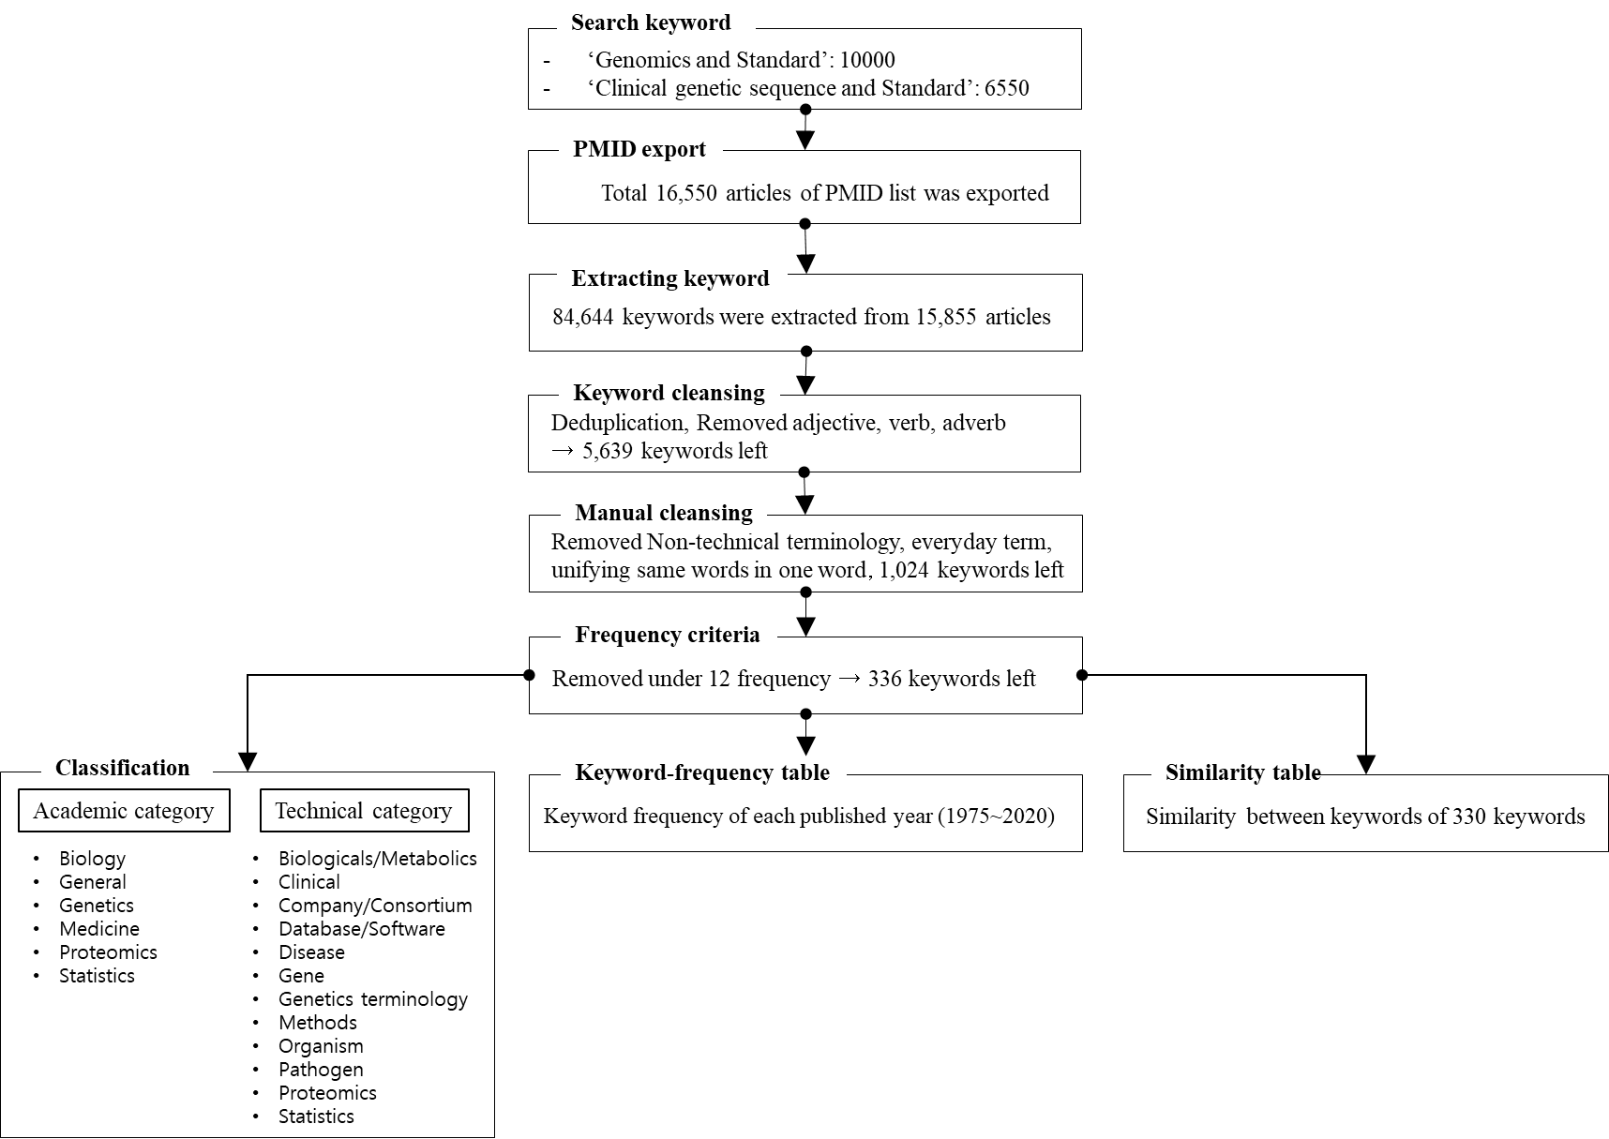
Figure S1. Keyword-data preparation procedure

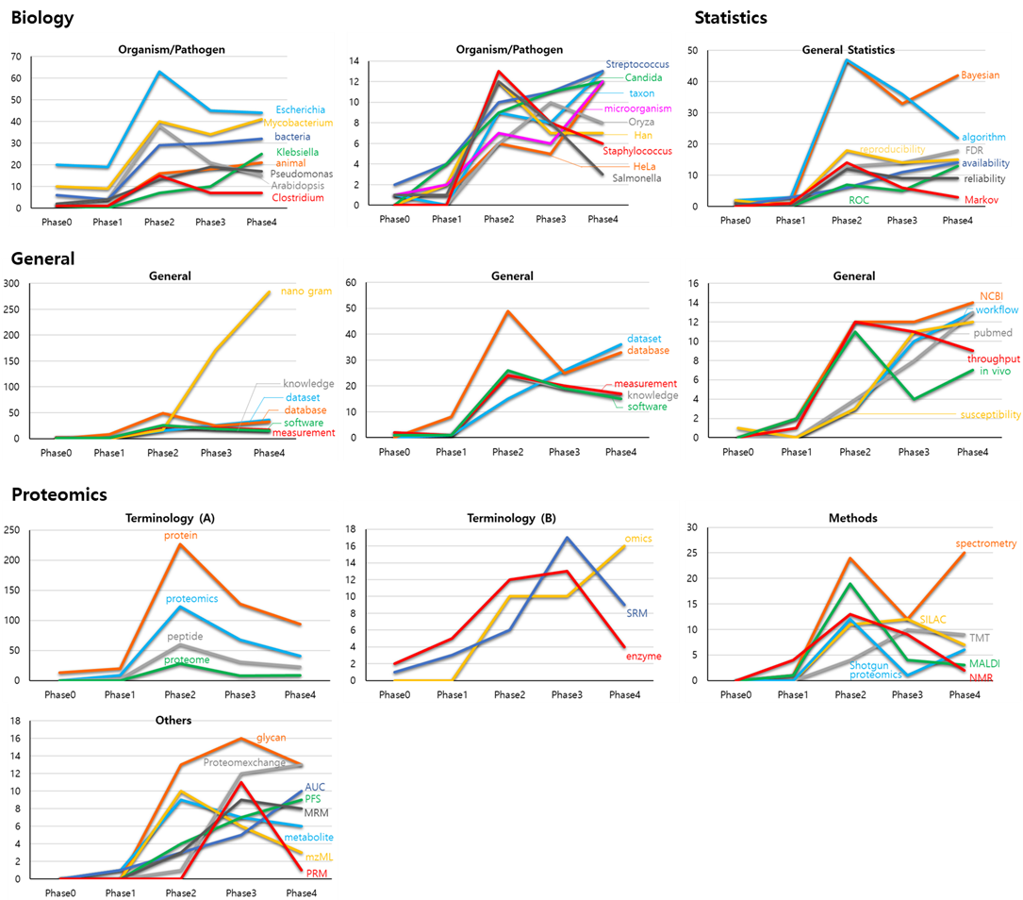
Figure S2. Keyword frequency of each keyword displayed by the academic categories.
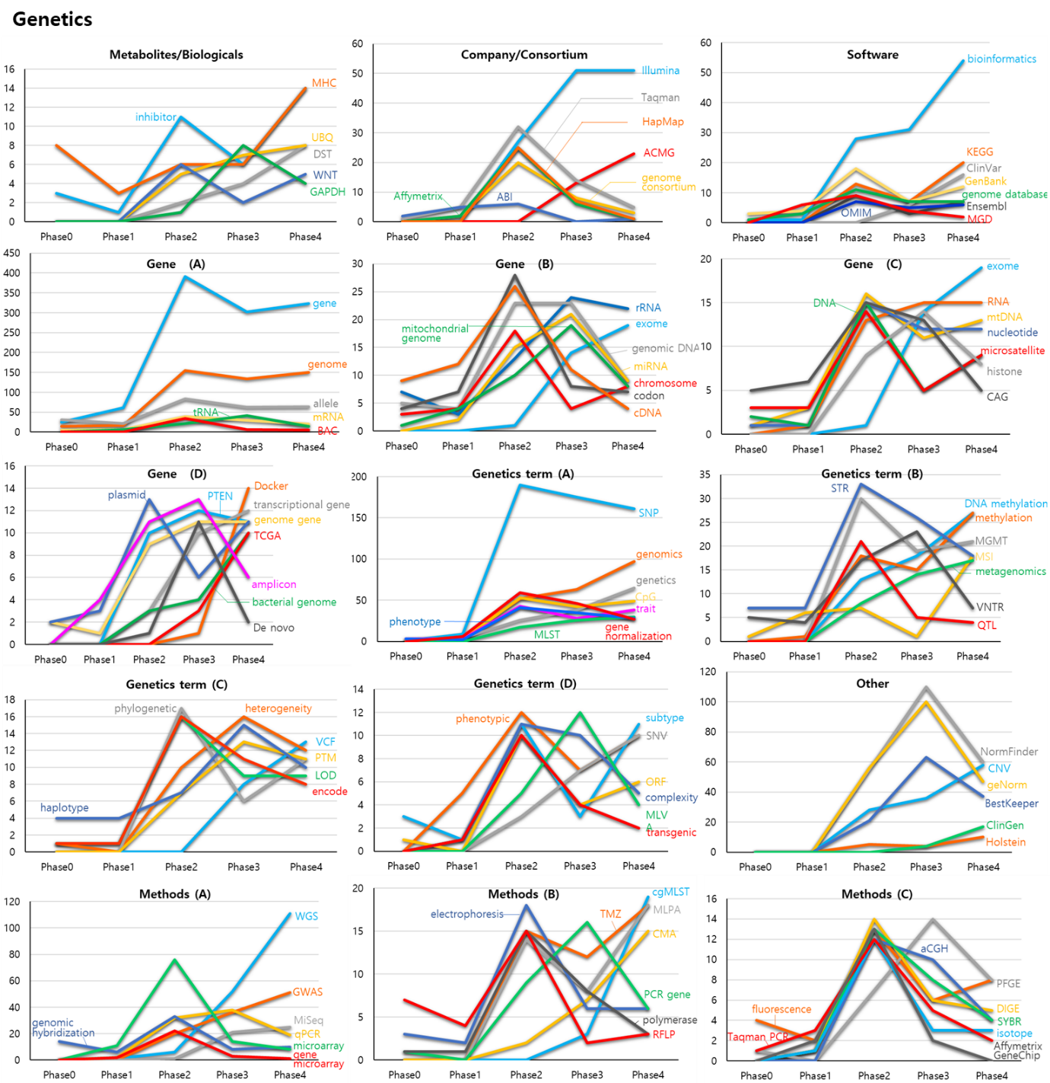
Database
Figure S3. Keyword frequency graph of the “Genetics” academy category.
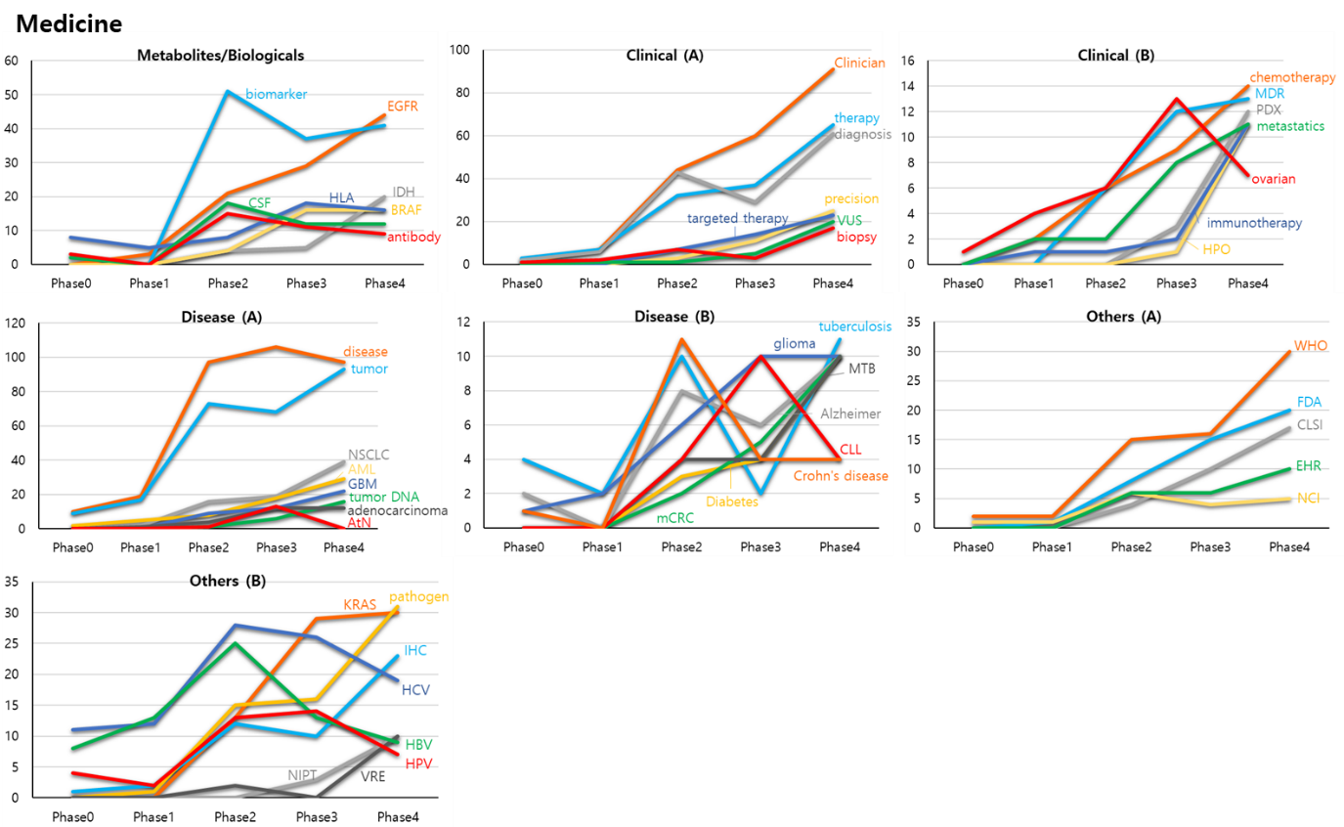
Figure S4. Keyword frequency graph of the “Medicine” academic category.

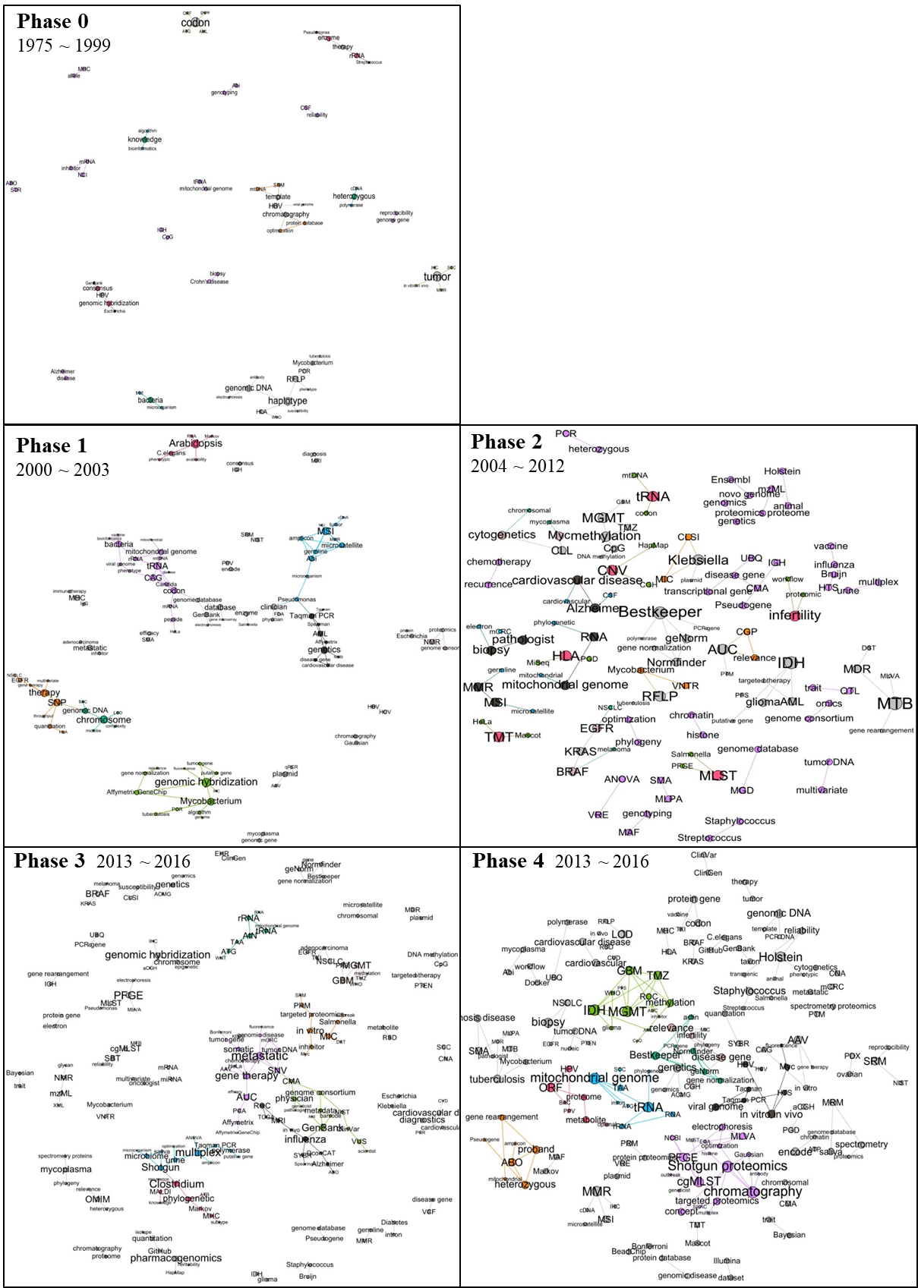Figure S5. Keyword network of each phase.

