Supplements
Sensitivity of global land-based mitigation potential to land-use scenarios and interactions across sectors

Contents

Methods 2
Detailed Scenario Components Descriptions 2
Emission Pricing 2
Global diet 3
Agricultural self-sufficiency 3
Biodiversity habitat conservation 4
Biomaterial utilisation 4
Wildfire activity 5
Model Modifications for this study 6
Additional Figures 7
Glossary 22
References in this document 24

Methods

Detailed Scenario Components Descriptions

Emission Pricing
The emission pricing cases represent different levels of progressive emission penalties applied per tonne of net positive CO₂, CH₄, and N₂O emissions remaining in the atmosphere at the end of each time step. These penalties are derived from shadow prices in a baseline SuCCESs run, where global temperature limits were imposed as constraints.
In the none emission pricing case, no temperature limits are applied, meaning there is no emission penalty. The steady transition case maintains a strict 2°C limit throughout the century, prohibiting overshoot, with the emission penalty increasing gradually over time. The early decarbonisation case enforces a 1.5°C limit without overshoot flexibility, causing the penalty to rise sharply until mid-century before stabilizing, ultimately converging with the steady transition penalty by 2100. In contrast, the overshoot case allows temporary overshoot as long as the temperature returns to or below 1.5°C by 2100. This results in an exponentially increasing penalty, reaching three times the level of the other pricing cases by the end of the century.
For a discussion of the comparably low emission pricing for temperature pathways, please refer to page 9 in this document.
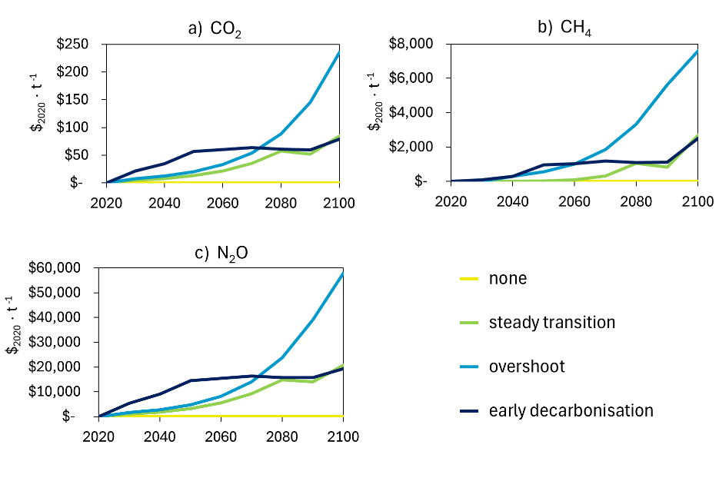
Fig. S-F1: Price development per tonne of a) carbon dioxide, b) methane, and c) nitrous oxide in the four emission pricing cases.

Global diet
The four global diet scenarios reflect different per-capita consumption patterns across key food categories, including crops (cereals, fruits, nuts, and vegetables), milk (90% cow), eggs (90% chicken), poultry (97% chicken), pork, beef, and “shoat” meat (50% goat, 50% sheep) (Fig. S-F2). Each diet assumes a caloric supply of around 3000 kcal per person per day (FAO, 2023a; van Dijk et al., 2021). The per-capita consumption was derived from MAgPIE validation runs for SSP2 and SSP1 (Dietrich, 2019; Dietrich et al., 2019). Global demand is then estimated by scaling per-capita consumption with SSP2 decadal population projections (IIASA, 2024; Samir et al., 2024).
The Omnivore diet follows MAgPIE’s SSP2 assumptions, characterized by increasing demand for livestock products over time. The Flexitarian diet aligns with the MAgPIE’s SSP1 scenario, which adapts a sustainable livestock products consumption in the latter half of the century (Dietrich, 2019). The Lacto-Ovo diet maintains SSP2-level milk and egg consumption but transitions to consuming only culled livestock for meat between 2030 and 2050. Finally, the Vegan diet gradually transitions to a fully crop-based diet over the same period. To compensate for the reduced intake of animal products, we assumed an increase in per-capita crop demand in the Lacto-Ovo (+8.9%) and Vegan (+26.3%) diets (Smith et al., 2022).

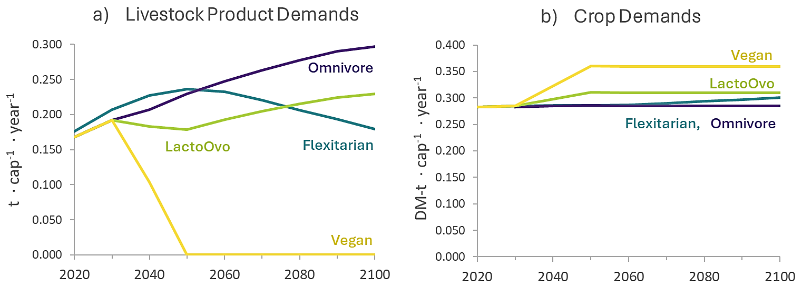
Fig. S-F2: Per-capita food demand for a) livestock-derived products (milk, eggs, beef, pork, poultry, sheep, goat) and b) crops (cereals, fruits, nuts, vegetables).

Global food distirbution
On average, national agricultural self-sufficiency exceeds 60% globally (Economist Impact & Corteva Agriscience, 2022; FAO, 2023b; Izraelov and Silber, 2019). The SuCCESs model operates as a global single-region framework without explicit regional resolution. However, its land use module, CLASH, optimizes land use within ten major biomes (supplement Fig. S-F3) (Ekholm et al., 2024b). To model spatial variations in food demand and availability, we estimated the share of the global population residing in each biome and used this to approximate the distribution of global food demand (Gao, 2017; Jones and O’Neill, 2016).
In our scenarios, the global food market case assumes unrestricted food distribution, allowing food to be produced and consumed anywhere. In contrast, the restricted food distribution case imposes a constraint requiring 65% of each biome’s food demand to be met within that biome, reflecting stylized limitations on global food distribution. Due to SuCCESs’ coarse spatial resolution, this approach cannot represent realistic national self-sufficiency constraints or international trade but offers an order-of-magnitude estimate of how regional land use restrictions could impact global mitigation potential within the model’s current capabilities.

Biodiversity habitat conservation
In this study, biodiversity habitat is counted as the SuCCESs land use classes primary ecosystems (pristine forests and non-forests), managed non-forests (e.g., grasslands and shrublands), and managed forests older than 80 years (mature forests). The model cannot create pristine ecosystems.
The No Additional Habitat Protection case follows the Land Use Harmonization Project’s SSP2-projected land use as a lower limit (Hurtt et al., 2020; Ekholm et al., 2024b). This also includes the current global protected land area of 17% (UNEP-WCMC, 2020). Above this, the model can allocate and manage land freely. The Primary Ecosystem Protection case prevents any net loss of primary ecosystems from 2020 levels, aiming to minimize species and population declines (Díaz et al., 2020). The Maturing habitats case doubles the area of mature managed forests from 2020 level until 2100.
The Halting Biodiversity Loss case represents large-scale restoration efforts to reverse land-use change-driven biodiversity loss. It requires a net increase in natural land classes—including primary ecosystems, secondary non-forests, and secondary forests older than 80 years—by 1.44 million km² by 2050 and 4.32 million km² by 2100 (Leclère et al., 2020). This component made scenarios infeasible, likely because the optimisation was not able to expand natural areas by this magnitude and fulfil food and wood demands simultaneously. Therefore, these results are not further presented or discussed in this paper.

Biomaterial utilisation
The Forestry as Usual scenario follows SSP2-level demand for wood-derived products, including timber, paper, and pulp (IIASA, 2018). The Electronic Papers scenario assumes a 90% shift of graphic paper use to digital formats, covering newspapers, magazines, books, and advertisements. Following 2020 statistics, we assume graphic paper accounts for 24% of total paper demand (FAO, 2021). To enhance urban carbon storage, the Timber Cities scenario follows Mishra et al. (2022), assuming that half of new urban residential buildings are constructed with wood, thereby reducing cement demand (Table 1). Urbanization trends follow SSP2 projections for population growth and urban expansion (IIASA, 2024, 2018).

Table 1: Scenarios for wood-based products demand. “Forestry as Usual” refers to the original demands for timber and paper in SuCCESs.
 | Wood demand  (Mt DM ∙yr⁻¹) |  |  | cement demand  (Mt ∙yr⁻¹) |  |  | Paper demand  (Mt ∙yr⁻¹)
 | Forestry as Usual | Timber Cities | Change | Forestry as Usual | Timber Cities | Change | Forestry as Usual | Electronic Papers | Change
2020 | 780 | 780 | 0% | 4050 | 4050 | 0% | 116 | 116 | 0%
2030 | 870 | 1000 | 15% | 5463 | 5349 | -2% | 98 | 77 | -21%
2040 | 945 | 1197 | 27% | 6387 | 6167 | -3% | 87 | 68 | -21%
2050 | 1005 | 1365 | 36% | 7001 | 6687 | -4% | 79 | 62 | -21%
2060 | 1052 | 1498 | 42% | 7413 | 7024 | -5% | 74 | 58 | -21%
2070 | 1090 | 1616 | 48% | 7701 | 7242 | -6% | 70 | 55 | -21%
2080 | 1118 | 1719 | 54% | 7891 | 7367 | -7% | 68 | 53 | -21%
2090 | 1140 | 1810 | 59% | 8018 | 7433 | -7% | 66 | 52 | -21%
2100 | 1157 | 1878 | 62% | 8102 | 7472 | -8% | 65 | 51 | -21%

Wildfire activity
Wildfire activity is determined by the parametrization of SuCCESs’ land-use module CLASH, and they occur only in secondary (managed) forests in the current model version (Ekholm et al., 2024b). The parametrization has originally been calculated with the LPJ-Guess-Simfire-Blaze model (Knorr et al., 2014; Rabin et al., 2017). Simfire-Blaze has been shown to outperform other wildfire models in the estimation of annual globally burnt area in intercomparisons with satellite observations (Andela et al., 2017). While Simfire-Blaze has effectively depicted global wildfires in the early 21st century, there is no assurance it will maintain accuracy under climate shifts. To illustrate the current uncertainties surrounding climatic forest fires, we symmetrically incorporated into SuCCESs’ default projections the range of estimated changes in global burnt forest area due to climatic change by an ensemble of leading integrated assessment models (Jäger et al., 2024) (Table 2). Our three wildfire cases consist of the upper and lower limits of the range, along with the default value.

Table 2: Forest Fire Activity. The proportion of secondary forest burned up each year (reset to age class zero) per biome in the land-use model in SuCCESs (Ekholm et al., 2024b) listed from highest to lowest proportion in 2020. The range of uncertainty corresponds to the standard deviation in future estimated burnt forest area of five integrated assessment models.
Parametrization: EC-Earth 3  (bias-corrected) | 2020  % | 2050 (range)  % |  |  |  | 2100 (range)  %
Tropical-Dry | 16.356 | 14.105 | (13.176 | - | 15.034) | 10.355 | (8.649 | - | 12.060)
Semiarid | 5.658 | 6.572 | (6.250 | - | 6.893) | 8.094 | (7.504 | - | 8.684)
Desert | 1.865 | 2.004 | (1.898 | - | 2.110) | 2.234 | (2.040 | - | 2.429)
Temperate-Dry | 1.025 | 0.900 | (0.842 | - | 0.958) | 0.691 | (0.584 | - | 0.7989)
Tropical-Humid | 0.899 | 0.776 | (0.725 | - | 0.827) | 0.572 | (0.478 | - | 0.665)
Desert-Cold | 0.702 | 0.732 | (0.692 | - | 0.772) | 0.782 | (0.709 | - | 0.855)
Boreal | 0.368 | 0.373 | (0.352 | - | 0.394) | 0.380 | (0.342 | - | 0.419)
Tundra | 0.326 | 0.347 | (0.329 | - | 0.366) | 0.382 | (0.348 | - | 0.416)
Temperate-Humid | 0.247 | 0.214 | (0.200 | - | 0.228) | 0.160 | (0.134 | - | 0.186)
Unproductive | 0.046 | 0.066 | (0.064 | - | 0.069) | 0.100 | (0.096 | - | 0.105)

Model Modifications for this study
Study-specific modifications to SuCCESs firstly fixed carbon densities of managed land to 2020 values to exclude atmospheric CO₂ fertilization as anthropogenic mitigation. Food demand now follows SSP2 population projections (IIASA, 2024), and pasture use is directly tied to livestock numbers. Secondary forests must regenerate at a rate of 90% unless converted for other land uses. To prevent end-of-horizon distortions, cropland expansion is capped at 5% between 2090 and 2100. Lastly, this model version introduces a managed non-forest land category (“secdn2”), representing abandoned livestock pastures with pasture-level carbon density, which is counted as non-forested biodiversity habitat.
For the scenarios, we established emission penalties. The demand levels for timber, cement, pulp, and various food products were exogenously adjusted. We implemented the stylized representation of regional self-sufficiency by maintaining food production in proportion to each biome’s population share. Biodiversity conservation constraints limit harvesting and repurposing of pristine ecosystems while requiring habitat expansion. Wildfire activity scenarios adjust the proportion of managed forests burnt annually, resetting affected stands to age class zero.

Additional Figures

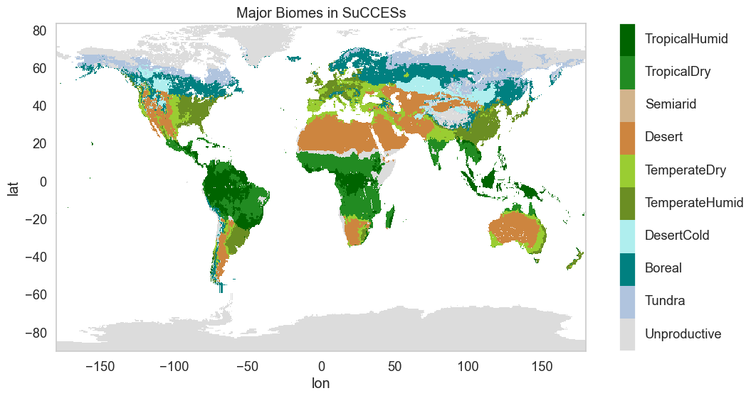
Fig. S-F3: Major biomes in the SuCCESs model. The model treats global land as point-sized single region, except for land-use considerations, which are separately solved with distinct parametrisations for the 10 major biomes.

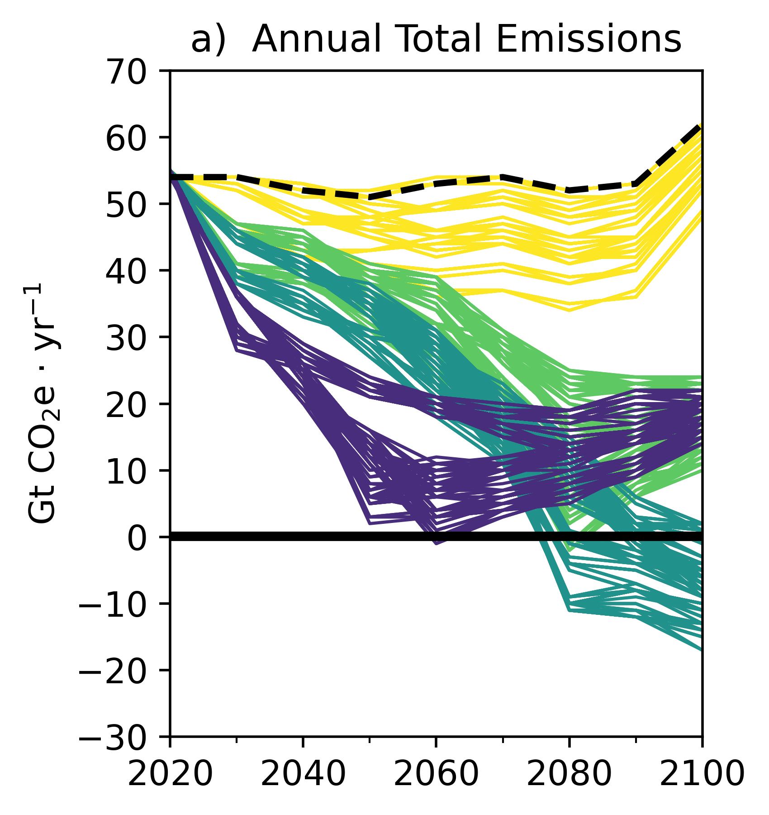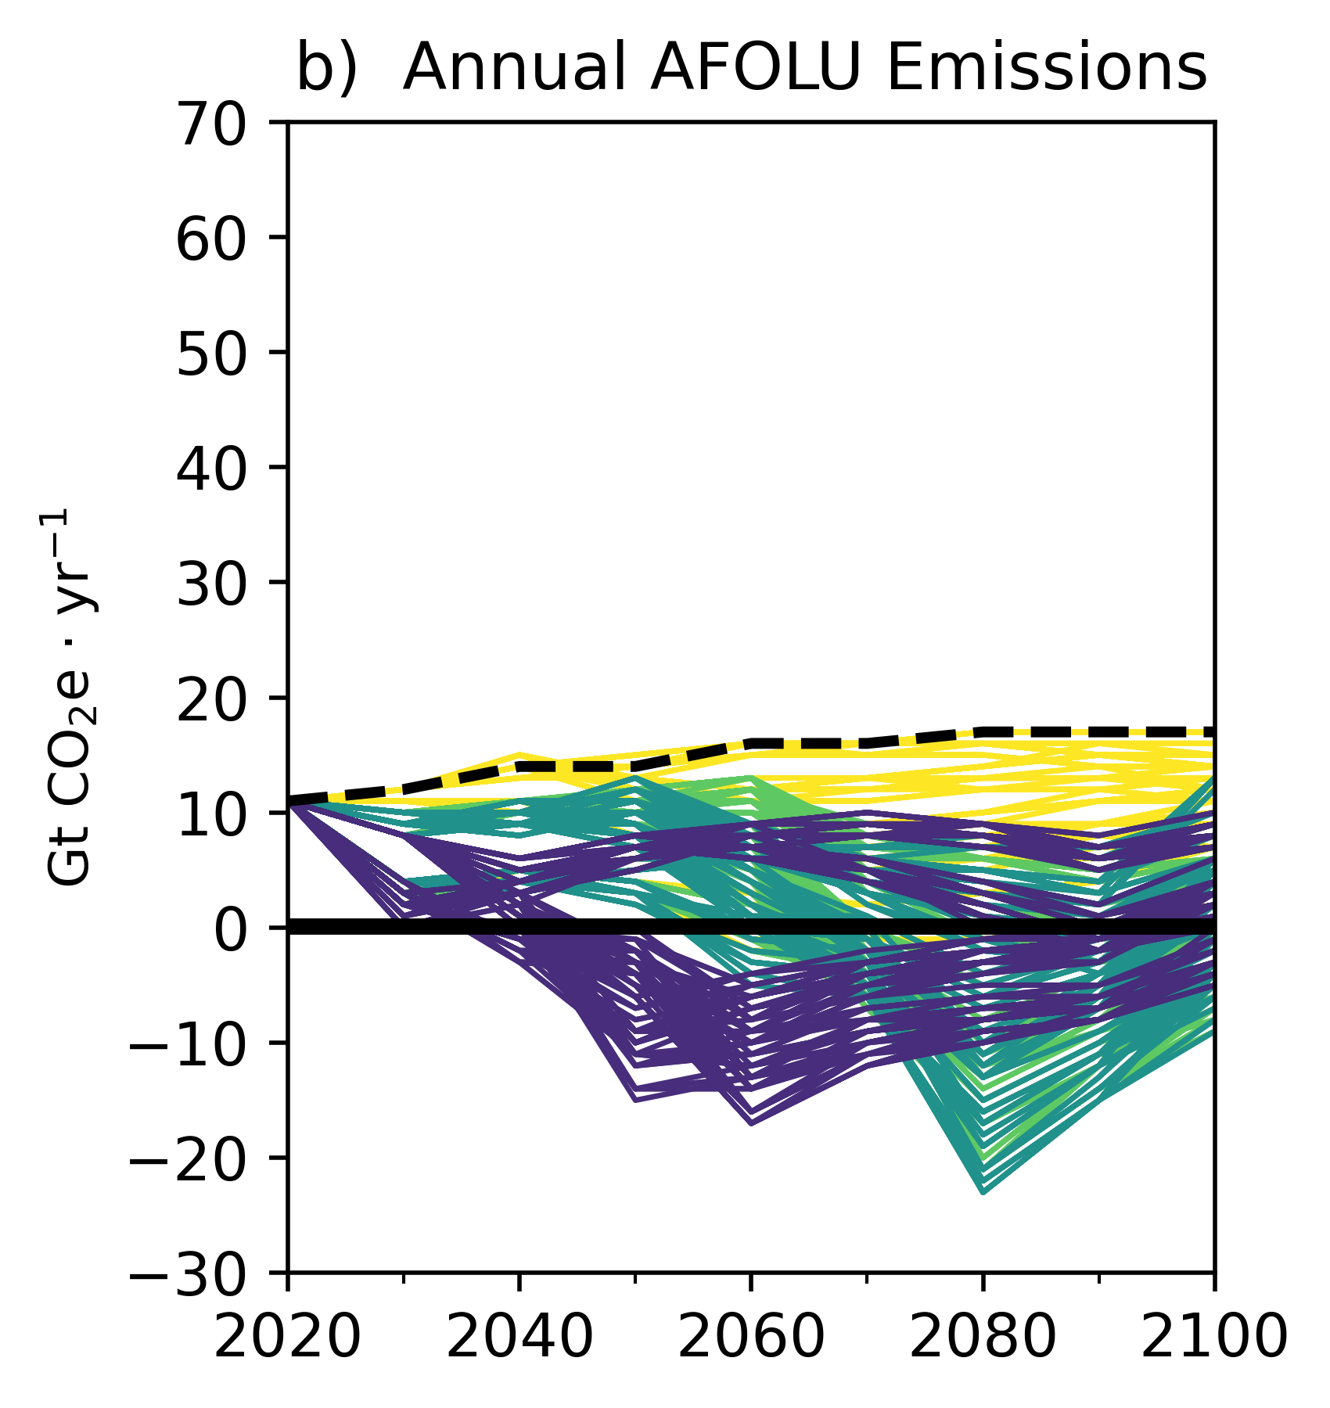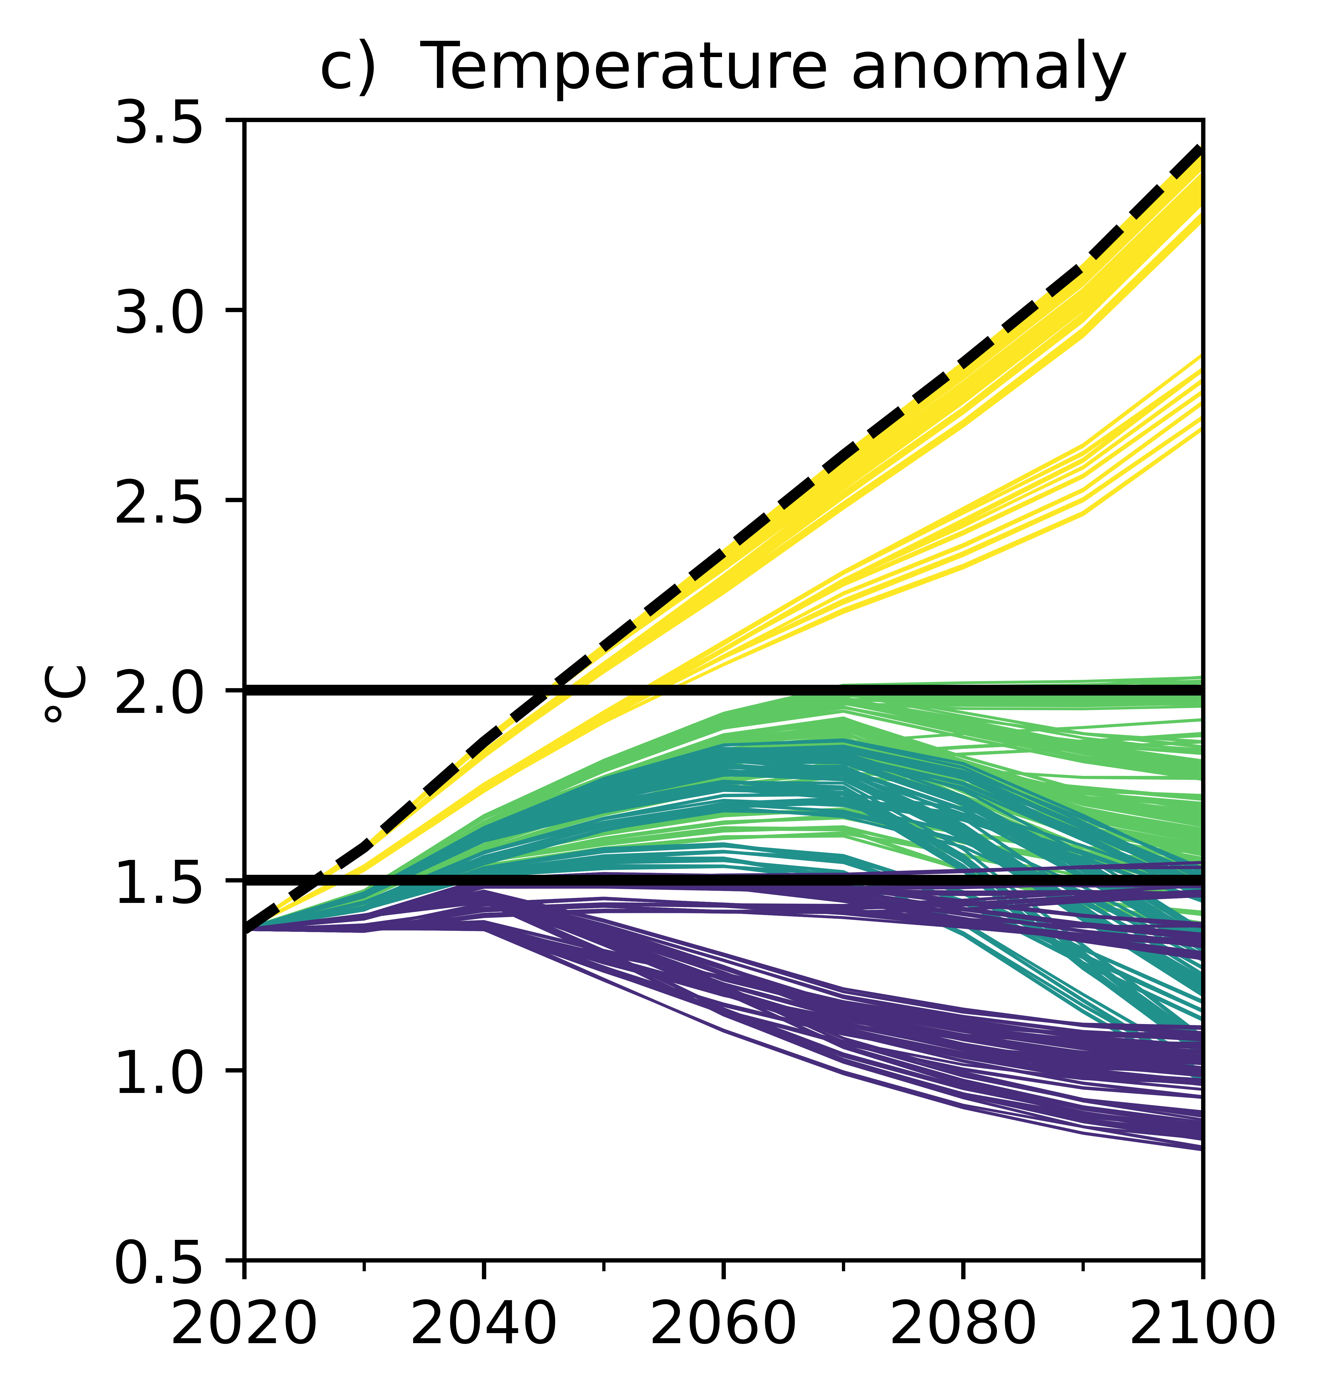
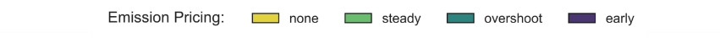
Fig. S-F4: a) Global annual total net emissions including fossil fuels, industry, and AFOLU sectors. b) Global annual AFOLU net emissions for different global diets. c) Global temperature anomaly. The trajectories are coloured according to emission pricing. The dashed black trajectory indicates the baseline scenario. The black lines in a) and b) mark net zero emissions. The two black lines in c) represent the two Paris Agreement limits. For discussion of line separations and emissions bounce-back of early decarbonisation and meat-free diets (dark blue lines), see discussion section below

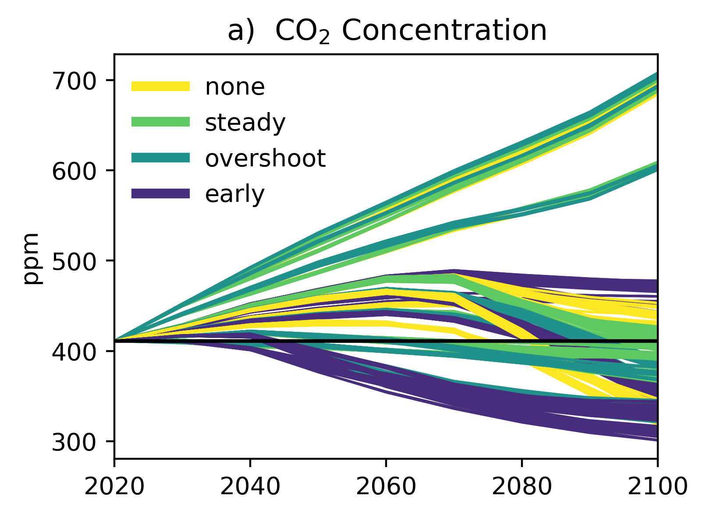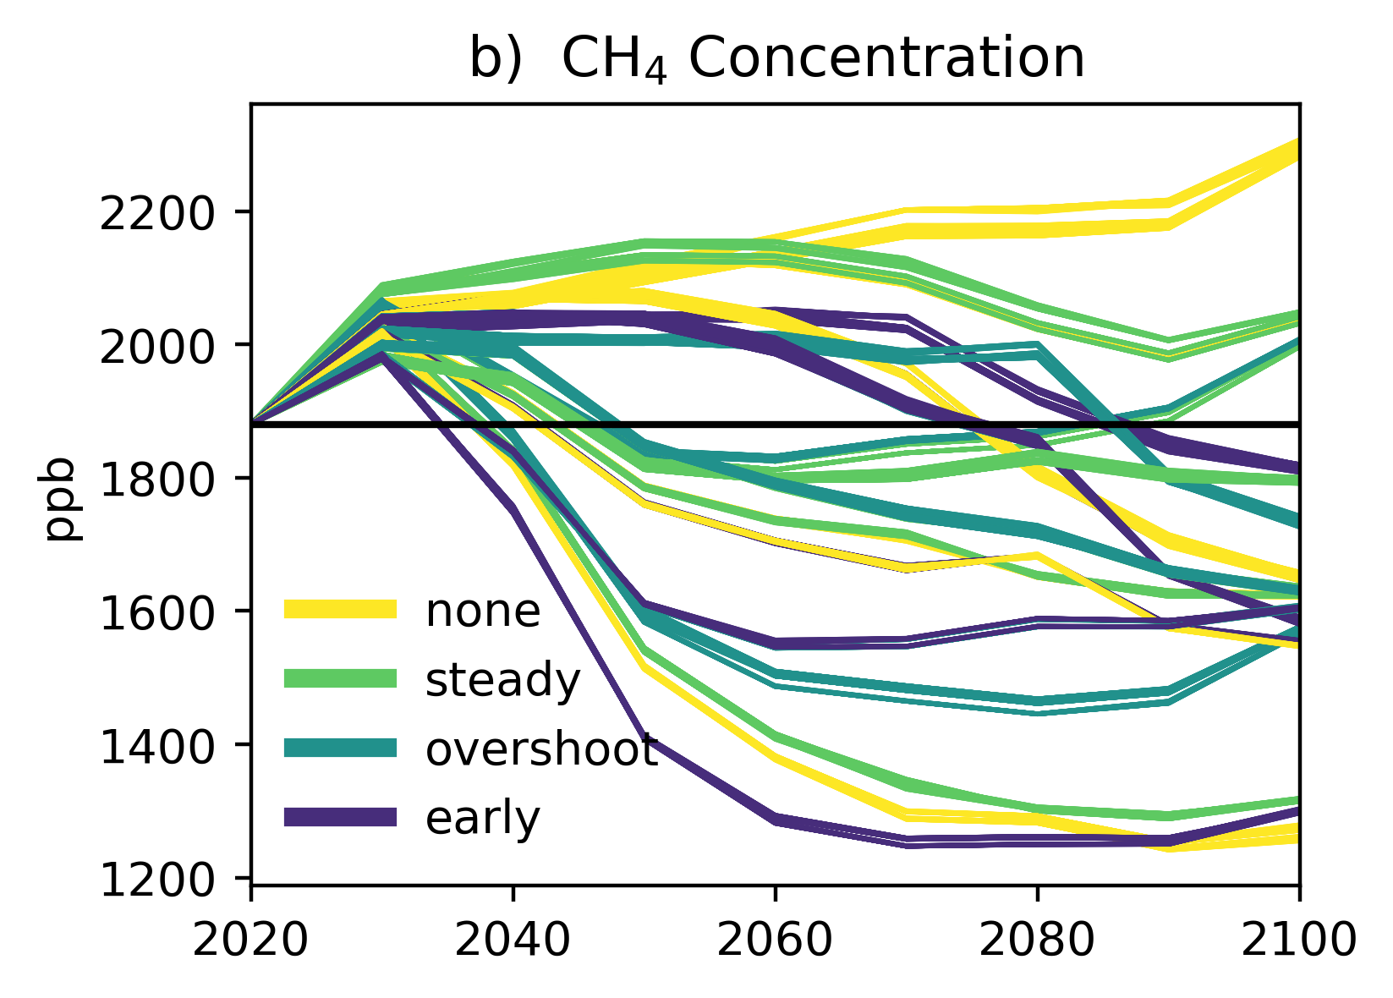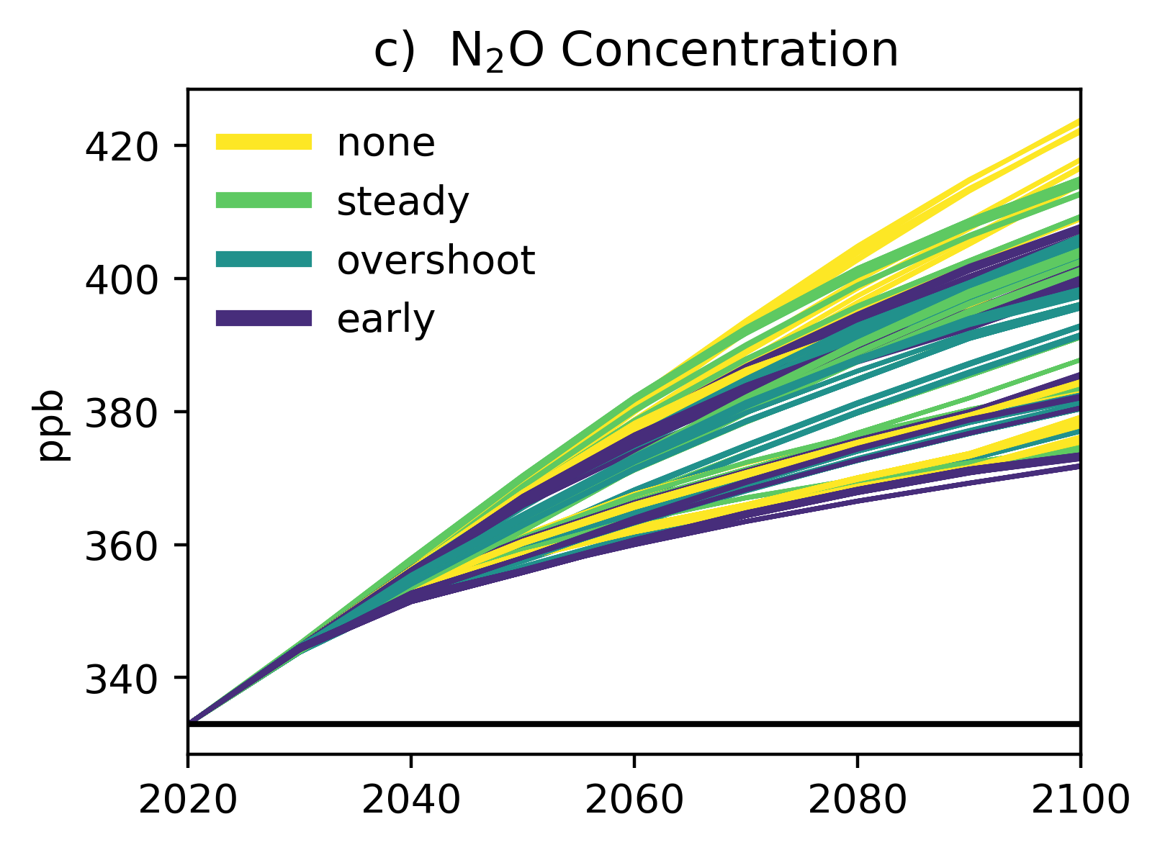
Fig. S-F5: Greenhouse gas concentrations among all scenarios, coloured by emission pricing. For discussion of GHG concentrations trajectories, see discussion section below

Discussion on emissions and concentrations trajectories
In Fig. S-F4, the clear divergence in emission pricing scenarios, particularly in early decarbonization (dark blue), is driven by dietary choices: lower emissions and temperatures result from reduced animal product consumption. In contrast, the pronounced trajectory separation in the no emission pricing scenarios (yellow lines), especially evident in panel c), stems from biodiversity conservation policies, distinguishing the Maturing Habitats case from less strict conservation.
In Fig. S-F4, in vegan and vegetarian scenarios under early decarbonisation emission pricing (dark blue lines, lower part of the separation), emissions decrease to almost net-zero by 2050, but continuously rise again thereafter while temperature anomaly steadily decreases. Conversely, the mitigation scenarios assessed by the IPCC limiting the temperature rise to 1.5°C with no or limited overshoot reach near-zero emissions already 2050s without the increasing trend in the latter half of the century (IPCC, 2023). This difference in higher allowed emissions for a given temperature response can be attributed to two factors. First, the natural (unmanaged) carbon sink in SuCCESs is stronger compared other IAMs, especially in vegan cases where primary ecosystem area remains large. Second, the transient climate response of SuCCESs (version 2024-10-23) seems to be low, which can be attributed to a parametrisation of the FaIR simple climate model (v2.0.0) on which SuCCESs’ temperature dynamics are based (Leach et al., 2021). This also leads to SuCCESs getting to lower radiative forcing levels with lower emission pricing than SSP scenarios (Ekholm et al., 2024a). However, this paper deals with the order of magnitude of relative interactions when combining variations, for which this feature is less relevant, although it likely has some impact on the exact values of the mitigation potentials.

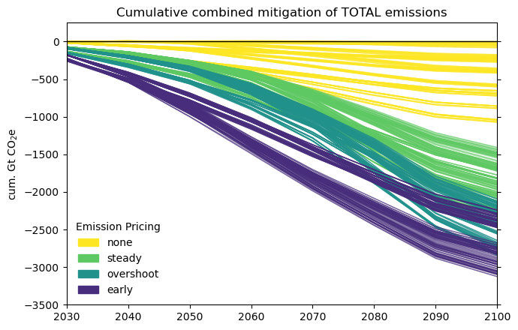
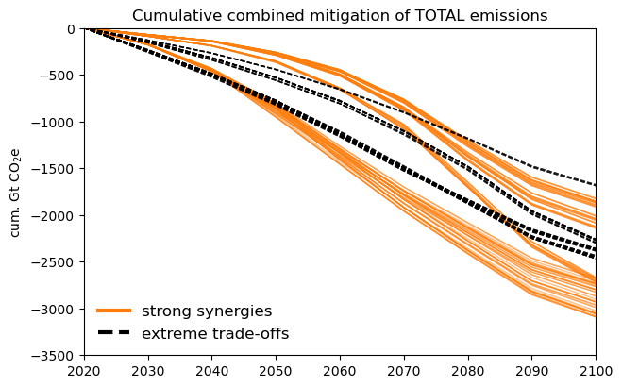
Fig. S-F6: Cumulative combined mitigation of total emissions (including fossil fuels, industry, and AFOLU sector) achieved in (top) all scenarios and (bottom) strong synergies and extreme trade-offs scenarios compared to baseline scenario (no emission price, omnivore diet, 65% self-sufficiency, no additional biodiversity habitat conservation, SSP2-level wood-product demand, and SuCCESs-default wildfire activity), coloured by emission pricing

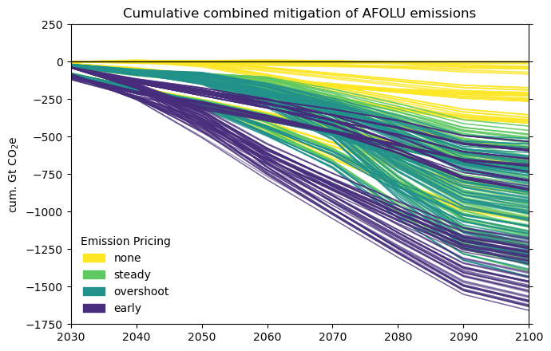
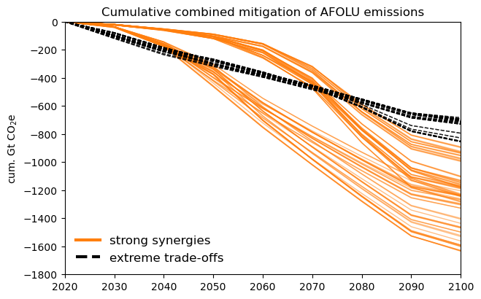
Fig. S-F7: Cumulative combined mitigation of agriculture, forestry, and land use (AFOLU) emissions achieved in (top panel) all scenarios and (bottom panel) strong synergies and extreme trade-offs scenarios compared to baseline scenario (no emission price, omnivore diet, 65% self-sufficiency, no additional biodiversity habitat conservation, SSP2-level wood-product demand, and SuCCESs-default wildfire activity), coloured by emission pricing. The strong separation between dark blue lines (early decarbonisation emission pricing) is caused by meat-eating versus meatless diets.

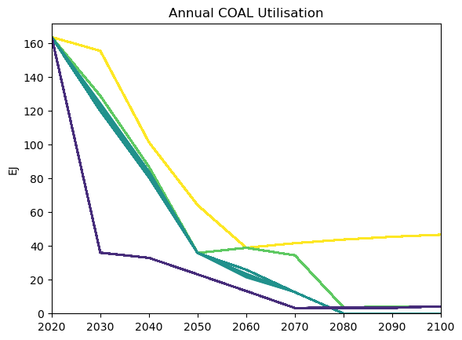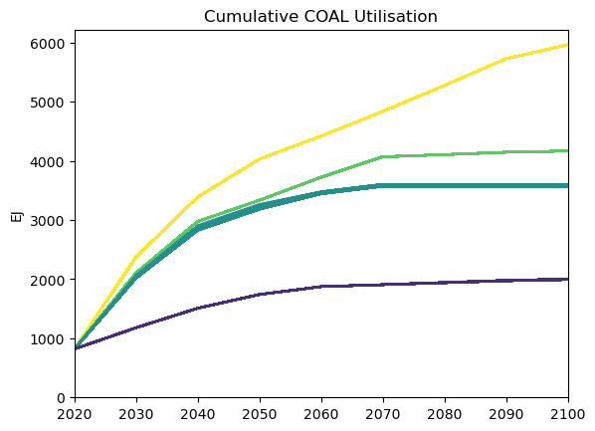
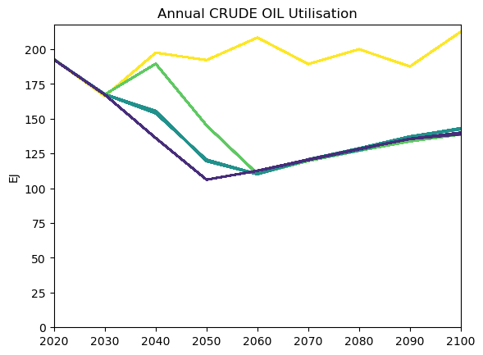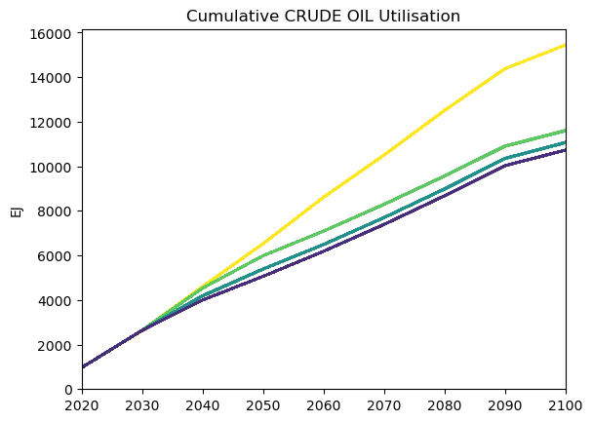
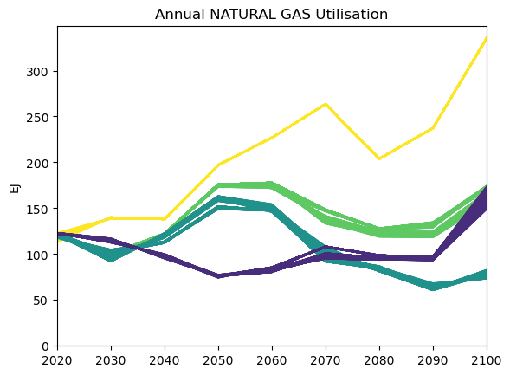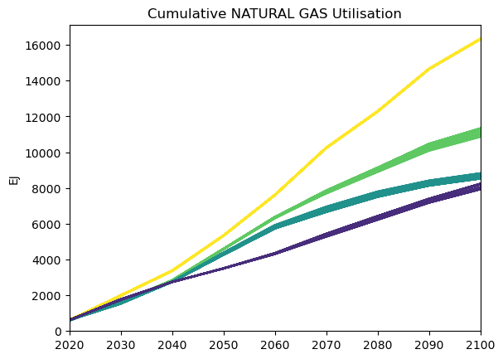
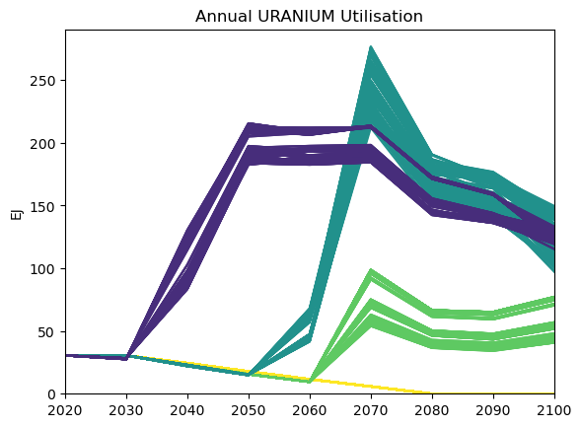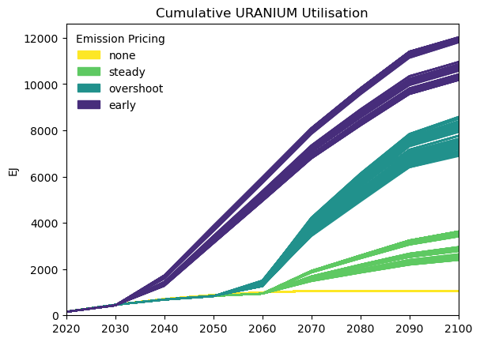
Fig. S-F8: Annual and cumulative non-renewable energy carriers’ utilisation coloured by emission pricing. Introducing emission pricing led to less fossil fuel and more nuclear power utilisation. SuCCESs (v2024-10-23) shows slightly lower temperature sensitivity to CO₂ and a stronger natural carbon sink than other IAMs, enabling more emissions at lower prices while still reducing temperature; for more information, see discussion on page 9
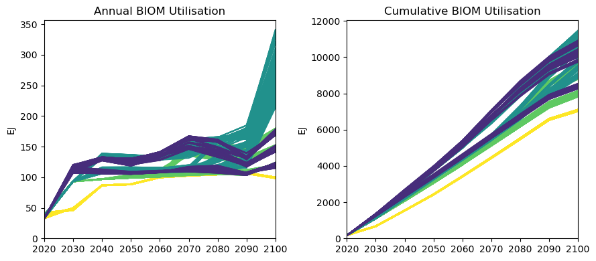
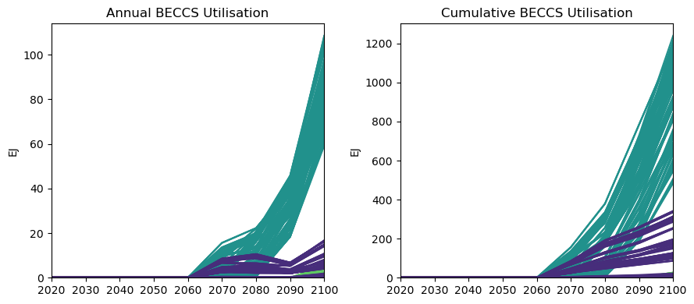
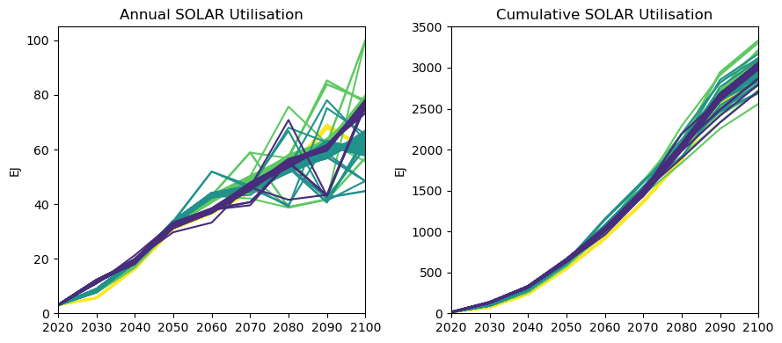
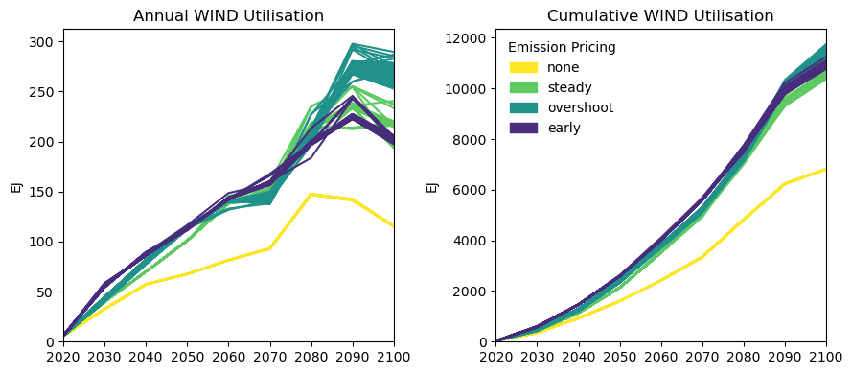
Fig. S-F9: Annual and cumulative renewable energy carriers’ utilisation coloured by emission pricing. Introducing emission pricing led to increased biomass and wind energy. Emission pricing aiming to limit warming to equal or below 1.5°C utilised bioenergy with carbon capture and storage (BECCS) (overshoot and early decarbonisation, teal and blue lines). Solar energy deployment was roughly the same across all scenarios
Fig. S-F10: Land-use change in 2100 compared to 2020 for all combinations of emission pricing, diet, and biodiversity habitat protection
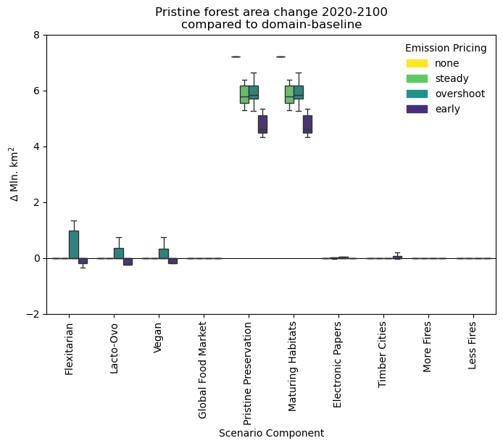
Fig. S-F11: Scenario components’ effect on pristine forest area change (2020-2100) compared to their corresponding dimension-baseline (e.g., vegan versus omnivore for the diet dimension). Biodiversity habitat protection had the biggest effect on preservation of pristine forests and preserved 4-7 Mkm² more forest than scenarios without habitat protection. Emission pricing made pristine habitat preservation less effective because emission pricing already preserved pristine ecosystems for carbon storage, leaving less added value for the habitat conservation scenarios
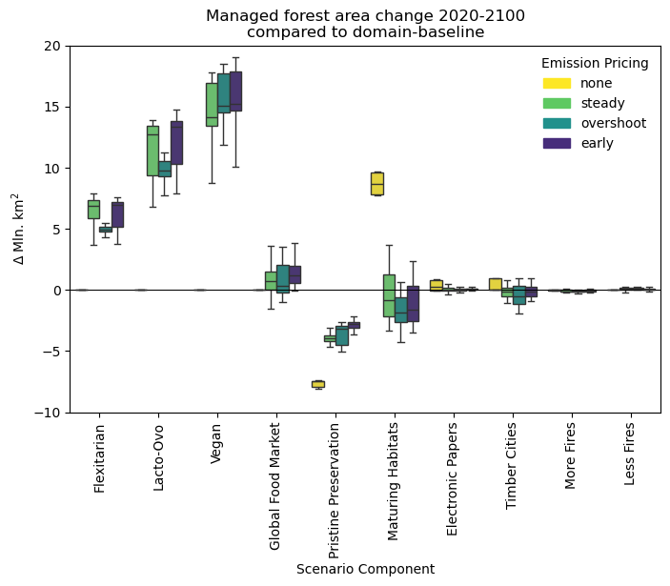
Fig. S-F12: Scenario components’ effect on total managed forest cover change (2020-2100) compared to their corresponding dimension-baseline (e.g., vegan versus omnivore for the diet dimension). Reduced meat consumption (Flexitarian, Lacto-Ovo, and Vegan cases) showed the strongest potential to expand managed forest area when combined with an incentive (emission pricing) as freed pastureland was afforested. Biodiversity habitat conservation caused net deforestation of up to 8 Mkm² in managed forests in most scenarios, as forestry intensified and focused entirely on unprotected land

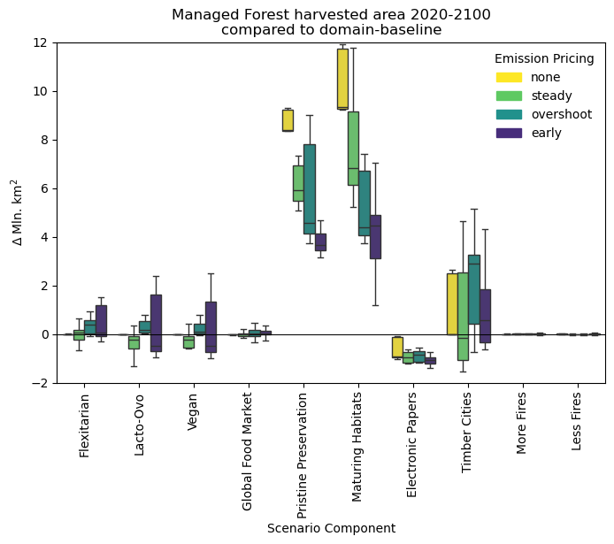
Fig. S-F13: Scenario components’ effect on harvesting area of managed forest (2020-2100) compared to their corresponding dimension-baseline (e.g., vegan versus omnivore for the diet dimension). Biodiversity habitat conservation (Pristine Preservation and Maturing Habitats cases) caused a spike of harvesting in managed forests, as forestry intensified and focused entirely on unprotected land. Reducing graphic paper demands (Electronic Papers case) consistently eased forestry intensity. Building 50% of new urban residential buildings out of wood (Timber Cities case) increased harvest intensity, especially when in land competition with meat-rich diets’ food production systems.
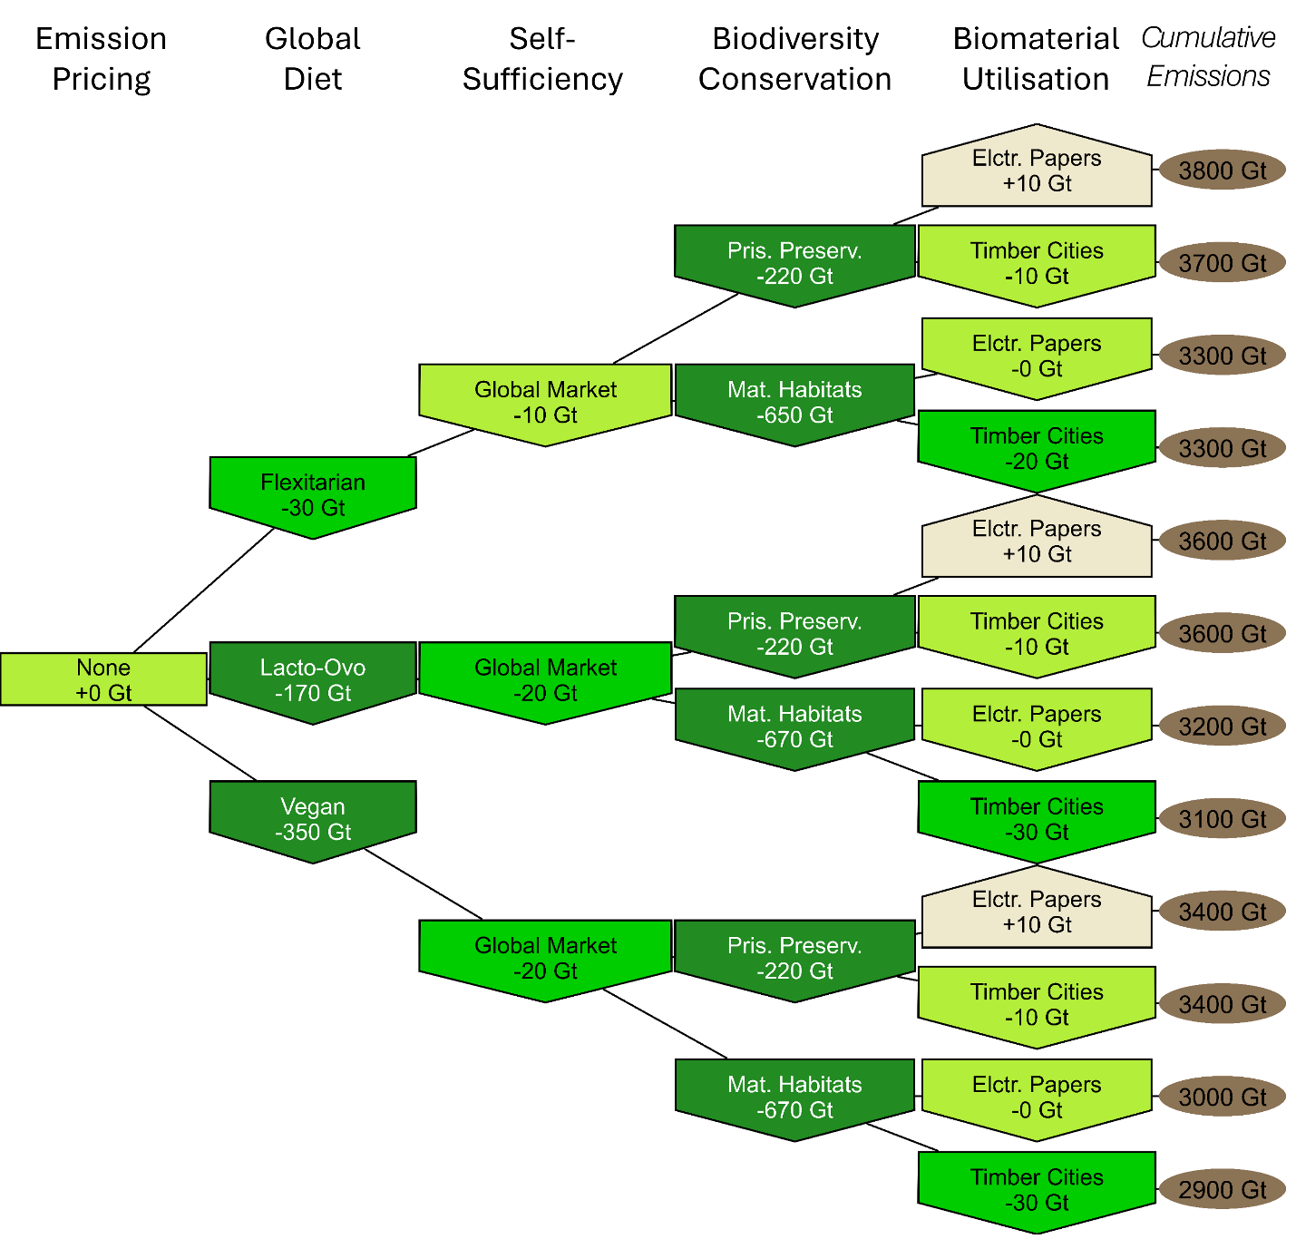
Fig. S-F14: Stacked mitigation potentials for individual non-baseline scenario components under the no emission pricing. Each column represents a scenario dimension, excluding wildfires due to their minimal impact. Nodes represent scenario components indicated by the label, while edges link all components of a complete scenario (assuming SuCCESs-default wildfire activity). The shape, colour and colour gradient of the nodes depend on the mitigation potential indicated in Gigatonnes CO₂-equivalents cumulatively between 2020 and 2100. Brown colour and upward arrow nodes indicate rise in emissions compared to the corresponding domain baseline case (e.g., Omnivore for diet dimension). Green-coloured downward arrow nodes indicate mitigation. The round bubble in the rightmost column shows total cumulative net emissions between 2020 and 2100 in the linked scenario

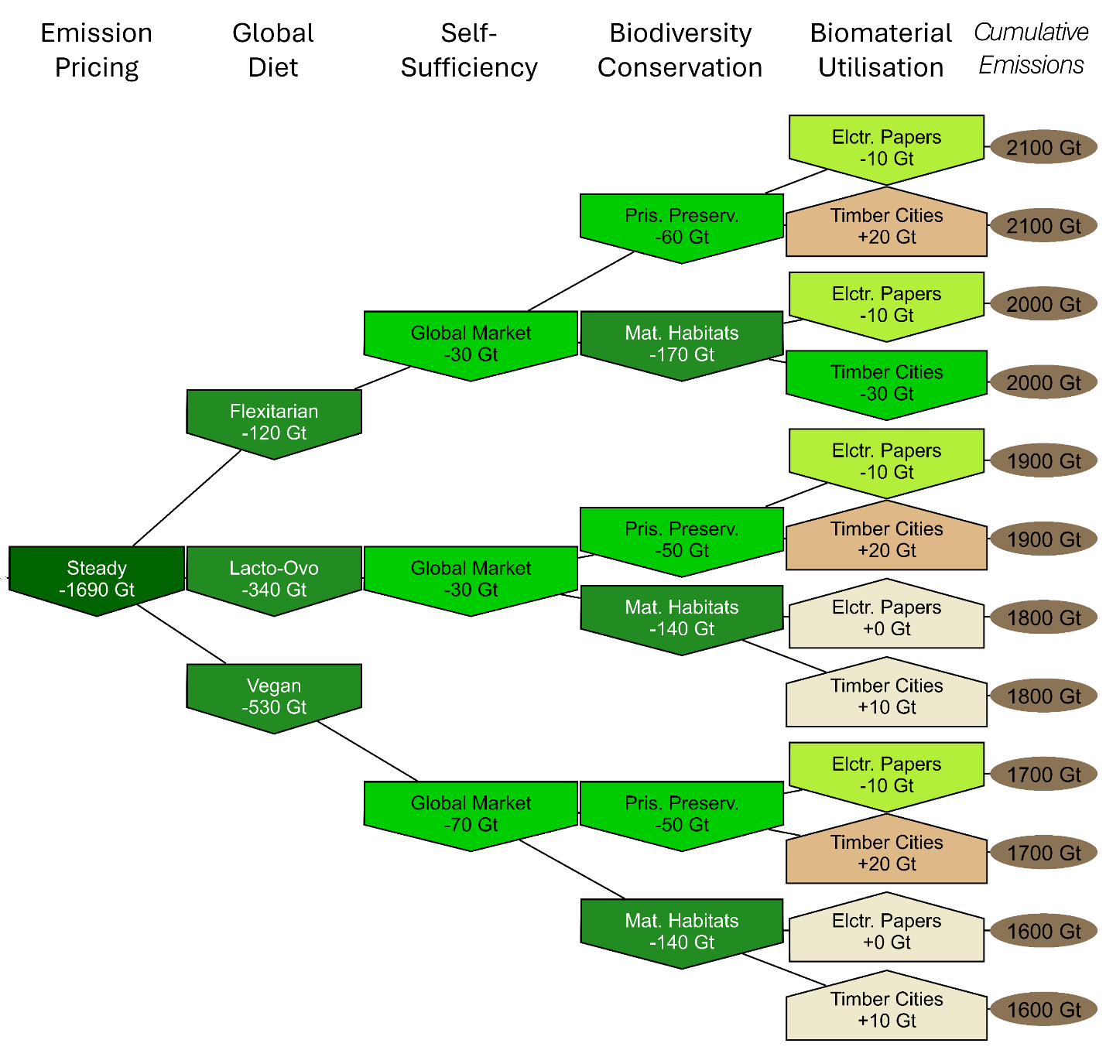
Fig. S-F15: Stacked mitigation potentials for individual non-baseline scenario components under the Steady transition emission pricing. Each column represents a scenario dimension, excluding wildfires due to their minimal impact. Nodes represent scenario components indicated by the label, while edges link all components of a complete scenario (assuming SuCCESs-default wildfire activity). The shape, colour and colour gradient of the nodes depend on the mitigation potential indicated in Gigatonnes CO₂-equivalents cumulatively between 2020 and 2100. Brown colour and upward arrow nodes indicate rise in emissions compared to the corresponding domain baseline case (e.g., Omnivore for diet dimension). Green-coloured downward arrow nodes indicate mitigation. The round bubble in the rightmost column shows total cumulative net emissions between 2020 and 2100 in the linked scenario
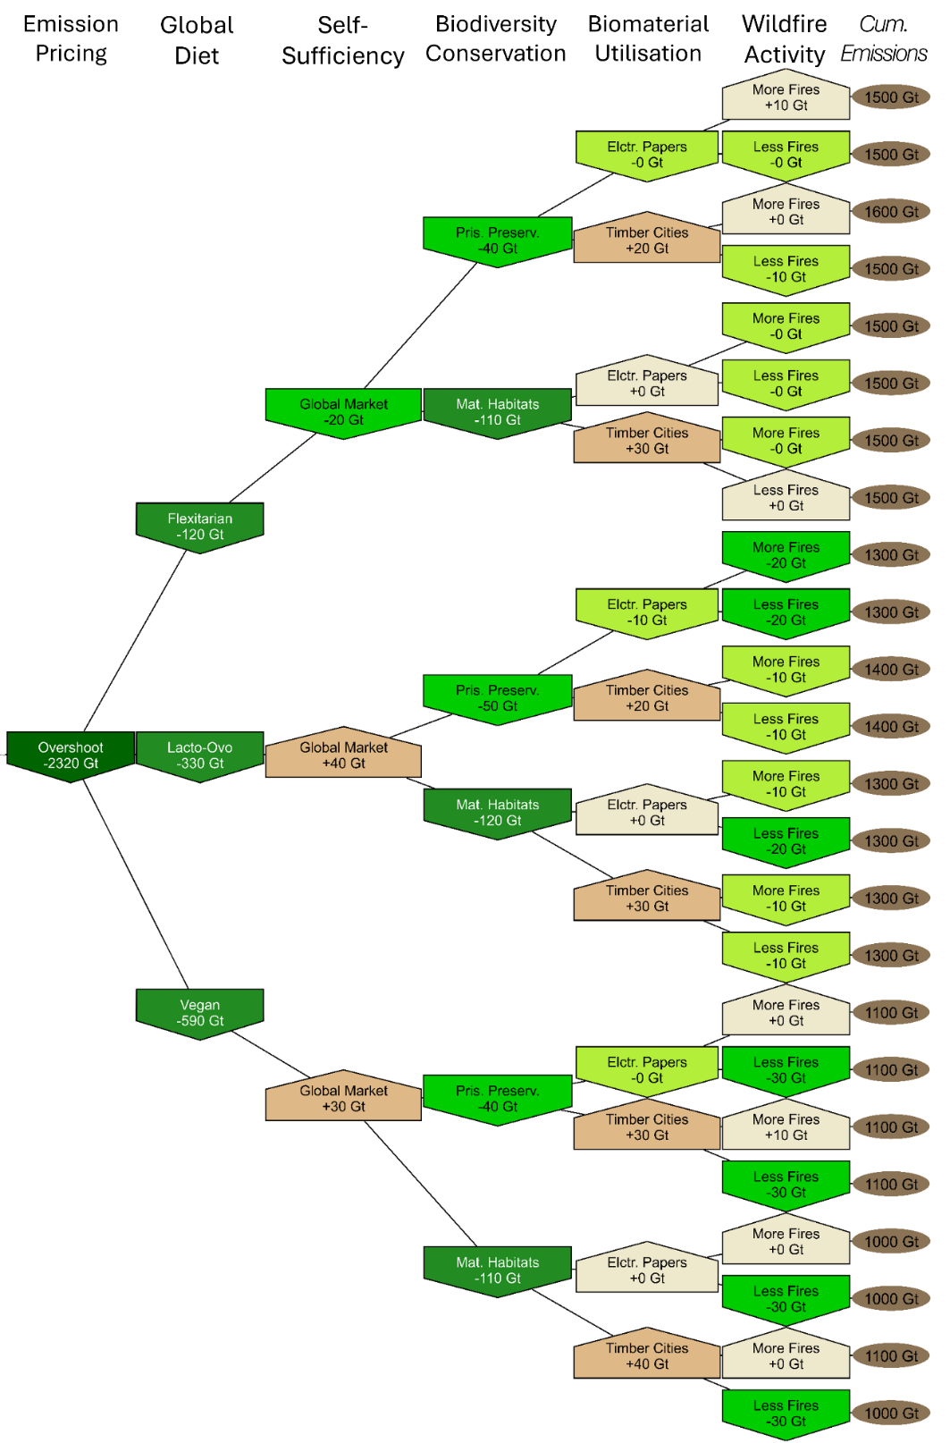
Fig. S-F16: Stacked mitigation potentials for individual non-baseline scenario components under the Overshoot emission pricing. Each column represents a scenario dimension. Nodes represent scenario components indicated by the label, while edges link all components of a complete scenario. The shape, colour and colour gradient of the nodes depend on the mitigation potential indicated in Gigatonnes CO₂-equivalents cumulatively between 2020 and 2100. Brown colour and upward arrow nodes indicate rise in emissions compared to the corresponding domain baseline case (e.g., Omnivore for diet dimension). Green-coloured downward arrow nodes indicate mitigation. The round bubble in the rightmost column shows total cumulative net emissions between 2020 and 2100 in the linked scenario
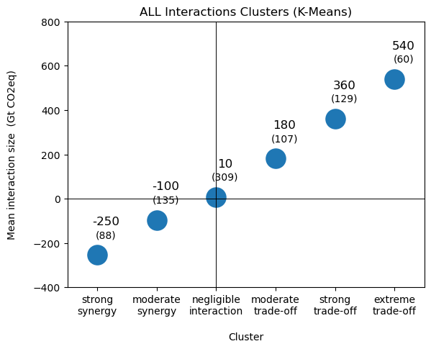
Fig. S-F17: K-means clustering of interaction sizes. The large number above each cluster indicates the mean interaction size of that cluster. The small number in parentheses below indicated the number of scenarios in this cluster. The is no extreme synergy cluster

Glossary

Abbreviation (alphabetical) | Full name | Definition
AFOLU | Agriculture, Forestry, and Other Land Use sector | Refers to activities related to land use that impact greenhouse gas emissions and carbon sequestration.
A/R | Afforestation or Reforestation | The establishment of forests on previously non-forested (afforestation) or deforested (reforestation) land.
BECCS | BioEnergy with Carbon Capture and Storage | Energy generation using biomass while capturing and storing its CO₂ emissions, creating net-negative emissions to mitigate climate change.
CLASH | Climate-responsive Land Allocation model with carbon Storage and Harvests | Global land-use model used in SuCCESs (Ekholm et al., 2024b).
DM | Dry matter | Represents the mass of the crop after all water content has been removed, leaving only the solid components such as carbohydrates, proteins, fats, fibers, and minerals.
GHG | Greenhouse Gas(es) | The three climate-active greenhouse gases considered in this paper are carbon dioxide (CO₂), methane (CH₄), and nitrous oxide (N₂O).
IAM | Integrated Assessment Model | Model combines climate, economic, and energy data to assess mitigation strategies, policy impacts, and sustainability pathways.
PA | Paris Agreement | Treaty of the parties of the United Nations Framework Convention on Climate Change that legally binds parties to “keep the increase in the global average temperature to well below 2°C above pre-industrial levels and pursue efforts to limit the temperature increase to 1.5°C above pre-industrial levels.” (UNFCCC, 2015)
RCP | Representative Concentration Pathway | Greenhouse gas concentration trajectories formally adopted by the IPCC (van Vuuren et al., 2011)
SSP | Shared Socio-economic Pathway | Scenarios describing social, economic and technological global changes until 2100, defined in IPCC’s Sixth Assessment Report (Chen et al., 2021; Riahi et al., 2017)
SSP2 | Shared Socio-economic Pathway 2 | Scenario with many socio-economic dimensions that describe a “Middle of the Road” or “Business as Usual” story of the future (Riahi et al., 2017).
SSP1 | Shared Socio-economic Pathway 1 | Scenario with many socio-economic dimensions that describe a “Green Road” or “Sustainability-oriented” story of the future (Riahi et al., 2017).
SuCCESs | Sustainable Climate Change mitigation strategies in Energy-land-material Systems | Integrated assessment model used in this study (Ekholm et al., 2024a).

References in this document
Andela, N., Morton, D.C., Giglio, L., Chen, Y., van der Werf, G.R., Kasibhatla, P.S., DeFries, R.S., Collatz, G.J., Hantson, S., Kloster, S., Bachelet, D., Forrest, M., Lasslop, G., Li, F., Mangeon, S., Melton, J.R., Yue, C., Randerson, J.T., 2017. A human-driven decline in global burned area. Science 356, 1356–1362. https://doi.org/10.1126/science.aal4108
Chen, D., Rojas, M., Samset, B.H., Cobb, K., Diongue Niang, A., Edwards, P., Emori, S., Faria, S.H., Hawkins, E., Hope, P., Huybrechts, P., Meinshausen, M., Mustafa, S.K., Plattner, G.-K., Tréguier, A.-M., 2021. Chapter 1.6: Dimensions of Integration: Scenarios, Global Warming Levels and Cumulative Carbon Emissions, in: Contribution of Working Group I to the Sixth Assessment Report of the Intergovernmental Panel on Climate Change (IPCC AR6): The Phycial Science Basis. Cambridge University Press, Cambridge.
Díaz, S., Zafra-Calvo, N., Purvis, A., Verburg, P.H., Obura, D., Leadley, P., Chaplin-Kramer, R., De Meester, L., Dulloo, E., Martín-López, B., Shaw, M.R., Visconti, P., Broadgate, W., Bruford, M.W., Burgess, N.D., Cavender-Bares, J., DeClerck, F., Fernández-Palacios, J.M., Garibaldi, L.A., Hill, S.L.L., Isbell, F., Khoury, C.K., Krug, C.B., Liu, J., Maron, M., McGowan, P.J.K., Pereira, H.M., Reyes-García, V., Rocha, J., Rondinini, C., Shannon, L., Shin, Y.-J., Snelgrove, P.V.R., Spehn, E.M., Strassburg, B., Subramanian, S.M., Tewksbury, J.J., Watson, J.E.M., Zanne, A.E., 2020. Set ambitious goals for biodiversity and sustainability. Science 370, 411–413. https://doi.org/10.1126/science.abe1530
Dietrich, J.P., 2019. MAgPIE 4.0 paper - evaluation documents. https://doi.org/10.5281/zenodo.2572581
Dietrich, J.P., Bodirsky, B.L., Humpenöder, F., Weindl, I., Stevanović, M., Karstens, K., Kreidenweis, U., Wang, X., Mishra, A., Klein, D., Ambrósio, G., Araujo, E., Yalew, A.W., Baumstark, L., Wirth, S., Giannousakis, A., Beier, F., Meng-Chuen Chen, D., Lotze-Campen, H., Popp, A., 2019. MAgPIE 4-a modular open-source framework for modeling global land systems - Supplemental Material: Evaluation Documents (SSP2). Geoscientific Model Development 12, 1299–1317. https://doi.org/10.5194/GMD-12-1299-2019
Economist Impact & Corteva Agriscience, 2022. Global Food Security Index.
Ekholm, T., Freistetter, N.-C., Mattlar, T., Schaber, T., Rautiainen, A., 2024a. SuCCESs &ndash; a global IAM for exploring the interactions between energy, materials, land-use and climate systems in long-term scenarios (model version 2024-10-23). Geoscientific Model Development Discussions 1–26. https://doi.org/10.5194/gmd-2024-196
Ekholm, T., Freistetter, N.-C., Rautiainen, A., Thölix, L., 2024b. CLASH – Climate-responsive Land Allocation model with carbon Storage and Harvests. Geoscientific Model Development 17, 3041–3062. https://doi.org/10.5194/gmd-17-3041-2024
FAO, 2023a. FAOSTAT: Food Balances, Indicator: Food Supply (kcal/capita/day).
FAO, 2023b. FAOSTAT: Crops and livestock products.
FAO, 2021. Pulp and Paper Capacities Survey 2020-2025 (No. ISSN 2664-7508). Food and Agricultural Organization of the United Nations, Rome.
Gao, J., 2017. Downscaling Global Spatial Population Projections from 1/8-degree to 1-km Grid Cells. https://doi.org/10.5065/D60Z721H
Hurtt, G.C., Chini, L., Sahajpal, R., Frolking, S., Bodirsky, B.L., Calvin, K., Doelman, J.C., Fisk, J., Fujimori, S., Klein Goldewijk, K., Hasegawa, T., Havlik, P., Heinimann, A., Humpenöder, F., Jungclaus, J., Kaplan, J.O., Kennedy, J., Krisztin, T., Lawrence, D., Lawrence, P., Ma, L., Mertz, O., Pongratz, J., Popp, A., Poulter, B., Riahi, K., Shevliakova, E., Stehfest, E., Thornton, P., Tubiello, F.N., van Vuuren, D.P., Zhang, X., 2020. Harmonization of global land use change and management for the period 850–2100 (LUH2) for CMIP6. Geoscientific Model Development 13, 5425–5464. https://doi.org/10.5194/gmd-13-5425-2020
IIASA, 2024. SSP Scenario Explorer (SSP 3.0, Release March 2024).
IIASA, 2018. SSP Database.
IPCC (Ed.), 2023. Technical Summary Table 3.2, in: Working Group III Contribution to the Sixth Assessment Report of the Intergovernmental Panel on Climate Change: Climate Change 2022 - Mitigation of Climate Change. Cambridge University Press, pp. 51–148. https://doi.org/10.1017/9781009157926.002
Izraelov, M., Silber, J., 2019. An assessment of the global food security index. Food Sec. 11, 1135–1152. https://doi.org/10.1007/s12571-019-00941-y
Jäger, F., Schwaab, J., Quilcaille, Y., Windisch, M., Doelman, J., Frank, S., Gusti, M., Havlik, P., Humpenöder, F., Lessa Derci Augustynczik, A., Müller, C., Narayan, K.B., Padrón, R.S., Popp, A., Van Vuuren, D., Wögerer, M., Seneviratne, S.I., 2024. Fire Weather Compromises Forestation-reliant Climate Mitigation Pathways. https://doi.org/10.5194/egusphere-2024-15
Jones, B., O’Neill, B.C., 2016. Spatially explicit global population scenarios consistent with the Shared Socioeconomic Pathways. Environ. Res. Lett. 11, 084003. https://doi.org/10.1088/1748-9326/11/8/084003
Knorr, W., Kaminski, T., Arneth, A., Weber, U., 2014. Impact of human population density on fire frequency at the global scale. Biogeosciences 11, 1085–1102. https://doi.org/10.5194/bg-11-1085-2014
Leach, N.J., Jenkins, S., Nicholls, Z., Smith, C.J., Lynch, J., Cain, M., Walsh, T., Wu, B., Tsutsui, J., Allen, M.R., 2021. FaIRv2.0.0: a generalized impulse response model for climate uncertainty and future scenario exploration. Geoscientific Model Development 14, 3007–3036. https://doi.org/10.5194/gmd-14-3007-2021
Leclère, D., Obersteiner, M., Barrett, M., Butchart, S.H.M., Chaudhary, A., De Palma, A., DeClerck, F.A.J., Di Marco, M., Doelman, J.C., Dürauer, M., Freeman, R., Harfoot, M., Hasegawa, T., Hellweg, S., Hilbers, J.P., Hill, S.L.L., Humpenöder, F., Jennings, N., Krisztin, T., Mace, G.M., Ohashi, H., Popp, A., Purvis, A., Schipper, A.M., Tabeau, A., Valin, H., van Meijl, H., van Zeist, W.-J., Visconti, P., Alkemade, R., Almond, R., Bunting, G., Burgess, N.D., Cornell, S.E., Di Fulvio, F., Ferrier, S., Fritz, S., Fujimori, S., Grooten, M., Harwood, T., Havlík, P., Herrero, M., Hoskins, A.J., Jung, M., Kram, T., Lotze-Campen, H., Matsui, T., Meyer, C., Nel, D., Newbold, T., Schmidt-Traub, G., Stehfest, E., Strassburg, B.B.N., van Vuuren, D.P., Ware, C., Watson, J.E.M., Wu, W., Young, L., 2020. Bending the curve of terrestrial biodiversity needs an integrated strategy. Nature 585, 551–556. https://doi.org/10.1038/s41586-020-2705-y
Mishra, A., Humpenöder, F., Churkina, G., Reyer, C.P.O., Beier, F., Bodirsky, B.L., Schellnhuber, H.J., Lotze-Campen, H., Popp, A., 2022. Land use change and carbon emissions of a transformation to timber cities. Nat Commun 13, 4889. https://doi.org/10.1038/s41467-022-32244-w
Rabin, S.S., Melton, J.R., Lasslop, G., Bachelet, D., Forrest, M., Hantson, S., Kaplan, J.O., Li, F., Mangeon, S., Ward, D.S., Yue, C., Arora, V.K., Hickler, T., Kloster, S., Knorr, W., Nieradzik, L., Spessa, A., Folberth, G.A., Sheehan, T., Voulgarakis, A., Kelley, D.I., Prentice, I.C., Sitch, S., Harrison, S., Arneth, A., 2017. The Fire Modeling Intercomparison Project (FireMIP), phase 1: experimental and analytical protocols with detailed model descriptions. Geoscientific Model Development 10, 1175–1197. https://doi.org/10.5194/gmd-10-1175-2017
Riahi, K., van Vuuren, D.P., Kriegler, E., Edmonds, J., O’Neill, B.C., Fujimori, S., Bauer, N., Calvin, K., Dellink, R., Fricko, O., Lutz, W., Popp, A., Cuaresma, J.C., KC, S., Leimbach, M., Jiang, L., Kram, T., Rao, S., Emmerling, J., Ebi, K., Hasegawa, T., Havlik, P., Humpenöder, F., Da Silva, L.A., Smith, S., Stehfest, E., Bosetti, V., Eom, J., Gernaat, D., Masui, T., Rogelj, J., Strefler, J., Drouet, L., Krey, V., Luderer, G., Harmsen, M., Takahashi, K., Baumstark, L., Doelman, J.C., Kainuma, M., Klimont, Z., Marangoni, G., Lotze-Campen, H., Obersteiner, M., Tabeau, A., Tavoni, M., 2017. The Shared Socioeconomic Pathways and their energy, land use, and greenhouse gas emissions implications: An overview. Global Environmental Change 42, 153–168. https://doi.org/10.1016/J.GLOENVCHA.2016.05.009
Samir, K., Moradhvaj, Potancokova, M., Adhikari, S., Yildiz, D., Mamolo, M., Sobotka, T., Zeman, K., Abel, G., Lutz, W., Goujon, A., 2024. Wittgenstein Center (WIC) Population and Human Capital Projections - 2023. https://doi.org/10.5281/zenodo.10618931
Smith, N.W., Fletcher, A.J., Hill, J.P., McNabb, W.C., 2022. Modeling the Contribution of Meat to Global Nutrient Availability. Frontiers in Nutrition 9.
UNEP-WCMC, 2020. Protected Planet Report 2020. United Nations Environment Programme - World Conservation Monitoring Centre.
UNFCCC, 2015. The Paris Agreement.
van Dijk, M., Morley, T., Rau, M.L., Saghai, Y., 2021. A meta-analysis of projected global food demand and population at risk of hunger for the period 2010–2050. Nat Food 2, 494–501. https://doi.org/10.1038/s43016-021-00322-9
van Vuuren, D.P., Edmonds, J., Kainuma, M., Riahi, K., Thomson, A., Hibbard, K., Hurtt, G.C., Kram, T., Krey, V., Lamarque, J.-F., Masui, T., Meinshausen, M., Nakicenovic, N., Smith, S.J., Rose, S.K., 2011. The representative concentration pathways: an overview. Climatic Change 109, 5. https://doi.org/10.1007/s10584-011-0148-z

