Appendix 1 – Scales and Reliability
Variable |  | Items/Measurement |  | *⍺ Esc | **⍺ Dim | VIF
People | LP1. The recruitment process must consider the feelings and soft skills of the people to be recruited. |  | ⍺ = 0.96 |  | 0.864 | 2.34
People | LP2.The selection of personnel capable of carrying out the tasks assigned to a position must consider the level of emotional intelligence of individuals. |  |  |  | 0.864 | 2.19
People | LP3. Training programs must be adapted to employee profiles. |  |  |  | 0.864 | 1.71
People | LP4. Reward plans should be designed based on the specific needs of each individual. |  |  |  | 0.864 | 1.67
People | LP5. Performance evaluation should advocate for the analysis of each person's hard and soft skills in relation to the task they perform. |  |  |  | 0.864 | 1.90
People | LP6. The relationship between those in charge of human talent management and collaborators will influence the effectiveness of the human talent management process. |  |  |  | 0.864 | 1.67
 | LP7. In human talent management, it is essential to understand people in order to reach various agreements, whether or not they are related to the company's operations. |  |  |  | 0.864 | 1.95
Interests | LI1. Recruiters must be very clear about the intentions behind the interest in recruiting a new employee. |  |  |  | 0.911 | 2.08
Interests | LI2. Identifying the interests of the selected collaborator is essential to developing effective agreements related to human talent management. |  |  |  | 0.911 | 3.04
Interests | LI3. It is essential to know the employee's interests in relation to training programs. |  |  |  | 0.911 | 2.73
Interests | LI4. It is necessary to be clear about the interests that a collaborator presents in relation to the reward systems within the organization. |  |  |  | 0.911 | 2.11
Interests | LI5. It is important to consider the employee's interest in relation to the performance evaluation process that will be applied to him/her. |  |  |  | 0.911 | 2.05
Interests | LI6. Clearly understanding the interests of each member of the organization will allow for greater efficiency in human talent management. |  |  |  | 0.911 | 2.83
Interests | LI7. In human talent management, it is essential to understand people's interests in order to reach agreements. |  |  |  | 0.911 | 2.21
Options | LO1. Those in charge of the recruitment process must have various options that allow them to recruit collaborators more easily. |  |  |  | 0.908 | 2.05
Options | LO2. The number of options available to select the ideal candidate for a position is essential. |  |  |  | 0.908 | 1.95
Options | LO3. The various training options that can be offered to staff are vital for effective human talent management. |  |  |  | 0.908 | 2.02
Options | LO4. The various reward options that can be offered to staff are vital to effective human talent management. |  |  |  | 0.908 | 2.12
Options | LO5. The various performance evaluation options that can be offered to staff are vital for effective human talent management. |  |  |  | 0.908 | 2.30
 | LO6. By having a variety of options related to recruitment, selection, training, rewards and performance evaluation, the human talent management process will be more effective and efficient. |  |  |  | 0.908 | 3.53
 | LO7. In human talent management, it is essential to have various options in order to reach agreements. |  |  |  | 0.908 | 2.91
Objective Criteria | LCO1. Those responsible for human talent management must establish objective criteria for the recruitment process. |  |  |  | 0.967 | 3.29
Objective Criteria | LCO2. Objective criteria must exist in order to proceed with the selection of personnel. |  |  |  | 0.967 | 5.92
Objective Criteria | LCO3. Training programs must be developed and designed based on objective criteria. |  |  |  | 0.967 | 4.94
Objective Criteria | LCO4. Reward programs should be designed based on objective criteria. |  |  |  | 0.967 | 9.05
Objective Criteria | LCO5. Performance evaluation must be developed based on objective criteria. |  |  |  | 0.967 | 8.43
 | LCO6. The identification and presentation of objective criteria in each of the stages of the human talent management process are important for its objectivity and effectiveness. |  |  |  | 0.967 | 9.15
 | LCO7. In human talent management, it is essential to have objective criteria in order to reach agreements. |  |  |  | 0.967 | 8.39
THM Effectiveness | On a scale of 0 to 100 How would you rate the set of guidelines and actions implemented by your organization in relation to the recruitment, selection, training, rewards and performance evaluation?
Theoretical Support DNM | Fisher & Ury (1985), Graham (2018), Lewis et al., (2018), Caputo et al., (2019), Hart & Schweitzaer (2022)., van Kleef & Cote. (2017)., Ashraf et al., (2020)., Gaspar et al., (2022)., Brett & Mitchell (2019)., Saorín-Iborra & Cubillo (2019)., Chiavenato (2009); Mendoza Mera., et al., (2023); Leyva-Grijalva et al., (2024).
Theoretical Support HTM | Chiavenato (2009); Mendoza Mera., et al., (2023); Leyva-Grijalva et al., (2024); d'Armagnac et al., (2022)
Scores: * Cronbach's alpha for the entire scale. ** Cronbach's alpha of each dimension
Source: Prepared by the authors

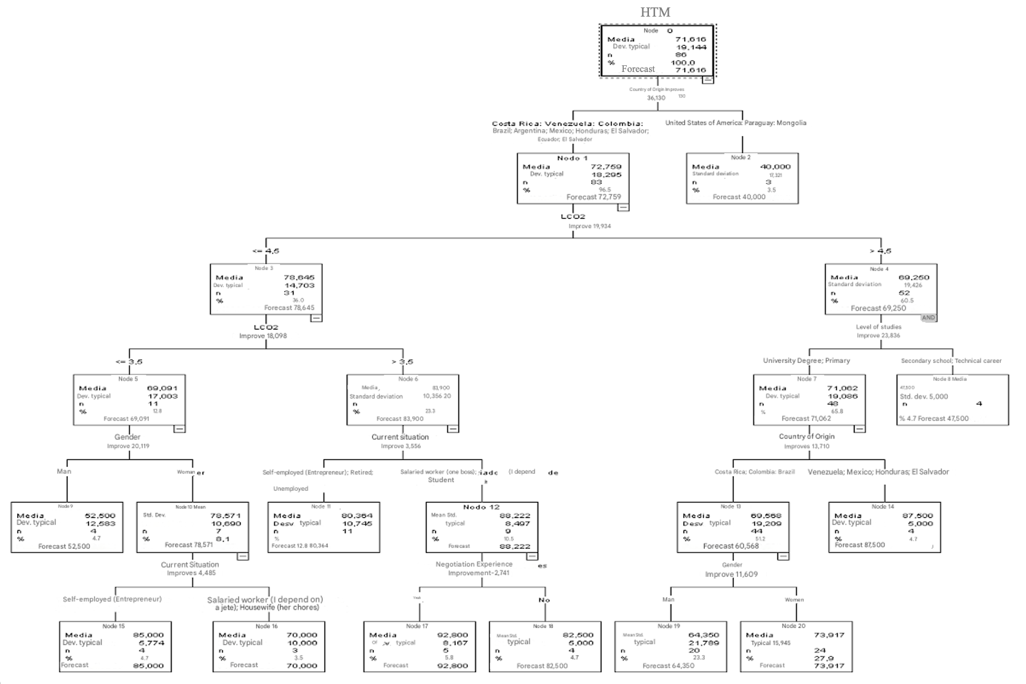
Appendix 2 – Decision Tree

