Linking Urban Growth and Surface Temperature Change in Capital and Secondary Cities of Southeast Asia

Supplementary information

Ronghua Xuª, Shankar Acharya Kamarajugeddaª, Raffaele Lafortezza^{b,c} Perrine Hamel^{a,d} *

ª Asian School of the Environment, Nanyang Technological University, 639798, Singapore
^{b} Department of Agricultural and Environmental Sciences, University of Bari, 70126, Italy
^{c} Center for Global Change and Earth Observations, Michigan State University, 48823, United States of America
^{d} Earth Observatory of Singapore, Nanyang Technological University, 639798, Singapore

The corresponding author’s* email addresses:
perrine.hamel@ntu.edu.sg

Postal addresses:
Asian School of the Environment, Nanyang Technological University, 50 Nanyang Avenue, 639798, Singapore

This file contains:
Table S1
Figure S1-S6

Table S1. Description and sources of remote sensing datasets
Type | Description | Resolution | Unit | Source
LCLU | Land Cover and Land Use | 30 m | - | https://glad.umd.edu/dataset/
 | Estimate PLAND | - | % | -
LST | Land Surface Temperature | 30 m | ℃ | GEE platform; Ermida et. al. (2020)
NDVI | Normalized Difference Vegetation Index | 30 m | value [-1,1] | GEE platform
POP | Population | 1 km | ppl/km² | https://hub.worldpop.org/
 | Create Urban cluster | 1 km | km² | -
Economic | Gross domestic product | 1 km | US $ | https://figshare.com/
Note: the year of all datasets is 2000 and 2020. The GDP datasets can be retrieved from Chen et al. (2022).

Figure S1-S6

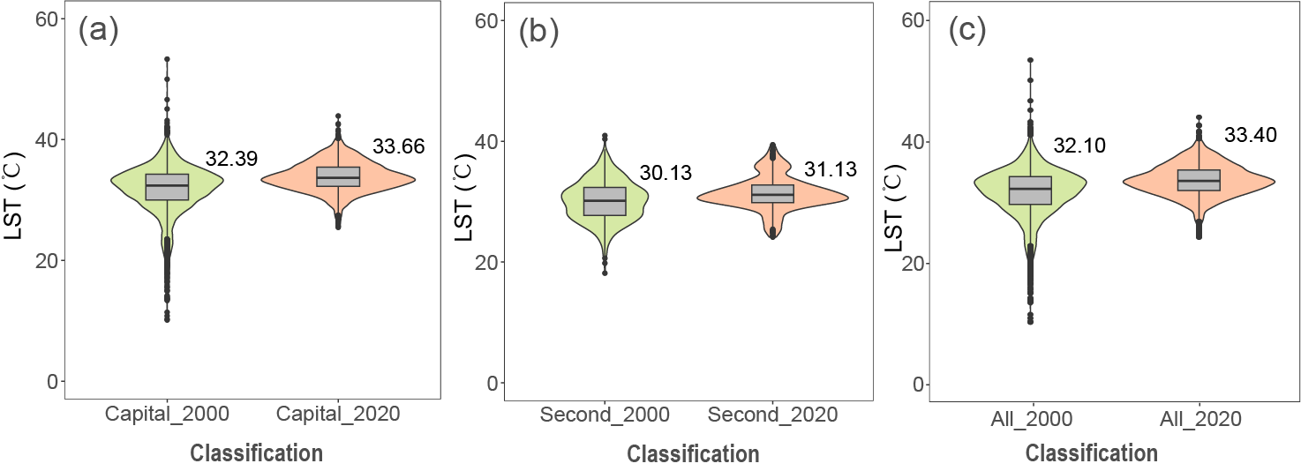
Figure S1. LST of the urban core areas between the capital and secondary cities in 2000 and 2020. The values marked in the figure are the median of LST.

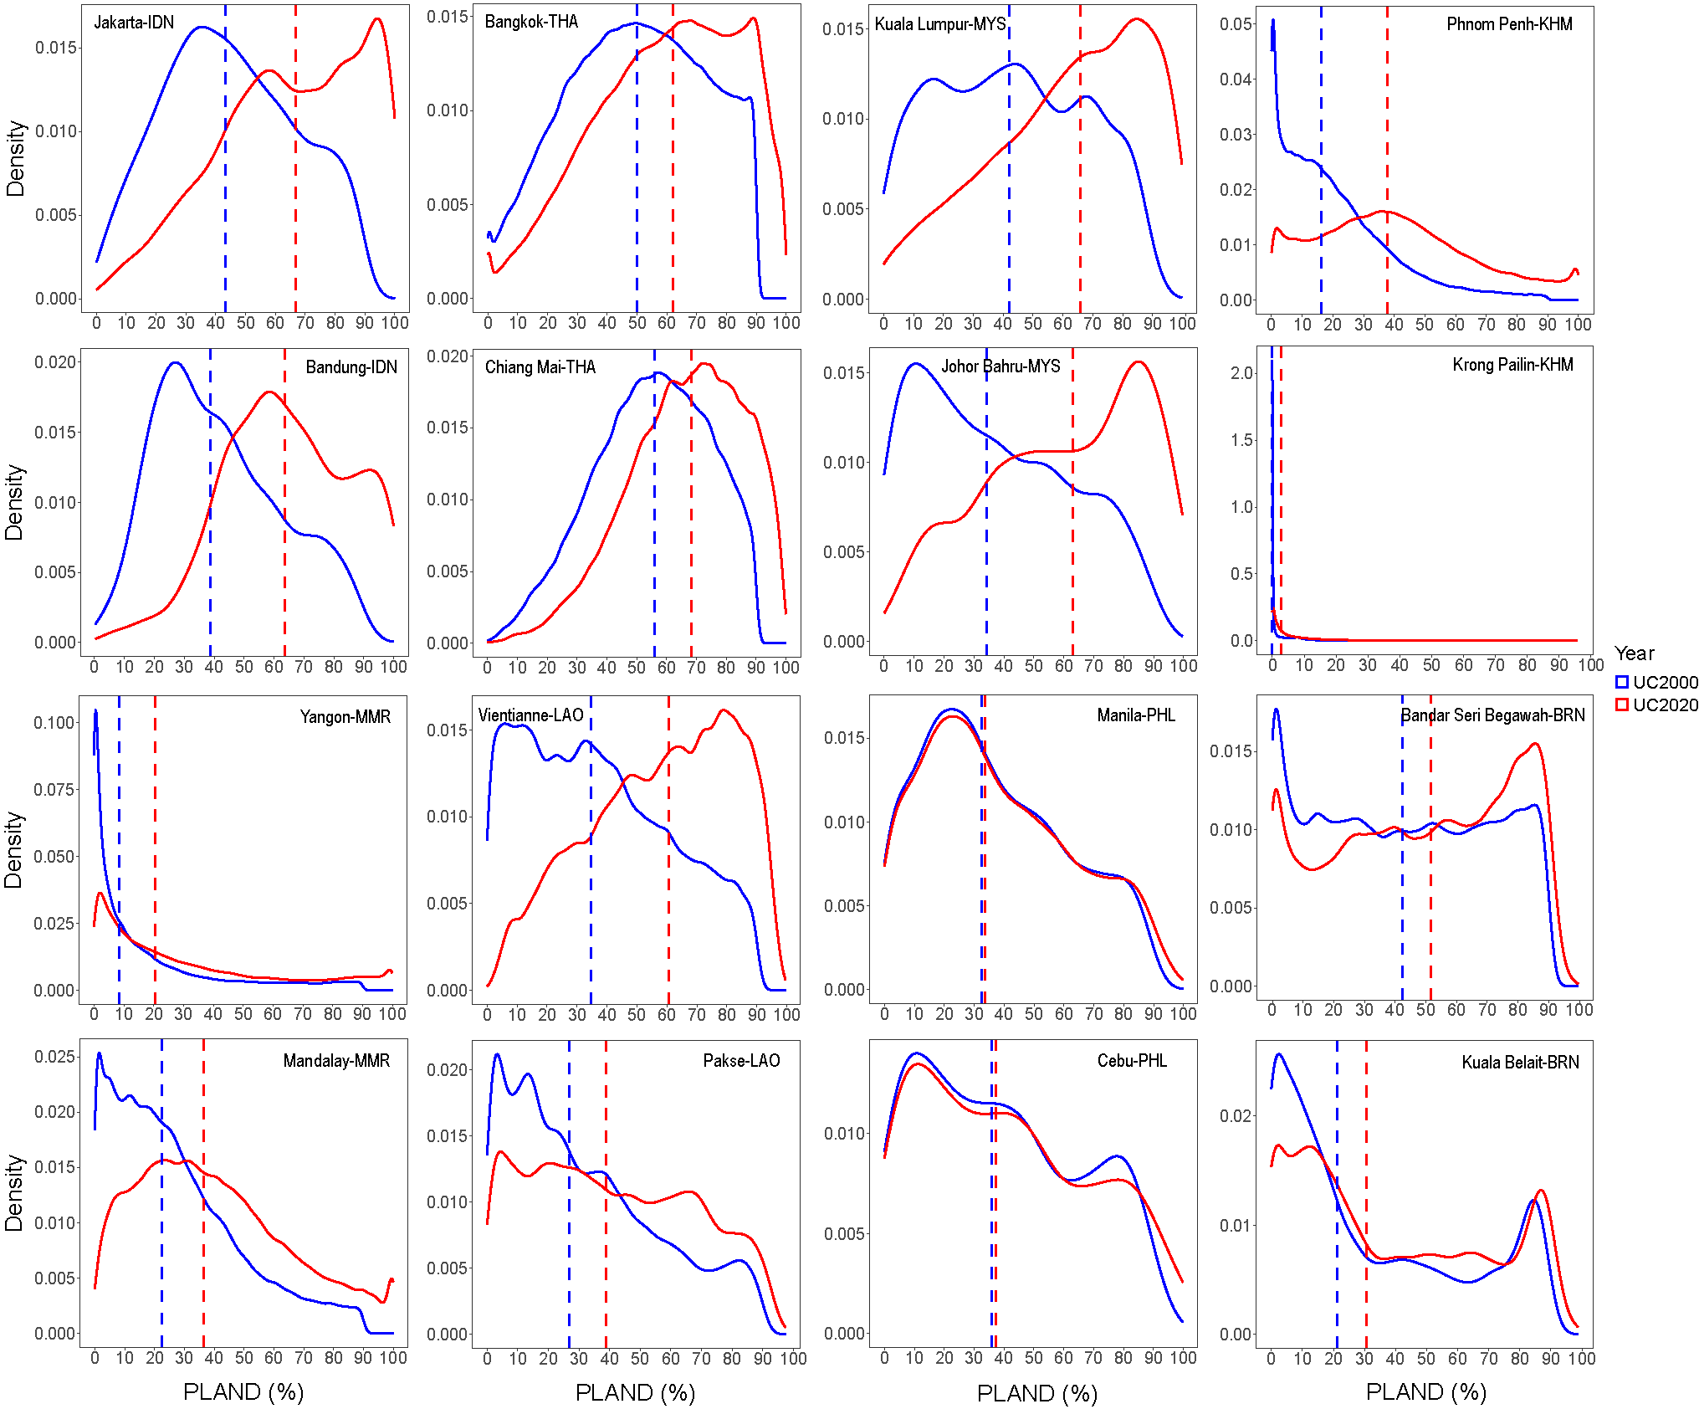
Figure S2. PLAND density plot for major SEA urban clusters in 2000 and 2020. Dashed lines represent median values. The first and third rows represent the urban cluster as the capital city, while the second and fourth rows correspond to the secondary city, respectively.

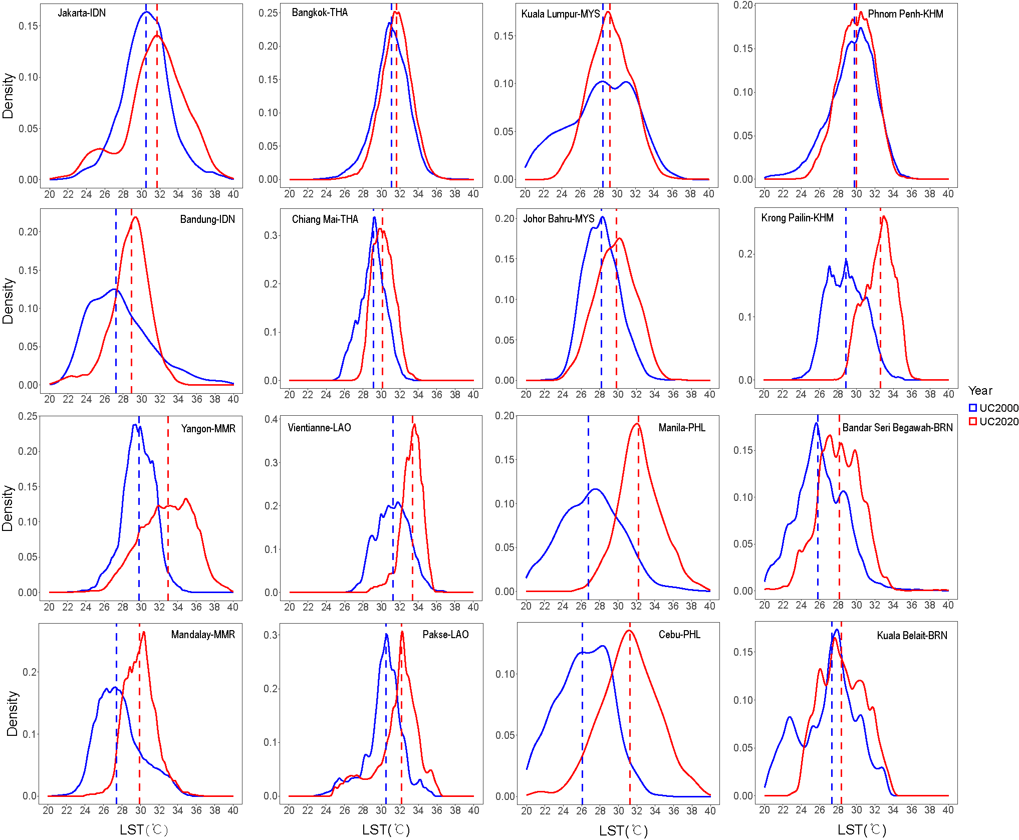
Figure S3. LST density plot for major SEA urban clusters in 2000 and 2020. Dashed lines represent median values. The first and third rows represent the urban cluster as the capital city, while the second and fourth rows correspond to the secondary city, respectively.

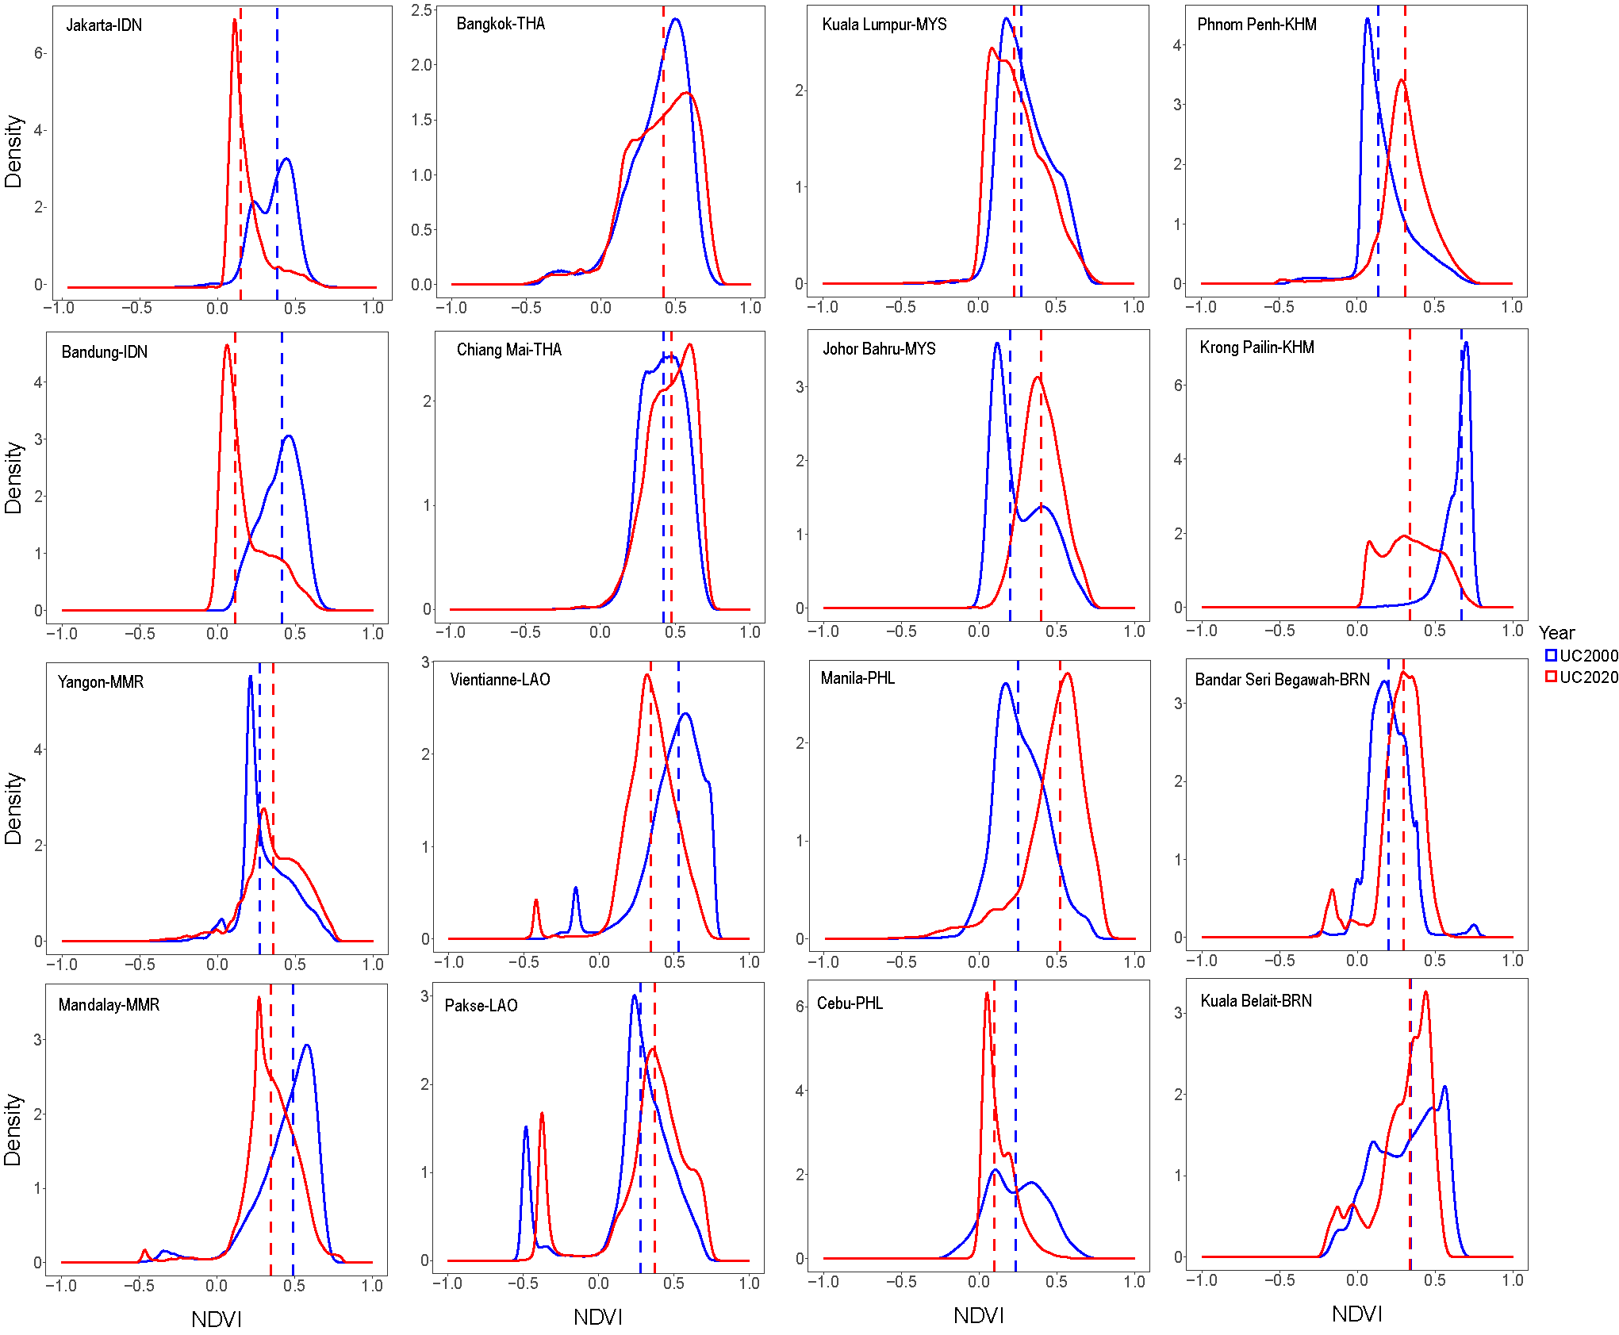
Figure S4. NDVI density plot for major SEA urban clusters between 2000 and 2020. Dashed lines represent median values. The first and third rows represent the urban cluster as the capital city, while the second and fourth rows correspond to the secondary city, respectively.

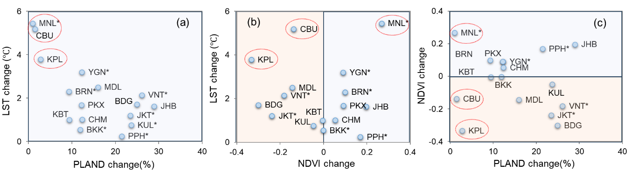
Figure S5. Correlation relationships between urban forms and LST changes from 2000 to 2020. Each point represents the median change of the corresponding variable for each urban cluster. The light blue and yellow backgrounds represent increased and decreased change from 2000 to 2020, respectively. The urban clusters with red circles are emphasized to support the results in Figure 4.

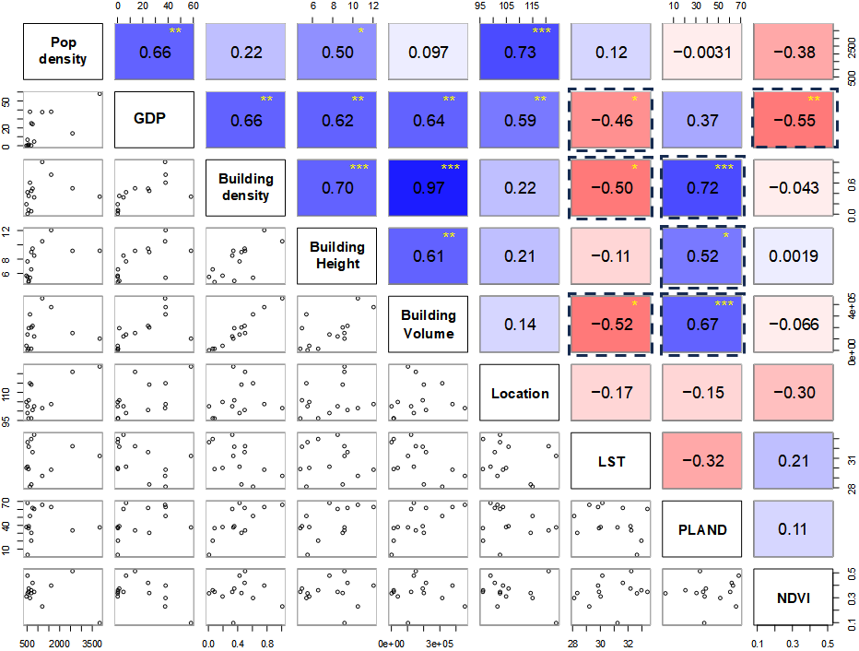
Figure S6. Pearson correlations among spectral indices and socioeconomic factors. Blue shades indicate positive correlations, while red shades indicate negative correlations. Black dashed boxes indicate significant correlation values that emphasize the significance relationship. Pop density and GDP represent population density and gross domestic product, respectively. The plot data used the median of each urban cluster in the year 2020. Significance level: *** p ≤ 0.01, ** p ≤ 0.05, * p ≤ 0.1.

References:
¹ Ermida, S. L., Soares, P., Mantas, V., Göttsche, F. & Trigo, I. F., Google Earth Engine Open-Source Code for Land Surface Temperature Estimation from the Landsat Series. REMOTE SENS-BASEL 12 1471 (2020).
² Chen, J. et al., Global 1 km x 1 km gridded revised real gross domestic product and electricity consumption during 1992-2019 based on calibrated nighttime light data. SCI DATA 9 (2022).

