Supplementary data

These supplementary materials provide an overview of the raw data collected for each sample, consisting of SEM backscatter images and SEM-EDS measurements. Each table provide the raw analytical data for each sample, with reference to the spectrum and related image.

Crucible fragments

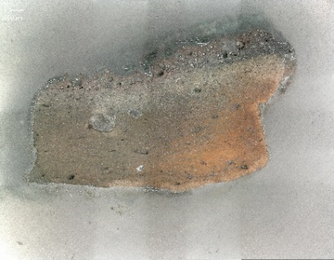 | 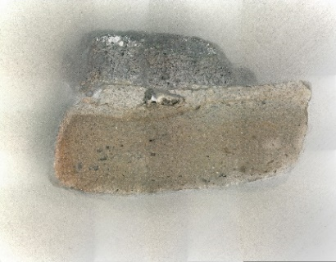
a) | b)
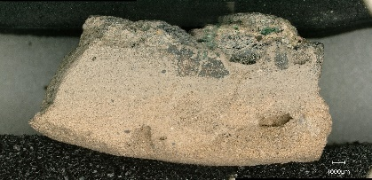 | 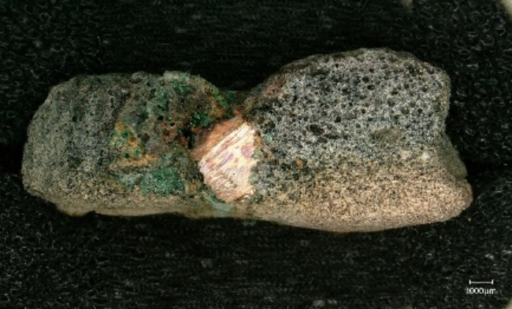
c) | d)
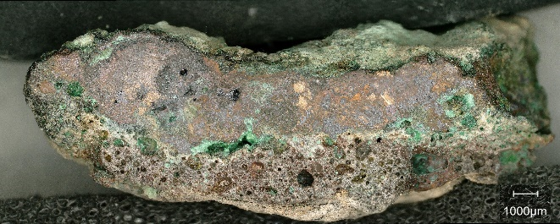 | 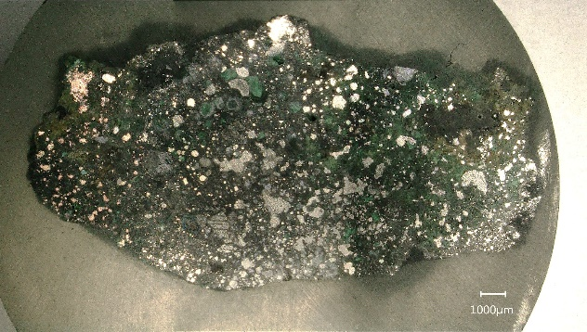
e) | f)
Fig. 1 Reflected Light images showing the cross-sections of the secondary metallurgical products and by-products investigated: a) TSRP115a; b) TSR115b; c) TSRP91; d) TSRP124; e) TSRP149; f) TSRP91a

TSRP91
Crucible areas | Bloated areas
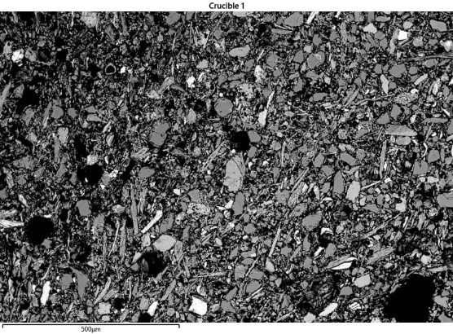 | 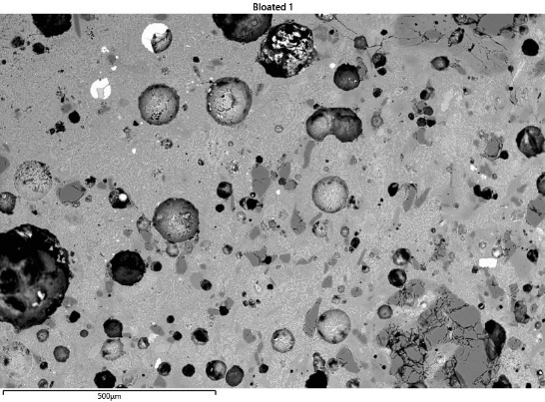
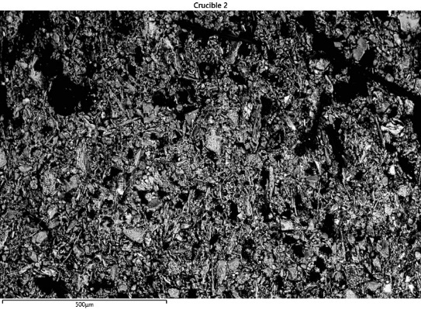 | 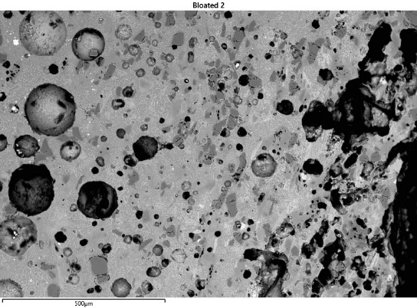
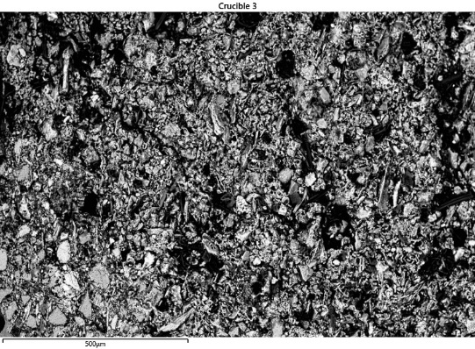 | 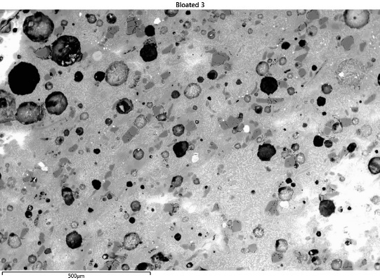
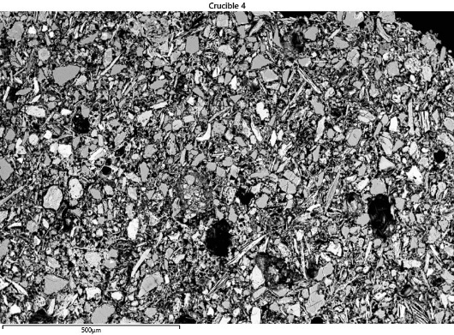 | 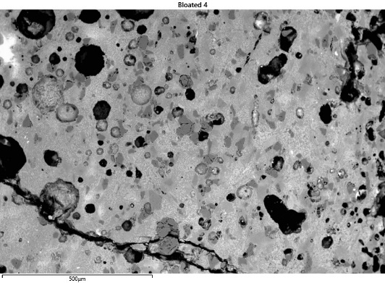
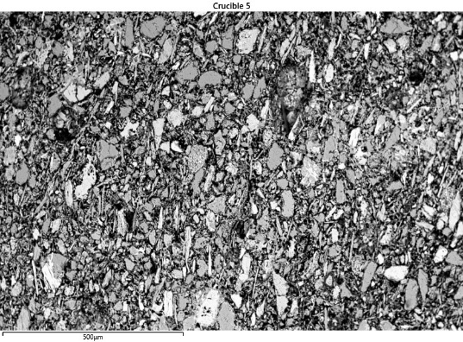 | 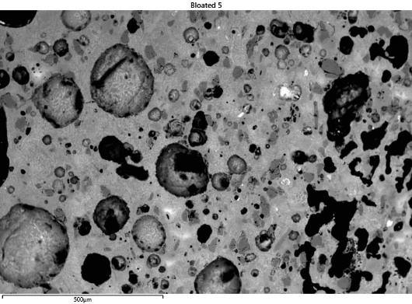
Fig. 2 Analysed crucible and bloated areas of sample TSRP91 - area at 100x magnification (c. 1mm²).
Table 2 Analyses carried out on sample TSRP91
Description | Sp. | O | Mg | Al | Si | P | S | Cl | K | Ca | Fe | Ni | Cu | Zn | As | Ag | Sn | Sb | Pb
Image 1
Cu-Sn oxidised | 63 | 27.5 | 0.1 | 0.1 | 3.3 | 0.7 | 0.1 | 0.1 | 0.2 | 1.0 | 0.8 |  | 18.7 | 0.1 | 0.4 |  | 46.0 | 1.0 | 0.1
Cu-Sn oxidised | 64 | 6.4 |  |  | 0.3 |  |  |  | 0.1 |  |  | 0.2 | 59.3 |  | 0.2 |  | 32.2 | 0.9 | 0.2
High-Sn prill | 65 |  |  |  |  |  |  |  |  |  | 0.1 | 0.1 | 55.3 |  | 0.4 |  | 42.2 | 0.9 | 0.9
High-Sn prill | 66 |  |  |  |  |  |  |  |  |  | 0.2 | 0.0 | 48.7 |  | 0.9 |  | 44.9 | 1.2 | 4.1
Sn | 67 |  |  |  |  |  |  |  |  |  | 1.4 | 0.9 | 0.3 |  | 0.1 |  | 94.2 | 3.0 | 0.1
Image 2
High-Sn prill | 68 |  |  |  |  |  |  |  |  |  |  | 0.1 | 54.6 |  | 0.2 |  | 43.5 | 1.3 | 0.4
High-Sn prill | 69 |  |  |  |  |  |  |  |  |  |  | 0.1 | 77.6 |  | 0.2 |  | 21.1 | 0.6 | 0.5
Cu-Sn prill | 70 |  |  |  |  |  |  | 0.2 |  |  | 0.3 |  | 83.5 | 0.3 | 0.3 |  | 14.7 | 0.5
High-Sn prill | 71 |  |  |  |  |  |  |  |  |  |  | 0.1 | 71.5 |  | 0.2 |  | 27.2 | 0.8 | 0.1
Cu-Sn prill | 72 |  |  |  | 0.1 |  |  | 0.1 |  | 0.1 | 0.2 | 0.1 | 82.2 |  | 0.2 |  | 16.4 | 0.6
High-Sn prill | 73 |  |  |  |  |  |  |  |  |  | 0.2 | 0.1 | 73.2 |  | 0.3 |  | 25.2 | 0.8 | 0.2
Image 3
Cu-Sn prill | 74 | 6.9 |  | 0.1 | 0.4 | 0.2 | 0.1 | 0.1 | 0.1 |  | 0.1 | 0.1 | 54.1 | 0.2 | 0.3 |  | 35.8 | 0.8 | 0.8
Malayaite | 75 | 29.6 | 0.7 | 2.7 | 7.2 |  |  | 0.1 | 0.2 | 17.9 | 8.6 | 0.1 | 0.3 | 0.2 |  |  | 31.3 | 1.3
Image 4
High-Sn prill | 76 |  |  |  |  |  |  |  |  |  | 0.3 | 0.2 | 64.2 |  | 0.2 |  | 33.3 | 0.9 | 1.0
Cu-Sn prill | 77 | 10.9 | 0.1 |  | 0.2 | 0.1 | 0.1 | 0.1 | 0.1 | 0.2 | 0.2 | 0.2 | 45.5 | 0.1 | 0.1 |  | 40.4 | 1.4 | 0.6
High-Sn prill | 78 |  |  |  |  |  |  |  |  |  | 0.3 | 0.2 | 69.3 |  | 0.2 |  | 29.1 | 0.9 | 0.2
Malayaite | 79 | 29.2 | 0.6 | 4.2 | 5.4 |  |  | 0.1 | 0.2 | 17.3 | 5.1 |  | 0.3 | 0.3 |  |  | 35.9 | 1.5
Malayaite | 80 | 29.1 | 0.6 | 4.4 | 5.8 |  |  | 0.1 | 0.3 | 17.6 | 5.6 | 0.1 | 0.3 | 0.2 |  |  | 34.3 | 1.5
Image 5
High-Sn prill | 81 |  |  |  |  |  |  |  |  |  | 0.4 | 0.2 | 72.4 |  | 0.1 |  | 25.6 | 0.5 | 1.0
Cu-Sn prill | 82 |  |  |  |  |  |  | 0.1 | 0.2 |  | 0.3 | 0.3 | 78.8 | 0.3 |  |  | 18.7 | 0.6 | 0.4
Cu-Sn prill | 83 |  |  |  |  |  |  | 0.1 |  |  | 0.4 | 0.1 | 82.1 | 0.1 |  |  | 16.6 | 0.4 | 0.1
High-Sn prill | 84 |  |  |  |  |  |  |  |  |  | 0.3 | 0.2 | 73.5 |  | 0.1 |  | 24.5 | 0.6 | 0.9
Cu-Sn prill | 85 | 7.1 |  |  | 0.3 | 0.2 |  | 0.1 | 0.2 | 0.2 | 0.2 | 0.1 | 55.3 |  | 0.5 |  | 34.6 | 0.8 | 0.7
Cu oxide | 86 | 32.0 |  |  | 0.2 | 0.4 | 0.2 | 0.1 |  | 0.6 | 0.2 |  | 65.8 | 0.1 |  | 0.1 |  | 0.1 | 0.2
Image 6
Cu oxide | 87 | 31.4 | 0.1 | 0.1 | 0.2 |  |  |  |  | 1 | 0.3 |  | 66.4 | 0.1 |  |  |  | 0.1
Matrix (area) | 88 | 43.0 | 2.4 | 7.5 | 28.2 | 0.6 |  |  | 5.6 | 8.1 | 3.7 |  | 0.4 |  |  |  | 0.4 |  | 0.1
Image 7
Cu-Sn oxidised | 90 | 16.0 |  |  | 0.4 | 0.2 | 0.1 | 0.1 | 0.2 |  | 0.1 | 0.2 | 11.3 |  | 0.5 |  | 68.6 | 1.4 | 1.0
Cu-Sn oxidised | 91 | 23.9 |  | 0.3 | 1.4 | 0.6 |  |  | 0.3 | 0.5 | 0.4 | 0.1 | 20.2 | 0.1 | 0.3 | 0.2 | 50.4 | 1.0 | 0.3
Image 8
Cu oxide | 163 | 27.5 |  |  | 0.9 | 0.3 | 0.2 | 0.1 |  | 0.9 | 0.3 |  | 69.4 | 0.3
Cu oxide | 164 | 23.4 |  |  | 1.2 |  |  |  |  | 0.8 | 0.7 |  | 73.6 | 0.1 |  | 0.1 |  |  | 0.4
Cu oxide | 168 | 33.8 |  |  | 0.4 |  | 0.3 | 0.1 |  | 0.2 | 0.7 |  | 64.1 | 0.1 | 0.1 |  |  |  | 0.2
Inclusion | 169 | 43.5 |  | 0.6 | 30.9 | 20.2 |  |  | 0.2 | 1.0 | 1.6 |  |  |  | 0.1 | 0.8 |  | 0.3 | 0.7
Cu oxide | 170 | 31.3 |  |  | 3.1 |  |  |  |  | 0.6 | 0.5 | 0.2 | 63.1 | 0.8 |  |  |  |  | 0.4
Image 9
Cu oxide | 171 | 26.9 |  |  | 0.9 | 0.2 | 0.1 | 0.2 |  | 0.9 | 0.5 |  | 69.9 | 0.2 | 0.1 |  |  | 0.1 | 0.2
Cu oxide | 172 | 13.5 |  |  | 0.6 |  |  | 0.8 |  | 0.2 | 0.9 |  | 83.8 | 0.2
Image 10
Cu oxide | 179 | 16.7 |  |  | 0.3 | 0.3 | 0.3 | 0.2 |  | 0.6 | 0.9 |  | 80.2 |  |  | 0.4 |  |  | 0.2
Inclusion | 180 | 42.7 |  |  | 31.9 | 22.9 |  |  |  | 0.3 | 0.9 |  |  |  | 0.1 | 0.4 |  | 0.1 | 0.9
Image 11
Cu oxide | 185 | 31.0 | 0.1 |  | 2.4 | 0.3 | 0.1 | 0.2 |  | 0.8 | 0.2 | 0.1 | 64.2 | 0.3 |  |  | 0.1 | 0.1 | 0.1
Cu oxide | 186 | 20 | 0.2 |  | 1.4 | 0.4 | 0.1 | 0.1 |  | 0.9 | 0.3 |  | 76.0 | 0.3 |  |  | 0.1 | 0.1
Cu oxide | 188 | 27.0 |  |  | 1.2 |  | 0.1 | 0.1 | 0.1 | 0.3 | 0.3 |  | 70.9 | 0.1 | 0.1
Cu oxide | 189 | 24.6 |  |  | 0.3 |  | 0.2 |  |  | 0.8 | 0.6 |  | 73.0 | 0.4 | 0.1
Malayaite | 190 | 28.6 |  | 0.2 | 8.0 |  |  | 0.1 | 0.3 | 10.8 | 0.4 |  | 1.0 |  |  |  | 49.7 | 0.8
Cu oxide | 191 | 11.4 |  |  | 0.3 |  |  | 0.9 |  |  | 0.4 |  | 86.6 |  |  |  | 0.2
Cu sulphide | 192 |  |  |  | 0.2 |  | 32.1 |  |  | 0.1 | 0.2 |  | 65.3 |  |  | 1.3 |  |  | 0.8

Description | Sp. | O | Si | P | Ca | La | Ce | Pr | Nd | Sm | Gd | Os | Th
Image 12
Inclusion (monazite) | 89 | 25.2 | 0.8 | 13.3 | 1.2 | 11.8 | 24.1 | 2.7 | 8.8 | 1.4 | 1.0 | 0.1 | 9.8

Description | Sp. | O | Mg | Al | Si | Cl | K | Ca | Ti | Cr | Fe | Cu | Sm | Eu
Image 13
Inclusion | 181 | 28.8 | 4.2 | 1.2 | 1.0 | 0.1 | 0.1 | 0.3 | 0.5 | 27.4 | 33.4 | 0.9 | 0.9 | 1.3

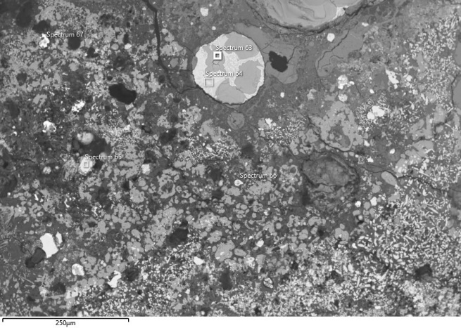 | 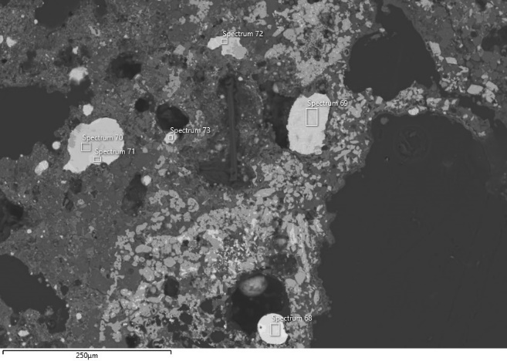
Image 1 | Image 2
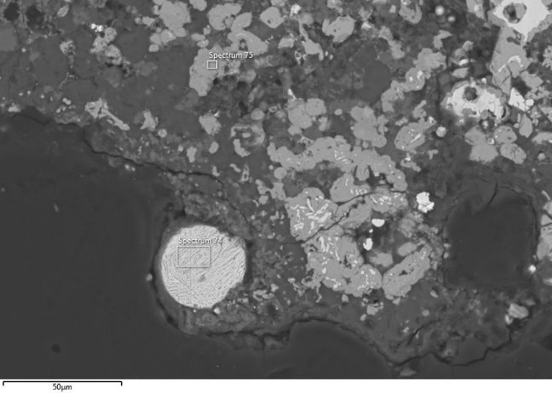 | 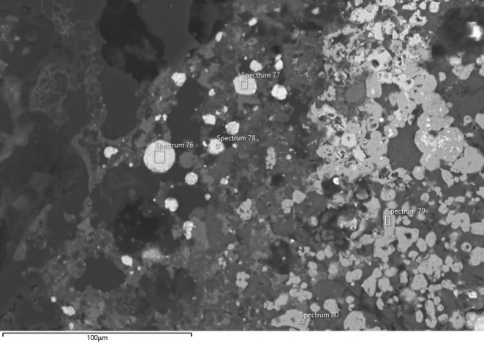
Image 3 | Image 4
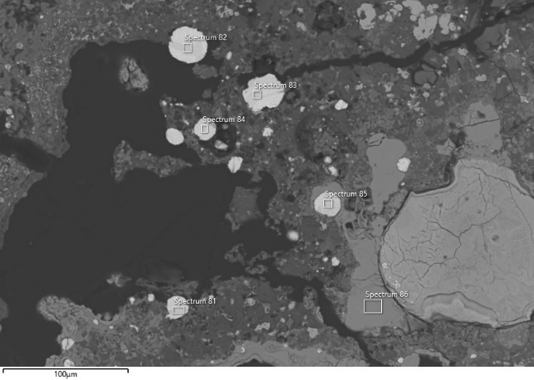 | 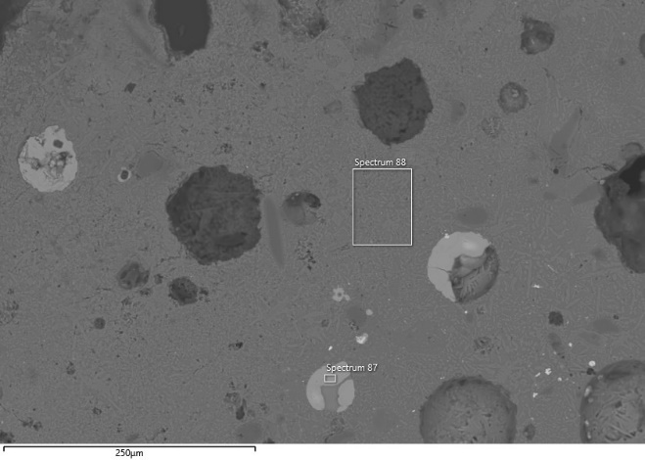
Image 5 | Image 6
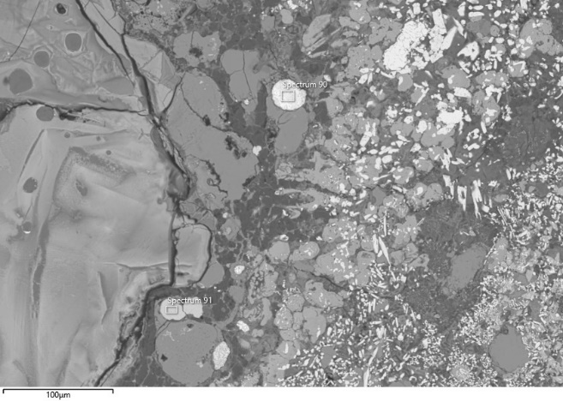 | 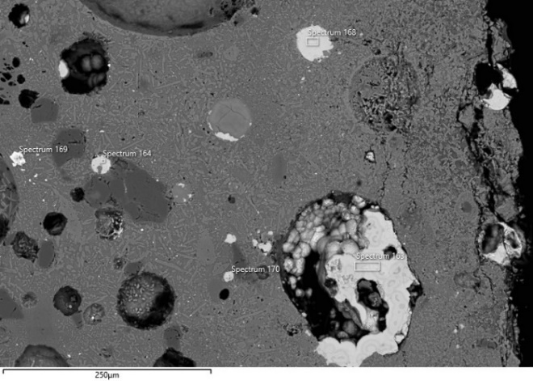
Image 7 | Image 8
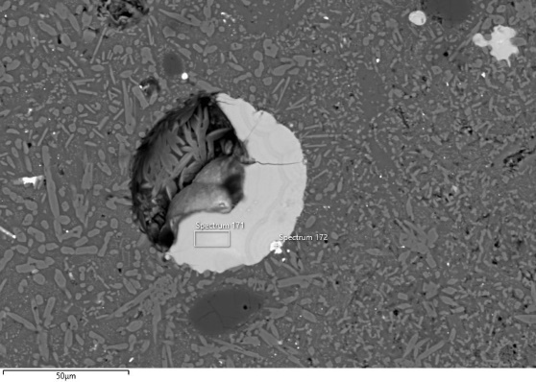 | 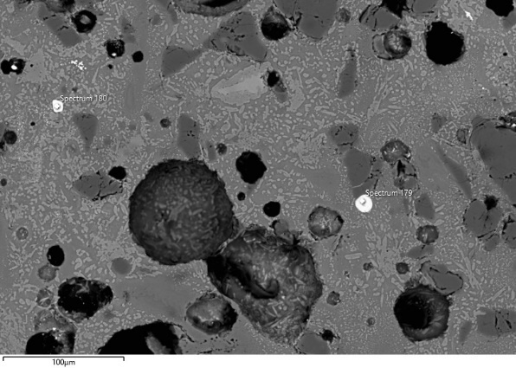
Image 9 | Image 10
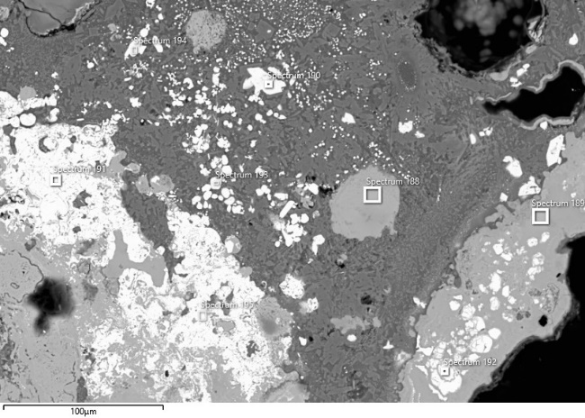 | 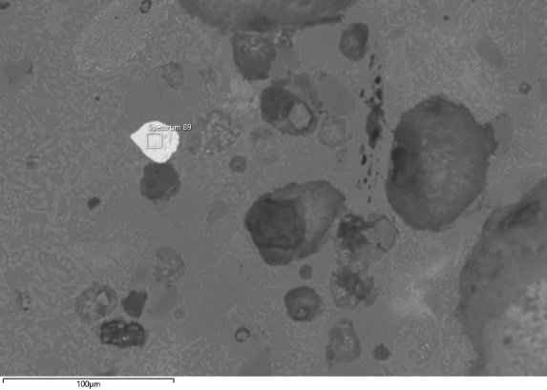
Image 11 | Image 12
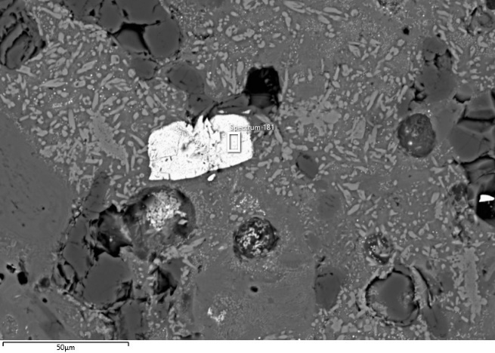
Image 13
Fig. 3 Locations of the analyses performed on specimen TSRP91. The corresponding analytical results are reported in the table above.

TSRP124
Crucible areas | Bloated areas
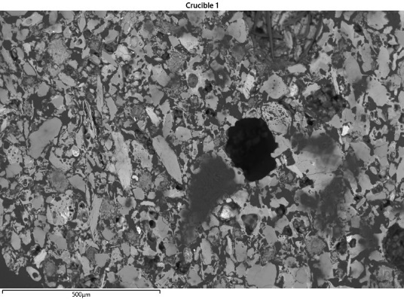 | 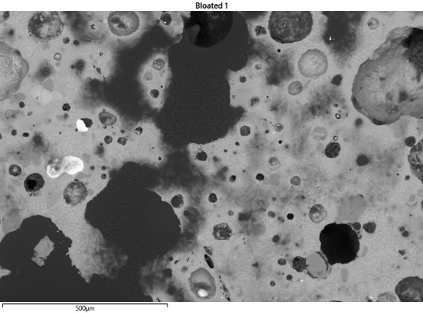
 | 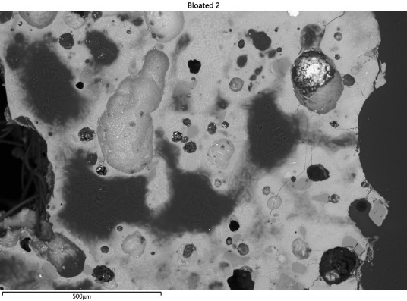
 | 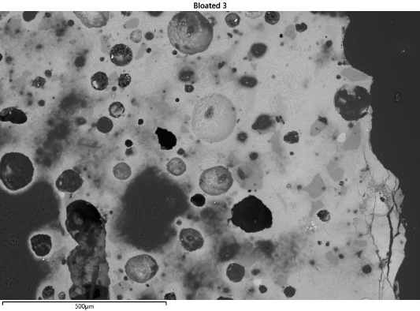
 | 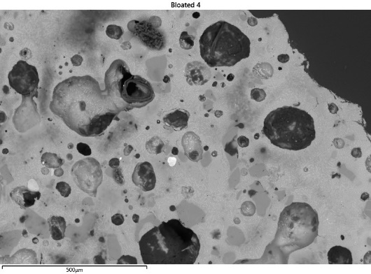
 | 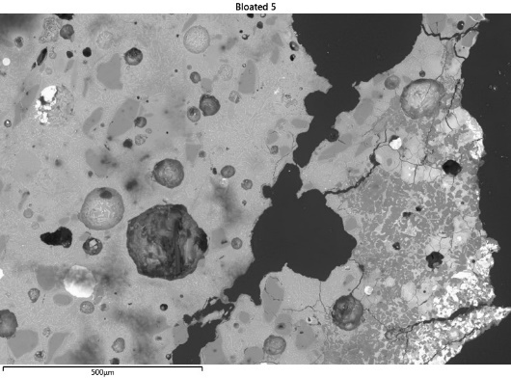
Fig. 4 Analysed crucible and bloated areas of sample TSRP124 - area at 100x magnification (c. 1mm²).
Table 3 Analyses carried out on sample TSRP124
Description | Sp. | O | Mg | Al | Si | P | S | Cl | K | Ca | Fe | Ni | Cu | Zn | As | Ag | Sn | Sb | Pb
Image 1
Cu prill | 70 |  |  |  |  |  |  | 0.3 |  |  |  | 0.2 | 98.4 |  | 0.4 | 0.1 |  | 0.6
Cu prill oxidised | 71 | 11.8 |  |  |  |  |  | 0.2 |  |  |  |  | 87.6 |  | 0.2 |  |  |  | 0.1
Sn oxide | 72 | 21.6 |  |  |  |  |  | 0.1 | 0.3 |  | 0.3 |  | 2.9 |  |  |  | 73.6 | 1.1
Image 2
Cu prill | 74 |  |  |  |  |  |  | 0.2 |  |  | 0.1 |  | 98.4 |  | 0.3 | 0.3 | 0.7
Sn oxide | 75 | 21.9 |  |  |  |  |  | 0.1 | 0.3 |  | 0.3 |  | 0.8 | 0.1 |  |  | 75.4 | 1.0
Image 3
Cu prill phase | 77 |  |  |  |  |  |  | 0.2 |  |  | 0.3 |  | 98.8 |  | 0.4 | 0.1 |  |  | 0.1
Cu prill phase | 78 | 9.2 |  |  |  |  |  | 0.4 |  |  | 0.2 |  | 89.8 | 0.1
Image 4
Cu prill phase | 80 |  |  |  |  |  |  | 0.1 |  |  | 0.1 |  | 98.7 | 0.2 | 0.3 | 0.1 |  | 0.3 | 0.1
Cu prill oxidised phase | 81 | 9.1 |  | 0.2 |  |  |  | 0.1 |  |  | 0.1 |  | 90.1 | 0.1 | 0.1 |  |  |  | 0.1
Cu oxide | 82 | 31.0 |  | 0.3 |  | 0.1 | 0.1 | 0.1 |  | 0.1 | 0.4 |  | 67.7 |  |  |  |  |  | 0.1
Image 5
Cu prill | 83 |  |  |  |  |  |  | 0.2 |  |  | 0.2 |  | 98.5 | 0.1 | 0.3 | 0.1 | 0.1 | 0.3
Cu prill | 84 |  |  |  |  |  | 0.1 | 0.1 |  |  | 0.3 | 0.1 | 98.5 | 0.1 | 0.3 | 0.1 |  | 0.2
Cu prill phase | 85 |  |  |  |  |  |  | 0.2 |  |  | 0.5 |  | 98.1 | 0.1 | 0.5 |  | 0.2 | 0.2 | 0.1
Cu prill | 86 |  |  |  |  |  |  | 0.2 |  | 0.1 | 0.4 |  | 98.4 | 0.1 | 0.2 | 0.1 |  | 0.2
Image 6
Cu prill phase | 87 | 1.6 |  |  |  |  | 0.1 | 0.1 |  |  |  |  | 95.3 |  | 0.2 |  | 2.3 | 0.1 | 0.2
Cu prill oxidised phase | 88 | 9.5 |  |  |  |  |  | 0.1 |  |  | 0.1 |  | 89.9 |  |  | 0.3 |  | 0.1
Cu oxide | 89 | 28.5 |  | 0.4 | 0.3 | 0.4 | 0.2 | 0.1 |  | 0.3 | 0.3 |  | 68.9 | 0.1 | 0.1 |  |  |  | 0.5
Image 7
Cu prill | 90 |  |  |  |  |  |  | 0.1 |  | 0.1 | 0.6 |  | 98.6 | 0.1 |  | 0.4
Cu prill | 91 |  |  |  |  |  |  | 0.3 |  |  | 0.7 |  | 98.9 | 0.1
Image 8
Cu prill | 93 |  |  |  |  |  |  | 0.1 | 0.1 |  | 0.3 |  | 94.9 | 0.2 | 0.4 |  | 2.3 | 1.7

Description | Sp. | O | Al | Si | P | Ca | La | Ce | Pr | Nd | Sm | Th
Image 9
Inclusion (monazite) | 92 | 25.23 | 0.12 | 0.18 | 13.41 | 0.34 | 17.51 | 29.42 | 2.75 | 9 | 0.99 | 1.03

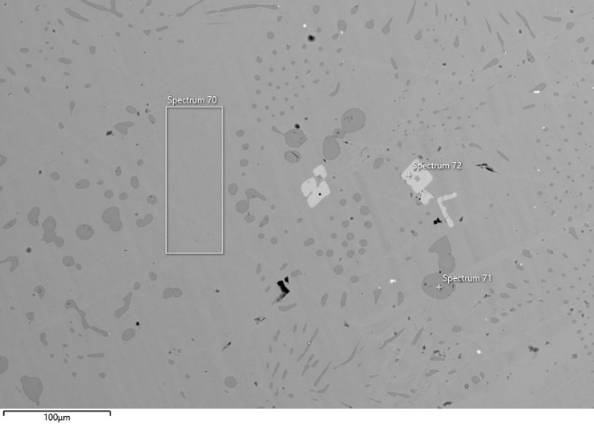 | 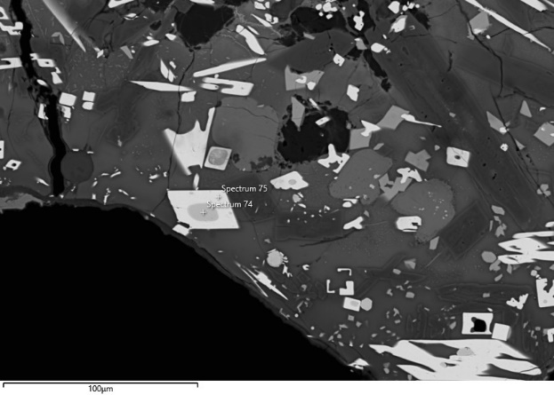
Image 1 | Image 2
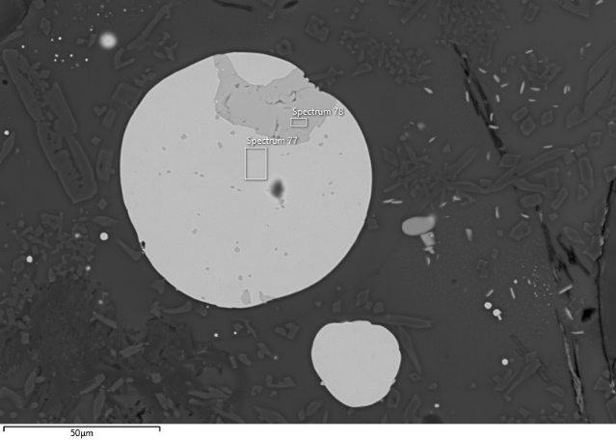 | 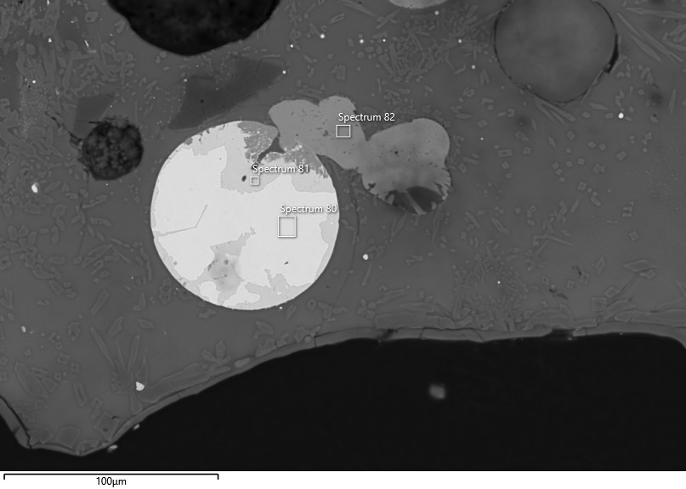
Image 3 | Image 4
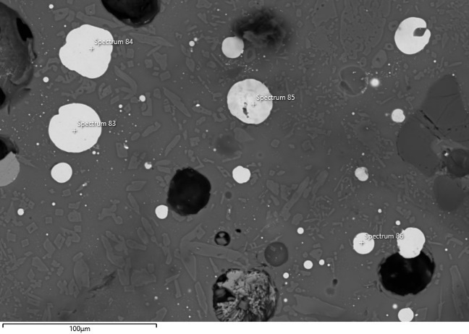 | 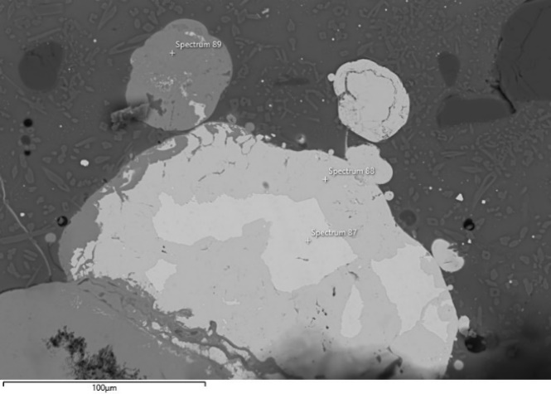
Image 5 | Image 6
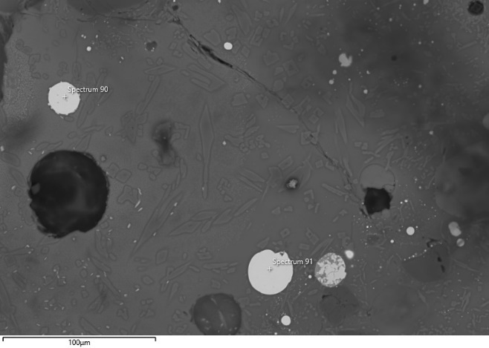 | 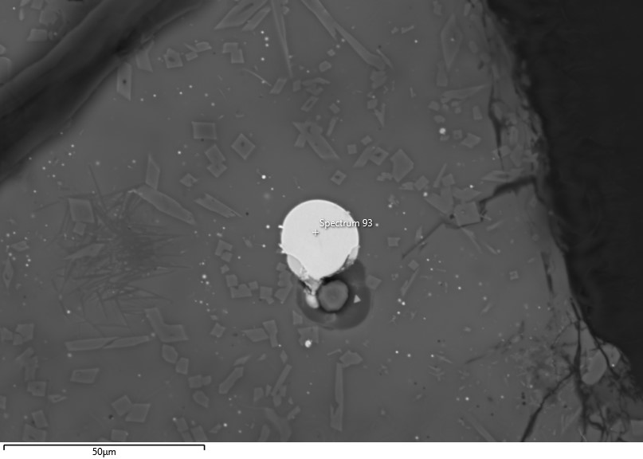
Image 7 | Image 8
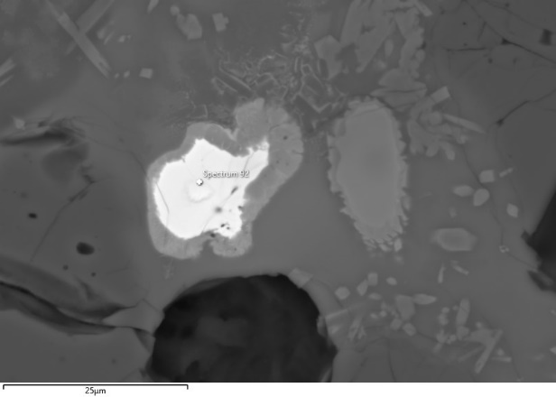
Image 9
Fig. 5 Locations of the analyses performed on specimen TSRP124. The corresponding analytical results are reported in the table above.

TSRP115a
Crucible areas | Bloated areas
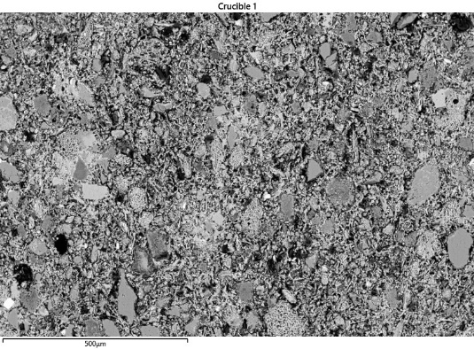 | 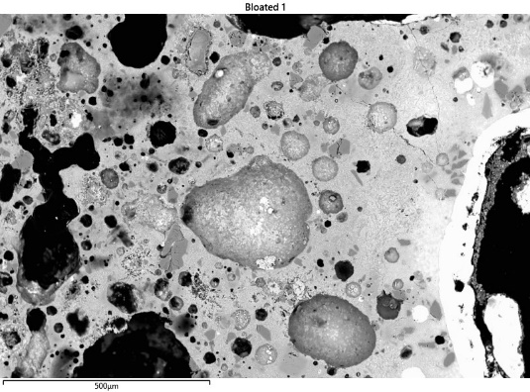
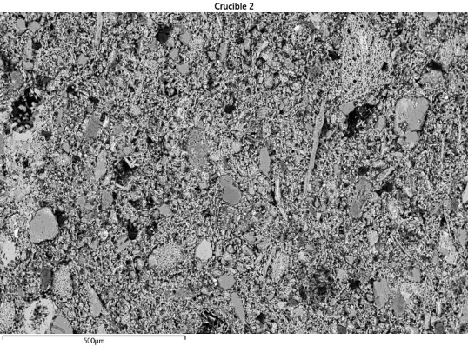 | 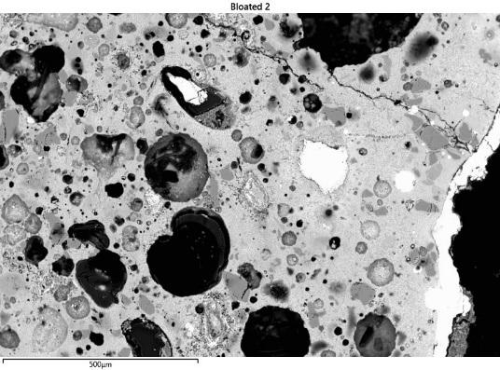
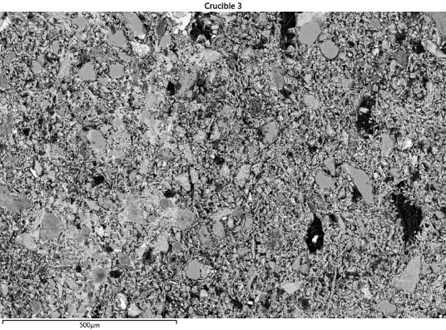 | 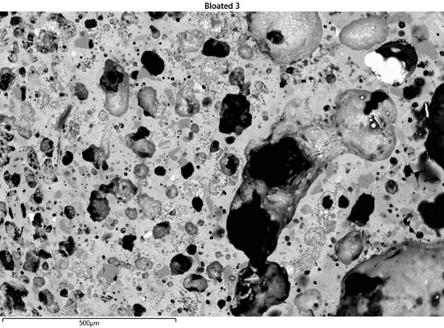
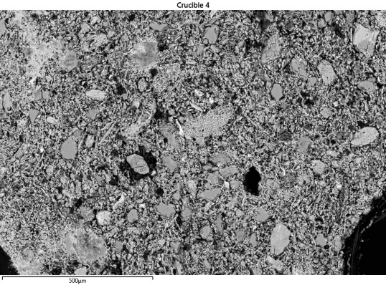 | 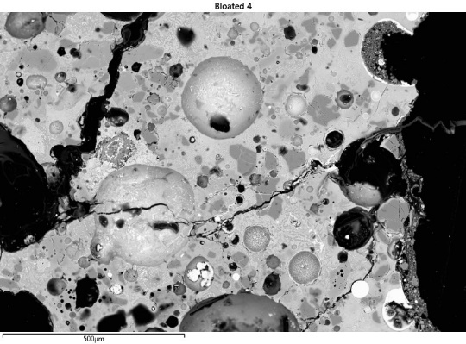
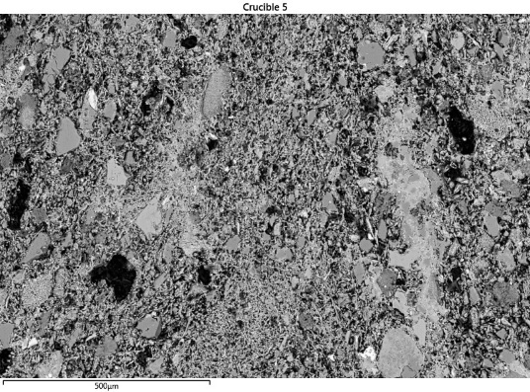 | 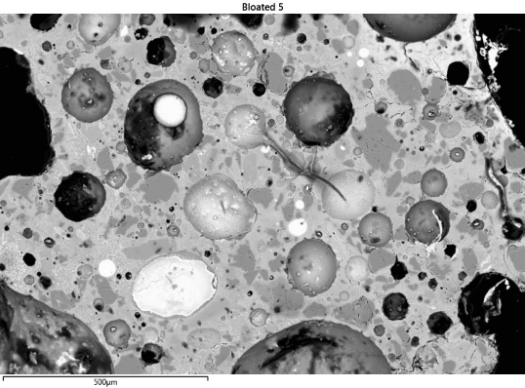
Fig. 6 Analysed crucible and bloated areas of sample TSRP115a - area at 100x magnification (c. 1mm²).
Table 4 Analyses carried out on sample TSRP115a
Description | Sp. | O | Mg | Al | Si | P | S | Cl | K | Ca | Fe | Ni | Cu | Zn | As | Ag | Sn | Sb | Pb
Image 1
Cu prill | 136 | 2.0 |  | 0.2 | 0.4 |  | 0.3 |  | 0.3 | 0.4 | 1.2 |  | 94.8 | 0.1 | 0.2 | 0.1 | 0.1 | 0.1
Cu prill | 137 | 3.2 |  | 0.5 | 1.7 |  | 0.1 | 0.2 | 0.6 | 0.9 | 1.4 | 0.1 | 90.8 | 0.1 | 0.1 | 0.1 | 0.1 | 0.1 | 0.1
Cu oxide | 138 | 17.6 | 0.2 | 4.2 | 13.1 | 0.3 |  | 0.1 | 2.2 | 5.1 | 2.9 |  | 53.1 | 0.2 |  | 0.1 | 0.3 | 0.1 | 0.5
Image 2
Cu oxide | 139 | 34.1 |  | 0.1 | 0.2 | 0.1 | 0.2 | 0.1 |  | 0.3 | 1.3 | 0.3 | 61.3 | 1.5 | 0.1 |  |  |  | 0.4
Image 3
Cu prill | 140 |  |  |  |  |  |  | 0.1 |  |  | 0.5 |  | 98.1 | 0.3 |  | 0.2 | 0.4 | 0.3
Sn oxide | 141 | 21.3 |  |  |  |  |  |  | 0.4 |  | 0.2 |  | 0.9 | 0.2 | 0.1 |  | 76.2 | 0.9
Image 4
Cu oxide phase | 142 | 34.1 |  |  |  |  |  | 0.1 |  | 0.2 | 0.5 | 0.1 | 63.9 | 0.7 |  | 0.1 |  |  | 0.3
Cu oxide phase | 143 | 11.1 |  |  | 0.1 |  |  | 0.2 |  | 0.1 | 0.5 |  | 87.8 | 0.1
Image 5
Cu prill | 144 |  |  |  |  |  |  |  |  |  | 0.2 |  | 98.1 | 0.1 | 0.2 | 0.4 | 0.2 | 0.3 | 0.6
Cu prill | 145 |  |  |  |  |  |  | 0.1 |  |  | 0.3 |  | 98.9 | 0.3 | 0.2 | 0.2 |  | 0.1
Cu prill | 146 |  |  |  |  |  | 0.1 | 0.2 |  |  | 0.7 |  | 98.6 | 0.1 | 0.1 | 0.1 | 0.1 | 0.3
Image 6
Cu prill | 147 |  |  |  |  |  |  |  |  |  | 0.2 | 0.1 | 98.2 | 0.1 | 0.5 | 0.2 | 0.1 | 0.3 | 0.3
Cu prill | 148 | 1.7 |  |  |  |  |  |  |  |  | 0.5 |  | 97.4 | 0.2 | 0.1 | 0.1 | 0.1 | 0.1
Cu prill | 149 |  |  |  |  |  |  |  |  | 0.1 | 0.7 |  | 98.2 | 0.2 |  |  | 0.3 | 0.5
Image 7
Cu oxide | 150 | 30.6 |  |  |  |  |  |  |  | 0.2 | 0.9 |  | 66.5 | 0.3 | 0.1 |  |  |  | 1.5
Cu oxide phase | 151 | 32.7 |  |  |  |  |  |  |  | 0.1 | 0.6 |  | 65.7 | 0.3 |  |  |  |  | 0.6
Cu prill | 152 |  |  |  |  |  | 0.1 | 0.1 |  | 0.1 | 0.8 |  | 98.2 | 0.1 |  | 0.1 | 0.1 | 0.3
Image 8
Cu prill | 153 |  |  |  |  |  |  |  |  | 0.1 | 0.9 |  | 97.9 | 0.1 | 0.7 | 0.2 |  |  | 0.1
Cu prill | 154 | 1.7 |  | 0.1 | 0.2 |  |  | 0.1 |  | 0.1 | 0.9 |  | 96.1 | 0.1 | 0.4 | 0.1 | 0.1 |  | 0.1
Cu prill | 155 |  |  |  |  |  | 0.1 | 0.1 | 0.1 | 0.1 | 1.0 |  | 97.0 |  | 0.7 |  | 0.2 |  | 0.6
Image 9
Cu prill | 156 | 1.8 |  |  |  |  |  | 0.1 |  |  | 0.9 |  | 97.1 | 0.1 |  | 0.1
Cu prill | 157 |  |  |  |  |  |  | 0.1 | 0.1 |  | 0.7 |  | 98.6 | 0.2 |  |  | 0.2 |  | 0.1
Image 10
Cu sulphide | 158 | 7.0 |  | 0.1 | 0.1 | 0.1 | 28.1 |  | 0.1 | 0.1 | 22.8 |  | 40.2 |  | 0.2 | 0.6 |  | 0.1 | 0.7
Image 11
Cu prill | 159 |  |  |  | 0.2 |  |  |  |  | 0.1 | 0.8 |  | 98.3 | 0.2 |  | 0.2 |  |  | 0.1
Cu prill | 160 |  |  |  |  |  |  |  |  | 0.1 | 1.0 |  | 98.7 |  | 0.1 |  |  |  | 0.1
Cu prill | 161 | 4.4 |  | 0.1 | 0.2 | 0.1 |  | 0.1 | 0.1 | 0.1 | 0.8 |  | 93.8 | 0.1 | 0.1 |  |  |  | 0.1
Image 12
Cu-Sn oxide | 162 | 27.3 | 2.2 | 1.1 | 0.5 | 0.1 |  | 0.1 | 0.3 | 0.1 | 55.8 | 1.6 | 1.1 | 0.7 |  |  | 9.2
Sn oxide | 163 | 21.2 |  |  | 0.1 |  |  | 0.1 | 0.4 |  | 0.6 |  | 0.8 |  |  |  | 75.9 | 0.9 | 0.1
Cu prill | 164 |  |  |  |  |  |  | 0.2 |  |  | 0.5 |  | 97.9 |  |  | 0.4 | 0.6 | 0.5

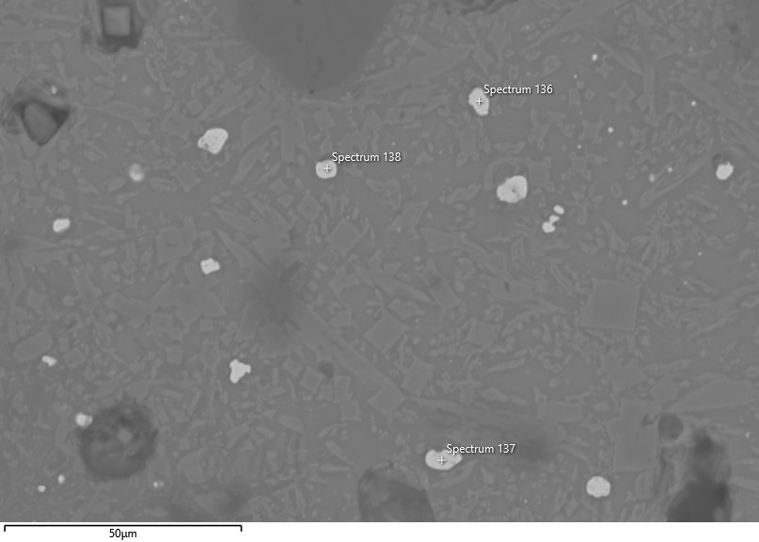 | 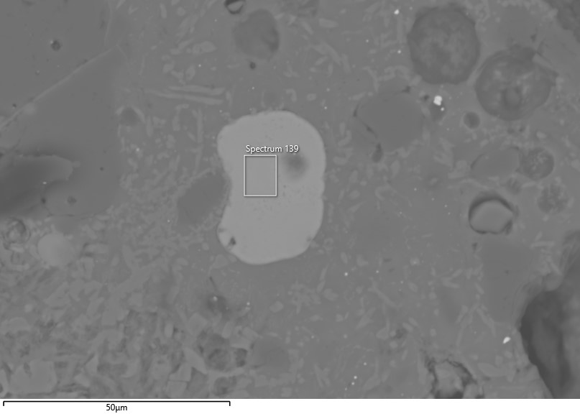
Image 1 | Image 2
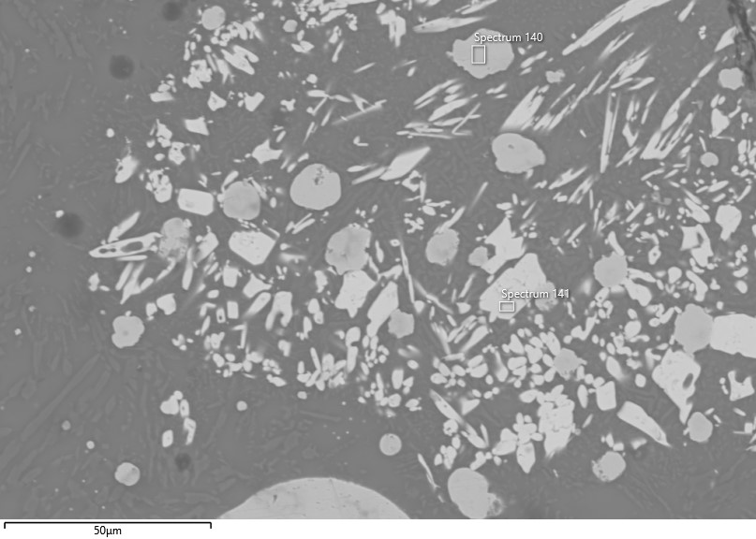 | 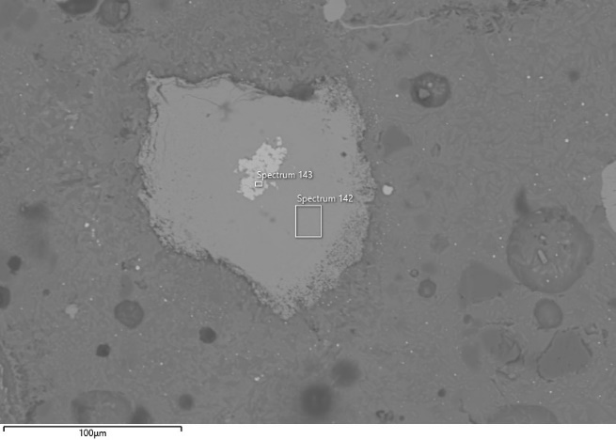
Image 3 | Image 4
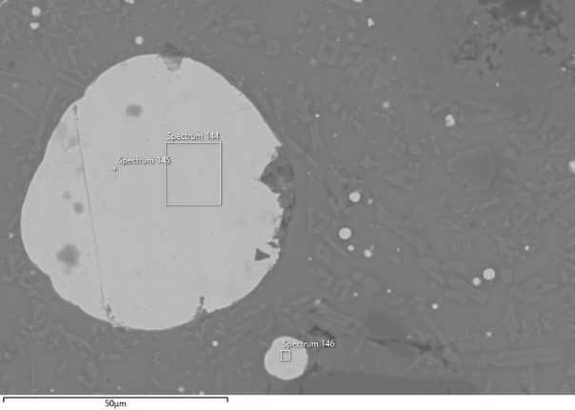 | 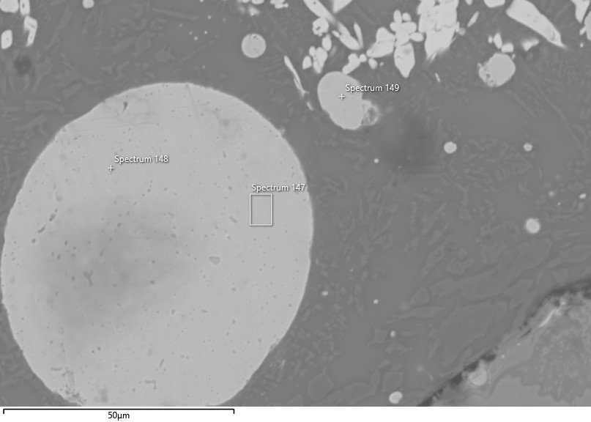
Image 5 | Image 6
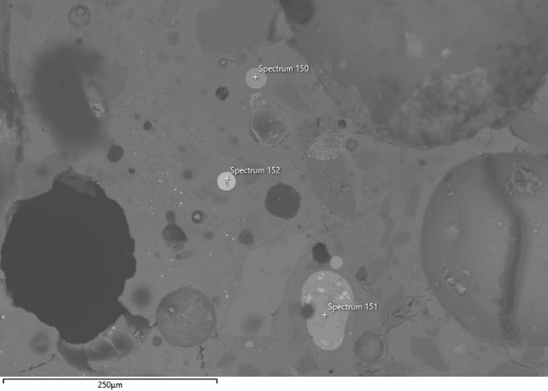 | 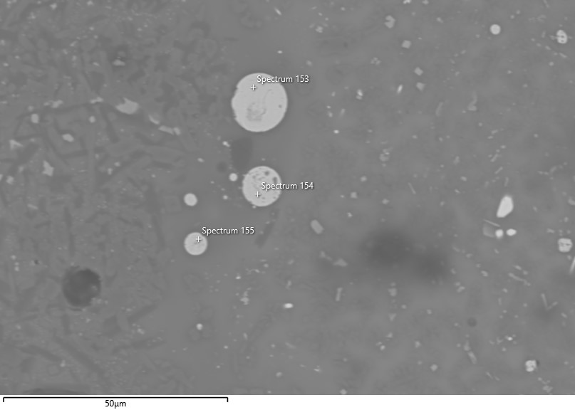
Image 7 | Image 8
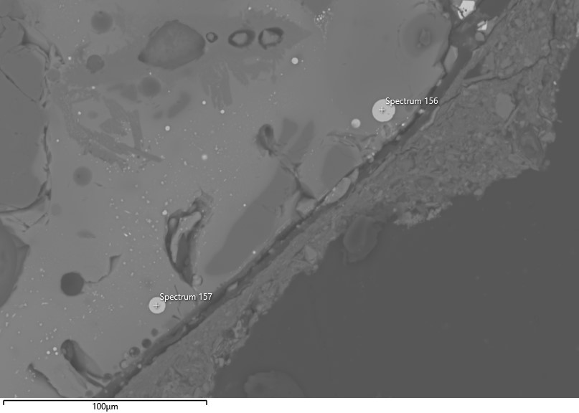 | 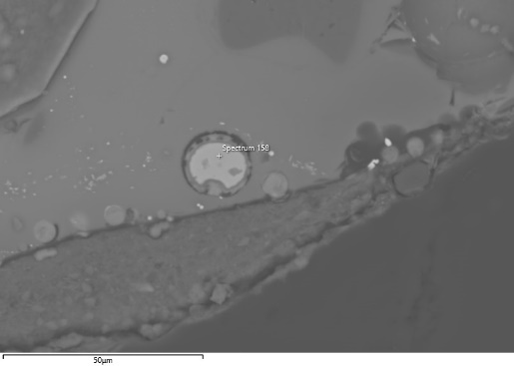
Image 9 | Image 10
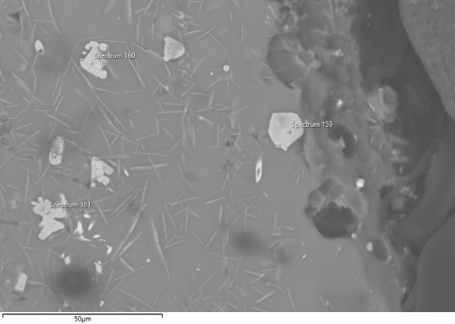 | 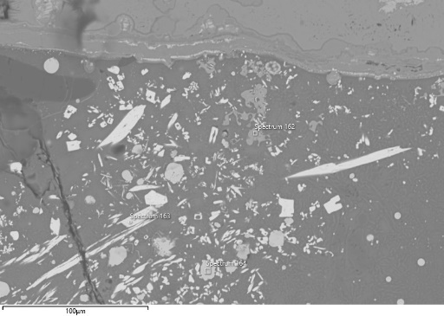
Image 11 | Image 12
Fig. 7 Locations of the analyses performed on specimen TSRP115a. The corresponding analytical results are reported in the table above.

TSRP115b
Crucible areas | Bloated areas
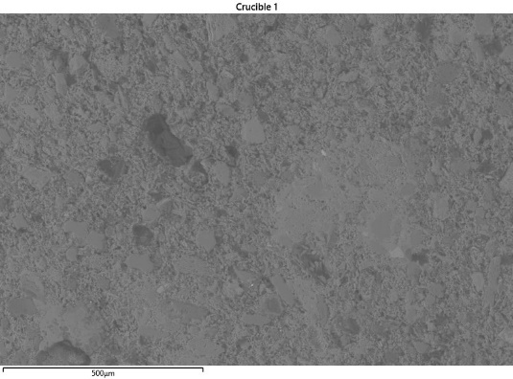 | 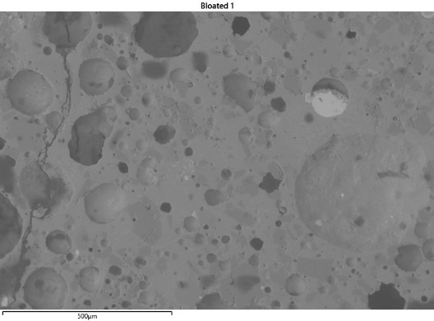
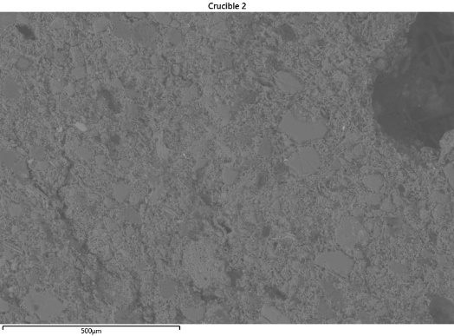 | 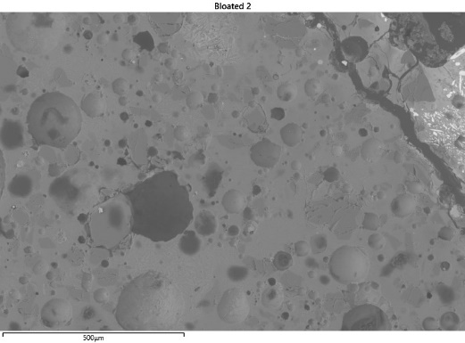
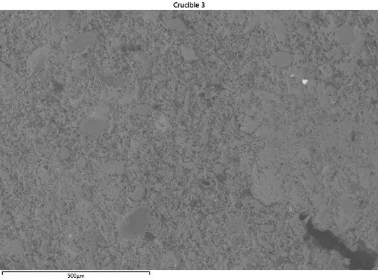 | 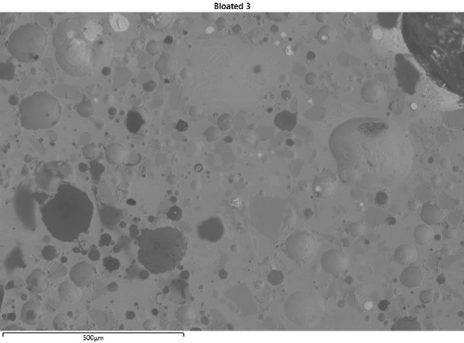
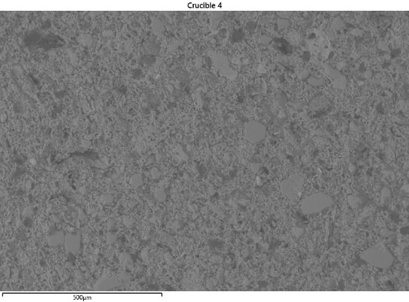 | 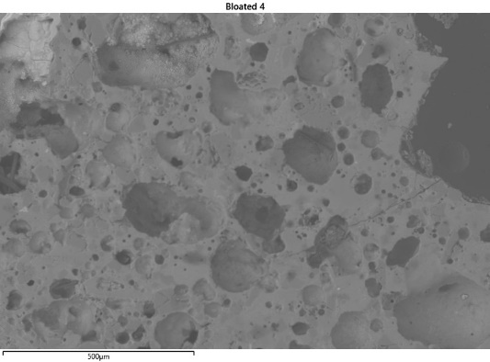
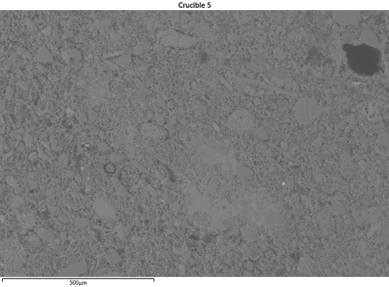 | 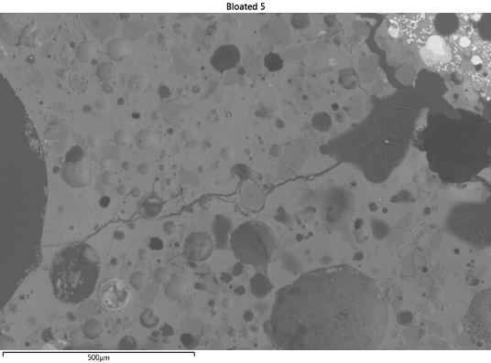
Fig. 8 Analysed crucible and bloated areas of sample TSRP115b - area at 100x magnification (c. 1mm²).
Table 5 Analyses carried out in sample TSRP115b
Description | Sp. | O | Mg | Al | Si | P | S | Cl | K | Ca | Fe | Ni | Cu | Zn | As | Ag | Sn | Sb | Pb
Image 1
High-Sn prill | 213 |  |  |  |  |  |  |  |  |  | 0.1 | 0.1 | 64.7 |  |  |  | 33.1 | 0.9 | 1.2
High-Sn prill | 214 |  |  |  |  |  |  |  |  |  |  | 0.2 | 64.0 |  | 0.1 |  | 33.4 | 1.0 | 1.4
High-Sn prill | 215 |  |  |  |  |  |  |  |  |  |  | 0.3 | 70.0 |  | 0.3 |  | 26.3 | 1.2 | 1.9
High-Sn prill | 216 |  |  |  |  |  |  |  |  |  |  | 0.2 | 55.5 |  |  |  | 43.1 | 1.1 | 0.1
High-Sn prill | 217 |  |  |  |  |  |  |  |  |  |  | 0.1 | 51.5 |  | 0.2 |  | 42.0 | 1.5 | 4.5
High-Sn prill | 218 |  |  |  |  |  |  |  |  |  |  | 0.2 | 56.3 |  | 0.1 |  | 40.5 | 1.2 | 1.4
High-Sn prill | 219 |  |  |  |  |  |  |  |  |  |  |  | 40.5 |  | 0.1 |  | 52.4 | 1.7 | 5.3
High-Sn prill | 220 |  |  |  |  |  |  |  |  |  |  | 0.2 | 53.7 |  | 0.2 |  | 42.6 | 1.9 | 1.5
High-Sn prill | 221 |  |  |  |  |  |  |  |  |  |  | 0.3 | 60.6 |  | 0.2 |  | 36.8 | 1.4 | 0.8
Image 2
High-Sn prill | 222 |  |  |  |  |  |  |  |  |  |  | 0.3 | 57.2 |  | 0.1 |  | 39.6 | 1.4 | 1.5
High-Sn prill | 223 |  |  |  |  |  |  |  |  |  |  |  | 73.9 |  |  |  | 22.8 | 0.5 | 2.8
Cu-Sn prill | 224 |  |  |  |  |  |  | 0.2 | 0.2 |  | 0.2 | 0.3 | 83.9 | 0.1 |  | 0.1 | 12.8 | 0.4 | 1.8
Cu-Sn prill | 225 | 1.4 |  |  |  |  | 0.1 | 0.3 | 0.2 |  | 0.1 | 0.1 | 81.5 | 0.1 | 0.1 | 0.1 | 13.6 | 0.7 | 2.0
Image 3
Cu-Sn prill | 226 | 1.9 |  |  |  |  |  | 0.2 | 0.1 |  | 0.2 | 0.1 | 74.1 | 0.1 | 0.1 |  | 18.1 | 0.6 | 4.7
High-Sn prill | 227 |  |  |  |  |  |  |  |  |  |  | 0.4 | 63.7 |  | 0.1 |  | 33.4 | 0.9 | 1.4
Image 4
Cu-Sn prill | 228 | 2.0 |  |  |  |  | 0.1 | 0.1 | 0.1 |  | 0.3 | 0.1 | 80.4 | 0.1 | 0.2 |  | 10.8 | 0.6 | 5.3
High-Sn prill | 229 |  |  |  |  |  |  |  |  |  |  | 0.3 | 57.7 |  | 0.2 |  | 38.6 | 1.2 | 2.1
High-Sn prill | 230 |  |  |  |  |  |  |  |  |  |  | 0.2 | 63.5 |  | 0.2 |  | 33.9 | 1.0 | 1.2
High-Sn prill | 231 |  |  |  |  |  |  |  |  |  |  | 0.1 | 64.3 |  | 0.1 |  | 33.4 | 1.0 | 1.2
Cu-Sn prill | 232 |  |  |  |  |  |  | 0.1 | 0.1 |  | 0.1 | 0.1 | 85.7 | 0.3 | 0.2 | 0.1 | 9.4 | 0.5 | 3.4
High-Sn prill | 233 |  |  |  |  |  |  |  |  |  |  | 0.2 | 53.6 |  | 0.1 |  | 43.3 | 1.1 | 1.7
Sn oxide | 234 | 20.4 |  | 0.1 | 0.1 |  |  | 0.1 | 0.3 |  | 0.2 | 0.1 | 14.2 |  |  |  | 63.7 | 0.7 | 0.2
Image 5
Cu-Sn prill | 235 | 5.2 |  | 0.1 | 0.1 |  | 0.1 | 0.1 | 0.1 |  | 0.1 | 0.1 | 65.1 | 0.2 | 0.2 |  | 19.1 | 0.6 | 9.0
High-Sn prill | 236 |  |  |  |  |  |  |  |  |  | 0.2 | 0.2 | 60.0 |  | 0.1 |  | 37.6 | 0.9 | 0.9
High-Sn prill | 237 |  |  |  |  |  |  |  |  |  | 0.2 | 0.0 | 59.3 |  | 0.1 |  | 37.4 | 0.8 | 2.2
High-Sn prill | 238 |  |  |  |  |  |  |  |  |  |  | 0.2 | 63.3 |  | 0.2 |  | 33.5 | 0.9 | 1.9
High-Sn prill | 239 |  |  |  |  |  |  |  |  |  | 0.2 | 0.1 | 55.6 |  | 0.1 |  | 43.0 | 0.8 | 0.3
High-Sn prill | 240 |  |  |  |  |  |  |  |  |  | 0.5 | 0.4 | 62.1 |  | 0.1 |  | 34.5 | 0.9 | 1.5
Cu oxide | 241 | 34.9 | 0.1 | 0.2 | 0.2 | 0.1 | 0.1 | 0.1 |  | 0.1 | 0.7 |  | 62.8 |  | 0.2 |  |  |  | 0.5
High-Sn prill | 242 |  |  |  |  |  |  |  |  |  | 0.3 | 0.3 | 61.5 |  | 0.1 |  | 35.3 | 1.0 | 1.6
High-Sn prill | 243 |  |  |  |  |  |  |  |  |  | 0.4 | 0.1 | 54.7 |  | 0.2 |  | 42.1 | 1.0 | 1.6
Image 6
Cu-Sn prill | 244 | 33.9 | 0.3 | 0.2 | 4.2 | 4.0 |  | 0.1 | 0.1 | 3.6 | 0.2 | 0.1 | 14.9 |  | 0.1 | 0.3 | 26.6 | 0.9 | 10.6
Cu oxide | 245 | 31.9 |  |  | 0.3 | 0.2 | 3.0 |  |  | 0.3 | 0.7 |  | 59.8 | 0.2 | 0.1 | 0.1 | 0.6 | 0.1 | 2.6
Cu oxide | 246 | 34.4 |  |  | 0.1 | 0.2 | 0.2 |  |  | 0.1 | 0.5 |  | 62.8 | 0.1 | 0.1 |  | 0.1 | 0.1 | 1.4
Image 7
Cu oxide | 247 | 35.1 |  | 0.2 | 0.1 | 0.4 | 0.3 | 0.1 |  | 0.3 | 0.5 |  | 61.5 | 0.2 | 0.1 |  |  |  | 1.2
Cu oxide | 248 | 33.6 | 0.1 | 0.3 | 0.5 | 0.2 | 0.1 | 0.1 |  | 0.3 | 1.2 |  | 60.5 | 1.2 | 0.1 |  |  | 0.1 | 1.4
Cu oxide | 249 | 35.4 |  | 0.1 | 0.2 | 0.1 | 0.3 | 0.1 | 0.1 | 0.2 | 0.7 |  | 61.3 |  |  |  |  |  | 1.4

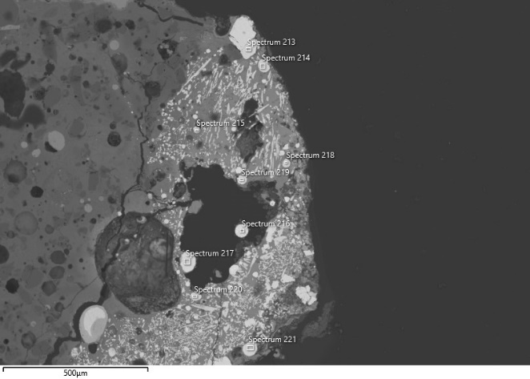 | 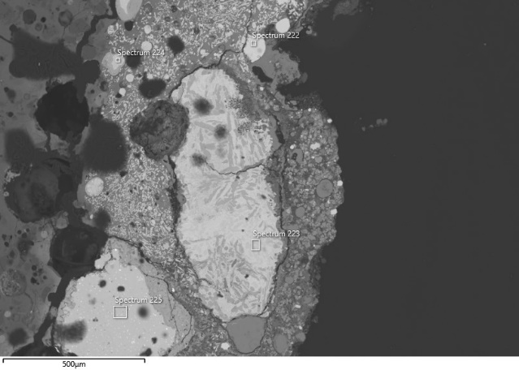
Image 1 | Image 2
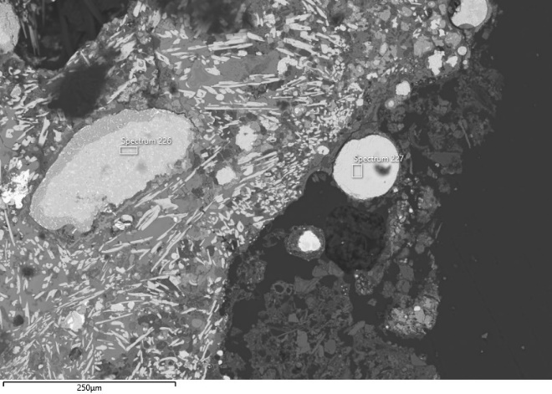 | 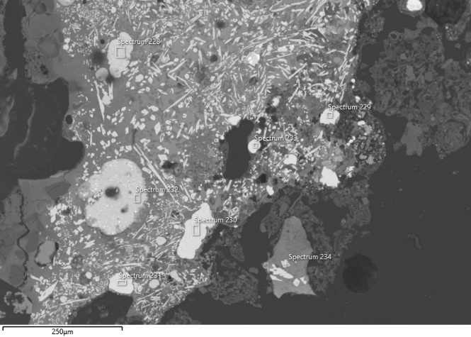
Image 3 | Image 4
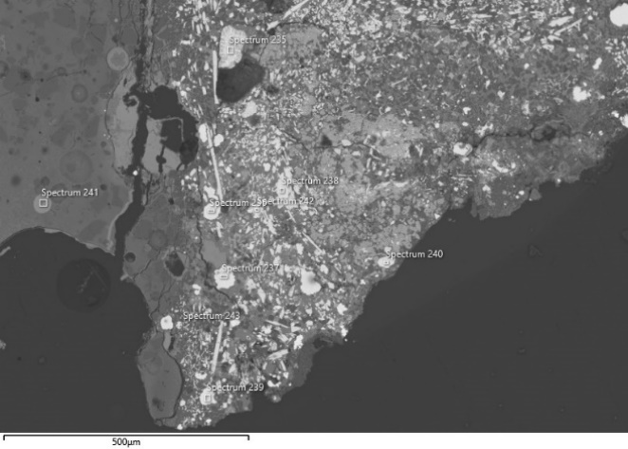 | 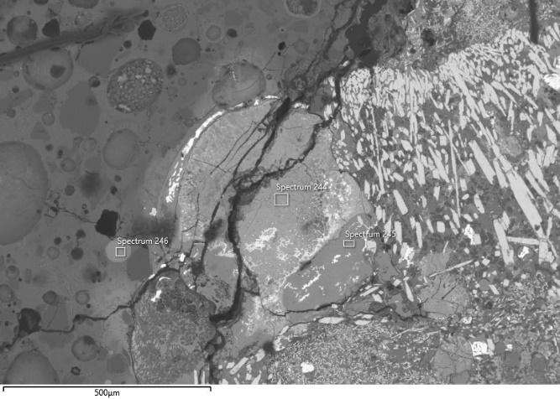
Image 5 | Image 6
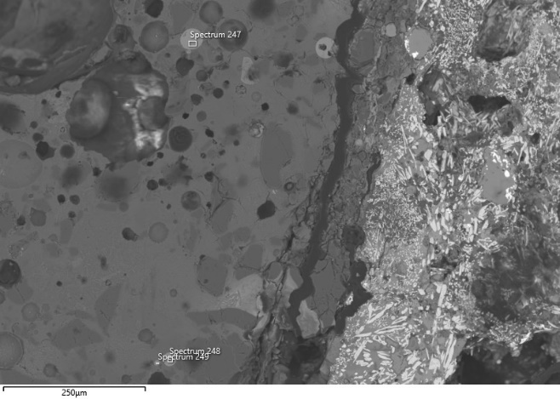
Image 7
Fig. 9 Locations of the analyses performed on specimen TSRP115b. The corresponding analytical results are reported in the table above.

TSRP149
Bloated areas | Metal-rich areas
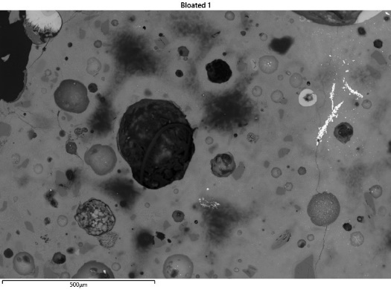 | 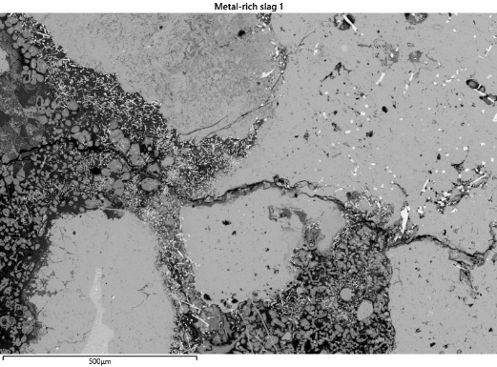
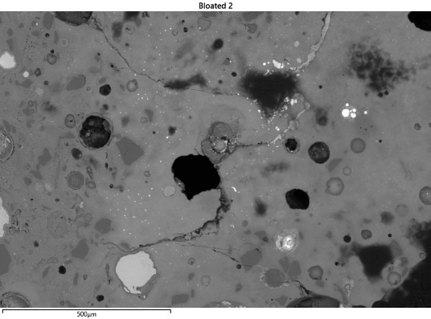 | 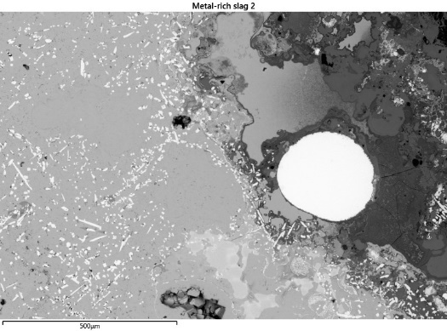
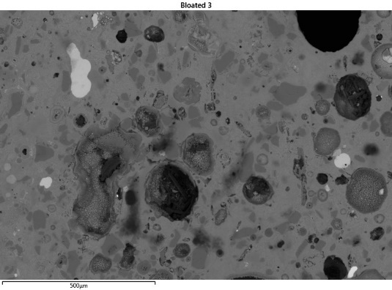 | 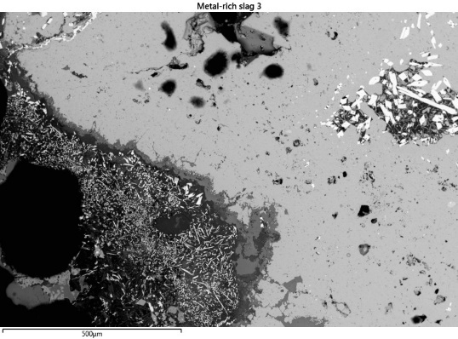
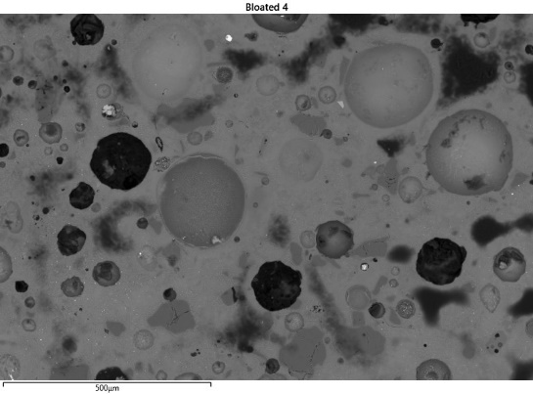 | 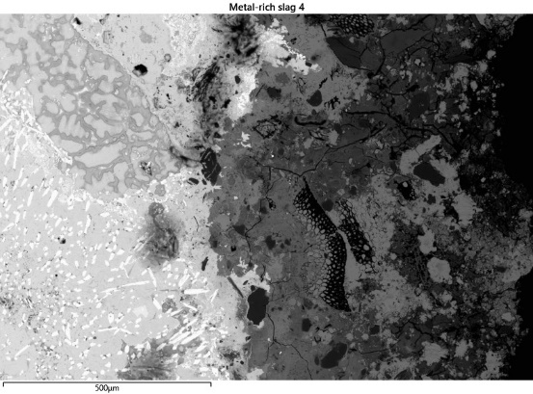
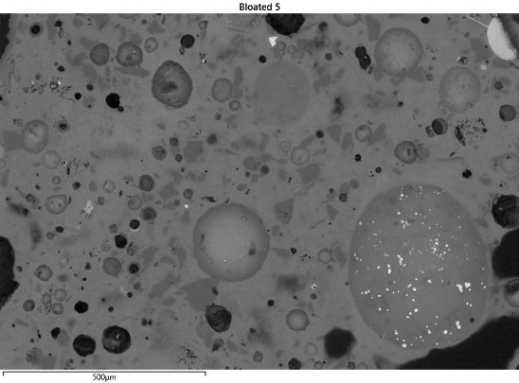 | 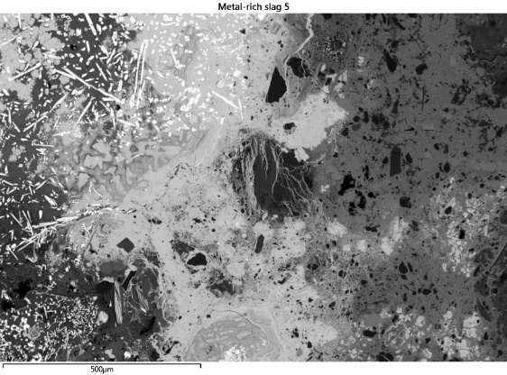
Fig. 10 Analysed crucible and bloated areas of sample TSRP149 - area at 100x magnification (c. 1mm²).
Table 6 Analyses carried out on sample TSRP149
Description | Sp. | O | Mg | Al | Si | P | S | Cl | K | Ca | Fe | Ni | Cu | Zn | As | Ag | Sn | Sb | Pb
Image 1
Cu-Sn prill phase | 94 |  |  |  |  |  |  |  |  |  |  |  | 97.2 | 0.1 |  |  | 2.3 | 0.1
Cu-Sn oxidised phase | 95 | 17.8 |  | 0.2 | 1.4 |  | 0.1 | 0.2 | 0.1 |  | 0.8 |  | 61.7 |  |  |  | 17.3 | 0.3 | 0.2
Cu-Sn prill phase | 96 | 1.5 | 0.1 |  | 0.1 |  |  | 0.1 | 0.1 |  |  | 0.1 | 68.4 | 0.1 |  |  | 28.7 | 0.6 | 0.3
Image 2
Cu-Sn prill phase | 97 | 1.6 |  | 0.1 | 0.1 |  |  | 0.1 | 0.1 |  |  | 0.2 | 60.5 | 0.1 |  |  | 36.7 | 0.5 | 0.1
Cu-Sn oxidised phase | 98 | 26.3 |  |  | 0.6 |  | 0.2 | 0.1 | 0.2 |  | 0.1 | 0.3 | 13.3 | 0.1 | 0.1 |  | 57.3 | 0.6 | 0.9
Image 3
High-Sn prill phase | 99 |  |  |  |  |  |  |  |  |  |  | 0.1 | 56.2 |  | 0.1 | 0.0 | 43.0 | 0.5 | 0.1
High-Sn prill phase | 100 |  |  |  |  |  |  |  |  |  |  | 0.0 | 37.3 |  | 0.1 | 0.0 | 61.7 | 1.0 | 0.0
Image 4
Cu prill phase | 101 | 1.5 | 0.1 |  | 0.1 |  | 0.3 | 0.1 |  |  |  |  | 95.9 |  | 0.1 |  | 1.7 | 0.1 | 0.1
Image 5
Cu-Sn oxidised phase | 102 | 12.1 |  | 0.2 | 0.4 | 0.3 | 0.7 | 0.5 |  |  | 0.1 |  | 82.0 |  |  |  | 3.4 | 0.2 | 0.1
Fe oxide | 103 | 27.6 | 2.5 | 1.0 | 0.1 |  |  | 0.1 | 0.1 | 0.2 | 59.9 | 0.1 | 1.8 | 1.4 |  |  | 5.3
Fe oxide | 104 | 25.5 | 2.8 | 1.2 | 0.2 | 0.1 |  | 0.1 | 0.2 | 0.4 | 58.3 | 0.3 | 1.9 | 1.8 |  |  | 7.2 | 0.1
Fe oxide | 105 | 27.2 | 2.5 | 0.9 | 0.1 |  |  | 0.1 |  | 0.2 | 57.6 | 0.3 | 2.1 | 1.5 |  |  | 7.5
Fe oxide | 106 | 1.8 | 0.1 |  | 0.1 |  | 0.2 | 0.2 |  | 0.1 | 5.4 |  | 91.4 | 0.2 |  | 0.1 | 0.1 |  | 0.2
Fe oxide | 107 | 26.3 | 2.3 | 0.4 | 0.1 |  |  | 0.1 | 0.1 | 0.2 | 62.3 | 0.5 | 2.6 | 1.2 |  |  | 3.8 |  | 0.1
Image 6
Fe oxide | 108 | 26.8 | 2.8 | 1.1 |  |  |  | 0.1 |  | 0.1 | 62.6 | 0.6 | 2.3 | 0.9 |  |  | 2.7 | 0.1
Sn oxide | 109 | 21.7 |  |  | 0.1 |  |  | 0.1 | 0.3 |  | 1.0 |  | 0.9 | 0.1 |  |  | 75.2 | 0.7
??? | 110 | 28.7 | 3.1 | 1.3 | 0.1 |  |  | 0.1 | 0.1 | 0.1 | 54.4 | 0.2 | 2.2 | 1.1 |  | 0.1 | 8.8
Image 7
Malayaite | 111 | 31.9 | 0.8 | 2.1 | 7.9 |  |  |  | 0.1 | 17.5 | 1 |  |  |  |  |  | 28.8 | 0.7
Malayaite | 112 | 38.3 | 2.5 | 4.5 | 18.2 | 1.9 |  | 0.1 | 5.9 | 11.8 | 10.5 |  | 0.3 | 0.4 |  | 0.1 | 5.4 | 0.2 | 0.1
Malayaite | 113 | 34.7 | 1.5 | 1.6 | 13.4 | 0.3 |  | 0.1 | 0.1 | 19.0 | 11.2 |  | 0.2 |  |  |  | 17.1 | 0.7
Image 8
Malayaite | 114 | 31.4 | 0.8 | 2.2 | 7.8 | 0.1 |  | 0.1 | 0.2 | 17.6 | 9.5 |  | 0.1 |  |  |  | 29.1 | 1.1
Malayaite | 115 | 33.2 | 1.3 | 1.5 | 10.4 | 0.1 |  | 0.1 | 0.1 | 18.5 | 9.9 | 0.1 | 0.2 | 0.1 |  |  | 23.7 | 1.0
Malayaite | 116 | 35.9 | 2.0 | 1.8 | 13.4 | 0.4 |  | 0.1 | 0.2 | 19.4 | 9.7 |  | 0.4 |  |  |  | 16.1 | 0.6 | 0.1
Cu prill oxidised | 117 | 10.6 |  |  | 0.1 |  |  | 0.3 |  | 0.1 | 0.3 |  | 88.3 | 0.1 |  |  | 0.1 | 0.1
Image 9
Malayaite | 118 | 29.7 | 0.6 | 2.4 | 7.3 |  |  | 0.1 | 0.1 | 17.7 | 10.2 |  | 0.5 | 0.1 |  |  | 30.4 | 0.9
Malayaite | 119 | 29.6 |  | 0.1 | 10.1 | 0.2 |  | 0.1 | 0.2 | 13.9 | 0.4 | 0.1 | 0.6 |  |  |  | 43.5 | 1.1
Cu prill oxidised | 120 | 9.2 |  | 0.1 |  |  |  | 0.3 |  | 0.1 | 0.5 |  | 89.3 | 0.2 |  |  | 0.2 | 0.1
Sn oxide | 121 | 21.9 |  |  | 0.1 |  |  | 0.1 | 0.3 |  | 0.1 | 0.1 | 0.3 |  | 0.1 |  | 76.3 | 0.7
Image 10
Malayaite | 122 | 29.7 | 0.6 | 2.1 | 6.6 |  |  | 0.1 | 0.2 | 17.2 | 11.0 | 0.1 | 0.6 |  |  |  | 30.6 | 1.3
Cu prill oxidised | 123 | 9.3 |  |  | 0.1 |  |  | 0.2 | 0.1 | 0.2 | 1.0 |  | 88.8 |  | 0.1 |  | 0.2
Malayaite | 124 | 36.8 | 2.9 | 4.1 | 18.6 | 1.8 | 0.3 | 0.1 | 6.0 | 14.8 | 6.6 | 0.2 | 5.9 | 0.2 |  | 0.1 | 0.5 | 0.4 | 1.0
Image 11
Malayaite | 135 | 37.4 | 4.1 | 2.8 | 19.3 | 0.5 |  | 0.1 |  | 16.3 | 14.2 |  | 0.9 | 0.1 |  |  | 3.8 | 0.3 | 0.2
Inclusion | 136 | 29.4 |  | 9.9 | 0.3 | 7.6 | 2.6 |  |  | 1.1 | 4.1 |  | 7.3 | 0.1 | 0.2 |  | 4.8 | 0.2 | 32.6
Malayaite | 137 | 38.7 | 4.8 | 2.6 | 18.6 | 0.9 |  |  | 0.1 | 15.7 | 12.9 |  | 0.7 | 0.1 |  |  | 4.5 | 0.3
???? | 138 | 36.2 | 0.2 | 6.7 | 25.6 | 0.8 | 0.2 | 0.2 | 0.1 | 2.3 | 2.5 |  | 22.3 | 0.1 |  |  | 2.5 | 0.1 | 0.2
???? | 139 | 25.6 | 0.2 | 6.0 | 24.9 | 0.5 | 0.1 | 0.2 | 0.1 | 2.4 | 3.3 | 0.1 | 34.6 | 0.1 |  |  | 1.7 |  | 0.1
Image 12
Malayaite | 140 | 37.6 | 2.2 | 3.0 | 16.9 | 1.6 |  | 0.1 | 1.8 | 13.7 | 16.0 |  | 0.7 | 0.2 |  |  | 5.9 | 0.3 | 0.2
Malayaite | 141 | 29.0 | 0.6 | 2.7 | 7.3 |  |  | 0.1 | 0.2 | 18.1 | 9.3 |  |  |  |  |  | 31.5 | 1.2

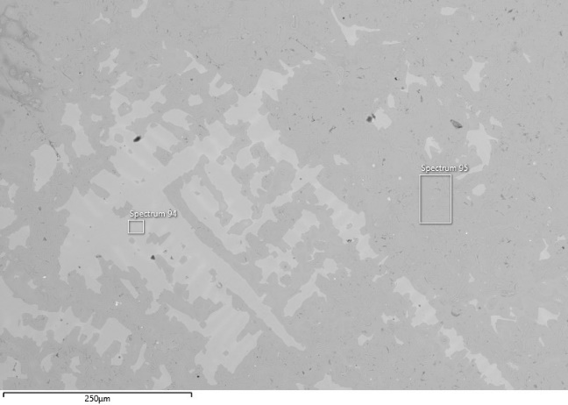 | 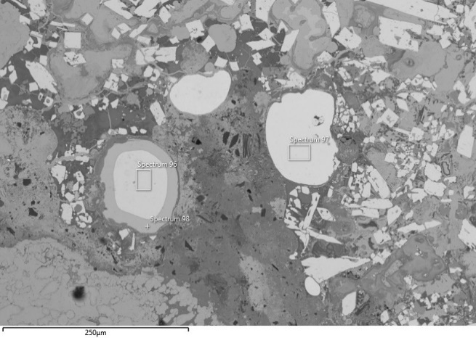
Image 1 | Image 2
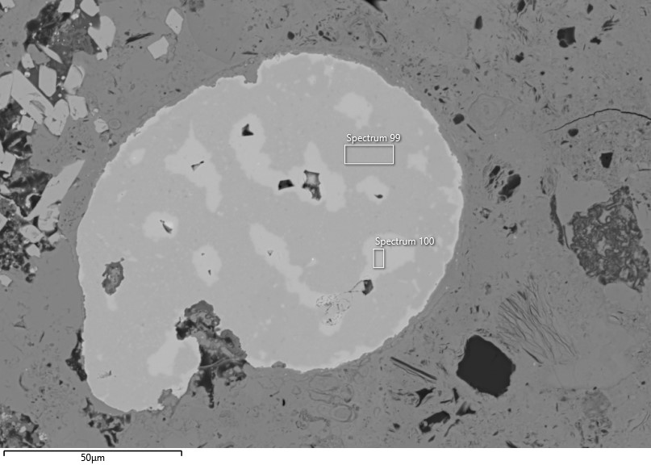 | 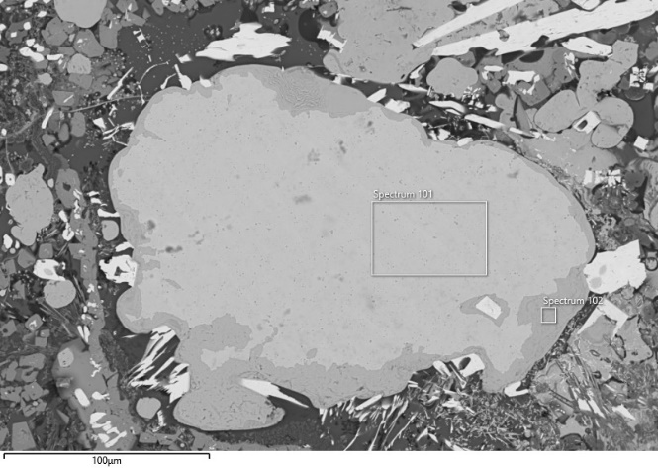
Image 3 | Image 4
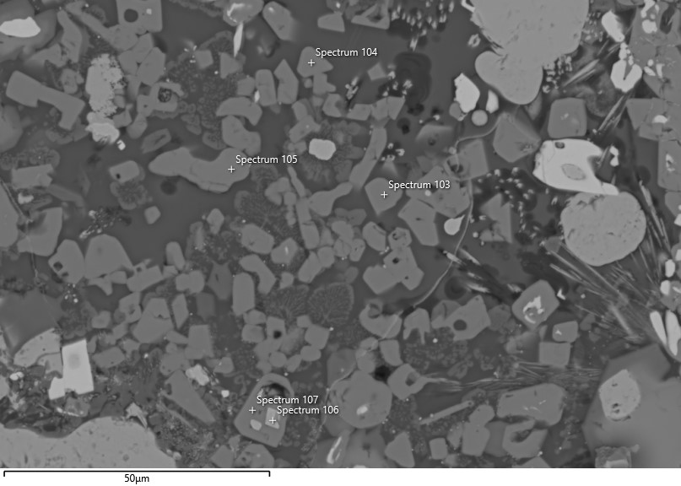 | 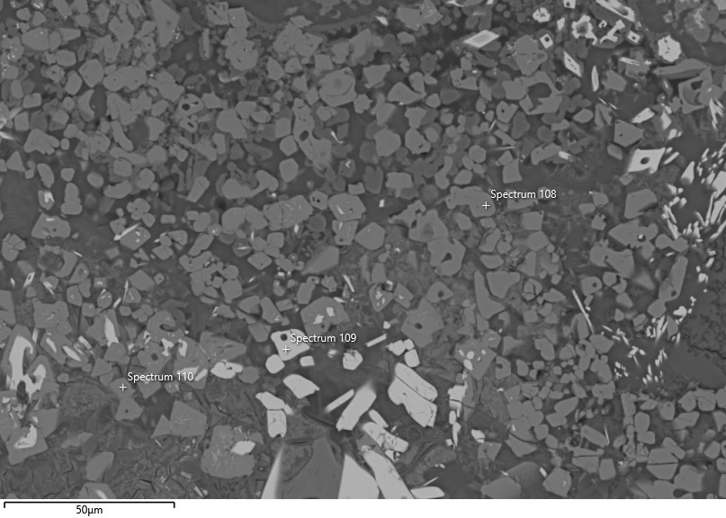
Image 5 | Image 6
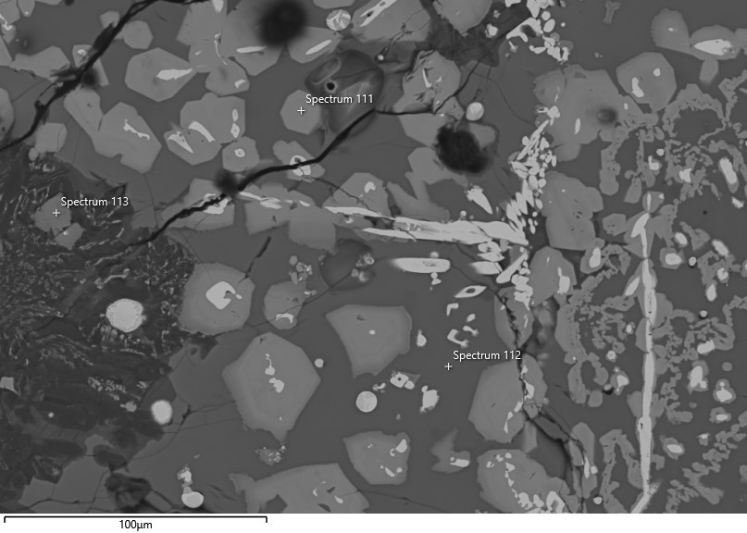 | 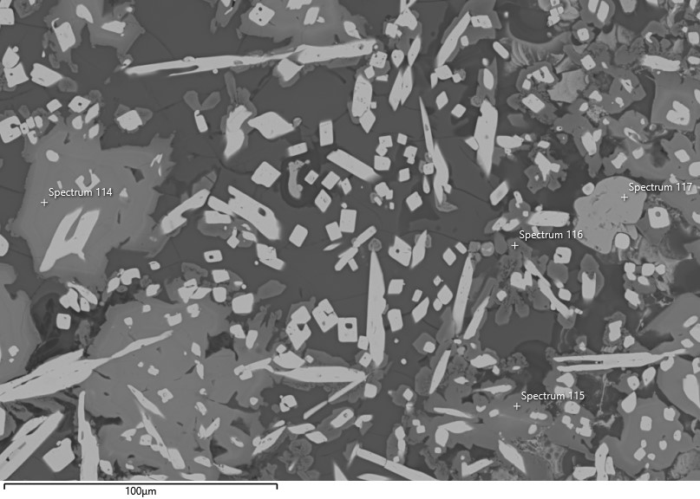
Image 7 | Image 8
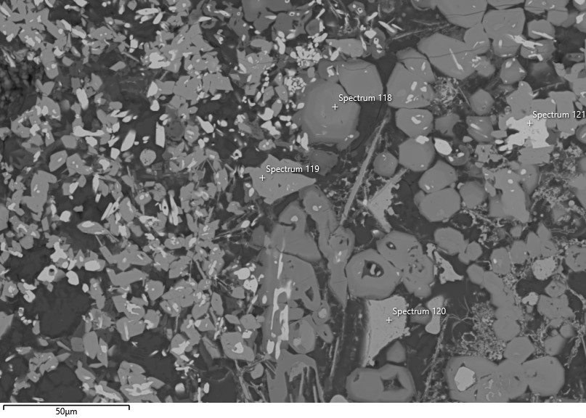 | 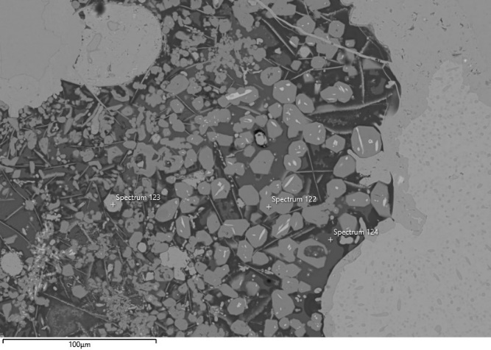
Image 9 | Image 10
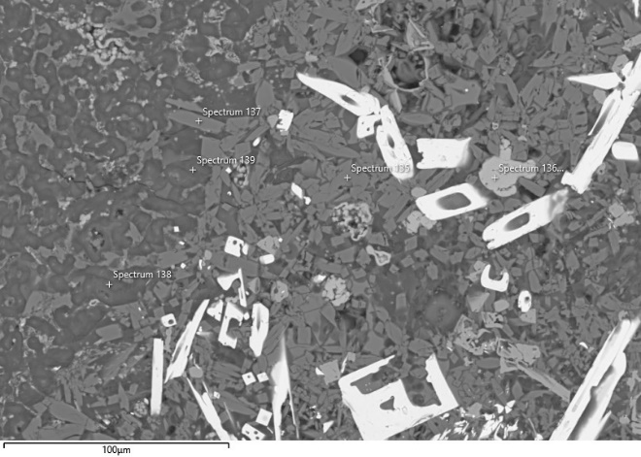 | 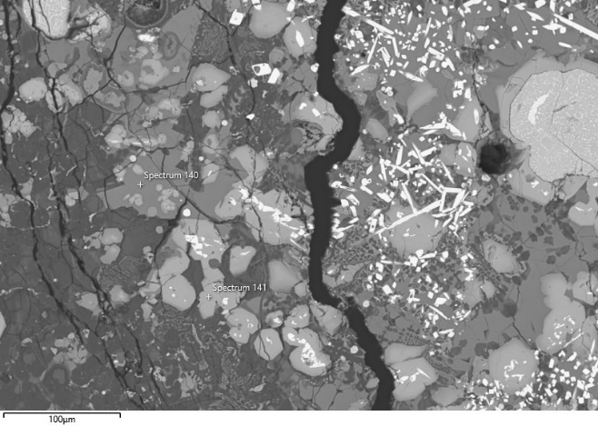
Image 11 | Image 12
Fig. 11 Locations of the analyses performed on specimen TSRP149. The corresponding analytical results are reported in the table above.

TSRP91a
Crucible/bloated areas | Metal-rich areas
 | 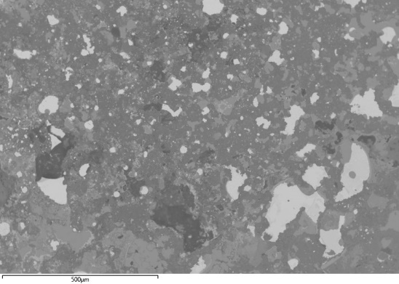
 | 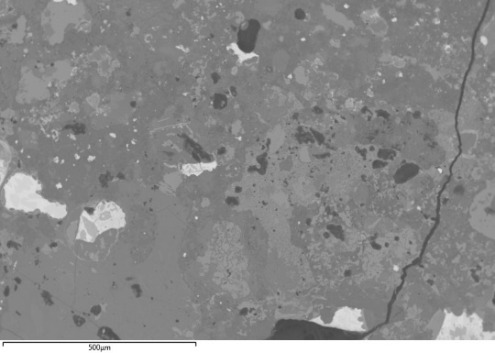
 | 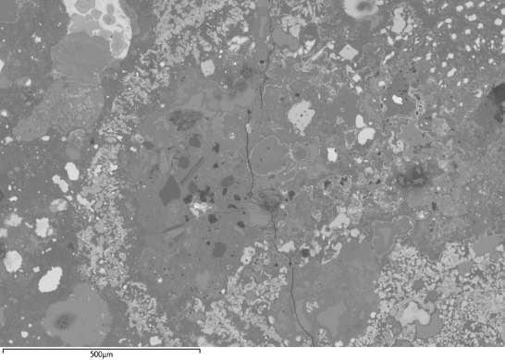
 | 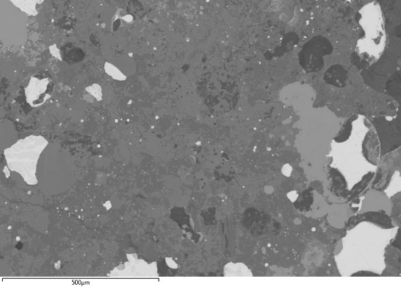
 | 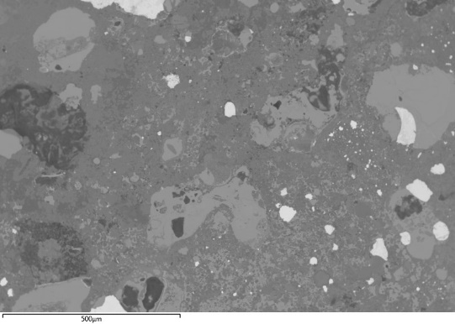
Fig. 12 Analysed crucible and bloated areas of sample TSRP91a - area at 100x magnification (c. 1mm²).
Table 7 Analyses carried out on sample TSRP91a
Description | Sp. | O | Na | Mg | Al | Si | P | S | Cl | K | Ca | Fe | Co | Ni | Cu | As | Ag | Sn | Sb | Pb
Image 1
High-Sn prill | 6 |  |  |  |  |  |  |  |  |  |  | 0.3 |  | 0.2 | 59.0 | 0.3 |  | 38.5 | 1.5 | 0.2
High-Sn prill | 7 |  |  |  |  |  |  |  |  |  |  | 0.3 |  | 0.3 | 59.6 | 0.1 | 0.1 | 38.4 | 1.1 | 0.2
High-Sn prill | 8 |  |  |  |  |  |  |  |  |  |  | 0.7 |  | 0.2 | 56.8 | 0.2 |  | 40.7 | 1.2 | 0.2
Image 2
High-Sn prill | 9 |  |  |  |  |  |  |  |  |  |  | 0.2 |  | 0.3 | 61.2 | 0.3 |  | 36.8 | 1.1 | 0.2
High-Sn prill | 10 |  |  |  |  |  |  |  |  |  |  | 0.6 |  | 0.2 | 59.5 | 0.3 |  | 38.4 | 0.9 | 0.1
High-Sn prill | 11 |  |  |  |  |  |  |  |  |  |  | 0.7 |  | 0.2 | 62.3 | 0.3 |  | 35.3 | 1.0 | 0.3
High-Sn prill | 12 |  |  |  |  |  |  |  |  |  |  | 0.2 |  | 0.1 | 61.8 | 0.4 |  | 36.3 | 1.0 | 0.1
Image 3
Malayaite | 13 | 26.1 | 4.4 |  | 0.1 |  |  |  | 0.2 |  | 16.4 | 1.6 |  |  | 0.7 |  |  | 46.0 | 4.5
Malayaite | 14 | 31.3 | 7.7 | 0.2 | 2.6 | 4.2 |  |  | 0.1 |  | 14.9 | 8.5 |  |  | 0.5 |  |  | 30.1
Malayaite | 15 | 29.9 | 0.6 | 0.4 | 4.3 | 4.3 |  |  | 0.1 |  | 16.5 | 6.2 |  |  | 0.7 |  |  | 37.1
Cu-Sn oxide | 16 | 24.1 |  |  | 1.5 | 7.4 | 0.6 |  | 0.1 | 0.3 | 3.9 | 2.6 | 0.2 | 0.2 | 35.5 |  |  | 22.5 | 1.1
Image 4
Malayaite | 17 | 28.0 |  | 0.5 | 4.1 | 4.2 |  |  | 0.1 |  | 16.7 | 6.9 |  |  | 0.3 |  |  | 37.2 | 2.0
Malayaite | 18 | 43.1 |  | 3.6 | 2.3 | 17.3 | 4.8 |  |  | 0.9 | 7.0 | 4.5 |  |  | 16.8
Image 5
High-Sn prill | 19 |  |  |  |  |  |  |  |  |  |  | 1.3 | 0.7 | 0.6 | 55.5 | 0.1 |  | 40.4 | 1.3 | 0.3
High-Sn prill | 20 |  |  |  |  |  |  |  |  |  |  | 1.7 |  | 0.5 | 54.9 | 0.1 |  | 41.3 | 1.4 | 0.1
High-Sn prill | 21 |  |  |  |  |  |  |  |  |  |  | 0.2 | 0.5 | 1.0 | 56.1 | 0.2 |  | 40.2 | 1.5 | 0.3
High-Sn prill | 22 |  |  |  |  |  |  |  |  |  |  | 0.6 | 0.5 | 0.7 | 55.5 | 0.2 |  | 41.0 | 1.5 | 0.0
Image 6
Cu oxide phase | 23 | 34.4 |  |  |  |  | 0.2 |  |  |  |  | 0.1 |  | 0.1 | 65.1 | 0.1 | 0.1 |  | 0.0 | 0.0
High-Sn prill phase | 24 |  |  |  |  |  |  |  |  |  |  |  |  | 0.2 | 67.4 | 0.2 |  | 30.5 | 1.4 | 0.3
Image 7
Cu oxide phase | 25 | 34.0 |  |  |  | 0.1 | 0.3 |  | 0.1 |  | 0.2 | 0.3 |  | 0.1 | 64.8 | 0.1
Cu oxide phase | 26 | 29.5 |  |  |  | 15.3 | 0.7 |  |  |  | 1.4 | 2.5 |  | 0.1 | 49.9 | 0.4 |  |  |  | 0.2
High-Sn prill phase | 27 |  |  |  |  |  |  |  | 0.1 |  |  | 0.2 | 0.6 | 0.6 | 63.7 | 0.9 |  | 32.1 | 1.7 | 0.2
Image 8
Cu oxide phase | 28 | 34.5 |  |  |  | 0.3 | 0.6 |  |  |  | 0.4 | 0.4 |  | 0.1 | 63.4 | 0.0 |  |  | 0.0 | 0.2
Image 9
Cu Sn phase | 1 | 6.7 |  |  |  | 0.7 |  |  |  |  |  | 0.3 |  |  | 57.0 |  |  | 33.8 | 1.5
Cu Sn phase | 2 | 31.2 |  |  | 0.8 | 7.0 | 0.8 | 0.1 | 0.1 |  |  | 2.2 |  | 0.0 | 24.4 | 0.2 |  | 32.5 | 0.5 | 0.2
Cu Sn phase | 3 | 2.5 |  |  |  |  |  |  | 0.1 |  |  |  |  | 0.4 | 61.8 | 0.2 |  | 33.8 | 1.3 | 0.1
Image 10
Cu oxide phase | 4 | 30.7 |  |  |  |  | 0.3 |  |  |  | 0.2 | 0.2 |  | 0.1 | 68.4
Cu Sn phase | 5 |  |  |  |  | 0.1 |  |  | 0.1 |  |  |  |  | 0.2 | 85.3 | 0.2 | 0.1 | 13.5 | 0.5
Cu Sn phase | 6 | 2.3 |  |  |  |  |  |  | 0.1 |  |  |  |  | 0.2 | 66.9 | 0.2 | 0.1 | 28.8 | 1.2 | 0.3
Image 11
High-Sn prill | 7 |  |  |  |  |  |  |  |  |  |  | 0.3 |  | 0.0 | 72.9 | 0.2 |  | 25.8 | 0.6 | 0.1
High-Sn prill | 8 |  |  |  |  |  |  |  |  |  |  | 0.4 |  | 0.1 | 70.2 | 0.5 |  | 27.8 | 0.8 | 0.2
High-Sn prill | 9 |  |  |  |  |  |  |  |  |  |  | 0.6 |  | 0.0 | 70.8 | 0.3 |  | 27.5 | 0.6 | 0.1
High-Sn prill | 10 |  |  |  |  |  |  |  |  |  |  | 0.5 |  | 0.1 | 65.1 | 0.2 |  | 33.2 | 0.7 | 0.2
Cu-Sn prill | 11 | 5.0 |  |  |  |  |  |  |  |  |  | 1.7 |  | 0.0 | 77.1 | 0.4 |  | 15.5 | 0.2 | 0.1
High-Sn prill | 12 |  |  |  |  |  |  |  |  |  |  | 0.8 |  | 0.1 | 64.3 | 0.4 |  | 33.5 | 0.7 | 0.2
Image 12
Cu oxide | 13 | 31.4 |  |  |  | 0.2 | 1.3 |  |  |  | 0.6 | 0.2 |  | 0.0 | 66.1 | 0.1
Image 13
Cu-Sn prill | 14 |  |  |  |  | 0.1 |  |  | 0.1 |  |  | 0.3 |  | 0.1 | 89.5 | 0.1 | 0.1 | 9.2 | 0.4 | 0.2
Cu-Sn prill | 15 |  |  |  |  | 0.1 |  |  | 0.1 |  |  | 0.4 |  | 0.1 | 90.1 | 0.1 |  | 8.8 | 0.3 | 0.0
Cu-Sn prill | 16 |  |  |  |  |  |  |  | 0.1 |  |  | 0.2 |  | 0.1 | 83.6 | 0.1 |  | 15.2 | 0.5 | 0.2
High-Sn prill | 17 |  |  |  |  |  |  |  |  |  |  |  |  | 0.1 | 72.7 | 0.2 |  | 26.2 | 0.6 | 0.2
Cu-Sn prill | 18 |  |  |  |  |  |  |  |  |  |  | 0.3 |  | 0.1 | 86.7 | 0.1 | 0.1 | 12.0 | 0.3 | 0.5
Image 14
High-Sn prill | 19 |  |  |  |  |  |  |  | 0.1 |  |  | 0.2 |  | 0.3 | 57.1 | 0.2 |  | 40.7 | 1.3 | 0.1
High-Sn prill | 20 |  |  |  |  |  |  |  |  |  |  |  |  | 0.4 | 57.5 | 0.2 |  | 40.3 | 1.5 | 0.2
High-Sn prill | 21 |  |  |  |  |  |  |  |  |  |  |  |  | 0.2 | 55.9 | 0.2 |  | 42.2 | 1.3 | 0.2
High-Sn prill | 22 |  |  |  |  |  |  |  |  |  |  |  |  | 0.3 | 57.3 | 0.1 |  | 40.6 | 1.4 | 0.3
Cu-Sn prill | 23 | 1.7 |  |  |  |  |  |  |  |  |  | 0.2 |  | 0.1 | 83.3 | 0.0 | 0.0 | 14.3 | 0.3 | 0.1
Cu-Sn prill | 24 |  |  |  |  |  |  | 0.1 |  |  |  | 0.3 |  | 0.2 | 90.9 | 0.2 | 0.1 | 7.6 | 0.4 | 0.3
High-Sn prill | 25 |  |  |  |  |  |  |  |  |  |  |  |  | 0.2 | 63.5 | 0.1 |  | 34.6 | 0.9 | 0.7
Image 15
High-Sn prill | 27 |  |  |  |  |  |  |  |  |  |  |  |  | 0.0 | 73.9 | 0.2 |  | 25.2 | 0.6 | 0.1
High-Sn prill | 28 |  |  |  |  |  |  |  |  |  |  |  |  | 0.2 | 68.1 | 0.2 |  | 30.3 | 1.1 | 0.1
Image 16
Cu oxide | 29 | 20.2 |  |  |  |  |  |  |  |  |  | 0.2 |  |  | 0.5 |  |  | 79.2
Cu | 30 | 1.5 |  |  |  |  |  |  | 0.1 |  |  |  |  | 0.1 | 98.0 | 0.1 | 0.2
Cu oxide | 31 | 31.7 |  |  |  | 0.2 | 0.7 | 0.1 | 0.1 |  | 0.6 | 0.4 |  |  | 66.2
Image 17
High-Sn prill | 32 |  |  |  |  |  |  |  | 0.1 |  |  |  |  | 0.1 | 72.6 | 0.2 |  | 26.1 | 0.8 | 0.1
High-Sn prill | 33 |  |  |  |  |  |  |  |  |  |  | 0.2 | 0.4 | 0.2 | 70.5 | 0.1 | 0.1 | 27.6 | 0.9 | 0.2
High-Sn prill | 34 |  |  |  |  |  |  |  |  |  |  |  |  | 0.1 | 72.3 | 0.2 | 0.1 | 26.3 | 0.9 | 0.1
Cu-Sn prill | 35 |  |  |  |  |  |  | 0.1 |  |  |  | 0.6 |  | 0.8 | 80.0 | 0.2 | 0.1 | 17.4 | 0.8 | 0.0
High-Sn prill | 36 |  |  |  |  |  |  |  |  |  |  | 0.7 |  |  | 71.2 | 0.2 |  | 27.0 | 0.8 | 0.1
Image 18
Cu-Sn prill | 37 |  |  |  |  |  |  |  |  |  |  |  |  | 0.2 | 81.5 | 0.1 | 0.1 | 17.2 | 0.8 | 0.2
Malayaite | 38 | 25.2 |  | 0.2 | 2.3 | 5.4 |  |  |  | 0.2 | 18.0 | 11.6 |  |  | 1.0 |  |  | 34.6 | 1.4 | 0.1
Malayaite | 39 | 26.3 |  |  | 2.4 | 4.7 |  |  |  |  | 17.7 | 12.1 |  |  | 0.6 |  |  | 36.3
Image 19
Cu | 55 |  |  |  |  |  |  |  |  |  |  |  |  |  | 99.8 |  | 0.1 | 0.0 |  | 0.1
Cu oxide | 56 | 33.0 |  |  | 0.8 | 0.4 | 0.7 |  | 0.1 |  | 0.5 | 0.6 |  |  | 63.7 |  | 0.1 | 0.1 |  | 0.1
Malayaite | 57 | 32.8 |  |  | 1.6 | 15.6 | 1.3 | 0.4 | 0.1 |  | 10.6 | 0.6 |  |  | 35.8 |  |  | 0.9 | 0.4
Malayaite | 58 | 26.9 |  | 0.3 | 4.0 | 4.3 |  |  |  |  | 17.1 | 7.8 |  |  | 1.0 |  |  | 36.2 | 2.3 | 0.0
Malayaite | 59 | 21.7 |  |  |  |  |  |  |  |  | 18.3 | 0.7 |  |  | 0.9 | 0.1 |  | 55.7 | 2.5 | 0.0
Malayaite | 60 | 27.3 |  | 1.1 | 2.5 | 6.3 |  |  |  |  | 17.7 | 7.6 |  |  | 1.0 |  |  | 34.5 | 1.9 | 0.1
Image 20
Cu Sn oxide | 61 | 35.8 |  |  |  |  |  |  |  |  |  | 4.2 |  |  | 17.7 | 0.6 |  | 40.5 | 0.9 | 0.3
Cu Sn oxide | 62 | 10.4 |  |  |  |  |  |  |  |  |  | 1.0 |  | 0.2 | 51.5 | 0.2 | 0.1 | 35.0 | 1.1 | 0.5
Image 21
Cu Sn prill | 63 |  |  |  |  |  |  |  |  |  |  |  |  |  | 80.5 | 0.1 |  | 18.7 | 0.5 | 0.2
High-Sn prill | 64 |  |  |  |  |  |  |  |  |  |  |  |  | 0.2 | 72.5 | 0.3 |  | 26.0 | 0.7 | 0.2
High-Sn prill | 65 |  |  |  |  |  |  |  |  |  |  |  |  | 0.1 | 72.8 | 0.1 | 0.1 | 26.0 | 0.8 | 0.2
High-Sn prill | 66 |  |  |  |  |  |  |  | 0.1 |  |  |  |  | 0.1 | 78.6 | 0.2 | 0.1 | 20.3 | 0.5 | 0.1
High-Sn prill | 67 |  |  |  |  |  |  |  |  |  |  | 0.1 |  | 0.1 | 70.9 | 0.1 | 0.0 | 27.5 | 1.0 | 0.3
High-Sn prill | 68 |  |  |  |  |  |  |  |  |  |  | 0.2 | 0.5 | 0.1 | 69.4 | 0.1 | 0.0 | 28.7 | 0.8 | 0.2

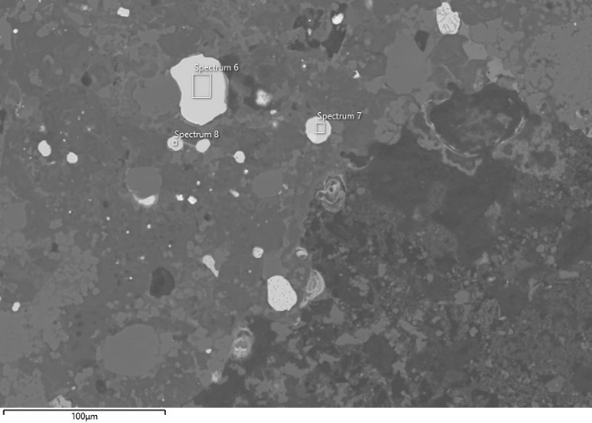 | 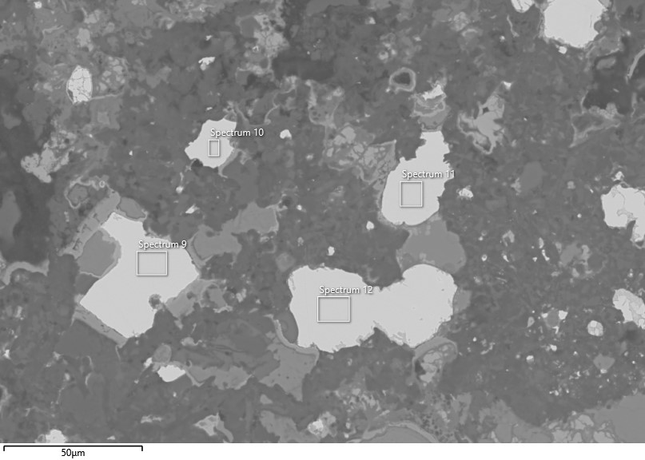
Image 1 | Image 2
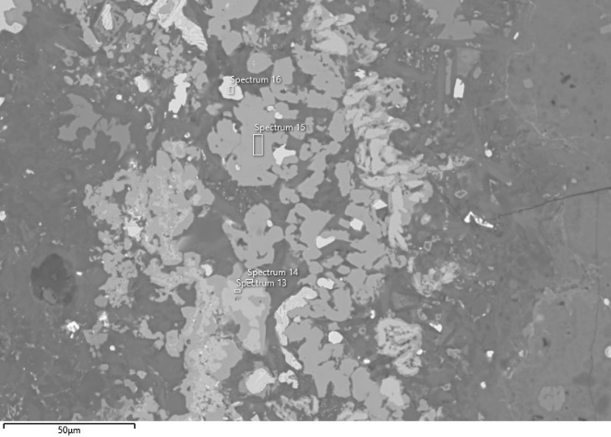 | 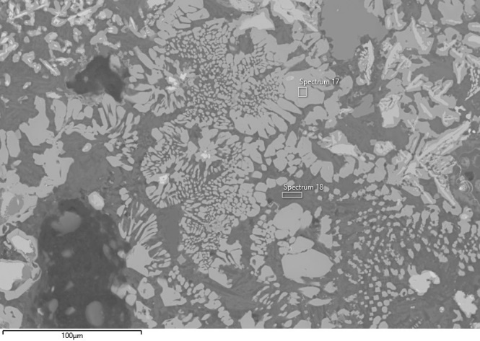
Image 3 | Image 4
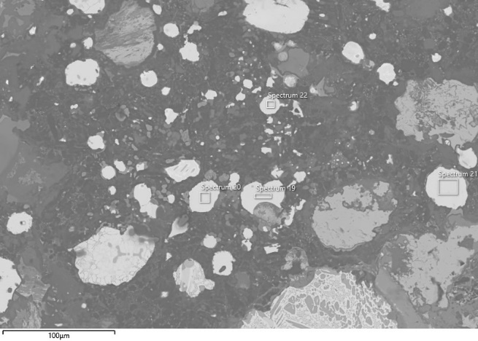 | 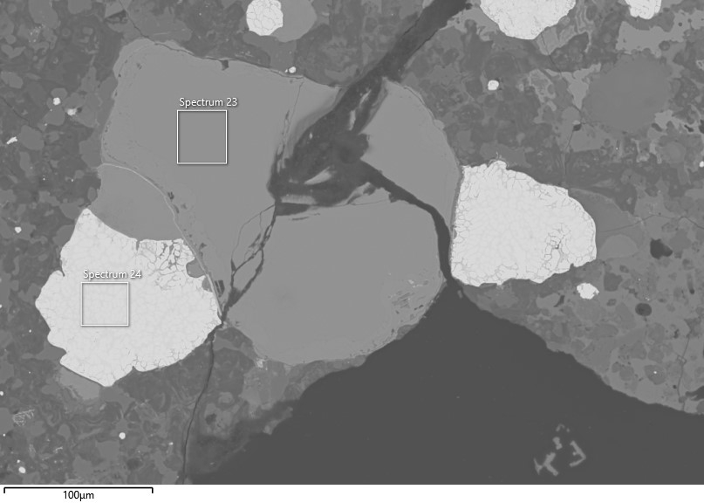
Image 5 | Image 6
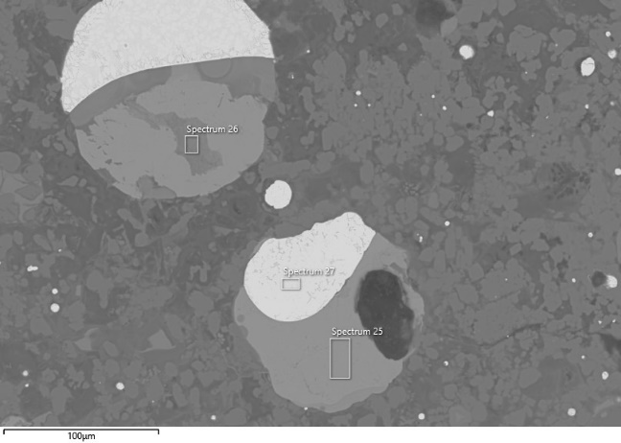 | 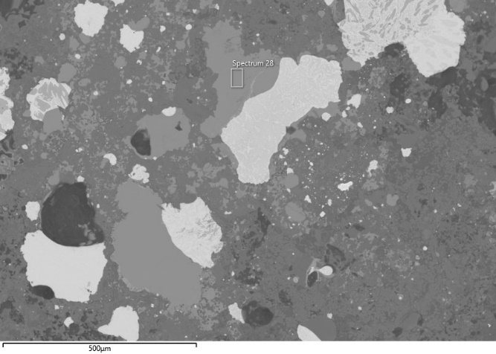
Image 7 | Image 8
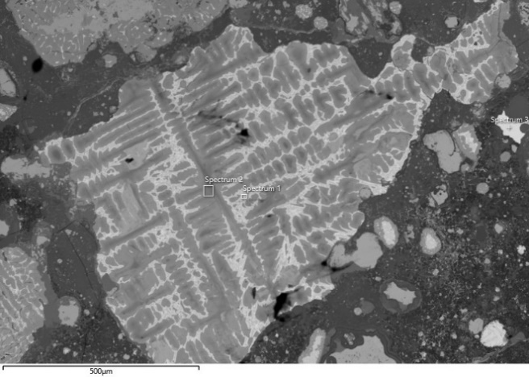 |  | 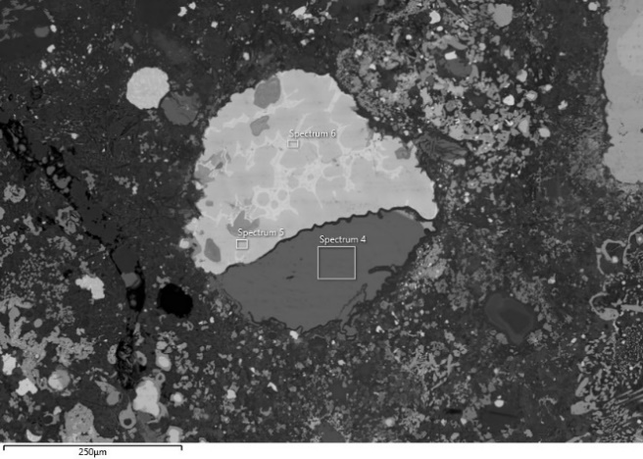
Image 9 |  | Image 10
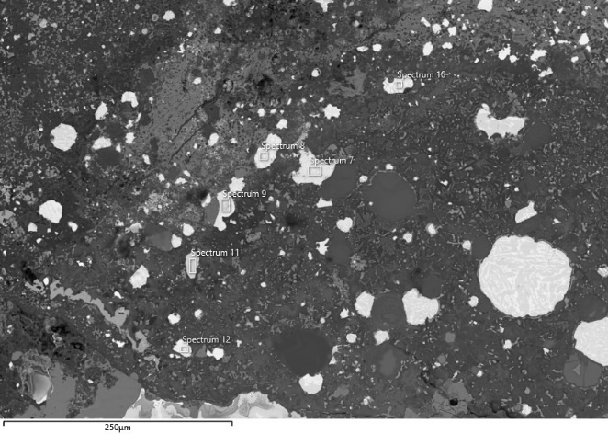 |  | 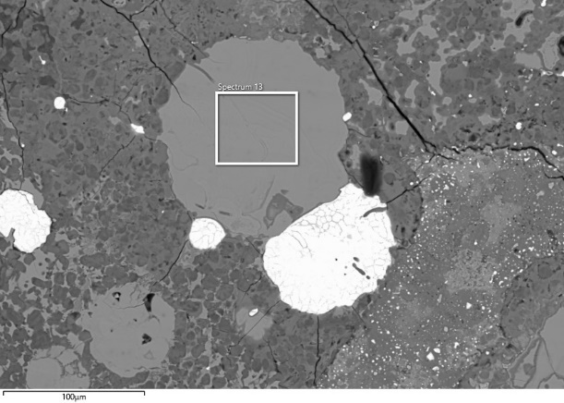
Image 11 |  | Image 12
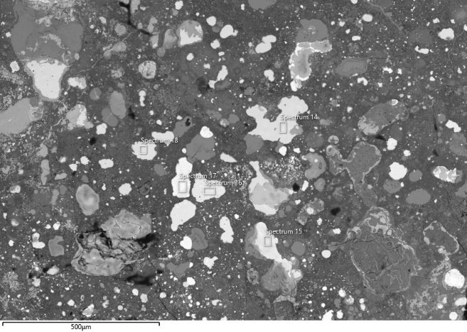 |  | 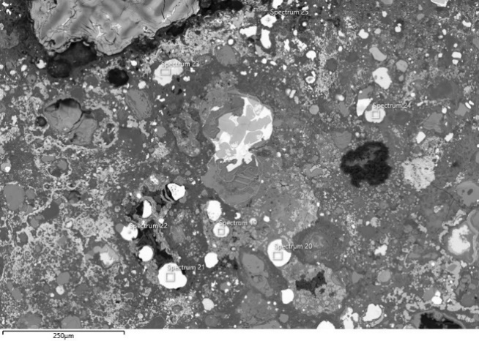
Image 13 |  | Image 14
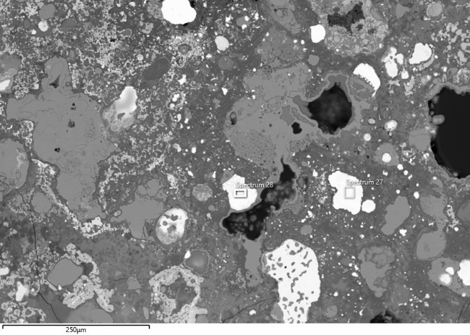 |  | 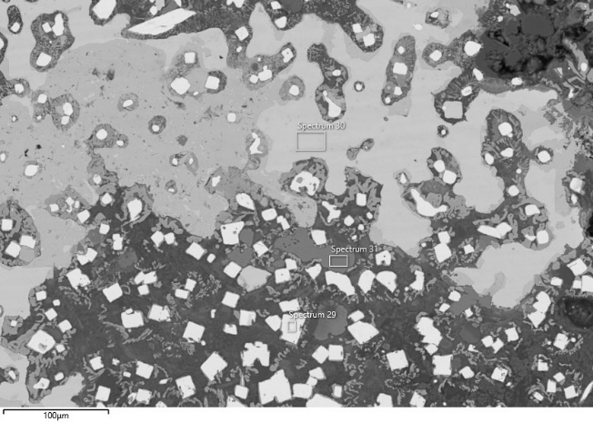
Image 15 |  | Image 16
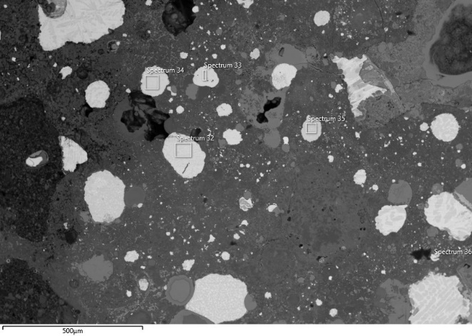 |  | 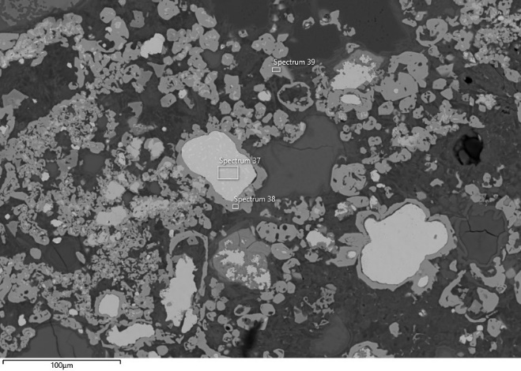
Image 17 |  | Image 18
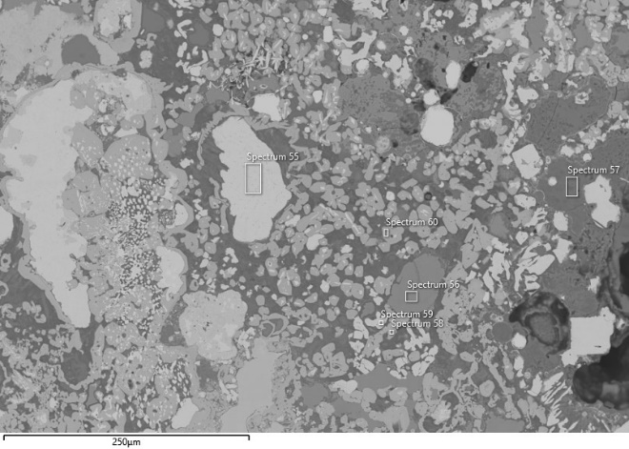 |  | 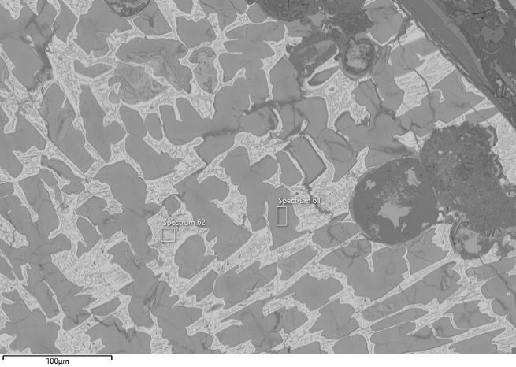
Image 19 |  | Image 20
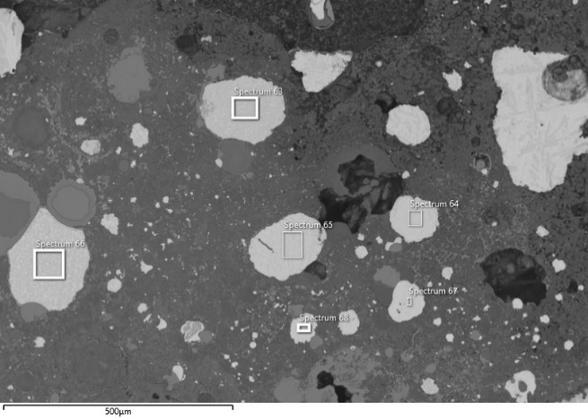
Image 21
Fig. 13 Locations of the analyses performed on specimen TSRP91a. The corresponding analytical results are reported in the table above.

Bulk composition
This section provides the bulk composition of both the ceramic areas (Table 7) and the bloated areas (Table…8) of the crucibles. Additionally, the bulk composition of the slagged-bronze areas analysed in crucible TSRP149 is presented (Table 9). Furthermore, the ratios of elements to Al2O3 for ceramic areas (Table 10), bloated areas (Table 11), metal-rich areas (Table 12) are detailed. Table 13 highlights the changes in elemental ratios between these distinct zones.
The investigation followed the established methodology developed by Rademaker (2015 and references therein). The study focused on comparing the outer ceramic zone, which is less affected by thermal processes, with the inner bloated zone, which undergoes significant morphological and chemical changes due to exposure to high temperatures. This comparison allows for a deeper understanding of the thermal degradation and transformation within the material. The methodology involved analyzing five disSnct areas from each zone, with each area corresponding to the visible field at 100x magnification (±1mm²).

Table 8 Average bulk composition of the crucible ceramic areas in the crucibles investigated. All results in wt%, normalised to 100%
Sample | Na₂O | MgO | Al₂O₃ | SiO₂ | P₂O₅ | SO₃ | K₂O | CaO | TiO₂ | MnO | FeO | CuO | ZnO | As₃O | Ag₂O | SnO | Sb₂O₃ | PbO
TSRP91 | 1.5 | 3.5 | 14.2 | 58.6 | 0.7 | 0.6 | 2.5 | 11.9 | 0.7 | 0.1 | 5.0 | 0.3 |  |  | 0.1 | 0.3 | 0.2 | 0.1
σ (5ms) | 0.1 |  | 0.3 | 3.1 | 0.2 | 0.2 | 0.2 | 2.0 | 0.1 |  | 0.4 | 0.1 | 0.1 |  | 0.1 | 0.1 | 0.1 | 0.1
Min | 1.3 | 3.4 | 13.7 | 55.0 | 0.5 | 0.4 | 2.2 | 9.4 | 0.5 | 0.1 | 4.6 | 0.2 |  |  |  | 0.2 | 0.1
Max | 1.6 | 3.5 | 14.5 | 61.9 | 0.9 | 0.9 | 2.6 | 14.0 | 0.9 | 0.2 | 5.7 | 0.5 | 0.1 |  | 0.2 | 0.4 | 0.3 | 0.2
TSRP124 | 1.8 | 3.5 | 13.0 | 62.5 | 0.4 | 0.7 | 3.1 | 8.9 | 0.7 | 0.1 | 4.2 | 0.3 | 0.1 |  | 0.1 | 0.3 | 0.4 | 0.1
σ (1ms)
Min
Max
TSRP115b | 1.2 | 2.5 | 13.9 | 56.9 | 0.8 | 0.3 | 2.4 | 15.1 | 0.7 | 0.2 | 5.1 | 0.4 |  |  |  | 0.1 | 0.3 | 0.2
σ (5ms) | 0.2 | 0.3 | 0.6 | 1.3 | 0.1 | 0.1 | 0.1 | 1.3 | 0.1 | 0.1 | 0.3 | 0.1 | 0.1 | 0.1 |  | 0.1 | 0.1 | 0.1
Min | 1.0 | 2.2 | 13.4 | 55.6 | 0.7 | 0.3 | 2.3 | 13.7 | 0.5 | 0.1 | 4.8 | 0.2 |  |  |  | 0.1 | 0.2
Max | 1.4 | 2.7 | 14.9 | 58.9 | 0.9 | 0.5 | 2.4 | 17.0 | 0.9 | 0.3 | 5.5 | 0.6 | 0.1 | 0.1 | 0.1 | 0.2 | 0.4 | 0.3
TSRP115a | 1.2 | 2.6 | 14.1 | 55.9 | 1.0 | 0.8 | 2.5 | 15.2 | 0.7 | 0.1 | 4.9 | 0.4 |  |  |  | 0.3 | 0.4 | 0.1
σ (5ms) | 0.1 | 0.3 | 0.4 | 0.6 | 0.2 | 0.1 | 0.1 | 0.6 | 0.1 |  | 0.3 | 0.1 |  |  |  | 0.1 | 0.1 | 0.1
Min | 1.1 | 2.2 | 13.6 | 55.0 | 0.6 | 0.7 | 2.2 | 14.5 | 0.6 | 0.1 | 4.5 | 0.3 |  |  |  | 0.3 | 0.2
Max | 1.4 | 2.9 | 14.6 | 56.4 | 1.2 | 1.0 | 2.6 | 15.9 | 0.7 | 0.2 | 5.1 | 0.5 |  |  | 0.1 | 0.4 | 0.5 | 0.2

Table 9 Average bulk composition of the crucible bloated areas in the 4 crucibles investigated. All results in wt%, normalised to 100%
Sample | Na2O | MgO | Al2O₃ | SiO2 | P2O5 | SO₃ | K2O | CaO | TiO2 | MnO | FeO | CuO | ZnO | As3O | Ag2O | SnO | Sb₂O₃ | PbO
TSRP91 | 1.7 | 3.6 | 13.6 | 61.1 | 0.2 | 0.1 | 3.0 | 9.6 | 0.7 | 0.1 | 5.0 | 0.8 | 0.1 |  |  | 0.2 |  | 0.1
σ (5ms) | 0.2 | 0.1 | 0.3 | 0.3 | 0.1 | 0.1 | 0.2 | 0.4 | 0.1 |  | 0.2 | 0.5 | 0.1 |  |  |  |  | 0.1
Min | 1.5 | 3.5 | 13.3 | 60.7 | 0.1 |  | 2.8 | 9.1 | 0.6 | 0.1 | 4.7 | 0.3 |  |  |  | 0.2
Max | 1.9 | 3.8 | 13.9 | 61.4 | 0.2 | 0.2 | 3.3 | 10.3 | 0.8 | 0.2 | 5.3 | 1.6 | 0.1 |  | 0.1 | 0.3 | 0.1 | 0.1
TSRP124 | 1.6 | 3.0 | 12.4 | 62.2 | 0.2 | 0.3 | 3.5 | 9.2 | 0.7 | 0.1 | 4.3 | 1.7 |  |  | 0.1 | 0.6 | 0.1 | 0.2
σ (5ms) | 0.4 | 0.2 | 0.4 | 1.1 | 0.1 | 0.1 | 0.5 | 0.6 | 0.1 |  | 0.2 | 0.7 | 0.1 |  |  | 0.7 | 0.1 | 0.1
Min | 1.3 | 2.7 | 11.8 | 60.5 | 0.1 | 0.2 | 2.7 | 8.4 | 0.6 | 0.1 | 4.1 | 0.9 |  |  |  | 0.2 |  | 0.1
Max | 2.2 | 3.3 | 12.9 | 63.6 | 0.3 | 0.4 | 4.0 | 9.8 | 0.7 | 0.1 | 4.6 | 2.8 | 0.1 |  | 0.1 | 1.8 | 0.2 | 0.4
TSRP115b | 1.9 | 3.4 | 12.9 | 65.2 | 0.4 | 0.3 | 2.8 | 3.7 | 0.7 | 0.1 | 5.8 | 1.5 | 0.2 |  |  | 0.6 |  | 0.5
σ (5ms) | 0.1 | 0.4 | 0.4 | 0.9 | 0.2 | 0.2 | 0.3 | 0.3 | 0.1 | 0.1 | 1.5 | 0.8 | 0.1 |  |  | 0.5 |  | 0.3
Min | 1.7 | 3.0 | 12.3 | 63.8 | 0.2 | 0.1 | 2.4 | 3.3 | 0.6 | 0.1 | 4.8 | 0.7 | 0.1 |  |  | 0.2 |  | 0.2
Max | 2.0 | 4.0 | 13.3 | 66.0 | 0.7 | 0.7 | 3.2 | 4.1 | 0.8 | 0.2 | 8.5 | 2.7 | 0.3 |  | 0.1 | 1.5 | 0.1 | 0.7
TSRP115a | 1.6 | 3.1 | 13.8 | 58.7 | 0.4 | 0.3 | 2.4 | 8.7 | 0.7 | 0.1 | 5.8 | 3.5 | 0.1 |  |  | 0.3 | 0.1 | 0.4
σ (5ms) | 0.3 | 0.4 | 0.4 | 3.8 | 0.1 | 0.1 | 0.1 | 4.2 | 0.1 |  | 0.7 | 2.2 | 0.1 |  |  | 0.2 | 0.1 | 0.1
Min | 1.3 | 2.6 | 13.3 | 54.3 | 0.3 | 0.2 | 2.3 | 3.2 | 0.6 | 0.1 | 5.1 | 0.9 | 0.1 |  |  | 0.1 |  | 0.2
Max | 2.0 | 3.6 | 14.4 | 63.1 | 0.6 | 0.5 | 2.5 | 12.2 | 0.8 | 0.2 | 6.8 | 6.8 | 0.2 |  | 0.1 | 0.6 | 0.3 | 0.5
TSRP149 | 1.7 | 3.3 | 12.5 | 59.4 | 0.5 | 0.1 | 3.3 | 8.7 | 0.6 | 0.1 | 5.4 | 3.0 | 0.1 |  |  | 1.0 | 0.2 | 0.1
σ (5ms) | 0.1 | 0.2 | 0.9 | 2.9 | 0.3 |  | 0.7 | 1.1 | 0.1 | 0.1 | 0.5 | 1.3 | 0.1 |  | 0.1 | 0.8 | 0.1 | 0.1
Min | 1.6 | 3.1 | 11.6 | 54.9 | 0.2 | 0.1 | 2.6 | 7.2 | 0.5 | 0.1 | 4.9 | 1.9 |  |  |  | 0.3
Max | 1.9 | 3.6 | 13.7 | 61.5 | 0.8 | 0.2 | 4.4 | 10.1 | 0.8 | 0.2 | 6.0 | 5.0 | 0.2 |  | 0.1 | 2.1 | 0.4 | 0.3

Table 10 Average bulk composition of the slagged-bronze areas in crucible TSRP149 and TSRP91a. All results in wt%, normalised to 100%
Sample | Na2O | MgO | Al2O₃ | SiO2 | P2O5 | SO₃ | K2O | CaO | TiO2 | MnO | FeO | CuO | ZnO | As3O | Ag2O | SnO | Sb₂O₃ | PbO
TSRP149 |  | 0.6 | 2.7 | 11.6 | 0.8 | 1.0 | 0.2 | 1.3 | 0.1 |  | 1.8 | 68.2 | 0.1 |  |  | 11.0 | 0.4 | 0.3
σ (5ms) |  | 0.3 | 1.5 | 5.4 | 0.5 | 0.9 | 0.1 | 1.2 | 0.1 |  | 0.8 | 7.5 | 0.1 |  | 0.1 | 1.4 | 0.5 | 0.2
Min |  | 0.1 | 0.7 | 2.9 | 0.4 | 0.1 |  | 0.3 |  |  | 0.8 | 80 |  |  |  | 9.0 |  | 0.1
Max |  | 1.0 | 4.9 | 17.6 | 1.6 | 2.3 | 0.3 | 3.2 | 0.1 | 0.1 | 2.9 | 60. | 0.3 |  | 0.1 | 12.3 | 1.1 | 0.6
TSRP91a |  | 0.6 | 7.8 | 28.7 | 5.3 | 1.1 | 3.6 | 6.1 | 0.3 | 0.0 | 4.5 | 33.6 | 0.1 |  |  | 7.7 | 0.4 | 0.2
σ (5ms) |  | 0.2 | 2.9 | 5.1 | 0.9 | 1.3 | 2.2 | 2.4 | 0.1 |  | 1.9 | 7.1 |  |  |  | 5.4 | 0.2 | 0.1
Min |  | 0.3 | 4.6 | 23.0 | 4.4 | 0.1 | 1.7 | 3.0 | 0.1 |  | 2.6 | 22.3 | 0.1 |  |  | 3.8 | 0.2
Max |  | 2.9 | 39.1 | 143.6 | 26.5 | 5.5 | 17.8 | 30.4 | 1.3 | 0.1 | 22.7 | 167.9 | 0.5 | 0.1 | 0.1 | 38.5 | 2.1 | 0.8

Table 11 Ceramic areas. Ratio of oxides to Al₂O₃, metals removed.
Sample | $$\frac{{Na}^{2}O}{{Al}^{2}O^{3}}$$ | $$\frac{MgO}{Al₂O₃}$$ | $$\frac{SiO₂}{Al₂O₃}$$ | $$\frac{P₂O₅}{Al₂O₃}$$ | $$\frac{K₂O}{Al₂O₃}$$ | $$\frac{CaO}{Al₂O₃}$$ | $$\frac{TiO₂}{Al₂O₃}$$ | $$\frac{MnO}{Al₂O₃}$$ | $$\frac{FeO}{Al₂O₃}$$
91 | 0.11 | 0.25 | 4.14 | 0.05 | 0.17 | 0.84 | 0.05 | 0.01 | 0.35
124 | 0.14 | 0.27 | 4.81 | 0.03 | 0.24 | 0.68 | 0.05 | 0.01 | 0.33
115b | 0.09 | 0.18 | 4.09 | 0.06 | 0.17 | 1.08 | 0.05 | 0.01 | 0.37
115a | 0.09 | 0.18 | 3.96 | 0.07 | 0.17 | 1.08 | 0.05 | 0.01 | 0.35

Table 12 Bloated areas. Ratio of oxides to Al₂O₃, metals removed.
Sample | $$\frac{{Na}^{2}O}{{Al}^{2}O^{3}}$$ | $$\frac{MgO}{Al₂O₃}$$ | $$\frac{SiO₂}{Al₂O₃}$$ | $$\frac{P₂O₅}{Al₂O₃}$$ | $$\frac{K₂O}{Al₂O₃}$$ | $$\frac{CaO}{Al₂O₃}$$ | $$\frac{TiO₂}{Al₂O₃}$$ | $$\frac{MnO}{Al₂O₃}$$ | $$\frac{FeO}{Al₂O₃}$$
91 | 0.12 | 0.27 | 4.48 | 0.01 | 0.22 | 0.71 | 0.05 | 0.01 | 0.37
124 | 0.13 | 0.24 | 5.02 | 0.01 | 0.28 | 0.74 | 0.05 | 0.01 | 0.34
115b | 0.14 | 0.26 | 5.06 | 0.03 | 0.22 | 0.28 | 0.05 | 0.01 | 0.45
115a | 0.12 | 0.22 | 4.27 | 0.03 | 0.17 | 0.63 | 0.05 | 0.01 | 0.42
149 | 0.14 | 0.27 | 4.75 | 0.04 | 0.26 | 0.69 | 0.05 | 0.01 | 0.43

Table 13 Metal-rich areas. Ratio of oxides to Al₂O₃, metals removed.
Sample | $$\frac{{Na}^{2}O}{{Al}^{2}O^{3}}$$ | $$\frac{MgO}{Al₂O₃}$$ | $$\frac{SiO₂}{Al₂O₃}$$ | $$\frac{P₂O₅}{Al₂O₃}$$ | $$\frac{K₂O}{Al₂O₃}$$ | $$\frac{CaO}{Al₂O₃}$$ | $$\frac{TiO₂}{Al₂O₃}$$ | $$\frac{MnO}{Al₂O₃}$$ | $$\frac{FeO}{Al₂O₃}$$
149 | 0.00 | 0.20 | 4.25 | 0.29 | 0.06 | 0.48 | 0.03 | 0.01 | 0.66
91a | 0.00 | 0.07 | 3.67 | 0.68 | 0.45 | 0.78 | 0.03 | 0.00 | 0.58

Table 14 Change (in %) in ratio of oxides to Al₂O₃ between ceramic and bloated areas, metals removed.
Sample | $$\frac{{Na}^{2}O}{{Al}^{2}O^{3}}$$ | $$\frac{MgO}{Al₂O₃}$$ | $$\frac{SiO₂}{Al₂O₃}$$ | $$\frac{P₂O₅}{Al₂O₃}$$ | $$\frac{K₂O}{Al₂O₃}$$ | $$\frac{CaO}{Al₂O₃}$$ | $$\frac{TiO₂}{Al₂O₃}$$ | $$\frac{MnO}{Al₂O₃}$$ | $$\frac{FeO}{Al₂O₃}$$
91 | 9 | 8 | 8 | -80 | 29 | -15 | 0 | 0 | 6
124 | -7 | -11 | 4 | -67 | 17 | 9 | 0 | 0 | 3
115b | 56 | 44 | 24 | -50 | 29 | -74 | 0 | 0 | 22
115a | 33 | 22 | 8 | -57 | 0 | -42 | 0 | 0 | 20

Metal prills
Table 15. A comprehensive list of high-tin prills identified in the in the bloated and slagged layers of the four samples (TSRP91, TSRP115b, TSRP149, TSRP91a), (wt%, data normalized to 100%).
Sample | Type | Sp. | Fe | Co | Ni | Cu | As | Ag | Sn | Sb | Pb
91a | Crucible | 6 | 0.3 |  | 0.2 | 59.0 | 0.3 |  | 38.5 | 1.5 | 0.2
91a | Crucible | 7 | 0.3 |  | 0.3 | 59.6 | 0.1 | 0.1 | 38.4 | 1.1 | 0.2
91a | Crucible | 8 | 0.7 |  | 0.2 | 56.8 | 0.2 |  | 40.7 | 1.2 | 0.2
91a | Crucible | 9 | 0.2 |  | 0.3 | 61.2 | 0.3 |  | 36.8 | 1.1 | 0.2
91a | Crucible | 10 | 0.6 |  | 0.2 | 59.5 | 0.3 |  | 38.4 | 0.9 | 0.1
91a | Crucible | 11 | 0.7 |  | 0.2 | 62.3 | 0.3 |  | 35.3 | 1.0 | 0.3
91a | Crucible | 12 | 0.2 |  | 0.1 | 61.8 | 0.4 |  | 36.3 | 1.0 | 0.1
91a | Crucible | 19 | 1.3 | 0.7 | 0.6 | 55.5 | 0.1 |  | 40.4 | 1.3 | 0.3
91a | Crucible | 20 | 1.7 |  | 0.5 | 54.9 | 0.1 |  | 41.3 | 1.4 | 0.1
91a | Crucible | 21 | 0.2 | 0.5 | 1.0 | 56.1 | 0.2 |  | 40.2 | 1.5 | 0.3
91a | Crucible | 22 | 0.6 | 0.5 | 0.7 | 55.5 | 0.2 |  | 41.0 | 1.5 | 0.0
91a | Crucible | 24 |  |  | 0.2 | 67.4 | 0.2 |  | 30.5 | 1.4 | 0.3
91a | Crucible | 27 | 0.2 | 0.6 | 0.6 | 63.7 | 0.9 |  | 32.1 | 1.7 | 0.2
91a | Crucible | 7 | 0.3 |  | 0.0 | 72.9 | 0.2 |  | 25.8 | 0.6 | 0.1
91a | Crucible | 8 | 0.4 |  | 0.1 | 70.2 | 0.5 |  | 27.8 | 0.8 | 0.2
91a | Crucible | 9 | 0.6 |  |  | 70.8 | 0.3 |  | 27.5 | 0.6 | 0.1
91a | Crucible | 10 | 0.5 |  | 0.1 | 65.1 | 0.2 |  | 33.2 | 0.7 | 0.2
91a | Crucible | 12 | 0.8 |  | 0.1 | 64.3 | 0.4 |  | 33.5 | 0.7 | 0.2
91a | Crucible | 17 |  |  | 0.1 | 72.7 | 0.2 |  | 26.2 | 0.6 | 0.2
91a | Crucible | 19 | 0.2 |  | 0.3 | 57.1 | 0.2 |  | 40.7 | 1.3 | 0.1
91a | Crucible | 20 |  |  | 0.4 | 57.5 | 0.2 |  | 40.3 | 1.5 | 0.2
91a | Crucible | 21 |  |  | 0.2 | 55.9 | 0.2 |  | 42.2 | 1.3 | 0.2
91a | Crucible | 22 |  |  | 0.3 | 57.3 | 0.1 |  | 40.6 | 1.4 | 0.3
91a | Crucible | 25 |  |  | 0.2 | 63.5 | 0.1 |  | 34.6 | 0.9 | 0.7
91a | Crucible | 27 |  |  | 0.0 | 73.9 | 0.2 |  | 25.2 | 0.6 | 0.1
91a | Crucible | 28 |  |  | 0.2 | 68.1 | 0.2 |  | 30.3 | 1.1 | 0.1
91a | Crucible | 32 |  |  | 0.1 | 72.6 | 0.2 |  | 26.1 | 0.8 | 0.1
91a | Crucible | 33 | 0.2 | 0.4 | 0.2 | 70.5 | 0.1 | 0.1 | 27.6 | 0.9 | 0.2
91a | Crucible | 34 |  |  | 0.1 | 72.3 | 0.2 | 0.1 | 26.3 | 0.9 | 0.1
91a | Crucible | 36 | 0.7 |  |  | 71.2 | 0.2 |  | 27.0 | 0.8 | 0.1
91a | Crucible | 64 |  |  | 0.2 | 72.5 | 0.3 |  | 26.0 | 0.7 | 0.2
91a | Crucible | 65 |  |  | 0.1 | 72.8 | 0.1 | 0.1 | 26.0 | 0.8 | 0.2
91a | Crucible | 66 |  |  | 0.1 | 78.6 | 0.2 | 0.1 | 20.3 | 0.5 | 0.1
91a | Crucible | 67 | 0.1 |  | 0.1 | 70.9 | 0.1 |  | 27.5 | 1.0 | 0.3
91a | Crucible | 68 | 0.2 | 0.5 | 0.1 | 69.4 | 0.1 |  | 28.7 | 0.8 | 0.2
91 | Crucible | 65 | 0.1 |  | 0.1 | 55.3 | 0.4 |  | 42.2 | 0.9 | 0.9
91 | Crucible | 66 | 0.2 |  | 0.0 | 48.7 | 0.9 |  | 44.9 | 1.2 | 4.1
91 | Crucible | 67 |  | 1.4 | 0.9 | 0.3 | 0.1 |  | 94.2 | 3.0 | 0.1
91 | Crucible | 68 |  |  | 0.1 | 54.6 | 0.2 |  | 43.5 | 1.3 | 0.4
91 | Crucible | 69 |  |  | 0.1 | 77.6 | 0.2 |  | 21.1 | 0.6 | 0.5
91 | Crucible | 71 |  |  | 0.1 | 71.5 | 0.2 |  | 27.2 | 0.8 | 0.1
91 | Crucible | 73 | 0.2 |  | 0.1 | 73.2 | 0.3 |  | 25.2 | 0.8 | 0.2
91 | Crucible | 76 | 0.3 |  | 0.2 | 64.2 | 0.2 |  | 33.3 | 0.9 | 1.0
91 | Crucible | 78 | 0.3 |  | 0.2 | 69.3 | 0.2 |  | 29.1 | 0.9 | 0.2
91 | Crucible | 81 | 0.4 |  | 0.2 | 72.4 | 0.1 |  | 25.6 | 0.5 | 1.0
91 | Crucible | 84 | 0.3 |  | 0.2 | 73.5 | 0.1 |  | 24.5 | 0.6 | 0.9
149 | Crucible | 99 |  |  | 0.1 | 56.2 | 0.1 |  | 43.0 | 0.5 | 0.1
149 | Crucible | 100 |  |  | 0.0 | 37.3 | 0.1 |  | 61.7 | 1.0
115b | Crucible | 213 | 0.1 |  | 0.1 | 64.7 | 0.1 |  | 33.0 | 0.9 | 1.2
115b | Crucible | 214 |  |  | 0.2 | 64.0 | 0.1 |  | 33.4 | 1.0 | 1.4
115b | Crucible | 215 |  |  | 0.3 | 70.0 | 0.3 |  | 26.3 | 1.2 | 1.9
115b | Crucible | 216 |  |  | 0.2 | 55.5 |  |  | 43.1 | 1.1 | 0.1
115b | Crucible | 217 |  |  | 0.1 | 51.5 | 0.2 |  | 42.0 | 1.5 | 4.5
115b | Crucible | 218 | 0.4 |  | 0.2 | 56.3 | 0.1 |  | 40.5 | 1.2 | 1.4
115b | Crucible | 219 |  |  | 0.2 | 40.3 | 0.1 |  | 52.4 | 1.7 | 5.3
115b | Crucible | 220 |  |  | 0.2 | 53.7 | 0.2 |  | 42.6 | 1.9 | 1.5
115b | Crucible | 221 |  |  | 0.3 | 60.6 | 0.2 |  | 36.8 | 1.4 | 0.8
115b | Crucible | 222 |  |  | 0.3 | 57.2 | 0.1 |  | 39.6 | 1.4 | 1.5
115b | Crucible | 223 |  |  | 0.0 | 73.9 | 0.1 |  | 22.7 | 0.5 | 2.8
115b | Crucible | 227 |  |  | 0.4 | 63.7 | 0.1 |  | 33.4 | 0.9 | 1.4
115b | Crucible | 229 |  |  | 0.3 | 57.7 | 0.2 |  | 38.6 | 1.2 | 2.1
115b | Crucible | 230 |  |  | 0.2 | 63.5 | 0.2 |  | 33.9 | 1.0 | 1.2
115b | Crucible | 231 |  |  | 0.1 | 64.3 | 0.1 |  | 33.4 | 1.0 | 1.2
115b | Crucible | 233 |  |  | 0.2 | 53.6 | 0.1 |  | 43.3 | 1.1 | 1.7
115b | Crucible | 236 | 0.2 |  | 0.2 | 60.0 | 0.1 |  | 37.6 | 0.9 | 0.9
115b | Crucible | 237 | 0.2 |  | 0.0 | 59.3 | 0.1 |  | 37.4 | 0.8 | 2.2
115b | Crucible | 238 |  |  | 0.2 | 63.3 | 0.2 |  | 33.5 | 0.9 | 1.9
115b | Crucible | 239 | 0.2 |  | 0.1 | 55.6 | 0.1 |  | 43.0 | 0.8 | 0.3
115b | Crucible | 240 | 0.5 |  | 0.4 | 62.1 | 0.1 |  | 34.5 | 0.9 | 1.5
115b | Crucible | 242 | 0.3 |  | 0.3 | 61.5 | 0.1 |  | 35.3 | 1.0 | 1.6
115b | Crucible | 243 | 0.4 |  | 0.1 | 54.7 | 0.2 |  | 42.1 | 1.0 | 1.6

Secondary metal by-products

TSRP19
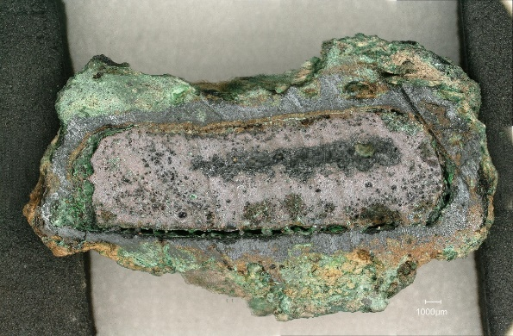
Fig. 14 Cross-section of sample TSRP19 before undergoing the mounSng and polishing processes.

Table 16 Analyses carried out on sample TSRP19
Description | Sp. | O | Mg | Al | Si | P | S | Cl | K | Ca | Fe | Ni | Cu | Zn | As | Ag | Sn | Sb | Pb | Bi
Image 1
Cu oxide | 32 | 9.9 |  |  | 0.1 |  | 0.1 | 0.2 |  |  |  |  | 88.7 |  | 0.2 |  | 0.5 | 0.2
Cu sulphide | 33 |  |  |  |  |  | 19.6 |  |  |  | 0.1 |  | 79.6 |  |  | 0.2 |  | 0.1 | 0.3
Inclusion | 34 | 13.9 |  | 0.1 | 0.3 | 0.1 | 0.6 | 1.0 | 0.5 | 0.8 | 0.5 |  | 10.1 |  | 0.3 | 0.2 | 7.2 | 2.2 | 8.0 | 54.1
Image 2
Inclusion | 35 | 16.1 |  |  | 0.1 |  |  |  |  |  | 0.1 |  | 2.2 |  |  |  |  |  | 81.5
Cu oxide | 36 | 11.1 |  |  | 0.1 |  |  | 0.3 |  |  | 0.1 | 0.1 | 87.2 |  | 0.1 |  | 0.7 | 0.2
Cu sulphide | 37 |  |  |  |  |  | 20.8 | 0.1 |  |  | 0.1 |  | 76.7 | 0.2 |  | 0.2 | 0.7 | 0.2 | 0.9
Image 3
Cu | 38 |  |  |  |  |  |  |  |  |  | 0.6 |  | 95.5 | 0.8 | 0.8 |  | 1.1 | 1.8
Cu oxide | 39 | 11.0 |  |  |  |  |  | 0.2 |  |  |  |  | 88.6 | 0.1 |  |  |  |  | 0.1
Cu sulphide | 40 |  |  |  |  |  | 20.9 |  |  |  | 0.3 |  | 77.2 | 0.1 |  | 0.2 | 0.3 | 0.1 | 0.8
Image 4
Cu sulphide | 41 | 0.9 |  |  |  |  | 21.4 | 0.1 |  |  | 0.2 |  | 75.9 | 0.5 |  | 0.3 | 0.1 |  | 0.5
Cu sulphide | 42 | 1.2 |  |  |  |  | 21.6 |  |  |  | 0.9 |  | 75.5 | 0.2 |  | 0.2 |  |  | 0.4
Cu oxide | 43 | 10.7 | 0.1 |  |  |  |  | 0.2 |  |  | 0.1 | 0.1 | 88.4 | 0.1 | 0.1 |  | 0.1 | 0.1 | 0.1
Cu sulphide | 44 |  |  |  |  |  | 21.1 |  |  |  |  |  | 78.2 |  |  |  |  | 0.1 | 0.6
Cu sulphide | 45 | 1.0 |  |  |  |  | 20.7 |  |  |  |  |  | 77.6 |  |  |  | 0.1 | 0.3 | 0.3
Image 5
Cu sulphide | 46 | 1.9 |  |  |  |  | 20.3 |  |  |  | 0.2 |  | 76.5 |  |  | 0.5 |  |  | 0.5
Cu sulphide | 47 | 0.9 |  |  |  |  | 20.5 |  |  |  | 0.3 |  | 77.0 | 0.3 |  | 0.4 |  |  | 0.6
Cu oxide | 48 | 10.1 | 0.1 | 0.1 | 0.1 |  |  | 0.2 |  |  |  |  | 89.2 | 0.2 |  |  | 0.1
Cu sulphide | 49 | 1.0 |  |  |  |  | 20.6 |  |  |  | 0.4 |  | 76.7 |  |  | 0.5 |  |  | 0.7
Cu sulphide | 50 | 0.8 |  |  |  |  | 20.8 | 0.1 |  |  | 0.4 |  | 76.7 | 0.7 |  |  |  |  | 0.6
Cu oxide | 51 | 10.8 |  |  |  |  |  | 0.2 | 0.1 |  | 0.2 |  | 87.9 | 0.1 | 0.1 |  | 0.2 | 0.1 | 0.2
Image 6
Cu oxide | 52 | 10.7 |  |  |  |  |  | 0.3 |  |  | 0.2 |  | 88.1 | 0.2 |  |  | 0.3 | 0.1
Cu sulphide | 53 | 1.0 |  |  | 0.1 |  | 20.6 |  |  |  |  |  | 77.5 | 0.1 |  |  |  | 0.1 | 0.7
Cu sulphide | 54 | 0.9 |  |  |  |  | 20.4 | 0.1 |  |  |  |  | 77.4 | 0.1 | 0.1 | 0.5 |  |  | 0.4
Cu sulphide | 55 | 1.0 |  |  |  |  | 20.7 | 0.2 |  |  |  |  | 77.4 | 0.3 |  | 0.1 |  |  | 0.4
Cu sulphide | 56 | 0.9 |  |  |  |  | 20.4 | 0.3 |  |  |  |  | 77.6 |  |  | 0.1 | 0.1 | 0.1 | 0.7
Image 7
Cu sulphide | 57 | 1.2 |  |  |  |  | 20.9 | 0.1 |  |  | 0.5 |  | 76.3 | 0.6 |  |  |  |  | 0.4
Cu sulphide | 58 | 1.1 |  |  |  |  | 20.6 |  |  |  | 0.3 |  | 77.0 | 0.2 |  | 0.3 |  |  | 0.5
Cu oxide | 59 | 10.5 |  |  | 0.1 |  |  | 0.3 |  |  | 0.1 |  | 88.8 |  | 0.1 |  | 0.1 | 0.1
Cu sulphide | 60 | 1.2 |  |  |  |  | 20.3 | 0.1 |  |  |  |  | 77.3 | 0.1 |  | 0.3 |  |  | 0.7
Cu sulphide | 61 | 1.2 | 0.1 |  | 0.1 | 0.1 | 17.6 |  |  |  | 4.9 |  | 63.4 | 2.0 |  | 9.5 |  | 0.5 | 0.6
Cu oxide | 62 | 10.9 |  |  | 0.1 |  | 0.8 | 0.3 |  |  | 0.2 |  | 87.0 | 0.1 |  |  | 0.3 | 0.2 | 0.1
Image 8
Cu sulphide | 63 | 0.9 |  |  |  |  | 20.6 |  |  |  | 0.3 |  | 77.3 | 0.2 |  |  |  |  | 0.7
Cu sulphide | 64 | 1.0 |  |  |  |  | 20.9 |  |  |  | 0.3 |  | 76.9 |  |  |  |  |  | 0.7
Cu sulphide | 65 | 1.0 |  |  |  |  | 20.7 |  |  |  | 0.2 |  | 77.6 |  |  |  |  |  | 0.4
Cu oxide | 66 | 11.0 |  |  |  |  | 0.1 |  |  |  | 0.2 |  | 86.8 | 0.3 | 0.1 |  | 0.6 | 0.2 | 0.1
Image 9
Cu oxide | 67 | 10.7 |  |  |  |  | 0.3 | 0.3 |  |  | 0.1 |  | 87.5 |  | 0.1 |  | 0.4 | 0.2 | 0.3
Cu sulphide | 68 | 0.8 |  |  |  |  | 20.5 |  |  |  | 0.1 |  | 77.5 | 0.2 |  | 0.2 |  |  | 0.7
Cu sulphide | 69 | 1.0 |  |  |  |  | 20.5 | 0.1 |  |  | 0.2 |  | 76.9 | 0.2 |  | 0.3 |  |  | 0.6
Cu sulphide | 70 | 1.3 |  |  |  |  | 20.7 |  |  |  | 0.4 |  | 76.6 | 0.4 |  | 0.2 |  |  | 0.6
Cu oxide | 71 | 10.1 |  |  |  |  |  | 0.2 |  |  |  |  | 89.5

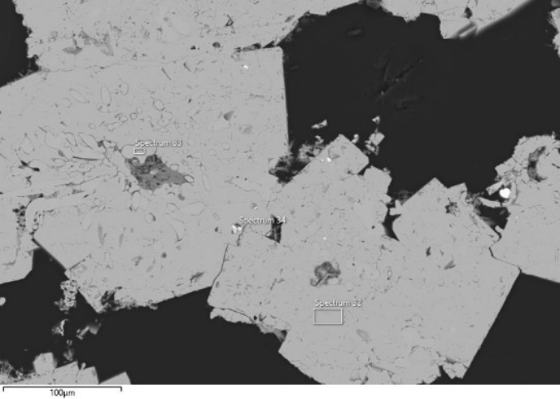 | 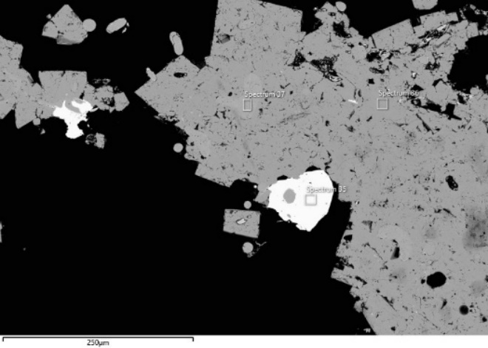
Image 1 | Image 2
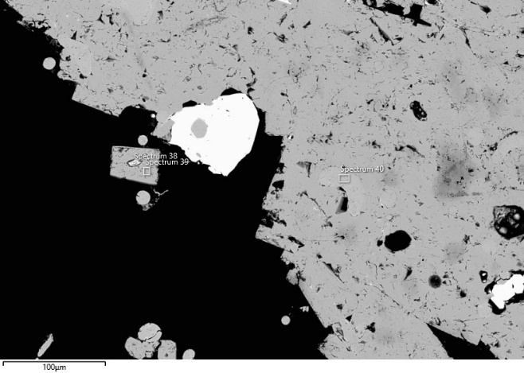 | 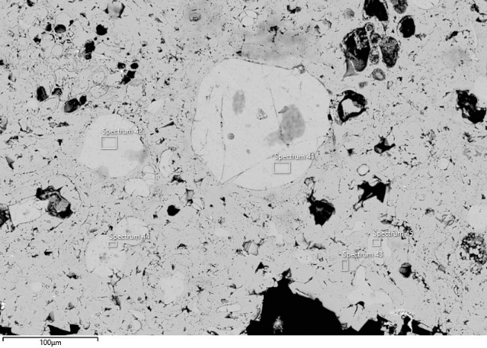
Image 3 | Image 4
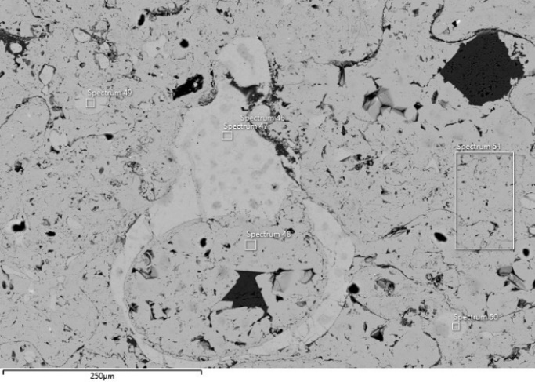 | 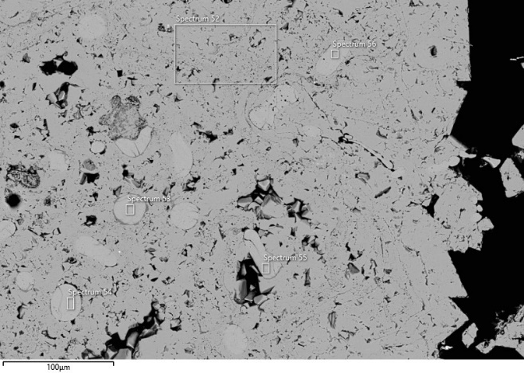
Image 5 | Image 6
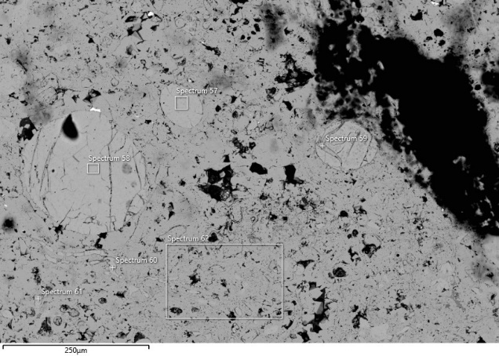 | 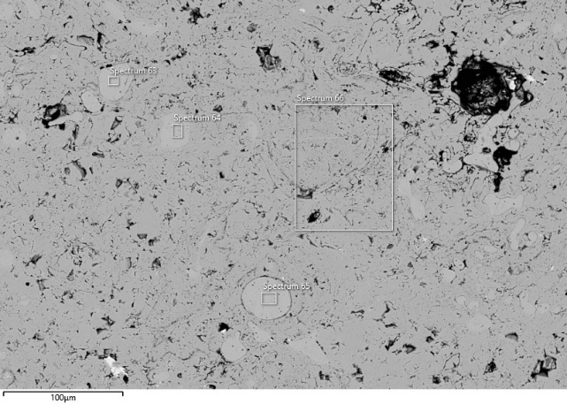
Image 7 | Image 8
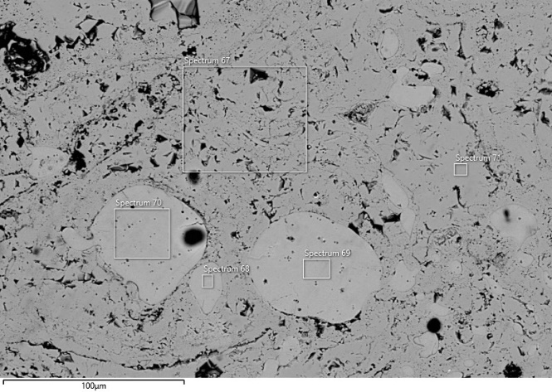 | Fig. 15 Locations of the analyses performed on specimen TSRP19. The corresponding analytical results are reported in the table above.
Image 9

TSRP46
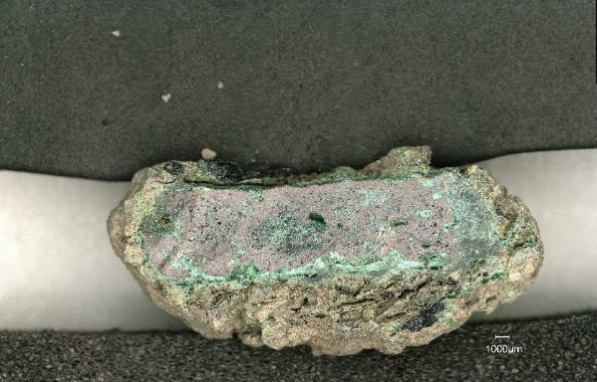
Fig. 16 Cross-section of sample TSRP46 before undergoing the mounting and polishing processes

Table 17 Analyses carried out on sample TSRP46
Description | Sp. | O | Mg | Al | Si | P | S | Cl | K | Ca | Fe | Ni | Cu | Zn | As | Ag | Sn | Sb | Pb | Bi
Image 10
Cu sulphide | 1 | 4.2 |  |  |  |  | 17.5 |  |  |  | 1.4 |  | 75.9 |  |  | 0.3 |  |  | 0.6
Cu sulphide | 2 | 3.3 |  |  |  |  | 19.0 |  |  |  | 1.7 |  | 75.6 |  |  | 0.2 |  |  | 0.6
Cu oxide | 3 | 13.6 |  |  |  |  |  | 0.6 |  |  | 0.8 |  | 83.9 | 0.1 | 0.6 | 0.1 |  |  | 0.4
Cu oxide | 4 | 12.1 |  |  |  |  | 0.2 | 0.6 |  |  | 0.7 |  | 83.9 |  | 1.2 | 0.1 |  | 0.1 | 1.6
Image 11
Cu oxide | 5 | 10.7 |  |  |  |  |  | 0.3 |  |  | 0.3 |  | 88.6 |  |  | 0.1 |  |  | 0.1
Cu sulphide | 6 | 1.2 |  |  |  |  | 21.1 | 0.1 |  |  | 0.2 |  | 76.3 | 0.1 |  | 0.2 |  | 0.2 | 0.9
Cu oxide | 7 | 10.6 |  |  |  |  |  | 0.3 |  |  | 0.2 |  | 88.3 | 0.1 | 0.3 |  | 0.1
Image 12
Cu sulphide | 8 | 1.6 |  |  | 0.2 |  | 21.3 | 0.1 |  |  | 0.8 |  | 75.1 | 0.4 |  | 0.3 |  |  | 0.3
Cu sulphide | 9 | 0.8 |  |  |  |  | 21.1 | 0.1 |  |  | 0.2 |  | 76.3 | 0.1 |  | 0.3 |  |  | 0.8
Image 13
Cu sulphide | 10 | 4.1 |  |  | 0.1 |  | 17.6 | 0.1 |  |  | 1.0 |  | 76.0 | 0.2 | 0.2 | 0.3 |  |  | 0.3
Image 14
Cu sulphide | 11 | 2.7 |  |  |  |  | 20.5 | 0.1 |  |  | 0.9 |  | 75.0 | 0.1 | 0.1 | 0.2 |  |  | 0.6
Cu oxide | 12 | 10.9 |  |  |  |  | 0.6 | 0.3 |  |  | 0.1 |  | 87.9 |  |  | 0.3
Image 15
Cu sulphide | 40 | 2.0 |  |  |  |  | 22.4 |  |  |  | 0.2 |  | 73.7 | 0.5 | 0.1 | 0.3 |  |  | 0.8
Cu oxide | 41 | 12.0 |  |  |  |  |  | 0.3 |  |  | 0.1 |  | 86.7 | 0.1 | 0.2 | 0.1 | 0.1 |  | 0.2
Image 16
Cu sulphide | 42 | 2.1 |  |  |  |  | 22.2 |  |  |  | 0.3 |  | 73.3 | 1.0 | 0.1 | 0.4 | 0.1 |  | 0.8
Cu sulphide | 43 | 2.2 |  |  |  |  | 21.8 |  |  |  | 0.1 |  | 74.6 | 0.1 |  | 0.4 |  |  | 0.9
Cu oxide | 44 | 10.9 |  |  |  |  | 0.2 | 0.3 |  |  |  |  | 88.0 | 0.2 | 0.2 |  | 0.1
Image 17
Cu sulphide | 45 |  |  |  |  |  | 22.5 |  |  |  | 0.3 |  | 76.3 | 0.1 |  |  |  |  | 0.8
Cu oxide | 46 | 13.1 |  |  |  |  | 0.2 | 0.6 |  |  | 0.7 |  | 82.9 | 0.1 | 1.4 |  |  | 0.1 | 0.9
Cu sulphide (area) | 47 | 3.0 |  |  |  |  | 20.6 | 0.1 |  |  | 1.3 |  | 73.9 | 0.1 |  | 0.2 |  |  | 0.8
Image 18
Cu sulphide (area) | 48 | 5.1 |  | 0.3 | 0.1 |  | 17.3 | 0.3 |  |  | 1.0 |  | 75.0 | 0.2 |  | 0.2 | 0.1 |  | 0.5
Image 19
Inclusion | 49 | 8.3 |  | 0.2 | 0.2 | 0.1 | 0.3 | 3.1 |  | 0.1 | 0.1 |  | 11.3 | 0.1 | 0.2 | 0.7 |  |  | 24.4 | 51.1
Cu (area) | 50 | 1.3 |  |  |  |  |  |  |  |  | 0.9 |  | 93.1 | 0.8 | 3.1 | 0.3 | 0.2 | 0.1 | 0.2
Image 20
Cu sulphide | 51 | 1.3 |  |  |  |  | 22.7 |  |  |  | 0.2 |  | 74.7 | 0.2 |  | 0.3 |  | 0.1 | 0.6
Cu sulphide | 52 | 3.2 |  |  |  |  | 21.1 |  |  |  | 4.8 |  | 69.8 | 0.2 |  | 0.2 |  |  | 0.7

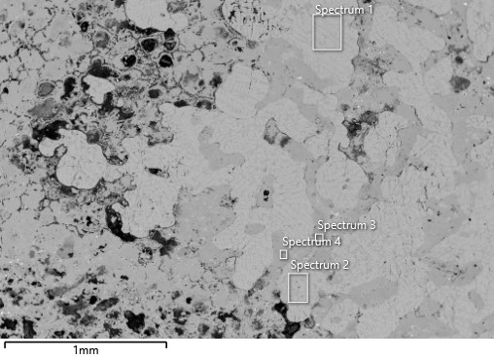 | 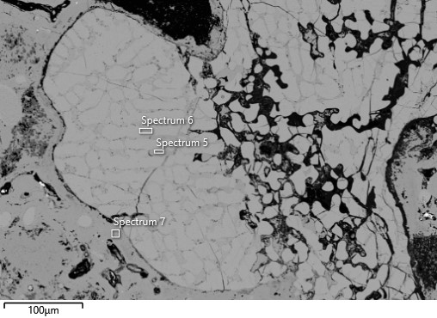
Image 10 | Image 11
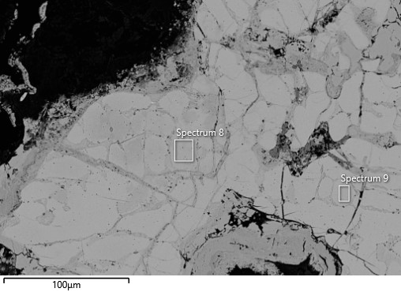 | 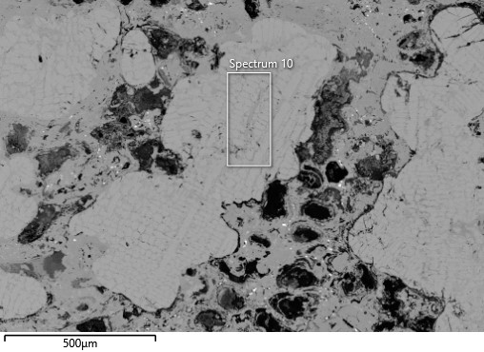
Image 12 | Image 13
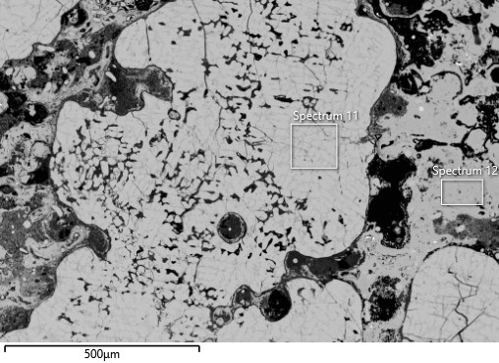 | 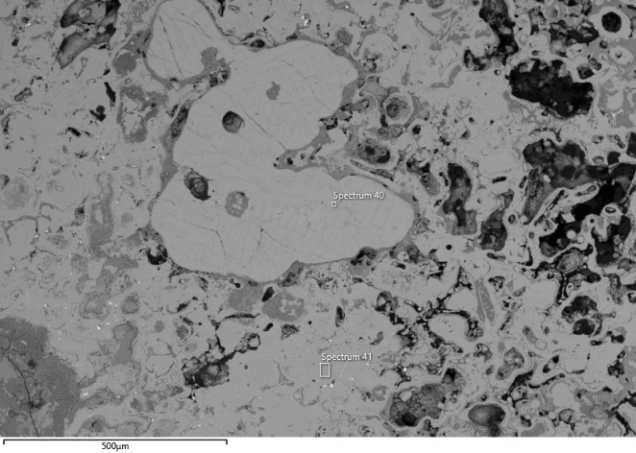
Image 14 | Image 15
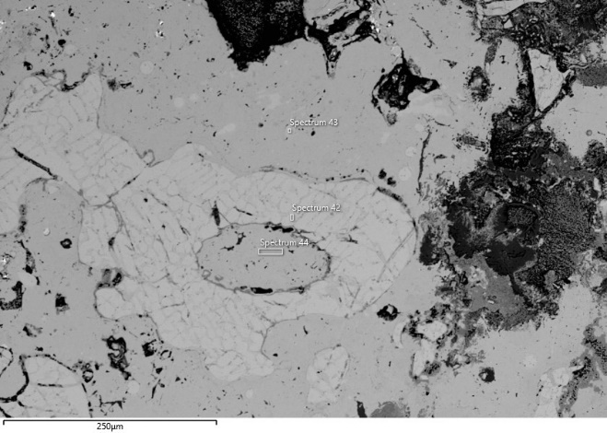 | 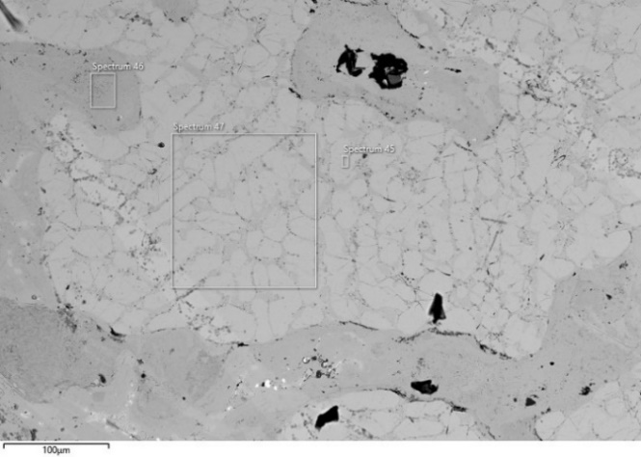
Image 16 | Image 17
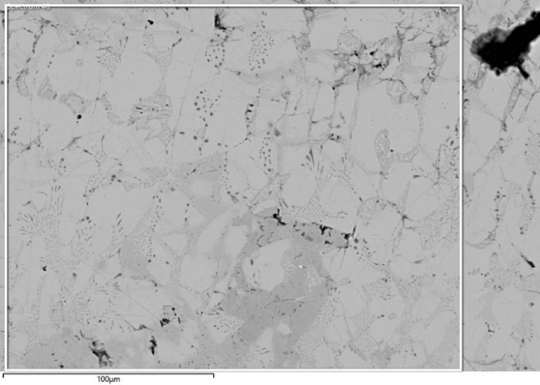 | 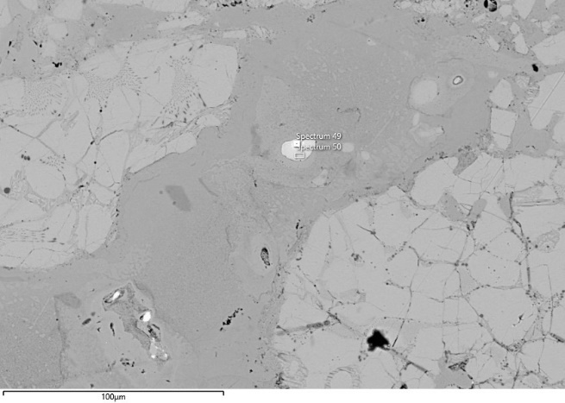
Image 18 | Image 19
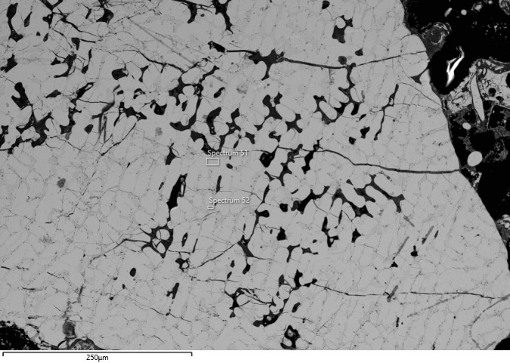 | Fig. 17 Locations of the analyses performed on specimen TSRP46. The corresponding analytical results are reported in the table above.
Image 20

TSRP12
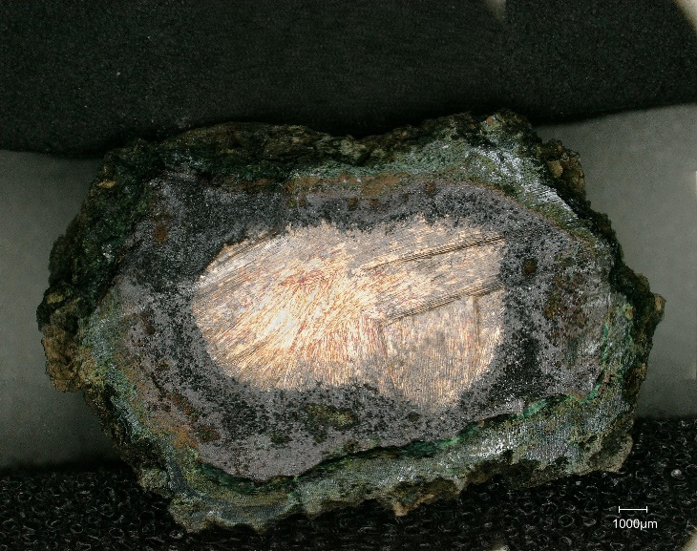
Fig. 18 Cross-section of sample TSRP12 before undergoing the mounting and polishing processes.

Table 18 Analyses carried out on sample TSRP12
Description | Sp. | O | Mg | Al | Si | P | S | Cl | K | Ca | Fe | Ni | Cu | Zn | As | Ag | Sn | Sb | Pb
Image 1
Cu (area) | 1 | 1.5 |  |  |  |  |  |  |  |  | 0.9 |  | 96.7 | 0.4 |  | 0.1 | 0.1 | 0.3 | 0.1
Cu sulphide | 4 | 1.3 |  |  |  |  | 20.9 |  |  |  | 0.1 |  | 77.2 | 0.1 |  | 0.2 |  |  | 0.3
Inclusion | 5 | 10.1 |  |  | 0.2 |  |  |  |  |  | 0.1 |  | 6.1 | 0.1 |  | 2.4 |  | 0.2 | 81.0
Image 2
Cu (area) | 6 | 1.2 |  |  |  |  |  |  |  |  | 0.8 | 0.1 | 97.2 | 0.4 |  | 0.1 |  | 0.1 | 0.1
Inclusion | 7 | 16.3 |  |  |  | 0.1 | 9.8 |  |  |  | 0.1 |  | 4.8 | 0.1 |  |  |  |  | 69.1
Cu sulphide | 8 | 1.4 |  |  |  |  | 20.5 |  |  |  | 0.1 |  | 77.6 | 0.1 |  |  |  |  | 0.2
Cu oxide | 9 | 9.7 |  |  |  |  |  | 0.2 |  |  | 0.1 |  | 89.9 |  |  |  | 0.2
Image 3
Cu oxide (area) | 10 | 9.6 |  |  |  |  |  | 0.2 |  |  | 0.2 |  | 89.5 | 0.1 |  |  | 0.1 |  | 0.2
Inclusion | 11 | 16.8 |  |  |  |  | 9.8 |  | 0.1 |  |  |  | 3.2 |  |  |  |  |  | 69.9
Cu (area) | 12 | 1.4 |  |  |  |  |  | 0.1 |  |  | 0.6 |  | 96.5 | 0.4 |  |  | 0.3 | 0.6 | 0.1
Cu | 13 |  |  |  |  |  |  | 0.2 |  |  | 0.1 |  | 90.4 | 0.1 |  |  |  |  | 0.1
Image 4
Cu oxide (area) | 18 | 9.6 |  |  |  |  | 0.2 |  |  |  | 0.1 | 0.1 | 88.9 | 0.1 |  |  | 0.1 | 0.1
Cu (area) | 19 | 1.4 |  |  |  |  |  |  |  |  | 0.9 |  | 96.8 | 0.3 | 0.1 | 0.1 |  | 0.1 | 0.3
Image 5
Inclusion | 21 | 16.5 |  |  |  |  | 9.8 |  |  |  | 0.1 |  | 3.4 |  | 0.1 | 0.2 |  |  | 69.9
Inclusion | 22 | 16.4 |  |  |  |  | 2.4 | 4.2 |  |  | 0.1 | 0.1 | 7.6 |  | 0.2 | 1.3 |  | 3.0 | 64.8
Inclusion | 23 | 16.5 |  |  |  |  | 9.6 |  |  |  | 0.1 |  | 6.0 | 0.1 |  |  |  |  | 67.6
Image 6
Cu sulphide | 24 | 4.7 |  |  | 0.1 |  | 13.6 |  |  |  | 0.1 |  | 81.1 | 0.1 |  |  |  |  | 0.3
Cu sulphide | 25 | 2.7 |  |  |  |  | 19.6 |  |  |  | 0.6 |  | 75.6 | 0.5 |  | 0.1 |  | 0.1 | 0.8
Cu sulphide | 26 | 2.6 |  |  |  |  | 19.6 |  |  |  | 0.4 |  | 76.3 | 0.1 |  |  |  |  | 1.0
Cu sulphide | 27 | 2.4 |  |  |  |  | 20.1 |  |  |  | 0.1 |  | 76.6 | 0.2 |  |  |  | 0.1 | 0.5
Image 7
Inclusion | 28 | 7.1 |  |  |  |  |  | 9.4 |  |  | 0.2 |  | 20.5 | 0.1 | 0.5 | 0.1 | 0.2 | 11.6 | 50.4
Inclusion | 29 | 16.2 |  |  |  |  | 9.3 |  |  |  | 0.5 |  | 5.7 |  |  |  |  |  | 68.3
Cu sulphide | 30 | 2.5 |  |  |  |  | 19.5 | 0.2 |  |  | 0.2 |  | 76.8 | 0.2 |  |  |  |  | 0.6

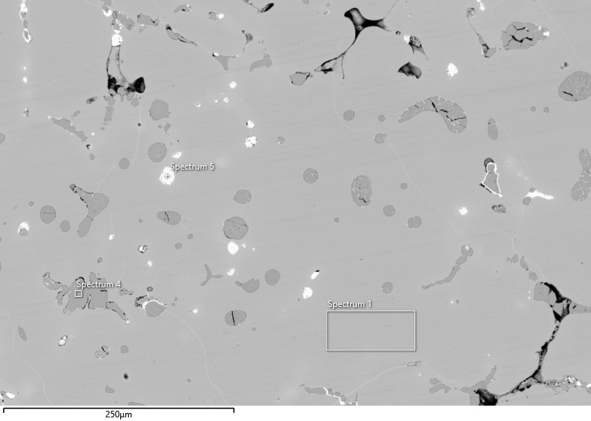 | 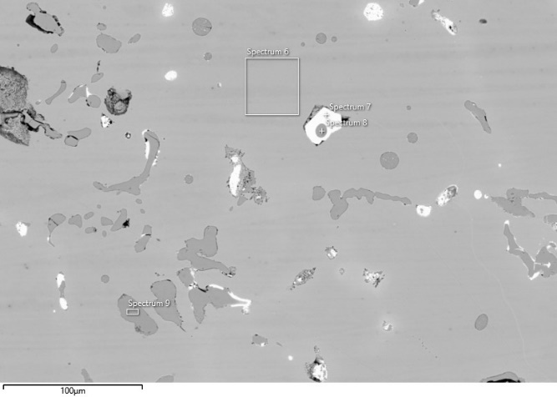
Image 1 | Image 2
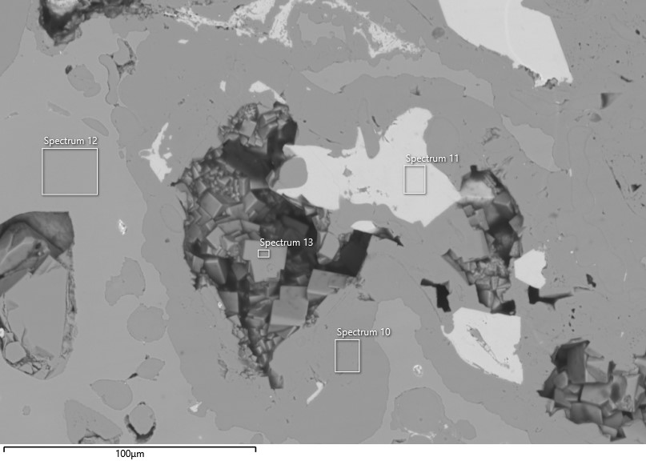 | 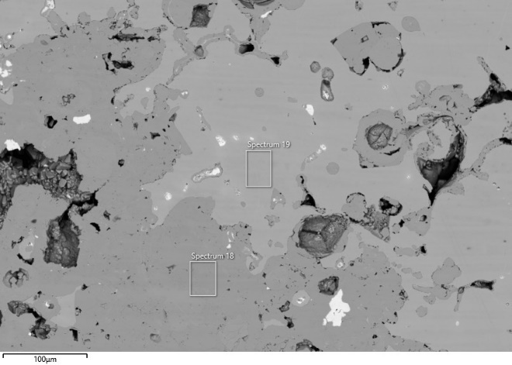
Image 3 | Image 4
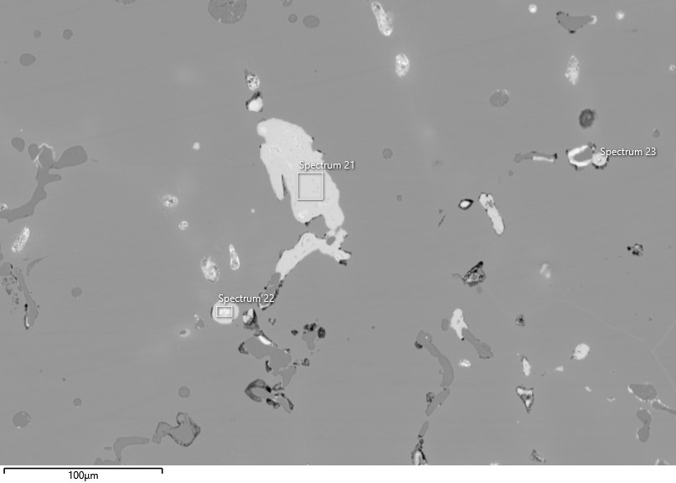 | 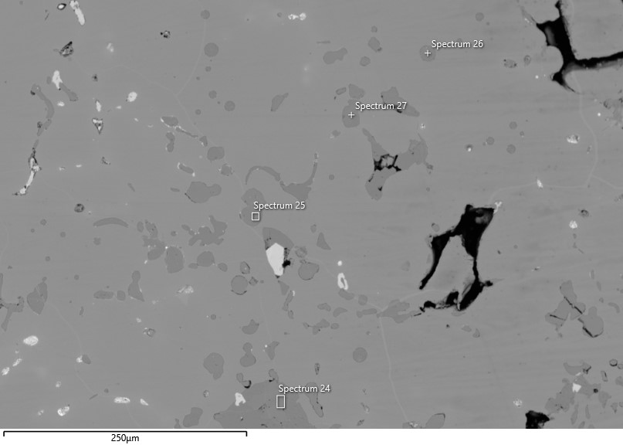
Image 5 | Image 6
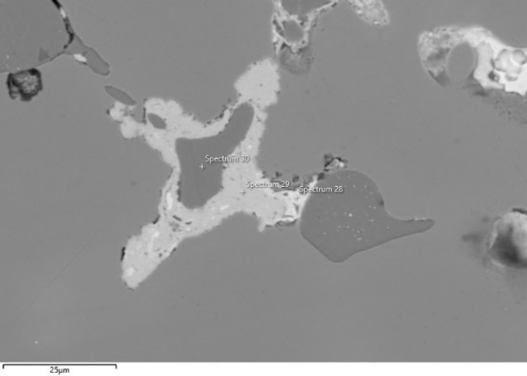 | 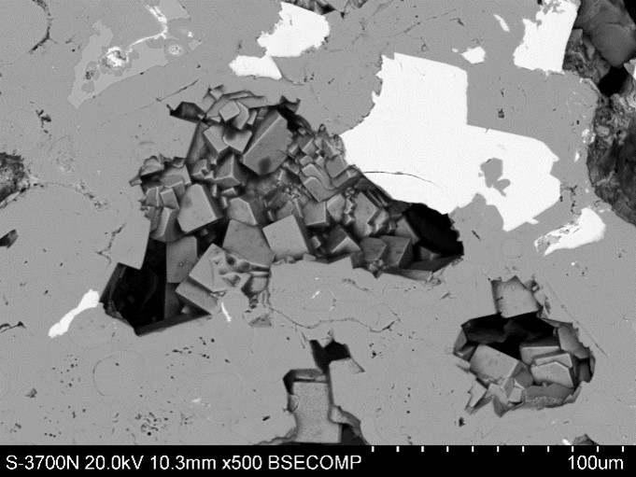
Image 7 | Image 8
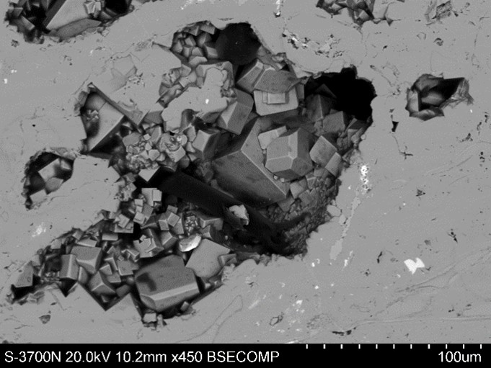 | 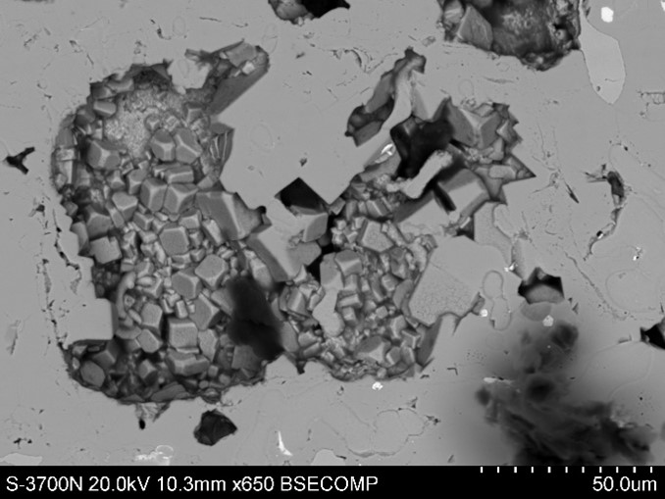
Image 9 | Image 10
Fig. 19 Locations of the analyses performed on specimen TSRP12. The corresponding analytical results are reported in the table above.

TSRP20
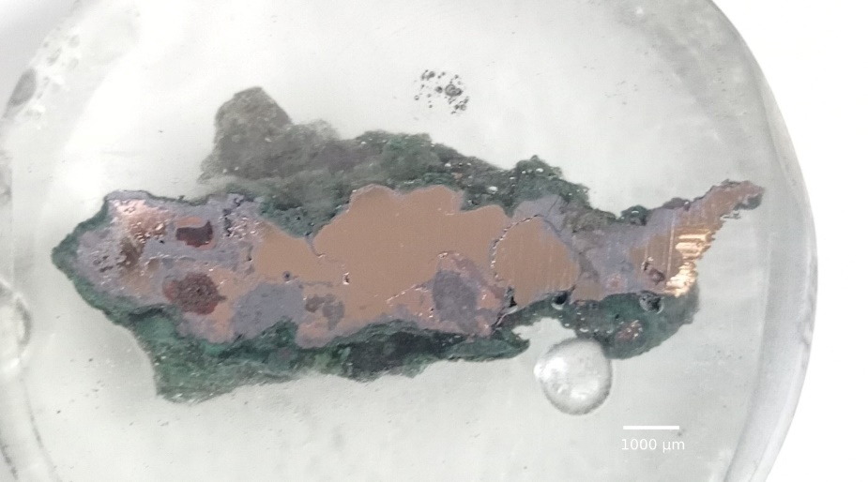
Fig. 20 Cross-section of sample TSRP20 (length = 2.7 cm)

Table 19 Analyses carried out on sample TSRP20
Description | Sp. | O | Mg | Al | Si | P | S | Cl | K | Ca | Fe | Ni | Cu | Zn | As | Ag | Sn | Sb | Pb
Image 3
Cu sulphide | 31 | 3.2 |  |  |  |  | 18.6 |  |  |  | 0.1 |  | 77.3 |  |  |  | 0.1 |  | 0.7
Cu (area) | 32 |  |  |  |  |  |  |  |  |  |  | 0.3 | 97.9 |  | 0.7 | 0.1 | 0.9 |  | 0.2
High-Sn spot | 33 |  |  |  |  |  |  | 0.1 | 0.1 |  | 0.1 | 0.1 | 69.9 | 0.1 | 1.4 | 0.9 | 22.9 | 2.6 | 0.9
Inclusion | 34 | 8.9 |  | 0.2 |  |  |  | 0.4 |  |  |  | 0.1 | 41.1 |  | 0.2 | 0.1 | 4.3 | 0.2 | 44.5
Cu | 35 |  |  |  |  |  |  |  |  |  |  |  | 98.3 | 0.1 | 0.3 |  | 1.1 |  | 0.1
Image 4
Cu-Sn (area) | 36 | 2.8 |  |  |  |  |  |  |  |  |  |  | 89.9 | 0.1 | 0.9 | 0.2 | 4.0 | 0.1 | 2.0
Image 5
Sn oxide | 37 | 18.5 |  |  |  |  |  |  | 0.5 |  | 0.1 | 0.1 | 2.8 |  |  |  | 76.9 | 1.0
Sn oxide | 38 | 20 |  |  |  |  |  |  | 0.3 |  | 0.1 |  | 4.9 |  |  |  | 71.0 | 1.0 | 2.7
Cu-Sn | 39 | 3.3 |  |  |  |  |  |  |  |  |  | 0.1 | 66.9 | 0.1 | 2.8 | 0.9 | 20.1 | 2.3 | 3.6
Cu (area) | 40 | 1.8 |  |  |  |  |  |  |  |  |  | 0.1 | 96.9 | 0.2 | 0.1 | 0.1 | 0.8
Image 6
Cu oxide | 41 | 8.9 |  |  |  |  |  |  |  |  |  |  | 90.9
Inclusion | 42 | 15.8 |  |  |  |  | 10.3 |  |  |  |  |  | 2.0 |  |  |  |  |  | 71.9
Cu | 43 | 1.3 |  |  |  |  |  |  |  |  |  |  | 96.9 | 0.1 | 0.3 | 0.1 | 1.0 | 0.1
Sn oxide | 44 | 20.2 |  |  |  |  |  |  | 0.2 |  | 0.1 |  | 4.1 |  |  |  | 74.4 | 0.8 | 0.1
Image 7
Cu oxide | 47 | 33.3 |  |  |  | 0.3 |  |  |  | 0.7 | 0.1 |  | 64.6 | 0.2 |  |  |  | 0.1 | 0.7
Cu-Sn oxidised | 48 | 19.5 |  |  |  |  |  |  | 0.4 |  | 13.7 | 2.7 | 38.1 | 1.2 |  |  | 21.2 | 0.2 | 3.1
Ferrite | 49 | 28.1 |  |  |  |  |  |  | 1.0 |  | 38.9 | 7.7 | 2.9 | 3.0 | 0.1 |  | 17.8 |  | 0.3
Image 8
Cu | 53 | 1.2 |  |  |  |  |  |  |  |  | 0.1 | 0.1 | 98.3 |  | 0.2 | 0.1 | 0.1
Cu oxide | 54 | 10.2 |  |  |  |  |  |  |  |  |  |  | 89.2 | 0.2 | 0.1

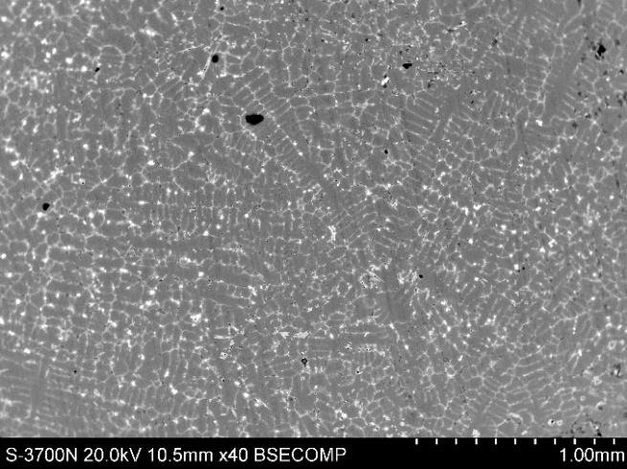 | 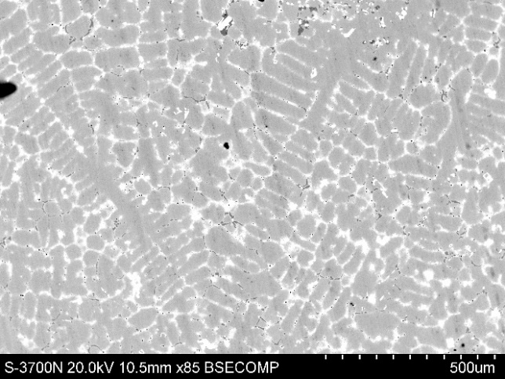
Image 1 | Image 2
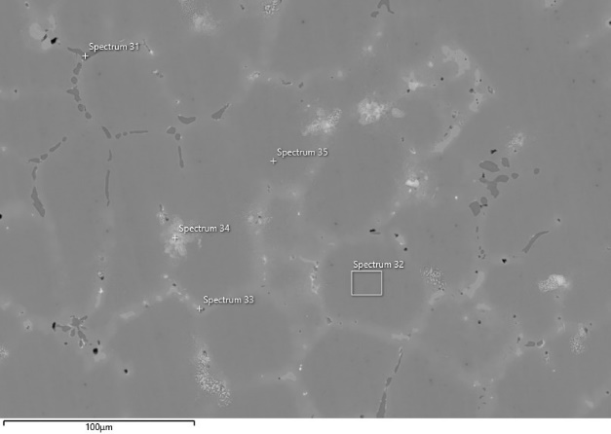 | 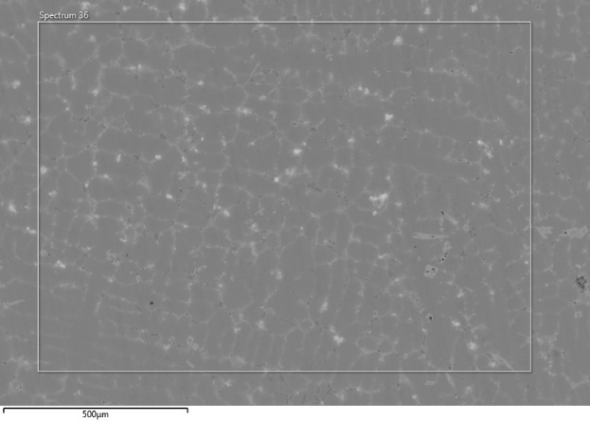
Image 3 | Image 4
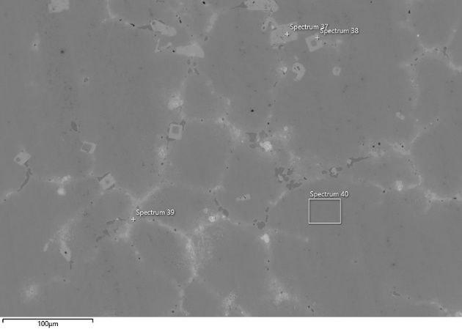 | 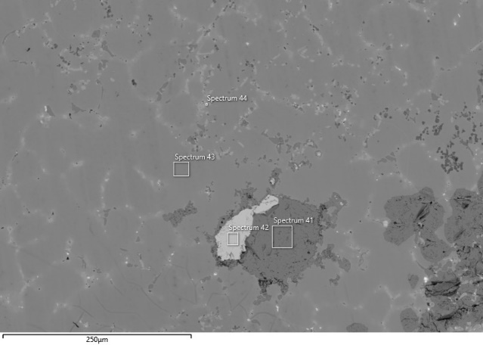
Image 5 | Image 6
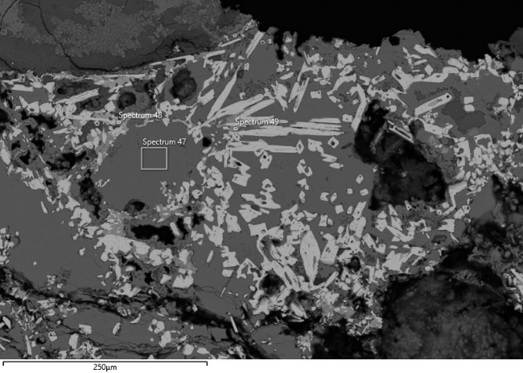 | 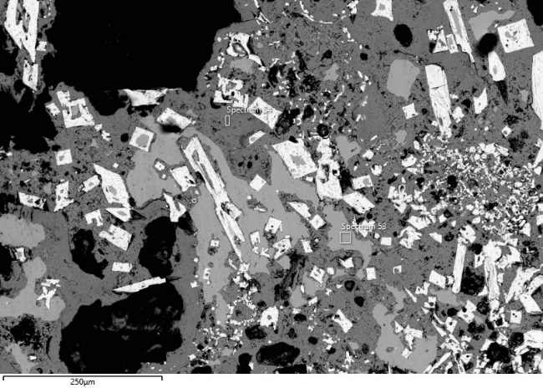
Image 7 | Image 8
Fig. 21 Locations of the analyses performed on specimen TSRP20. The corresponding analytical results are reported in the table above.

TSRP104
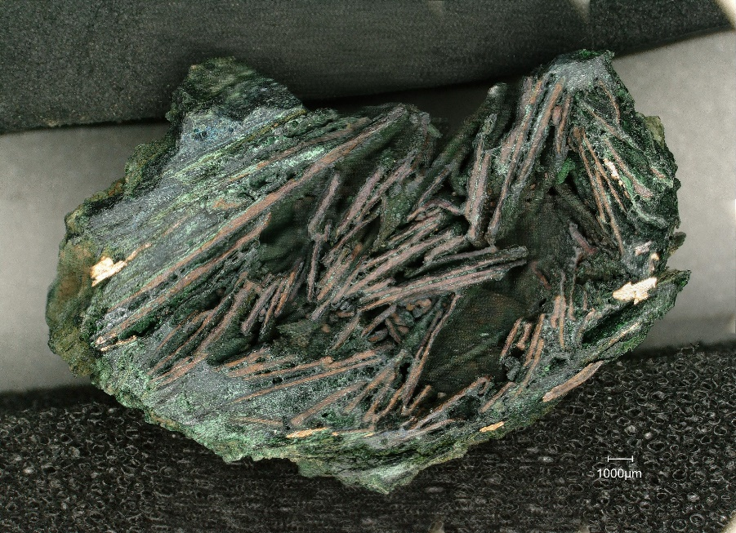
Fig. 22 Cross-section of sample TSRP104 before undergoing the mounSng and polishing processes.

Table 20. Compositional analysis of the low-oxidized regions in sample TSRP104, with the Cu-Sn alloy values normalized to 100%.
Sp. | O | Fe | Ni | Cu | Zn | As | Ag | Sn | Sb | Pb |  | Cu | Sn
Image 1
102 | 0.6 |  | 0.1 | 93.5 |  | 0.1 | 0.1 | 5.3 | 0.3 | 0.1 |  | 94.9 | 5.1
103 | 0.9 |  | 0.1 | 91.5 |  |  | 0.2 | 6.9 | 0.2 | 0.2 |  | 93.2 | 6.8
Image 2
106 | 1.0 | 0.1 | 0.2 | 90.7 | 0.1 |  | 0.1 | 7.4 | 0.2 | 0.3 |  | 92.4 | 7.6
Image 3
108 | 0.9 | 0.1 | 0.1 | 91.0 | 0.1 | 0.5 |  | 7.0 | 0.3 |  |  | 92.8 | 7.2
109 | 1.0 | 0.1 | 0.1 | 90.6 | 0.1 | 0.2 | 0.1 | 7.5 | 0.4 | 0.1 |  | 92.5 | 7.5
Image 4
112 | 0.8 |  | 0.1 | 91.3 |  | 0.2 | 0.1 | 7.0 | 0.4 | 0.1 |  | 92.8 | 7.2
113 | 0.9 | 0.1 | 0.1 | 93.3 |  | 0.2 |  | 5.1 | 0.2 | 0.1 |  | 94.8 | 5.2
114 | 1.1 | 0.1 | 0.2 | 90.9 |  | 0.1 | 0.1 | 6.9 | 0.7 |  |  | 92.9 | 7.1
115 | 1.0 | 0.1 |  | 90.9 | 0.2 | 0.1 | 0.1 | 6.8 | 0.2 | 0.4 |  | 93.1 | 6.9
Image 5
116 | 1.0 |  | 0.1 | 92.7 | 0.1 | 0.2 |  | 5.5 | 0.2 | 0.1 |  | 94.4 | 5.6
117 | 1.0 |  |  | 93.7 | 0.1 | 0.1 | 0.4 | 4.5 | 0.3 |  |  | 95.4 | 4.6
Image 6
118 | 1.1 |  |  | 92.8 | 0.1 | 0.2 | 0.1 | 5.5 | 0.2 |  |  | 94.6 | 5.4
Image 7
119 | 1.4 |  |  | 91.9 | 0.1 | 0.1 | 0.1 | 6.3 | 0.2 |  |  | 93.8 | 6.2
120 | 0.9 |  | 0.1 | 94.7 | 0.1 | 0.1 | 0.1 | 3.8 | 0.1 |  |  | 96.1 | 3.9
Image 8
121 | 1.2 |  |  | 94.6 |  | 0.1 | 0.1 | 4.0 | 0.1 |  |  | 96.0 | 4.0
122 | 1.2 |  | 0.1 | 95.2 | 0.1 | 0.1 | 0.1 | 3.1 | 0.1 |  |  | 96.8 | 3.2
123 | 1.0 |  |  | 93.5 | 0.1 | 0.1 |  | 5.2 |  | 0.1 |  | 94.8 | 5.2
124 | 1.6 |  | 0.2 | 92.9 |  |  |  | 4.8 | 0.4 |  |  | 95.1 | 4.9
Image 9
125 | 0.7 |  | 0.1 | 94.3 | 0.2 | 0.2 | 0.1 | 4.2 | 0.2 |  |  | 95.7 | 4.3
126 | 0.7 |  | 0.1 | 93.7 | 0.1 | 0.1 |  | 5.0 | 0.2 |  |  | 95.0 | 5.0
Image 10
127 | 0.8 |  | 0.1 | 92.2 | 0.2 |  | 0.1 | 6.5 | 0.1 | 0.1 |  | 93.4 | 6.6
128 | 0.9 |  | 0.1 | 91.6 | 0.1 | 0.1 | 0.1 | 6.7 | 0.4 |  |  | 93.2 | 6.8
Image 11
129 | 1.0 |  |  | 92.3 |  | 0.1 | 0.1 | 6.1 | 0.4 | 0.1 |  | 93.8 | 6.2
130 | 0.9 |  | 0.1 | 92.8 | 0.1 | 0.1 | 0.1 | 5.6 | 0.3 |  |  | 94.3 | 5.7
131 | 1.0 |  |  | 93.8 |  | 0.1 | 0.1 | 4.6 | 0.2 | 0.1 |  | 95.3 | 4.7
132 | 1.3 |  | 0.1 | 93.9 | 0.1 | 0.1 | 0.1 | 3.9 | 0.4 | 0.1 |  | 96.0 | 4.0
Max | 1.6 | 0.1 | 0.2 | 94.9 | 0.2 | 0.3 | 0.2 | 7.4 | 0.4 | 0.4
Min | 0.6 |  |  | 90.3 |  |  |  | 3.1
Average | 1.0 | 0.1 | 0.1 | 92.5 | 0.1 | 0.1 | 0.1 | 5.5 | 0.2 | 0.1 |  | 94.3 | 5.7
σ | 0.2 |  |  | 1.3 |  | 0.1 |  | 1.2 | 0.1 | 0.1

Table 21 Analyses carried out on the corroded/oxidised areas and the inclusion.
Area | Sp | O | Mg | Al | Si | P | S | Cl | K | Ca | Fe | Ni | Cu | Zn | As | Ag | Sn | Sb | Pb
Image 1
Corroded/oxidised | 104 | 25.0 | 0.1 |  | 3.8 | 2.5 | 0.1 | 0.1 | 0.1 | 2.3 | 0.5 | 0.1 | 4 | 0.2 | 0.3 |  | 21.1 | 0.6 | 3.2
Corroded/oxidised | 105 | 18.0 |  |  | 0.1 | 0.2 | 4.1 | 0.3 |  |  |  |  | 74.7 | 0.1 | 0.2 | 0.7 | 1.2 |  | 0.4
Image 2
Corroded/oxidised | 107 | 16.4 |  | 0.1 | 0.5 | 0.3 | 0.1 | 1.4 | 0.1 |  | 0.1 | 0.1 | 66.3 | 0.2 | 0.1 | 0.1 | 13.4 | 0.6 | 0.5
Image 3
Corroded/oxidised | 111 | 10 |  | 0.1 |  | 0.1 |  | 0.1 |  |  | 0.1 | 0.1 | 88.1 | 0.1 |  |  | 1.2 | 0.1 | 0.1
Inclusion | 110 | 16.5 |  |  |  |  | 8.2 |  | 0.1 |  | 0.1 |  | 15.5 |  |  |  | 3.4 |  | 56.2

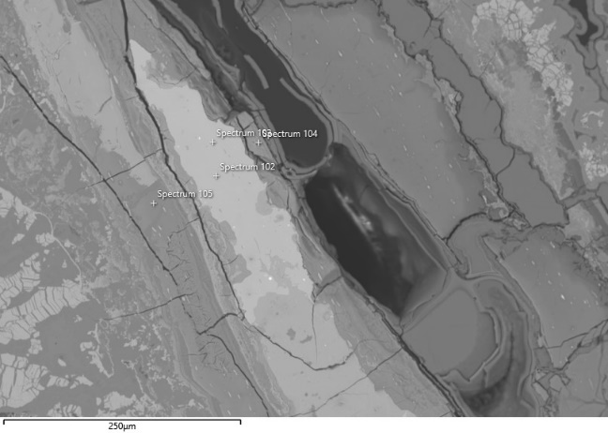 | 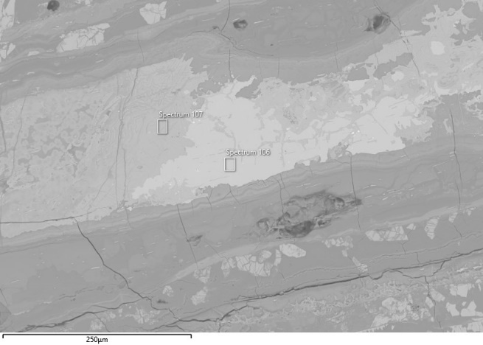
Image 1 | Image 2
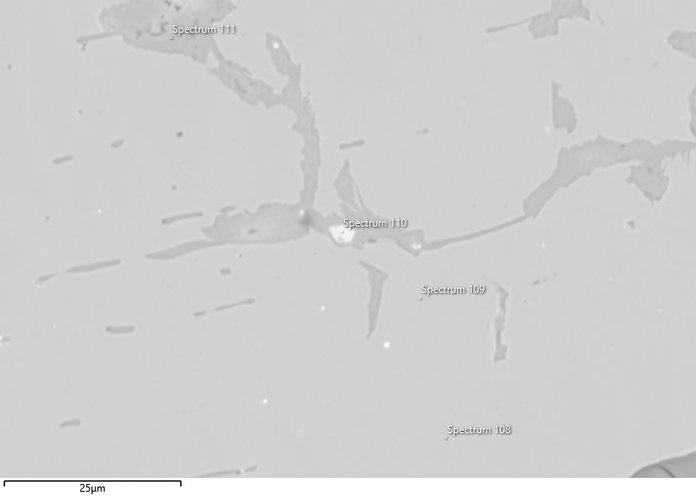 | 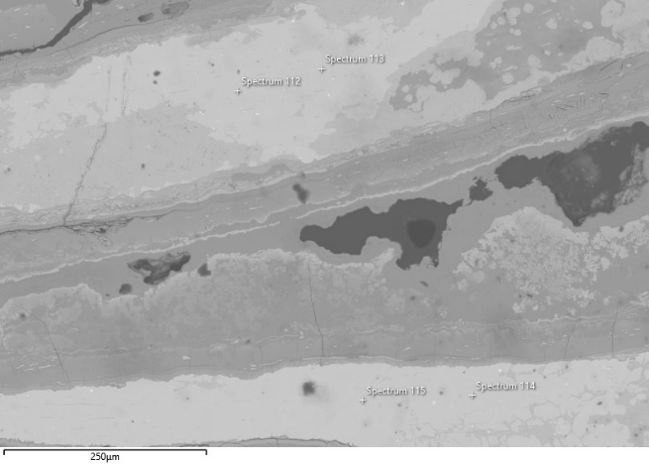
Image 3 | Image 4
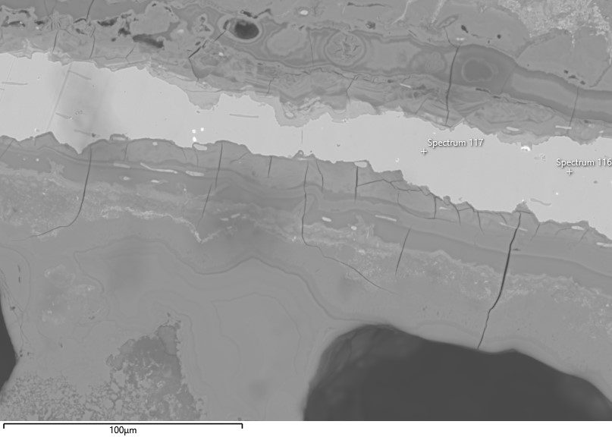 | 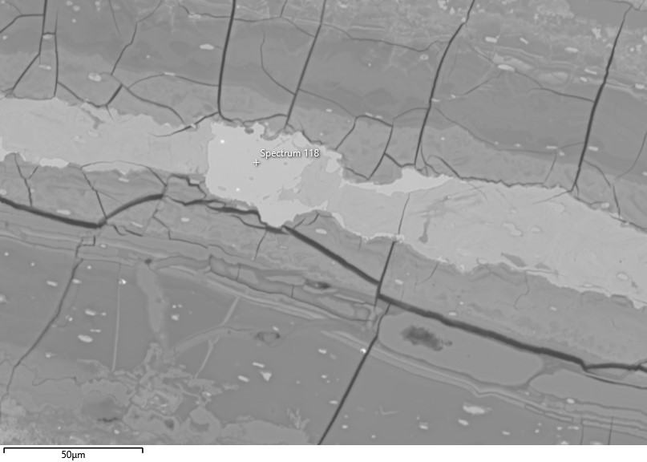
Image 5 | Image 6
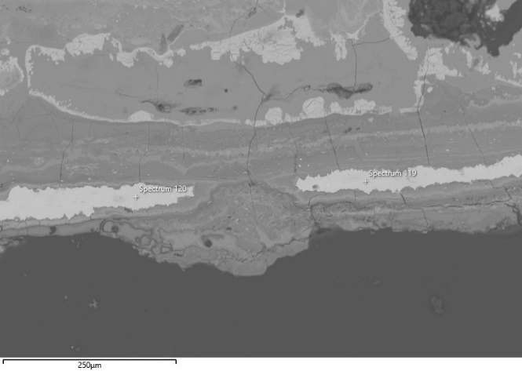 | 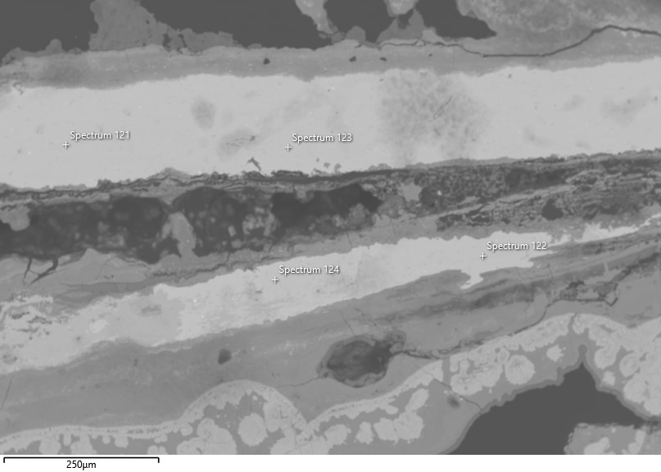
Image 7 | Image 8
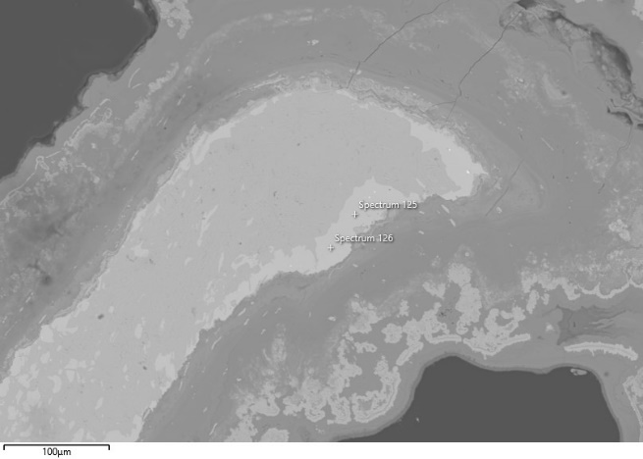 | 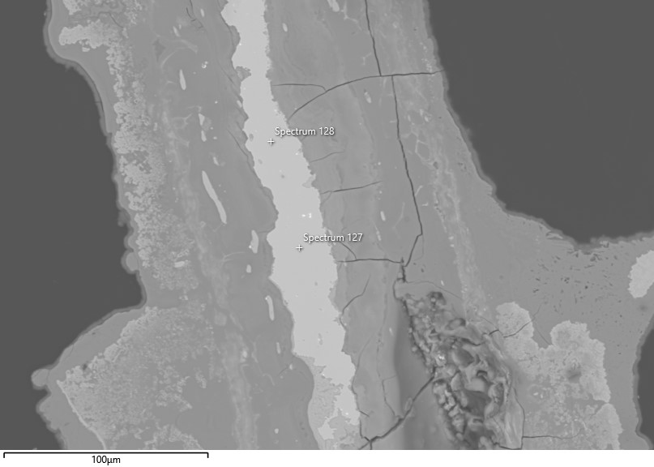
Image 9 | Image 10
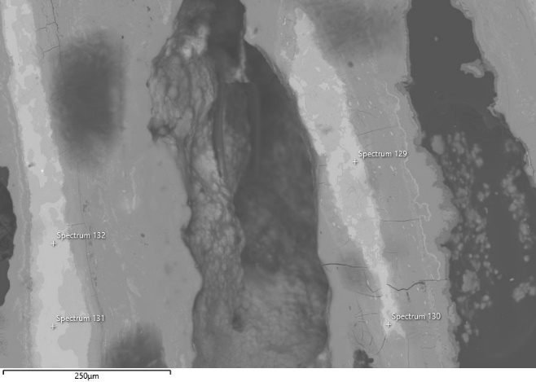 | Fig. 23 Locations of the analyses performed on specimen TSRP104. The corresponding analytical results are reported in the table above.
Image 11

