Supplementary Materials

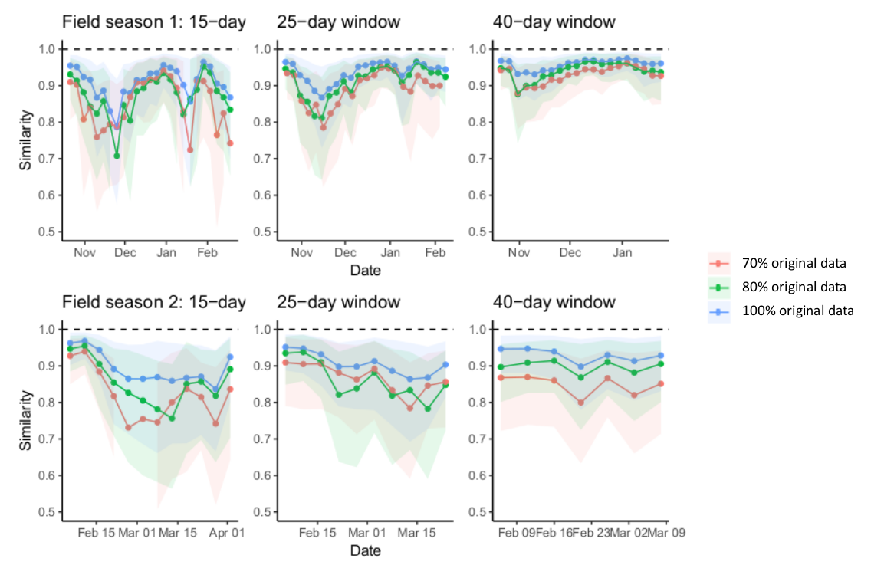
Figure S1: Moving time window and bootstrapping analysis of grooming networks for the Blue Group. Each row of plots represents one continuous field season of data collection (field season 1: Oct 2013-Mar 2014; field season 2: February 2015-April 2015). Each point represents the mean cosine similarity between the observed grooming networks and the bootstrapped networks, the shaded polygons represent the 95% confidence intervals of that similarity estimate, with points and polygons coloured according to the sensitivity of the bootstrapping. In each field season, three different length time windows were examined, 15-, 25-, and 40-days.

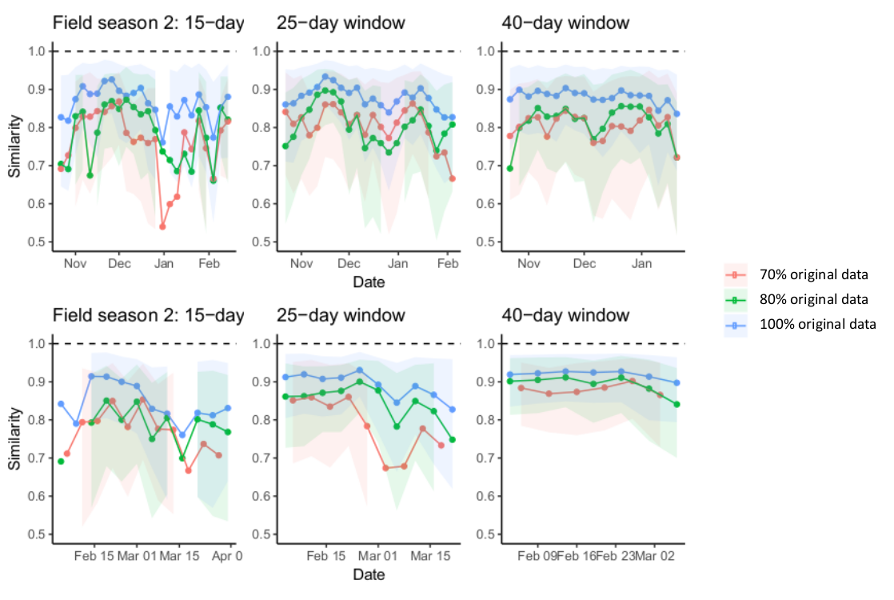
Figure S2: Moving time window and bootstrapping analysis of grooming networks for the Green Group. Each row of plots represents one continuous field season of data collection (field season 1: Oct 2013-Mar 2014; field season 2: February 2015-April 2015). Each point represents the mean cosine similarity between the observed grooming networks and the bootstrapped networks, the shaded polygons represent the 95% confidence intervals of that similarity estimate, with points and polygons coloured according to the sensitivity of the bootstrapping. In each field season, three different length time windows were examined, 15-, 25-, and 40-days.

Table S3: Summary statistics per time group per time window of data collection.
Group | Season | Time window | Mean min temp (C) | Mean food availability | Mean anthropogenic index | Mean ± SD obs time (hrs) per subject
Blue | Mating | 1 | 12.00 | 0.06 | 0.65 | 3.46 ± 0.82
Blue | Mating | 2 | 3.30 | 0.05 | 0.74 | 5.55 ± 1.05
Blue | Mating | 3 | 6.20 | 0.05 | 0.65 | 6.65 ± 1.50
Blue | Mating/Non-mating 1 | 4* | 5.10 | 0.03 | 1.13 | 6.28 ± 0.62
Blue | Non-mating 1 | 5 | 4.19 | 0.03 | 1.14 | 3.95 ± 0.83
Blue | Non-mating 1 | 6 | 7.16 | 0.01 | 0.82 | 4.44 ± 0.90
Blue | Non-mating 2 | 7 | 1.78 | 0.01 | 1.02 | 5.76 ± 1.25
Blue | Non-mating 2 | 8 | 5.27 | 0.01 | 0.78 | 5.63 ± 0.86
Blue | Non-mating 2 | 9 | 9.79 | 0.02 | 0.86 | 6.83 ± 0.51
Blue | Whole study | - | 6.41 | 0.02 | 0.84 | 46.38 ± 1.84
Green | Mating | 1 | 11.24 | 0.13 | 0.02 | 4.29 ± 0.90
Green | Mating | 2 | 7.18 | 0.18 | 0.00 | 6.59 ± 0.92
Green | Mating | 3 | 6.44 | 0.19 | 0.04 | 7.54 ± 0.83
Green | Mating | 4 | 5.36 | 0.14 | 0.05 | 6.98 ± 0.73
Green | Non-mating 1 | 5 | 4.95 | 0.06 | 0.04 | 4.75 ± 0.96
Green | Non-mating 1 | 6 | 9.62 | 0 | 0.02 | 6.99 ± 0.90
Green | Non-mating 2 | 7 | 2.22 | 0.14 | 0.02 | 6.40 ± 0.80
Green | Non-mating 2 | 8 | 5.06 | 0.07 | 0.02 | 7.35 ± 0.89
Green | Non-mating 2 | 9 | 9.27 | 0.1 | 0.17 | 7.65 ± 0.96
Green | Whole study | - | 6.53 | 0.09 | 0.05 | 45.32 ± 1.09
* For the Blue group, the mating season concluded and the first non-mating season commenced in the middle of time window 4.

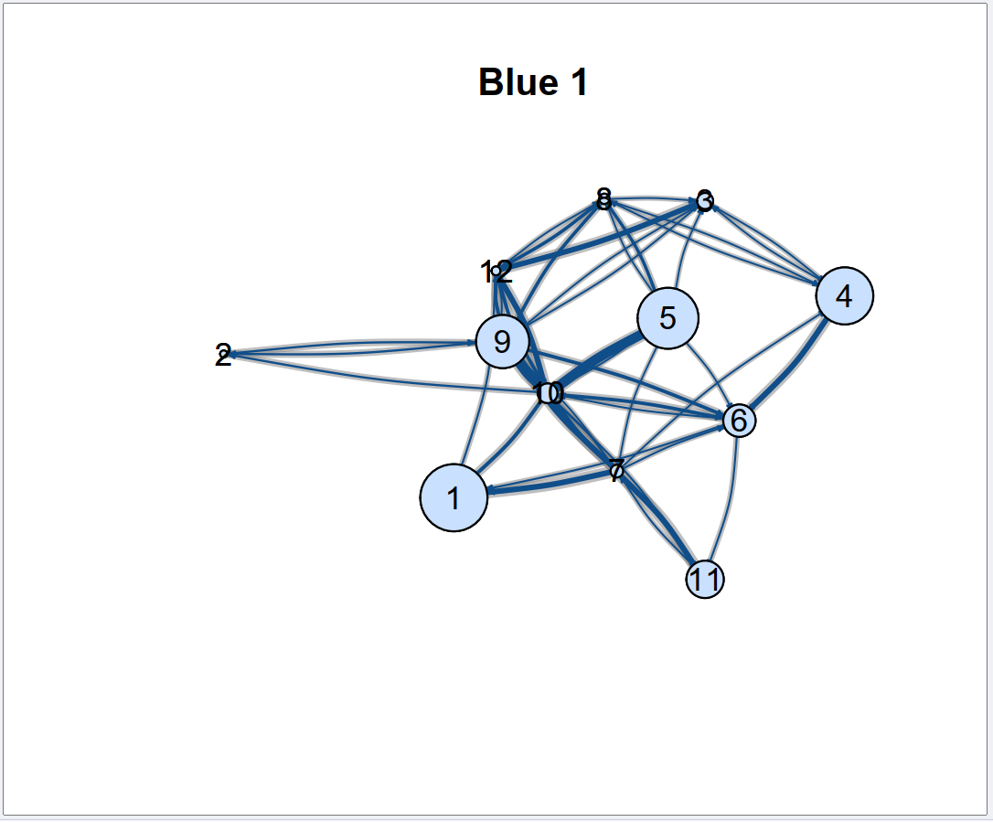
Figure S4: Grooming social networks for the Blue group (n=12 subjects) in time window 1. Nodes are sized based on Excitability/Boldness score (larger nodes were bolder, smaller nodes were shyer) and edges are sized based on the grooming association indices between the dyads. Dark blue edges are the median edge weight from 3000 draws of the posterior of a model estimating edge weights; the grey lines indicate the 90% credible interval around this median edge weight. The node numbers are individual identities for comparison across plots.

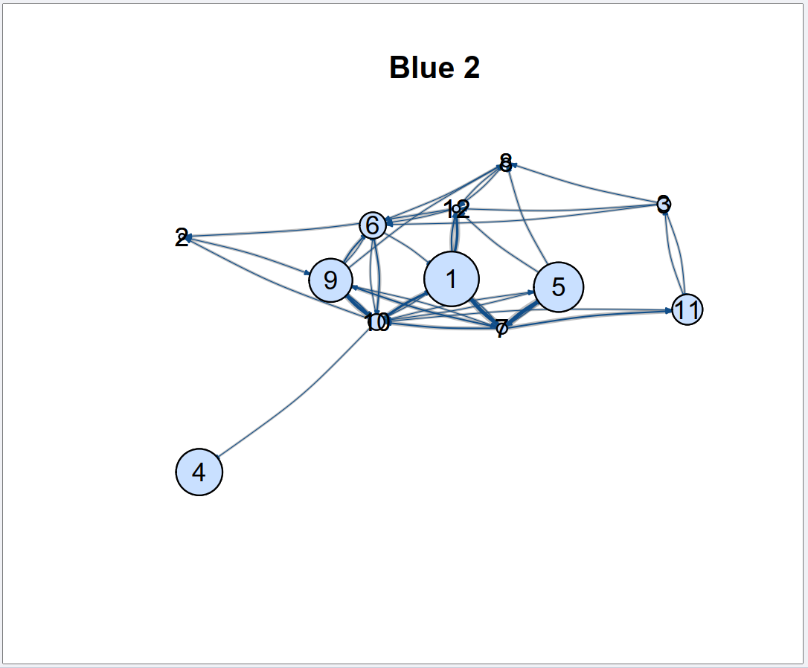
Figure S5: Grooming social networks for the Blue group (n=12 subjects) in time window 2. Nodes are sized based on Excitability/Boldness score (larger nodes were bolder, smaller nodes were shyer) and edges are sized based on the grooming association indices between the dyads. Dark blue edges are the median edge weight from 3000 draws of the posterior of a model estimating edge weights; the grey lines indicate the 90% credible interval around this median edge weight. The node numbers are individual identities for comparison across plots.

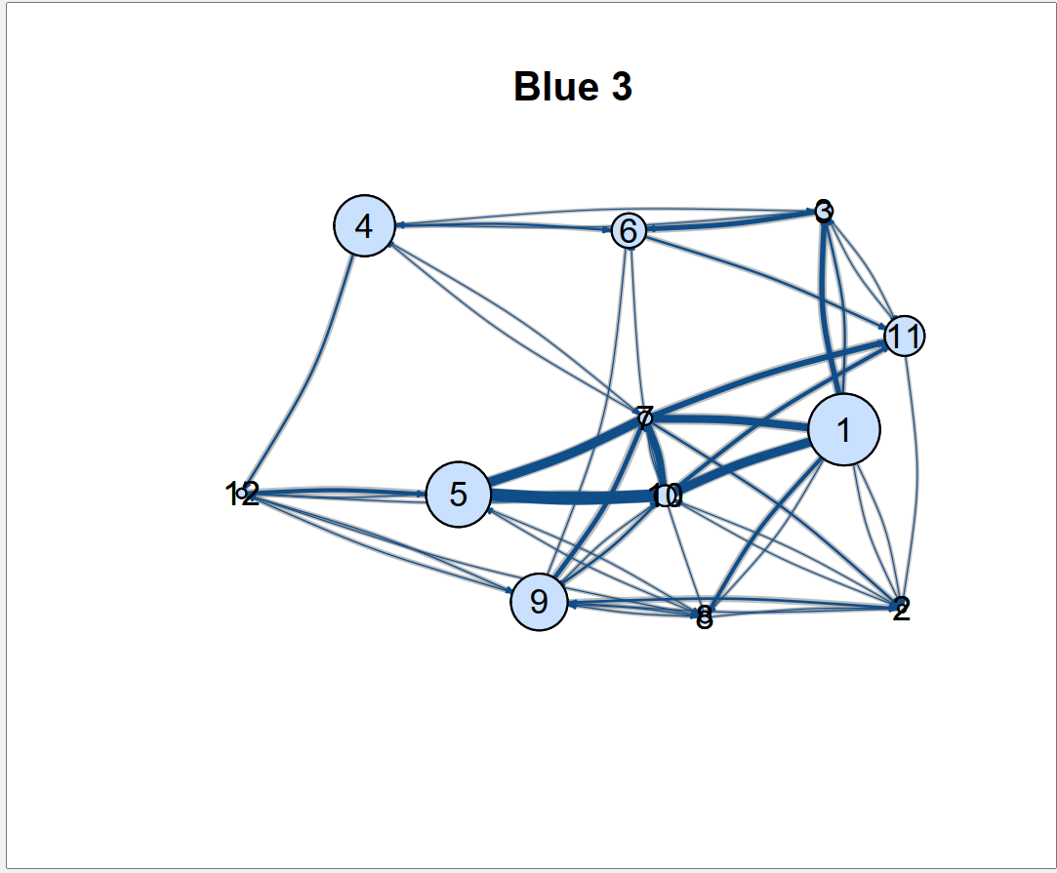
Figure S6: Grooming social networks for the Blue group (n=12 subjects) in time window 3. Nodes are sized based on Excitability/Boldness score (larger nodes were bolder, smaller nodes were shyer) and edges are sized based on the grooming association indices between the dyads. Dark blue edges are the median edge weight from 3000 draws of the posterior of a model estimating edge weights; the grey lines indicate the 90% credible interval around this median edge weight. The node numbers are individual identities for comparison across plots.

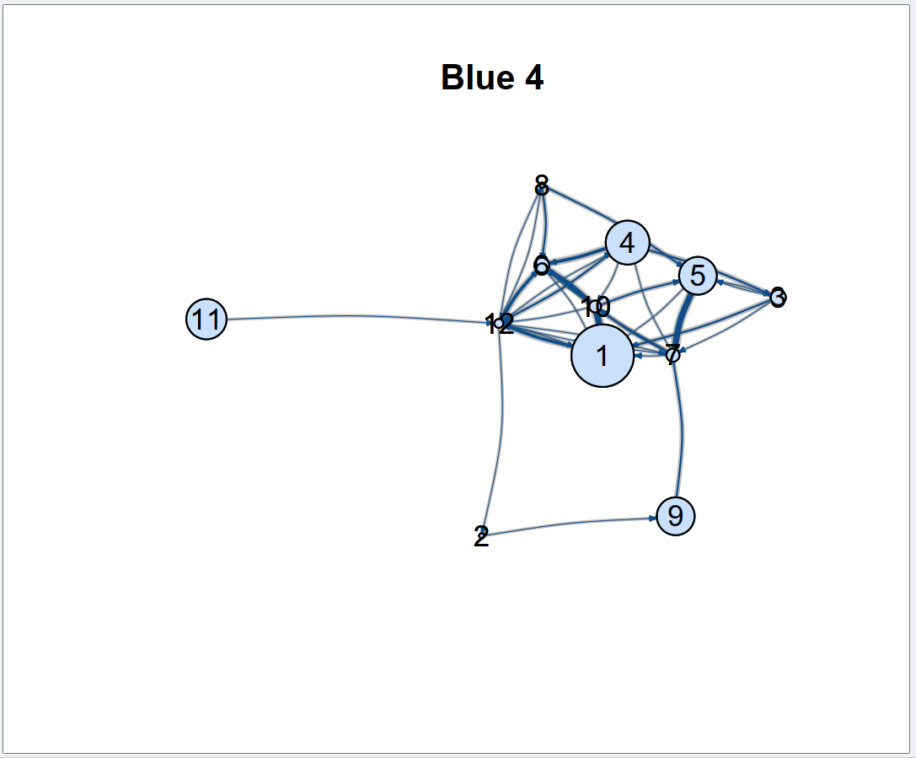
Figure S7: Grooming social networks for the Blue group (n=12 subjects) in time window 4. Nodes are sized based on Excitability/Boldness score (larger nodes were bolder, smaller nodes were shyer) and edges are sized based on the grooming association indices between the dyads. Dark blue edges are the median edge weight from 3000 draws of the posterior of a model estimating edge weights; the grey lines indicate the 90% credible interval around this median edge weight. The node numbers are individual identities for comparison across plots.

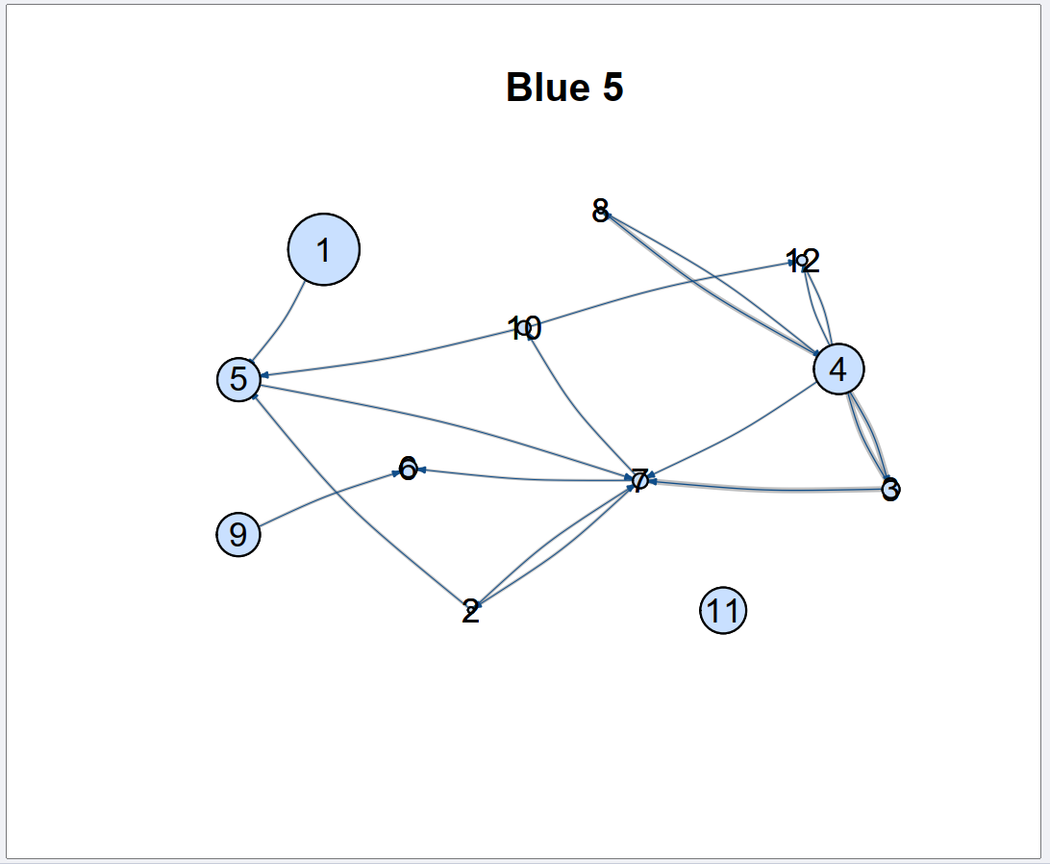
Figure S8: Grooming social networks for the Blue group (n=12 subjects) in time window 5. Nodes are sized based on Excitability/Boldness score (larger nodes were bolder, smaller nodes were shyer) and edges are sized based on the grooming association indices between the dyads. Dark blue edges are the median edge weight from 3000 draws of the posterior of a model estimating edge weights; the grey lines indicate the 90% credible interval around this median edge weight. The node numbers are individual identities for comparison across plots.

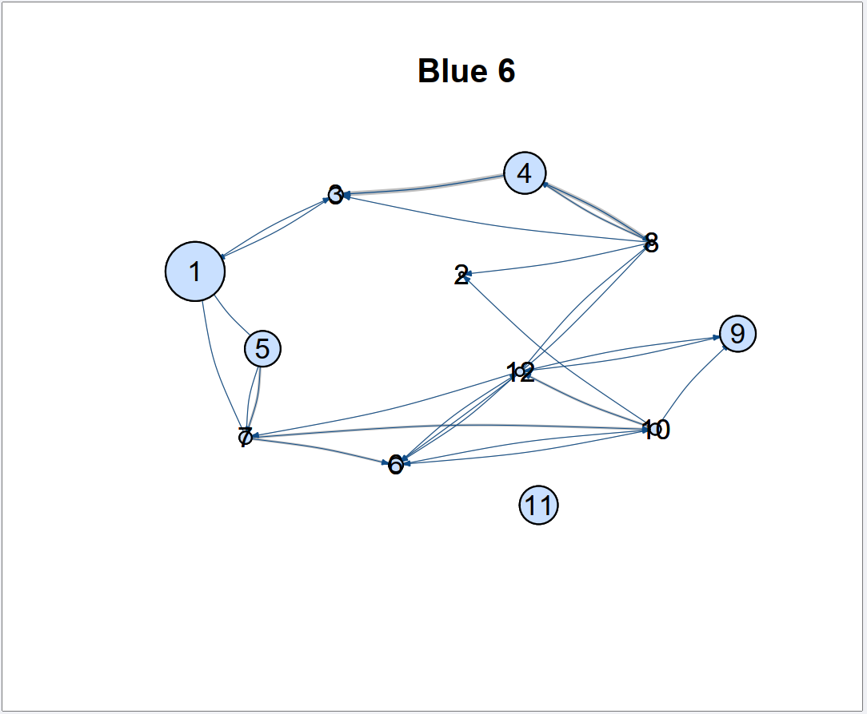
Figure S9: Grooming social networks for the Blue group (n=12 subjects) in time window 6. Nodes are sized based on Excitability/Boldness score (larger nodes were bolder, smaller nodes were shyer) and edges are sized based on the grooming association indices between the dyads. Dark blue edges are the median edge weight from 3000 draws of the posterior of a model estimating edge weights; the grey lines indicate the 90% credible interval around this median edge weight. The node numbers are individual identities for comparison across plots.

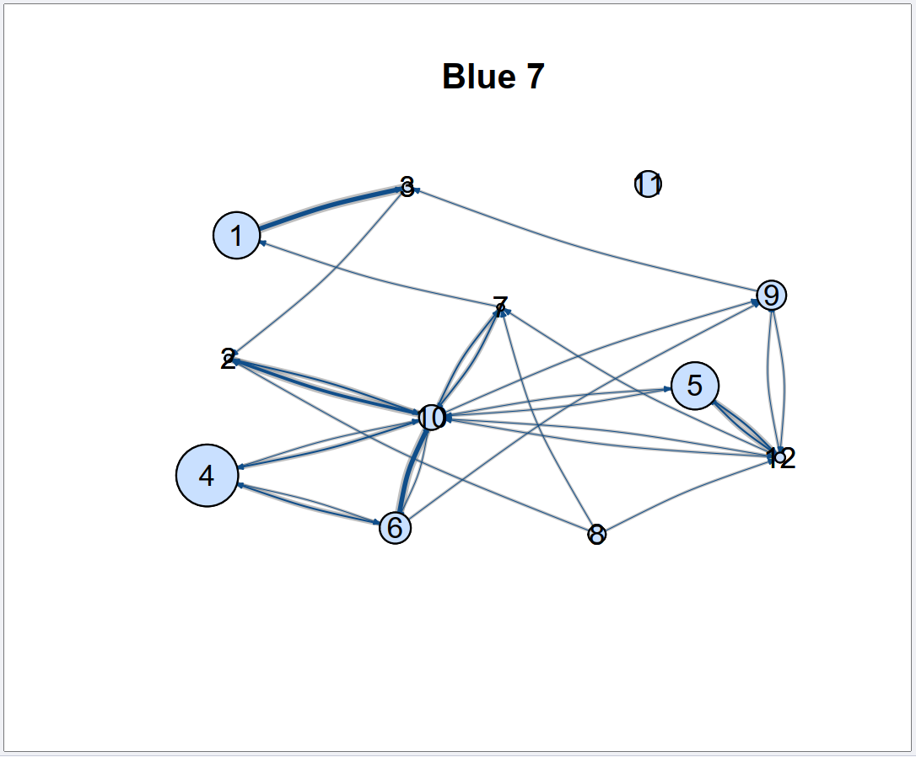
Figure S10: Grooming social networks for the Blue group (n=12 subjects) in time window 7. Nodes are sized based on Excitability/Boldness score (larger nodes were bolder, smaller nodes were shyer) and edges are sized based on the grooming association indices between the dyads. Dark blue edges are the median edge weight from 3000 draws of the posterior of a model estimating edge weights; the grey lines indicate the 90% credible interval around this median edge weight. The node numbers are individual identities for comparison across plots.

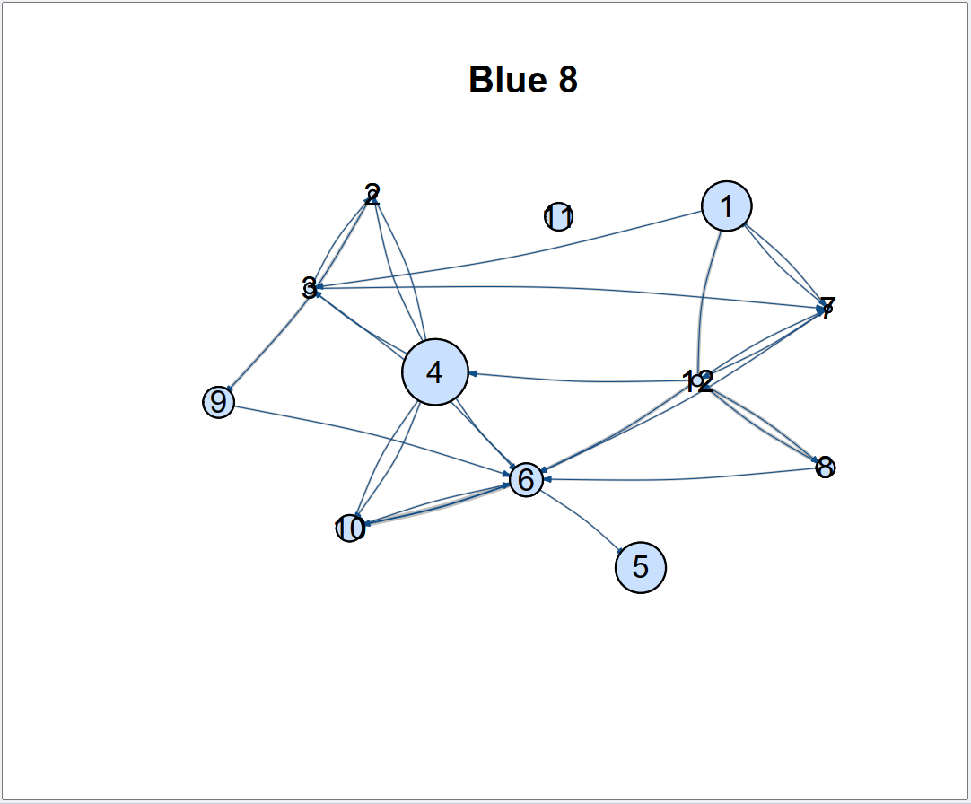
Figure S11: Grooming social networks for the Blue group (n=12 subjects) in time window 8. Nodes are sized based on Excitability/Boldness score (larger nodes were bolder, smaller nodes were shyer) and edges are sized based on the grooming association indices between the dyads. Dark blue edges are the median edge weight from 3000 draws of the posterior of a model estimating edge weights; the grey lines indicate the 90% credible interval around this median edge weight. The node numbers are individual identities for comparison across plots.

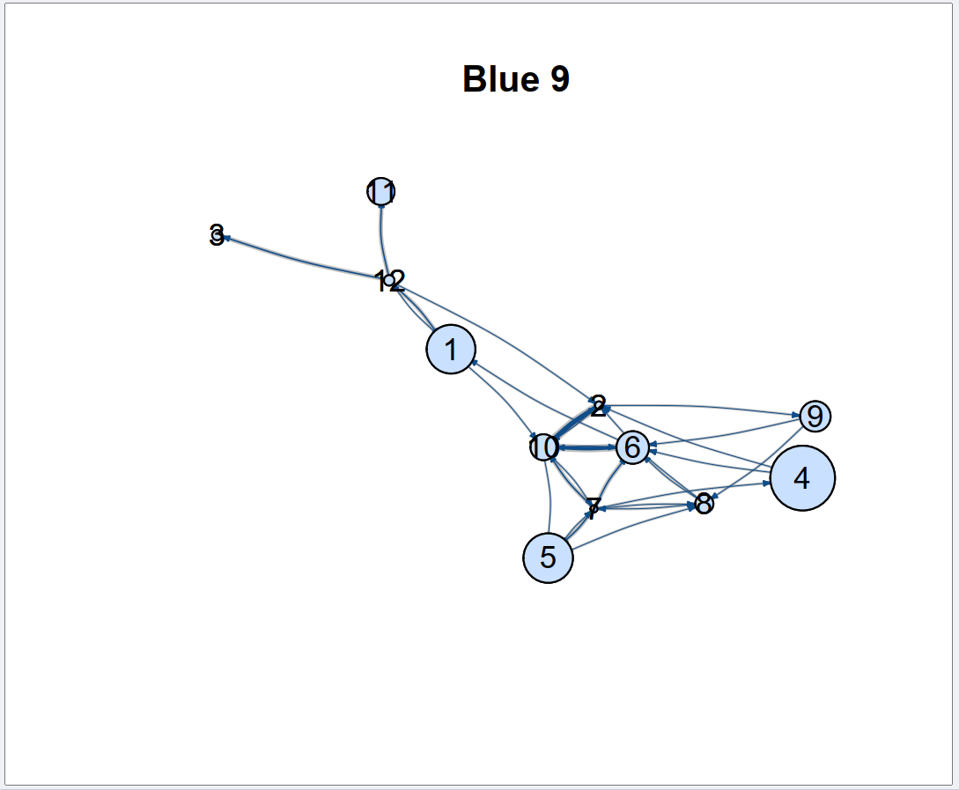
Figure S12: Grooming social networks for the Blue group (n=12 subjects) in time window 9. Nodes are sized based on Excitability/Boldness score (larger nodes were bolder, smaller nodes were shyer) and edges are sized based on the grooming association indices between the dyads. Dark blue edges are the median edge weight from 3000 draws of the posterior of a model estimating edge weights; the grey lines indicate the 90% credible interval around this median edge weight. The node numbers are individual identities for comparison across plots.

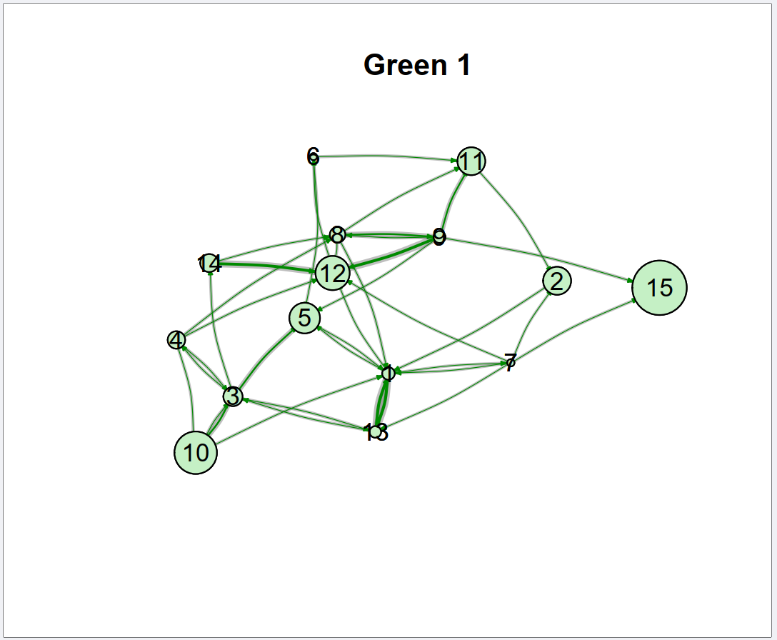
Figure S13: Grooming social networks for the Green group (n=15 subjects) in time window 1. Nodes are sized based on Excitability/Boldness score (larger nodes were bolder, smaller nodes were shyer) and edges are sized based on the grooming association indices between the dyads. Dark green edges are the median edge weight from 3000 draws of the posterior of a model estimating edge weights; the grey lines indicate the 90% credible interval around this median edge weight. The node numbers are individual identities for comparison across plots.

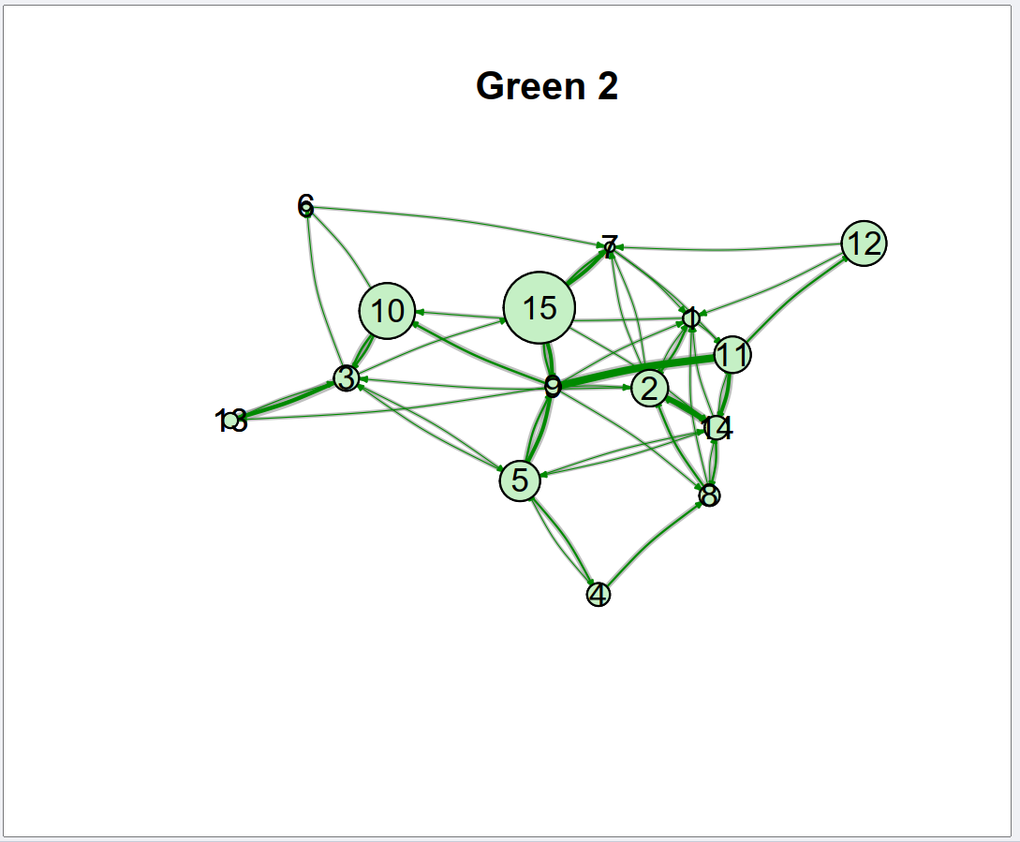
Figure S14: Grooming social networks for the Green group (n=15 subjects) in time window 2. Nodes are sized based on Excitability/Boldness score (larger nodes were bolder, smaller nodes were shyer) and edges are sized based on the grooming association indices between the dyads. Dark green edges are the median edge weight from 3000 draws of the posterior of a model estimating edge weights; the grey lines indicate the 90% credible interval around this median edge weight. The node numbers are individual identities for comparison across plots.

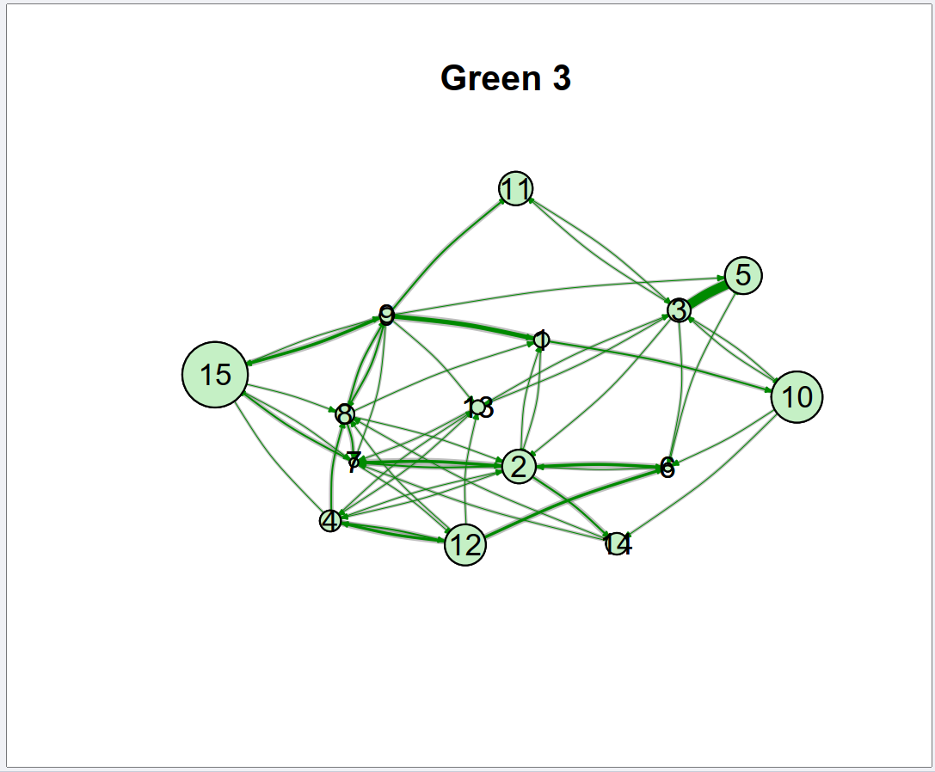
Figure S15: Grooming social networks for the Green group (n=15 subjects) in time window 3. Nodes are sized based on Excitability/Boldness score (larger nodes were bolder, smaller nodes were shyer) and edges are sized based on the grooming association indices between the dyads. Dark green edges are the median edge weight from 3000 draws of the posterior of a model estimating edge weights; the grey lines indicate the 90% credible interval around this median edge weight. The node numbers are individual identities for comparison across plots.

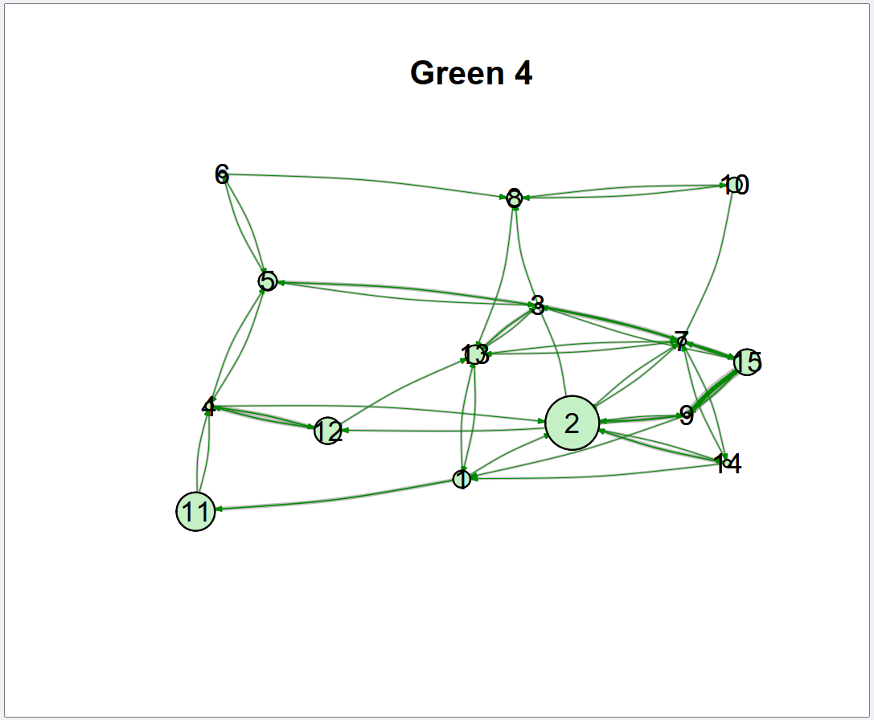
Figure S16: Grooming social networks for the Green group (n=15 subjects) in time window 4. Nodes are sized based on Excitability/Boldness score (larger nodes were bolder, smaller nodes were shyer) and edges are sized based on the grooming association indices between the dyads. Dark green edges are the median edge weight from 3000 draws of the posterior of a model estimating edge weights; the grey lines indicate the 90% credible interval around this median edge weight. The node numbers are individual identities for comparison across plots.

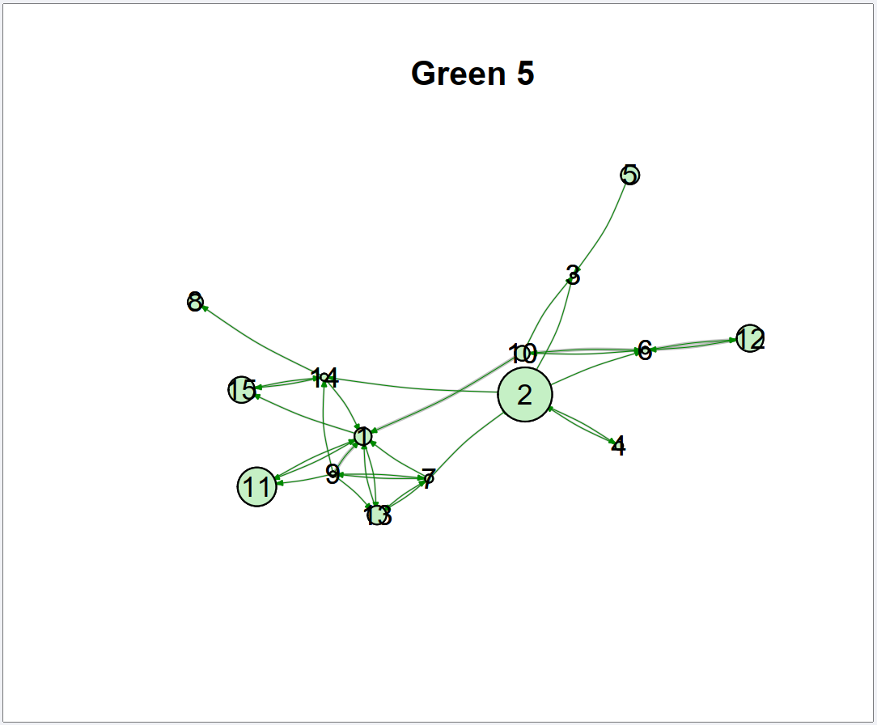
Figure S17: Grooming social networks for the Green group (n=15 subjects) in time window 5. Nodes are sized based on Excitability/Boldness score (larger nodes were bolder, smaller nodes were shyer) and edges are sized based on the grooming association indices between the dyads. Dark green edges are the median edge weight from 3000 draws of the posterior of a model estimating edge weights; the grey lines indicate the 90% credible interval around this median edge weight. The node numbers are individual identities for comparison across plots.

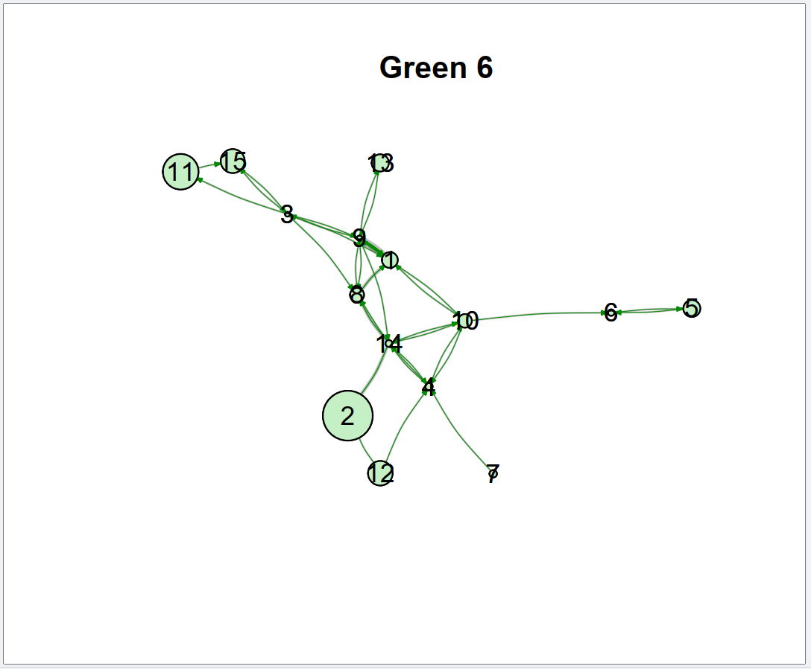
Figure S18: Grooming social networks for the Green group (n=15 subjects) in time window 6. Nodes are sized based on Excitability/Boldness score (larger nodes were bolder, smaller nodes were shyer) and edges are sized based on the grooming association indices between the dyads. Dark green edges are the median edge weight from 3000 draws of the posterior of a model estimating edge weights; the grey lines indicate the 90% credible interval around this median edge weight. The node numbers are individual identities for comparison across plots.

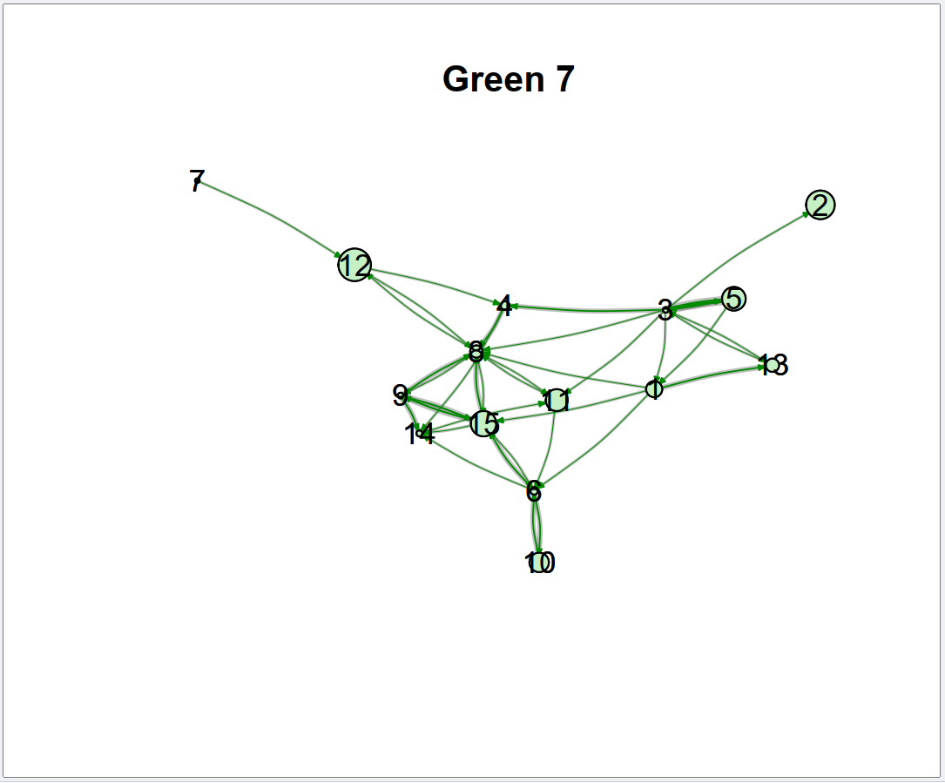
Figure S19: Grooming social networks for the Green group (n=15 subjects) in time window 7. Nodes are sized based on Excitability/Boldness score (larger nodes were bolder, smaller nodes were shyer) and edges are sized based on the grooming association indices between the dyads. Dark green edges are the median edge weight from 3000 draws of the posterior of a model estimating edge weights; the grey lines indicate the 90% credible interval around this median edge weight. The node numbers are individual identities for comparison across plots.

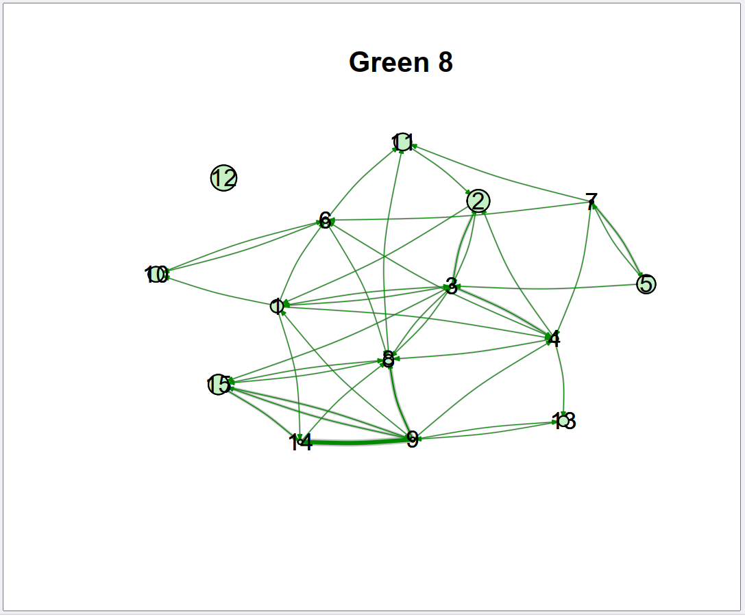
Figure S20: Grooming social networks for the Green group (n=15 subjects) in time window 8. Nodes are sized based on Excitability/Boldness score (larger nodes were bolder, smaller nodes were shyer) and edges are sized based on the grooming association indices between the dyads. Dark green edges are the median edge weight from 3000 draws of the posterior of a model estimating edge weights; the grey lines indicate the 90% credible interval around this median edge weight. The node numbers are individual identities for comparison across plots.

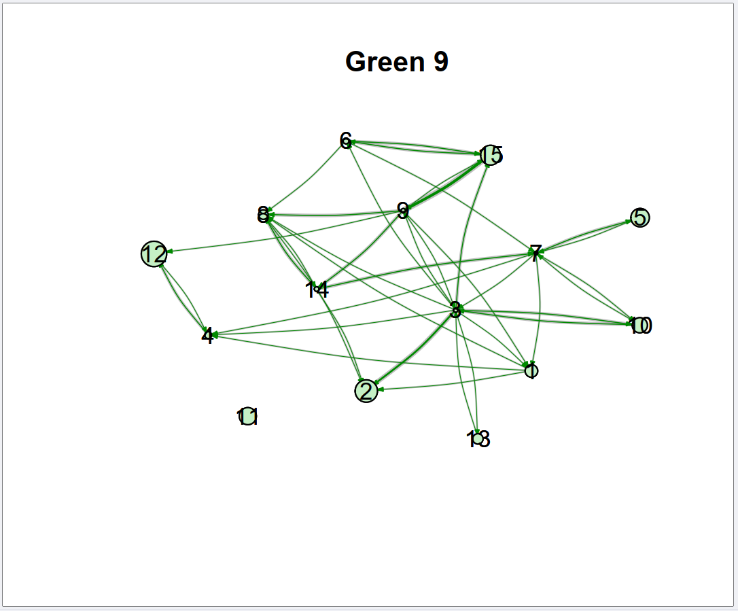
Figure S21: Grooming social networks for the Green group (n=15 subjects) in time window 9. Nodes are sized based on Excitability/Boldness score (larger nodes were bolder, smaller nodes were shyer) and edges are sized based on the grooming association indices between the dyads. Dark green edges are the median edge weight from 3000 draws of the posterior of a model estimating edge weights; the grey lines indicate the 90% credible interval around this median edge weight. The node numbers are individual identities for comparison across plots.

Table S22: Variance inflation factors (VIFs) for variables included in models.
Model | Coefficient | VIF
1: Plasticity in Social Decision Making | Group identity | 1.231
1: Plasticity in Social Decision Making | Sex | 4.256
1: Plasticity in Social Decision Making | Excitability | 2.447
1: Plasticity in Social Decision Making | Anthropogenic presence | 1.036
1: Plasticity in Social Decision Making | Mean minimum temperature | 1.014
1: Plasticity in Social Decision Making | Conspecifics within 10 metres | 1.120
1: Plasticity in Social Decision Making | Largest rank difference with by-standers | 1.530
1: Plasticity in Social Decision Making | Individual rank | 3.228
1: Plasticity in Social Decision Making | Time of day | 1.011
2/3: Plasticity in Network Connectivity | Season | 2.963
2/3: Plasticity in Network Connectivity | Excitability | 2.798
2/3: Plasticity in Network Connectivity | Anthropogenic index | 16.483
2/3: Plasticity in Network Connectivity | Fruit availability | 4.174
2/3: Plasticity in Network Connectivity | Mean minimum temperature | 1.296
2/3: Plasticity in Network Connectivity | Individual rank | 2.914
2/3: Plasticity in Network Connectivity | Sex | 4.333
2/3: Plasticity in Network Connectivity | Group identity | 20.068
2/3: Plasticity in Network Connectivity - Group removed | Season | 1.756
2/3: Plasticity in Network Connectivity - Group removed | Excitability | 2.798
2/3: Plasticity in Network Connectivity - Group removed | Anthropogenic index | 2.570
2/3: Plasticity in Network Connectivity - Group removed | Fruit availability | 2.982
2/3: Plasticity in Network Connectivity - Group removed | Mean minimum temperature | 1.292
2/3: Plasticity in Network Connectivity - Group removed | Individual rank | 2.912
2/3: Plasticity in Network Connectivity - Group removed | Sex | 4.332

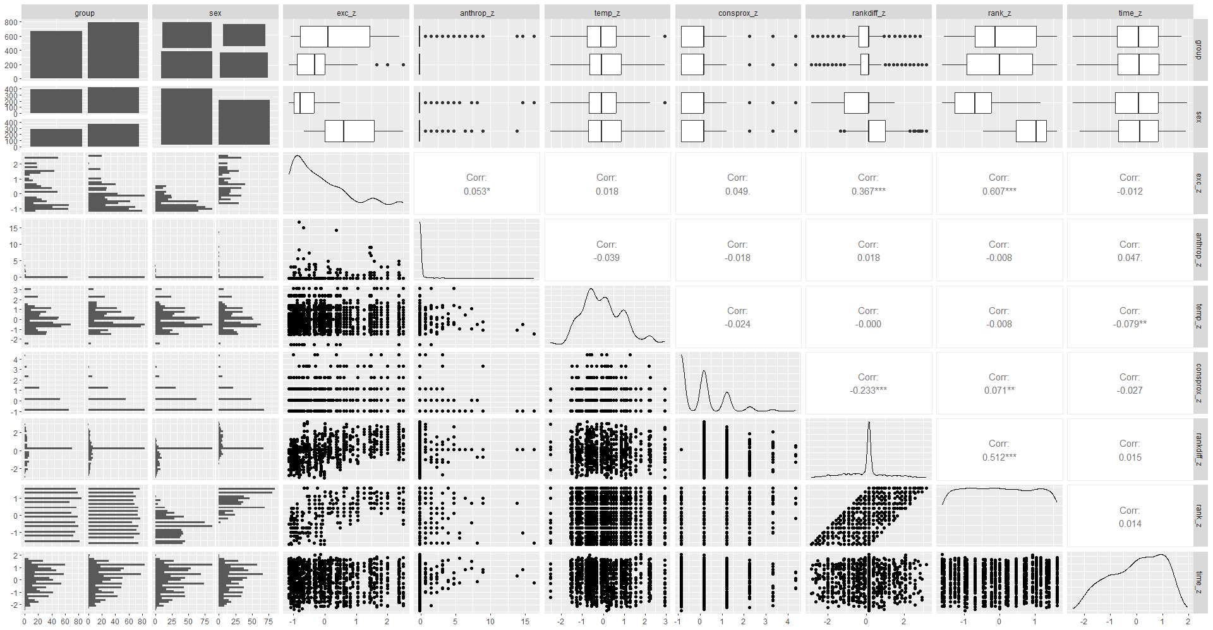
Figure S23: Correlations between variables included in model 1 (“Plasticity in social decision making in relation to current social environment”). The plot was generated using the ggpairs function of the GGally package (Schloerke et al, 2024; full reference in main manuscript).

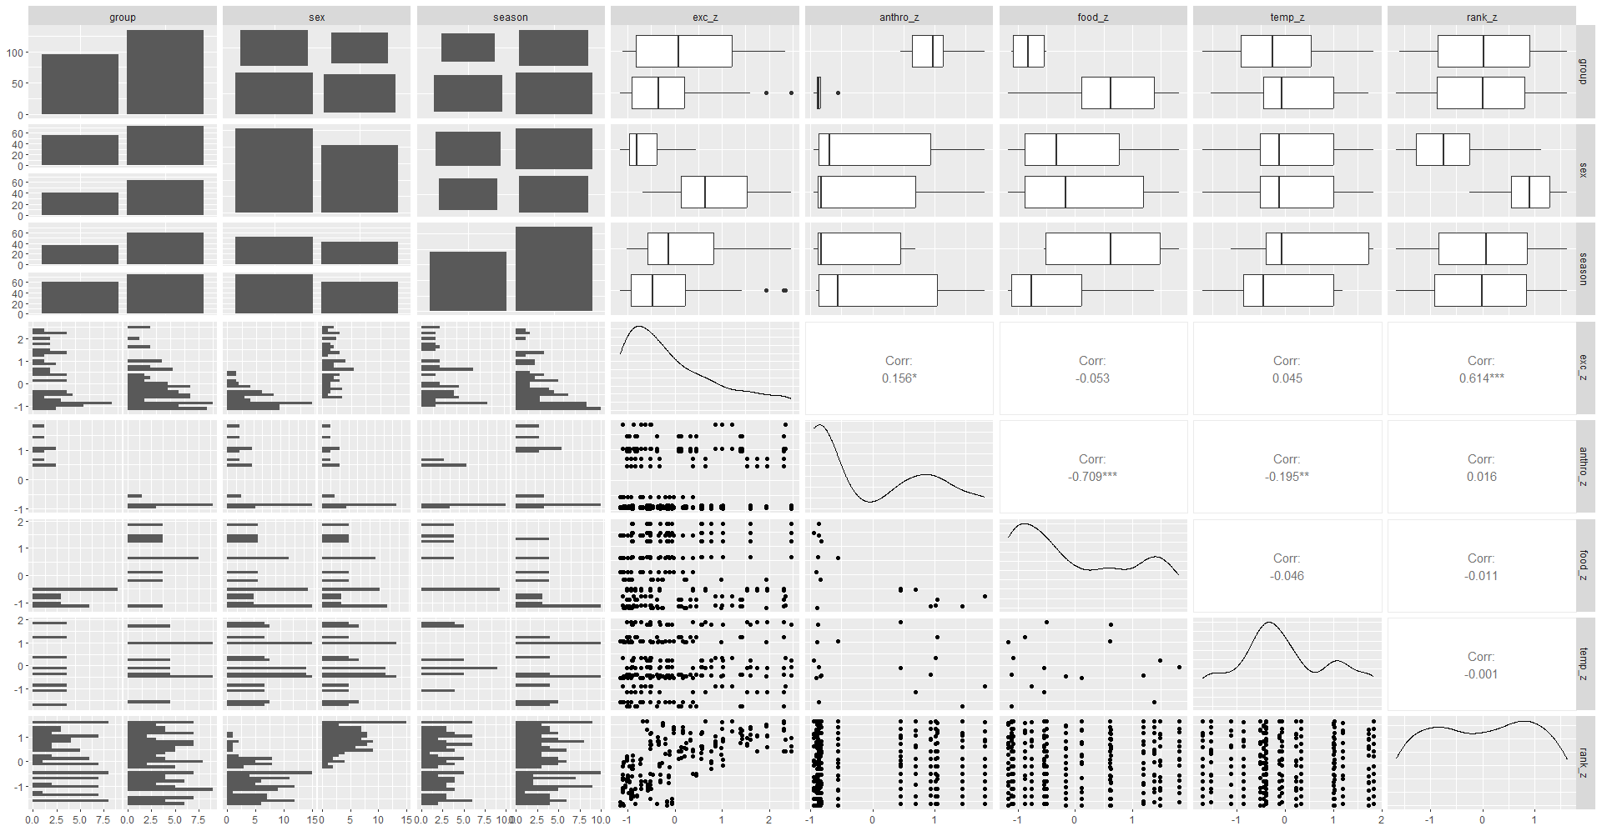
Figure S24: Correlations between variables included in models 2 and 3 (“Plasticity in Social Connectivity”). The plot was generated using the ggpairs function of the GGally package (Schloerke et al, 2024; full reference in main manuscript).

Table S25: Model validation values for “Model 1: Plasticity in social decision making in relation to current social environment”. ESS refers to “effective samples size” of the model.
Level | Rhat | Bulk_ESS | Tail_ESS
Fixed effects
Intercept | 1.000 | 2387 | 2500
exc_z | 1.000 | 2368 | 3369
anthrop_z | 1.000 | 2285 | 2587
consprox_z | 1.000 | 2632 | 2855
rankdiff_z | 1.000 | 2890 | 2953
temp_z | 1.000 | 3013 | 3211
rank_z | 1.000 | 3039 | 3324
time_z | 1.000 | 3298 | 3305
Itime_zE2 | 1.000 | 2373 | 2846
sexM | 1.000 | 2748 | 2876
groupG | 1.000 | 2404 | 2747
exc_z:anthrop_z | 1.000 | 3200 | 3255
exc_z:consprox_z | 1.000 | 3385 | 3398
exc_z:rankdiff_z | 1.000 | 2621 | 2943
Random effects, slopes and correlations
~date_obs
sd(Intercept) | 1.000 | 1136 | 1493
~subject
sd(Intercept) | 1.000 | 1606 | 1201
sd(anthrop_z) | 1.000 | 1790 | 2628
sd(consprox_z) | 1.000 | 1830 | 2336
sd(rankdiff_z) | 1.000 | 1298 | 1208
sd(temp_z) | 1.000 | 1634 | 1325
sd(rank_z) | 1.000 | 2033 | 2937
sd(time_z) | 1.000 | 2296 | 2305
sd(Itime_zE2) | 1.000 | 1381 | 2365
cor(Intercept,anthrop_z) | 1.000 | 3081 | 3275
cor(Intercept,consprox_z) | 1.000 | 2900 | 3182
cor(anthrop_z,consprox_z) | 1.000 | 2551 | 3397
cor(Intercept,rankdiff_z) | 1.000 | 2344 | 3351
cor(anthrop_z,rankdiff_z) | 1.000 | 2462 | 3062
cor(consprox_z,rankdiff_z) | 1.000 | 2531 | 3122
cor(Intercept,temp_z) | 1.000 | 2670 | 3047
cor(anthrop_z,temp_z) | 1.000 | 2524 | 3076
cor(consprox_z,temp_z) | 1.000 | 2894 | 2988
cor(rankdiff_z,temp_z) | 1.000 | 2640 | 3035
cor(Intercept,rank_z) | 1.000 | 2986 | 2969
cor(anthrop_z,rank_z) | 1.000 | 3153 | 3503
cor(consprox_z,rank_z) | 1.000 | 3360 | 3272
cor(rankdiff_z,rank_z) | 1.000 | 3111 | 3219
cor(temp_z,rank_z) | 1.000 | 3279 | 3498
cor(Intercept,time_z) | 1.000 | 3309 | 3229
cor(anthrop_z,time_z) | 1.000 | 3056 | 3269
cor(consprox_z,time_z) | 1.000 | 3023 | 3385
cor(rankdiff_z,time_z) | 1.000 | 3249 | 3332
cor(temp_z,time_z) | 1.000 | 2942 | 2898
cor(rank_z,time_z) | 1.000 | 3052 | 3240
cor(Intercept,Itime_zE2) | 1.000 | 2815 | 3137
cor(anthrop_z,Itime_zE2) | 1.000 | 2408 | 3208
cor(consprox_z,Itime_zE2) | 1.000 | 2501 | 2744
cor(rankdiff_z,Itime_zE2) | 1.000 | 2686 | 3004
cor(temp_z,Itime_zE2) | 1.000 | 3519 | 3362
cor(rank_z,Itime_zE2) | 1.000 | 3099 | 3736
cor(time_z,Itime_zE2) | 1.000 | 3037 | 3185
sd(Intercept) | 1.000 | 1606 | 1201
sd(anthrop_z) | 1.000 | 1790 | 2628
sd(consprox_z) | 1.000 | 1830 | 2336
sd(rankdiff_z) | 1.000 | 1298 | 1208
sd(temp_z) | 1.000 | 1634 | 1325
sd(rank_z) | 1.000 | 2033 | 2937
sd(time_z) | 1.000 | 2296 | 2305
sd(Itime_zE2) | 1.000 | 1381 | 2365
cor(Intercept,anthrop_z) | 1.000 | 3081 | 3275

Table S26: Model validation values for “Model 2: Plasticity in social connectivity – out-degree”. ESS refers to “effective samples size” of the model.
Level | Rhat | Bulk_ESS | Tail_ESS
Fixed effects
Intercept | 1.000 | 2869 | 3224
exc_z | 1.000 | 2391 | 2953
seasonNonMmating | 1.000 | 2669 | 2895
anthro_z | 1.000 | 2814 | 3211
food_z | 1.000 | 3077 | 3310
temp_z | 1.000 | 3234 | 3532
rank_z | 1.000 | 3215 | 3226
sexM | 1.000 | 2790 | 3054
exc_z:seasonNonMmating | 1.000 | 2725 | 3012
exc_z:anthro_z | 1.000 | 2605 | 3364
exc_z:food_z | 1.000 | 2579 | 3308
exc_z:temp_z | 1.000 | 2523 | 2805
Random effects, slopes and correlations
~subject_ID
sd(Intercept) | 1.000 | 1611 | 1861
sd(seasonNonMmating) | 1.000 | 1129 | 1074
sd(anthro_z) | 1.000 | 1368 | 2097
sd(food_z) | 1.000 | 1780 | 2890
sd(temp_z) | 1.000 | 1417 | 1801
cor(Intercept,seasonNonMmating) | 1.000 | 1916 | 2103
cor(Intercept,anthro_z) | 1.000 | 2664 | 2782
cor(seasonNonMmating,anthro_z) | 1.000 | 3194 | 3218
cor(Intercept,food_z) | 1.000 | 2605 | 3050
cor(seasonNonMmating,food_z) | 1.000 | 2567 | 3210
cor(anthro_z,food_z) | 1.000 | 3202 | 3464
cor(Intercept,temp_z) | 1.000 | 2860 | 2783
cor(seasonNonMmating,temp_z) | 1.000 | 2932 | 2817
cor(anthro_z,temp_z) | 1.000 | 2482 | 2775
cor(food_z,temp_z) | 1.000 | 2744 | 3487
Distribution parameters
phi | 1.000 | 1893 | 2125

Table S27: Model validation values for “Model 3: Plasticity in social connectivity – strength”. ESS refers to “effective samples size” of the model.
Level | Rhat | Bulk_ESS | Tail_ESS
Fixed effects
Intercept | 1.000 | 1758 | 2665
exc_z | 1.000 | 1976 | 2602
seasonNonMmating | 1.000 | 1775 | 2725
anthro_z | 1.000 | 2730 | 3256
food_z | 1.000 | 2409 | 2656
temp_z | 1.000 | 3017 | 3360
rank_z | 1.000 | 2709 | 3119
sexM | 1.000 | 2978 | 3116
exc_z:seasonNonMmating | 1.000 | 2034 | 2660
exc_z:anthro_z | 1.000 | 3130 | 3324
exc_z:food_z | 1.000 | 3103 | 3264
exc_z:temp_z | 1.000 | 3165 | 3328
Random effects, slopes and correlations
~subject_ID
sd(Intercept) | 1.000 | 1877 | 2209
sd(seasonNonMmating) | 1.000 | 2247 | 2874
sd(anthro_z) | 1.000 | 2533 | 3053
sd(food_z) | 1.000 | 1671 | 2807
sd(temp_z) | 1.000 | 2797 | 3053
cor(Intercept,seasonNonMmating) | 1.000 | 2047 | 2530
cor(Intercept,anthro_z) | 1.000 | 3132 | 3495
cor(seasonNonMmating,anthro_z) | 1.000 | 3168 | 3370
cor(Intercept,food_z) | 1.000 | 2648 | 2867
cor(seasonNonMmating,food_z) | 1.000 | 2298 | 2924
cor(anthro_z,food_z) | 1.000 | 2996 | 3508
cor(Intercept,temp_z) | 1.000 | 2555 | 2777
cor(seasonNonMmating,temp_z) | 1.000 | 3048 | 3263
cor(anthro_z,temp_z) | 1.000 | 2618 | 3301
cor(food_z,temp_z) | 1.000 | 2630 | 3048
Distribution parameters
phi | 1.000 | 2722 | 3326

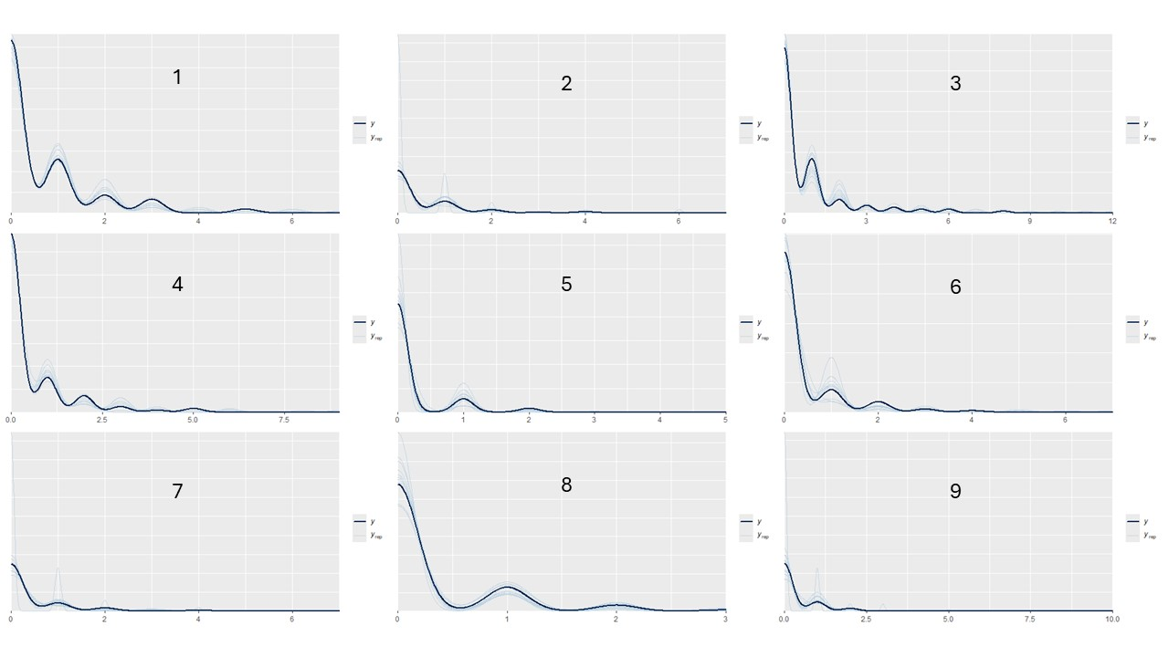
Figure S28: Posterior predictive checks of the response (times dyads were observed grooming) from the models used to estimate the grooming network edge weights for the Blue group across 9 different time windows. The dark blue (y) represents the observed edge weights, the light blue lines (y_{rep}) are 100 draws from the posterior of each respective model.

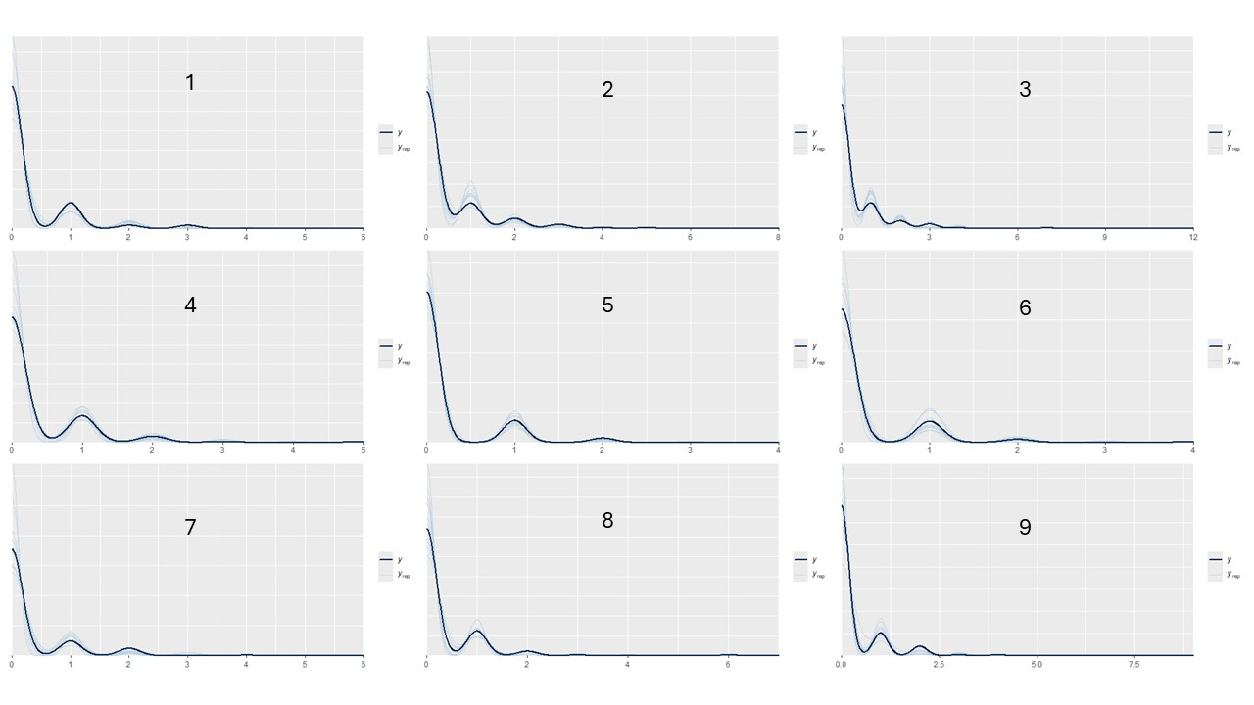
Figure S29: Posterior predictive checks of the response (times dyads were observed grooming) from the models used to estimate the grooming network edge weights for the Green group across 9 different time windows. The dark blue (y) represents the observed edge weights, the light blue lines (y_{rep}) are 100 draws from the posterior of each respective model.

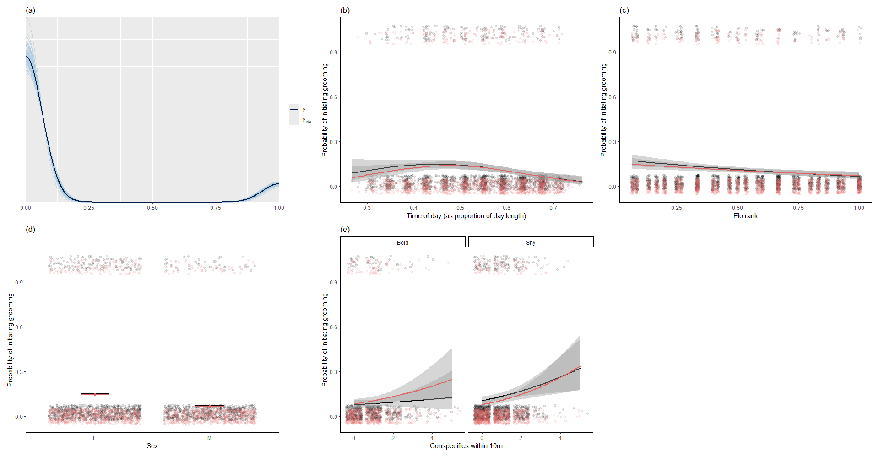
Figure S30: Posterior predictive checks for “Model 1: Plasticity in social decision making in relation to current social environment”. In (a), the dark blue (y) represents the overall observed probability to initiate grooming, the light blue lines (y_{rep}) are 100 draws from the posterior representing estimated overall probability to initiate grooming. For (b), (c), (d), and (e), the relationships between the main effects found in Model 1 and probability to initiate grooming are plotted. For (b), (c) and (e), the black points and regression lines represent the observed probability to initiate grooming, the red points and regression lines are 100 draws from the posterior representing estimated probability to initiate grooming. The grey lines around the regression lines represent the 90% credible intervals. In (d), the horizontal black and red lines represented the observed and predicted means respectively.
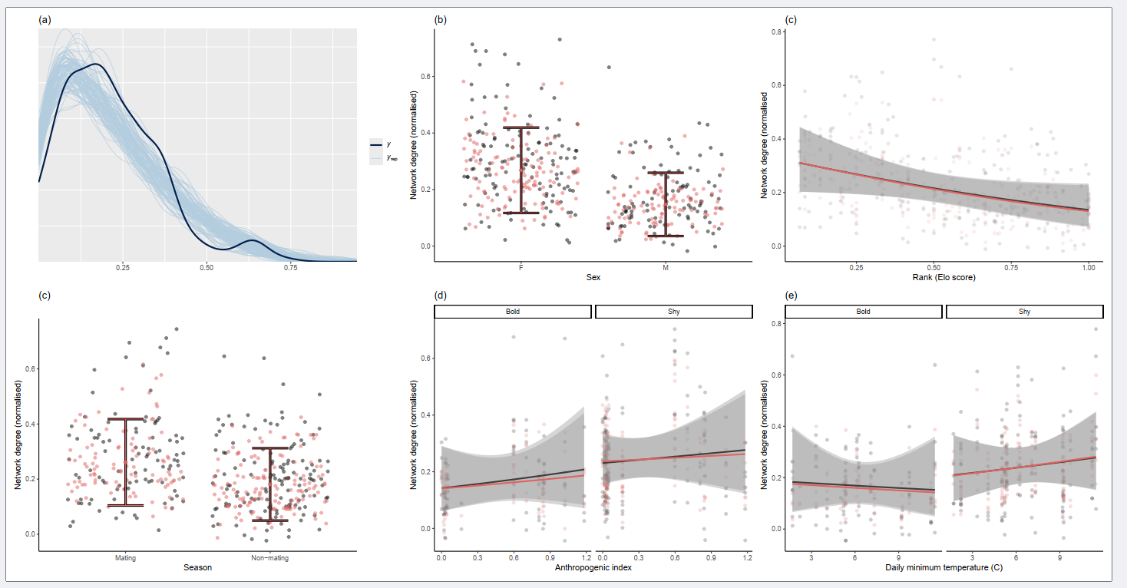
Figure S31: Posterior predictive checks for “Model 2: Plasticity in social connectivity – out-degree”. In (a), the dark blue (y) represents the overall observed network out-degree, the light blue lines (y_{rep}) are 100 draws from the posterior representing estimated overall network out-degree. For (b), (c), (d) and (e), the relationships between the main effects found in Model 2 and network out-degree are plotted. Here, the black points and regression lines represent the observed network out-degree, the red points and regression lines are 100 draws from the posterior representing estimated network out-degree. The grey lines around the regression lines represent the 90% credible intervals.

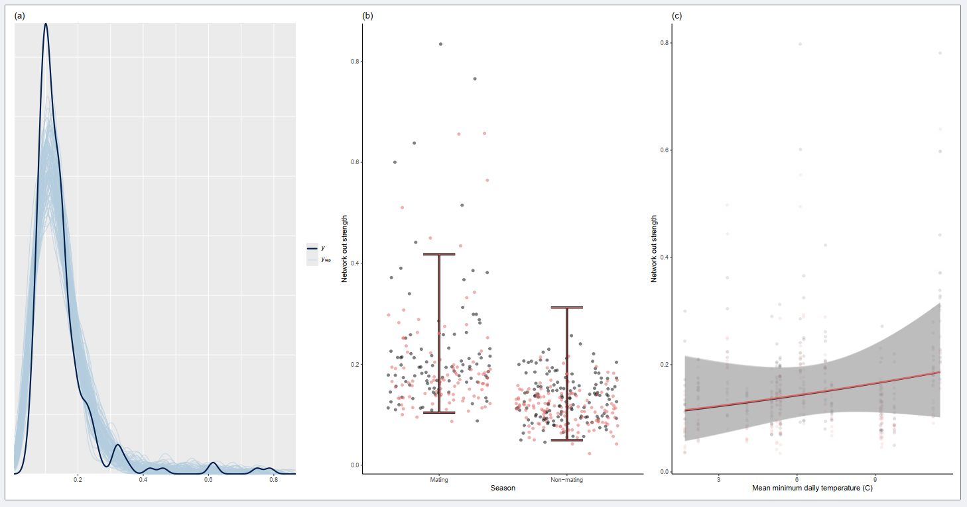
Figure S32: Posterior predictive checks for “Model 3: Plasticity in social connectivity – strength”. In (a), the dark blue (y) represents the overall observed network strength, the light blue lines (y_{rep}) are 100 draws from the posterior representing estimated overall network strength. For (b) and (c), the relationships between the main effects found in Model 3 and network strength are plotted. Here, the black points and regression lines represent the observed network out-degree, the red points and regression lines are 100 draws from the posterior representing estimated network strength. The grey lines around the regression lines represent the 90% credible intervals.

Table S33: Fixed and random effect/slope estimates from supplementary “Plasticity in social decision making in relation to current social environment” model, here using a 5-minute interval for the social choice. Fixed effect estimates supported by more than 95% of the posterior are highlighted in bold; fixed effect estimates supported by more than 90% of the posterior are highlighted in italics. For categorical variables, the reference level is in parentheses.
 | Estimate | Est error | Lower  90% CI | Upper  90% CI
Fixed effects
Intercept | -3.283 | 0.441 | -4.040 | -2.591
Excitability/Boldness score | 0.154 | 0.258 | -0.267 | 0.574
Number of humans within 10m | -1.543 | 0.637 | -2.687 | -0.592
Number of conspecifics within 10m | 0.258 | 0.169 | -0.021 | 0.531
Maximum rank difference with bystander | 0.118 | 0.181 | -0.175 | 0.419
Daily minimum temperature | 0.083 | 0.160 | -0.187 | 0.338
Rank | -0.476 | 0.310 | -0.998 | 0.017
Time of day | -0.253 | 0.192 | -0.581 | 0.048
Time of day² | -0.553 | 0.224 | -0.934 | -0.223
Sex (female) | -0.360 | 0.596 | -1.342 | 0.610
Group (Blue group) | 0.051 | 0.425 | -0.632 | 0.747
Excitability/Boldness score*Number of humans within 10m | -0.199 | 0.570 | -1.185 | 0.660
Excitability/Boldness score*Number of conspecifics within 10m | -0.246 | 0.167 | -0.538 | 0.017
Excitability/Boldness score*Max rank difference with bystander | 0.145 | 0.155 | -0.125 | 0.395
Random effects and slopes
Day of observation | 0.274 | 0.193 | 0.022 | 0.644
Individual identity – Intercept | 0.549 | 0.316 | 0.067 | 1.092
Individual identity – Excitability/Boldness score | 0.775 | 0.712 | 0.052 | 2.161
Individual identity – Number of humans within 10m | 0.300 | 0.217 | 0.025 | 0.700
Individual identity – Number of conspecifics within 10m | 0.175 | 0.136 | 0.013 | 0.435
Individual identity – Max rank difference with bystander | 0.269 | 0.187 | 0.024 | 0.619
Individual identity – Daily minimum temperature | 0.488 | 0.343 | 0.037 | 1.111
Individual identity – Rank | 0.316 | 0.220 | 0.030 | 0.711
Individual identity – Time of day | 0.319 | 0.229 | 0.033 | 0.737
Individual identity – Time of day² | 0.274 | 0.193 | 0.022 | 0.644

Table S34: Fixed and random effect/slope estimates from supplementary “Plasticity in social decision making in relation to current social environment” model, here using a 30-minute interval for the social choice. Fixed effect estimates supported by more than 95% of the posterior are highlighted in bold; fixed effect estimates supported by more than 90% of the posterior are highlighted in italics. For categorical variables, the reference level is in parentheses.
 | Estimate | Est error | Lower  90% CI | Upper  90% CI
Fixed effects
Intercept | -1.423 | 0.347 | -2.012 | -0.885
Excitability/Boldness | 0.068 | 0.186 | -0.247 | 0.365
Number of humans within 10m | -0.229 | 0.177 | -0.549 | 0.014
Number of conspecifics within 10m | 0.067 | 0.107 | -0.112 | 0.242
Maximum rank difference with bystander | 0.228 | 0.129 | 0.014 | 0.445
Daily minimum temperature | 0.101 | 0.110 | -0.079 | 0.280
Individual rank | -0.382 | 0.202 | -0.723 | -0.064
Time of day | -0.180 | 0.098 | -0.342 | -0.021
Time of day2 | -0.275 | 0.103 | -0.450 | -0.114
Sex (female) | -0.647 | 0.490 | -1.419 | 0.180
Group (Blue) | -0.035 | 0.359 | -0.619 | 0.546
Excitability/Boldness:Number of humans within 10m | 0.112 | 0.129 | -0.086 | 0.325
Excitability/Boldness:Number of conspecifics within 10m | -0.237 | 0.108 | -0.418 | -0.066
Excitability/Boldness:Maximum rank difference with bystander | 0.069 | 0.107 | -0.108 | 0.246
Random effects and slopes
Day of observation: Intercept | 0.491 | 0.151 | 0.235 | 0.735
Individual identity: Intercept | 0.732 | 0.207 | 0.428 | 1.102
Individual identity: Slope for Number of humans within 10m | 0.227 | 0.197 | 0.017 | 0.612
Individual identity: Slope for Number of conspecifics within 10m | 0.200 | 0.142 | 0.016 | 0.462
Individual identity: Slope for Maximum rank difference | 0.307 | 0.169 | 0.043 | 0.596
Individual identity: Slope for Daily minimum temperature | 0.219 | 0.137 | 0.023 | 0.458
Individual identity: Slope for Individual rank | 0.277 | 0.212 | 0.023 | 0.681
Individual identity: Slope for Time of day | 0.155 | 0.116 | 0.012 | 0.376
Individual identity: Slope for Time of day2 | 0.183 | 0.133 | 0.018 | 0.427
Intercept | -1.423 | 0.347 | -2.012 | -0.885

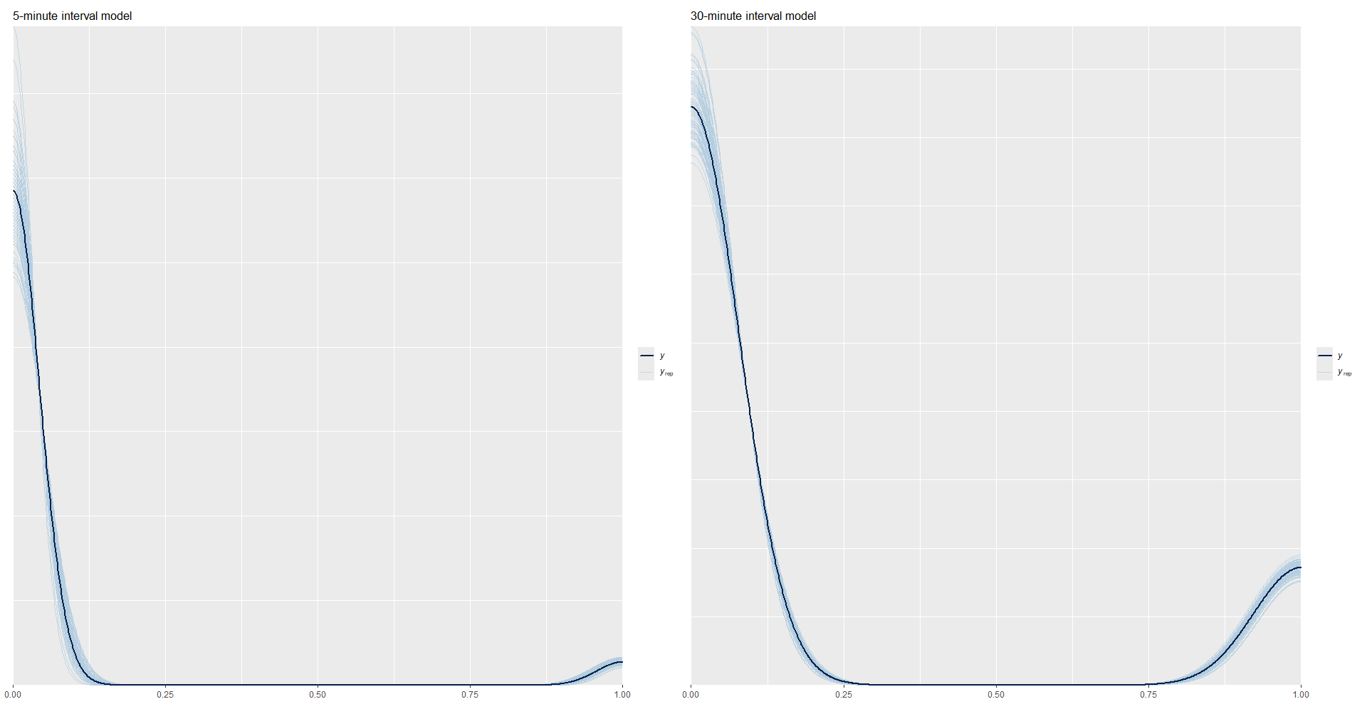
Figure S35: Posterior predictive checks for supplementary versions of “Model 1: Plasticity in social decision making” using 5- and 30-minute intervals. The dark blue (y) represents the overall density of observed probability to initiate grooming, the light blue lines (y_{rep}) are 100 draws from the posterior represent the density of the estimated probabilities.

