Appendix
Appendix A: Establishment, evaluation, and calculation of the circularity level system
The steps to establish the Circularity Level System are as follows:
Step 1: Determine CE standards and sustainable priority options for industrial WM. CE has been redefined and newly added to the three concepts of ESG proposed by the UN.
Step 2: Establish recycling grade standards for industrial WM. CLs are developed based on CE key factors and sustainability preferences. This classification first adopts the EU's WH concept, which prioritizes the recycling process in the following order: (1) Return to the original resource, (2) Recycle as material used for new products, (3) Recycle as an energy source, and (4) Return to the biosphere. Combining economic (value change) and social (lifetime) considerations, these four categories were further refined and a recycling classification was developed.
Step 3: Develop a procedure to quantify R_{c}. The concept of relative CL n is introduced to quantify recycling cycles.
The procedure for assigning CLs is as follows:
(1) Establishment of a recycling treatment process list: All industrial waste treatment process lists are derived from waste statistics. Basic information shall include the quantities of Taiwan's all sectoral waste generated and their respective treatment methods.
(2) Pairing recycling processes with Recycling Levels: A list of recycling processes is aligned with the established recycling levels. To ensure optimal evaluation, all 9 recycling levels should be matched with the corresponding recycling processes, based on data availability.
(3) Assign a CL: The CL indicates the relative sustainability preference of the paired recycling process. CL 1 is assigned to the least preferred circularity class, followed by level 2 to the next least preferred circularity class, until all paired circularity classes are assigned CLs. If the recycling process is paired with all nine levels, then nine loop levels are used, with level 1 being the least preferred. In the case study, the 20 recycling processes present in the waste statistics correspond to 7 of the 9 recycling levels. (Additional information on recycling costs and the material condition during recycling is needed to further align the recycling processes with the remaining two recycling levels.) The results are detailed in Table S1. (Yang et al., 2023a; 2023b)
Table S1 The circularity class corresponds to the circularity level and treatment code
Circularity class (n) | Circularity level (C_{L}) | Treatment code | Definition
C1 | CL7 | R01 | Unlimited recycling as raw material in original form
C2 | CL6 | R02 | Multiple recycling as raw material in original form
C3 | CL6 | R02 | Multiple recycling as raw materials in different forms with a higher market value (upcycling)
C4 | CL6 | R02 | Multiple recycling as raw materials in different forms
C5 | CL5 | R03 | Single recycling as additives of other products
C6 | CL4 | R04 | Single recycling as an energy source with no potential to be reused and a negative market value
C7 | CL3 | R05, R06 | Single recycling returned to the biosphere with no potential to be reused and a negative market value
C8 | CL2 | R07 | Direct return to the biosphere without treatment and a negative market value
C9 | CL1 | R08, R09, R10, R99 | Other land related recycling applications
Source: Yang et al.（2023a、2023b）
Table S2 displays the parameters and mathematical formulas used to calculate R_{c} and C_{p}. To aid in data interpretation and comparison, R_{c} results are normalized and expressed as a percentage, termed NR_{c}.
Table S2 Definitions and equations of parameters
No. | Term | Unit | Definitions and equations
1 | Total waste generated (W_{TG}) | Tonnes | Refers to the amount of waste generated by a particular manufacturing sector under circularity level n.  W_{TG} = W₁ + W₂ + W₃ + … + W_{n}  n ranges from 1 to the number of circularity class used.
2 | Total recycled waste (W_{TR}) | Tonnes | Refers to the waste resources generated by the manufacturing sector that are recycled. Total recycled waste (W_{TR}) is the sum of all recycled waste under circularity level n.  W_{TR} = W_{R1} + W_{R2} + W_{R3} + … + W_{Rn}  n ranges from 1 to the number of circularity class used.
3 | Recycling rate (R_{r}) | Percentage | The recycling rate is the proportion of recycled waste among total waste generated.  R_{r} = （W_{TR} / W_{TG}） * 100%
4 | Circularity level score (C_{Ln}) | Unitless | Refers to the product of the assigned circularity class and the weight of the recycled waste.  C_{Ln} = n * W_{Rn}  n is the assigned circularity class of the recycling process.
5 | Cumulative circularity level score (C_{T}) | Unitless | Refers to the sum of all circularity level scores for all circularity levels assigned.  C_{T} = C_{L1} + C_{L2} + C_{L3} + … + C_{Ln}
6 | Recycling circularity (R_{C}) | Unitless | Refers to the average circularity score as an indicator of relative circularity efficiency with respect to the target of concern (sector, city, waste type, etc.). This parameter is calculated by dividing the cumulative circularity level score by the total weight of the waste generated.  R_{C} = C_{T} / W_{TG}
7 | Normalized Recycling circularity (NR_{C}) | Percentage | The recycling cycle degree is normalized based on statistical principles to facilitate calculation and comparison of various levels. Normalized formula calculate:  n_{normalized} = （n - n_{minimum}） / （n_{maximum} - n_{minimum}） and n_{minimum} = 0  n_{normalized} = （n / n_{maximum}）  NR_{C} = [（C_{T} / W_{TG}）) / n_{maximum}] * 100%
8 | Circularity performance (C_{P}) | Percentage | Refers to the overall circularity of all industrial waste generated. It is the product of the recycling rate and normalized recycling circularity.  C_{P} = R_{r} * NR_{C}
Appendix B: Supplementary explanation of the research system boundaries
The system boundaries of this study are based on the EU Circular Economy Monitoring Framework. The EU Circular Economy Monitoring Framework uses 10 monitoring indicators to measure CE progress. The indicators are divided into four phases and cover all stages of the resource, product and service life cycle: (1) Production and consumption, (2) Waste management, (3) Secondary raw materials, and (4) Competitiveness and innovation. The recycling indicator in the study examines how waste resources are processed to allow further recycling of resources during the WM stage. Waste minimization is also a crucial aspect of CE, but is not included in this study as it occurs at (1) Production and consumption and (4) Competitiveness and innovation.
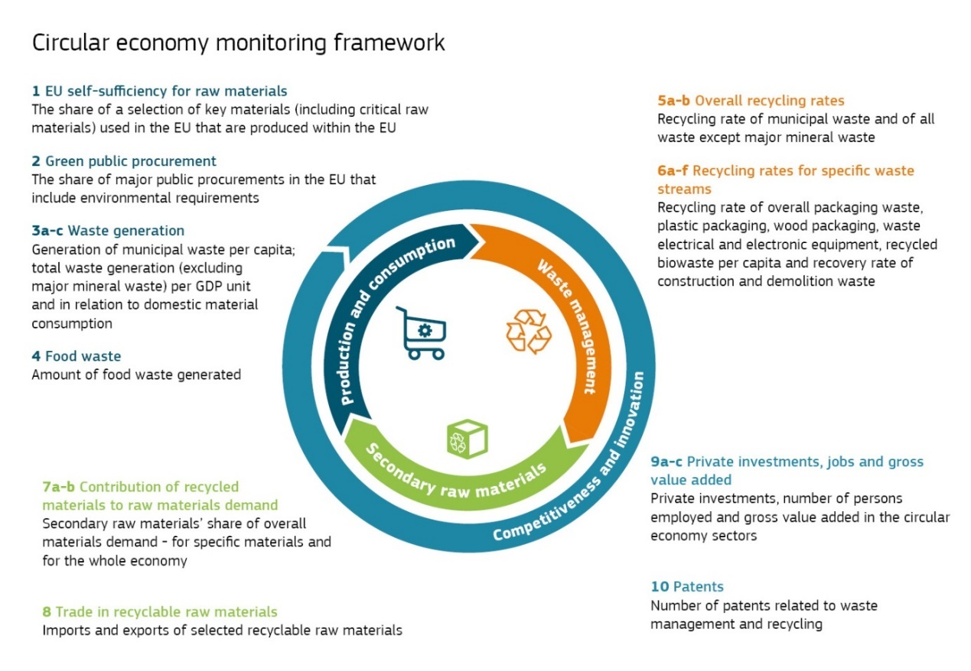
Figure S1 EU circular economy monitoring framework
Source: European Commission, 2018¹
Appendix C: Industry classification and sector codes
The study is based on the 11th revision of the latest industry classification "Industry Statistical Classification" released by Taiwan's General Accounting Office DGBAS in January 2021. This classification is based on the UN’s International Standard Industrial Classification of All Economic Activities (ISIC). It is revised every five years in line with the industrial and service census processing cycle.
Industry statistical classification is divided into four levels: Section, Division, Group, and Class. The category identified by one English letter is called "Section"; the 2-digit category is called "Division"; the 3-digit category is called "Group" and the 4-digit category is called "Class". The manufacturing industry belongs to the Industry Classification System-Section C, from Division 08 to 34, and is divided into Group 84 and Class 194. The calculation objects of this study are Division 26 (covering Group 5 items) - Manufacture of Electronic Parts and Components and Group 263 - Manufacture of Bare Printed Circuit Boards. For convenience, they are summarized in Sections to Groups. The complete list of manufacturing industry codes and industry names is shown in Table S3 below.
Table S3 Sector code and sector name of manufacture
Sector Code |  |  | Sector Name
Section | Division | Group | Sector Name
C |  |  | Manufacturing
 | 08 |  | Manufacture of Food Products and Prepared Animal Feeds
 | 09 |  | Manufacture of Beverages
 | 10 |  | Manufacture of Tobacco Products
 | 11 |  | Manufacture of Textiles
 | 12 |  | Manufacture of Wearing Apparel and Clothing Accessories
 | 13 |  | Manufacture of Leather, Fur and Related Products
 | 14 |  | Manufacture of Wood and of Products of Wood and Bamboo
 | 15 |  | Manufacture of Paper and Paper Products
 | 16 |  | Printing and Reproduction of Recorded Media
 | 17 |  | Manufacture of Petroleum and Coal Products
 | 18 |  | Manufacture of Chemical Material and Fertilizers
 | 19 |  | Manufacture of Other Chemical Products
 | 20 |  | Manufacture of Pharmaceuticals and Medicinal Chemical Products
 | 21 |  | Manufacture of Rubber Products
 | 22 |  | Manufacture of Plastics Products
 | 23 |  | Manufacture of Other Non-metallic Mineral Products
 | 24 |  | Manufacture of Basic Metals
 | 25 |  | Manufacture of Fabricated Metal Products
 | 26 |  | Manufacture of Electronic Parts and Components
 |  | 261 | Manufacture of Semi-conductors
 |  | 262 | Manufacture of Electronic Passive Devices
 |  | 263 | Manufacture of Bare Printed Circuit Boards
 |  | 264 | Manufacture of Optoelectronic Materials and Components
 |  | 269 | Manufacture of Other Electronic Parts and Components
 | 27 |  | Manufacture of Computers, Electronic and Optical Product
 | 28 |  | Manufacture of Electrical Equipment
 | 29 |  | Manufacture of Machinery and Equipment
 | 30 |  | Manufacture of Motor Vehicles and Parts
 | 31 |  | Manufacture of Other Transport Equipment and Parts
 | 32 |  | Manufacture of Furniture
 | 33 |  | Other Manufacturing
 | 34 |  | Repair and Installation of Industrial Machinery and Equipment
Source: Directorate-General of Budget, Accounting and Statistics, 2021. Industry statistical classification

Appendix D: Industrial waste classification, characteristics, and treatment process codes
The recycling potential of industrial waste is greatly influenced by the different waste characteristics generated by different industries. According to Taiwan's "Waste Disposal Act," industrial waste is divided into hazardous industrial waste and general industrial waste, which are defined as follows:
Hazardous industrial waste: waste produced by industry that is toxic or dangerous with the concentration or volume sufficient to influence human health or pollute the environment.
General industrial waste: waste produced by industry that is not hazardous industrial waste.
The waste produced by the electronic component and parts manufacturing industry as well as the manufacturing of bare printed circuit boards was divided into three categories in this study: Hazardous industrial waste, General industrial waste, and Recyclable waste according to MOENV's waste code, as shown in Table S4. Additionally, according to MOENV, there are relevant regulations regarding the methods and uses of waste recycling and reusing, as well as a "Waste and Renewable Resources Code List" developed to assist industry, the waste removal and treatment operators and government agencies in complying with these codes. Table S6 and Table S5 below provide waste recycling and reuse codes related to this study.
Table S4 Waste category, waste definition and waste class code
No. | Waste Category | Definition | Taiwan MOENV Waste Class
1 | Hazardous industrial waste | Waste produced by industry that is toxic or dangerous with the concentration or volume sufficient to influence human health or pollute the environment | Class B and C
2 | General waste | Waste produced by industry that is not hazardous industrial waste | Class D
3 | Recyclable waste | Recyclable and reusable waste | Class R

Table S5 Recycling and reuse treatment process codes
Category | Code | Name | Description
Recycling and reuse | R01 | Recycling of waste through channels certified by the waste fund management board | Recycling of listed recyclable waste announced by the waste recycling fund management board through certified channels
Recycling and reuse | R02 | Recycling of waste as raw material | Used as a raw material of a product
Recycling and reuse | R03 | Recycling of waste as an ingredient or additive | Used as a material or additive for other purposes (such as graded aggregates)
Recycling and reuse | R04 | Recycling of waste as fuel | Used as a material for energy generation through combustion
Recycling and reuse | R05 | Recycling of waste as feedstock | Used as direct animal feedstock
Recycling and reuse | R06 | Recycling of waste as fertilizer | Used as a nutrient for cultivating plants
Recycling and reuse | R07 | Recycling of waste as an engineering filling material | Used as filling material for engineering purposes
Recycling and reuse | R08 | Recycling of waste for improvement of land (soil) quality | Improved quality of land (soil) through the recycled waste
Recycling and reuse | R09 | Recycling of waste as reusable land | The transformation of land unfill for farming into land that can be used for farming
Recycling and reuse | R10 | Recycling of waste for land reclamation | The transformation of land unfill for farming into land that can be used for farming through scientific methods
Recycling and reuse | R99 | Recycling for other purposes | Other uses recognized by the central competent authorities
Source: Taiwan Ministry of Environment Resource Circulation Administration, 2024, “Waste and renewable resources code”

https://eur-lex.europa.eu/legal-content/en/TXT/?uri=CELEX%3A52018DC0029
https://eng.stat.gov.tw/News_Content.aspx?n=2597&s=224515
https://unstats.un.org/unsd/publication/seriesM/seriesm_4rev4e.pdf
https://waste.moenv.gov.tw/RWD/PDL/?page=D20_WasteCode
https://waste1.epa.gov.tw/NMS40/_res/FileLoad.ashx?i=E28B60160D56F706
https://waste.moenv.gov.tw/RWD/PDL/?page=D20_WasteCode

