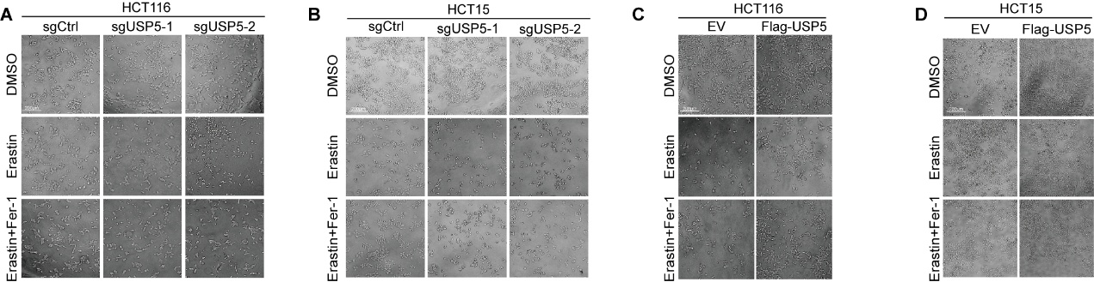
Figure S1 USP5 knockout sensitizes CRC cells to ferroptosis
(A-D) In HCT116 and HCT15 cell lines, USP5 knockout cells were treated with erastin (15 µM) for 72 hours, while USP5 overexpressing cells received erastin (20 µM) under the same conditions. Cell viability was subsequently assessed using the Capture images under the microscope.

Figure S2 USP5 promotes the development and progression of colorectal cancer
(A) Cell viability assay of HCT116 and HCT15 cells transduced with control sgRNA (sgCtrl) or two independent sgRNAs targeting USP5 (sgUSP5-1 and sgUSP5-2) over a 5-day period. (B) Cell viability assay of empty vector (EV) and Flag-tagged USP5 (Flag-USP5) in HCT116 and HCT15 cells over a 5-day period. (C) Colony formation assay of sgCtrl and sgUSP5 in HCT116 and HCT15 cells with or without fer-1 treatment. Representative images of crystal violet-stained colonies are shown (left), and quantification of colony numbers is presented (right). Data are presented as mean ± SEM. Statistical significance was determined using unpaired two-tailed t-tests. *p < 0.05, **p < 0.01, ***p < 0.001.

Figure S3 USP5 promotes lysosomal degradation of YBX3
(A) Perform transient transfection of Flag-USP5 and HA-SLC7A11 vector into 293T cells and use exogenous Co-IP to detect interactions. (B) Co-transfect full-length Flag-tagged USP5 and its five truncated mutants with HA-YBX3 into HEK293T cells for 48 hours, then prepare cell lysates and perform IP using specific antibodies. (C) Western blotting analysis exhibiting YBX3 remaining level at indicated time in HCT16 with USP5 knockout and treatment with CHX (100 μg/mL). Data are shown as means ± SDs. *p < 0.05, **p < 0.01, ***p < 0.001, unpaired Student’ s t test or two-way ANOVA.

