8. APPENDIX
8.1 Spatial correlation analysis using pressure and wall shear stress
Pressure distributions computed from the initial baseline CTA were compared to aortic growth rate heatmaps in Figure A1. It is difficult to observe any clear association between pressure and growth rate. A similar comparison between wall shear stress and aortic growth rate heatmaps is shown in Figure A2. While wall shear stress was elevated near regions of high velocity and narrow cross-sections, such as around the primary intimal tear, wall shear stress remained low throughout much of the false lumen, where aortic expansion typically occurs.
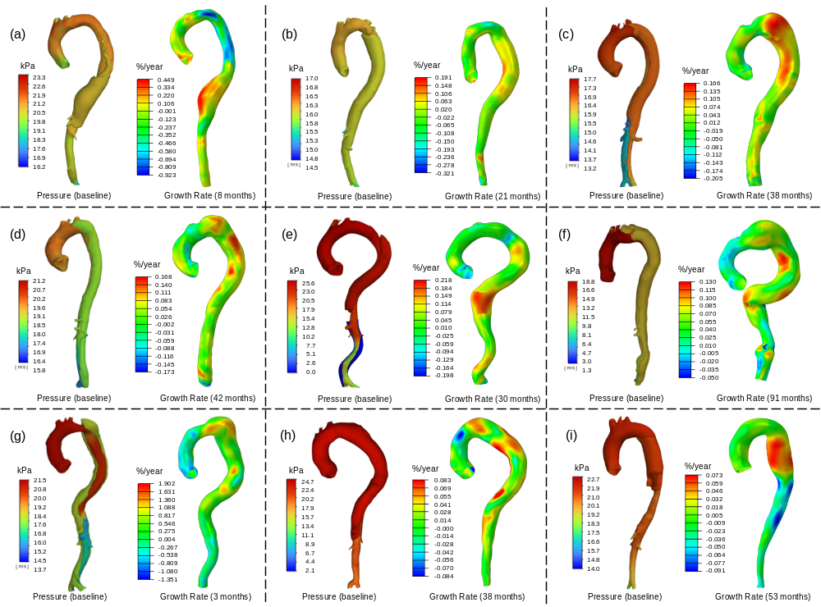
[Figure A1. Pressure distributions and heatmaps of aortic growth rate of the TBAD patients. (a) ~ (i): P1 to P9.]

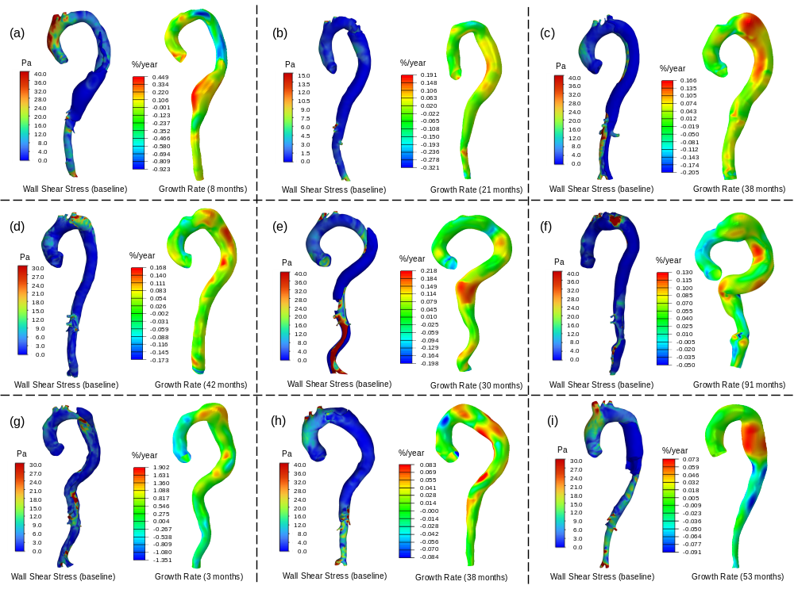
[Figure A2. Wall shear stress distributions and heatmaps of aortic growth rate of the TBAD patients. (a) ~ (i): P1 to P9.]
Figure A3 summarizes the individual correlations between pressure distributions and growth rate heatmaps for the 9 patients. Although the Pearson correlation coefficients were statistically significant in 7 out of 9 patients, the slopes varied considerably across individuals. The standard deviation of the random-effect slopes $b_{1m}$ was estimated at 15.85%/(year·kPa) with a 95% CI of [9.66, 26.00]%/(year·kPa), indicating substantial inter-patient variability. This high variability contributed to the wide CI and the non-significant p-value for the fixed-effect association.

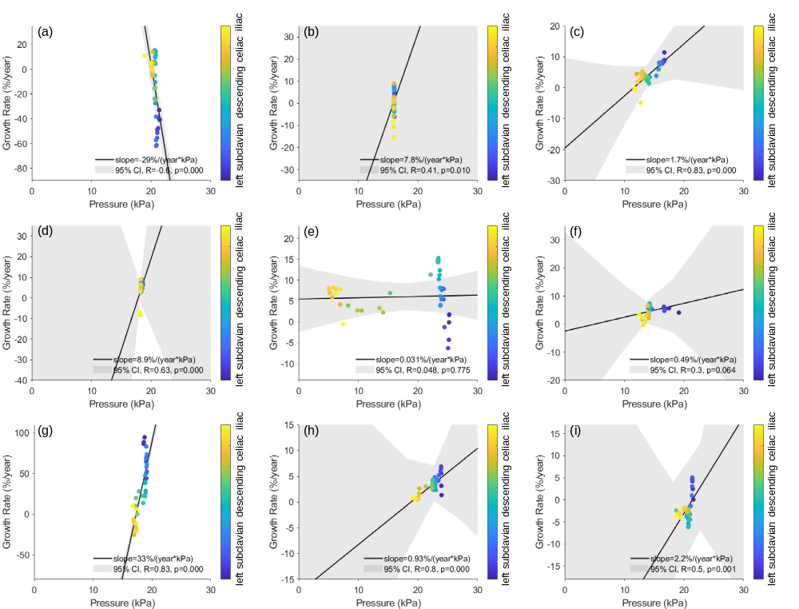
[Figure A3. Pressure distribution and aortic growth rate of individual patients. (a) ~ (i): P1 to P9. Data points are color-coded by spatial location from proximal to distal aorta. The regression lines were obtained by using both fixed- and random- effects in the linear mixed-effects model. CI: confidence interval; R, p: Pearson correlation coefficient and p-value.]
Figure A4 shows the individual correlations between wall shear stress distributions and growth rate heatmaps for the 9 patients. The Pearson correlation coefficients were statistically significant in only 2 of the 9 cases. The standard deviation of the random-effect slopes $b_{1m}$ could not be estimated using MATLAB’s ‘fminunc’ optimization algorithm, suggesting that the variation in slopes across patients was negligible. This implies that the wall shear stress–growth rate relationship may be adequately modeled using a common near-zero, negative slope. These findings suggest that the role of wall shear stress in TBAD-related aortic expansion requires further investigation. 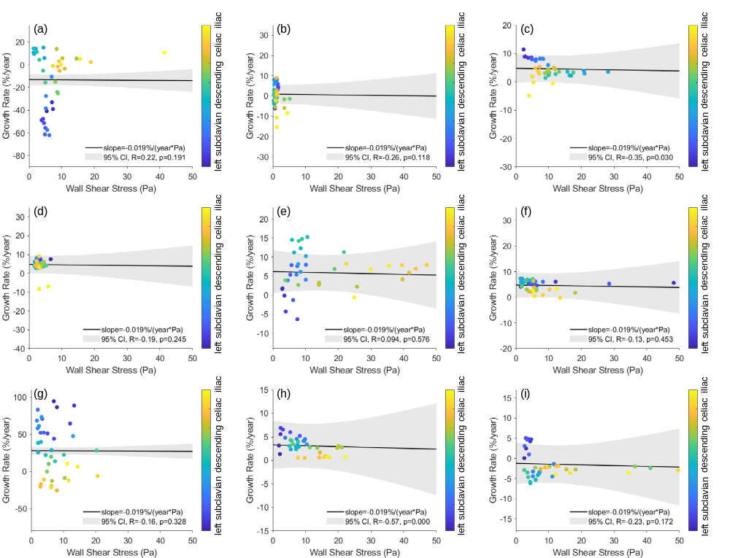
[Figure A4. Wall shear stress distribution and aortic growth rate of individual patients. (a) ~ (i): P1 to P9. Data points are color-coded by spatial location from proximal to distal aorta. The regression lines were obtained by using both fixed- and random- effects in the linear mixed-effects model. CI: confidence interval; R, p: Pearson correlation coefficient and p-value.]
8.2 Validation of the forward penalty stress computation method using a fully-coupled FSI model
To validate stress computation using the forward penalty method, we conducted fully coupled FSI simulations that accounted for nonlinear material properties and blood pressure-induced pre-stress. A patient-specific CT-derived geometry was used, and the corresponding zero-pressure geometry was obtained via the generalized pre-stressing algorithm [70]. The aortic tissue was modeled using the nonlinear Gasser-Ogden-Holzapfel [63] constitutive relation with representative material parameters derived from an experimental study ($c_{10}, k_{1}, k_{2}, κ, θ=27 kPa, 500 kPa, 0.02, 0.16, 30°$) [71]. In the FSI model, blood flow was simulated using the smooth particle hydrodynamics (SPH) method, allowing interaction between structural and fluid domains through contact mechanics algorithms. In the forward penalty method, structural stress was computed directly on the CT-derived geometry without needing to incorporate nonlinear material properties or estimate the zero-pressure geometry. We compared structural stress results from the FSI and forward penalty method under a constant population-average inlet flow rate of 25 L/min and Windkessel outlets. As shown in Figure A5, the stress field results showed only a small difference with MAPE of 7.57%, which demonstrates that the forward penalty approach achieved accurate stress computations in significantly less time (forward penalty: ~20 minutes vs. fully coupled FSI: ~40 hours on a desktop computer with Intel i9-14900K CPU).
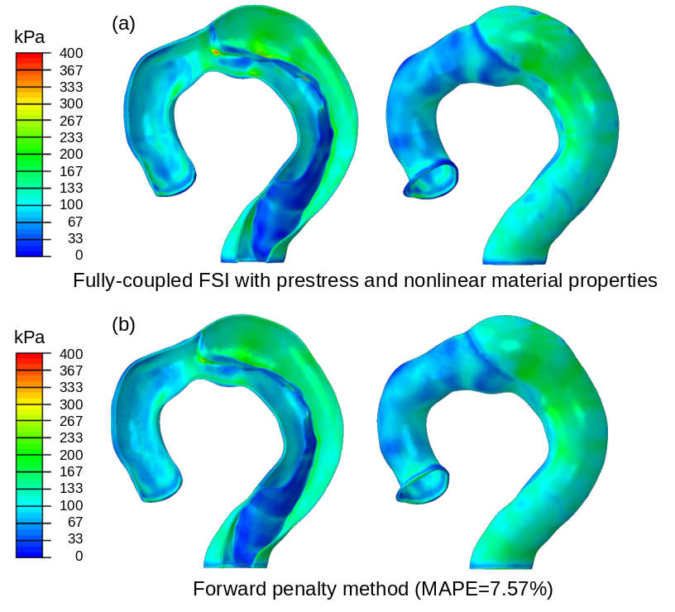
[Figure A5. Structural wall stress distribution calculated using a fully coupled fluid-structure interaction (FSI) model (a), which accounts for prestress and nonlinear material properties, compared to results from the forward penalty method (b). MAPE: mean absolute percentage error.]

