Supplementary materials for
Untethered ultrafast wall-climbing microbots
Xiangyu Yang, Jinzhe Peng, Wei Shen, Jingyu Che, Jingyi Li, Xiufeng Yang, Ruohan Wang, Mingjing Qi
Corresponding author: Mingjing Qi, qimingjing@buaa.edu.cn

This file includes:
Fig. S1
Video 1 to 3
Table S1

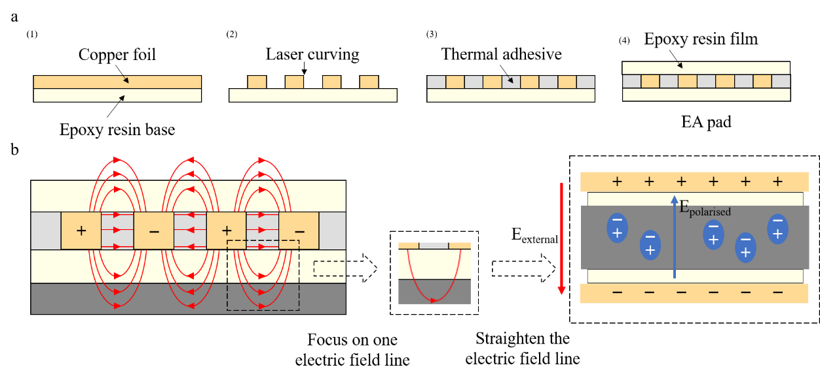
Fig. S1 | Manufacturing and modeling of EA pads. a, The structure and fabrication process of each layer of the EA pad are described in detail. Notably, the copper foil can be substituted with other conductive materials, and the epoxy resin can similarly be replaced with alternative dielectric materials possessing high dielectric constants. b, The distribution of the electric field within the EA pad and substrate under high voltage is illustrated. For clarity, a single electric field line can be isolated, straightened, and analyzed to examine the relationship between the external electric field and the induced polarized electric field.

Video 1. Climbing of robots with different de-adhesion methods.
This video presents an experimental comparison of electroadhesive robot climbing performance using different de-adhesion methods, in contrast to gecko locomotion. Experiments were conducted on a vertical wall surface coated with release paper. The robot equipped with an external self-excited pulse module achieved a step cycle of 0.45 s and a climbing velocity of 44.4 mm/s (~0.45 BL/s). In contrast, the robot utilizing a conventional de-adhesion method exhibited a step cycle of 5.05 s and experienced progressive slippage due to adhesion decay, ultimately detaching from the wall. All footage is shown at real-time speed (1x).

Video 2. Inverted locomotion of robots on the ceiling.
This video showcases an experimental demonstration of a robot climbing on an inverted indoor surface. The ceiling material is a painted wall, and a gecko specimen, comparable in length to the robot, is attached to the vertical wall for reference. The robot operates with a stepping cycle of 1 second. The video is presented at real-time speed (1x).

Video 3. Multi-surface vertical locomotion of untethered robots.
This video presents an experimental demonstration of the untethered robot climbing on vertical walls. The experiments were conducted on three different wall surfaces: an outdoor tiled wall, an interior-painted wall, and the release paper. The robot was controlled via Bluetooth, with the stepping cycle set to 3 seconds. The video is displayed at 2x speed for clarity.
Table S1 Parameters of the substrate materials
 | Length | Width | Thickness | Weight
Cotton fabric | 125 mm | 125 mm | 0.25 mm | 1.25 g
Balsa wood | 138 mm | 100 mm | 1.1 mm | 2.28 g
Plain paper | 100 mm | 100 mm | 2.5 mm | 8.81g
Release paper | 118 mm | 113 mm | 3.0 mm | 13.06 g

