Supplementary Material

Table S1 – Coordinates of the sites for soil and plant collections at the Rio Doce estuary in decimal degrees.

Site of collection | Lat | Long
Theobroma cacao | -19.6165 | -39.8235
Manihot esculenta | -19.6135 | -39.8223
Musa spp. | -19.641 | -39.8233

Table S2 - The potential toxic elements (PTE) for oral reference dose
Contaminant | RfD (mg/kg-day)
Al | 1.0E+00
Ba | 2.0E-01
Cd | 1.0E-03
Cr | 1.5E+00
Co | 3.0E-04
Cu | 4.0E-02
Fe | 7.0E-01
Pbª | 3.5E-04
Mn | 1.4E-01
Ni | 2.0E-02
Zn | 3.0E-01
ªRupert et al. (2004)

Table S3 - Parameters used to calculate the average daily dose (ADD) for the exposure route for the consumption of M. esculenta, Musa spp. and T. cacao.
Parameter Description |  | Adults | Children | Unit | Reference
M. esculenta per capita intake rate | IR_{m} | 0.0045 | 0.0025 | kg_{fw}/day | IBGE, 2020
Musa spp. per capita intake rate | IR_{b} | 0.0165 | 0.0186 | kg_{fw}/day | IBGE, 2020
T. cacao per capita intake rate | IR_{c} | 0.0088 | 0.0029 | kg_{fw}/day | IBGE, 2020
Exposure duration | ED | 78.5 | 6.0 | years | IBGE, 2018
Exposure frequency | EF | 350 | 350 | day/year | CETESB, 2023
Body mass | BW | 66 | 15.7 | kg | IBGE, 2010
Average Time for non-carcinogenic effects | AT_{nc} | 28653 | 2190 | days | USEPA, 1989
Weight conversion factor from dry base to wet base (M. esculenta) | CF_{m} | 2.48 |  | - | USEPA, 2018
Weight conversion factor from dry base to wet base (Musa spp.) | CF_{b} | 5.07 |  | - | USEPA, 2018
Weight conversion factor from dry base to wet base (T. cacao) | CF_{c} | 7.34 |  | - | Nunes et al., 2020

Table S4. Geochemical fractionation of potentially toxic elements (PTEs) in soils (mg kg⁻¹) cultivated with Musa spp.; Manihot esculenta and Theobroma cacao.
PTEs | Specie | EX | CA | FR | LP | OX | PY
Mn | Manihot esculenta | 19.14 | 4.22 | 236.07 | 358.04 | 118.08 | 0.00
Mn | Theobroma cacao | 16.50 | 4.06 | 236.27 | 326.90 | 85.33 | 0.00
Mn | Musa spp. | 19.95 | 4.44 | 237.93 | 367.30 | 92.49 | 0.00
Ba | Manihot esculenta | 33.23 | 12.52 | 3.27 | 14.02 | 6.08 | 19.27
Ba | Theobroma cacao | 51.22 | 22.83 | 9.11 | 18.79 | 4.70 | 7.61
Ba | Musa spp. | 58.24 | 18.31 | 8.39 | 18.88 | 6.05 | 6.76
Cd | Manihot esculenta | 0.01 | 0.05 | 0.00 | 0.05 | 0.00 | 0.00
Cd | Theobroma cacao | 0.01 | 0.07 | 0.02 | 0.07 | 0.17 | 0.00
Cd | Musa spp. | 0.05 | 0.07 | 0.00 | 0.03 | 0.66 | 0.00
Co | Manihot esculenta | 0.27 | 0.18 | 5.05 | 5.26 | 3.02 | 0.16
Co | Theobroma cacao | 0.37 | 0.22 | 2.82 | 3.54 | 2.47 | 0.14
Co | Musa spp. | 0.17 | 0.10 | 2.19 | 3.38 | 2.50 | 0.25
Cr | Manihot esculenta | 0.04 | 0.25 | 0.46 | 4.74 | 18.47 | 0.21
Cr | Theobroma cacao | 0.02 | 0.04 | 0.26 | 4.66 | 20.36 | 0.01
Cr | Musa spp. | 0.05 | 0.07 | 0.62 | 4.83 | 23.23 | 0.00
Cu | Manihot esculenta | 0.14 | 0.86 | 0.61 | 0.65 | 4.58 | 0.00
Cu | Theobroma cacao | 0.21 | 0.72 | 0.31 | 1.31 | 1.75 | 0.04
Cu | Musa spp. | 0.07 | 0.85 | 1.01 | 1.05 | 3.30 | 0.05
Ni | Manihot esculenta | 0.22 | 0.00 | 0.02 | 0.05 | 0.47 | 0.55
Ni | Theobroma cacao | 0.91 | 0.14 | 0.09 | 0.46 | 0.87 | 0.05
Ni | Musa spp. | 1.04 | 0.21 | 0.00 | 0.54 | 1.18 | 0.07
Pb | Manihot esculenta | 1.85 | 2.38 | 0.00 | 7.77 | 3.33 | 5.30
Pb | Theobroma cacao | 1.25 | 2.57 | 1.06 | 4.58 | 0.95 | 5.94
Pb | Musa spp. | 0.97 | 2.43 | 0.11 | 7.41 | 2.05 | 4.95
Zn | Manihot esculenta | 0.16 | 0.33 | 0.86 | 5.17 | 9.00 | 1.10
Zn | Theobroma cacao | 0.04 | 0.35 | 1.82 | 8.09 | 8.26 | 0.30
Zn | Musa spp. | 0.00 | 0.43 | 1.84 | 8.78 | 9.94 | 0.06

Table S5. Potentially toxic elements threshold in edible parts of plants according to international organizations.
PTE | Threshold | Reference
PTE | mg kg⁻¹ | Reference
Cd | 0.05 (fruits) | EC/FAO/WHO
Cd | 0.1 (tuber) | EC/FAO/WHO
Cr | 0.5 - 1.0 | SEPA (2006)
Cu | 20.0 | SEPA (2006)
Ni | 0.5 - 1.0 | USDA (2018)
Pb | 0.8 - 2.3 | EC/FAO/WHO
Zn | 50.0 | EC/FAO/WHO

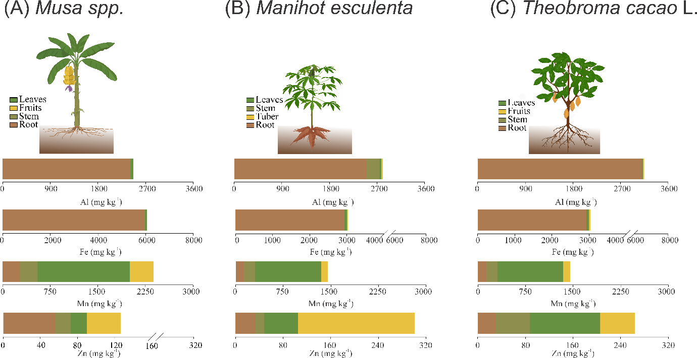
Figure S1. Major elements (Al, Fe, Mn, and Zn) concentration of (A) Musa spp., (B) M. esculenta and (C) T. cacao in different plant compartments.

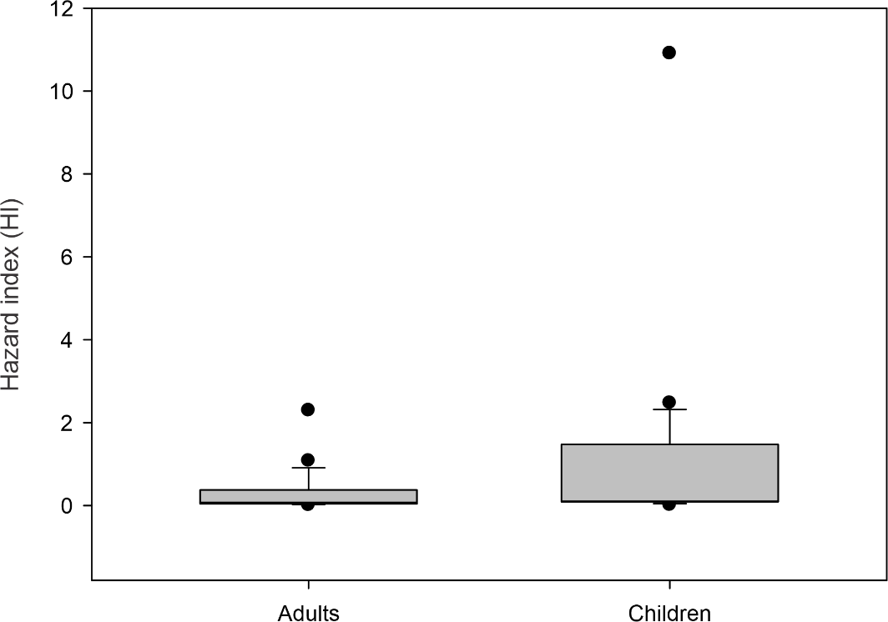
Figure S2. Total Hazard Index (THI) for adults and children considering the consumption of food cultivated in a mine tailing impacted soil.

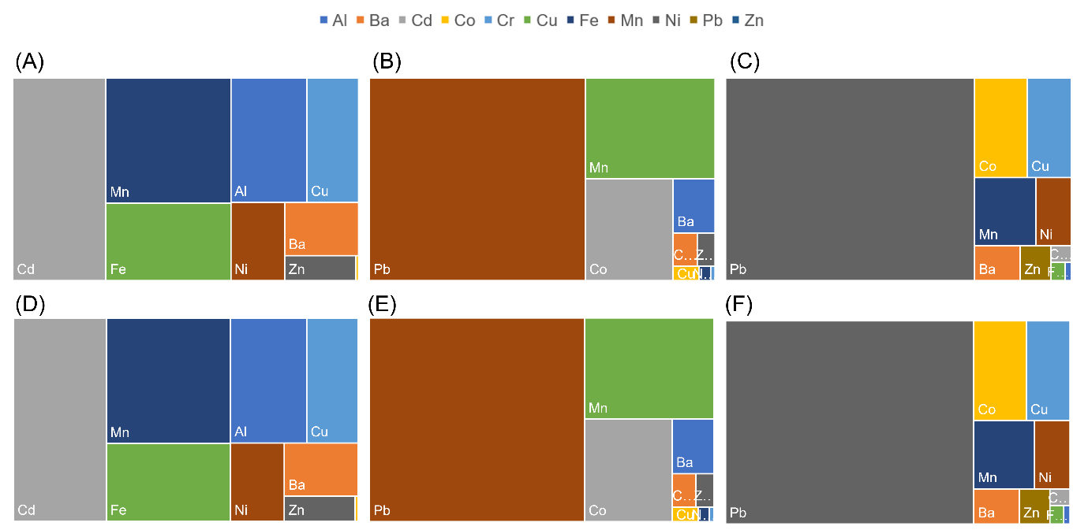
Figure S3. Contribution of each element for the Hazard Index (HI) for adults (A, B, and C) and children (D, E, and F), focusing on consuming M. esculenta (A, D), Musa spp. (B, E), and T. cacao (C, F) cultivated in a mine tailing impacted soil.

