Supplementary Materials

Supplementary Material 1: Study Materials
Outcome Measures
Mental health status was assessed using a modified version of the Strengths and Difficulties Questionnaire (SDQ-H; Goodman, 1999), which contains 25 items, each rated on a 3-point scale. The scale has 5 sub-scales, collectively measuring emotional difficulties, behavioral problems, hyperactivity, social difficulties and social behaviors. Here, we omitted two of the items, dealing with bullying and theft (items 17 and 18), due to their sensitivity for the study population, remaining with 23 items. In addition, for two of the items (item 13: “often unhappy, downhearted, or tearful” and item 24: “many fears, easily scared”) the direction of response was modified so that the items were phrased as positive rather than negative. Their scoring was adjusted accordingly. The total score is the sum of the scores of all individual items, with lower scores indicating better mental health. Cutoff scores for this scale were taken from Mansbach-Kleinfeld et al. (2010), reflecting norms in the general Israeli adolescent population (see Table S1). The internal consistency (Cronbach’s α) of the scale in our sample was 0.77 for the total score.

Supplementary Table S1. Cutoff scores (raw scores) for Hebrew version of SDQ-H
 | Normal range | Borderline range | Abnormal range
Total Difficulties | 0-12 | 13-14 | 15-40
Emotional symptoms | 0-4 | 5 | 6-10
Conduct problems | 0-2 | 3 | 4-10
Hyperactivity | 0-4 | 5 | 6-10
Peer problems | 0-2 | 3 | 4-10
Prosocial behaviors | 8-10 | 7 | 0-6

Independent Variables
Perception of events as traumatic was measured using a shortened version of the Children’s Revised Impact of Event Scale (CRIES; Perrin et al. 2005), designed to screen children at risk for Post-Traumatic Stress Disorder (PTSD). The questionnaire, designed for use by children aged 8 years and above, refers to a stressful life event and to a specific period of time in which stressful or traumatic events occurred. For this study, we used 3 items from the CRIES, one item for each domain: avoidance, intrusion and arousal. Children rated the frequency with which they have experienced each of the items during the past week using a 4-point Likert scale (values of 0 = not at all, 1, 3, and 5 = often).
Psychological resilience was assessed using the Child and Youth Resilience Measure, Revised version (CYRM-R; Jefferies et al., 2018). Each item is scored on a 3-point scale, ranging from 1 (“no”) to 3 (“yes”). The scale assesses resilience on two domains: personal resilience and caregiver resilience, as well as a total resilience score. Higher scores indicate higher levels of resilience; the range of the scores is 16 to 48. For this study, we omitted item 6 which asks about hunger, due to its potential sensitivity. The internal consistency in our sample was 0.86 for the total scale.
Self-reported executive functions were assessed using the Teenage Executive Functioning Inventory (TEXI; Thorell et al., 2020). The scale is designed for children aged 12-18 years, and includes 20 items, divided into 2 scales: inhibition and working memory. Total scores range from 1 (normal executive functions) to 5 (very impaired executive functions). The scale has a very good internal consistency (Cronbach α of 0.86) (Fogel et al., 2024). The internal consistency in our study was 0.91 for the total score.
Participation was measured based on the Adolescence Participation Questionnaire (APQ; Rosenberg et al., 2010). Participants were asked to rate the change in their occupations following the October 7th events on the following nine domains, derived from the APQ: basic daily functions, IADLs, sleep, play, leisure, social participation, school, spiritual activity and work (when applicable). Rating on each of the 9 items was provided using a visual analog scale (VAS), which ranged from -5 (noticeable reduce in participation) to +5 (noticeable expansion in participation), with 0 indicating no significant change in participation. The extent of change in participation in occupations was calculated as the mean of standard deviations for all domains.
Finally, the level of resources for management in stressful situations was measured using the Sense of Coherence Scale (SOC; Antonovsky, 1978). The tool measures one’s ability to perceive his/her surrounding as comprehensible, manageable and meaningful. It was found to mediate adaptive behaviors following a stressful event. In this study we used a shortened version of 13 items, which was found to be highly correlated with the long version (Sagy, 1998). Each item is rated on a 7-point Likert scale, and higher total scores indicate higher sense of coherence. The tool has excellent internal consistency (Cronbach’s α: 0.84-0.93). Still, in the current cohort, the internal consistency was found to be satisfactory (Cronbach’s α: 0.76).

References
- Goodman R (1999). The extended version of the Strengths and Difficulties Questionnaire as a guide to child psychiatric caseness and consequent burden. J Child Psychol Psychiatry Allied Discipl 40(5):791–799. https://doi.org/10.1111/1469-7610.00494.
- Mansbach-Kleinfeld I, Apter A, Farbstein I, Levine SZ, Ponizovsky AM (2010). A population-based psychometric validation study of the Strengths and Difficulties Questionnaire–Hebrew version. Front Psychiatry 1:151. https://doi.org/ 10.3389/fpsyt.2010.00151.
- Perrin S, Meiser-Stedman R, Smith P (2005). The children’s revised impact of event scale (CRIES): validity as a screening instrument for PTSD. Behav Cogn Psychother 33:487–498. https://doi.org/10.1017/S1352465805002419.
- Jefferies P, McGarrigle L, Ungar M (2018). The CYRM-R: a Rasch-validated revision of the Child and Youth Resilience Measure. J Evid Info Soc Work, 1-24. https://doi.org/10.1080/23761407.2018.1548403.
- Thorell LB, Lazarević N, Milovanović I, Bugarski Ignjatović V. (2020). Psychometric properties of the teenage executive functioning inventory (TEXI): A freely Available questionnaire for assessing deficits in working memory and inhibition among adolescents. Child Neuropsychol 26:857–864. https://doi.org/10.1080/09297049.2020.1726885
- Fogel, Y., Gilboa, Y., & Meyer, S. (2024). Exploratory Factor Analysis and Convergent Validity of the Adult Executive Function Inventory (ADEXI). Am J Occup Ther 78(6). https://doi.org/10.5014/ajot.2024.050686
- Rosenberg L, Jarus T, Bart O (2010). Development and initial validation of the Children Participation Questionnaire (CPQ). Disabil Rehabil 32(20):1633–1644. https://doi.org/10.3109/09638281003611086
- Antonovsky A (1978). Unraveling the mystery of health: How people manage stress and stay well. Jossey Bass Social and Behavioral Science Series, Jossey-Bass: Hoboken, NJ, USA, 1987.
- Sagy, S. (1998). Effects of personal, family, and community characteristics on emotional reactions in a stress situation: The Golan Heights negotiations. Youth & Society, 29(3), 311-329. https://doi.org/10.1177/0044118X98029003003

Supplementary Material 2: Decision Tree Analysis and Models

- Decision tree analysis

Tree training. (A) Tuning. To predict the SDQH , a regression decision tree model was constructed using the rpart package (Therneau and Atkinson 2023) within the tidymodels framework (Kuhn and Wickham 2020) in R (R Core Team 2023).
The list of predictors used is given in Supplementary Material 1. The tree was tuned to optimize their out-of-sample performance and reduce over-fitting by employing a 10-fold cross-validation approach. The cost-complexity parameter (CP), which controls the size of the tree (larger values producing smaller, pruned, trees), was systematically varied across a grid of 10 values ranging from 10^(-3) to 1. The optimal CP value was determined by selecting the model that yielded the lowest average root mean squared error (RMSE) across the 10 validation folds. The selected CP value was 0.01 (10^(-2) for the 10^log10(CP)).
Additionally, the maximum tree depth was set to 30, and the minimum number of observations required to split a node was fixed at 5 (the default values). Prior to model training, missing values in all predictor variables, excluding the “remote_learning” predictors, were imputed using a K-nearest neighbors (KNN) algorithm with k=5. This imputation strategy helped to address data gaps and maintain model accuracy and generalizability.
(B) Out-of-sample estimation. Given the relatively small sample size (N=976), a nested cross-validation approach was adopted to rigorously evaluate the model’s out-of-sample performance and mitigate concerns of overfitting. An inner loop consisted of 10-fold cross-validation employed to tune the CP as described above. Then, to estimate the model’s generalization performance, an outer loop of 10-fold cross-validation was used: in this outer loop, the trained models with the tuned CP values from the inner loops were evaluated on each of the 10 validation folds via the R2 and RMSE metrics. Finally, the mean and standard deviations of these metrics were computed across all 10 outer folds, resulting in a more realistic assessment of the model’s generalization ability and improves its robustness.
SHAP Values. To gain a deeper understanding of how the top predictors contribute to the model’s predictions, we employed SHAP values (Lundberg 2017; Mayer 2024; Mayer and Watson 2023). This method decomposes the model’s output into predictor-specific contributions, revealing how each predictor, both individually and in conjunction with others, influences the final prediction. This provides a more granular understanding of the underlying mechanisms driving the model’s decision-making process. By examining a predictor’s SHAP values across individual predictions, we can identify the pattern of that predictor’s impact on the predicted outcome.

- List of model predictors

To predict the SDQH , a regression decision tree model was constructed using the rpart package (Therneau and Atkinson 2023) within the tidymodels framework (Kuhn and Wickham 2020) in R (R Core Team 2023). The following 25 predictors were used:

Predictor Name | Category
Gender | Demographics
Geographic Area | Demographics
School Type | Demographics
Grade | Demographics
Change in school | Changes due to war events
Remote learning partial | Changes due to war events
Remote learning final | Changes due to war events
Military Reserve of Family Member - current | Changes due to war events
Military Reserve of Family Member - past | Changes due to war events
Family presence in Oct 7th events | Changes due to war events
CRIES Intrusion | Exposure to trauma
CRIES Avoidance | Exposure to trauma
CRIES Arousal | Exposure to trauma
TEXI Total | Executive Functions
TEXI Inhibition | Executive Functions
TEXI WM | Executive Functions
IADL | Occupations / Participation
ADL | Occupations / Participation
Change in Sleep | Occupations / Participation
Change in Games | Occupations / Participation
Change in Learning | Occupations / Participation
Change in Social Activities | Occupations / Participation
Change in Work | Occupations / Participation
Change in Leisure Activities | Occupations / Participation
Change in Religious Activities | Occupations / Participation

- Predicting SDQ-H - Variable Importance

Variable importance for each predictor is based on the total reduction in the loss function (in our case, a reduction in the squared prediction error) achieved by splits involving that predictor. This measure reflects the extent to which a predictor contributes to the overall predictive power of the model. Additionally, some predictors may not appear as a primary split in the decision tree, but can still have a significant impact on the model’s predictive power. This can occur when a predictor is highly correlated with the primary split predictor and provides similar information. Such predictors are called surrogate predictors, and they can be used to make similar predictions as the primary predictor at a given node. In such cases, the surrogate predictor mechanism can capture the importance of these non-primary variables, even though they are not directly used for decision-making. Therefore, the predictor importance scores calculated by rpart provide a comprehensive assessment of the relative contributions of each predictor to the model’s overall performance, taking into account both primary splits and surrogate relationships.
Below are the variable importance metrics for the prediction of SDQ-H:

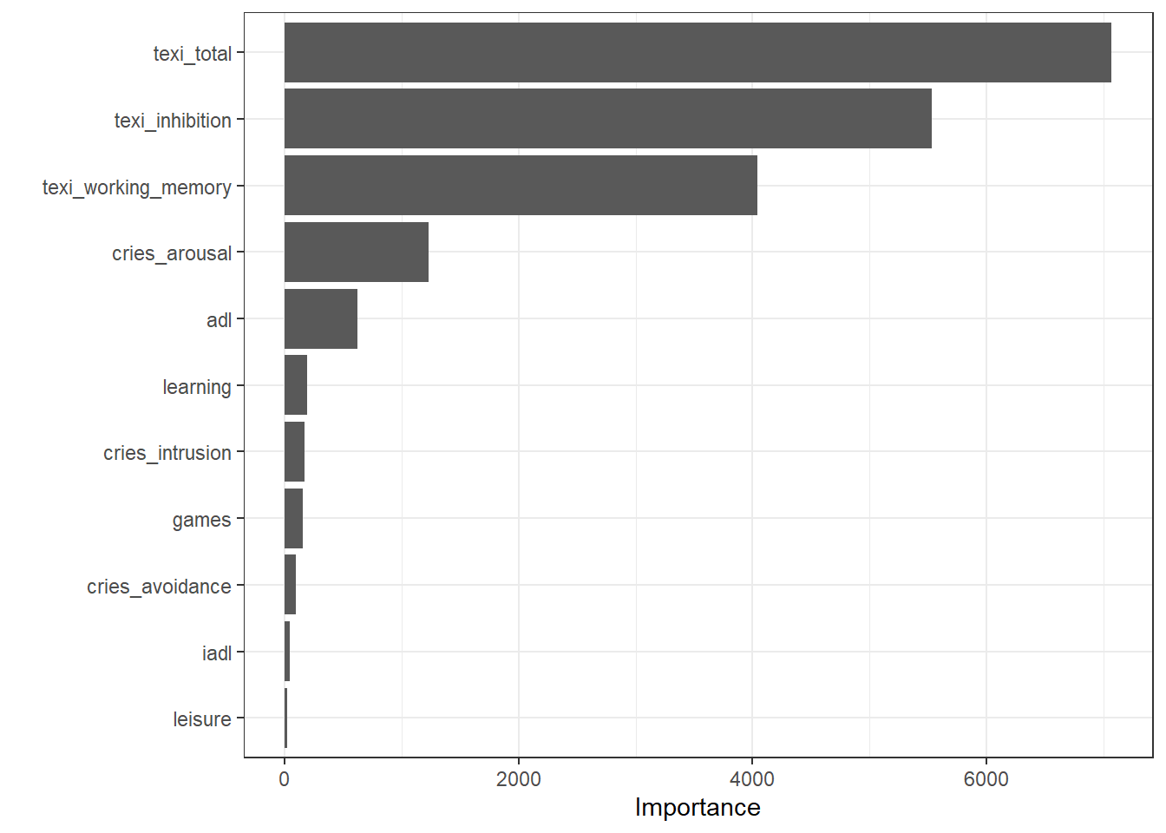

References

R Core Team. 2023. R: A Language and Environment for Statistical Computing. Vienna, Austria: R Foundation for Statistical Computing. https://www.R-project.org/.
Therneau, Terry, and Beth Atkinson. 2023. Rpart: Recursive Partitioning and Regression Trees. https://CRAN.R-project.org/package=rpart.
Kuhn, Max, and Hadley Wickham. 2020. Tidymodels: A Collection of Packages for Modeling and Machine Learning Using Tidyverse Principles. https://www.tidymodels.org.
Lundberg, S. M., & Lee, S. I. (2017). A unified approach to interpreting model predictions. Advances in neural information processing systems, 30.
Mayer, Michael. 2024. Shapviz: SHAP Visualizations. https://CRAN.R-project.org/package=shapviz.
Mayer, Michael, and David Watson. 2023. Kernelshap: Kernel SHAP. https://CRAN.R-project.org/package=kernelshap.

Supplementary Table S2. Descriptive statistics of study variables.

 | Total  Mdn (IQR) | High school Mdn (IQR) | Junior High Mdn (IQR)
SDQ-H |  | N=616 | N=360
Emotional problems | 5 (3-6) | 5 (3-6) | 4 (2-6)
Conduct problems | 2 (1-3) | 2 (1-3) | 2 (1-4)
Hyperactivity | 4 (2-5) | 4 (2-5) | 4 (2-6)
Peer problems | 2 (1-4) | 2 (1-4) | 2 (1-4)
Prosocial Behaviors | 8 (6-9) | 8 (6-9) | 8 (6-9)
Total score | 13 (9-17) | 13 (9-17) | 12 (8-17)
CYMR |  | N=582 | N=338
Personal | 27 (24-29) | 27 (24-29) | 27 (24-29)
Caregiver | 16 (14-18) | 16 (14-18) | 16 (14-18)
Total | 43 (38-46) | 43 (38-46) | 43 (38-46)
TEXI |  | N=557 | N=331
Inhibition | 23 (19-27.75) | 23 (19-27.5) | 23 (18-28)
Working memory | 32 (26-37) | 32 (26-32) | 32 (27-37)
Total | 56 (46-63) | 55 (46-63) | 57 (46-64)
Coherence |  | N=551 | N=325
Total | 53 (47-56) | 54 (47-57) | 52 (47-56)
Participation Change |  | N=540 | N=320
ADL | 0 (0-2) | 0 (0-2) | 0 (0-1)
IADL | 0 (0-2) | 0 (0-2) | 0 (0-2)
Sleep | 0 (-2-0) | 0 (-2-1) | 0 (-1-0)
Games | 0 (0-2) | 0 (0-1.75) | 0 (0-2)
Leisure | 0 (0-2) | 0 (0-1.75) | 0 (0-2)
Social activities | 0 (-1-2) | 0 (-1-2) | 0 (-1-2)
Learning | 0 (-1-1) | 0 (-2-1) | 0 (-1-0)
Religious activities | 0 (0-1) | 0 (0-2) | 0 (0-1)
Work | 0 (0-1) | 0 (0-2) | 0 (0-0)
Occupational variability | 1.68 (1.06-2.44) | 1.8 (1.21-2.5) | 1.45 (.86602.3)
CRIES Intrusion |  | N=594 | N=341
Not at all | 178 (18.2%) | 104 (16.9%) | 74 (20.6%)
Seldom | 244 (25%) | 155 (25.2%) | 89 (24.7%)
Sometimes | 374 (38.3%) | 238 (38.6%) | 136 (37.8%)
Frequently | 139 (14/2%) | 97 (15.7%) | 42 (11.7%)
CRIES Avoidance |  | N=594 | N=342
Not at all | 254 (26%) | 151 (24.5%) | 103 (28.6%)
Seldom | 248 (25.4%) | 159 (25.8%) | 89 (24.7%)
Sometimes | 293 (30%) | 195 (31.7%) | 98 (27.2%)
Frequently | 141 (14.4%) | 89 (14/4%) | 52 (14.4%)
CRIES Arousal |  | N=594 | N=341
Not at all | 215 (22%) | 115 (18.7%) | 100 (27.8%)
Seldom | 258 (26.4%) | 160 (26%) | 98 (27.2%)
Sometimes | 284 (29.1%) | 188 (30.5%) | 96 (26.7%)
Frequently | 178 (18.2%) | 131 (21.3%) | 47 (13.1%)

Supplementary Material 3

Analysis of mental health status (SDQ-H) in relation to demographic variables

We analysed the mental health status (SDQ-H scale) in relation to study demographic variables. The results are summarized in Supplementary Table S3. In summary, females scored lower on the prosocial behaviors (i.e., better prosocial functioning), but higher on emotional and total mental health problems, indicating worse mental health compared to male participants. Older adolescents had higher level of emotional problems. Those who attend not-religious schools reported higher levels of emotional problems, hyperactivity, peer problems and total mental health problems compared to those in non-religious schools. In addition, differences were found by area of living in conduct behaviors, hyperactivity and general mental health, while all parameters were higher for those living in the south.

Supplementary Table S3. Differences in SDQ-H Scores based on demographic parameters.

Demographic | Gender | Grade | School type | Geographic area
 | Statistics:  U | Statistics:  U | Statistics:  U | Statistics:  U
Emotional Problems | 65337.5  p<.001 | 93024.5  p<.01 | 92156.5  p<.001 | 2.49  p>.05
Conduct Problems | 4161.5  p>.05 | 99935.5  p>.05 | 107131  p>.05 | 5.66  p<.05
Hyper-activity | 89840  p>.05 | 102936  p>.05 | 105370.5  p<.001 | 11.44  p<.01
Peer  Problems | 88810  p>.05 | 97388  p>.05 | 97239  p<.001 | 1.25  p>.05
Prosocial Behaviors | 80833.5  p<.001 | 99156.5  p>.05 | 109485  p>.05 | 4.2  p>.05
Total  Score | 78378  p<.001 | 97646  p>.05 | 94217.5  p<.001 | 9.17  p<.05

Supplementary Table S4. Pearson correlations between study outcomes and variables.

Variable | SDQ-H Total | BMSLSS Total
SOC Comprehensibility | -.44** | .36**
SOC Manageability | -.49** | .44**
SOC Meaningfulness | -.40 | .46**
SOC Total | -.56 | .52**
TEXI Inhibition | .53** | -.35**
TEXI WM | .48** | -.35**
TEXI Total | .55** | -.38**
CYMR Personal | -.52** | .59**
CYMR Relational | -.34** | .51**
CYMR Total | -.51** | .63**
CRIES Intrusion | .26** | -.09**
CRIES Avoidance | .21** | -.10**
CRIES Arousal | .32** | -.13**
P - ADL | .002 | .06
P - IADL | -.05 | .09*
P - Sleep | -.09** | .14**
P - Games | .02 | -.05
P - Leisure | .06 | .06
P - Social | -.15** | .24**
P - Learning | -.17** | .24**
P - Religious | -.10** | .07*
P - Variability | .24 | -.16
SOC – Sense of Coherence; P – Participation; *p<.05; **p<.01

