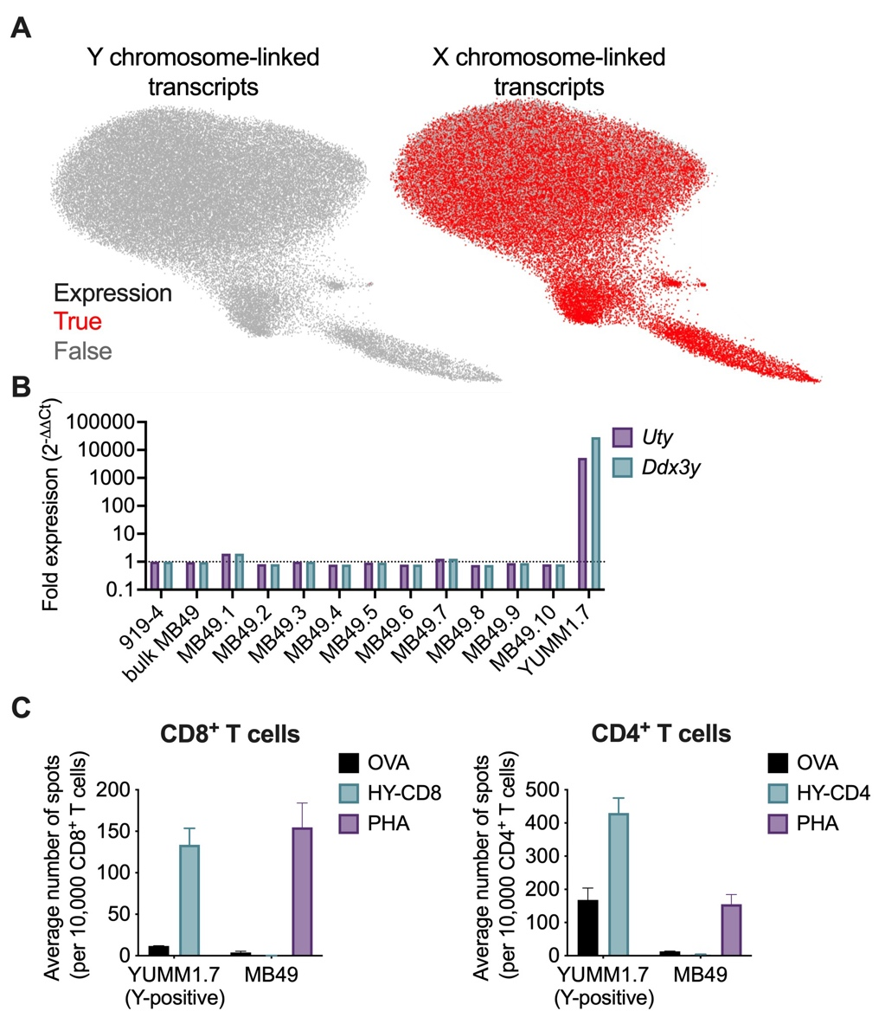
Fig. S1. MB49 tumor cells do not elicit immune responses against the Y chromosome. (A) 58,045 MB49 cells were analyzed by scRNAseq. UMAP plots are shown overlaid with the expression level of Y chromosome-linked (left) and X chromosome-linked (right) transcripts. Red indicates cells expressing sex chromosome-linked transcripts while grey indicates cells not expressing sex chromosome-linked transcripts. (B) Gene expression analysis of Y chromosome-encoded Uty and Ddx3y transcripts in parental MB49 and 10 independent MB49 single cell clones. The female-derived MCA-induced sarcoma 919-4 was used as a negative control to which Uty and Ddx3y transcript expression was compared using the 2^{-ΔΔCt} method. The male-derived YUMM1.7 melanoma cell line was used as a positive control. (C) Female C57BL/6 mice were implanted with YUMM1.7 (Y chromosome-positive) or MB49 tumor cells and CD8⁺ and CD4⁺ T cells were isolated 14 days later using magnetic bead enrichment. IFNγ production following T cell stimulation with the major MHC-I (left) and MHC-II (right) restricted male-specific histocompatibility antigens (HY) was evaluated using ELISPOT assay. Stimulation with OVA peptide was used as a negative control. Data are presented as mean number of spots ± SEM from 3 independent tumors.

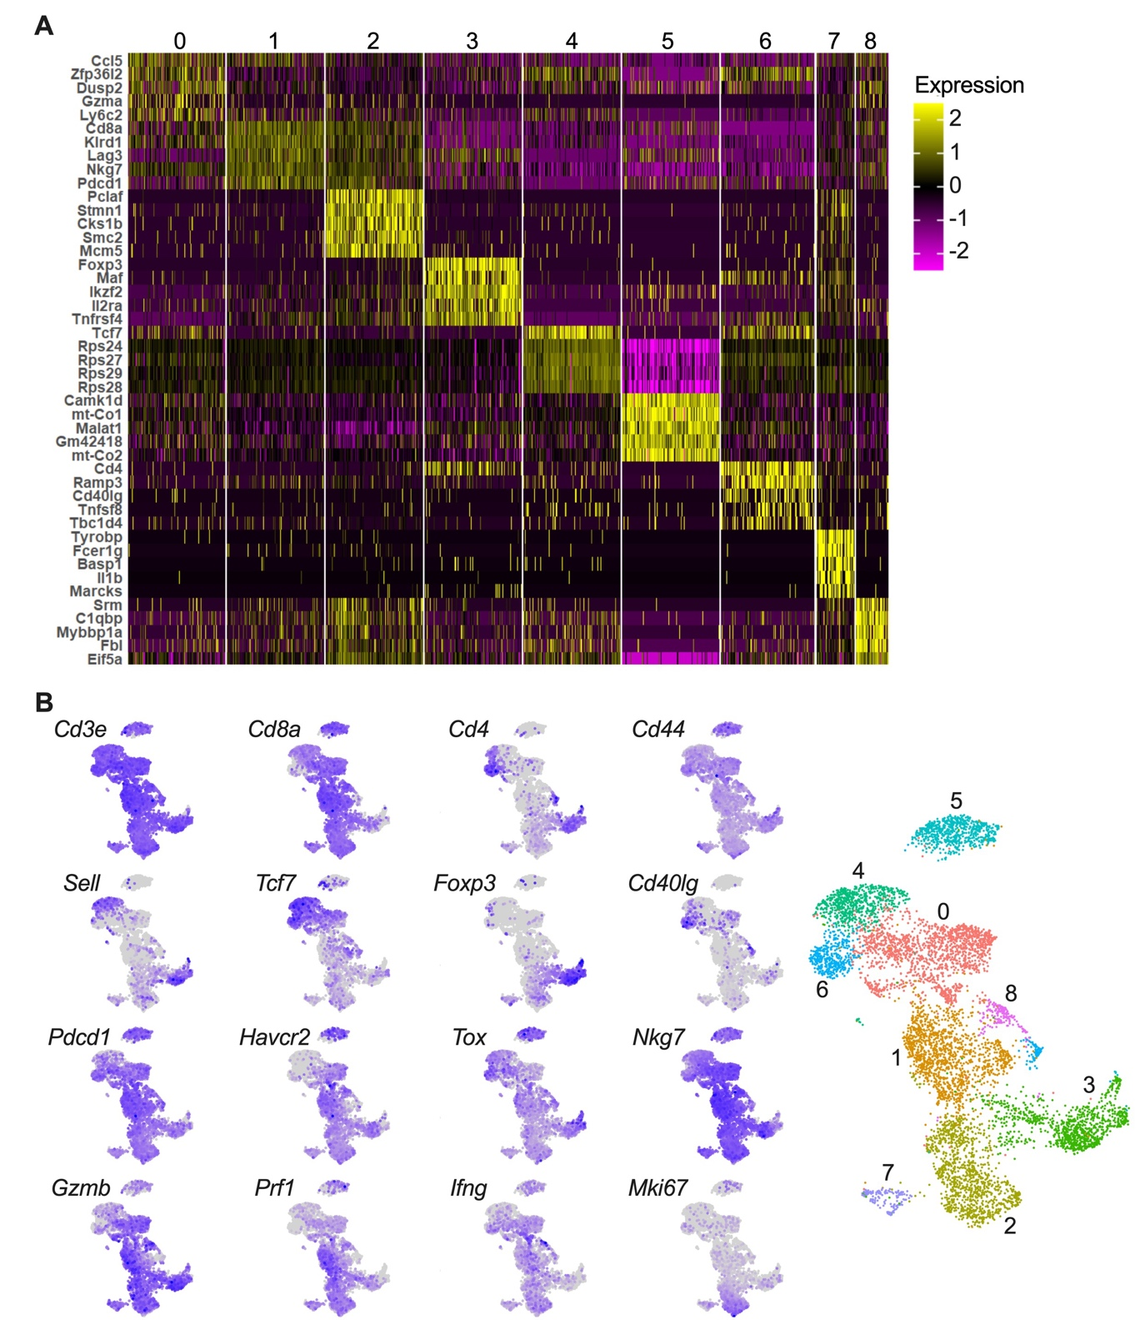
Fig. S2. MB49 tumors display sex differences in T cell phenotypes. (A) Heatmap displaying the expression level of the top 5 most differentially upregulated genes from CD4⁺ and CD8⁺ T cell clusters identified by scRNAseq analysis of cells infiltrating MB49 tumors. (B) UMAP plots of MB49-infiltrating CD4⁺ and CD8⁺ T cells overlaid with the expression level of the indicated transcripts.

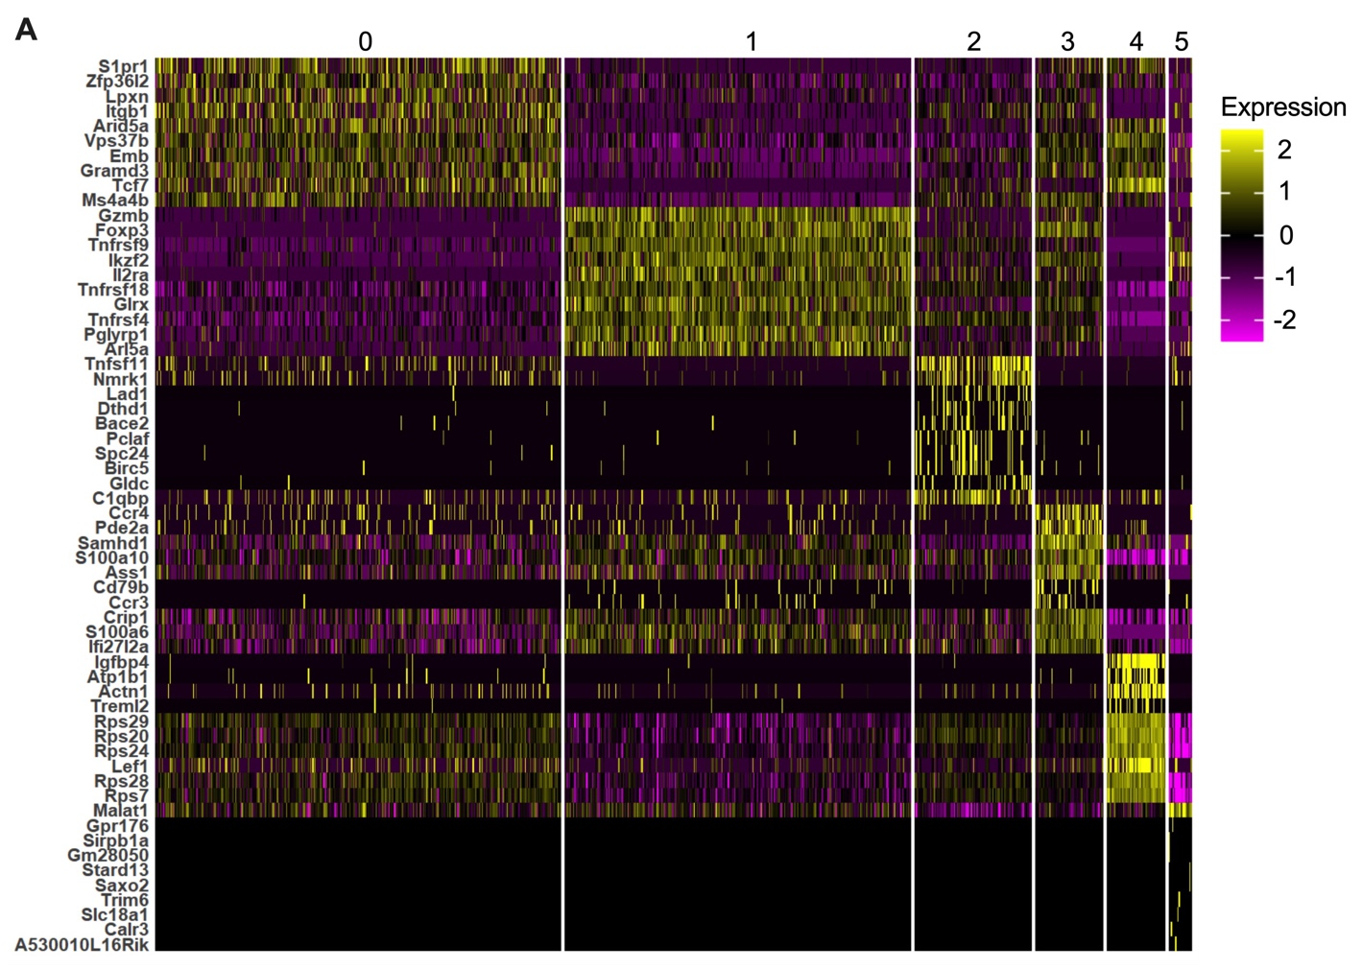
Fig. S3. CD4⁺ T cells from MB49 tumors show sex-based phenotypic differences. Heatmap displaying the expression level of the top 7 most differentially upregulated genes from CD4⁺ T cell clusters identified by scRNAseq analysis of cells infiltrating MB49 tumors.

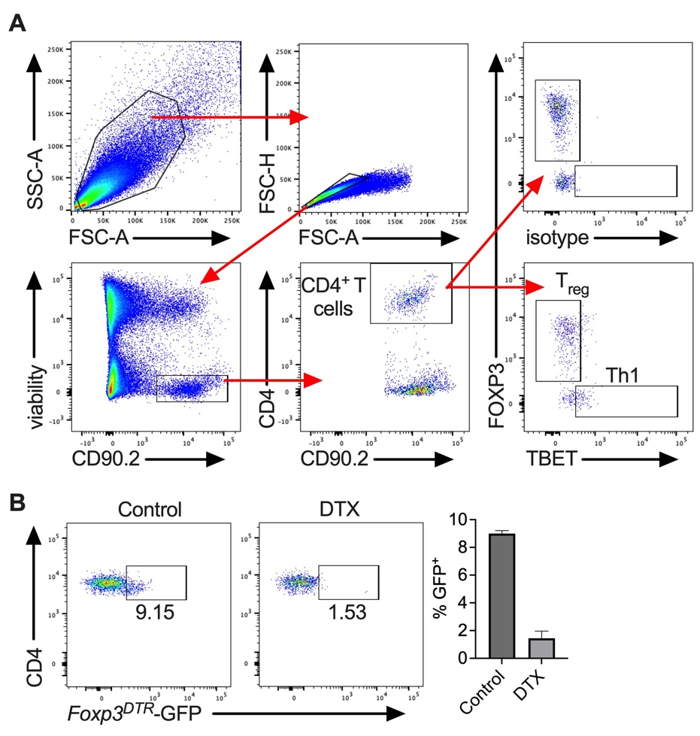
Fig. S4. Flow cytometry analysis of CD4⁺ T cells. (A) Gating strategy of flow cytometry analysis of tumor-infiltrating CD4⁺ T cells. (B) Flow cytometry analysis of Foxp3^{DTR} mice treated with vehicle control or diphtheria toxin (DTX). Cells were previously gated on viable, CD90.2⁺CD4⁺ population.

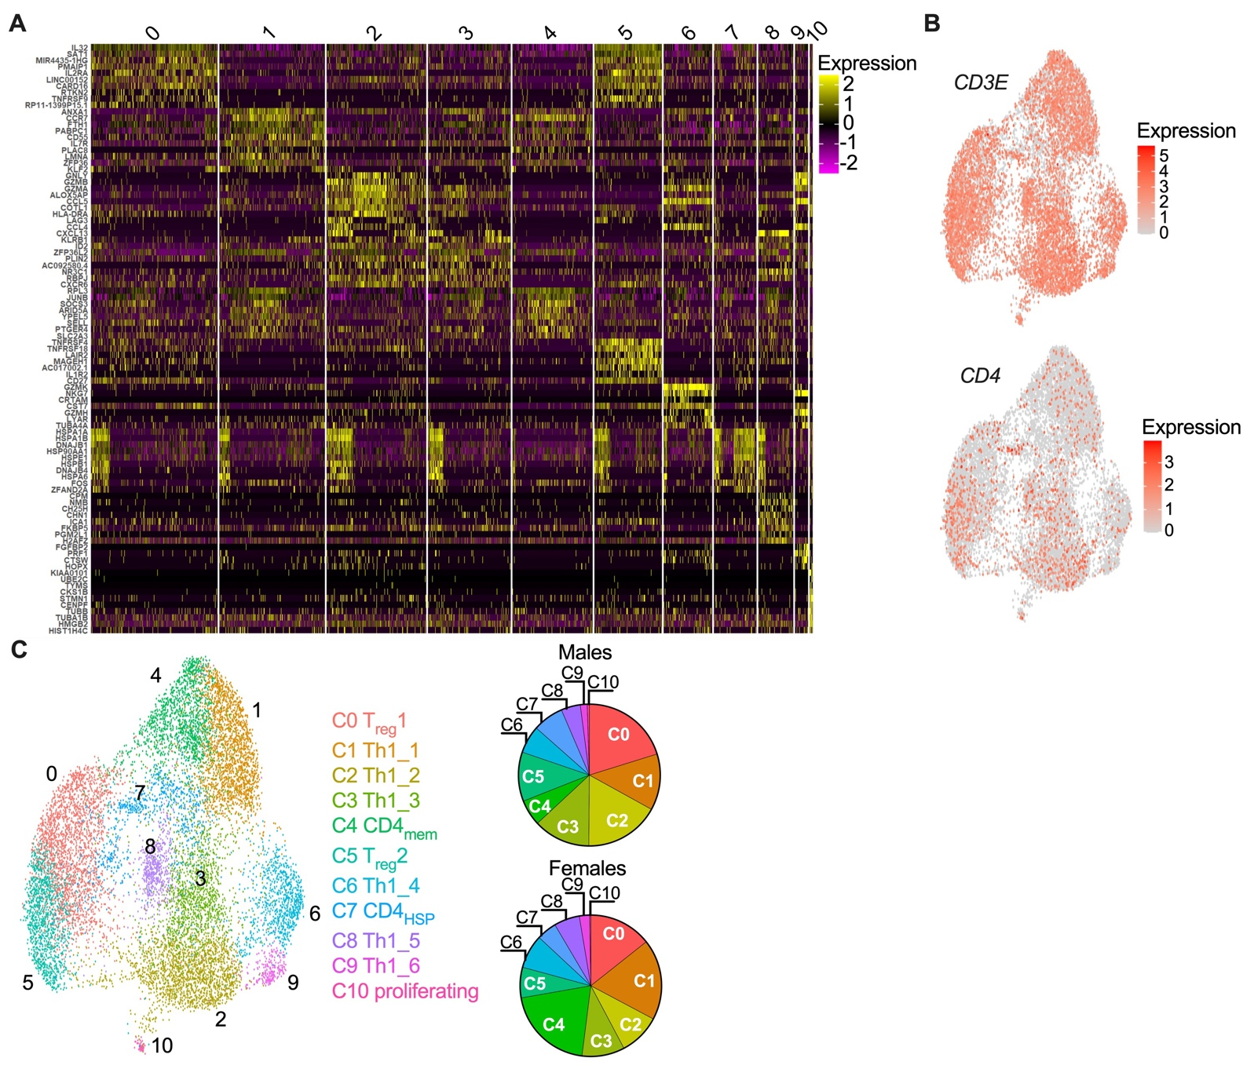
Fig. S5. Sex-based differences in CD4⁺ T cells infiltrating human bladder tumors. (A) Heatmap displaying the expression level of the 10 most differentially upregulated genes from CD4⁺ T cell clusters identified by scRNAseq analysis. (B) UMAP plots of CD4⁺ T cells isolated from human bladder tumors overlaid with the expression of CD3E (top) and CD4 (bottom). (C) UMAP plots as in (B) are colored to show cluster boundaries. Pie charts on right show the proportion of male- and female-derived CD4⁺ T cells present within each cluster.
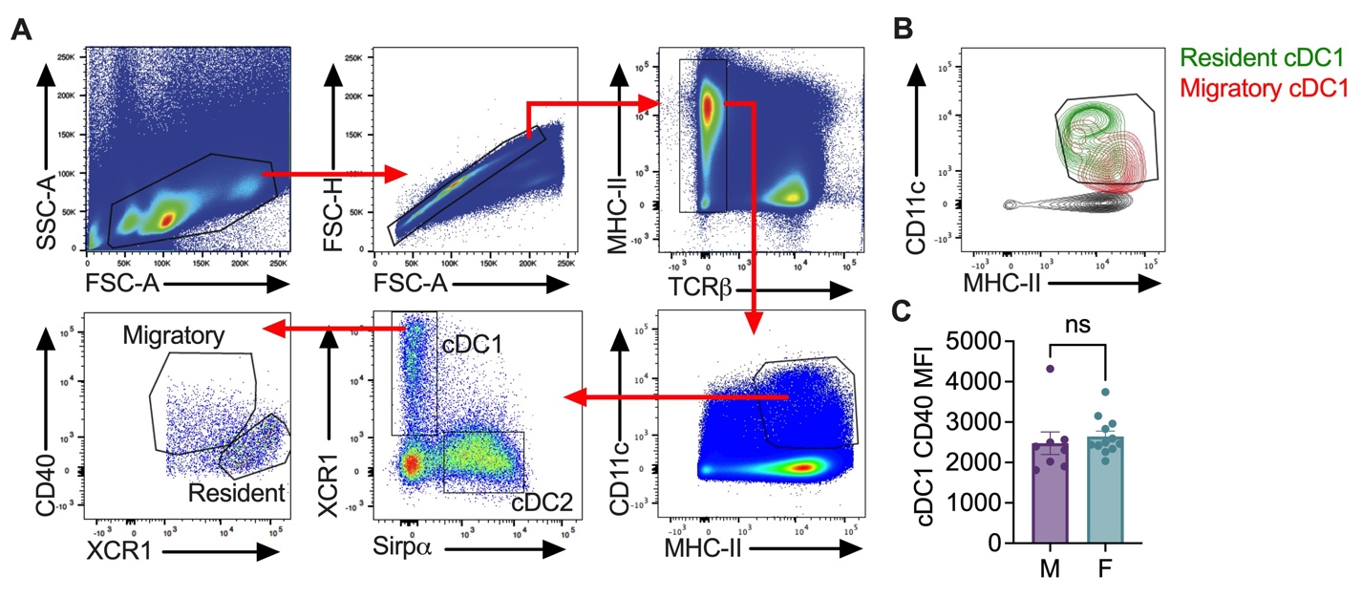
Fig. S6. cDC1s from MB49 tumor-bearing male and female mice display equivalent expression levels of CD40. (A) Gating strategy used for flow cytometry analysis of dendritic cells within tumor-draining lymph nodes. (B) Resident and migratory cDC1 populations as gated in A overlaid to show CD11c and MHC-II expression. (C) Quantification of flow cytometry analysis of migratory cDC1s in male- and female-derived MB49 tdLNs. Data are shown as mean migratory cDC1 CD40 MFI ± SEM from 8 males and 12 females from 3 independent experiments. ns: non-significant, p>0.05. p value calculated using unpaired, two-tailed t test.

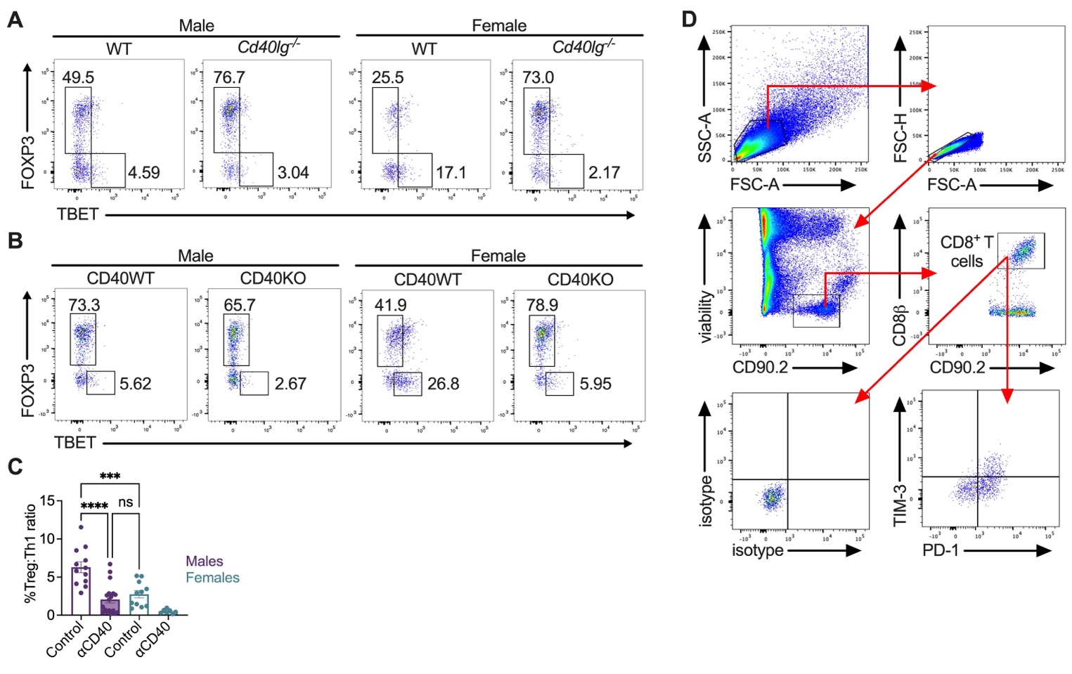
Fig. S7. Modulation of CD40L-CD40 signaling impacts both CD4⁺ and CD8⁺ T cell function. (A, B) Representative flow cytometry analysis of CD4⁺ T cells isolated from MB49 tumors implanted in male and female WT or Cd40lg^{-/-} mice (A), or male and female cDC1^{CD40WT} or cDC1^{CD40KO} mice (B). Cells were previously gated on viable, CD90.2⁺CD4⁺ population. (C) Quantification of the T_{reg}:Th1 CD4⁺ T cell ratio measured by flow cytometry analysis of MB49 tumor-bearing mice treated with control IgG or agonistic αCD40 antibody. Data are shown as mean T_{reg}:Th1 CD4⁺ T cell ratio ± SEM from 7-18 tumors per cohort from 4 independent experiments. (D) Gating strategy for flow cytometry analysis of tumor-infiltrating CD8⁺ T cells. ns, non-significant, p>0.05; ***, p≤0.001; ****, p<0.0001. p values calculated using 2-way ANOVA with Bonferroni correction for multiple comparisons.

