SUPPLEMENTAL FILE
Supplementary Figure 1. Missingness patterns in FFCWS national sample (N=3,442).
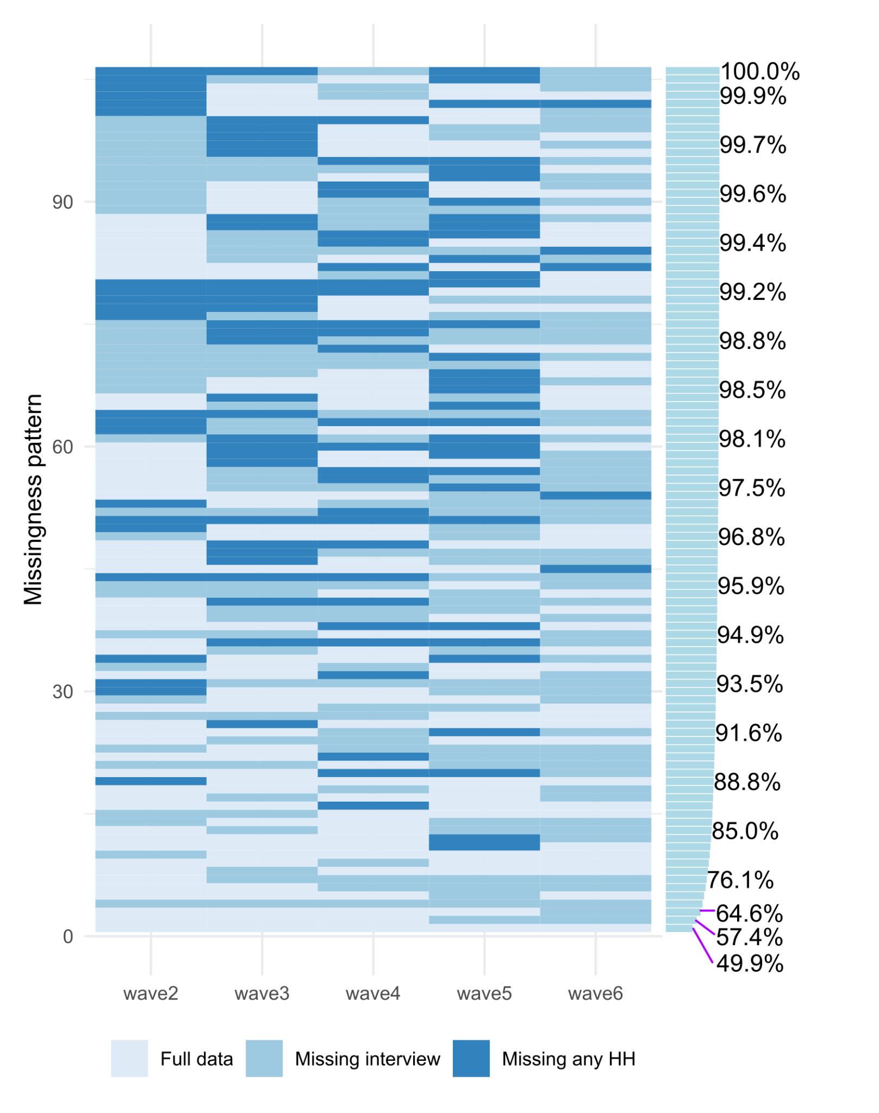

Supplementary Figure 2. Lower bound cumulative incidence and modeled cumulative incidence curves.
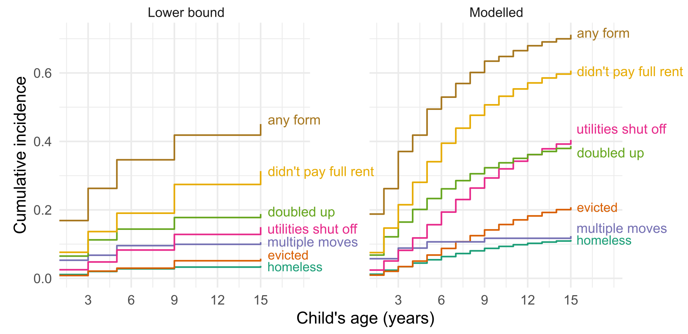
Supplementary Figure 3. Lower bound and modeled MCC curves.
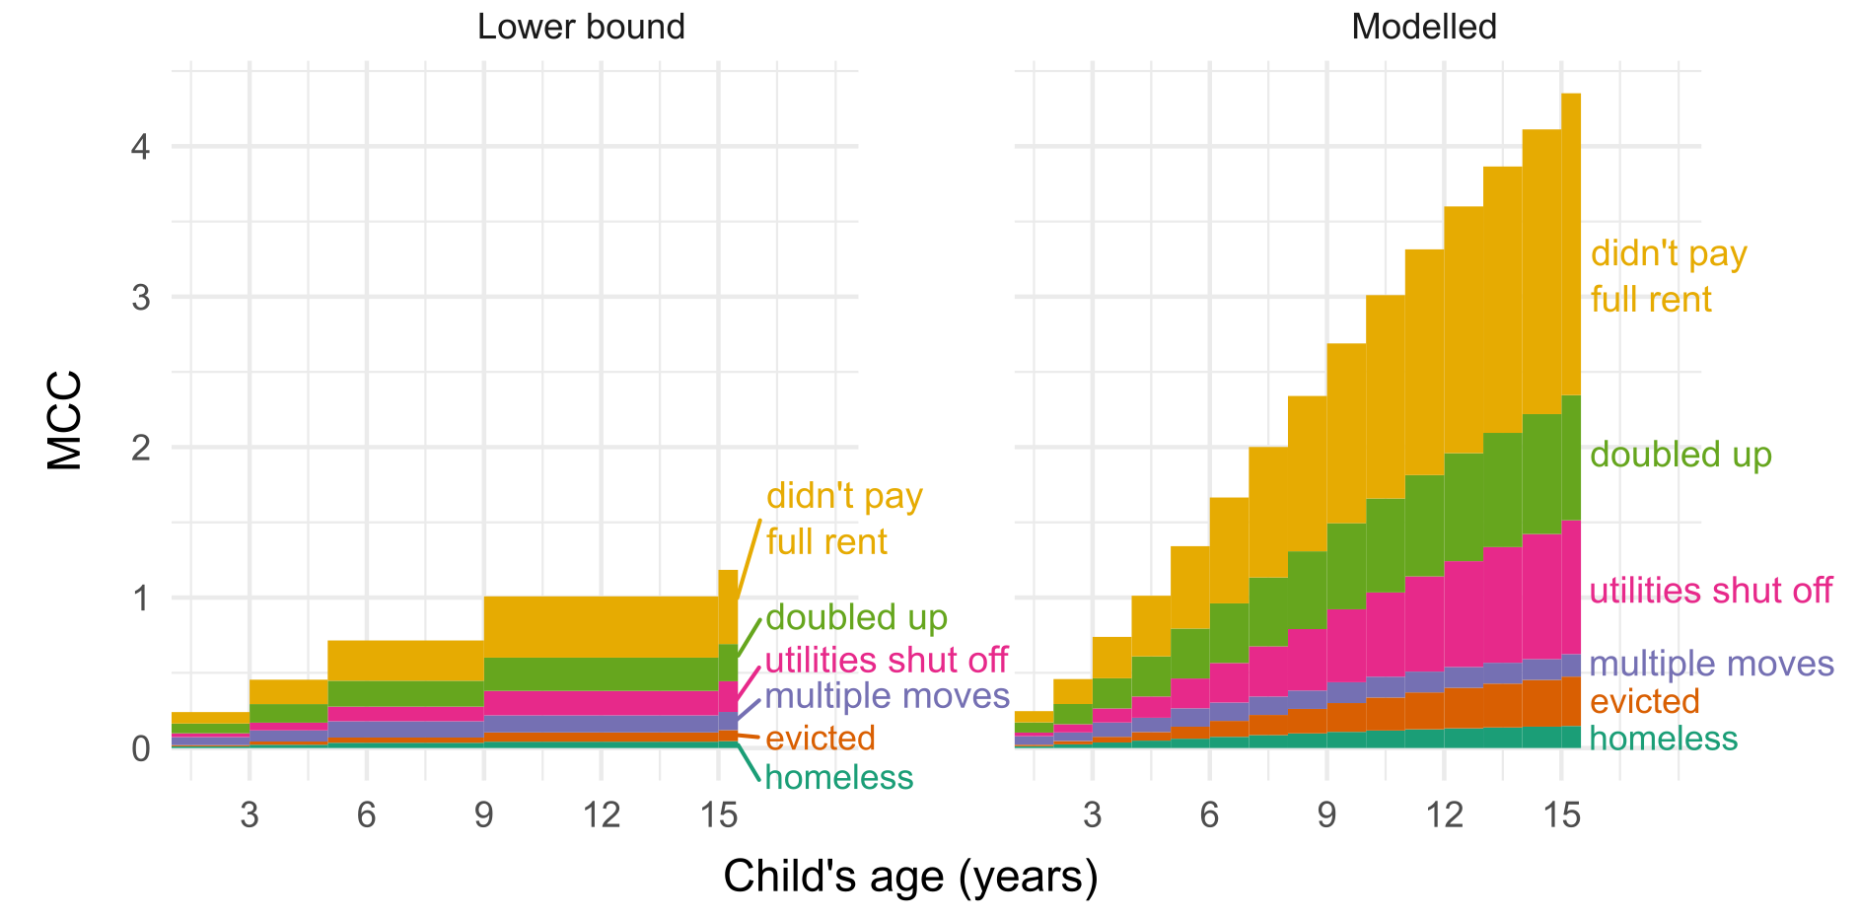

Supplementary Table 1. Modeled cumulative incidence, mean cumulative count, and conditional mean cumulative count estimates at age 15 (95% confidence intervals).
 | Cumulative incidence (CI) | Mean cumulative count (MCC) | Conditional MCC*
Event type
Any event | 0.71 (0.65, 0.77) | 4.35 (3.81, 4.90) | 6.12 (5.33, 6.90)
Didn't pay full rent | 0.61 (0.55, 0.66) | 2.01 (1.76, 2.25) | 3.31 (2.98, 3.63)
Doubled up | 0.39 (0.35, 0.43) | 0.83 (0.69, 0.97) | 2.15 (1.92, 2.38)
Utilities shut off | 0.40 (0.34, 0.46) | 0.89 (0.69, 1.09) | 2.20 (1.92, 2.48)
Multiple moves | 0.12 (0.10, 0.14) | 0.15 (0.12, 0.18) | 1.21 (1.14, 1.28)
Evicted | 0.21 (0.14, 0.27) | 0.33 (0.18, 0.48) | 1.58 (1.32, 1.84)
Homeless | 0.11 (0.08, 0.14) | 0.15 (0.10, 0.20) | 1.31 (1.20, 1.42)
*Conditional MCC is defined as MCC/CI, and indicates the average number of events among individuals experiencing at least one event.

Supplementary Table 2. All results (provided as an excel file)

