Supplemental Figures:
Table 1. Scoring parameters. The presented scoring sheet was approved by the IACUC and used to assess health of individual animals by a study group blinded investigator.

Table 2. Tissue histopathology. The table provides an overview on tissue histopathology scores for hematoxylin and eosin (H&E) stain and immunohistochemistry performed with an Anti-Influenza A nucleoprotein antibody (Millipore Sigma; ABF1820-25UL) at a 1:12,000 dilution.

Supplemental Figure 1
Supplemental Figure 1: Hematological changes in Sinclair nanopigs inoculated with HPAIV H5N1. Whole blood was collected at each clinical examination and at the time of euthanasia to assess the effects of inoculation on hematological parameters over the course of the study. Data represent 4 animals per time point

Supplemental Figure 2
Supplemental Figure 2: Blood Chemistries in Sinclair nanopigs inoculated with HPAIV H5N1. Serum was collected at each clinical examination and at the time of euthanasia and blood chemistry analysis was performed to assess organ function over the course of the study. Data represent 4 animals per time point.

Supplemental Figure 3
Supplemental Figure 3: Urogenital and Rectal shedding and Viremia following HPAIV H5N1 inoculation. PCR was used to determine the viral load in (A) Urogenital swabs, (B) Rectal swabs, and (C) Blood collected at each clinical examination and at the time of euthanasia to establish viral shedding in the pathogenesis study. Data represent 4 animals per time point.
PCR was used to determine the viral load in (D) Urogenital swabs, (E) Rectal swabs, and (F) Blood collected at each clinical examination and at the time of euthanasia to establish viral shedding in the transmission study. Data represent 4 animals per group.

Supplemental Figure 4
Supplemental Figure 4: Viral loads in tissues collected at D5 and D21. PCR was used to determine the viral load in tissues collected at the time of euthanasia. Data represent 4 animals per time point.

Supplemental Figure 5
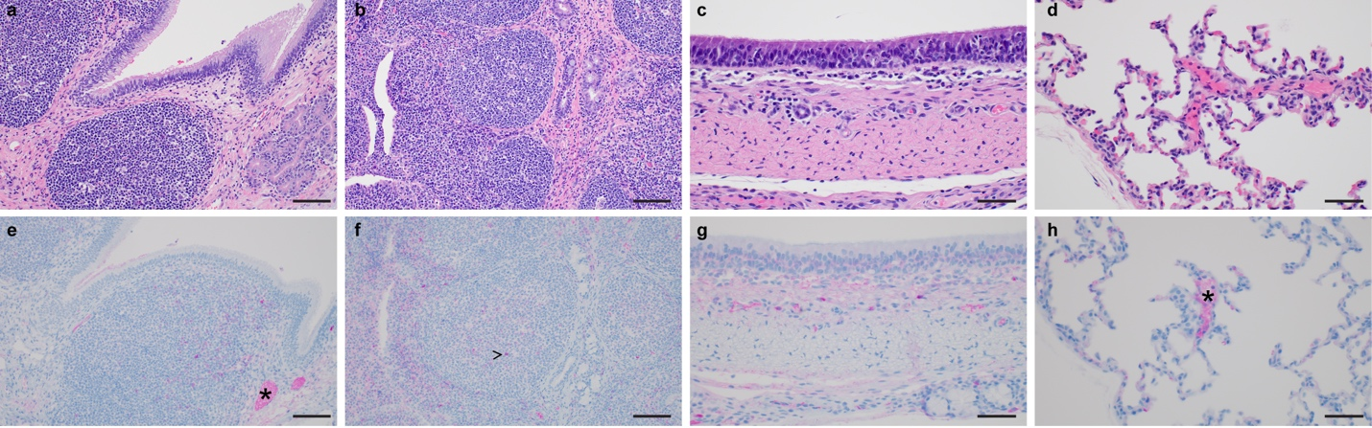
Supplemental Figure 5: Histopathology at D21 of HPAIV H5N1 infected Sinclair nanopigs. (A, E) Turbinal epithelium (200x); (B, F) Pharyngeal tonsil (200x); (C, G) Trachea (400x); (D, H) Lung (400x). Hematoxylin and eosin (H&E) stains are shown in A-D); immunohistochemistry (IHC) stains are shown in E-H and were performed with an Anti-Influenza A nucleoprotein antibody (Millipore Sigma; ABF1820-25UL) at a 1:12,000 dilution. At 21 days post infection there is minimal mixed inflammation noted in the sub-mucosa and mucosa of the turbinal epithelium and trachea (A,C) with sparse single cell immunoreactivity and non-specific staining within small caliber veins (*) and capillaries (E, G). The pharyngeal tonsil appears normal (B) with rare single cell immunoreactivity (>) (F). The lungs appear normal and there is non-specific staining within small caliber veins (*) and septal capillaries (H)

Supplemental Figure 6
Supplemental Figure 6: Weight and Temperature change following inoculation with HPAIV H5N1 and co-housing. (A) Weight and (B) Temperature changes over the course of the study for inoculated (red) and naïve (blue) animals.

Supplemental Figure 7
Supplemental Figure 7: Hematological changes in Sinclair nanopigs following inoculation with HPAIV H5N1 and co-housing with naïve sentinel pigs. Whole blood was collected at each clinical examination and at the time of euthanasia to assess the effects of inoculation on hematological parameters over the course of the study. Data represent 4 animals per time point

Supplemental Figure 8
Supplemental Figure 8: Blood Chemistries in Sinclair nanopigs following inoculation with HPAIV H5N1 and co-housing with naïve sentinel pigs. Serum was collected at each clinical examination and at the time of euthanasia and blood chemistry analysis was performed to assess organ function over the course of the study. Data represent 4 animals per time point.
Supplemental Figure 9
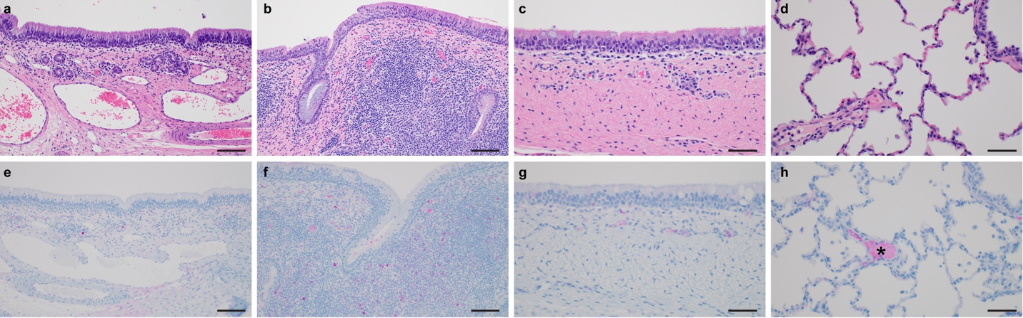
Supplemental Figure 9: Histopathology at D28 of naïve sentinel Sinclair nanopigs co-housed with HPAIV H5N1 infected pigs. (A, E) Turbinal epithelium (200x); (B, F) Pharyngeal tonsil (200x); (C, G) Trachea (400x); (D, H) Lung (400x). Hematoxylin and eosin (H&E) stains are shown in A-D); immunohistochemistry (IHC) stains are shown in E-H and were performed with an Anti-Influenza A nucleoprotein antibody (Millipore Sigma; ABF1820-25UL) at a 1:12,000 dilution. At 28 days post infection there is minimal mixed inflammation noted in the sub-mucosa and mucosa of the turbinal epithelium and trachea (A,C) with sparse single cell immunoreactivity and non-specific staining within small caliber veins (*) and capillaries (E, G). The pharyngeal tonsil appears normal (B) with rare single cell immunoreactivity (>)(F). The lungs appear normal and there is non-specific staining within small caliber veins (*) and septal capillaries (H).

