Table 2. Schematic representation of the evaluated SecSSE models. (λ) speciation parameters, (τ) transition parameters, (μ) extintion parameters, (n) total number o parameters

Model | Description | n
ETD 1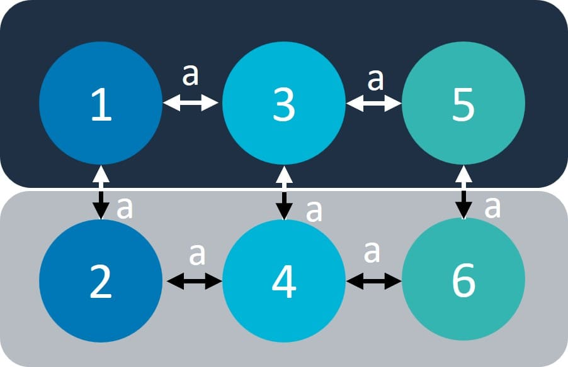  (λ): 6 (1,2,3,4,5,6)  (τ): 1 (a)  (μ): 1 (e) | Six speciation rates (λ): three for freshwater in trait states Low (1), Mid (3), High (5) and three for marine in trait states Low (2), Mid (4), High (6). One transition rate (τ) between all trait states (a) and one extinction rate (μ: e). | 8
ETD 2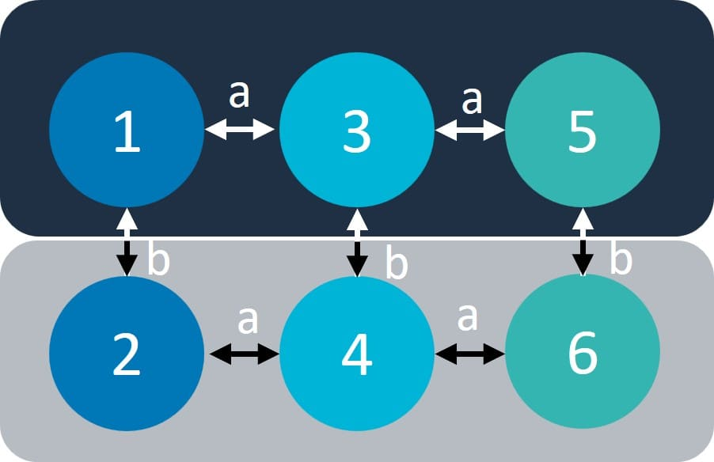  (λ): 6 (1,2,3,4,5,6)  (τ): 2 (a,b)  (μ): 1 (e) | Six speciation rates(λ): three for freshwater in trait states Low (1), mid (3), high (5) and three for marine in trait states Low (2), Mid (4), high (6). Two transition rates (τ): one between states Low, Mid, High (a) and one between marine and freshwater (b). One extinction rate (μ: e). | 9
ETD 3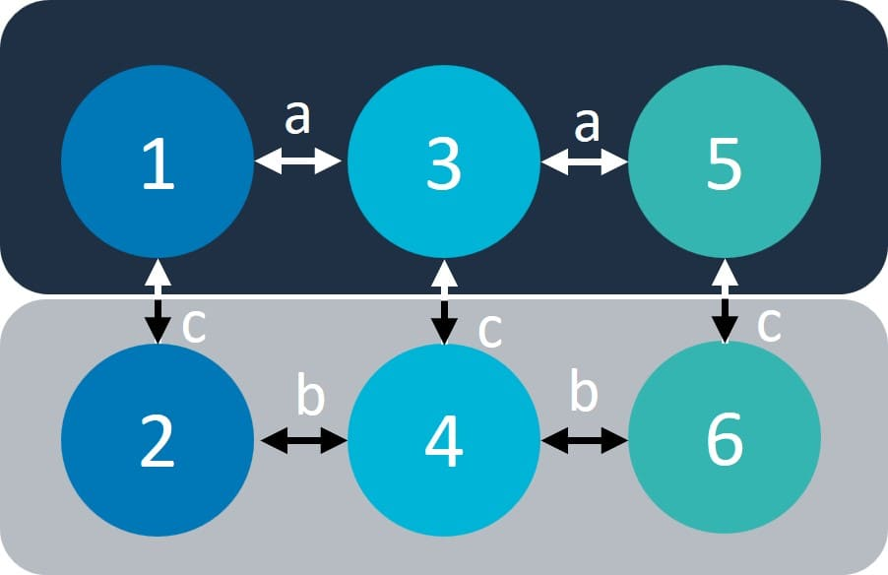  (λ): 6 (1,2,3,4,5,6)  (τ): 3 (a,b,c)  (μ): 1 (e) | Six speciation rates (λ): three for freshwater in trait states Low (1), Mid (3), High (5) and three for marine in trait states Low (2), Mid (4), High (6). Three transition rates (τ): One transition rate between states Low, Mid, High in freshwater (a), one for states Low, Mid, High in marine (b) and one between marine and freshwater (c). One extinction rate (μ: e). | 10
ETD 4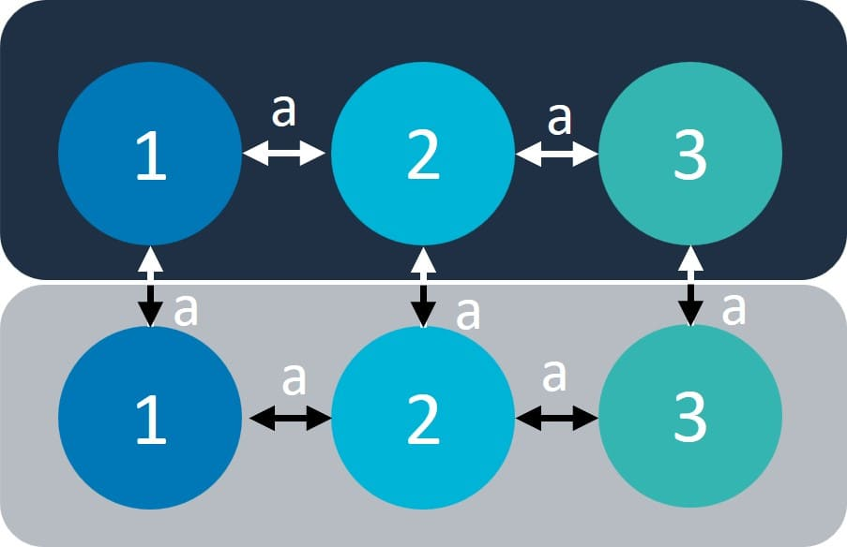  (λ): 3 (1,2,3)  (τ): 1 (a)  (μ): 1 (e) | Three speciation rates (λ): one for each trait state Low (1), Mid (2), High (3). One transition rate (τ) between all trait states (a) and one extinction rate (μ = e). | 4
ETD 5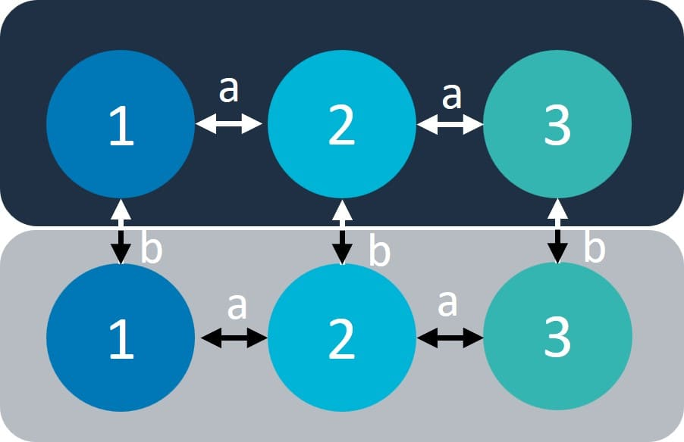  (λ): 3 (1,2,3)  (τ): 2 (a,b)  (μ) = 1 (e) | Three speciation rates (λ): one for each trait state Low (1), Mid (2), High (3). Two transition rates (τ): one between states Low, Mid, High (a) and one between marine and freshwater (b). One extinction rate (μ = e). | 5
ETD 6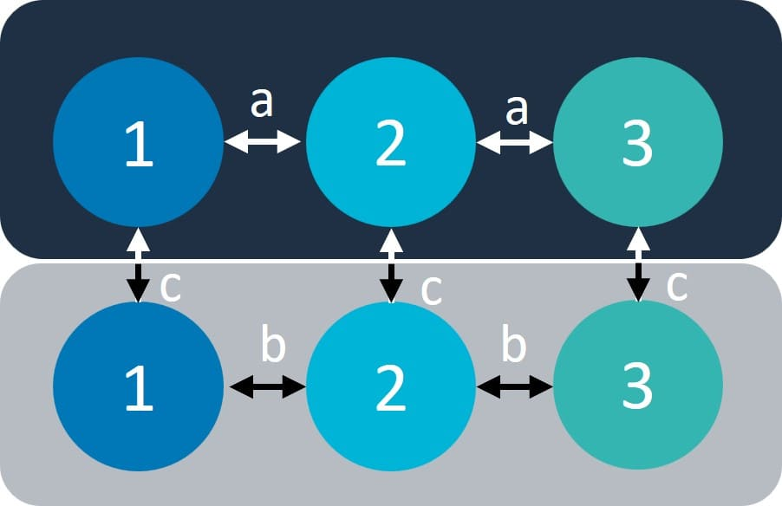  (λ): 3 (1,2,3)  (τ): 3 (a,b,c)  (μ) = 1 (e) | Three speciation rates (λ): one for each trait state Low (1), Mid (2), High (3). Three transition rates (τ): one transition rate between states Low, Mid, High in freshwater (a), one for states Low, Mid, High in marine (b) and one between marine and freshwater (c). One extinction rate (μ: e). | 6
CTD Models | Same configuration of ETD models (CTD1-CTD6) | --
CR model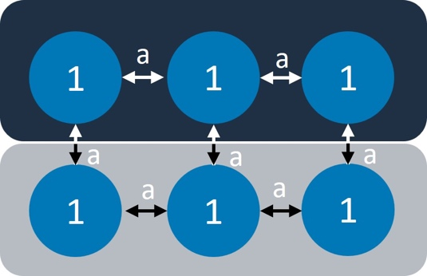  (λ): 1  (τ): 1 (a)  (μ): 1 | One speciation rate (λ): 1, one transition rate (τ): a, one extinction rate (μ: e). | 3

