Morphological traits of actinopterygian fishes do not influence their diversification rates
Juliana Herrera-Pérez, Juan D. Carvajal-Quintero, Pablo A. Tedesco, Leonel Herrera-Alsina, Alejandro Espinosa de los Monteros, Fabricio Villalobos

Supplementary Information
Table S1: Statistical fit of 13 models for each trait. The table is ordered by the best-fitting model based on weighted AICw for each trait and each initial value. k: number of parameters; ΔAIC: difference in AIC relative to the best model within each initial value; minAIC: minimum AIC for each trait; ΔAICt: difference relative to the minimum AIC for each trait; AICw: model weight within each initial value; AICwt: model weight across all initial values for each trait.
Trait | Initial values | Model | k | Log-likelihood | AIC | ΔAIC | AICw | minAIC | ΔAICt | AICwt
bel | 1 | Model 2 CTD | 9 | -49157 | 98332 | 0 | 1 | 98332 | 0 | 1
bel | 1 | Model 3 CTD | 10 | -49411 | 98842 | 510.8 | 1.23E-111 | 98332 | 511 | 1.23E-111
bel | 1 | Model 5 CTD | 6 | -49496 | 99004 | 672.8 | 8.14E-147 | 98332 | 673 | 8.14E-147
bel | 1 | Model 1 CTD | 8 | -49548 | 99111 | 779.6 | 5.26E-170 | 98332 | 780 | 5.26E-170
bel | 1 | Model 4 CTD | 5 | -49773 | 99556 | 1225 | 1.01E-266 | 98332 | 1225 | 1.01E-266
bel | 1 | Model 6 CTD | 7 | -49875 | 99764 | 1433 | 6.8 E-312 | 98332 | 1433 | 6.80E-312
bel | 1 | Model Null CR | 3 | -51301 | 102609 | 4277 | 0 | 98332 | 4277 | 0
bel | 1 | Model 1 ETD | 8 | -51344 | 102703 | 4372 | 0 | 98332 | 4372 | 0
bel | 1 | Model 4 ETD | 5 | -51447 | 102903 | 4572 | 0 | 98332 | 4572 | 0
bel | 1 | Model 5 ETD | 6 | -51859 | 103730 | 5398 | 0 | 98332 | 5398 | 0
bel | 1 | Model 6 ETD | 7 | -52328 | 104670 | 6338 | 0 | 98332 | 6338 | 0
bel | 1 | Model 2 ETD | 9 | -52689 | 105396 | 7064 | 0 | 98332 | 7064 | 0
bel | 1 | Model 3 ETD | -- | This model did not achieve convergence | -- | -- | -- | -- | -- | --
bel | 2 | Model 3 CTD | 10 | -49168 | 98356 | 0 | 1 | 98356 | 25 | 4.36E-06
bel | 2 | Model 2 CTD | 9 | -49202 | 98422 | 65.64 | 5.57E-15 | 98356 | 90 | 2.43E-20
bel | 2 | Model 5 CTD | 6 | -49826 | 99664 | 1308 | 1.10E-284 | 98356 | 1332 | 4.80E-290
bel | 2 | Model 4 CTD | 5 | -50196 | 100401 | 2045 | 0 | 98356 | 2070 | 0
bel | 2 | Model 6 CTD | 7 | -50486 | 100986 | 2630 | 0 | 98356 | 2655 | 0
bel | 2 | Model 3 ETD | 10 | -50889 | 101799 | 3442 | 0 | 98356 | 3467 | 0
bel | 2 | Model 2 ETD | 9 | -50936 | 101890 | 3534 | 0 | 98356 | 3559 | 0
bel | 2 | Model 6 ETD | 7 | -51035 | 102083 | 3727 | 0 | 98356 | 3752 | 0
bel | 2 | Model 5 ETD | 6 | -51082 | 102175 | 3819 | 0 | 98356 | 3844 | 0
bel | 2 | Model Null CR | 3 | -51301 | 102609 | 4252 | 0 | 98356 | 4277 | 0
bel | 2 | Model 1 ETD | 8 | -51344 | 102703 | 4347 | 0 | 98356 | 4372 | 0
bel | 2 | Model 4 ETD | 5 | -51447 | 102903 | 4547 | 0 | 98356 | 4572 | 0
bel | 2 | Model 1 CTD | 8 | -52573 | 105161 | 6805 | 0 | 98356 | 6830 | 0
bel | 3 | Model 6 CTD | 7 | -49372 | 98758 | 0 | 1 | 98757.9 | 426 | 2.58E-93
bel | 3 | Model 3 CTD | 10 | -49461 | 98942 | 183.9 | 1.16E-40 | 98757.9 | 610 | 3.00E-133
bel | 3 | Model 5 CTD | 6 | -49496 | 99004 | 246.4 | 3.13E-54 | 98757.9 | 673 | 8.08E-147
bel | 3 | Model 2 CTD | 9 | -49496 | 99009 | 251.3 | 2.73E-55 | 98757.9 | 678 | 7.05E-148
bel | 3 | Model 1 CTD | 8 | -49661 | 99337 | 579.2 | 1.69E-126 | 98757.9 | 1006 | 4.37E-219
bel | 3 | Model 4 CTD | 5 | -50361 | 100732 | 1974 | 0 | 98757.9 | 2400 | 0
bel | 3 | Model Null CR | 3 | -51301 | 102609 | 3851 | 0 | 98757.9 | 4277 | 0
bel | 3 | Model 4 ETD | 5 | -51447 | 102903 | 4145 | 0 | 98757.9 | 4572 | 0
bel | 3 | Model 2 ETD | 9 | -51586 | 103190 | 4432 | 0 | 98757.9 | 4859 | 0
bel | 3 | Model 6 ETD | 7 | -51806 | 103626 | 4868 | 0 | 98757.9 | 5294 | 0
bel | 3 | Model 5 ETD | 6 | -51859 | 103730 | 4972 | 0 | 98757.9 | 5398 | 0
bel | 3 | Model 1 ETD | 8 | -52002 | 104019 | 5261 | 0 | 98757.9 | 5688 | 0
bel | 3 | Model 3 ETD | 10 | -56390 | 112800 | 14042 | 0 | 98757.9 | 14468 | 0

Trait | Initial values | Model | k | Log-likelihood | AIC | ΔAIC | AICw | minAIC | ΔAICt | AICwt
bls | 1 est | Model 3 CTD | 10 | -51086 | 102192 | 0 | 1 | 102192 | 263 | 6.98E-58
bls | 1 est | Model 2 CTD | 9 | -51235 | 102488 | 296 | 5.60E-65 | 102192 | 559 | 3.91E-122
bls | 1 est | Model 6 CTD | 7 | -51367 | 102748 | 556 | 1.64E-121 | 102192 | 819 | 1.14E-178
bls | 1 est | Model 1 CTD | 8 | -51803 | 103622 | 1430 | 0 | 102192 | 1693 | 0
bls | 1 est | Model 5 CTD | 6 | -52047 | 104107 | 1915 | 0 | 102192 | 2179 | 0
bls | 1 est | Model 4 CTD | 5 | -52192 | 104394 | 2202 | 0 | 102192 | 2465 | 0
bls | 1 est | Model Null CR | 3 | -53599 | 107204 | 5012 | 0 | 102192 | 5275 | 0
bls | 1 est | Model 2 ETD | 9 | -53632 | 107282 | 5091 | 0 | 102192 | 5354 | 0
bls | 1 est | Model 1 ETD | 8 | -53756 | 107528 | 5336 | 0 | 102192 | 5599 | 0
bls | 1 est | Model 6 ETD | 7 | -53849 | 107711 | 5519 | 0 | 102192 | 5783 | 0
bls | 1 est | Model 4 ETD | 5 | -54747 | 109505 | 7313 | 0 | 102192 | 7576 | 0
bls | 1 est | Model 5 ETD | 6 | -55521 | 111055 | 8863 | 0 | 102192 | 9126 | 0
bls | 1 est | Model 3 ETD | 10 | -56770 | 113560 | 11369 | 0 | 102192 | 11632 | 0
bls | 2 doub | Model 3 CTD | 10 | -50954 | 101928 | 0 | 1 | 101928 | 0 | 1
bls | 2 doub | Model 2 CTD | 9 | -51156 | 102331 | 402.1 | 4.95E-88 | 101928 | 402 | 4.95E-88
bls | 2 doub | Model 6 CTD | 7 | -51543 | 103099 | 1171 | 6.28E-255 | 101928 | 1171 | 6.28E-255
bls | 2 doub | Model 5 CTD | 6 | -51584 | 103180 | 1252 | 1.62E-272 | 101928 | 1252 | 1.62E-272
bls | 2 doub | Model 1 CTD | 8 | -52016 | 104049 | 2120 | 0 | 101928 | 2120 | 0
bls | 2 doub | Model 4 CTD | 5 | -52190 | 104390 | 2461 | 0 | 101928 | 2461 | 0
bls | 2 doub | Model 2 ETD | 9 | -52822 | 105661 | 3733 | 0 | 101928 | 3733 | 0
bls | 2 doub | Model 5 ETD | 6 | -52943 | 105899 | 3970 | 0 | 101928 | 3970 | 0
bls | 2 doub | Model Null CR | 3 | -53599 | 107204 | 5275 | 0 | 101928 | 5275 | 0
bls | 2 doub | Model 1 ETD | 8 | -53756 | 107528 | 5599 | 0 | 101928 | 5599 | 0
bls | 2 doub | Model 3 ETD | 10 | -54744 | 109508 | 7580 | 0 | 101928 | 7580 | 0
bls | 2 doub | Model 4 ETD | -- | This model did not achieve convergence | -- | -- | -- | -- | -- | --
bls | 2 doub | Model 6 ETD | -- | This model did not achieve convergence | -- | -- | -- | -- | -- | --
bls | 3 mid | Model 2 CTD | 9 | -51268 | 102553 | 0 | 1 | 102553 | 625 | 2.24E-136
bls | 3 mid | Model 1 CTD | 8 | -51953 | 103923 | 1370 | 0 | 102553 | 1994 | 0
bls | 3 mid | Model 3 CTD | 10 | -52009 | 104038 | 1485 | 0 | 102553 | 2109 | 0
bls | 3 mid | Model 5 CTD | 6 | -52047 | 104107 | 1554 | 0 | 102553 | 2179 | 0
bls | 3 mid | Model 6 CTD | 7 | -52606 | 105226 | 2673 | 0 | 102553 | 3298 | 0
bls | 3 mid | Model 5 ETD | 6 | -52943 | 105899 | 3345 | 0 | 102553 | 3970 | 0
bls | 3 mid | Model Null CR | 3 | -53599 | 107204 | 4651 | 0 | 102553 | 5275 | 0
bls | 3 mid | Model 4 CTD | 5 | -53720 | 107451 | 4898 | 0 | 102553 | 5523 | 0
bls | 3 mid | Model 6 ETD | 7 | -53755 | 107523 | 4970 | 0 | 102553 | 5595 | 0
bls | 3 mid | Model 1 ETD | 8 | -53756 | 107528 | 4975 | 0 | 102553 | 5599 | 0
bls | 3 mid | Model 3 ETD | 10 | -54253 | 108525 | 5972 | 0 | 102553 | 6597 | 0
bls | 3 mid | Model 2 ETD | 9 | -57423 | 114864 | 12311 | 0 | 102553 | 12935 | 0
bls | 3 mid | Model 4 ETD | 5 | -60730 | 121469 | 18916 | 0 | 102553 | 19541 | 0

Trait | Initial values | Model | k | Log-likelihood | AIC | ΔAIC | AICw | minAIC | ΔAICt | AICwt
len | 1 est | Model 3 CTD | 10 | -50463 | 100946 | 0 | 0.999999998 | 100946 | 139 | 6.13E-31
len | 1 est | Model 2 CTD | 9 | -50484 | 100986 | 40.01 | 2.05E-09 | 100946 | 179 | 1.26E-39
len | 1 est | Model 6 CTD | 7 | -50785 | 101585 | 638.7 | 2.05E-139 | 100946 | 778 | 1.26E-169
len | 1 est | Model 5 CTD | 6 | -50975 | 101962 | 1016 | 2.58E-221 | 100946 | 1155 | 1.58E-251
len | 1 est | Model 1 CTD | 8 | -51238 | 102492 | 1546 | 0 | 100946 | 1685 | 0
len | 1 est | Model 4 CTD | 5 | -51480 | 102970 | 2024 | 0 | 100946 | 2163 | 0
len | 1 est | Model 2 ETD | 9 | -52297 | 104612 | 3666 | 0 | 100946 | 3805 | 0
len | 1 est | Model 5 ETD | 6 | -52424 | 104859 | 3913 | 0 | 100946 | 4052 | 0
len | 1 est | Model Null CR | 3 | -52930 | 105866 | 4920 | 0 | 100946 | 5059 | 0
len | 1 est | Model 4 ETD | 5 | -53141 | 106293 | 5347 | 0 | 100946 | 5486 | 0
len | 1 est | Model 6 ETD | 7 | -54655 | 109324 | 8378 | 0 | 100946 | 8517 | 0
len | 1 est | Model 1 ETD | 8 | -54723 | 109462 | 8516 | 0 | 100946 | 8655 | 0
len | 1 est | Model 3 ETD | 10 | -55309 | 110638 | 9692 | 0 | 100946 | 9831 | 0
len | 2 doub | Model 3 CTD | 10 | -50393 | 100807 | 0 | 1 | 100807 | 0 | 1
len | 2 doub | Model 2 CTD | 9 | -50477 | 100971 | 164.3 | 2.12E-36 | 100807 | 164 | 2.12E-36
len | 2 doub | Model 6 CTD | 7 | -50785 | 101585 | 778 | 1.13E-169 | 100807 | 778 | 1.13E-169
len | 2 doub | Model 5 CTD | 6 | -50974 | 101960 | 1153 | 4.18E-251 | 100807 | 1153 | 4.18E-251
len | 2 doub | Model 1 CTD | 8 | -51355 | 102726 | 1919 | 0 | 100807 | 1919 | 0
len | 2 doub | Model 4 CTD | 5 | -51850 | 103711 | 2904 | 0 | 100807 | 2904 | 0
len | 2 doub | Model 3 ETD | 10 | -52255 | 104530 | 3723 | 0 | 100807 | 3723 | 0
len | 2 doub | Model 2 ETD | 9 | -52297 | 104612 | 3805 | 0 | 100807 | 3805 | 0
len | 2 doub | Model 6 ETD | 7 | -52374 | 104762 | 3955 | 0 | 100807 | 3955 | 0
len | 2 doub | Model 5 ETD | 6 | -52424 | 104859 | 4052 | 0 | 100807 | 4052 | 0
len | 2 doub | Model Null CR | 3 | -52930 | 105866 | 5059 | 0 | 100807 | 5059 | 0
len | 2 doub | Model 4 ETD | 5 | -53141 | 106293 | 5486 | 0 | 100807 | 5486 | 0
len | 2 doub | Model 1 ETD | -- | This model did not achieve convergence | -- | -- | -- | -- | -- | --
len | 3 mid | Model 3 CTD | 10 | -50549 | 101118 | 0 | 0.999999148 | 101118 | 311 | 3.09E-68
len | 3 mid | Model 2 CTD | 9 | -50564 | 101146 | 27.95 | 8.52E-07 | 101118 | 339 | 2.64E-74
len | 3 mid | Model 6 CTD | 7 | -50785 | 101585 | 466.9 | 4.08E-102 | 101118 | 778 | 1.26E-169
len | 3 mid | Model 1 CTD | 8 | -51280 | 102576 | 1458 | 0.00E+00 | 101118 | 1769 | 0
len | 3 mid | Model 5 CTD | 6 | -51454 | 102921 | 1803 | 0 | 101118 | 2114 | 0
len | 3 mid | Model 4 CTD | 5 | -51480 | 102971 | 1853 | 0 | 101118 | 2164 | 0
len | 3 mid | Model Null CR | 3 | -52930 | 105866 | 4748 | 0 | 101118 | 5059 | 0
len | 3 mid | Model 4 ETD | 5 | -53141 | 106293 | 5175 | 0 | 101118 | 5486 | 0
len | 3 mid | Model 6 ETD | 7 | -53268 | 106551 | 5433 | 0 | 101118 | 5744 | 0
len | 3 mid | Model 5 ETD | 6 | -53320 | 106653 | 5535 | 0 | 101118 | 5846 | 0
len | 3 mid | Model 2 ETD | 9 | -55054 | 110125 | 9007 | 0 | 101118 | 9318 | 0
len | 3 mid | Model 1 ETD | 8 | -55212 | 110441 | 9323 | 0 | 101118 | 9634 | 0
len | 3 mid | Model 3 ETD | 10 | -60038 | 120097 | 18979 | 0 | 101118 | 19290 | 0

Figure S1: Values of a) AIC scores AIC , b) delta AIC (ΔAIC) and c) AIC weigths (AICw) for each morpholocal trait : bel: elongation, bls: lateral shape, len: maximum body length.
 | bel | bls | len
a) | 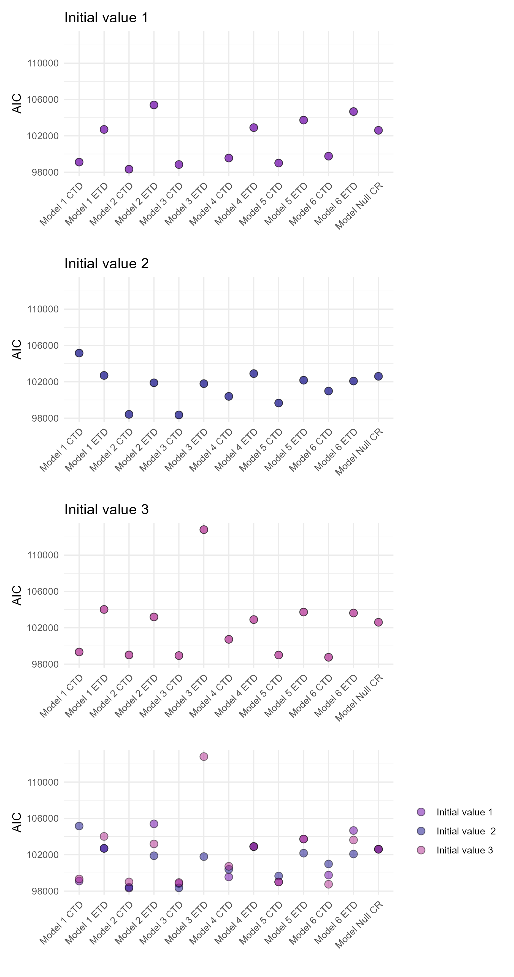 | 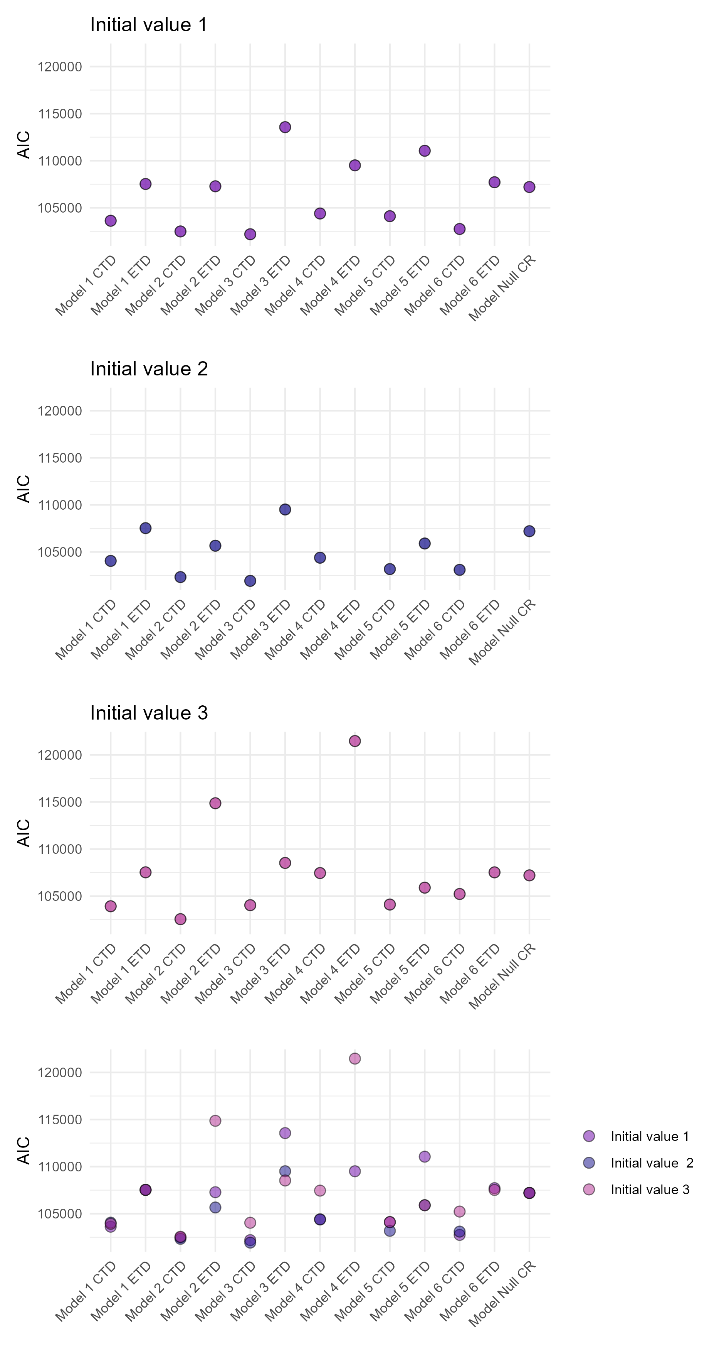 | 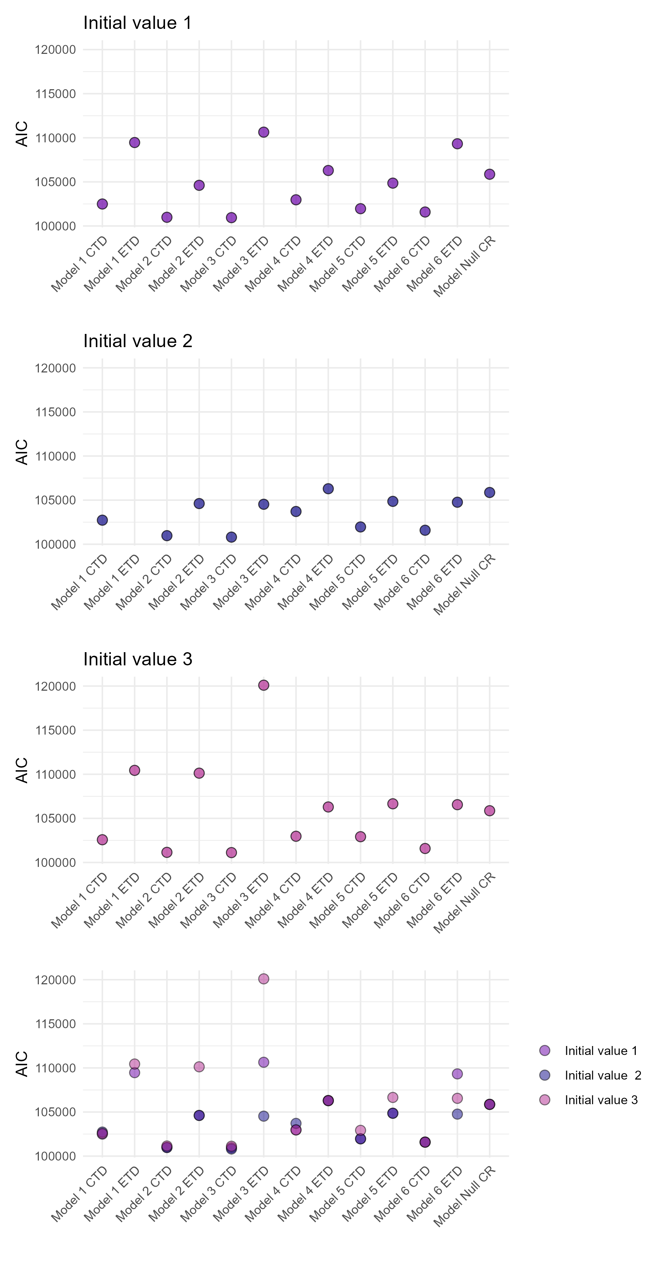
b) | 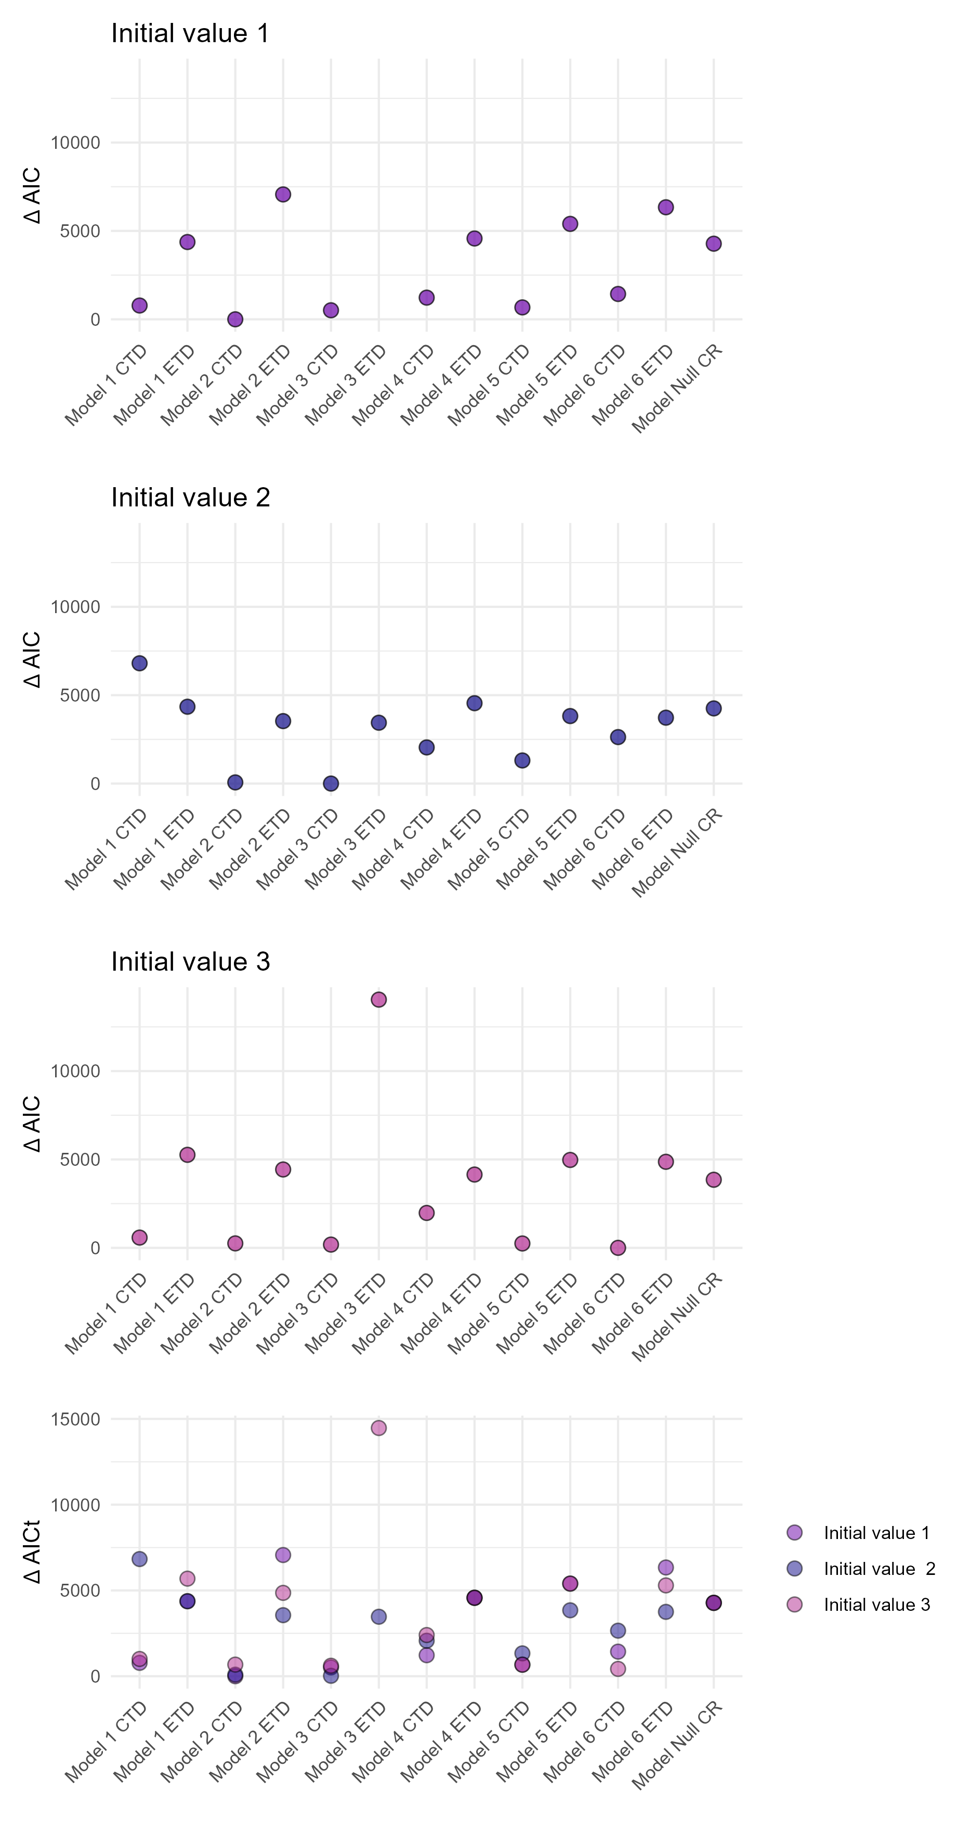 | 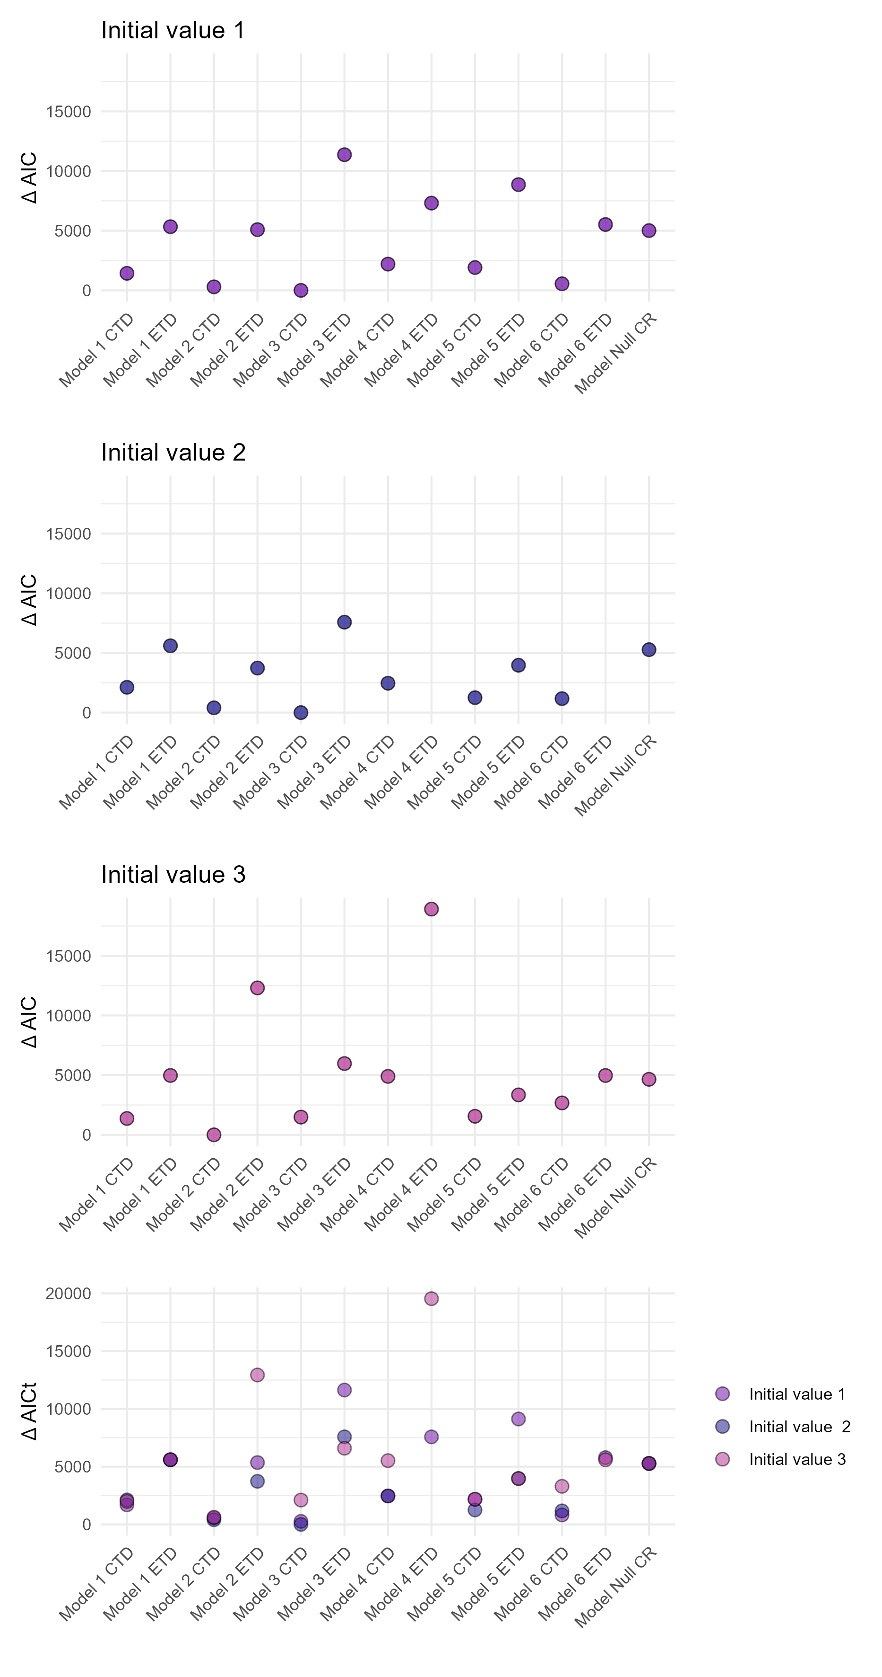 | 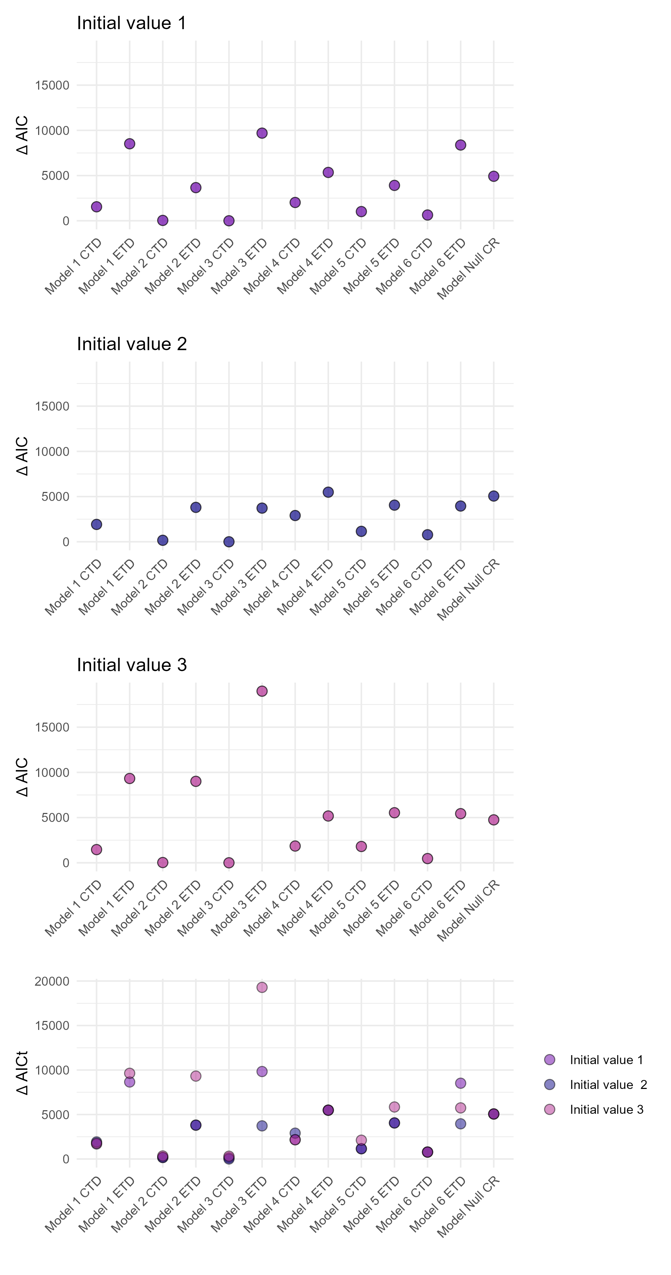
c) | 7 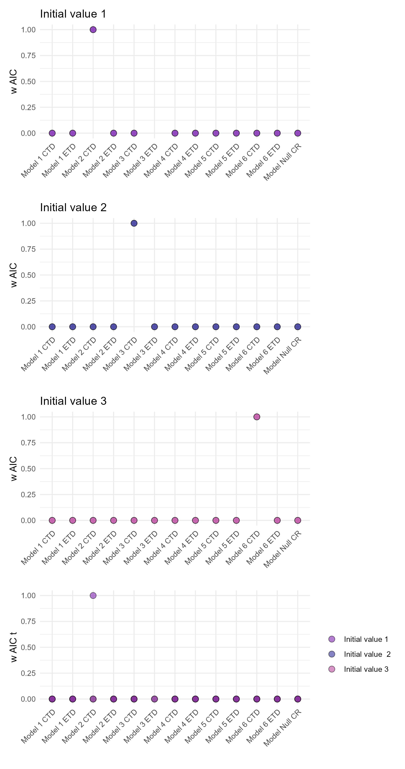 | 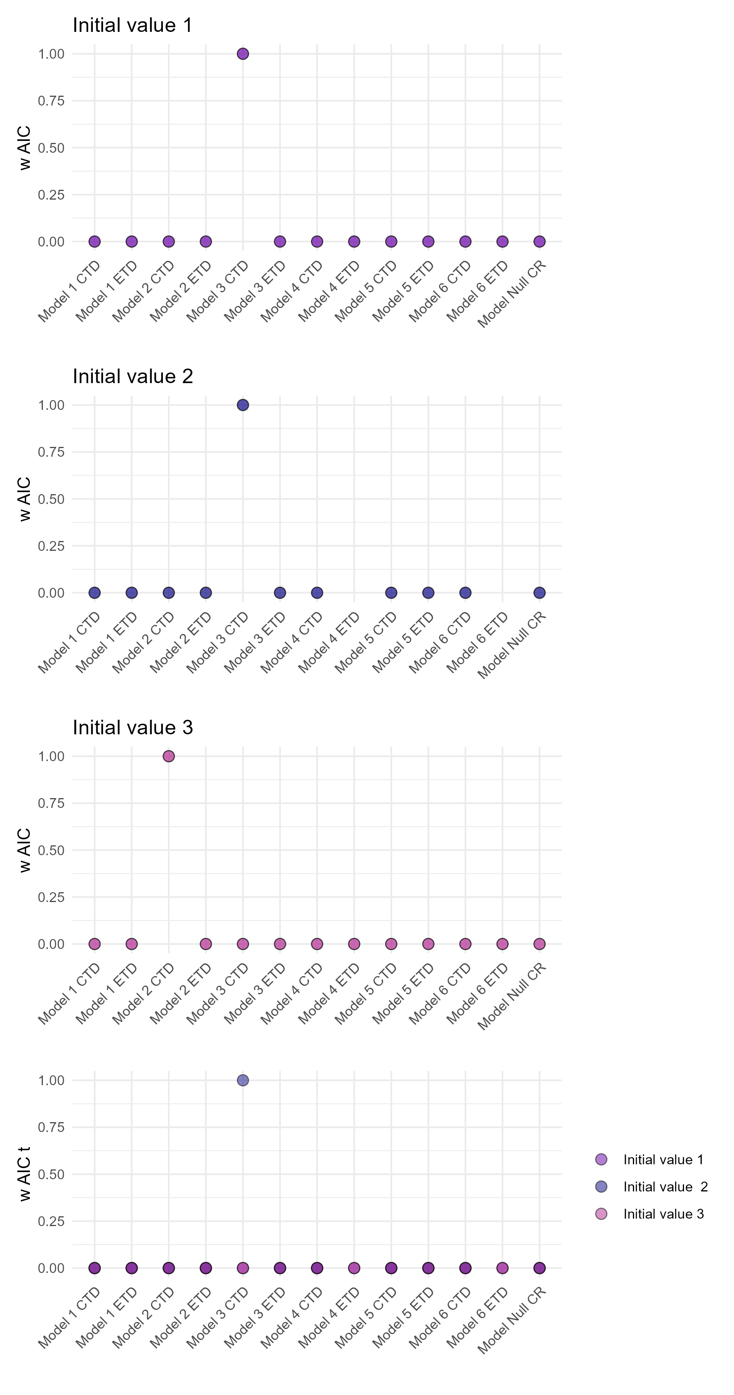 | 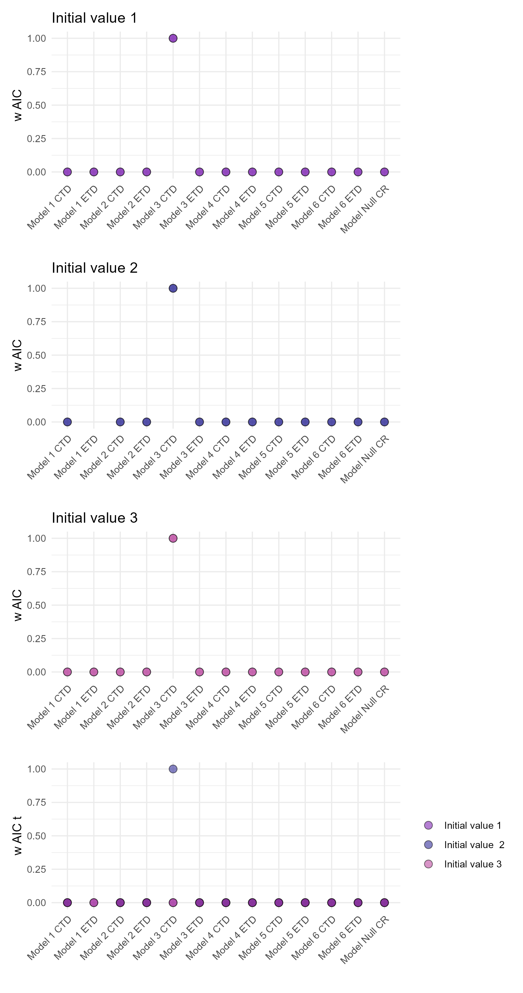

Figure S2. Illustration of morphological measurements to derive the traits considered in this study. (a) Elongation (ble = body length/body depth), b) Lateral shape (bls=head depth/body depth) c) Maximum body length (len)
