Appendix:

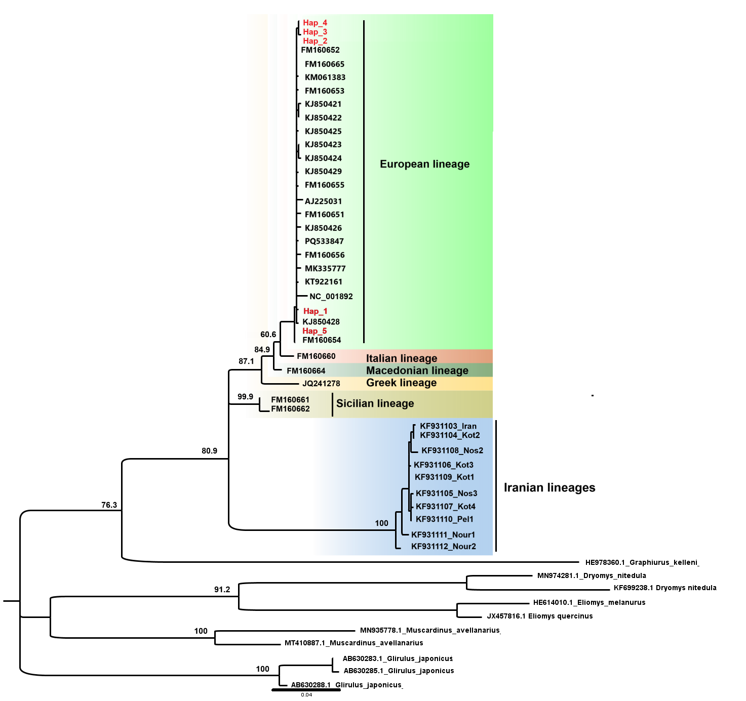
Figure 5 Phylogenetic relationships between Glis lineages based on ML analysis using CYTB sequences

