Title: Cancer-associated Fibroblasts in Pan-Cancer Drive CXCR2+VNN2+ Neutrophil Reprogramming to Mediate Immunosuppression and Immunotherapy Resistance

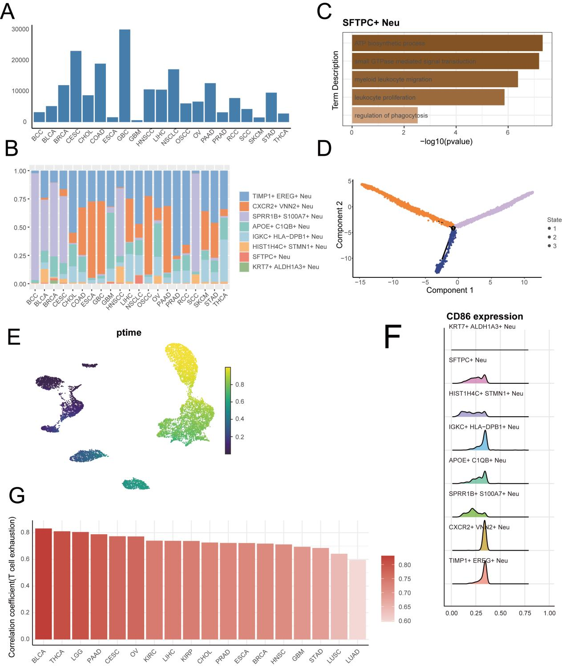
Figure S1 A. Histogram of neutrophil counts in 21 cancer species. B. Histogram showing the percentage of 8 neutrophil subpopulations in 21 cancer types. C. Histogram of functional enrichment of SFTPC+ Neu subpopulations in tumor tissues, with darker colors representing smaller p-values and greater significance. D. Neutrophil subpopulation Monocle analysis of 3 kinds of state display, orange, purple and blue represent 3 kinds of state, respectively. E. scTour analysis of neutrophil evolution trajectory proposed time sequence display, purple represents the starting point of evolution, green represents the end point of evolution. F. Mountain range plot demonstrating the expression of the co-suppressor molecule CD86 in 8 neutrophil subpopulations in tumor tissues. G. Correlation between TIMP1+ EREG+ Neu in pan-cancer species and CD8+ T cell depletion markers.

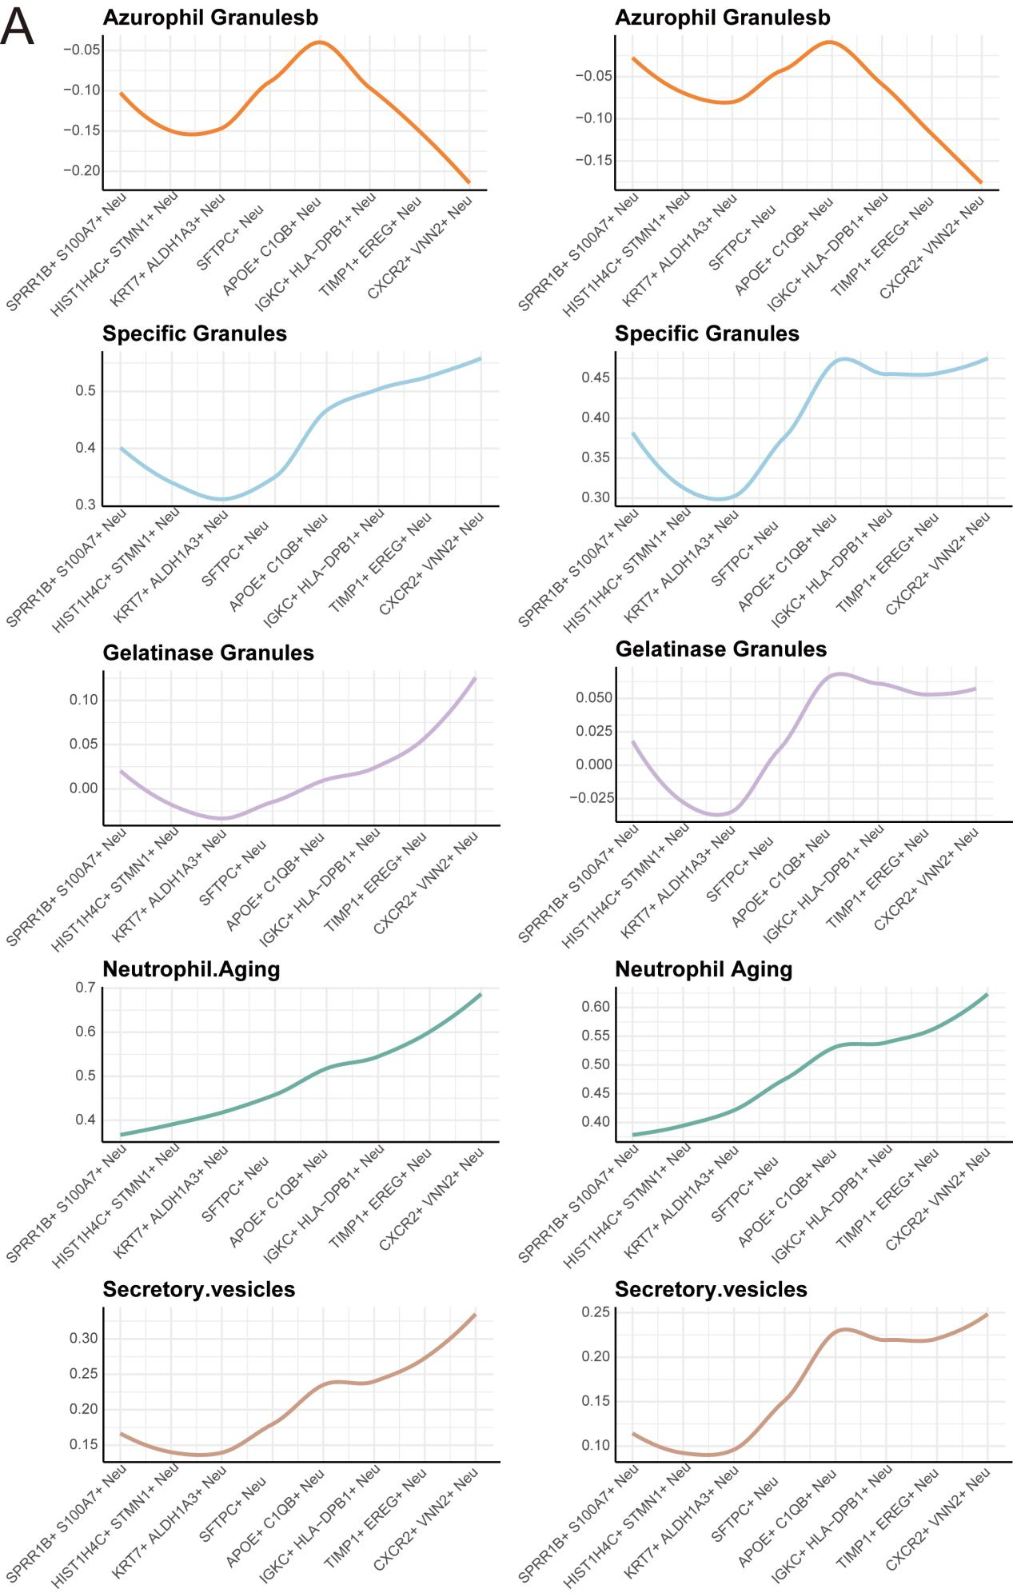
Figure S2 A. Changes in Azurophil Granulesb, Specific Granules, Gelatinase Granules, Neutrophil Aging, and Secretory vesicles scores during neutrophil evolution in tumor tissue (left) and normal tissue (right).

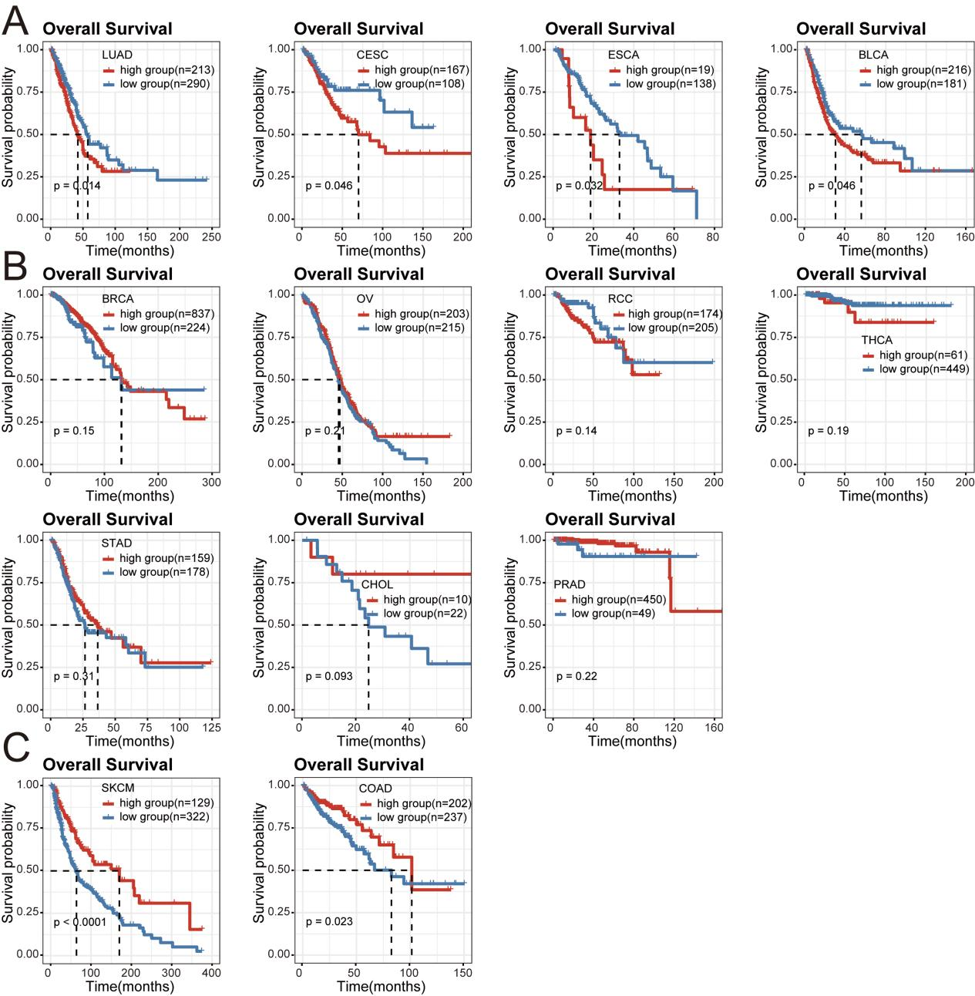
Figure S3 A. Kaplan-Meier survival curves demonstrating the difference in prognosis between patients with high and low CXCR2+ VNN2+ Neu expression in the TCGA datasets LUAD, CESC, ESCA, BLCA. B. Kaplan-Meier survival curves demonstrating the difference in prognosis between patients with high and low CXCR2+ VNN2+ Neu expression in the TCGA datasets BRCA, OV, RCC, THCA, STAD, CHOL, PRAD. C. Kaplan-Meier survival curves demonstrating the difference in prognosis between patients with high and low CXCR2+ VNN2+ Neu expression in the TCGA dataset SKCM, COAD.

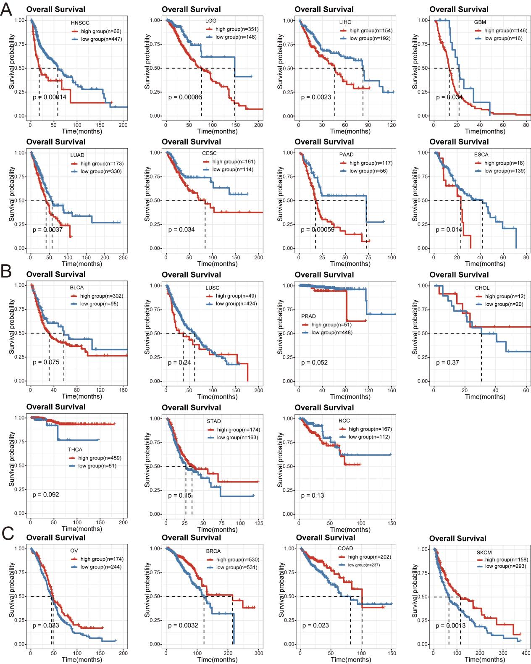
Figure S4 A. Kaplan-Meier survival curves for the prognosis of patients in the TIMP1+ EREG+ Neu high group and patients in the low group in the TCGA datasets HNSCC, LGG, LIHC, GBM, LUAD, CESC, PAAD, ESCA. B. Kaplan-Meier survival curves for the prognosis of patients in the TIMP1+ EREG+ Neu high group and patients in the low group in the TCGA datasets BLCA, LUSC, PRAD, CHOL, THCA, STAD, and RCC. C. Kaplan-Meier survival curves for the prognosis of patients in the high and low TIMP1+ EREG+ Neu groups in the TCGA dataset OV, BRCA, COAD, and SKCM.

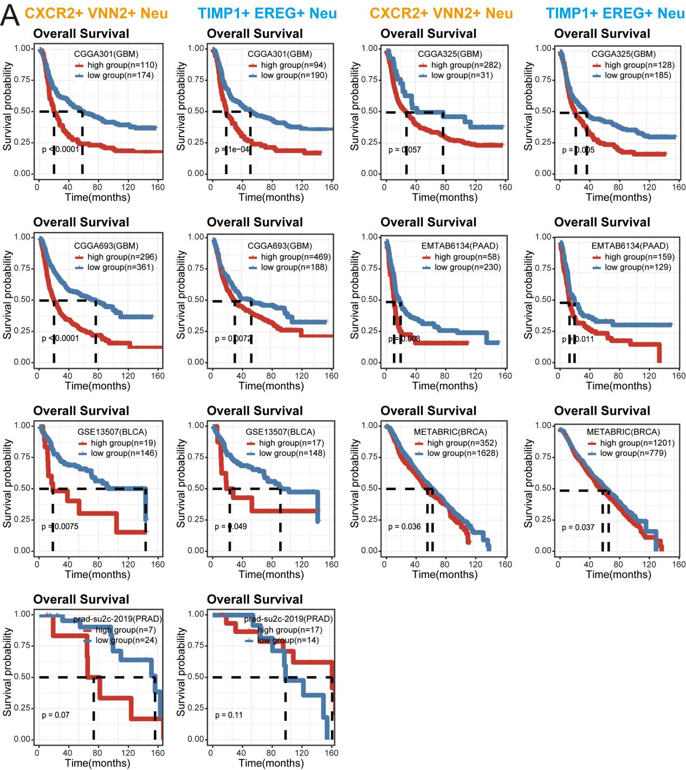
Figure S5 A. CGGA301, CGGA325, CGGA693, EMTAB6134, GSE13507, METABRIC, prad-su2c-Prognostic Kaplan-Meier survival curves for patients in the CXCR2+ VNN2+ Neu (orange), TIMP1+ EREG+ Neu (blue) high group and patients in the low group in the 2019 dataset.

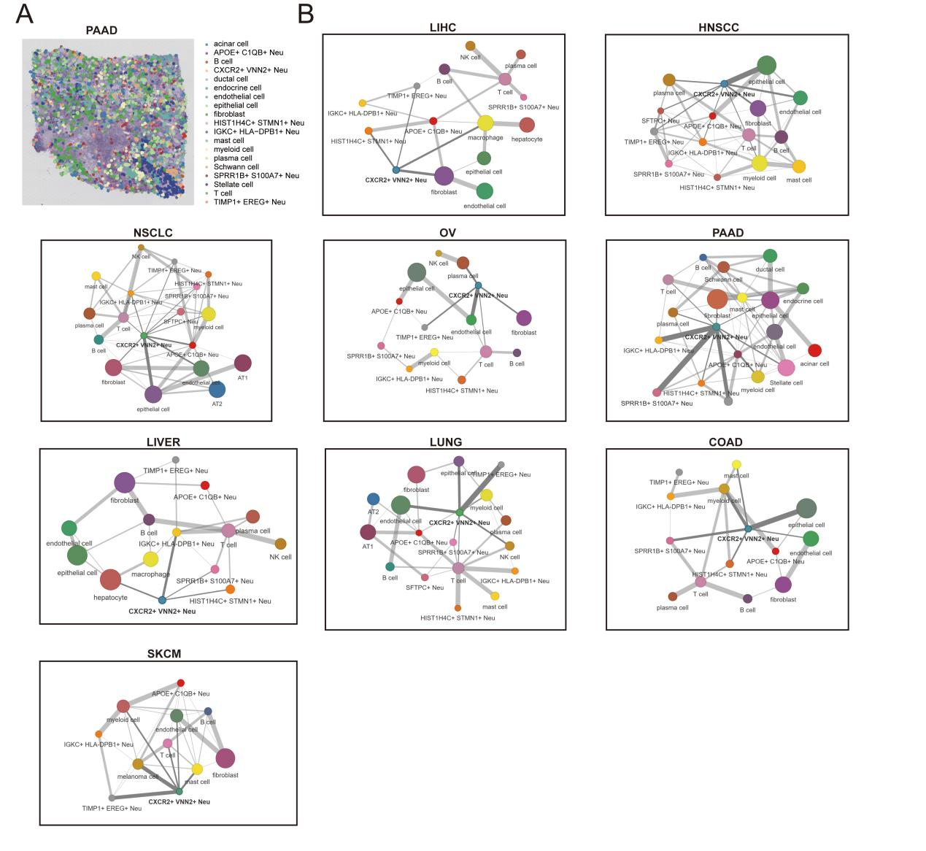
Figure S6 A. Spatial distribution of spatial transcriptome neutrophil subpopulations and neighboring cell subpopulations in PAAD patients. B. Network diagram showing interactions between neutrophil subpopulations together with other cell cell populations in LIHC, LIVER (normal liver tissue), NSCLC, LUNG (normal lung tissue), HNSCC, OV, COAD, SKCM, with thick lines indicating interactions between CXCR2+ VNN2+ Neu and other cell populations, and the size of the dots indicating the number of cell population interactions.

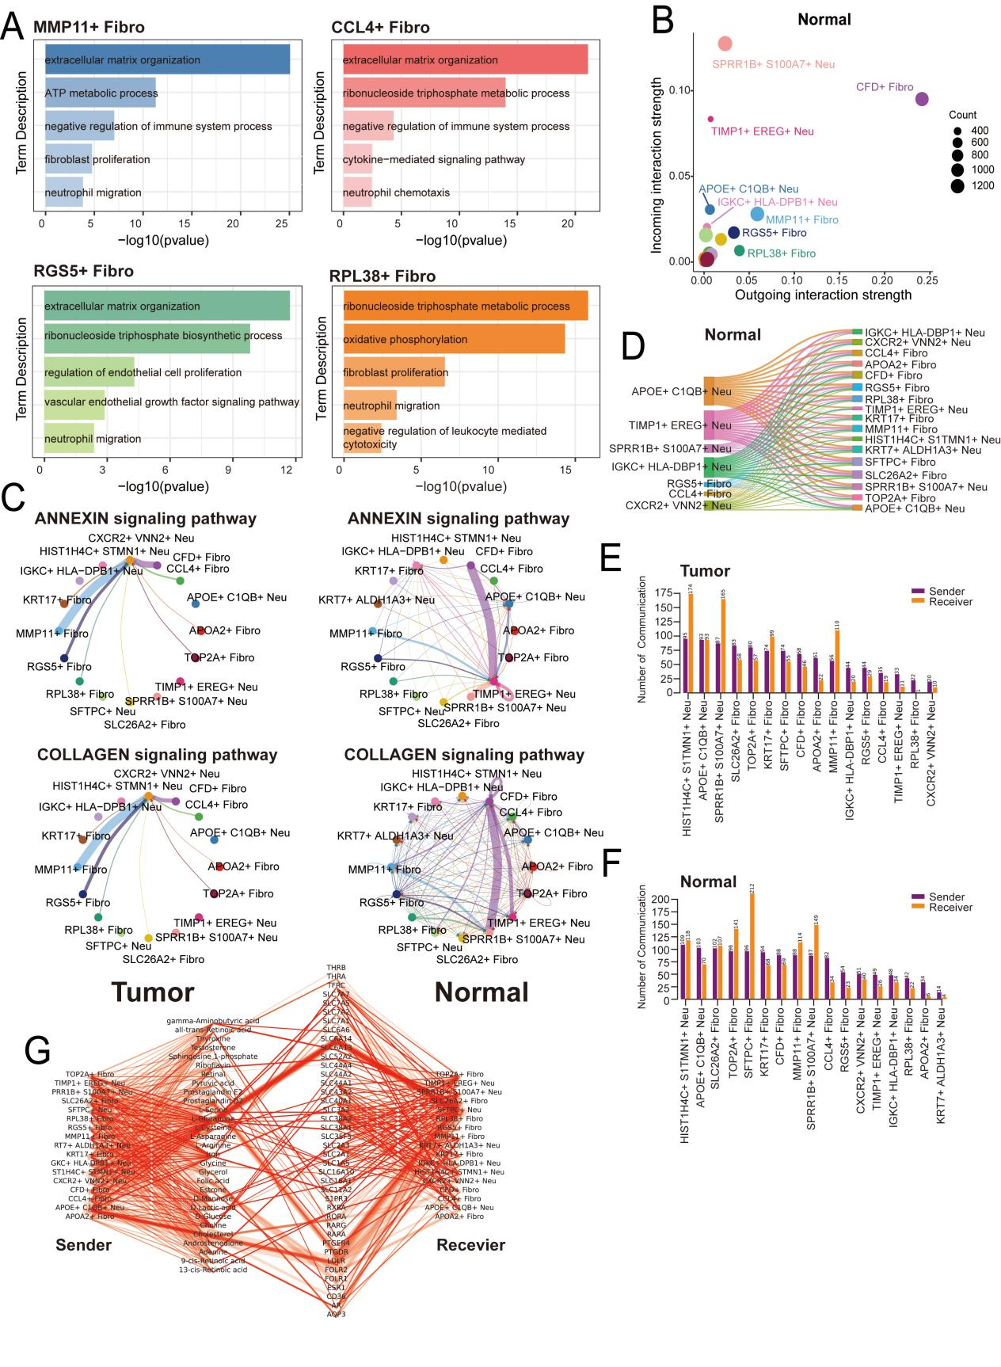
Figure S7 A. Histogram of functional enrichment analysis of MMP11+ Fibro (blue), CCL4+ Fibro (red), RGS5+ Fibro (green), and RPL38+ Fibro (orange) in tumor tissues relative to normal tissues. B. Cellular communication between fibroblast subpopulations and neutrophil subpopulations in normal tissues, with the size of the dots representing the amount of communication. C. Circle diagrams show the distribution of ANNEXIN and COLLAGEN signaling pathways in various cell subpopulations in tumor tissue (left) and normal tissue (right). D. Sankey diagram demonstrating extracellular vesicle interaction of neutrophil subpopulations and fibroblast subpopulations in normal tissue. E-F. Histogram of the number of metabolite interactions between neutrophil and fibroblast subpopulations in tumor tissue (E) and normal tissue (F), with purple representing Sender and orange representing Recevier. G. Network diagram of metabolite interactions in normal tissues, with the thickness of the line representing the intensity of the interaction.

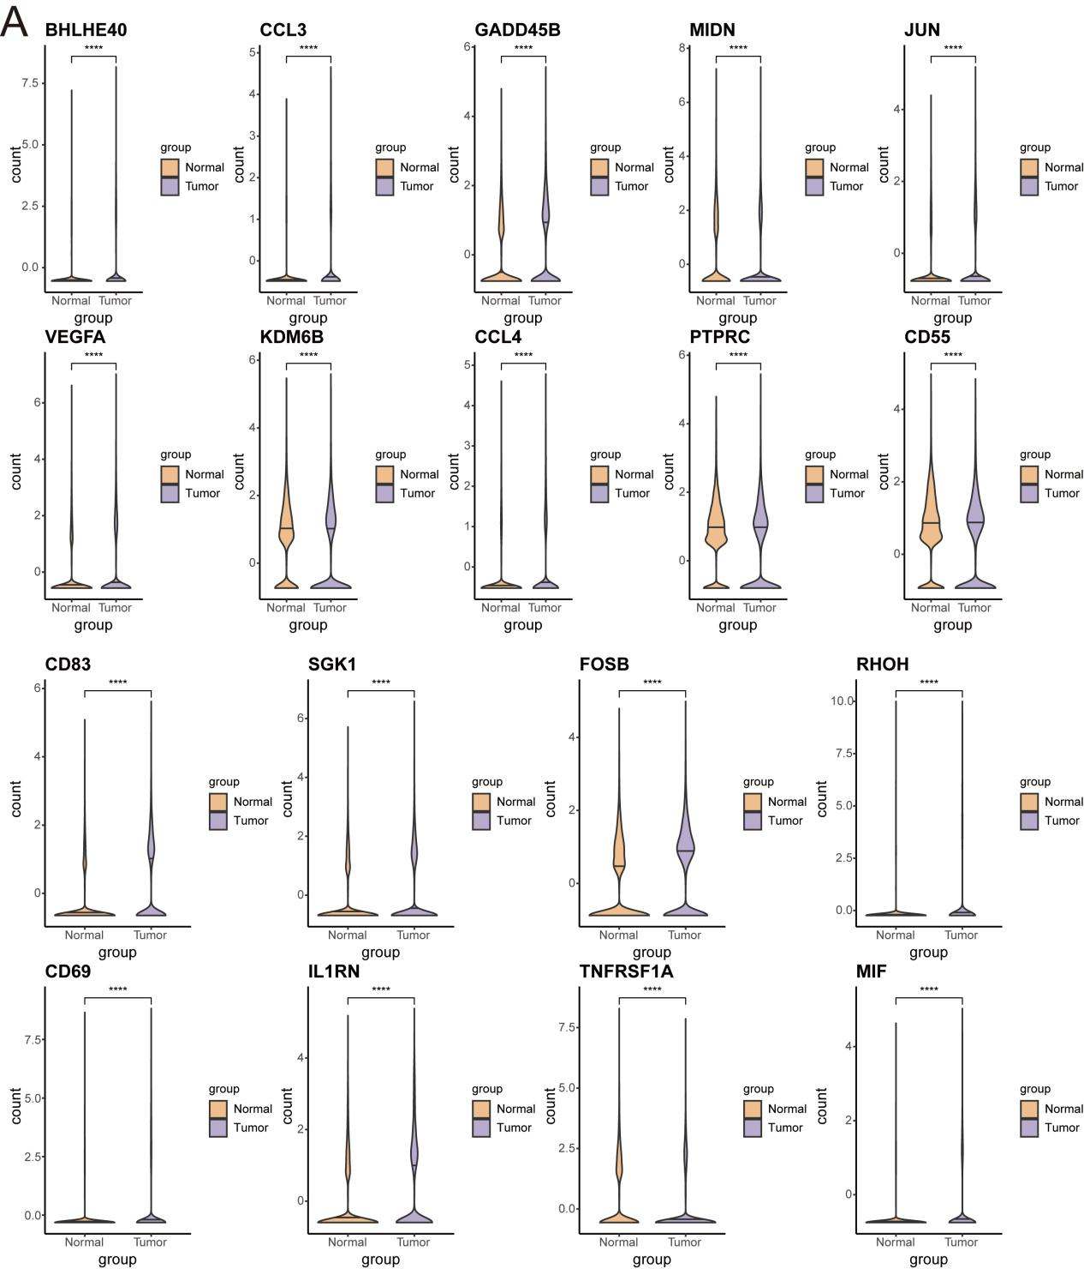
Figure S8 A. Violin plot demonstrating 18 up-regulated genes regulated by MMP11+ Fibro in CXCR2+ VNN2+ Neu of tumor tissues compared to normal tissues, with tumor tissues in purple and normal tissues in orange.

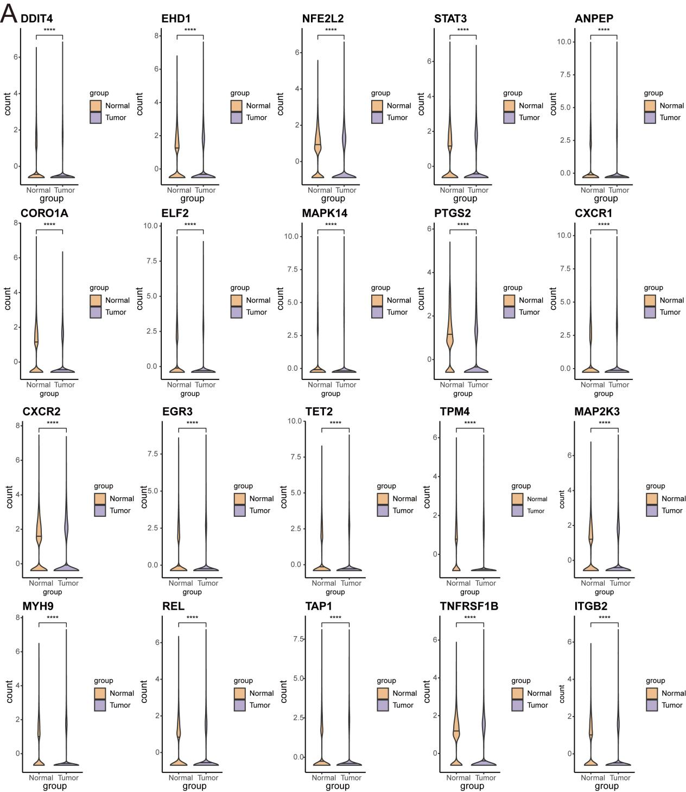
Figure S9 A. Violin plot demonstrating 20 down-regulated genes regulated by MMP11+ Fibro in CXCR2+ VNN2+ Neu of tumor tissue compared to normal tissue, with tumor tissue in purple and normal tissue in orange.

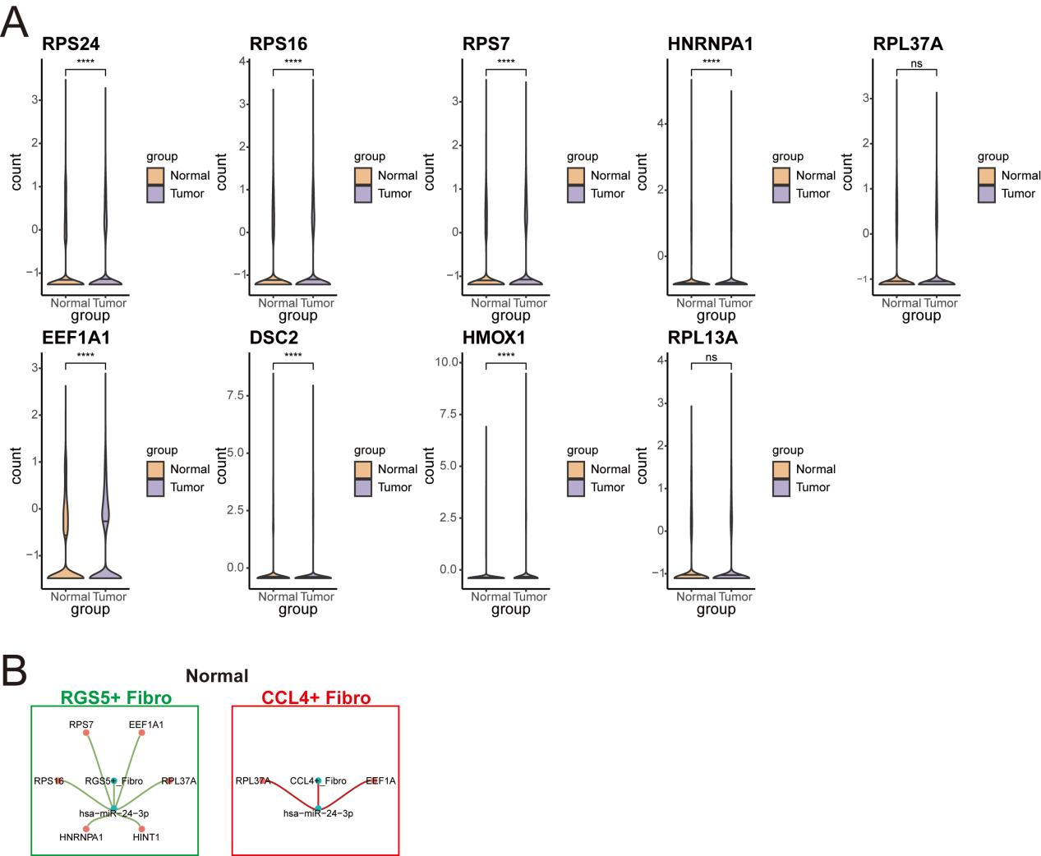
Figure S10 A. Violin plots demonstrating the differences in the expression of nine genes in CXCR2+ VNN2+ Neu regulated by fibroblasts through extracellular vesicles in tumor and normal tissues, with tumor tissues in purple and normal tissues in orange. B. Regulation of CXCR2+ VNN2+ Neu-related genes by RGS5+ Fibro (green) as well as CCL4+ Fibro (red) in normal tissues.

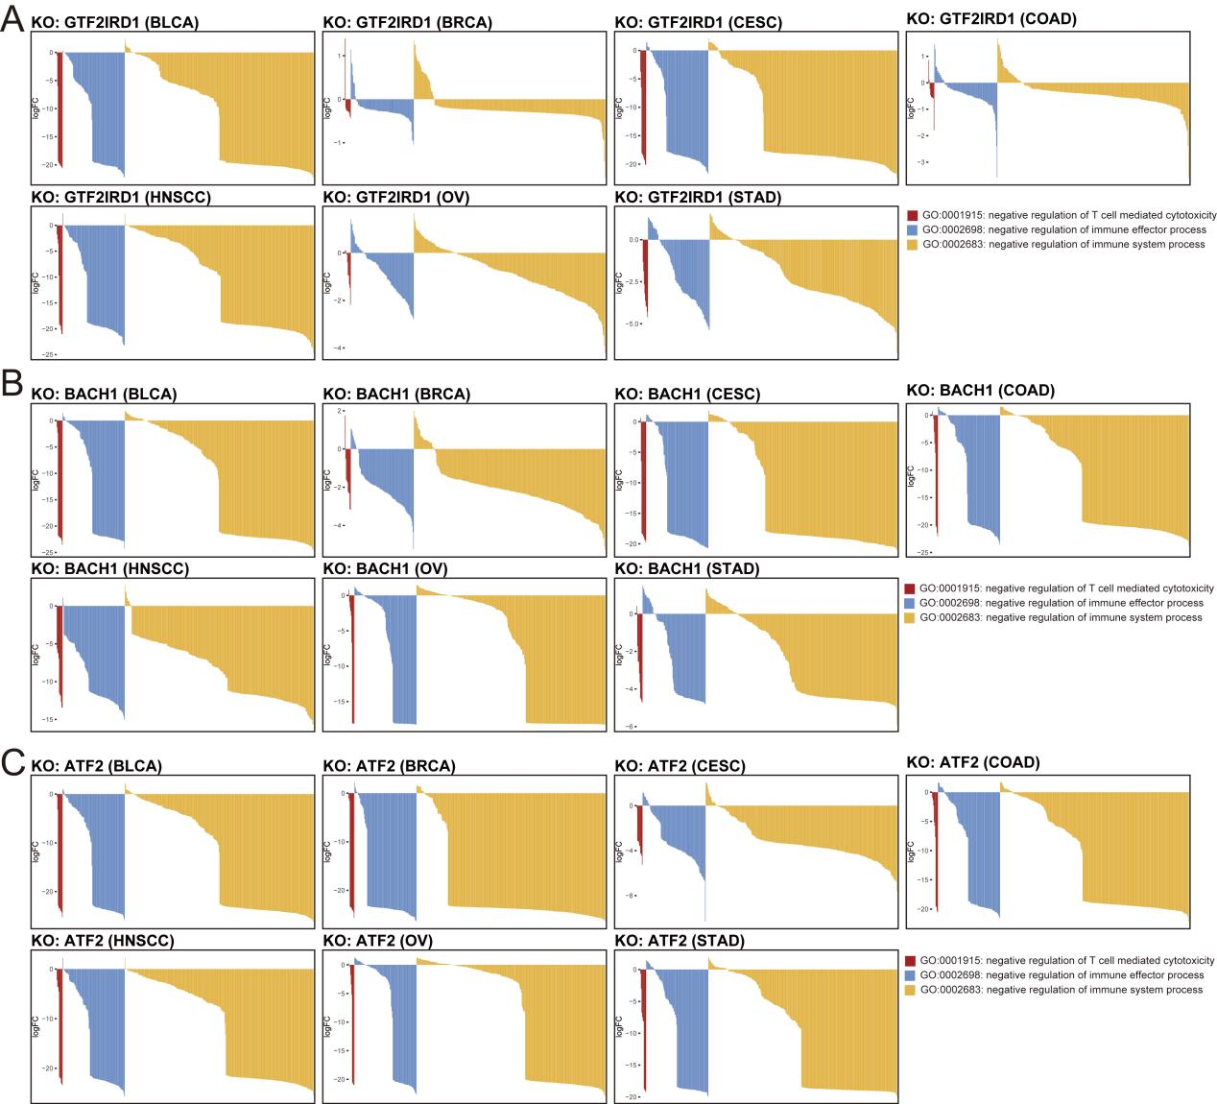
Figure S11 A Bar graph demonstrating the expression changes of 3 immunosuppressive pathway related genes in BLCA, BRCA, CESC, COAD, HNSCC, OV, STAD with knockdown of GTF2IRD1, GO:0001915 (red), GO:0002698 (blue) and GO:0002683 yellow). B Bar graph demonstrating the expression changes of 3 immunosuppressive pathway-related genes in BLCA, BRCA, CESC, COAD, HNSCC, OV, and STAD with knockdown of BACH1, GO:0001915(red), GO:0002698(blue) and GO:0002683 yellow). C Bar graph showing the expression changes of 3 immunosuppressive pathway-related genes in BLCA, BRCA, CESC, COAD, HNSCC, OV, and STAD with knockdown of ATF2, GO:0001915(red), GO:0002698(blue) and GO:0002683 yellow).

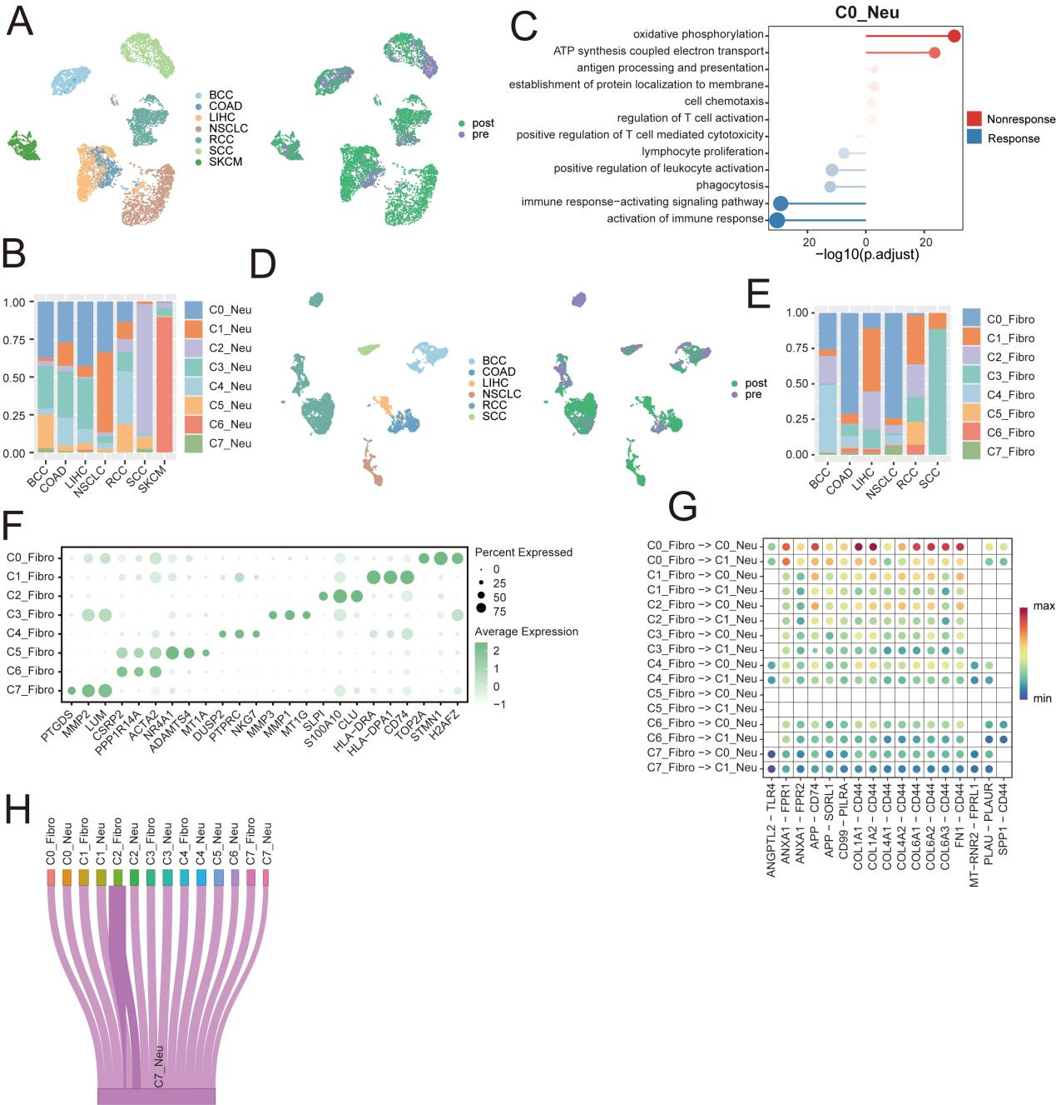
Figure S12 A. UMAP plot of the distribution of neutrophils in the immunotherapy cohort across cancer types (left) and in treatment-responsive and non-responsive patients (right). B. Bar graph showing the distribution of the 8 neutrophil subpopulations across cancer types. C. Functional enrichment analysis of C0_Neu in treatment non-responders (red) and responders (blue). D. UMAP plot of the distribution of immunotherapy cohort fibroblasts in different cancer types (left) as well as in treatment-responsive and non-responsive patients (right). E. Bar graph showing the distribution of 8 fibroblast subpopulations in different cancer types. F. Bubble diagram showing marker genes of the 8 fibroblast subpopulations. G. Cellular communication between fibroblast subpopulations and C0_Neu and C1_Neu in patients responding to immunotherapy. H. Sankey diagram of extracellular vesicle-mediated cellular interactions between neutrophils and fibroblast subpopulations in patients responding to immunotherapy.

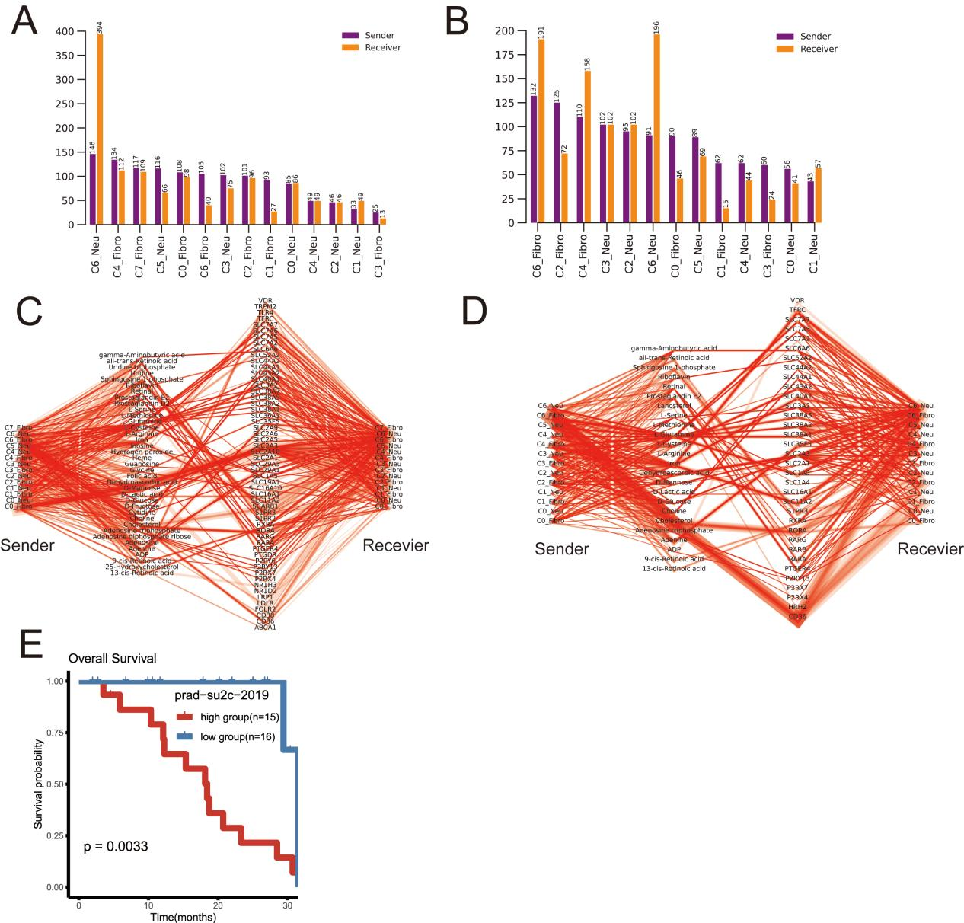
Figure S13 A-B. Histogram of the number of metabolite-mediated cell interactions in immunotherapy non-responding patients (left) and immunotherapy responding patients (right). C-D. Network diagram showing metabolite-mediated cell interactions in immunotherapy-non responding patients (left) and immunotherapy-responding patients (right), from left to right, signaling SENDER, METABOLITE, SENSOR, and SIGNALING RECEIVER. E. prad-su2c-2019 cohort constitutes the test set, with patients in the high-scoring group (red) and patients in the low-scoring group (blue) prognostic Kaplan-Meier survival curves.

