Supplemental Information for:
Identifying the effects of new technologies for extreme flood adaptation in China
Table of contents of the Supplemental Information：

Text.S1 Data retrieval and pre-processing 3

Text.S2 Flood Loss Perception Dictionary for multiple sectoral classification 3

Text.S3 LDA modelling 4

Text.S4 Mode decomposition of flood loss perception index 5

Text.S5 Discount factor transformation for precipitation data 6

Text.S6 Mathematical background in structural equation modeling 7

Table.S1 Precipitation observatory information of Zhengzhou and its area through the Tyson polygon 8

Table.S2 Precipitation observatory information of Xinxiang and its area through the Tyson polygon 8

Table.S3 Multisectoral Flood Loss Perception Dictionaries 9

Table.S4 Terms related to five sectors 10

Table.S5 Granger causality test of Flood Loss Perception and maximum rainfall 11

Table.S6 Results of structural equation model for casualty loss perception (CA1) 12

Table.S7 Results of structural equation model for communication perception（C1） 13

Table.S8 Results of structural equation model for water and electricity supply perception (WE1) 14

Table.S9 Results of structural equation model for transport perception (T1) 15

Table.S10 Results of structural equation model for building perception (B1) 16

Table.S11 Ranking the top 30 LSD topic word by weight 17

Table.S12 Ranking the top 30 UAV topic word by weight 18

Table.S13 Ranking the top 30 AMap topic word by weight 19

Table.S14 Ranking the top 30 DW topic word by weight 20

Table.S15 Ranking the top 30 BS topic word by weight 21

Table.S16 Ranking the top 30 MC topic word by weight 22

Table.S17 Ranking the top 30 MP topic word by weight 23

Table.S18 Description of symbols and formulas 24

Table.S19 Interpretation of the statistics used 25

Statistics 25

Table.S20 Performance of text classification model 26

Figure.S1 Max rainfall indicator 26

Figure.S2 The proportion of the four most popular technology strategies discussed on the Weibo platform 27

Figure.S3 Land use in Henan Province 28

Figure.S4 The Wing Loong UAV 28

Figure.S5 Life-saving documents 29

Figure.S6 The "Dragon Water" drainage device (DW) 30

Figure.S7 AMap 31

Figure.S8 Comparison of multiple path models for casualty loss perception 32

Figure.S9 Comparison of multiple path models for transport loss perception 33

Figure.S10 Comparison of multiple path models for communication loss perception 34

Figure.S11 Comparison of multiple path models for water and electricity supply loss perception 35

Figure.S12 Comparison of multiple path models for building loss perception 36

Text.S1 Data retrieval and pre-processing
We collected Weibo data sets with hourly rainfall data in this study. Weibo is one of most popular social platforms in China. We collected all the microblogs from July 10, 2021 to August 10, 2021 that were simultaneously related to two key words, “Henan” and “flood”. According to users with IP addresses in Henan Province, a total of 3586895 posts were posted during the flood in Henan. Weibo data set consists of three fields, release time, user name and published content. Release time is the exact time a user posts information to Weibo platform, and it is accurate to minute-level. The three steps of data preprocessing are as follows:
Step 1: Data cleaning. Specifically, in terms of the first sub-step, the valuable microblogs were retained by removing the irrelevant microblogs (such as high-frequency words and non-Chinese language review) among the collected microblogs. Meanwhile, reviews that were repeated within a short period of time are deleted.
Step 2: Tokenization and removing stop words. Next, an effective Python program based on Jieba toolkit , an extensively used Chinese word tokenization tool, is developed for segmenting the review words. And then, we removed the stop words that provided limited review information.
Step 3: We filtered the Weibo dataset for words related to technical tools during the Henan flood disaster, including life-saving documents (救命文档), Dragon Water (龙吸水), lifesaving robot (救生机器人), UAV (无人机), AMap (高德地图), Smart Water (智慧水务), and other emerging technologies. The frequency of these words was extracted and counted on an hourly basis to create the emerging technology index. Using this index, we specifically extracted the emerging technology-related microblog dataset (Tech dataset) from the original Weibo dataset. The Tech dataset, consisting of 9,629 microblogs, reflects the public's perception and evaluation of emerging technologies during the Henan flooding, providing insight into the effectiveness of these technologies from a public perspective. Similarly, we utilized multisectoral terms (see Appendix Table.1) to extract a microblogging dataset that captures flood perceptions across multiple sectors.

Text.S2 Flood Loss Perception Dictionary for multiple sectoral classification
Urban flooding leads to severe damages that affect all aspects of the urban system¹. We classified the Weibo data used in this study into six sectoral datasets based on related sectoral words. Appendix Table 1 presents the specific sectoral words and the size of each corresponding dataset after classification.
The flood perception dictionary was constructed based on the following process (refer to the Appendix for the flood perception dictionary). Next, we will process the microblog data of various topics, divided by the aforementioned steps, as indicated in Figure 2.
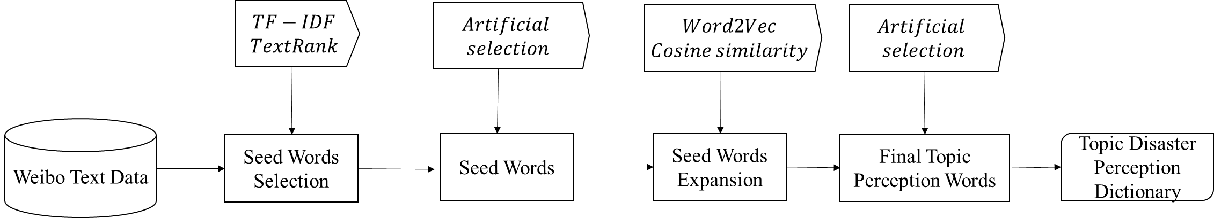
Fig. 2 Flood awareness dictionary construction processes for multiple sectoral

Step 1: The initial screening of seed words involves a keyword extraction algorithm that utilizes TF-IDF (Term Frequency-Inverse Document Frequency)² and TextRank³ for the microblog data of relevant topics. TF-IDF is a method used to measure the significance of a word in a specific document collection or corpus. It is defined as:
$$\begin{aligned}tfidf\left(t,d,D\right)=f_{t,d}∙\log{\frac{N}{n_{t}}}\#\left(1\right)\end{aligned}$$
Where, $f_{t,d}$ is the original frequency of term $t$ in document d, N is the total number of documents in the corpus, and $n_{t}$ is the total number of documents containing term $t$ appearing at least once.
TextRank algorithm considers each word in the microblog text as a graph point and sorts them based on a voting principle. The resulting weighted directed graph G includes every word, which constitutes point set V, and edges represented by the co-occurrence relationship between words that form edge set E. The edge weight is denoted as w. In addition, In(V) represents a set of other points that point to point V, and Out(V) represents a set of points that point from point V to other points. TextRank is calculated using the following formula:
$$\begin{aligned}WS\left(V_{i}\right)=\left(1-d\right)+d×\sum_{V_{i}∈In\left(V_{i}\right)}{\frac{w_{ji}}{\sum_{V_{k}∈Out\left(V_{j}\right)}{w_{ji}}}WS\left(V_{j}\right)}\#\left(2\right)\end{aligned}$$

Where, $d∈[0,1]$ is the damping coefficient, which represents the probability of pointing from one point in the graph to any other point, normally $d$ is 0.85.
Step 2: the preliminary screening results were manually screened, mainly to remove some obviously unreasonable words.
Step 3: We used Word2Vec(38, 39) to represent and map each word in the microblog text into a corresponding word vector.^{4, 5}. Word2Vec is a shallow neural network-based computational tool for generating word vectors. It can efficiently compute word vectors on a large dataset, and the similarity between words can be accurately measured by calculating cosine similarity between their corresponding word vectors.
$$\begin{aligned}COS_{w_{i},w_{j}}=\frac{I∙J}{\left|\left|I\right|\right|∙\left|\left|J\right|\right|}\#\left(3\right)\end{aligned}$$
where $i$ is the serial number of the word, $w_{i}$ is a word, I is word vector of i-word, J is word vector of j-word.
Following this, we expanded upon the seed words using word vector cosine similarity and selected the top 100 words with the highest similarity scores. We then conducted a secondary manual screening process to eliminate irrelevant words and obtained the final flood disaster perception dictionary for specific sectors. This procedure was repeated for each of the six sectors' microblog data to develop their respective perception dictionaries.

Text.S3 LDA modelling
The LDA model works on the assumption that each comment is a combination of different topics and that each topic has a probability distribution for different words used in the comment. To elaborate further, each comment is treated as a multinomial distribution θ(c) of the topic T, with each topic $T_{j}$, j=1, 2, …t. A multinomial distribution ϕ(j) over a set of words is assumed. To uncover the existing topics from the microblog corpus, and the distribution of these topics within each comment, it is necessary to estimate the values of θ and ϕ. Generally, it is challenging to calculate various distributions and exact extrapolations of word probabilities for each topic in this model. In this study, we utilized Gibbs sampling, which is a widely-used method for approximate reasoning, to estimate these distributions ^{2, 6}.

Text.S4 Mode decomposition of flood loss perception index
From a temporal perspective, both the flood perception index and emerging technology index, derived from microblog comments, exhibit day-night periodicity. People tend to post more microblogs during the day than at night when they are asleep, resulting in a regular signal fluctuation caused by the day-night cycle.
To investigate the relation between emerging technology and disaster recovery, we employed the Variational mode decomposition (VMD)⁷ technique to decompose time series of the emerging technology index and the flood disaster perception index into high frequency and low frequency signals. The high-frequency signals primarily reflect the trend influenced by day and night, while the low-frequency signals primarily reflect the main trend influenced by heavy rain events.
Dragomiretskiy and Zosso introduced the Variational Mode Decomposition (VMD) as a new, multi-resolution technique for non-recursive signal processing in 2014. VMD employs adaptive decomposition of real-valued signals (f(t)) into a discrete number of Basis Intrinsic Mode Functions (BIMF). Each BIMF ($u_{k}$) is centred around a pulsation ($ω_{k}$) that is determined during the decomposition process. The bandwidth of each BIMF is estimated using the Gaussian smoothness function (H1) of the shifted signal, with the method implementing constrained variational problem-solving, as shown in Equation 1.
$$\begin{aligned}\left\{\begin{aligned}\min_{\left\{u_{k}\right\}，\left\{ω_{k}\right\}}\left\{\sum_{k=1}^{K}{{\left|\left|∂_{t}\left\{\left[δ\left(t\right)+\frac{j}{πt}\right]*u_{k}\left(t\right)\right\}e^{-jw_{k}t}\right|\right|}_{2}^{2}}\right. \\ s.t. \sum_{k=1}^{K}{u_{k}} \end{aligned}\right.\#\left(4\right)\end{aligned}$$
The introduction of augmented Lagrangian multipliers (λ) transforms the aforementioned constrained optimization problem for VMD into an unconstrained problem. Equation (2) illustrates the augmented Lagrangian multiplier, where the balancing parameter of the data-fidelity constraint is represented by α.
$$\begin{aligned}L\left(\left\{u_{k}\right\},\left\{ω_{k}\right\},λ\right)=α\sum_{k=1}^{K}{\left|\left|∂_{t}\left\{\left[δ\left(t\right)+\frac{j}{πt}\right]*u_{k}\left(t\right)\right\}e^{-jw_{k}t}\right|\right|}+ \\ {\left|\left|f\left(t\right)-\sum_{k=1}^{K}{u_{k}\left(t\right)}\right|\right|}_{2}^{2}+〈λ\left(t\right),f\left(t\right)-\sum_{k=1}^{K}{u_{k}\left(t\right)}〉\#\left(5\right)\end{aligned}$$
The optimal solutions for $u_{k}$,$w_{k}$and λ are settled using the Alternate Direction Method of Multipliers (ADMM), which is written as:
$$\begin{aligned}{\hat{u}}_{k}^{n+1}=\frac{\tilde{f}\left(ω\right)-\sum_{i≠k}{{\hat{u}}_{i}^{n}\left(ω\right)}+\frac{\hat{λ}\left(ω\right)}{2}}{1+2α{\left(ω-ω_{k}\right)}^{2}}\#\left(6\right)\end{aligned}$$
$$\begin{aligned}{\hat{ω}}_{k}^{n+1}=\frac{\int_{0}^{∞}{ ω{\left|{\hat{u}}_{k}\left(ω\right)\right|}^{2}dω }}{\int_{0}^{∞}{ {\left|{\hat{u}}_{k}\left(ω\right)\right|}^{2}dω }}\#\left(7\right)\end{aligned}$$
$$\begin{aligned}{\hat{λ}}^{n+1}\left(ω\right)={\hat{λ}}^{n}\left(ω\right)+γ\left[\hat{f}\left(ω\right)-\sum_{k=1}^{K}{{\hat{u}}_{k}^{n+1}}\right]\#\left(8\right)\end{aligned}$$
where $\tilde{f}\left(ω\right)$, ${\hat{u}}_{i}^{n}\left(ω\right)$, $\tilde{λ}\left(ω\right)$ and ${\hat{u}}_{i}^{n+1}\left(ω\right)$ represent the Fourier transforms of $f(t)$, and n is the number of iterations. The complete processes if VMD are explained as followed:
(a) Initialize the{ˆm1k},{ˆw1k},ˆλ1and n, where n=0;
(b) update the $u_{k}$,$w_{k}$ and λ according to the formulas(3)-(5)
(c) Given a threshold ε, if the condition is met:$\sum_{k=1}^{K}{{\left|\left|{\hat{u}}_{k}^{n+1}-{\hat{u}}_{k}^{n}\right|\right|}_{2}^{2}//\left|\left|{\hat{u}}_{k}^{n}\right|\right|<ε}$, stop the iteration else repeat step 2 to 5.

Text.S5 Discount factor transformation for precipitation data
The adoption of emerging technologies during flooding disaster has an immediate impact on urban flood mitigation, but their effect diminishes over time. To capture this concept, a discount factor^{8, 9} was introduced to adjust the time series of the emerging technology index. The discount factor represents the current share equivalent to one past or future share, and typically ranges between 0 and 1. In this study, a discount factor of 0.8 was used.
$$\begin{aligned}I_{t}^{'}=I_{t}+αI_{t-1}+α^{2}I_{t-2}+α^{3}I_{t-3}+…+α^{p}I_{t-p}\#\left(9\right)\end{aligned}$$
The lasting impact of rainfall and emerging technologies during flood disaster relief is accounted for by discounting the past share of each to its present value. This process involves adjusting the value of past shares to current values to accurately reflect their current impact on urban flood mitigation. Since the maximum lag order between flood perception and rainfall is 6, we determine the value of p to be 6 in this work.

Text.S6 Mathematical background in structural equation modeling
Structural equation modeling (SEM) is a multivariate statistical technique that integrates factor analysis and path analysis, which is suitable for quantitative research on the interaction between multiple variables. The basic structural equation model is divided into two parts: measurement equation and structural equation. The measurement equation is used to express the relationship between the latent variables and the observed indicators, and the structural equation is used to express the relationship between the potential endogenous variables and the potential exogenous variables.
- Measurement equation
The measurement equation is a confirmatory factor analysis model used to link latent variables with their corresponding observable variables (explicit indicators), and to account for measurement error, this part can be viewed as a regression model by the regression of observable variables on a small number of latent variables. The measurement equation is shown below
$$y_{i}=∆ω_{i}+ε_{i}, i=1,…,n$$
Here, $y_{i}$ is the $p×1$ dimension observable random vector, $∆$ is $p×q$ dimension Factor loading matrix, $ω_{i}=(η_{i}^{T}, ξ_{i}^{T})$ is latent variable, where is the potential dependent variable and is the potential independent variable, $ε_{i}$ is the error difference term independent of $ω_{i}$. Suppose $ε_{i}$follows the N [0, Ψε] distribution and Ψε is a diagonal matrix.

- Structural equation
A structural equation is a regressive structural equation in which the endogenous latent variables are regressed on the linear terms of a number of endogenous and exogenous latent variables. The structural equation is as follows:
$$η_{i}=\prod{η_{i}+Γξ_{i}+δ_{i},}i=1,…,n$$
Here, ∏ (q₁ ×q₁) and Γ (q₁ ×q₂) are the matrix of unknown regression coefficients, δ_{i} is the q₁ ×1 error term. Suppose that it follows the N [0, Φ] distribution and δ_{i} follows the N [0, Ψ_{δ}] distribution, where Ψ_{δ} is a diagonal matrix and is independent of δ_{i}.
In this paper, we use the Diagonally Weighted Least Squares(DWLS)¹⁰ method to estimate the structural equation model based on the establishment of the sample covariance matrix S.

Table.S1 Precipitation observatory information of Zhengzhou and its area through the Tyson polygon
Station number | longitude | latitude | District (county) | area | Tyson area ratio
57084 | 113.05 | 34.5 | Songshan | 462.8875995 | 0.061557
57080 | 112.97 | 34.73 | Gongyi | 777.08164 | 0.103341
57082 | 113.02 | 34.47 | Dengfeng | 811.4508506 | 0.107911
57081 | 113.43 | 34.8 | Xingyang | 1021.602965 | 0.135858
57083 | 113.65 | 34.72 | Zhengzhou | 1013.869432 | 0.13483
57085 | 113.33 | 34.53 | Xinmi | 1059.550678 | 0.140905
57086 | 113.72 | 34.38 | Xinzheng | 913.6703192 | 0.121505
57090 | 113.97 | 34.72 | Zhongmou | 1459.502744 | 0.194093

Table.S2 Precipitation observatory information of Xinxiang and its area through the Tyson polygon
Station number | longitude | latitude | District (county) | area | Tyson area ratio
53994 | 114.07 | 35.38 | Weihui | 958.7253907 | 0.115794
53986 | 113.88 | 35.32 | Xinxiang | 477.8357608 | 0.057713
53988 | 113.67 | 35.27 | Huojia | 1274.942924 | 0.153986
53997 | 114.18 | 35.15 | Yanjin | 892.7160325 | 0.107821
53989 | 113.98 | 35.08 | Yuanyang | 992.7955328 | 0.119909
53983 | 114.42 | 35.03 | Fengqiu | 899.4273955 | 0.108632
53985 | 113.82 | 35.5 | Huixian | 1434.325462 | 0.173236
53998 | 114.65 | 35.2 | Changyuan | 1348.812279 | 0.162908

Table.S3 Multisectoral Flood Loss Perception Dictionaries
Dict Name | Dict Content
Transport  perception dictionary | '瘫痪','湿滑','积水','堵塞','封闭','预警','中断','不便','事故','断行','瘫痪','淹','失望','受阻','停运','拥堵','趟水','被困','停','打不到车','堵','过不去','不畅','进水','塌方','塌','落石','延误','灌水','中断','拥挤','阻碍','缓慢','倒灌','进退两难','停滞','封','被封','揪心','担忧','停摆','塌陷','不好','隔绝','不稳定','不畅通','时有时无','问题','故障','时好时坏','微弱' ,'满目疮痍','混乱','被淹','交通拥堵','交通不便','坍塌','淹没','受损','受灾','崩溃','封闭','毁','被淹'
Building  perception dictionary | '倒塌','坍塌', '被淹', '冲毁', '受损','冲断','塌陷','损坏', '损毁','冲垮','冲塌', '裂开', '危房', '要塌','尽毁','摧毁','晃动','垮塌', '倾倒','巨大损失','破损','震塌','断裂','毁损','沉陷','塌掉','泡坏','塌陷','冲塌','泡坏','震塌','震动','被砸','砸断','砸伤','震碎','被淹','漏水','保不住','冲没','被刮','塌','倒塌','被埋','坍塌','渗水','倒塌','冲塌','塌了','泡塌', '淹没','夷为平地','开裂'
Water and electricity supply perception dictionary | '切断','停了','停','裂开','全停','不通','没有','中断','失联','已断','缺少','影响','断了','断掉','切断','停水','停电','断水','断电','停','没来','不通'
Communication perception dictionary | '断','失联','无网络','无通信','中断','信号太差','困难','险情','瘫痪','被困','远古时代','退服','受损','差','极差','阻断','失去','无服务','打不出去','弱','无法','影响','异常','断掉','时断时续','停','太差','间断','没有','没','反反复复','断断续续','不好','停摆','槽糕','暴力','发不出来','无','较差','不行'
Casualty  perception  dictionary | '遇难','人员伤亡','伤亡','伤亡惨重','过高','伤亡人数','不计其数','惨重','失踪','魂灵','流离失所','受伤'

Table.S4 Terms related to five sectors
Several thematic  data sets | Several topic classification method
Traffic | “交通”(“traffic”)，公路(“highway”)，地铁(“subway”)，公交(“bus”)，运输(“transport”)
Water and electricity | 水（waster），电(electricity)
Communication | 通讯(communication)，网络(network)，信号(signal)，光缆(cable)
Casualties | 受伤(injured)，死亡(death)，伤亡(casualties)，遇难(killed)
Building | 建筑(building)，房屋(housing)，房子(house)

Table.S5 Granger causality test of Flood Loss Perception and maximum rainfall
Lag order | FLP | CMLP | CALP | TRLP | BDLP | WELP
1 | 2.374  (0.124) | 0.782  (0.377) | 0.496  (0.481) | 0.927  (0.336) | 3.391  (0.066) | 8.299  (0.004)
2 | 2.987  (0.051) | 19.281  (0.000) | 0.238  (0.787) | 0.473  (0.623) | 3.642  (0.027) | 4.000  (0.019)
3 | 3.157  (0.025) | 12.091  (0.000) | 0.225  (0.878) | 0.356  (0.784) | 4.479  (0.004) | 9.212  (0.000)
4 | 3.021  (0.018) | 8.027  (0.000) | 3.407  (0.009) | 0.504  (0.732) | 2.904  (0.022) | 11.277  (0.000)
5 | 2.416  (0.036) | 6.314  (0.000) | 3.496  (0.004) | 1.012  (0.410) | 2.281  (0.046) | 8.882  (0.000)
6 | 6.796  (0.000) | 5.434  (0.000) | 8.252  (0.000) | 3.655  (0.001) | 2.744  (0.013) | 15.161  (0.000)
7 | 7.006  (0.000) | 5.175  (0.000) | 9.405  (0.000) | 3.511  (0.001) | 2.273  (0.028) | 15.354  (0.000)
Note: The F test value is shown in the table, and the corresponding p value is shown in parentheses. The lag order between the loss index of different industries and the maximum rainfall is different.

Table.S6 Results of structural equation model for casualty loss perception (CA1)

lval | op | rval | Estimate | Std. Err | z-value | p-value
REE | ~ | UAV | 0.078112 | 0.043703 | 1.787334 | 7.388354e-02
REE | ~ | Rain | -0.114023 | 0.041453 | -2.750628 | 5.948112e-03
REE | ~ | LSD | 0.577588 | 0.039721 | 14.541164 | 0.000000e+00
LSD | ~ | UAV | 0.309267 | 0.062219 | 4.970583 | 6.675172e-07
LSD | ~ | Rain | 0.661908 | 0.047544 | 13.921875 | 0.000000e+00
d_CALP | ~ | UAV | -0.364807 | 0.046905 | -7.777603 | 7.327472e-15
d_CALP | ~ | Rain | 0.708172 | 0.044823 | 15.799347 | 0.000000e+00
d_CALP | ~ | LSD | -0.302967 | 0.055831 | -5.426501 | 5.746936e-08
d_CALP | ~ | REE | -0.192869 | 0.062894 | -3.066549 | 2.165454e-03
REE | ~~ | REE | 0.540090 | 0.045008 | 12.000000 | 0.000000e+00
LSD | ~~ | LSD | 1.188600 | 0.099050 | 12.000000 | 0.000000e+00
d_CALP | ~~ | d_CALP | 0.615294 | 0.051275 | 12.000000 | 0.000000e+00
Note: ∼ to specify structural part, =∼ to specify measurement part, ∼∼ to specify common variance between variables.

Table.S7 Results of structural equation model for communication perception（C1）

lval | op | rval | Estimate | Std. Err | z-value | p-value
REE | ~ | UAV | 0.078264 | 0.043709 | 1.790557 | 7.336438e-02
REE | ~ | Rain | -0.114280 | 0.041463 | -2.756194 | 5.847823e-03
REE | ~ | LSD | 0.577762 | 0.039730 | 14.542099 | 0.000000e+00
LSD | ~ | UAV | 0.308821 | 0.062220 | 4.963334 | 6.929336e-07
LSD | ~ | Rain | 0.661888 | 0.047545 | 13.921253 | 0.000000e+00
d_CMLP | ~ | UAV | -0.608689 | 0.045401 | -13.406894 | 0.000000e+00
d_CMLP | ~ | Rain | 0.740413 | 0.043392 | 17.063524 | 0.000000e+00
d_CMLP | ~ | LSD | -0.099499 | 0.054047 | -1.840977 | 6.562486e-02
d_CMLP | ~ | REE | -0.203238 | 0.060869 | -3.338969 | 8.408982e-04
LSD | ~~ | LSD | 1.188635 | 0.099053 | 12.000000 | 0.000000e+00
REE | ~~ | REE | 0.540362 | 0.045030 | 12.000000 | 0.000000e+00
d_CMLP | ~~ | d_CMLP | 0.576587 | 0.048049 | 12.000000 | 0.000000e+00
Note: ∼ to specify structural part, =∼ to specify measurement part, ∼∼ to specify common variance between variables.

Table.S8 Results of structural equation model for water and electricity supply perception (WE1)

lval | op | rval | Estimate | Std. Err | z-value | p-value
REE | ~ | UAV | 0.078064 | 0.043702 | 1.786264 | 7.405651e-02
REE | ~ | Rain | -0.114275 | 0.041460 | -2.756254 | 5.846766e-03
REE | ~ | LSD | 0.577635 | 0.039729 | 14.539243 | 0.000000e+00
LSD | ~ | UAV | 0.308740 | 0.062213 | 4.962648 | 6.953860e-07
LSD | ~ | Rain | 0.661938 | 0.047539 | 13.924042 | 0.000000e+00
d_WELP | ~ | UAV | -0.470869 | 0.047908 | -9.828584 | 0.000000e+00
d_WELP | ~ | Rain | 0.707697 | 0.045793 | 15.454288 | 0.000000e+00
d_WELP | ~ | LSD | -0.169125 | 0.057036 | -2.965247 | 3.024399e-03
d_WELP | ~ | REE | -0.418732 | 0.064241 | -6.518108 | 7.119993e-11
LSD | ~~ | LSD | 1.188341 | 0.099028 | 12.000000 | 0.000000e+00
REE | ~~ | REE | 0.540204 | 0.045017 | 12.000000 | 0.000000e+00
d_WELP | ~~ | d_WELP | 0.642067 | 0.053506 | 12.000000 | 0.000000e+00

Note: ∼ to specify structural part, =∼ to specify measurement part, ∼∼ to specify common variance between variables.

Table.S9 Results of structural equation model for transport perception (T1)

lval | op | rval | Estimate | Std. Err | z-value | p-value
REE | ~ | Rain | 0.187455 | 0.037619 | 4.983028 | 6.259704e-07
REE | ~ | AMap | 0.394036 | 0.045155 | 8.726393 | 0.000000e+00
REE | ~ | DW | 0.061580 | 0.035771 | 1.721534 | 8.515389e-02
AMap | ~ | UAV | 0.775738 | 0.047711 | 16.259260 | 0.000000e+00
AMap | ~ | Rain | 0.246555 | 0.036458 | 6.762810 | 1.353406e-11
d_TRLP | ~ | Rain | 0.523383 | 0.040590 | 12.894261 | 0.000000e+00
d_TRLP | ~ | AMap | -0.176130 | 0.062929 | -2.798859 | 5.128355e-03
d_TRLP | ~ | REE | -0.444827 | 0.055472 | -8.018979 | 1.110223e-15
d_TRLP | ~ | UAV | -0.423984 | 0.066172 | -6.407326 | 1.480940e-10
AMap | ~~ | AMap | 0.698894 | 0.058241 | 12.000000 | 0.000000e+00
REE | ~~ | REE | 0.782913 | 0.065243 | 12.000000 | 0.000000e+00
d_TRLP | ~~ | d_TRLP | 0.700924 | 0.058410 | 12.000000 | 0.000000e+00
Note: ∼ to specify structural part, =∼ to specify measurement part, ∼∼ to specify common variance between variables.

Table.S10 Results of structural equation model for building perception (B1)

lval | op | rval | Estimate | Std. Err | z-value | p-value
REE | ~ | UAV | 0.245713 | 0.055214 | 4.450216 | 8.578398e-06
REE | ~ | Rain | 0.273584 | 0.042056 | 6.505243 | 7.756795e-11
REE | ~ | DW | 0.072705 | 0.039009 | 1.863802 | 6.234947e-02
DW | ~ | UAV | 0.149434 | 0.082937 | 1.801769 | 7.158176e-02
DW | ~ | Rain | -0.074594 | 0.063376 | -1.177009 | 2.391921e-01
d_BDLP | ~ | UAV | -0.626973 | 0.053588 | -11.699913 | 0.000000e+00
d_BDLP | ~ | Rain | 0.531183 | 0.042284 | 12.562257 | 0.000000e+00
d_BDLP | ~ | DW | -0.209429 | 0.036842 | -5.684436 | 1.312450e-08
d_BDLP | ~ | REE | -0.317469 | 0.055320 | -5.738770 | 9.536672e-09
DW | ~~ | DW | 2.111946 | 0.175996 | 12.000000 | 0.000000e+00
REE | ~~ | REE | 0.925567 | 0.077131 | 12.000000 | 0.000000e+00
d_BDLP | ~~ | d_BDLP | 0.815766 | 0.067980 | 12.000000 | 0.000000e+00
Note: ∼ to specify structural part, =∼ to specify measurement part, ∼∼ to specify common variance between variables.

Table.S11 Ranking the top 30 LSD topic word by weight
 | Word in English | Word in Chinese | Weight | Perceptual category
0 | Rescue | 救援 | 0.041 | Casualties
1 | Seek assist | 求助 | 0.029 | Casualties
2 | Rescue team | 救援队 | 0.024 | Casualties
3 | Information | 信息 | 0.024
4 | Provide | 提供 | 0.020
5 | Telephone | 电话 | 0.019 | Communication
6 | Support material | 物资 | 0.015
7 | Channel | 通道 | 0.014
8 | Mutual assistance | 互助 | 0.013
9 | Document | 文档 | 0.013
10 | Contact information | 联系方式 | 0.011
11 | Exigency | 紧急 | 0.010
12 | Board and lodging | 食宿 | 0.009
13 | Canoe | 皮划艇 | 0.006
14 | help | 救助 | 0.006 | Casualties
15 | Flood prevention | 防汛 | 0.006
16 | Emergency | 应急 | 0.006
17 | Fill in | 填写 | 0.005
18 | Hydrops | 积水 | 0.005 | Transport/Building
19 | Be trapped | 被困 | 0.005 | Casualties
20 | Power supply | 供电 | 0.005 | WE
21 | Special population | 特殊人群 | 0.005
22 | Thank you | 感谢 | 0.005
23 | Tencent | 腾讯 | 0.004
24 | Cell phone | 手机 | 0.004 | Communication
25 | Map | 地图 | 0.004
26 | Life-saving | 救命 | 0.004 | Casualties
27 | UAV | 无人机 | 0.004
28 | Life jacket | 救生衣 | 0.004
29 | Support | 支援 | 0.003

Table.S12 Ranking the top 30 UAV topic word by weight
 | Word in English | Word in Chinese | Weight | Perceptual category
0 | 'UAV', | '无人机', | 0.044
1 | 'Rescue', | '救援', | 0.043 | Casualties
2 | 'Cell phone' | '手机', | 0.022 | Communication
3 | 'Information ', | '信息', | 0.016
4 | 'Mutual aid ', | '互助', | 0.015
5 | 'Help ', | '求助', | 0.014 | Casualties
6 | 'Rescue Team ', | '救援队', | 0.013
7 | 'Flashlight ', | '手电筒', | 0.013
8 | 'Search ', | '搜寻', | 0.012 | Casualties
9 | 'Offer ', | '提供', | 0.012
10 | 'Telephone ', | '电话', | 0.011 | Communication
11 | 'in the air' | '空中', | 0.010
12 | 'Save yourself ', | '自救', | 0.008
13 | 'disaster' | '受灾', | 0.008
14 | 'Material ', | '物资', | 0.008
15 | 'Diffuse information ', | '扩散', | 0.007
16 | 'Channel ', | '通道', | 0.006
17 | 'Emergency ', | '应急', | 0.006
18 | 'urgent' | '紧急', | 0.006
19 | 'Contact information ', | '联系方式', | 0.005
20 | 'spread information ', | '扩转', | 0.005
21 | 'Flood control ', | '防汛', | 0.004
22 | 'Trapped ', | '被困', | 0.004
23 | 'Room and board ', | '食宿', | 0.004
24 | 'Kayaking' | '皮划艇', | 0.004
25 | 'Communication ', | '通信', | 0.003 | Communication
26 | 'hydrops' | '积水', | 0.003 | Transport/Buildings
27 | 'Rescue2', | '救助', | 0.003 | Casualties
28 | 'Power supply ', | '供电', | 0.003 | WE
29 | 'Fill in' | '填写' | 0.002

Table.S13 Ranking the top 30 AMap topic word by weight
 | Word in English | Word in Chinese | Weight | Perceptual category
0 | 'Mutual aid ', | '互助', | 0.044
1 | 'AMap ', | '高德', | 0.043
2 | 'Channel ', | '通道', | 0.022
3 | 'Information ', | '信息', | 0.016
4 | 'Rescue ', | '救援', | 0.015 | Casualties
5 | 'Amap2 ', | '高德地图', | 0.014
6 | 'Ask for help ', | '求助', | 0.013 | Casualties
7 | 'Map ', | '地图', | 0.013
8 | 'Function ', | '功能', | 0.012
9 | 'Hydrops ', | '积水', | 0.012 | Transport/Buildings
10 | 'Telephone ', | '电话', | 0.011 | Communication
11 | 'User ', | '用户', | 0.008
12 | 'Refuge ', | '避难', | 0.008 | Casualties
13 | 'Click ', | '点击', | 0.007
14 | 'Icon ', | '图标', | 0.006 | Transport
15 | 'Rescue Team ', | '救援队', | 0.006 | Casualties
16 | 'Material ', | '物资', | 0.006
17 | 'Cell phone ', | '手机', | 0.005 | Communication
18 | 'Offer ', | '提供', | 0.005
19 | 'The Internet ', | '互联网', | 0.004
20 | 'Urgent ', | '紧急', | 0.004
21 | 'Rush to the aid ', | '驰援', | 0.003
22 | 'Method ', | '方法', | 0.003
23 | 'Rescue2 ', | '救助', | 0.003
24 | 'Public good ', | '公益', | 0.003
25 | 'Disaster relief' | '救灾' | 0.002
26 | ‘Come on’ | 加油 | 0.002
27 | 'Hard work' | 辛苦 | 0.002
28 | 'Guarantee' | 保障 | 0.002
29 | 'One side is in trouble' | 一方有难 | 0.002

Table.S14 Ranking the top 30 DW topic word by weight
 | Word in English | Word in Chinese | Weight | Perceptual category
0 | 'Rescue', | '救援', | 0.049025446, | Casualties
1 | 'Dragon water drainage' | '龙吸水', | 0.04264485,
2 | 'Equipment' | '设备', | 0.023501871,
3 | 'Subway', | '地铁', | 0.018889911, | Transport
4 | 'Urgent need ', | '急需', | 0.015604705,
5 | 'Fire ', | '消防', | 0.012129947,
6 | 'Tunnel ', | '隧道', | 0.010803213, | Transport
7 | 'Emergency' | '应急', | 0.009855573,
8 | 'Drainage ', | '排涝', | 0.0070125735, | Transport/Building
9 | 'Urgent ', | '紧急', | 0.006949406,
10 | 'Rush to the aid ', | '驰援', | 0.0047381907,
11 | 'Commander ', | '指战员', | 0.004548657,
12 | 'Flood control ', | '防汛', | 0.004548657,
13 | 'Equipment2', | '装备', | 0.004548657,
14 | 'Water-logged ', | '积水', | 0.004422305, | Transport/Building
15 | 'Boat ', | '舟艇', | 0.004043238,
16 | 'Reinforcements ', | '增援', | 0.0039800643,
17 | 'Dispatch ', | '调派', | 0.0039800643,
18 | 'Drain ', | '排水', | 0.0037273522, | Transport/Building
19 | 'Trapped ', | '被困', | 0.0036641753, | Casualties
20 | 'Mutual aid ', | '互助', | 0.003600997,
21 | 'High power ', | '大功率', | 0.0031587554,
22 | 'Remote ', | '远程', | 0.0031587551,
23 | 'Flood fighting and rescue ', | '抗洪抢险', | 0.0029692245,
24 | 'Rescue and disaster relief' | '抢险救灾', | 0.0029060459,
25 | 'Disaster relief ', | '救灾', | 0.0027796903,
26 | 'Hebei ', | '河北', | 0.002716512,
27 | 'Transfer ', | '转移', | 0.0025901587,
28 | 'Detachment ', | '支队', | 0.0025269813,
29 | 'Disaster relief' | '山西' | 0.0024638034

Table.S15 Ranking the top 30 BS topic word by weight
 | Word in English | Word in Chinese | Weight
0 | ' Bike-sharing ', | 共享单车 | 0.009695
1 | ' Hydrops ' | 积水 | 0.007162
2 | ' Cell phone ' | 手机 | 0.005412
3 | 'Signal ', | 信号 | 0.00327
4 | 'Riding ', | 骑行 | 0.003224
5 | 'Heavy rain', | 大雨 | 0.003132
6 | 'Power failure', | 停电 | 0.002671
7 | 'Bicycle', | 单车 | 0.002073
8 | 'Traffic ', | 通行 | 0.001796
9 | 'Pavement ', | 路面 | 0.001796
10 | 'No electricity ', | 没电 | 0.00152
11 | ' Electric vehicle ', | 电动车 | 0.001428
12 | ' Depth of water ', | 水深 | 0.000897
13 | 'In the water ', | 水里 | 0.001382
14 | 'Rainwater ', | 雨水 | 0.001359
15 | ' A section of a road ', | 路段 | 0.001336
16 | ' Network ', | 网络 | 0.001267
17 | Be flooded | 被淹 | 0.00122
18 | Network | 网 | 0.000944
19 | Motorcycle | 电单车 | 0.000806
20 | Tram | 电车 | 0.000737
21 | No signal | 没信号 | 0.000714
22 | Outage | 断电 | 0.000714
23 | No Internet connection | 没网 | 0.000690769

Table.S16 Ranking the top 30 MC topic word by weight
 | Word in English | Word in Chinese | Weight
0 | 'Telephone' | 电话 | 0.037182
1 | ' Not working ', | 打不通 | 0.033317
2 | ' Mobile phone ', | 手机 | 0.005063
3 | 'Signal ', | 信号 | 0.004382
4 | ' Loss of connection', | 失联 | 0.004079
5 | ' power failure ', | 停电 | 0.00326
7 | ' text ', | 发短信 | 0.002511
8 | ' No electricity ', | 没电 | 0.001879
9 | ' Electrical circuit', | 线路 | 0.001859
10 | ' Outage ', | 断电 | 0.001827
11 | ' Shutdown ', | 关机 | 0.001804
12 | ' No signal ', | 没信号 | 0.001758
13 | ' WeChat ', | 微信 | 0.001749
14 | ' Busy line', | 占线 | 0.001253
15 | ' Phone shutdown ', | 电话关机 | 0.000917
16 | ' Network disconnection ', | 断网 | 0.000854
17 | ' network ', | 网络 | 0.000833
18 | ' Mobile phone signal ', | 手机信号 | 0.000616

Table.S17 Ranking the top 30 MP topic word by weight
 | Word in English | Word in Chinese | Weight
0 | Mobile payment' | 手机支付 | 0.009752
1 | 'Mobile phone' | 手机 | 0.007558
2 | 'Power outage' | 停电 | 0.007314
3 | 'Network' | 网络 | 0.005364
4 | 'Signal' | 信号 | 0.004389
5 | 'Electronic payment' | 电子支付 | 0.004145
6 | 'Disaster' | 灾难 | 0.004145
7 | 'Outage' | 断电 | 0.003413
8 | 'No electricity' | 没电 | 0.003169
9 | 'No network' | 没网 | 0.002926
10 | 'Mobile phone signal' | 手机信号 | 0.002926
11 | 'Internet' | 互联网 | 0.002438
12 | 'No signal' | 没信号 | 0.002194
13 | 'WeChat' | 微信 | 0.00195
14 | Mobile payment' | 移动支付 | 0.00195
15 | 'Takeaway' | 外卖 | 0.00195
16 | 'Payment' | 支付 | 0.001707
17 | 'On credit' | 赊账 | 0.001707
18 | 'Network disconnection' | 断网 | 0.001707

Table.S18 Description of symbols and formulas
Symbols or formulas | Formulas
∼ | to specify structural part
=∼ | to specify measurement part
∼∼ | to specify common variance between variables
FLP | Overall flood loss perception
CMLP | Communication perception loss percaption
CALP | Casualty loss perception
TRLP | Transport loss perception
WELP | Water and electricity loss perception
BDLP | Building loss perception
UAV index | text frequency index of UAVs
LSD index | text frequency index of lifesaving document
Amap index | text frequency index of Amap
DW index | text frequency index of DW（dragon water absorption）
Precipitation,Rainfall | Precipitation intensity
d_CMLP | Change in Communication Loss Perception: the difference between the CLI of the current hour and the CLI of the previous hour
d_CALP | Change in Casuality Loss Perception: the difference between the CALI of the current hour and the CALI of the previous hour
d_WELP | Change in Water and electricity supply Loss Perception: the difference between the WELP of the current hour and the WELP of the previous hour,
d_TRLP | Change in Transport Loss perception: the difference between the TRLP of the current hour and the TRLP of the previous hour,
d_BDLP | Change in Building Loss perception: the difference between the BDLP of the current hour and the BDLP of the previous hour,

Table.S19 Interpretation of the statistics used
Statistics | Interpretation | Source
FLP | Overall flood loss perception | Weibo text data
CMLP | Communication perception loss perception | Weibo text data
CALP | Casualty loss perception | Weibo text data
TRLP | Transport loss perception | Weibo text data
WELP | Water and electricity loss perception | Weibo text data
BDLP | Building loss perception | Weibo text data
UAV index | text frequency index of UAVs | Weibo text data
LSD index | text frequency index of lifesaving document | Weibo text data
Amap index | text frequency index of Amap | Weibo text data
DW index | text frequency index of DW（dragon water absorption） | Weibo text data
Hourly Precipitation/Rainfall | Precipitation data from a total of 16 stations in Zhengzhou and Xinxiang | China National Meteorological Science Data Center
Note: The time interval for the subsequent data was from 0:00 on July 12, 2021 to 24:00 on August 10, 2021, and the samples were collected at an interval of one hour.

Table.S20 Performance of text classification model
 | precision | recall | f1-score
class1 | 0.92 | 0.83 | 0.87
class2 | 0.81 | 0.84 | 0.83
class3 | 0.87 | 0.92 | 0.89
accuracy |  |  | 0.87
Macro avg | 0.87 | 0.86 | 0.86
Weighted avg | 0.87 | 0.87 | 0.87

Figure.S1 Max rainfall indicator
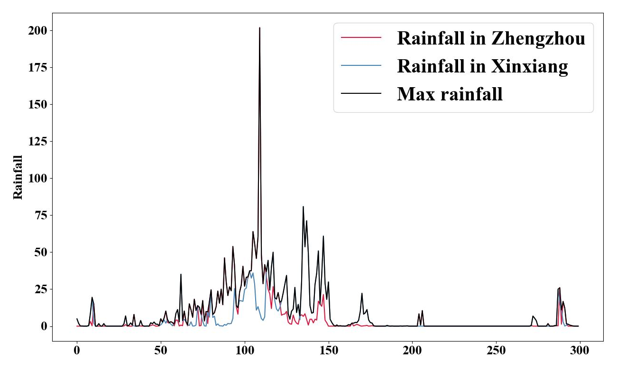
Fig.S1 Max rainfall indicator during the flood events

Note: Rainfall in Zhengzhou is the weighted average precipitation by Tyson polygon for 8 precipitation observation points in Zhengzhou City. Rainfall in Xinxiang is the weighted average precipitation by Tyson polygon for 8 precipitation observation points in Xinxiang City.

Figure.S2 The proportion of the four most popular technology strategies discussed on the Weibo platform
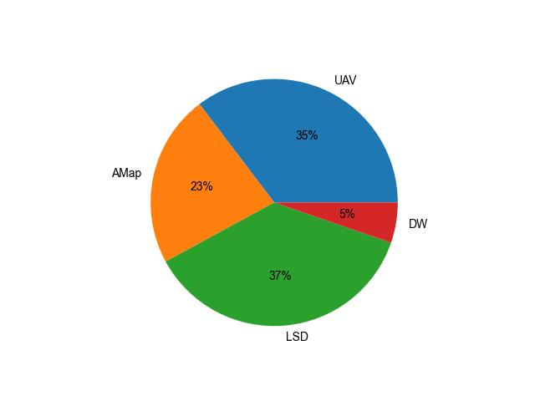

Figure.S3 Land use in Henan Province
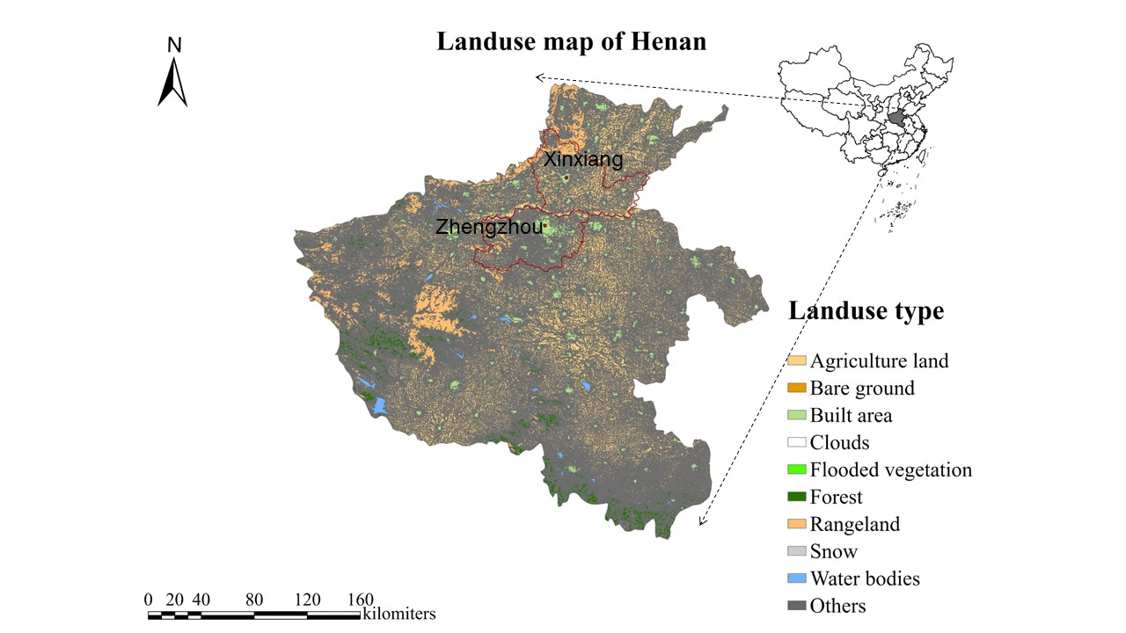
Note: Land use distribution map in Henan province

Figure.S4 The Wing Loong UAV
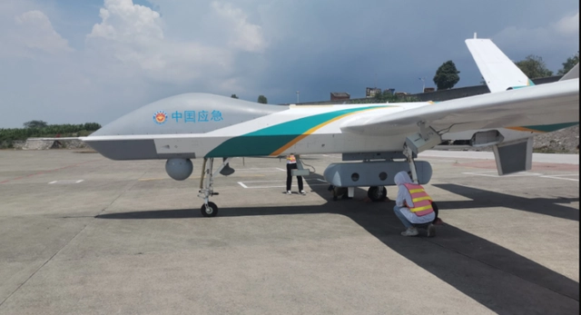
Note: This is Chinese Wing Loong UAV. The words on the surface of the UAV are “China Emergency” in English.

Figure.S5 Life-saving documents
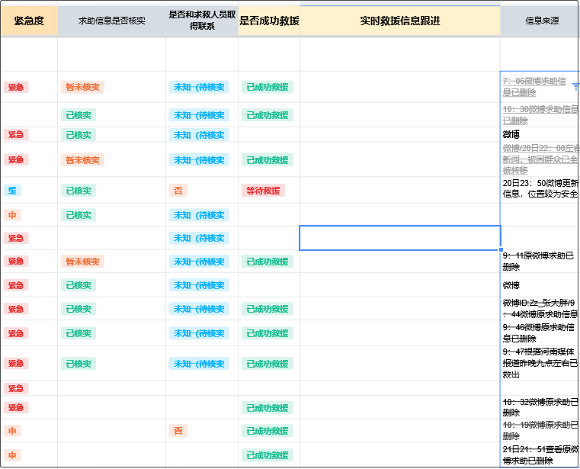
Note: This is the interface of Tencent rescue document used in Henan rainstorm in 2021, which is divided into the fields of emergency degree, whether the rescue information is verified, whether the rescue information is contacted with the rescuers, whether the rescue is successful, the implementation of rescue information follow-up, and the source of information.

Figure.S6 The "Dragon Water" drainage device (DW)
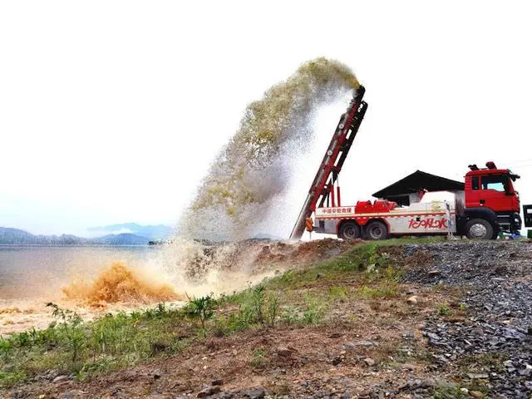
Note: This is Chinese Dragon water absorbent equipment (DW). The words on the surface of the DW are “Dragon water absorbent” in English.

Figure.S7 AMap
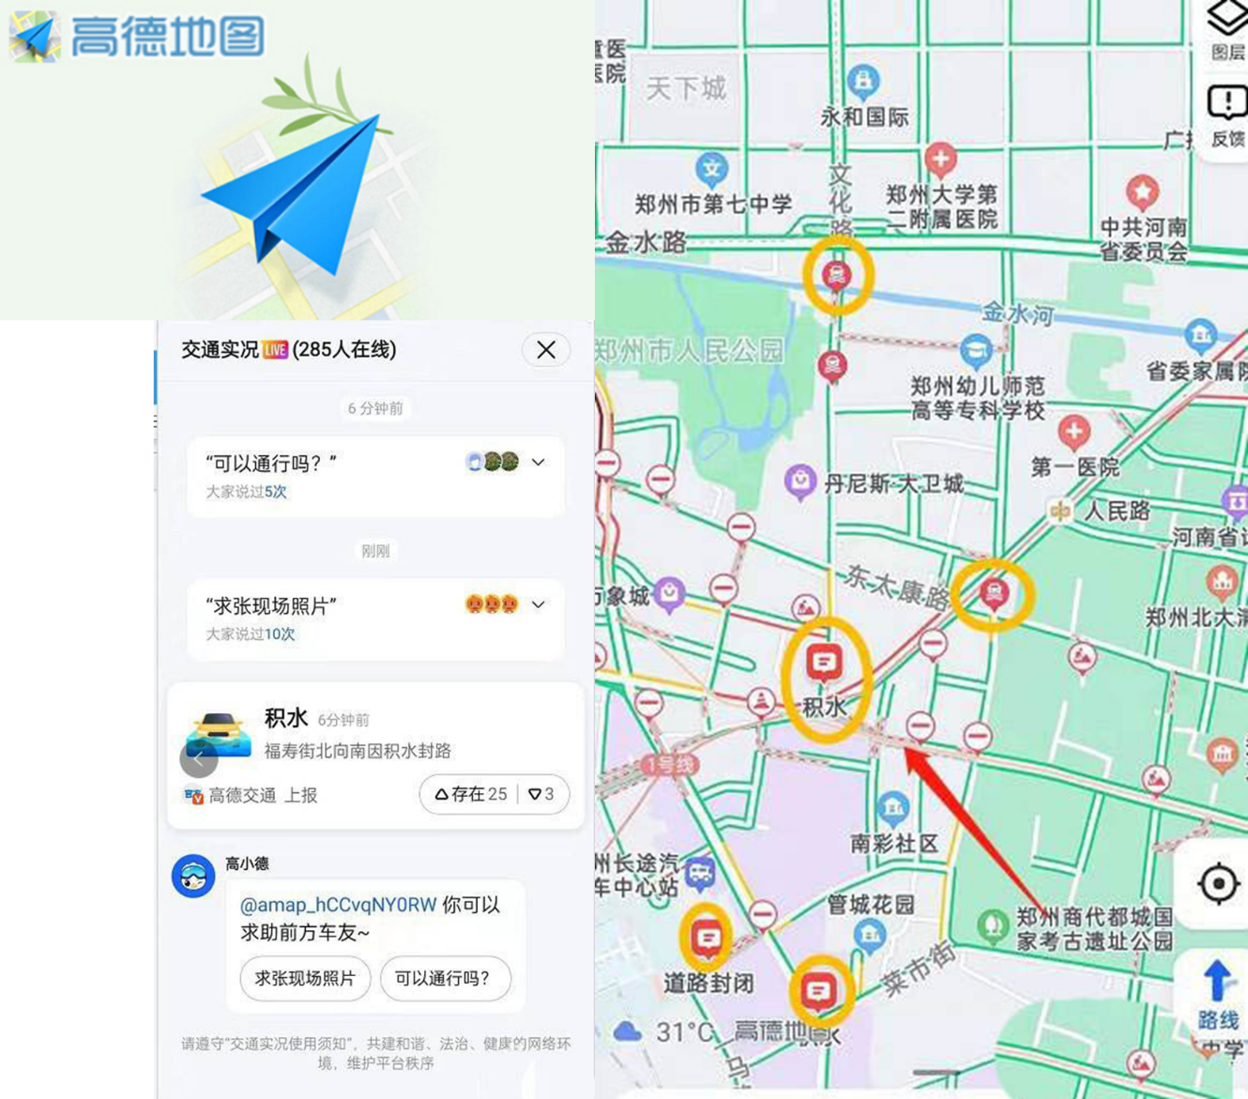
Note: This is the interface of Autonavi Map (AMap) used in Henan rainstorm in 2021. The red sign in picture indicates standing water (" standing water "is standing water). The above text indicates some online disaster information exchange and help information

Figure.S8 Comparison of multiple path models for casualty loss perception
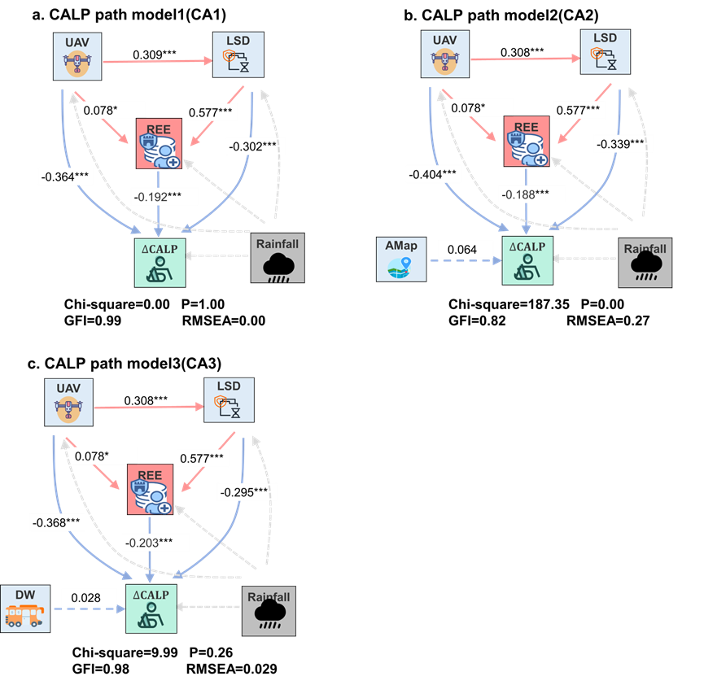

Figure.S9 Comparison of multiple path models for transport loss perception
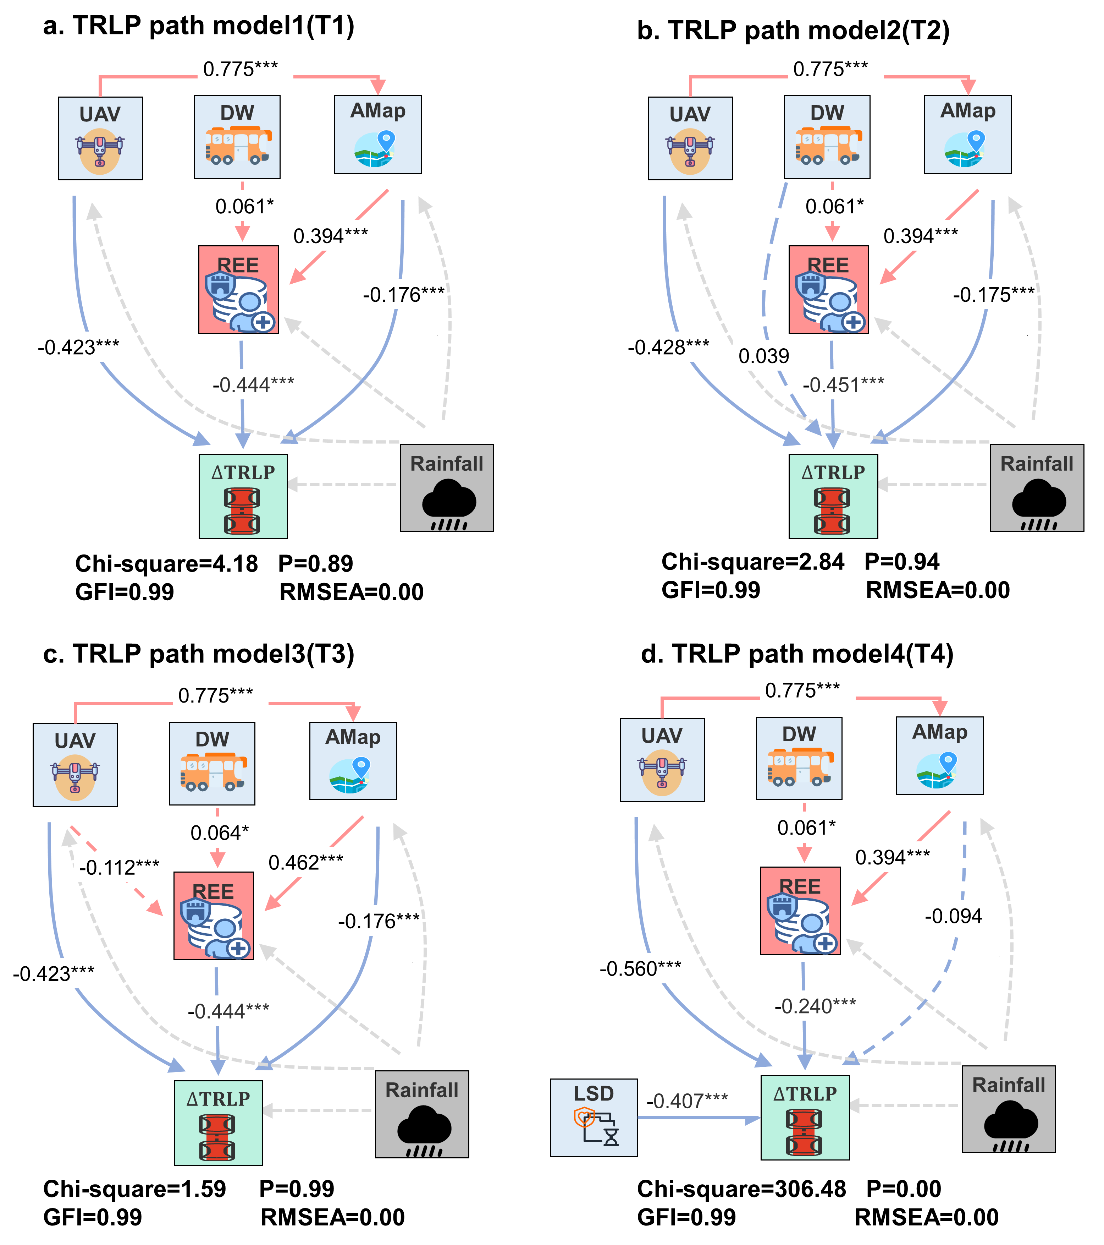

Figure.S10 Comparison of multiple path models for communication loss perception
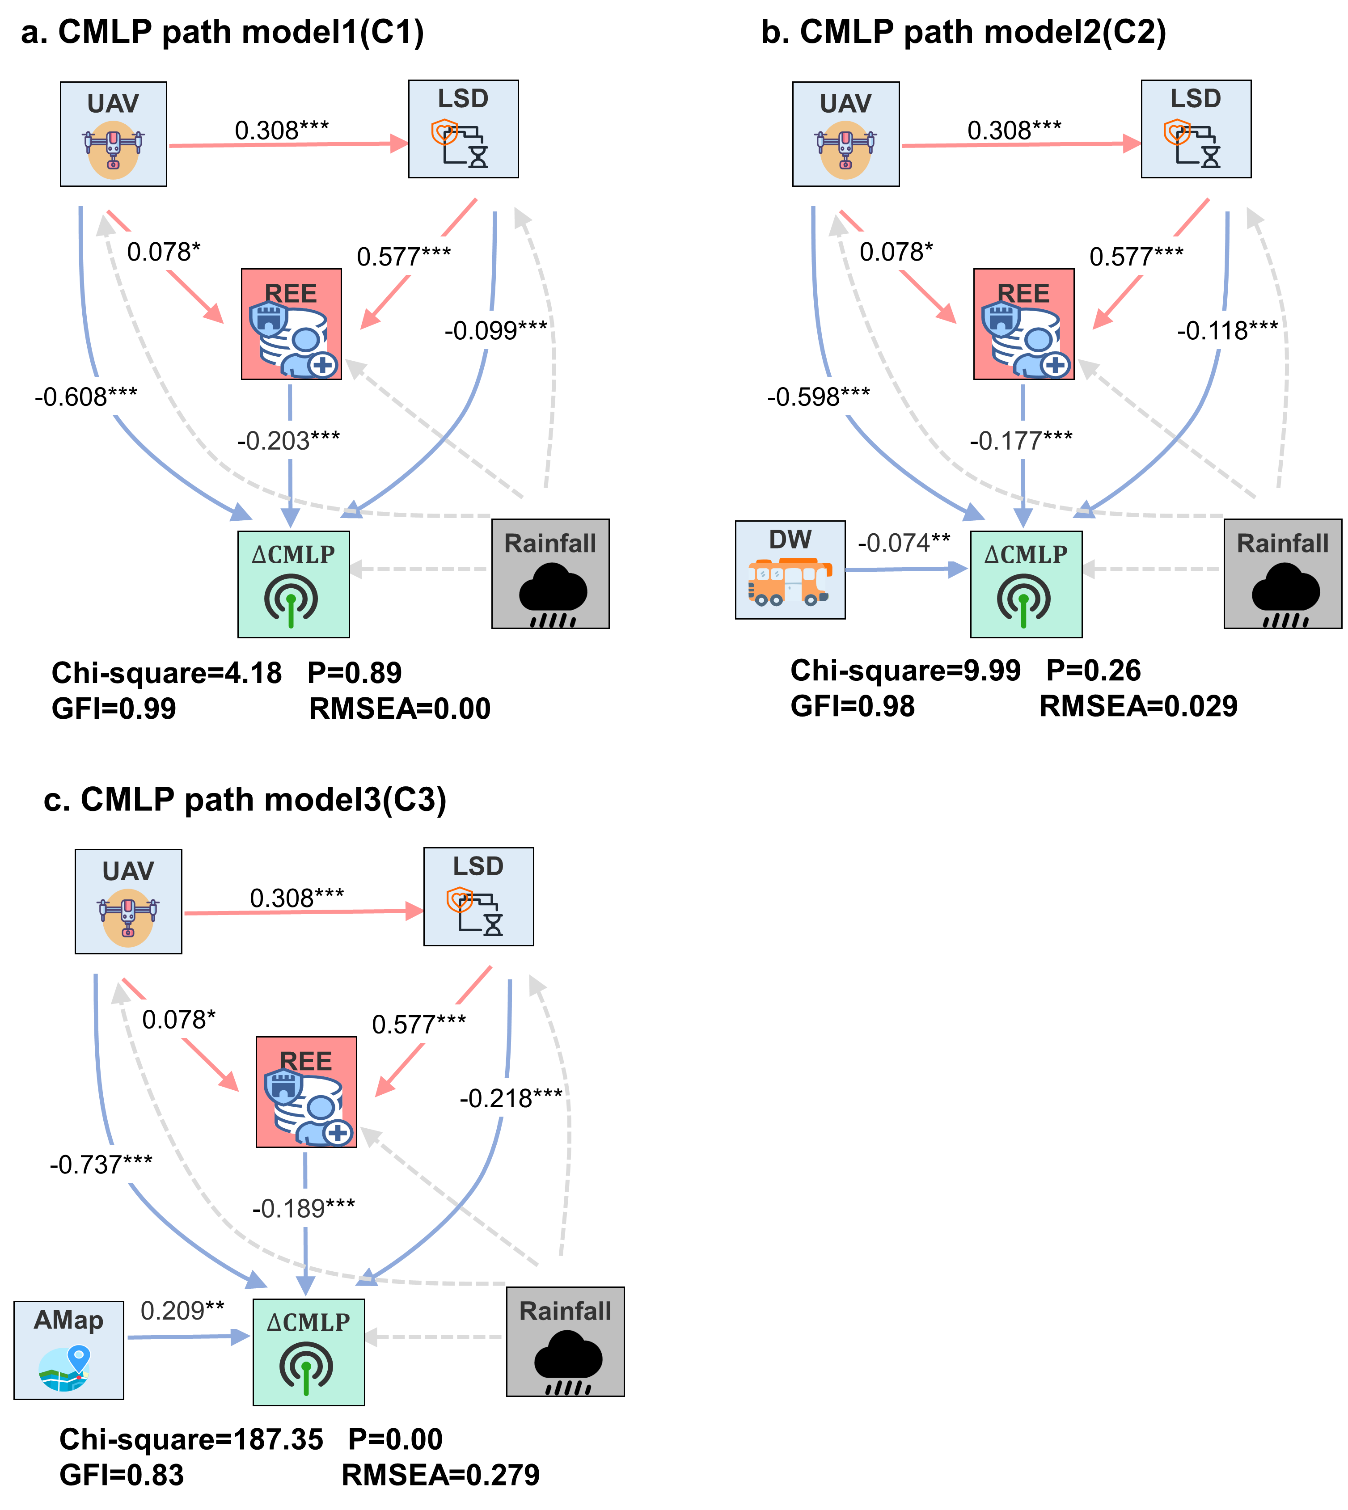

Figure.S11 Comparison of multiple path models for water and electricity supply loss perception
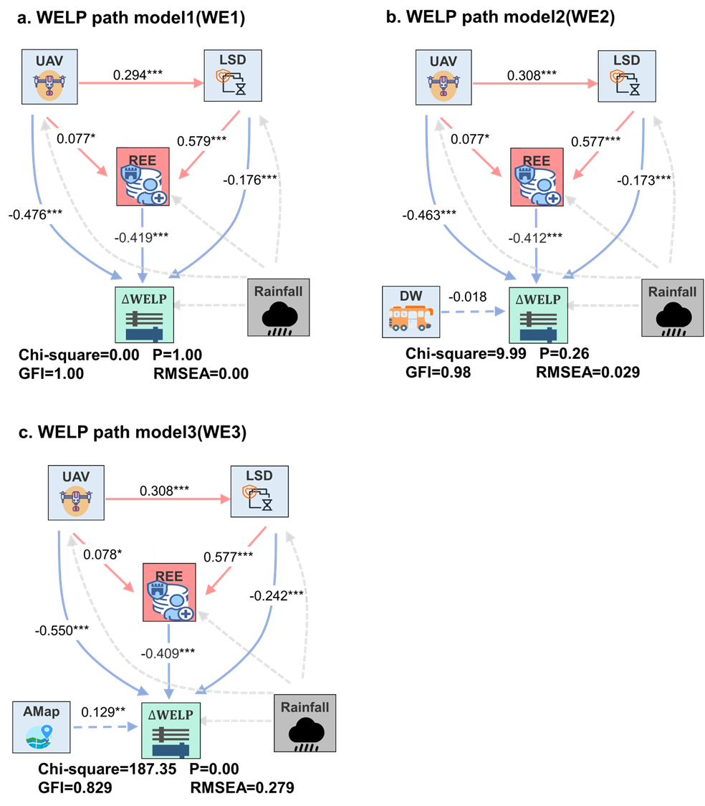

Figure.S12 Comparison of multiple path models for building loss perception
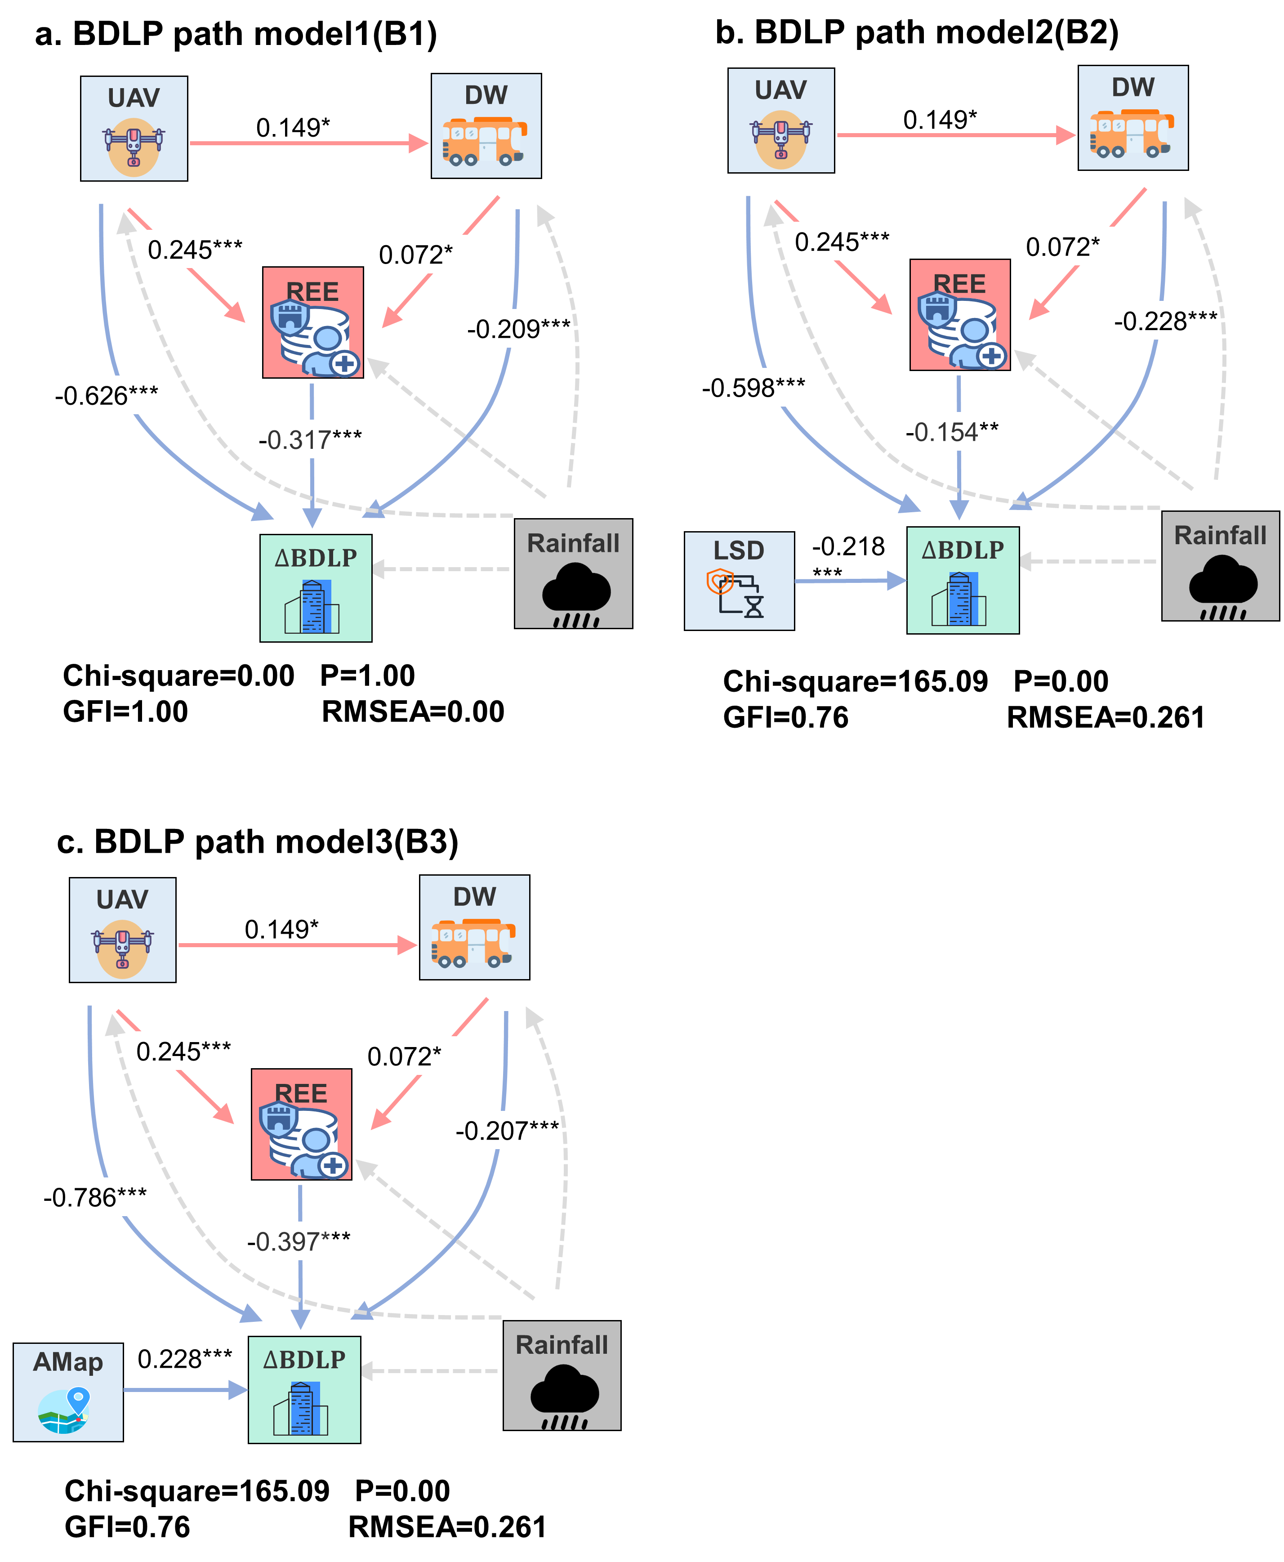

References
1. Fang J, Hu J, Shi X, Zhao L. Assessing disaster impacts and response using social media data in China: A case study of 2016 Wuhan rainstorm. International Journal of Disaster Risk Reduction 34, 275-282 (2019).

2. Li X, Shang W, Wang S. Text-based crude oil price forecasting: A deep learning approach. International Journal of Forecasting 35, 1548-1560 (2019).

3. Mihalcea R, Tarau P. TextRank: Bringing Order into Texts. (2004).

4. Xue B, Fu C, Zhan S. A Study on Sentiment Computing and Classification of Sina Weibo with Word2vec. In: IEEE International Congress on Big Data) (2014).

5. Mikolov T, Chen K, Corrado G, Dean J. Efficient Estimation of Word Representations in Vector Space. Computer Science, (2013).

6. Sun S, Jiang F, Feng G, Wang S, Zhang C. The impact of COVID-19 on hotel customer satisfaction: evidence from Beijing and Shanghai in China. International Journal of Contemporary Hospitality Management 34, 382-406 (2021).

7. Wu Q, Lin H. Daily urban air quality index forecasting based on variational mode decomposition, sample entropy and LSTM neural network. Sustainable Cities and Society 50, (2019).

8. Mnih V, et al. Playing Atari with Deep Reinforcement Learning. Computer Science, (2013).

9. Org Z. A Note on Measurement of Utility.

10. Mindrila D. Maximum Likelihood (ML) and Diagonally Weighted Least Squares (DWLS) Estimation Procedures: A Comparison of Estimation Bias with Ordinal and Multivariate Non-Normal Data. International Journal of Digital Society 1, (2010).

