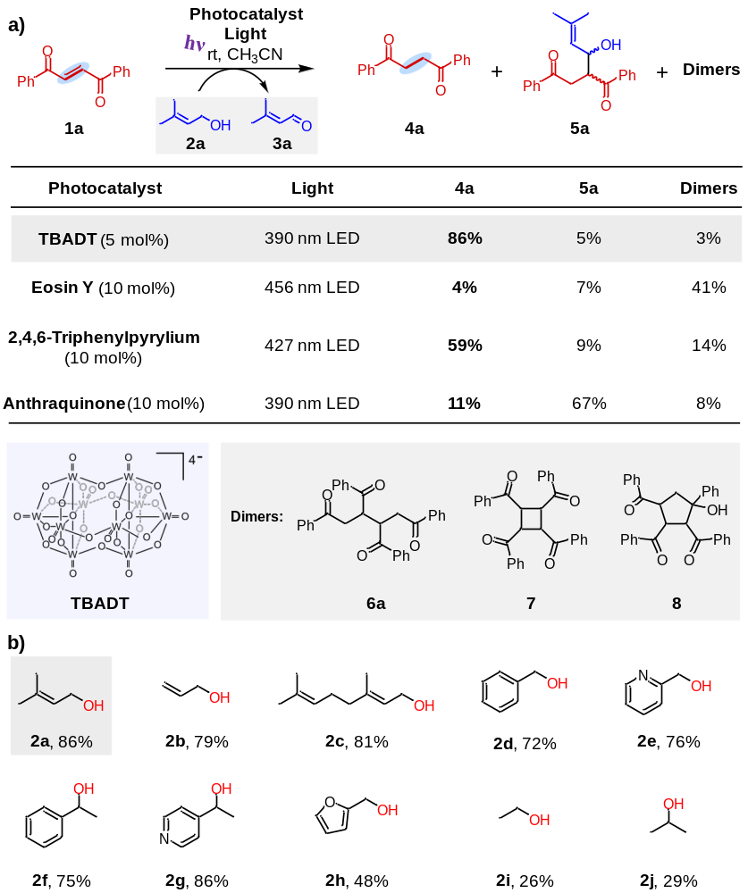
Table 1. (a) Photosensitizers catalyzed hydrogenation of 1,2-dibenzoylethylene 1a with prenol 2a as the hydrogen source. (b) Scope of alcohols. Reaction conditions: olefin (0.1 mmol), alcohol (5 equiv.), CH₃CN (2 mL), TBADT (5 mol%), 390 nm LEDs (40 W), 6 hours reaction time, room temperature. Yields are isolated yields.
Table 2. TBADT photocatalyzed hydrogenation of alkenes and alkynes with prenol as the hydrogen source. Reaction conditions: alkenes or alkynes (0.1 mmol), alcohol (5 equiv.), CH₃CN (2 mL), TBADT (5 mol%), 390 nm LEDs (40 W), 24 hours reaction time, room temperature; all yields are isolated yields. *6 hours reaction time. †400 nm LEDs (40 W). ‡Reaction performed at 70 °C.

