Supporting Information
Mechanistic Insights into Poly-(rC)-binding protein 1 driven Unfolding of Selected i-motif DNA at G₁/S checkpoint

Pallabi Sengupta¹, Natacha Gillet², Ikenna Obi¹, and Nasim Sabouri^{1#}

¹ Department of Medical Biochemistry and Biophysics, Umeå University, SE-901 87 Umeå, Sweden
² CNRS, ENS de Lyon, Université Claude Bernard Lyon 1, Laboratoire de Chimie UMR 5182, F-69342 Lyon, France

# Corresponding author: nasim.sabouri@umu.se
Phone: +46 786 50 00

Materials and methods
Electrophoretic mobility shift assay (EMSA) 2
Thermal-shift assay 2
Microscale Thermophoresis (MST) 2
Circular dichroism (CD) 3
I-motif destabilization-trapping assay 3
Bromine footprinting 4
Isothermal titration calorimetry (ITC) 5
Purification of recombinant PCBP1 and KH mutants 5
High-resolution-primer extension assay 6
¹H 1D NMR 6
Docking and Molecular Dynamics (MD) simulation 6
Bioinformatic analyses 7
Cell culture and PCBP1-knockdown 7
Western blot 8
iMab, PCBP1, and BG4 Chromatin immunoprecipitation (ChIP) 8
Flow cytometry-based cell cycle analyses 9
Cell synchronization using double-thymidine block 9
Anti-BrdU dot-bot assay 9
Statistical analyses 10
Supporting Tables
Table S1: Oligonucleotides used in this study for in vitro studies 10
Table S2: GC-richness of the PCR amplicons in iMab-ChIP-qPCR 11
Table S3: Melting temperatures (T_{m}) of PCBP1 at different pH. 11
Table S4: Apparent binding dissociation constants (K_{D,app}) calculated from MST binding curves 11
Table S5: Melting temperatures (T_{m}) of KH1+2 and KH3 at different pH 12
Table S6: Forward and reverse primer pairs used in ChIP-qPCR assays 12
Supporting Figures 13
Supporting video legends 24
References 25

Materials and Methods:
Electrophoretic mobility shift assay (EMSA): For qualitative estimation of PCBP1’s affinity towards folded and unfolded forms of i-motifs, we performed EMSA. 5 nM of the 5'-Cy5-labeled i-motif-forming sequences (iMfs) (Table S1) were incubated in assay buffers containing either 20 mM Bis-Tris (pH 6.4) or 20 mM Tris-HCl (pH 8.0), supplemented with 100 mM NaCl and 0.25 mg/mL bovine serum albumin (BSA). Increasing concentrations of purified recombinant PCBP1 were then added to these mixtures. The reactions, prepared in a total volume of 50 µL, were incubated at 25 °C for 30 minutes to allow potential binding interactions. Following the incubation, 10 µL of 80% glycerol was mixed to each reaction tube and 20 µL of the reaction mixture was loaded onto 15% native PAGE (Polyacrylamide gel electrophoresis). The gel matrix was prepared with either 50 mM Bis-Tris (pH 6.4) or 50 mM Tris-HCl (pH 8.0), supplemented with 100 mM NaCl, to match the respective assay buffer conditions and pH during experiments. Electrophoresis was conducted at 70 V at 6 °C, using a 1× running buffer containing the same composition of either Bis-Tris or Tris-HCl buffer with NaCl as described. After electrophoresis, gels were imaged using an Amersham Typhoon scanner equipped with a Cy5 laser at 300 V with a resolution of 25 μm per pixel. Each assay was performed in triplicates.
Thermal-shift assay: pH tolerance of purified PCBP1 and KH-mutants (KH1+2 and KH3) was determined by thermal-shift assay using Sypro-orange-based protein thermal-shift dye kit (Applied biosystems). We prepared 20 µL of 10 µM protein solutions in 20 mM MES buffer at pH 5.5, 6.0, 6.4 and in 20 mM Tris-Cl buffer at pH 7.0 and 8.0, supplemented with 100 mM NaCl into flat-bottom 96-well plates (BioRad) and heated in a CFX96TM realtime system (BioRad) from 25 ºC to 95 ºC in increments of 0.2 ºC. Changes in Sypro-orange fluorescence were monitored and the melting temperatures (T_{m}) (Table S3, S5) were determined by calculating the derivative of the midpoint of the protein unfolding transition, defined by –dF/dT, representing the negative derivative of Sypro-Orange fluorescence signal with respect to temperature. Preparation of the proteins in the storage buffer (20 mM Tris-Cl (pH 8.0), 150 mM NaCl) was used as a reference. The experiment was performed in triplicates.
Microscale Thermophoresis (MST): We performed MST to study the interaction between PCBP1/KH mutants and 5′-Cy5-labelled oligonucleotides (iMfs and other control sequences including G4 and non-GC-rich sequences) by measuring the movement of oligos in response to a temperature gradient, allowing precise quantification of apparent binding affinities (K_{D,app}), in solution. 40 nM of 5'-Cy5-labeled iMfs were incubated in 20 mM MES (pH 6.4) or phosphate buffer (pH 7.0) or Tris-Cl (pH 8.0) with 100 mM NaCl and varying concentrations of PCBP1 or KH mutants (35 nM to 2.5 µM) in 20 µL reactions at 25 °C for 15 minutes. Then, samples were centrifuged at 10,000 rpm for 10 minutes at 25 °C, followed by loading them into Monolith NT Capillaries (NanoTemper). Fluorescence intensities and MST were measured in Monolith NT.LabelFree (NanoTemper) instrument at LED excitation 30%. Data were normalized with MO.Control (v1.6.1) and fitted using the following Slogistic1 equations in OriginPro 2020 where $a$=amplitude, $x_{c}$= K_{D,app}, $k$=coefficient:
$y=\frac{a}{1+e^{-k\left(x-x_{c}\right)}}$ ………… (1)
Results were expressed as mean ± SD from triplicate measurements.
Circular dichroism (CD): To observe i-motif-spectral changes upon PCBP1/KH mutants interactions, CD spectra of 4 µM iMfs were acquired using Jasco J1700-CD spectrophotometer after annealing them into 20 mM MES (pH 6.4) and 100 mM NaCl. PCBP1 or KH-mutants were titrated into iMfs in increasing concentrations (1-4 µM) and incubated for 30 min at 25 °C before spectral acquisitions. To measure the transition pH (pH_{T}) of i-motifs, we acquired i-motif spectra at 4 µM concentration within a broad range of pH from 5.4 – 7.2, as previously performed¹. CD scans were performed within 320-210 nm range and at 100 nm/min scanning speed. Data-points were obtained at 0.5 intervals and averaged over three accumulations. We used 1 mm-pathlength quartz cuvettes (Hellma) carrying 200 µL samples. Digital integration time and bandwidths were 2 s and 1 nm respectively. CD values were corrected for buffer contributions and converted to molar ellipticities (MCD) using the following formula (2), where θ is CD ellipticity in millidegrees, c is DNA concentration (mol/L), and l is path-length (cm):
$Δε\left(M^{-1}·{cm}^{-1}\right)=\frac{θ}{32980×c×l}$………… (2)
pH_{T} values were calculated by plotting fraction of folded i-motifs (calculated from MCDs at 287 nm (positive maxima)) vs pH, using the equation below:
$f(folded imotif)=\frac{{MCD}_{i}-{MCD}_{pH 7.2}}{{MCD}_{pH 5.4}-{MCD}_{pH 7.2}}$………… (3)
We fitted these data-points using the Slogistic1 equations (1) in OriginPro 2020, where $x_{c}$ = pH_{T}. Results were shown as means ± SD of triplicates.
I-motif-destabilization trapping assay: To estimate the i-motif unfolding kinetics by PCBP1 and KH mutants, we optimized an i-motif- destabilization trapping assay. In this assay, 5′-Cy5-labelled iMfs substrates were prepared at 5 nM in 20 mM MES (pH 6.4), 50 mM NaCl, 2 mM MgCl₂, and 0.25 mg/mL BSA followed by incubation for 30 min at 25 °C in presence of 5 nM PCBP1 or KH mutants. Reactions were performed by adding 25 nM i-motif-trap-complementary oligos (Table S1), specific for each iMfs at 25 °C for 14 minutes. At 2-min-intervals, 10 μL of reaction mix was quenched with 1:1 stop buffer (40% glycerol, 60 mM EDTA, 0.6% SDS, 0.5 μM unlabelled iMfs) and analyzed by 20% native PAGE at 110 V. Gels were imaged using Amersham Typhoon scanner with a Cy5 laser at 300 V with a resolution of 25 μm per pixel and quantified with ImageJ. Negative controls lacked i-motif-trap-complementary oligos, while in positive controls, iMfs were incubated with i-motif-trap-complementary oligos for 24 hours at room temperature to allow complete hybridization. The fraction of hybridization between unfolded i-motif and their complementary trap oligos was estimated and normalized by dividing the intensity of trapped or hybridized products with the sum of trapped and unhybridized band intensity. Data-points plotted against time-points were fitted using 4PL (four-parameter logistic) equation (4) to calculate the rate of i-motif-unfolding (k). Experiments were repeated three times.
$Y=D+\frac{A-D}{1+({x/C)}^{B}}$………(4)
where Y denotes the normalized amount of hybridized products, $x$ defines the time-points during the reactions; A and D denote the minimum (at zero concentration of trap) and maximum asymptotes respectively (at 14 minutes). C defines the inflection point (EC₅₀) — the concentration at which the response is halfway between A and D, used to calculate the k for each reaction. B denotes the hill slope, which describes the steepness of the curve.
Bromine footprinting: To map the destabilized C:CH⁺ pairs in cMYC-i-motif upon PCBP1 or KH mutant binding, we performed bromine footprinting assay. This assay relies on preferential bromination of single-stranded or unpaired Cs rather than those engaged in C:CH⁺ base pairs due to the chemical accessibility and electronic environment of Cs in i-motif structure. Bromine reacts with Cs via electrophilic substitution at the C5 position in the pyrimidine ring. In single-stranded or unpaired Cs, the C5 position is more exposed and readily accessible to bromine while in intercalated C:CH⁺ base pairs formed within i-motifs, Cs are stacked and hydrogen-bonded, reducing their accessibility. Further, protonated Cs in i-motif at N3 position has altered electron density that affects the electrophilic susceptibility of the C5 position, making it less reactive toward bromination². 10 µM of 3′-Cy5-labeled cMYC-iMfs were annealed in 20 mM MES (pH 6.4) or 20 mM phosphate buffer (pH 7.0) with 50 mM NaCl by heating at 95 °C for 5 minutes, followed by slow cooling overnight. 5 µM iMfs pre-incubated with or without 5 µM PCBP1/KH-mutants for 30 minutes at 25 °C was treated with molecular bromine formed in situ by mixing equimolar KBr and KHSO₅ (20 µM) for 20 minutes at room temperature. Reactions were stopped by 80 µL of 0.3 M sodium acetate (pH 7.0) and 25 µg/mL calf thymus DNA on ice. Unreacted bromine was removed by two successive ethanol precipitation. The DNA pellet was resuspended in 100 µL of 100 mM piperidine (Sigma), heated at 90 °C for 20 minutes to induce bromination-specific strand cleavage, then washed thrice and dried using speed-vac. Samples were dissolved in 95% formamide and 20 mM EDTA, heated at 95°C for 5 minutes, and snap-cooled. Purine- and pyrimidine-specific reactions were performed using 4% formic acid and hydrazine to generate A+G and C+T sequencing markers respectively following Maxam-Gilbert reactions³. Samples were analyzed on 20% denaturing PAGE at 60 W, imaged using Amersham Typhoon scanner with Cy5 laser (500 V, 25 μm pixel resolution), and quantified with ImageJ. Each assay was performed in triplicates.
Isothermal titration calorimetry (ITC): Thermodynamic binding profiles between iMfs and proteins (PCBP1 and KH-mutants) were determined using ITC with a MicroCal Auto iTC200 at 25 °C. For the binding studies involving KH1+2 and KH3, 5 µM of KH1+2 was prepared in 20 mM MES (pH 6.4) and 150 mM NaCl and placed in the calorimetric cell. The syringe contained 350 µM KH3 in the same buffer. To investigate the interactions between KH-mutants (KH1+2 and KH3) and i-motif, 5 µM KH1+2 was pre-incubated with an equimolar concentration of cMYC-i-motifs for 30 minutes before being placed in the cell, while the syringe was filled with 350 µM KH3. For binding studies between proteins and cMYC-i-motif, 5 µM of each protein was loaded into the cell, and 300 µM of i-motifs was placed in the syringe. Control experiments were conducted simultaneously by injecting the same concentrations of substrates into a buffer without ligand to account for the heat of dilution. Oligonucleotides were injected 20 times at 150-second intervals into the calorimeter cell to achieve binding saturation. Data analysis was performed using the Malvern Microcal PEAQ-ITC software, employing a ‘one-site’ binding model to obtain the best-fit values for changes in enthalpy (∆H) and entropy (∆S) of binding.
Purification of recombinant PCBP1 and KH mutants: cDNAs of PCBP1, KH1+2, and KH3 were cloned into the pET-His1a vector for overexpression of recombinant PCBP1 in Escherichia coli BL21(DE3) cells. PCBP1 was induced at 18 °C before harvesting by centrifugation. The cell pellet was resuspended in lysis buffer (50 mM NaP 8.0, 500 mM NaCl, 10% glycerol, 0.2% Triton X100, 10 mM Imidazole, 5 mM β-mercaptoethanol, DNase) followed by sonication. The sample was centrifuged (30 min, 20,000× g, 4 °C), and the supernatant was incubated (1.5 h, 4 °C) with ThermoS NiNTA previously equilibrated in lysis buffer. The mixture was then poured into a gravity flow column and the resin was washed with wash buffer (wash buffer 1: 50 mM NaP pH 8.0, 500 mM NaCl, 10% glycerol, 0.2% Triton X100, 10 mM Imidazole, 5 mM β-me; wash buffer 2: 50 mM NaP pH 8.0, 1 M NaCl, 10% glycerol, 0.2% Triton X100, 10 mM Imidazole, 5 mM β-me). The elution was performed stepwise with two elution buffers (Elution buffer 1: 50 mM NaP pH 8.0, 500 mM NaCl, 20 mM Imidazole, 5 mM β-me; elution buffer 2: 50 mM NaP pH 8.0, 300 mM NaCl, 300 mM Imidazole, 5 mM β-me). The eluates were analyzed by SDS-PAGE, pooled together according to their purity, and desalted by dialysis in 20 mM NaP pH 8.0, 150 mM NaCl, 5 mM β-me. His tag was cleaved by TEV protease and final dialysis was done in 20 mM Tris-Cl 8.0, 150 mM NaCl, 20% Glycerol, 1 mM DTT (Dithiothreitol).
High-resolution-primer extension assay: To examine the effect of i-motif/hairpin formation to slow down in vitro replication, we performed primer extension assays, as previously performed⁴. 5´-TET (Tetrachlorofluorescein)-labelled primer (1 μM) was annealed to i-motif-forming templates (1.5 μM) in 75 mM NaCl and 6 mM MgCl₂ by heating at 95 °C for 5 min followed by slow-cooling overnight. 40 nM of annealed samples were incubated in 50 μl reactions containing 20 mM MES (pH 6.0), 6 mM MgCl₂, 0.2 mg/ml BSA, and 0.05 μU/L Klenow fragment (Thermo Scientific) with/without 40 nM PCBP1 or KH-mutants for 15 minutes at 25 ºC. Primer extension was started with 0.2 mM dNTPs for and continued for specific time-points. Reacted samples were collected at designated time-intervals, quenched with stop solution (95% formamide, 20 mM EDTA), denatured at 95°C for 5 minutes, and snap-cooled. 5 μl was loaded on 12% denaturing PAGE (8 M urea, 25% formamide, 1×TBE), and run at 60 W in 1× TBE running buffer. The gel was visualized using Amersham Typhoon (GE Healthcare) with Cy3 laser (500 V, 25 μm pixel resolution) and quantified using ImageJ. Each experiment was performed in triplicates.
¹H 1D NMR: NMR experiments were conducted using a Bruker DRX 850 MHz NMR spectrometer, equipped with a 0.7 mm ultra-fast MAS probe to understand the impact of PCBP1/KH mutants binding on i-motif’s structural dynamics. For the experiments, 100 µM of iMfs from cMYC, BCL2 (wild-type and mutants), Telomere, and ILPR were prepared and annealed in 20 mM MES buffer (pH 6.4) containing 100 mM NaCl in a solvent mixture of 90% water and 10% D₂O. The 1D ¹H NMR experiments were performed in 3 mm NMR tubes with an active sample volume of 200 µL. Spectral referencing was performed using an internal standard, TSP [3-(trimethylsilyl)-2,2′,3,3′-tetradeuteropropionic acid] (Sigma), set at 0.0 ppm. In the 1D proton spectra, imino proton resonances corresponding to C:CH⁺ bonds in the i-motifs were observed at 15-16 ppm, while resonances indicative of hairpins involving Watson-Crick base pairs were detected at 12-14 ppm. These measurements were obtained using the pulse program "zgesgp," with a spectral width of 20 ppm, 256 scans (ns), and a calibrated pulse length (pl) of 9.48 μs. NMR titrations were performed by incrementally adding aliquots of purified proteins (PCBP1 and KH-mutants) to the 100 µM iMfs. Samples were thoroughly mixed and allowed to reach thermal equilibrium. Proton spectra were recorded at each titration point, following an incubation period of 15 minutes at 25 °C.
Docking and MD simulations: Molecular Dynamics simulations (MDs) were performed using Amber20 package on structure obtained from Alphafold⁵ and RoseTTAFold⁶ or RoseTTAFoldNA⁷. Amberff14SB⁸ and parmbsc1⁹ force fields were used to model protein and DNA i-motif respectively, with the CUFIX correction for ionic interaction¹⁰ and Amberff14IDPSFF¹¹ force field for the intrinsically disordered part of PCBP1 between domains 2 and 3 (residues 170 to 268). The protonation state of amino acids of PCBP1 protein was determined on the basis of PropKa¹² calculations. All the systems were solvated in a cubic box of TIP3P water with a solvent buffer of at least 12 Å and about 0.10 M of NaCl salt taking into account the neutralization of the box. Periodic conditions were applied in combination with Particle Mesh Ewald method for electrostatic and a cutoff of 10 Å for intermolecular interactions. All the systems were first minimized for 10,000 steps (5,000 steepest descent, 5,000 conjugated gradient) and then heat from 0 to 300 K during 30 ps in NVT ensemble with a timestep of 1 fs. Equilibration (100 ns) and production (1 to 3 µs) were run in NPT ensemble at 300 K and 1 bar using Langevin thermostat. SHAKE algorithm was applied to constrain hydrogen-heavy atoms bonds and maintain a time step of 2 fs. Trajectories were analysed using CPPTRAJ¹³. First, MD simulations were performed on 6 conformations of PCBP1 alone, one from AlphaFold prediction, 5 from RoseTTAFold prediction. We selected the representative structure of the most important cluster from a cluster analysis based on the RMSD of the protein residues and hierachical agglomerative approach for each trajectory of 100 ns. These structures were combined with the 8AYG¹⁴ structure for i-motif DNA with the ILPR sequence using RoseTTAFoldNA docking. Five docked conformations (Fig. S21A) were selected based on the localization of the DNA towards the different domains, especially KH1 and KH3, and DNA-RNA binding part of these domains. Three simulations setups were created with only neutral cytosines in the i-motif, one neutral (set a); one with one positively charged cytosine for on half on the cytosine pair (set b); and one with one positively charged cytosine per i-motif cytosine pair (set c). The production runs last 1 μs for set a structures 1, 4 and 5; 2 μs for set a structures 2 and 3 and for all structures of set c; 3 μs for all structures of set b.
Bioinformatic analyses: De novo motif discovery was performed on the bed file extracted from the ChIP-seq datasets using MEME-ChIP web-interface setting the following parameters. Enrichment mode: Classic; Set of known motifs: Eukaryote DNA, Human and Mouse (HOCOMOCO v12 CORE), background model: 1st order model, MEME Site Distribution: 0 or 1 occurrence, MEME motif count: 3 and MEME Motif width: 6–15 wide. We used plotheatmap tool in Galaxy to visualize ChIP-enrichment values around 2000 bp around the TSS (transcription start site).
Cell culture and PCBP1-knockdown (PCBP1-KD): HeLa cells (ATCC) were cultured at required density in Dulbecco's modified Eagle's medium (DMEM) in presence of 10% FBS (Fetal bovine serum) (Gibco) at 37 °C and 5% CO₂ in the incubator. PCBP1 knockdown (KD) was performed using small interfering RNA (siRNA) (PCBP1 Human siRNA Oligo Duplex (Locus ID 5093, Origene)) transfection with Lipofectamine 3000 (Thermo Fisher Scientific) according to the manufacturer's protocol. Briefly, cells were seeded in 6-well plate at a density of 10⁶ cells per well and allowed to adhere overnight. The following day, 5 ng of siRNA targeting PCBP1 (siPCBP1) or 5 ng of non-targeting scrambled siRNA (siScramble, negative control) was diluted separately in Opti-MEM reduced serum medium (Thermo Fisher Scientific). In parallel, Lipofectamine 3000 reagent was also diluted in Opti-MEM and incubated for 5 minutes at room temperature. The diluted siRNA was then combined with the diluted Lipofectamine 3000 reagent, mixed gently, and incubated for 10–15 minutes at room temperature to allow complex formation. The siRNA-lipid complexes were added dropwise to the cells, and the plates were gently swirled to ensure even distribution. Cells were then incubated at 37°C with 5% CO₂ for 48 hours, and the KD was confirmed by western blot analyses with anti-PCBP1 antibody.
Western blot: To confirm PCBP1-KD and estimate DNA double-strand breaks upon PCBP1-KD, we performed western blot analyses of PCBP1 and γH2AX (H2AX histones phosphorylated at Ser139) respectively in HeLa cells upon 48 hours of PCBP1-KD. Cells were seeded at a density of 7 × 10⁵ cells per well into 60 mm dishes and allowed to attach overnight. At 48 hours post-transfection, total protein was extracted from the cells using freshly prepared RIPA lysis buffer (50 mM Tris (pH 8.0), 150 mM NaCl, 1% NP-40, 0.1% SDS, 0.5% sodium deoxycholate) supplemented with Phenylmethylsulfonyl fluoride (PMSF) (Merck) and protease inhibitor (complete mini EDTA-free tablets, Roche). Protein concentration was quantified using the BCA assay (Pierce™ BCA Protein Assay Kit). 30 µg protein lysates were resolved on mini protean TGX precast SDS-PAGE gels (BioRad) and transferred onto nitrocellulose membranes (Amersham™ Protran® Premium Western blotting membranes). Membranes were blocked with 5% non-fat milk in 1× Tris-buffered saline (TBS) with Tween 20 (Amresco) for 1 hour at 4°C. Then, membranes were briefly washed with 1× TBST and incubated overnight at 4°C with rabbit monoclonal anti-PCBP1 primary antibody (dilution 1:1000, Abcam), or rabbit anti- γH2AX antibody (dilution 1:1000, Cell signalling technologies) and mouse monoclonal anti-β-Actin antibody (dilution 1:5000, Abcam). Then, membranes were incubated with HRP-conjugated Goat anti-mouse/anti-rabbit IgG (H+L), (dilution 1:5000, Thermo-fisher) for 2 hours at room temperature. Target proteins were visualized on membranes using Western Supersignal West pico chemiluminescence substrate (Thermo-fisher) and images are captured using ChemiDoc MP system with Image Lab™ software. After incubation with each antibody, membranes were washed for 15 min at room temperature three times with 1× TBST. β-Actin was used as a loading control.
iMab, PCBP1, and BG4 Chromatin immunoprecipitation (ChIP): 2$×$10⁶ HeLa cells were crosslinked in 1% formaldehyde (Thermo-Fisher) for 10 min at room temperature followed by quenching with 125 mM glycine. After quenching, cells were washed with ice-cold 1$×$PBS and collected by centrifugation at 500 × g for 5 minutes at 4 °C. Cells were lysed on ice in ChIP lysis buffer (50 mM HEPES, pH 7.0; 140 mM NaCl; 1 mM EDTA; 1% Triton X-100; 0.1% Na-deoxycholate) for 10 min at 4°C. Chromatin was isolated and sheared to 200-600 bp using the Covaris E220 system. After RNase A treatment (10 µg/mL) (Thermo-fisher scientific) at 37°C for 30 minutes, chromatin was incubated overnight (4 °C) with 2 µg iMab antibody (Absolute Antibody) or 500 ng BG4 antibody (in-house prepared)¹⁵ or rabbit monoclonal anti-PCBP1 primary antibody (1:500, Abcam) in ChIP lysis buffer containing 1% non-fat milk in 200 µL, shaking at 500 rpm. For iMab and BG4, rabbit anti-FLAG antibody (Cell Signalling Technologies) (8 µg) bound to 10 µL dynabeads protein-G (Invitrogen) was prepped by shaking at 1200 rpm for 2-4 hours at 4 °C, then washed and incubated with 80 µL chromatin-iMab complex at 600 rpm for 4 hours at 4 °C. Beads were washed four times with 100 µL ChIP lysis buffer and twice with 100 µL wash buffer at 4 °C, then immunoprecipitants were eluted with TE buffer (10 mM Tris-Cl, pH 8.0; 1 mM EDTA) containing 0.5 mg/mL Proteinase K by incubation at 37 °C for 1 hour and 65 °C for 2 hours. Eluates were purified using the ChIP-DNA Clean and Concentrate kit (ZYMO Research) following manufacturer’s protocol. qPCR was conducted using primers (Table S6) targeting promoters with iMfs or non-i-motif-forming control regions. ChIP enrichment was quantified using the percentage of input method, where input DNA corresponds to a fraction of total chromatin collected before immunoprecipitation. For background correction, ChIP-IP enrichment was determined by normalizing the percentage of input from immunoprecipitation (IP) to the corresponding mock IP, where rabbit anti-FLAG IgG was used as the mock control for iMab and BG4, and anti-rabbit IgG was used for anti-PCBP1 ChIP. For iMab and BG4 ChIP, the relative enrichment of target oncogene promoter regions was further normalized to non-i-motif-forming genomic regions to ensure that the observed enrichment was specific to i-motif-forming regions.
Flow cytometry-based cell cycle analyses: HeLa cells were sub-cultured at a density of 1 × 10⁶ cells per well. Following treatment with either double-thymidine block or PCBP1-KD as described above, cells were harvested using trypsinization and subsequently washed with cold 1× PBS. The cells were then fixed with chilled 70% ethanol and stored at −20 °C overnight. After fixation, the cells were centrifuged at 850 × g for 15 minutes at 4 °C. The resulting pellets were resuspended in 500 µL of FxCycle PI/RNase staining solution (Invitrogen) and incubated in the dark at 4 °C with gentle rocking for 4 hours. DNA content was analyzed using a BD FACS Verse™ flow cytometer. Gating of single cells, histograms of DNA content (Propidium iodide (PI) fluorescence intensity) were analyzed in FCS Express. The percentage of cells in each phase of the cell cycle (G₁, S, and G₂/M) was determined by fitting the data into Cox multivariate analyses.
Cell synchronization using double-thymidine block: HeLa cells were synchronized at the G₁/S boundary using a double-thymidine block protocol. Cells were seeded at an appropriate density (30–40% confluence) in DMEM supplemented with 10% fetal bovine serum (FBS) and allowed to adhere overnight. The following day, thymidine (2 mM final concentration) was added to the culture medium and incubated for 18 hours to inhibit DNA synthesis by depleting the nucleotide pool. Cells were then washed three times with 1× PBS and released into fresh, thymidine-free medium for 9 hours to allow progression through the cell cycle. Subsequently, a second thymidine treatment (2 mM final concentration) was applied for another 15–18 hours to achieve synchronization at the G₁/S transition. After the second block, cells were either harvested at the G₁/S boundary or released into fresh medium for 2 hours to obtain synchronized populations in S phase. Synchronization efficiency was confirmed by flow cytometry analysis of DNA content as described above.
Anti-BrdU dot-bot assay: HeLa cells were synchronized at G₁/S boundary using double-thymidine block method as described above. After second thymidine block, cells were released into fresh medium at four time-points at an interval of 1 hour up to 4 hours. A total of 1.3 µg genomic DNA isolated from cells using at each time-point using DNeasy Blood & Tissue Kit (Qiagen), and were heated at 95 °C and immediately cooled on ice to denature the DNA. 0.3 M final concentration of NaOH was added, and DNA was loaded onto a Hybond-N+ membrane (GE Healthcare) using a Bio-Dot Microfiltration Apparatus (Bio-Rad). The membrane was blocked overnight with 1% non-fat milk in Phosphate Buffered Saline (PBS) and later incubated with Rat anti BrdU (Abcam) (1:1000 dilution) in 1% non-fat milk. After washing the membrane for 15 min twice with PBS, it was incubated with goat anti-rat IgG antibody peroxidase (Merck) (1:5000 dilution) in 1% non-fat milk, and dots were developed using a chemiluminescent reagent (Western Supersignal West pico chemiluminescence substrate (Thermo-fisher)) and images are captured using ChemiDoc MP system with Image Lab™ software.
Statistical analyses: All statistical analyses in this study were performed using GraphPad Prism or OriginPro 2020. One-way ANOVA followed by Tukey-Kramer post hoc test was used for ChIP enrichment analyses to compare multiple groups. For all other experiments (e.g., comparing K_{D,app} values between PCBP1/KH mutants and multiple i-motifs), a two-tailed Student’s t-test was used to assess statistical significance. Data from biochemical and cellular studies are presented as mean ± standard deviation (SD) from three biological replicates. A p-value < 0.05 was considered statistically significant.

Supporting Tables:
Table S1: Oligonucleotides used in this study for in vitro studies.
Name | Sequence (5´-3´) |  | Experiments
cMYC-iMfs | AATCCCACCCCTCCCATCCCTT |  | CD, EMSA‡, MST‡,
BCL2-iMfs | CAGCCCCGCTCCCGCCCCCTTCCTCCCGCGCCCGCCCCT |  | CD, EMSA‡, MST‡,
ILPR-iMfs | TGTCCCCACACCCCTGTCCCCACACCCCTGT |  | CD, EMSA‡, MST‡,
Telomere-iMfs | CCCTAACCCTAACCCTAACCCT |  | CD, EMSA‡, MST‡,
C7T3-iMfs | CCCCCCCTTTCCCCCCCTTTCCCCCCCTTTCCCCCCC |  | CD, EMSA‡, MST‡,
Non-GC | AATTGATGTTATTCTTCTTATT |  | CD, EMSA‡, MST‡,
cMYC-G4 | AAGGGATGGGAGGGGTGGGATT |  | CD, EMSA‡, MST‡,
BCL2-G10TG12T | CAGCCCCGCTCCCGCCCCCTTCCTCCCTCTCCCGCCCCT |  | CD
BCL2-G_{all}→T | CATCCCCTCTCCCTCCCCCTTCCTCCCTCTCCCTCCCCT |  | CD
cMYC-iMfs-Br* | AATCCCACCCCTCCCATCCCTTTTT-Cy5 |  | Bromine footprinting
cMYC-iMfs-PE | AATCCCACCCCTCCCATCCCTTatatatatatCGGACGCTCGACGCCATTAATAATGTTTTCA |  | High resolution primer extension assay
BCL2-iMfs-PE | CAGCCCCGCTCCCGCCCCCTTCCTCCCGCGCCCGCCCCTatatatatatCGGACGCTCGACGCCATTAATAATGTTTTCA |  | High resolution primer extension assay
Non-i-motif-PE | GAGACCATTCAAAAGGATAATGTTTGTCATTatatatatatCGGACGCTCGACGCCATTAATAATGTTTTCA |  | High resolution primer extension assay
BCL2-m1-PE | CAGCCCCGCTCCCGCCCCCTTCCTCCCTCTCCCGCCCCTatatatatatCGGACGCTCGACGCCATTAATAATGTTTTCA |  | High resolution primer extension assay
BCL2-m3-PE | CATCCCCTCTCCCTCCCCCTTCCTCCCTCTCCCTCCCCTatatatatatCGGACGCTCGACGCCATTAATAATGTTTTCA |  | High resolution primer extension assay
TET-primer† | (TET)-TGAAAACATTATTAATGGCGTCGAGCGTCCG |  | High resolution primer extension assay
cMYC-trap | AAGGGATGGGAGGGGTGGGATT |  | I-motif destabilization-trapping assay
BCL2-trap | AGGGGCGGGCGCGGGAGGAAGGGGGCGGGAGCGGGGCTG |  | I-motif destabilization-trapping assay
ILPR-trap | ACAGGGGTGTGGGGACAGGGGTGTGGGGGACA |  | I-motif destabilization-trapping assay
Telomere-trap | AGGGTTAGGGTTAGGGTTAGGG |  | I-motif destabilization-trapping assay
‡ In these experiments, oligonucleotides are all Cy5 (cyanine 5) labelled at 5´-ends.
*cMYC-iMfs-Br is Cy5 labelled with T₃-linker at 3´-end.
† TET primer is Tetrachlorofluorescein (TET)-labelled at 5´-end.
Table S2: GC-richness of the PCR amplicons in iMab-ChIP-qPCR:
 | GC-richness (%)
cMYC | 56.6
BCL2 | 75.1
ILPR | 67.9
PDGFa | 81.2
VEGFa | 73.7
HIF1a | 72.1
ARHGEF10L | 51.2
GAPDH | 54.1
HTR6 | 56.9
IL36G | 49.2

Table S3: Melting temperatures (T_{m}) of PCBP1 at different pH, obtained from thermal shift assay. Errors calculated from 5 biological replicates (n = 5)

pH | Melting temperatures (T_{m}) (ºC)
8.0 | 55.1 ± 3
7.0 | 54.9 ± 2.5
6.4 | 54.5 ± 2.1
6.0 | 50.5 ± 1.6
5.5 | 48.6 ± 1.2

Table S4: Apparent binding dissociation constants (K_{D,app}) calculated from MST binding curves showing binding profiles between PCBP1 and iMfs or control sequences at pH 6.4, 7.0, and 8.0. Errors calculated from 3 biological replicates (n = 3)

 |  | Apparent binding dissociation constants (K_{D,app}) (in nM)
 |  | MST
 |  | pH 6.4 | pH 7.0 | pH 8.0
iMfs | cMYC | 238 ± 5.4 | 982 ± 19.5 | 978 ± 21.8
iMfs | ILPR | 255 ± 9.5 | 764 ± 13.7 | 757 ± 10.5
iMfs | BCL2 | 217 ± 6.6 | 972 ± 7.8 | 978 ± 8.5
iMfs | Telomere | 283 ± 10.6 | 745 ± 6.6 | 748 ± 8.8
iMfs | C7T3 | 189 ± 3.4 | 191 ± 2.4 | 288 ± 10.8
control | cMYC-G4 | > 3000 | 2892 ± 24.9 | 2994 ± 26.2
control | Non-GC | 1955 ± 23.4 | 2032 ± 33.6 | 1525 ± 13.4

Table S5: Melting temperatures (T_{m}) of KH1+2 and KH3 at different pH, obtained from thermal shift assay. Errors calculated from 5 biological replicates (n = 3)

pH | Melting temperatures (T_{m}) (ºC)
 | KH1+2 | KH3
8.0 | 55.1 ± 1.3 | 55.6 ± 2.3
7.0 | 54.5 ± 1.6 | 55.2 ± 1.8
6.4 | 54.1 ± 2.3 | 55.1 ± 1.2
6.0 | 51.2 ± 0.23 | 54.7 ± 1.1
5.5 | 50.2 ± 0.22 | 54.4 ± 1.7
Table S6: Forward and reverse primer pairs used in ChIP-qPCR assays:
Primers | Primer sequences (5′-3′)
PDGFa-F | GGAGAGGGTTATAGCGCCG
PDGFa-R | ACGAACCCCGAGCGCTTC
cMYC-F | AGGCGCGCGTAGTTAATTCA
cMYC-R | CATTATAAAGGGCCGGTGGG
BCL2-F | TGTGACGTTACGCACAGGAA
BCL2-R | TTCTCCTCCTCCTGGTCCTG
Hif1a-F | CTCTTTCCTCCGCCGCTAAA
Hif1a-R | CCCAGACCCGCTCTCCAG
VEGFa-F | ATCCTCCTGTCCCCTCAGAC
VEGFa-R | CCGCTACCAGCCGACTTTTA
HTR6-F | GGCGATTTGTCCAATATTTCCC
HTR6-R | CTGTGACCTGCCCTTATCC
ARHGEF10L-F | TGCCAAGTTACTCTCAGTTCTG
ARHGEF10L-R | AGCCAAACCTCCAAGAACAA
IL36G-F | GCCCACCTCTTTACTTCCTTA
IL36G-F | AACACTCTTTCAGCTCCATCC
TMCC1-F | GTGGTACACTGCCTACAGTATT
TMCC1-R | GTATAACGCCTGGGCTATGT
ILPR-F | CTTTCCACATTAGACCAGGAG
ILPR-R | GACAGGGGTCCGGGGGACAG
GAPDH-F | TCCAATTCCCCATCTCAGTC
GAPDH-R | TAGTAGCCGGGCCCTACTTT

Supporting Figures:
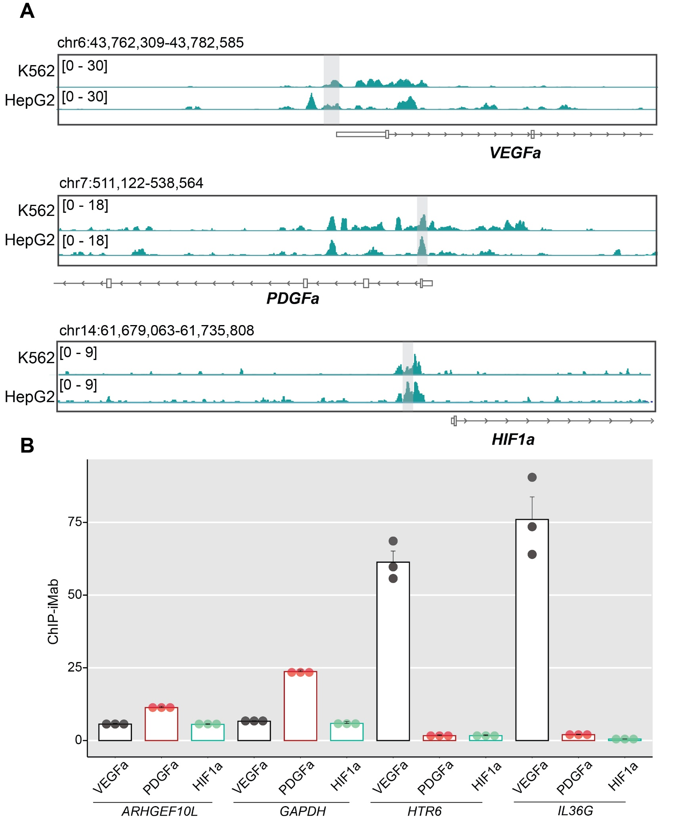
Fig. S1. PCBP1 occupancy at C-rich genomic sequences at VEGFa, PDGFa, and HIF1α promoters and their potential to form i-motif structures. (A) IGV tracks visualizing ChIP-seq data of PCBP1-bound regions at VEGFa, PDGFa, and HIF1a promoters in K562 and HepG2 cells. Each track shows the signal intensity range, with a scale noted in brackets for each genomic region, indicating the level of PCBP1 occupancy across those genomic regions for different cell types. The highlighted light grey regions overlap with i-motif-forming regions. (B) Quantification of iMab-ChIP efficiency at VEGFa, PDGFa, and HIF1a promoters versus several non-i-motif control sites in HeLa cells (ARHGEF10L, GAPDH, HTR6, IL36G), using percentage of input method. ChIP-qPCR bar plots represented as means ± SD of triplicates.
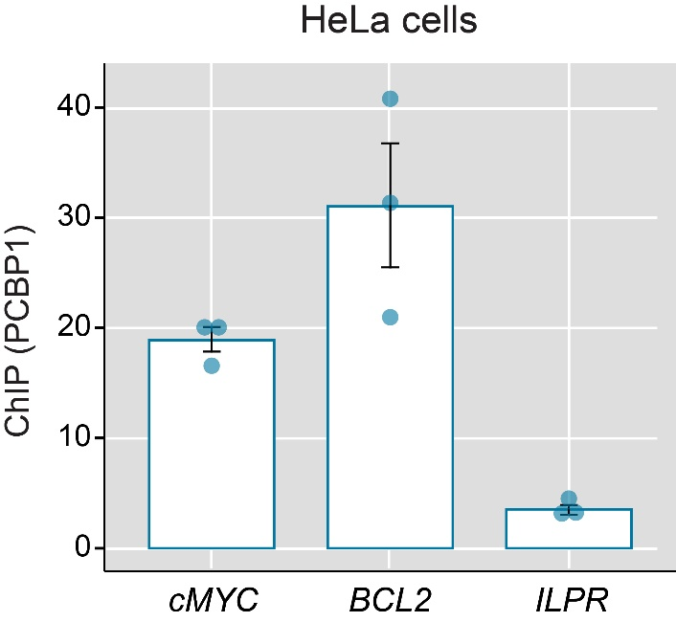
Fig. S2: ChIP-qPCR results in HeLa cells using anti-PCBP1 antibody. PCBP1 recruitment shown within cMYC, BCL2, and ILPR promoter regions that harbour iMfs. Quantification of PCBP1 binding by % of input method compared to the control site (GAPDH) based on qPCRs.
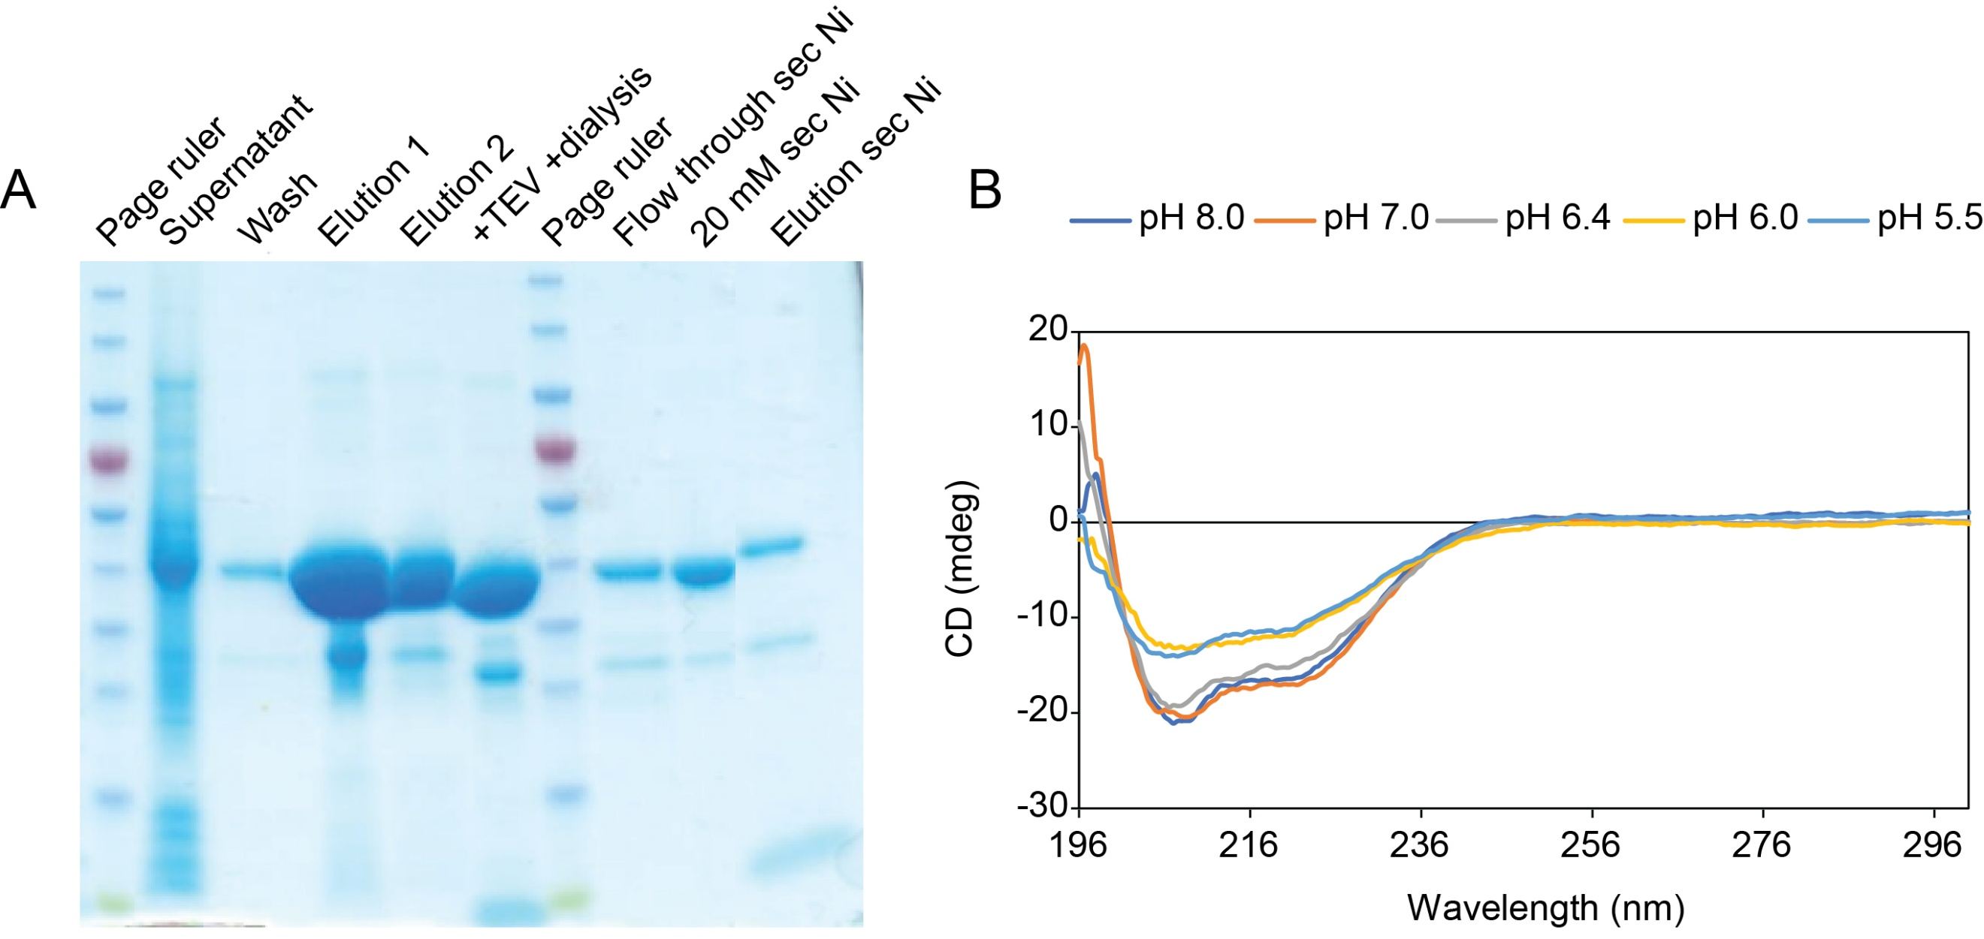
Fig. S3: Purification of recombinant PCBP1 and its secondary structures at different pH. (A) Recombinant PCBP1 purified from Escherichia coli BL21(DE3) cells induced at 18 °C. Supernatant showing soluble fraction after cell lysis, sonication and centrifugation. The supernatant was filtered through a 0.45 µm membrane and loaded onto Thermo Scientific Ni-NTA gravity columns. After washing, PCBP1 was eluted with 300 mM NaCl and 300 mM imidazole, then dialyzed and subjected to TEV (Tobacco Etch Virus) protease cleavage to cleave off the His-tag. The final elution was obtained in a buffer containing 20 mM Tris-HCl (pH 8.0), 150 mM NaCl, 20% glycerol, and 1 mM DTT (Dithiothreitol). (B) CD spectra of full-length PCBP1 at 25 ºC in 20 mM Tris, 150 mM NaCl in different pH.

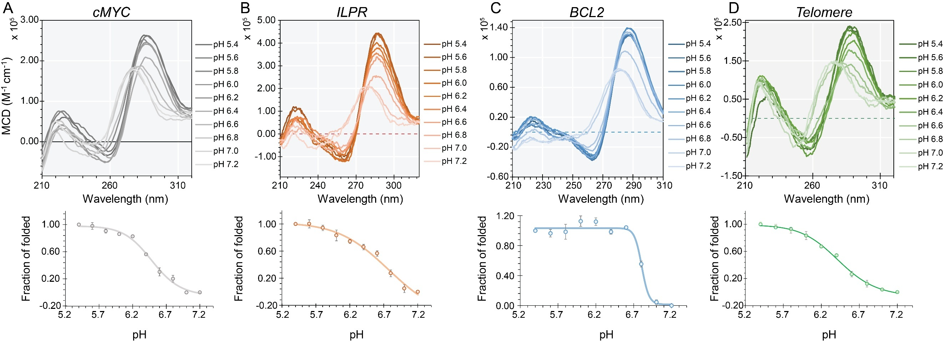
Fig. S4. CD melting profiles of (A) cMYC, (B) ILPR, (C) BCL2, and (D) Telomere i-motifs within a broad pH range (5.4-7.2). The positive maxima around 287 nm indicate i-motif structure (Top) in the CD spectra of the i-motifs. The sigmoidal curves fitted to the data-points corresponding to the positive maxima of each i-motif at different pH (Bottom) to calculate the pH_{T} or transition pH. Error bars expressed as means ± SD from three biological replicates.

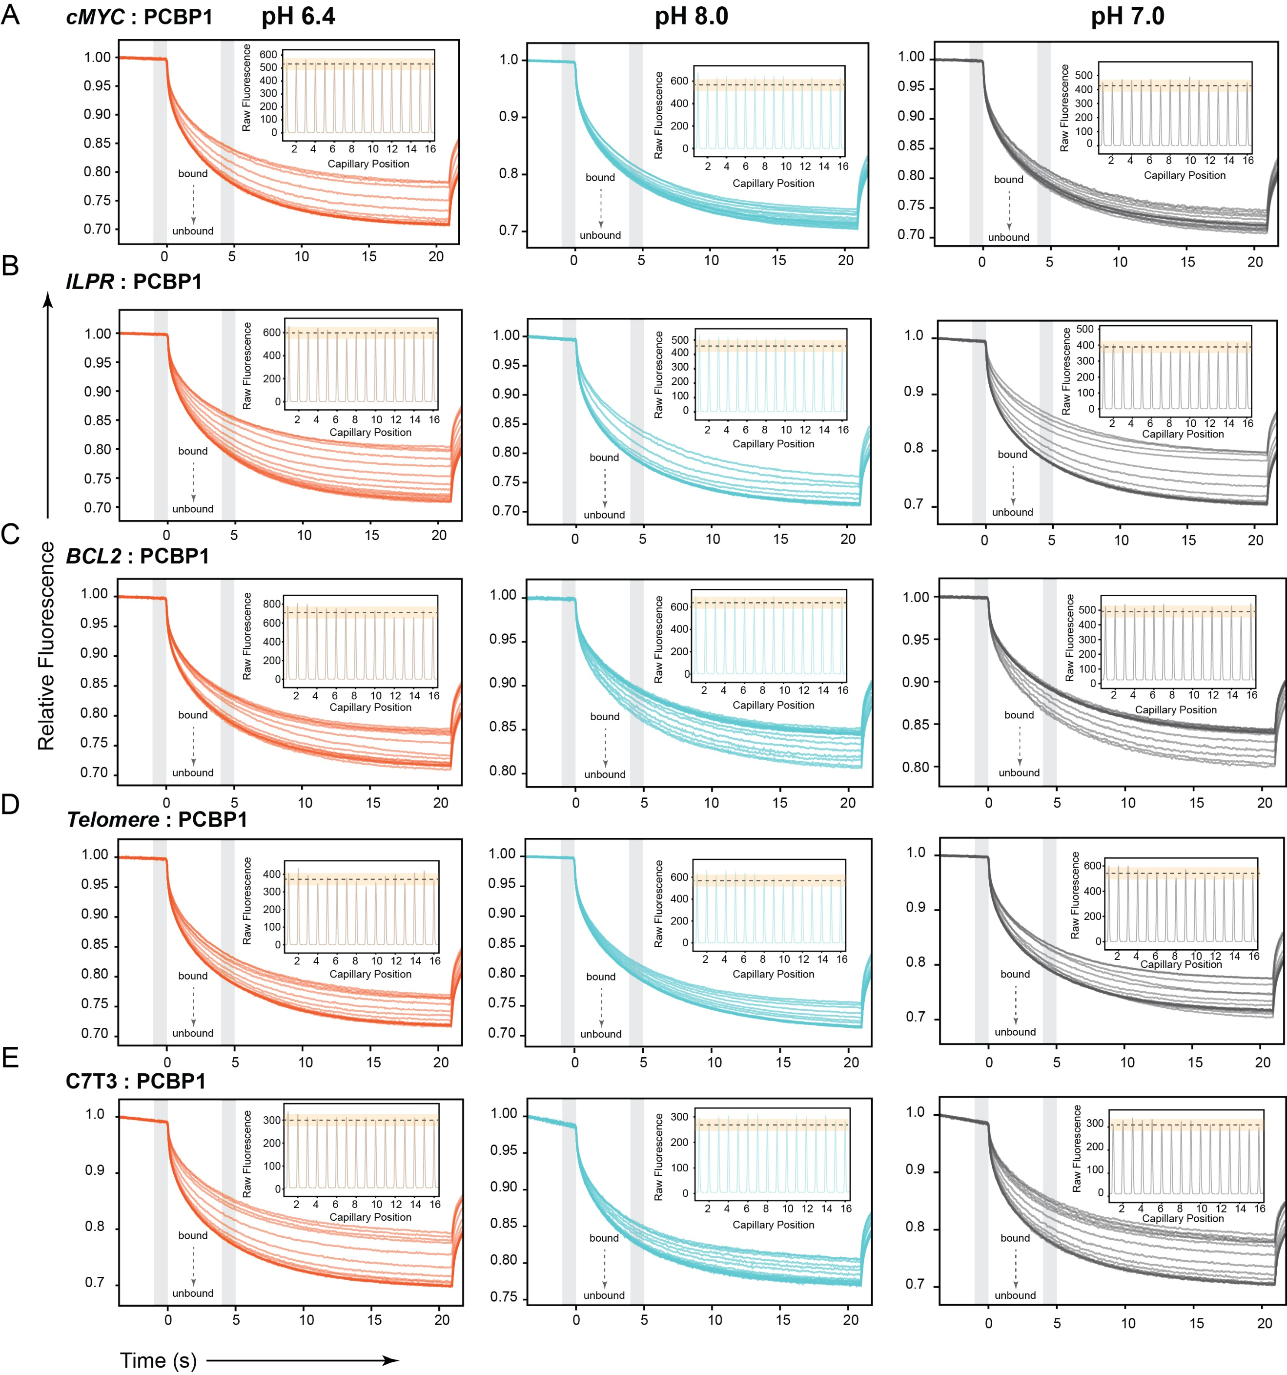
Fig. S5. MST traces and raw fluorescence profiles showing the binding interactions between PCBP1 and iMfs (A) cMYC, (B) ILPR, (C) BCL2, (D) Telomere and (E) C7T3 at 25 ºC under three different pH conditions: in 20 mM MES, 100 mM NaCl at pH 6.4 (orange traces), in 20 mM Tris, 100 mM NaCl at pH 8.0 (cyan traces), and in 20 mM sodium phosphate, 100 mM NaCl at pH 7.0 (gray traces). MST traces showing relative fluorescence of the PCBP1-bound and unbound iMfs vs MST experimental time. Insets in each graph display the raw fluorescence as a function of capillary position.

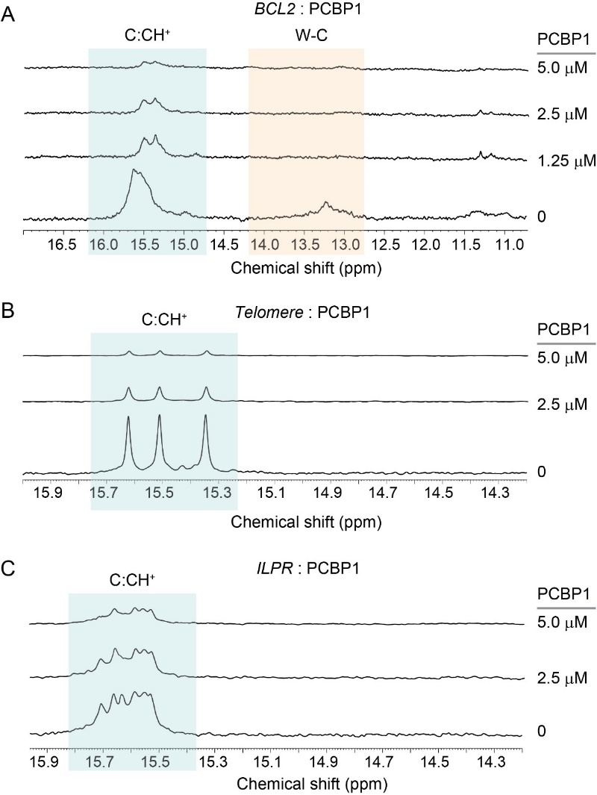
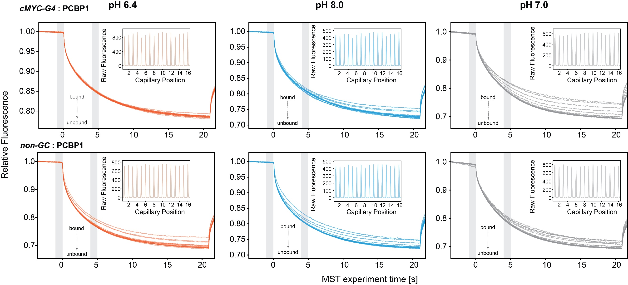
Fig. S7. Changes in the imino proton resonances (15-16 ppm) in the ¹H 1D NMR spectra of (A) BCL2, (B) Telomere, and (C) ILPR i-motifs upon titration of various concentrations of PCBP1 at 25 ºC in 20 mM MES, 100 mM NaCl at pH 6.4. The C:CH⁺ pairs for i-motif structures (15-16 ppm) and W-C (Watson-Crick) base pairs of hairpin structures (13-14 ppm) highlighted in the ¹H 1D NMR spectra.
Fig. S6. MST traces and raw fluorescence profiles showing the binding interactions between PCBP1 and control sequences (cMYC-G4 and non-GC) at 25 ºC under three different pH conditions: in 20 mM MES, 100 mM NaCl at pH 6.4 (orange traces), in 20 mM Tris, 100 mM NaCl at pH 8.0 (cyan traces), and in 20 mM sodium phosphate, 100 mM NaCl at pH 7.0 (gray traces). MST traces showing relative fluorescence of the PCBP1-bound and unbound control sequences vs MST experimental time. Insets in each graph display the raw fluorescence as a function of capillary position.

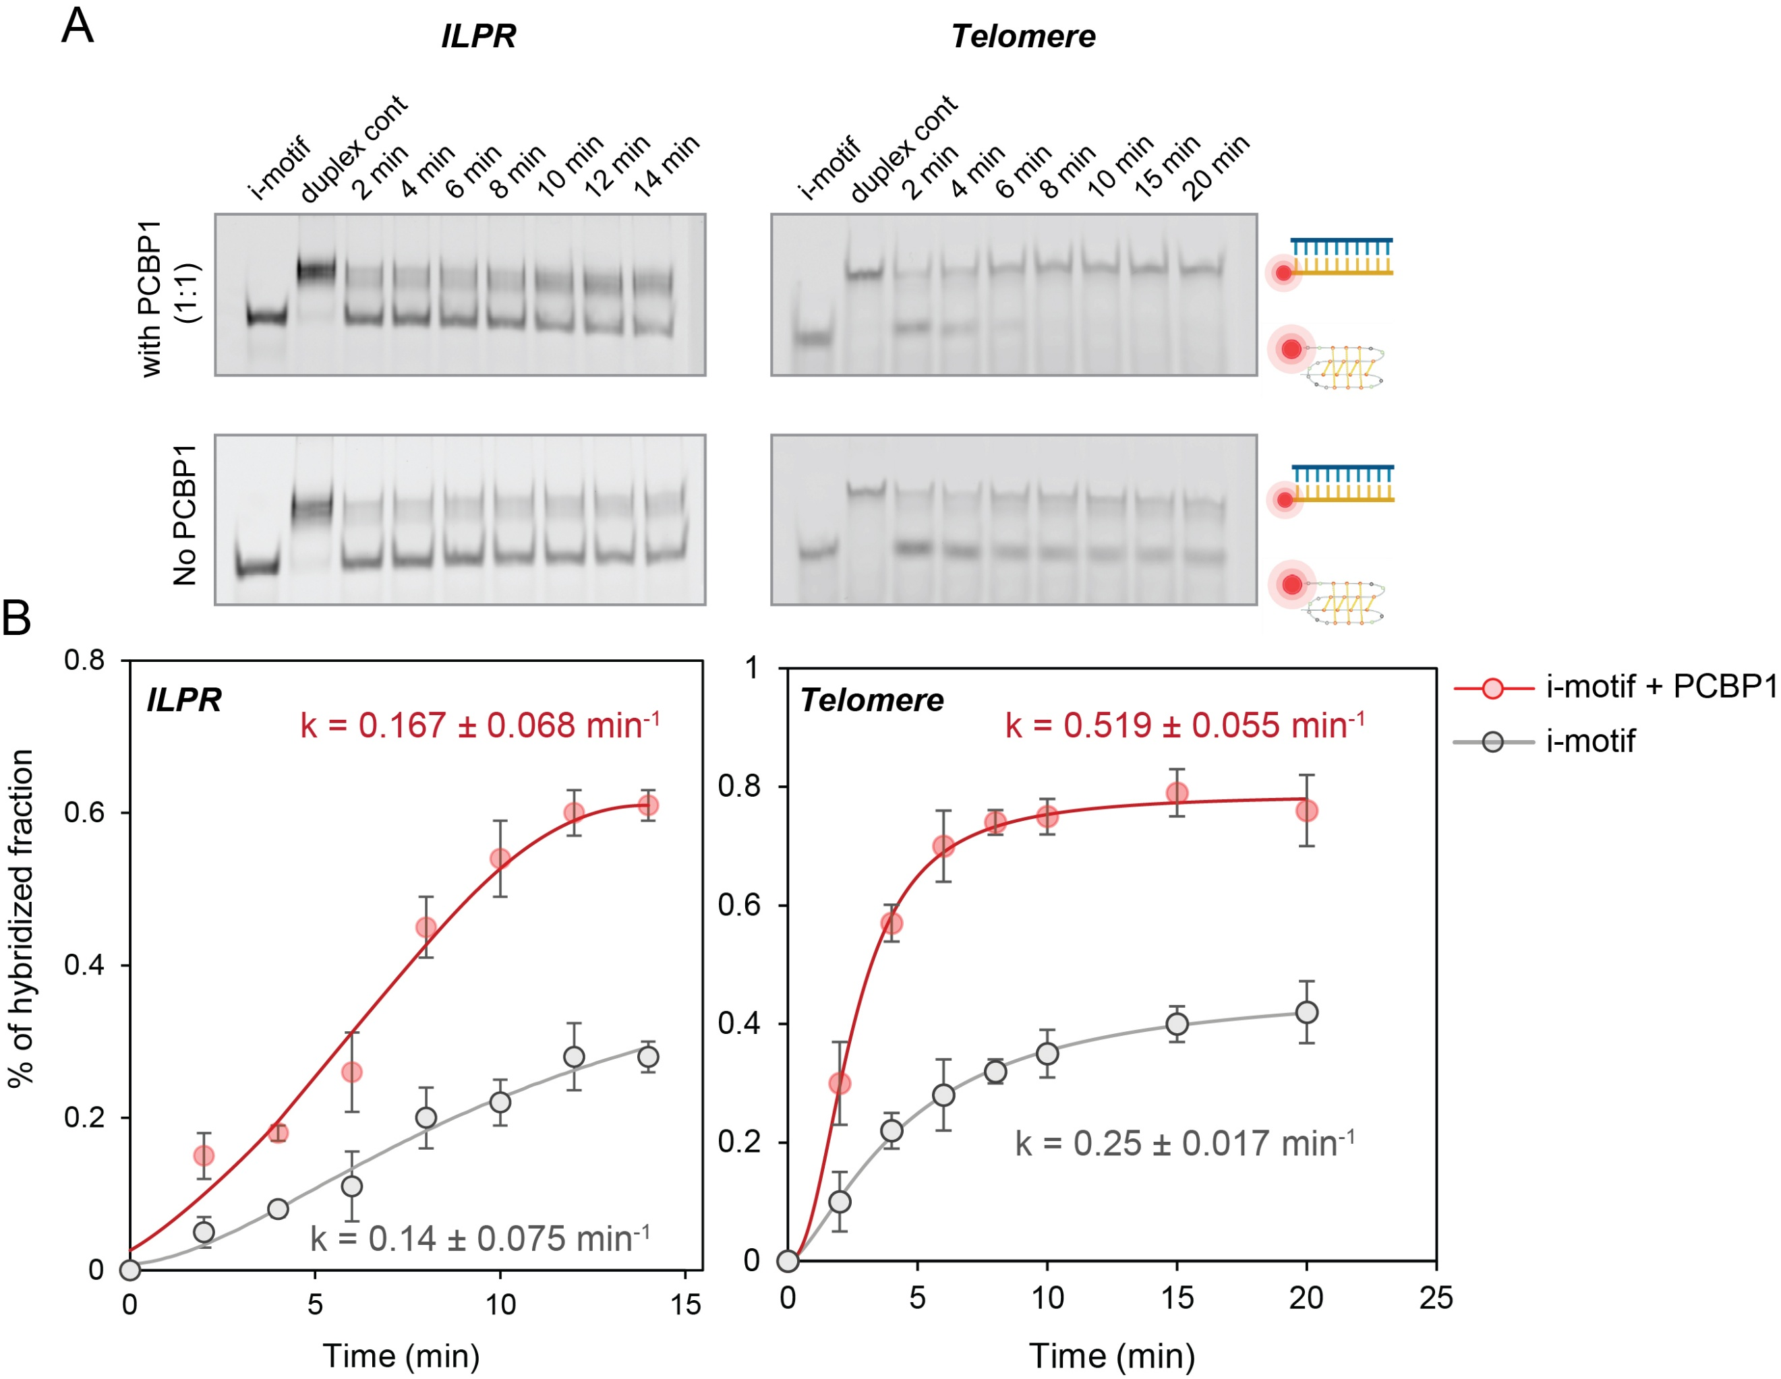
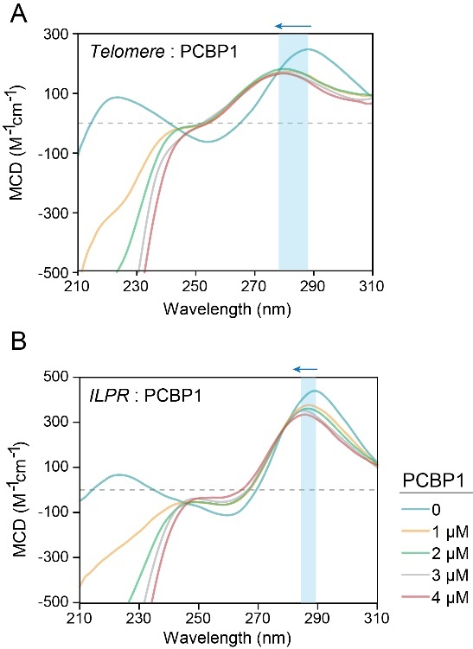
Fig. S9. I-motif-destabilization trapping assay in ILPR and Telomere. (A) Native PAGE visualizing hybridization reaction aliquots at different time intervals up to 14 min and 20 min respectively for ILPR and Telomere, alongside negative control (i-motifs without complementary strands) and positive controls (hybridized duplex). Reactions performed at 25 ºC in 20 mM MES (pH 6.4), 50 mM NaCl, 2 mM MgCl₂, and 0.25 mg/mL BSA. (B) Densitometric analysis of i-motif-trapping. Percentage intensities of hybridized fractions calculated from three biological replicates at different time points, fitted to mono-exponential function.
Fig. S8. CD spectra of (A) Telomere and (B) ILPR i-motifs upon PCBP1 titrations at 25 ºC in 20 mM MES, 100 mM NaCl at pH 6.4. The highlighted regions showing blue-shift (with arrow) and hypochromic effects.

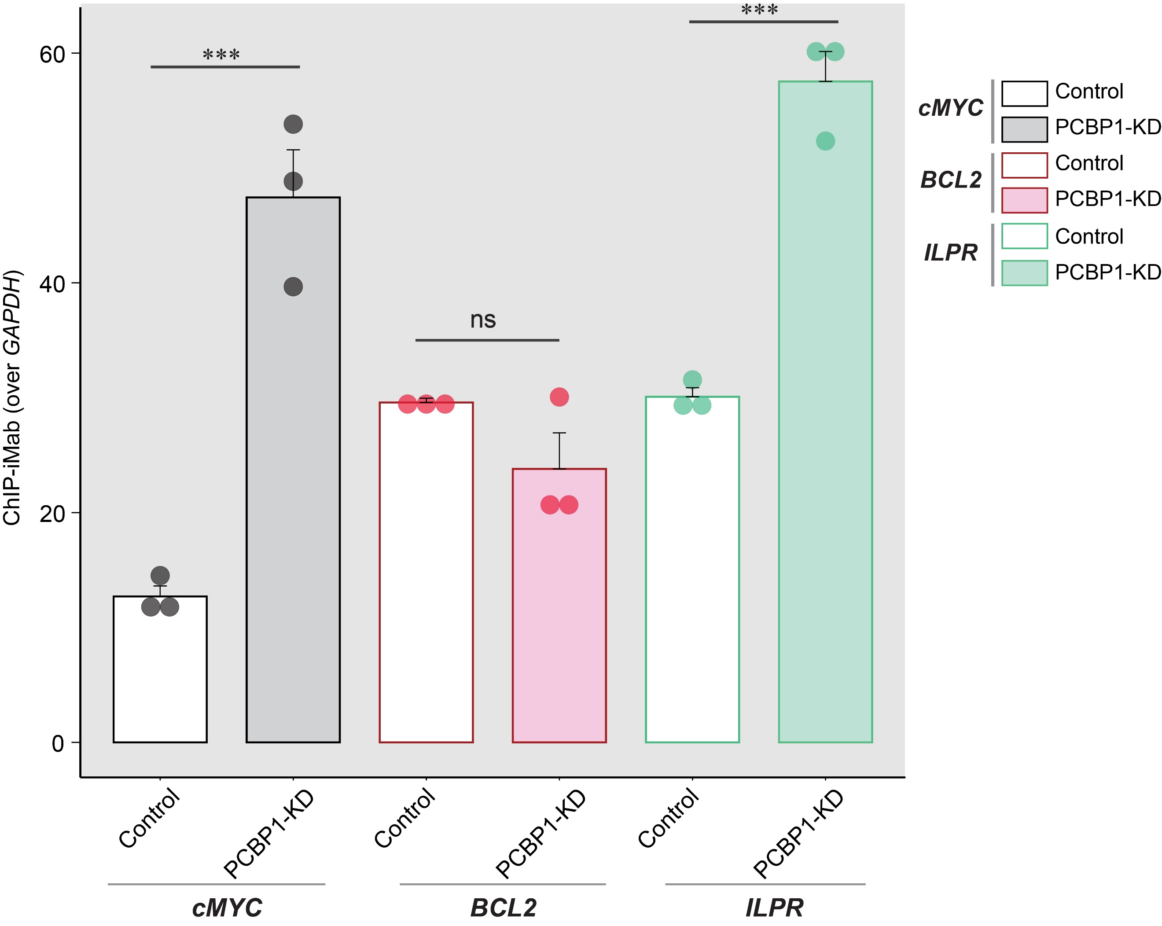
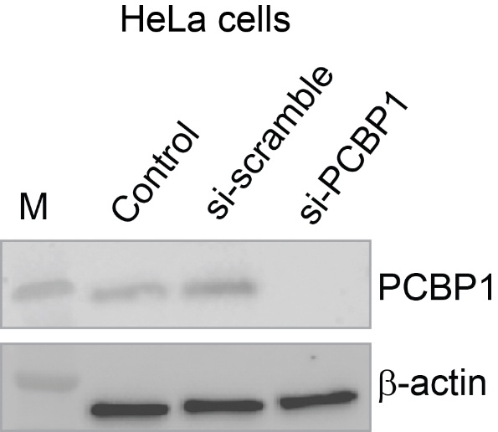
Fig. S10. Western blot confirmation of siRNA-mediated PCBP1 knockdown (PCBP1-KD) in HeLa cells. β-actin used as loading reference. M indicates molecular size marker.
Fig. S11. Quantification of iMab-ChIP efficiency at i-motif-harboring oncogene promoters (cMYC, BCL2, ILPR) versus non-i-motif control site (GAPDH) at pH 7.4, using percentage of input method; error bars from three biological replicates. Statistical differences between control and PCBP-KD determined by one-way ANOVA followed by Tukey–Kramer test (* indicating p-value < 0.05, ** indicating p-value < 0.01, *** indicating p-value < 0.001 and ns indicating non-significant results).
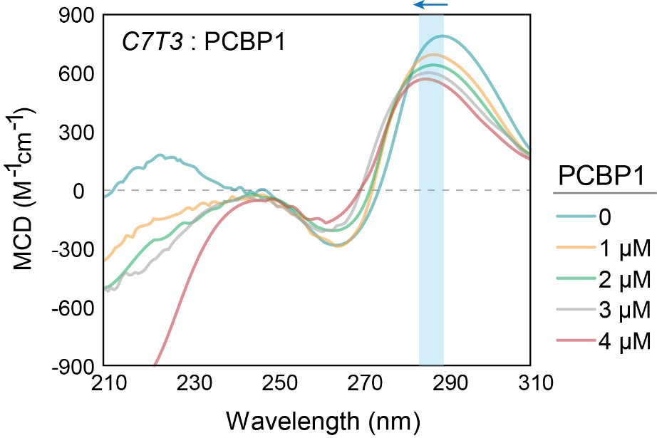
Fig. S12. CD spectra of C7T3 i-motif upon different concentrations of PCBP1 titrations at 25 ºC in 20 mM MES, 100 mM NaCl at pH 6.4, with highlighted regions showing blue-shift (with arrows) and hypochromic effects.
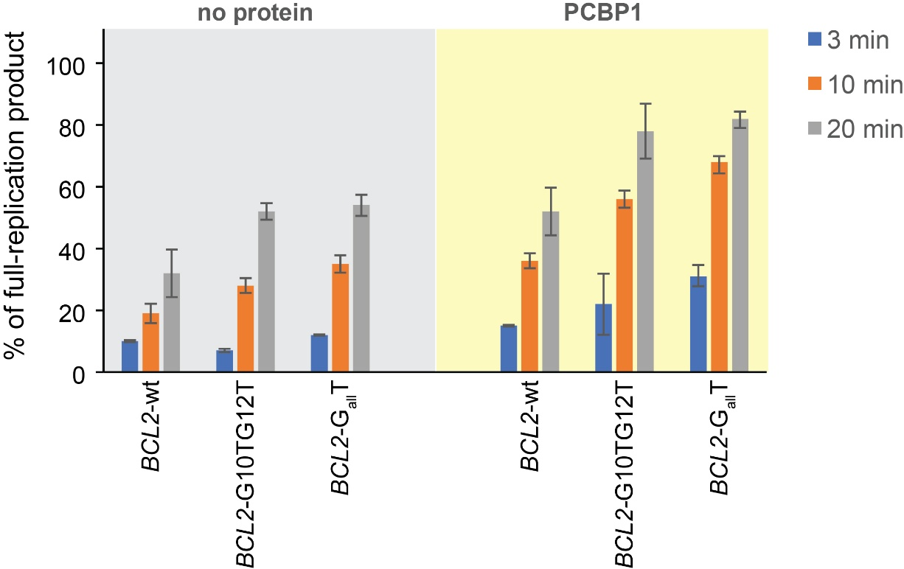
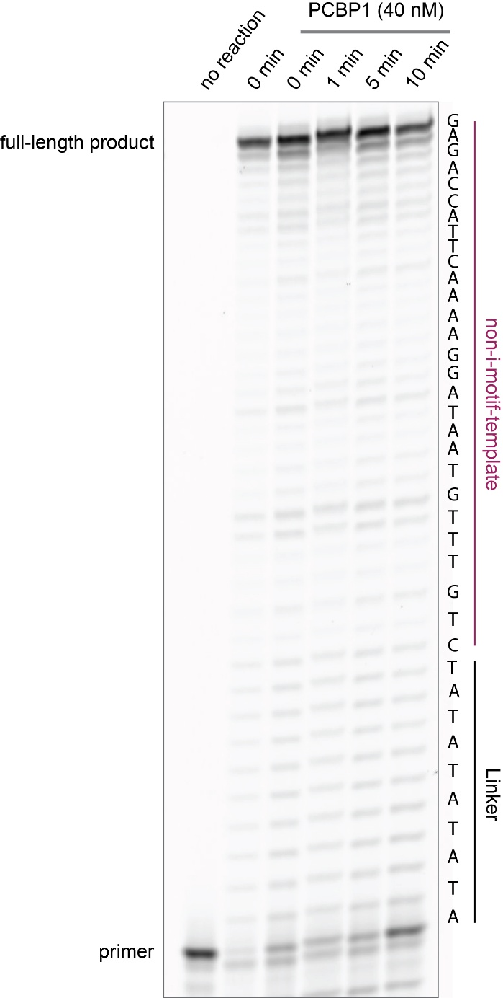
Fig. S14. Densitometric analyses of the % of full-replication products in BCL2-wt and mutant templates. In presence of 40 nM PCBP, increase in full-replication products in time-dependent manner. Reactions performed at 25 ºC in 20 mM MES (pH 6.0), 6 mM MgCl₂, 0.2 mg/ml BSA, 0.05 μU/L Klenow fragment, and 0.2 mM dNTPs. Error bars calculated from three biological replicates.
Fig. S13. Primer extension assay with non-i-motif template. In presence of 40 nM PCBP1 at different time-points (1 – 10 min) alongside 0 min reaction with no PCBP1 and no reaction controls. Reactions performed at 25 ºC in 20 mM MES (pH 6.0), 6 mM MgCl₂, 0.2 mg/ml BSA, 0.05 μU/L Klenow fragment, and 0.2 mM dNTPs.

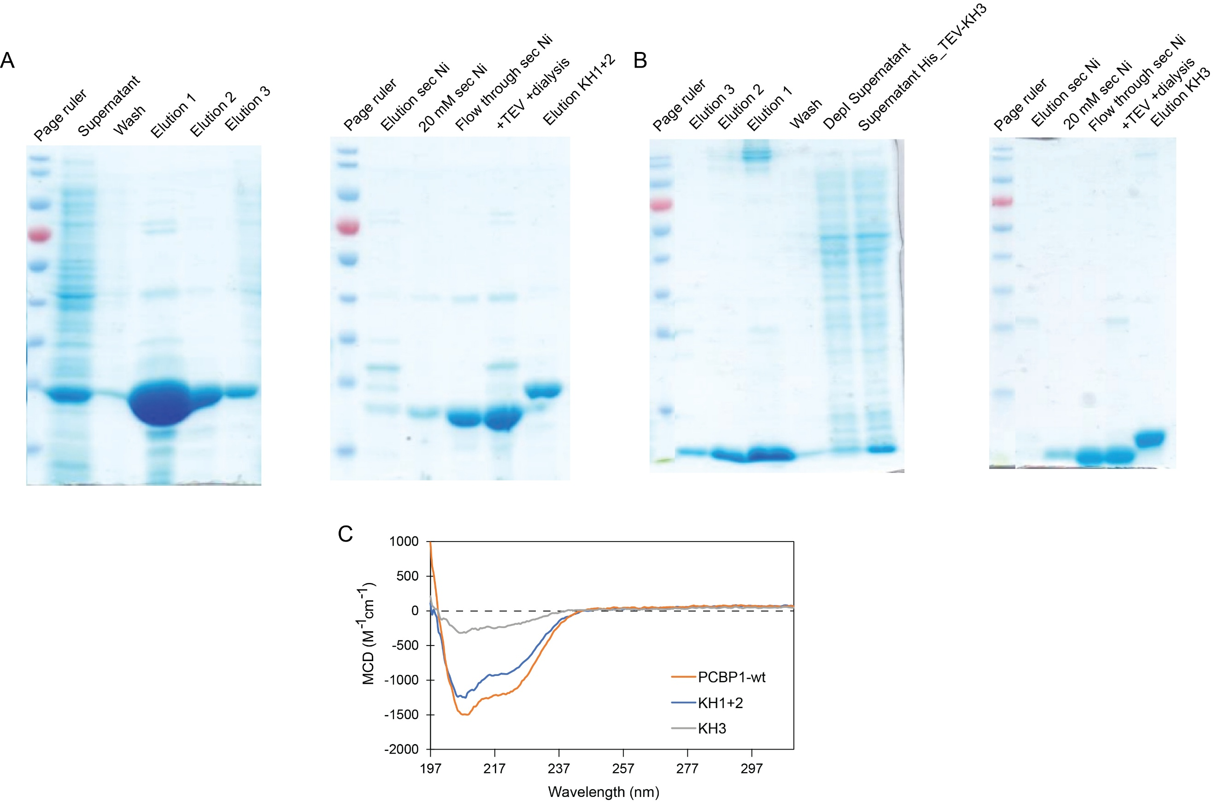
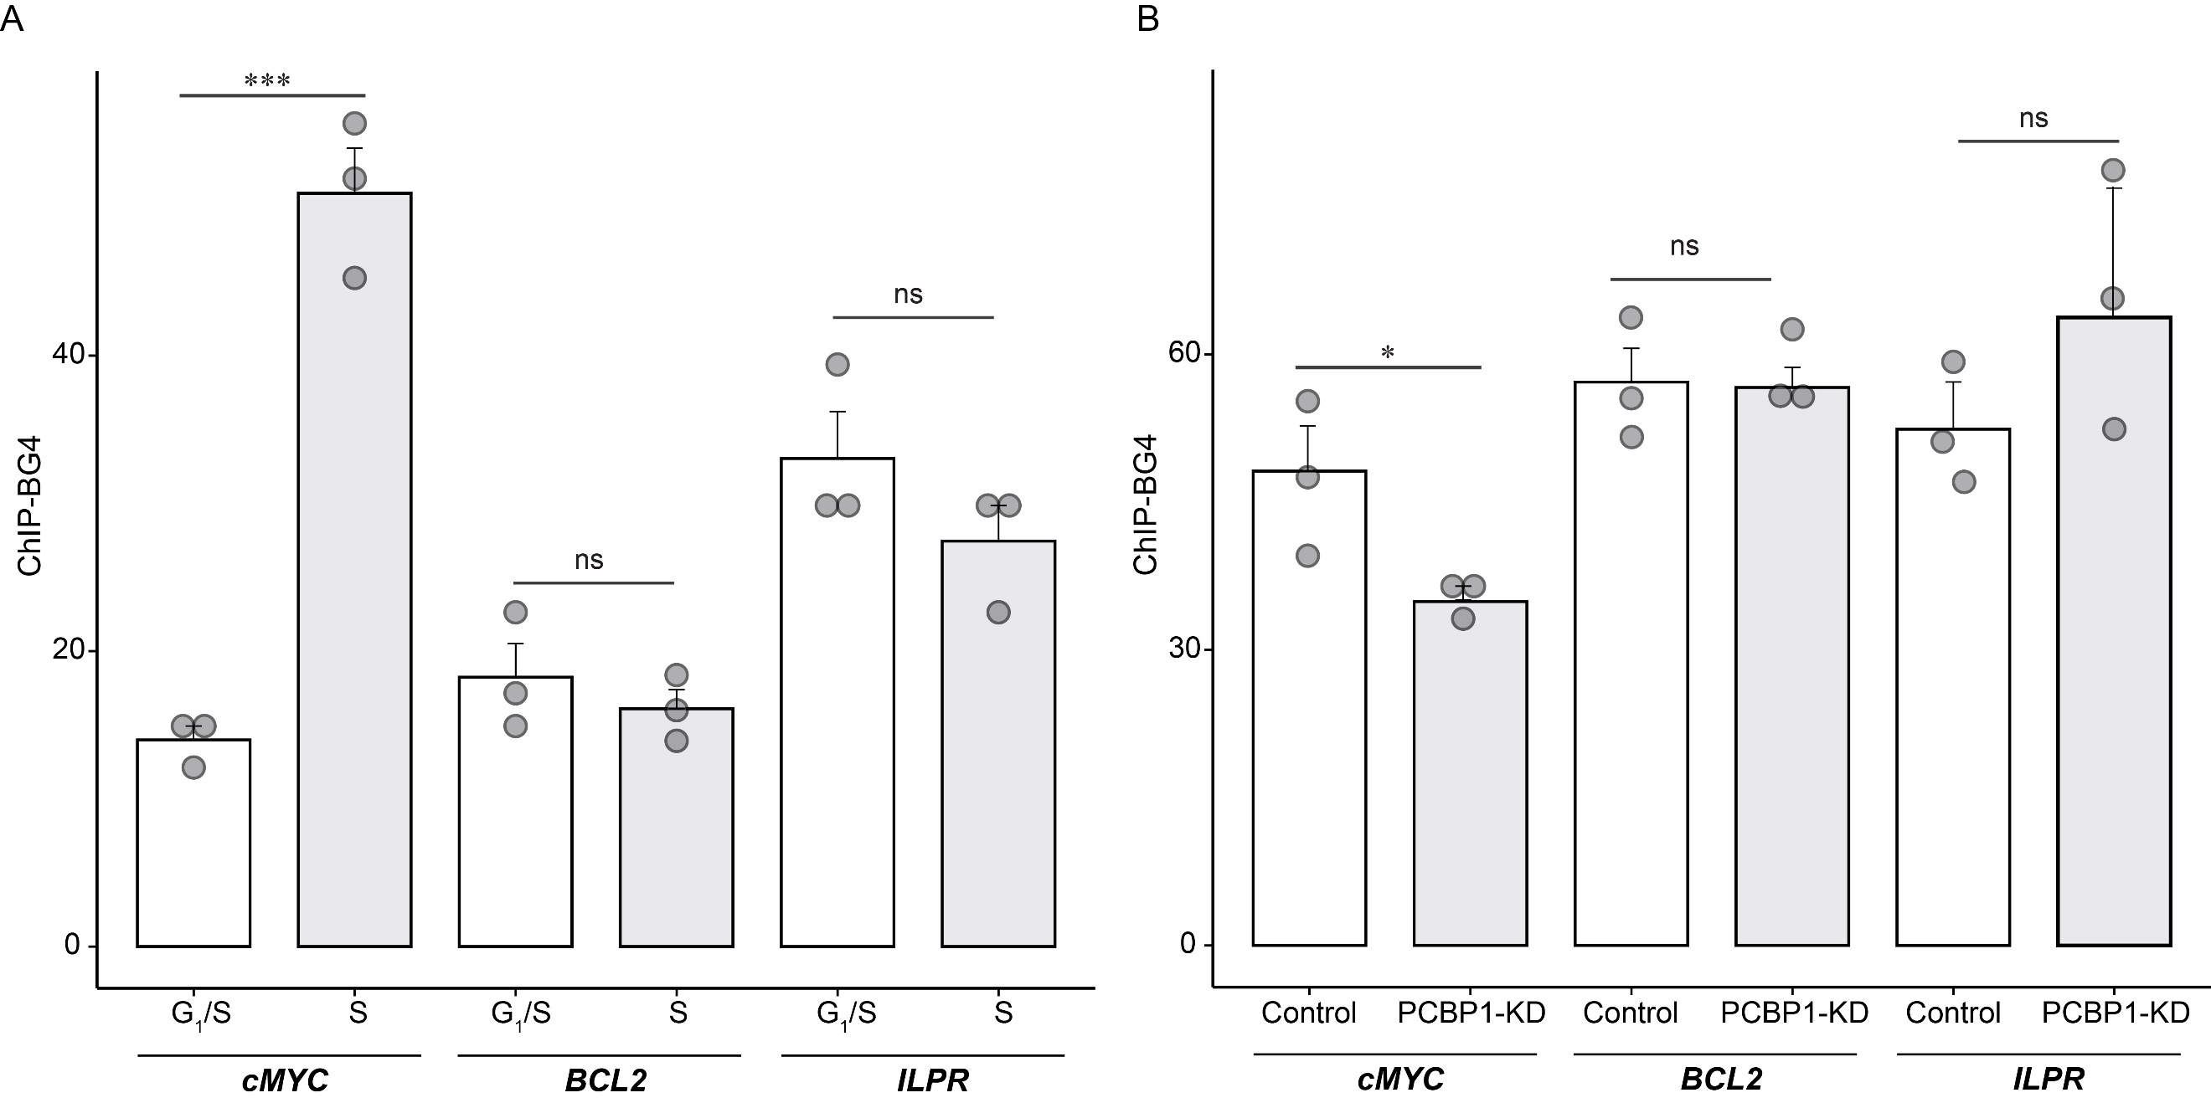
Fig. S15. Quantification of BG4-ChIP efficiency at i-motif-harboring oncogene promoters (cMYC, BCL2, ILPR) versus non-G4 control site (TMCC1), using percentage of input method; error bars from three biological replicates. Statistical differences between (A) G₁/S and S phase cells and (B) Control and PCBP1-KD cells were determined by one-way ANOVA followed by Tukey–Kramer test (* indicating p-value < 0.05, ** indicating p-value < 0.01, *** indicating p-value < 0.001 and ns indicating non-significant results).
Fig. S16. Purification of (A) KH1+2 and (B) KH3 domains of PCBP1. Recombinant KH mutants purified from Escherichia coli BL21(DE3) cells induced at 20 °C. Supernatant showing soluble fraction after cell lysis, sonication and centrifugation. The supernatant was filtered through a 0.45 µm membrane and loaded onto Thermo Scientific Ni-NTA gravity columns. After washing, KH mutants were eluted with 300 mM NaCl and 300 mM imidazole, then dialyzed and subjected to TEV protease cleavage to cleave off the His-tag. The final elution was obtained in a buffer containing 20 mM Tris-HCl (pH 8.0), 150 mM NaCl, 20% glycerol, and 1 mM DTT. (C) CD spectral profiles of 4 µM of purified PCBP1 and the KH-mutants (KH1+2 and KH3) in 20 mM Tris-HCl (pH 8.0), 150 mM NaCl, 20% glycerol, and 1 mM DTT at 25 ᵒC.
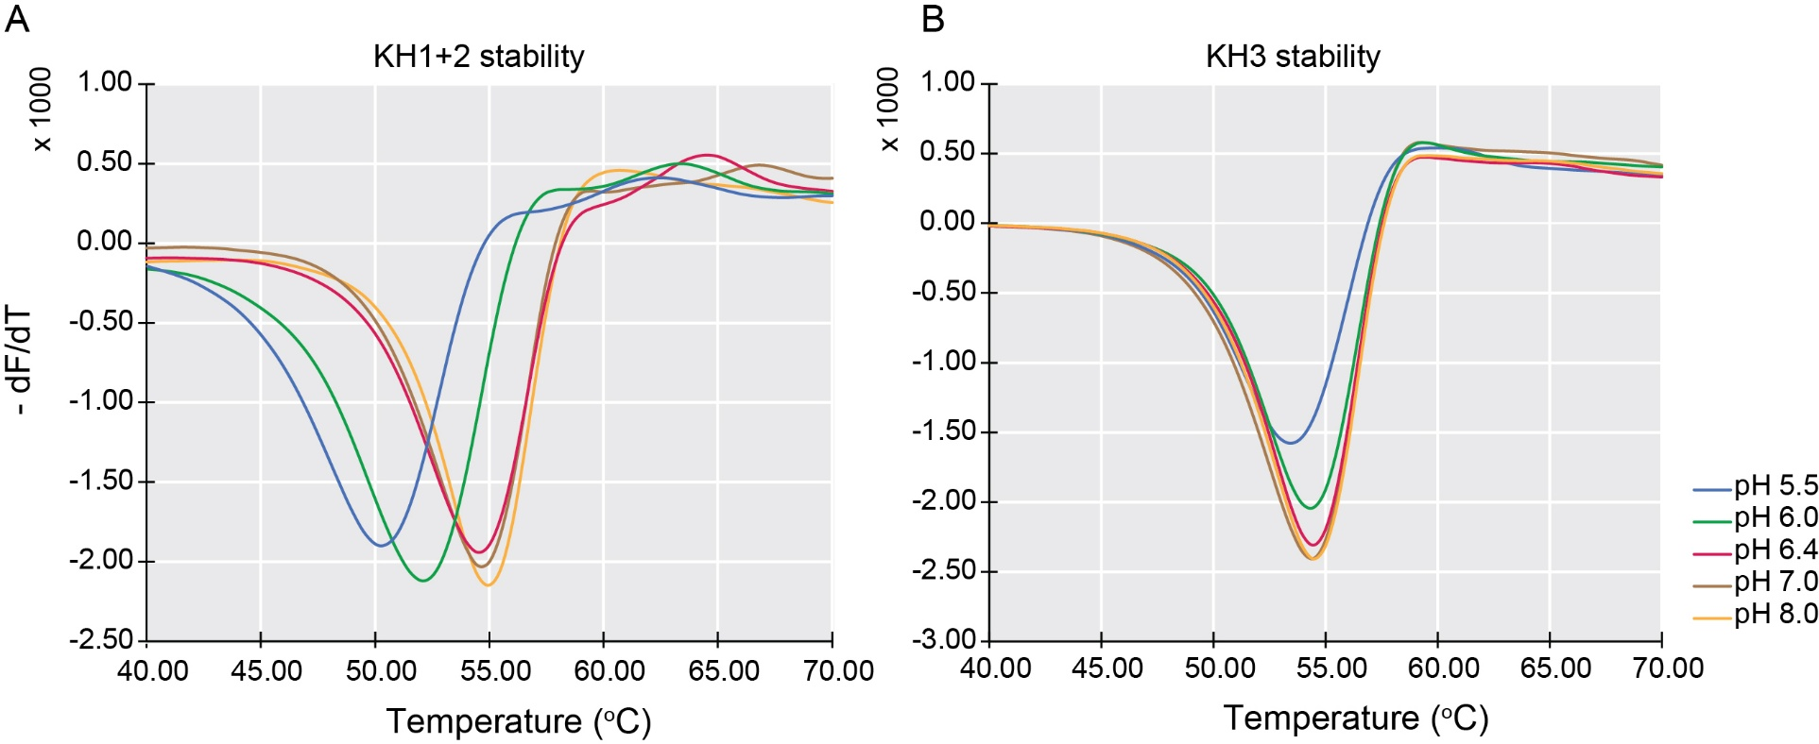

Fig. S17. Thermal stability of KH mutants. Thermal-shift assay of (A) KH1+2 and (B) KH3, with $-\frac{dF}{dT}$ representing the negative derivative of SYPRO-Orange fluorescence signal with respect to temperature; T_{m} defined by negative maxima at different pH values. Assays performed in 20 mM MES buffer at pH 5.5, 6.0, 6.4 and in 20 mM Tris-Cl buffer at pH 7.0 and 8.0, supplemented with 100 mM NaCl.
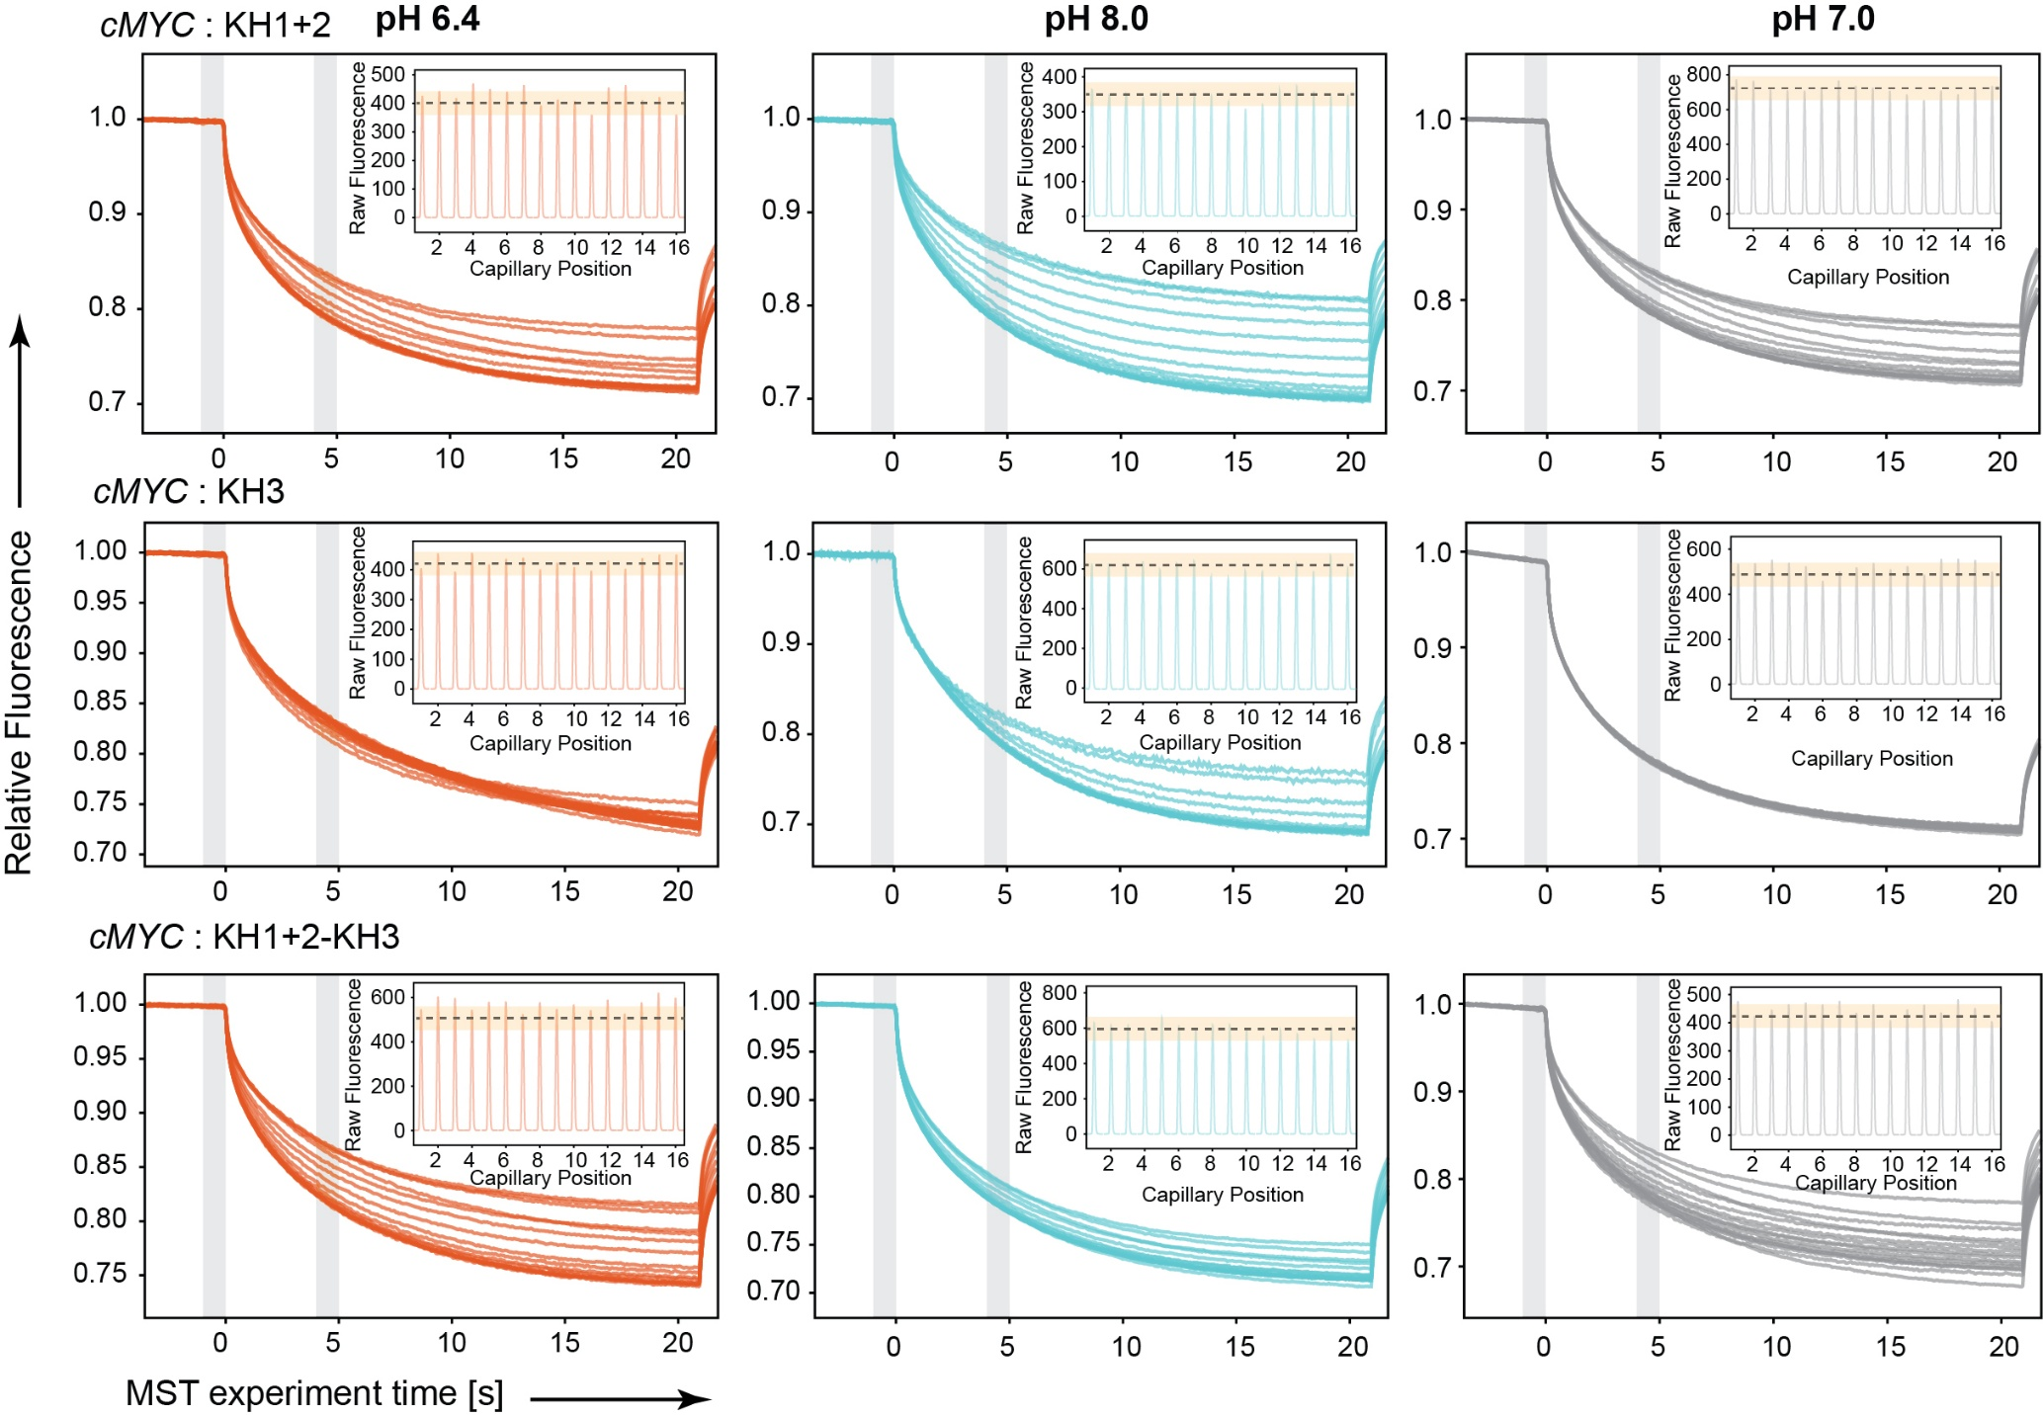

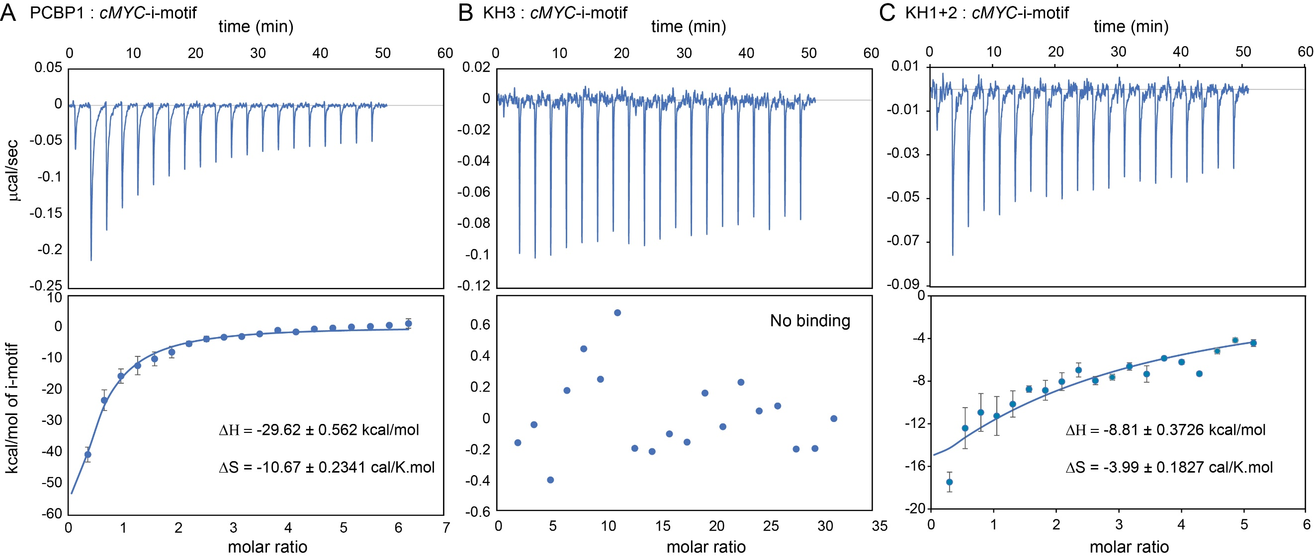
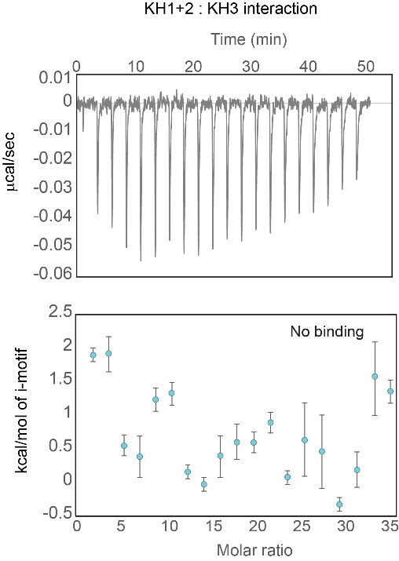
Fig. S18. MST traces and raw fluorescence profiles showing the binding interactions between KH-mutants and cMYC-iMfs at 25 ºC under three different pH conditions: in 20 mM MES, 100 mM NaCl at pH 6.4 (orange traces), in 20 mM Tris, 100 mM NaCl at pH 8.0 (cyan traces), and in 20 mM sodium phosphate, 100 mM NaCl at pH 7.0 (gray traces). MST traces showing relative fluorescence of the KH-mutants-bound and unbound cMYC-iMfs vs MST experimental time. Insets in each graph display the raw fluorescence as a function of capillary position.
Fig. S19. ITC profile showing intermolecular interactions between KH1+2 and KH3. Top panel: enthalpic heat released versus time at 25ºC in 20 mM MES (pH 6.4), 100 mM NaCl during titrations. Bottom panel: thermogram of the integrated peak intensities plotted against molar ratio.
Fig. S20. ITC profile showing intermolecular interactions between PCBP1 and KH mutant proteins and cMYC-i-motif at pH 6.4. (A) PCBP1-cMYC-i-motif interaction. (B) KH3 mutant-cMYC-i-motif interaction. (C) KH1+2 mutant-cMYC-i-motif interaction. Top: enthalpic heat released versus time at 25ºC in 20 mM MES (pH 6.4), 100 mM NaCl during titrations. Bottom: thermogram of the integrated peak intensities plotted against molar ratio. ΔH and ΔS calculated based on one-site binding model using integrated software and indicate enthalpic and entropic contributions of binding. Error bars indicate three biological replicates.

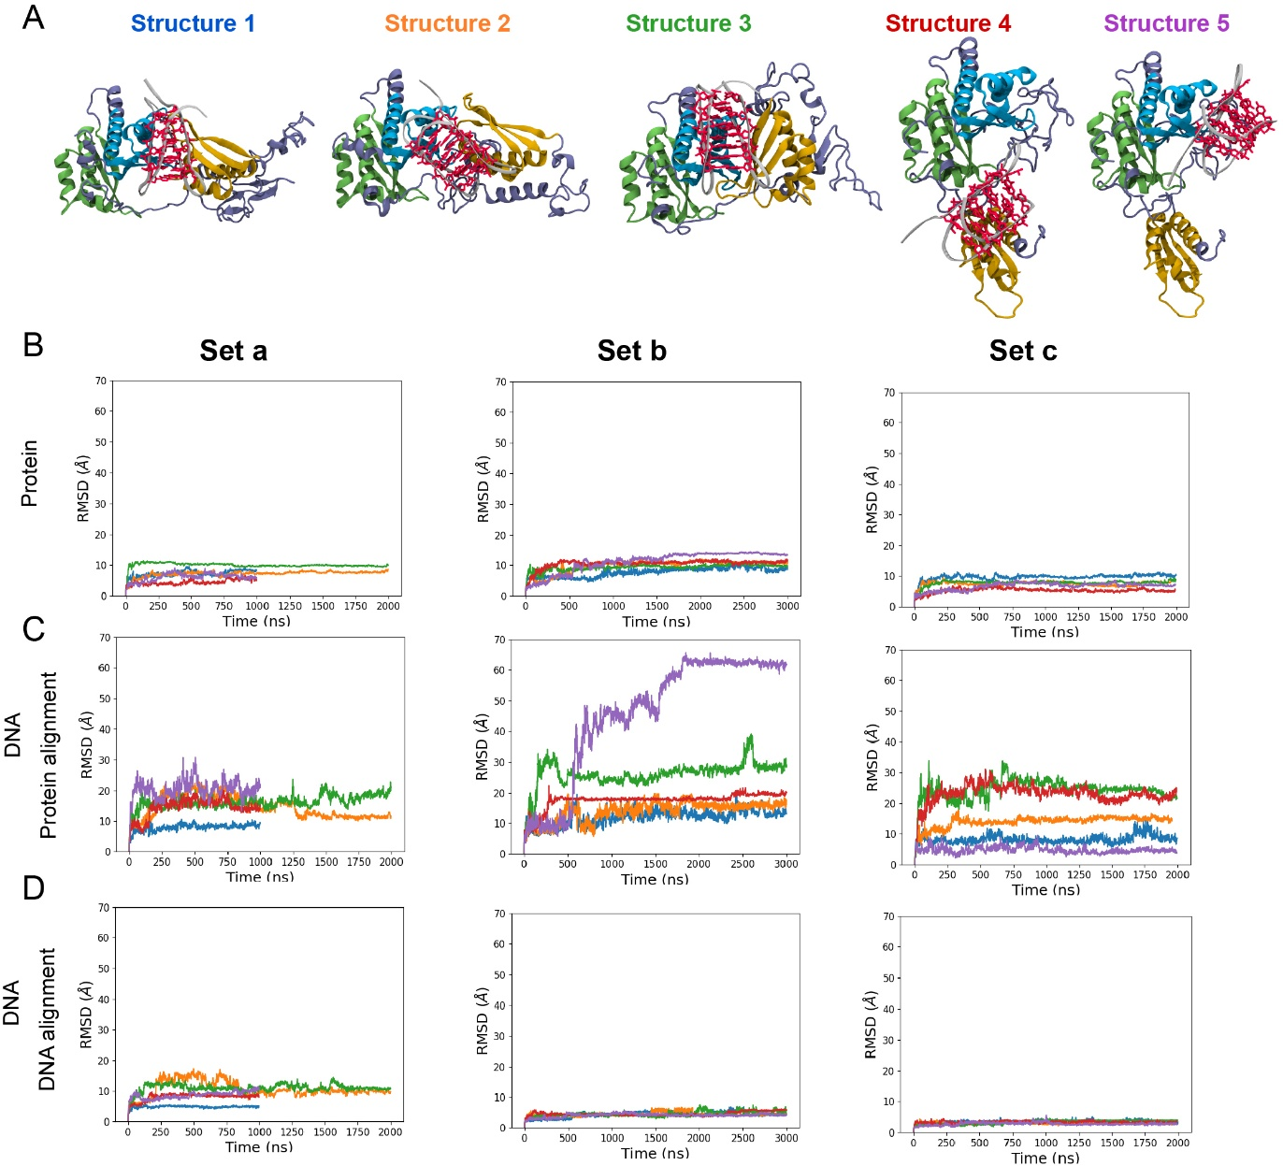

Fig. S21. In silico modelling of PCBP1-ILPR-i-motif complexes (A) Five starting structures for MD simulations with ILPR-i-motif backbone (silver), cytosines (red), KH1 domain (cyan), KH2 domain (light green), KH3 domain (yellow), interconnecting domains (violet). RMSD evolution along the MD simulations for the five structures (1: blue; 2: orange; 3: green; 4: red; 5: purple) in set a, b and c for (B) the whole protein, (C) DNA after alignment of the trajectories on the protein position and (D) DNA after alignment on DNA position.
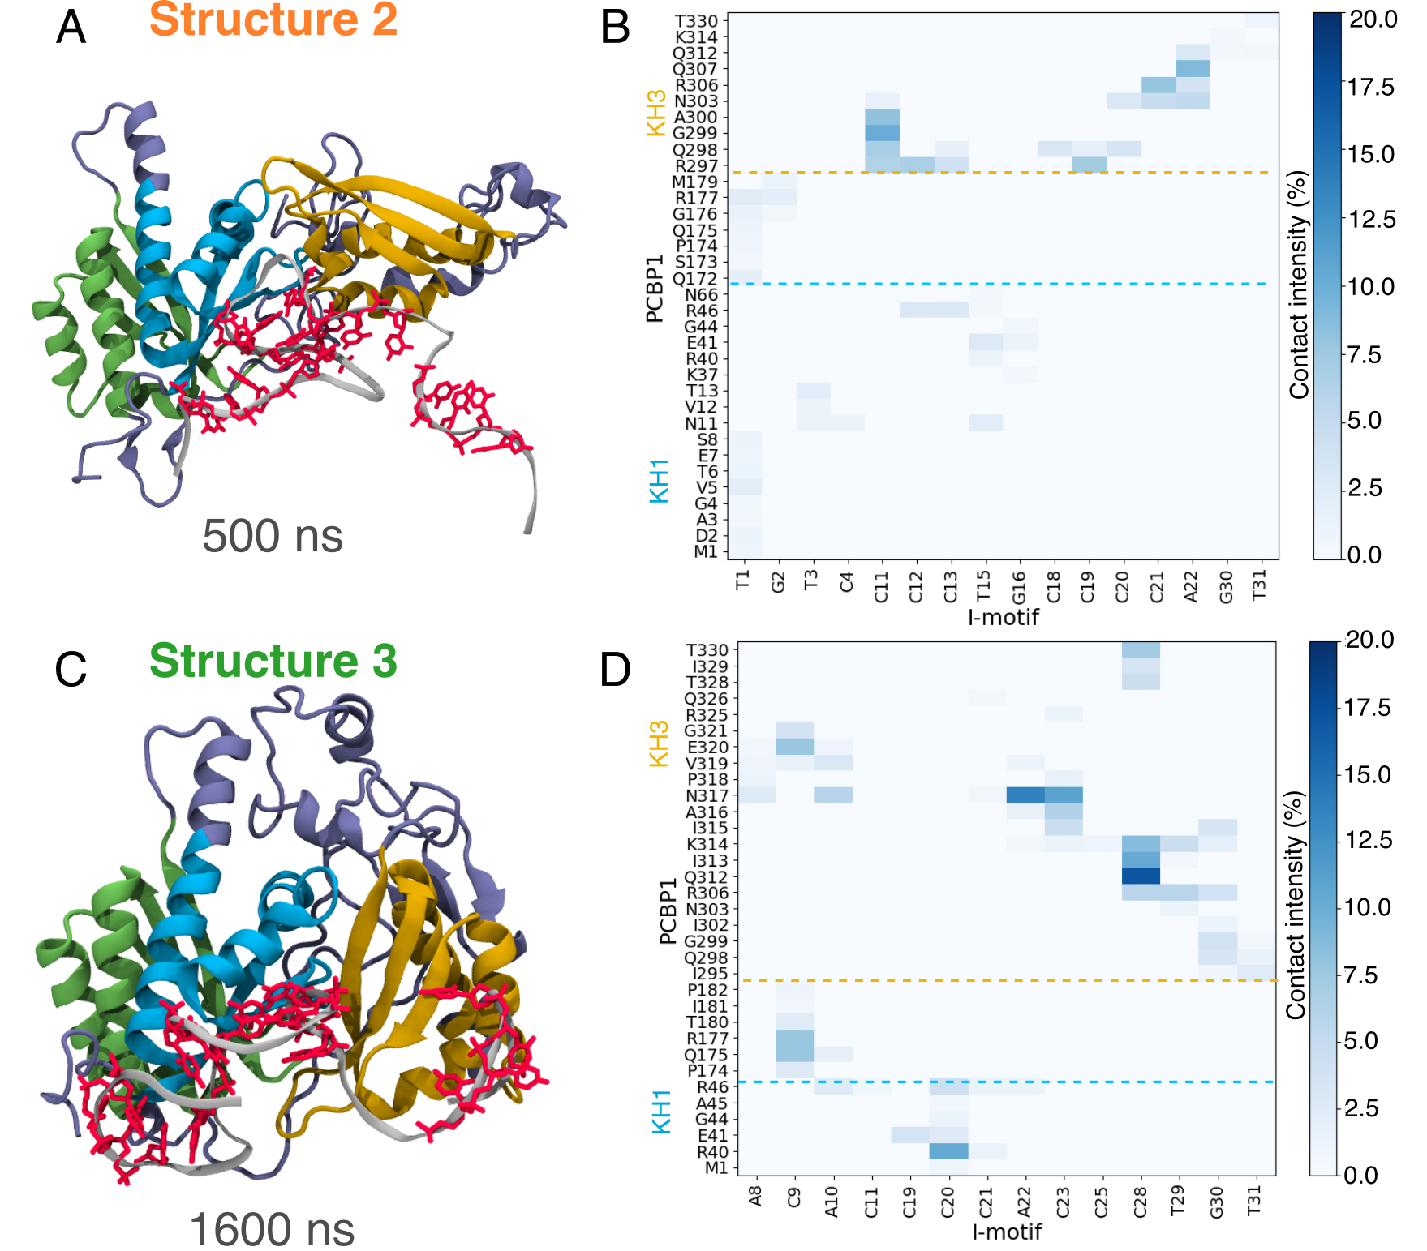
Fig. S22. Unfolding event in Molecular Dynamics simulations in set (a). (A) and (C) Structures 2 and 3 from set (a) from molecular dynamics simulation with a partial unfold of the ILPR-i-motif. (B) and (D) Contact heatmap between PCBP1 and ILPR-i-motif for the 3 μs molecular dynamics simulation; a contact is counted with one heavy atom of an amino-acid is at less than 4 Å for structure 2 (B) or 3 (D).
Supporting video legends:
SV1: Molecular dynamics simulation of PCBP1–ILPR-i-motif complex for 2500 ns. The video depicts the structural evolution of structure 1 under set (a) unprotonated condition. ILPR-i-motif backbone (silver), unprotonated cytosines (red), KH1 domain (cyan), KH2 domain (light green), KH3 domain (yellow), interconnecting domains (violet). Progressive unfolding events, base-pair disruptions, or stabilization features can be observed over the course of the 2500 ns simulation.
SV2: Molecular dynamics simulation of PCBP1–ILPR-i-motif complex for 2500 ns. The video depicts the structural evolution of structure 3 under set (a) unprotonated condition. ILPR-i-motif backbone (silver), unprotonated cytosines (red), KH1 domain (cyan), KH2 domain (light green), KH3 domain (yellow), interconnecting domains (violet). Progressive unfolding events, base-pair disruptions, or stabilization features can be observed over the course of the 2500 ns simulation.
SV3: Molecular dynamics simulation of PCBP1–ILPR-i-motif complex for 2500 ns. The video depicts the structural evolution of structure 1 under set (b) partially protonated condition. ILPR-i-motif backbone (silver), unprotonated cytosines (red), protonated cytosines (violet), KH1 domain (cyan), KH2 domain (light green), KH3 domain (yellow), interconnecting domains (violet). Progressive unfolding events, base-pair disruptions, or stabilization features can be observed over the course of the 2500 ns simulation.
SV4: Molecular dynamics simulation of PCBP1–ILPR-i-motif complex for 2500 ns. The video depicts the structural evolution of structure 1 under set (c) fully protonated condition. ILPR-i-motif backbone (silver), unprotonated cytosines (red), protonated cytosines (violet), KH1 domain (cyan), KH2 domain (light green), KH3 domain (yellow), interconnecting domains (violet). Progressive unfolding events, base-pair disruptions, or stabilization features can be observed over the course of the 2500 ns simulation.

References:
1. Sengupta, P., Jamroskovic, J. & Sabouri, N. A beginner’s handbook to identify and characterize i-motif DNA. in Methods in Enzymology vol. 695 45–70 (Elsevier, 2024).
2. Ross, S. A. & Burrows, C. J. Cytosine-specific chemical probing of DNA using bromide and monoperoxysulfate. Nucleic Acids Research 24, 5062–5063 (1996).
3. Maxam, A. M. & Gilbert, W. [57] Sequencing end-labeled DNA with base-specific chemical cleavages. in Methods in Enzymology vol. 65 499–560 (Elsevier, 1980).
4. Jamroskovic, J., Deiana, M. & Sabouri, N. Probing the folding pathways of four-stranded intercalated cytosine-rich motifs at single base-pair resolution. Biochimie 199, 81–91 (2022).
5. Jumper, J. et al. Highly accurate protein structure prediction with AlphaFold. Nature 596, 583–589 (2021).
6. Baek, M. et al. Accurate prediction of protein structures and interactions using a three-track neural network. Science 373, 871–876 (2021).
7. Baek, M. et al. Accurate prediction of protein–nucleic acid complexes using RoseTTAFoldNA. Nat Methods 21, 117–121 (2024).
8. Maier, J. A. et al. ff14SB: Improving the Accuracy of Protein Side Chain and Backbone Parameters from ff99SB. J. Chem. Theory Comput. 11, 3696–3713 (2015).
9. Ivani, I. et al. Parmbsc1: a refined force field for DNA simulations. Nat Methods 13, 55–58 (2016).
10. Yoo, J. & Aksimentiev, A. New tricks for old dogs: improving the accuracy of biomolecular force fields by pair-specific corrections to non-bonded interactions. Phys. Chem. Chem. Phys. 20, 8432–8449 (2018).
11. Song, D., Luo, R. & Chen, H.-F. The IDP-Specific Force Field ff14IDPSFF Improves the Conformer Sampling of Intrinsically Disordered Proteins. J. Chem. Inf. Model. 57, 1166–1178 (2017).
12. Olsson, M. H. M., Søndergaard, C. R., Rostkowski, M. & Jensen, J. H. PROPKA3: Consistent Treatment of Internal and Surface Residues in Empirical p K_{a} Predictions. J. Chem. Theory Comput. 7, 525–537 (2011).
13. Roe, D. R. & Cheatham, T. E. PTRAJ and CPPTRAJ: Software for Processing and Analysis of Molecular Dynamics Trajectory Data. J. Chem. Theory Comput. 9, 3084–3095 (2013).
14. Guneri, D. et al. Structural insights into i-motif DNA structures in sequences from the insulin-linked polymorphic region. Nat Commun 15, 7119 (2024).
15. Deiana, M. et al. A new G-quadruplex-specific photosensitizer inducing genome instability in cancer cells by triggering oxidative DNA damage and impeding replication fork progression. Nucleic Acids Research 51, 6264–6285 (2023).

