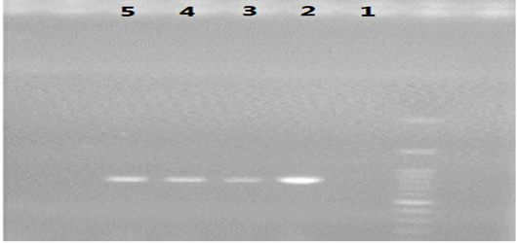
Fig 1. Bands related to the rolB gene. (The first and second wells are related to a positive control (bacterial plasmid) and negative control (non-inoculated sample), and the third, fourth, and fifth wells are related to hairy roots of Echium khuzestanicm plant.

Table 1:The results of variance analysis of the effect of different times on the growth rate of Echium khuzestanicm
 | df | Sum square | F Value
Time | 4 | 0.044 | 91.007**
Error | 10 | 0.0004
Total | 14 | - | CV=7.28
Note: ** p<0.01.

Table 2: The variance analysis of different concentrations of salicylic acid and methyl jasmonate on the growth of Echium khuzestanicm
 | df | Sum square | F Value
salicylic acid and methyl jasmonate | 6 | 0.062 | 125.42**
Error | 14 | 0.00049
Total | 20 | - | CV=13.15
Note: ** p<0.01.

Table 3: The variance analysis of different concentrations of Yeast on the growth of Echium khuzestanicm
 | df | Sum square | F Value
Yeast | 3 | 0.0007 | 260.47**
Error | 8 | 0.0000002
Total | 11 | - | CV=4.50
Note: ** p<0.01.

Table 4: The results of variance analysis of different times and elicitors on the amount of shikonin
 | df | Sum square | F Value
Time and elicitros | 11 | 0.117 | 448.19**
Error | 12 | 0.0002
Total | 23 | - | CV=5.7
Note: ** p<0.01.

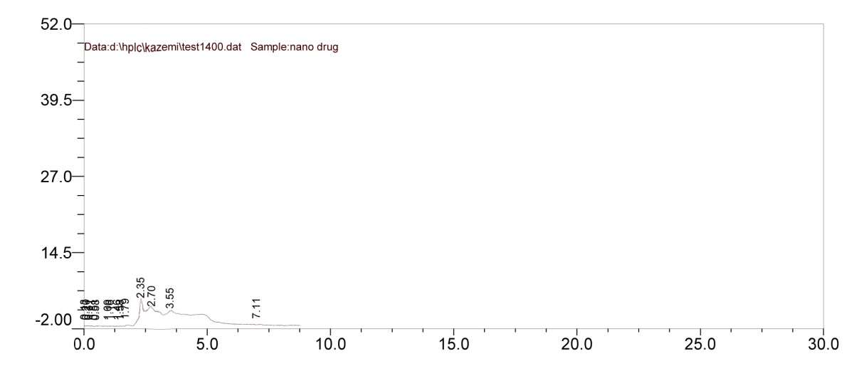
Fig 2:Peak diagram from the interaction of salicylic acid and methyl jasmonate in the HPLC

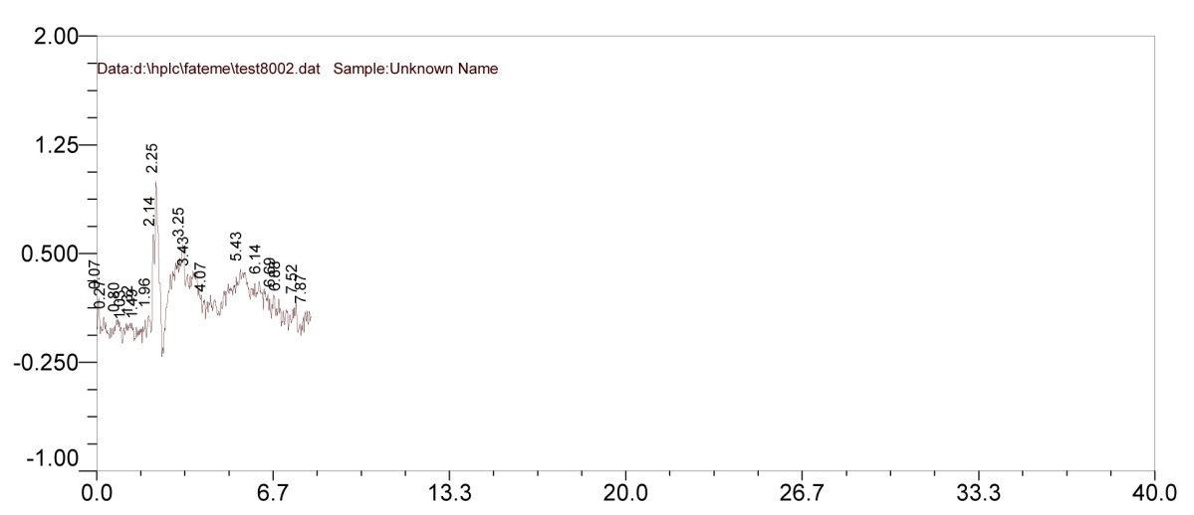
Fig 3: Peak diagram from the 30 minutes of dry time and 15 minutes of immersion in the HPLC

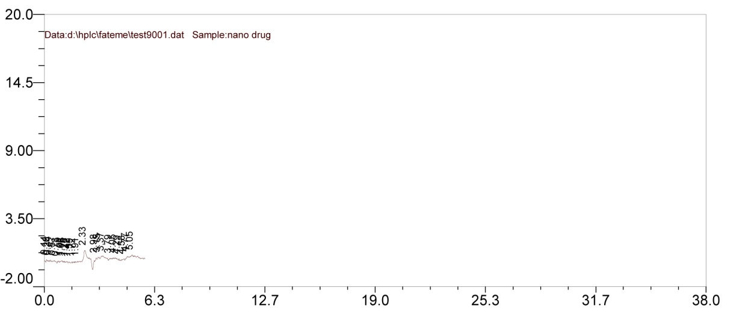
Fig 4: Peak diagram from 45 minutes of dry time and 15 minutes of immersion in the HPLC

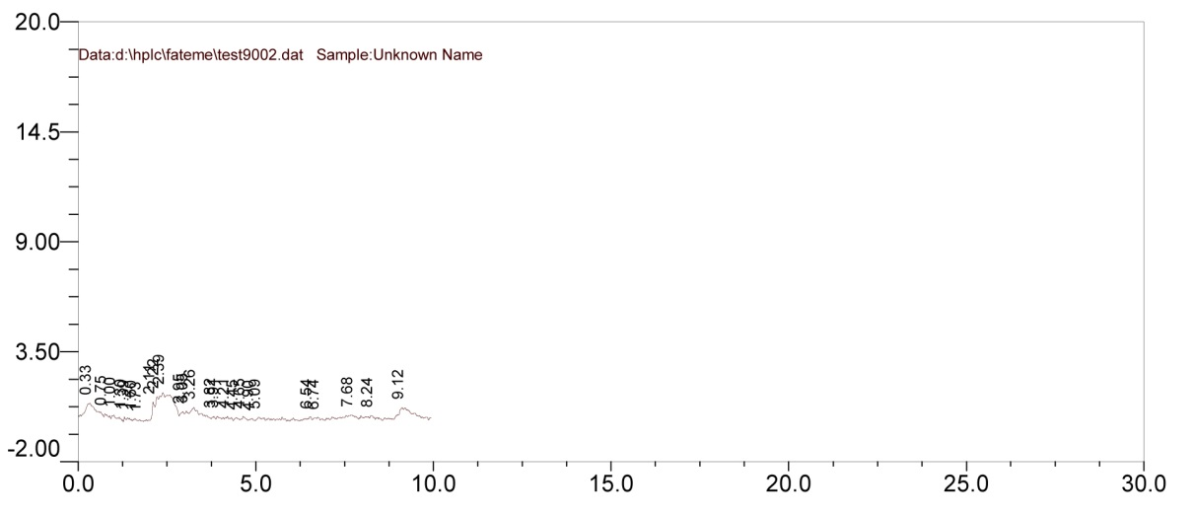
Fig 5: Peak diagram from the concentration of 125 μM of salicylic acid in the HPLC
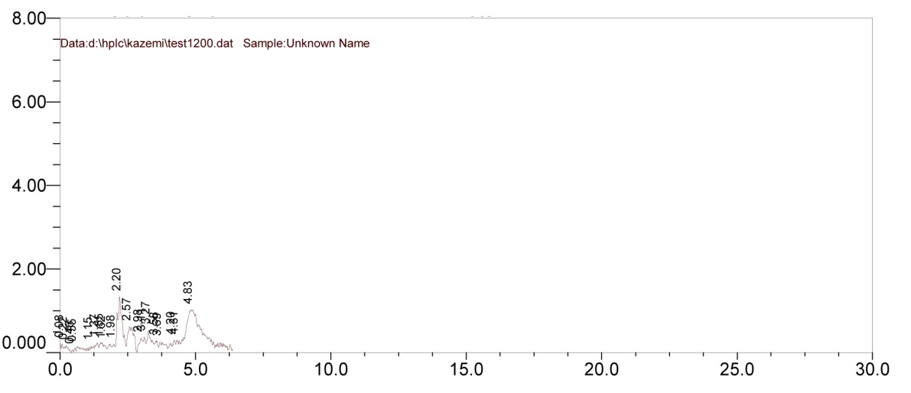
Fig 6: Peak diagram from the concentration of 250 μM of salicylic acid in the HPLC
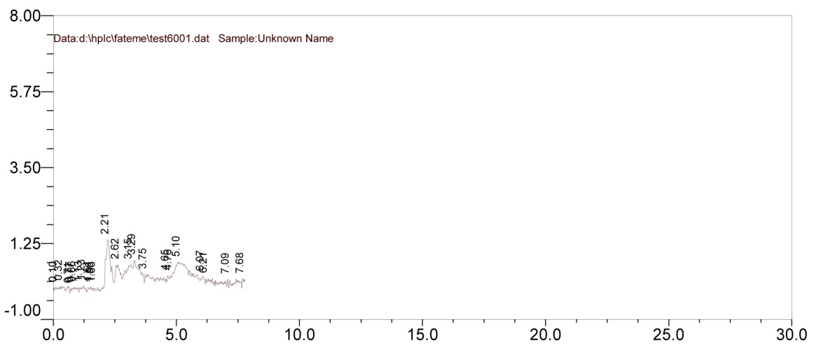

Fig 7: Peak diagram from the concentration of 500 μM of salicylic acid in the HPLC

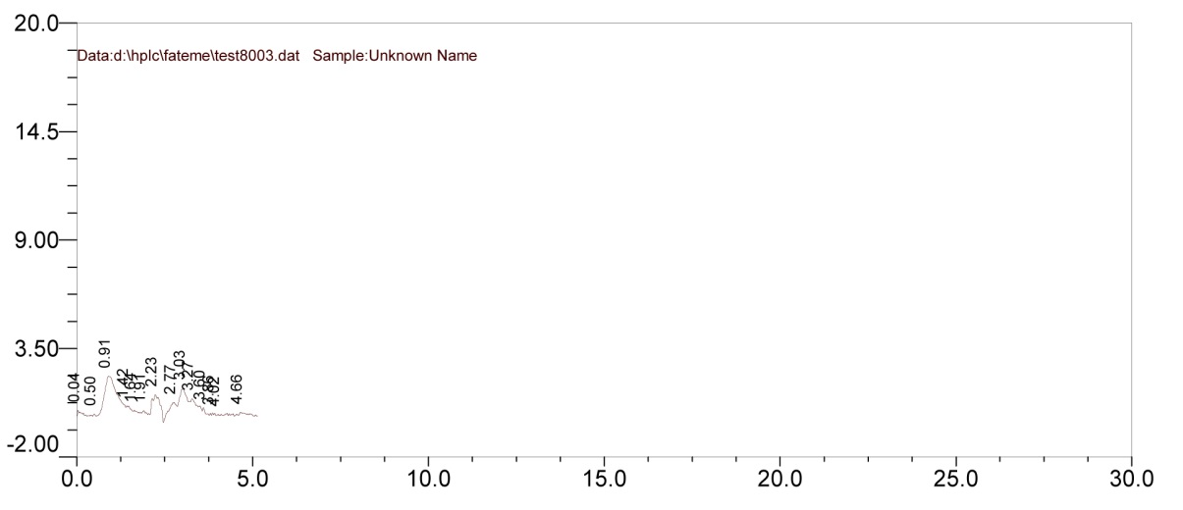
Fig 8: Peak diagram from yeast at a concentration of 250 mg in the HPLC

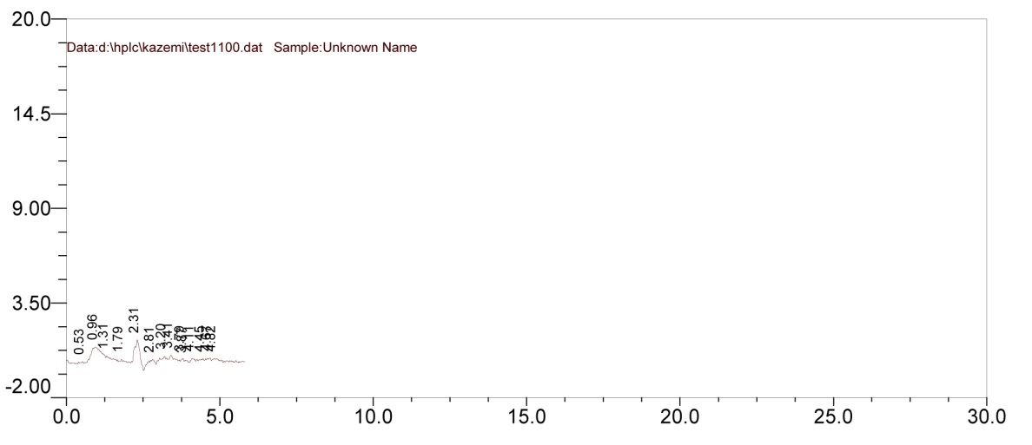
Fig 9: Peak diagram from yeast at a concentration of 500 mg in the HPLC

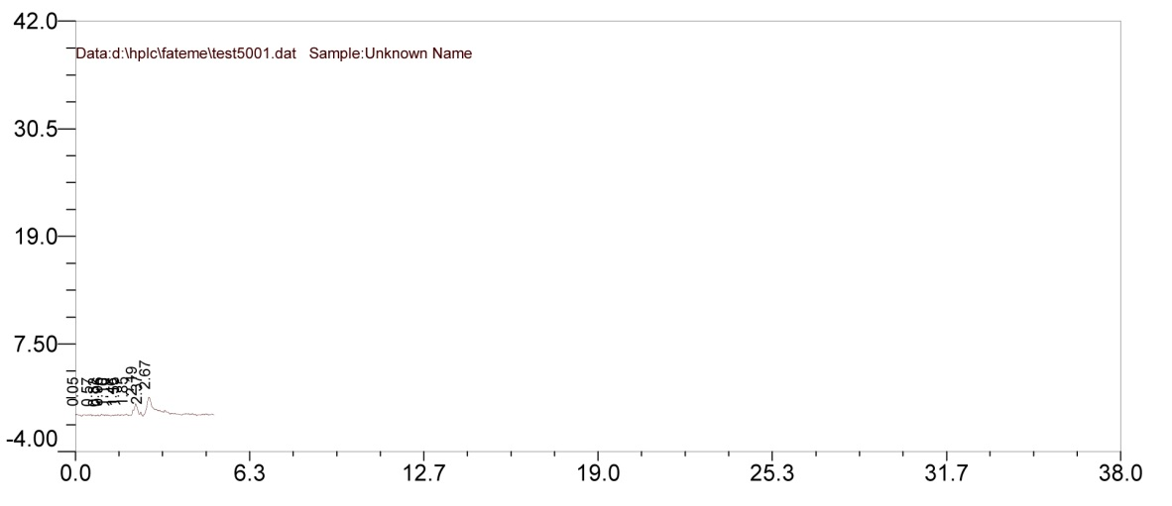
Fig 10: Peak diagram from yeast at a concentration of 1000 mg in the HPLC

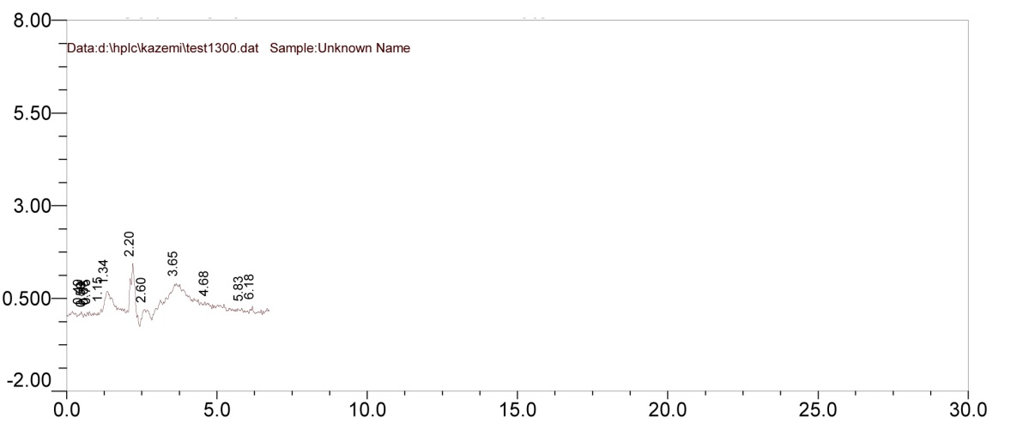
Fig 11: Peak diagram from Control Time (Full Immersion) in the HPLC

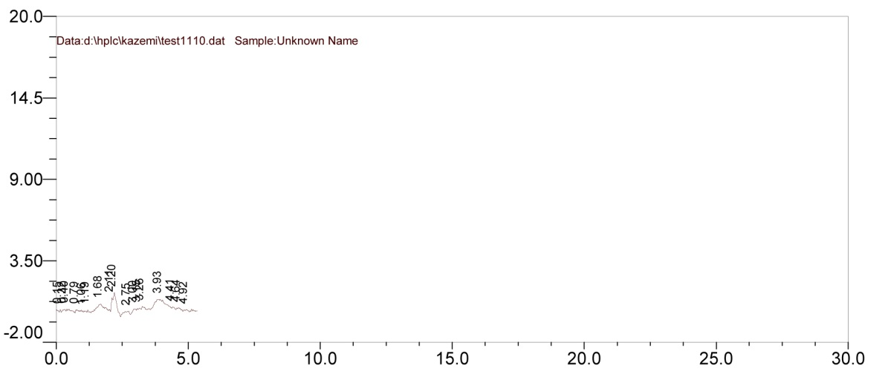
Fig 12: Peak diagram from Control (0 mg) in the HPLC

