Supplementary data

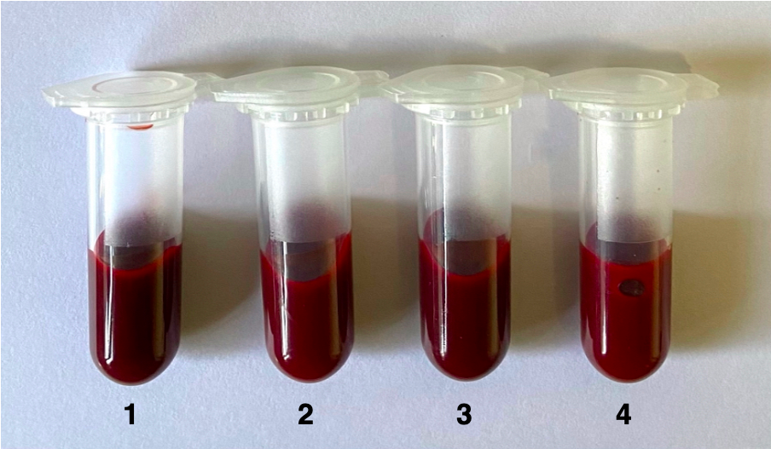

Figure S1. Visual color change in ozonated blood samples compared to non-ozonated (control) blood samples. Sample 1 is the non-ozonated control, while 2, 3, and 4 were treated with 40, 60, and 80 µg/mL of ozone, respectively.

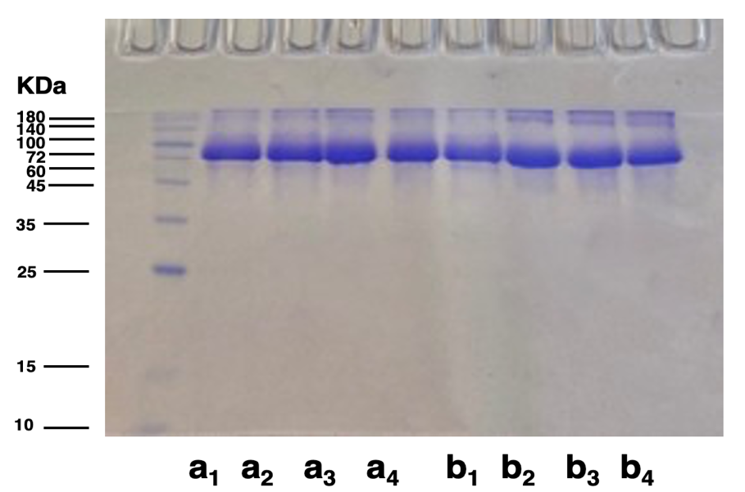

Figure S2. SDS-PAGE analysis of purified non-ozonated and ozonated HSA. The purity of the samples was assessed using 15% SDS-PAGE. Purified HSA from a healthy individual (a) and an RRMS patient (b) is shown. Sample 1 is the non-ozonated control, while samples 2, 3, and 4 were treated with 40, 60, and 80 µg/mL of ozone, respectively. The molecular weight of HSA is 66.4 kDa. This analysis was performed to evaluate the effectiveness of the ammonium sulfate precipitation protocol.

