Late-stage C–H thiolation via sulfonium salts using β-sulfinylesters as the versatile sulfur source
Yanhui Chen, Si Wen, Qingyu Tian, Yuqing Zhang, and Guolin Cheng*

Table of Contents
1. General Information S2
2. Experimental Section S3
2.1 Table S1 Optimization of the Reaction Conditions S3
2.2 Procedure for the Synthesis of 1 S4
2.3 Procedure for the Synthesis of 3 S7
2.4 Procedure for the Synthesis of 4 S16
2.5 Procedure H for the Synthesis of 6 S19
2.6 Procedure I for the Synthesis of 8 S26
2.7 Procedure J for the Synthesis of 10 S30
3. Gram-Scale Synthesis of 11 S33
4. Iterative C–H Thiolation Reaction for the Synthesis of 13 and 14 S33
5. Procedure for the Synthesis of 15 S35
6. ¹H and ¹³C NMR Spectra S37
Reference S137

1. General Information
All the solvents were used without further purification. the other commercial chemicals were used without further purification. All reactions were performed under an inert atmosphere of nitrogen in flame-dried glassware, unless otherwise stated. Analytical thin-layer chromatography was performed on 0.25 mm silica gel, 60-F254. Visualization was carried out with UV light and Vogel’s permanganate. Preparative TLC was performed on 1.0 mm silica gel. ¹H NMR spectra were recorded on a Bruker DRX-500 instrument (500 MHz). ¹³C NMR spectra were recorded on a Bruker DRX-500 instrument (126 MHz) and were fully decoupled by broad band proton decoupling. High-resolution mass spectra (HRMS) were recorded on an Agilent 1290 mass spectrometer using ESI-TOF (electrospray ionization time-of-flight). NMR spectra were recorded in CDCl₃. ¹H NMR spectra were referenced to residual CHCl₃ at 7.26 ppm, and ¹³C NMR spectra were referenced to the central peak of CDCl₃ at 77.0 ppm. Chemical shifts (δ) are reported in ppm, and coupling constants (J) are reported in hertz (Hz). Multiplicities are reported using the following abbreviations: s = singlet, d = doublet, t = triplet, q = quartet, m = multiplet.

- Experimental Section
2.1 Table S1 Optimization of the Reaction Conditionsª
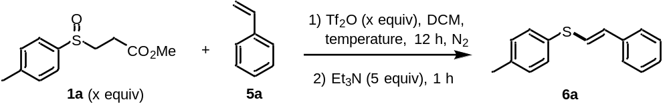
Entry | X equiv | Temperature (ºC) | Yield (%)^{b} | E ：Z
1 | 1.3 | 60 | 70 | 2.6：1
2 | 1.3 | 25 | 65 | 12：1
3 | 1.3 | 0 | 66 | 32：1
4 | 1.5 | 0 | 86 | 40：1
4 | 1.5 | -20 | 84 | 40：1
ª 1a, 5a (0.3 mmol, 1.0 equiv), Tf₂O, DCM (3 mL), under N₂ atmosphere for 12 h, then Et₃N (1.5 mmol, 5 equiv), at room temperature for 1 h. ^{b} Isolated yield.

Structures of Compounds 1 in SI
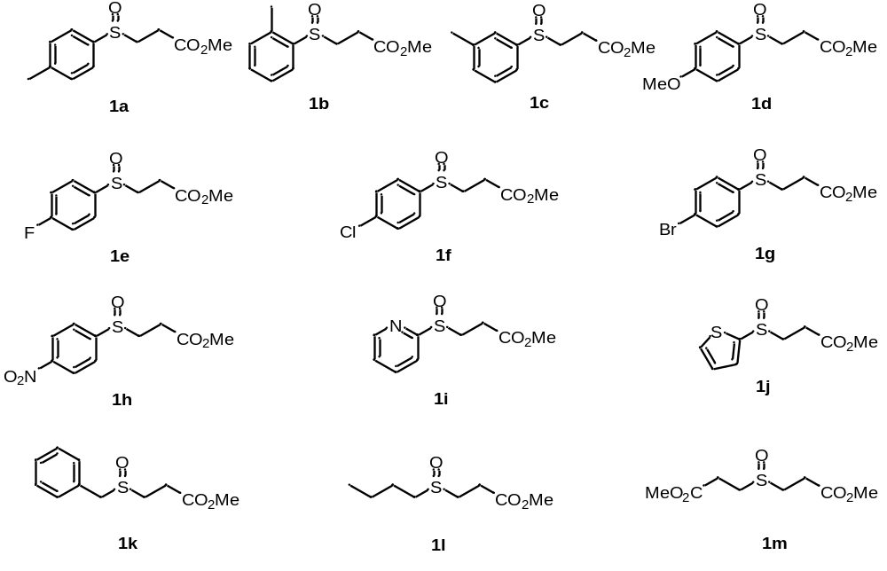

2.2 Procedure for the Synthesis of 1
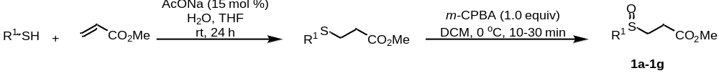
Method 1: A 100 mL round bottom flask was charged with thiol (10 mmol, 1.0 equiv), methyl acrylate (0.9 mL, 1.0 equiv), THF (15 mL), H₂O (15 mL) and AcONa (124 mg, 15 mol %). The mixture was stirred at room temperature for 24 h. Upon completion, the reaction mixture was poured into saturated aq. NaHCO₃ (25 mL) and the aqueous mixture was extracted with EtOAc (3 × 25 mL). The combined organic layer was dried (MgSO₄), filtered and the solvent was removed under vacuum. The resulting residue was used without further purification. The residue was dissolved in DCM (25 mL) and treated with m-CPBA (10 mmol, dissolved in 25 mL DCM) under 0 ºC. Upon completion, the reaction mixture was quenched with saturated aq. NaHCO₃ (25 mL) and the aqueous mixture was extracted with DCM (3 × 25 mL). The combined the organic layer was dried (MgSO₄), filtered and the solvent was removed under vacuum. Purification by flash chromatography afforded products 1a-1g.¹
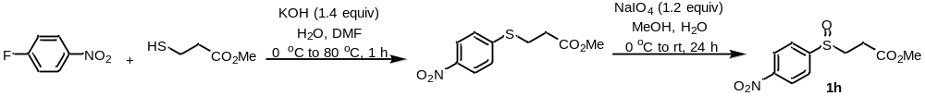
Method 2: To a mixture of 1-fluoro-4-nitrobenzene (1.754 g, 12 mmol) and methyl 3-mercaptopropionate (2.62 g, 1.7 equiv) in 20 mL of DMF was added KOH (0.96 g, 1.40 equiv, dissolved in 6 mL of dimethylformamide; DMF) at 0 °C with stirring. This mixture was stirred at 80 °C for 1 h followed by pouring into ice-water (60 mL). A yellow-colored solid was obtained by vacuum filtration, and then recrystallized from methanol-water. Methyl 3-((4-nitrophenyl)thio)propanoate (2 g) was dissolved in methanol (200 mL) and cooled to 0 °C. Sodium periodate (1.2 equiv, dissolved in 100 mL water) was then added dropwise. The reaction mixture was then left to warm to room temperature under stirring overnight. The precipitated solid was then filtered off through a Celite pad and washed with methanol. Methanol was evaporated under reduced pressure. The obtained aqueous layer was extracted three times with DCM (3 × 20 mL). The organic layer was combined, washed with brine (10 mL), dried (Na₂SO₄), and filtered. Solvent was then evaporated under reduced pressure before submitting the crude material to column chromatography, affording product 1h.²
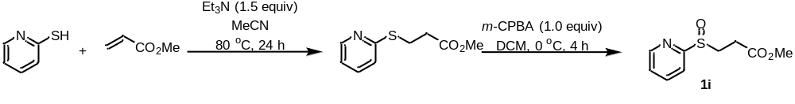
Method 3: A 100 mL round bottom flask was charged with pyridine-2-thiol (10 mmol, 1.0 equiv), methyl acrylate (1.3 mL, 1.2 equiv), MeCN (15 mL) and Et₃N (2.08 mL, 1.5 equiv). The mixture was stirred at 80 ºC for 24 h. Cooled to room temperature, the reaction mixture was poured into saturated aq. NaHCO₃ (25 mL) and the aqueous mixture was extracted with EtOAc (3 × 25 mL). The combined organic layer was dried (MgSO₄), filtered and the solvent was removed under vacuum. The resulting residue was used without further purification. The residue was dissolved in DCM (25 mL) and treated with m-CPBA (10 mmol, dissolved in 25 mL DCM) under 0 ºC. Upon completion, the reaction mixture was quenched with saturated aq. NaHCO₃ (25 mL) and the aqueous mixture was extracted with DCM (3 × 25 mL). The combined the organic layer was dried (MgSO₄), filtered and the solvent was removed under vacuum. Purification by flash chromatography afforded product 1i.¹
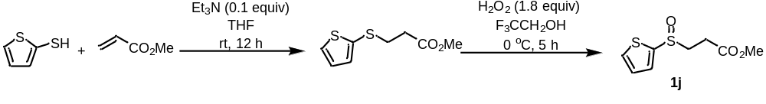
Method 4: Thiophene-2-thiol (1.0 equiv) and methyl acrylate (1.0 equiv) were dissolved in THF (5 M based on the thiol) in a round-bottomed flask equipped with a magnetic stirrer. Triethylamine (0.1 equiv) was added, and the reaction mixture was stirred at room temperature overnight. Then concentrate under reduced pressure to remove the volatiles. The crude material was then submitted to column chromatography, affording methyl 3-(thiophen-2-ylthio)propanoate. Methyl 3-(thiophen-2-ylthio)propanoate (1.0 equiv) was dissolved in TFE (2 M based on thiopropanoate) and the resulting solution was cooled to 0 °C. H₂O₂ (30% v/v in water; 1.8 equiv) was added dropwise at 0 °C. The mixture was allowed to warm to room temperature and stirred for 5 h. Then, soldium sulfite (1.8 equiv) was added and the mixture was vigorously stirred for 30 min. It was filtered through a plug of Celite, which was then washed with DCM. The filtrate was dried (MgSO₄), filtered, and concentrated under a vacuum. The resulting crude oil was submitted to column chromatography to afford products 1j.¹
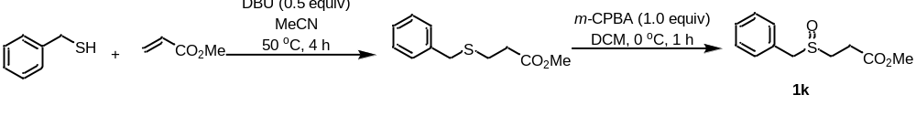
Method 5: A 25 mL round bottom flask was charged with phenylmethanethiol (10 mmol, 1.0 equiv), methyl acrylate (1.4 mL, 1.5 equiv), MeCN (5 mL) and DBU (0.75 mL, 0.5 equiv). The mixture was stirred at 50 ºC for 4 h. Cool to room temperature, add saturated aq. NaHCO₃ (25 mL) and the aqueous mixture was extracted with EtOAc (3 × 25 mL). The combined organic layer was dried (MgSO₄), filtered and the solvent was removed under vacuum. The resulting residue was used without further purification. The residue was dissolved in DCM (25 mL) and treated with m-CPBA (10 mmol, dissolved in 25 mL DCM) under 0 ºC. Upon completion, the reaction mixture was quenched with saturated aq. NaHCO₃ (25 mL) and the aqueous mixture was extracted with DCM (3 × 25 mL). The combined organic layer was dried (MgSO₄), filtered and the solvent removed under vacuum. Purification by flash chromatography afforded product 1k.³
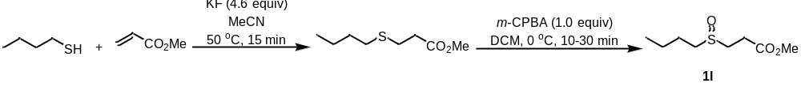
Method 6: the thiol (1.0 equiv) was added to a suspension of KF/alumina 45 wt % (4.6 equiv) in acetonitrile (0.05 M based on thethiol). The reaction mixture was stirred for 5 min at rt. tert-Butylacrylate (1.0 equiv) was added, and the reaction was heated to 50−60°C for 15 min. The reaction mixture was filtered on a Celite pad, then concentrated under reduced pressure, filtered a second time on Celite and sand, and washed with DCM. Solvent was evaporated under reduced pressure. The resulting residue was used without further purification. The residue was dissolved in DCM (25 mL) and treated with m-CPBA (10 mmol, dissolved in 25 mL DCM) under 0 ºC. Upon completion, the reaction mixture was quenched with saturated aq. NaHCO₃ (25 mL) and the aqueous mixture was extracted with DCM (3 × 25 mL). The combined organic layer was dried (MgSO₄), filtered and the solvent removed under vacuum. Purification by flash chromatography afforded product 1l.¹
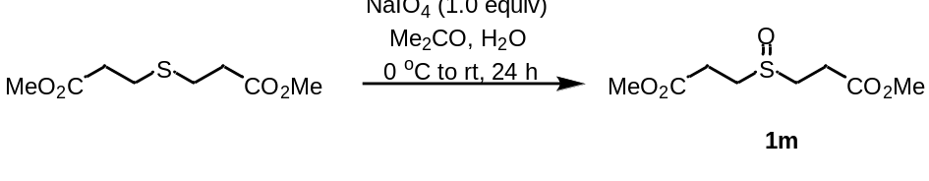
Method 7: Dimethyl 3,3'-thiodipropionate (4.12 g, 20 mmol) and NaIO₄ (4.28 g, 20 mmol) in a mixture of acetone (100 mL) and water (100 mL) was stirred at 0 °C and the mixture was allowed to warm to room temperature and stirred for 24 h.. Acetone was evaporated under vacuum. The aqueous phase was extracted with DCM (3 × 100 mL). The organic phase was collected, dried (MgSO₄), and concentrated under vacuum to afforded product 1m.⁴

2.3 Procedure for the Synthesis of 3
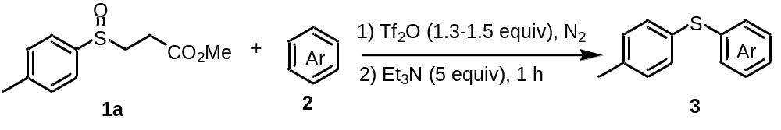
2.3.1 Procedure A for Synthesis of 3a, 3c, 3d and 3l-q
A dried 15 ml Schlenk tube was charged with methyl 3-(p-tolylsulfinyl)propanoate 1a (0.39 mmol, 1.3 equiv), arenes 2 (0.3 mmol, 1.0 equiv), and DCM (3 mL). Trifluoromethanesulfonic anhydride (0.39 mmol, 1.3 equiv) was added at room temperature under nitrogen atmosphere. The reaction mixture was stirred for 1 h. Upon completion, Et₃N (0.2 mL, 5.0 equiv) was added and the reaction mixture was stirred at room temperature for 1 h. The mixture was concentrated under vacuum, and purified by preparative thin layer chromatography (PTLC) with hexane/ethyl acetate to give the corresponding products 3a, 3c, 3d and 3l-q.
2.3.2 Procedure B for Synthesis of 3b, 3e, 3f, 3h-k, 3w and 3r
A dried 15 ml Schlenk tube was charged with methyl 3-(p-tolylsulfinyl)propanoate 1a (0.39 mmol, 1.3 equiv), aromatic hydrocarbon 2 (0.3 mmol, 1.0 equiv) and DCM (3 mL). Trifluoromethanesulfonic anhydride (0.39 mmol, 1.3 equiv) was added at room temperature under nitrogen atmosphere. The reaction mixture was stirred for 12 h. Upon completion, Et₃N (0.2 mL, 5.0 equiv) was added and the reaction mixture was stirred for 1 h. The mixture was concentrated under vacuum, and purified by preparative thin layer chromatography (PTLC) with hexane/ethyl acetate to give the corresponding products 3b, 3e, 3f, 3h-k, 3w and 3r.
2.3.3 Procedure C for Synthesis of 3g, 3t, 3v, 3v`, 3aa, 3ad-af
A dried 15 ml Schlenk tube was charged with methyl 3-(p-tolylsulfinyl)propanoate 1a (0.45 mmol, 1.5 equiv), aromatic hydrocarbon 2 (0.3 mmol, 1.0 equiv) and DCM (3 mL). Trifluoromethanesulfonic anhydride (0.45 mmol, 1.5 equiv) was added at 0 °C under nitrogen atmosphere. The reaction mixture was stirred for 12 h. Upon completion, Et₃N (0.2 mL, 5.0 equiv) was added and the reaction mixture was stirred for 1 h. The mixture was concentrated under vacuum, and purified by preparative thin layer chromatography (PTLC) with hexane/ethyl acetate to give the corresponding products 3g, 3t, 3v, 3v`, 3aa, 3ad-af.
2.3.4 Procedure D for Synthesis of 3s, 3u, 3ac
A dried 15 ml Schlenk tube was charged with methyl 3-(p-tolylsulfinyl)propanoate 1a (0.45 mmol, 1.5 equiv), aromatic hydrocarbon 2 (0.3 mmol, 1.0 equiv) and DCE (3 mL). Trifluoromethanesulfonic anhydride (0.45 mmol, 1.5 equiv) was added at room temperature under nitrogen atmosphere. The reaction mixture was heated to 60 °C for 24 h. Upon completion, the reaction mixture was cooled to room temperature, Et₃N (0.2 mL, 5.0 equiv) was added and the reaction mixture was stirred for 1 h. The mixture was concentrated under vacuum, and purified by preparative thin layer chromatography (PTLC) with hexane/ethyl acetate to give the corresponding products 3s, 3u, 3ac.
2.3.5 Procedure E for Synthesis of 3ab
A dried 15 ml Schlenk tube was charged with methyl 3-(p-tolylsulfinyl)propanoate 1a (0.45 mmol, 1.5 equiv), aromatic hydrocarbon 2 (0.3 mmol, 1.0 equiv) and DCM (3 mL). Trifluoromethanesulfonic anhydride (0.45 mmol, 1.5 equiv) was added at 0 °C under nitrogen atmosphere. The reaction mixture was stirred for 48 h. Upon completion, Et₃N (0.2 mL, 5.0 equiv) was added and the reaction mixture was stirred for 1 h. The mixture was concentrated under vacuum, and purified by preparative thin layer chromatography (PTLC) with hexane/ethyl acetate to give the corresponding products 3ab.
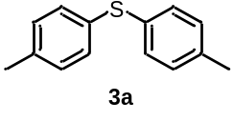
di-p-tolylsulfane (3a) (59.2 mg, 92%) was prepared from procedure A as white solid, after puriﬁcation by preparative thin layer chromatography (PTLC) (hexane). ¹H NMR (500 MHz, CDCl₃) δ 7.38 (d, J = 8.1 Hz, 4H), 7.10 (d, J = 7.9 Hz, 4H), 2.32 (s, 6H); ¹³C{1H} NMR (126 MHz, CDCl₃) δ 136.7, 132.6, 130.9, 129.8, 21.0.
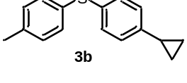
(4-cyclopropylphenyl)(p-tolyl)sulfane (3b) (32.5 mg, 45%) was prepared from procedure B as light yellow oil, after puriﬁcation by preparative thin layer chromatography (PTLC) (hexane).¹H NMR (500 MHz, CDCl₃) δ 7.2 – 7.2 (m, 4H), 7.1 (d, J = 7.9 Hz, 2H), 7.0 (d, J = 8.3 Hz, 2H), 2.3 (s, 3H), 1.9 – 1.8 (m, 1H), 1.0 – 0.9 (m, 2H), 0.7 – 0.6 (m, 2H); ¹³C{1H} NMR (126 MHz, CDCl₃) δ 143.2, 136.8, 132.7, 132.4, 131.2, 130.9, 129.9, 126.4, 21.0, 15.1, 9.4; HRMS (ESI) calcd for (C₁₆H₁₇S) [M+H]⁺: 241.1045, found 241.1041.

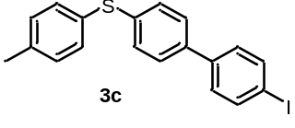
(4'-iodo-[1,1'-biphenyl]-4-yl)(p-tolyl)sulfane (3c) (106.4 mg, 88%) was prepared from procedure A as white solid, after puriﬁcation by preparative thin layer chromatography (PTLC) (hexane). ¹H NMR (500 MHz, CDCl₃) δ 7.73 (d, J = 8.4 Hz, 2H), 7.43 (d, J = 8.4 Hz, 2H), 7.34 (d, J = 8.2 Hz, 2H), 7.31 – 7.26 (m, 4H), 7.16 (d, J = 7.9 Hz, 2H), 2.35 (s, 3H); ¹³C{1H} NMR (126 MHz, CDCl₃) δ 139.9, 137.9, 137.9, 137.2, 132.6, 130.7, 130.2, 129.8, 128.7, 127.4, 93.0, 21.2; HRMS (ESI) calcd for (C₁₉H₁₆IS) [M+H]⁺: 403.0012, found 403.0007.
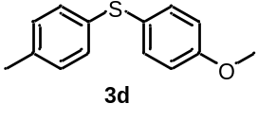
(4-methoxyphenyl)(p-tolyl)sulfane (3d) (57.5 mg, 84%) was prepared from procedure A as white solid, after puriﬁcation by preparative thin layer chromatography (PTLC) (hexane). ¹H NMR (500 MHz, CDCl₃) δ 7.36 (d, J = 8.8 Hz, 2H), 7.13 (d, J = 8.1 Hz, 2H), 7.06 (d, J = 7.9 Hz, 2H), 6.86 (d, J = 8.8 Hz, 2H), 3.80 (s, 3H), 2.30 (s, 3H); ¹³C{1H} NMR (126 MHz, CDCl₃) δ 159.4, 136.1, 134.3, 134.3, 129.7, 129.3, 125.6, 114.8, 55.3, 21.0.
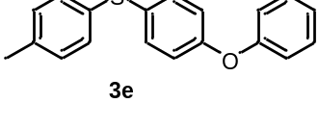
(4-phenoxyphenyl)(p-tolyl)sulfane (3e) (52.9 mg, 60%) was prepared from procedure B as white solid, after puriﬁcation by preparative thin layer chromatography (PTLC) (hexane). ¹H NMR (500 MHz, CDCl₃) δ 7.35 – 7.28 (m, 4H), 7.22 (d, J = 8.2 Hz, 2H), 7.13 – 7.08 (m, 3H), 7.00 (d, J = 7.7 Hz, 2H), 6.92 (d, J = 8.7 Hz, 2H), 2.31 (s, 3H); ¹³C{1H} NMR (126 MHz, CDCl₃) δ 156.7, 136.9, 132.9, 132.8, 130.8, 129.9, 129.8, 129.7, 123.6, 119.3, 119.1, 21.0.
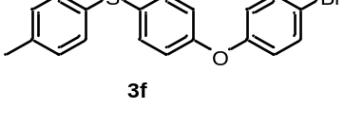
(4-(4-bromophenoxy)phenyl)(p-tolyl)sulfane (3f) (106.6 mg, 95%) was prepared from procedure B as white solid, after puriﬁcation by preparative thin layer chromatography (PTLC) (hexane).¹H NMR (500 MHz, CDCl₃) δ 7.41 (d, J = 8.9 Hz, 2H), 7.29 (d, J = 8.7 Hz, 2H), 7.24 (d, J = 8.3 Hz, 2H), 7.11 (d, J = 7.9 Hz, 2H), 6.93 – 6.85 (m, 4H), 2.32 (s, 3H); ¹³C{1H} NMR (126 MHz, CDCl₃) δ 156.0, 156.0, 137.2, 132.7, 132.6, 132.3, 131.1, 130.8, 130.0, 120.6, 119.5, 116.0, 21.1.
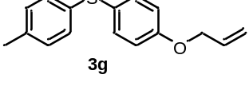
(4-(allyloxy)phenyl)(p-tolyl)sulfane (3g) (69.2 mg, 90%) was prepared from procedure C as light yellow oil, after puriﬁcation by preparative thin layer chromatography (PTLC) (hexane). ¹H NMR (500 MHz, CDCl₃) δ 7.3 (d, J = 8.8 Hz, 2H), 7.1 (d, J = 8.3 Hz, 2H), 7.0 (d, J = 8.0 Hz, 2H), 6.9 (d, J = 8.8 Hz, 2H), 6.1 – 6.0 (m, 1H), 5.4 – 5.4 (m, 1H), 5.3 – 5.2 (m, 1H), 4.5 – 4.5 (m, 2H), 2.3 (s, 3H); ¹³C{1H} NMR (126 MHz, CDCl₃) δ 158.3, 136.1, 134.1, 132.9, 129.7, 129.4, 125.8, 117.8, 115.6, 68.8, 20.9; HRMS (ESI) calcd for (C₁₆H₁₇OS) [M+H]⁺: 257.0995, found 257.0998.
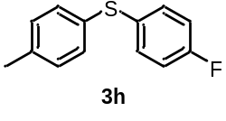
(4-fluorophenyl)(p-tolyl)sulfane (3h) (43.0 mg, 65%) was prepared from procedure B as colorless oil, after puriﬁcation by preparative thin layer chromatography (PTLC) (hexane). ¹H NMR (500 MHz, CDCl₃) δ 7.31 – 7.27 (m, 2H), 7.22 (d, J = 8.2 Hz, 2H), 7.11 (d, J = 7.9 Hz, 2H), 7.00 – 6.95 (m, 2H), 2.32 (s, 3H); ¹³C{1H} NMR (126 MHz, CDCl₃) δ 161.9 (d, J = 246.9 Hz), 137.3, 132.7 (d, J = 8.1 Hz), 132.2, 131.5 (d, J = 3.3 Hz), 131.2, 130.0, 116.2 (d, J = 22.1 Hz), 21.0.
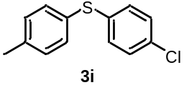
(4-chlorophenyl)(p-tolyl)sulfane (3i) (36.9 mg, 52%) was prepared from procedure B as white solid, after puriﬁcation by preparative thin layer chromatography (PTLC) (hexane). ¹H NMR (500 MHz, CDCl₃) δ 7.29 (d, J = 8.2 Hz, 2H), 7.23 – 7.20 (m, 2H), 7.19 – 7.12 (m, 4H), 2.34 (s, 3H); ¹³C{1H} NMR (126 MHz, CDCl₃) δ 138.0, 135.9, 132.5, 132.3, 130.8, 130.7, 130.2, 129.1, 21.1.
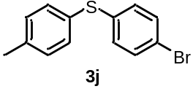
(4-bromophenyl)(p-tolyl)sulfane (3j) (43.3 mg, 52%) was prepared from procedure B as white solid, after puriﬁcation by preparative thin layer chromatography (PTLC) (hexane). ¹H NMR (500 MHz, CDCl₃) δ 7.35 (d, J = 8.3 Hz, 2H), 7.30 (d, J = 7.8 Hz, 2H), 7.15 (d, J = 7.9 Hz, 2H), 7.09 (d, J = 8.5 Hz, 2H), 2.35 (s, 3H); ¹³C{1H} NMR (126 MHz, CDCl₃) δ 138.1, 136.8, 132.6, 132.0, 130.9, 130.4, 130.2, 120.1, 21.1.
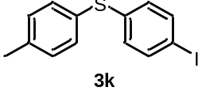
(4-iodophenyl)(p-tolyl)sulfane (3k) (61.2 mg, 62%) was prepared from procedure B as white solid, after puriﬁcation by preparative thin layer chromatography (PTLC) (hexane). ¹H NMR (500 MHz, CDCl₃) δ 7.56 – 7.52 (m, 2H), 7.31 (d, J = 8.1 Hz, 2H), 7.15 (d, J = 7.9 Hz, 2H), 6.97 – 6.92 (m, 2H), 2.35 (s, 3H); ¹³C{1H} NMR (126 MHz, CDCl₃) δ 138.2, 137.9, 137.8, 132.9, 130.8, 130.2, 130.0, 91.0, 21.2.
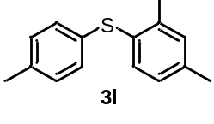
(2,4-dimethylphenyl)(p-tolyl)sulfane (3l) (61.3 mg, 90%) was prepared from procedure A as light yellow oil, after puriﬁcation by preparative thin layer chromatography (PTLC) (hexane). ¹H NMR (500 MHz, CDCl₃) δ 7.18 (d, J = 7.7 Hz, 1H), 7.11 – 7.03 (m, 5H), 6.93 (d, J = 7.7 Hz, 1H), 2.33 (s, 3H), 2.31 – 2.27 (m, 6H); ¹³C{1H} NMR (126 MHz, CDCl₃) δ 139.8, 137.7, 136.0, 133.1, 133.0, 131.4, 130.6, 129.8, 129.5, 127.4, 21.0, 21.0, 20.5.
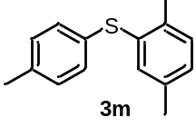
(2,5-dimethylphenyl)(p-tolyl)sulfane (3m) (62.5 mg, 91%) was prepared from procedure A as light yellow oil, after puriﬁcation by preparative thin layer chromatography (PTLC) (hexane). ¹H NMR (500 MHz, CDCl₃) δ 7.15 – 7.04 (m, 6H), 6.97 (d, J = 7.6 Hz, 1H), 2.32 (s, 3H), 2.30 (s, 3H), 2.22 (s, 3H); ¹³C{1H} NMR (126 MHz, CDCl₃) δ 136.4, 136.2, 134.2, 132.7, 132.2, 130.3, 130.3, 129.9, 128.3, 21.0, 20.8, 20.0.
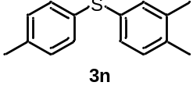
(3,4-dimethylphenyl)(p-tolyl)sulfane (3n) (59.2 mg, 87%) was prepared from procedure A as light yellow oil, after puriﬁcation by preparative thin layer chromatography (PTLC) (hexane). ¹H NMR (500 MHz, CDCl₃) δ 7.22 (d, J = 8.1 Hz, 2H), 7.14 (s, 1H), 7.11 – 7.03 (m, 4H), 2.32 (s, 3H), 2.23 (s, 3H), 2.21 (s, 3H); ¹³C{1H} NMR (126 MHz, CDCl₃) δ 137.6, 136.7, 135.7, 132.9, 132.6, 132.4, 130.8, 130.4, 129.8, 128.7, 21.0, 19.7, 19.4.
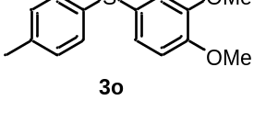
(3,4-dimethoxyphenyl)(p-tolyl)sulfane (3o) (77.6 mg, 99%) was prepared from procedure A as yellow oil, after puriﬁcation by preparative thin layer chromatography (PTLC) (hexane/ethyl acetate (20:1)). ¹H NMR (500 MHz, CDCl₃) δ 7.14 (d, J = 8.3 Hz, 2H), 7.06 (d, J = 8.0 Hz, 2H), 7.00 (dd, J = 8.3, 2.1 Hz, 1H), 6.94 (d, J = 2.1 Hz, 1H), 6.81 (d, J = 8.3 Hz, 1H), 3.86 (s, 3H), 3.81 (s, 3H), 2.29 (s, 3H); ¹³C{1H} NMR (126 MHz, CDCl₃) δ 149.3, 148.9, 136.1, 134.0, 129.7, 129.3, 125.9, 125.5, 115.7, 111.7, 55.9, 20.9.
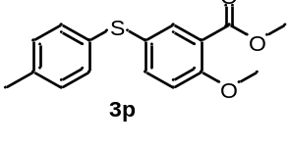
methyl 2-methoxy-5-(p-tolylthio)benzoate (3p) (70.1 mg, 81%) was prepared from procedure A as light yellow oil, after puriﬁcation by preparative thin layer chromatography (PTLC) (hexane/ethyl acetate (10:1)). ¹H NMR (500 MHz, CDCl₃) δ 7.86 (d, J = 2.4 Hz, 1H), 7.48 (dd, J = 8.7, 2.5 Hz, 1H), 7.15 (d, J = 8.2 Hz, 2H), 7.08 (d, J = 8.0 Hz, 2H), 6.93 (d, J = 8.7 Hz, 1H), 3.89 (s, 3H), 3.86 (s, 3H), 2.31 (s, 3H); ¹³C{1H} NMR (126 MHz, CDCl₃) δ 165.9, 158.6, 137.5, 136.6, 135.6, 133.2, 129.9, 129.9, 126.1, 120.9, 113.0, 56.1, 52.1, 21.0; HRMS (ESI) calcd for (C₁₆H₁₇O₃S) [M+H]⁺: 289.0893, found 289.0890.
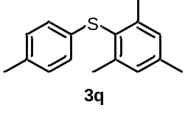
mesityl(p-tolyl)sulfane (3q) (64.4 mg, 89%) was prepared from procedure A as white solid, after puriﬁcation by preparative thin layer chromatography (PTLC) (hexane). ¹H NMR (500 MHz, CDCl₃) δ 7.00 – 6.94 (m, 4H), 6.82 (d, J = 8.1 Hz, 2H), 2.38 (s, 6H), 2.30 (s, 3H), 2.24 (s, 3H); ¹³C{1H} NMR (126 MHz, CDCl₃) δ 143.6, 139.0, 134.7, 134.2, 129.6, 129.2, 127.5, 125.7, 21.7, 21.1, 20.8.
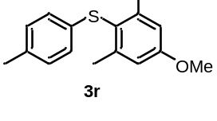
(4-methoxy-2,6-dimethylphenyl)(p-tolyl)sulfane (3r) (29.9 mg, 39%) was prepared from procedure B as white solid, after puriﬁcation by preparative thin layer chromatography (PTLC) (hexane). ¹H NMR (500 MHz, CDCl₃) δ 6.98 (d, J = 8.0 Hz, 2H), 6.81 (d, J = 8.2 Hz, 2H), 6.73 (s, 2H), 3.81 (s, 3H), 2.40 (s, 6H), 2.25 (s, 3H); ¹³C{1H} NMR (126 MHz, CDCl₃) δ 159.9, 145.4, 135.1, 134.1, 129.6, 125.4, 121.9, 113.8, 55.1, 22.1, 20.8.
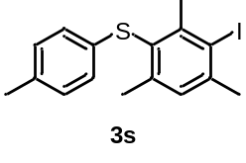
(3-iodo-2,4,6-trimethylphenyl)(p-tolyl)sulfane (3s) (89.7 mg, 81%) was prepared from procedure D as light yellow solid, after puriﬁcation by preparative thin layer chromatography (PTLC) (hexane). ¹H NMR (500 MHz, CDCl₃) δ 7.10 (s, 1H), 7.00 (d, J = 8.1 Hz, 2H), 6.81 (d, J = 8.2 Hz, 2H), 2.75 (s, 3H), 2.48 (s, 3H), 2.36 (s, 3H), 2.26 (s, 3H); ¹³C{1H} NMR (126 MHz, CDCl₃) δ 146.5, 143.4, 143.4, 134.6, 134.2, 129.7, 129.5, 128.4, 125.8, 106.2, 30.2, 29.2, 21.8, 20.9; HRMS (ESI) calcd for (C₁₆H₁₈IS) [M+H]⁺: 369.0168, found 369.0166.
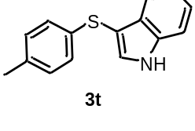
3-(p-tolylthio)-1H-indole (3t) (74.8 mg, 97%) was prepared from procedure C as brown solid, after puriﬁcation by preparative thin layer chromatography (PTLC) (hexane/ethyl acetate (4:1)). ¹H NMR (500 MHz, CDCl₃) δ 8.39 (s, 1H), 7.61 (d, J = 7.9 Hz, 1H), 7.47 (d, J = 2.6 Hz, 1H), 7.42 (d, J = 8.2 Hz, 1H), 7.25 (t, J = 7.9 Hz, 1H), 7.15 (t, J = 7.6 Hz, 1H), 7.03 (d, J = 8.4 Hz, 2H), 6.97 (d, J = 8.1 Hz, 2H), 2.24 (s, 3H); ¹³C{1H} NMR (126 MHz, CDCl₃) δ 136.4, 135.4, 134.6, 130.4, 129.9, 129.4, 129.1, 126.2, 122.9, 120.8, 119.7, 111.5, 20.8.
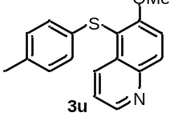
6-methoxy-5-(p-tolylthio)quinoline (3u) (26.2 mg, 31%) was prepared from procedure D as yellow solid, after puriﬁcation by preparative thin layer chromatography (PTLC) (hexane/ethyl acetate (4:1)). ¹H NMR (500 MHz, CDCl₃) δ 8.84 – 8.73 (m, 2H), 8.23 (d, J = 9.3 Hz, 1H), 7.59 (d, J = 9.3 Hz, 1H), 7.44 – 7.36 (m, 1H), 7.00 – 6.87 (m, 4H), 3.99 (s, 3H), 2.24 (s, 3H); ¹³C{1H} NMR (126 MHz, CDCl₃) δ 159.2, 148.4, 144.3, 135.0, 134.0, 133.8, 133.1, 131.6, 129.6, 126.8, 122.3, 116.5, 113.5, 56.9, 20.8; HRMS (ESI) calcd for (C₁₇H₁₆NOS) [M+H]⁺: 282.0947, found 282.0953.
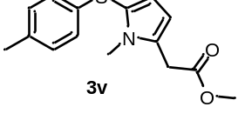
methyl 2-(1-methyl-5-(p-tolylthio)-1H-pyrrol-2-yl)acetate (3v) (25.6 mg, 31%) was prepared from procedure C as red-brown oil, after puriﬁcation by preparative thin layer chromatography (PTLC) (hexane/ethyl acetate (4:1)). ¹H NMR (500 MHz, CDCl₃) δ 7.02 – 6.93 (m, 4H), 6.68 (d, J = 2.9 Hz, 1H), 6.25 (d, J = 2.9 Hz, 1H), 3.78 (s, 2H), 3.63 (s, 3H), 3.57 (s, 3H), 2.25 (s, 3H); ¹³C{1H} NMR (126 MHz, CDCl₃) δ 170.4, 136.6, 134.2, 130.3, 129.3, 125.9, 122.7, 113.7, 108.4, 52.1, 34.9, 30.2, 20.8; HRMS (ESI) calcd for (C₁₅H₁₈NO₂S) [M+H]⁺: 276.1053, found 276.1057.
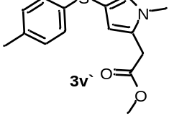
methyl 2-(1-methyl-4-(p-tolylthio)-1H-pyrrol-2-yl)acetate (3v') (51.2 mg, 62%) was prepared from procedure C as red-brown oil, after puriﬁcation by preparative thin layer chromatography (PTLC) (hexane/ethyl acetate (4:1)). ¹H NMR (500 MHz, CDCl₃) δ 7.06 (d, J = 8.3 Hz, 2H), 7.00 (d, J = 7.9 Hz, 2H), 6.78 (d, J = 1.9 Hz, 1H), 6.12 (d, J = 1.8 Hz, 1H), 3.71 (s, 3H), 3.61 (s, 2H), 3.57 (s, 3H), 2.26 (s, 3H); ¹³C{1H} NMR (126 MHz, CDCl₃) δ 170.6, 136.8, 134.4, 129.3, 128.2, 126.3, 126.3, 114.8, 107.8, 52.2, 34.1, 32.3, 20.8; HRMS (ESI) calcd for (C₁₅H₁₈NO₂S) [M+H]⁺: 276.1053, found 276.1055.
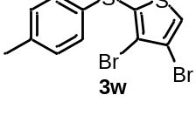
3,4-dibromo-2-(p-tolylthio)thiophene (3w) (107.2 mg, 98%) was prepared from procedure B as dark green oil, after puriﬁcation by preparative thin layer chromatography (PTLC) (hexane). ¹H NMR (500 MHz, CDCl₃) δ 7.39 (s, 1H), 7.26 – 7.21 (m, 2H), 7.14 – 7.08 (m, 2H), 2.33 (s, 3H); ¹³C{1H} NMR (126 MHz, CDCl₃) δ 137.8, 131.8, 131.0, 130.1, 130.0, 126.3, 120.9, 114.0, 21.1; HRMS (ESI) calcd for (C₁₁H₉Br₂S₂) [M+H]⁺: 364.8486, found 364.8487.
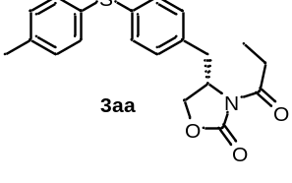
(S)-3-propionyl-4-(4-(p-tolylthio)benzyl)oxazolidin-2-one (3aa) (38.3 mg, 36%) was prepared from procedure C as light yellow oil, after puriﬁcation by preparative thin layer chromatography (PTLC) (hexane/ethyl acetate (10:1)). ¹H NMR (500 MHz, CDCl₃) δ 7.30 (d, J = 7.9 Hz, 2H), 7.20 (d, J = 8.2 Hz, 2H), 7.15 (d, J = 7.9 Hz, 2H), 7.10 (d, J = 8.1 Hz, 2H), 4.67 – 4.58 (m, 1H), 4.23 – 4.17 (m, 1H), 4.16 – 4.11 (m, 1H), 3.28 – 3.21 (m, 1H), 3.02 – 2.87 (m, 2H), 2.78 – 2.68 (m, 1H), 2.35 (s, 3H), 1.19 (t, J = 7.3 Hz, 2H); ¹³C{1H} NMR (126 MHz, CDCl₃) δ 174.0, 153.4, 137.9, 136.6, 133.4, 132.5, 130.7, 130.1, 130.0, 129.9, 66.2, 55.0, 37.4, 29.2, 21.1, 8.3; HRMS (ESI) calcd for (C₂₀H₂₂NO₃S) [M+H]⁺: 356.1315, found 356.1313.
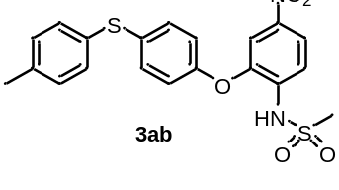
N-(4-nitro-2-(4-(p-tolylthio)phenoxy)phenyl)methanesulfonamide (3ab) (105.0 mg, 81%) was prepared from procedure E as yellow solid, after puriﬁcation by preparative thin layer chromatography (PTLC) (hexane/ethyl acetate (4:1)). ¹H NMR (500 MHz, CDCl₃) δ 8.00 – 7.93 (m, 1H), 7.74 (d, J = 9.0 Hz, 1H), 7.65 (d, J = 2.5 Hz, 1H), 7.52 (s, 1H), 7.34 (d, J = 8.2 Hz, 2H), 7.28 (d, J = 8.7 Hz, 2H), 7.18 (d, J = 7.9 Hz, 2H), 6.96 (d, J = 8.8 Hz, 2H), 3.16 (s, 3H), 2.36 (s, 3H); ¹³C{1H} NMR (126 MHz, CDCl₃) δ 152.6, 146.0, 143.4, 138.2, 134.9, 134.0, 132.6, 131.3, 130.3, 130.2, 120.2, 119.4, 117.3, 111.8, 40.4, 21.1; HRMS (ESI) calcd for (C₂₀H₁₉N₂O₅S₂) [M+H]⁺: 431.0730, found 431.0739.

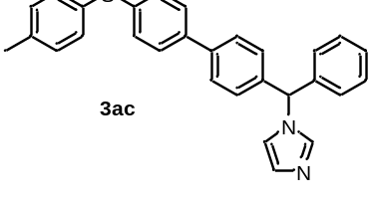
1-(phenyl(4'-(p-tolylthio)-[1,1'-biphenyl]-4-yl)methyl)-1H-imidazole (3ac) (52.7 mg, 41%) was prepared from procedure D as yellow oil, after puriﬁcation by preparative thin layer chromatography (PTLC) (hexane/ethyl acetate (10:1)). ¹H NMR (500 MHz, CDCl₃) δ 7.53 (d, J = 8.3 Hz, 2H), 7.46 (d, J = 8.5 Hz, 3H), 7.35 (t, J = 8.4 Hz, 5H), 7.30 (d, J = 8.3 Hz, 2H), 7.19 – 7.08 (m, 7H), 6.87 (s, 1H), 6.54 (s, 1H), 2.35 (s, 3H); ¹³C{1H} NMR (126 MHz, CDCl₃) δ 140.4, 138.9, 138.1, 137.9, 137.3, 137.3, 137.0, 132.6, 130.6, 130.1, 129.7, 129.2, 128.9, 128.5, 128.4, 128.0, 127.5, 127.2, 119.3, 64.7, 21.1; HRMS (ESI) calcd for (C₂₉H₂₅N₂S) [M+H]⁺: 433.1733, found 433.1731.

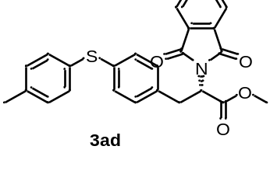
methyl 2-(1,3-dioxoisoindolin-2-yl)-3-(4-(p-tolylthio)phenyl)propanoate (3ad) (92.4 mg, 71%) was prepared from procedure C as light yellow oil, after puriﬁcation by preparative thin layer chromatography (PTLC) (hexane/ethyl acetate (10:1)). ¹H NMR (500 MHz, CDCl₃) δ 7.81 – 7.75 (m, 2H), 7.73 – 7.65 (m, 2H), 7.16 (d, J = 8.2 Hz, 2H), 7.11 – 7.02 (m, 6H), 5.18 – 5.06 (m, 1H), 3.77 (s, 3H), 3.60 – 3.45 (m, 2H), 2.31 (s, 3H); ¹³C{1H} NMR (126 MHz, CDCl₃) δ 169.1, 167.3, 137.3, 135.1, 135.1, 134.1, 131.8, 131.7, 131.4, 131.3, 130.1, 129.9, 129.5, 123.4, 53.0, 52.8, 34.1, 21.0; HRMS (ESI) calcd for (C₂₅H₂₂NO₄S) [M+H]⁺: 432.1264, found 432.1264.
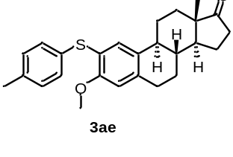
(8R,9S,13S,14S)-3-methoxy-13-methyl-2-(p-tolylthio)-6,7,8,9,11,12,13,14,15,16-decahydro-17H-cyclopenta[a]phenanthren-17-one (3ae) (87.3 mg, 71%) was prepared from procedure C as white solid, after puriﬁcation by preparative thin layer chromatography (PTLC) (hexane/ethyl acetate (10:1)). ¹H NMR (500 MHz, CDCl₃) δ 7.19 (d, J = 8.2 Hz, 2H), 7.13 – 7.07 (m, 3H), 6.63 (s, 1H), 3.82 (s, 3H), 2.95 – 2.87 (m, 2H), 2.54 – 2.43 (m, 1H), 2.32 (s, 3H), 2.21 – 2.08 (m, 3H), 2.08 – 1.97 (m, 2H), 1.93 – 1.85 (m, 1H), 1.63 – 1.24 (m, 8H), 0.89 (s, 3H); ¹³C{1H} NMR (126 MHz, CDCl₃) δ 220.7, 155.9, 137.3, 136.4, 132.5, 131.8, 130.4, 130.0, 129.7, 120.5, 111.4, 55.9, 50.3, 47.9, 43.8, 38.2, 35.8, 31.5, 29.6, 26.4, 25.7, 21.5, 21.1, 13.8; HRMS (ESI) calcd for (C₂₆H₃₁O₂S) [M+H]⁺: 407.2039, found 407.2033.
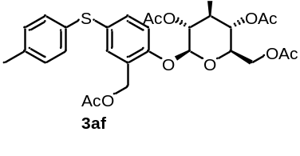
(2R,3R,4S,5R,6S)-2-(acetoxymethyl)-6-(2-(acetoxymethyl)-4-(ptolylthio)phenoxy)tetrahydro-2H-pyran-3,4,5-triyl triacetate (3af) (146.2 mg, 79%) was prepared from procedure C as light yellow oil, after puriﬁcation by preparative thin layer chromatography (PTLC) (hexane/ethyl acetate (2:1)). ¹H NMR (500 MHz, CDCl₃) δ 7.30 (d, J = 2.3 Hz, 1H), 7.22 (d, J = 8.2 Hz, 3H), 7.12 (d, J = 7.8 Hz, 2H), 7.01 (d, J = 8.6 Hz, 1H), 5.33 – 5.26 (m, 2H), 5.21 – 5.14 (m, 1H), 5.09 – 5.03 (m, 2H), 4.97 (d, J = 13.3 Hz, 1H), 4.31 – 4.24 (m, 1H), 4.21 – 4.12 (m, 1H), 3.90 – 3.79 (m, 1H), 2.33 (s, 3H), 2.10 (s, 3H), 2.07 – 2.02 (m, 12H); ¹³C{1H} NMR (126 MHz, CDCl₃) δ 170.5, 170.5, 170.2, 169.3, 169.2, 153.4, 137.3, 132.0, 131.8, 131.6, 131.2, 130.9, 130.0, 127.2, 116.6, 99.2, 72.5, 72.0, 70.9, 68.2, 61.8, 60.6, 21.0, 20.8, 20.6, 20.5; HRMS (ESI) calcd for (C₃₀H₃₄O₁₂SNa) [M+Na]⁺: 641.1663, found 643.1667.

2.4 Procedure for the Synthesis of 4
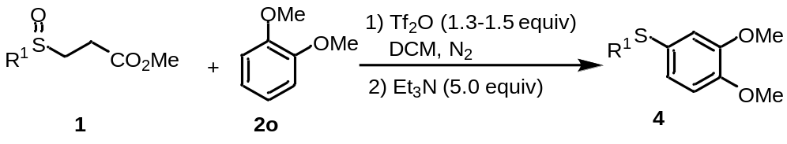
2.4.1 Procedure F for Synthesis of 4a-f
A dried 15 ml Schlenk tube was charged with sulphoxide 1 (0.39 mmol, 1.3 equiv), 1,2-dimethoxybenzene 2o (0.3 mmol, 1.0 equiv) and DCM (3 mL). Trifluoromethanesulfonic anhydride (0.39 mmol, 1.3 equiv) was added at room temperature under nitrogen atmosphere. The reaction mixture was stirred for 1 h. Upon completion, Et₃N (0.2 mL, 5.0 equiv) was added and the reaction mixture was stirred for 1 h. The mixture was concentrated under vacuum, and purified by preparative thin layer chromatography (PTLC) with hexane/ethyl acetate to give the corresponding products 4a-f.
2.4.2 Procedure G for Synthesis of 4g-l
A dried 15 ml Schlenk tube was charged with sulphoxide 1 (0.45 mmol, 1.5 equiv), 1,2-dimethoxybenzene 2o (0.3 mmol, 1.0 equiv) and DCM (3 mL). Trifluoromethanesulfonic anhydride (0.45 mmol, 1.5 equiv) was added at room temperature under nitrogen atmosphere. The reaction mixture was stirred for 12 h. Upon completion, Et₃N (0.2 mL, 5.0 equiv) was added and the reaction mixture was stirred for 1 h. The mixture was concentrated under vacuum, and purified by preparative thin layer chromatography (PTLC) with hexane/ethyl acetate to give the corresponding products 4g-l.
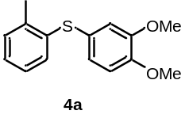
(3,4-dimethoxyphenyl)(o-tolyl)sulfane (4a) (64.4 mg, 83%) was prepared from procedure F as light yellow solid, after puriﬁcation by preparative thin layer chromatography (PTLC) (hexane/ethyl acetate (20:1)). ¹H NMR (500 MHz, CDCl₃) δ 7.18 (d, J = 7.4 Hz, 1H), 7.13 – 7.04 (m, 2H), 7.01 – 6.95 (m, 2H), 6.92 (d, J = 2.1 Hz, 1H), 6.85 (d, J = 8.3 Hz, 1H), 3.89 (s, 3H), 3.82 (s, 3H), 2.38 (s, 3H); ¹³C{1H} NMR (126 MHz, CDCl₃) δ 149.5, 149.0, 137.0, 136.8, 130.2, 129.0, 126.5, 126.2, 125.8, 124.7, 115.9, 111.8, 55.9, 20.2; HRMS (ESI) calcd for (C₁₅H₁₆O₂SNa) [M+Na]⁺: 283.0763, found 283.0767.

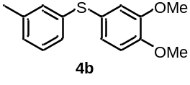
(3,4-dimethoxyphenyl)(m-tolyl)sulfane (4b) (76.3 mg, 98%) was prepared from procedure F as light yellow solid, after puriﬁcation by preparative thin layer chromatography (PTLC) (hexane/ethyl acetate (20:1)). ¹H NMR (500 MHz, CDCl₃) δ 7.13 (t, J = 7.7 Hz, 1H), 7.06 (dd, J = 8.3, 2.1 Hz, 1H), 7.02 (s, 1H), 7.00 – 6.93 (m, 3H), 6.84 (d, J = 8.4 Hz, 1H), 3.88 (s, 3H), 3.83 (s, 3H), 2.27 (s, 3H); ¹³C{1H} NMR (126 MHz, CDCl₃) δ 149.3, 149.2, 138.7, 137.9, 128.9, 128.8, 126.8, 126.5, 125.4, 124.7, 116.4, 111.7, 55.9, 55.9, 21.3.
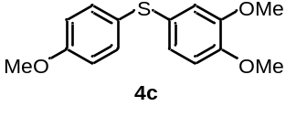
(3,4-dimethoxyphenyl)(4-methoxyphenyl)sulfane (4c) (68.3 mg, 82%) was prepared from procedure F as yellow oil, after puriﬁcation by preparative thin layer chromatography (PTLC) (hexane/ethyl acetate (20:1)). ¹H NMR (500 MHz, CDCl₃) δ 7.29 (d, J = 8.8 Hz, 2H), 6.92 – 6.82 (m, 4H), 6.78 (d, J = 8.3 Hz, 1H), 3.85 (s, 3H), 3.80 (s, 3H), 3.78 (s, 3H); ¹³C{1H} NMR (126 MHz, CDCl₃) δ 158.9, 149.2, 148.4, 132.7, 127.7, 126.9, 123.6, 114.7, 114.2, 111.6, 55.9, 55.8, 55.2.
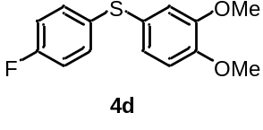
(3,4-dimethoxyphenyl)(4-fluorophenyl)sulfane (4d) (67.6 mg, 85%) was prepared from procedure F as light yellow oil, after puriﬁcation by preparative thin layer chromatography (PTLC) (hexane/ethyl acetate (20:1)). ¹H NMR (500 MHz, CDCl₃) δ 7.25 – 7.17 (m, 2H), 7.02 – 6.91 (m, 4H), 6.83 (d, J = 8.2 Hz, 1H), 3.88 (s, 3H), 3.82 (s, 3H); ¹³C{1H} NMR (126 MHz, CDCl₃) δ 161.6 (d, J = 246.1 Hz), 149.3 (d, J = 30.3 Hz), 132.8 (d, J = 3.5 Hz), 131.1 (d, J = 8.2 Hz), 125.7, 125.5, 120.8, 116.0 (d, J = 21.9 Hz), 115.7, 111.7, 55.9, 55.9; HRMS (ESI) calcd for (C₁₄H₁₄FO₂S) [M+H]⁺: 265.0693, found 265.0685.

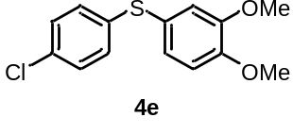
(4-chlorophenyl)(3,4-dimethoxyphenyl)sulfane (4e) (86.7 mg, 97%) was prepared from procedure F as light yellow oil, after puriﬁcation by preparative thin layer chromatography (PTLC) (hexane/ethyl acetate (20:1)). ¹H NMR (500 MHz, CDCl₃) δ 7.19 (d, J = 8.6 Hz, 2H), 7.11 – 7.03 (m, 3H), 6.97 (d, J = 2.1 Hz, 1H), 6.85 (d, J = 8.3 Hz, 1H), 3.89 (s, 3H), 3.83 (s, 3H); ¹³C{1H} NMR (126 MHz, CDCl₃) δ 149.5, 149.4, 137.0, 131.5, 129.2, 128.9, 126.8, 123.8, 116.5, 111.7, 55.9, 55.8; HRMS (ESI) calcd for (C₁₄H₁₄ClO₂S) [M+H]⁺: 281.0398, found 281.0394.

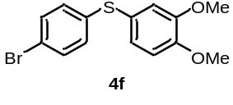
(4-bromophenyl)(3,4-dimethoxyphenyl)sulfane (4f) (95.6 mg, 98%) was prepared from procedure F as light yellow oil, after puriﬁcation by preparative thin layer chromatography (PTLC) (hexane/ethyl acetate (20:1)). ¹H NMR (500 MHz, CDCl₃) δ 7.34 (d, J = 8.6 Hz, 2H), 7.07 (dd, J = 8.3, 2.1 Hz, 1H), 7.02 (d, J = 8.5 Hz, 2H), 6.97 (d, J = 2.1 Hz, 1H), 6.86 (d, J = 8.3 Hz, 1H), 3.90 (s, 3H), 3.84 (s, 3H); ¹³C{1H} NMR (126 MHz, CDCl₃) δ 149.7, 149.5, 137.9, 131.9, 129.4, 127.0, 123.6, 119.4, 116.7, 111.8, 56.0, 55.9; HRMS (ESI) calcd for (C₁₄H₁₄BrO₂S) [M+H]⁺: 324.9892, found 324.9895.
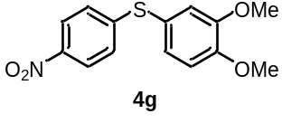
(3,4-dimethoxyphenyl)(4-nitrophenyl)sulfane (4g) (22.3 mg, 26%) was prepared from procedure G as yellow solid, after puriﬁcation by preparative thin layer chromatography (PTLC) (hexane/ethyl acetate (10:1)). ¹H NMR (500 MHz, CDCl₃) δ 8.05 (d, J = 8.9 Hz, 2H), 7.18 (dd, J = 8.3, 2.1 Hz, 1H), 7.11 (d, J = 8.9 Hz, 2H), 7.04 (d, J = 2.0 Hz, 1H), 6.96 (d, J = 8.3 Hz, 1H), 3.95 (s, 3H), 3.88 (s, 3H); ¹³C{1H} NMR (126 MHz, CDCl₃) δ 150.7, 149.9, 149.9, 145.0, 128.8, 125.6, 124.0, 120.3, 117.8, 112.1, 56.1, 56.0.
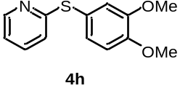
2-((3,4-dimethoxyphenyl)thio)pyridine (4h) (17.7 mg, 24%) was prepared from procedure G as yellow solid, after puriﬁcation by preparative thin layer chromatography (PTLC) (hexane/ethyl acetate (4:1)). ¹H NMR (500 MHz, CDCl₃) δ 8.42 (d, J = 4.2 Hz, 1H), 7.48 – 7.39 (m, 1H), 7.25 – 7.20 (m, 1H), 7.12 (d, J = 2.1 Hz, 1H), 7.00 – 6.96 (m, 1H), 6.93 (d, J = 8.2 Hz, 1H), 6.81 (d, J = 8.0 Hz, 1H), 3.93 (s, 3H), 3.87 (s, 3H); ¹³C{1H} NMR (126 MHz, CDCl₃) δ 162.7, 150.2, 149.6, 149.4, 136.6, 128.8, 121.3, 120.4, 119.5, 118.2, 111.9, 56.0, 55.9.
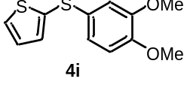
2-((3,4-dimethoxyphenyl)thio)thiophene (4i) (26.0 mg, 34%) was prepared from procedure G as light yellow oil, after puriﬁcation by preparative thin layer chromatography (PTLC) (hexane/ethyl acetate (20:1)). ¹H NMR (500 MHz, CDCl₃) δ 7.41 – 7.36 (m, 1H), 7.24 – 7.20 (m, 1H), 7.04 – 6.98 (m, 1H), 6.93 – 6.85 (m, 2H), 6.78 (d, J = 8.3 Hz, 1H), 3.84 (s, 3H), 3.82 (s, 3H); ¹³C{1H} NMR (126 MHz, CDCl₃) δ 149.2, 148.4, 134.1, 133.8, 130.2, 128.7, 127.6, 122.0, 112.8, 111.7, 55.9, 55.9; HRMS (ESI) calcd for (C₁₂H₁₃O₂S₂) [M+H]⁺: 253.0351, found 253.0355.
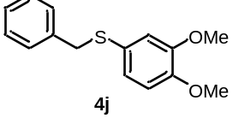
benzyl(3,4-dimethoxyphenyl)sulfane (4j) (47.1 mg, 61%) was prepared from procedure G as light yellow oil, after puriﬁcation by preparative thin layer chromatography (PTLC) (hexane/ethyl acetate (20:1)). ¹H NMR (500 MHz, CDCl₃) δ 7.29 – 7.16 (m, 5H), 6.93 (dd, J = 8.3, 2.1 Hz, 1H), 6.77 – 6.70 (m, 2H), 3.99 (s, 2H), 3.84 (s, 3H), 3.73 (s, 3H); ¹³C{1H} NMR (126 MHz, CDCl₃) δ 148.7, 138.1, 128.9, 128.3, 126.9, 126.2, 125.2, 115.8, 111.3, 55.8, 55.7, 41.1.
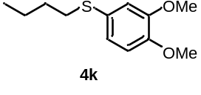
butyl(3,4-dimethoxyphenyl)sulfane (4k) (58.1 mg, 86%) was prepared from procedure G as yellow oil, after puriﬁcation by preparative thin layer chromatography (PTLC) (hexane/ethyl acetate (20:1)). ¹H NMR (500 MHz, CDCl₃) δ 6.99 – 6.92 (m, 2H), 6.81 (d, J = 8.3 Hz, 1H), 3.88 (s, 3H), 3.87 (s, 3H), 2.85 (t, J = 7.4 Hz, 2H), 1.66 – 1.54 (m, 2H), 1.48 – 1.38 (m, 2H), 0.91 (t, J = 7.3 Hz, 3H); ¹³C{1H} NMR (126 MHz, CDCl₃) δ 148.9, 148.1, 127.3, 123.6, 114.5, 111.4, 55.9, 35.3, 31.4, 21.8, 13.6.
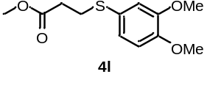
methyl 3-((3,4-dimethoxyphenyl)thio)propanoate (4l) (67.8 mg, 88%) was prepared from procedure G as yellow oil, after puriﬁcation by preparative thin layer chromatography (PTLC) (hexane/ethyl acetate (10:1)). ¹H NMR (500 MHz, CDCl₃) δ 7.02 (dd, J = 8.2, 2.1 Hz, 1H), 6.97 (d, J = 2.1 Hz, 1H), 6.82 (d, J = 8.3 Hz, 1H), 3.89 (s, 3H), 3.88 (s, 3H), 3.68 (s, 3H), 3.08 (t, J = 7.3 Hz, 2H), 2.59 (t, J = 7.4 Hz, 2H); ¹³C{1H} NMR (126 MHz, CDCl₃) δ 172.3, 149.0, 148.8, 125.3, 125.2, 115.6, 111.5, 55.9, 55.9, 51.8, 34.3, 31.0.

2.5 Procedure H for the Synthesis of 6
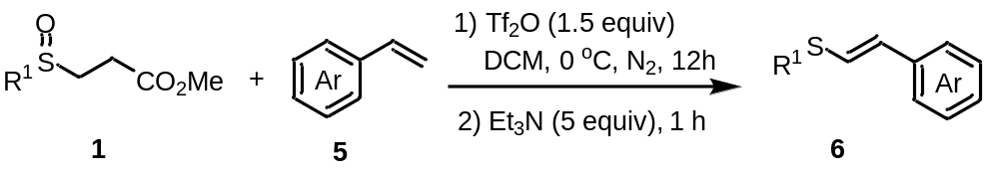
A dried 15 ml Schlenk tube was charged with sulphoxide 1 (0.45 mmol, 1.5 equiv), olefin 5 (0.3 mmol, 1.0 equiv) and DCM (3 mL). Trifluoromethanesulfonic anhydride (0.45 mmol, 1.5 equiv) was added at 0 ºC under nitrogen atmosphere. The reaction mixture was stirred for 12 h. Upon completion, Et₃N (0.2 mL, 5.0 equiv) was added and the reaction mixture was stirred for 1 h. The mixture was concentrated under vacuum, and purified by preparative thin layer chromatography (PTLC) with hexane/ethyl acetate to give the corresponding products 6a-y.
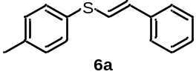
(E)-styryl(p-tolyl)sulfane (6a) (58.4 mg, 86%) was prepared from procedure H as light yellow oil, after puriﬁcation by preparative thin layer chromatography (PTLC) (hexane). ¹H NMR (500 MHz, CDCl₃) δ 7.35 – 7.25 (m, 6H), 7.22 – 7.17 (m, 1H), 7.14 (d, J = 7.9 Hz, 2H), 6.84 (d, J = 15.4 Hz, 1H), 6.64 (d, J = 15.4 Hz, 1H), 2.33 (s, 3H); ¹³C{1H} NMR (126 MHz, CDCl₃) δ 137.2, 136.6, 131.1, 130.6, 130.4, 129.9, 128.6, 127.3, 125.9, 124.4, 21.0.
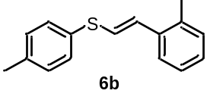
(E)-(2-methylstyryl)(p-tolyl)sulfane (6b) (61.8 mg, 86%) was prepared from procedure H as light yellow oil, after puriﬁcation by preparative thin layer chromatography (PTLC) (hexane). ¹H NMR (500 MHz, CDCl₃) δ 7.42 – 7.37 (m, 1H), 7.34 – 7.29 (m, 2H), 7.17 – 7.11 (m, 5H), 6.89 (d, J = 15.3 Hz, 1H), 6.75 (d, J = 15.3 Hz, 1H), 2.33 (s, 3H), 2.31 (s, 3H); ¹³C{1H} NMR (126 MHz, CDCl₃) δ 137.1, 135.6, 135.0, 131.4, 130.4, 130.2, 129.9, 128.7, 127.4, 126.1, 125.2, 125.2, 21.1, 19.8; HRMS (ESI) calcd for (C₁₆H₁₇S) [M+H]⁺: 241.1045, found 241.1047.
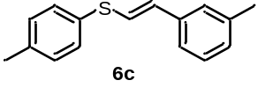
(E)-(3-methylstyryl)(p-tolyl)sulfane (6c) (53.7 mg, 74%) was prepared from procedure H as yellow oil, after puriﬁcation by preparative thin layer chromatography (PTLC) (hexane). ¹H NMR (500 MHz, CDCl₃) δ 7.35 – 7.28 (m, 2H), 7.21 – 7.09 (m, 5H), 7.03 (d, J = 7.4 Hz, 1H), 6.83 (d, J = 15.5 Hz, 1H), 6.62 (d, J = 15.5 Hz, 1H), 2.34 (s, 3H), 2.32 (s, 3H); ¹³C{1H} NMR (126 MHz, CDCl₃) δ 138.2, 137.2, 136.5, 131.2, 130.7, 130.5, 129.9, 128.5, 128.2, 126.6, 124.0, 123.1, 21.4, 21.1; HRMS (ESI) calcd for (C₁₆H₁₆SNa) [M+Na]⁺: 263.0865, found 263.0870.
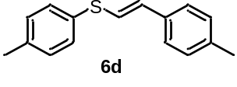
(E)-(4-methylstyryl)(p-tolyl)sulfane (6d) (64.7 mg, 90%) was prepared from procedure H as white solid, after puriﬁcation by preparative thin layer chromatography (PTLC) (hexane). ¹H NMR (500 MHz, CDCl₃) δ 7.30 (d, J = 8.2 Hz, 2H), 7.21 (d, J = 8.2 Hz, 2H), 7.13 (d, J = 7.9 Hz, 2H), 7.09 (d, J = 7.9 Hz, 2H), 6.78 (d, J = 15.4 Hz, 1H), 6.64 (d, J = 15.4 Hz, 1H), 2.33 (s, 3H), 2.31 (s, 3H).; ¹³C{1H} NMR (126 MHz, CDCl₃) δ 137.3, 137.0, 133.8, 131.5, 131.0, 130.3, 129.9, 129.3, 125.8, 122.9, 21.2, 21.0.
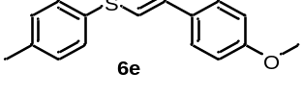
(E)-(4-methoxystyryl)(p-tolyl)sulfane (6e) (19.1 mg, 25%) was prepared from procedure H as yellow solid, after puriﬁcation by preparative thin layer chromatography (PTLC) (hexane). ¹H NMR (500 MHz, CDCl₃) δ 7.32 – 7.24 (m, 4H), 7.14 (d, J = 7.8 Hz, 2H), 6.84 (d, J = 8.7 Hz, 2H), 6.68 (d, J = 3.5 Hz, 2H), 3.80 (s, 3H), 2.34 (s, 3H); ¹³C{1H} NMR (126 MHz, CDCl₃) δ 159.2, 136.9, 131.8, 131.3, 130.0, 129.9, 129.5, 127.2, 121.1, 114.1, 55.3, 21.1.
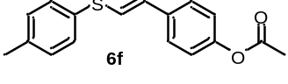
(E)-4-(2-(p-tolylthio)vinyl)phenyl acetate (6f) (53.5 mg, 63%) was prepared from procedure H as white solid, after puriﬁcation by preparative thin layer chromatography (PTLC) (hexane/ethyl acetate (10:1)). ¹H NMR (500 MHz, CDCl₃) δ 7.35 – 7.29 (m, 4H), 7.16 (d, J = 7.9 Hz, 2H), 7.02 (d, J = 8.6 Hz, 2H), 6.81 (d, J = 15.5 Hz, 1H), 6.61 (d, J = 15.5 Hz, 1H), 2.35 (s, 3H), 2.29 (s, 3H); ¹³C{1H} NMR (126 MHz, CDCl₃) δ 169.4, 149.8, 137.4, 134.5, 130.9, 130.6, 130.0, 129.3, 126.8, 124.8, 121.7, 21.1, 21.1; HRMS (ESI) calcd for (C₁₇H₁₇O₂S) [M+H]⁺: 285.0944, found 285.0940.
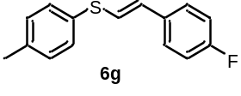
(E)-(4-fluorostyryl)(p-tolyl)sulfane (6g) (58.7 mg, 80%) was prepared from procedure H as light yellow solid, after puriﬁcation by preparative thin layer chromatography (PTLC) (hexane). ¹H NMR (500 MHz, CDCl₃) δ 7.33 – 7.30 (m, 2H), 7.28 – 7.24 (m, 2H), 7.15 (d, J = 8.0 Hz, 2H), 7.02 – 6.93 (m, 2H), 6.76 (d, J = 15.4 Hz, 1H), 6.59 (d, J = 15.4 Hz, 1H), 2.34 (s, 3H); ¹³C{1H} NMR (126 MHz, CDCl₃) δ 162.1 (d, J = 247.0 Hz), 137.3, 132.8 (d, J = 3.4 Hz), 130.9, 130.6, 130.0, 129.2, 127.4 (d, J = 8.1 Hz), 124.1 (d, J = 2.4 Hz), 115.5 (d, J = 21.7 Hz), 21.1.
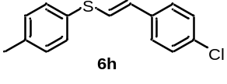
(E)-(4-chlorostyryl)(p-tolyl)sulfane (6h) (74.6 mg, 94%) was prepared from procedure H as yellow solid, after puriﬁcation by preparative thin layer chromatography (PTLC) (hexane). ¹H NMR (500 MHz, CDCl₃) δ 7.32 (d, J = 8.2 Hz, 2H), 7.26 – 7.18 (m, 4H), 7.15 (d, J = 7.9 Hz, 2H), 6.82 (d, J = 15.5 Hz, 1H), 6.53 (d, J = 15.4 Hz, 1H), 2.34 (s, 3H); ¹³C{1H} NMR (126 MHz, CDCl₃) δ 137.6, 135.1, 132.8, 130.9, 130.5, 130.0, 128.7, 128.4, 127.0, 125.6, 21.1.
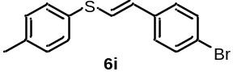
(E)-(4-bromostyryl)(p-tolyl)sulfane (6i) (87.7 mg, 95%) was prepared from procedure H as white solid, after puriﬁcation by preparative thin layer chromatography (PTLC) (hexane). ¹H NMR (500 MHz, CDCl₃) δ 7.39 (d, J = 8.5 Hz, 2H), 7.32 (d, J = 8.2 Hz, 2H), 7.19 – 7.11 (m, 4H), 6.84 (d, J = 15.5 Hz, 1H), 6.50 (d, J = 15.5 Hz, 1H), 2.35 (s, 3H); ¹³C{1H} NMR (126 MHz, CDCl₃) δ 137.6, 135.6, 131.7, 131.0, 130.4, 130.0, 128.3, 127.3, 125.9, 120.9, 21.1.
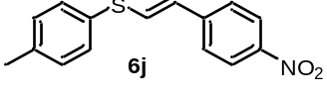
(E)-(4-nitrostyryl)(p-tolyl)sulfane (6j) (52.6 mg, 65%) was prepared from procedure H as yellow solid, after puriﬁcation by preparative thin layer chromatography (PTLC) (hexane/ethyl acetate (10:1)). ¹H NMR (500 MHz, CDCl₃) δ 8.12 (d, J = 8.8 Hz, 2H), 7.40 – 7.32 (m, 4H), 7.21 (d, J = 7.7 Hz, 2H), 7.11 (d, J = 15.5 Hz, 1H), 6.46 (d, J = 15.5 Hz, 1H), 2.38 (s, 3H); ¹³C{1H} NMR (126 MHz, CDCl₃) δ 146.1, 143.0, 138.6, 132.2, 132.1, 130.2, 128.8, 125.8, 125.1, 124.1, 21.2.
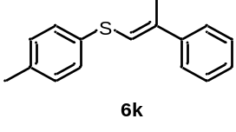
(E)-(2-phenylprop-1-en-1-yl)(p-tolyl)sulfane (6k) (40.5 mg, 56%) was prepared from procedure H as light yellow oil, after puriﬁcation by preparative thin layer chromatography (PTLC) (hexane). ¹H NMR (500 MHz, CDCl₃) δ 7.42 – 7.37 (m, 2H), 7.34 – 7.29 (m, 4H), 7.24 – 7.21 (m, 1H), 7.13 (d, J = 7.9 Hz, 2H), 6.53 (s, 1H), 2.33 (s, 3H), 2.23 (s, 3H); ¹³C{1H} NMR (126 MHz, CDCl₃) δ 141.7, 136.6, 136.0, 132.6, 129.8, 129.7, 128.3, 127.0, 125.3, 122.5, 21.0, 17.7; HRMS (ESI) calcd for (C₁₆H₁₇S) [M+H]⁺: 241.1045, found 241.1047.
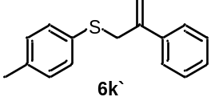
(2-phenylallyl)(p-tolyl)sulfane (6k') (19.6 mg, 27%) was prepared from procedure H as light yellow oil, after puriﬁcation by preparative thin layer chromatography (PTLC) (hexane). ¹H NMR (500 MHz, CDCl₃) δ 7.45 (d, J = 7.5 Hz, 2H), 7.38 – 7.27 (m, 3H), 7.24 (d, J = 7.9 Hz, 2H), 7.08 (d, J = 7.8 Hz, 2H), 5.36 (s, 1H), 5.12 (s, 1H), 3.93 (s, 2H), 2.32 (s, 3H); ¹³C{1H} NMR (126 MHz, CDCl₃) δ 143.3, 139.5, 136.6, 132.3, 131.2, 129.6, 128.3, 127.8, 126.3, 115.5, 40.2, 21.0; HRMS (ESI) calcd for (C₁₆H₁₇S) [M+H]⁺: 241.1045, found 241.1054.
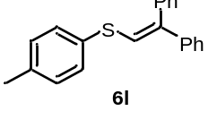
(2,2-diphenylvinyl)(p-tolyl)sulfane (6l) (80.3 mg, 89%) was prepared from procedure H as white solid, after puriﬁcation by preparative thin layer chromatography (PTLC) (hexane). ¹H NMR (500 MHz, CDCl₃) δ 7.43 – 7.31 (m, 7H), 7.28 – 7.19 (m, 5H), 7.12 (d, J = 8.2 Hz, 2H), 6.82 (s, 1H), 2.31 (s, 3H); ¹³C{1H} NMR (126 MHz, CDCl₃) δ 141.5, 140.1, 139.2, 136.9, 132.8, 130.0, 129.9, 129.7, 128.3, 128.2, 127.7, 127.1, 125.2, 21.0.
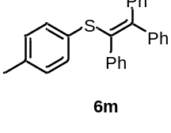
p-tolyl(1,2,2-triphenylvinyl)sulfane (6m) (52.7 mg, 46%) was prepared from procedure H as white solid, after puriﬁcation by preparative thin layer chromatography (PTLC) (hexane). ¹H NMR (500 MHz, CDCl₃) δ 7.42 – 7.37 (m, 2H), 7.35 – 7.23 (m, 5H), 7.09 – 6.94 (m, 10H), 6.89 (d, J = 7.9 Hz, 2H), 2.19 (s, 3H); ¹³C{1H} NMR (126 MHz, CDCl₃) δ 145.7, 143.8, 142.5, 139.2, 135.6, 134.4, 131.9, 131.1, 130.7, 129.8, 129.6, 129.2, 128.1, 127.6, 127.5, 127.2, 126.9, 126.6, 20.9.
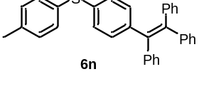
p-tolyl(4-(1,2,2-triphenylvinyl)phenyl)sulfane (6n) (118.9 mg, 87%) was prepared from procedure H as white solid, after puriﬁcation by preparative thin layer chromatography (PTLC) (hexane). ¹H NMR (500 MHz, CDCl₃) δ 7.20 (d, J = 8.1 Hz, 2H), 7.10 – 6.96 (m, 19H), 6.91 (d, J = 8.4 Hz, 2H), 2.29 (s, 3H); ¹³C{1H} NMR (126 MHz, CDCl₃) δ 143.5, 143.4, 142.0, 141.2, 140.2, 137.3, 134.7, 131.9, 131.8, 131.3, 131.3, 131.2, 129.9, 129.1, 127.7, 127.6, 127.6, 126.5, 126.5, 126.4, 21.1; HRMS (ESI) calcd for (C₃₃H₂₈SNa) [M+Na]⁺: 477.1647, found 477.1655.
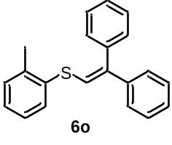
(2,2-diphenylvinyl)(o-tolyl)sulfane (6o) (50.7 mg, 56%) was prepared from procedure H as yellow oil, after puriﬁcation by preparative thin layer chromatography (PTLC) (hexane). ¹H NMR (500 MHz, CDCl₃) δ 7.49 – 7.45 (m, 1H), 7.45 – 7.33 (m, 5H), 7.29 – 7.22 (m, 5H), 7.21 – 7.13 (m, 3H), 6.74 (s, 1H), 2.37 (s, 3H); ¹³C{1H} NMR (126 MHz, CDCl₃) δ 141.5, 141.3, 139.2, 138.3, 135.6, 130.3, 130.3, 129.8, 128.3, 128.3, 127.7, 127.2, 127.1, 127.0, 126.7, 124.2, 20.6.

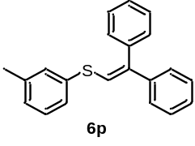
(2,2-diphenylvinyl)(m-tolyl)sulfane (6p) (61.3 mg, 68%) was prepared from procedure H as yellow oil, after puriﬁcation by preparative thin layer chromatography (PTLC) (hexane). ¹H NMR (500 MHz, CDCl₃) δ 7.44 – 7.17 (m, 13H), 7.04 (d, J = 7.5 Hz, 1H), 6.86 (s, 1H), 2.33 (s, 3H); ¹³C{1H} NMR (126 MHz, CDCl₃) δ 141.5, 140.7, 139.2, 138.9, 136.1, 130.2, 129.7, 128.9, 128.4, 128.3, 127.7, 127.7, 127.2, 127.1, 126.6, 124.4, 21.3.
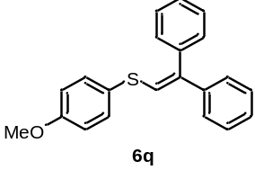
(2,2-diphenylvinyl)(4-methoxyphenyl)sulfane (6q) (24.7 mg, 26%) was prepared from procedure H as yellow oil, after puriﬁcation by preparative thin layer chromatography (PTLC) (hexane). ¹H NMR (500 MHz, CDCl₃) δ 7.46 – 7.32 (m, 7H), 7.29 – 7.19 (m, 5H), 6.87 (d, J = 8.7 Hz, 2H), 6.76 (s, 1H), 3.79 (s, 3H); ¹³C{1H} NMR (126 MHz, CDCl₃) δ 159.2, 141.5, 139.2, 139.2, 132.5, 129.7, 128.4, 128.2, 127.7, 127.1, 127.0, 126.8, 126.5, 114.8, 55.4.
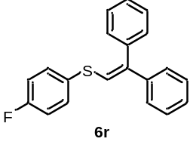
(2,2-diphenylvinyl)(4-fluorophenyl)sulfane (6r) (65.0 mg, 71%) was prepared from procedure H as light yellow oil, after puriﬁcation by preparative thin layer chromatography (PTLC) (hexane). ¹H NMR (500 MHz, CDCl₃) δ 7.45 – 7.40 (m, 4H), 7.38 – 7.33 (m, 3H), 7.29 – 7.22 (m, 5H), 7.07 – 7.00 (m, 2H), 6.76 (s, 1H); ¹³C{1H} NMR (126 MHz, CDCl₃) δ 162.1 (d, J = 247.1 Hz), 141.3, 140.8, 139.0, 132.0 (d, J = 8.2 Hz), 131.5 (d, J = 3.3 Hz), 129.7, 128.4, 128.3, 127.9, 127.3, 127.2, 124.6, 116.2 (d, J = 22.1 Hz).
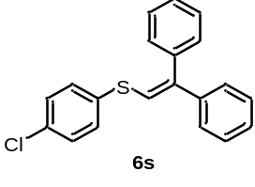
(4-chlorophenyl)(2,2-diphenylvinyl)sulfane (6s) (88.1 mg, 92%) was prepared from procedure H as white solid, after puriﬁcation by preparative thin layer chromatography (PTLC) (hexane). ¹H NMR (500 MHz, CDCl₃) δ 7.40 (td, J = 7.1, 1.2 Hz, 2H), 7.36 – 7.30 (m, 5H), 7.29 – 7.22 (m, 7H), 6.76 (s, 1H); ¹³C{1H} NMR (126 MHz, CDCl₃) δ 141.9, 141.2, 138.9, 135.0, 132.7, 130.6, 129.6, 129.2, 128.4, 128.3, 127.9, 127.4, 127.2, 123.1.
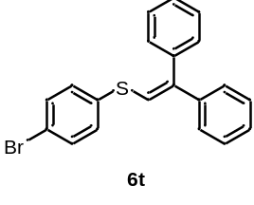
(4-bromophenyl)(2,2-diphenylvinyl)sulfane (6t) (65.0 mg, 59%) was prepared from procedure H as white solid, after puriﬁcation by preparative thin layer chromatography (PTLC) (hexane). ¹H NMR (500 MHz, CDCl₃) δ 7.48 – 7.20 (m, 14H), 6.77 (s, 1H); ¹³C{1H} NMR (126 MHz, CDCl₃) δ 142.1, 141.2, 138.9, 135.7, 132.1, 130.8, 129.7, 128.4, 128.3, 127.9, 127.5, 127.2, 122.9, 120.6.
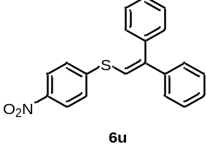
(2,2-diphenylvinyl)(4-nitrophenyl)sulfane (6u) (100.0 mg, 99%) was prepared from procedure H as yellow solid, after puriﬁcation by preparative thin layer chromatography (PTLC) (hexane/ethyl acetate (10:1)). ¹H NMR (500 MHz, CDCl₃) δ 8.13 (d, J = 8.9 Hz, 2H), 7.48 – 7.26 (m, 12H), 6.85 (s, 1H); ¹³C{1H} NMR (126 MHz, CDCl₃) δ 146.5, 146.2, 145.6, 140.7, 138.5, 129.5, 128.4, 128.4, 128.2, 128.1, 127.4, 127.1, 124.0, 118.4.
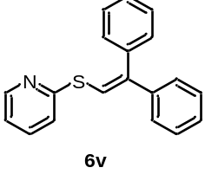
2-((2,2-diphenylvinyl)thio)pyridine (6v) (18.3 mg, 21%) was prepared from procedure H as yellow solid, after puriﬁcation by preparative thin layer chromatography (PTLC) (hexane/ethyl acetate (10:1)). ¹H NMR (500 MHz, CDCl₃) δ 8.53 – 8.47 (m, 1H), 7.76 (s, 1H), 7.54 – 7.48 (m, 1H), 7.45 – 7.40 (m, 2H), 7.39 – 7.28 (m, 7H), 7.27 – 7.23 (m, 1H), 7.20 – 7.17 (m, 1H), 7.06 – 7.01 (m, 1H); ¹³C{1H} NMR (126 MHz, CDCl₃) δ 157.2, 149.7, 141.4, 140.3, 139.7, 136.3, 129.6, 128.4, 128.2, 127.8, 127.2, 122.5, 120.2, 119.5; HRMS (ESI) calcd for (C₁₉H₁₆NS) [M+H]⁺: 290.0998, found 290.0998.
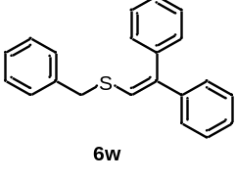
benzyl(2,2-diphenylvinyl)sulfane (6w) (50.2 mg, 55%) was prepared from procedure H as white solid, after puriﬁcation by preparative thin layer chromatography (PTLC) (hexane). ¹H NMR (500 MHz, CDCl₃) δ 7.39 – 7.18 (m, 13H), 7.14 – 7.10 (m, 2H), 6.57 (s, 1H), 3.94 (s, 2H); ¹³C{1H} NMR (126 MHz, CDCl₃) δ 141.7, 139.4, 139.2, 137.7, 129.7, 128.9, 128.6, 128.2, 128.2, 127.5, 127.3, 127.0, 126.9, 124.7, 38.8.
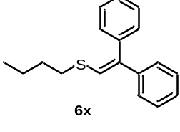
butyl(2,2-diphenylvinyl)sulfane (6x) (84.7 mg, 99%) was prepared from procedure H as yellow oil, after puriﬁcation by preparative thin layer chromatography (PTLC) (hexane). ¹H NMR (500 MHz, CDCl₃) δ 7.39 – 7.35 (m, 2H), 7.33 – 7.23 (m, 5H), 7.22 – 7.17 (m, 3H), 6.58 (s, 1H), 2.74 (t, J = 7.4 Hz, 2H), 1.70 – 1.60 (m, 2H), 1.47 – 1.37 (m, 2H), 0.92 (t, J = 7.4 Hz, 3H); ¹³C{1H} NMR (126 MHz, CDCl₃) δ 141.9, 139.5, 138.2, 129.7, 128.2, 128.2, 127.3, 126.9, 126.7, 126.3, 34.5, 32.4, 21.7, 13.6; HRMS (ESI) calcd for (C₁₈H₂₁S) [M+H]⁺: 269.1358, found 269.1353.
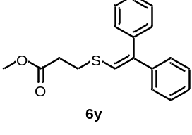
methyl 3-((2,2-diphenylvinyl)thio)propanoate (6y) (89.0 mg, 97%) was prepared from procedure H as light yellow oil, after puriﬁcation by preparative thin layer chromatography (PTLC) (hexane). ¹H NMR (500 MHz, CDCl₃) δ 7.40 – 7.18 (m, 10H), 6.56 (s, 1H), 3.68 (s, 3H), 3.01 (t, J = 7.3 Hz, 2H), 2.69 (t, J = 7.3 Hz, 2H); ¹³C{1H} NMR (126 MHz, CDCl₃) δ 171.9, 141.6, 139.6, 139.2, 129.6, 128.2, 128.2, 127.5, 126.9, 124.8, 51.8, 35.2, 29.6; HRMS (ESI) calcd for (C₁₈H₁₉O₂S) [M+H]⁺: 299.1100, found 299.1104.

2.6 Procedure I for the Synthesis of 8
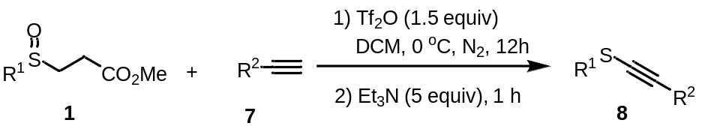
A dried 15 ml Schlenk tube was charged with sulphoxide 1 (0.45 mmol, 1.5 equiv),
alkyne 7 (0.3 mmol, 1.0 equiv) and DCM (3 mL). Trifluoromethanesulfonic anhydride (0.45 mmol, 1.5 equiv) was added at 0 ºC under nitrogen atmosphere. The reaction mixture was stirred for 12 h. Upon completion, Et₃N (0.2 mL, 5.0 equiv) was added and the reaction mixture was stirred for 1 h. The mixture was concentrated under vacuum, and purified by preparative thin layer chromatography (PTLC) with hexane/ethyl acetate to give the corresponding products 8a-u.
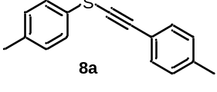
p-tolyl(p-tolylethynyl)sulfane (8a) (50.9 mg, 71%) was prepared from procedure I as white solid, after puriﬁcation by preparative thin layer chromatography (PTLC) (hexane). ¹H NMR (500 MHz, CDCl₃) δ 7.41 – 7.33 (m, 4H), 7.13 (t, J = 8.0 Hz, 4H), 2.34 (s, 3H), 2.32 (s, 3H); ¹³C{1H} NMR (126 MHz, CDCl₃) δ 138.8, 136.4, 131.7, 130.0, 129.4, 129.1, 126.4, 119.9, 97.4, 75.1, 21.5, 21.0.
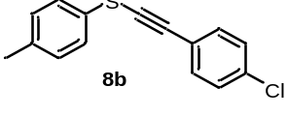
((4-chlorophenyl)ethynyl)(p-tolyl)sulfane (8b) (54.8 mg, 71%) was prepared from procedure I as light yellow solid, after puriﬁcation by preparative thin layer chromatography (PTLC) (hexane). ¹H NMR (500 MHz, CDCl₃) δ 7.40 (d, J = 8.5 Hz, 2H), 7.36 (d, J = 8.3 Hz, 2H), 7.29 (d, J = 8.5 Hz, 2H), 7.16 (d, J = 8.0 Hz, 2H), 2.33 (s, 3H); ¹³C{1H} NMR (126 MHz, CDCl₃) δ 136.8, 134.5, 132.8, 130.1, 128.8, 128.7, 126.7, 121.5, 95.9, 77.6, 21.0.
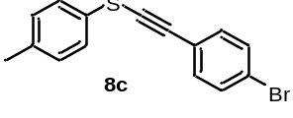
((4-bromophenyl)ethynyl)(p-tolyl)sulfane (8c) (68.6 mg, 76%) was prepared from procedure I as light yellow solid, after puriﬁcation by preparative thin layer chromatography (PTLC) (hexane). ¹H NMR (500 MHz, CDCl₃) δ 7.45 (d, J = 8.4 Hz, 2H), 7.38 – 7.30 (m, 4H), 7.16 (d, J = 8.0 Hz, 2H), 2.33 (s, 3H); ¹³C{1H} NMR (126 MHz, CDCl₃) δ 136.8, 132.9, 131.6, 130.1, 128.7, 126.8, 122.7, 121.9, 96.0, 77.8, 21.0.
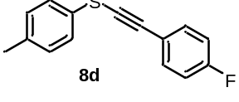
((4-fluorophenyl)ethynyl)(p-tolyl)sulfane (8d) (57.2 mg, 79%) was prepared from procedure I as yellow solid, after puriﬁcation by preparative thin layer chromatography (PTLC) (hexane). ¹H NMR (500 MHz, CDCl₃) δ 7.49 – 7.43 (m, 2H), 7.36 (d, J = 8.3 Hz, 2H), 7.15 (d, J = 8.0 Hz, 2H), 7.04 – 6.97 (m, 2H), 2.33 (s, 3H); ¹³C{1H} NMR (126 MHz, CDCl₃) δ 162.6 (d, J = 250.4 Hz), 136.7, 133.8 (d, J = 8.2 Hz), 130.0, 129.0, 126.6, 119.1 (d, J = 3.6 Hz), 115.6 (d, J = 22.2 Hz), 96.0, 76.0 (d, J = 1.8 Hz), 21.0.
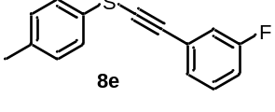
((3-fluorophenyl)ethynyl)(p-tolyl)sulfane (8e) (42.2 mg, 58%) was prepared from procedure I as light yellow oil, after puriﬁcation by preparative thin layer chromatography (PTLC) (hexane). ¹H NMR (500 MHz, CDCl₃) δ 7.37 (d, J = 8.2 Hz, 2H), 7.31 – 7.25 (m, 2H), 7.20 – 7.15 (m, 3H), 7.06 – 7.01 (m, 1H), 2.35 (s, 3H); ¹³C{1H} NMR (126 MHz, CDCl₃) δ 162.3 (d, J = 246.8 Hz), 136.9, 130.1, 129.9 (d, J = 8.7 Hz), 128.6, 127.3 (d, J = 3.2 Hz), 126.8, 124.8 (d, J = 9.5 Hz), 118.2 (d, J = 22.8 Hz), 115.7 (d, J = 21.3 Hz), 95.8, 77.8, 21.0; HRMS (ESI) calcd for (C₁₅H₁₂FS) [M+H]⁺: 243.0638, found 243.0635.
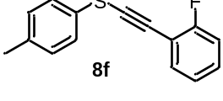
((2-fluorophenyl)ethynyl)(p-tolyl)sulfane (8f) (44.2 mg, 61%) was prepared from procedure I as white solid, after puriﬁcation by preparative thin layer chromatography (PTLC) (hexane). ¹H NMR (500 MHz, CDCl₃) δ 7.48 – 7.44 (m, 1H), 7.40 (d, J = 8.3 Hz, 2H), 7.33 – 7.28 (m, 1H), 7.17 (d, J = 8.0 Hz, 2H), 7.13 – 7.06 (m, 2H), 2.34 (s, 3H); ¹³C{1H} NMR (126 MHz, CDCl₃) δ 162.7 (d, J = 251.7 Hz), 136.7, 133.2, 130.1, 130.0, 128.7, 126.6, 124.0 (d, J = 3.8 Hz), 115.5 (d, J = 20.8 Hz), 111.7 (d, J = 15.6 Hz), 90.6, 81.7, 21.0; HRMS (ESI) calcd for (C₁₅H₁₂FS) [M+H]⁺: 243.0638, found 243.0639.
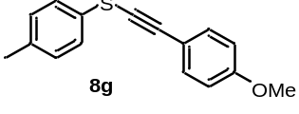
((4-methoxyphenyl)ethynyl)(p-tolyl)sulfane (8g) (59.4 mg, 78%) was prepared from procedure I as yellow oil, after puriﬁcation by preparative thin layer chromatography (PTLC) (hexane). ¹H NMR (500 MHz, CDCl₃) δ 7.45 (d, J = 8.7 Hz, 2H), 7.36 (d, J = 8.3 Hz, 2H), 7.14 (d, J = 8.0 Hz, 2H), 6.85 (d, J = 8.7 Hz, 2H), 3.80 (s, 3H), 2.32 (s, 3H); ¹³C{1H} NMR (126 MHz, CDCl₃) δ 159.9, 136.3, 133.6, 129.9, 129.6, 126.3, 115.0, 114.0, 97.2, 74.1, 55.3, 20.9.
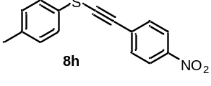
((4-nitrophenyl)ethynyl)(p-tolyl)sulfane (8h) (46.1 mg, 57%) was prepared from procedure I as yellow solid, after puriﬁcation by preparative thin layer chromatography (PTLC) (hexane/ethyl acetate (10:1)). ¹H NMR (500 MHz, CDCl₃) δ 8.19 (d, J = 8.7 Hz, 2H), 7.57 (d, J = 8.9 Hz, 2H), 7.39 (d, J = 8.3 Hz, 2H), 7.21 (d, J = 7.9 Hz, 2H), 2.36 (s, 3H); ¹³C{1H} NMR (126 MHz, CDCl₃) δ 146.7, 137.5, 131.5, 130.3, 129.9, 127.8, 127.3, 123.7, 95.4, 84.0, 21.0.
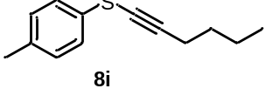
hex-1-yn-1-yl(p-tolyl)sulfane (8i) (10.2 mg, 17%) was prepared from procedure I as yellow oil, after puriﬁcation by preparative thin layer chromatography (PTLC) (hexane). ¹H NMR (500 MHz, CDCl₃) δ 7.30 (d, J = 8.3 Hz, 2H), 7.13 (d, J = 8.0 Hz, 2H), 2.44 (t, J = 7.1 Hz, 2H), 2.32 (s, 3H), 1.62 – 1.54 (m, 2H), 1.51 – 1.41 (m, 2H), 0.93 (t, J = 7.3 Hz, 3H); ¹³C{1H} NMR (126 MHz, CDCl₃) δ 136.0, 130.0, 129.8, 126.1, 99.3, 65.1, 30.7, 22.0, 20.9, 20.0, 13.6.
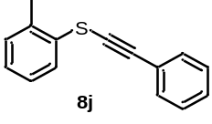
(phenylethynyl)(o-tolyl)sulfane (8j) (53.0 mg, 80%) was prepared from procedure I as yellow oil, after puriﬁcation by preparative thin layer chromatography (PTLC) (hexane). ¹H NMR (500 MHz, CDCl₃) δ 7.71 (d, J = 7.8 Hz, 1H), 7.53 – 7.47 (m, 2H), 7.34 – 7.30 (m, 3H), 7.26 – 7.20 (m, 1H), 7.16 – 7.11 (m, 2H), 2.35 (s, 3H); ¹³C{1H} NMR (126 MHz, CDCl₃) δ 135.2, 131.9, 131.7, 130.2, 128.6, 128.4, 126.9, 126.6, 126.5, 123.0, 97.5, 75.6, 19.5.
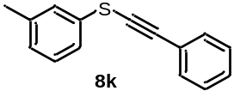
(phenylethynyl)(m-tolyl)sulfane (8k) (51.0 mg, 77%) was prepared from procedure I as yellow oil, after puriﬁcation by preparative thin layer chromatography (PTLC) (hexane). ¹H NMR (500 MHz, CDCl₃) δ 7.52 – 7.48 (m, 2H), 7.35 – 7.27 (m, 5H), 7.25 – 7.20 (m, 1H), 7.05 – 7.01 (m, 1H), 2.35 (s, 3H); ¹³C{1H} NMR (126 MHz, CDCl₃) δ 139.2, 132.5, 131.7, 129.1, 128.5, 128.3, 127.4, 126.7, 123.3, 123.0, 97.7, 75.7, 21.4.
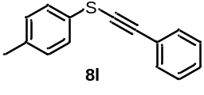
(phenylethynyl)(p-tolyl)sulfane (8l) (49.4 mg, 75%) was prepared from procedure I as yellow oil, after puriﬁcation by preparative thin layer chromatography (PTLC) (hexane). ¹H NMR (500 MHz, CDCl₃) δ 7.51 – 7.47 (m, 2H), 7.38 (d, J = 8.3 Hz, 2H), 7.34 – 7.30 (m, 3H), 7.16 (d, J = 7.9 Hz, 2H), 2.33 (s, 3H); ¹³C{1H} NMR (126 MHz, CDCl₃) δ 136.6, 131.6, 130.0, 129.2, 128.5, 128.3, 126.6, 123.0, 97.2, 76.1, 21.0.

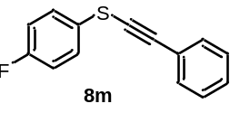
(4-fluorophenyl)(phenylethynyl)sulfane (8m) (48.1 mg, 70%) was prepared from procedure I as light yellow oil, after puriﬁcation by preparative thin layer chromatography (PTLC) (hexane). ¹H NMR (500 MHz, CDCl₃) δ 7.53 – 7.47 (m, 2H), 7.47 – 7.42 (m, 2H), 7.36 – 7.31 (m, 3H), 7.10 – 7.02 (m, 2H); ¹³C{1H} NMR (126 MHz, CDCl₃) δ 161.8 (d, J = 246.5 Hz), 131.7, 128.7, 128.4, 128.3 (d, J = 8.0 Hz), 127.8 (d, J = 3.2 Hz), 122.7, 116.4 (d, J = 22.6 Hz), 97.5, 75.6.
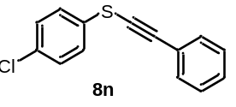
(4-chlorophenyl)(phenylethynyl)sulfane (8n) (69.0 mg, 89%) was prepared from procedure I as yellow solid, after puriﬁcation by preparative thin layer chromatography (PTLC) (hexane). ¹H NMR (500 MHz, CDCl₃) δ 7.52 – 7.47 (m, 2H), 7.41 – 7.37 (m, 2H), 7.36 – 7.28 (m, 5H); ¹³C{1H} NMR (126 MHz, CDCl₃) δ 132.5, 131.7, 131.5, 129.3, 128.8, 128.4, 127.4, 122.6, 98.4, 74.8.
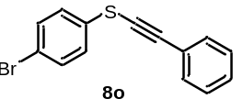
(4-bromophenyl)(phenylethynyl)sulfane (8o) (86.9 mg, 97%) was prepared from procedure I as yellow oil, after puriﬁcation by preparative thin layer chromatography (PTLC) (hexane). ¹H NMR (500 MHz, CDCl₃) δ 7.52 – 7.48 (m, 2H), 7.47 – 7.43 (m, 2H), 7.36 – 7.31 (m, 5H); ¹³C{1H} NMR (126 MHz, CDCl₃) δ 132.3, 132.2, 131.8, 128.8, 128.4, 127.7, 122.6, 120.3, 98.5, 74.6.
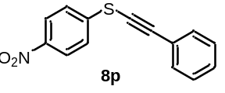
(4-nitrophenyl)(phenylethynyl)sulfane (8p) (60.2 mg, 79%) was prepared from procedure I as yellow solid, after puriﬁcation by preparative thin layer chromatography (PTLC) (hexane/ethyl acetate (10:1)). ¹H NMR (500 MHz, CDCl₃) δ 8.20 (d, J = 8.9 Hz, 2H), 7.63 – 7.52 (m, 4H), 7.44 – 7.33 (m, 3H); ¹³C{1H} NMR (126 MHz, CDCl₃) δ 146.2, 142.9, 132.0, 129.4, 128.5, 125.6, 124.2, 121.9, 100.5, 72.4.
butyl(phenylethynyl)sulfane (8q) (32.5 mg, 58%) was prepared from procedure I as yellow oil, after puriﬁcation by preparative thin layer chromatography (PTLC) (hexane). ¹H NMR (500 MHz, CDCl₃) δ 7.42 – 7.38 (m, 2H), 7.31 – 7.27 (m, 3H), 2.84 – 2.77 (t, J = 7.2 Hz, 2H), 1.83 – 1.71 (m, 2H), 1.54 – 1.42 (m, 2H), 0.96 (t, J = 7.4 Hz, 3H); ¹³C{1H} NMR (126 MHz, CDCl₃) δ 131.4, 128.2, 127.9, 123.5, 92.8, 79.7, 35.5, 31.4, 21.4, 13.6.
methyl 3-((phenylethynyl)thio)propanoate (8r) (43.2 mg, 67%) was prepared from procedure I as yellow oil, after puriﬁcation by preparative thin layer chromatography (PTLC) (hexane). ¹H NMR (500 MHz, CDCl₃) δ 7.43 – 7.39 (m, 2H), 7.31 – 7.28 (m, 3H), 3.71 (s, 3H), 3.04 (t, J = 7.2 Hz, 2H), 2.87 (t, J = 7.1 Hz, 2H); ¹³C{1H} NMR (126 MHz, CDCl₃) δ 171.7, 131.5, 128.2, 128.2, 123.1, 94.0, 78.0, 51.9, 34.1, 30.3; HRMS (ESI) calcd for (C₁₂H₁₃O₂S) [M+H]⁺: 221.0631, found 221.0627.

2.7 Procedure J for the Synthesis of 10
A dried 15 ml Schlenk tube was charged with sulphoxide 1 (0.45 mmol, 1.5 equiv),
diketone 7 (0.3 mmol, 1.0 equiv) and DCM (3 mL). Trifluoromethanesulfonic anhydride (0.45 mmol, 1.5 equiv) was added at 0 ºC under nitrogen atmosphere. The reaction mixture was stirred for 12 h. Upon completion, Et₃N (0.2 mL, 5 equiv) was added and the reaction mixture was stirred at room temperature for 1 h. The mixture was concentrated under vacuum, and purified by preparative thin layer chromatography (PTLC) with hexane/ethyl acetate to give the corresponding products 10a-i.
1-phenyl-2-(p-tolylthio)butane-1,3-dione (10a) (44.0 mg, 54%) was prepared from procedure J as yellow solid, after puriﬁcation by preparative thin layer chromatography (PTLC) (hexane/ethyl acetate (20:1)). ¹H NMR (500 MHz, CDCl₃) δ 7.66 – 7.62 (m, 2H), 7.42 (t, J = 7.4 Hz, 1H), 7.32 (t, J = 7.7 Hz, 2H), 7.09 (d, J = 8.0 Hz, 2H), 7.00 (d, J = 8.2 Hz, 2H), 2.41 (s, 3H), 2.30 (s, 3H); ¹³C{1H} NMR (126 MHz, CDCl₃) δ 203.4, 190.3, 135.6, 135.0, 135.0, 131.1, 130.0, 128.4, 127.7, 124.9, 101.1, 25.8, 20.8.
3-(p-tolylthio)pentane-2,4-dione (10b) (30.2 mg, 45%) was prepared from procedure J as yellow solid, after puriﬁcation by preparative thin layer chromatography (PTLC) (hexane/ethyl acetate (50:1)). ¹H NMR (500 MHz, CDCl₃) δ 7.09 (d, J = 7.9 Hz, 2H), 6.99 (d, J = 8.3 Hz, 2H), 2.34 (s, 6H), 2.30 (s, 3H); ¹³C{1H} NMR (126 MHz, CDCl₃) δ 198.2 (d, J = 3.1 Hz), 135.1, 134.1, 129.9, 124.9, 102.0, 24.4, 20.8.
methyl (S)-1-oxo-2-(p-tolylthio)-2,3-dihydro-1H-indene-2-carboxylate (10c) (60.9 mg, 65%) was prepared from procedure J as yellow solid, after puriﬁcation by preparative thin layer chromatography (PTLC) (hexane/ethyl acetate (10:1)). ¹H NMR (500 MHz, CDCl₃) δ 7.77 (d, J = 7.7 Hz, 1H), 7.57 (t, J = 7.5 Hz, 1H), 7.41 – 7.32 (m, 4H), 7.06 (d, J = 8.0 Hz, 2H), 3.87 (d, J = 17.8 Hz, 1H), 3.77 (s, 3H), 3.32 (d, J = 17.7 Hz, 1H), 2.30 (s, 3H); ¹³C{1H} NMR (126 MHz, CDCl₃) δ 196.6, 169.3, 150.8, 140.0, 136.3, 135.4, 134.2, 129.5, 127.9, 126.2, 125.9, 125.1, 63.6, 53.4, 39.1, 21.2; HRMS (ESI) calcd for (C₁₈H₁₇O₃S) [M+H]⁺: 313.0893, found 313.0897.
methyl 2-((4-methoxyphenyl)thio)-1-oxo-2,3-dihydro-1H-indene-2-carboxylate (10d) (71.6 mg, 73%) was prepared from procedure J as yellow oil, after puriﬁcation by preparative thin layer chromatography (PTLC) (hexane/ethyl acetate (10:1)). ¹H NMR (500 MHz, CDCl₃) δ 7.77 (d, J = 7.7 Hz, 1H), 7.57 (d, J = 7.4 Hz, 1H), 7.43 (d, J = 8.6 Hz, 2H), 7.40 – 7.32 (m, 2H), 6.78 (d, J = 8.5 Hz, 2H), 3.86 (d, J = 17.8 Hz, 1H), 3.77 (s, 6H), 3.31 (d, J = 17.8 Hz, 1H); ¹³C{1H} NMR (126 MHz, CDCl₃) δ 196.7, 169.3, 161.0, 150.7, 138.4, 135.4, 134.3, 128.0, 126.0, 125.1, 120.3, 114.3, 63.6, 55.2, 53.3, 39.0; HRMS (ESI) calcd for (C₁₈H₁₇O₄S) [M+H]⁺: 329.0842, found 329.0847.
methyl 2-((4-fluorophenyl)thio)-1-oxo-2,3-dihydro-1H-indene-2-carboxylate (10e) (82.0 mg, 86%) was prepared from procedure J as yellow oil, after puriﬁcation by preparative thin layer chromatography (PTLC) (hexane/ethyl acetate (10:1)). ¹H NMR (500 MHz, CDCl₃) δ 7.77 (d, J = 7.6 Hz, 1H), 7.59 (t, J = 7.4 Hz, 1H), 7.52 – 7.47 (m, 2H), 7.42 – 7.34 (m, 2H), 6.95 (t, J = 8.6 Hz, 2H), 3.89 (d, J = 17.8 Hz, 1H), 3.76 (s, 3H), 3.30 (d, J = 17.8 Hz, 1H); ¹³C{1H} NMR (126 MHz, CDCl₃) δ 196.5, 169.2, 163.8 (d, J = 251.0 Hz), 150.6, 138.8 (d, J = 8.6 Hz), 135.5, 134.1, 128.1, 126.0, 125.1, 125.0 (d, J = 3.4 Hz), 115.9 (d, J = 21.8 Hz), 63.5, 53.4, 39.3; HRMS (ESI) calcd for (C₁₇H₁₄FO₃S) [M+H]⁺: 317.0642, found 317.0646.
methyl 2-((4-chlorophenyl)thio)-1-oxo-2,3-dihydro-1H-indene-2-carboxylate (10f) (84.9 mg, 88%) was prepared from procedure J as yellow oil, after puriﬁcation by preparative thin layer chromatography (PTLC) (hexane/ethyl acetate (10:1)). ¹H NMR (500 MHz, CDCl₃) δ 7.77 (d, J = 7.7 Hz, 1H), 7.60 (t, J = 7.4 Hz, 1H), 7.44 (d, J = 8.4 Hz, 2H), 7.42 – 7.34 (m, 2H), 7.23 (d, J = 8.1 Hz, 2H), 3.90 (d, J = 17.7 Hz, 1H), 3.76 (s, 3H), 3.30 (d, J = 17.8 Hz, 1H); ¹³C{1H} NMR (126 MHz, CDCl₃) δ 196.3, 169.1, 150.5, 137.5, 136.1, 135.6, 134.0, 128.9, 128.3, 128.1, 126.0, 125.2, 63.5, 53.4, 39.3; HRMS (ESI) calcd for (C₁₇H₁₄ClO₃S) [M+H]⁺: 333.0347, found 333.0354.

methyl 2-((4-bromophenyl)thio)-1-oxo-2,3-dihydro-1H-indene-2-carboxylate (10g) (80.9 mg, 71%) was prepared from procedure J as yellow oil, after puriﬁcation by preparative thin layer chromatography (PTLC) (hexane/ethyl acetate (10:1)). ¹H NMR (500 MHz, CDCl₃) δ 7.77 (d, J = 7.7 Hz, 1H), 7.60 (t, J = 7.4 Hz, 1H), 7.44 – 7.36 (m, 6H), 3.90 (d, J = 17.8 Hz, 1H), 3.76 (s, 3H), 3.30 (d, J = 17.8 Hz, 1H); ¹³C{1H} NMR (126 MHz, CDCl₃) δ 196.3, 169.1, 150.6, 137.6, 135.6, 134.0, 131.9, 129.0, 128.2, 126.0, 125.2, 124.5, 63.4, 53.5, 39.4; HRMS (ESI) calcd for (C₁₇H₁₄BrO₃S) [M+H]⁺: 376.9842, found 376.9850.
methyl 2-((4-nitrophenyl)thio)-1-oxo-2,3-dihydro-1H-indene-2-carboxylate (10h) (39.0 mg, 38%) was prepared from procedure J as yellow solid, after puriﬁcation by preparative thin layer chromatography (PTLC) (hexane/ethyl acetate (10:1)). ¹H NMR (500 MHz, CDCl₃) δ 8.14 – 8.10 (m, 2H), 7.81 (d, J = 7.7 Hz, 1H), 7.69 – 7.62 (m, 3H), 7.48 – 7.42 (m, 2H), 4.02 (d, J = 17.7 Hz, 1H), 3.79 (s, 3H), 3.36 (d, J = 17.8 Hz, 1H); ¹³C{1H} NMR (126 MHz, CDCl₃) δ 195.7, 169.0, 150.5, 147.6, 140.1, 136.0, 134.1, 133.6, 128.5, 126.1, 125.5, 123.6, 63.3, 53.8, 39.9; HRMS (ESI) calcd for (C₁₇H₁₄NO₅S) [M+H]⁺: 344.0587, found 344.0588.

methyl 2-(benzylthio)-1-oxo-2,3-dihydro-1H-indene-2-carboxylate (10i) (39.3 mg, 40%) was prepared from procedure J as white solid, after puriﬁcation by preparative thin layer chromatography (PTLC) (hexane/ethyl acetate (10:1)). ¹H NMR (500 MHz, CDCl₃) δ 7.85 (d, J = 7.7 Hz, 1H), 7.63 (t, J = 7.4 Hz, 1H), 7.47 – 7.39 (m, 2H), 7.33 – 7.21 (m, 5H), 4.20 (d, J = 12.2 Hz, 1H), 4.08 (d, J = 12.1 Hz, 1H), 3.88 (d, J = 17.9 Hz, 1H), 3.74 (s, 3H), 3.14 (d, J = 17.8 Hz, 1H); ¹³C{1H} NMR (126 MHz, CDCl₃) δ 196.6, 169.8, 150.3, 136.3, 135.4, 133.8, 129.3, 128.5, 128.2, 127.2, 126.1, 125.5, 58.8, 53.2, 39.9, 34.8; HRMS (ESI) calcd for (C₁₈H₁₇O₃S) [M+H]⁺: 313.0893, found 313.0897.

3. Gram-Scale Synthesis of 11
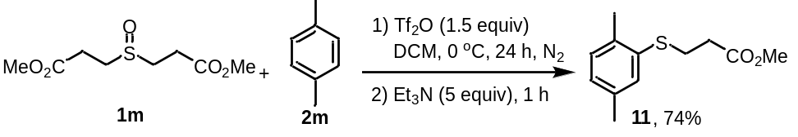
A dried 250 ml Schlenk tube was charged with dimethyl 3,3'-sulfinyldipropionate 1m (3.3339 g, 15 mmol, 1.5 equiv), p-xylene 2m (10 mmol, 1.0 equiv) and DCM (100 mL). Trifluoromethanesulfonic anhydride (2.5 mL, 1.5 equiv) was added at 0 ºC under nitrogen atmosphere. The reaction mixture was stirred for 24 h. Upon completion, Et₃N (0.2 mL, 5 equiv) was added and the reaction mixture was stirred at room temperature for 1 h. The mixture was concentrated under vacuum, purified by chromatography with hexane/ethyl acetate (10:1) to give product 11 (1.6580 g, 74%).
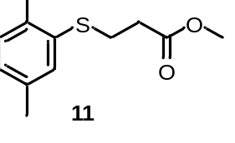
methyl 3-((2,5-dimethylphenyl)thio)propanoate (11) (1.6580 g, 74%) was yellow oil, after puriﬁcation by chromatography (hexane/ethyl acetate (10:1)). ¹H NMR (500 MHz, CDCl₃) δ 7.13 (s, 1H), 7.06 (d, J = 7.6 Hz, 1H), 6.93 (d, J = 7.4 Hz, 1H), 3.68 (s, 3H), 3.13 (t, J = 7.5 Hz, 2H), 2.63 (t, J = 7.5 Hz, 2H), 2.34 (s, 3H), 2.30 (s, 3H); ¹³C{1H} NMR (126 MHz, CDCl₃) δ 172.2, 136.0, 135.4, 134.0, 130.1, 130.0, 127.3, 51.8, 34.1, 28.3, 20.9, 19.9.

4. Iterative C–H Thiolation Reaction for the Synthesis of 13 and 14

Methyl 3-((phenylethynyl)thio)propanoate 11 (1.1121 g, 5 mmol, 1.0 equiv) were dissolved in DCM (25 mL) in a round-bottomed flask equipped with a magnetic stirrer.and cool to 0 ºC. Then m-CPBA (5 mmol, dissolveed in 25 mL DCM) was added. Upon completion, the reaction mixture was quenched with saturated aq. NaHCO₃ (25 mL) and the aqueous mixture extracted with DCM (3 × 25 mL). The combined organic layer was dried (MgSO₄), filtered and the solvent was removed under vacuum. Purification by flash chromatography afforded product 12 (1.1052 g, 92%).
A dried 15 ml Schlenk tube was charged with methyl 3-((2,5-dimethylphenyl)sulfinyl)propanoate 12 (0.45 mmol, 1.5 equiv), 4-bromostyrene 5i (0.3 mmol, 1.0 equiv) and DCM (3 mL). Trifluoromethanesulfonic anhydride (0.45 mmol, 1.5 equiv) was added at 0 ºC under nitrogen atmosphere. The reaction mixture was stirred for 12 h. Upon completion, Et₃N (0.2 mL, 5 equiv) was added and the reaction mixture was stirred at room temperature for 1 h. The mixture was concentrated under vacuum, and purified by preparative thin layer chromatography (PTLC) with hexane to give the corresponding products 13 (66 mg, 72%).
A dried 15 ml Schlenk tube was charged with methyl 3-((2,5-dimethylphenyl)sulfinyl)propanoate 15 (0.45 mmol, 1.5 equiv), (2R,3R,4S,5R,6S)-2-(acetoxymethyl)-6-(2-(acetoxymethyl)phenoxy)tetrahydro-2H-pyran-3,4,5-triyl triacetate 2af (0.3 mmol, 1.0 equiv) and DCM (3 mL). Trifluoromethanesulfonic anhydride (0.45 mmol, 1.5 equiv) was added at 0 ºC under nitrogen atmosphere. The reaction mixture was stirred for 12 h. Upon completion, Et₃N (0.2 mL, 5 equiv) was added and the reaction mixture was stirred at room temperature for 1 h. The mixture was concentrated under vacuum, and purified by preparative thin layer chromatography (PTLC) with hexane to give the corresponding products 14 (141 mg, 73%).
methyl 3-((2,5-dimethylphenyl)sulfinyl)propanoate (12) (1.1052 g, 92%) was yellow oil, after puriﬁcation by chromatography (hexane/ethyl acetate (4:1)). ¹H NMR (500 MHz, CDCl₃) δ 7.66 (s, 1H), 7.19 (d, J = 6.6 Hz, 1H), 7.10 (d, J = 7.7 Hz, 1H), 3.66 (s, 3H), 3.25 – 3.15 (m, 1H), 2.95 – 2.84 (m, 2H), 2.71 – 2.60 (m, 1H), 2.40 (s, 3H), 2.35 (s, 3H); ¹³C{1H} NMR (126 MHz, CDCl₃) δ 171.8, 140.4, 137.1, 131.7, 131.3, 130.7, 124.0, 52.0, 48.9, 26.0, 21.0, 17.6.
(E)-(4-bromostyryl)(2,5-dimethylphenyl)sulfane (13) (22 mg, 72%) was yellow oil, after puriﬁcation by preparative thin layer chromatography (PTLC) (hexane). ¹H NMR (500 MHz, CDCl₃) δ 7.40 (d, J = 8.4 Hz, 2H), 7.22 (s, 1H), 7.17 – 7.11 (m, 3H), 7.03 (d, J = 7.4 Hz, 1H), 6.80 (d, J = 15.4 Hz, 1H), 6.42 (d, J = 15.4 Hz, 1H), 2.37 (s, 3H), 2.31 (s, 3H); ¹³C{1H} NMR (126 MHz, CDCl₃) δ 136.5, 136.0, 135.7, 132.5, 132.1, 131.7, 130.4, 128.7, 128.3, 127.3, 125.1, 120.9, 20.8, 19.9; HRMS (ESI) calcd for (C₁₆H₁₆BrS) [M+H]⁺: 319.0151, found 319.0155.
(2R,3R,4S,5R,6S)-2-(acetoxymethyl)-6-(2-(acetoxymethyl)-4-((2,5-dimethylphenyl)thio)phen
-oxy)tetrahydro-2H-pyran-3,4,5-triyl triacetate (14) (141 mg, 73%) was yellow oil, after puriﬁcation by preparative thin layer chromatography (PTLC) (hexane/ethyl acetate (4:1)). ¹H NMR (500 MHz, CDCl₃) δ 7.20 (d, J = 2.3 Hz, 1H), 7.14 – 7.09 (m, 2H), 7.05 (s, 1H), 7.01 (t, J = 7.7 Hz, 2H), 5.31 – 5.25 (m, 2H), 5.21 – 5.14 (m, 1H), 5.10 – 5.02 (m, 2H), 4.97 (d, J = 13.3 Hz, 1H), 4.32 – 4.23 (m, 1H), 4.21 – 4.13 (m, 1H), 3.88 – 3.81 (m, 1H), 2.32 (s, 3H), 2.25 (s, 3H), 2.10 (s, 3H), 2.06 – 2.03 (m, 12H); ¹³C{1H} NMR (126 MHz, CDCl₃) δ 170.5, 170.2, 169.3, 169.3, 153.2, 136.4, 133.6, 132.8, 130.9, 130.7, 130.6, 130.4, 128.6, 127.4, 116.7, 99.4, 72.6, 72.1, 71.0, 68.3, 61.8, 60.7, 20.8, 20.8, 20.6, 20.6, 20.0; HRMS (ESI) calcd for (C₃₁H₃₆O₁₂SK) [M+K]⁺: 671.1559, found 671.1559.

5. Procedure for the Synthesis of 15

A dried 15 ml Schlenk tube was charged with methyl 3-(p-tolylsulfinyl)propanoate 1a (0.45 mmol, 1.5 equiv), iodobenzene 2k (0.3 mmol, 1.0 equiv) and DCE (3 mL). Trifluoromethanesulfonic anhydride (0.45 mmol, 1.5 equiv) was added under nitrogen atmosphere. The reaction mixture was stirred for 12 h. Upon completion, Et₃N (0.2 mL, 5 equiv) and Ph(PPh₃)₄ (34.7 mg, 10 mol%) was added and the reaction mixture was stirred at 80 ºC for 12 h. The mixture was concentrated under vacuum, and purified by preparative thin layer chromatography (PTLC) with hexane/ethyl acetate to give the products 15 (21.4 mg, 25%) and 16 (20.0 mg, 40%).
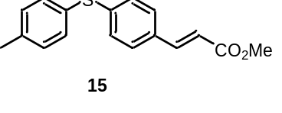
methyl (E)-3-(4-(p-tolylthio)phenyl)acrylate (15) (21.4 mg, 25%) was yellow oil, after puriﬁcation by preparative thin layer chromatography (PTLC) (hexane/ethyl acetate (4:1)). ¹H NMR (500 MHz, CDCl₃) δ 7.62 (d, J = 16.0 Hz, 1H), 7.37 (dd, J = 8.4, 2.3 Hz, 4H), 7.21 – 7.13 (m, 4H), 6.37 (d, J = 16.1 Hz, 1H), 3.79 (s, 3H), 2.38 (s, 3H); ¹³C{1H} NMR (126 MHz, CDCl₃) δ 167.4, 144.1, 141.5, 138.7, 133.7, 131.8, 130.3, 129.1, 128.5, 128.2, 117.1, 51.7, 21.2; HRMS (ESI) calcd for (C₁₇H₁₇O₂S) [M+H]⁺: 285.0944, found 285.0947.

6. ¹H and ¹³C NMR Spectra

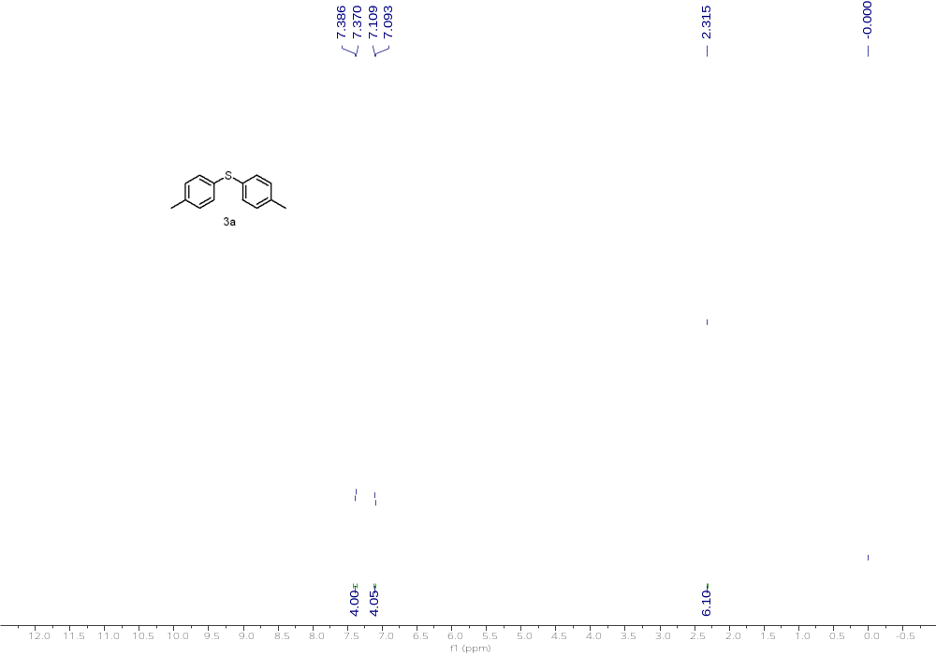
¹H NMR (500 MHz, CDCl₃) of 3a
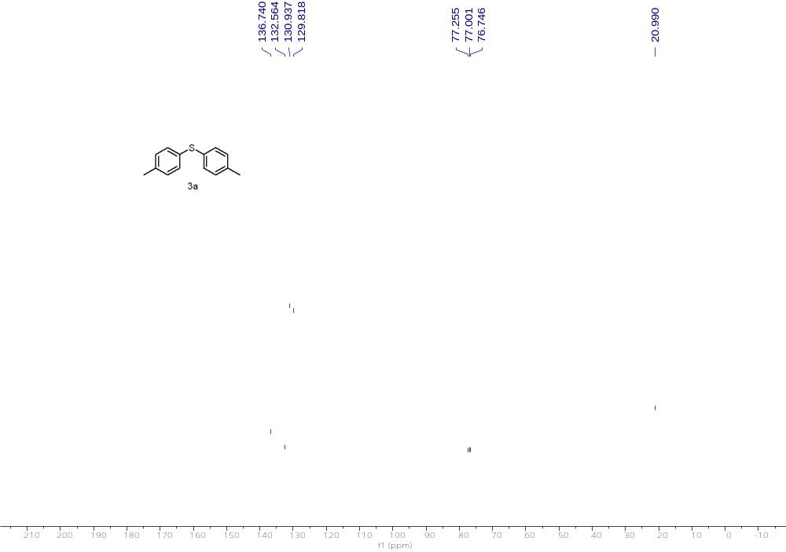
¹³C NMR (126 MHz, CDCl₃) of 3a

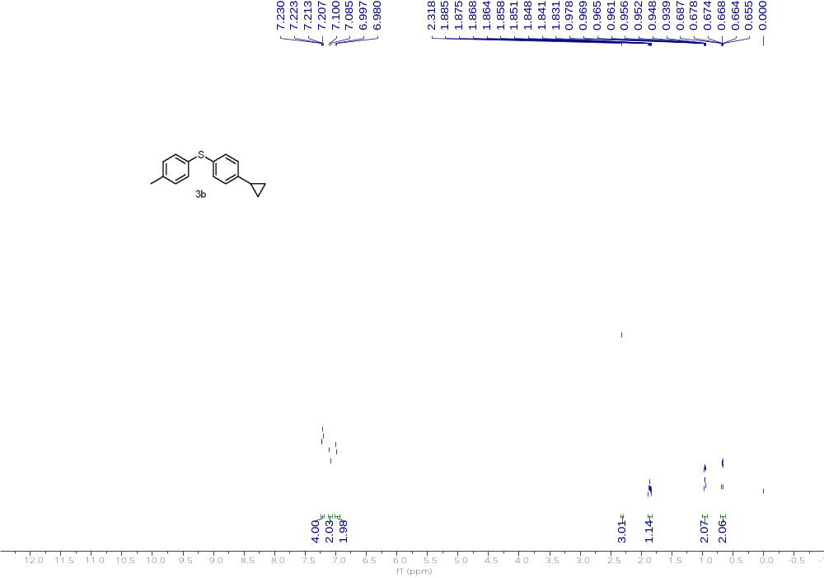
¹H NMR (500 MHz, CDCl₃) of 3b
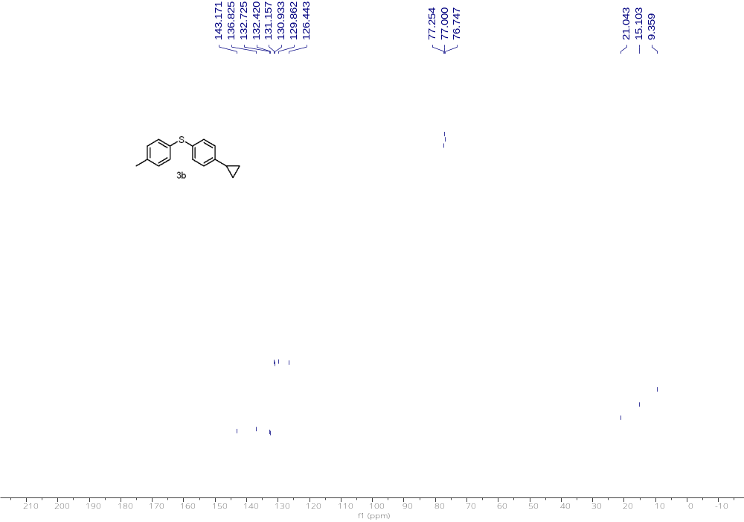
¹³C NMR (126 MHz, CDCl₃) of 3b

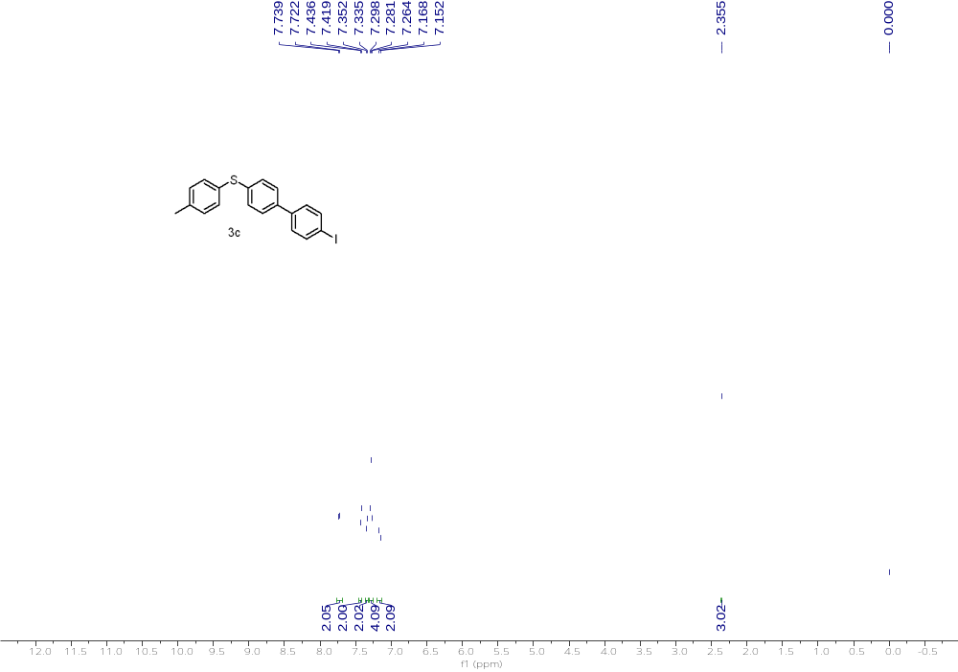
¹H NMR (500 MHz, CDCl₃) of 3c
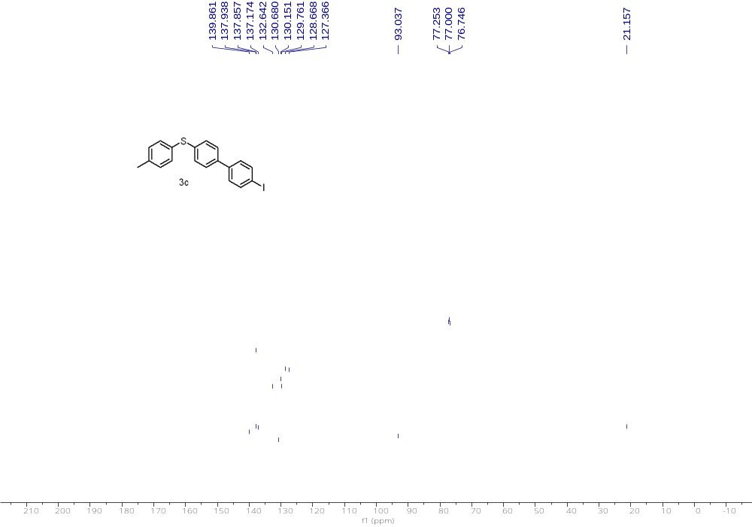
¹³C NMR (126 MHz, CDCl₃) of 3c

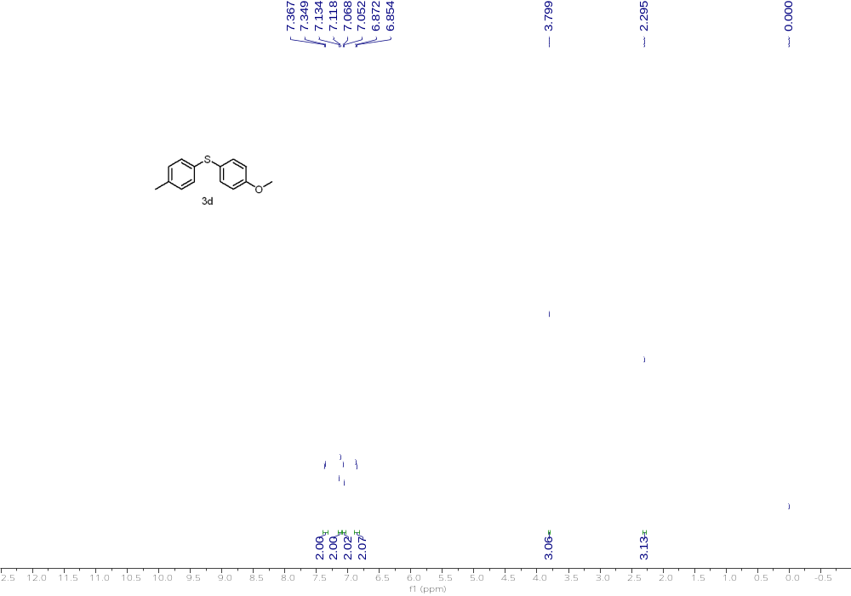
¹H NMR (500 MHz, CDCl₃) of 3d
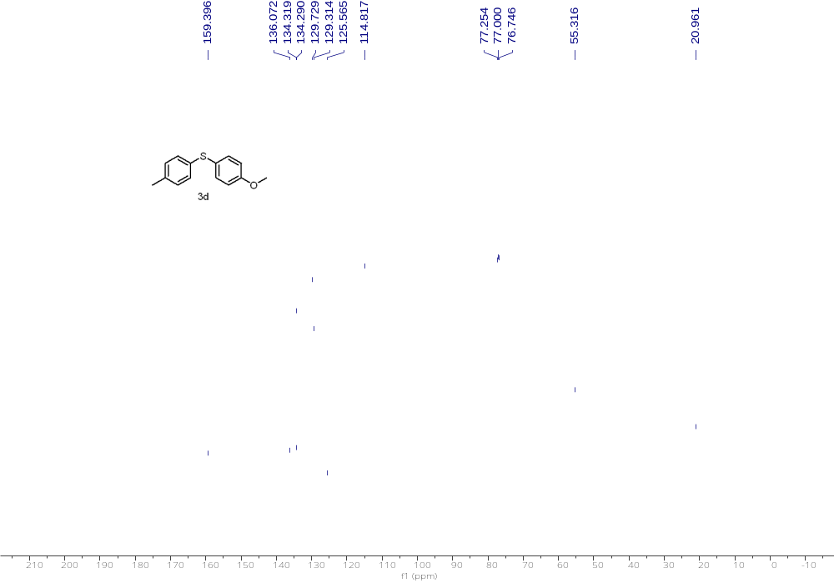
¹³C NMR (126 MHz, CDCl₃) of 3d

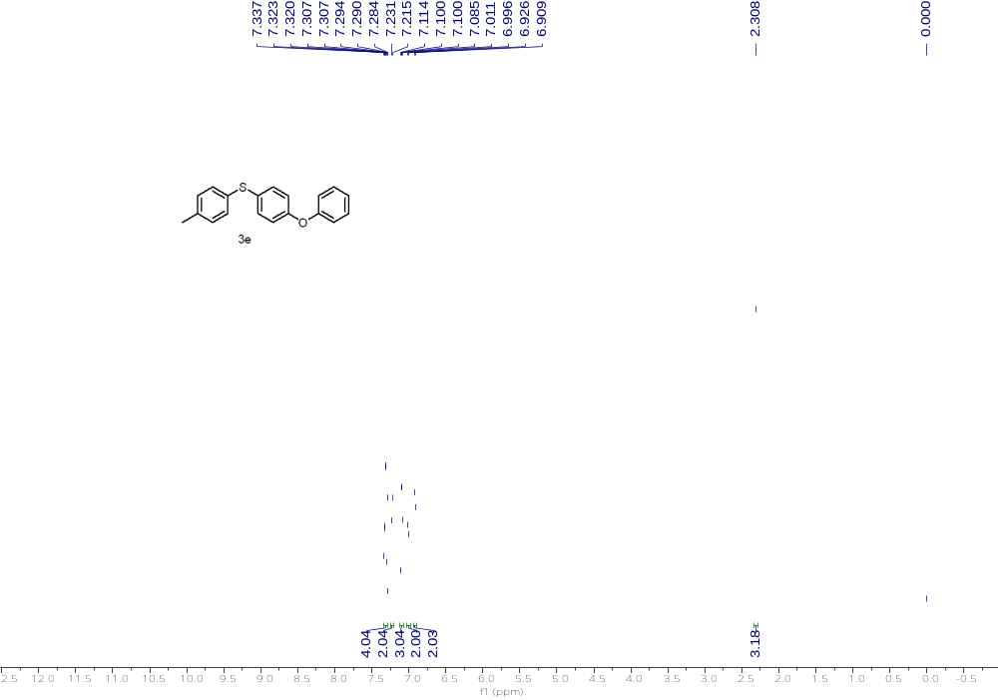
¹H NMR (500 MHz, CDCl₃) of 3e
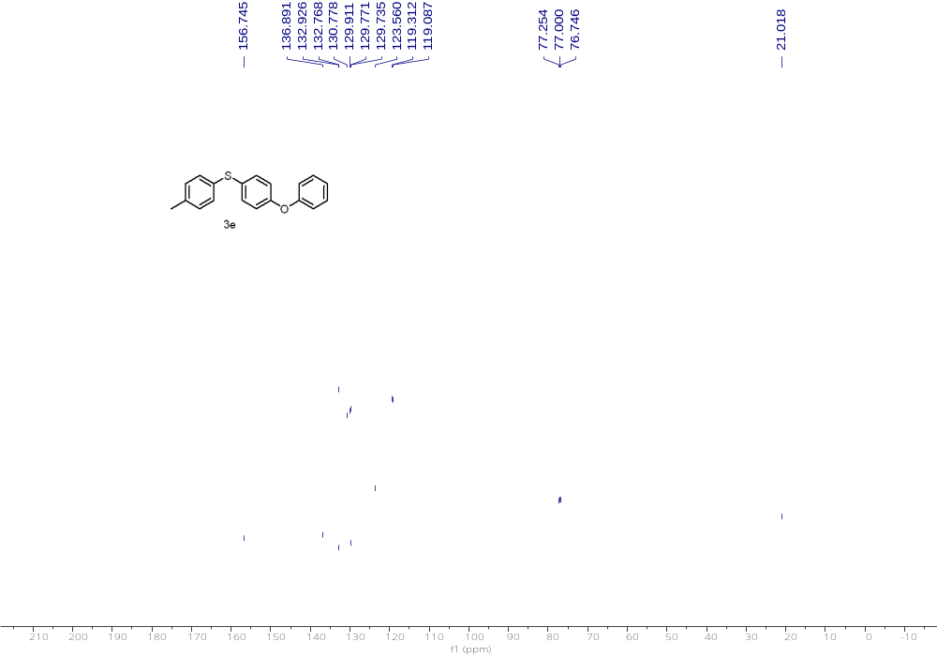
¹³C NMR (126 MHz, CDCl₃) of 3e

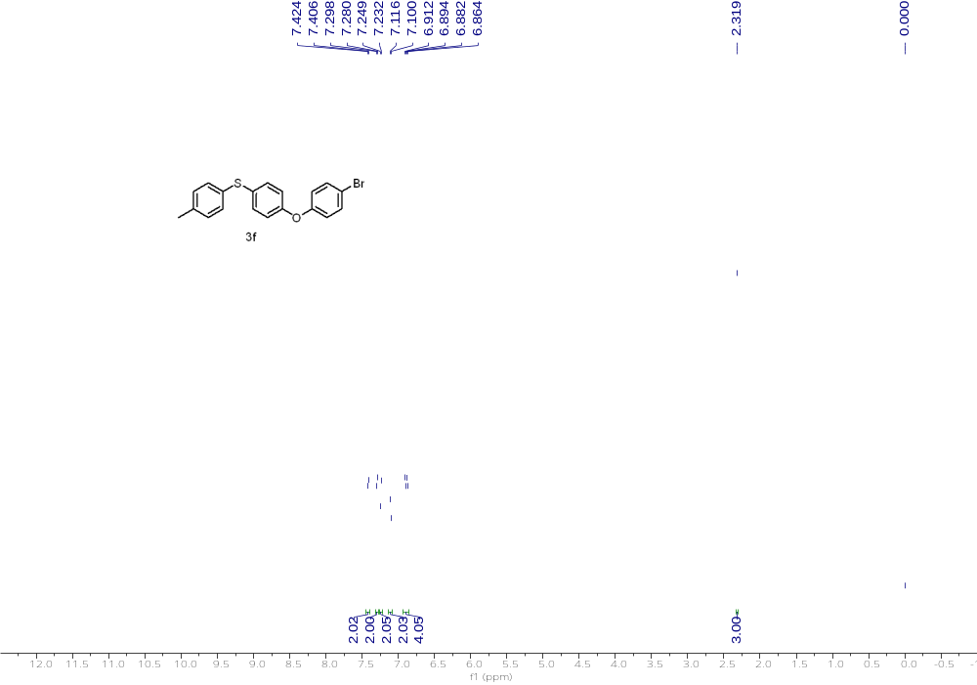
¹H NMR (500 MHz, CDCl₃) of 3f
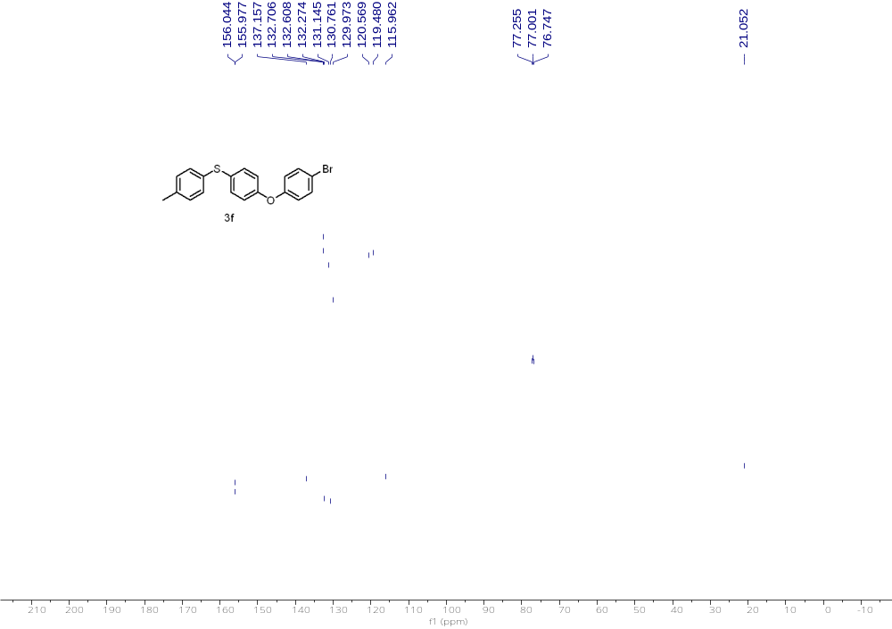
¹³C NMR (126 MHz, CDCl₃) of 3f

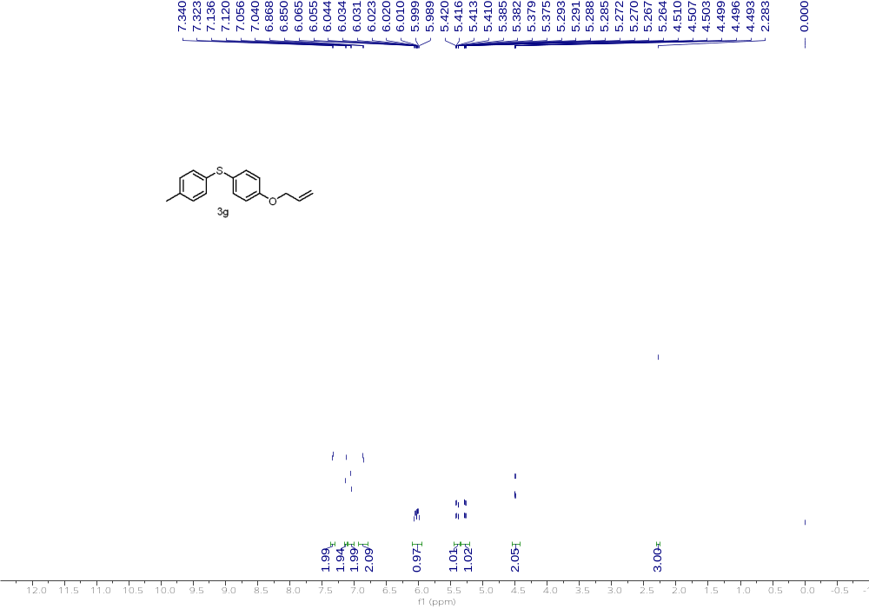
¹H NMR (500 MHz, CDCl₃) of 3g
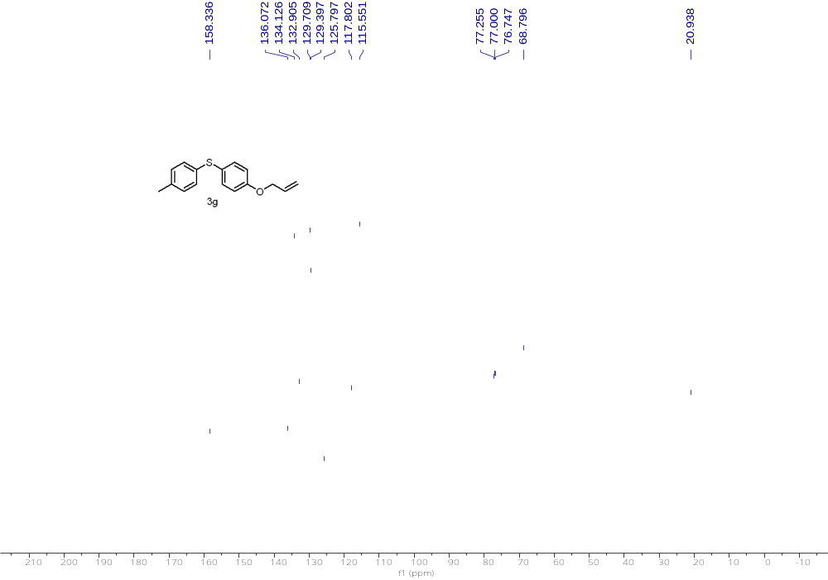
¹³C NMR (126 MHz, CDCl₃) of 3g

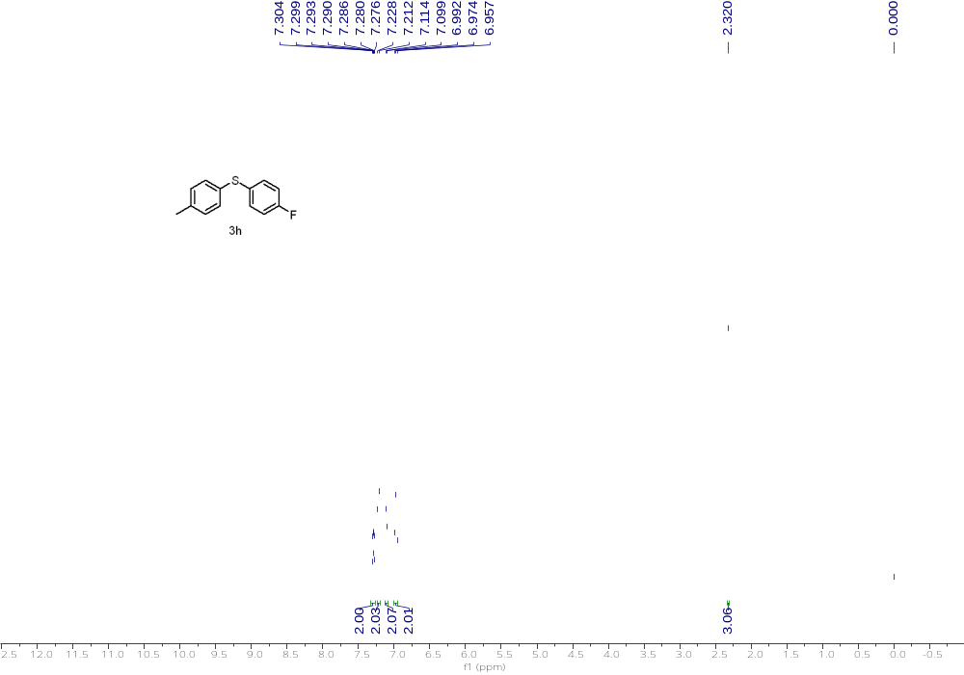
¹H NMR (500 MHz, CDCl₃) of 3h
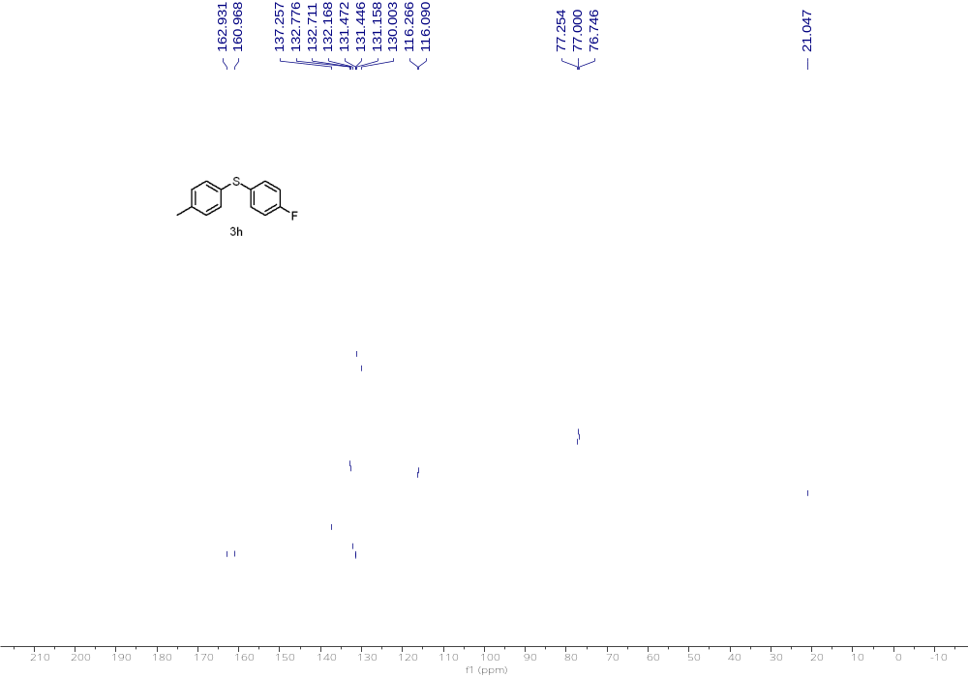
¹³C NMR (126 MHz, CDCl₃) of 3h

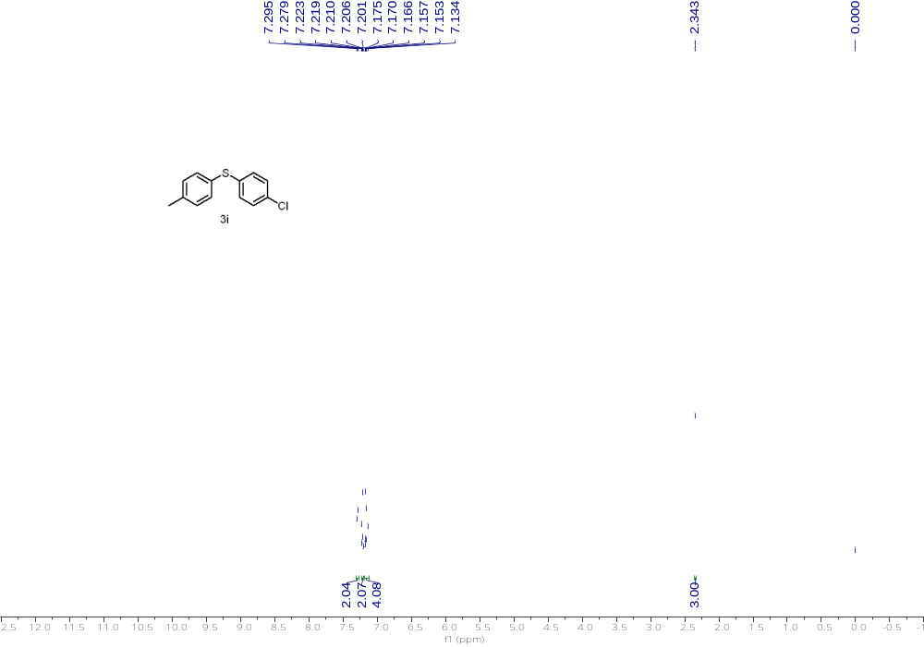
¹H NMR (500 MHz, CDCl₃) of 3i
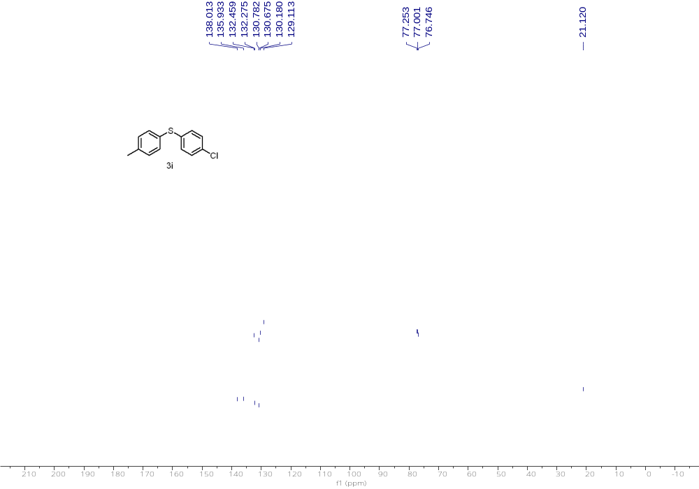
¹³C NMR (126 MHz, CDCl₃) of 3i

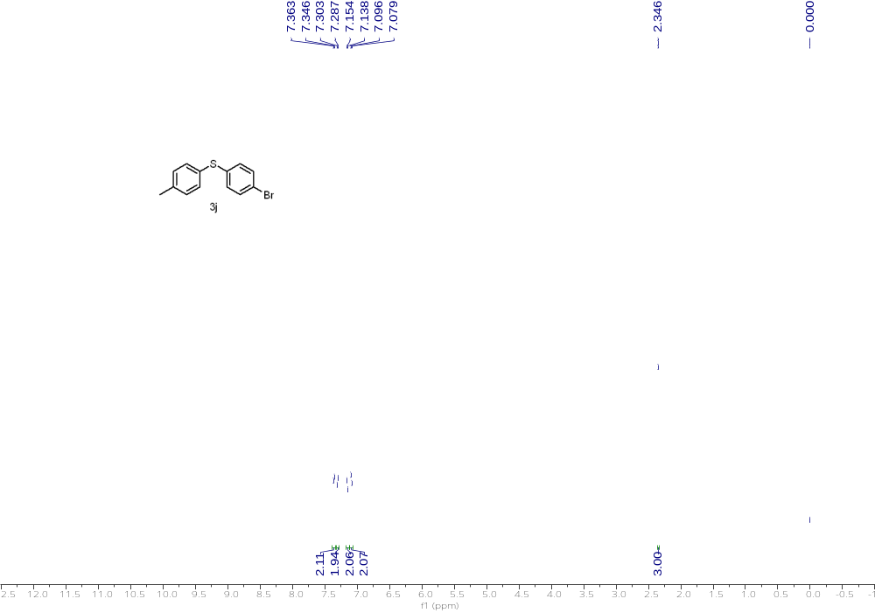
¹H NMR (500 MHz, CDCl₃) of 3j
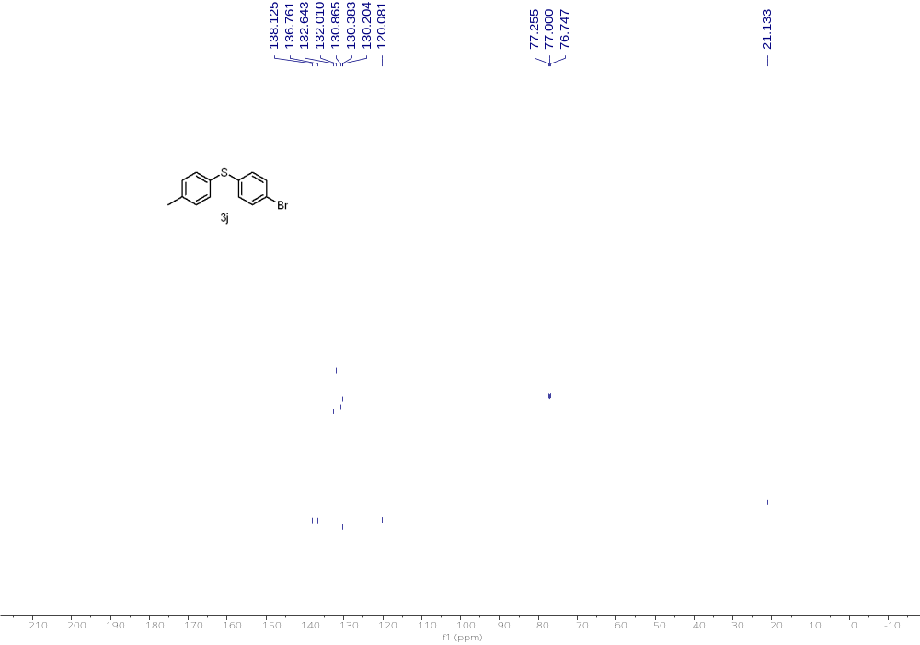
¹³C NMR (126 MHz, CDCl₃) of 3j

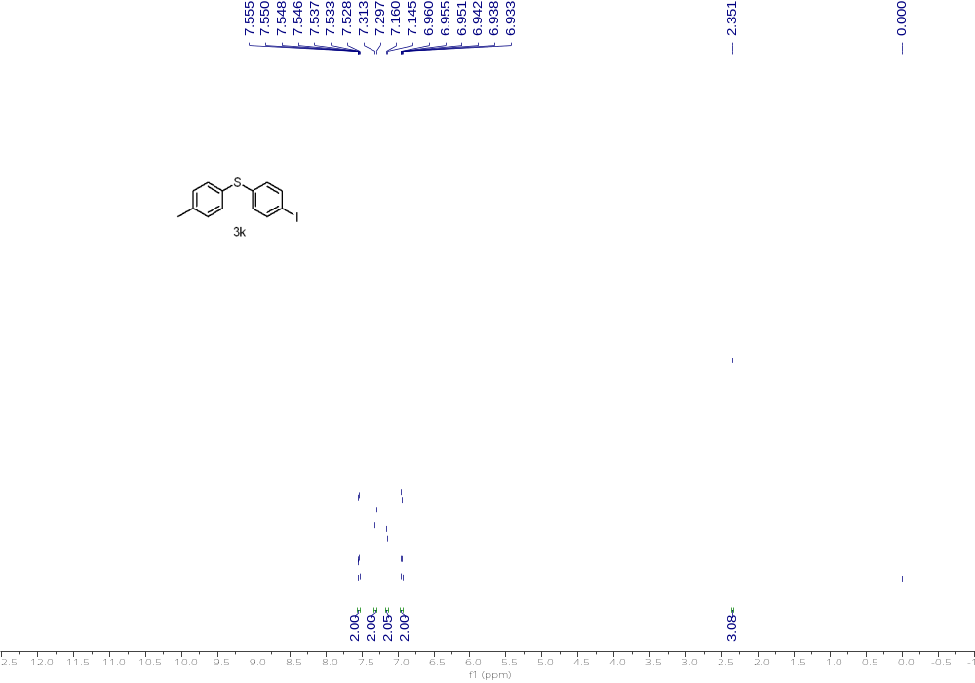
¹H NMR (500 MHz, CDCl₃) of 3k

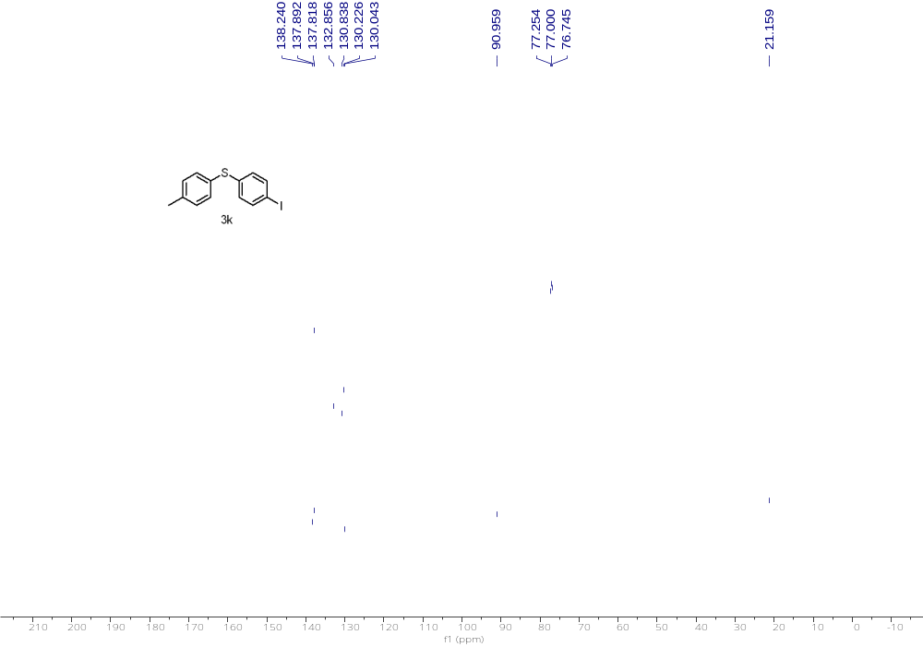
¹³C NMR (126 MHz, CDCl₃) of 3k

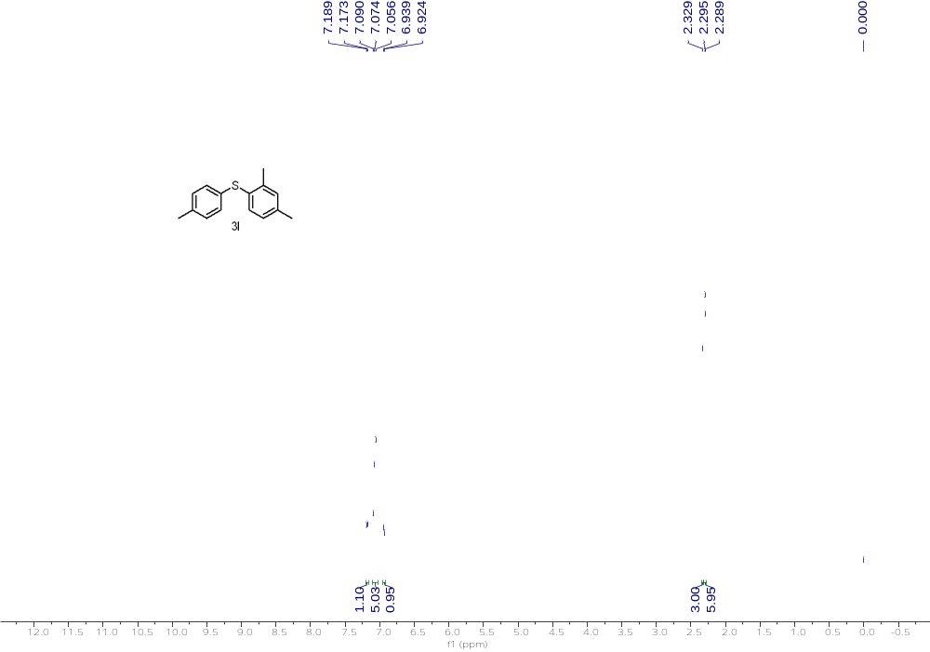
¹H NMR (500 MHz, CDCl₃) of 3l
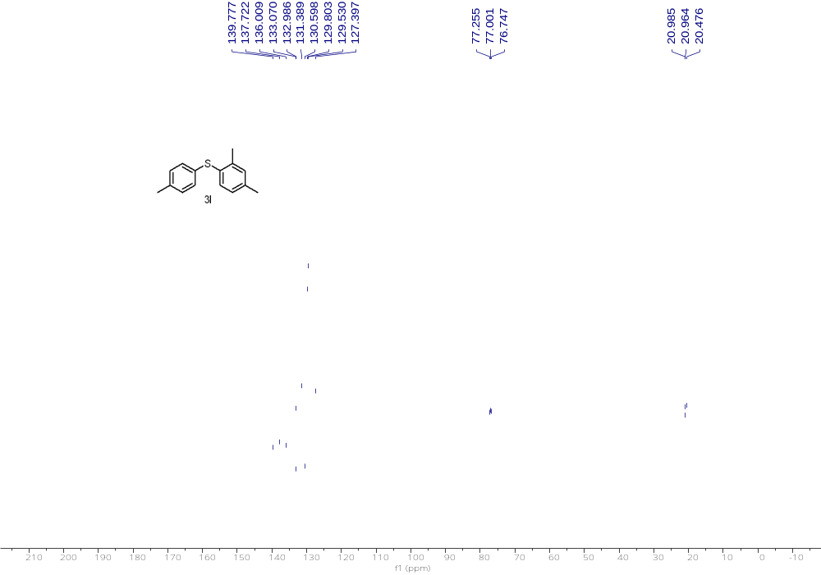
¹³C NMR (126 MHz, CDCl₃) of 3l

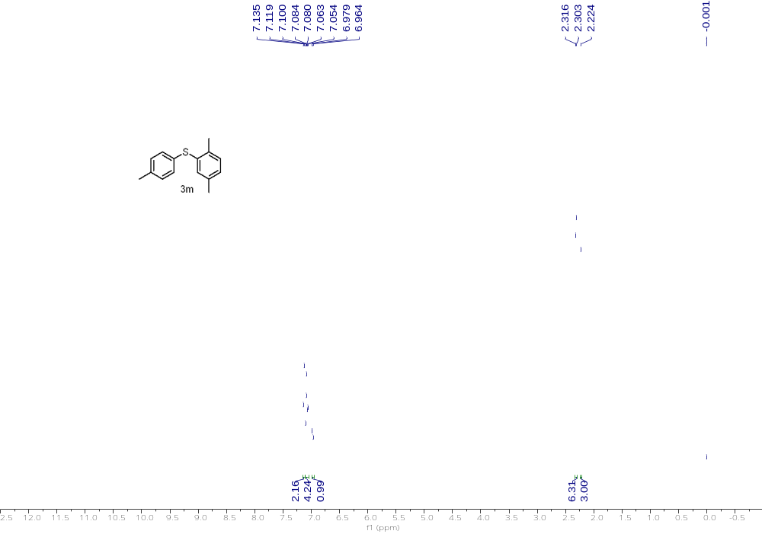
¹H NMR (500 MHz, CDCl₃) of 3m
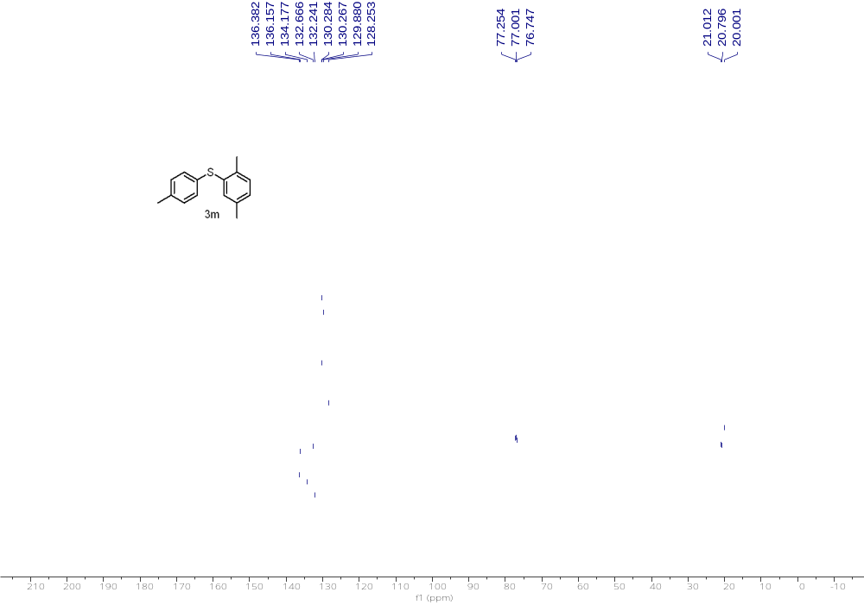
¹³C NMR (126 MHz, CDCl₃) of 3m

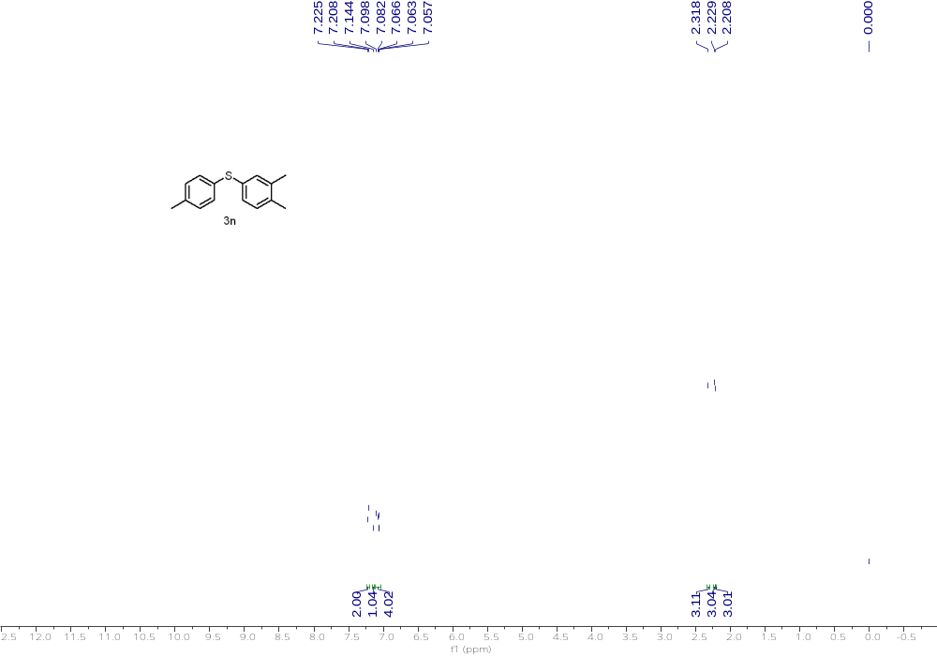
¹H NMR (500 MHz, CDCl₃) of 3n
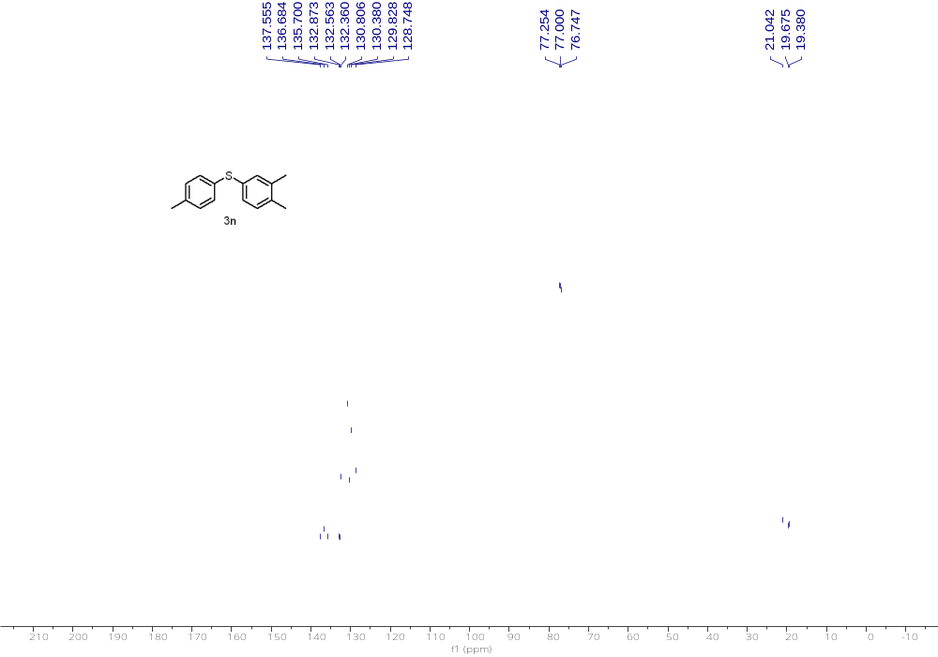
¹³C NMR (126 MHz, CDCl₃) of 3n

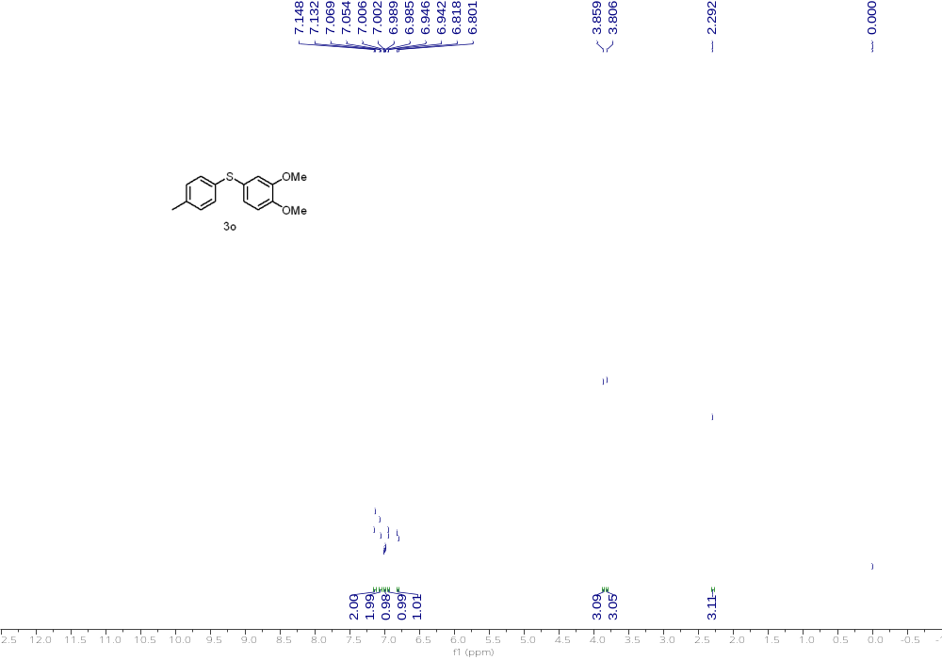
¹H NMR (500 MHz, CDCl₃) of 3o
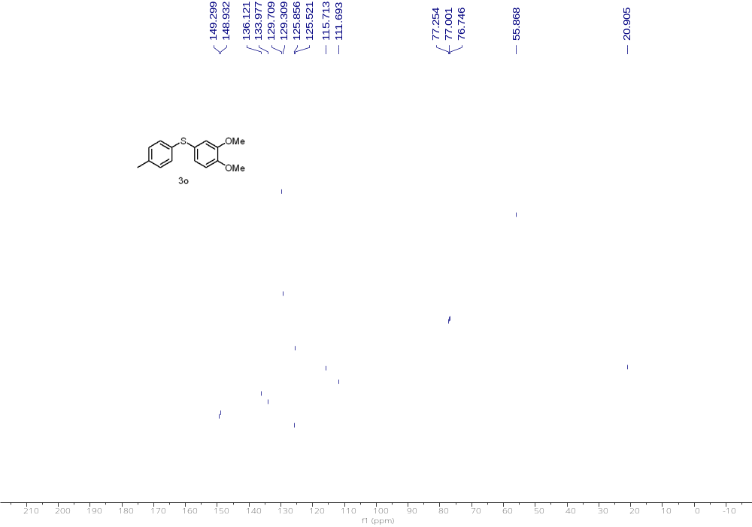
¹³C NMR (126 MHz, CDCl₃) of 3o

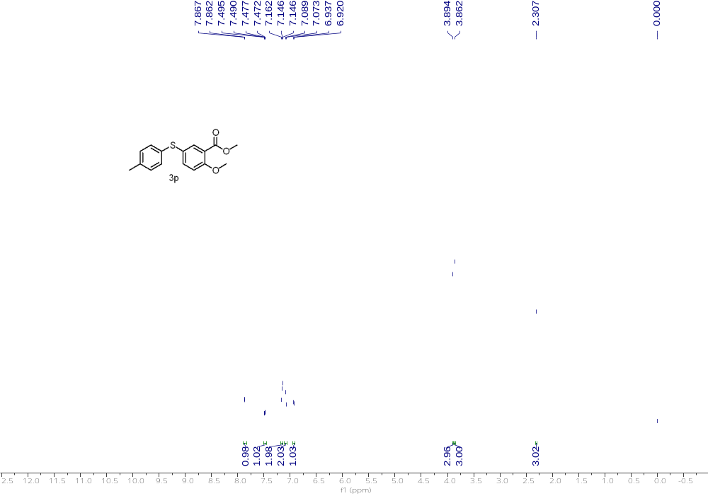
¹H NMR (500 MHz, CDCl₃) of 3p
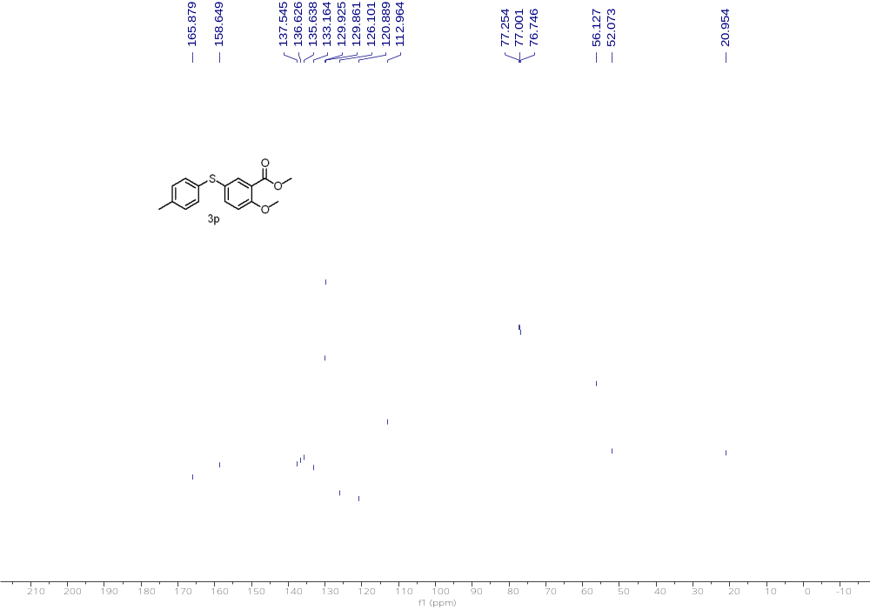
¹³C NMR (126 MHz, CDCl₃) of 3p

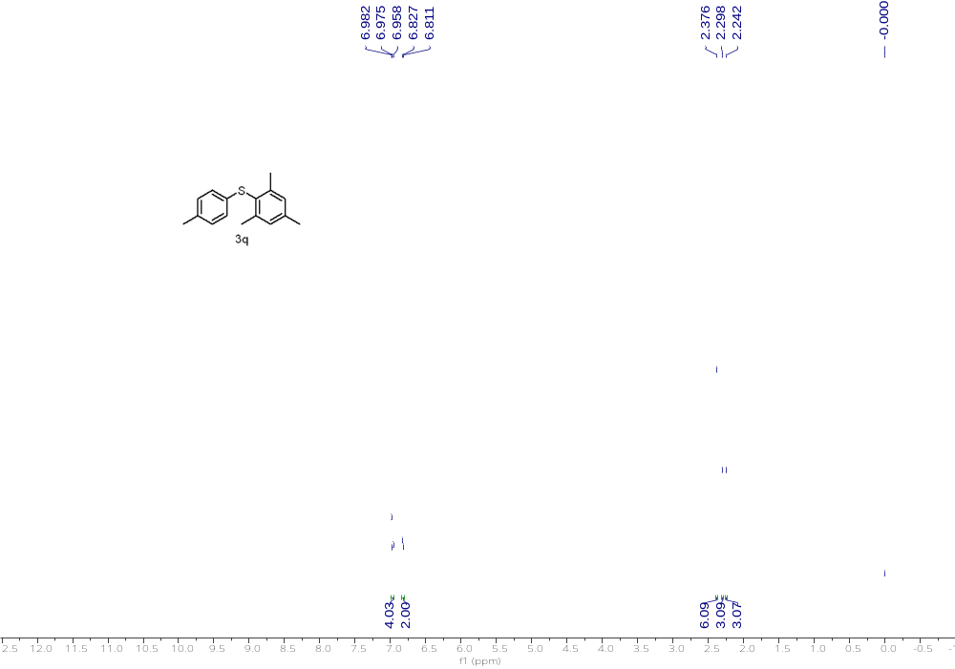
¹H NMR (500 MHz, CDCl₃) of 3q
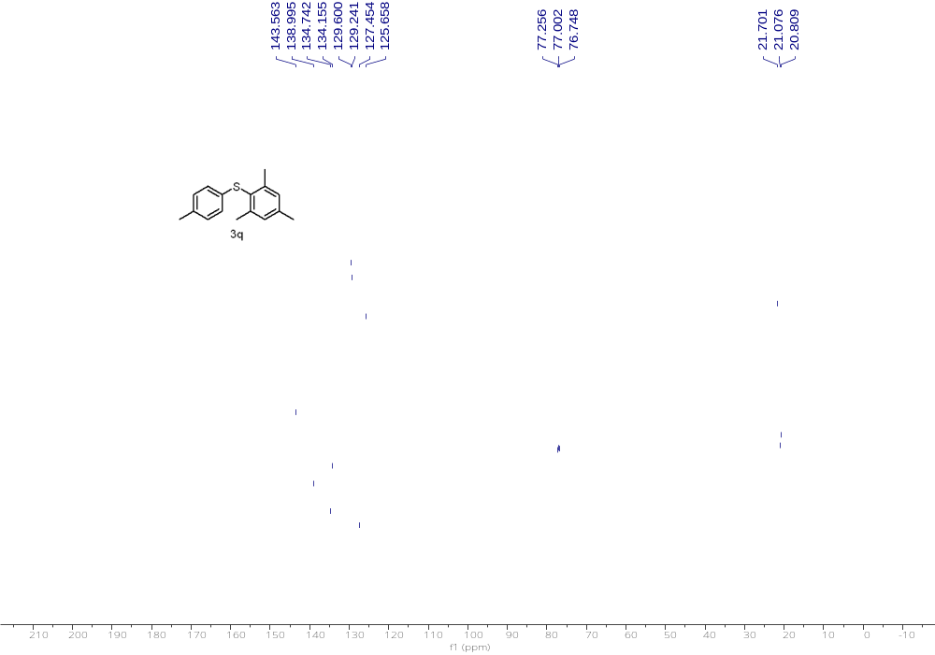
¹³C NMR (126 MHz, CDCl₃) of 3q

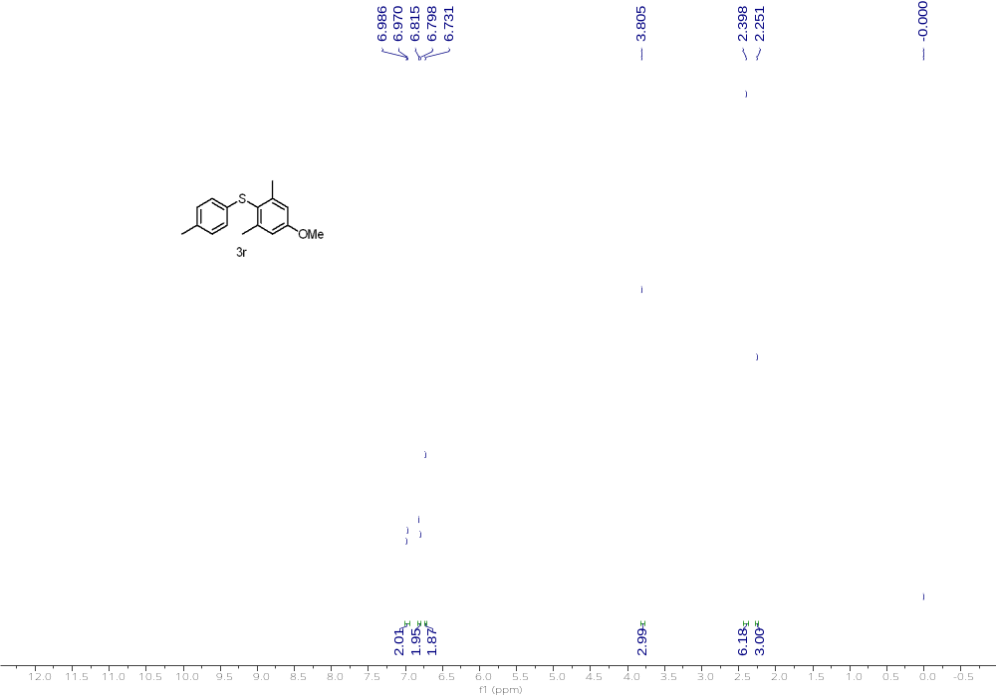
¹H NMR (500 MHz, CDCl₃) of 3r
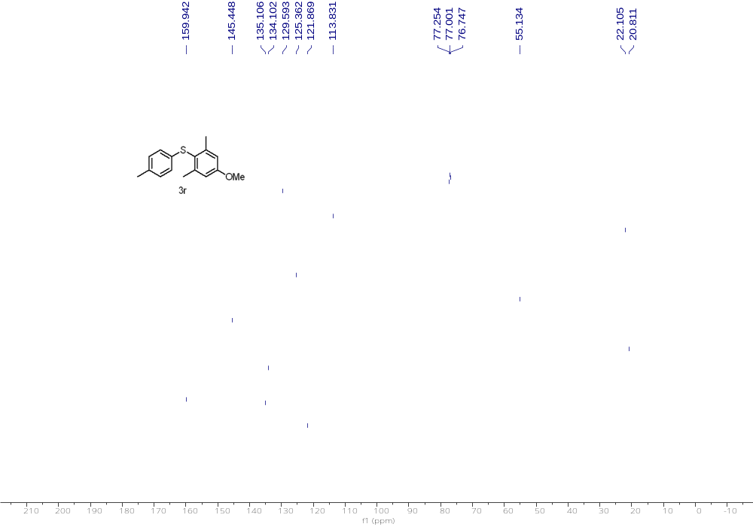
¹³C NMR (126 MHz, CDCl₃) of 3r

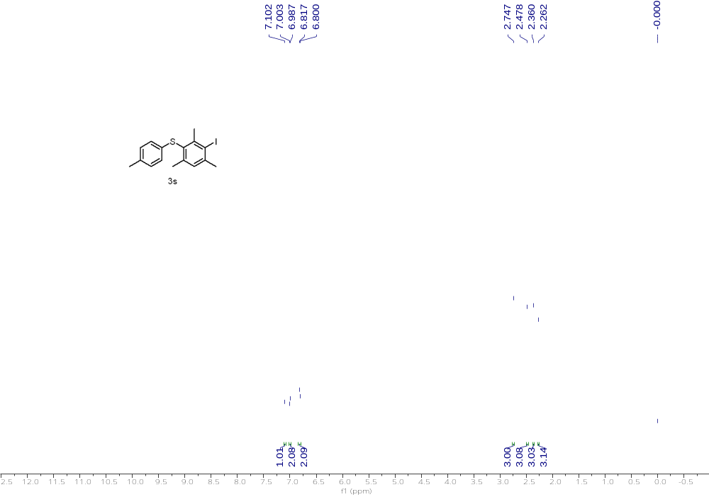
¹H NMR (500 MHz, CDCl₃) of 3s
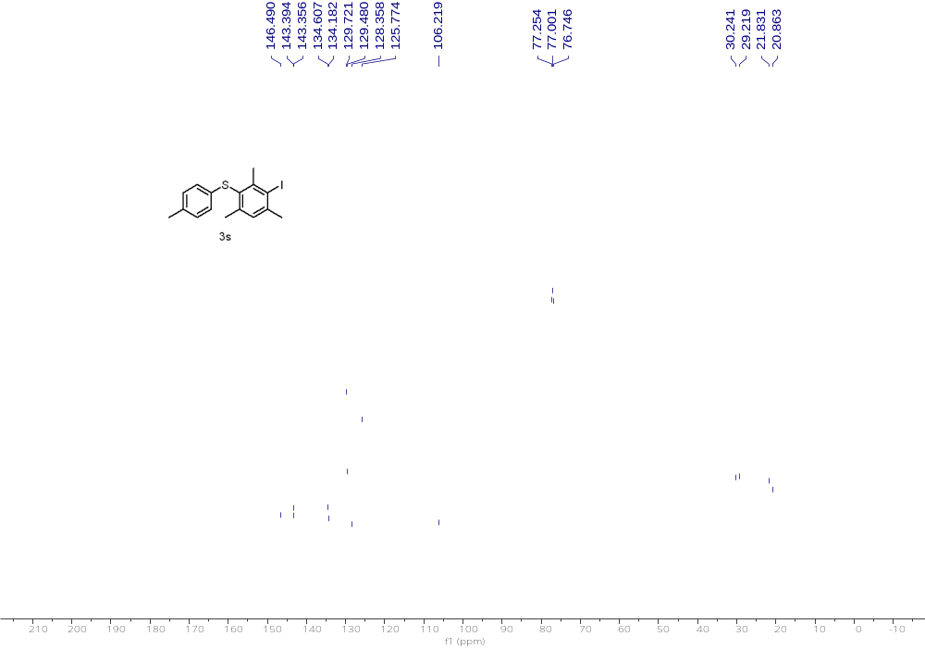
¹³C NMR (126 MHz, CDCl₃) of 3s

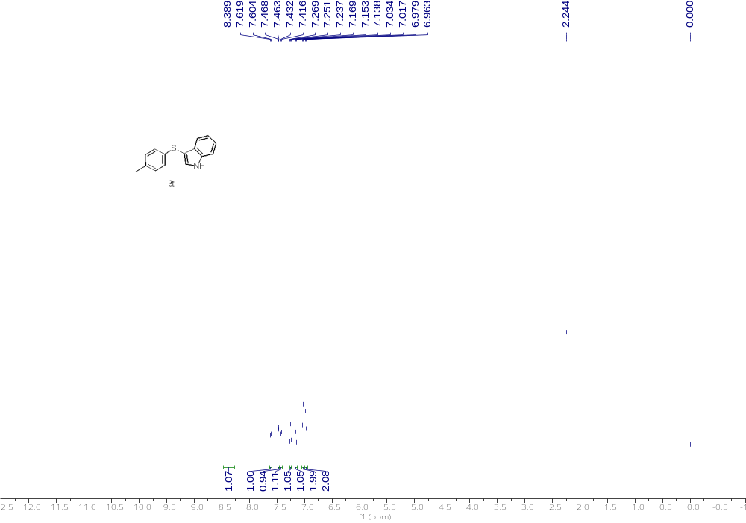
¹H NMR (500 MHz, CDCl₃) of 3t
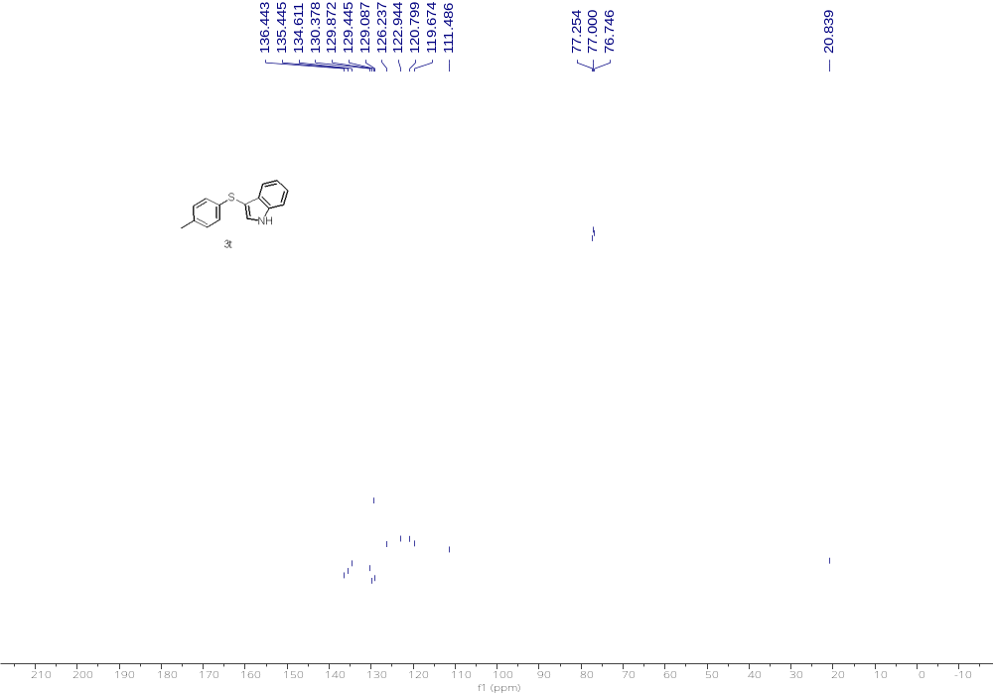
¹³C NMR (126 MHz, CDCl₃) of 3t

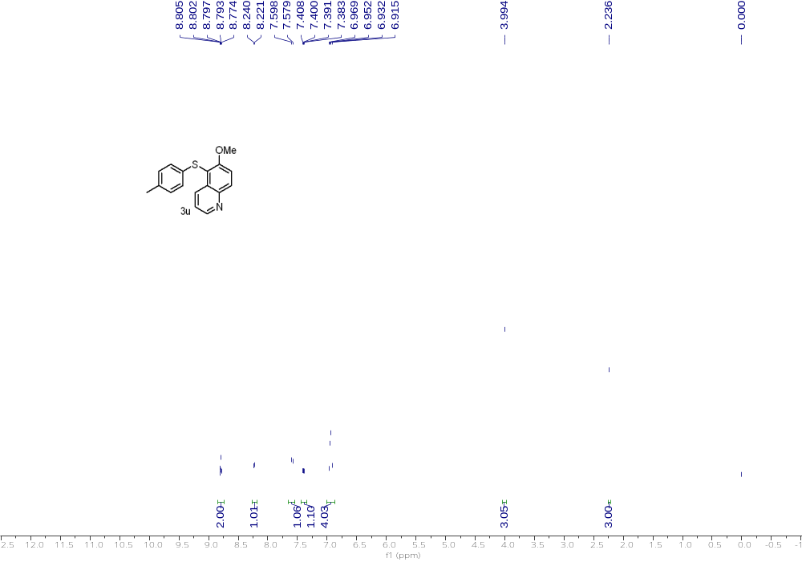
¹H NMR (500 MHz, CDCl₃) of 3u
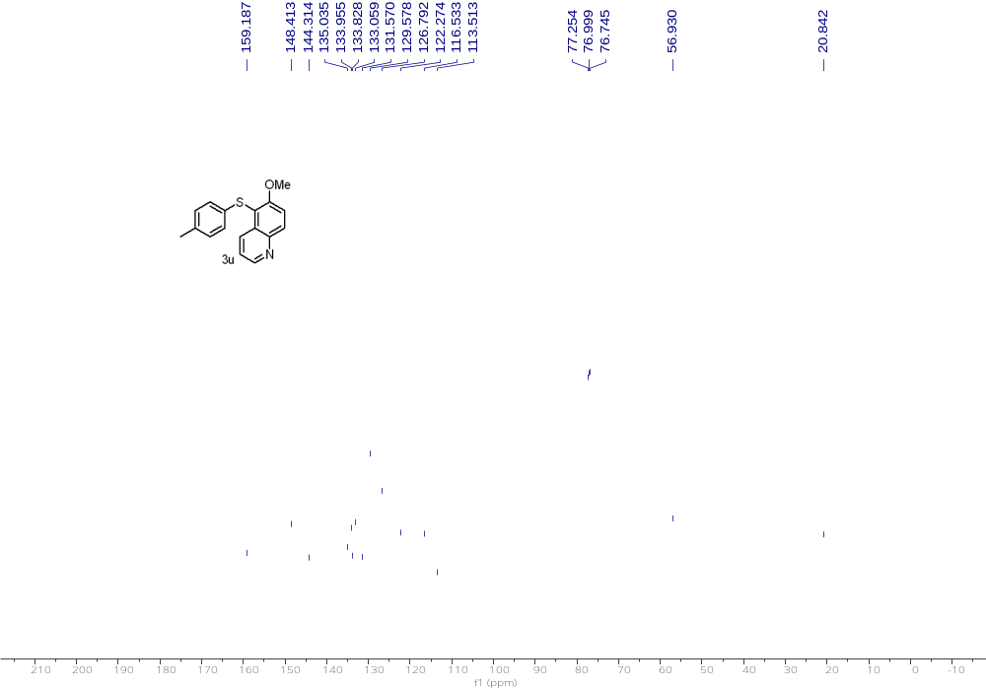
¹³C NMR (126 MHz, CDCl₃) of 3u

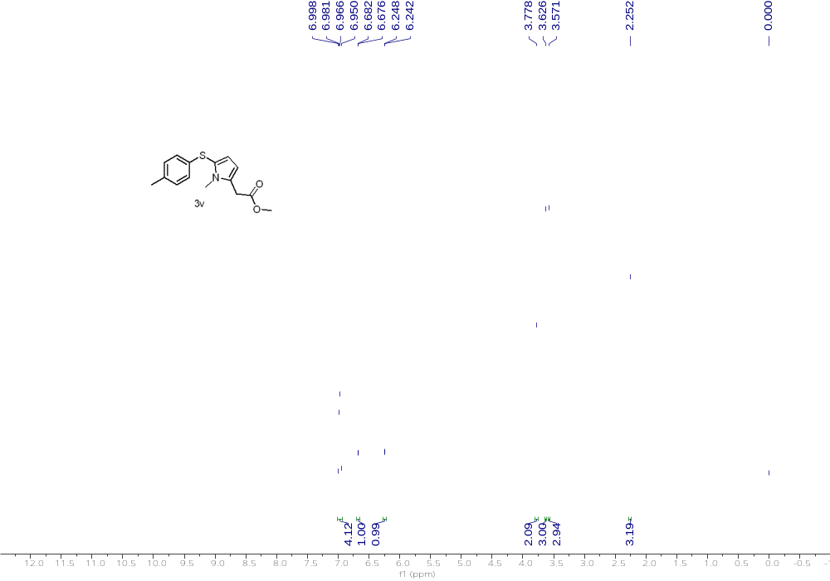
¹H NMR (500 MHz, CDCl₃) of 3v
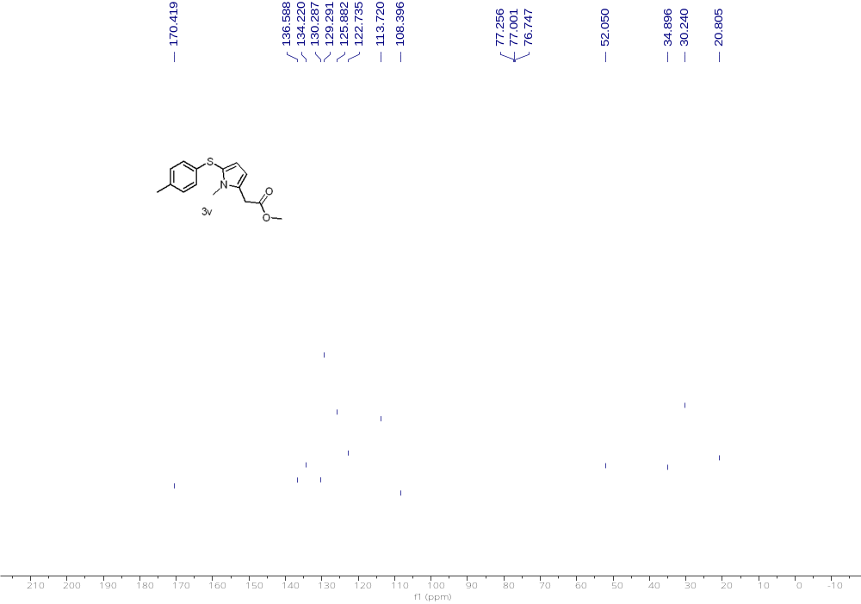
¹³C NMR (126 MHz, CDCl₃) of 3v

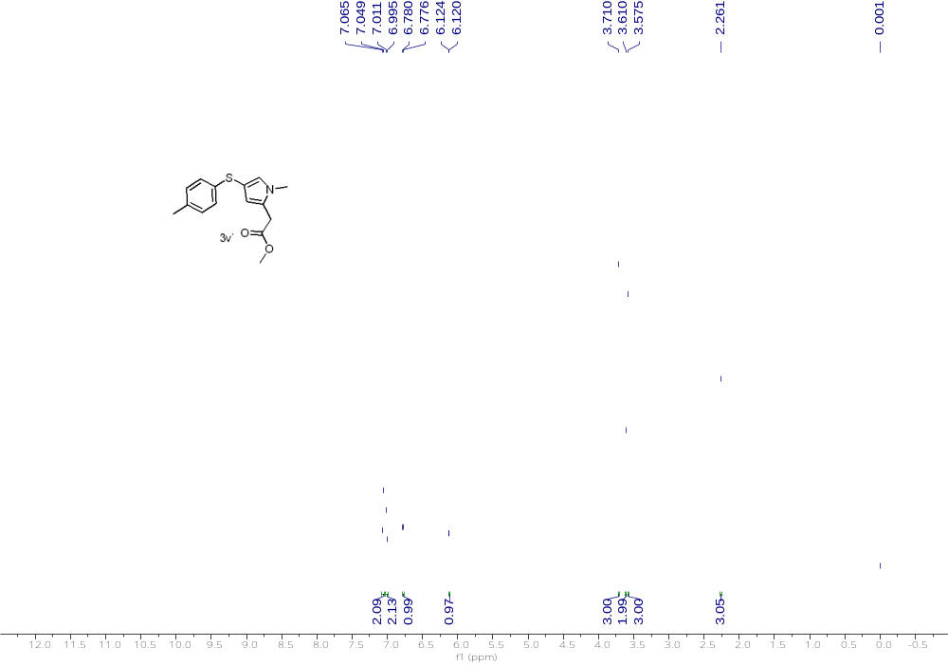
¹H NMR (500 MHz, CDCl₃) of 3v'
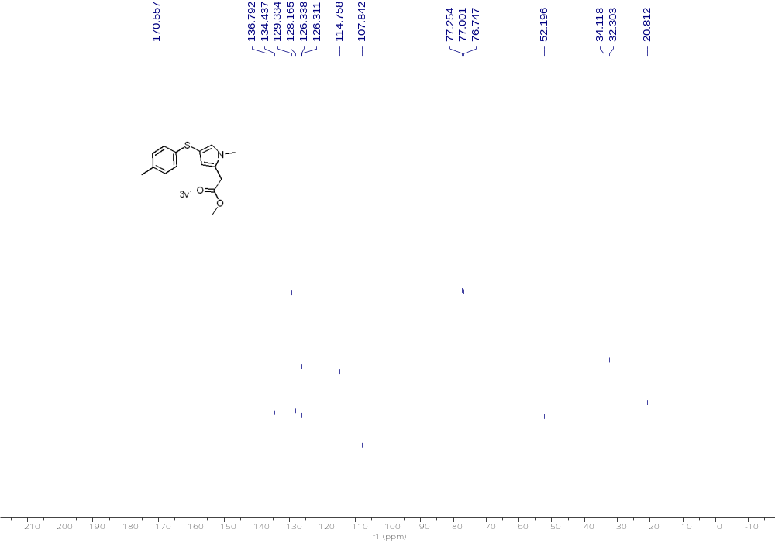
¹³C NMR (126 MHz, CDCl₃) of 3v'

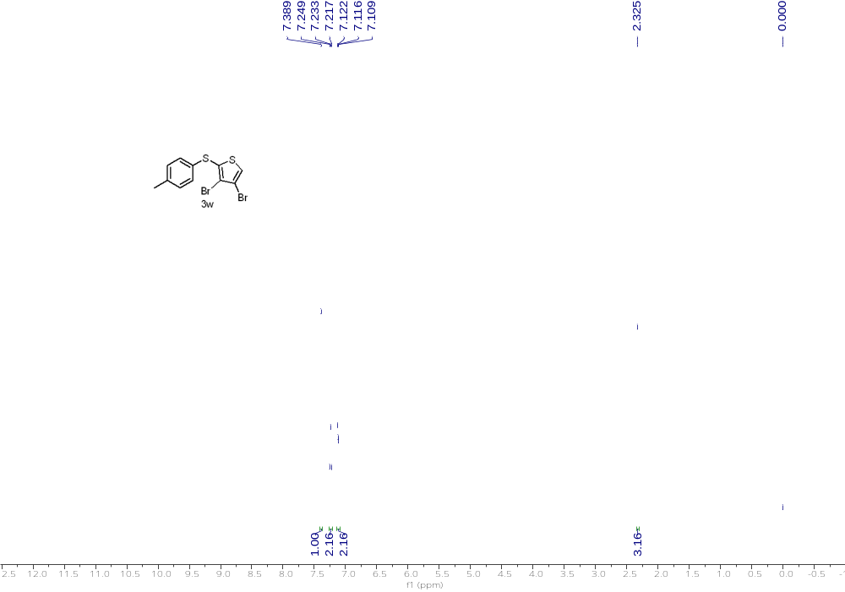
¹H NMR (500 MHz, CDCl₃) of 3w
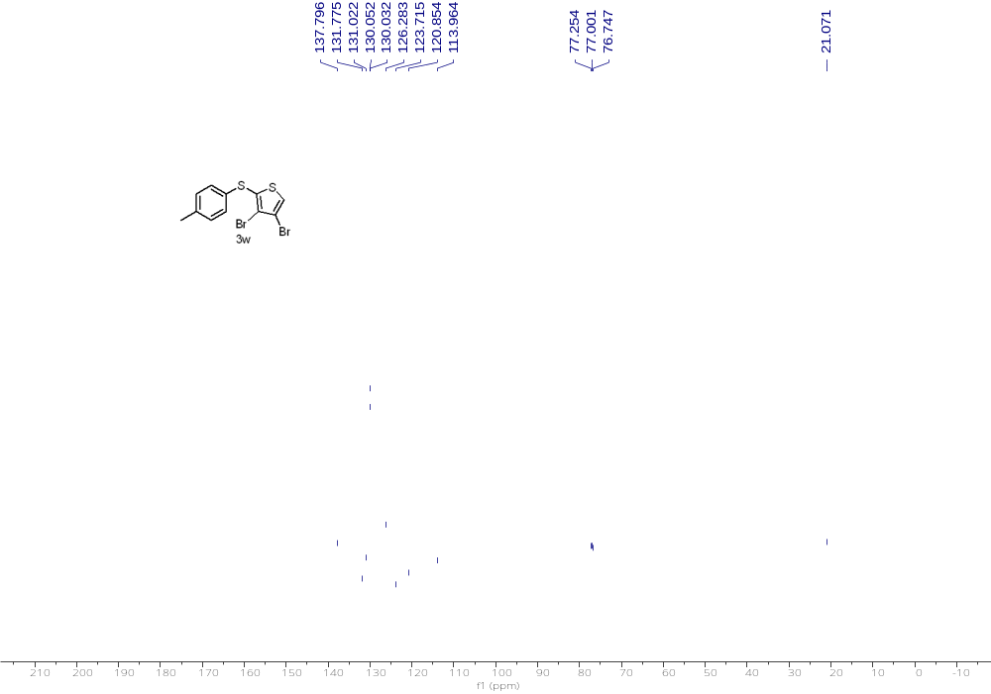
¹³C NMR (126 MHz, CDCl₃) of 3w

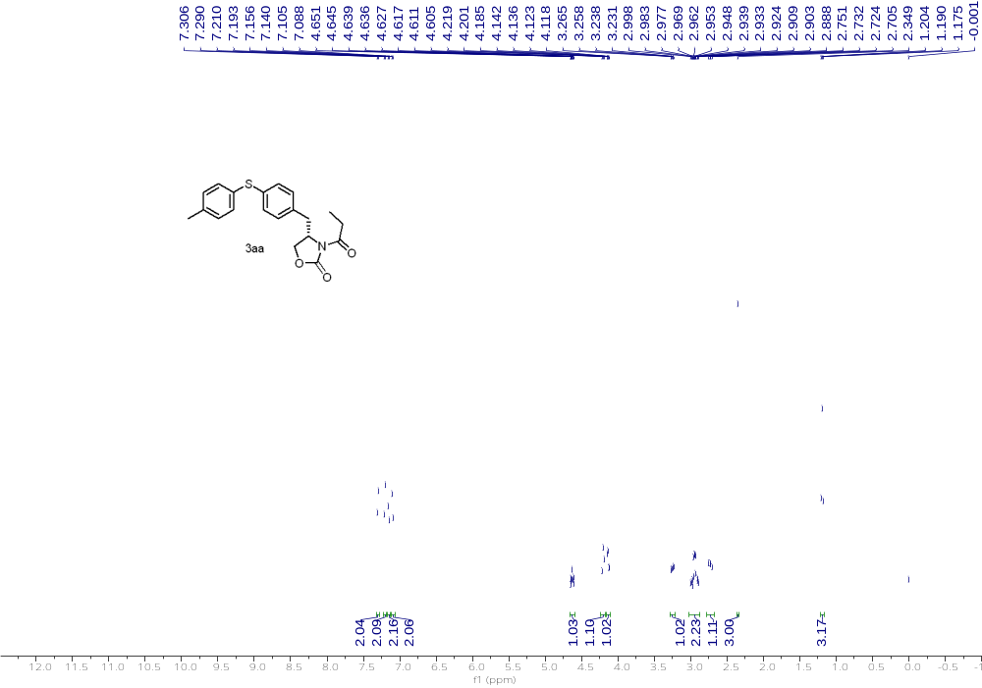
¹H NMR (500 MHz, CDCl₃) of 3aa
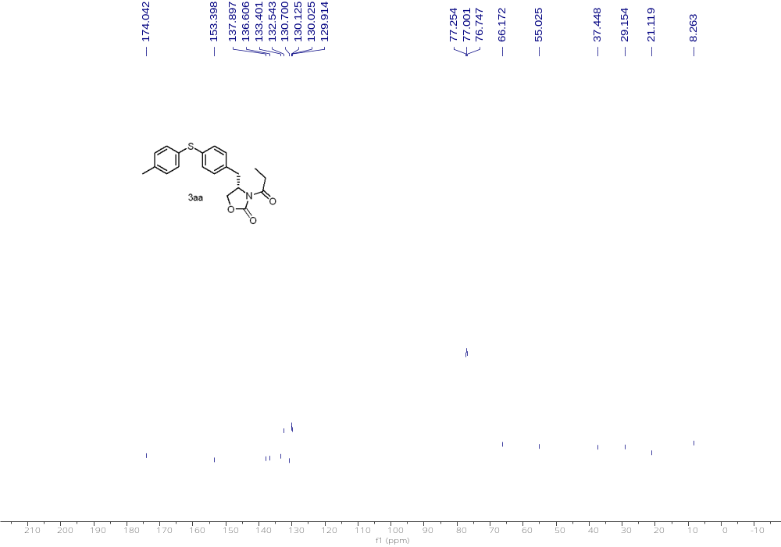
¹³C NMR (126 MHz, CDCl₃) of 3aa

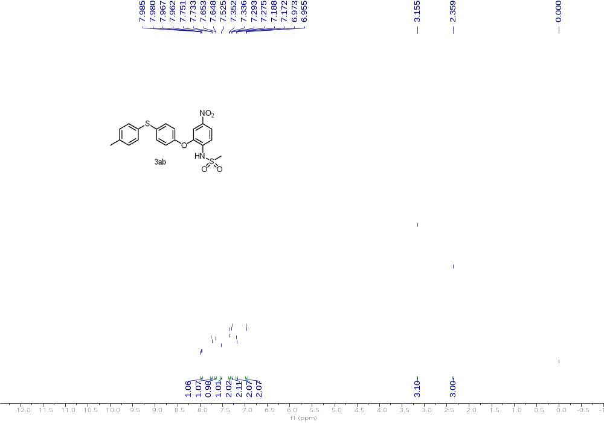
¹H NMR (500 MHz, CDCl₃) of 3ab
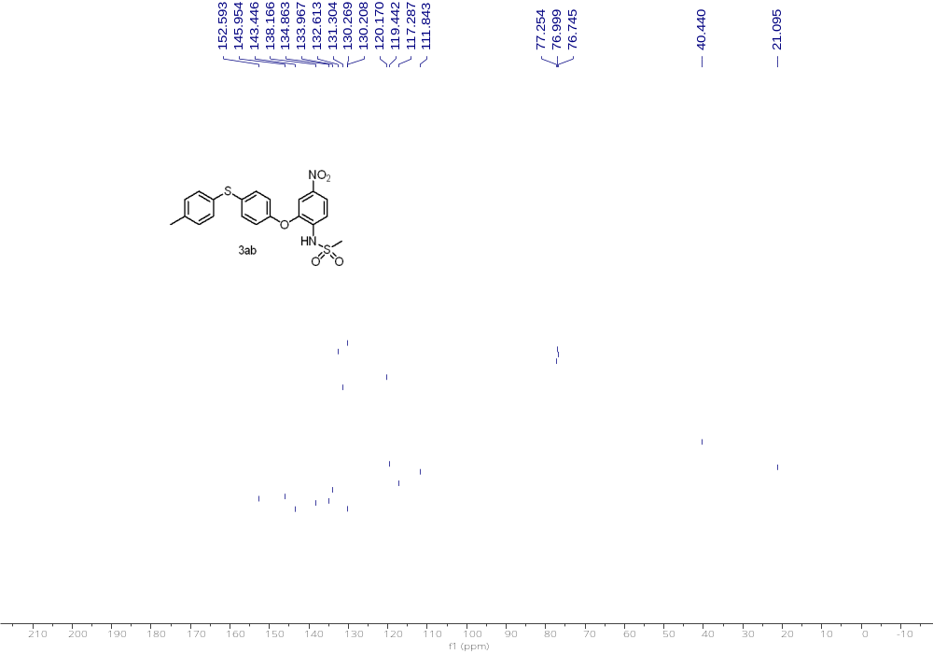
¹³C NMR (126 MHz, CDCl₃) of 3ab

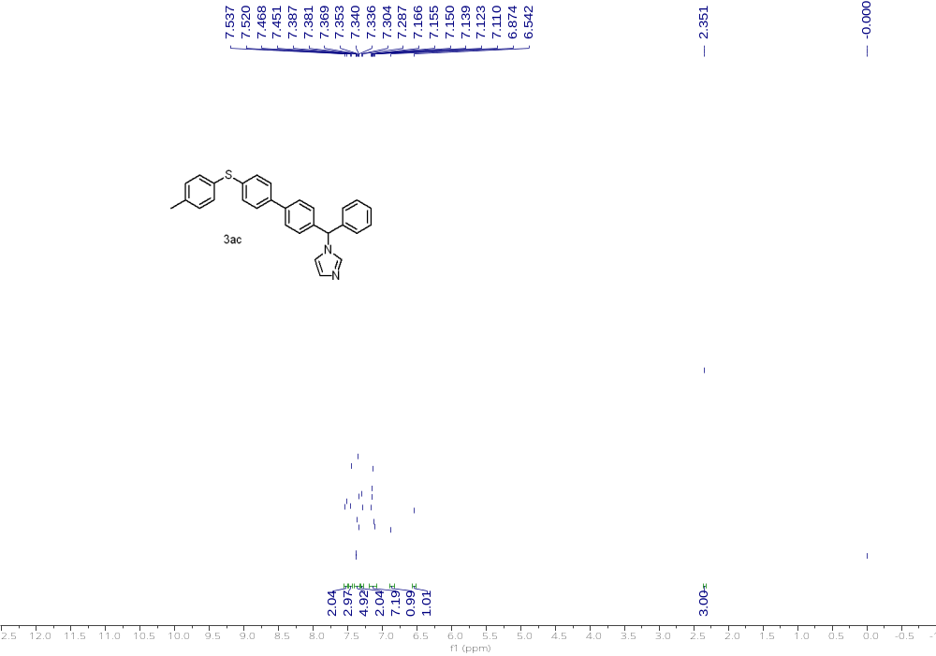
¹H NMR (500 MHz, CDCl₃) of 3ac
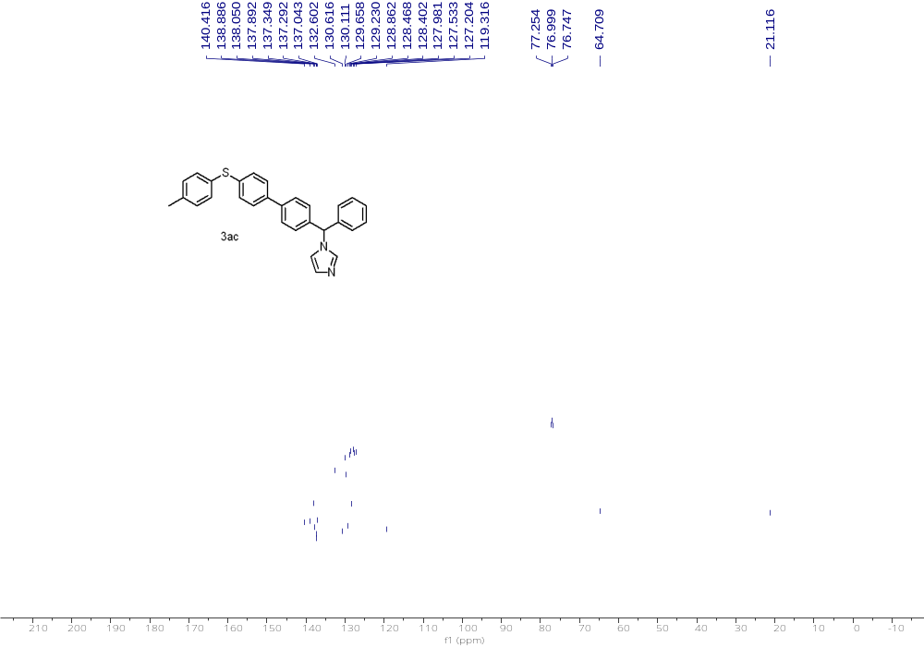
¹³C NMR (126 MHz, CDCl₃) of 3ac

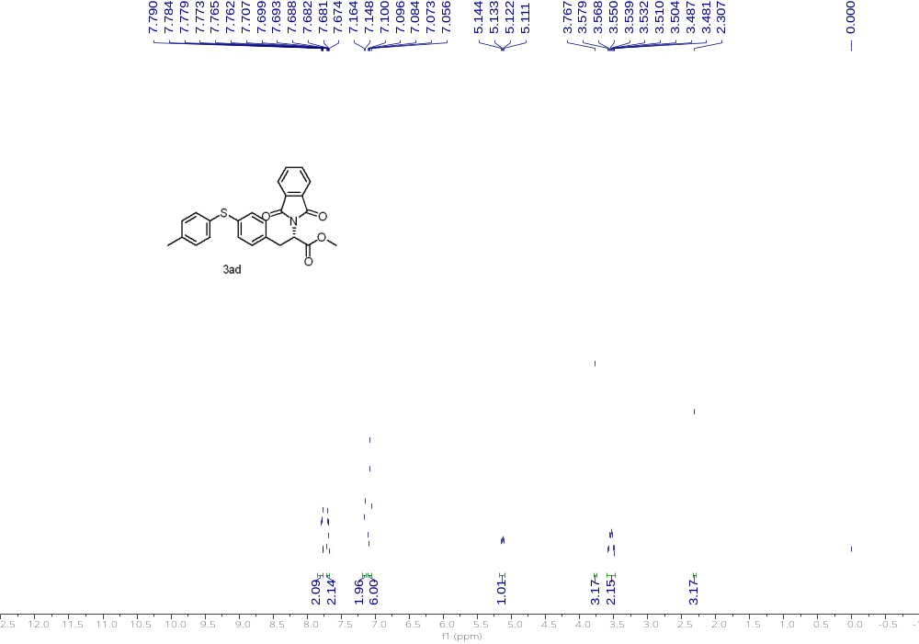
¹H NMR (500 MHz, CDCl₃) of 3ad
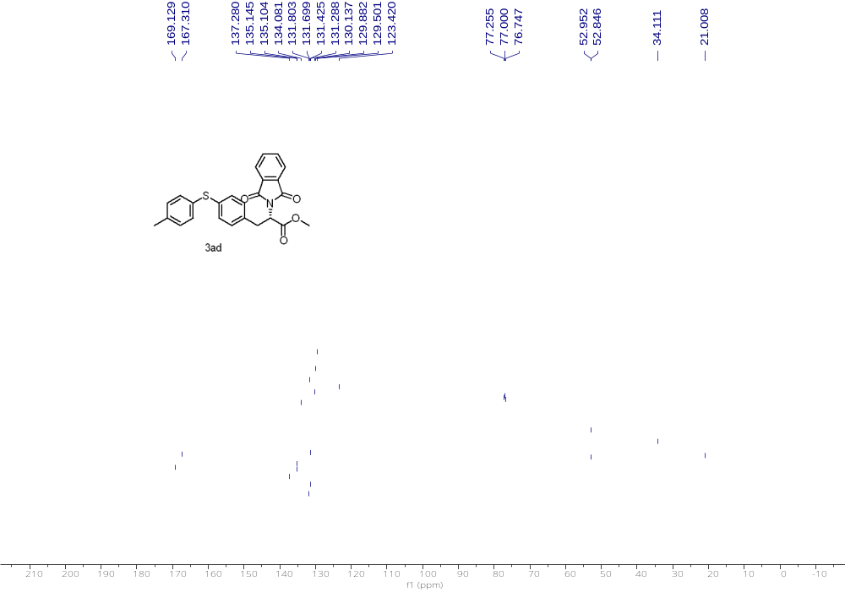
¹³C NMR (126 MHz, CDCl₃) of 3ad

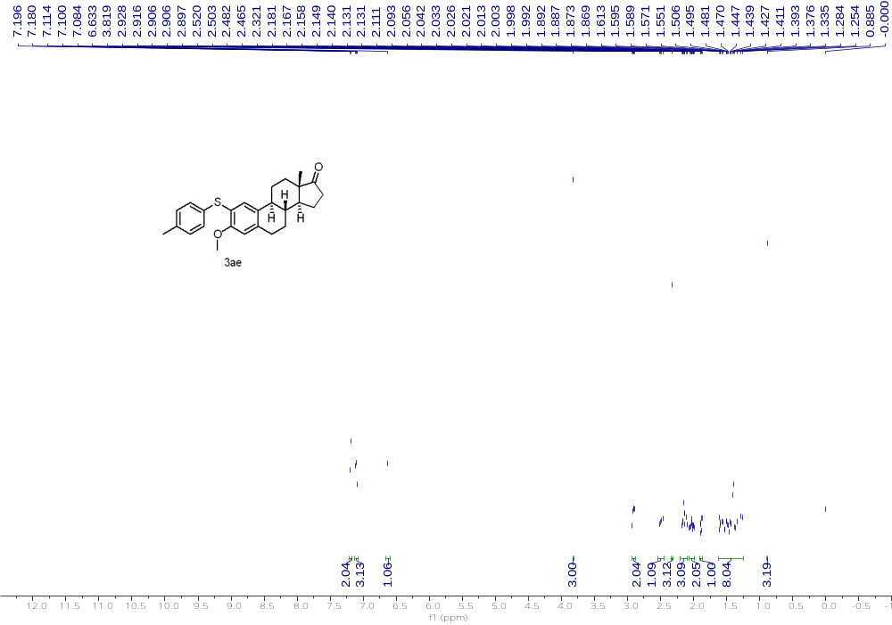
¹H NMR (500 MHz, CDCl₃) of 3ae
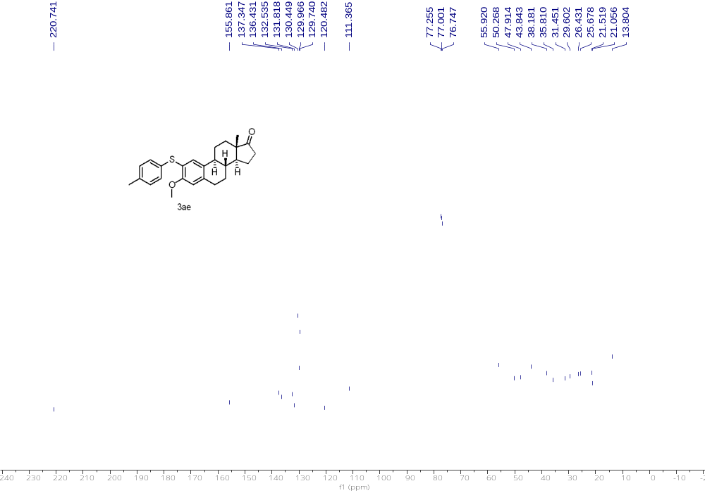
¹³C NMR (126 MHz, CDCl₃) of 3ae

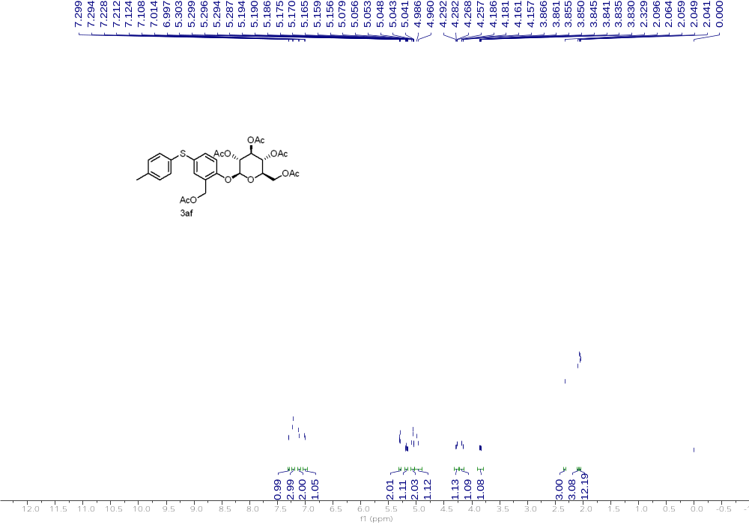
¹H NMR (500 MHz, CDCl₃) of 3af
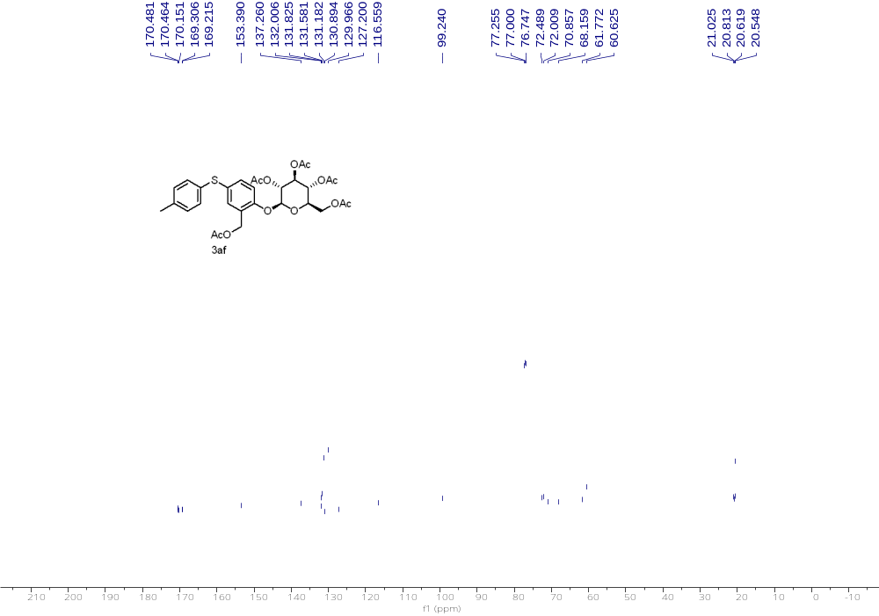
¹³C NMR (126 MHz, CDCl₃) of 3af

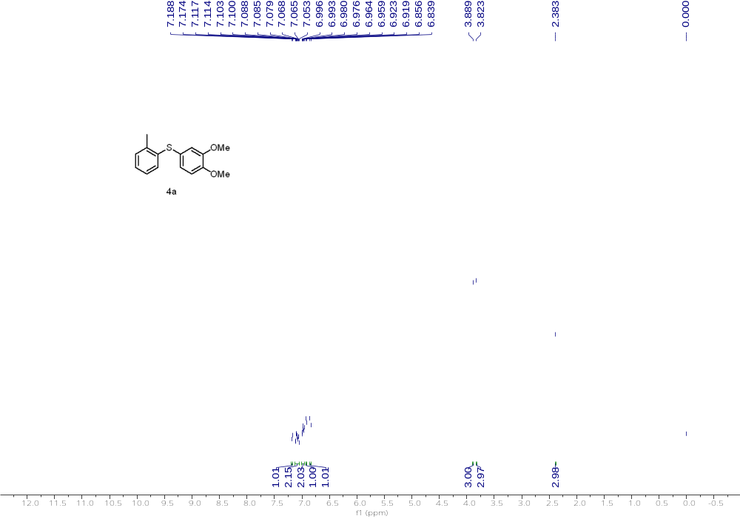
¹H NMR (500 MHz, CDCl₃) of 4a
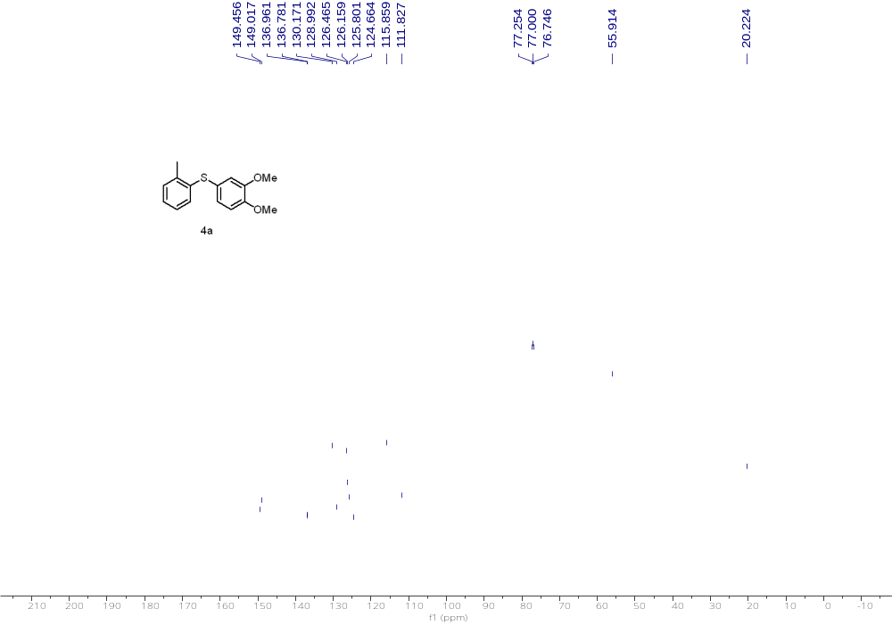
¹³C NMR (126 MHz, CDCl₃) of 4a

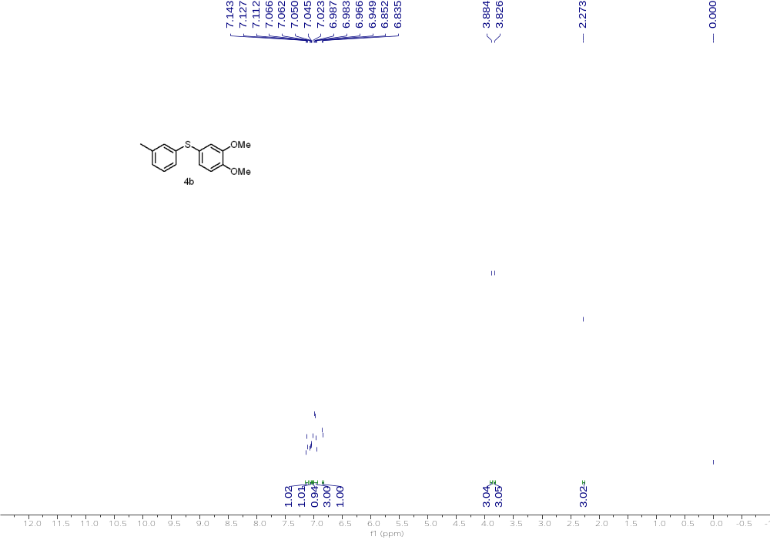
¹H NMR (500 MHz, CDCl₃) of 4b
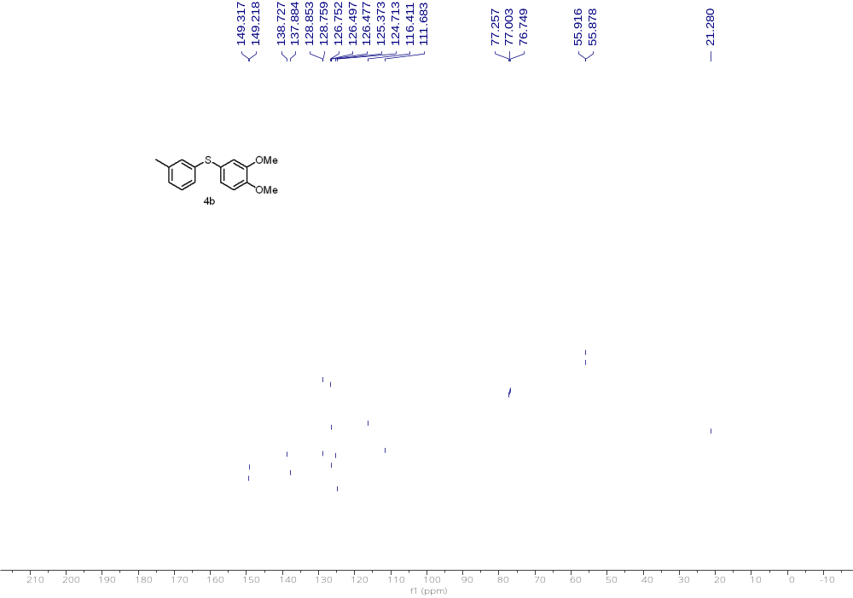
¹³C NMR (126 MHz, CDCl₃) of 4b

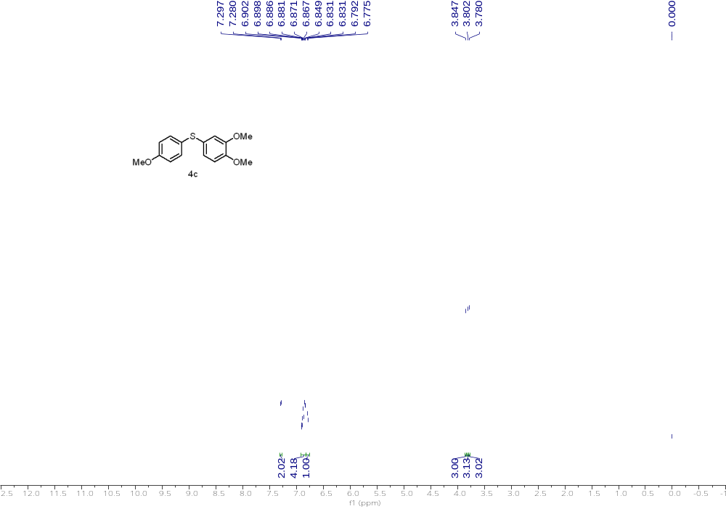
¹H NMR (500 MHz, CDCl₃) of 4c
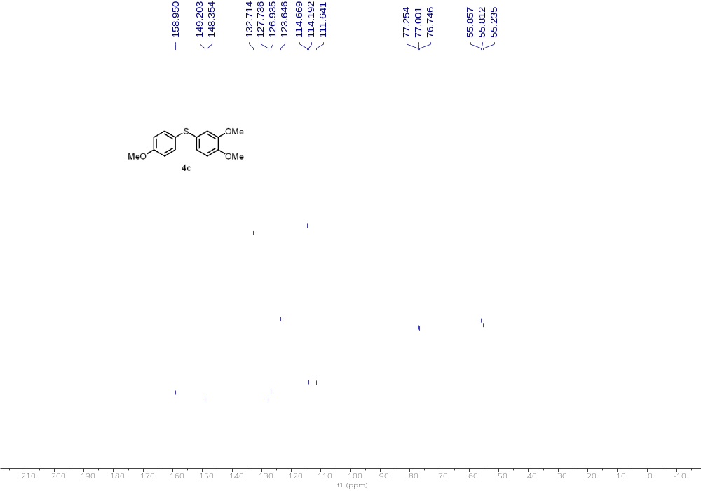
¹³C NMR (126 MHz, CDCl₃) of 4c

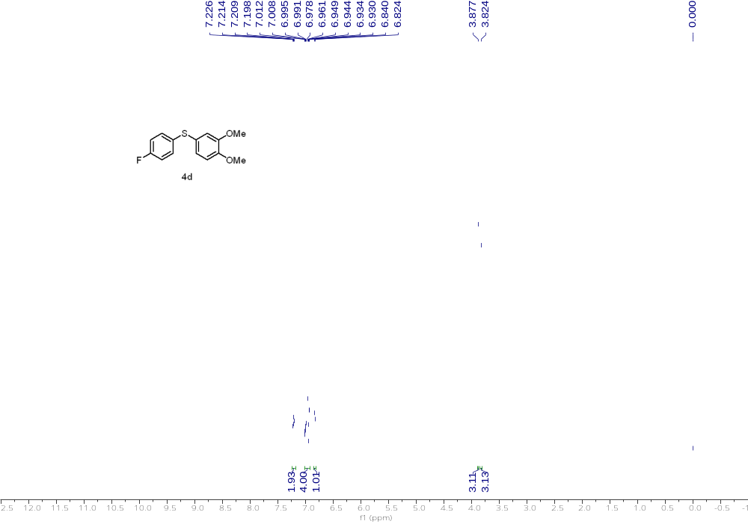
¹H NMR (500 MHz, CDCl₃) of 4d
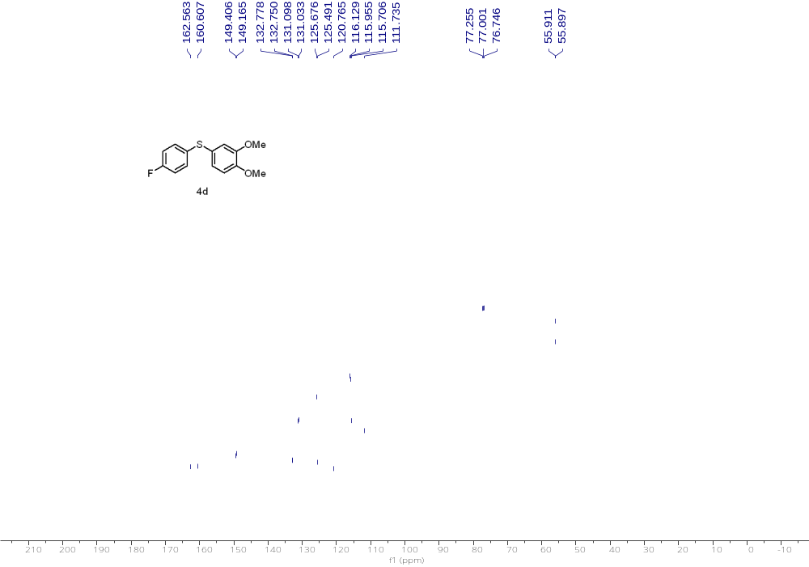
¹³C NMR (126 MHz, CDCl₃) of 4d

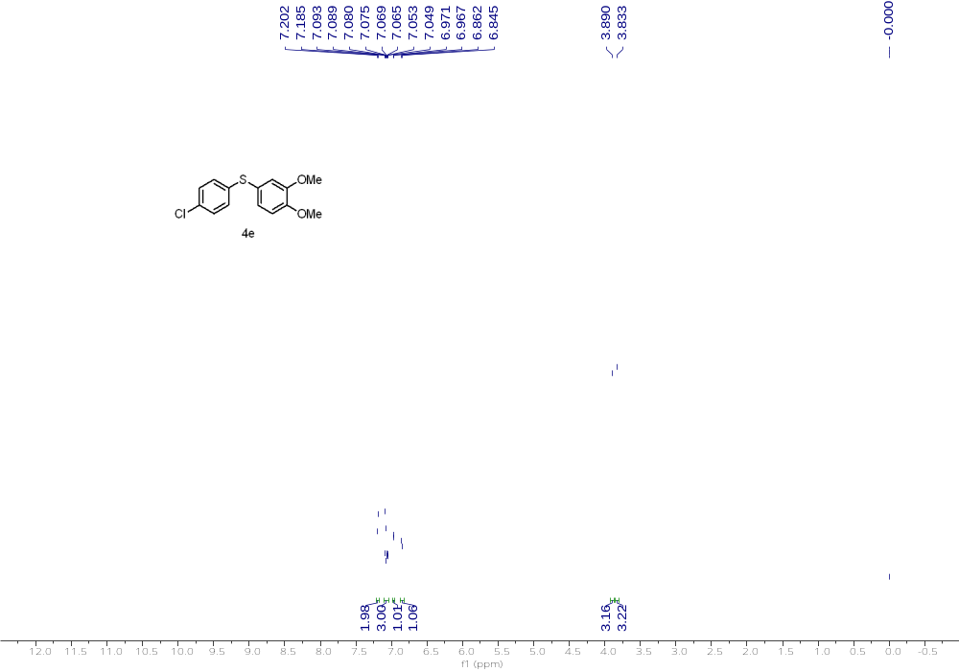
¹H NMR (500 MHz, CDCl₃) of 4e
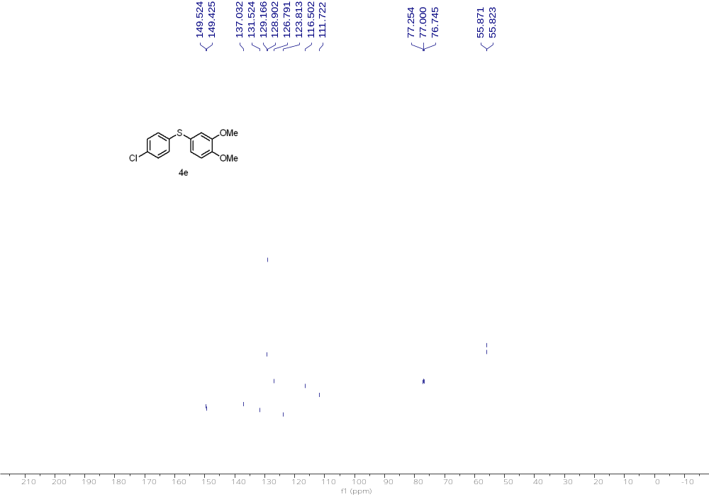
¹³C NMR (126 MHz, CDCl₃) of 4e

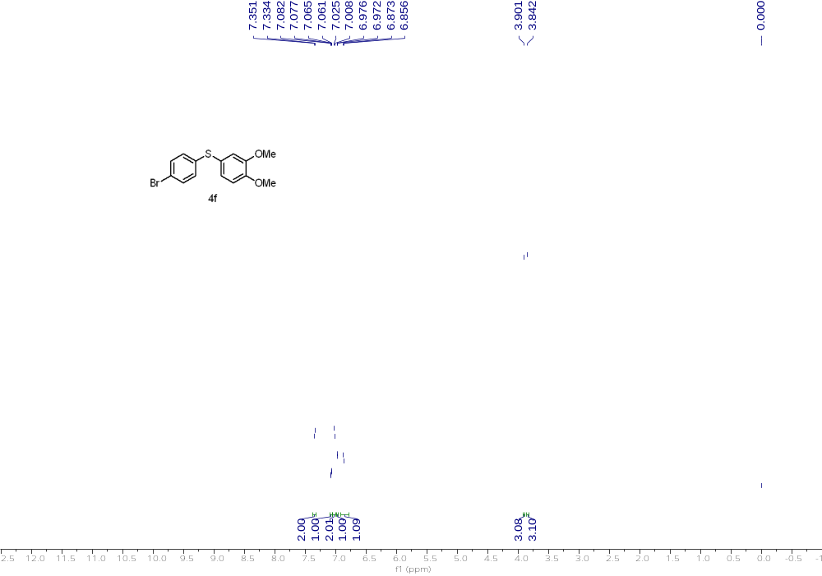
¹H NMR (500 MHz, CDCl₃) of 4f
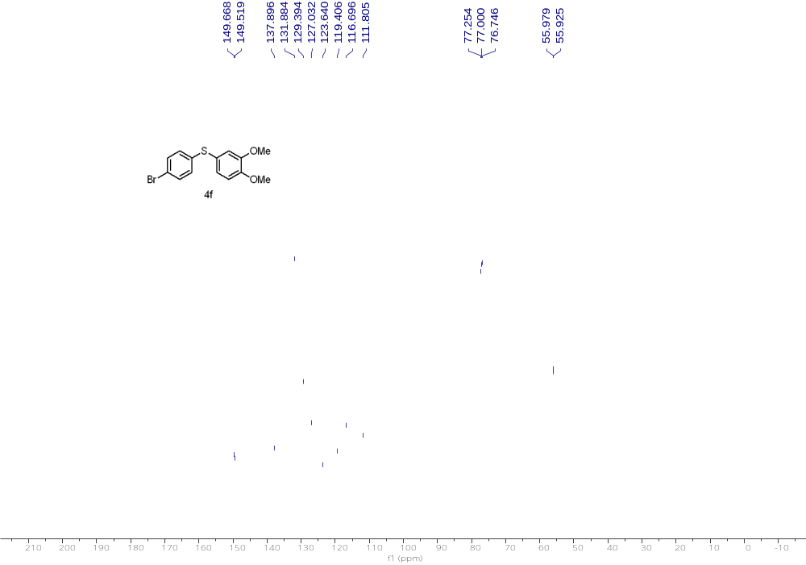
¹³C NMR (126 MHz, CDCl₃) of 4f

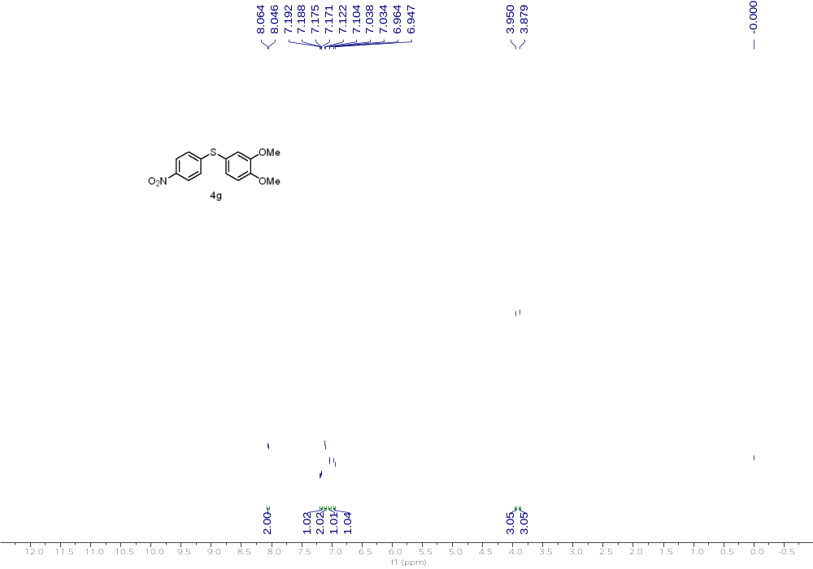
¹H NMR (500 MHz, CDCl₃) of 4g
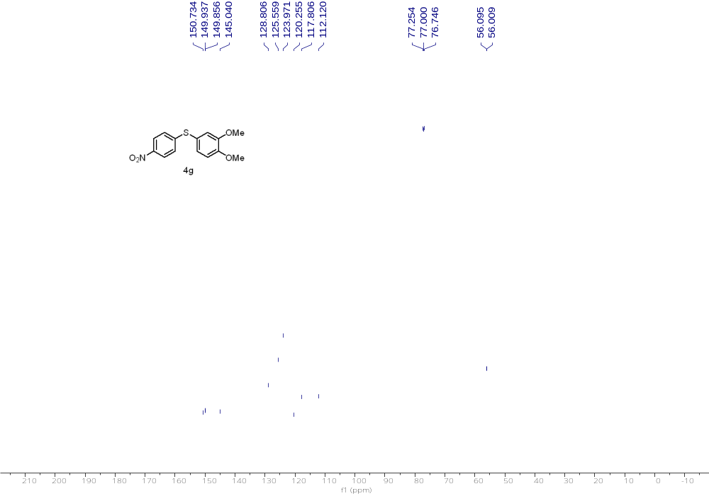
¹³C NMR (126 MHz, CDCl₃) of 4g

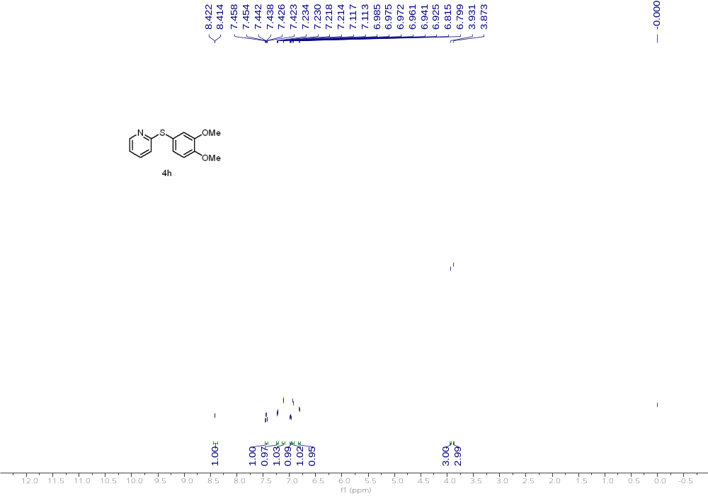
¹H NMR (500 MHz, CDCl₃) of 4h
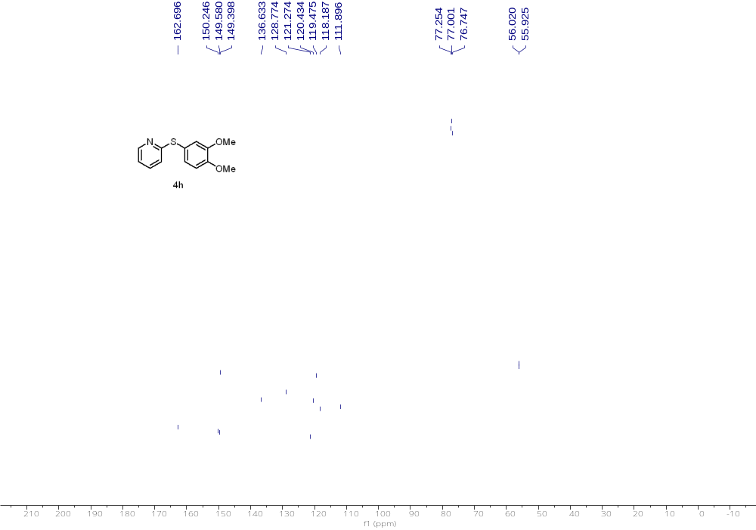
¹³C NMR (126 MHz, CDCl₃) of 4h

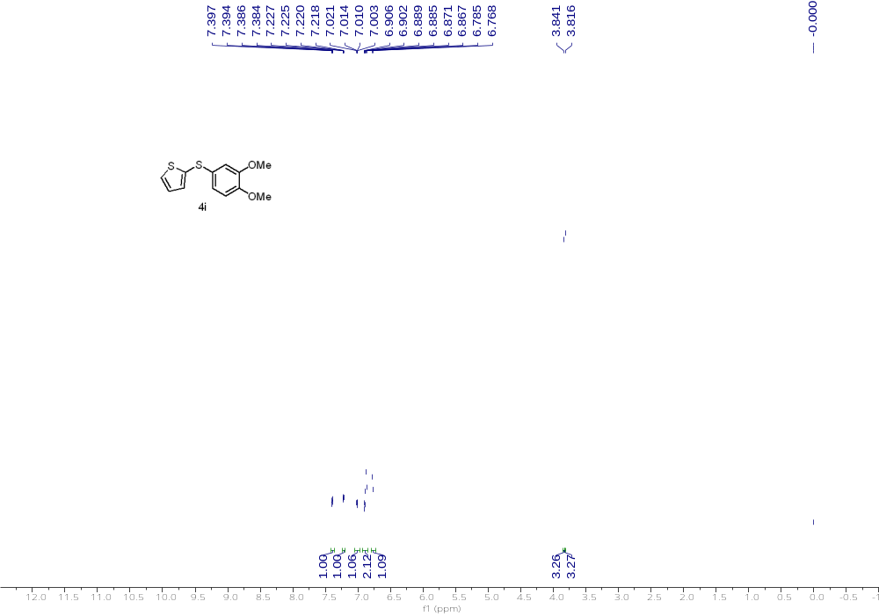
¹H NMR (500 MHz, CDCl₃) of 4i
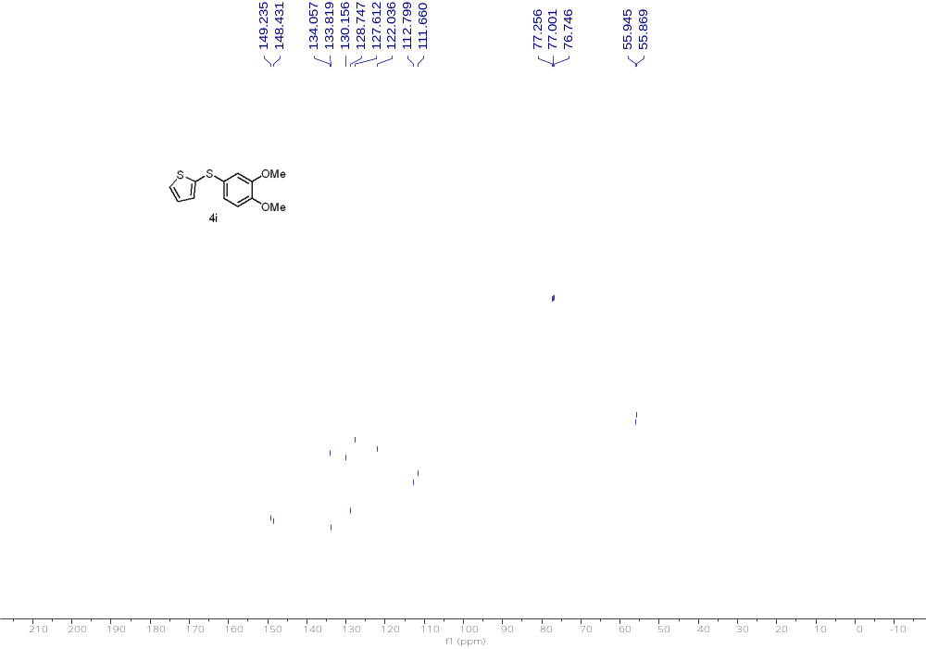
¹³C NMR (126 MHz, CDCl₃) of 4i

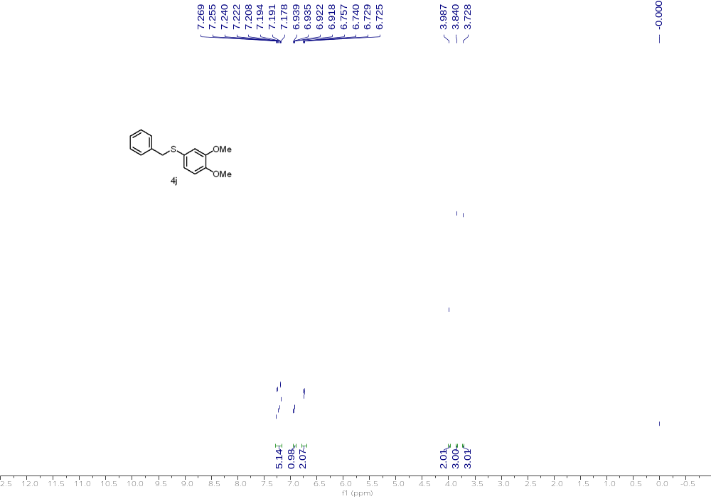
¹H NMR (500 MHz, CDCl₃) of 4j
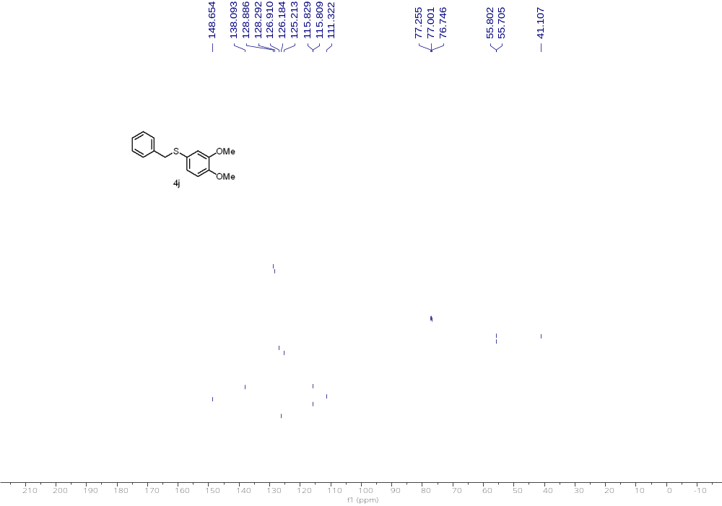
¹³C NMR (126 MHz, CDCl₃) of 4j

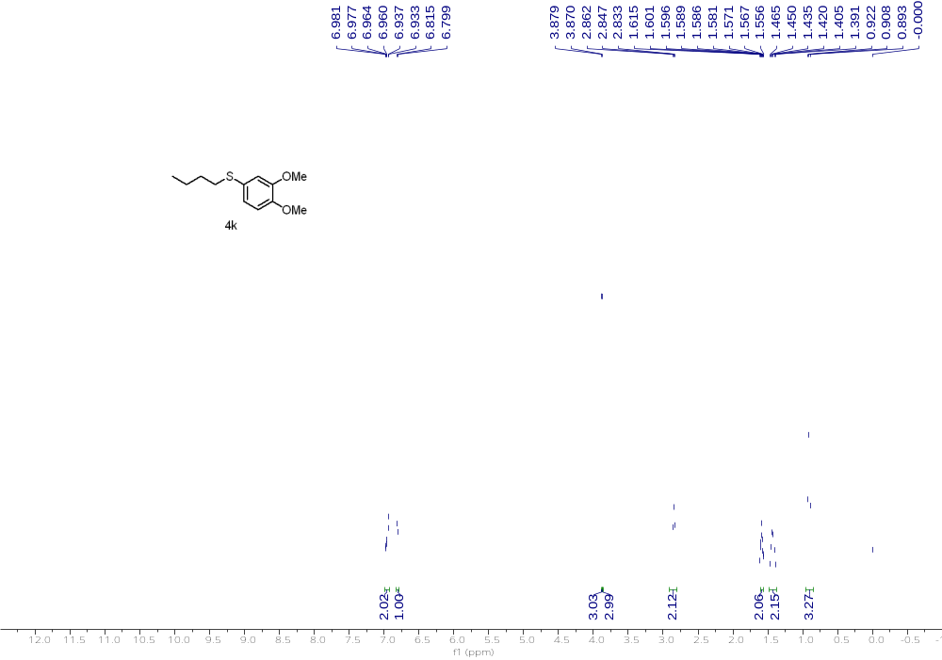
¹H NMR (500 MHz, CDCl₃) of 4k
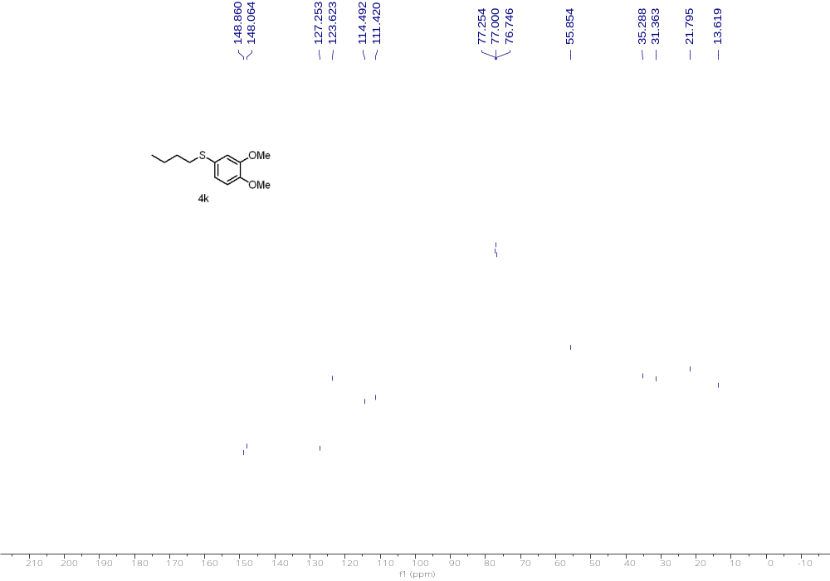
¹³C NMR (126 MHz, CDCl₃) of 4k

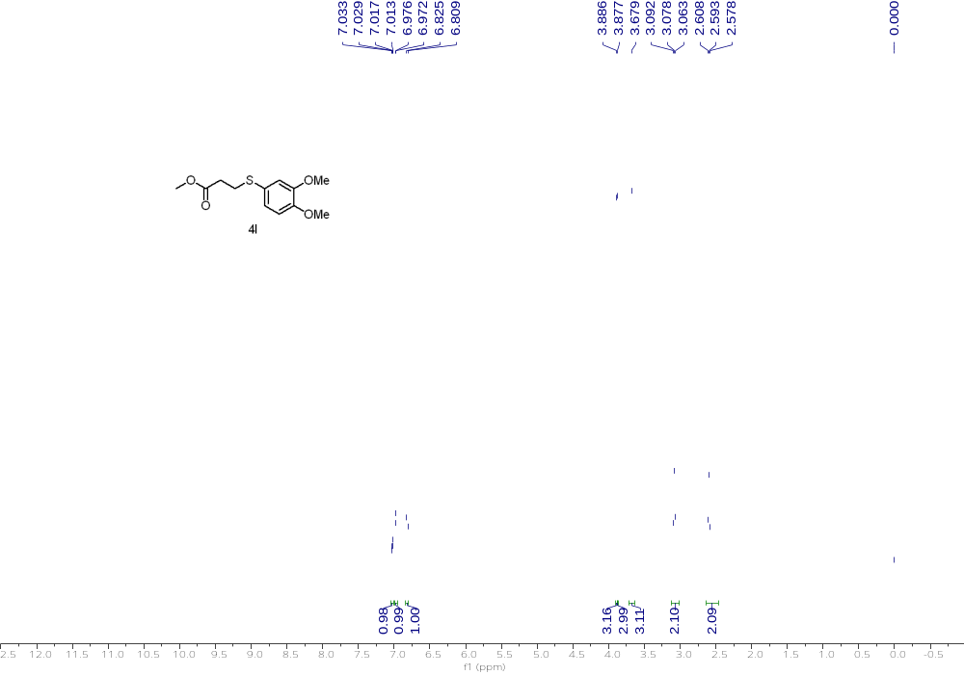
¹H NMR (500 MHz, CDCl₃) of 4l
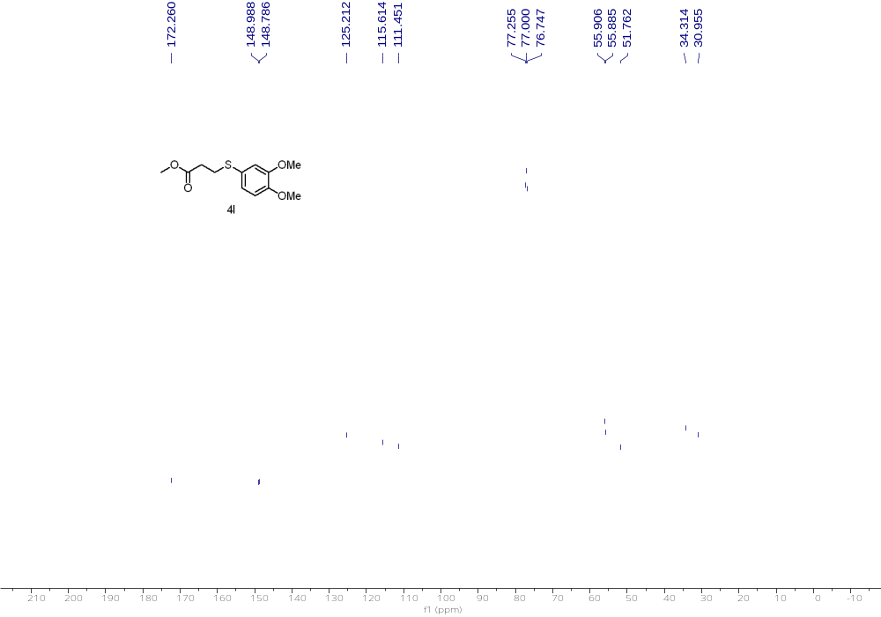
¹³C NMR (126 MHz, CDCl₃) of 4l

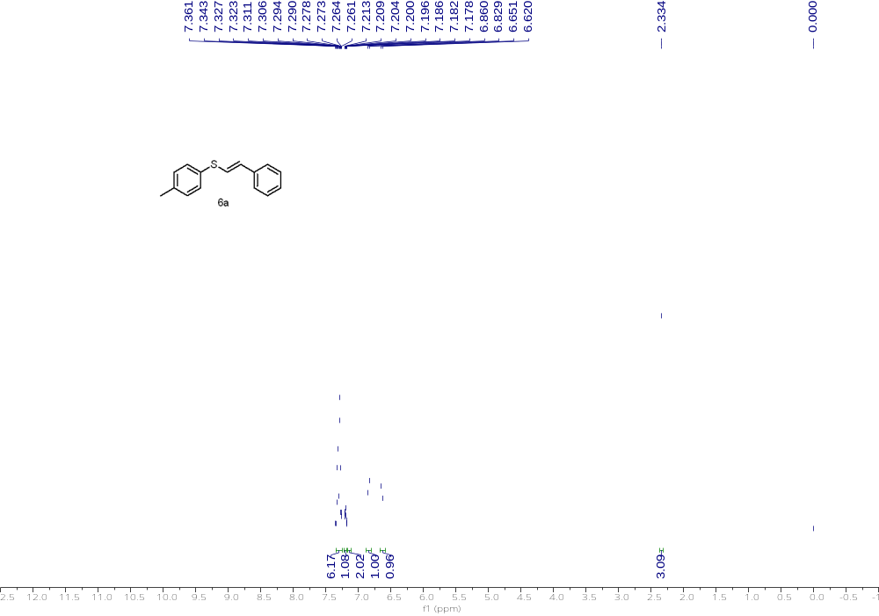
¹H NMR (500 MHz, CDCl₃) of 6a

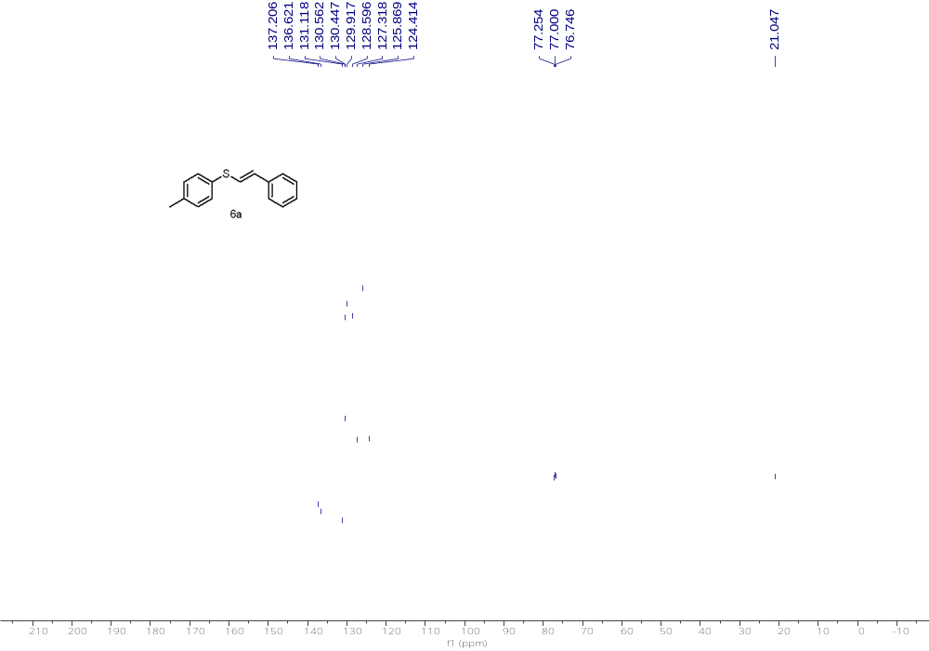
¹³C NMR (126 MHz, CDCl₃) of 6a

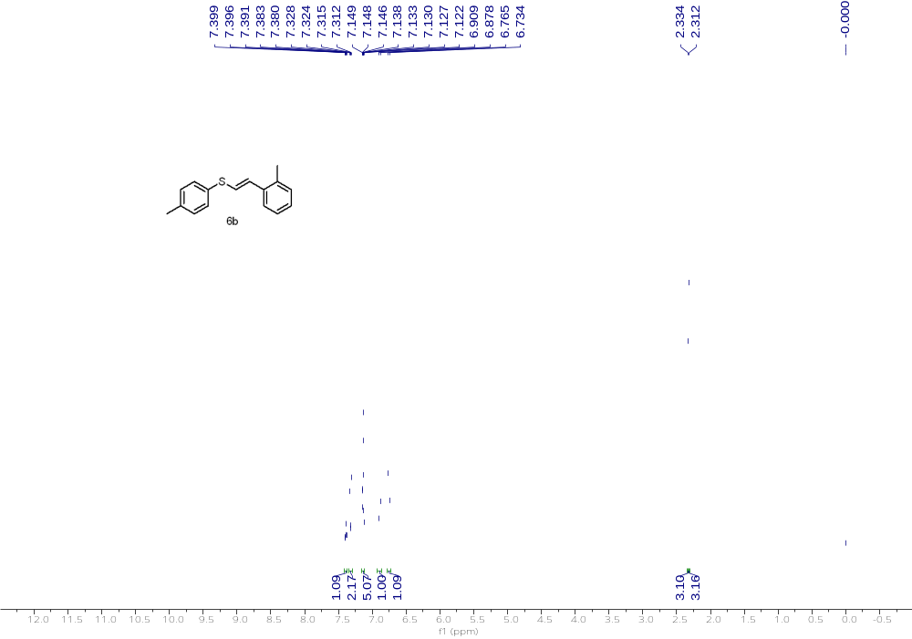
¹H NMR (500 MHz, CDCl₃) of 6b

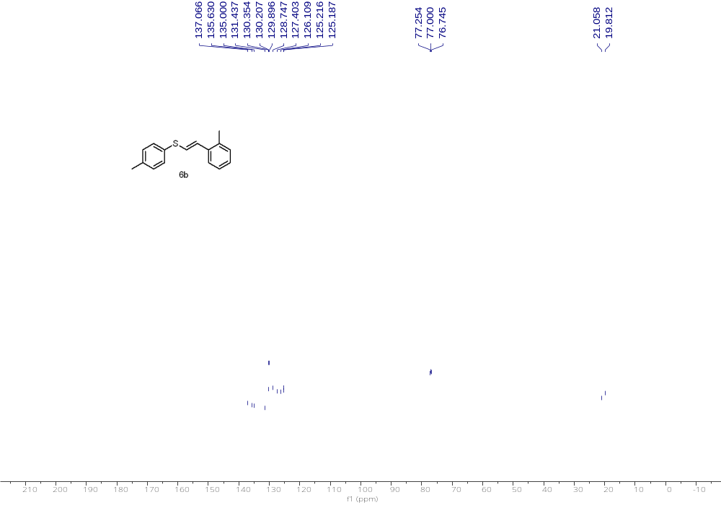
¹³C NMR (126 MHz, CDCl₃) of 6b

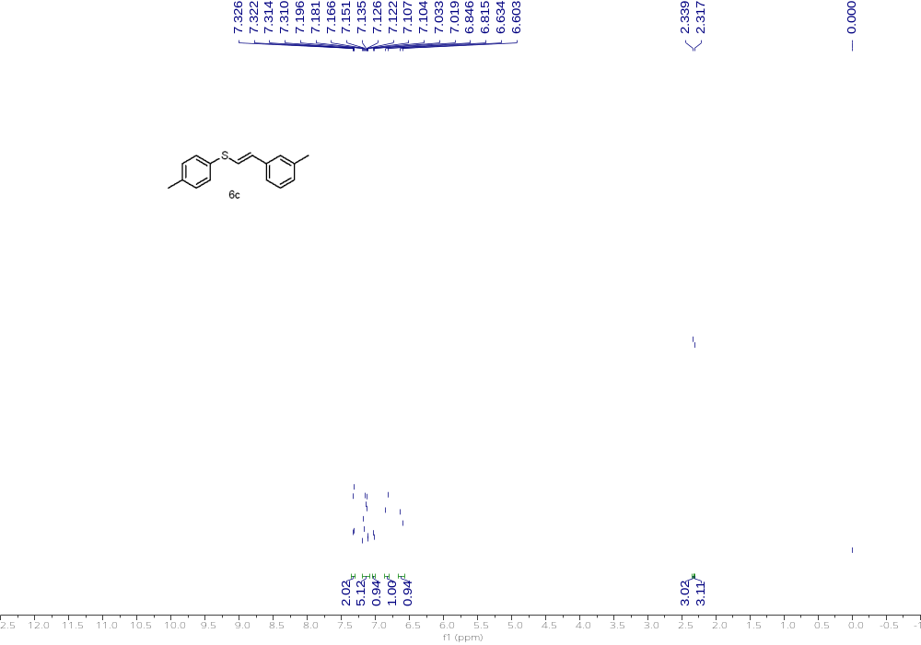
¹H NMR (500 MHz, CDCl₃) of 6c

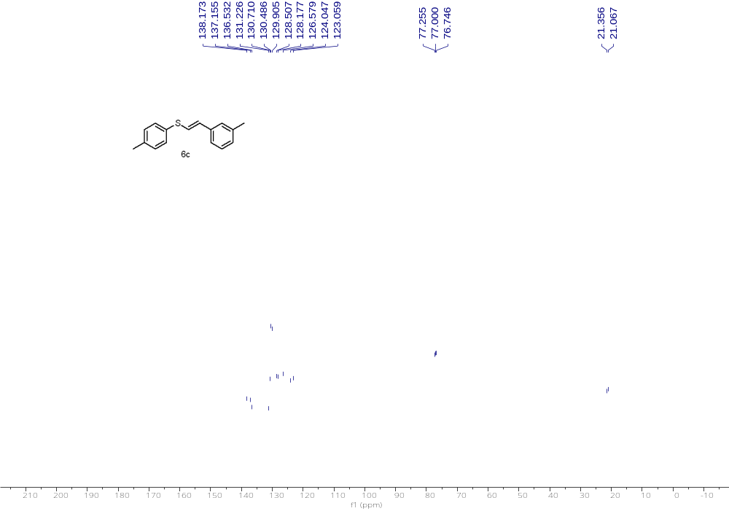
¹³C NMR (126 MHz, CDCl₃) of 6c

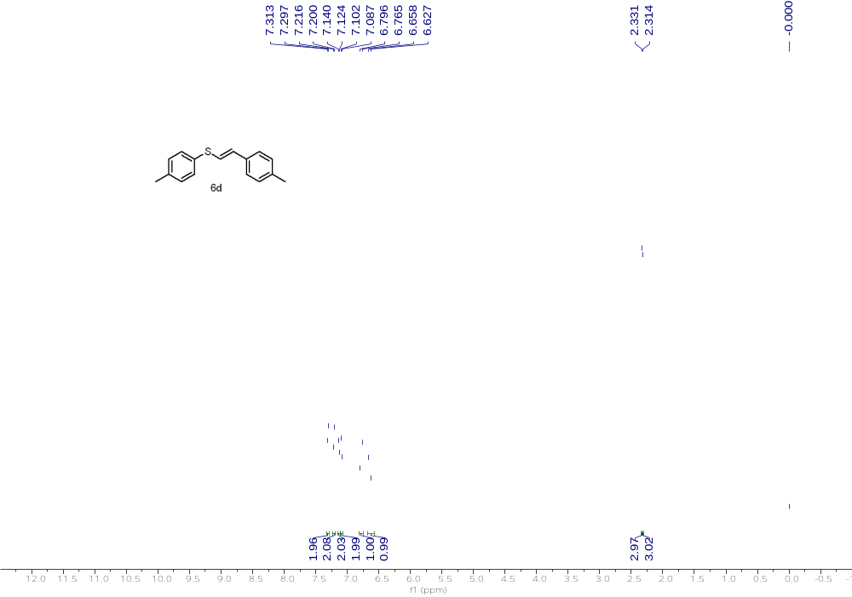
¹H NMR (500 MHz, CDCl₃) of 6d

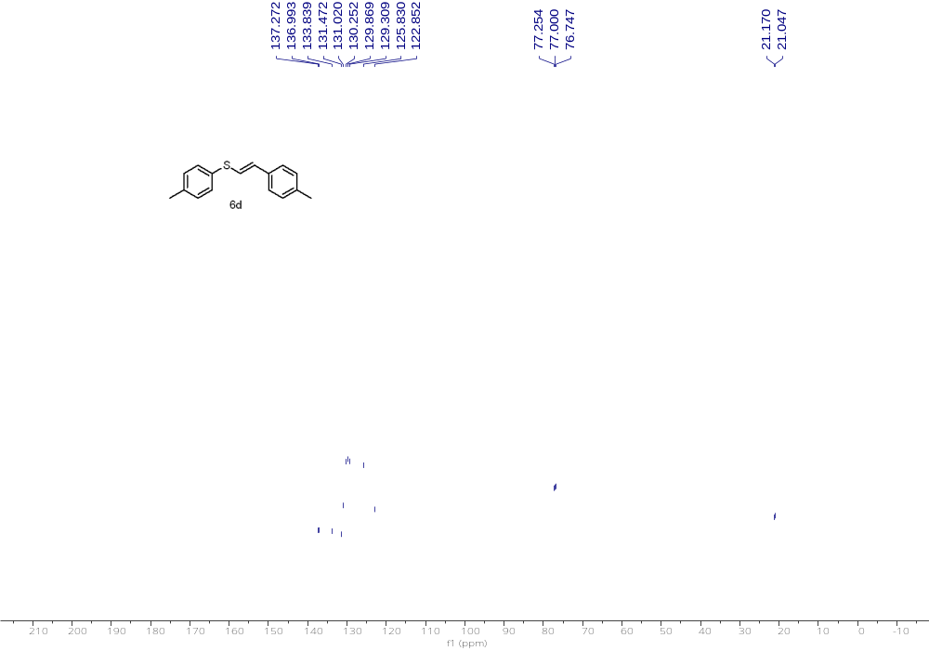
¹³C NMR (126 MHz, CDCl₃) of 6d

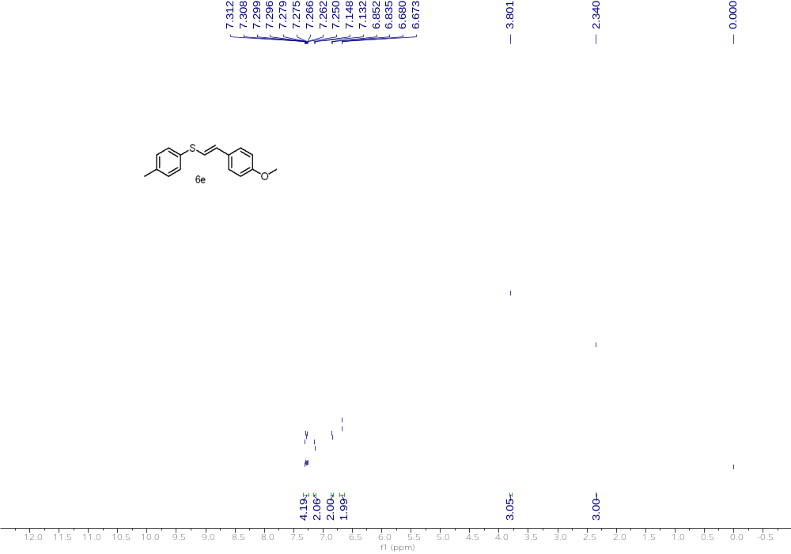
¹H NMR (500 MHz, CDCl₃) of 6e

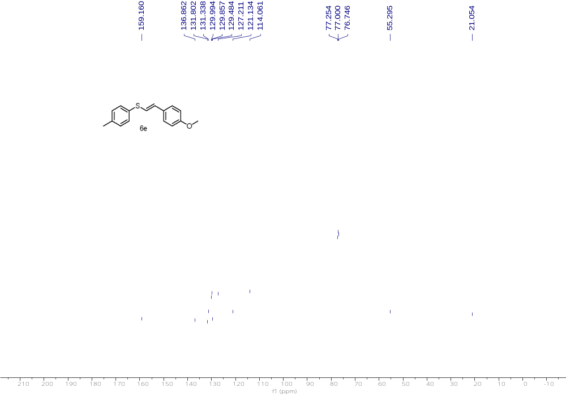
¹³C NMR (126 MHz, CDCl₃) of 6e

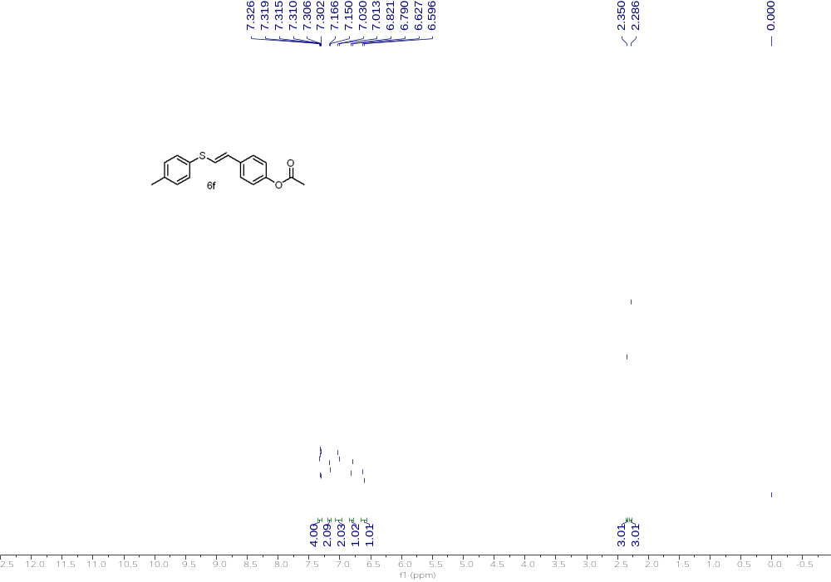
¹H NMR (500 MHz, CDCl₃) of 6f

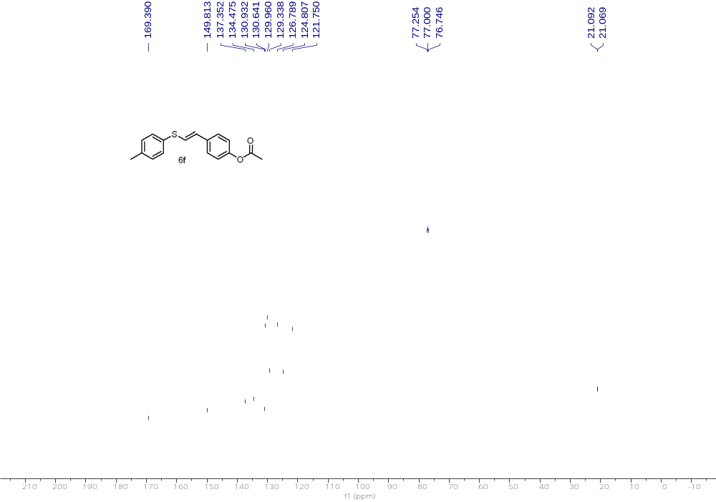
¹³C NMR (126 MHz, CDCl₃) of 6f

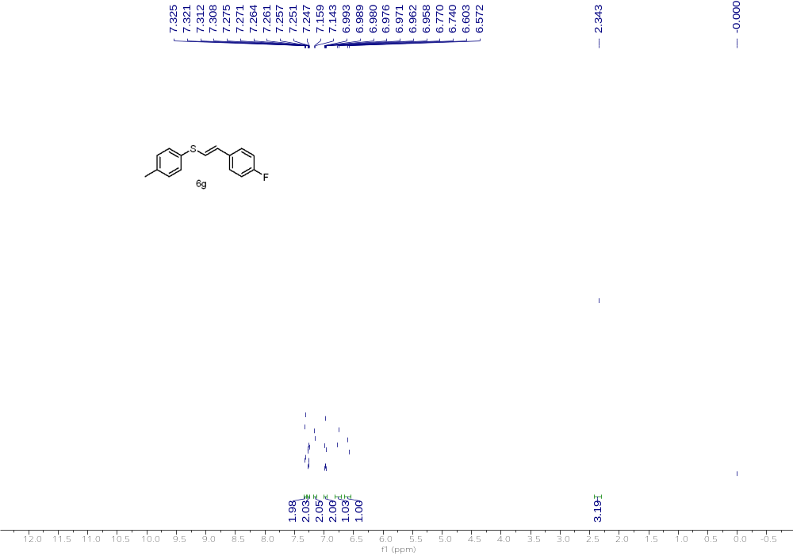
¹H NMR (500 MHz, CDCl₃) of 6g

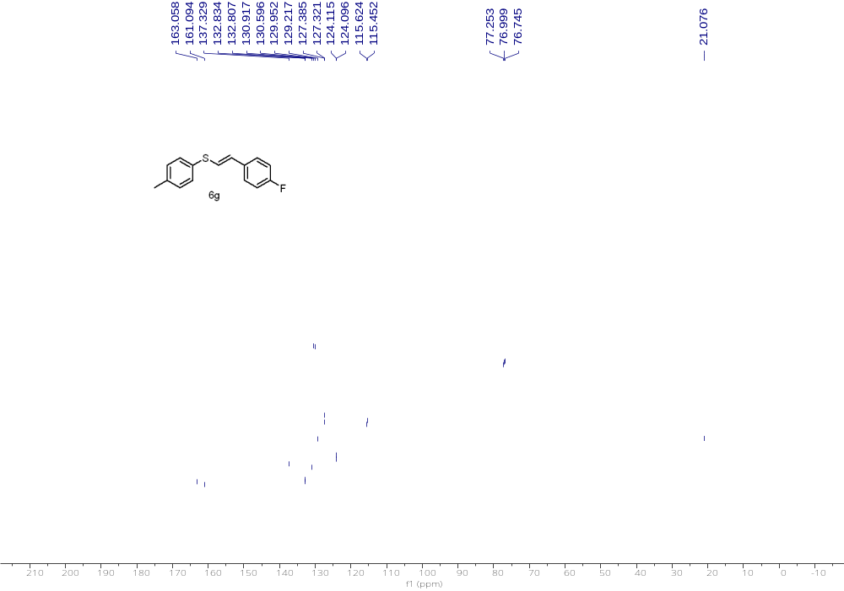
¹³C NMR (126 MHz, CDCl₃) of 6g

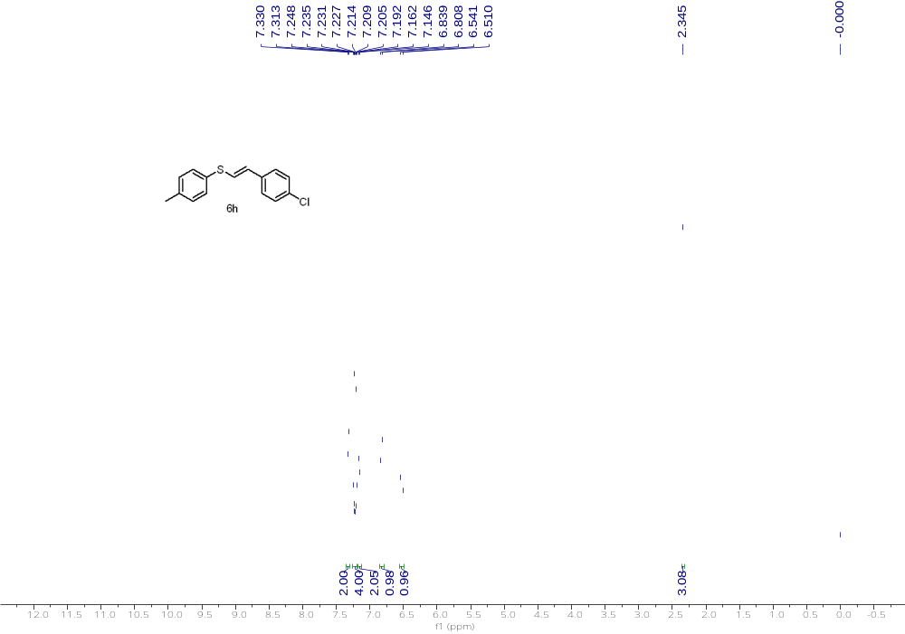
¹H NMR (500 MHz, CDCl₃) of 6h

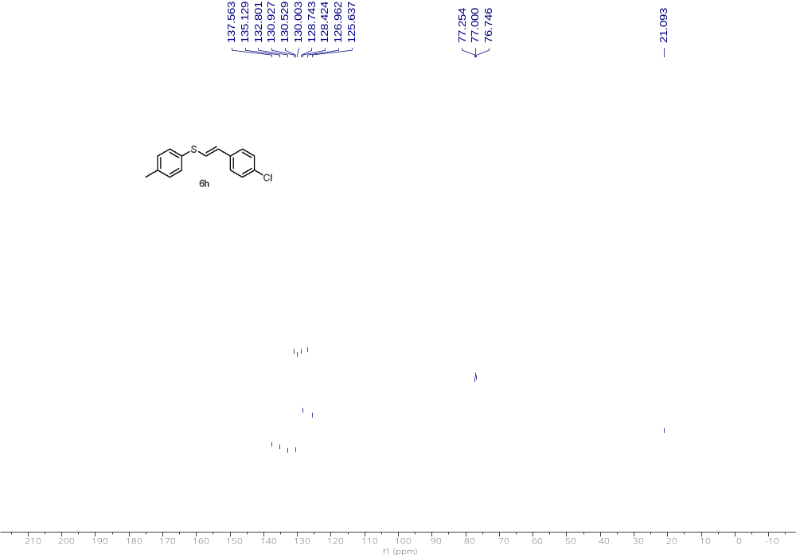
¹³C NMR (126 MHz, CDCl₃) of 6h

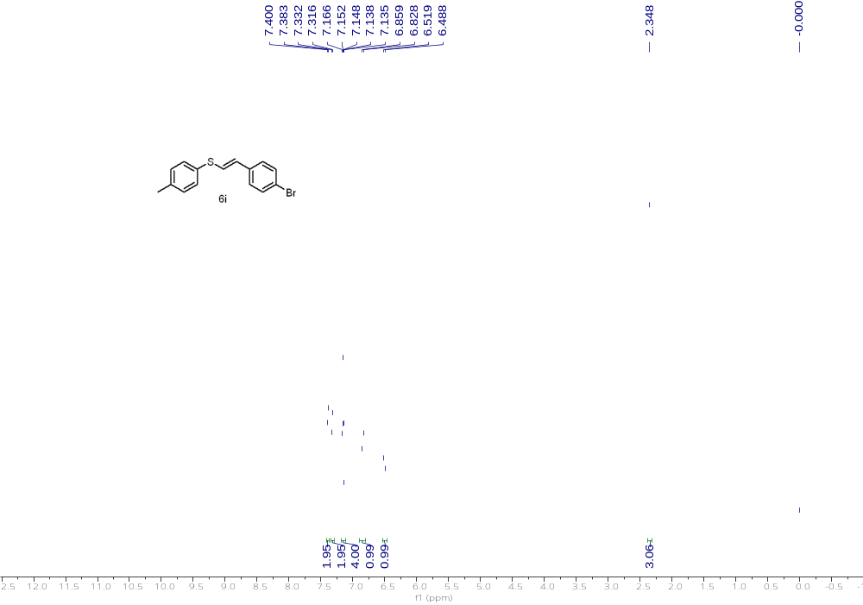
¹H NMR (500 MHz, CDCl₃) of 6i

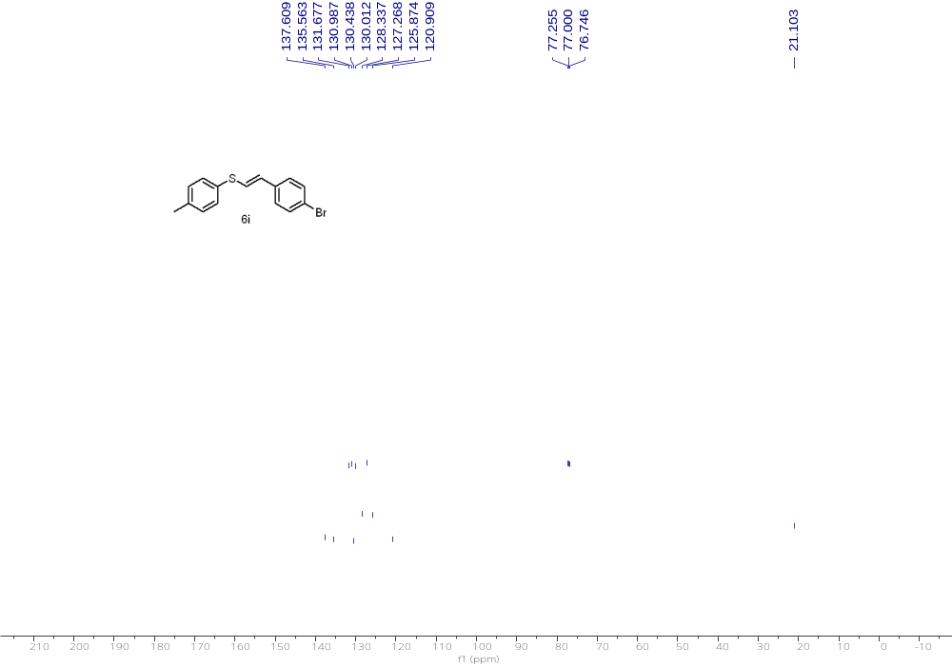
¹³C NMR (126 MHz, CDCl₃) of 6i

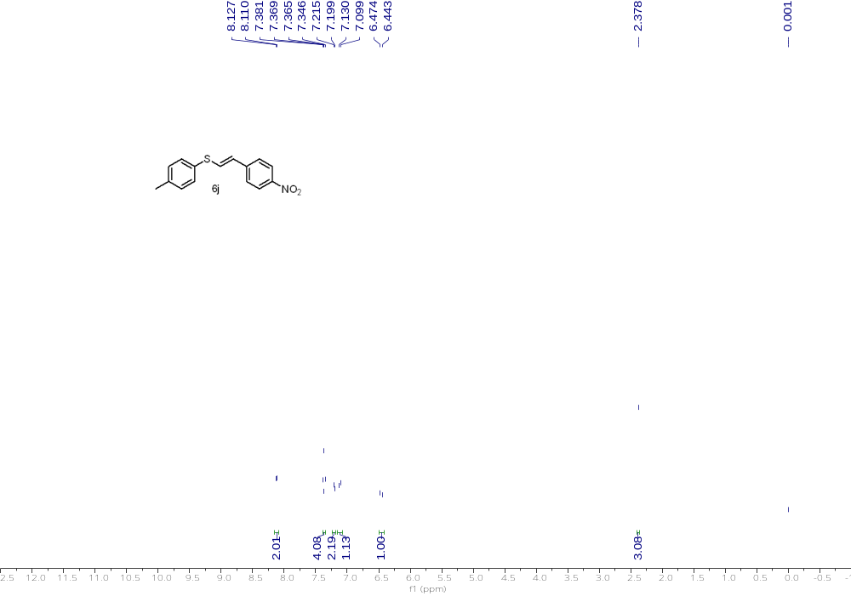
¹H NMR (500 MHz, CDCl₃) of 6j

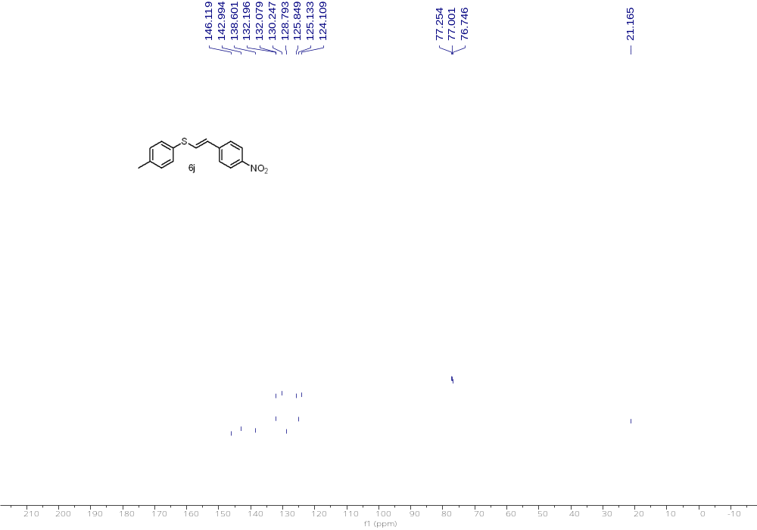
¹³C NMR (126 MHz, CDCl₃) of 6j

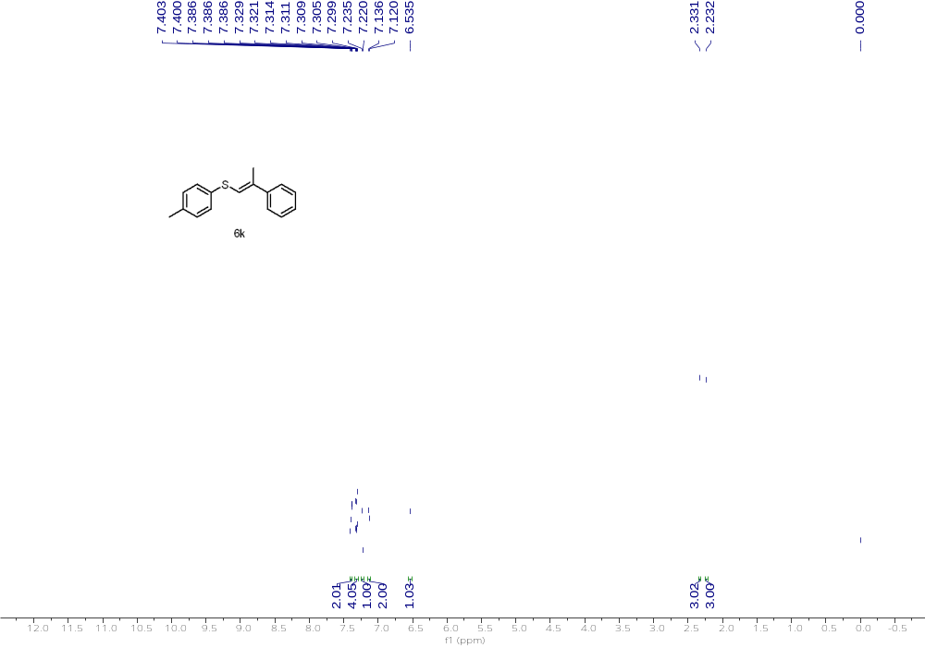
¹H NMR (500 MHz, CDCl₃) of 6k

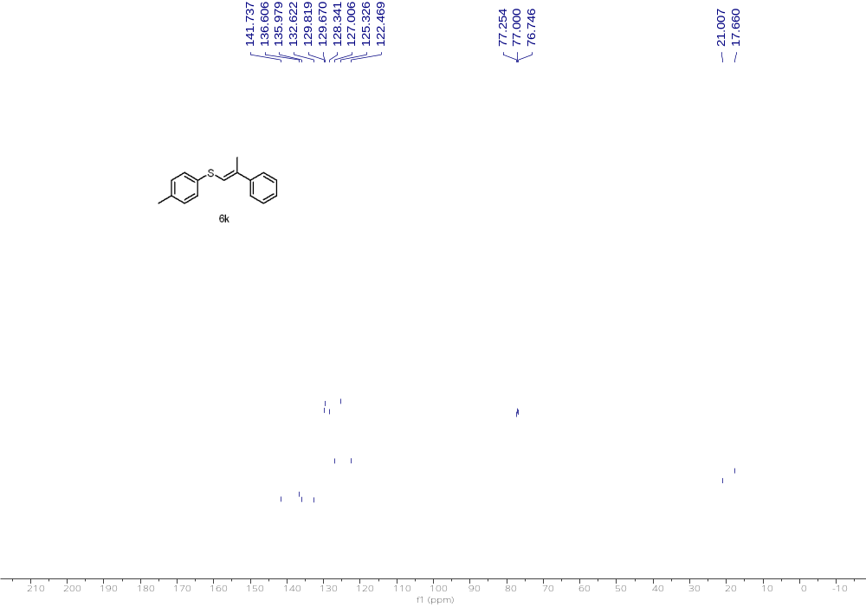
¹³C NMR (126 MHz, CDCl₃) of 6k

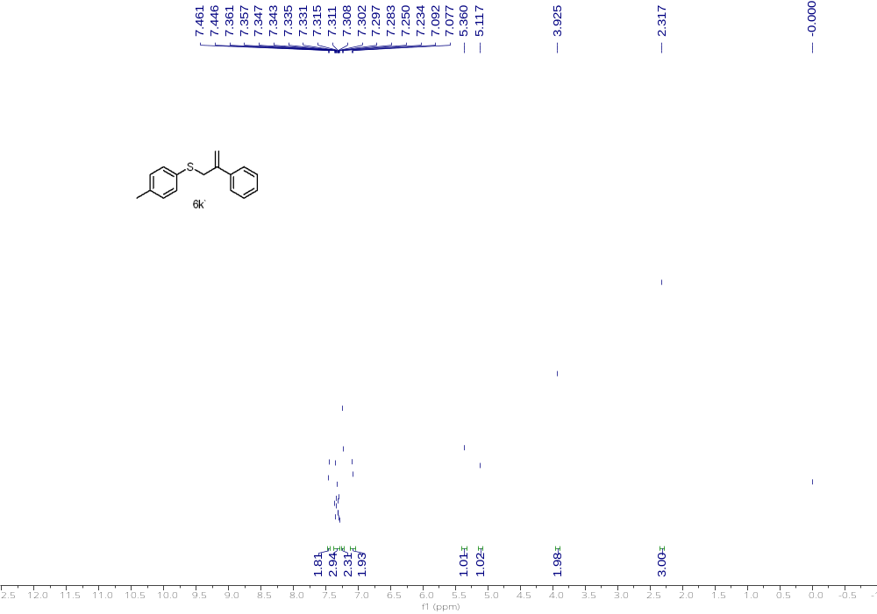
¹H NMR (500 MHz, CDCl₃) of 6k'

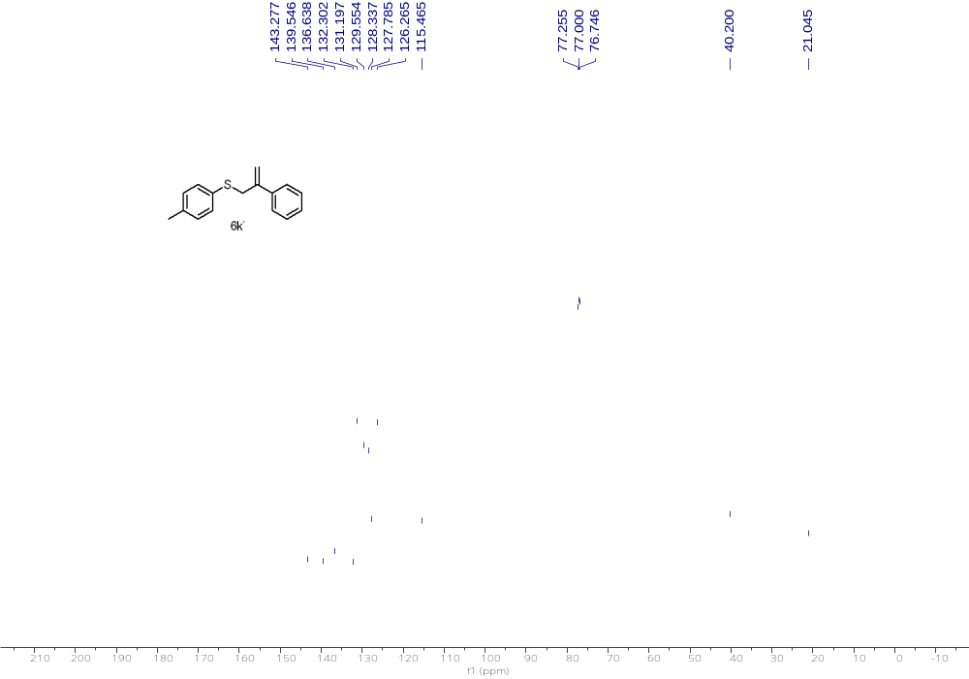
¹³C NMR (126 MHz, CDCl₃) of 6k'

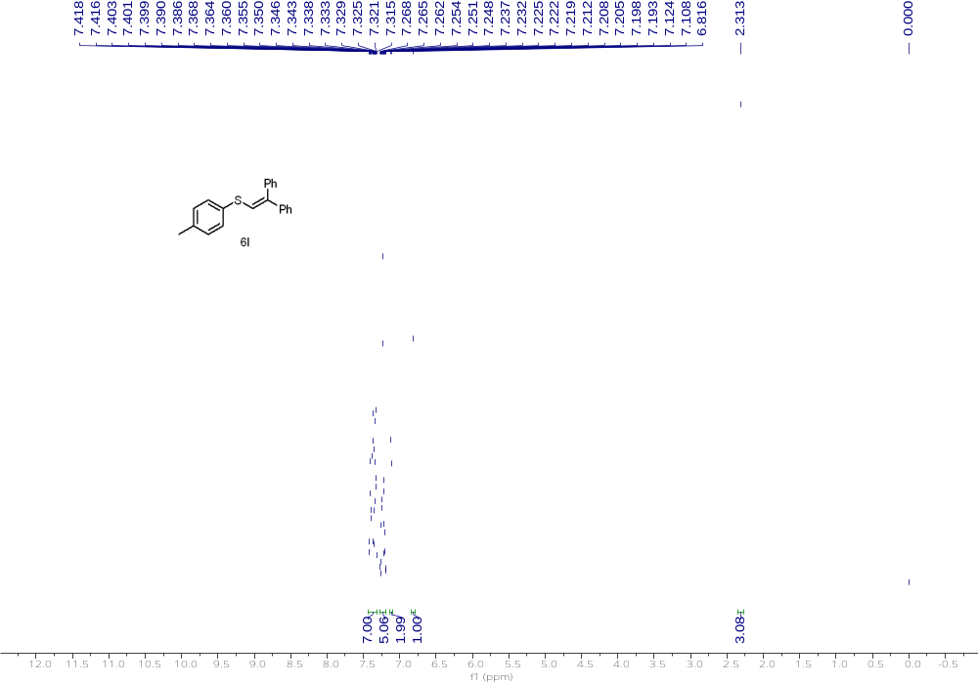
¹H NMR (500 MHz, CDCl₃) of 6l

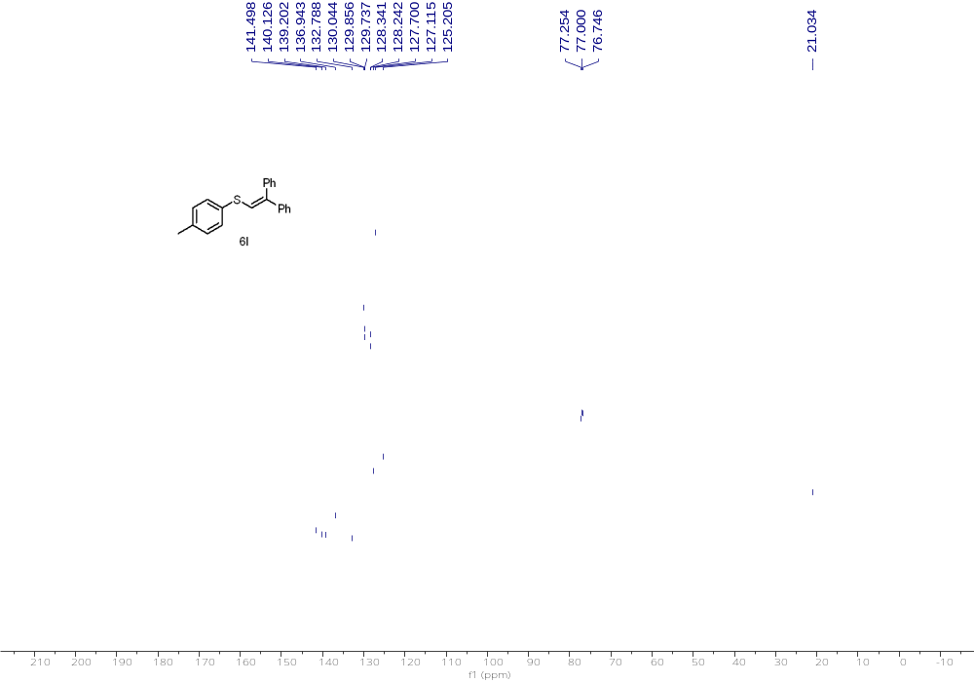
¹³C NMR (126 MHz, CDCl₃) of 6l

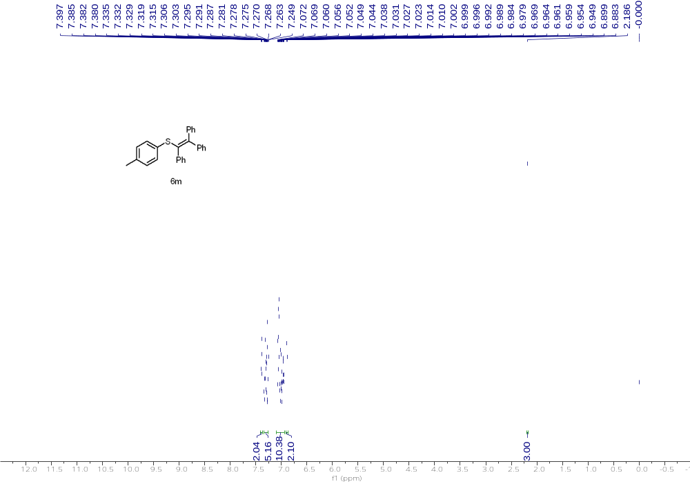
¹H NMR (500 MHz, CDCl₃) of 6m

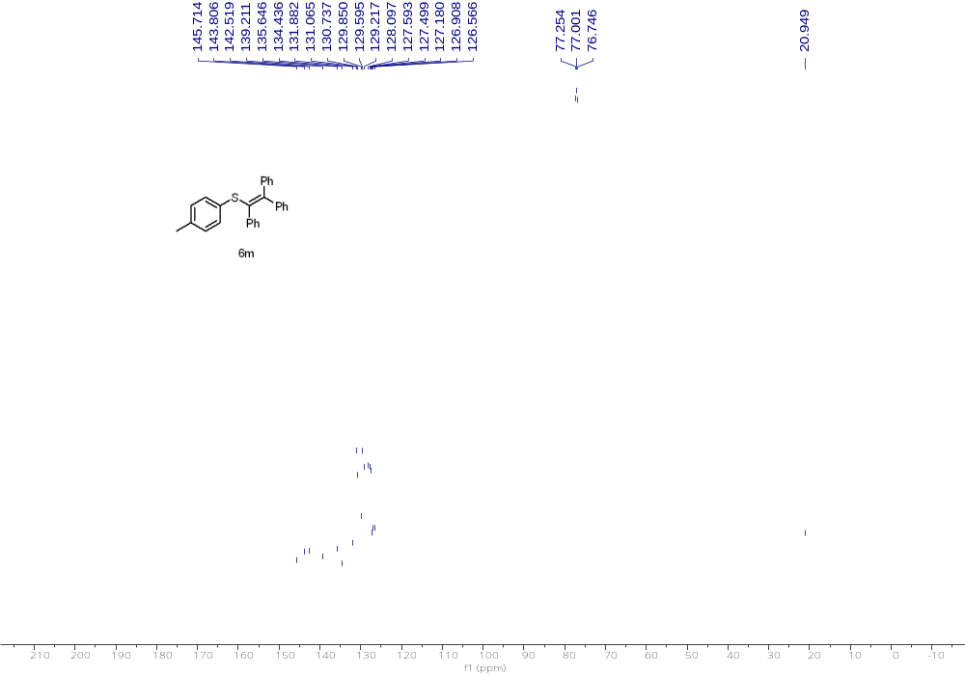
¹³C NMR (126 MHz, CDCl₃) of 6m

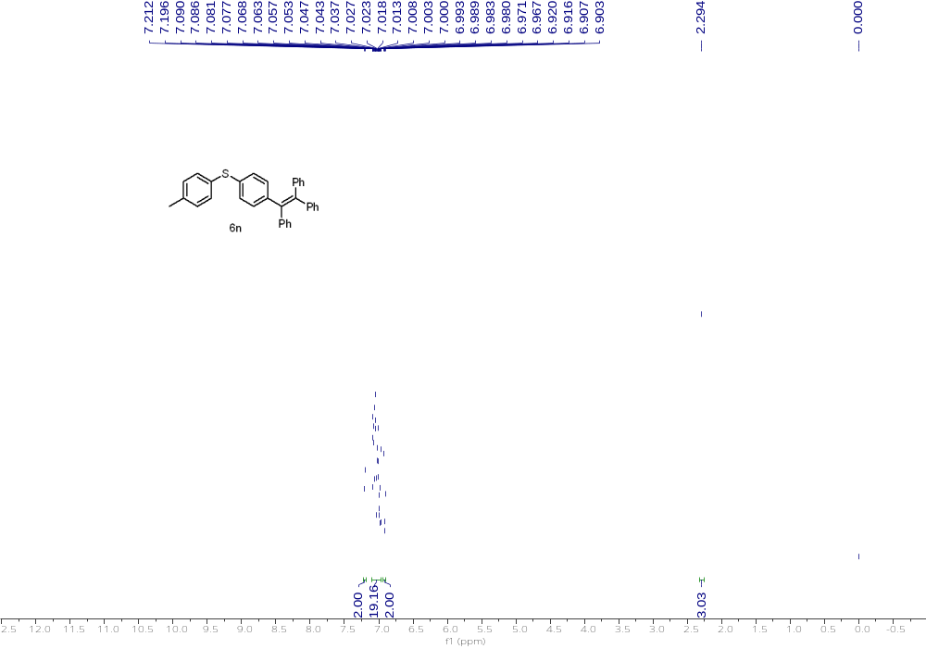
¹H NMR (500 MHz, CDCl₃) of 6n

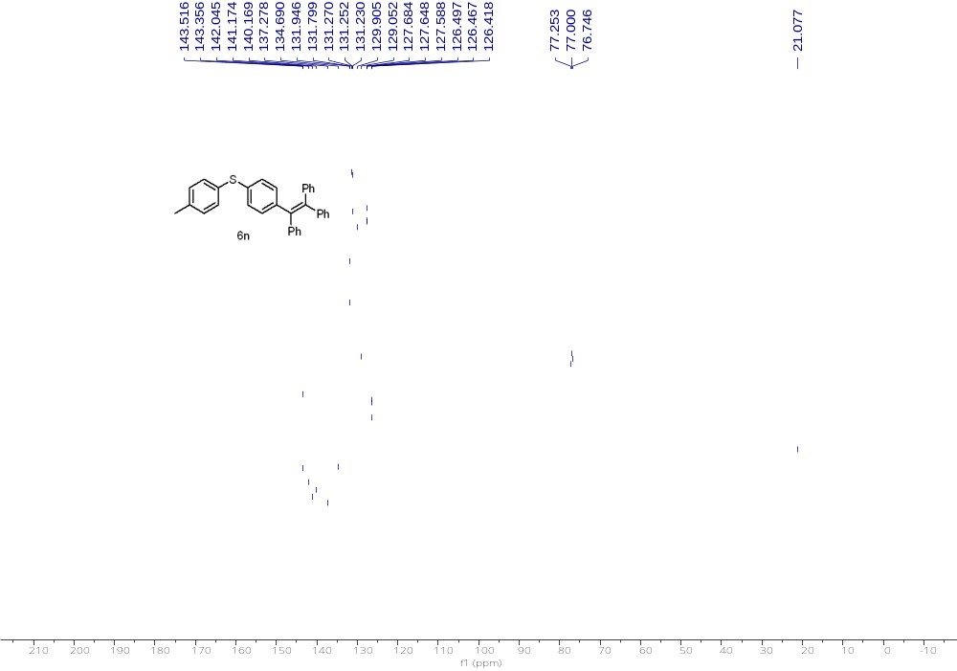
¹³C NMR (126 MHz, CDCl₃) of 6n

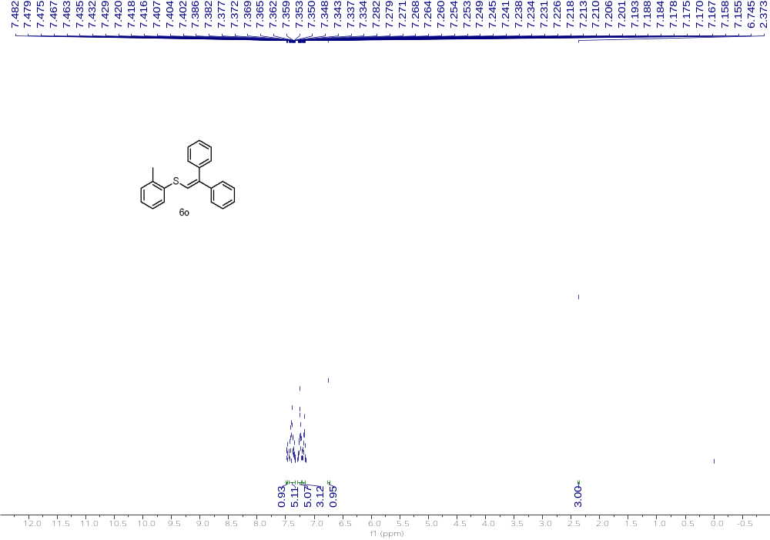
¹H NMR (500 MHz, CDCl₃) of 6o

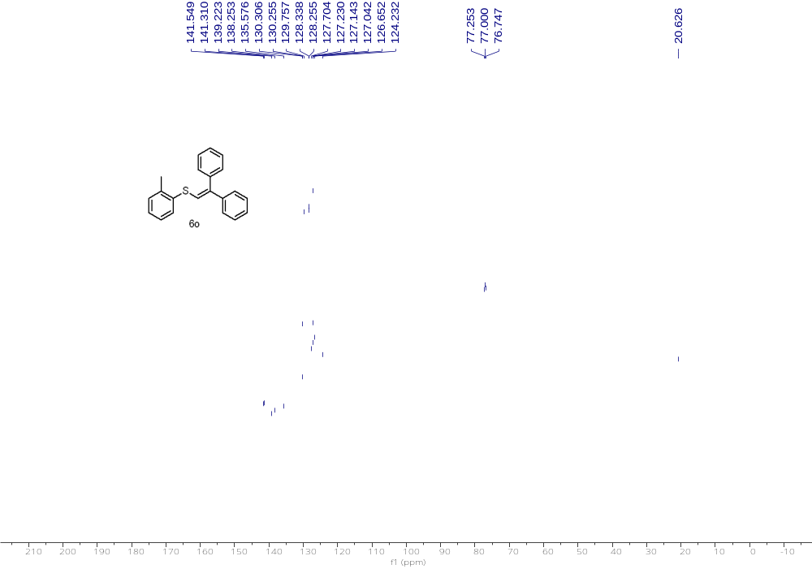
¹³C NMR (126 MHz, CDCl₃) of 6o

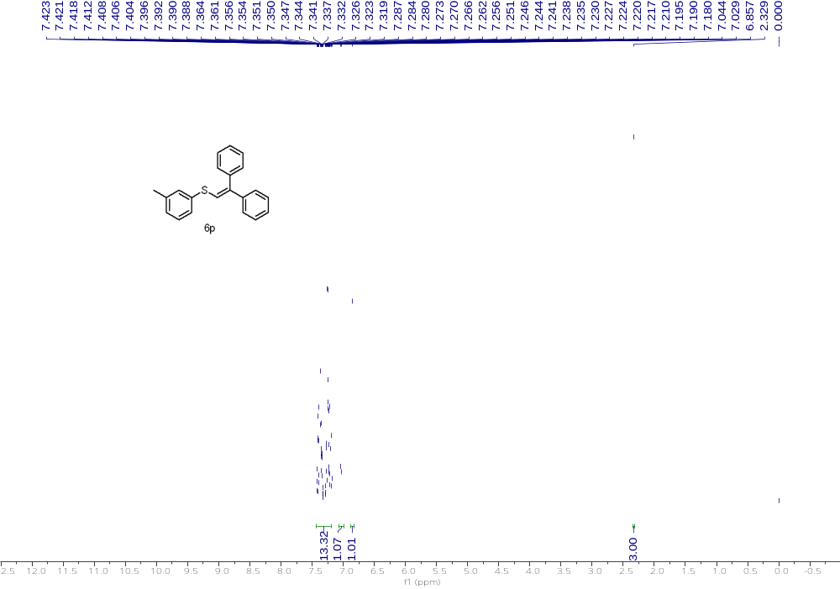
¹H NMR (500 MHz, CDCl₃) of 6p

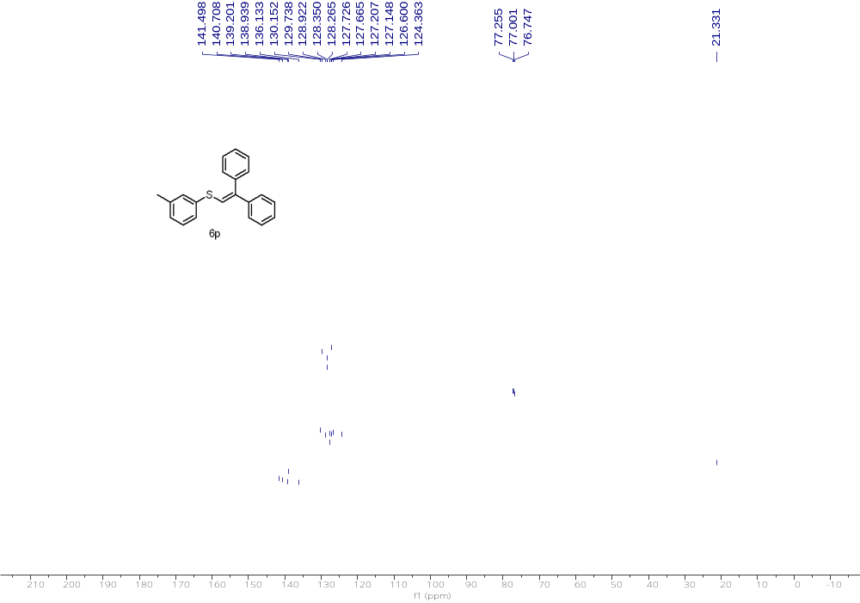
¹³C NMR (126 MHz, CDCl₃) of 6p

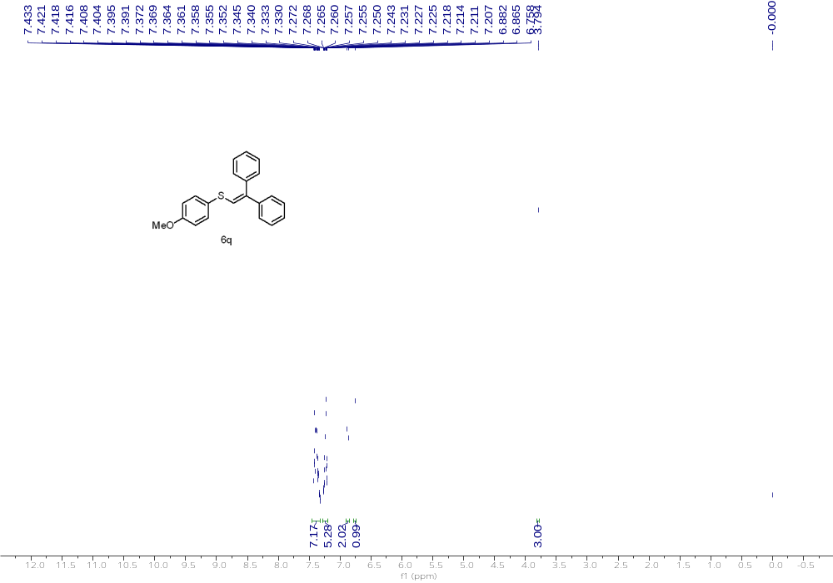
¹H NMR (500 MHz, CDCl₃) of 6q

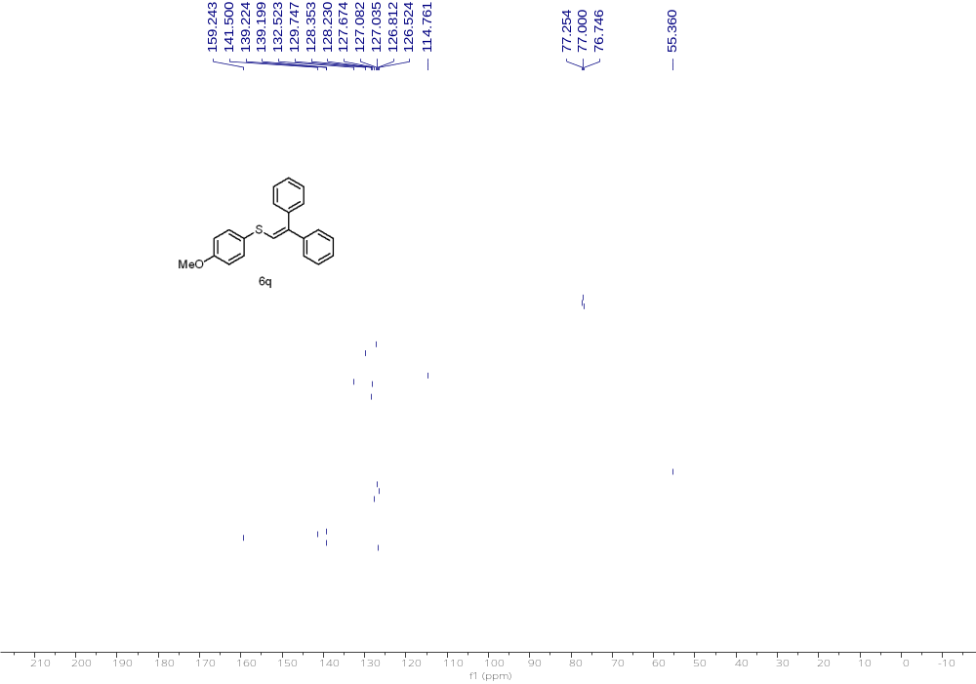
¹³C NMR (126 MHz, CDCl₃) of 6q

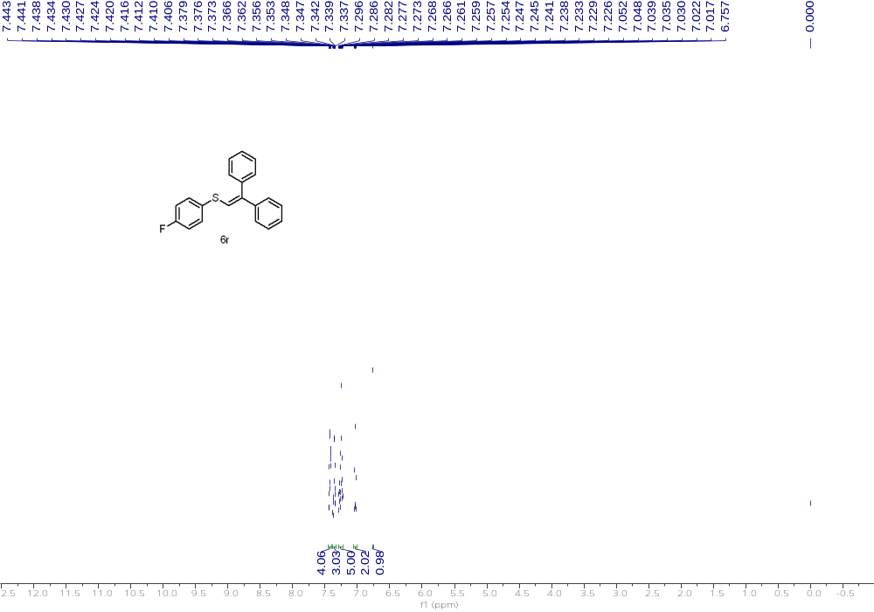
¹H NMR (500 MHz, CDCl₃) of 6r

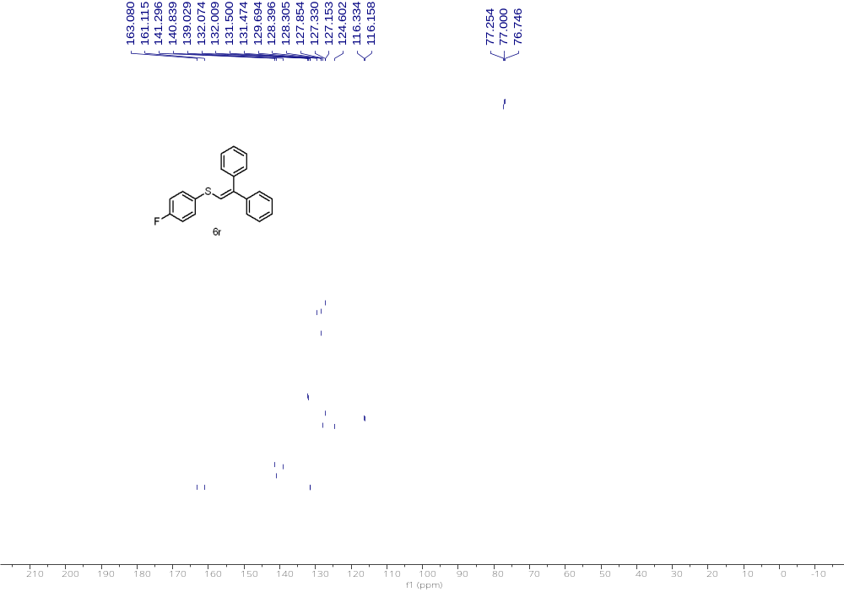
¹³C NMR (126 MHz, CDCl₃) of 6r

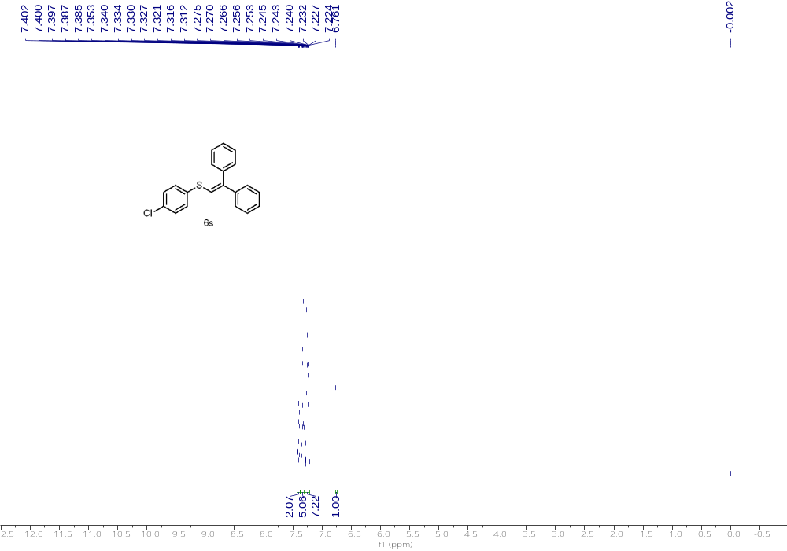
¹H NMR (500 MHz, CDCl₃) of 6s

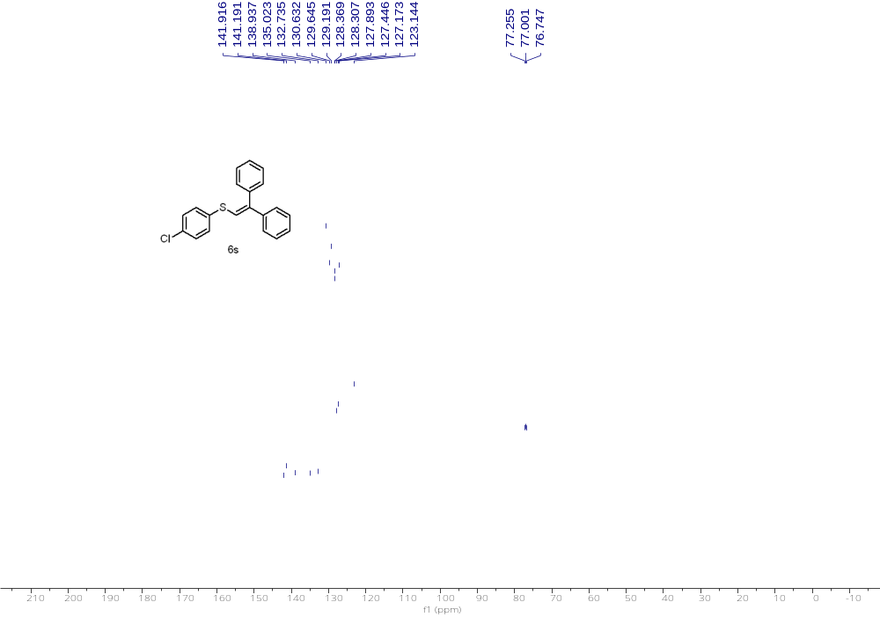
¹³C NMR (126 MHz, CDCl₃) of 6s

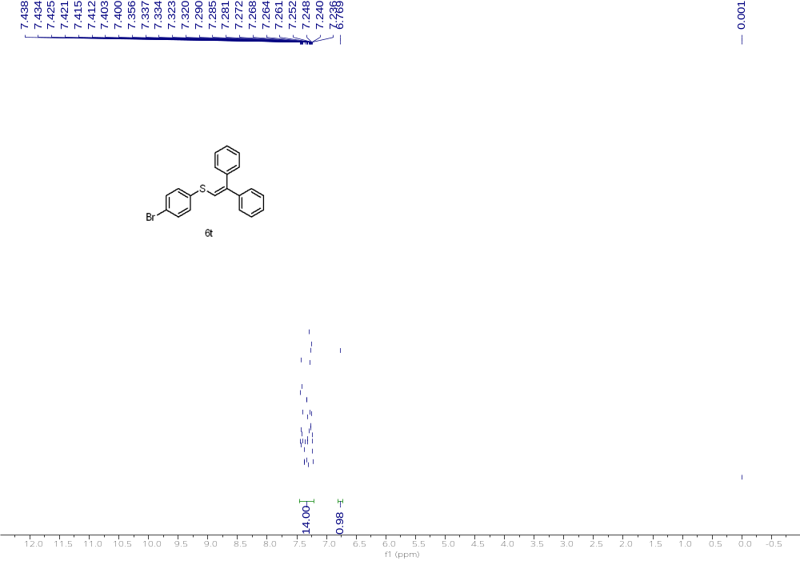
¹H NMR (500 MHz, CDCl₃) of 6t

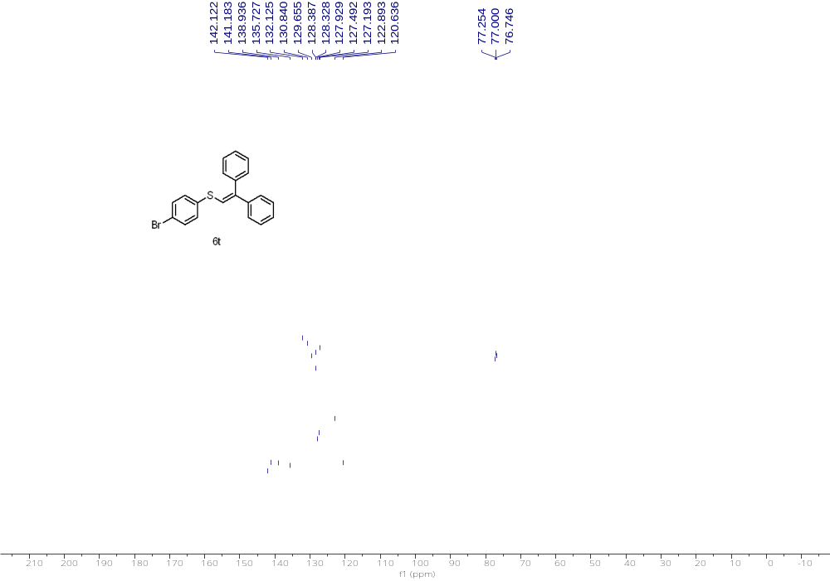
¹³C NMR (126 MHz, CDCl₃) of 6t

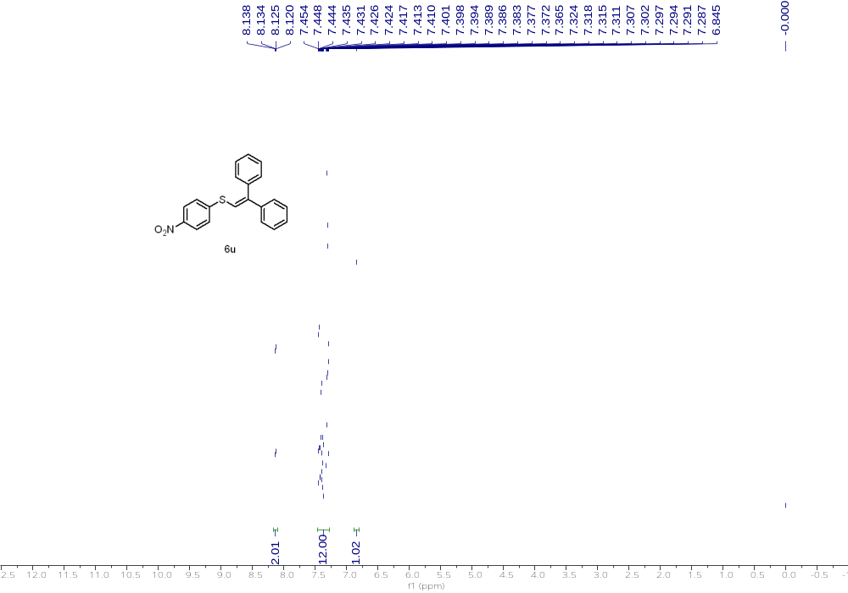
¹H NMR (500 MHz, CDCl₃) of 6u

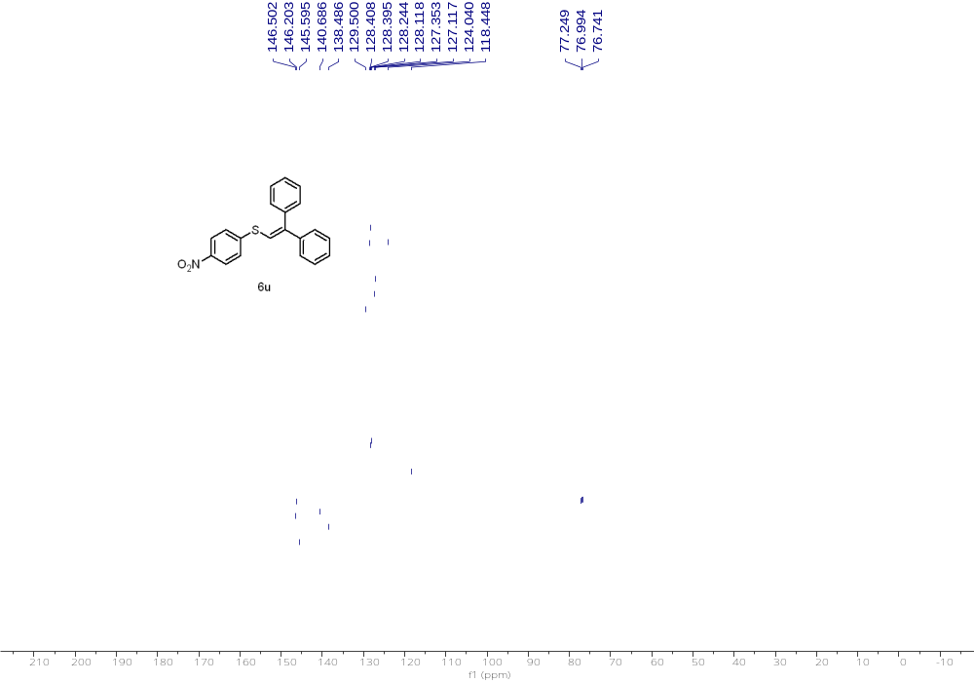
¹³C NMR (126 MHz, CDCl₃) of 6u

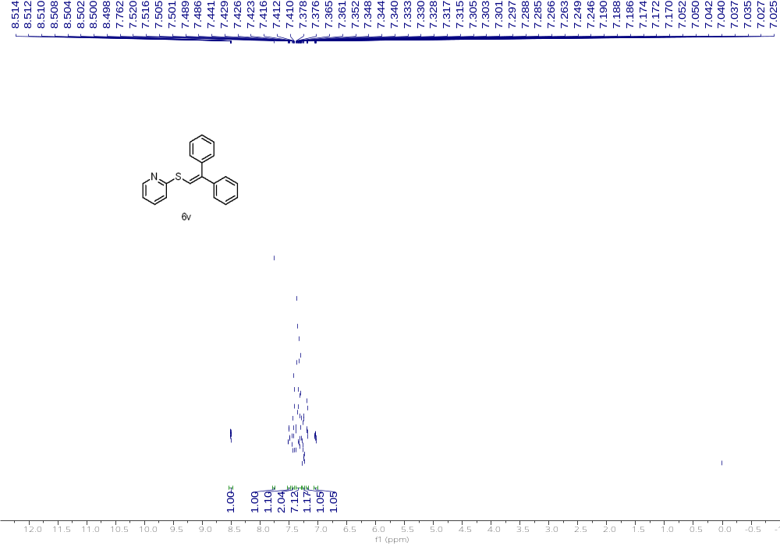
¹H NMR (500 MHz, CDCl₃) of 6v
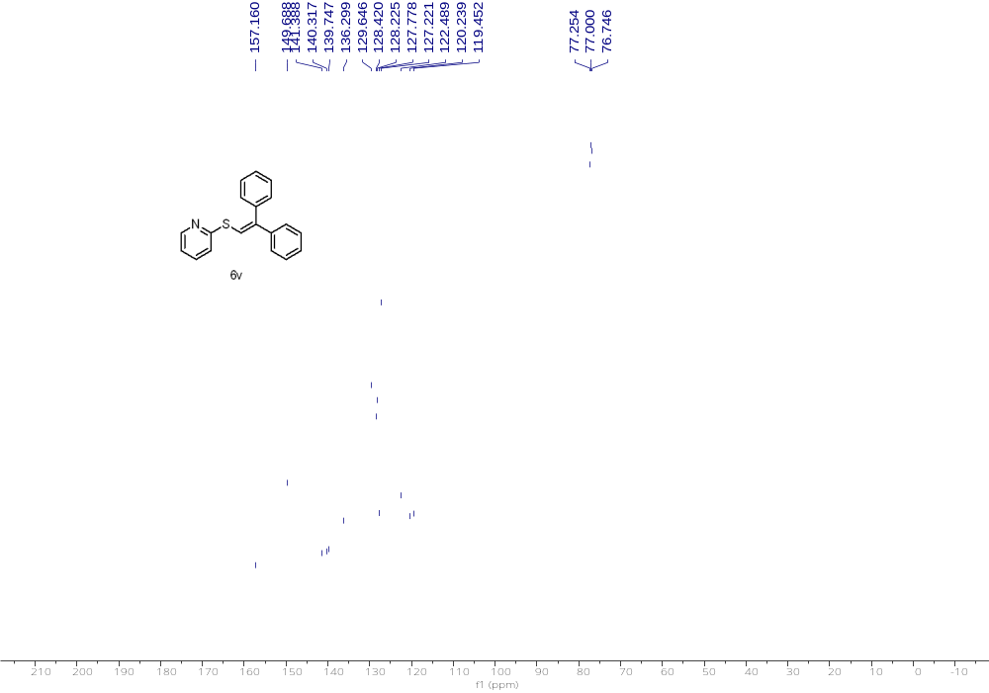
¹³C NMR (126 MHz, CDCl₃) of 6v

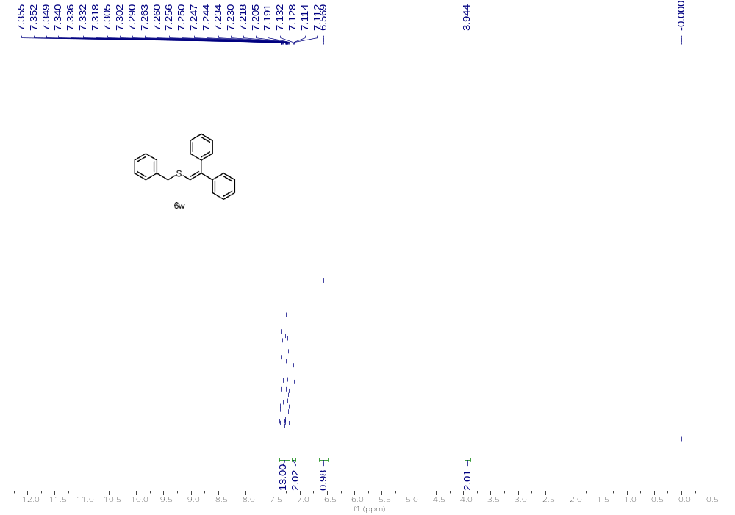
¹H NMR (500 MHz, CDCl₃) of 6w
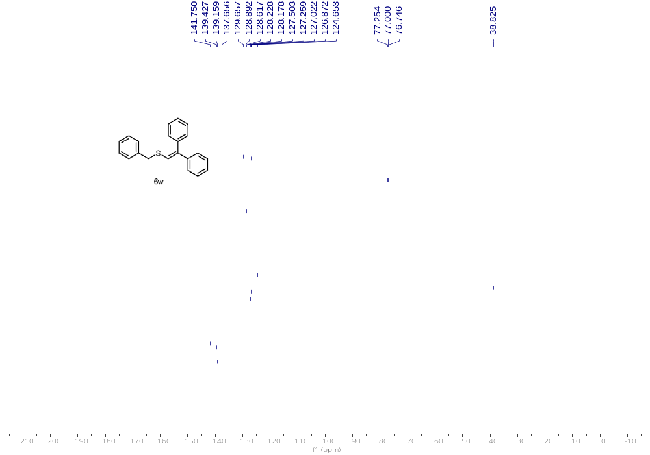
¹³C NMR (126 MHz, CDCl₃) of 6w

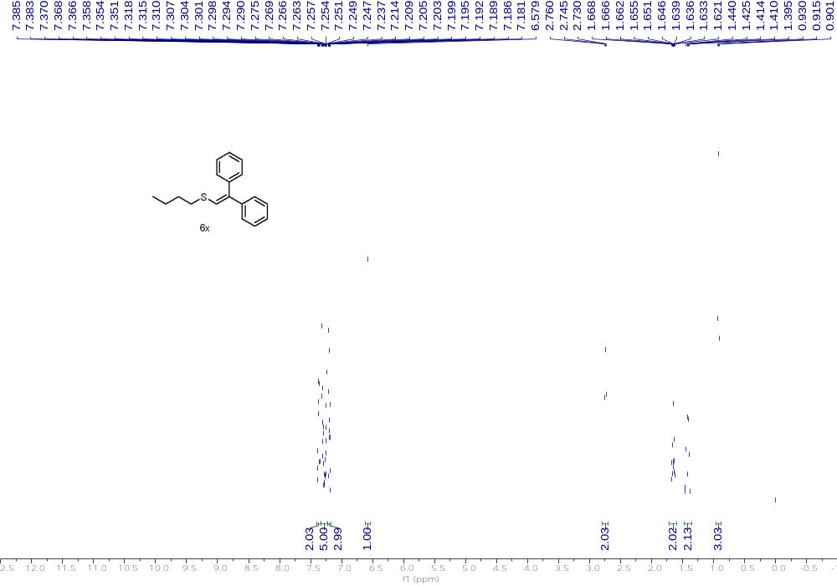
¹H NMR (500 MHz, CDCl₃) of 6x

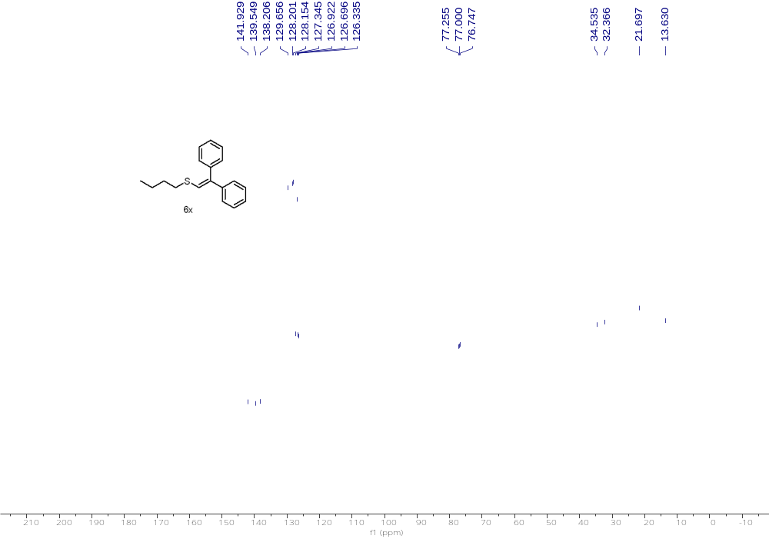
¹³C NMR (126 MHz, CDCl₃) of 6x

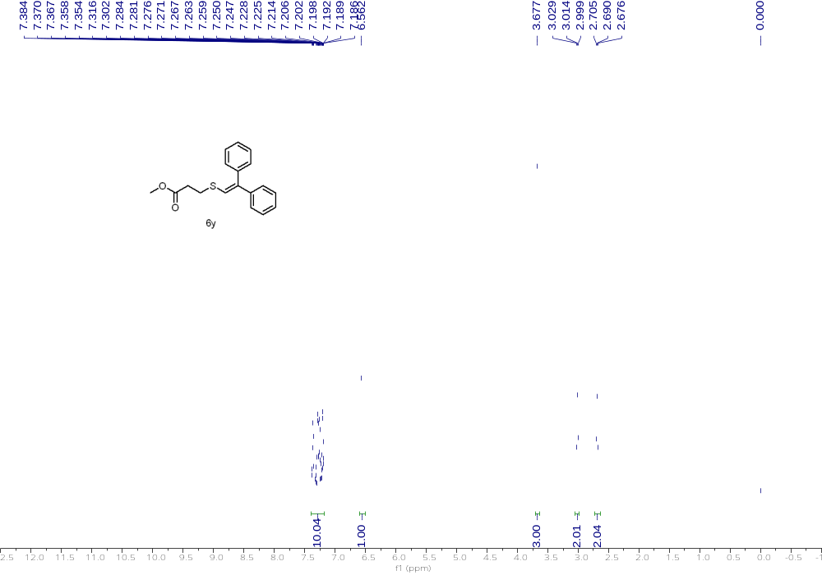
¹H NMR (500 MHz, CDCl₃) of 6y
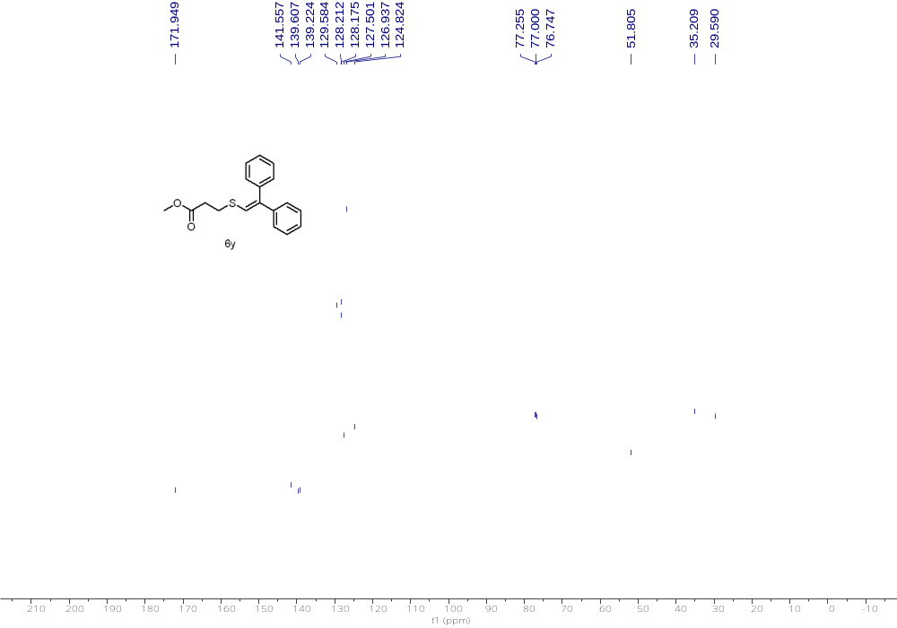
¹³C NMR (126 MHz, CDCl₃) of 6y

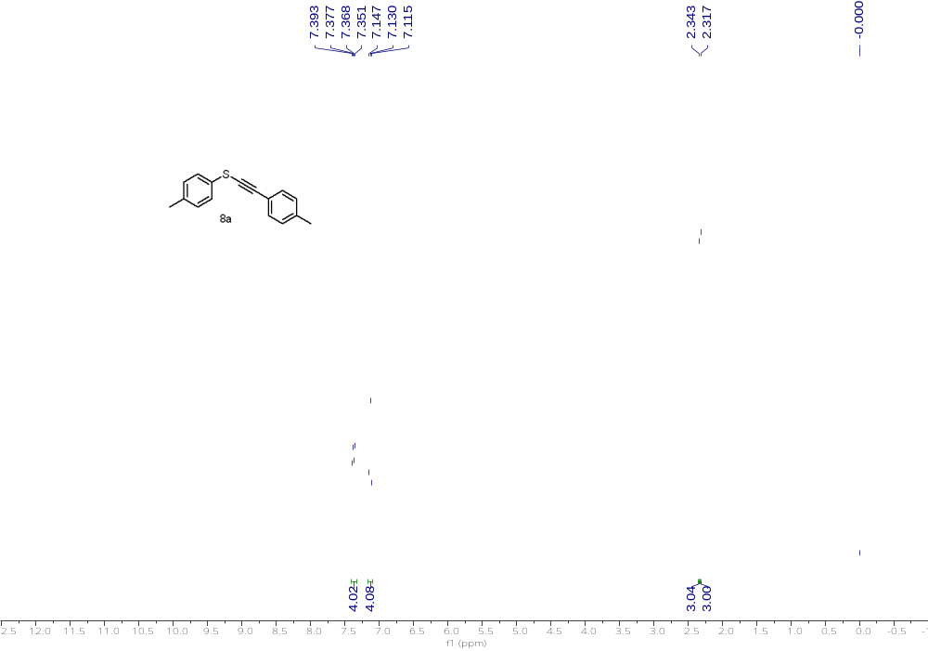
¹H NMR (500 MHz, CDCl₃) of 8a

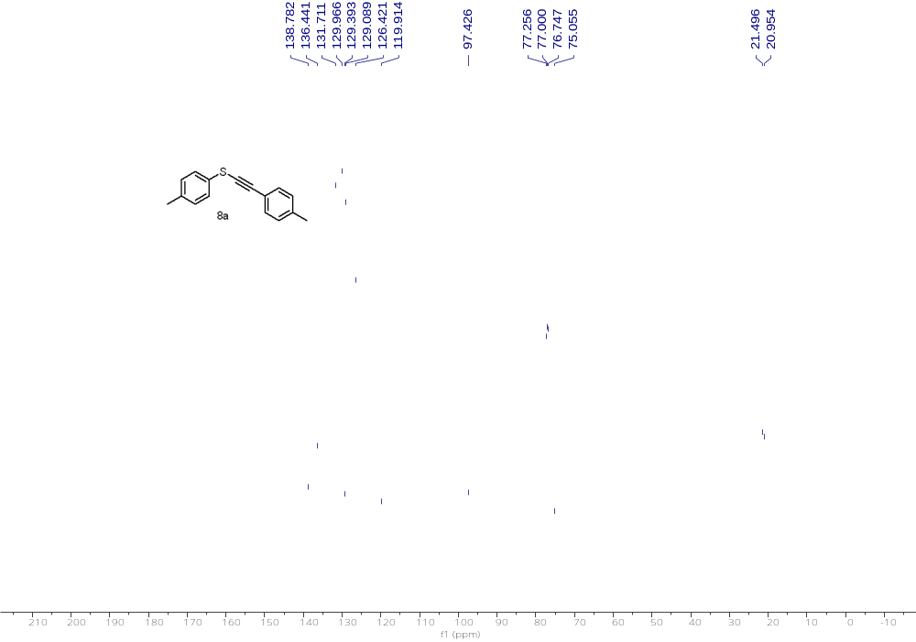
¹³C NMR (126 MHz, CDCl₃) of 8a

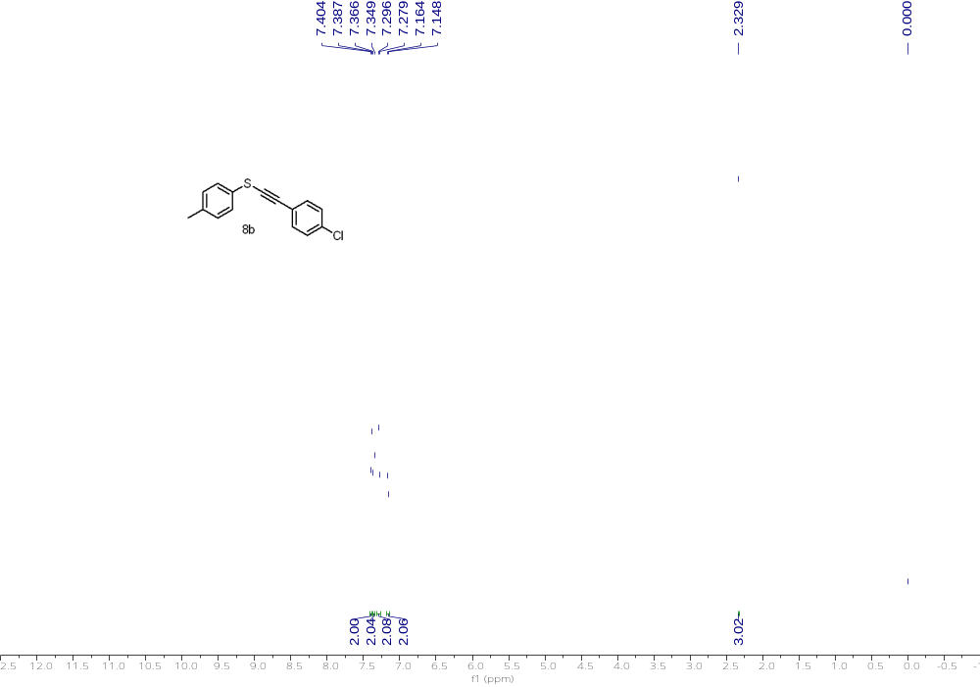
¹H NMR (500 MHz, CDCl₃) of 8b

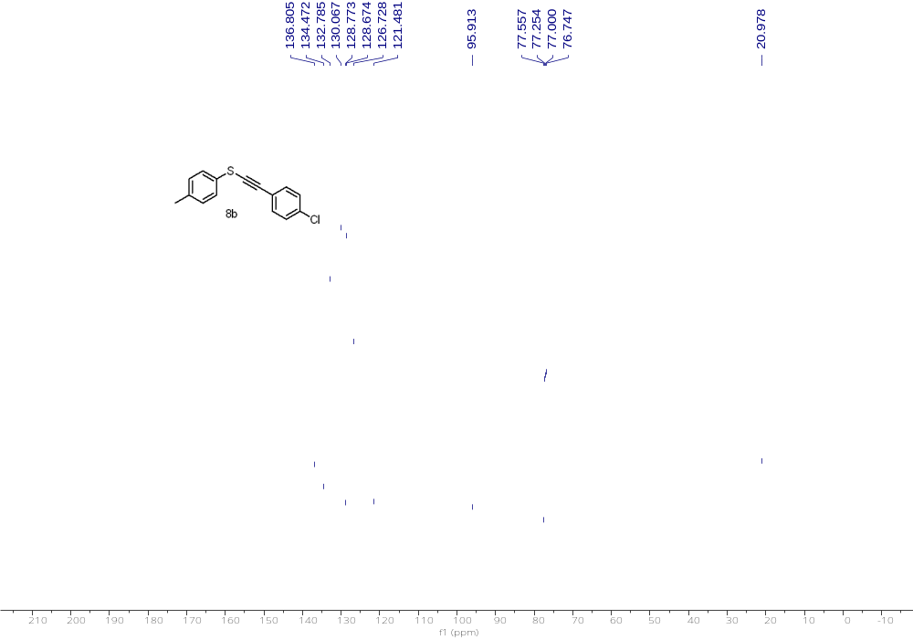
¹³C NMR (126 MHz, CDCl₃) of 8b

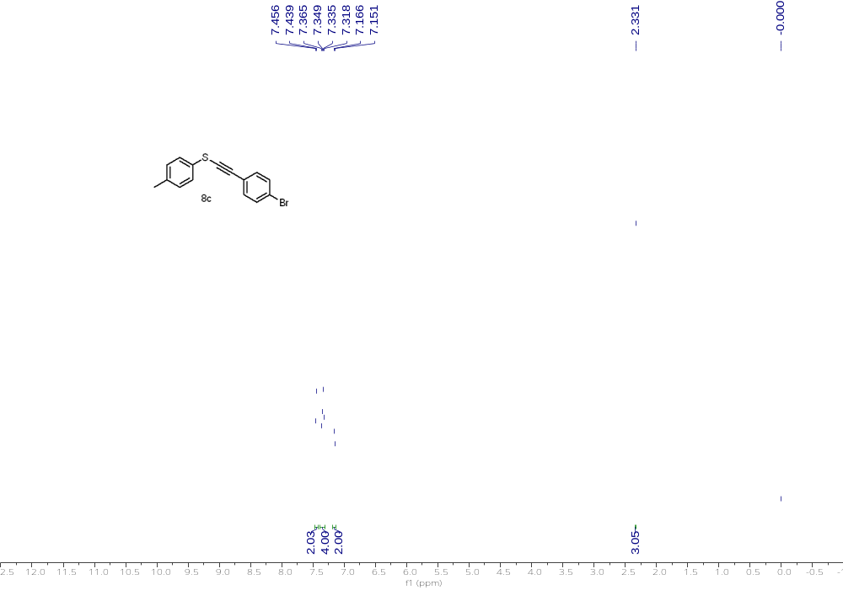
¹H NMR (500 MHz, CDCl₃) of 8c

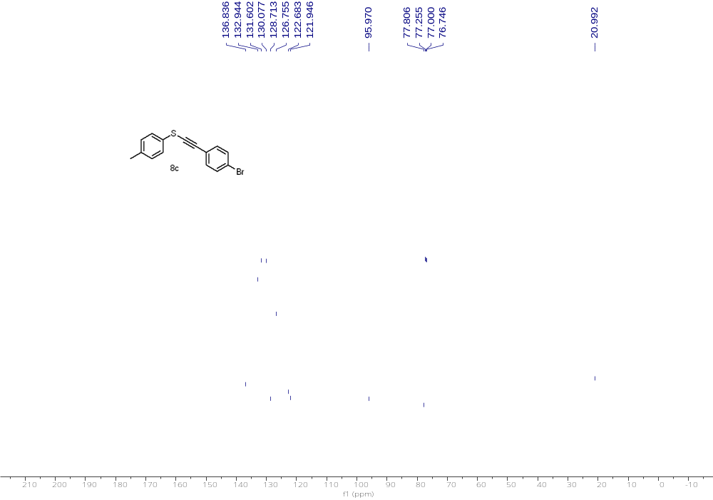
¹³C NMR (126 MHz, CDCl₃) of 8c

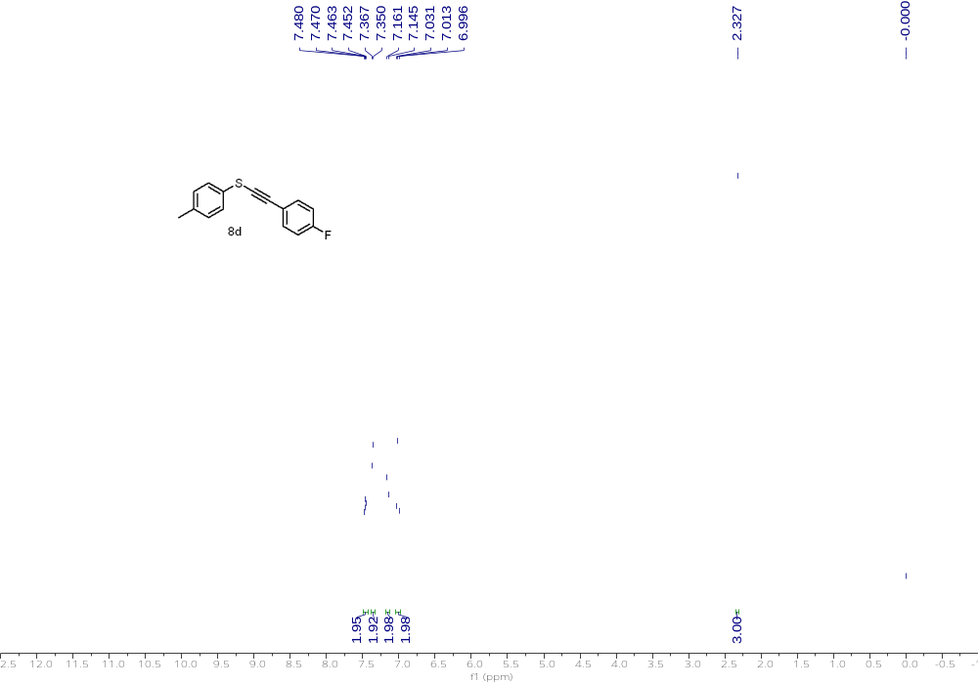
¹H NMR (500 MHz, CDCl₃) of 8d

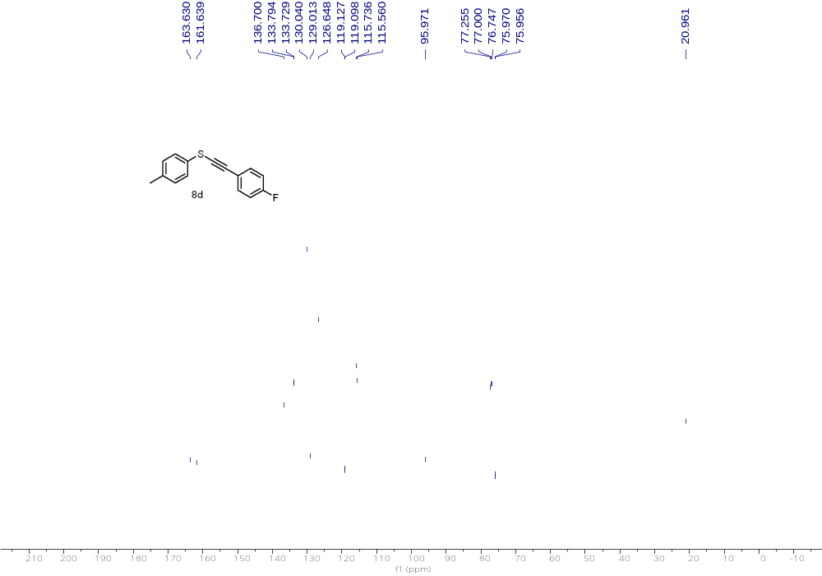
¹³C NMR (126 MHz, CDCl₃) of 8d

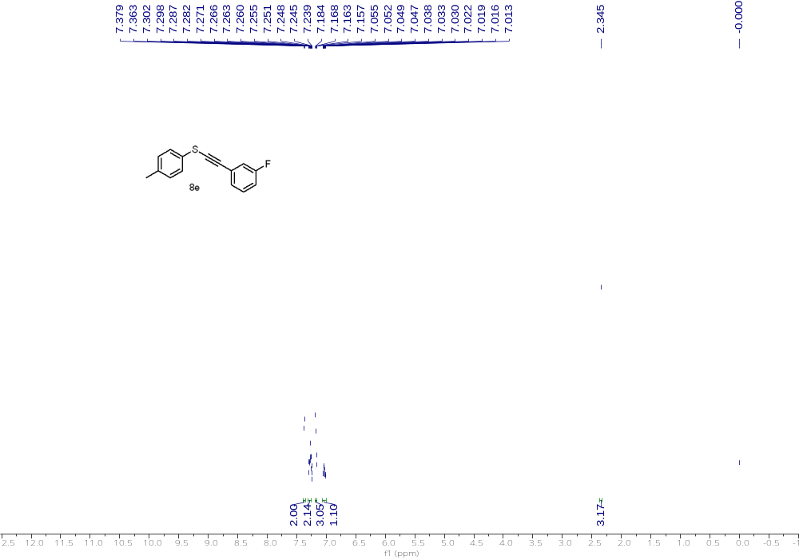
¹H NMR (500 MHz, CDCl₃) of 8e

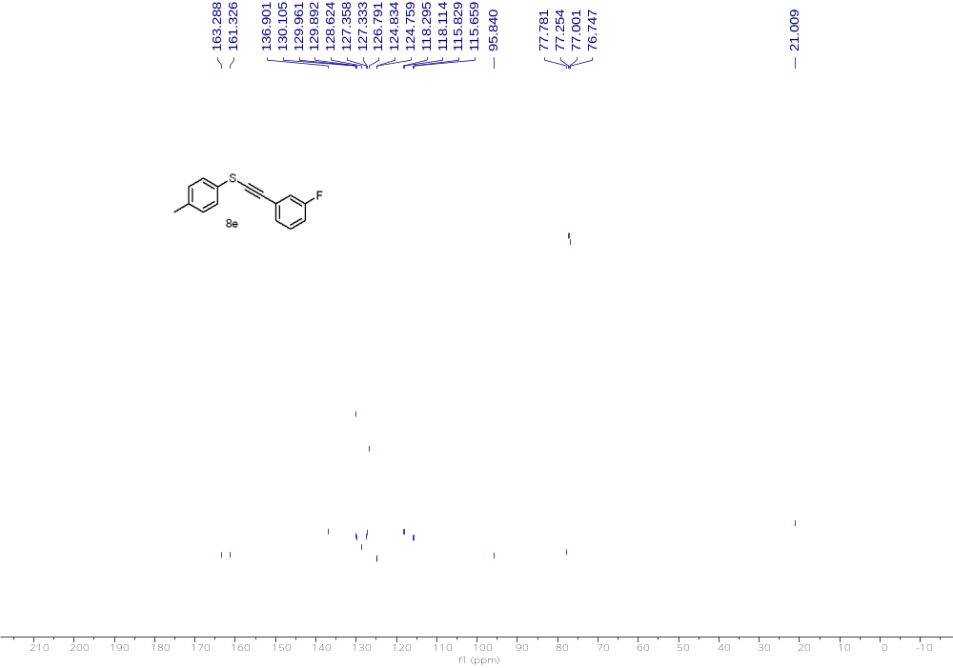
¹³C NMR (126 MHz, CDCl₃) of 8e

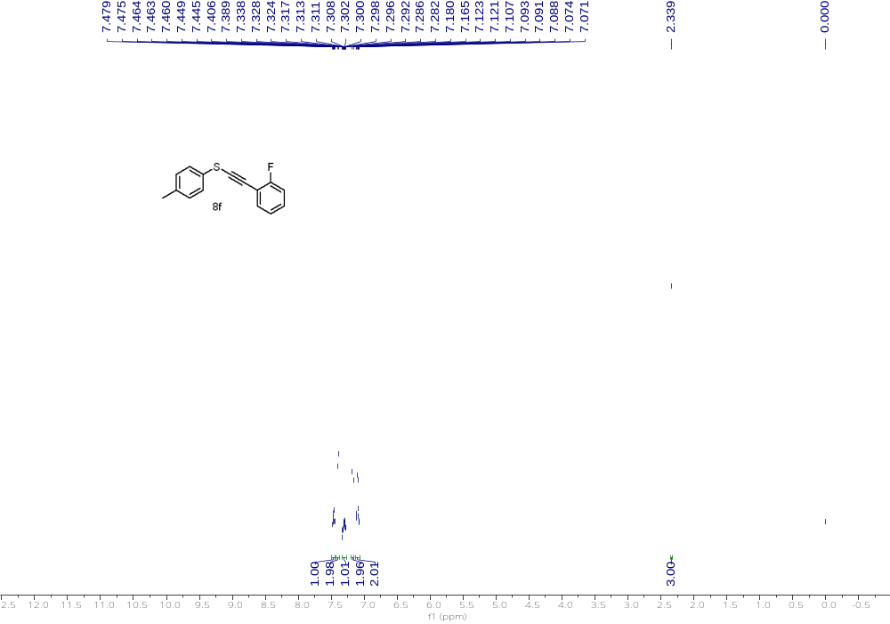
¹H NMR (500 MHz, CDCl₃) of 8f

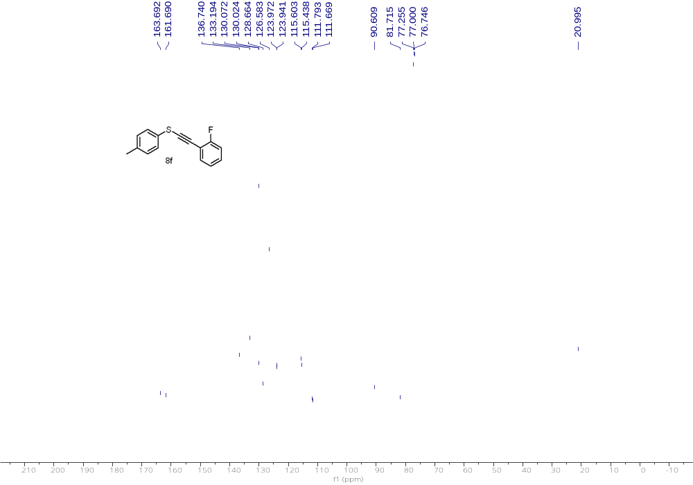
¹³C NMR (126 MHz, CDCl₃) of 8f

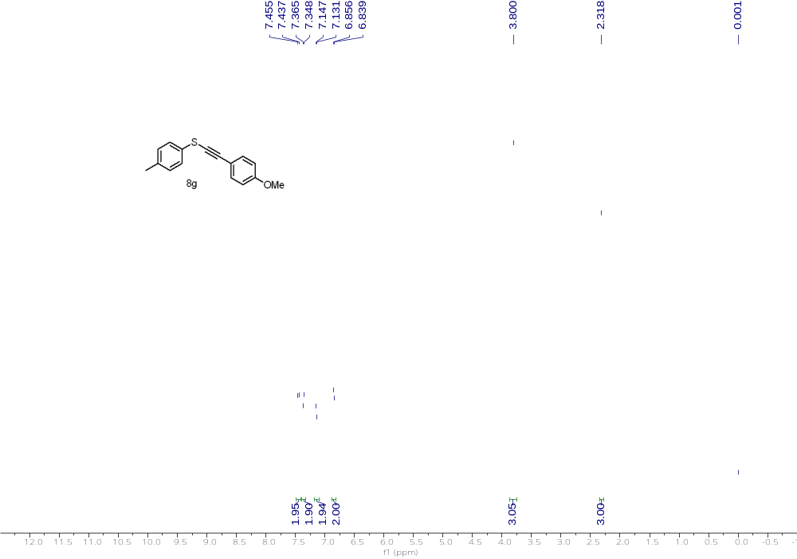
¹H NMR (500 MHz, CDCl₃) of 8g

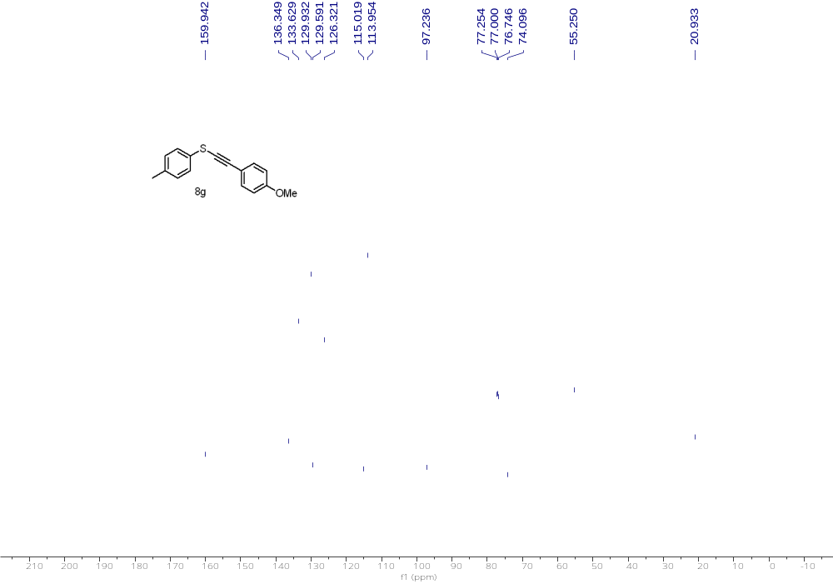
¹³C NMR (126 MHz, CDCl₃) of 8g

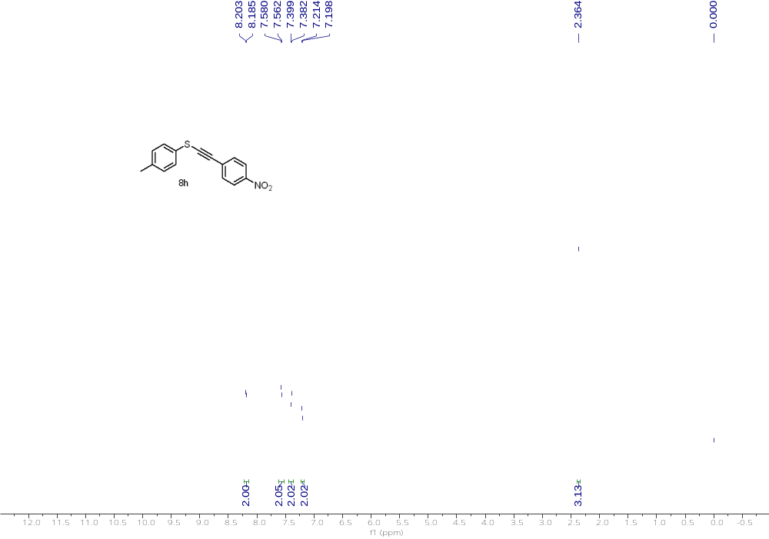
¹H NMR (500 MHz, CDCl₃) of 8h

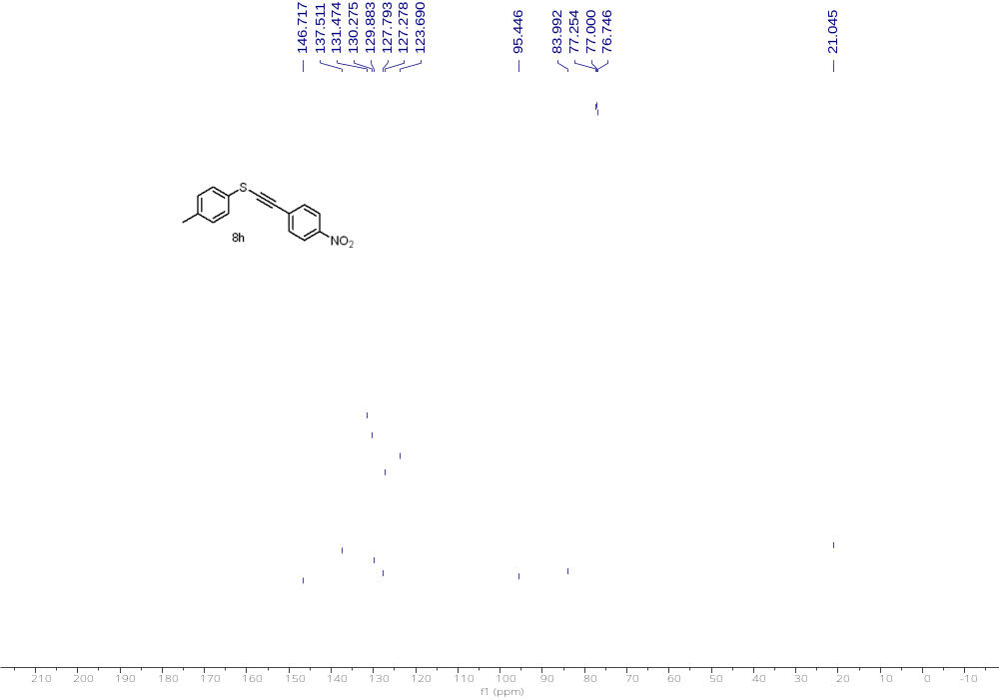

¹³C NMR (126 MHz, CDCl₃) of 8h

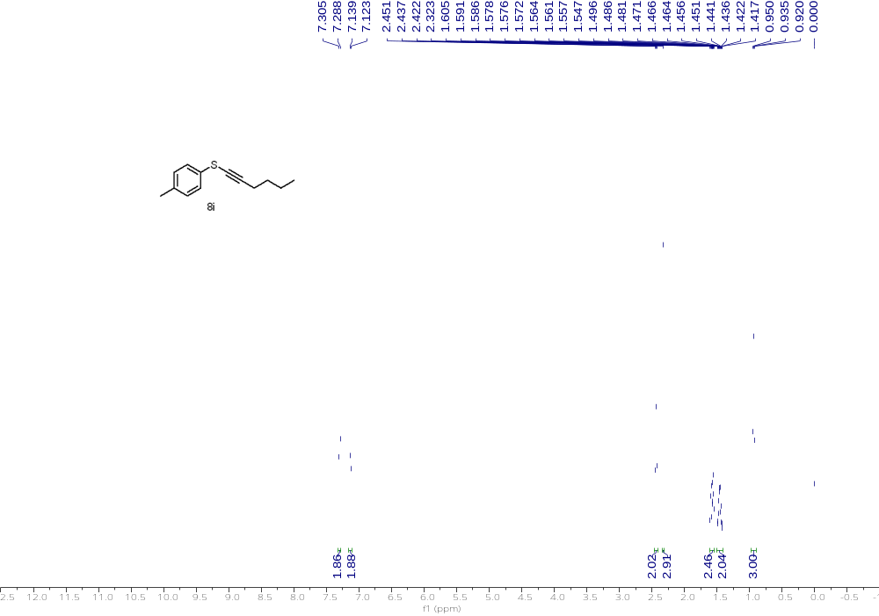
¹H NMR (500 MHz, CDCl₃) of 8i

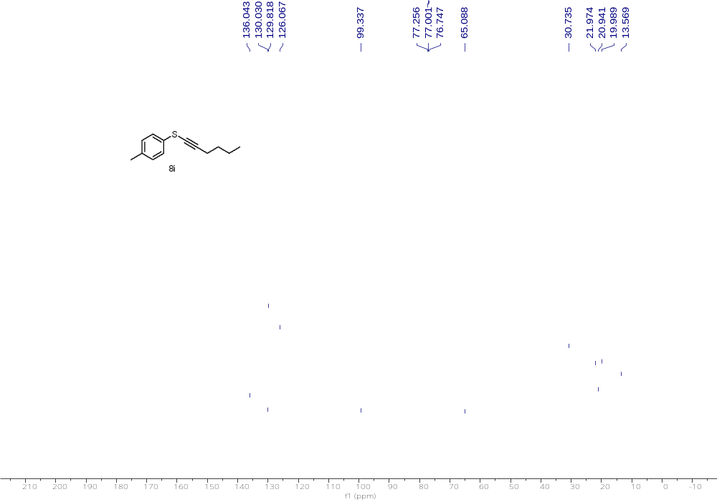
¹³C NMR (126 MHz, CDCl₃) of 8i

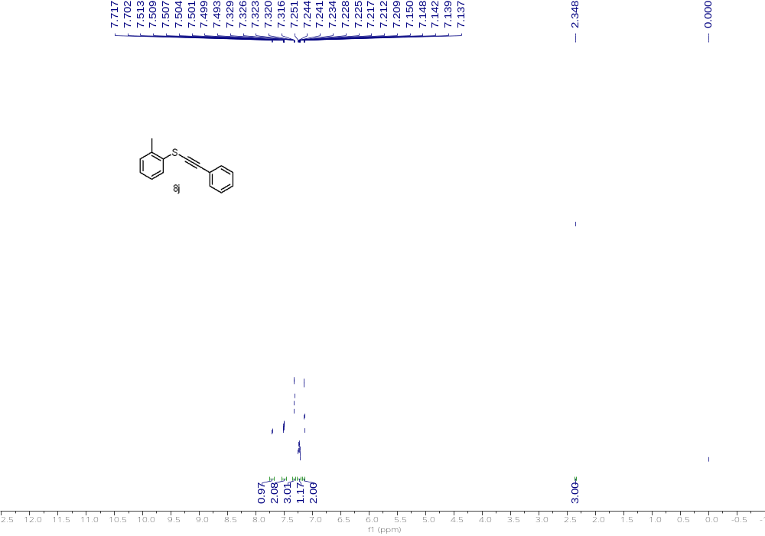
¹H NMR (500 MHz, CDCl₃) of 8j

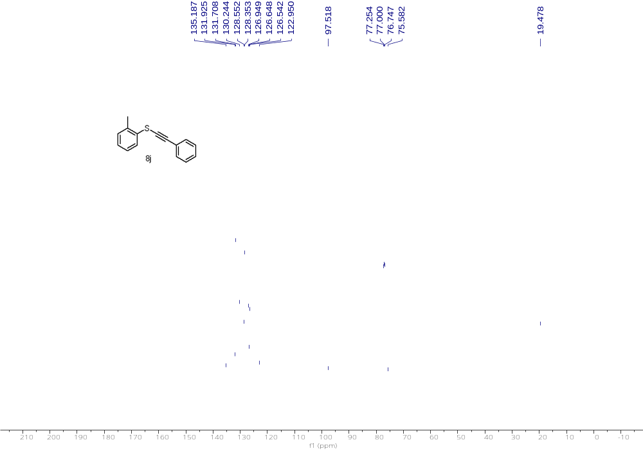

¹³C NMR (126 MHz, CDCl₃) of 8j

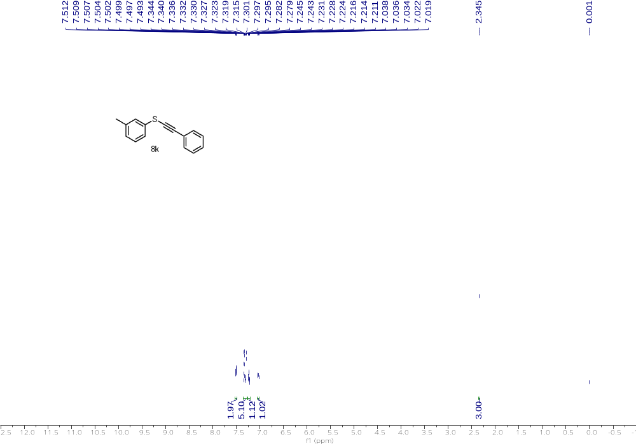
¹H NMR (500 MHz, CDCl₃) of 8k

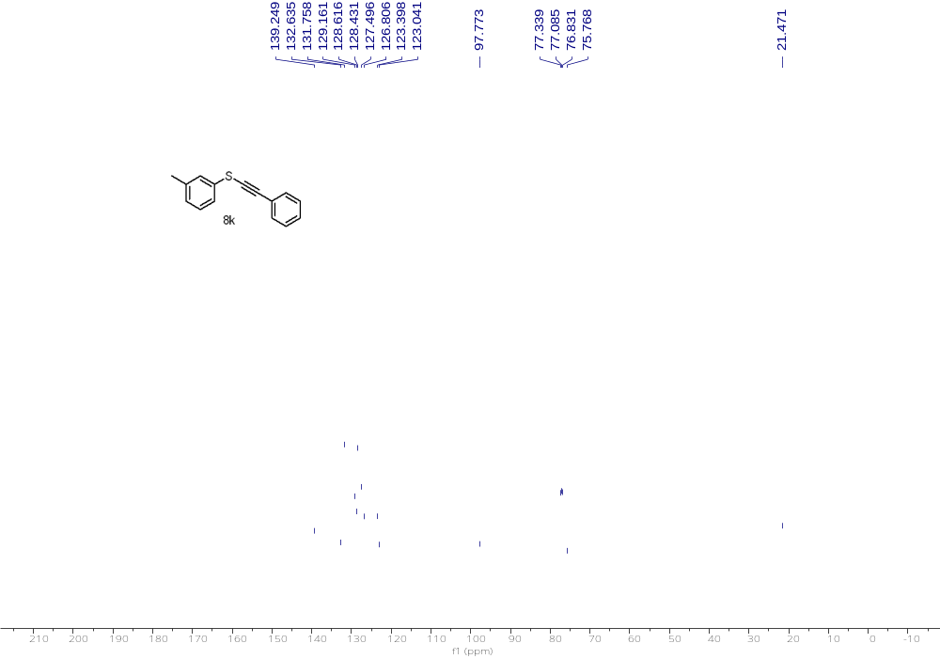

¹³C NMR (126 MHz, CDCl₃) of 8k

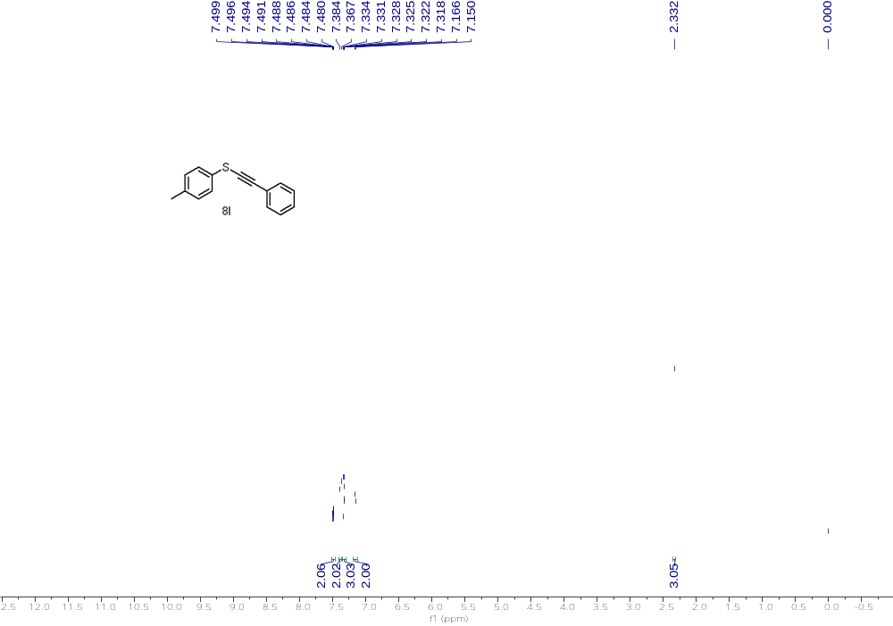
¹H NMR (500 MHz, CDCl₃) of 8l

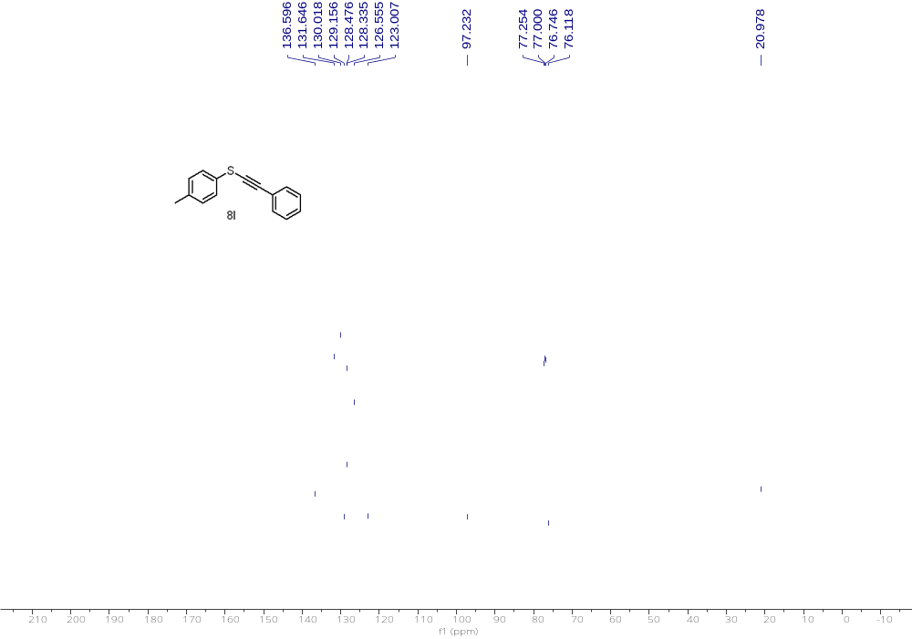
¹³C NMR (126 MHz, CDCl₃) of 8l

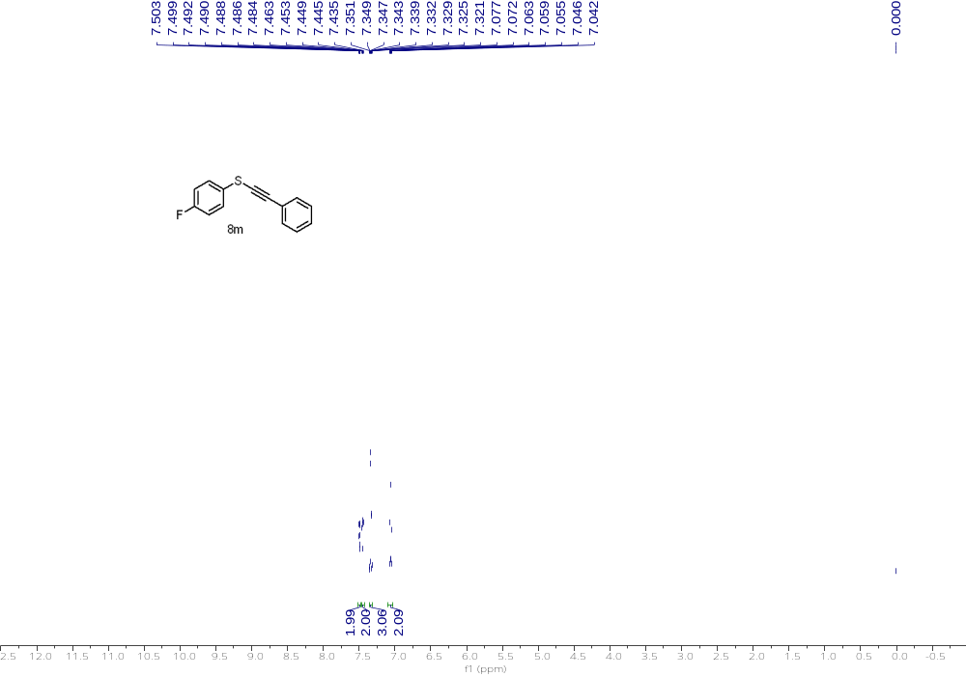
¹H NMR (500 MHz, CDCl₃) of 8m

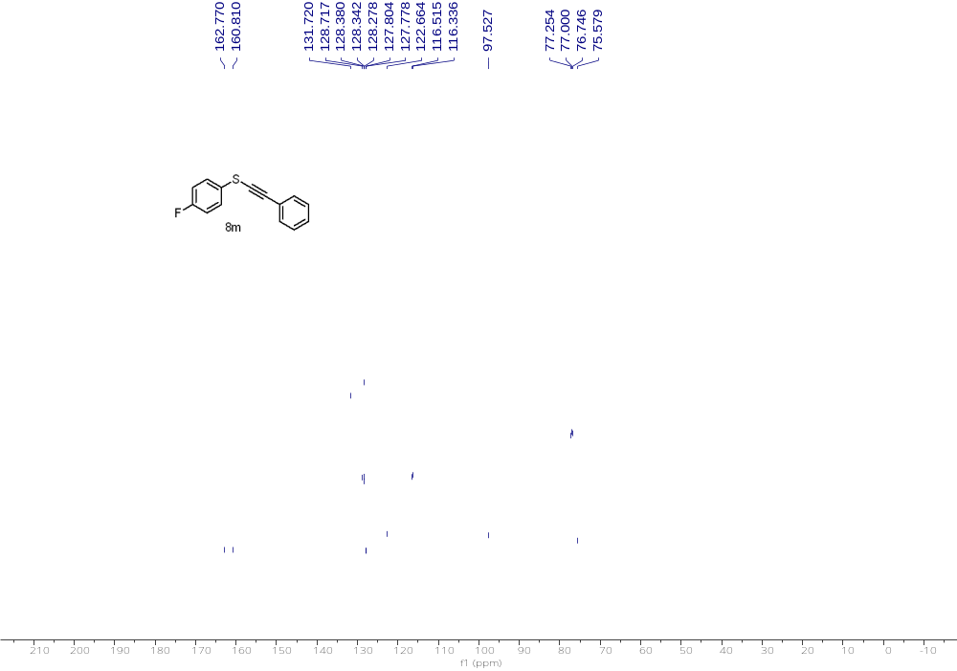
¹³C NMR (126 MHz, CDCl₃) of 8m

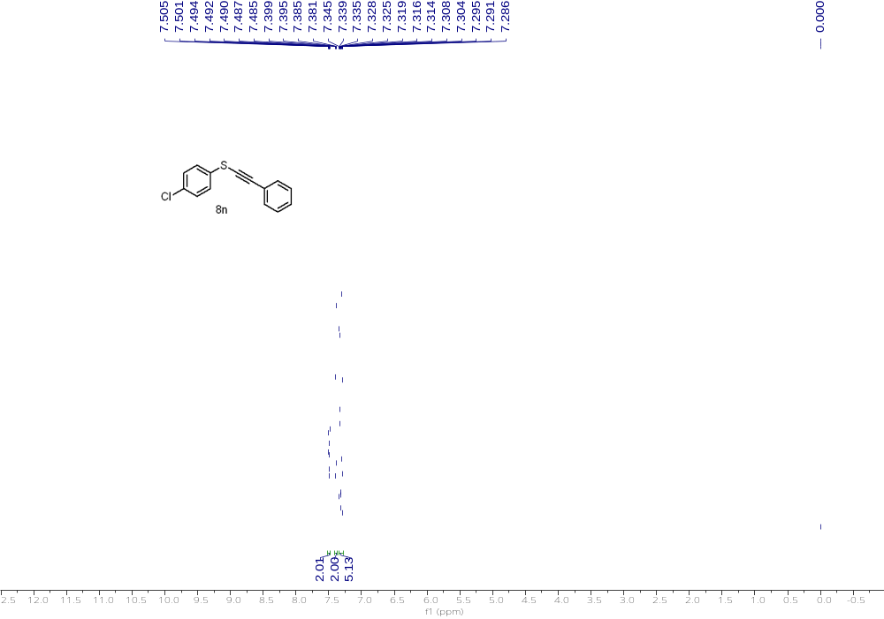
¹H NMR (500 MHz, CDCl₃) of 8n

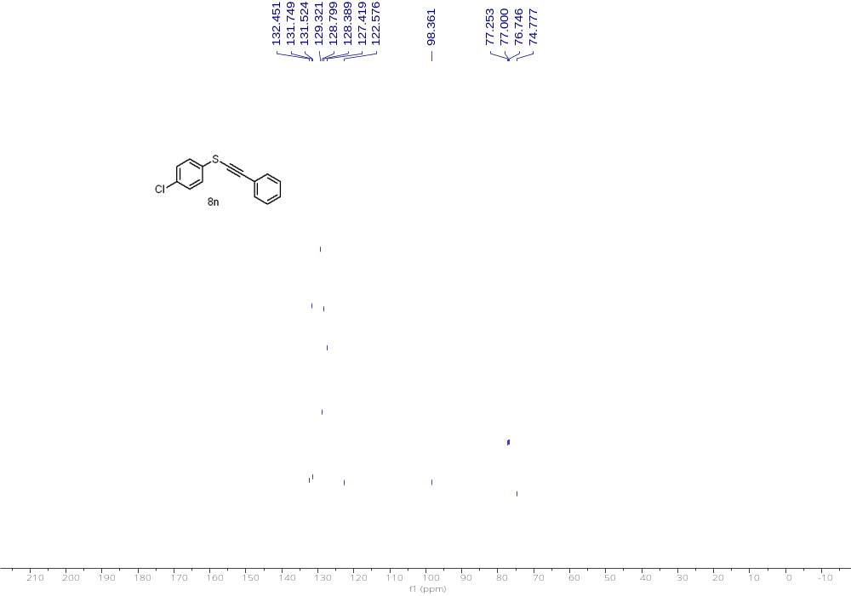
¹³C NMR (126 MHz, CDCl₃) of 8n

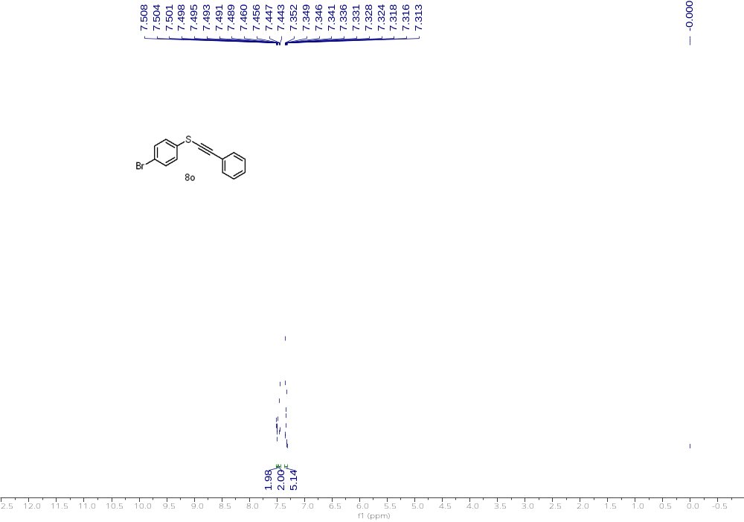
¹H NMR (500 MHz, CDCl₃) of 8o

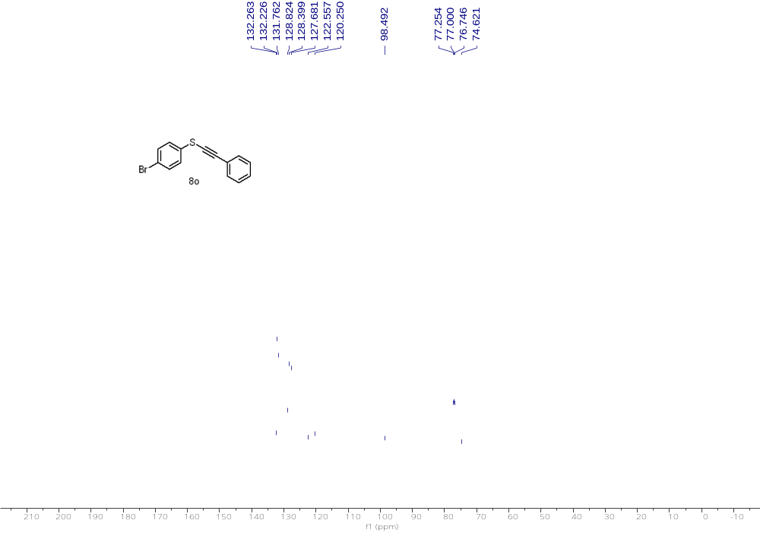
¹³C NMR (126 MHz, CDCl₃) of 8o

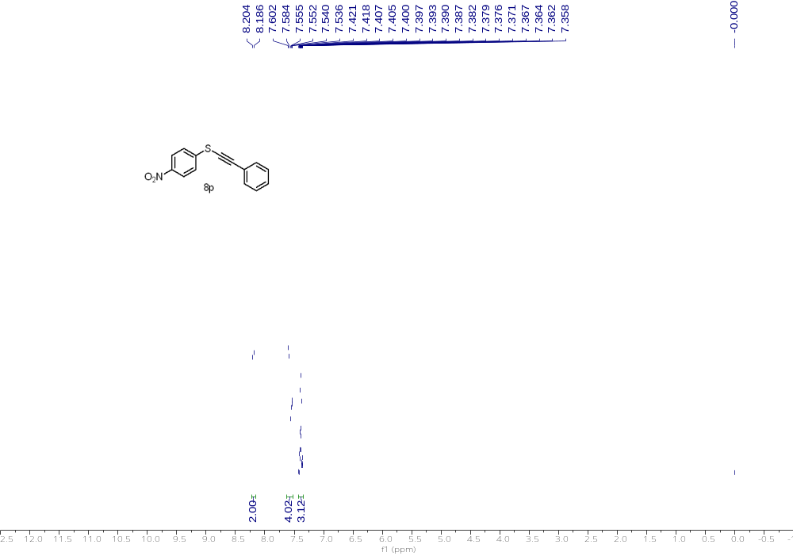
¹H NMR (500 MHz, CDCl₃) of 8p

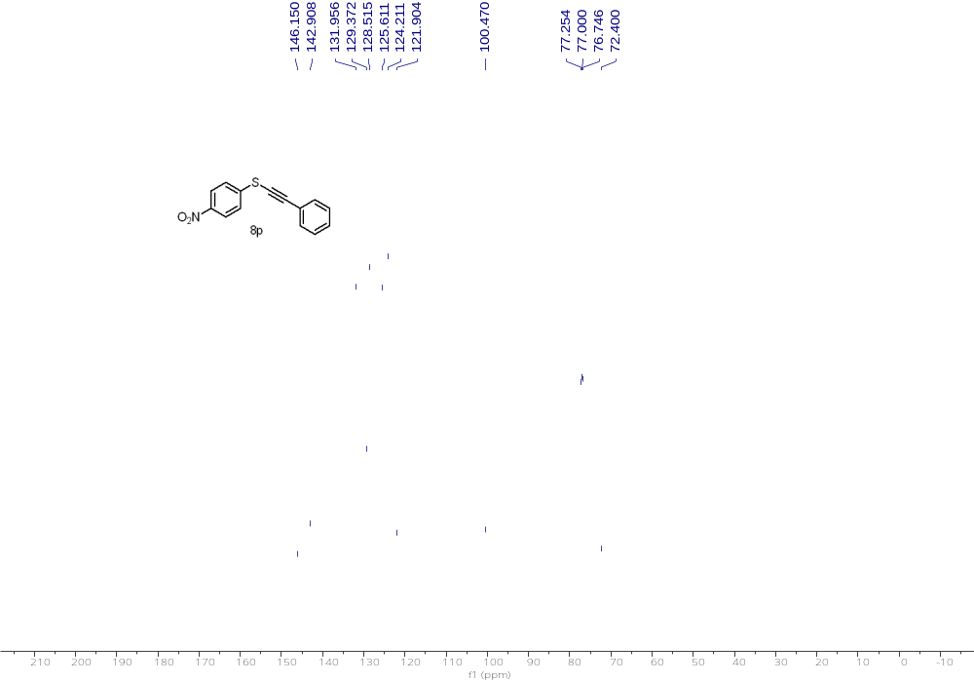
¹³C NMR (126 MHz, CDCl₃) of 8p

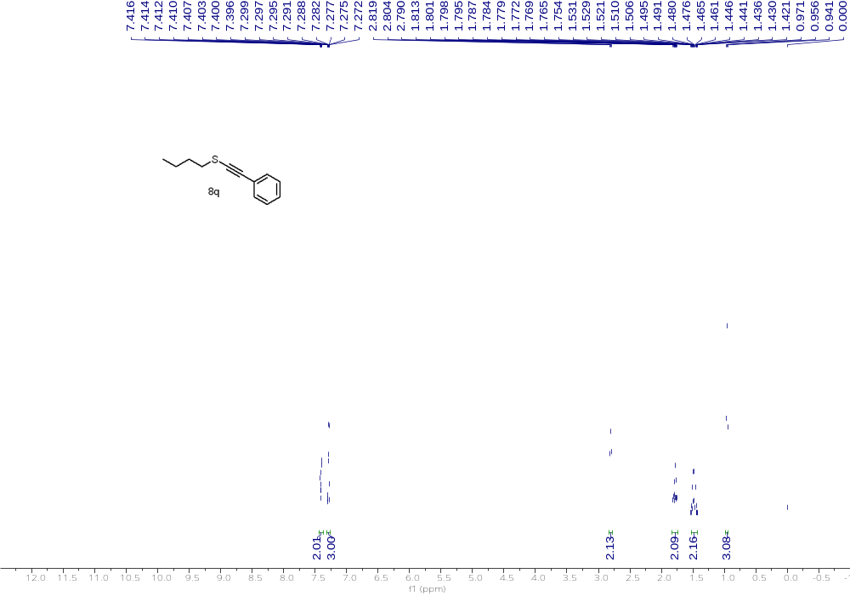
¹H NMR (500 MHz, CDCl₃) of 8q

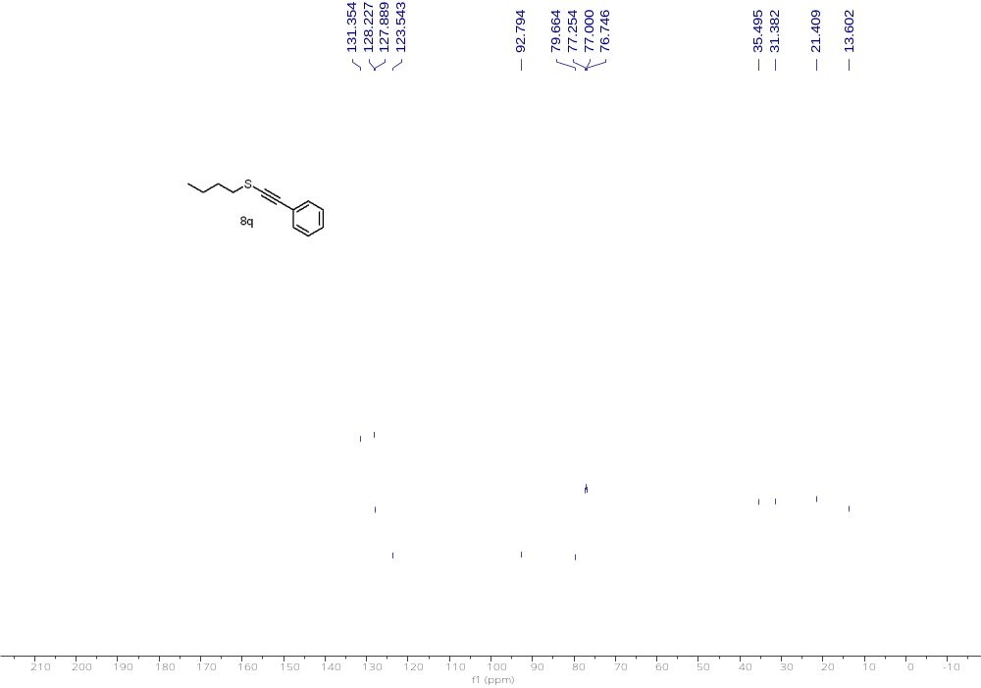
¹³C NMR (126 MHz, CDCl₃) of 8q

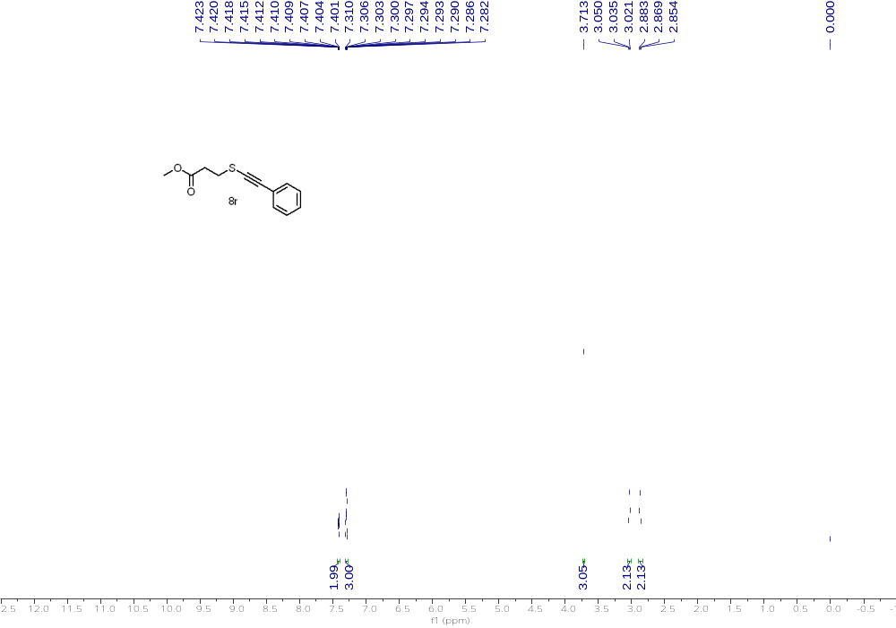
¹H NMR (500 MHz, CDCl₃) of 8r

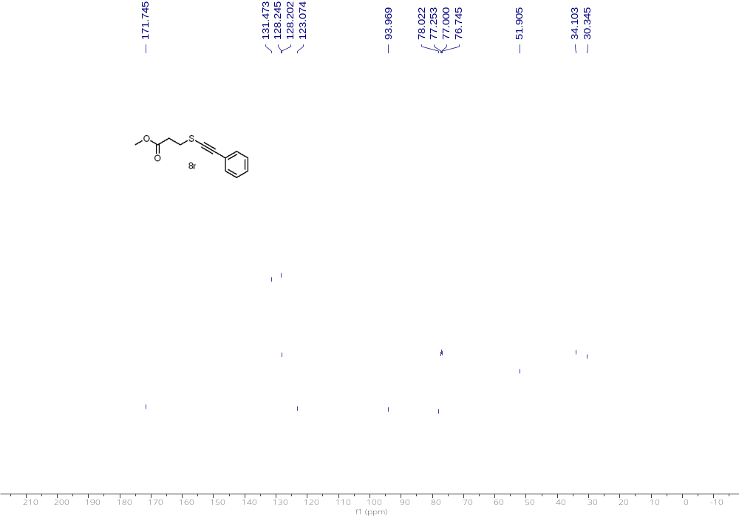
¹³C NMR (126 MHz, CDCl₃) of 8r

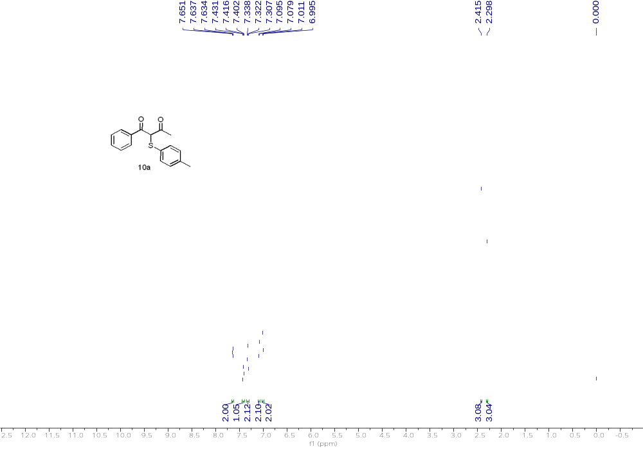
¹H NMR (500 MHz, CDCl₃) of 10a

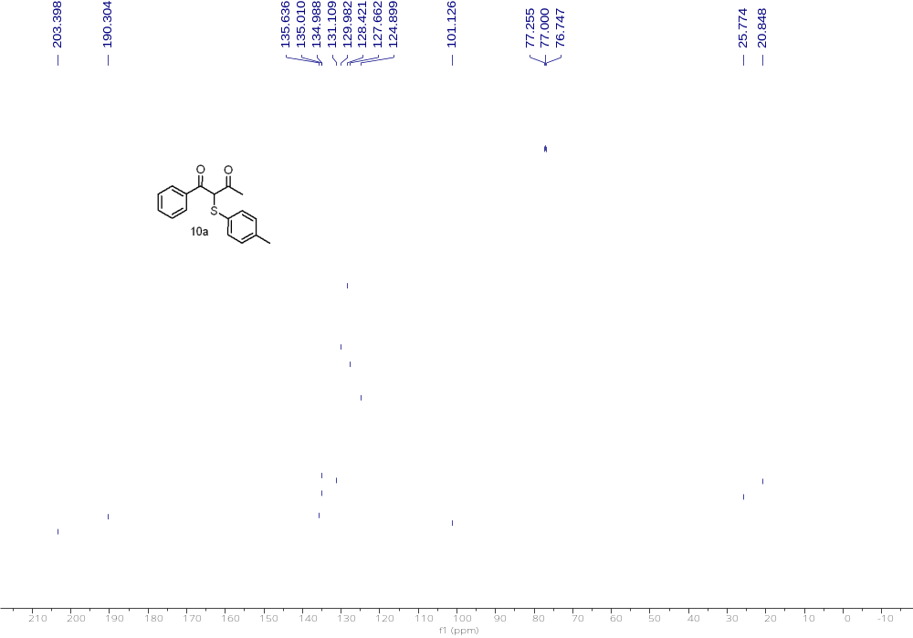
¹³C NMR (126 MHz, CDCl₃) of 10a

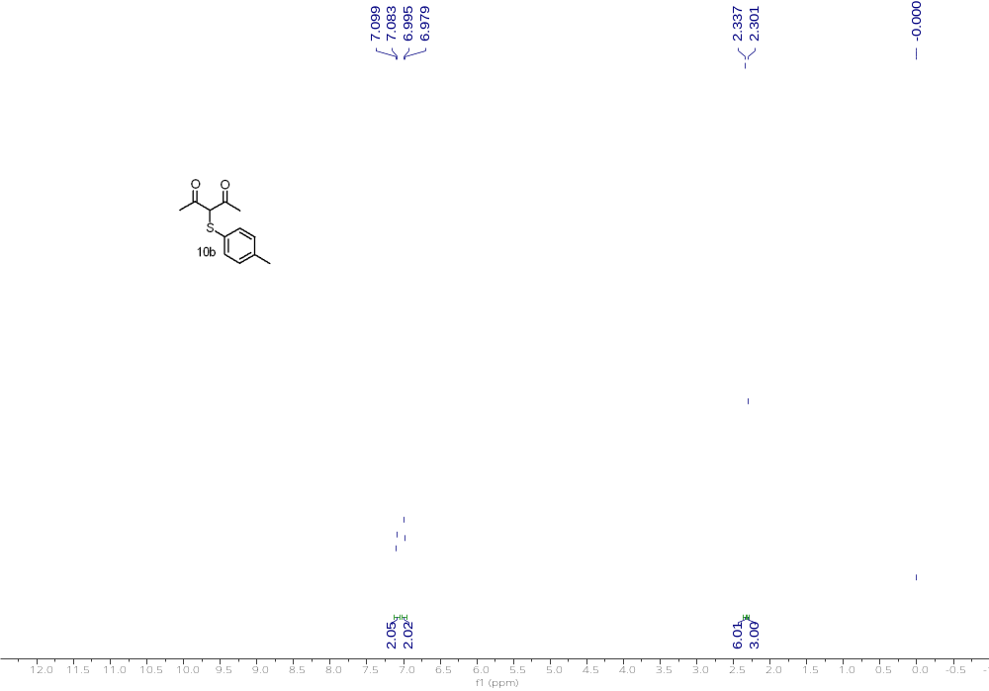

¹H NMR (500 MHz, CDCl₃) of 10b

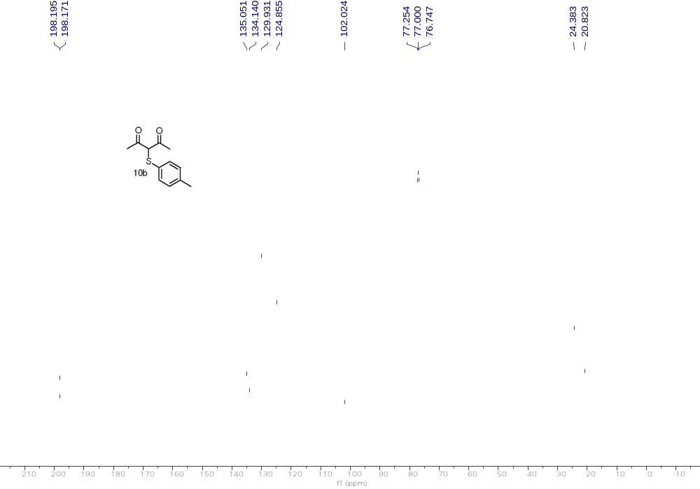

¹³C NMR (126 MHz, CDCl₃) of 10b

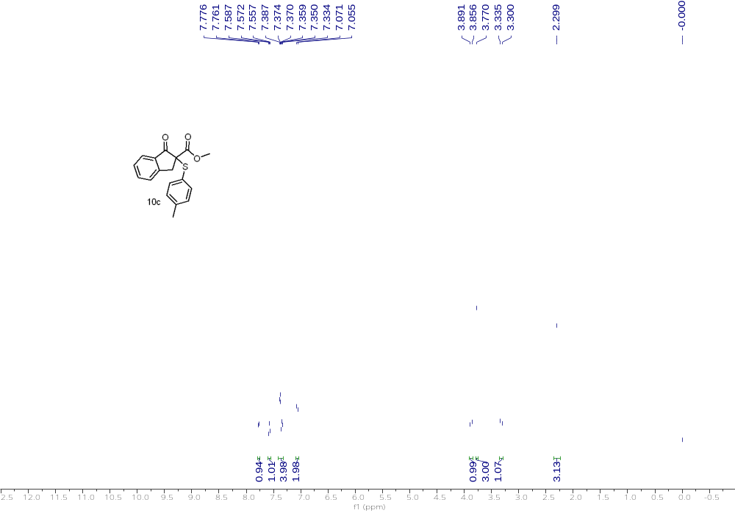
¹H NMR (500 MHz, CDCl₃) of 10c

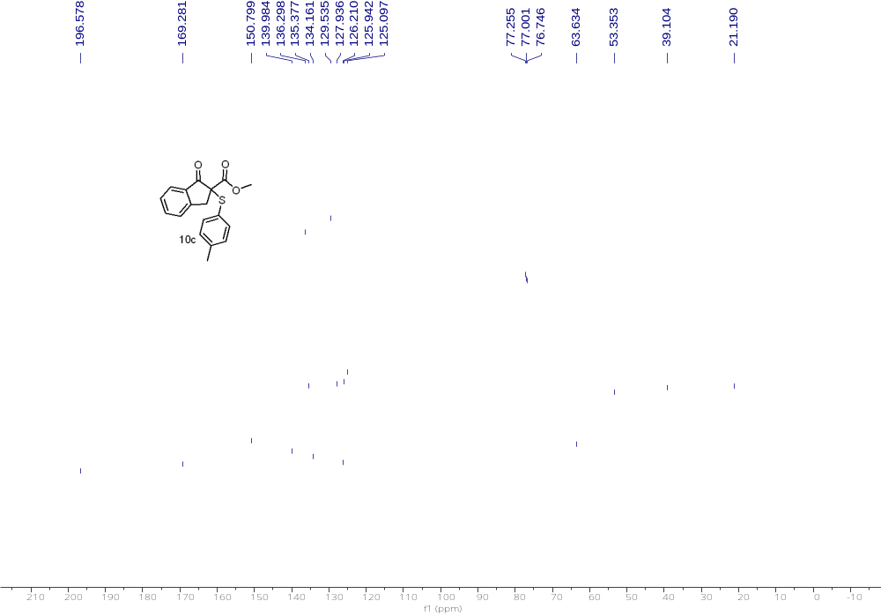
¹³C NMR (126 MHz, CDCl₃) of 10c

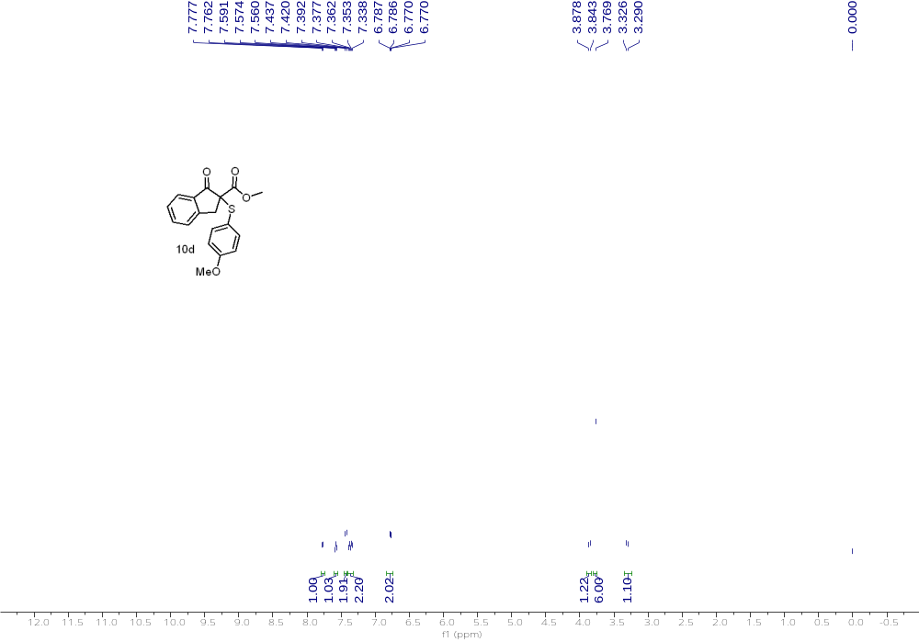
¹H NMR (500 MHz, CDCl₃) of 10d

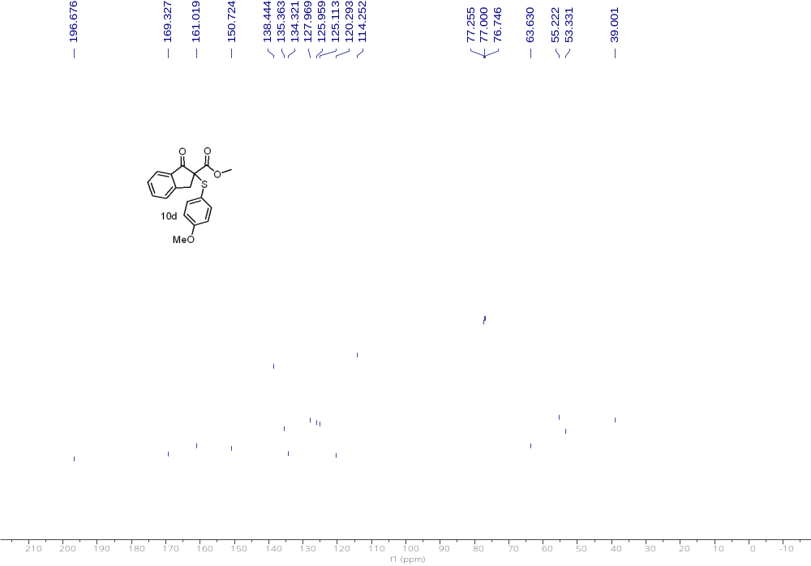
¹³C NMR (126 MHz, CDCl₃) of 10d

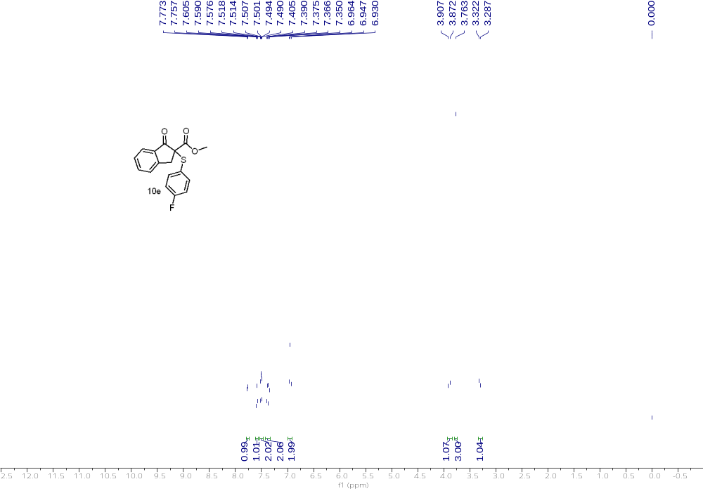
¹H NMR (500 MHz, CDCl₃) of 10e

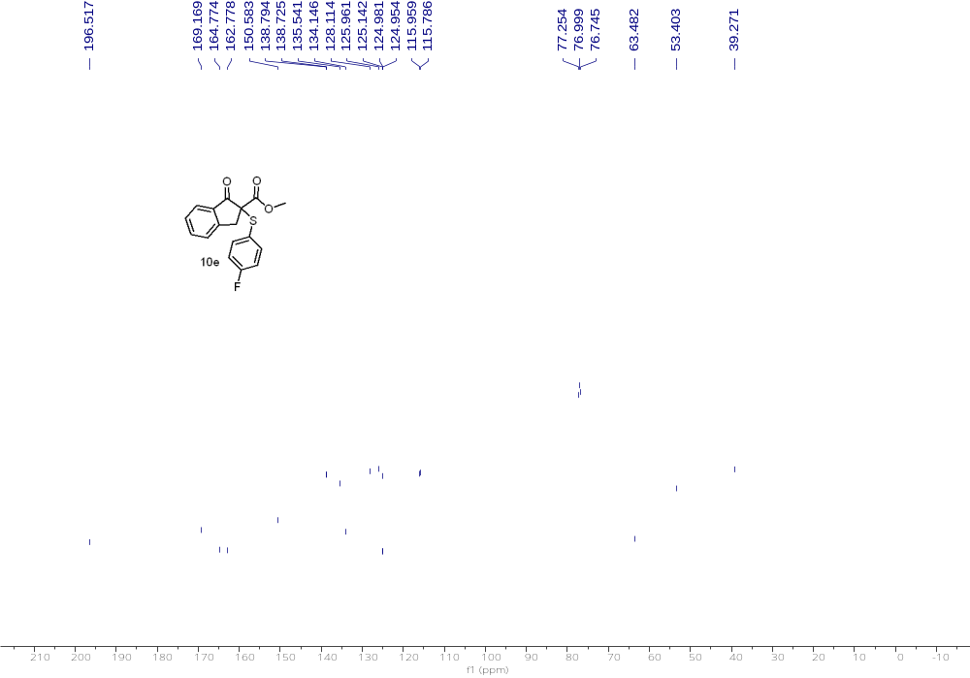
¹³C NMR (126 MHz, CDCl₃) of 10e

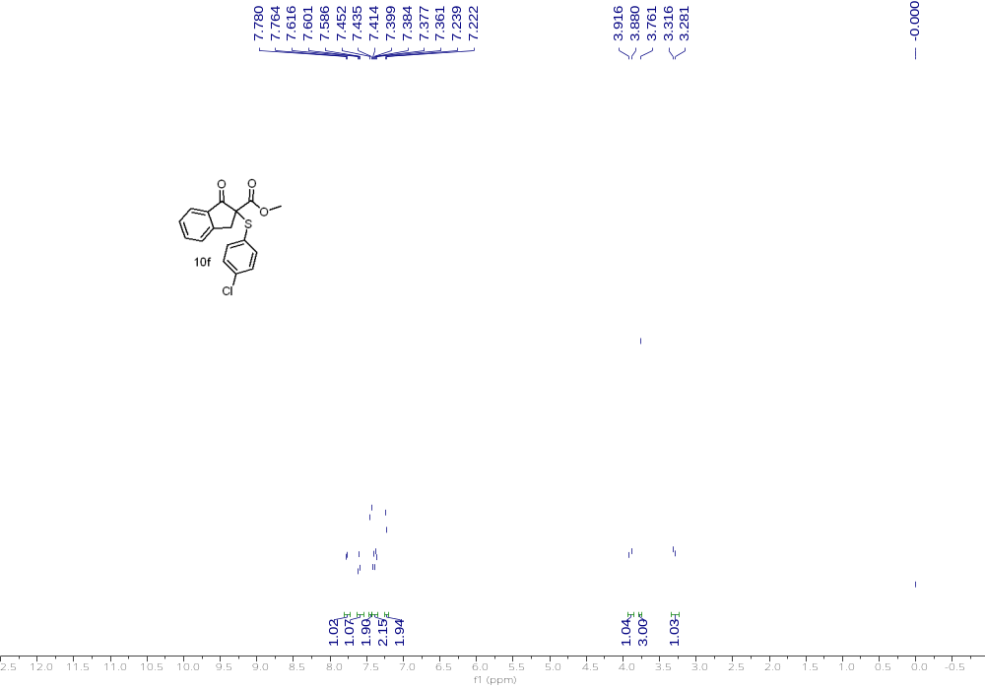
¹H NMR (500 MHz, CDCl₃) of 10f

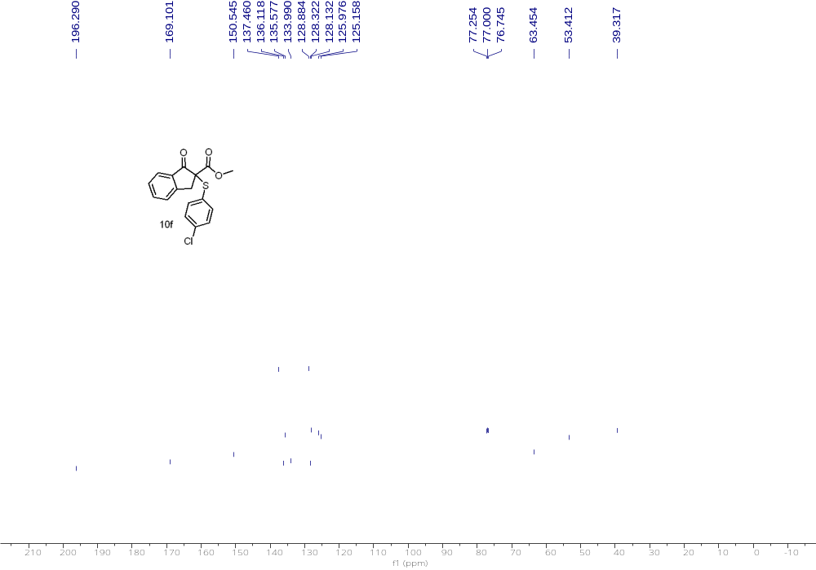
¹³C NMR (126 MHz, CDCl₃) of 10f

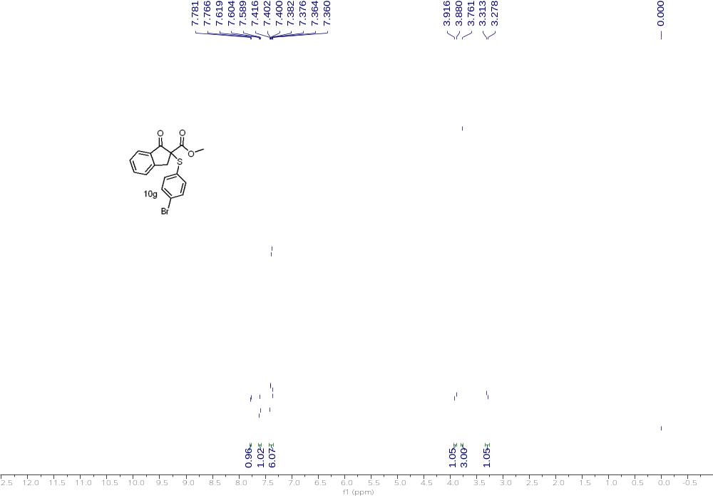
¹H NMR (500 MHz, CDCl₃) of 10g

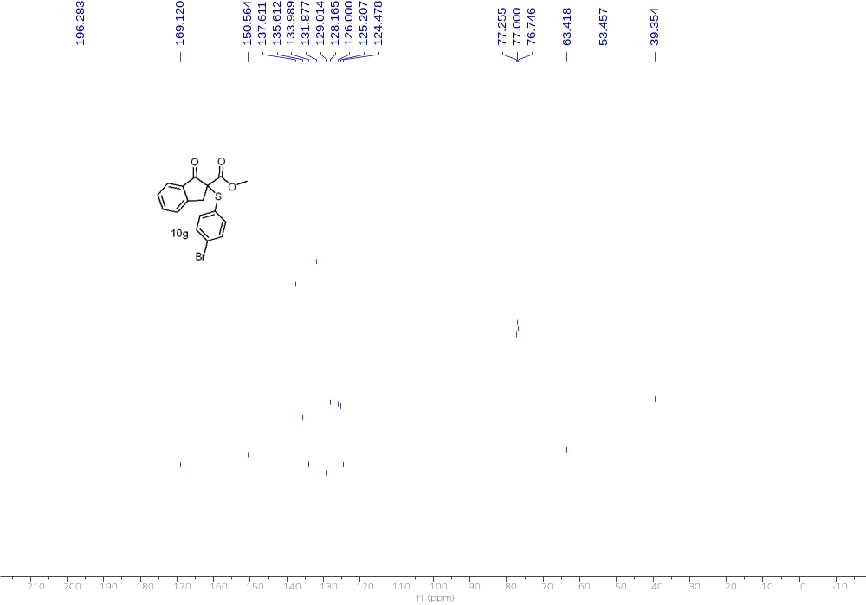
¹³C NMR (126 MHz, CDCl₃) of 10g

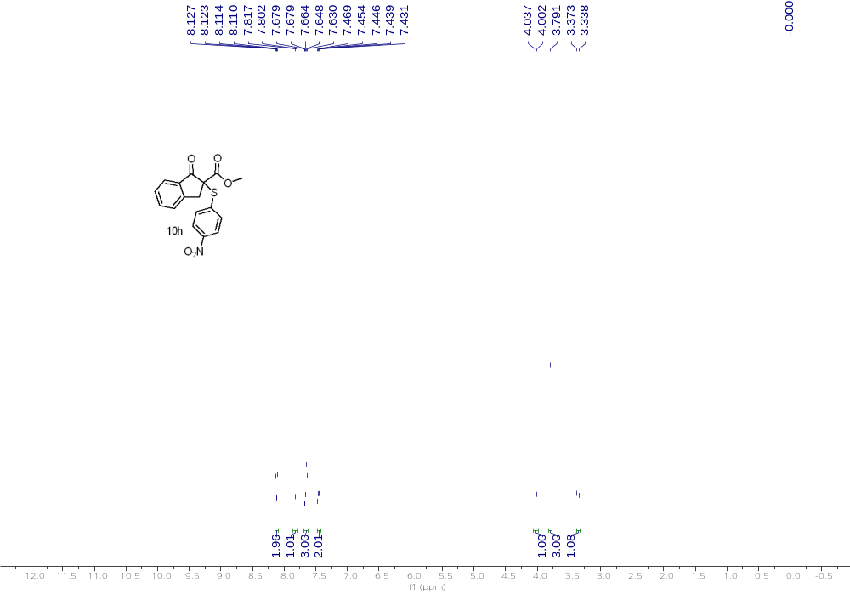
¹H NMR (500 MHz, CDCl₃) of 10h

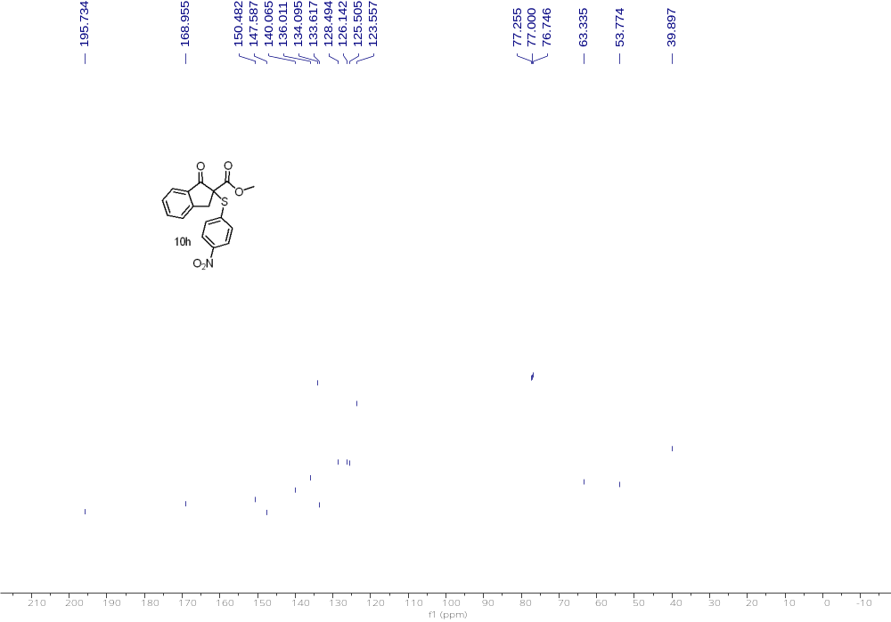
¹³C NMR (126 MHz, CDCl₃) of 10h

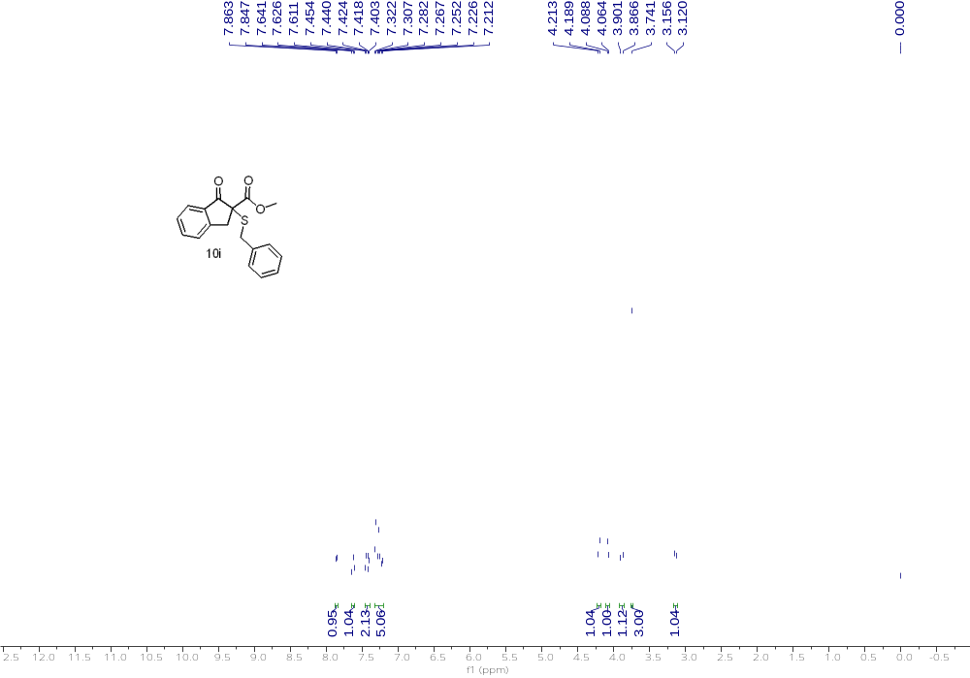
¹H NMR (500 MHz, CDCl₃) of 10i

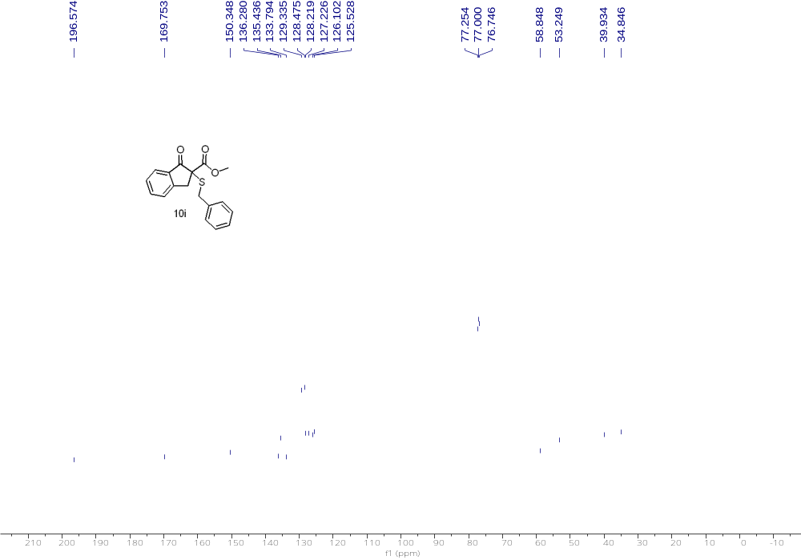
¹³C NMR (126 MHz, CDCl₃) of 10i

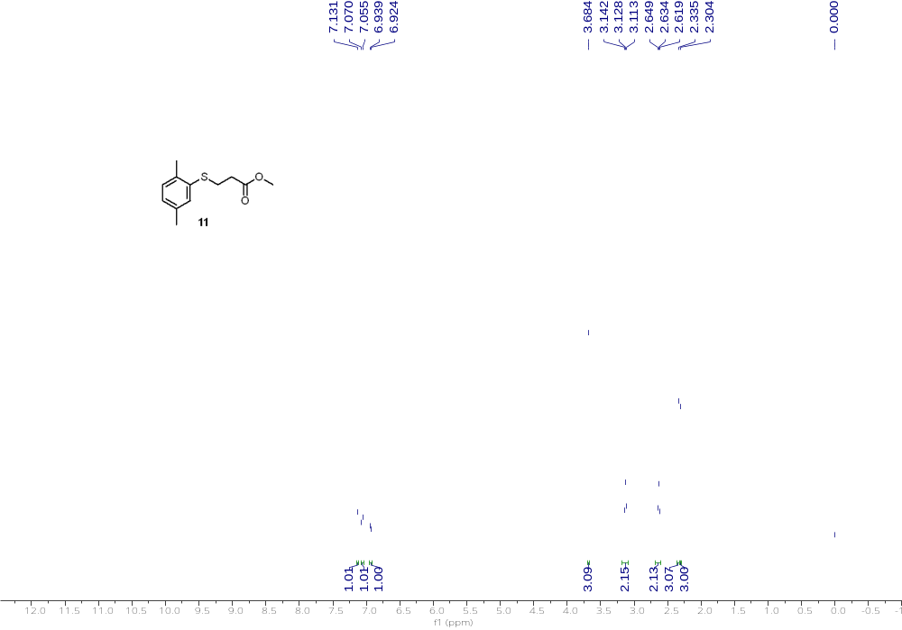
¹H NMR (500 MHz, CDCl₃) of 11
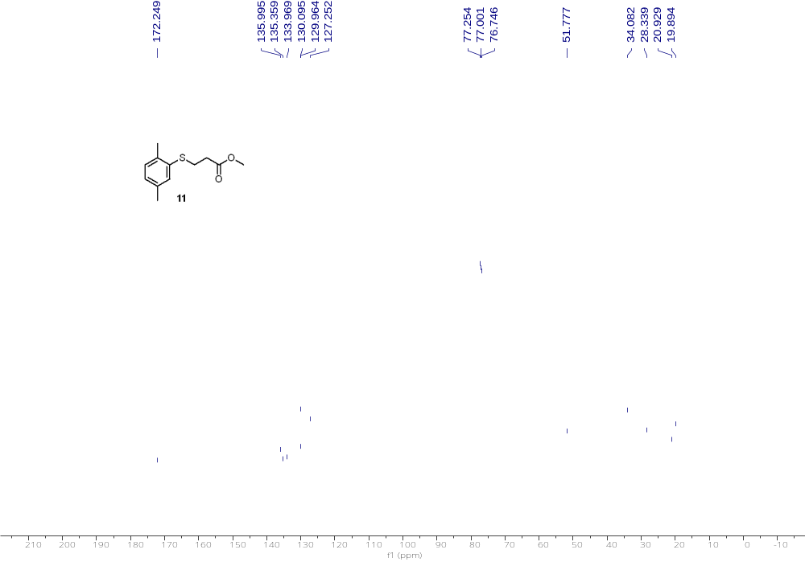
¹³C NMR (126 MHz, CDCl₃) of 11

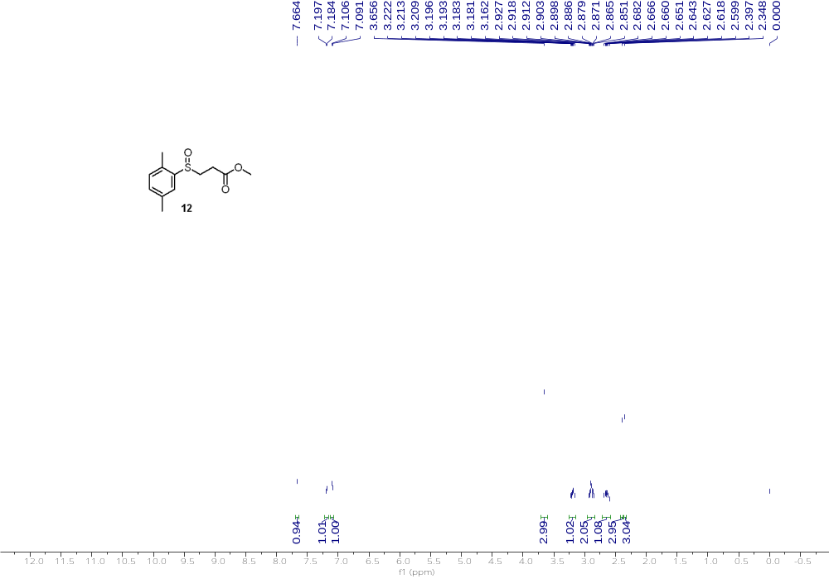
¹H NMR (500 MHz, CDCl₃) of 12
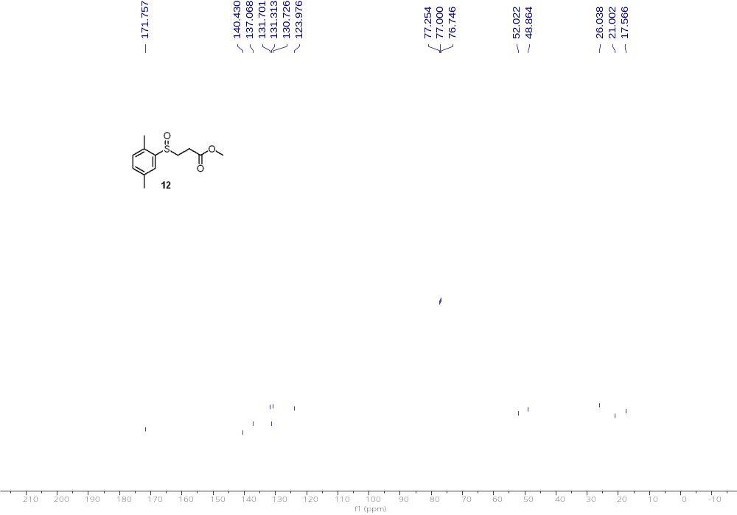
¹³C NMR (126 MHz, CDCl₃) of 12

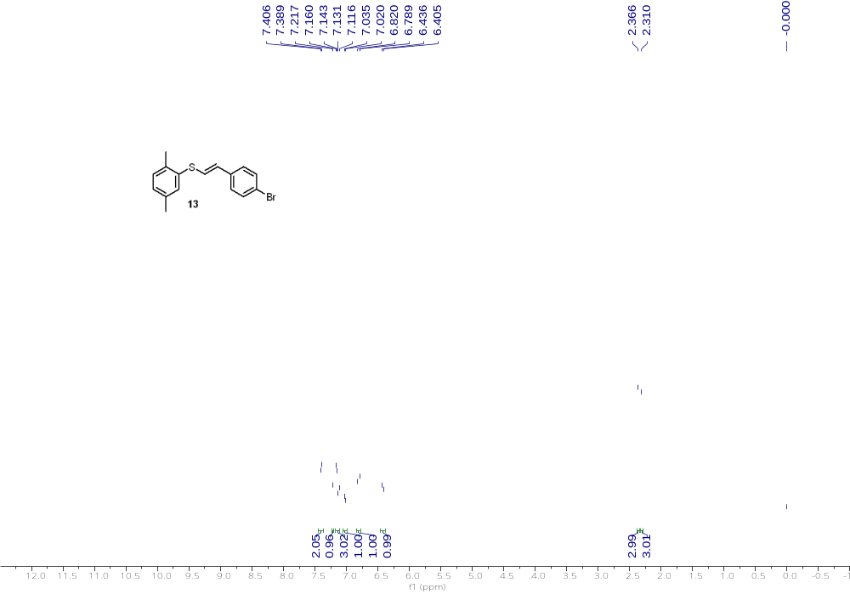
¹H NMR (500 MHz, CDCl₃) of 13
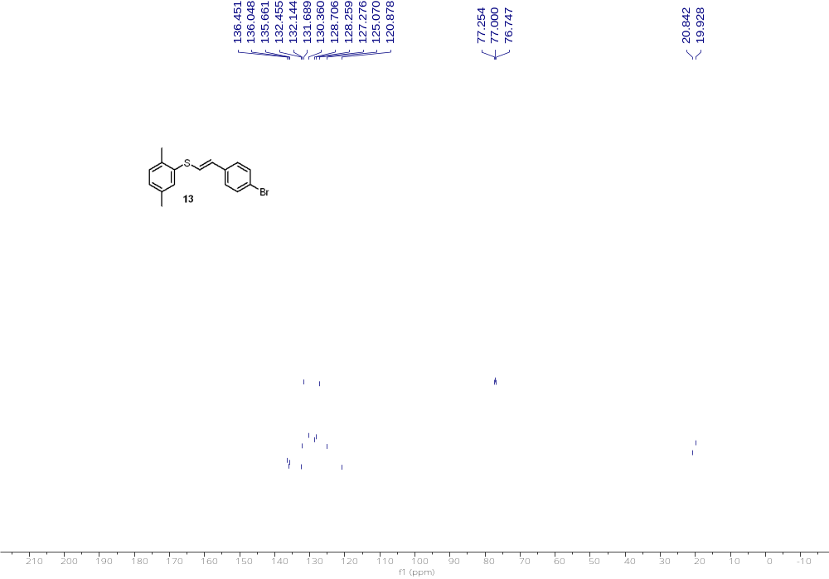
¹³C NMR (126 MHz, CDCl₃) of 13

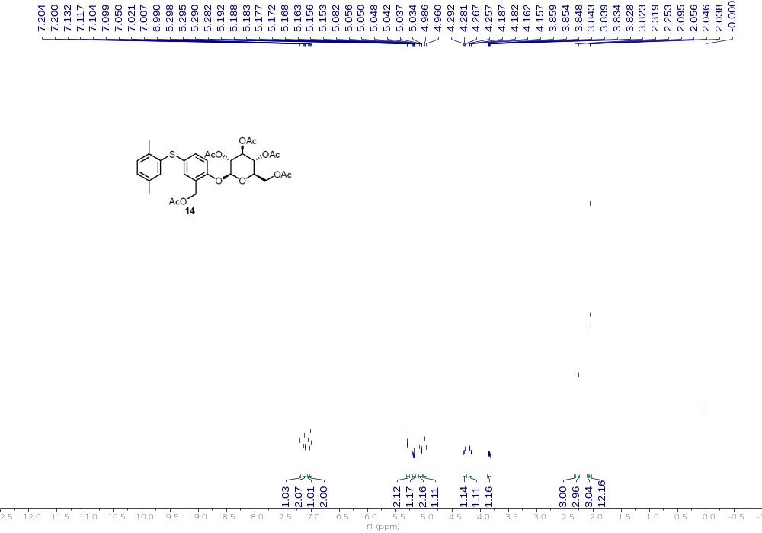
¹H NMR (500 MHz, CDCl₃) of 14
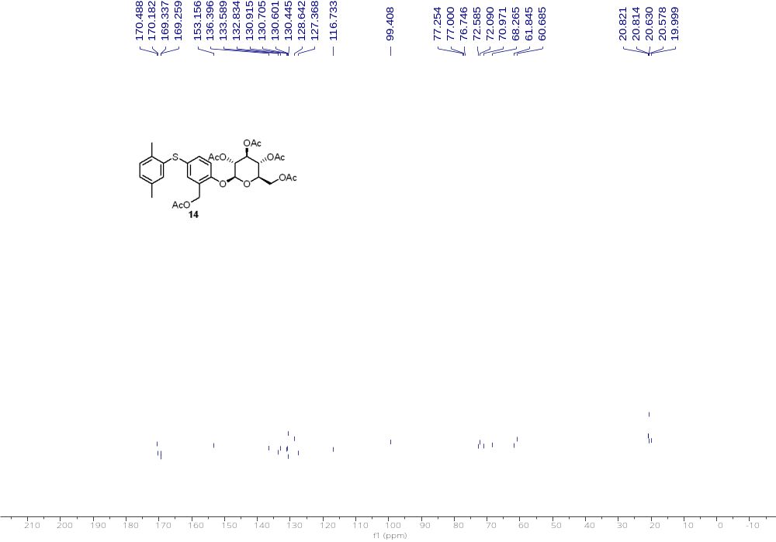
¹³C NMR (126 MHz, CDCl₃) of 14

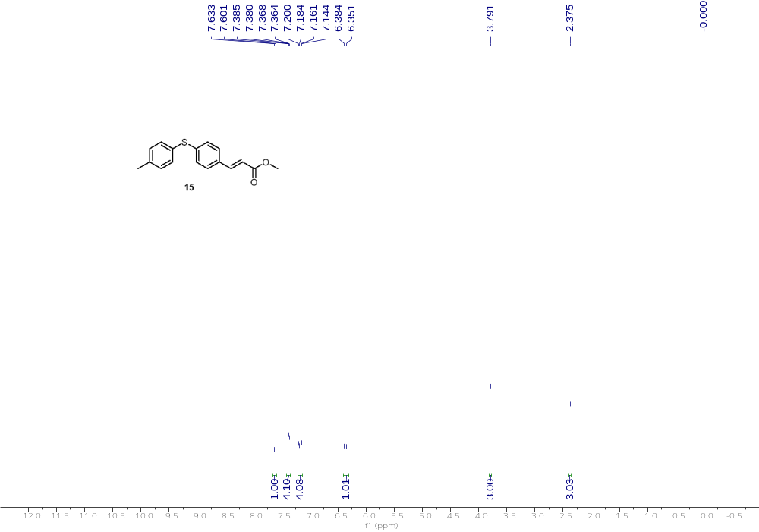
¹H NMR (500 MHz, CDCl₃) of 15
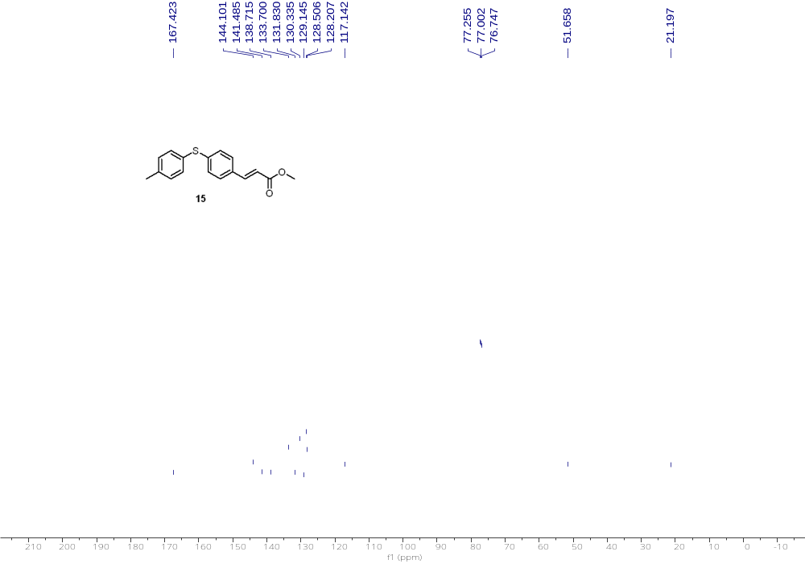
¹³C NMR (126 MHz, CDCl₃) of 15

Reference
- 1 Amos, S. G. E., Nicolai, S., Gagnebin, A., Le Vaillant, F. & Waser, J. Metal-Free Electrophilic Alkynylation of Sulfenate Anions with Ethynylbenziodoxolone Reagents. J. Org. Chem. 84, 3687-3701 (2019).
- Ahn, K. C. et al. An Immunoassay To Evaluate Human/Environmental Exposure to the Antimicrobial Triclocarban. Environ. Sci. Technol. 46, 374-381 (2012).
- Yeom, C.-E., Kim, M. J. & Kim, B. M. 1,8-Diazabicyclo[5.4.0]undec-7-ene (DBU)-promoted efficient and versatile aza-Michael addition. Tetrahedron 63, 904-909 (2007).
- Becht, J.-M., Wagner, A. & Mioskowski, C. Facile Introduction of SH Group on Aromatic Substrates via Electrophilic Substitution Reactions. J. Org. Chem. 68, 5758-5761 (2003).
.

