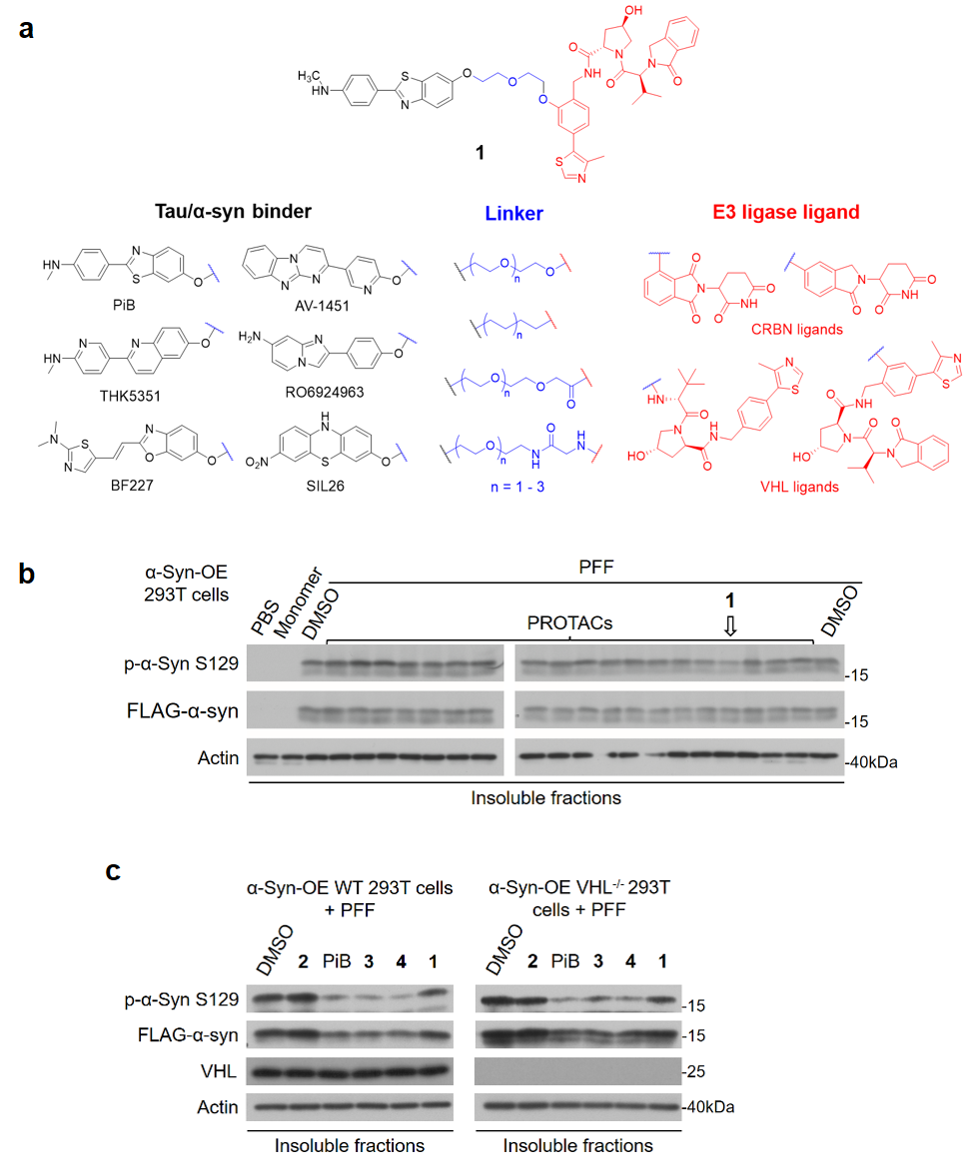
Extended Data Fig. 1: Serendipitous discovery of α-syn aggregation inhibitors. a, Rational design of amyloid-PROTACs. b, 72h cellular anti-aggregation activity of PROTACs (5 µM) from panel a. c, Anti-aggregation activity of indicated compounds (0.5 µM) in WT or VHL-KO 293T cells overexpressing α-syn.

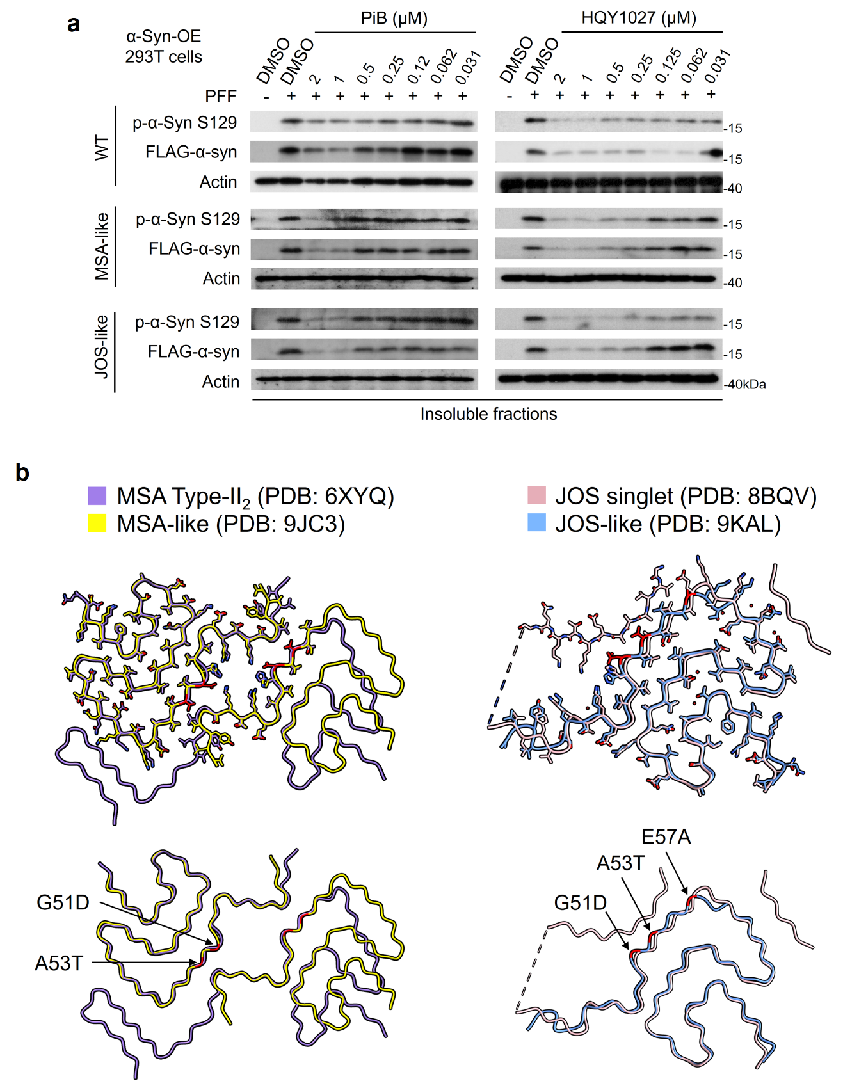
Extended Data Fig. 2: Lead optimization of HQY1027. a, PiB and HQY1027 inhibited α-syn in dose-dependent manners. Cells were treated with α-syn PFF (10 nM) and compounds at indicated concentrations for 72 h before lysis. PFF types were indicated as WT, MSA- or JOS-like. b, Overlay of the structures of endogenous α-syn fibrils (MSA Type-II₂ and JOS singlet) and synthetic PFFs (MSA/JOS-like), and the mutations of the latter are highlighted and annotated.
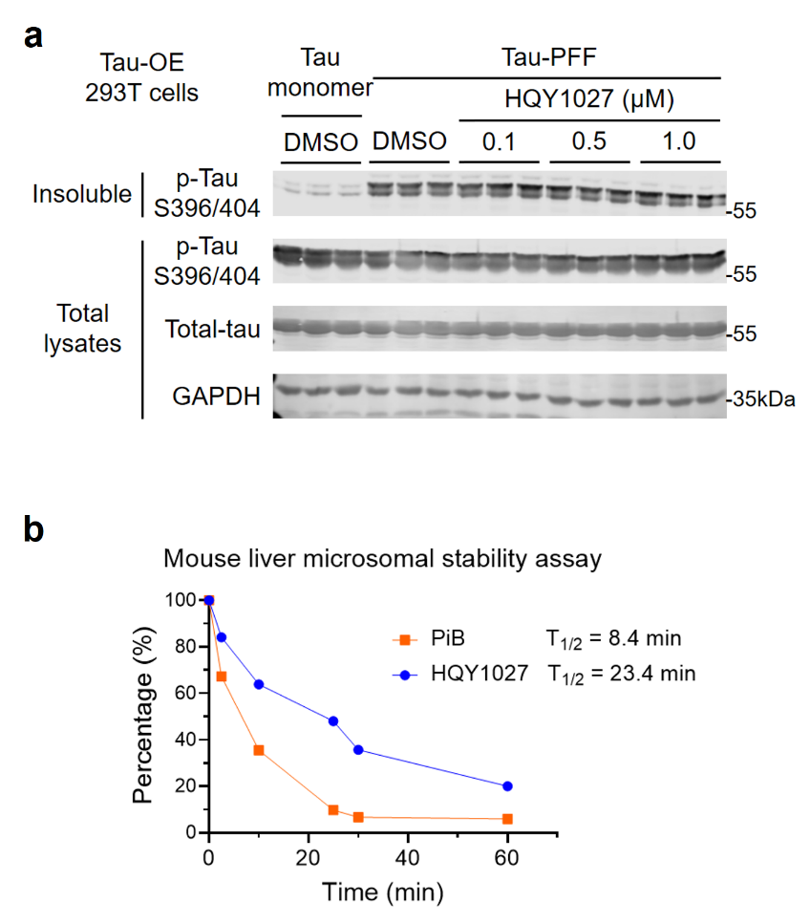
Extended Data Fig. 3: Lead optimization of HQY1027. a, Anti-aggregation activity of HQY1027 in 293T cells overexpressing tau. b, Metabolic stability of PiB and HQY1027 in mouse liver microsomes.

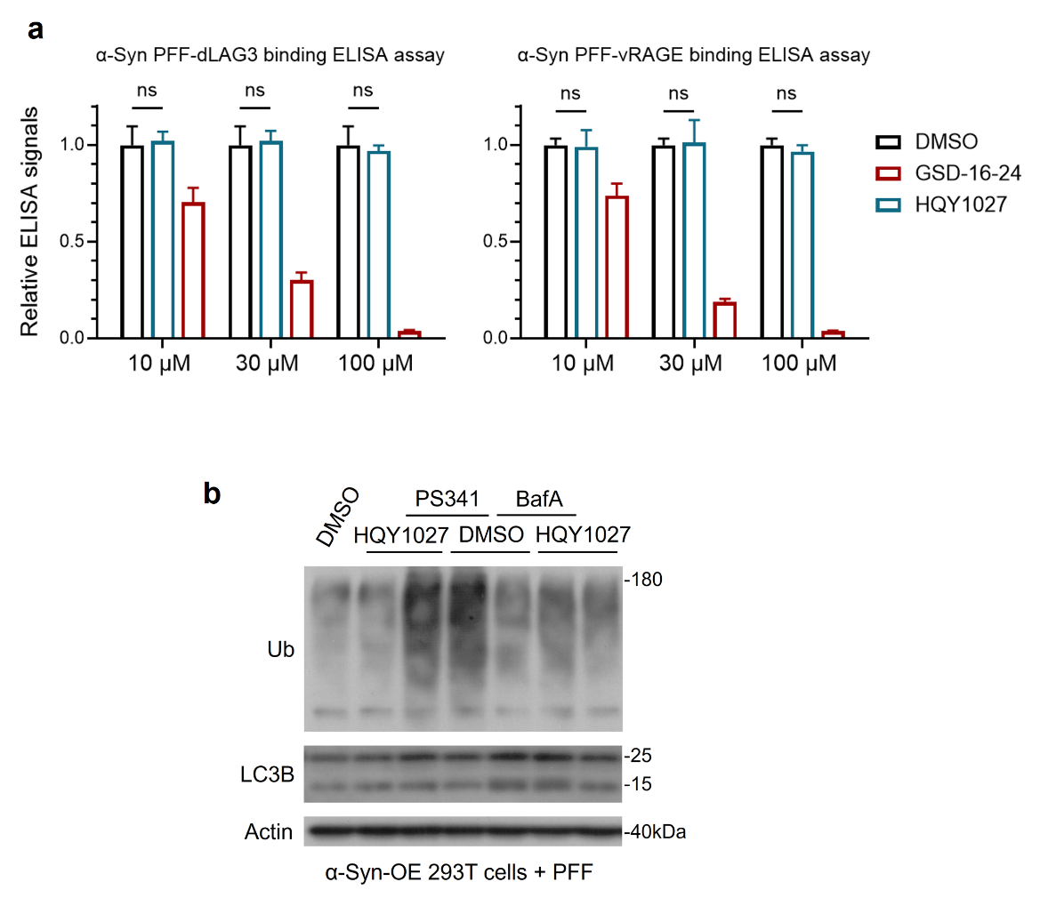
Extended Data Fig. 4: HQY1027 does not inhibit the interactions between α-syn fibrils and receptors. a, Bar graph summarizing the inhibitory effects of HQY1027 on the binding of α-syn PFF to dLAG3 or vRAGE based on ELISA assays. Reported inhibitor GSD-16-24 was used as a positive control. Data present mean ± SD (n = 4). Two-way repeated-measures ANOVA. b, Western blot results confirming that PS341 and BafA1 (0.1 µM) effectively inhibited proteasomal degradation and autophagic flux, respectively, in α-syn-aggregating 293T cells.

Extended Data Fig. 5: SPR analysis results. Sensorgrams depicting the kinetics for HQY1027 (a) and 5 (b) binding with molecular chaperones or α-syn PFF, respectively.

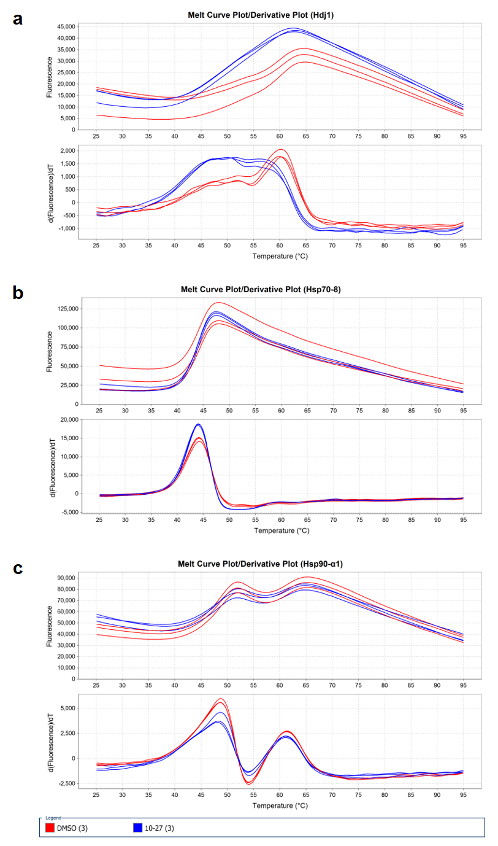
Extended Data Fig. 6: Protein thermostability shift assay results. The melt curve plots showing the effects of HQY1027 (blue curves) on the thermal stability of Hdj1 (a), Hsc70 (b) and Hsp90α (c). DMSO was used as control (red curves).

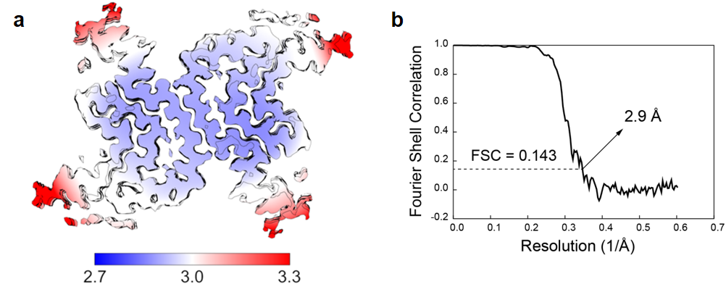
Extended Data Fig. 7: Resolution validation of the cryo-EM density map. a, The local resolution plots of the density map (bottom) estimated using RELION. b, Overall resolution estimates (black lines) calculated using the gold-standard 0.143 Fourier shell correlation (FSC) of two independently refined half-maps.

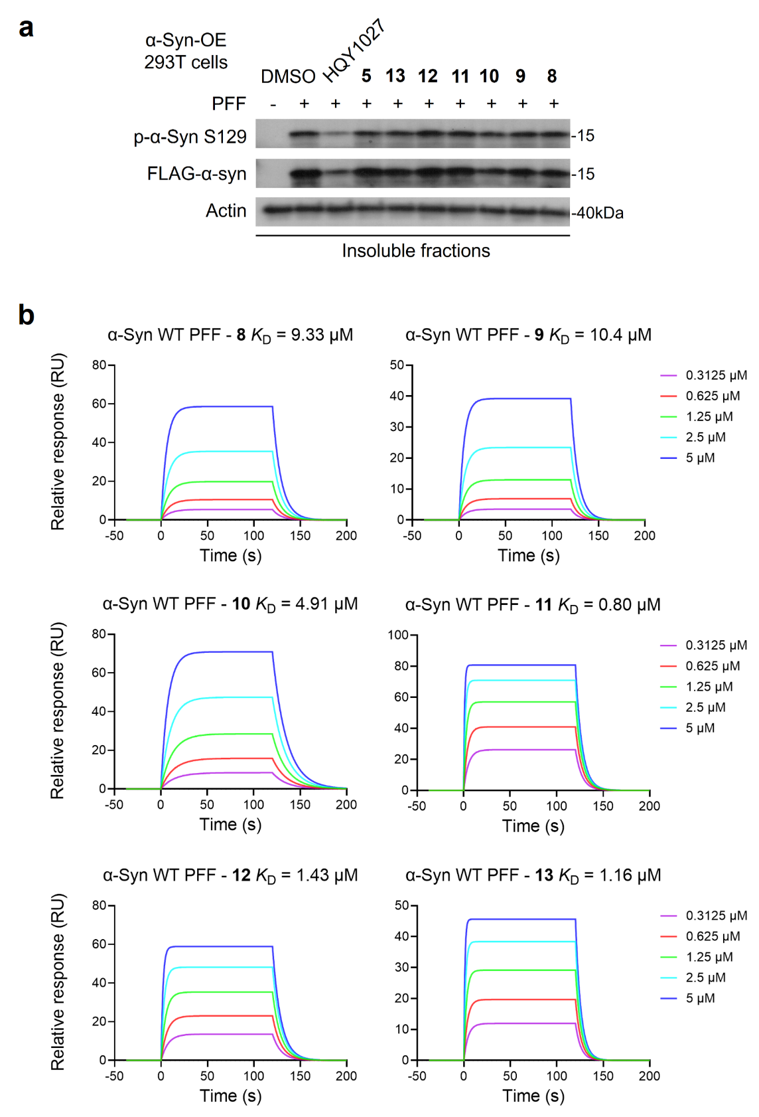
Extended Data Fig. 8: The activity of HQY1027 derivatives with hydrophilic or charged groups. a, Anti-aggregation activity of HQY1027 derivatives in 293T cells overexpressing α-syn. b, SPR sensorgrams depicting the kinetics for HQY1027 derivatives binding to WT α-syn PFF.

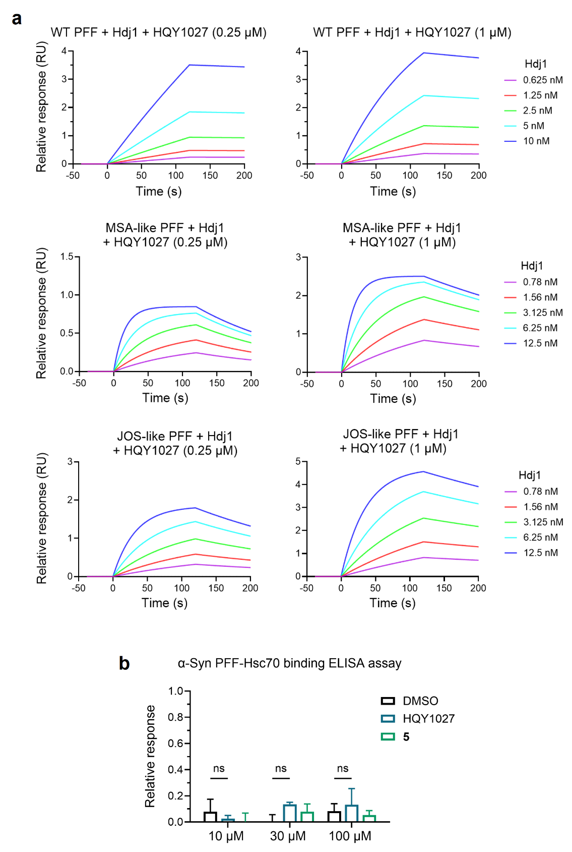
Extended Data Fig. 9: HQY1027 selectively enhances Hsp40’s binding to α-syn fibrils. a, SPR sensorgrams depicting the kinetics for Hsp40 binding to different types of α-syn PFF in presence of HQY1027. b, Bar graph summarizing the effects of HQY1027 or 5 on the Hsc70 binding to α-syn PFF based on ELISA assays. Data represent means ± SD (n = 4). Two-way ANOVA with Tukey’s post hoc test.
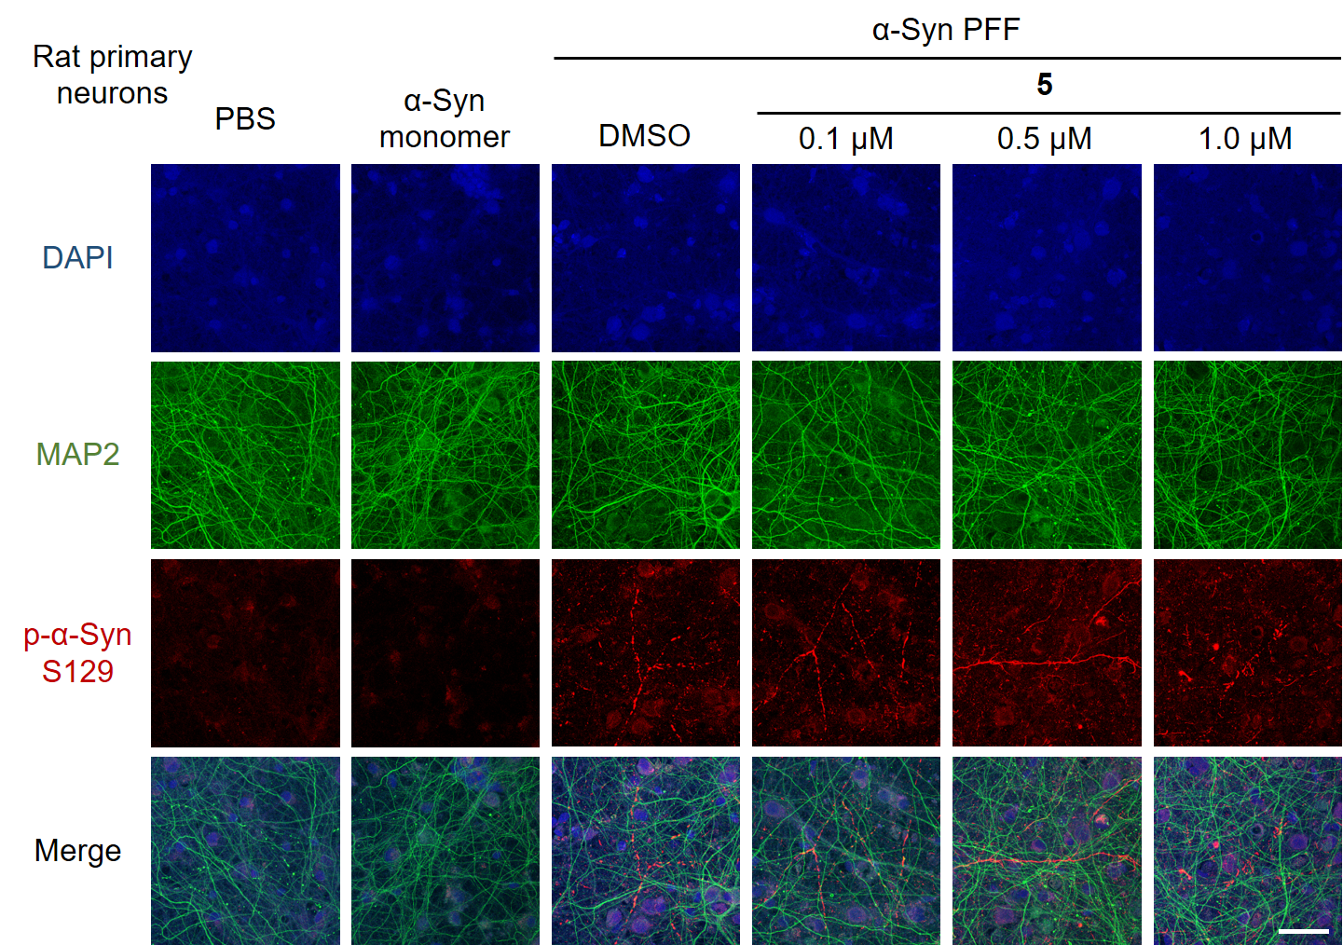
Extended Data Fig. 10: The inactive analog of HQY1027, 5, does not inhibit α-syn fibril aggregation in primary rat neurons. Representative images showing immunofluorescent staining results for the inactive analog 5 on PFF-induced α-syn aggregation in rat primary cortical neurons. α-Syn aggregates, neuronal dendrites and nuclei are indicated by α-syn p-S129 (red), MAP2 (green), and DAPI (blue), respectively. Scale bar, 50 µm.

