Supporting Information
Mechanistic Insights into the Atomic-Level Synergy of Ni–Ru Single-Atom Alloy on ZrO₂ for Efficient Photocatalytic CO₂ Methanation and Biogas Upgrading

Keywords: Single-atom alloy; Photocatalysis; CO₂ methanation; Biogas upgrading

1. Methods
1.1. Chemicals and materials
ZrO₂ [JRC-ZRO-3; major monoclinic and minor tetragonal phase, specific surface area (SA) 94.4 m² g⁻¹] was provided from Catalysis Society of Japan. Nickel chloride hexahydrate (NiCl₂·6H₂O) and ruthenium(Ⅲ) chloride anhydrate (RuCl₃) were purchased from Macklin Biochemical Technology Co. (Shanghai, China). Sodium borohydride (NaBH₄) was purchased from Sinopharm Chemical Reagent Co. (Shanghai, China). The deionized water (< 0.055 μS cm⁻¹) was used throughout the experiments. All reagents were used without further purification.
The reaction gases, e.g., CO₂, CH₄, and mixed gases (CO₂: H₂ = 1: 5 and H₂: Ar = 1: 9), were purchased from Dalian/Chengdu Special Gases Co., Ltd. The not mixed gases were 99.999% purity. ¹³CO₂ (purity > 99.9%; 99.0% ¹³C, 0.1% ¹⁷O, 0.7% ¹⁸O) was purchased from Cambridge Isotope Laboratories, Inc. (Tewksbury, MA, USA).

1.2. Photocatalyst preparation
To prepare the composite photocatalysts of Ni, Ru, and ZrO₂, the concentration of Ni was fixed at 10 wt % while the Ru loading was varied between 0.5 wt % and 2.0 wt %. In a typical preparation procedure, ZrO₂ (0.445 g) was dispersed in deionized water (200 mL). The suspension was ultrasonicated (360 W, 40 kHz) for 20 min, and magnetically stirred at 1000 rpm for 1 h. Next, NiCl₂·6H₂O (0.2025 g) and RuCl₃ (0.0051–0.0207 g) was added into the suspension and magnetically stirred for 1 h. Then, an aqueous solution (10 mL) contained NaBH₄ (0.1279–0.5181 g) was dropped into the suspension, and the mixture was stirred for 5 min at a rate of 1000 rpm. The obtained precipitate was filtered using a polytetrafluoroethylene-based membrane filter (pore size = 0.2 μm), and washed with deionized water (each 50 mL, five times). Finally, the resultant powder samples were subjected to H₂/Ar atmosphere (1: 9) at 450 ℃ for 2 h to obtain the ZrO₂ with the loading of 10 wt % Ni and 0.5–2.0 wt % Ru. The samples were denoted as Ni₁₀Ru_{x}/ZrO₂ (Ru x wt % where x = 0.5, 1, and 2).
The Ni/ZrO₂ and Ru/ZrO₂ samples were also prepared as references following the similar conditions to that for Ni₁₀Ru_{x}/ZrO₂ by using NiCl₂·6H₂O (0.2025 g) or RuCl₃ (0.0103 g). The obtained samples were denoted as Ni₁₀/ZrO₂ and Ru₁/ZrO₂, respectively.

1.3. Photocatalytic reduction of CO₂ and biogas
The CO₂ photoreduction tests using H₂ were conducted using 20 mg of the photocatalysts. The photocatalyst fine powder was placed in a U-shaped quartz reactor (internal volume 45 mL) connected to a glass circulation system (100 mL; Perfect 6A, China) and under vacuum for 1 h using a rotary pump (10⁻² Pa). Subsequently, the catalyst was reduced in the reactor under H₂/Ar gas mixture (1: 9) at 450 ℃ for 30 min, followed by evacuation and cooling to 22 ℃. Then, the reaction gas mixture of CO₂ (10 kPa) and H₂ (50 kPa) was introduced into the photoreactor. The photocatalyst was irradiated by UV–visible light from a 300 W xenon arc lamp (Model CEL-HXUV300-T3, China Education AuLight Technology Co., Ltd., China), and the distance between the UV–visible light exit and the photocatalyst was 80 mm. The light intensity of the xenon arc lamp was determined to 1.5 W cm⁻² at the center of the photocatalyst using optical power meter (Model CEL-NP2000-10A, China Education AuLight Technology Co.).
In-profile kinetic data were collected as a function of light excitation wavelength by using the combination of wavelength reflectors (types UVREF and VisREF for UV and visible light region, respectively) in the arc lamp house and inserting sharp-cut filters (types Cut400 and Cut800) at the light exit (China Education AuLight Technology Co.). The UVREF, the combination of VisREF and Cut400, and the combination of VisREF and Cut800, were used to irradiate UV light (λ = 200–400 nm), visible light (λ = 400–800 nm), and infrared light (λ > 800 nm), respectively.
To verify the catalytic rates driven by simply thermal energy compared to the photocatalytic reactions, the E_{act} value of Ni₁₀Ru₁/ZrO₂ catalyst was evaluated for methane formation starting from CO₂ under dark at reaction temperature between 50 ℃ and 200 ℃.
The biogas photoreduction tests using H₂ were performed using biogas produced in-house. To prepare the biogas, an inoculum sludge was prepared from an anaerobic reactor that had been continuously operated in the laboratory, comprising reaction substrates of pig manure, chicken manure, and straw as major sources, and the total solid content of inoculum sludge was 6 wt %. The prepared sample by anaerobic fermentation of agricultural waste comprised 30% CO₂, 60% CH₄, 8% N₂, and trace amounts of impurities, O₂, H₂S, and H₂O. In a 500 mL anaerobic bottle, 400 mL of the inoculum sludge and 20 g of dried straw powder (less than 80 mesh inch⁻¹) were added. The anaerobic bottle was placed in a water bath to maintain the temperature at 35 ± 2 ℃. Thus-produced biogas was collected in air-tight Al gas bag, and the daily gas production was monitored.
The photocatalytic reduction of biogas was tested under the similar conditions to those for the photocatalytic reduction of CO₂ (10.5 kPa) using H₂ (52.5 kPa) as described above. The pressure of biogas was controlled to 21.0 kPa in addition to H₂ (25.2 kPa) in the reaction system.
The photocatalytic products were analyzed using an online gas chromatograph (GC9720II, Fuli Instruments, China) using Ar (0.40 MPa, purity >99.9999%) as the carrier gas. The gas samples underwent pre-separation through a packed column of Hayesep-Q (2 m length, 4 mm internal diameter; Agilent, Santa Clara, CA, USA), followed by the analysis of H₂, O₂, and N₂ using a packed column of 5A molecular sieves (2 m length, 4 mm internal diameter; Agilent) to thermal conductivity detector (TCD), and passing through a converter furnace to flame ionization detector (FID) for the analysis of CO and CH₄. CO₂ and subsequent gas components were backflushed using an automatic valve. Plausible multicarbon gaseous products were analyzed using the other FID equipped with a plot column of HP-PLOT Q (30 m length, 0.53 mm internal diameter; Agilent).
The isotope-labeled photocatalytic tests using ¹³CO₂ were performed to investigate the photocatalytic reaction path. The ¹³CO₂ (2.3 kPa, chemical purity >99.9%; 99.0% ¹³C, 0.1% ¹⁷O, 0.7% ¹⁸O, Cambridge Isotope Laboratories, Inc., Tewksbury, MA, USA) and H₂ (21.7 kPa; >99.99%) were used. The U-shaped quartz reactor (internal volume 46.0 mL) containing the catalyst (20 mg) was irradiated with UV–visible light using a 500 W Xe arc lamp (SX-UID502XAM, Ushio, Japan) through a Y-shaped quartz light guide (Model 1.2S15-1000F-1Q7-SP-RX; 40-cm-long fiber and 80-cm-long branches; Optel, Tokyo, Japan) and also using a 300 W Xe arc lamp (MAX-303, Asahi Spectra, Japan) through a straight quartz light guide. The distance between the fiber light exit and the photocatalyst was 20 mm. The light intensity at the center of the sample was 0.142 W cm⁻² (SX-UID502XAM) and 1.4 W cm⁻² (MAX-303). A packed column of 13X-S molecular sieves (3 m length, 3 mm internal diameter; GL Sciences, Inc., Japan) for ¹³CO₂ photoreduction tests were used for online gas chromatography-mass spectrometry (GC-MS) analyses (Model JMS-Q1050GC, JEOL, Tokyo, Japan) using helium (0.40 MPa, purity >99.9999%) as the carrier gas. ¹³CH₄ and ¹²CH₄ were evaluated based on the mass number (m/z) of 17 and 16, respectively, considering the fragment ratio of CH₃⁺: CH₄⁺ (0.979: 1).

2. Characterizations
Temperature-programmed reduction under H₂ gas (H₂-TPR) was conducted using the BELCAT-II auto-chemisorption system (MicrotracBEL Corp., Osaka, Japan), equipped with a TCD as detector. The samples (0.10 g) were placed into a U-shaped quartz cell and initially heated from 22 ℃ to 200 ℃ at the heating rate of 10 ℃ min⁻¹ under an Ar atmosphere at a flow rate of 30 mL min⁻¹ and then cooled to 22 ℃. Subsequently, the sample was purged by H₂/Ar mixture (1: 9) at a flow rate of 30 mL min⁻¹. followed by heating at a rate of 10 ℃ min⁻¹ up to 800 ℃. A downstream trap comprising molecular sieve 5A removed water formed during the analysis.
The temperature-programmed desorption of CO₂ (CO₂-TPD) was conducted using the same apparatus as H₂-TPR following the procedure below. The samples were heated from 22 ℃ to 450 ℃ at a rate of 10 K min⁻¹ under H₂/Ar mixture (1: 9) at a flow rate of 30 mL min⁻¹ and kept at 450 ℃ for 2 h. Then, the sample was purged with He for 30 min at a flow rate of 30 mL min⁻¹ and cooled down to 50 ℃. Subsequently, CO₂/He mixture (1: 9) was introduced at a flow rate of 30 mL min⁻¹ and saturated at 50 °C. After that, physically adsorbed CO₂ was removed by flowing He for 30 min, followed by heating to 800 ℃ at a rate of 10 ℃ min⁻¹. The TPD of CH₄ (CH₄-TPD) was performed in similar procedure to CO₂-TPD.
X-ray diffraction (XRD) pattern was measured using Model Ultima IV (Rigaku, Tokyo, Japan) at 40 kV and 40 mA. Cu Kα (wavelength λ = 0.15419 nm) and Ni filter was used as a source light at a Bragg angle (θ_{Bragg}) of 2θ_{Bragg} = 5–80° with a scan step of 0.02° and the scan rate of 1 s per step.
Ultraviolet–visible–near infrared (UV–Vis–NIR) spectra were recorded on a spectrophotometer (Model UV-3600i Plus; Shimadzu, Japan) using deuterium and tungsten–halogen lamps below and above λ = 340 nm, respectively, equipped with a photomultiplier tube and an integrated sphere of 150 mm-diameter for diffuse-reflectance detection within the range between 200 and 2000 nm with a resolution of 1 nm. Kubelka–Munk function was used to transform the diffuse–reflectance spectra. The integrated sphere contains two detectors: a photomultiplier tube for UV–visible light and an InGaAs photodiode detector for NIR light monitoring.
The electron paramagnetic resonance (EPR) spectra for ZrO₂, Ni₁₀/ZrO₂, Ru₁/ZrO₂, and Ni₁₀Ru₁/ZrO₂ were recorded using a model Emxplus (Bruker, Karlsruhe, Germany). The experimental parameters were: center field 3510.00 G, sweep width 100.0 G, monitored frequency 9.8432 GHz, microwave power 20.00 mW, and power attenuation 10.0 dB using ~10 mg of sample for each measurement.
The absorption–fluorescence spectra were recorded on a model FLS1000 (Edinburgh Instruments, UK) using a 450 W Xe arc lamp equipped with a photomultiplier tube for the excitation at 200 nm within a fluorescence range of 300–800 nm. The incident excitation light from Xe arc lamp was monitored by Si photodiode, and monitored fluorescence light emitted from sample was normalized based on the incident light intensity at each wavelength. The excitation spectra were corrected for the incident light intensity and the emission spectra were corrected for the spectral sensitivity of the recording system.
The TRPL measurements (excitation wavelength: 350 nm) were conducted on an FLS-1000 transient-state fluorescence spectrometer (Edinburgh Instruments Ltd.).
The TEM and HR-TEM images were observed using a Model JED-2300T (JEOL, Japan) equipped with a field-emission gun (the acceleration voltage 200 kV). The samples were mounted on a Cu mesh (250 mesh inch⁻¹) coated with carbon and a copolymer film of poly (vinyl alcohol) and formaldehyde (Formvar, Monsanto, St. Louis, MO, USA). High-angle annular dark-field scanning TEM (HAADF-STEM) and HR-TEM images were observed for the Ni₁₀Ru₁/ZrO₂ sample. The elemental mapping was also performed using energy-dispersive spectra with a Si (Li) detector equipped in the TEM apparatus. Aberration-corrected scanning TEM (STEM) observations were performed using a model JEM-ARM200F (JEOL, Japan) at an accelerating voltage of 200 kV.
X-ray photoelectron spectroscopy (XPS) measurements were performed with a Model ESCALAB XI+ spectrometer (Thermo Scientific, Waltham, MA, USA) using 150 W X-ray radiation source of Al Kα. XP spectra were analyzed by a software Advantage and the binding energies were calibrated by the C 1s line at 284.8 eV for samples of Ni₁₀Ru₁/ZrO₂ at C 1s, Ni 3p, Ru 2p, Zr 3d, and O 1s electrons.
In-situ XPS spectra were measured using Ni₁₀Ru₁/ZrO₂ powder, which was placed on a reaction chamber of the spectrometer described above, and the spectra for O 1s, Zr 3d, Ni 3p, and Ru 2p electrons were collected for (i) initial state of Ni₁₀Ru₁/ZrO₂ at 22 ℃, (ii) under H₂/Ar mixture (1: 9) at 450 ℃ for 30 min and evacuated, (iii) under CO₂/H₂ mixture (1: 9), under the irradiation of UV–visible light using a 300-W xenon arc lamp (1.5 W cm⁻²) for 10–30 min, and (iv) after the light was turned off.
Ni K-edge and Ru K-edge X-ray absorption fine structure (XAFS) spectra were measured on beamline 9C and 12C at Photon Factory, High Energy Accelerator Research Organization (KEK, Tsukuba, Japan) in transmission mode at 22 ℃. The Ni₁₀Ru₁/ZrO₂ sample powder (120 mg) was prepared in a Pyrex glass U-tube connected to an XAFS cell (sample diameter ϕ = 20 mm, thickness t = 2.0 mm). The sample in Pyrex glass U-tube was reduced under a H₂ atmosphere at 450 ℃, then evacuated and filled with the reactant gas of CO₂ (2.3 kPa) and H₂ (21.7 kPa). The sample powder was transferred from the Pyrex glass U-tube section into the XAFS cell that was connected to the U-tube. The samples did not contact air throughout the experiments. The XAFS cell equipped with polyethylene terephthalate (PET) film windows (Toyobo Film Solutions, Japan, G200X-38; t = 38 µm) for both UV–visible light and X-ray transmission. The sample was then irradiated with UV–visible light from the Xe arc lamp through a quartz fiber light guide and the PET film window at the beamline. X-rays were perpendicularly transmitted from the disk, whereas the incident angles of UV–visible light were 45° and −135° relative to the X-rays. The distance between the light exit of the quartz fiber light guide and the sample was 50 mm.
The storage ring energy was 2.5 GeV, and the ring current was 449.9–450.0 mA. Si (1 1 1) double-crystal monochromator and a Rh-coated focusing bent cylindrical mirror were inserted into the X-ray beam path. A piezo transducer was used to detune the X-ray to two-thirds of the maximum intensity to suppress the higher harmonics. The Ni K-edge and Ru K-edge absorption energy was calibrated at 8331.65 eV and 22119.3 eV using the spectra of Ni metal (5.0 µm thick) and Ru metal powder, respectively. The obtained Ni an Ru K-edge XAFS data were analyzed using the XDAP and Athena software package. The empirical amplitude was extracted from the EXAFS data for the Ni or Ru metal foil and NiO or RuO₂ powder. For Ni metal (a = 0.35238 nm), the interatomic distance (R) for the Ni−Ni interatomic pair was set to 0.24917 nm with the coordination number (N) value of 12. For NiO (a = 0.4176 nm), the R values for the Ni–O and Ni−Ni interatomic pair were set to 0.2088 nm with an N value of 6 and to 0.2953 nm with an N value of 12. For Ru metal (a = 0.27059 nm, c = 0.42815 nm), the R value for the Ru−Ru interatomic pair was set to 0.26780 nm with an N value of 12. We assumed that the many-body reduction factor, S₀², was identical for both the sample and reference.
Artemis software package was used to curve-fit the angular wavenumber k²- or k³-weighted EXAFS spectra of Ni₁₀Ru₁/ZrO₂ based on the reference metal foil and metal oxide both in the k-space and R-space. Furthermore, k²- or k³-weighted wavelet transform analysis for Ru foil at the Ru K-edge, and for Ni₁₀Ru₁/ZrO₂ and Ni foil at the Ni K-edge, was conducted using Hama-Fortran software.
In-situ Fourier transform infrared (FTIR) spectra were collected using a Model FT/IR-4200 (JASCO, Tokyo, Japan), operating at 2 cm^{–1} resolution in the wave number range of 4000–400 cm^{–1} at 22 ℃ and the data accumulation included 256 scans. The diluted catalyst disk (ϕ = 2 cm) was prepared by uniformly mixing 25 mg of Ni₁₀Ru₁/ZrO₂ or Ni₁₀/ZrO₂ with 115 mg of ZrO₂. The prepared disk was reduced under H₂ at 450 ℃ in a quartz cell and transferred to a FTIR cell using a glove box (Model UN-6509LCIY, Unico, Japan) filled with Ar gas. In the FTIR analysis, the disk sample was under vacuum (10^{–6} Pa) for 1 h, and then a spectrum was recorded under vacuum as the background. Then, a mixed gas comprising ¹³CO₂ (2.3 kPa) and H₂ (21.7 kPa) was introduced to the FTIR cell, followed by the irradiation with UV–visible light at 0.1 W cm^{–2} from a 500-W Xe arc lamp (Model SX-UID502XAM, Ushio, Japan) and the light intensity was increased to 1.0 W cm^{–2} from a 300-W Xe arc lamp (Model MAX-350, Asahi Spectra, Japan) for Ni₁₀Ru₁/ZrO₂ through a quartz fiber light guide. The distance between the fiber light exit and the sample disk was 50 mm. The in-situ FTIR spectra and GC-MS analysis simultaneously were collected in time course to monitor changes in both the surface intermediate species on the catalyst and the gaseous products under UV–visible light irradiation.

3. DFT calculations
All the Spin-polarized calculations were performed in the framework of the density functional theory with the projector augmented plane-wave method, as implemented in the Vienna ab initio simulation package (1). The generalized gradient approximation proposed by Perdew-Burke-Ernzerhof (PBE) functional was adopted for the exchange-correlation potential (2). The long range van der Waals (vdW) interaction was described by the DFT-D3 method (3). The cut-off energy for plane wave is set to 400 eV. Hubbard corrections (4) for the Zr d-states were implemented with U − J = 4 eV. A vacuum layer with a thickness of 12 Å was added perpendicular to the sheet and the lateral distances between adsorbed molecules were maintained at a minimum of 8 Å to avoid artificial interaction between periodic images. During geometry optimization, all atomic coordinates were relaxed with the convergence criteria of 0.03 eV·Å⁻¹ for the forces on each atom, except for the atoms in the bottom layer of the ZrO₂(111) slab. For each self-consistent iteration, the total electronic energy was converged to 10⁻⁵ eV. The Brillouin zone integration is performed using a 3×3×1 k-mesh to ensure computational accuracy.
To optimize transition states, the climbing image nudged elastic band (5) and dimer (6) methods were employed and the optimized saddle points were confirmed to have only one imaginary vibrational frequency leading to the local minima.
The charge density diﬀerence was calculated as $∆ρ(r)={ ρ}^{cluster/slab}-{ ρ}^{cluster}-{ ρ}^{slab}$, where ${ ρ}^{cluster/slab}$ is the electron density of the interacting system, while ${ ρ}^{cluster}$ and ${ ρ}^{slab}$ are the electron densities of the Ni or NiRu cluster and ZrO₂(111) slab calculated for the isolated systems with the atoms fixed in their positions as in the composite cell. The electron density diﬀerence isosurfaces were visualized with VESTA (7).

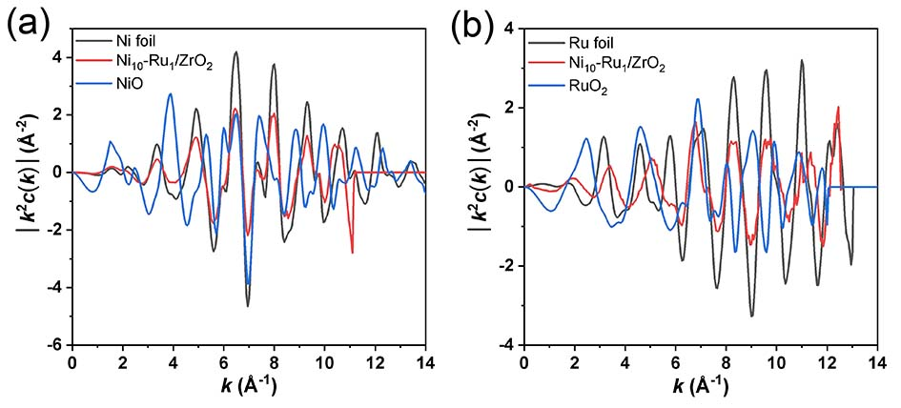
Figure S1. k²-weighted EXAFS oscillations [k²χ(k)] of Ni₁₀-Ru₁/ZrO₂ catalyst. The EXAFS data of Ni foil, NiO, Ru foil, and RuO₂ compounds are shown as references.

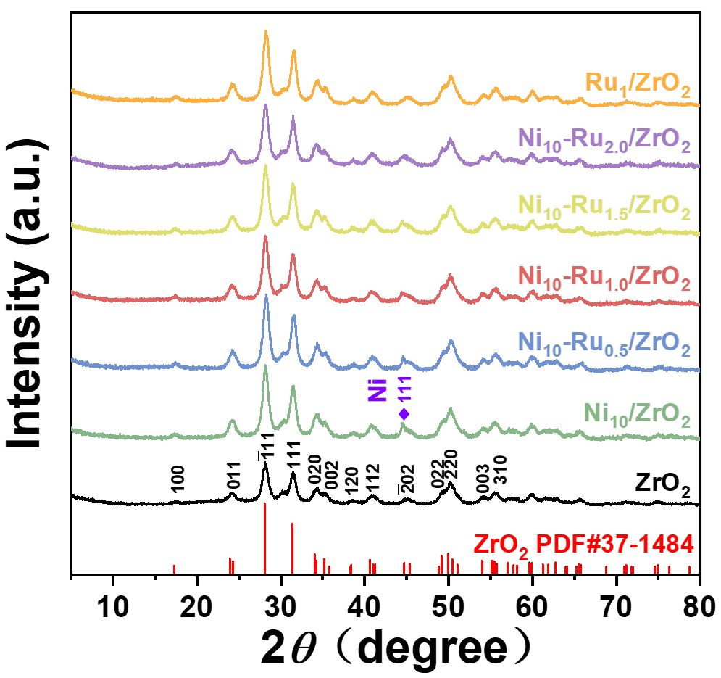
Figure S2. XRD patterns of ZrO₂, Ni–ZrO₂, Ru–ZrO₂, and bimetallic Ni–Ru/ZrO₂ samples.
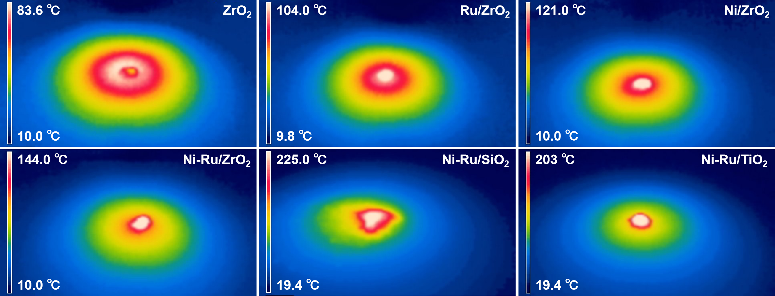
Figure S3. Infrared imaging temperature map of ZrO₂, Ru₁/ZrO₂ Ni₁₀/ZrO₂, Ni₁₀-Ru₁/ZrO₂, Ni₁₀Ru₁/SiO₂, and Ni₁₀Ru₁/TiO₂ from room temperature and stabilized within 300 seconds under light irradiation at intensity of 1.5 W cm⁻².

I(t)= A₁exp(-t/τ₁) + A₂exp(-t/τ₂)
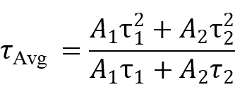

Equation S1

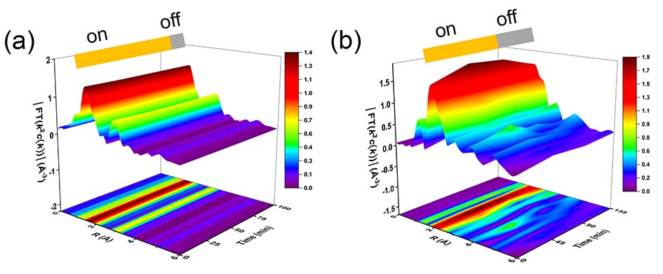
Figure S4. The k²-weighted Fourier transform spectra of in-situ EXAFS during photocatalytic reactions, the (a) Zr K-edge and (b) Ru L-edge of Ni₁₀Ru₁/ZrO₂ under light on and off conditions.

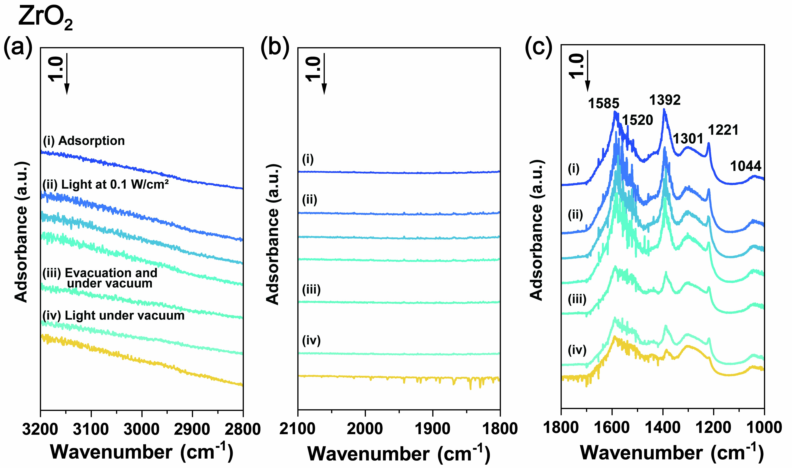
Figure S5. In situ FTIR spectra of ZrO₂ in photocatalytic CO₂ reduction under ¹³CO₂ (2.3 kPa) and H₂ (21.7 kPa). The spectra from top to bottom showed the operation and reaction times as follows: (i) Gas adsorption for 30 min, (ii) UV–visible light irradiation at 0.1 W cm⁻² for 1 h, 3 h and 19 h, (iii) evacuation and recording under vacuum for 30 min, and (iv) UV–visible light irradiation at 1.5 W cm⁻² under vacuum for 30 min and 90 min.

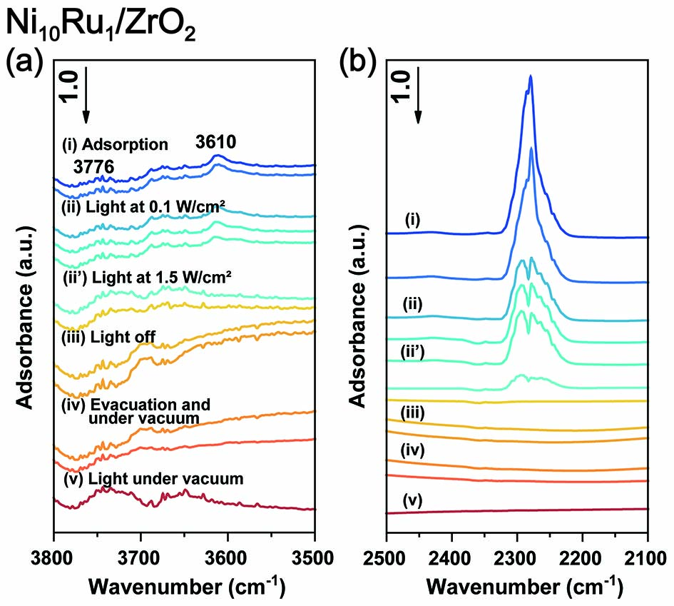
Figure S6. In situ FTIR spectra of SAA Ni₁₀-Ru₁/ZrO₂ in photocatalytic CO₂ reduction under ¹³CO₂ (2.3 kPa) and H₂ (21.7 kPa). The spectra from top to bottom showed the operation and reaction times as follows: (i) Gas adsorption for 30 min and 90 min, (ii) UV–visible light irradiation at 0.1 W cm⁻² for 1 h, 3 h and 19 h, (iiʹ) UV visible light irradiation at 1.5 W cm⁻² for 5 min and 2 h for Ni₁₀Ru₁/ZrO₂, (iii) light off for 5 min and 30 min, (iv) evacuation and recording under vacuum for 5 min and 30 min, and (v) UV–visible light irradiation at 1.5 W cm⁻² under vacuum for 30 min.
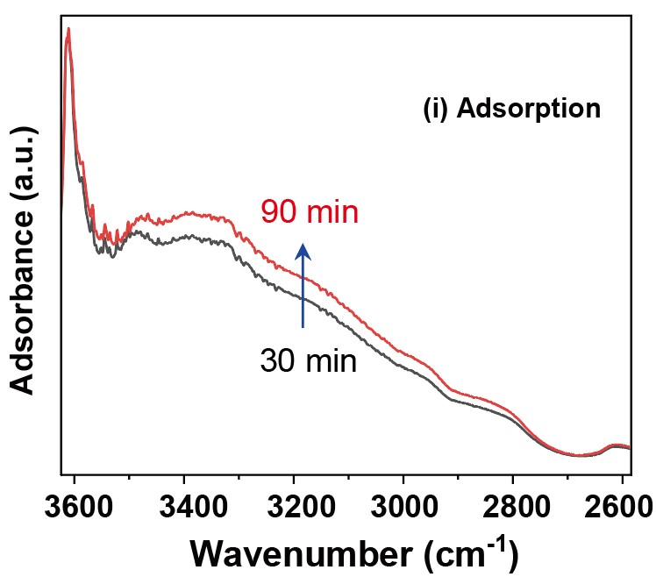
Figure S7. FTIR spectra showing CO₂ adsorption on Ni₁₀–Ru₁/ZrO₂ at room temperature in the dark for 30 and 90 min, indicating spillover of OH and/or H species from Ru sites to ZrO₂ surface (ν(OH), 3000–3600 cm⁻¹).

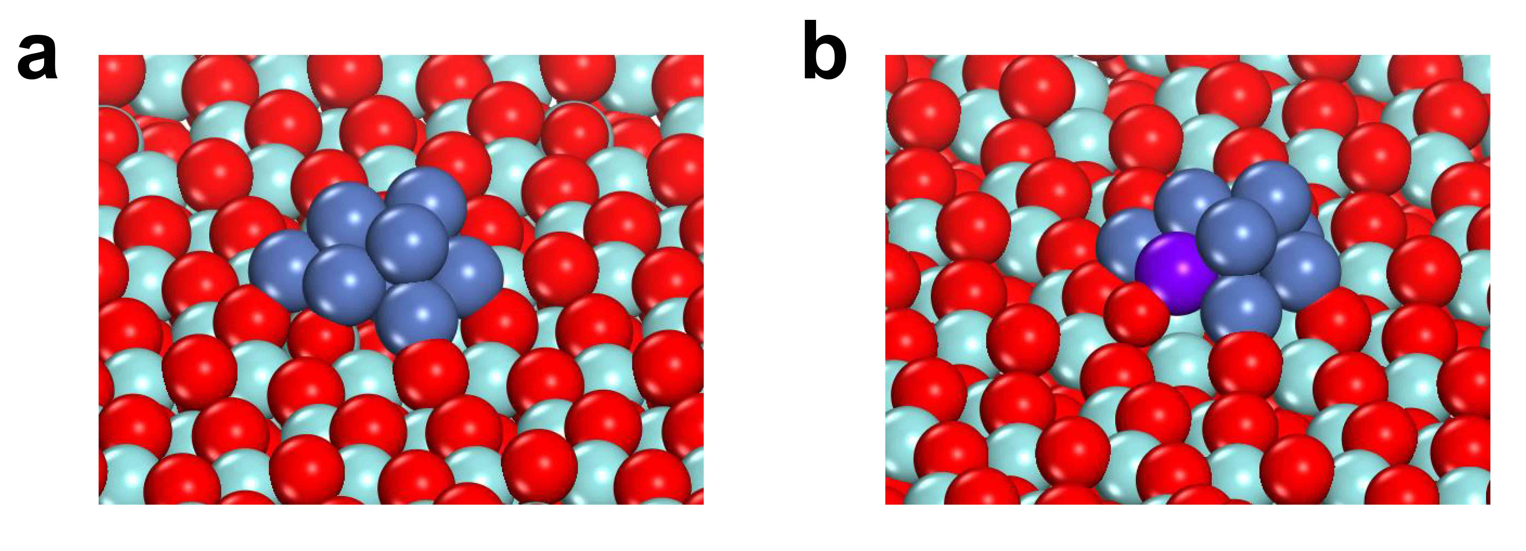
Figure S8. Computational structural modeling of Ni₁₀/ZrO₂ (a) and Ni₁₀–Ru₁/ZrO₂ (b).

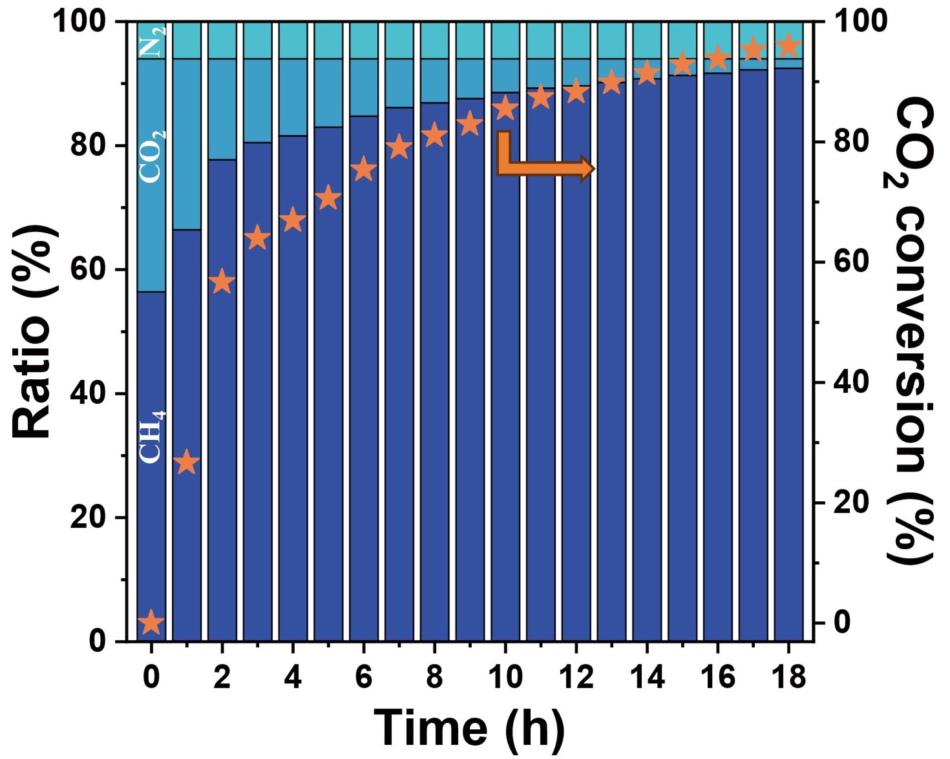
Figure S9. Time-course changes in the upgrading of homemade biogas.

Table S1. EXAFS fitting results of the SAA Ni₁₀-Ru₁/ZrO₂ catalysts, S₀² = 0.82.
Absorption edge | Shell | R (Å)ª | N^{b} | σ² (Å)^{c} | ΔE⁰ (eV)^{d} | R factor (%)^{e}
Ni K-edge | Ni–Ni | 2.49 | 6.50 | 0.00094 | −0.419 | 0.39
Ru L-edge | Ru–Ni | 2.49 | 3.88 | −0.08 | 0.331 | 4.2
ª R: Average distance between absorber and backscattered atoms.
^{b} Coordination number, determined by curve fitting.
^{c} Debye-Waller factor.
^{d} Inner potential correction.
^{e} R factor: goodness of fit, If R factor <5%, consistent with broadly correct models.

Table S2. Thermodynamic data of Ni₁₀-Ru₁/ZrO₂, Ni₁₀/ZrO₂ and Ru₁/ZrO₂.
entry | catalyst | applied temperature (℃) | CH₄ formation rate  (μmol h⁻¹ g_{cat}⁻¹)
1 | Ni₁₀-Ru₁/ZrO₂ | 50 | 0.9
2 | Ni₁₀-Ru₁/ZrO₂ | 100 | 4.8
3 | Ni₁₀-Ru₁/ZrO₂ | 150 | 25.9
4 | Ni₁₀-Ru₁/ZrO₂ | 200 | 73.6
5 | Ni₁₀/ZrO₂ | 150 | 4.0
6 | Ni₁₀/ZrO₂ | 200 | 13.2
7 | Ni₁₀/ZrO₂ | 250 | 22.3
8 | Ni₁₀/ZrO₂ | 300 | 107.4
9 | Ru₁/ZrO₂ | 150 | 87.5
10 | Ru₁/ZrO₂ | 200 | 542.1
11 | Ru₁/ZrO₂ | 250 | 1821.4
12 | Ru₁/ZrO₂ | 300 | 3466.5

Table S3. Time-resolved photoluminescence (TRPL) parameters of the Ni–Ru/ZrO₂ series sample.

Sample | τ1 (ns) | A1 | τ2 (ns) | A2 | τAvg (ns)
ZrO2 | 26.5 | 77.2% | 91.0 | 22.8% | 59.0
Ni10/ZrO2 | 33.5 | 75.5% | 120.7 | 24.5% | 80.5
Ru1/ZrO2 | 25.4 | 72.7% | 99.9 | 27.3% | 69.8
Ni10-Ru1/ZrO2 | 31.8 | 63.3% | 126.6 | 36.7% | 97.9

Table S4. Surface analysis of Ni–Ru/ZrO₂ series catalysts Zr 3d and O 1s based on XPS under different conditions.
Sample | Zr⁴⁺ |  | O_{α}  BE(eV) | O_{β}  BE(eV) | O_{γ}  BE(eV) | (O_{α}+O_{β})/(O_{total}) (%)
Sample | Zr 3d_{3/2}  BE(eV) | Zr 3d_{5/2}  BE(eV)
Ni₁₀/ZrO₂ | 184.4 | 182.0 | 531.7 | 530.2 | 529.6 | 63.8
Ni₁₀–Ru₁/ZrO₂ | 184.3 | 181.9 | 531.6 | 530.2 | 529.6 | 55.1
Ru₁/ZrO₂ | 184.3 | 181.9 | 531.6 | 530.2 | 529.6 | 54.2

Table S5. Surface analysis of Ni₁₀-Ru₁/ZrO₂ catalysts Zr 3d and O 1s based on in-situ XPS under different conditions.
Sample | Zr⁴⁺ |  | O_{α}  BE(eV) | O_{β}  BE(eV) | O_{γ}  BE(eV) | (O_{α}+O_{β})/(O_{total}) (%)
Sample | Zr 3d_{3/2}  BE(eV) | Zr 3d_{5/2}  BE(eV)
Pristine | 184.2 | 181.9 | 531.6 | 530.4 | 529.6 | 64.9
Reduced | 184.8 | 182.4 | 531.6 | 530.4 | 529.6 | 71.2
Light on | 184.9 | 182.6 | 531.6 | 530.4 | 529.6 | 66.4
Light off | 184.9 | 182.5 | 531.6 | 530.5 | 529.6 | 59.1

Table S6. Comparison with previously reported photo(thermal)-catalytic activities.
Catalysts | Light source | Temperature (℃) | CH₄ rate | Ref.
Ni-Ru/ZrO₂ | 300 W Xe lamp  1.5 W cm⁻² | - | 7.16 mmol g_{cat}⁻¹ h⁻¹ | This work
Ni-ZrO₂ | 500 W Xe arc lamp  142 mW cm⁻² | - | 0.98 mmol g_{cat}⁻¹ h⁻¹ | 8
In2O3@Ni | 300 W Xe lamp | - | 1043 μmol g⁻¹ h⁻¹ | 9
Co-ss@SiO2 | 300 W Xe lamp  2.5 W cm⁻² | - | 2.3 mmol g_{Co}⁻¹ h⁻¹ | 10
Ni/BN | 300 W Xe lamp | - | 2.03 mol g_{Ni}⁻¹ h⁻¹ | 11
0.35%Ru@Ni₂V₂O₇ | 300 W Xe lamp  2.0 W cm⁻² | - | 114.9 mmol g_{cat}⁻¹ h⁻¹ | 12
Ru/Al₂O₃ | 300 W Xe lamp | - | 18.16 mol g_{Ru}⁻¹h⁻¹ | 13
Ni/Al₂O₃ | 300 W Xe lamp | - | 2.3 mol g_{Ni}⁻¹h⁻¹ | 13
Ru/i-Si-O | 300 W Xe lamp  2.47 W cm⁻² | 150 | 2.8 mmol g_{cat}⁻¹ h⁻¹ | 14
Ru/MnCo₂O₄ | 300 W Xe lamp(420–780 nm)  1.25 W cm⁻² | 230 | 66.3 mmol g_{cat}⁻¹ h⁻¹ | 15
Ru-Al₂O₃-x-L | 300 W Xe lamp  2.0 W cm⁻² | 240 | 12.35 mmol g_{Ru}⁻¹ h⁻¹ | 16

Reference

1. G. Kresse, D. Joubert, From ultrasoft pseudopotentials to the projector augmented- wave method. Phys. Rev. B. 59, 1758-177 (1999).
2. J. P. Perdew, K. Burke, M. Ernzerhof, Generalized gradient approximation made simple. Phys. Rev. Lett. 77, 3865-3868 (1996).
3. S. Grimme, J. Antony, S. Ehrlich, H. Krieg. A consistent and accurate ab initio parametrization of density functional dispersion correction (DFT-D) for the 94 elements H-Pu. J. Chem. Phys. 132, 154104 (2010).
4. S. L. Dudarev, G. A. Botton, S. Y. Savrasov, C.J. Humphreys, A. P. Sutton. Electron-energy-loss spectra and the structural stability of nickel oxide: An LSDA+U study. Phys.Rev.B. 57, 1505 (1998).
5. G. Henkelman, H. Jónsson. Improved tangent estimate in the nudged elastic band method for finding minimum energy paths and saddle points. J. Chem. Phys. 113, 9978–9985 (2000).
6. G. Henkelman, H. Jónsson. A dimer method for finding saddle points on high dimensional potential surfaces using only first deri vatives. J. Chem. Phys. 111,7010–7022 (1999).
7. K. Momma, F. Izumi. VESTA 3 for three-dimensional visualization of crystal, volumetric and morphology data. J. Appl. Cryst. 44, 1272–1276 (2011).
8. H. W. Zhang, T. Itoi, T. Konishi, Y. Izumi, Efficient and Selective Interplay Revealed: CO₂ Reduction to CO over ZrO₂ by Light with Further Reduction to Methane over Ni by Heat Converted from Light. Angew. Chem. Int. Ed. 60, 9045–9054 (2021).
- F. Raziq, C. Feng, M. Hu, S. Zuo, M. Z. Rahman, Y. Yan, Q.-H. Li, J. Gascon, H. Zhang, Isolated Ni Atoms Enable Near-Unity CH₄ Selectivity for Photothermal CO₂ Hydrogenation, J. Am. Chem. Soc. 146, 30, 21008-21016 (2024).
- M. Cai, C. Li, X. An, B. Zhong, Y. Zhou, K. Feng, S. Wang, C. Zhang, M. Xiao, Z. Wu, J. He, C. Wu, J. Shen, Z. Zhu, K. Feng, J. Zhong, L. He, Supra-Photothermal CO₂ Methanation over Greenhouse-Like Plasmonic Superstructures of Ultrasmall Cobalt Nanoparticles, Adv. Mater. 36, 2308859 (2024).
- X. Zhu, H. Zong, C. J. V. Pérez, H. Miao, W. Sun, Z. Yuan, S. Wang, G. Zeng, H. Xu, Z. Jiang, G. A. Ozin, Supercharged CO₂ Photothermal Catalytic Methanation: High Conversion, Rate, and Selectivity, Angew. Chem. Int. Ed. 62, e202218694 (2023).
- Y. Chen, Y. Zhang, G. Fan, L. Song, G. Jia, H. Huang, S. Ouyang, J. Ye, Z. Li, Z. Zou, Cooperative catalysis coupling photo-/photothermal effect to drive Sabatier reaction with unprecedented conversion and selectivity, Joule 5, 3235–3251 (2021).
- X. Meng, Dr. T. Wang, Dr. L. Liu, Dr. S. Ouyang, Dr. P. Li, H. Hu, Dr. T. Kako, Dr. H. Iwai, Dr. A. Tanaka, Prof. J. Ye, Photothermal Conversion of CO₂ into CH₄ with H₂ over Group VIII Nanocatalysts: An Alternative Approach for Solar Fuel Production, Angew. Chem. Int. Ed. 53, 11478-11482 (2014).
- Y. Tang, Z. Yang, C. Guo, H. Han, Y. Jiang, Z. Wang, J. Liu, L. Wua, F. Wang, Encapsulating Ir nanoparticles into UiO-66 for photo-thermal catalytic CO₂ methanation under ambient pressure, J. Mater. Chem. A. 10, 12157−12167 (2022).
- C. Guo, Y. Tang, Z. Yang, T. Zhao, J. Liu, Y. Zhao, F. Wang, Reinforcing the Efficiency of Photothermal Catalytic CO₂ Methanation through Integration of Ru Nanoparticles with Photothermal MnCo₂O₄ Nanosheets, ACS Nano. 17, 23, 23761-23771 (2023).
- X. Liu, C. Xing, F. Yang, Z. Liu, Y. Wang, T. Dong, L. Zhao, H. Liu, W. Zhou, Strong Interaction over Ru/Defects-Rich Aluminium Oxide Boosts Photothermal CO₂ Methanation via Microchannel Flow-Type System, Adv. Energy Mater. 18, 2201009 (2022).

