Supplementary Information
Title: Sleep Deprivation Potentiates Silica Nanoparticle-Induced Circadian Disruption and Lacrimal Gland Dysfunction in Mice
Short title: SD Aggravates SiNP-Induced Lacrimal Gland Dysfunction
Wenxiao Zhang¹, Di Qi², Xiaoting Pei², Dingli Lu², Mengru Ba¹, Shuting Xuan³, Duliurui Huang¹, Tingting Yang³, Jingwen Yang², Zhijie Li^{1,2,3*}, Shenzhen Huang^{1,2,3*}
¹Department of Ophthalmology, People’s Hospital of Zhengzhou University, Henan Provincial People’s Hospital, Zhengzhou, China
²Henan Eye Institute, Henan Eye Hospital and Henan Key Laboratory of Ophthalmology and Visual Science, People’s Hospital of Henan University, People’s Hospital of Zhengzhou University, Henan Provincial People’s Hospital, Zhengzhou, China
³Department of Ophthalmology, People’s Hospital of Henan University, Henan Provincial People’s Hospital, Zhengzhou, China
*Corresponding author
Henan Eye Institute & Henan Eye Hospital, Henan Provincial People’s Hospital, No. 7, Weiwu Road, Zhengzhou, China (450003), Tel: +86-371-67120562; Fax: +86-371-67120562. Email address: tzhijieli@jnu.edu.cn (Zhijie Li), huangshenzhen@zzu.edu.cn (Shenzhen Huang)
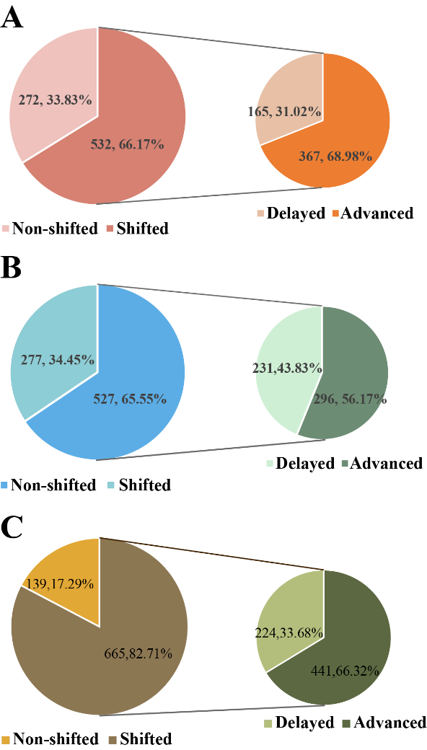
Figure S1. Phase shifts of rhythmic genes in response to SiNPs and SD+SiNPs treatments.
(A) Pie charts illustrate the distribution of non-shifted and shifted rhythmic genes in the SiNPs-treated group compared to the NC group. Of the 804 rhythmic genes in the NC group, 272 (33.83%) remained non-shifted, while 532 (66.17%) underwent phase shifts. Among the shifted genes, 367 (68.98%) were delayed and 165 (31.02%) were advanced.
(B) Pie charts show the phase shift distribution in the SD+SiNPs-treated group compared to the SiNPs-treated group. In the SD+SiNPs-treated group, 277 (34.45%) of 804 genes remained non-shifted, while 527 (65.55%) were shifted. Specifically, 296 (56.17%) were delayed and 231 (43.83%) were advanced.
(C) Pie charts depict the phase shifts of rhythmic genes in the NC group under SD+SiNPs treatment. Of the 804 genes, 139 (17.29%) remained non-shifted, while 665 (82.71%) were shifted. Among the shifted genes, 441 (66.32%) were advanced and 224 (33.68%) were delayed. N=24 individual mice per group.
Figure S2. Differential gene expression analysis in murine ELGs following SiNPs treatment and SD treatment.
(A) Volcano plot visualizing DEGs between NC and SD+SiNPs-treated groups. The x-axis indicates ZT points, and the y-axis shows fold change (FC). Red dots represent genes with adjusted P < 0.01, while gray dots indicate genes with adjusted P ≥ 0.01. N=24 individual mice per group.
(B) Volcano plot comparing DEGs between SiNPs-treated and SD+SiNPs-treated groups. The x-axis indicates ZT points, and the y-axis shows FC. Red dots represent genes with adjusted P < 0.01, while gray dots indicate genes with adjusted P ≥ 0.01. N=24 individual mice per group. N=24 individual mice per group.

Table S1. The top 10 DEGs between the SiNPs-treated group and the NC group.
Table S2. The top 10 DEGs between the SD+SiNPs-treated group and the NC group.
Table S3. The top 10 DEGs between the SD+SiNPs-treated group and the SiNPs-treated group.
Table S4. Unique and shared rhythmic genes identified in ELGs among NC, SiNPs, and SD+SiNPs treatments.
Table S5. KEGG pathways for rhythm genes unique to the NC group.
Table S6. KEGG pathways for rhythm genes unique to the SiNPs-treated group.
Table S7. KEGG pathways for rhythm genes unique to the SD+SiNPs-treated group.
Table S8. KEGG pathways for shared rhythmic genes among NC, SiNPs, SD+SiNPs treatments.
Table S9. Phase-set enriched pathways in the NC group.
Table S10. Phase-set enriched pathways in the SiNPs-treated group.
Table S11. Phase-set enriched pathways in the SD+SiNPs-treated group.
Table S12. KEGG pathways associated with clusters 1–4 unique to NC-treated ELGs.
Table S13. KEGG pathways associated with clusters 1–4 unique to SiNPs-treated ELGs.
Table S14. KEGG pathways associated with clusters 1–4 unique to SD+SiNPs-treated ELGs.
Table S15. Results of two-way repeated measures ANOVA of Core Clock Genes
Table S16. Immune-related transcripts in ELGs.
Table S17. KEGG pathways for immune-related transcripts in ELGs.
Table S18. Neuro-related transcripts in ELGs.
Table S19. KEGG pathways for neuro-related transcripts in ELGs.

